Marketing Plan
Travelodge hotel

Student Name: Maria-Mirabela Vasile
Student ID: 2207873
Module: Marketing Essentials BMIH4005
Name of the lecturer: Luciana Suardi
Word count: 1321

Date: 08.03.2023

Introduction.
A marketing plan can be explained as the process of planning various kinds of strategies by any organisation for growing their business activities while generating higher revenue. The following marketing plan will briefly identify an issue or marketing opportunity for Travelodge hotel, by covering the 5Cs of the company. A smart objective will be conducted followed by some strategies and tactics to overcome the issue with some action and control based on the situational analysis.
In the UK, Travelodge was established in 1985 when it opened its first hotel. Ever since that moment, Travelodge Hotels reached 582 hotels across 387 cities in the UK (ScrapHero, 2023).

The SOSTAC framework is a marketing model used for planning various marketing activities by including factors such as situation, strategy, action, objectives and many more.

Swot Analysis.
Strengths. The primary strength of Travelodge is their affordability in which they offer their services at a very affordable price rate included with various deals and offers. Convenient locations, easy booking process, free parking are also to be considered as strengths of Travelodge.
Weakness. As a budget hotel with affordable pricing, their customers are not offered a wide range of services since the rooms were described as boring and also plain looking (Toughnickel, 2022).
Opportunity. Ecotourism has turned out to be a new trend that is adopted by many hotel industries for increasing their brand reputation. Travelodge can implement such environment-friendly services as a better opportunity.
Threats. Travelodge has a very limited presence in terms of international locations as they are focussed mainly in the United Kingdom and Ireland. This can pose a threat if the brand is not further expanded (Desklib, 2020). Inside the market, competition is strong as Premierinn Hotels are one of the direct competitors, offering similar value for similar price.

Travelodge Customer Profile.
Being a budget hotel, Travelodge is best option for travellers that are price sensitive, that prioritise price over luxury. The brand is known for its affordable rates, basic accommodations and convenient locations. Customer base includes both domestic and international travellers. Customers such as families, tourists and business travellers, customers that value affordability and accessibility are constantly looking for Travelodge bookings.

Bowman’s Strategy Clock.
This is a comprehensive strategy tool, which offers positioning in any market based on price and value. They are segregated into eight factions and they are lower price with value-added, lowered rate, hybrid, differentiation, focused form of differentiation, risk of high margins, monopoly rate and loss in market share. Therefore, as Travelodge is a budget hotel, they can follow the low price and value-added factor for serving their customers better (Villagrasa et al., 2021).

Franchising.
This is a marketing concept that can be implemented by an organisation for its business expansion. Here, a franchisor licenses a few brand rights and sells every commodity and service to the franchisee. Since Travelodge has very little presence outside of the UK and Ireland, the company can implement this strategy for their business expansion (Bretas and Alon, 2021).

PESTLE Analysis.
Political: Government regulations and policies affecting the hotel industry. The impact of Brexit on the UK hospitality industry, including changes in visa and travel requirements for EU citizens and the availability of skilled labor. Economic: Fluctuations in the economy, including inflation, exchange rates, and interest rates, which may affect the hotel industry's profitability and demand for services. Social: Demographic trends, such as changes in population size, age, and income levels, which may affect the hotel industry's target market and customer preferences. Technological: The increasing use of technology in the hotel industry, such as mobile check-in and keyless room entry. The growth of online travel agencies and review sites, which may impact the hotel industry's reputation and revenue.
The aim of this marketing plan is to understand the current trends in the marketing field that are supporting Travelodge in increasing its customer base.

Objectives of Marketing plan:
- to increase the customer base of Travelodge, by implementing current marketing trends;
- to enrich the profit margins of Travelodge, by increasing its customer base;
- to promote the brand image of Travelodge, by deploying current social media marketing strategies.

Strategy. Better usage of Digital Marketing.
Digital marketing is the process of promoting the services and products, which are made by an organisation, to a certain customer base for growing the overall business. Digital marketing requires a method of collecting relevant data and information about a target market or customers. This data is retrieved from the way a particular segment is satisfied by the competitors and then, that data is analysed, processed and later interpreted. This will ensure that companies like Travelodge, will gather relevant data in a certain segment for obtaining a better understanding of the needs and wants of their customer base. As per the collected information, the company can further serve in a better way for satisfying their respective customers (Saura et al., 2019).

Marketing Mix.
Product. Travelodge already offers suitable and comfortable stay with basic amenities for their travellers. This can be improved by the brand when they start offering additional benefits and rewards with added costs. Those benefits would include discounts for the visitors for their stay within a particular time in which they can enjoy added benefits at the same price. Moreover, the hotel can introduce swimming pools for both adults and kids and pick-up services where they will be picked up from airports or stations (Nguyen-Viet, 2023).
Price. Travelodge has 582 branches across the United Kingdom. The brand can also explore new locations to launch its business by utilising its budget-friendly price approach. Hence, when their pricing is done in a way that will meet the needs and demands of customers without pushing too much pressure on their budgets, it will attract more travellers (Nikbin et al., 2022).
Place. Travelodge is located in multiple regions and cities across the UK for attracting customers from local and global destinations. Therefore, this has enabled them to launch 582 outlets to offer their services at a wider range. Moreover, launching new hotels in other locations, currently having most of their hotels in England, like expanding the numbers of hotels in Northern Ireland, Wales and Scotland, can also benefit the company to attract a higher customer base.
Promotion. The best way for Travelodge to promote its new and unique services, which might help them to stand out from the competitors, is by making use of social media to its full potential. The organisation can also give feedback to their older customers for generating a better brand reputation. Along with that, Travelodge can use auto chat features for taking queries from their customers and solving them including their bookings and reservations (Vilkaite-Vaitone and Skackauskiene, 2019).

Action.
As per the action plan, the marketing plan commences in the 1st week with the preparation of the marketing plan, going to week 5. Starting from week 3 to week 7, a full market research will take place. Week 7 to 11, the plan will benefit the full advantages offered by promotion via different marketing channels. Week 12-13 will be all about gathering the feedback.

Control.
There is a process which organisations can undertake which is the Unique Selling Points, commonly known as USPs. These unique selling points hinder other companies from copying and imitating the activities and make an organisation stand out in any market. Thus, Travelodge can make use of auto-booking systems, wireless transactions and feedback services by using AI.

Conclusion.
The above marketing plan has briefly shed light on the marketing strategies that can be implemented by Travelodge, to develop their business activities through necessary changes.
The better use of digital marketing, an expansion of hotel placements in parts like Northern Ireland, Wales and Scotland, adding benefits and rewards, embracing sustainability and ecotourism, strengthening their affordability and looking for new ways of attracting new customers are things that Travelodge hotels could do in order to keep existing customer base and to expand it.

References.
Bretas, V.P. and Alon, I., (2021). Franchising research on emerging markets: Bibliometric and content analyses. Journal of Business Research, pp.51-65.
Chaffey, D., (2022). SOSTAC marketing planning model guide and the RACE Growth System. Available at: https://www.smartinsights.com/digital-marketing-strategy/sostac-model/ Accessed: 05.02.2023.
David J., (2023). PESTEL analysis of the UK (Country Profile). Available at: https://www.howandwhat.net/pestel-analysis-uk/#:~:text=PESTEL%20analysis%20is%20a%20very,them%20in%20making%20strategic%20decisions.&text=The%20UK%20consists%20of%20England,%2C%20Scotland%2C%20and%20Northern%20Ireland Accessed: 12.02.2023
Desklib, (2020). SWOT Analysis of Travelodge Hotel - Assignment. Available at: https://desklib.com/document/particulars-1st-year-2nd-year-3rd-yea/ Accessed: 19.02.2023.
Association for project management (2022). What is a Gantt chart? Available at: https://www.apm.org.uk/resources/find-a-resource/gantt-chart/ Accessed: 21.02.2023
Kotler, Phil T., et al. (2019). Principles of Marketing, Pearson Education Limited. Available at: https://ebookcentral.proquest.com/lib/trinity/detail.action?docID=5978379 Accessed: 15.02.2022
Marketing91 (2019). What is Bowman’s Strategy Clock? Available at: Bowman’s Strategy Clock - What is Bowman’s Strategy Clock? (marketing91.com). Accessed: 17.02.2023
Nguyen-Viet, B., (2023). The impact of green marketing mix elements on green customer based brand equity in an emerging market. Asia-Pacific Journal of Business Administration, pp.96-116.
Nikbin, D., Iranmanesh, M., Ghobakhloo, M. and Foroughi, B., (2022). Marketing mix strategies during and after COVID-19 pandemic and recession: a systematic review. Asia-Pacific Journal of Business Administration, pp.405-420.
Saura, J.R., Palos-Sanchez, P.R. and Correia, M.B., (2019). Digital marketing strategies based on the e-business model: Literature review and future directions. Organizational transformation and managing innovation in the fourth industrial revolution, pp.86-103.
ScrapHero (2023). Number of Travelodge hotels in the United Kingdom in 2023. Available at: https://www.scrapehero.com/location-reports/Travelodge-UK/#:~:text=How%20many%20Travelodge%20hotelss%20are%20there%20in%20the,88%25%20of%20all%20Travelodge%20hotelss%20in%20the%20UK. Accessed: 16.02.2023
Toughnickel, (2022). Travelodge: Comprehensive Business Analysis and International Expansion Plan. [Online]Available at: https://toughnickel.com/industries/Travelodge-Comprehensive-Business-Analysis-and-International-Expansion-Plan Accessed: 24.02.2023
Travelodge, (2023). Introducing our new look Travelodge. Available at: https://www.travelodge.co.uk/ Accessed: 15.02.2023
Vilkaite-Vaitone, N. and Skackauskiene, I., (2019). Green marketing orientation: evolution, conceptualization and potential benefits. Open Economics, pp.53-62.
Villagrasa, J., Sánchez, F. and Donaldson, C., (2021). Deciphering the strategic clock hands: from theory to reality. In INTED2021 Proceedings, pp. 9571-9584.

APPENDICES
Figure 1: SOSTAC model, Source: (Chaffey, 2022)
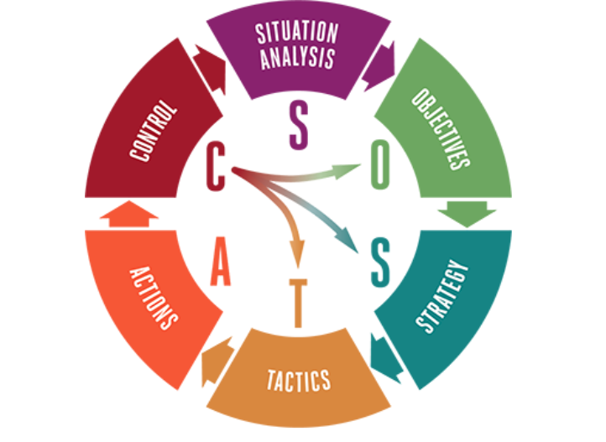

Figure 2: Bowman’s Strategy Clock. Source: Marketing91 (2019)
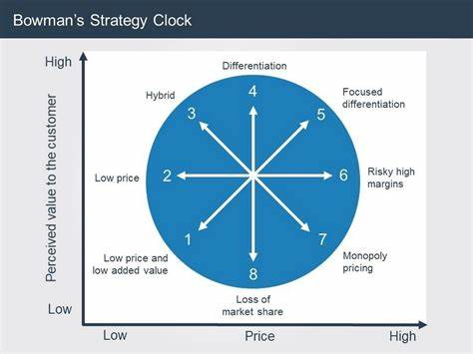

Figure 3. Gaant Chart

Objectives | Week 1-2 | Week 3-5 | Week 6-7 | Week 7-9 | Week 10-11 | Week 12-13
Preparation
Market Research
Marketing Channels
Gathering feedback



