Programme: BA (Hons) Business Management
Module: Data Handling and Business Intelligence
Module code: LCBB5000
Assessment 2

Table of Contents
Introduction 3
Task 1 4
Use of the IF function to find out the average price for hotel reservation 4
Use of pivot table function to find out the average price for hotel reservation 5
Increase or decrease in price 7
Evaluation of the use of Microsoft Excel for pre-processing, analysing and visualising data 8
Task 2 10
The number of male and female students 10
The number of students qualifies and do not qualify for reduced/free lunch 10
The mean and median of students who qualify and do not qualify for reduced/free lunch 10
The mean and median differences between students' pre-test and post-test scores 11
Clustering, its example and explanation 12
An explanation of different data mining and text mining methods 14
The advantages and disadvantages of using SPSS and Excel using relevant practical examples 16
Conclusion 18
References 19

Introduction
Data is required as the most important resource for making proper decisions in an organisation or for any other case. But only the collection of data can not help an individual or an organisation in the fulfilment of their purposes. Because the data which are collected for any purpose mainly remain unorganized that are not ready to use by any party for any purpose (Narasimhan & Jordache, 2020). There are various tools which are used for data arranging and analysis to make those ready for users' purposes. Microsoft Excel is such a type of tool which can be used for data listing, arranging and analysing to make them arranged for decision-making purposes. (Microsoft 365, 2023) SPSS is another application which is used for mainly statistical data analysis. SPSS provides a rapid and visible modelling environment that can handle models ranging in complexity from the simplest to the most sophisticated (EDUCBA, 2023). The data that is collected via SPSS is utilised for a variety of purposes, including surveys, data mining, and other types of market research. This report is going to be prepared to show the use and applications of both Microsoft Excel and SPSS to arrange and analyse data which are provided by the given context.

Task 1

Use of the IF function to find out the average price for hotel reservation
The IF function in Excel is among the most well-liked and practical ones. Excel's IF function is a logical function that enables the user to make judgements depending on a particular circumstance (Murray, 2022). The user may use this function by typing "if." A logical test is put to the test, and the result is either one value or another value, depending on whether or not the test was successful. The following is a representation of the correct syntax for the IF function:
IF(logical_test, [value_if_true], [value_if_false])
In this context, "logical test" refers to the condition that is being tested. It is open to either a True or a False verdict depending on how it is examined. The second parameter is called Value_if_true, and it specifies the value that should be returned if the logical test is found to have a result of TRUE, which indicates that the condition has been satisfied. If not provided, a value must be specified for the value_if_false parameter.
In the context of the given scenario of hotel reservation, the IF function can be used to find out the average price of the hotel from the year 2017 to 2021. The below formula have used to calculate those amounts,
=AVERAGEIF('Hotel Reservation'!J:J,IF_Function!A2,'Hotel Reservation'!Q:Q)
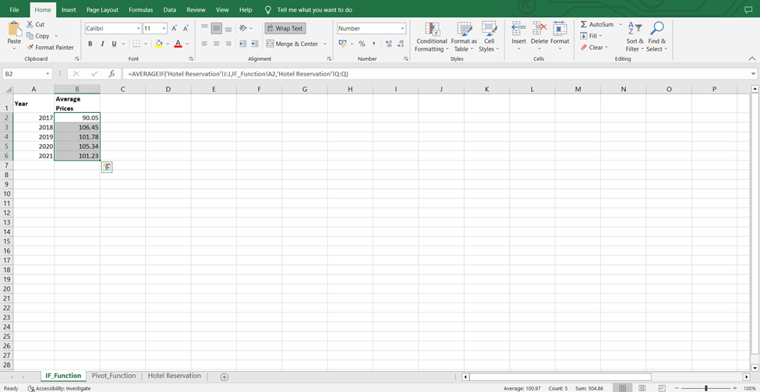
From the above screenshot of the spreadsheet, it can be seen that the average price of the hotel reservation cost during 2017-2021. With the application of the above formula, it has easily been calculated from a vast data set.

Use of pivot table function to find out the average price for hotel reservation
A pivot table is a sophisticated data analysis tool in Microsoft Excel that enables clients to easily summarise and analyse massive volumes of data in a short period (Murray, 2022). Users may access and work with pivot tables by clicking the "Data" tab. It provides the user with the ability to examine his data in a variety of ways, such as by summarising, grouping, and separating information based on a variety of criteria, which assists the user in making connections between the data he has collected. By using the pivot table function the average price from the year 2017 to 2021 can be shown with lots of other information.
The pivot table can be created in the same sheet where the original data exits or a new sheet can be selected to make that. In this case, a new sheet has been taken to create the pivot table for the given data set of hotel reservations. After creating the new sheet, the user has to go to the Insert option where the option for the pivot table can be seen as per the given screenshot,
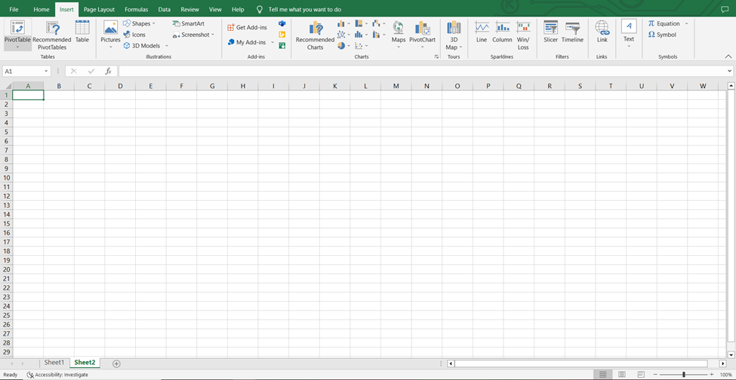
Now by clicking on the pivot table, excel will instruct the user to select the range. In the following screenshot, the range selection is demonstrated,
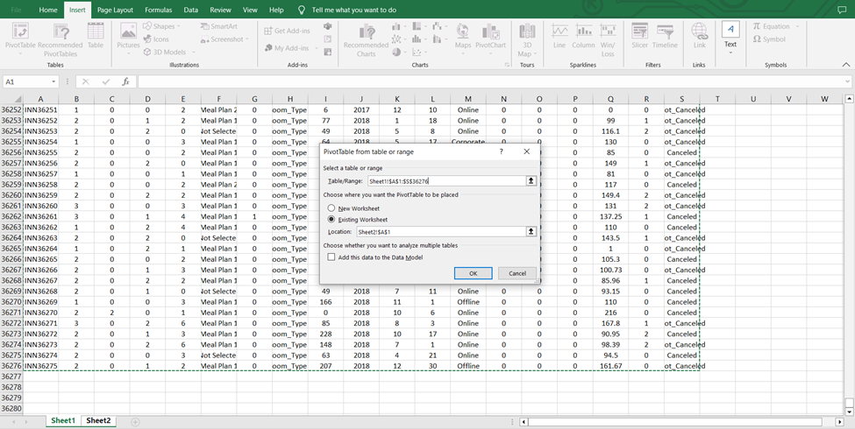
Then the following options will come from where we can make our required pivot table on our own.
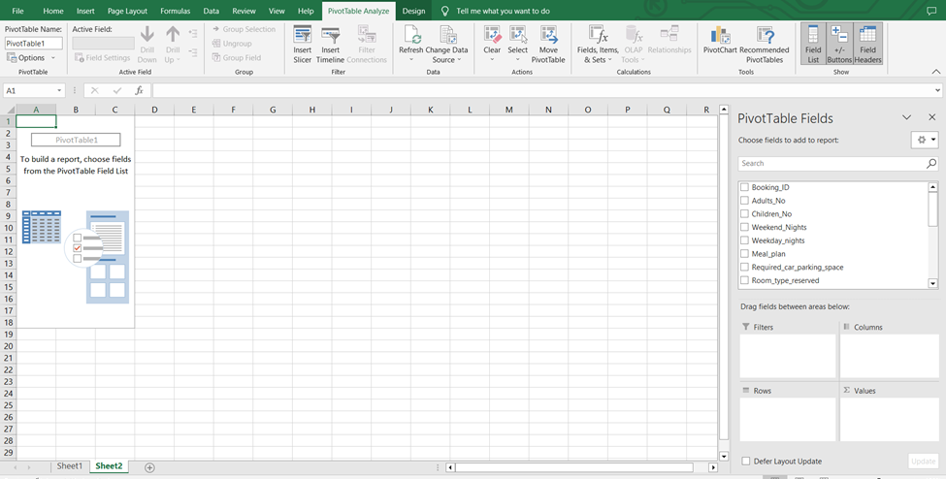
Then the row of the table and the required section of average price can be selected to show the following thing,
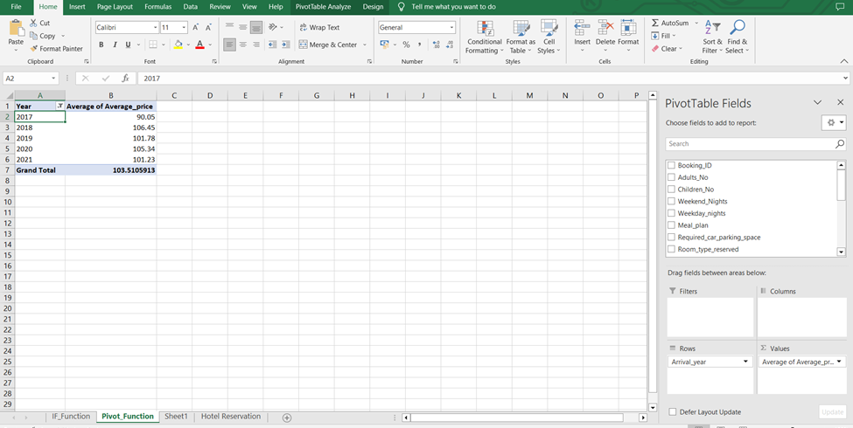
In this way by creating the pivot table, the average yearly price can be calculated and presented.

Increase or decrease in price
Now to calculate and show the increase and decrease in average price from the year 2017 to 2021 a new column can be inserted in the excel sheet. To show changes here 2017 was taken as the base year. So in the C3 cell, the following formula can be used to calculate an increase or decrease in the average price,
=(B3-B2)/B2*100
Then another column can be inserted to show the presentation of increase or decrease alphabetically by the following formula,
=IF(C3>=0,"Increase","Decrease")
Now a graph has shown the changes in the average price visually. The graph is attached below,

It has been seen from the above graph that the average price has increased from the year 2017 to 2018. That was the biggest increase in the average price. In 2019 the average price has decreased to some extent but in the year 2020, it has seen another increase. Finally, in the year 2021, the average price has decreased again as per the calculation and the graph.

Evaluation of the use of Microsoft Excel for pre-processing, analysing and visualising data
Spreadsheet software like Microsoft Excel gives users the ability to both enter and analyse data in a variety of formats. Users may also make charts, graphs, and even infographics to show their results (Ansell, 2016). Microsoft Excel is useful at any point throughout a study. Microsoft Excel reduces the amount of extra data that would otherwise be generated by the programme. This may be helpful for those who are less experienced with or new to quantitative data analysis since it can make training new statistical approaches less of a steep learning curve. When it comes to data preparation, analysis, and visualisation, Excel may be a huge help.
When working with structured data, Microsoft Excel is an excellent tool for preprocessing and management. Cleansing structured data is made simpler in Excel by the use of built-in functions and methods. Excel makes it simple for a user to create a list of the information he or she needs. Excel can help one to arrange his data so that it's simple to read and analyse. This means it can process data in preparation for further analysis (Pillai, 2015). It also provides filtering options, so you may get just the information you need based on what you specify. Excel may be used for the analysis of data after it has been preprocessed.
Excel's 400 built-in functions are put to use in a wide variety of data analysis scenarios. Excel's data visualisation tools let the user draw conclusions and share those conclusions with others. Excel's charting capabilities range from the basic (2D) variety to the more sophisticated (3D) models. There is a wide range of flexibility in terms of chart style, layout, and colour scheme.

Task 2

The number of male and female students
The “COUNTIF” function in excel can be used to calculate the number of male and female students in the school.
The formula for calculating the number of male students is: =COUNTIF(H2:H2134, "Male")
The formula for calculating the number of male students is: =COUNTIF(H2:H2134, "Female")
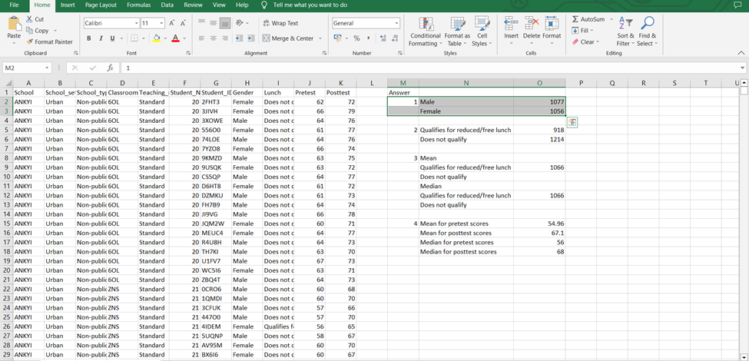
After entering the formula the cells shows that the number of male students is 1077 and the number of female students is 1056.

The number of students qualifies and do not qualify for reduced/free lunch
Here, the “COUNTIF” function in excel can be used to calculate the number of students qualifies and do not qualify for reduced/free lunch.
The formula for calculating the number of students qualified for reduced/ free lunch is: =COUNTIF(I2:I2134, "Qualifies for reduced/free lunch")
The formula for calculating the number of students who do not qualify for free/reduced lunch is: =COUNTIF(I3:I2134, "Does not qualify")
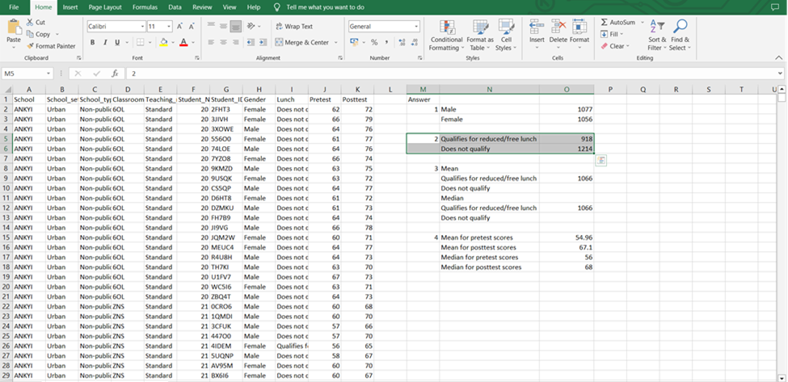
The output in the cells shows that 918 students have qualified for reduced or free lunch and 1214 students do not qualify for reduced or free lunch.

The mean and median of students who qualify and do not qualify for reduced/free lunch
The mean value refers to the average value of a data set. It is a measure of central tendency that calculate the arithmetic average of several observation or data. The mean is calculated by adding up all the values in the data set and dividing the some by the number of observations or data. In Microsoft Excel, the “Mean” function can be used to calculate the mean value of a data set. The function used to calculate the mean for the students who qualify and do not qualify for reduced or free lunch is:
Mean: =AVERAGE(O5,O6)
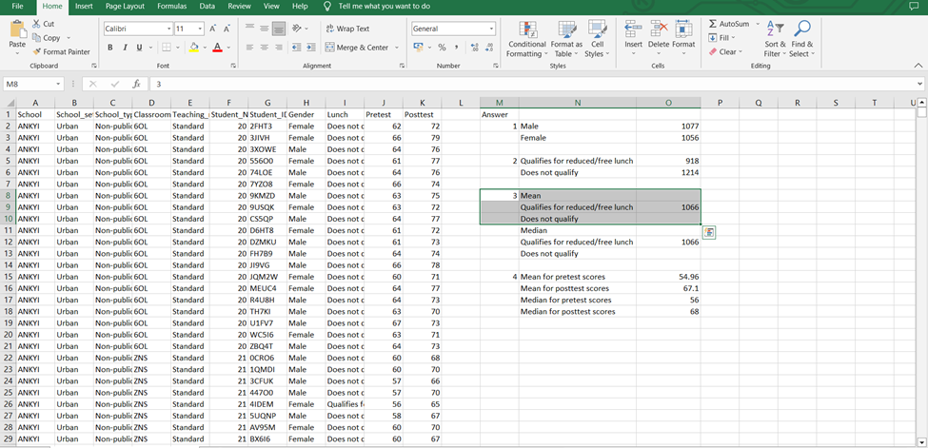
The cell shows that the mean value for the students who qualify and do not qualify for reduced or free lunch is 1066.
The median of a dataset refers to the middle value of data from a sorted list of datasets. The median value of a dataset helps to determine the central value of the data set in comparison to the mean value. In Microsoft Excel, the “MEDIAN” function can be used to determine the median value from a data set. For this, the data need to be sorted in ascending order. The function used to calculate the median for the students who qualify and do not qualify for reduced or free lunch is
Median: =MEDIAN(O5,O6)
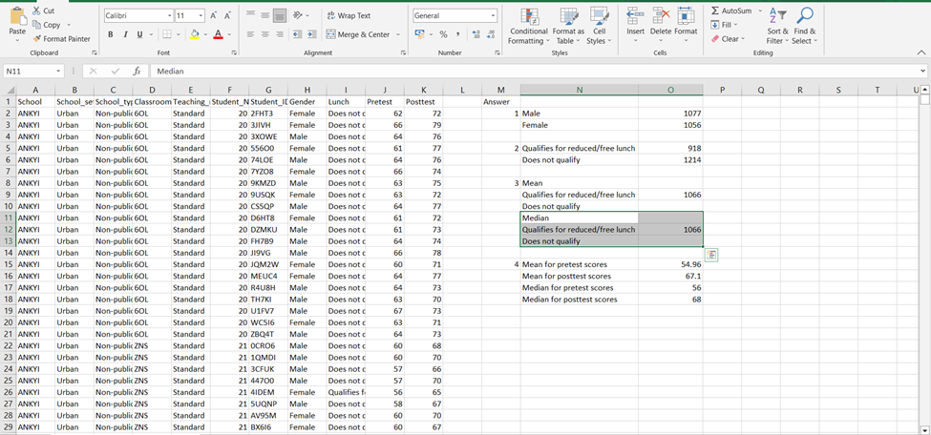
The cell shows that the median value for the students who qualify and do not qualify for reduced or free lunch is 1066.

The mean and median differences between students' pre-test and post-test scores
To determine the mean and median differences between students' pre-test and post-test scores, the mean and median values of the pre-test and post-test scores need to be calculated. The following formulas can be used in excel to calculate the mean and median value of the pre-test and post-test scores of the students.
Mean for pre-test scores: =AVERAGE(J2:J2134)
Mean for post-test scores: =AVERAGE(K2:K2134)
Median for pre-test scores: =MEDIAN(J2:J2134)
Median for post-test scores: =MEDIAN(K2:K2134)
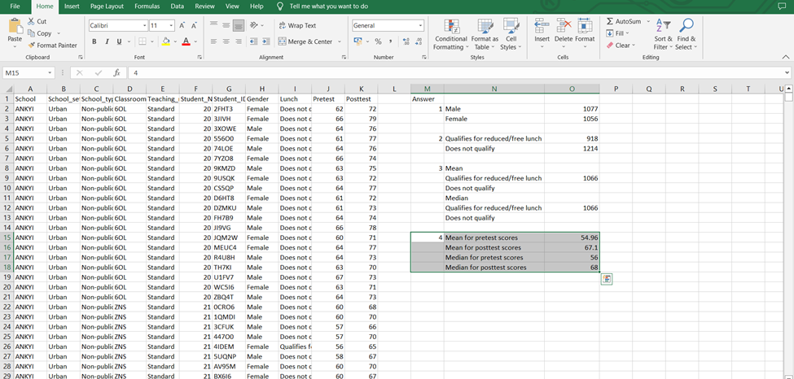
After applying the formula in excel, the cells show the following outcome:
Mean for pre-test scores: 54.96
Mean for post-test score: 67.10
The median for pre-test scores: 56
The median for post-test scores: 68
So, The mean differences between students' pre-test and post-test scores = (67.10 – 54.96)
= 12.14
The median differences of students' pre-test and post-test scores = (68 - 56)
= 12
The differences in the mean and median values of the student's pre-test and post-test scores indicate that the post-test scores of the students are comparatively higher than the pre-test scores of the students.

Clustering, its example and explanation
Clustering refers to the grouping of unlevelled data that have similar traits or characteristics. This refers to the separation of data from a large amount of dataset based on their traits. K-Means Clustering is an unsupervised Learning algorithm that clusters unlabelled datasets into distinct categories (Harper, 2010). It makes it possible to cluster the data into several groups and provides a practical method for discovering the types of groups that exist inside a data set that is unlabelled on its own.
In this case, the SPSS can be used to cluster the given data says about the student and their pre-test and post-test scores. Assuming that the cluster of the student will be conducted based on the pre-test and post-test scores of them. The steps class studying the data series in SPSS is given below:
Step 1: To cluster the data of the students the dataset regarding the pre-test and post-test scores of the students need to import into the SPSS.
Step 2: Click on Analyse > Classify > K-Means Cluster.
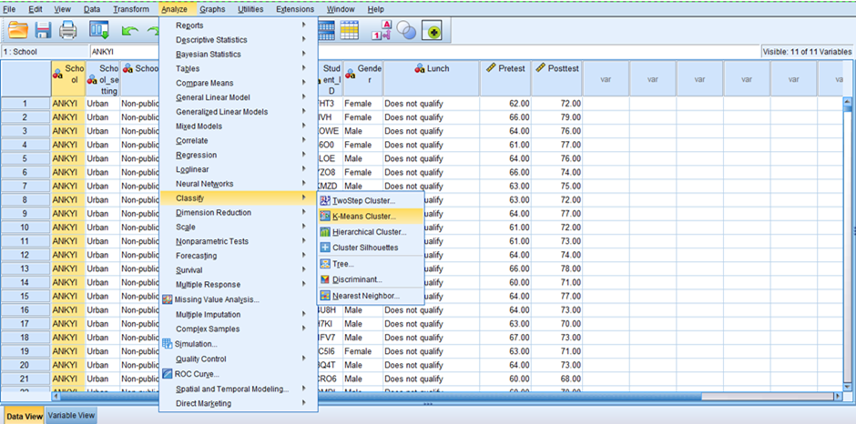
Step 3: In this step, the pre-test scores and post-test scores should be entered in the variable and the number of clusters should also be entered. In this case, the number of clustered has been chosen as 3, where K=3.
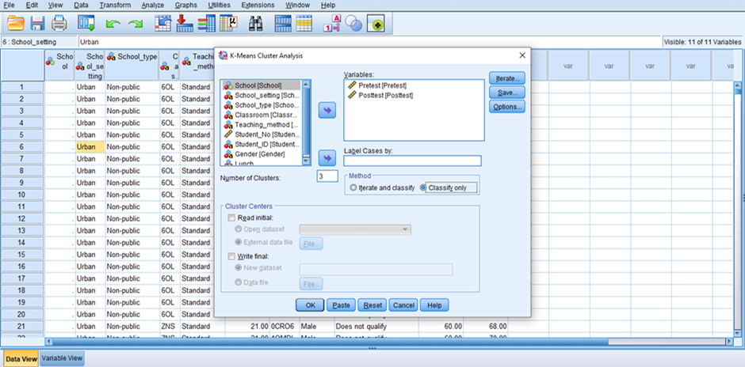
Step 4: After selecting the variables and entering K, press OK to run the algorithm.
Step 5: After running the algorithm these steps will show the results for the cluster in a new tab.
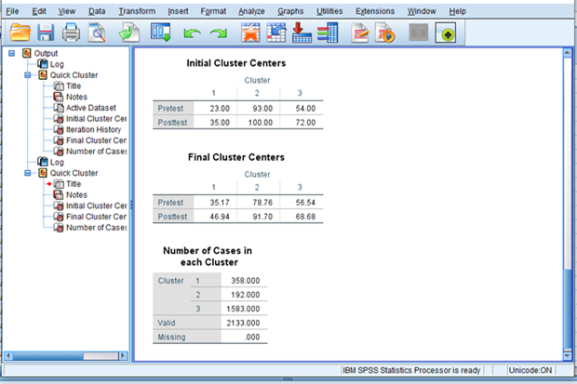
Explanation: The table titled " based on the variables from both the pre-test and the post-test. Following the completion of the algorithm, the "Final Cluster Centres" table displays the final centroids that were determined for each cluster. In this case, the fact that the final centroids for each cluster are different from the centroids that were used initially demonstrates that the algorithm was effective in locating a solution.
The table under "Number of Cases in each Cluster" displays the total number of cases that have been categorised into various groups. The result shows that the third cluster has the maximum number of cases which is 1583. The first and second cluster has only 358 and 192 cases.

An explanation of different data mining and text mining methods
Data mining is the procedure of finding trends, patterns, as well as insights in huge amounts of data, whereas text mining is the technique of extracting useful information from textual data (Henderson, 2016). The following is a list of the top five most frequent data mining and text mining methodologies that can be utilised in contemporary companies, along with some examples of their application:
Data Mining
Classification: Classification is a procedure that groups data into predetermined classes or divisions based on the qualities of the data itself. For example, a bank might apply classification to divide its customers into low-risk and high-risk categories according to their credit histories, incomes, and any other pertinent characteristics.
Clustering: Clustering is the process of gathering data items that are comparable and putting them together based on the features they share (Freedman et al., 2018). For example, clustering allows a store to divide its customer base into distinct groups according to interests, demographics, and other criteria, allowing for more precise advertising targeting.
Association rule mining: Association rule mining is a method for finding relevant connections between factors in a large dataset. For instance, a website that specialises in online retail can utilise association rule mining to determine which products are frequently purchased and then use this data to provide product recommendations that are pertinent to its users.
Regression analysis: Regression analysis is a statistical procedure that is used to determine the nature of the relationship that exists between a dependent variable and one or more independent variables (Freedman et al., 2018). For example, an insurance provider can use regression analysis to estimate the probability that a client will file a claim by taking into account the client's age, gender, and any other pertinent information.
Time Series Analysis: The time Series Analysis is a technique for determining trends and patterns by analysing data that is time-dependent. A store, for instance, can utilise time series analysis to spot seasonal patterns in customer spending and modify stock accordingly.
Text Mining
Sentiment analysis: Sentiment analysis is a method of getting subjective information, like views, mindsets, and feelings, from text data (Thuraisingham, 2013). For example, a hotel chain can utilise sentiment analysis to examine feedback from guests and discover areas where the business can make enhancements.
Topic modelling: Topic Modelling is the technique of identifying themes or subjects in a big body of text data. Topic modelling is also known as theme modelling. For example, a website that publishes news can use topic modelling to categorise the articles it publishes into categories like sports, politics, and entertainment.
Named Entity Recognition: Named Entity Recognition (NER) refers to the procedure of recognising and categorising entities in text data such as individuals, businesses, and geographic locations. For example, a law firm may use NER to mine legal papers for information about individuals, lawyers, and other pertinent entities to better serve their clients.
Text classification: Text classification refers to the process of classifying text data into a set of predetermined categories according to the information contained within the text (Schlichting & Palmer, 2015). For example, a social networking platform may make use of text classification to recognise postings that are associated with various subject areas, such as stories, sports, and entertainment.
Information Extraction: Information extraction refers to the procedure of mechanically removing relevant data structures from large amounts of unstructured text (Schlichting & Palmer, 2015). For example, a healthcare provider can use information extraction to get information from clinical notes about a patient, like their age, gender, and medical background.

The advantages and disadvantages of using SPSS and Excel using relevant practical examples
 | Advantages | Disadvantages
SPSS | - SPSS update for conducting Complex and difficult analyses such as regression analysis, ANOVA Test, correlation analysis and so on.  - In SPSS a large amount of data set can be easily analysed.  - SPSS has strong data manipulation abilities  - There are many built-in advanced statistical functions in the software that can be used to analyse the data set (EDUCBA, 2023).  - It can easily perform different analyses from a single data set. | - As SPSS is a Complex Sector it requires training and knowledge to operate this software.  - It may be expensive to purchase and maintain this software.  - Generally, SPSS requires more time to analyse the data in comparison to Excel.  - In SPSS there is limited scope for collaborative work.
Excel | - Excel is a software that is easy to use and requires less time to analyse data  - It is an excellent tool to manage and analyse a small amount of data set  - It can be used to generate charts or visualise the data very easily.  - This software can easily be integrated with other Microsoft programs and applications (Murray, 2022).  - Data can be shared with others very easily using Microsoft Excel. | - It has Limited statistical function in comparison to SPSS to analyse data.  - It is quite difficult to analyse a large data set using Excel.  - There is limited scope for collaborative work.

Conclusion
In summary, the use of tools like Excel and SPSS has made the way of data analysis more accurate and effective. Now people can make proper use of data and can make important decisions regarding business by analysing data with that software. In this report, a huge amount of data has been processed to get various solutions by using Microsoft Excel and SPSS which have also been presented graphically.

References
Ansell, E. (2016) Microsoft Excel. Sundbyberg: Docendo.
EDUCBA (2023) What is SPSS?: Features, types, and statistical methods of SPSS, EDUCBA. Available at: https://www.educba.com/what-is-spss/ (Accessed: May 5, 2023).
Freedman, D., Pisani, R. and Purves, R. (2018) Statistics. New Delhi etc.: Viva Books.
Harper, W.M. (2010) Statistics. London: Financial Times Pitman Pub.
Henderson, M.E. (2016) Data Management. Rowman & Littlefield.
Microsoft 365 (2023) Microsoft Excel Spreadsheet Software: Microsoft 365, Spreadsheet Software | Microsoft 365. Available at: https://www.microsoft.com/en/microsoft-365/excel (Accessed: May 5, 2023).
Murray, A. (2022) “Excel formulas: A quick primer,” Advanced Excel Formulas, pp. 1–37. Available at: https://doi.org/10.1007/978-1-4842-7125-4_1.
Murray, A. (2022) “Logical functions,” Advanced Excel Formulas, pp. 39–95. Available at: https://doi.org/10.1007/978-1-4842-7125-4_2.
Narasimhan, S. and Jordache, C. (2020) Data Reconciliation & Gross Error Detection: An intelligent use of process data. Houston: Gulf Pub. Co.
Pillai, P.S. (2015) Microsoft Excel. Kuala Lumpur: Utusan Pub. & Dist.
Schlichting, D. and Palmer, M. (2015) Data Management. Napanee, Ont.: S & S Learning Materials.
Thuraisingham, B.M. (2013) Handbook of Data Management. Boca Raton: Auerbach.

