Web Technologies: JavaScript-Enabled Website
By Matthew Overton

Introduction 3
Javascript Components 3
Character Viewer 3
Sorting, Searching and Filtering 4
Team Builder 5
Methodology 6
Character Viewer 6
Team Builder 6
Sorting, Searching and Filtering 7
Code 8
Loading the character portraits 8
Loading the JSON database 8
Loading character info onto the page 9
Searching 12
Sorting 13
Drag and Drop 13
Saving a team 15
Miscellaneous functions 18
Conclusion 18
Bibliography 19

Introduction
For this project I decided to create a JavaScript-enabled website that provides some out of game functionality to Marvel Strike Force, created by Foxnext Studios. During past personal projects I have created a database of information about the characters, however this information is difficult to navigate and use without an easily digestible front end.

JavaScript Components

Character Viewer
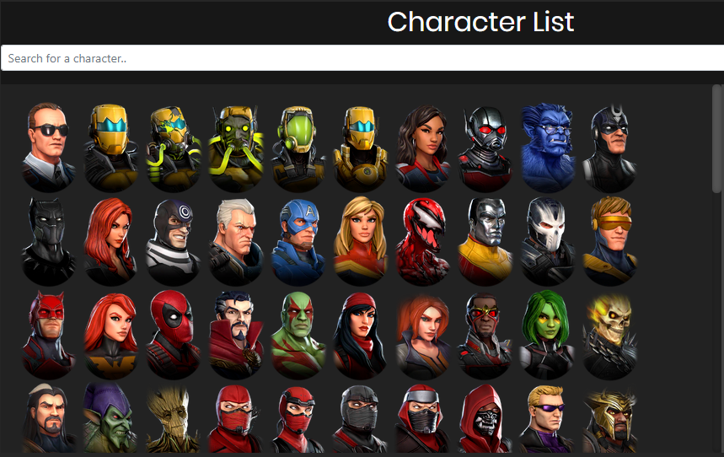
It was essential that my website was visual and so I created a large space where users could see the available heroes. The hero portraits are locally imported into the div on page load.
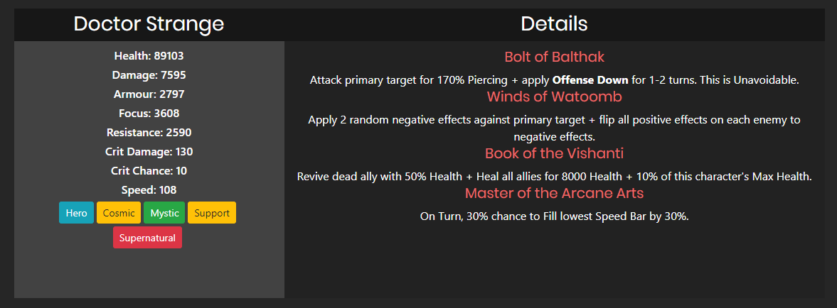
Upon clicking on a particular character you can see more detailed information about them including their stats, abilities and tags. The tags are buttons created dynamically which can then filter the character list with characters matching the selected tag. There are specific characters, Minions, which have alternate abilities and so it was important to cover that edge case.

Sorting, Searching and Filtering
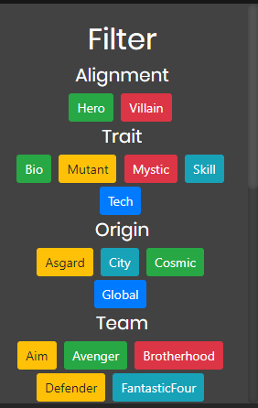
On both the Characters and Team Building page I felt it was necessary to add some extra navigation to the character list due to how many characters there actually are and how people would usually form teams. I created a search bar that updates the character list dynamically, it accepts either a character's name or a tag they match. You can also type in multiple tags if you’d like to show more than one group. Alternatively I added a filter panel next to the character list with all the available tags for quick filtering.

Team Builder
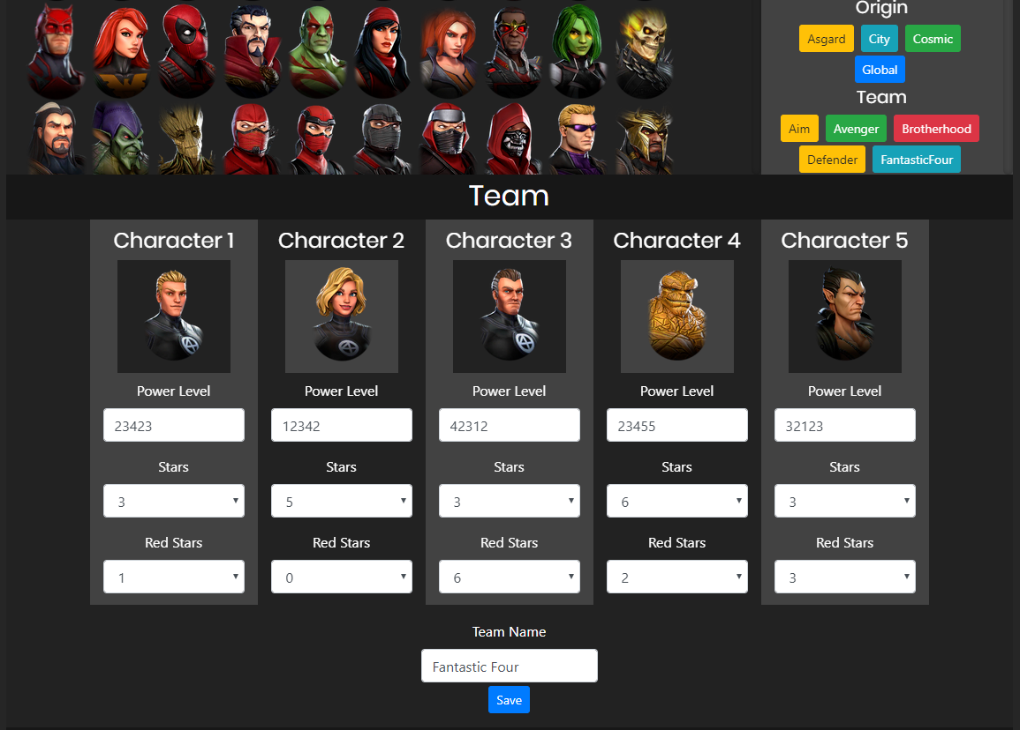
For the team building page I wanted to make it feel interactive so I added drag and drop functionality to the characters in the list. You can drag them into the appropriate boxes to put together a team. Once you’ve filled out the remaining information and named the team it will save below and reset the form.
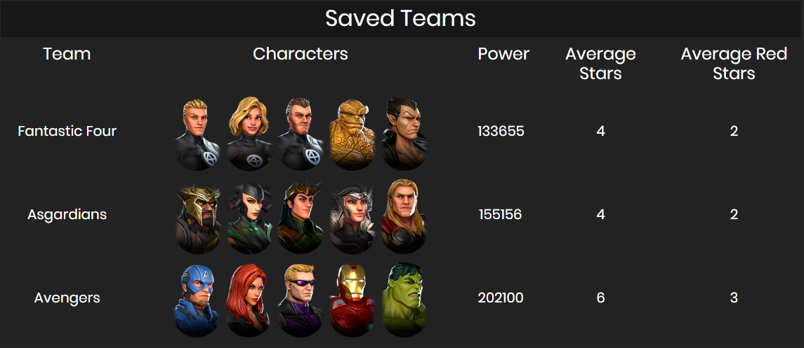
An example of some saved teams shows the team name, the characters in their correct order, their combined power rating along with the average stars and red stars. I’m pleased with how this display turned out, you can quickly see how your teams stack up with one another.

Methodology

Character Viewer
The character viewer can be split into several separate components. Firstly I had to load the character portraits onto the page inside the correct div, I chose to use images as opposed to a textual database because it’s more visually appealing. Then I had to decide how I wanted to access the data I had stored on the characters, I chose to just to navigate the raw JSON data. I considered converting the JSON database into an IndexedDB to allow for more complex queries but ultimately decided it was beyond the scope of my application and could lead to issues with browser compatibility. I opted to use event listeners to handle displaying appropriate character data on the page when clicked.

Team Builder
Expanding upon the character viewer I wanted more user interaction so I added drag and drop functionality to the character list. Using this I could populate a form which could be handled using another event handler. I would validate this form and then save the data chosen as a saved team for future use.

Sorting, Searching and Filtering
For both the character viewer and team builder I felt it would improve the user experience if there was a way to filter the characters seen as there are so many. I decided to add a search bar that filters the characters shown in real time, to accomplish this I used the onKeyUp() functionality of html along with a custom search function. I used this to check the id of the images in the character list against the input, if they didn’t match the image was hidden by manipulating it’s css style. After implementing the search functionality I realized it could be used to also match the tags the characters have. I created a filter section to the right of the character list filled with buttons that populated the search bar with the selected tag and ran the search function. I also added this functionality to the tags shown in the character information panel for easier access.

During the creation of the drag and drop functionality for the team builder I came across an issue where dragging a character back into the list would put it at the bottom of the list. This was very frustrating to navigate and so I implemented a sorting function that occurs when the dragEnd event happens.

Code

Loading the character portraits
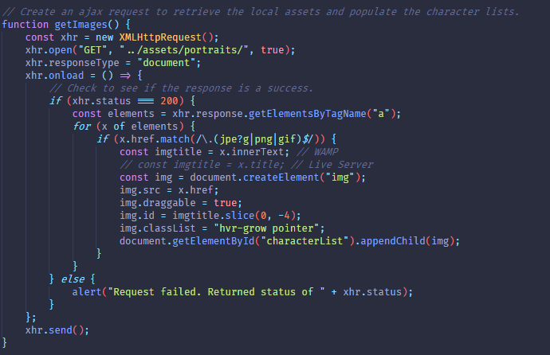
Using this function I open up an XMLHttpRequest to get the contents of the /assets/portraits folder. On success I set the response type to document, which converts the folder into html structure, so that I can select all of the links to images and loop through them. Upon looping through them I check to make sure the href has an image extension, if it does I create a new img element and set the appropriate information. Once the img element is ready I search the DOM for the characterList div and use appendChild() to add the new img element to the div.

Loading the JSON database
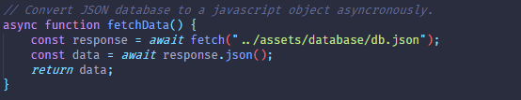
In order to load the local JSON database of character information I used a different, newer technique called fetch(). I did this asynchronously so that any other scripts running could continue. Once complete I parse the JSON into a JavaScript object and return it. This data can then be used and manipulated later.

Loading character info onto the page
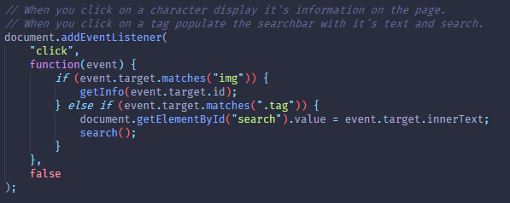
I created an event listener to listen for click events, when a click event happens on an image it passes the id of the image into the getInfo function. Alternatively if the click target has the tag class it finds the search bar on the page, takes the inner text of the tag and triggers the search() function.

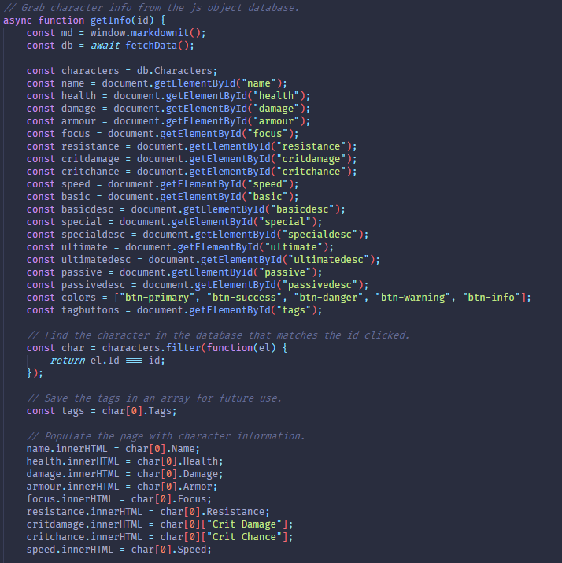
Due to past projects I had written the ability descriptions using Markdown, a lightweight markup language, which is used to create rich text in apps such as Discord. I utilize the JavaScript library markdownit[1] to render the text on the page correctly. I first fetch the database data and store it in a variable, then store the characters in a separate array. Secondly I search the DOM for the appropriate elements and store them in variables, I also store some button styles in an array for future use. Next I use the array.filter() function to return an object that matches the id of the element click on and store that character. I save the tags of the character for future use and populate the page with the character stats found using the element.innerHTML property.
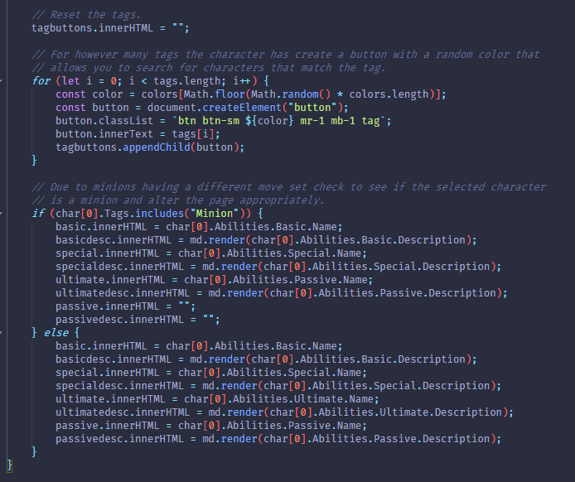
During the testing process of this function I found that as I clicked on more characters the number of tags they had were increasing infinitely. This was because I hadn’t cleared the tagbuttons on the page, I set the tagbuttons.innerHTML to nothing to fix this. I then loop through the tags the clicked character has, create a button element and fill it’s information before adding it to the DOM inside the tagbuttons element. I also used the color array I created earlier to add random colours to the buttons with the inbuilt Math library in JavaScript. Characters with the Minion tag had less abilities than those without so I had to check before populating the abilities section on the page, this is where I used markdownit[1] to render the correct text.

Searching
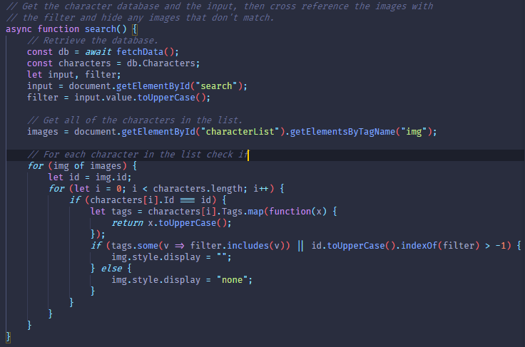
Once again I started by creating an array with all of the characters in it. I also got the input text in upper case to enable case insensitivity in the search box. I store a reference to all of the characters currently in the list by searching for all elements with the img tag inside the element with the characterList id. I use a for .. of loop to iterate through all of the images in the list, I then use a regular for loop to check the id of each character with their Id in the database. If the id matches I look at the characters tags and create a new array with the tags all in upper case using the array.map() function. Next I use an arrow function to see if the filter is included in any of the tags OR if the id of the character matches the filter. If either match the image is shown, otherwise the image is hidden.

Sorting
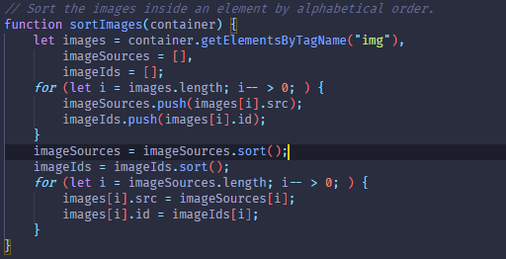
For sorting, I get all of the images inside of the element sent to the function. Then I loop through the images and use array.push() to store the src and id inside the imageSources and imageIds arrays respectively. I then use the inbuilt array.sort() function without any parameters to sort alphabetically. Finally I loop through the imageSources one last time to replace the src and id of the elements on the DOM with the new sorted src and id.

Drag and Drop
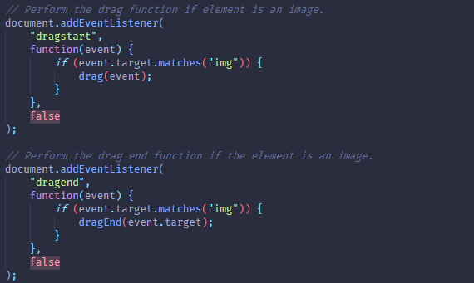
For drag and drop functionality I first added some event listeners for dragstart and dragend. When these events fire I make sure they’re on images and then send the element to the drag and dragEnd functions respectively.
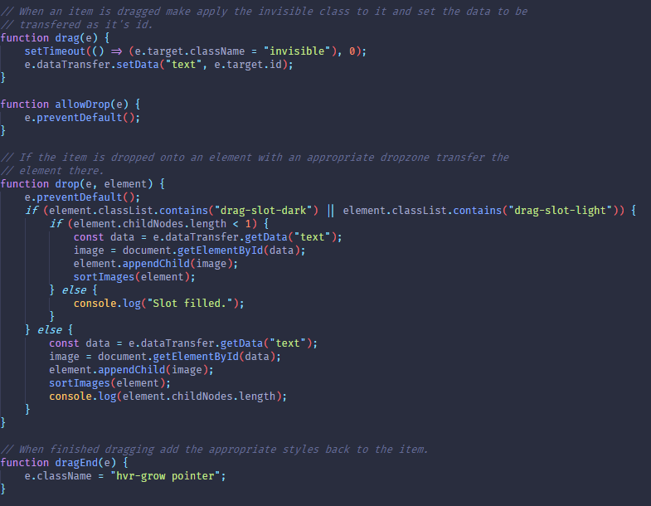
While dragging I used setTimeout() to add a callback function to the back of the message queue, this callback function sets the class of the element that’s currently being dragged to invisible making it seem like the image has been picked up. I also set the data that will be transferred when the dragging has completed to the id of the element being dragged. The allowDrop(e) function is there to prevent the default functionality from happening when an element is dragged over another element that can accept it being dropped there. The drop element takes the container that has been dropped on as an argument. If that element contains one of the specified classes and doesn’t already have an element inside it, one that has been dragged there before, it uses the data that’s been transferred from the element to find it in the DOM and append it to the new location of the element it’s being dropped onto. I then call sort the element’s images. When the dragging has finished I add back the appropriate classes to the element.

Saving a team
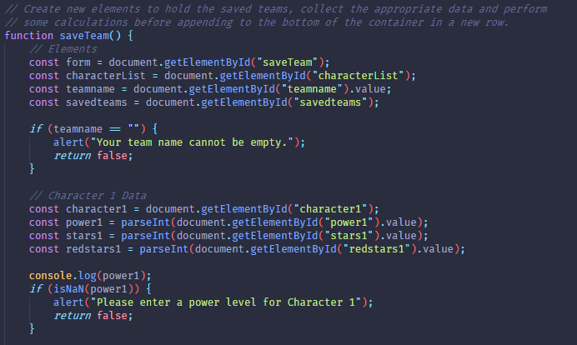
For saving a team I first got some references to elements in the DOM by searching the document once again. I validate the team name to make sure it has a name, if not I show an alert and exit the function. I then move on to collecting and storing the character the character data, another validation check occurs to make sure the user has entered a power level.
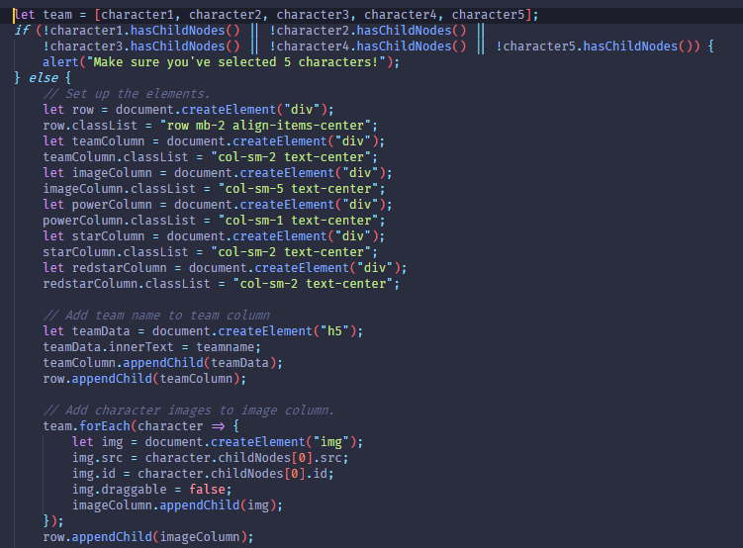
I create an array of the characters to loop through later and make sure that each draggable character slot has been filled. Next I do some more element creation structured using bootstrap classes. I populate the created elements with the appropriate data and append them to the current row. When it comes to adding the images of the characters I use an array.foreach() loop to create an image with the same source and id, I also make sure to set the draggable property to false to avoid problems.
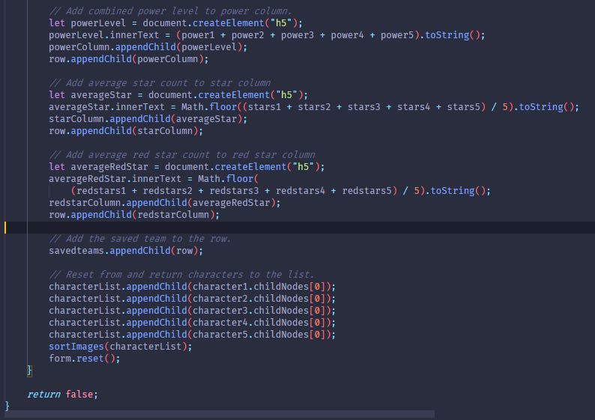
After adding all of the appropriate data I add the row to the saved teams div and reset the form.

Miscellaneous functions
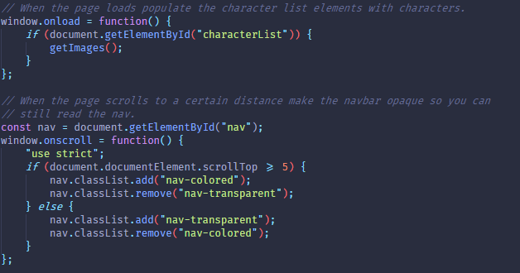
I populate the character list when the window has loaded using window.onload. A small quality of life feature I added was when you scroll down a certain amount the navbar becomes opaque so you can still read it.

Conclusion
In conclusion, I'm very happy with how this website turned out, it challenged me to think of the fundamentals of JavaScript more when creating my components due to the lack of jQuery. It’s helped me solidify my knowledge of manipulating the DOM and working with different variables in JavaScript. If I were to continue this project in the future I would add a backend server and store any saved teams to accounts. I would also look into serializing my JSON into IndexedDB for more advanced query making and opportunities to use SQL.

Bibliography
- https://github.com/markdown-it/markdown-it

