
Bachelor of Arts Business Management
Lecturer name: Eric Osei
Academic Skills
Academic year: 2022/2023
Student name: Viorica Birloiu
Student number: 2227895

Module code: LCBB4006

Table of Contents
Introduction 3
Discussion of Concepts 4
Explain the meaning of the concept 4
Team working 4
Academic Writing 5
Discussion key theories and frameworks if any 6
Team Working: 6
Analysis: 7
Academic Writing: 7
Analysis: 8
Discuss importance of the concept of Team working and Academic writing 9
Team Working: 9
Academic Writing: 9
Discuss how the concept can affect performance of a university student, giving as many examples as possible. 10
Team Working: 10
Academic Writing: 10
Conclusion 12
References 13

Table of figures
Figure 1: Teamwork and Academic writing (D Keith Denton, 2022) 4
Figure 2: Meaning of TEAM (Frey, Fisher and Everlove, 2019) 5
Figure 3: A complete guide for Academic Writing (Godfrey, 2015) 6
Figure 4: Tuckman's concept of group formation (Oshima, Hogue and Curtis, 2017) 8
Figure 5: IMRAD framework (Sword, 2012) 9

Introduction
The ability to collaborate effectively in a team and to write formally for academic or professional purposes are two fundamental skills necessary for advancement in many different disciplines. One way to guarantee achievement in these domains is via the deployment of diverse theories and frameworks (Bailey, 2018). Although the IMRAD structure and the critical thinking framework are more suited to academic writing, the Tuckman's model of group formation and the Belbin's team role theory are useful for teamwork. Yet these models have restrictions, so it's important to tailor them to individual needs (D Keith Denton, 2022). In order to foster teamwork, communication, and invention, as well as to aid in the expansion of knowledge and comprehension, it is essential that individuals have strong abilities in academic writing and teamwork.
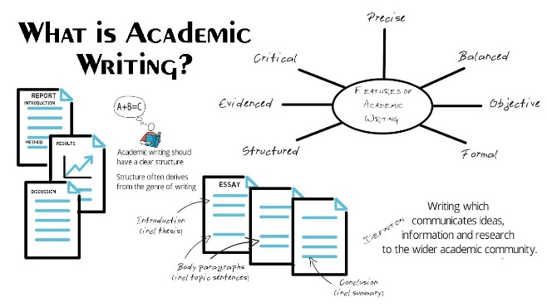
Figure 1: Teamwork and Academic writing (D Keith Denton, 2022)

Discussion of Concepts

Explain the meaning of the concept
The ability to collaborate effectively as a team and write academically are two fundamental principles that are required in educational environments. Academic writing is the production of written works like research papers, essays, and dissertations that match the criteria of academic institutions, whereas teamwork refers to the capacity of people to work cooperatively with others towards a shared objective (Frazer and Oswald, 2019). In this article, I will explain these ideas in depth and analyse their value in the classroom from a critical perspective.

Team working
Teamwork is crucial in the classroom because it encourages communication, innovation, and responsibility. When people contribute their skills and knowledge to a team effort, they help everyone benefit from the collective brainpower of the group. Teamwork also promotes mutual learning and development, which is beneficial on both a personal and professional level (Frey, Fisher and Everlove, 2019). By working on a collaborative project, for instance, students might benefit from hearing other people's thoughts on a certain issue. Working in a team also encourages responsibility, since everyone is held accountable for their contribution to the team's success.
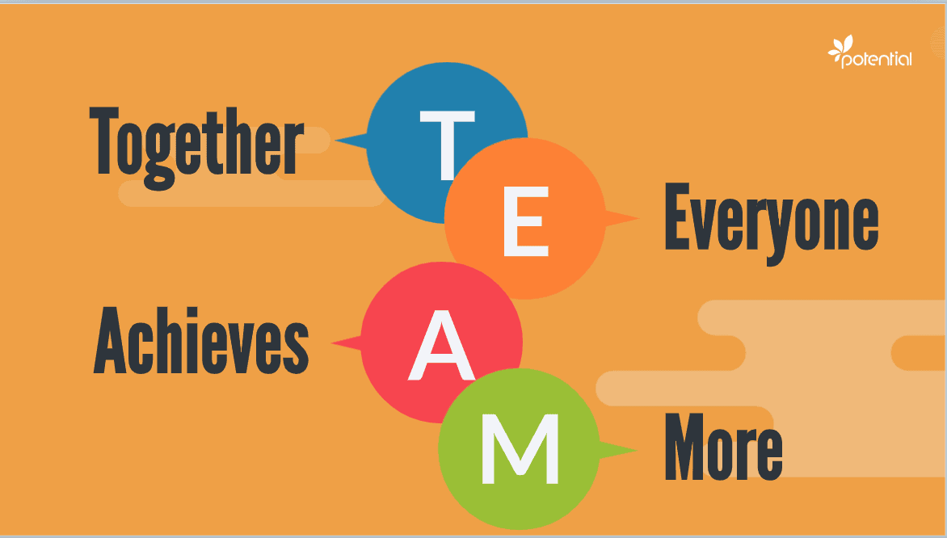
Figure 2: Meaning of TEAM (Frey, Fisher and Everlove, 2019)
There are benefits to working as a team, but there are also drawbacks. For instance, certain people may have trouble coordinating with others, which may cause tension and sluggish progress towards the team's goals. Some people may also lack motivation and dedication because they believe their ideas are not being taken seriously. Because of this, it is crucial to learn how to effectively communicate with one another and to establish trust within the group as a whole.

Academic Writing
Alternatively, academic writing is crucial in educational institutions because it facilitates the dissemination of information and understanding. When writing for an academic audience, it is important to use language suited to the subject area, properly cite your sources, and style your paper in accordance with established norms. In addition, the analytical thinking and research skills developed via academic writing might help to generate brand-new insights (Godfrey, 2015).
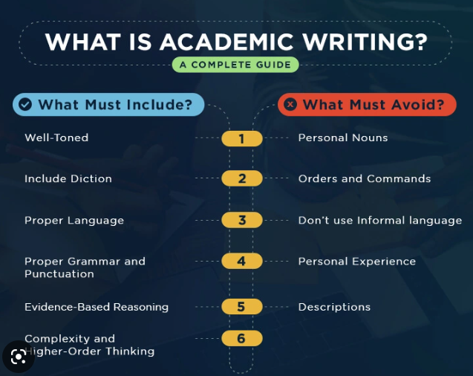
Figure 3: A complete guide for Academic Writing (Godfrey, 2015)
On the other hand, academic writing has its own unique set of difficulties, particularly for first-year students. It's not uncommon for students to make mistakes and misinterpret instructions when they're first learning the norms and standards of academic writing (Huitt, Killins and Brooks, 2014). Some pupils may also have difficulty articulating their thoughts clearly and coherently in writing because of this. That's why it's crucial to hone your writing chops and make use of academic tools like writing labs and peer tutors.
In conclusion, the principles of teamwork and academic writing are crucial in educational environments. Academic writing allows you to share your knowledge and thoughts with others, while teamwork encourages cooperative problem-solving, innovation, and personal responsibility (J Dan Rothwell, 2013). These notions, however, may provide difficulties, necessitating the development of strong verbal and written communication abilities. So, it is crucial to provide students with sufficient aid and materials to guarantee their academic achievement.

Discussion key theories and frameworks if any
Both academic writing and functioning in a team need the application of several ideas and models. In this essay, I will critically examine the significance of some prominent ideas and frameworks as they pertain to academic writing and teamwork.

Team Working:
Tuckman's concept of group formation is one of the main ideas that support collaborative efforts. According to Tuckman's approach, teams go through four phases: forming, storming, norming, and performing. In the formation phase, a team forms as its members get acquainted with one another and set norms for working together (Mayne, 2018). During the storming phase, team members communicate their disagreements with one another. The team's feeling of cohesion and common identity are formed throughout the norming phase. At last, at the performance stage, the crew has accomplished its goals and is giving its all.
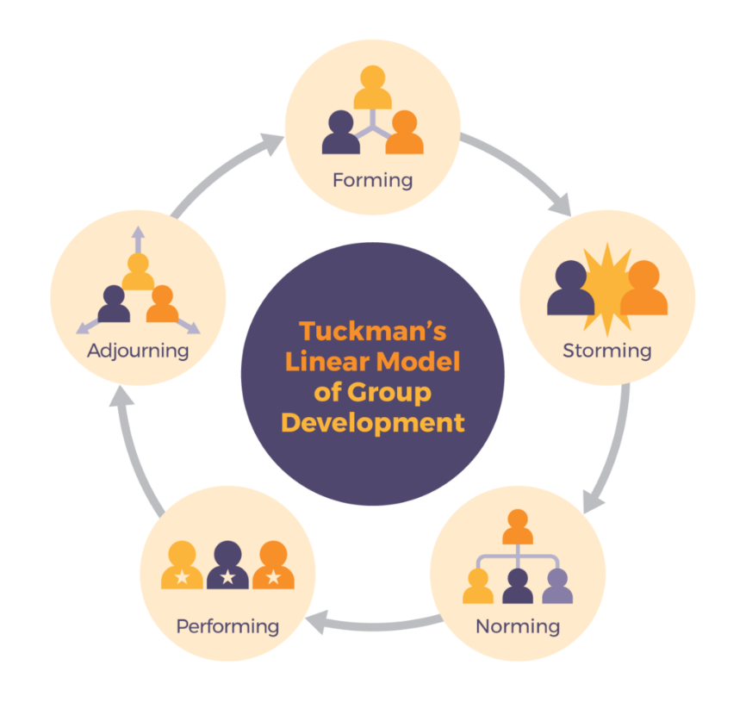
Figure 4: Tuckman's concept of group formation (Oshima, Hogue and Curtis, 2017)
Belbin's team role theory is another useful framework for understanding collaboration. According to Belbin's view, every member of a team brings something unique to the table and should be used accordingly. Nine distinct roles were defined by Belbin for teams: plant, monitor-evaluator, resource investigator, coordinator, implementer, completer-finisher, team worker, shaper, and specialist (Oshima, Hogue and Curtis, 2017). The most productive groups, as per Belbin's research, have members who cover a variety of different functions.

Analysis:
Tuckman and Belbin's models help us comprehend the dynamics of teamwork, but they have their own flaws. The teams in Tuckman's model are assumed to follow a sequential procedure, with problems and disputes being handled before peak performance can be achieved (Swales and Feak, 2019). Yet, in practise, teams may cycle between these phases, and disputes may remain even when the team is functioning well. Moreover, Belbin's approach presumes that people can be categorised cleanly into predetermined categories. In practise, however, people often have a mix of skills and limitations, and their roles often shift depending on the circumstances.

Academic Writing:
The IMRAD framework is a cornerstone of scholarly writing. Research articles often follow the IMRAD framework, which consists of an introduction, methodology, findings, and discussion. The introduction gives context and justification for the study, the methods section details the study's design and methodology, the results section details the study's findings, and the discussion part draws conclusions from the study (Sword, 2012).
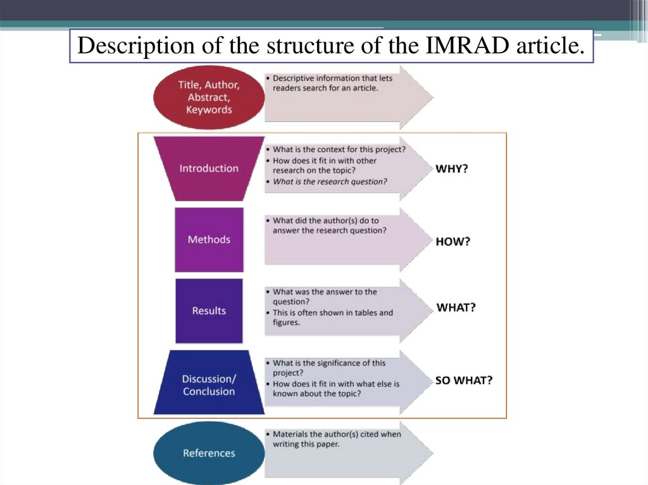
Figure 5: IMRAD framework (Sword, 2012)
The critical thinking framework is another useful one for college papers. Questioning presuppositions, analysing data, and weighing potential outcomes are all important tenets of the critical thinking paradigm (van Blankenstein et al., 2018). Academic writing, in the context of this model, is expected to be founded on rigorous reasoning and evidence rather than on the author's preconceived notions or assumptions.

Analysis:
Academic writing guides like the IMRAD structure and the critical thinking framework have their strengths and weaknesses. It is possible that not all sorts of research should adhere to the IMRAD structure's standardised format for research publications (Vermette and Kline, 2017). Additionally, the critical thinking paradigm presupposes that academic writing should be objective and evidence-based, which may not be doable in other fields, such as the humanities, where subjective interpretation is crucial. Because of this, it is crucial to modify these frameworks to meet the requirements of each profession and setting.
To sum up, both teamwork and academic writing benefit from the use of many theoretical frameworks. While these models aren't perfect, they do help shed light on the complexities of teamwork and academic writing so that more informed tactics and abilities may be developed (Zemach and Rumisek, 2016). Thus, it is crucial to evaluate these models rigorously and modify them to meet the requirements of each setting.

Discuss importance of the concept of Team working and Academic writing
In many sectors, such as academia, research, and business, the ability to work well in a team and to write formally for an academic audience are key

Team Working:
Teamwork is crucial because it fosters cooperation, dialogue, and innovation. It is possible to make better decisions, solve problems, and come up with creative solutions when a group of people with varied backgrounds and experiences work together (Bailey, 2018). Staff members who feel they are contributing to a common goal report higher levels of job satisfaction, motivation, and output after engaging in productive teamwork.

Academic Writing:
Scholars cannot succeed in their fields without the ability to disseminate their discoveries, ideas, and arguments to a larger audience, and this is why academic writing is so important. Scholars may contribute to the growth of knowledge, practise critical analysis, and find novel approaches to vexing issues via their writing (D Keith Denton, 2022). More importantly, academic writing is essential for students to succeed since it is often utilised as a means of evaluating their growth in these areas.
In conclusion, working as a team and academic writing are both fundamental skills necessary for achieving success in a wide range of disciplines (Frazer and Oswald, 2019). They make it possible for people to work together, share information, come up with new ideas, and further the spread of knowledge. So, it is essential to hone abilities like teamwork and academic writing to enable flexibility and propel one to greater heights in a variety of educational and professional environments.

Discuss how the concept can affect performance of a university student, giving as many examples as possible.
Having a firm grasp of both teamwork and academic writing may have a dramatic effect on a student's success in college. In this article, I'll explain how these ideas might influence a student's success in school and provide specific instances to back up my claims (Godfrey, 2015).

Team Working:
University students may benefit from working in teams. If a student works on a group project, for instance, they might get insight from the varying experiences and expertise of their classmates. Success in these areas—decision making, problem solving, and imagination—may result (Huitt, Killins and Brooks, 2014). In addition, working in a group may help kids hone their verbal and nonverbal communication and interpersonal skills, all of which can serve them well in the classroom and beyond.
By combining the varied perspectives of the group's members, the final product is more likely to be thorough and accurate. By taking this course of action, we can guarantee that our work will be of the highest quality and that the project will be a success. A student's ability to express themselves effectively and convincingly while also listening attentively to the thoughts of their peers may be honed via participation in group discussions.
Nonetheless, working in a group has the potential to hinder a student's academic progress (J Dan Rothwell, 2013). If a student isn't invested in the group's success or isn't putting in their due diligence, everyone's productivity takes a hit. Teamwork may also be hampered by less-than-ideal group dynamics including power struggles or a lack of consensus among members.

Academic Writing:
Writing well in school may have a major effect on a student's grades and overall success in college. Students' academic performance and GPAs might benefit from learning to write clearly and persuasively for academic purposes. Academic writing has been shown to improve students' ability to think critically by forcing them to examine and evaluate the validity of various claims and arguments (Jordan, 2016).
Students may develop their critical thinking abilities in a variety of contexts, including while writing essays by engaging in activities like research, assessing evidence, and considering many views. Writing assignments, essays, research papers, and even graduate school applications may all benefit from well-honed academic writing abilities (Oshima, Hogue and Curtis, 2017).
A student's academic achievement may suffer, though, from inadequate writing abilities. If a student's writing is imprecise or ambiguous, for instance, their ideas could not be compelling or persuasive, which would lead to lower marks (Swales and Feak, 2019). In addition, a student's paper may be deemed plagiarism if it lacks appropriate citations and research.
In conclusion, a university student's performance may be greatly impacted by learning both teamwork and academic writing. Both ideas have benefits and drawbacks, but mastery of either is crucial for a student's future success in school and the workplace. Hence, it is crucial that college students practise, get feedback, and receive help in order to develop these abilities and integrate them into their academic and personal life.

Conclusion
Overall, the importance of teamwork and academic writing cannot be overstated. Better decision-making, problem-solving, and innovation are the results of increased teamwork, which in turn fosters more cooperation, communication, and creativity among team members. Scholars may reach a broader audience with their research results, ideas, and arguments when they write them up in academic journals and books. Success in these domains may be ensured by the use of numerous theories and frameworks, but it is crucial to tailor them to individual settings and needs. Academic and professional success need the development of important abilities, including the ability to work effectively in teams and to write academically.

References
Bailey, S. (2018). Academic writing : a handbook for international students. Oxon ; New York: Routledge.
D Keith Denton (2022). Empowering intranets to implement strategy, build teamwork, and manage change. Westport, Conn.: Praeger.
Frazer, R. and Oswald, P. (2019). Teamwork! New York: Simon Spotlight.
Frey, N., Fisher, D. and Everlove, S. (2019). Productive group work : how to engage students, build teamwork, and promote understanding. Alexandria, Va.: Ascd.
Godfrey, J. (2015). Academic writing. Basingstoke: Macmillan Education/Palgrave.
Huitt, T.W., Killins, A. and Brooks, W.S. (2014). Team-based learning in the gross anatomy laboratory improves academic performance and students’ attitudes toward teamwork. Anatomical Sciences Education, 8(2), pp.95–103.
J Dan Rothwell (2013). In the company of others : an introduction to communication. New York: Oxford University Press.
Jordan, R.R. (2016). Academic writing course. Harlow: Longman.
Mayne, L. (2018). Reflective writing as a tool for assessing teamwork in bioscience: Insights into student performance and understanding of teamwork. Biochemistry and Molecular Biology Education, 40(4), pp.234–240.
Oshima, A., Hogue, A. and Curtis, J. (2017). Longman academic writing series. Level 3, Paragraphs to essays. White Plains, Ny: Pearson Education, . Copyright.
Swales, J.M. and Feak, C.B. (2019). Academic writing for graduate students: Essential tasks and skills. Ann Arbor: The University of Michigan Press.
Sword, H. (2012). Stylish academic writing. Cambridge, Mass.: Harvard University Press.
van Blankenstein, F.M., Saab, N., van der Rijst, R.M., Danel, M.S., Bakker-van den Berg, A.S. and van den Broek, P.W. (2018). How do self-efficacy beliefs for academic writing and collaboration and intrinsic motivation for academic writing and research develop during an undergraduate research project? Educational Studies, 45(2), pp.209–225.
Vermette, P.J. and Kline, C.L. (2017). Group work that works : student collaboration for 21st century success. New York, Ny: Routledge.
Zemach, D.E. and Rumisek, L.A. (2016). Academic writing from paragraph to essay. Ismaning] Hueber.

Reflective Writing Using Gibbs Model
The Gibbs reflective model served as a helpful structure for thinking about what I've learned in this academic writing course. The six steps in this paradigm are as follows: introduction, description, emotions, evaluation, analysis, conclusion, and strategy (Markkanen, et. al., 2020). By taking stock of my current academic writing abilities, both good and bad, I can better understand where I am and what steps I need to take to strengthen them.
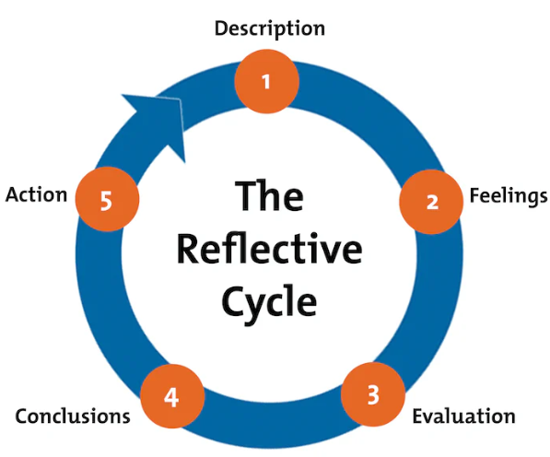
Figure 1: Gibbs Reflective Cycle (Potter, 2021)

Description:
The IMRAD format, critical thinking, and the literature review are just a few of the skills I picked up in this academic writing lesson. These are quite beneficial for any student (Nair, et. al., 2019). In addition, I gained knowledge on how to properly cite sources and prevent plagiarism. By completing the tasks and reflecting on the instructor's comments, I was able to develop my writing and analytical skills.

Feelings:
When we first started this programme, I was completely flummoxed by the sheer volume of material and the seemingly impenetrable nature of academic prose. In the same way, I was anxious about turning in my work and hearing what my professors thought. My writing skills and familiarity with academic writing rules both improved as the programme went on and I implemented my lecturer's comments.

Evaluation:
I feel that I improved much in my ability to write academically during this unit. The IMRAD framework has helped me improve as a writer and broaden my perspective. Even yet, I saw that I had room for development in other areas as well, such as my grammar and punctuation.

Analysis:
This lesson taught me that academic writing is more effective when it follows a predetermined plan. To study and assess materials and construct my own ideas, I learned the value of critical thinking, which is essential in academic writing. Analytical tools assist any student in properly getting overview about any element (Pennycook, Fugelsang, and Koehler, 2019). Also, I realised the significance of avoiding plagiarism and properly citing sources in order to exhibit my command of the literature and the validity of my ideas.

Conclusion:
When I look back on my education, I notice that my academic writing has improved greatly, but that I still have opportunity to grow. I need to hone my writing style and polish my language and punctuation. In order to make my arguments more convincing and my writing more credible, I need to keep honing my critical thinking and reference skills.

Action Plan:
I intend to consistently practise writing, particularly in the areas where I feel I am lacking, in order to enhance my academic writing abilities. In order to improve my writing skills, I plan to solicit criticism from my professor and classmates. In addition, I plan to keep reading scholarly works and engaging in practise with various reference methods to hone my critical thinking and citation abilities.
Using the Gibbs reflective model, I was able to evaluate my progress in the academic writing unit, determine where I excelled and where I could need some work, and create a strategy for future improvement. This introspection has inspired me to keep working on my academic writing abilities, as I now appreciate their value to my future success in both school and the workforce.

References
Markkanen, P., Välimäki, M., Anttila, M. and Kuuskorpi, M., 2020. A reflective cycle: Understanding challenging situations in a school setting. Educational Research, 62(1), pp.46-62.
Nair, P.R., Nair, V.D., Nair, P.R. and Nair, V.D., 2019. Organization of a research paper: The IMRAD format. Scientific writing and communication in agriculture and natural resources, pp.13-25.
Pennycook, G., Fugelsang, J.A. and Koehler, D.J., 2019. Everyday consequences of analytic thinking. Current directions in psychological science, 24(6), pp.425-432.
Potter, C., 2021. Leadership development: an applied comparison of Gibbs’ Reflective Cycle and Scharmer’s Theory U. Industrial and Commercial Training.

