12/16/2025
Assessment
Portfolio Report on Computer Architecture and Operating Systems
Student Name: Mohammed Hamid STUDENT ID :2440293

Module NaMe: Computer Architecture and Operating Systems
Module Code: ACCA4022
Lecturer: Redhwan Al-Amri
Trinity saint david University of Wales (London Campus)



Table of Contents
Introduction 2
Main Body 3
Task 1: Key Functions Of General Operating Systems 3
Task 2: Use of Windows OS CLI command 5
Task 3: Use of Linux OS CLI Commands 11
Task 4 Use of Windows OS Script 16
Task 5: Use Linux OS Scripts 17
Conclusion 18
References 18
Appendices 18

Introduction

Introduction
This report details the key functions and practical use of operating systems, focusing on both Windows and Linux environments. The aim of this report is to develop an understanding of how operating systems manage computer resources and how command-line interfaces (CLI) and scripts can be used to perform tasks efficiently.
The report is divided into five tasks. Task 1 explains the key functions of general operating systems. Task 2 demonstrates the use of common Windows operating system command-line commands, while Task 3 focuses on equivalent Linux command-line commands. Task 4 examines the use of scripts within the Windows operating system, and Task 5 covers scripting in Linux. Together, these tasks show how both operating systems can be managed and automated using command-line tools and scripts.
Operating systems (OS) are a fundamental component of modern computing, acting as the interface between computer hardware and users. They manage system resources, provide a platform for application software, and ensure efficient and secure operation of devices.
Through analysis, command examples, and scripting demonstrations, the report highlights how operating systems are managed and automated in real-world scenarios.

Main Body

Task 1: Key Functions Of General Operating Systems
The Modern general-purpose operating systems such as Windows 10/11 and Linux distributions perform several core functions that ensure system stability, usability, and security. The operating system (OS) acts as an interface between the computer hardware and the user, controlling resources effectively while accepting applications to run smoothly.
Function | Description
Hardware Management | Controls hardware components such as the CPU, memory (RAM), storage devices, and input/output devices.
File Management | Organises, stores, retrieves, and deletes files and folders on the computer.
Process Management | Manages running programs and decides how CPU time is shared between them.
User Interface | Provides ways for users to interact with the system, such as a GUI (windows and icons) or a CLI (typed commands).
Security & Access Control | Protects the system by managing user accounts, passwords, and permissions.
Networking | Allows the computer to connect to networks and communicate with other devices.
System Performance | Monitors and manages system resources to keep the computer running efficiently.

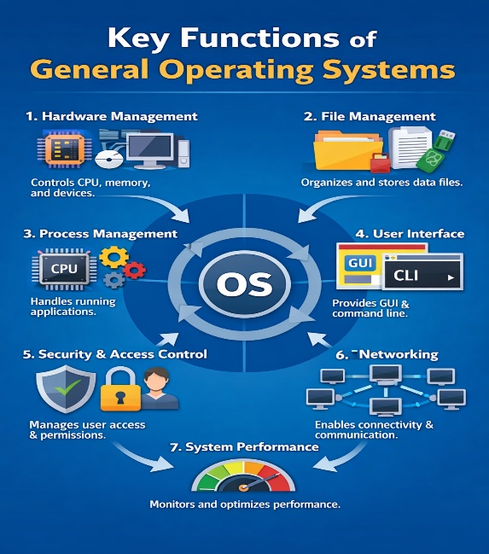

Process Management
One of the primary functions of an operating system is process management. The OS manages running programs (processes), allocating CPU time and ensuring tasks are executed efficiently. In Windows, this can be viewed and managed using Task Manager, where users can monitor CPU, memory, and disk usage. Linux provides similar functionality through tools such as System Monitor or commands like top. This involves creating, scheduling, and terminating processes. The OS ensures that multiple programs can run at the same time by allocating CPU time using scheduling algorithms. This enables multitasking and ensures that no single process monopolises system resources[1]
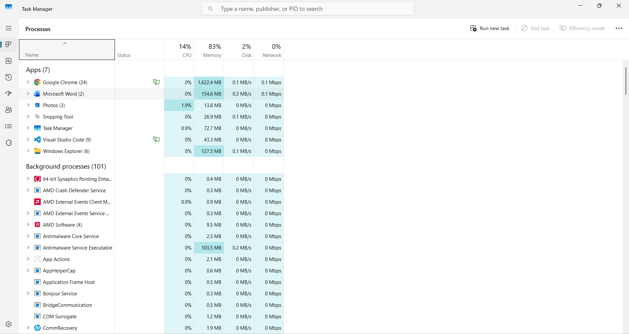
This is a snip of the Task Manager:
Fig1

Memory Management

Operating systems manage RAM usage to ensure applications run smoothly without conflicts. Virtual memory techniques allow systems to use disk space as additional memory. In Windows, memory usage can be viewed in Task Manager, while Linux systems display memory statistics using tools such as free.

File System Management
The OS controls how data is stored, accessed, and organised on storage devices. Windows uses file systems such as NTFS, managed through File Explorer and Disk Management. Linux commonly uses ext4 and similar file systems, accessed through file managers or the terminal.
This is a print screen of a disk management
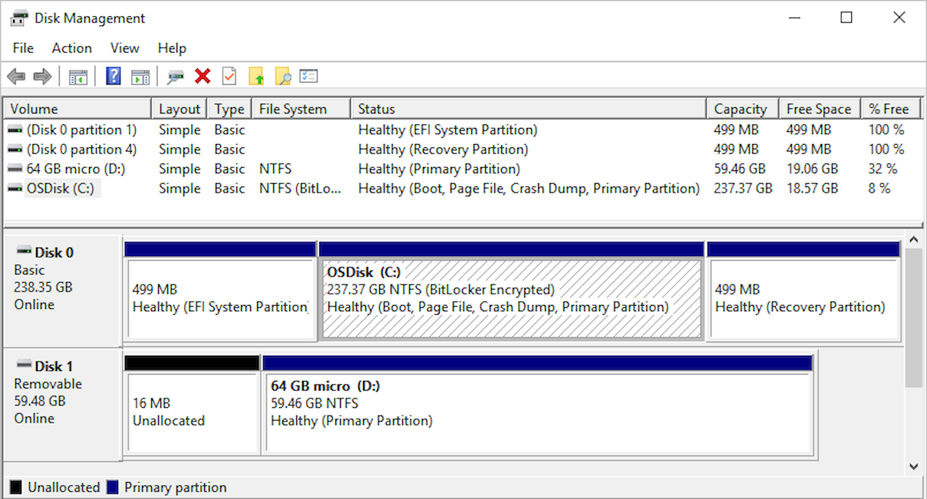
Fig 2 [2]

Device Management
Operating systems manage hardware devices through drivers. Windows users can manage devices via Device Manager, while Linux handles devices through kernel modules and system directories such as /dev.

Security and User Management
Security features include user authentication, permissions, and access control. Windows uses user accounts and security policies accessible via Settings and Control Panel. Linux uses file permissions and user/group management tools.
Overall, these functions allow operating systems to provide a stable, secure, and user-friendly computing environment.

Task 2: Use of Windows OS CLI command
Windows provides Command Prompt and PowerShell for command-line interaction.
Examples of commonly used command Prompt showing dir. and ipconfig commands:
- dir – Lists files and directories in the current location.
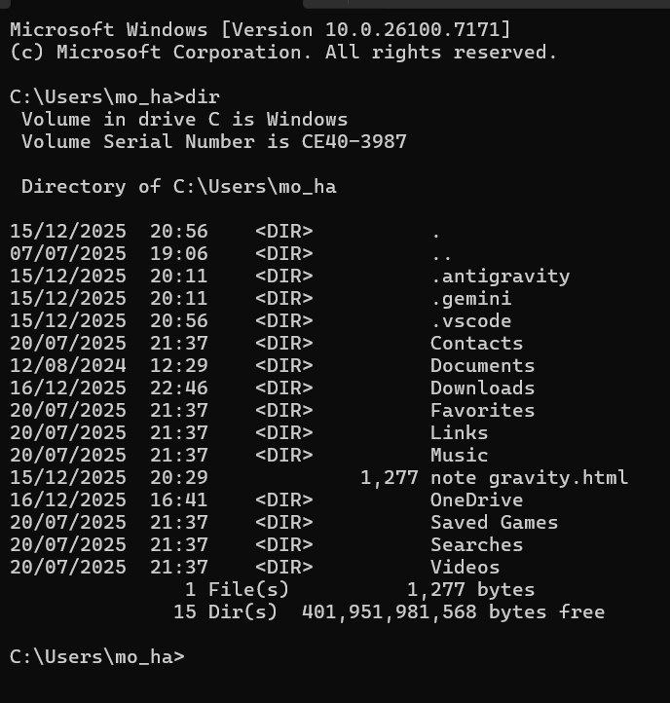
step 1
Here is the input that I typed in

Step 2
Here is the output which is the results

- cd – Changes the current directory.
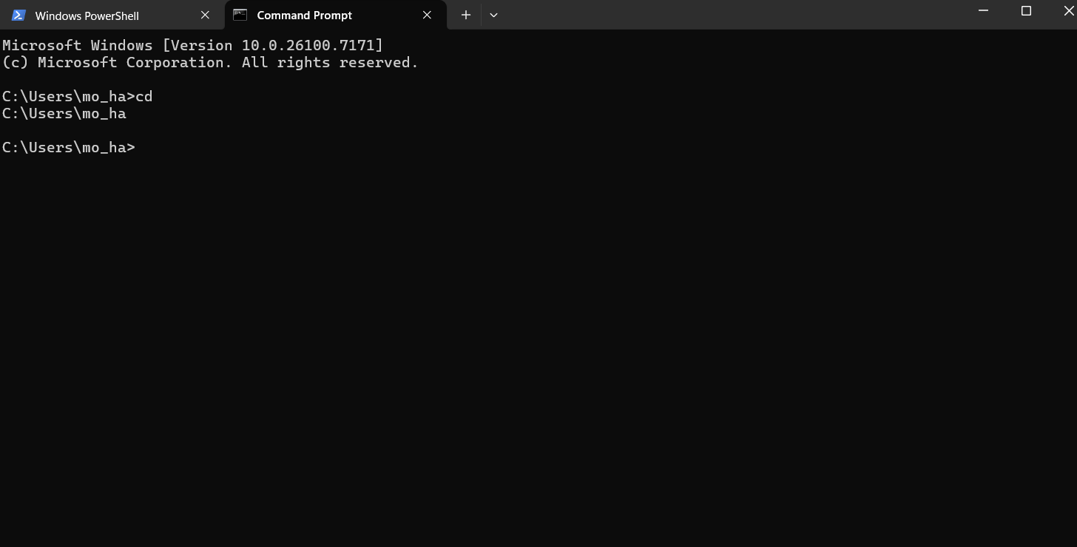
output
Input

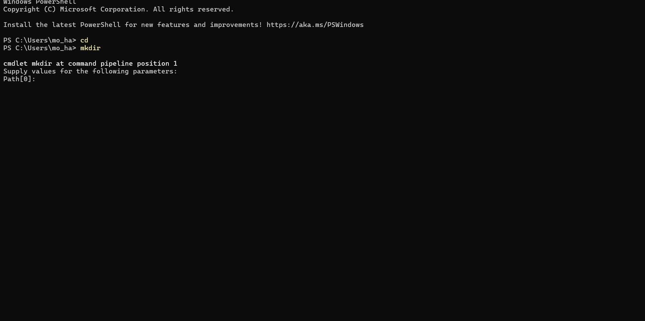
- mkdir – Creates a new directory.
output
Input

- Eventcreate/? – Enables an administrator to create a custom event in a specified event log. Displays help at the command prompt with the question mark.
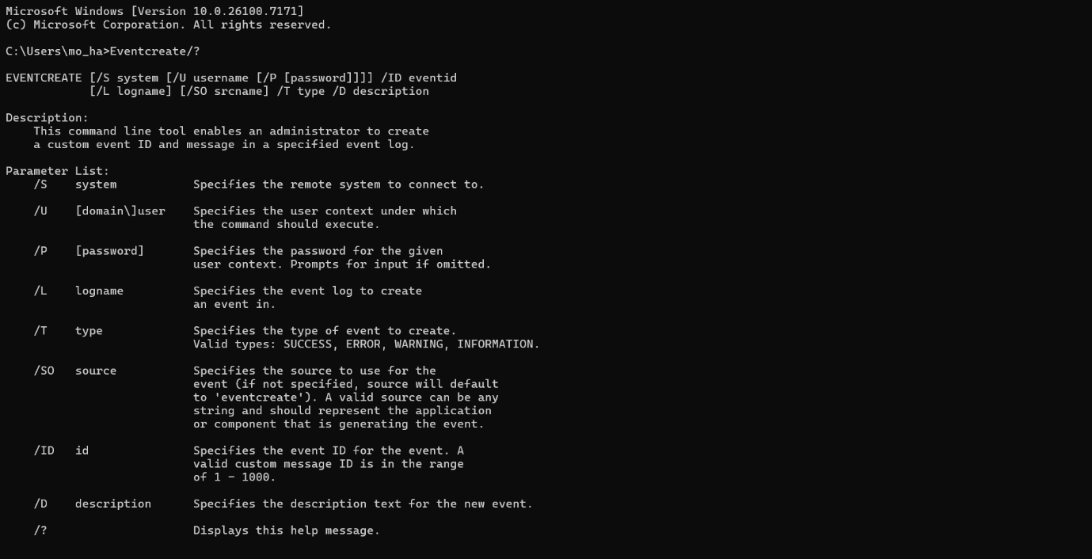

- Copy/? – Copies files from one location to another.

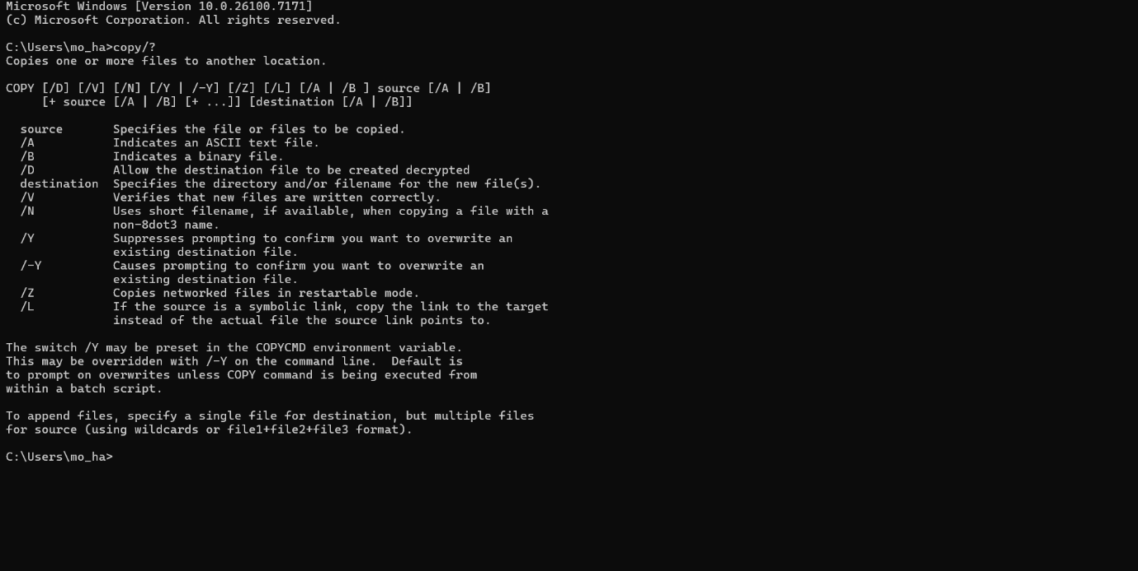

- Move/? – Moves files or directories with help of option .
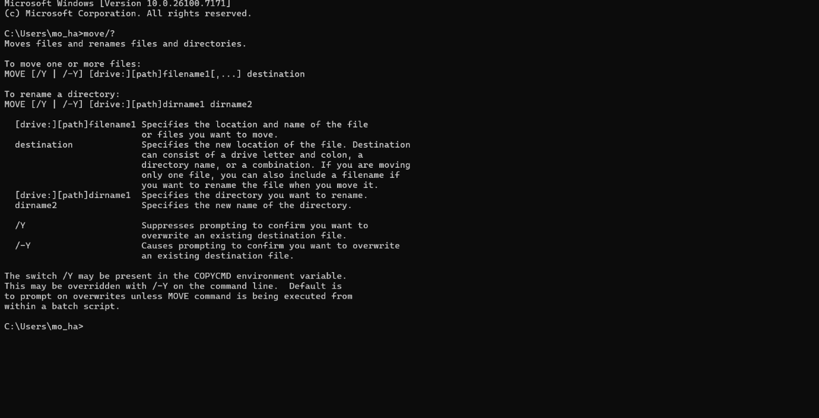
- Del/? – Deletes files with help of options.
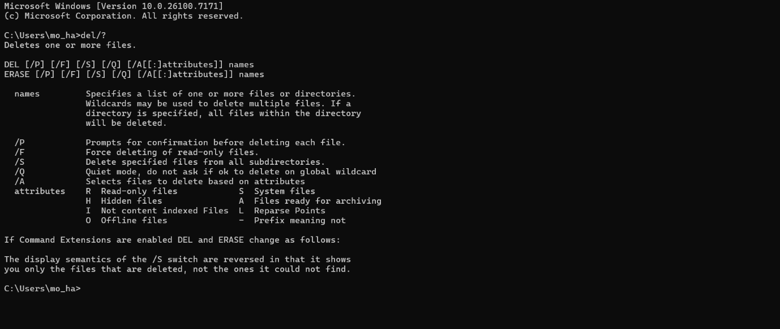

- ipconfig – Displays network configuration details.
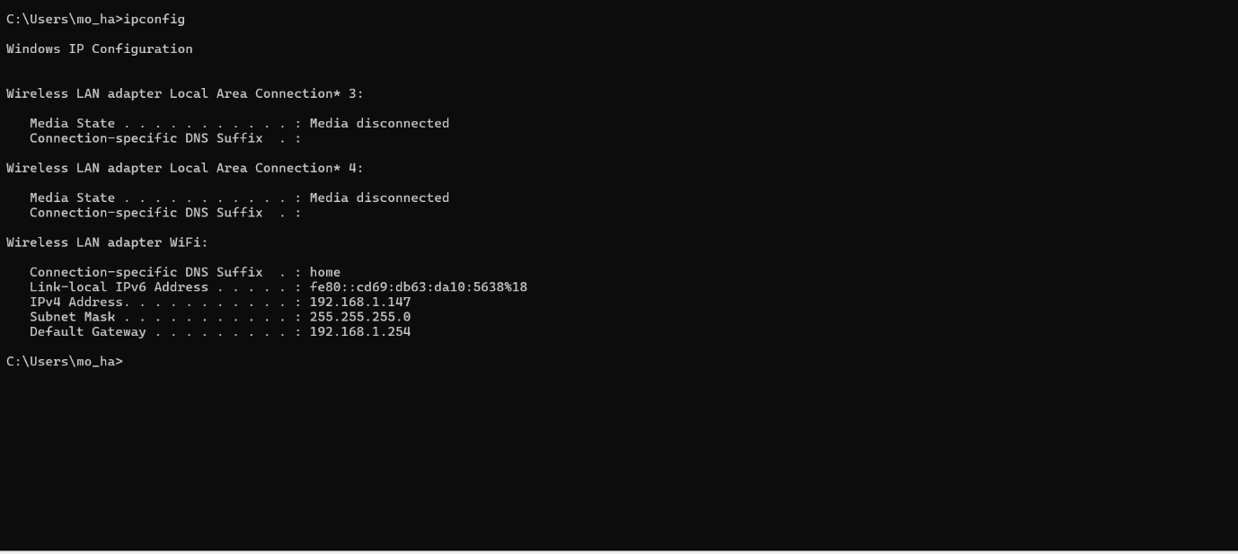
Fig 8 [3]
- ping – Tests network connectivity.
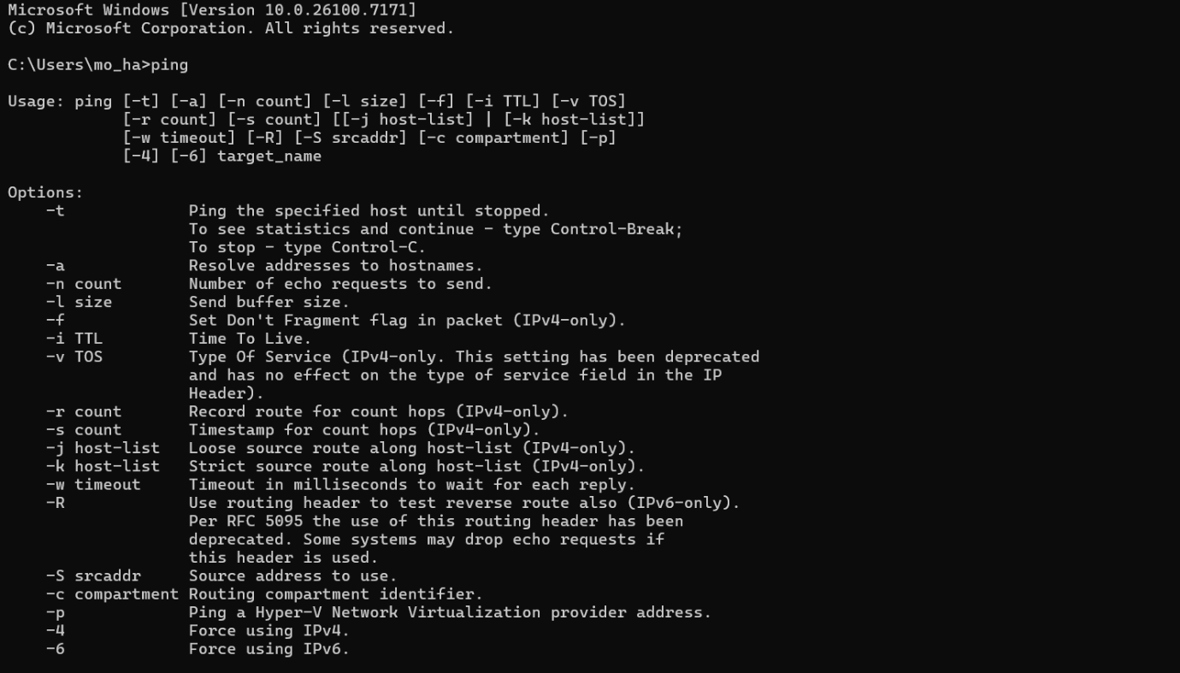

- tasklist – Displays currently running processes.
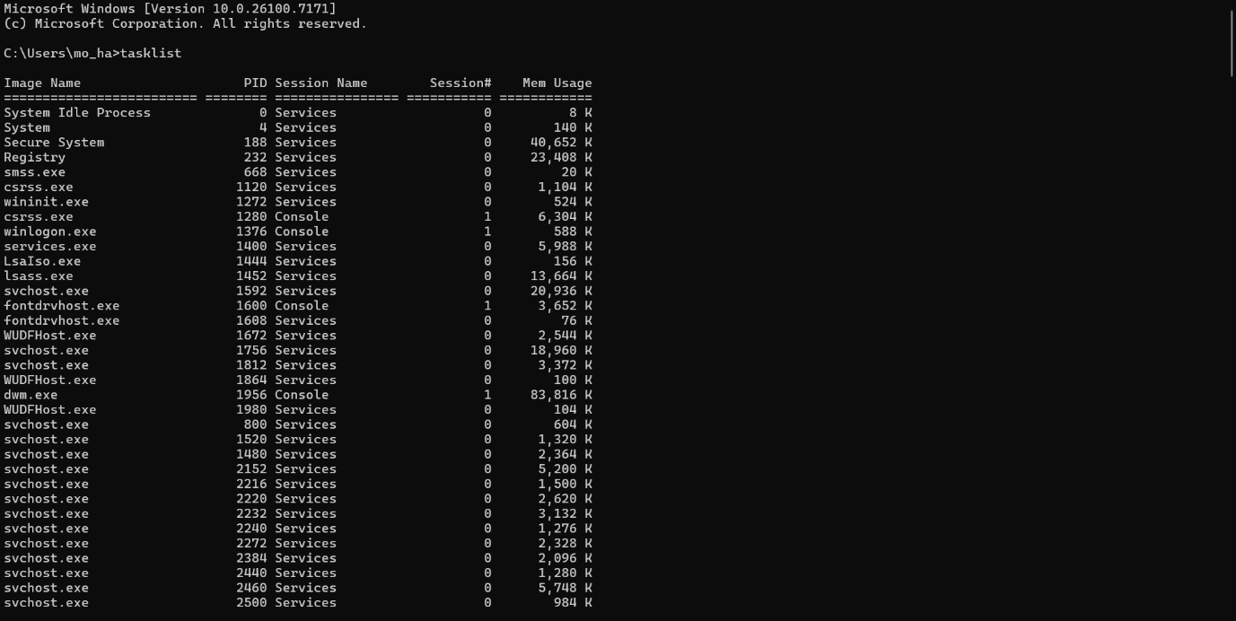
Fig10 [2]

All these commands are done on command prompt.
These commands allow administrators and users to manage files, diagnose network issues, and monitor system activity efficiently without relying on graphical tools.

Task 3: Use of Linux OS CLI Commands
Linux systems rely heavily on the Bash shell for command-line interaction. Commonly used Bash commands include:
- ls – Lists directory contents.
The ls command is used to list files and directories in the current working directory. This is going to be one of the most frequently used Linux commands you must know of.
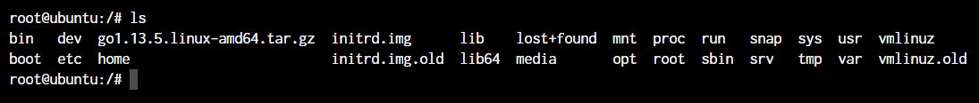
As you can see in the above image, using the command by itself without any arguments will give us an output with all the files and directories in the directory. The command offers a lot of flexibility in terms of displaying the data in the output.[3]

- cd – Changes directory.
The cd command is working within the terminal, moving around within directories is pretty much a necessity. The cd command is one of the important Linux commands you must know, and it will help you navigate through directories. Just type cd followed by directory, as shown below.
root@ubuntu:~# cd <directory path>
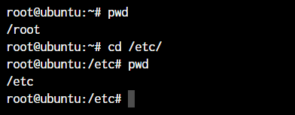
As you can see in the above command, you type cd /etc/ to get into the /etc directory. We use the pwd command to print the current working directory.[3]

- pwd – Displays the current directory path.
The pwd command allows you to print the current working directory on your terminal. It’s a very basic command and solves its purpose very well.
Now, your terminal prompt should usually have the complete directory anyway. But in case it doesn’t, this can be a quick command to see the directory that you’re in. Another application of this command is when creating scripts where this command can allow you to find the directory where the script has been saved.[3]

- mkdir – Creates a directory.
The mkdir command allows you to create directories from within the terminal.
root@ubuntu:~#mkdir <folder name>
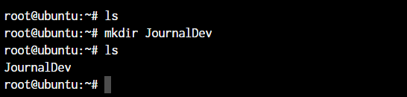
As you can see in the above screenshot, JournalDev directory with just this simple command has been created.[3]
- rm – Removes files or directories.
The rm command is used to delete files and folders and is one of the important Linux commands you must know.
root@ubuntu:~# rm <file name>
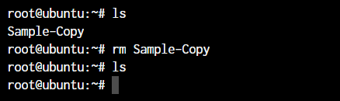
To delete a directory, you must add the -r argument to it. Without the -r argument, the rm command won’t delete directories.
root@ubuntu:~# rm -r <folder/directory name>
The -r flag in the rm command in Linux stands for “recursive”. When used with the rm command, it will remove not only the specified file but also all of its subdirectories and the files within those subdirectories recursively.[3]
- cp – Copies files or directories.
The cp command is to copy-paste and cut-paste commands in Windows. But since Linux doesn’t really have a command for renaming files, we also use the mv command to rename files and folders.
root@ubuntu:~# cp <source> <destination>
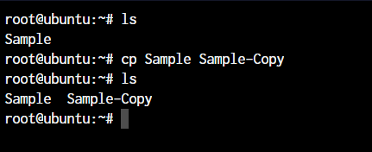
In the above command, its created a copy of the file named Sample. [3]
- mv – Moves or renames files.
we use the mv command in the same manner as cp.
root@ubuntu:~# mv <source> <destination
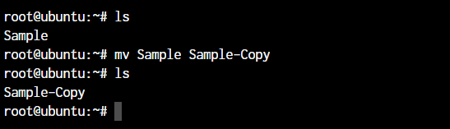
In the above case, since we were moving the file within the same directory, it acted as a rename. The file name is now changed.[3]

- chmod – Changes file permissions.
The chmod command is used to modify file permissions and ownership in Linux. It is used to change the permissions of a file or directory.
The default syntax for the commands is chmod <parameter> filename
root@ubuntu:~ chmod +x loop.sh
root@ubuntu:~ chmod root:root loop.sh
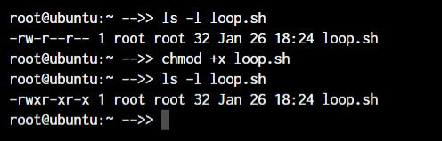
In the above example, we’re adding executable permissions to the loop.sh file with the chmod command. In addition, with the chown command, we’ve made it accessible only to the root user and users within the root group.
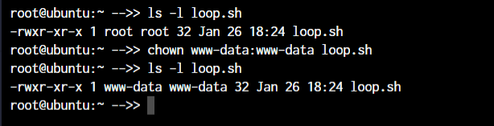

As you will notice, the root root part is now changed to www-data which is the new user who has full file ownership.[3]

- service – manage system services.
The service command i is used to manage system services, which are long-running processes that are started at boot time and run in the background. These services are responsible for providing various system functionalities, such as networking, database management, and user authentication. The service command is used to start, stop, restart, and check the status of these services. It is a front-end to the systemctl command, which is used to manage the systemd service manager.[3]
The basic syntax of the command is as below.
root@ubuntu:~ service ssh status
root@ubuntu:~ service ssh stop
root@ubuntu:~ service ssh start
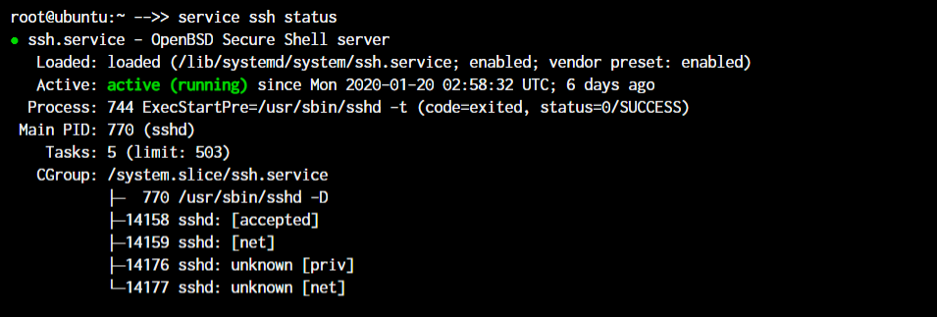

As you can see in the image, the ssh server is running on the system.
- top – Displays real-time system resource usage
The top command is like a CLI version of the task manager in Windows. The top command in Linux is a system monitoring tool that displays real-time information about system processes and resource usage. It provides a dynamic, real-time view of system activity, including CPU usage, memory usage, and process information.[3]
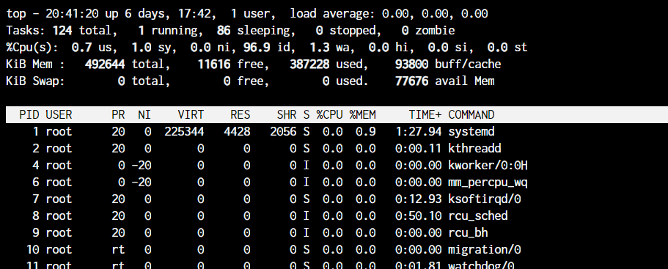

Task 4 Use of Windows OS Script
Windows scripting is commonly performed using Batch files or PowerShell scripts. PowerShell is particularly powerful due to its object-oriented nature. PowerShell Script has Get-Process | Sort-Object CPU -Descending | Select-Object -First 5 This script retrieves running processes, sorts them by CPU usage, and displays the top five processes. Other scripting features demonstrated include:
- Variables and pipelines
- Conditional statements (if)
- Loops (foreach)
- Output redirection
Run a PowerShell Command
Problem
You want to run a PowerShell command.
Solution
To run a PowerShell command, type its name at the command prompt. For example:
PS > Get-Process

Handles NPM(K) PM(K) WS(K) VM(M) CPU(s) Id ProcessName
------- ------ ----- ----- ----- ------ -- -----------
133 5 11760 7668 46 1112 audiodg
184 5 33248 508 93 1692 avgnsvr
143 7 31852 984 97 1788 avgenc
Discussion
The Get-Process command is an example of a native PowerShell command, called a cmdlet. As compared to traditional commands, cmdlets provide significant benefits to both administrators and developers:
- They share a common and regular command-line syntax.
- They support rich pipeline scenarios (using the output of one command as the input of another).
- They produce easily manageable object-based output, rather than error-prone plain-text output.
The Get-Processcmdlet generates rich object-based output, you can use its output for many process-related tasks.
Every PowerShell command lets you provide input to the command through its parameters. The Get-Process cmdlet is just one of the many that PowerShell supports. “Find a Command to Accomplish a Task” to learn techniques for finding additional commands that PowerShell supports. PowerShell scripting enables automation of administrative tasks such as system monitoring, user management, and maintenance. [4]

Task 5: Use Linux OS Scripts
Linux scripting is commonly done using Bash scripts, which automate tasks and simplify system administration. Its scripting is widely used for backups, system monitoring, and deployment tasks.
Key Bash scripting features include:
- Variables
- Conditional statements (if)
- Loops (for, while)
- Use of system commands
Example Bash Script this script displays the current date and system uptime.
#!/bin/bash
echo "System Information"
date
uptime

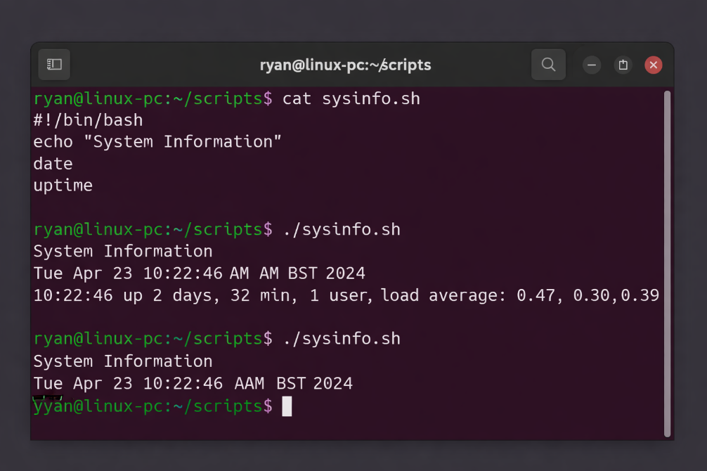
Fig7 Bash script execution in terminal. [5]

Conclusion
To conclude this report evaluates the key functions of modern operating systems and I demonstrated the practical use of command-line tools and scripting in both Windows and Linux environments. Operating systems play a vital role in managing hardware, software, and user interactions, while command-line interfaces and scripts improve efficiency through automation and precise system control. Developing these skills is essential for effective system administration and supports professional IT practice by reducing manual effort and improving productivity.

References
[1] A. Silberschatz, J. L. Peterson and P. B. Galvin,Operating system concepts, Addison-Wesley Longman Publishing Co., Inc., 1991.
[2] Microsoft, Windows 10 and Windows 11 Architecture, Microsoft Learn, 2023. [Online]. Available: https://learn.microsoft.com/
[3] https://www.digitalocean.com/community/tutorials/linux-commands#top-50-linux-commands-you-must-know-as-a-regular-user
[4] L. Holmes, Windows PowerShell Cookbook: The Complete Guide to Scripting Microsoft's Command Shell, " O'Reilly Media, Inc.", 2012.
[5] The Linux Documentation Project, Advanced Bash-Scripting Guide, 2024. [Online]. Available: https://tldp.org/LDP/abs/html/. [Accessed: 17-Dec-2025].

Appendices

