Title Page

Module: ACCA4022 – Computer Architecture and Operating Systems
Assignment: Operating Systems Assignment
Student Name: Akacha Laidi
Student ID: 2531578
Course: CertHE Computing Skills for Workplace

Table of Contents

1. Introduction
2. Key Functions of General Operating Systems
3. Windows OS CLI Commands
4. Linux OS CLI Commands
5. Windows Batch Scripts
6. Linux Bash Scripts
7. Conclusion
8. References

- Introduction
An operating system or OS is a vital piece of software that manages the computer hardware and software resources and provides services to application developers and users. Linux perform a number of tasks such as process management, memory management, file management, device management, networking management and security management. The report highlights various functions of an Operating System (OS) and shows how to use Windows and Linux CLI. To illustrate that using the command line for automation makes performing routine administrative tasks more efficient. Finally, the report summarises the knowledge and practical skills gained from using operating system commands and scripting techniques.

- Key Functions of General Operating Systems

2.1 process management
The operating system controls all the running programs and applications of the computer system. The function is called process management. The operating system assigns CPU time to various processes, draws up their schedules, and makes sure that several programs can run at the same time. Multitasking feature helps users browse the web, edit a document and play music simultaneously on the computer. The task manager displayed in (Figure 1), helps users view the active processes and the consumption of CPU, memory, disk, and network resources by each process. This tool can be used to monitor the performance of the system and end unresponsive software.

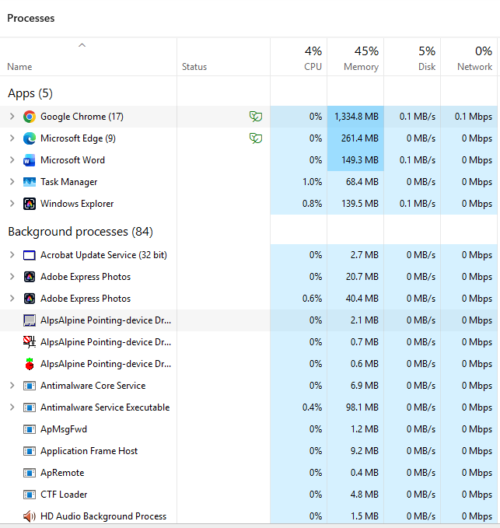
Figure 1

2.2 memory management
Memory management is the other important functions of an OS. It regulates the assignment of the computer’s RAM to different applications. When our physical RAM is not enough, then our operating system makes use of virtual memory. The memory section of task manager (Figure 2) shows the installed memory, memory in use, memory available and memory speed. By monitoring these values, users can spot problems with performance and see how well system resources are being used.

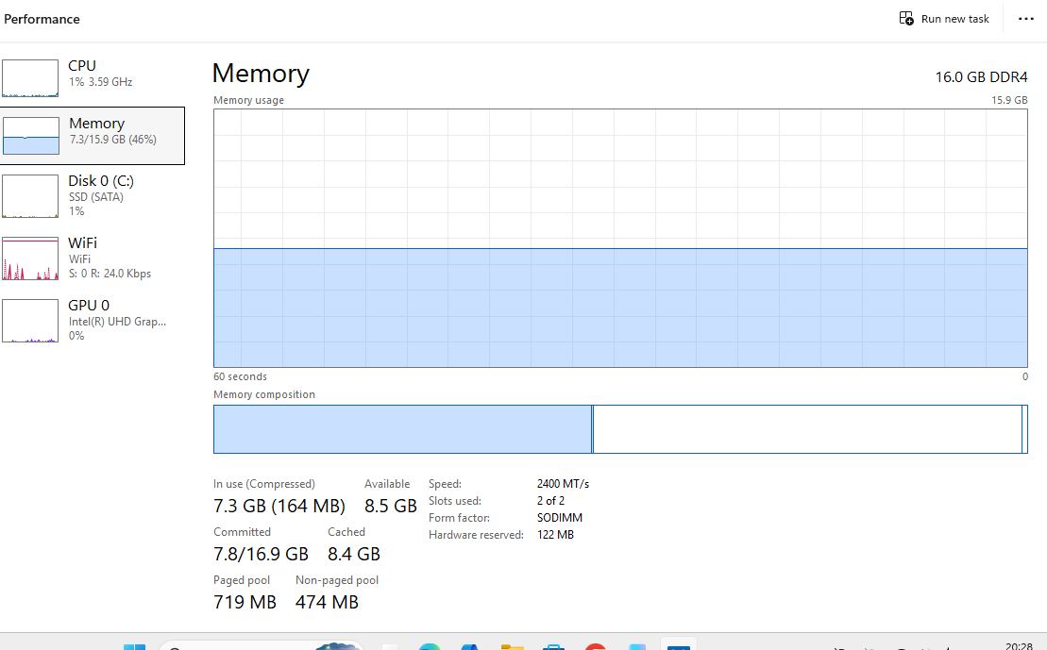
Figure 2

  - file management
Through use of a file system, operating systems manage files and organise files. File management allows users to create, rename, move, copy and delete files and access previously saved files in folders locations. (Figure 3) illustrates how file explorer helps go from one place on the computer to another to manage personal or work documents.

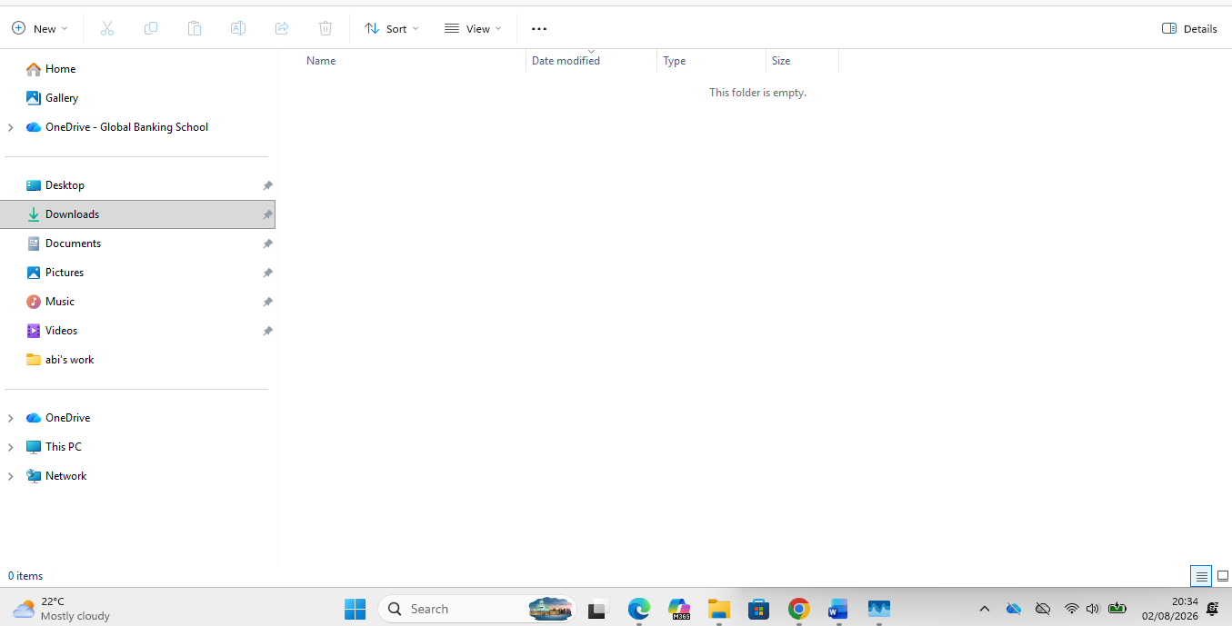
Figure 3

2.4 Device Management
Through device drivers, the software is enabled to communicate with the hardware. Device management helps manage and ensure proper functioning of keyboard, printer, graphics card, storage device, network adapter, etc. the device manager in (Figure 4), allows users to view installed hardware drivers, update drivers, troubleshoot devices, disable and enable hardware when needed. Device management helps in maintaining the stability of the system and hardware.
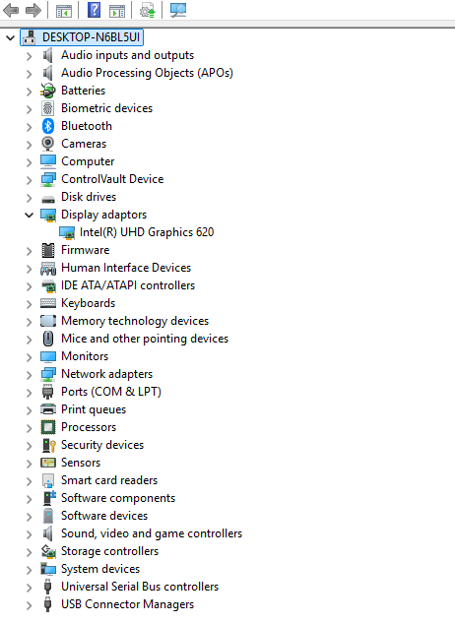
Figure 4

  - Security Management
Security management protects the operating system and user data from threats, including malware, viruses, and unauthorised access. Windows security has tools for antivirus software, firewall settings, account protection, and device security. As shown in (Figure 5), these security functions help notify the administrators of potential unwanted behaviour towards their devices within the organisation network. To protect its integrity, the system, like any computer system, is kept updated with regular security updates and active security.
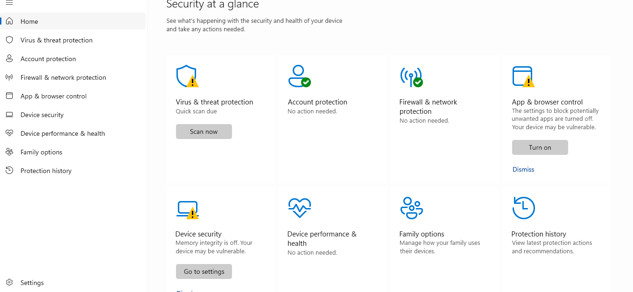
Figure 5
2.6 Network Management
Operating systems control network communication via the internet, network adaptors, and communication protocols. This enables computers to access local networks and the internet, allowing for the sharing of resources and communication online. The network & internet settings page (Figure 6) allows the users to modify Wi-Fi or Ethernet connection settings, VPN details and troubleshoots network issues. When your network is well managed, you have high assurance for online access.
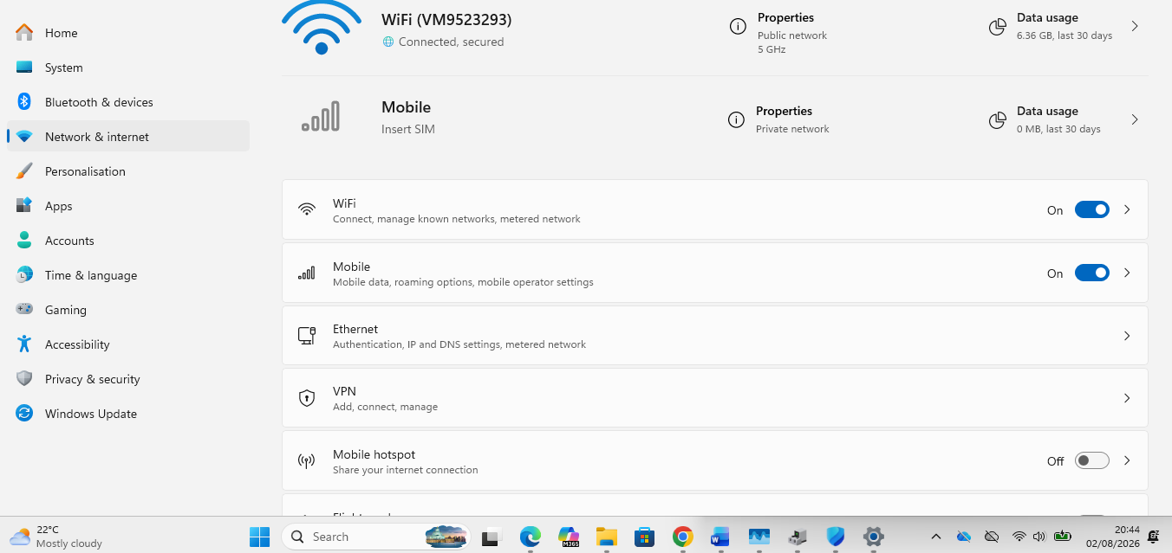
Figure 6
- Windows OS CLI Commands
3.1 tasklist – process management.
The tasklist command displays all currently running processes on the computer, including their process ID (PID) and memory storage usage. It is useful for monitoring system activity and identifying applications or background processes that are consuming system resources.
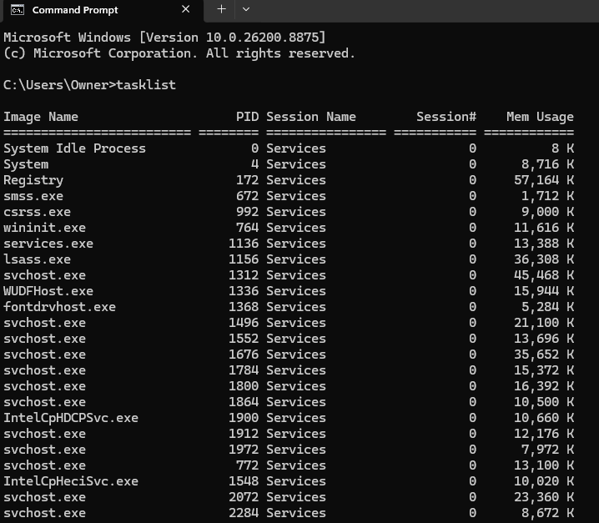
Figure 7

3.2 taskkill – process management.
The taskkill command is used to stop or terminate running processes. The /PID option ends a process using its process ID, while /IM ends a process using its image name. the /F option forces a process to close if it is not responding.
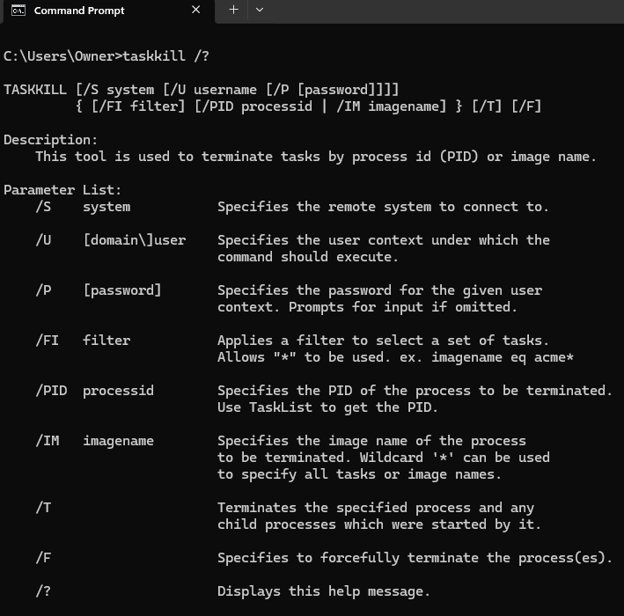
Figure 8

  - dir – File and Directory Management
the dir command lists all files and folders in the current directory. It helps users view the contents of a folder, check file names, sizes, and modification dates, making it useful for managing files through the command prompt.
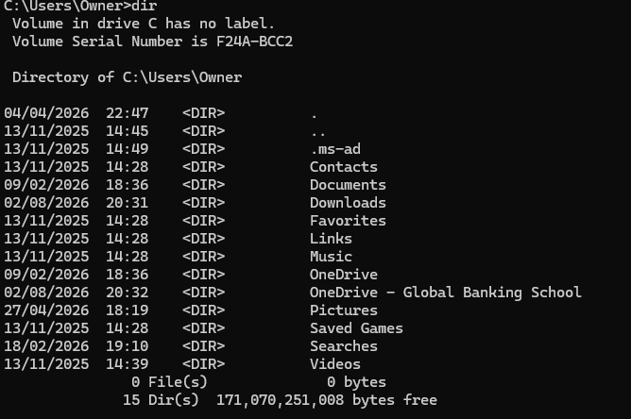
Figure 9

  - mkdir CourseworkFolder
the mkdir command creates a new directory or folder. It allows users to organise files into separate folders, improving file management and making it easier to store and locate documents.
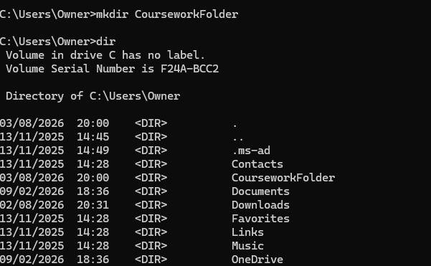
Figure 10

  - copy – File Management
the copy command duplicates files from one location to another. It is commonly used to back up important files or move files or move copies into different folders while keeping the original file uncharged.
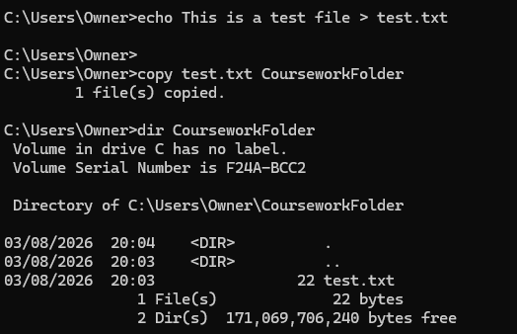
Figure 11

  - ipconfig /all – Network Testing and Monitoring
the ipconfig /all command displays detailed information about the computer’s network configuration, including the IP address, subnet mask, default gateway, DNS servers, and physical (MAC) address. It is commonly used to troubleshoot network connectivity issues.
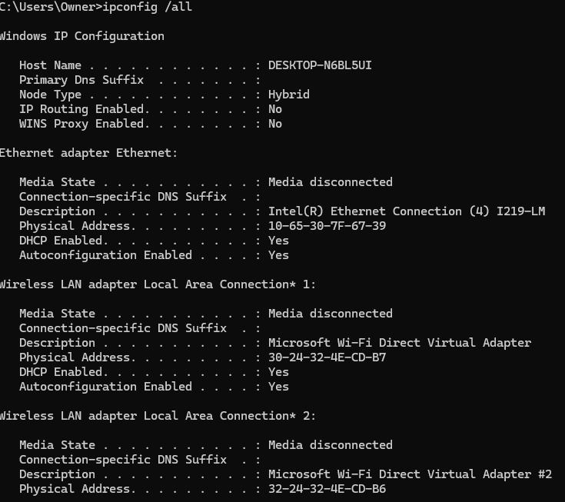
Figure 12

  - ping google.com – Network Testing
the ping command checks whether a remote device or website can be reached over the network. It measures the response time and confirms whether an internet connection is working correctly by sending test packets to the destination.
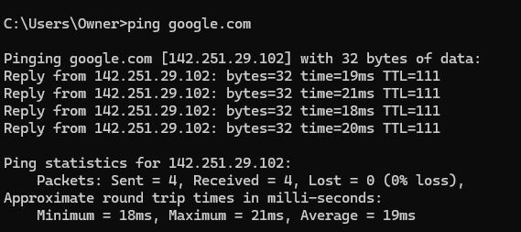
Figure13

  - whoami – User Management
the whoami command displays the username of the account currently logged into windows. It is useful for verifying the active user, especially when working on shared computers or systems with multiple user accounts.
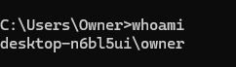
Figure 14

  - net user – User Management
the net user command lists all user accounts configured on the local computer. It can also be used by administrators to create, modify, or remove user accounts and manage passwords.
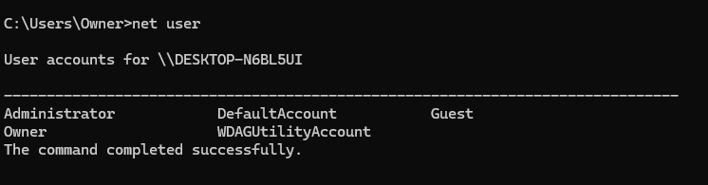
Figure 15

  - schtasks /query – Task Scheduling
the schtasks/query command displays all scheduled tasks on the computer, including their status and next run time. It is useful for monitoring automated maintenance tasks and verifying that scheduled jobs are configured correctly.
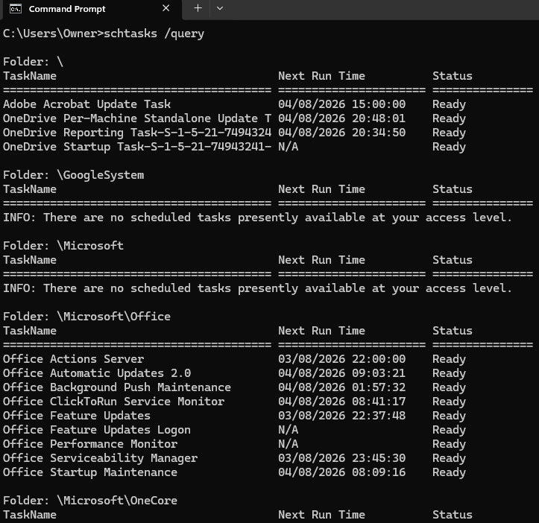
Figure 16

- Linux OS CLI Commands
4.1 ps -ef – Process Management
The ps-ef command displays all running processes on the linux system. It provides information such as the processID (PID), parent process ID (PPID), owner, and the command used to start each process. This command is commonly used to monitor active system processes.
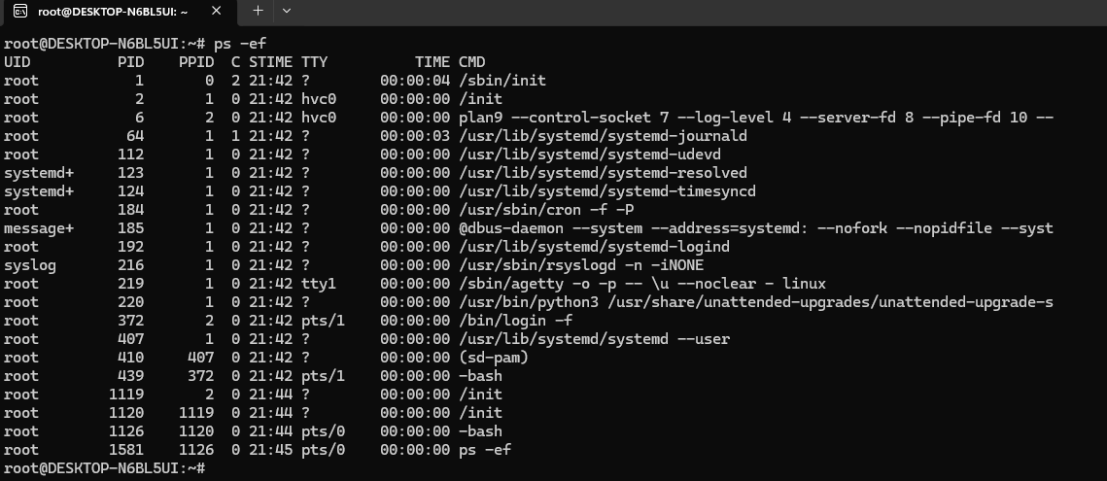
Figure 17

4.2 kill --help – Process Management
The kill command is used to terminate running processes by sending signals. The –help option displays the command syntax and available options, allowing users to understand how to stop processes safely without affecting system stability.
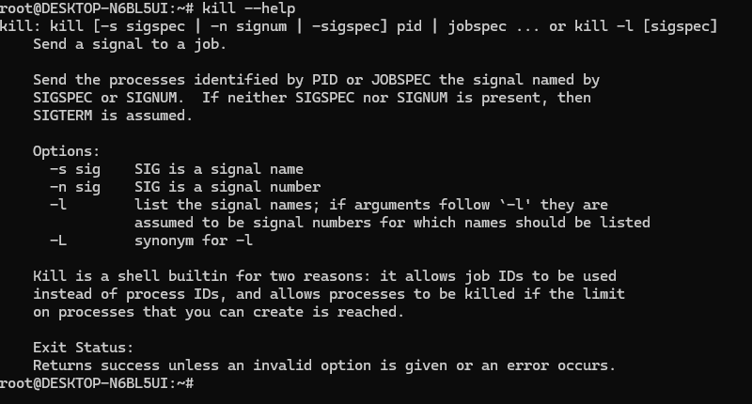
Figure 18

  - ls -la – File & Directory Management
the ls -la command lists all files and directories in the current location, including hidden files. It also displays permissions, file ownership, file size, and modification dates, making it useful for managing files within the linux file system.
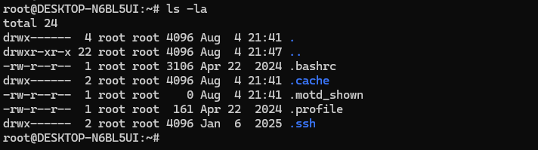
Figure 19

  - mkdir – Directory Management
the mkdir command creates a new directory within the current location. Directories help users organise files into structured folders, making it easier to manage and locate data stored on the system.
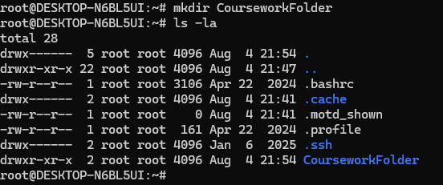
Figure 20

  - cp – File Management
the cp command files or directories from one location to another. It is commonly used to back up important files, duplicate documents, and organise data while keeping the original file unchanged.
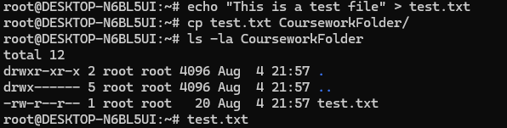
Figure 21
  - ip addr – Network Testing and Monitoring
the ip addr command displays detailed information about the system’s network interfaces, including IP addresses, interface names, and network status. It is commonly used to verify network configuration and troubleshoot connectivity problems.
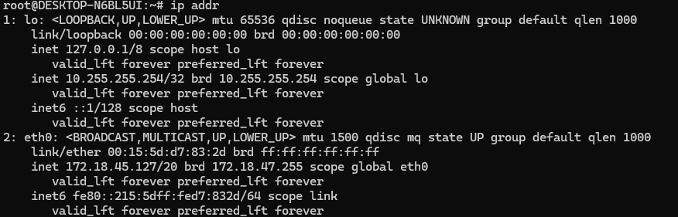
Figure 22
  - ping -c 4 google.com – Network Testing
the ping command tests communication between the local computer and remote server by sending network packets. The -c 4 option limits the command to four packets, making it useful for checking internet connectivity and measuring response times.
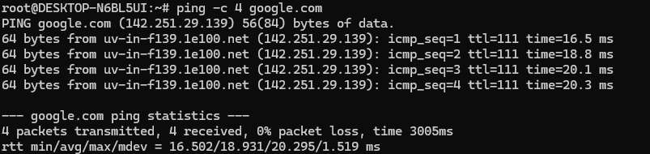
Figure 23
  - whoami – User Management
the whoami command displays the username of the currently logged-in linux user. It id useful for confirming the active user account, particularly when working on systems with multiple users or when administrative privileges are required.
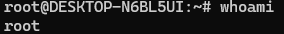
Figure 24
  - id – User Management
the id command displays detailed information about the current user, including the user (ID), group ID (GID), and the groups to which the user belongs. It is useful for checking user permissions and access rights.
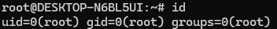 Figure 25
  - crontab -l – Task Scheduling
the crontab -l command displays the scheduled cron jobs for the current user. If no scheduled tasks exist, linux displays a message indicating that no crontab has been created. This command is commonly used to verify automated task scheduling.
Figure 26
5. Windows Batch Scripts
5.1 Batch Script 1 – Addition Calculator
Purpose:
This script asks the user to enter two numbers, adds them together, and displays the result.
Explanation:
The script set /p to collect two values from the user and stores them in the variable num1 and num2. The set /a command performs the arithmetic calculation and saves the answer in the variable total. The result is then displayed using %total%. The pause command keeps the window open so the user can view the output.
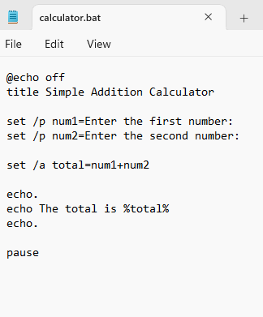 Figure 27
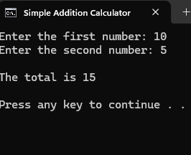 Figure 28
5.2 Batch Script 2 – Folder Creator
Purpose:
This script asks the user to enter a folder name and creates the folder only if it does not exist.
Explanation:
This script uses set /p to collect a folder name from the user and stores it in the variable folder. The if exist statement checks if the folder is already present. If it exists, the script displays a message. Otherwise, the mkdir command creates the folder. This demonstrates variables, user input, and conditional control flow.
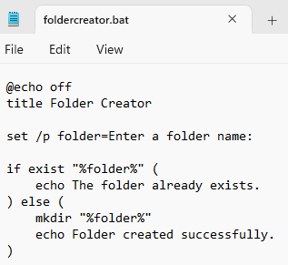 Figure 29
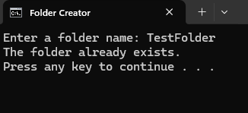 Figure 30
- Linux Bash Scripts
6.1 Bash Script 1 – Addition Calculator
Purpose:
This script asks the user to enter two numbers, adds them together, and displays the result.
Explanation:
The script uses read -p to collect the values from the user and stores them in the variables num1 and num2. The arithmetic expression $((num1 + num2)) calculates the total and stores it in the variable total. The echo command then displays the final result. The script also uses chmod +x so it can be executed directly from the terminal.
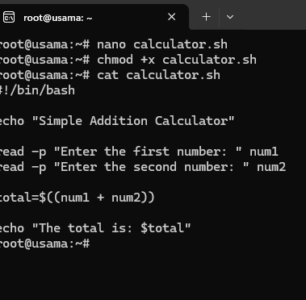 Figure 31
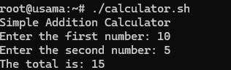 Figure 32
6.2 Bash Script 2 – Folder Creator
Purpose:
This script asks the user to enter a folder name and creates the folder only if it does not already exist.
Explanation:
The script stores user’s input in the variable folder. The condition [ -d "$folder" ] checks whether a directory with that name exists. If it does, the script displays a warning message. Otherwise, mkdir creates the new directory. This demonstrates user input, variables, directory management, and an if…else conditional.

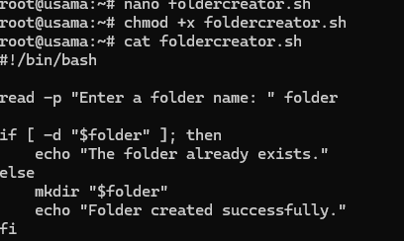 Figure 33
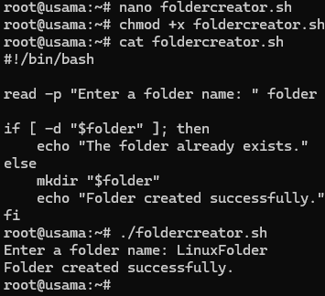 Figure 34

- Conclusion
This report explains important functions of an operating system in modern computers. The report demonstrates how windows and linux manage a computer’s resources. Through carrying out practical activities, we find that operating systems perform very important tasks including process management, memory management, file and directory management, device management, security, and networking.
For testing, various command-line instructions on process management, networking, user management, file management, and task scheduling were executed, through windows command prompt and linux bash terminal. Through these activities, I was better able to understand the management of operating systems through command line interfaces. Similarly, I understood the efficiency of administrators in performing tasks.
The windows batch scripts and linux bash scripts also showed how performing a repetitive task can be automated. The scripts illustrated how using variables, user input, arithmetic operations and conditional statements in command line programming can help realise more productivity and less manual work.
By and large, doing this assignment enhanced my understanding of operating systems (related to theories) and helped me become familiar with the windows and linux commands (related to practicals). The skills apply to technical support, systems administration, cybersecurity, information technology.
- References
[1] A. Silberschatz, P. B. Galvin and G. Gagne, Operating System Concepts, 10th ed. Hoboken, NJ: John Wiley & Sons, 2018.

[2] Microsoft, "Windows documentation," Microsoft Learn. [Online]. Available: https://learn.microsoft.com/. [Accessed: 5 Aug. 2026].

[3] Ubuntu, "Ubuntu Documentation." [Online]. Available: https://ubuntu.com/tutorials. [Accessed: 5 Aug. 2026].

[4] IBM, "Operating Systems." [Online]. Available: https://www.ibm.com/topics/operating-systems. [Accessed: 5 Aug. 2026].

[5] OpenAI, ChatGPT, private communication, Aug. 2026.

