Dean’a Comrie 1906643
BMHP5003_BIRM
BSc Health and Social Care
Introduction to Physiology
Mumtaz Goolam

Health Assessment Report
Health Assessment Report: (Written Report 2000 words)
Develop a health assessment report based on a case study, using the health assessment questionnaire

Contents Page
- Introduction Page 3
- Case study Page 3
- Assessment report Page 4
- Recommendation. Page 4
- Conclusion: Page 5
- References Page 6
- Index Page 7

Introduction

This a written piece of work based on the information given in the Health Assessment Report detailing the health of an individual for the case study. This written work will include all elements of the physiology of the Skeletal System including both normal and abnormal relating to the lifestyle of the said person. The collection of information about the health of the Miss AB will enable to conduct a health and fitness assessment report, discussing the impact and contribution to normal and abnormal physiology of the skeletal system, with recommendations to support the health of the individual.
The information provided to the participant should include a copy of the health assessment questionnaire (available on Moodle), documented consent and further purposes for which the data being collected should be developed by students. In accordance with the data protection act 1998 and the GDPR, students should ensure that any data that is collected is anonymised and cannot be used to uniquely identify any participant.

Case Study

In this Case study it is shown from the information given in the health assessment report shown below (Index) that Miss AB, frequently smokes up to one to nine cigarettes on a daily basis, drinks one unit a day of alcohol, exercises once a month and has a good quantity of fruit and vegetables in their diet. Due to her recent activity during a netball tournament had an accident resulting in a knee injury also known as her ACL, which is an anterior cruciate ligament (ACL) which is in the middle of the knee ,it prevents the shin bone from sliding out in front of the thigh bone , along with severing her meniscus, (Murphy, C.A.,2019) the meniscus is a c-shaped pad of cartilage in the knee that acts as a shock absorber. Each knee has two menisci. Meniscus tears are common knee injuries., An ACL injury is a tear or sprain of the anterior cruciate ligament (ACL), one of the strong bands of tissue that help connect your thigh bone (femur) to your shinbone (tibia). The anterior cruciate ligament (ACL) in the knee is the most commonly injured ligament. The ACL can be torn on its own, although other ligaments and menisci are frequently involved. Surgical or conservative treatment options are available for the injury. Injury results in discomfort, effusion, and inflammation, which leads to changes in muscle function. Though Miss AB has a stable diet her habits of smoking and drinking could have an impact on why she had this injury and her healing processes after her operation procedure.

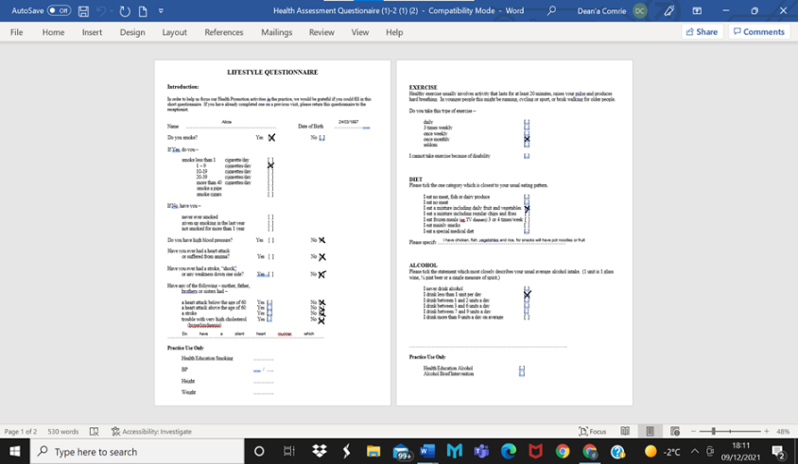

Assessment Report
Based on my assessment findings that where in the information given in the health assessment report filled in by Miss AB, the normal and abnormal physiological conditions of the skeletal system due to her knee injury that ruptured her anterior cruciate ligament (ACL) and find out as why she occurred the incident and what could have been prevented. Based on the information Miss AB has given she smokes one to nine cigarettes a day and drinks up to one unit per alcohol everyday this can have an effect in the skeletal system as cigarette smoking harms the skeletal system by lowering bone mass and increasing fracture risk through direct and indirect effects on bone healing. Smoking causes an imbalance in bone turnover, making bones vulnerable to osteoporosis and fragility fractures, according to new research. The impact of smoking on the skeletal system, particularly bone fractures, and to determine the pathophysiological mechanisms. Furthermore, cigarette smoking has been proven to have a negative impact on fracture healing, with a positive association between daily cigarette consumption and years of exposure. Smoking is also known to induce a number of medical/surgical issues that result in extended hospital stays (Tarantino, U.,2021). Drinking alcohol also can the common finding of reduced bone mass, lower bone production rate, and higher fracture incidence makes alcohol consumption a risk factor for osteoporosis. (Turner, R.T., 2000) Alcohol has also been demonstrated to inhibit bone formation and proliferation in cultured osteoblastic cells in healthy humans. Due to the development of her exercise routine, she only exercises once a month which can have an impact in her recovery in her knee injury because physical exercise has both systemic and local impacts on the immune system, (Malm, C., 2002). Physical exercise is a main part of the rehabilitation with the structure of the anterior cruciate ligament (ACL), (Kuenze, C.,2013) says as it encourages the leading to alteration in muscle function which allows the restoration of the healing process of the knee injury. The health assessment report shows that Miss AB has a reasonably healthy diet which consist of fruit and vegetables in day-to-day intake, A number of factors can affect bone health such as the amount of calcium in your diet. A diet low in calcium contributes to diminished bone density, early bone loss and an increased risk of fractures (Darias, M.J 2011). The potential benefits of calcium, vitamin D, vitamin K1 is important to determine which modifiable factors, especially nutritional factors, are able to improve bone health throughout life (Cashman, K.D., 2007). Having a sustainable diet with the nutritional benefits is a way of being able to help restore the Injury and help with the restoring process of the anterior cruciate ligament (ACL).

Recommendation
My recommendation is to propose life-style changes and a plan of care with admit change for Miss AB would be to quit smoking completely, stop drinking everyday as it has a long term effect on her anatomy from the skeletal system to her organs that help her body to function, taking a more active role in her physical activity and exercising more than once a month to three times a week to help strengthen the muscle that help bond her the anterior cruciate ligament (ACL), whilst also eating more sustainable fruits and vegetables more often and start taking vitamins supplements that cant be found in foods as often to help with the rehabilitation of her anterior cruciate ligament (ACL). Cigarettes are addictive, and willpower alone may not be enough to help Miss AB to quit so I suggest that find out why she was smoking in the first place to access the issue internally, chew chewing carrots and other veggies, and seek support from the NHS website, doctor, friends and family also using a nicotine replacement treatment can help to increase Miss AB chances of success nicotine replacement therapy (NRT). This can be obtained via your doctor, a local stop smoking service, or a pharmacist on prescription (Stead, L.F.,2012). Miss AB should have a personalised nutritional diet and exercise plan which will compromise each other to sustain a health diet for Miss AB by consuming eat at least 5 portions of a variety of fruit and vegetables every day also known as 5 A Day whilst also basing meals on higher fibre starchy foods like potatoes, bread, rice or pasta. have some dairy or dairy alternatives (such as soya drinks) eat some beans, pulses, fish, eggs, meat and other protein whilst also taking vitamins and supplements (Close, G.L.,2019).

Conclusion
My conclusion of the key findings in the Health Assessment Report helps me to summarise that Miss AB needs to change her diet and lifestyle immediately as her smoking cigarettes and drinking alcohol habits are preventing her anterior cruciate ligament (ACL) to be able to heal properly as it isn’t having sufficient nutrients as she has not been doing sufficient exercise to strength the knee injury including the muscle surrounding the skeletal system. Miss AB should have a more nutritional diet, a personalised exercise plan, take vitamins and supplements to help with her recovery.

References
Abate, M., Vanni, D., Pantalone, A. and Salini, V., 2013. Cigarette smoking and musculoskeletal disorders. Muscles, ligaments and tendons journal, 3(2), p.63.
Cashman, K.D., 2007. Diet, nutrition, and bone health. The journal of nutrition, 137(11), pp.2507S-2512S.
Close, G.L., Sale, C., Baar, K. and Bermon, S., 2019. Nutrition for the prevention and treatment of injuries in track and field athletes. International journal of sport nutrition and exercise metabolism, 29(2), pp.189-197.
Darias, M.J., Mazurais, D., Koumoundouros, G., Cahu, C.L. and Zambonino-Infante, J.L., 2011. Overview of vitamin D and C requirements in fish and their influence on the skeletal system. Aquaculture, 315(1-2), pp.49-60.
Helms, C.A., 2002. The meniscus: recent advances in MR imaging of the knee. American journal of roentgenology, 179(5), pp.1115-1122.
Kuenze, C., Hertel, J. and Hart, J.M., 2013. Effects of exercise on lower extremity muscle function after anterior cruciate ligament reconstruction. Journal of sport rehabilitation, 22(1), pp.33-40.
Malm, C., 2002. Exercise immunology: a skeletal muscle perspective. Exercise immunology review, 8, pp.116-167.
Markatos, K., Kaseta, M.K., Lallos, S.N., Korres, D.S. and Efstathopoulos, N., 2013. The anatomy of the ACL and its importance in ACL reconstruction. European Journal of Orthopaedic Surgery & Traumatology, 23(7), pp.747-752.
McDaniel, L.W., Rasche, A., Gaudet, L. and Jackson, A., 2010. Reducing the Risk of ACL Injury in Female Athletes. Contemporary Issues in Education Research, 3(3), pp.15-20.
Murphy, C.A., Garg, A.K., Silva-Correia, J., Reis, R.L., Oliveira, J.M. and Collins, M.N., 2019. The meniscus in normal and osteoarthritic tissues: facing the structure property challenges and current treatment trends. Annual review of biomedical engineering, 21, pp.495-521.
Stead, L.F., Perera, R., Bullen, C., Mant, D., Hartmann‐Boyce, J., Cahill, K. and Lancaster, T., 2012. Nicotine replacement therapy for smoking cessation. Cochrane database of systematic reviews, (11).
Tarantino, U., Cariati, I., Greggi, C., Gasbarra, E., Belluati, A., Ciolli, L., Maccauro, G., Momoli, A., Ripanti, S., Falez, F. and Brandi, M.L., 2021. Skeletal System Biology and Smoke Damage: From Basic Science to Medical Clinic. International Journal of Molecular Sciences, 22(12), p.6629.
Trees, A.H., Howe, T.E., Grant, M. and Gray, H.G., 2007. Exercise for treating anterior cruciate ligament injuries in combination with collateral ligament and meniscal damage of the knee in adults. Cochrane Database of Systematic Reviews, (3).
Turner, R.T., 2000. Skeletal response to alcohol. Alcoholism: Clinical and Experimental Research, 24(11), pp.1693-1701.
Wild, C.Y., Steele, J.R. and Munro, B.J., 2012. Why do girls sustain more anterior cruciate ligament injuries than boys? Sports medicine, 42(9), pp.733-749.
Xu, B., Chen, L. and Lee, J.H., 2020. Smoking and alcohol drinking and risk of non-union or delayed union after fractures: A protocol for systematic review and dose–response meta-analysis. Medicine, 99(5).
Yousaf, R., 2012. Anatomy of the Skeletal System. In Radionuclide and Hybrid Bone Imaging (pp. 3-27). Springer, Berlin, Heidelberg.

Index



