Module. Digital technologies
Lecturer. Munyaradzi N Murira
Student. Taiba Rashid 2229734
Task 3.
Evidence for completing course make a promotional flyer.

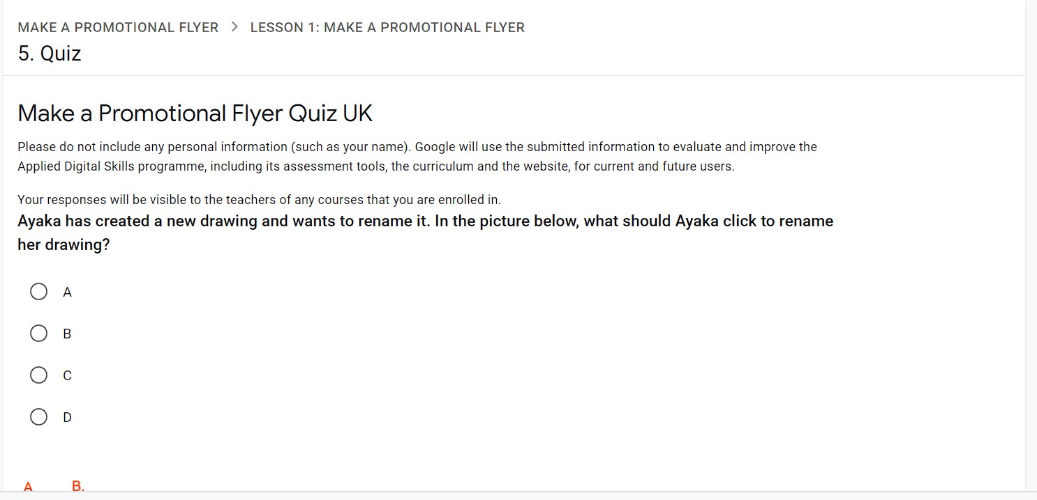

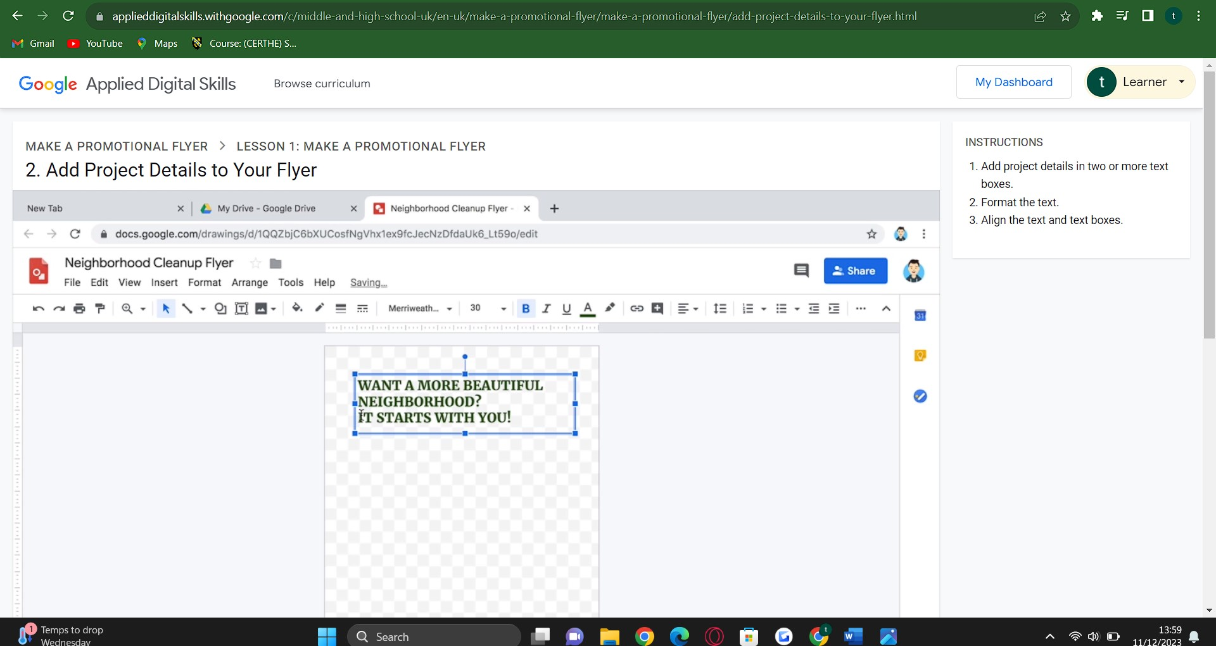

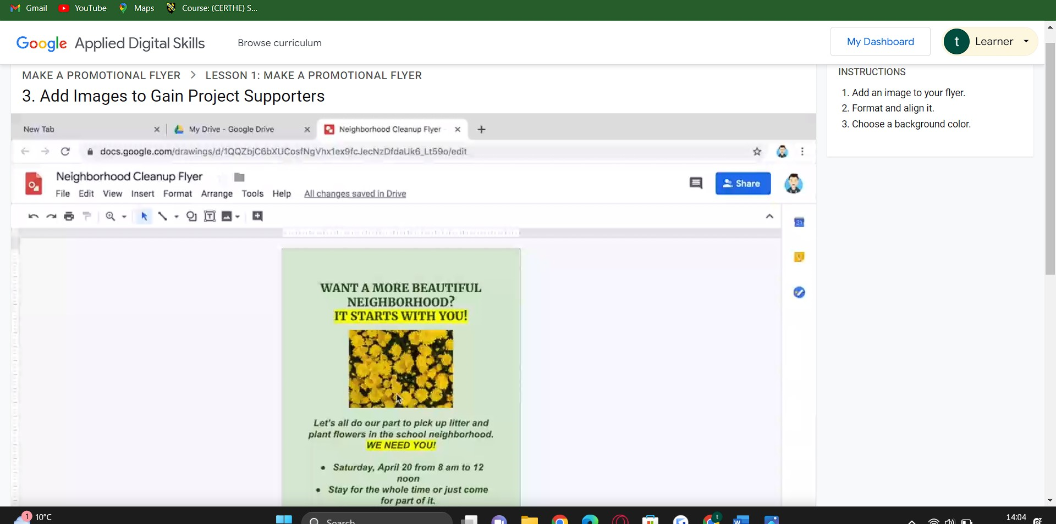
What I learnt from this course.
From this course I learnt how to make and share a promotional flyer how to make changes and edit the flyer for example how to add an image to your flyer format and align it also how to choose a background colour.

