Guide to using Mendeley for Referencing

Introduction
Referencing is an essential academic skill. It allows you to acknowledge the work of others, support your arguments with evidence, and avoid plagiarism.
Mendeley is a reference management tool that helps you organise your sources, insert citations into your assignments, and automatically generate reference lists in the appropriate referencing style (Harvard Cite them right - 12th edition).
This guide explains how to:
- Install Mendeley Reference Manager
- Install Mendeley Web Importer
- Install Mendeley Cite for Microsoft Word
- Add references to your Mendeley library
- Insert in-text citations in Word
- Generate a reference list using Harvard style

Step 1: Create a Mendeley Account
- Go to the Mendeley website: Mendeley | Homepage
- Select Create account
- Register using your student email address (it’s free!)
- Verify your account and sign-in

Step 2: Download and install Mendeley Reference Manager
Mendeley Reference Manager is the desktop software to organise and manage references.
Installation
- Visit the Mendeley download page: Download Mendeley Reference Manager For Desktop Windows | Mendeley
- Download the version appropriate for your operating system
- Run the installer
- Open Mendeley Reference Manager
- Sign in using your Mendeley account set-up before.
What can you do with Reference Manager?
- Store references
- Organise articles into folders
- Annotate PDFs
- Synchronise your library across devices

Step 3: Install Mendeley Web Importer
Mendeley Web Importer allows you to save references directly from websites, databases and Google Scholar into your Mendeley library (it is available for Chrome, Edge, Firefox and Safari).
Installation
- Visit: Web Importer | Mendeley
- Select your browser
- Follow the installation instructions
- Sign-in using your Mendeley account
Using Web Importer
- Search for an article using:
  - Google Scholar
  - PubMed
  - CINAHL
  - ScienceDirect
  - Other Academic databases
- Open the article
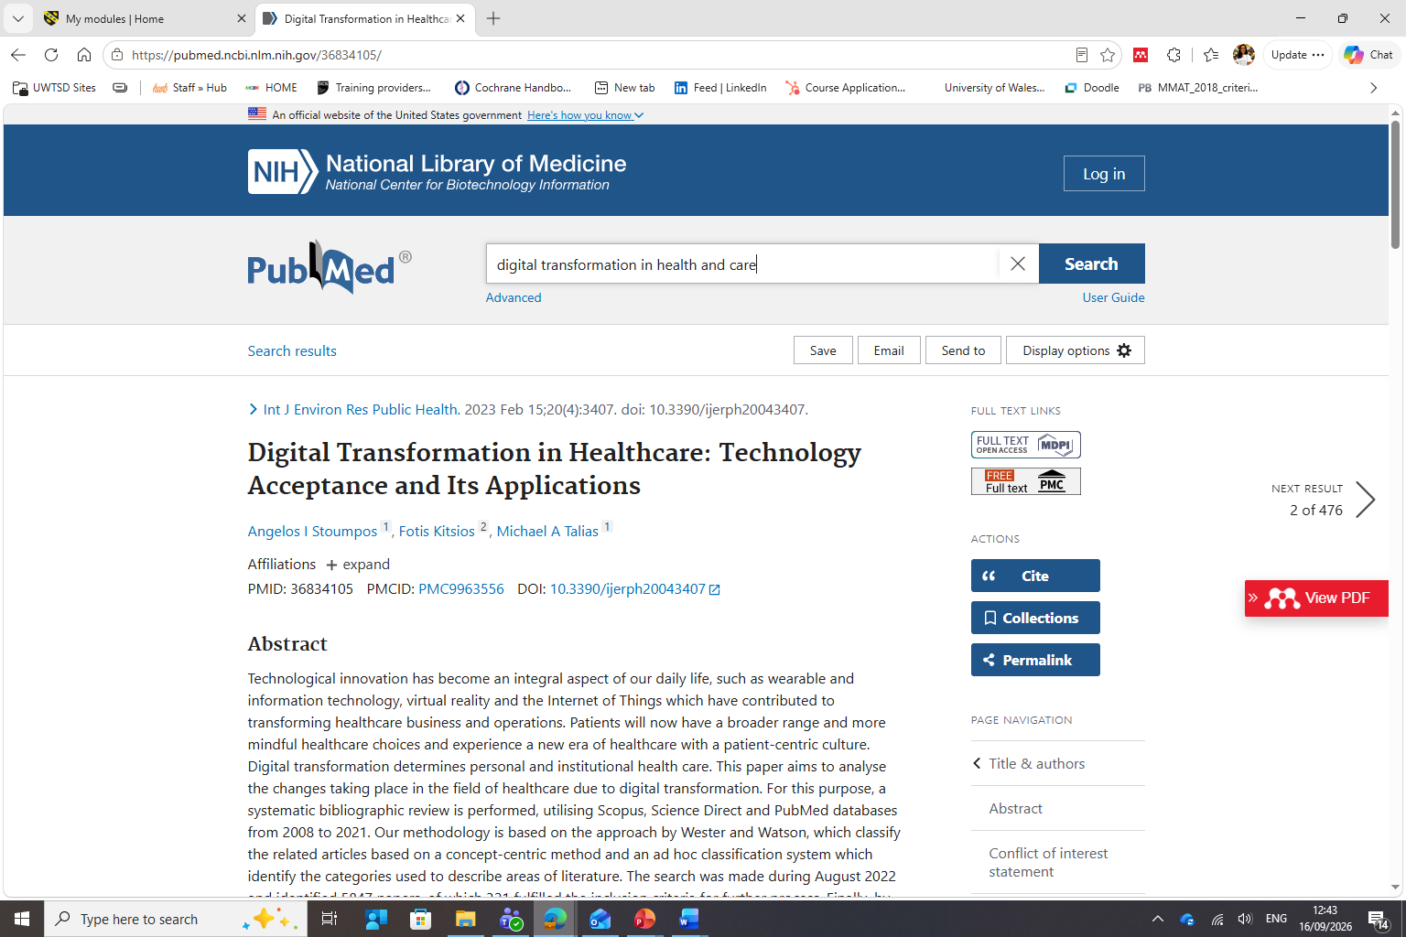
- Click the Mendeley Web Importer icon in your browser (Red circle in the figure above)
- Review the reference details
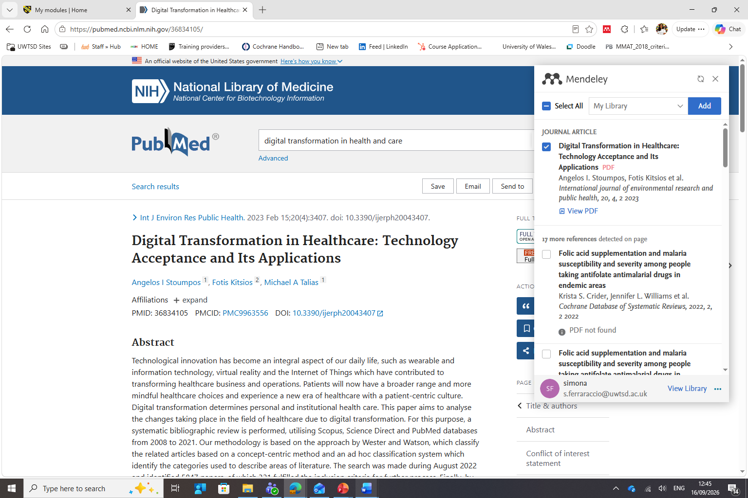
- Select the article in the list and click “Add”
N.B. Always check imported references for accuracy (capitalisation of titles, missing authors, missing page numbers for books and book chapters).

Step 4: Install Mendeley Cite in Microsoft Word
Mendeley Cite is the Microsoft Word add-in used to insert citations and generate bibliographies (reference lists). It works alongside Microsoft 365 and Word 2016 or later.
Installation
- Download Mendeley Cite: Mendeley Cite | Mendeley
- Open Microsoft Word
- Select Insert Get Add-ins
- Search for Mendeley Cite
- Select Add
- Open the add-in from the References tab in a Word document
- Sign in using the Mendeley account you created earlier

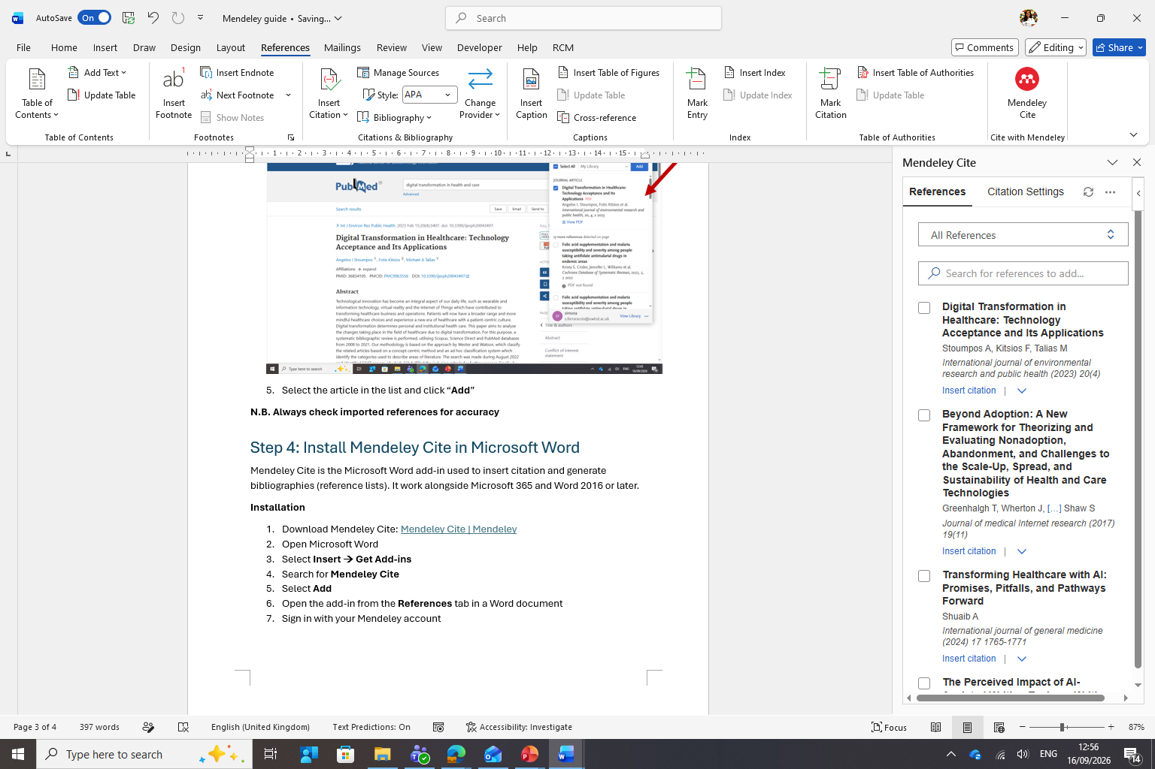

Step 5: Add references to your library
There are several ways to add references:
- Using Web Importer (Step 3)
  - Open an article online
  - Click the Web importer button
  - Save the reference to your library
- Drag and Drop PDFs
  - Open Mendeley Reference Manager
  - Drag a PDF into your library
  - Mendeley will attempt to extract the citation information automatically
- Add manually
  - Select Add new
  - Choose the reference type
  - Enter bibliographic information manually
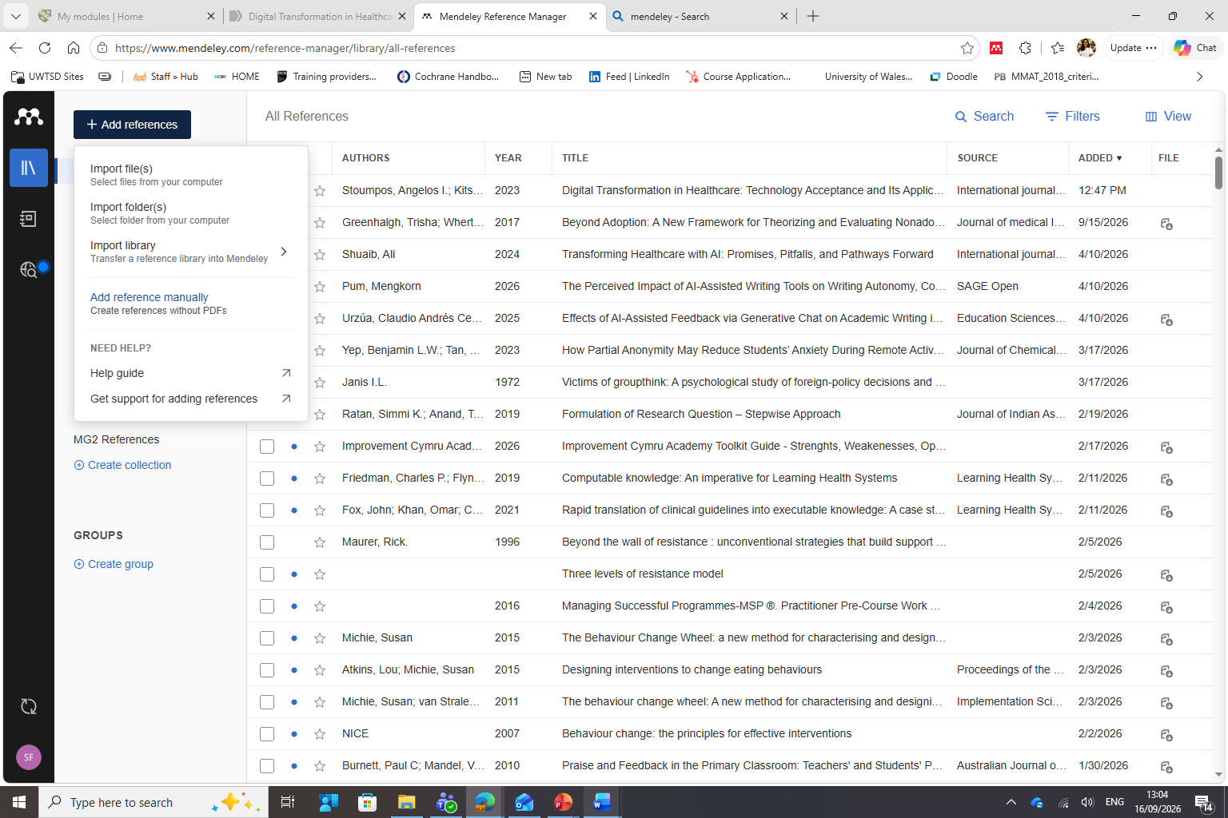
Always check:
- Author names
- Year
- Article title
- Journal title
- Volume and issue numbers
- DOI

Step 6: Insert an In-text citation
Example
Suppose you wish to cite: Digital Transformation is increasingly influencing healthcare delivery (Topol, 2019)
Steps
- Open your Word document
- Position your cursor where the citation should appear in the main text
- Open Mendeley Cite
- Select Insert Citation
- Search for the author or title
- Click Insert Citation
Mendeley will generate a citation such as: (Topol, 2019).
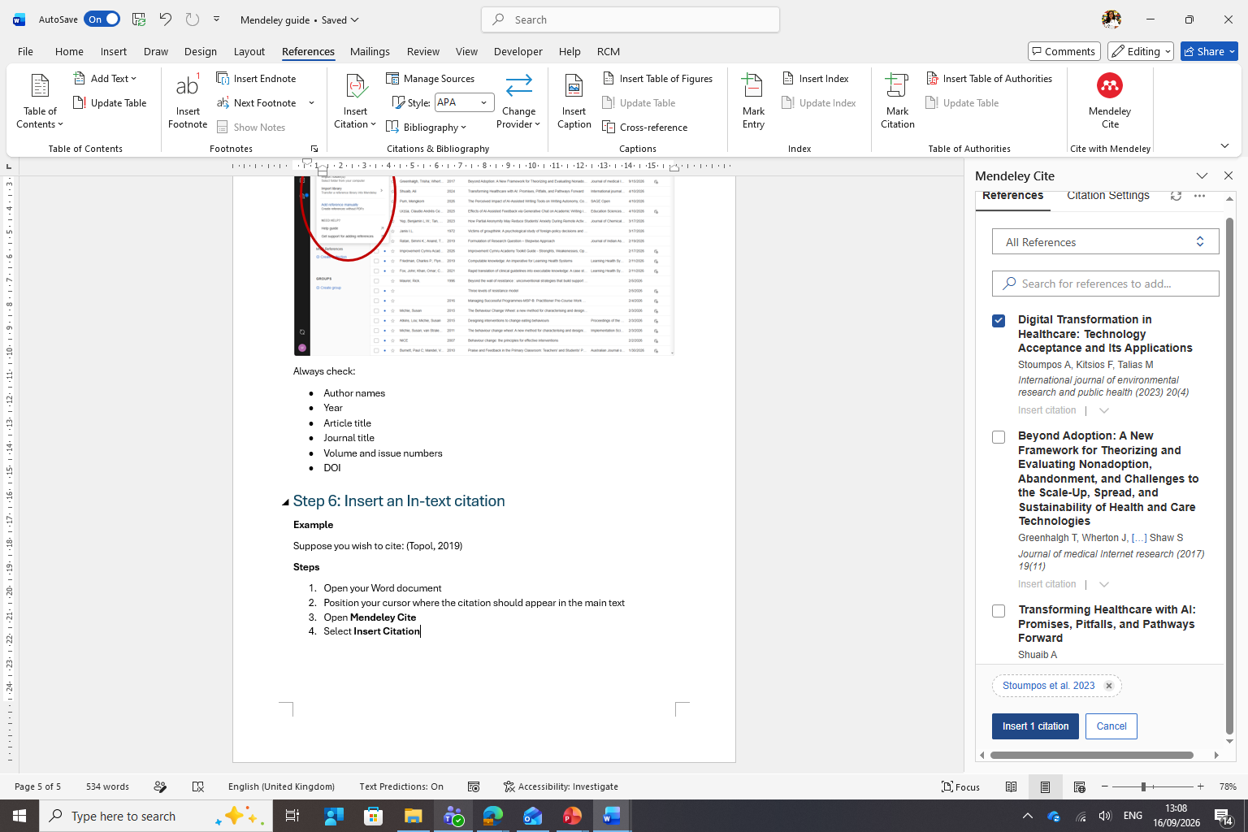

Step 7: Select Harvard Referencing Style
Before generating citations and references:
- Open Mendeley Cite
- Select Citation Settings
- Search for Cite Them Right 12th edition (this is the style required in the assignment specifications)
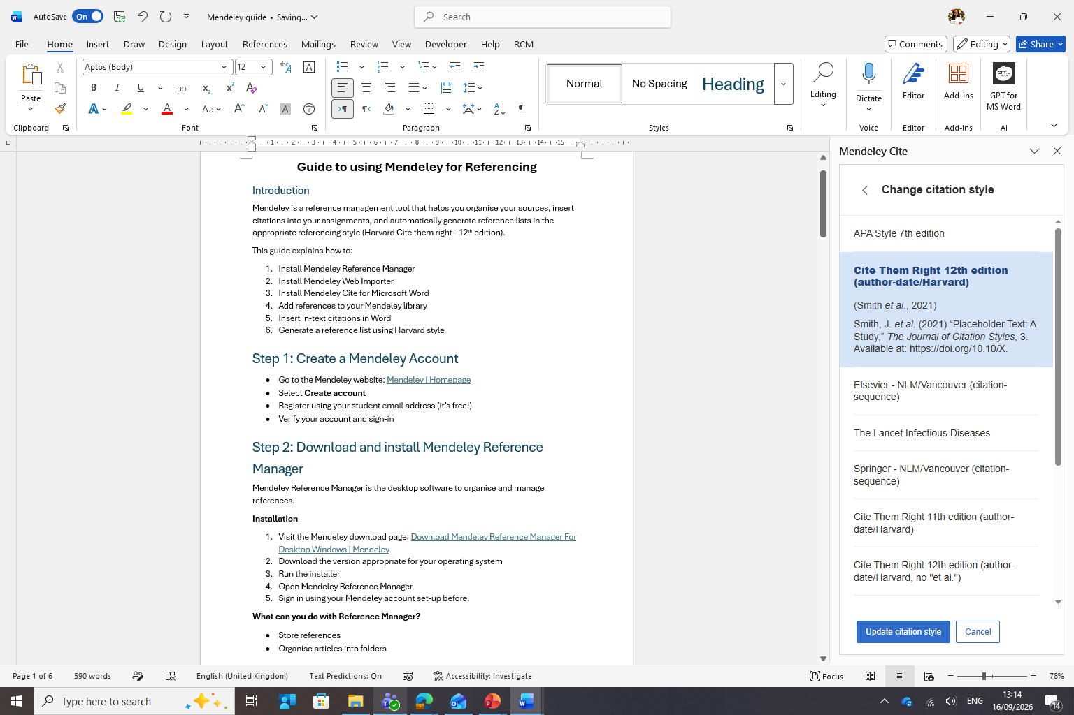

Step 8: Generate a Reference list
Once citations have been added:
- Place the cursor where the reference list should appear
- Open Mendeley Cite
- Select Insert Bibliography (click on “…”)
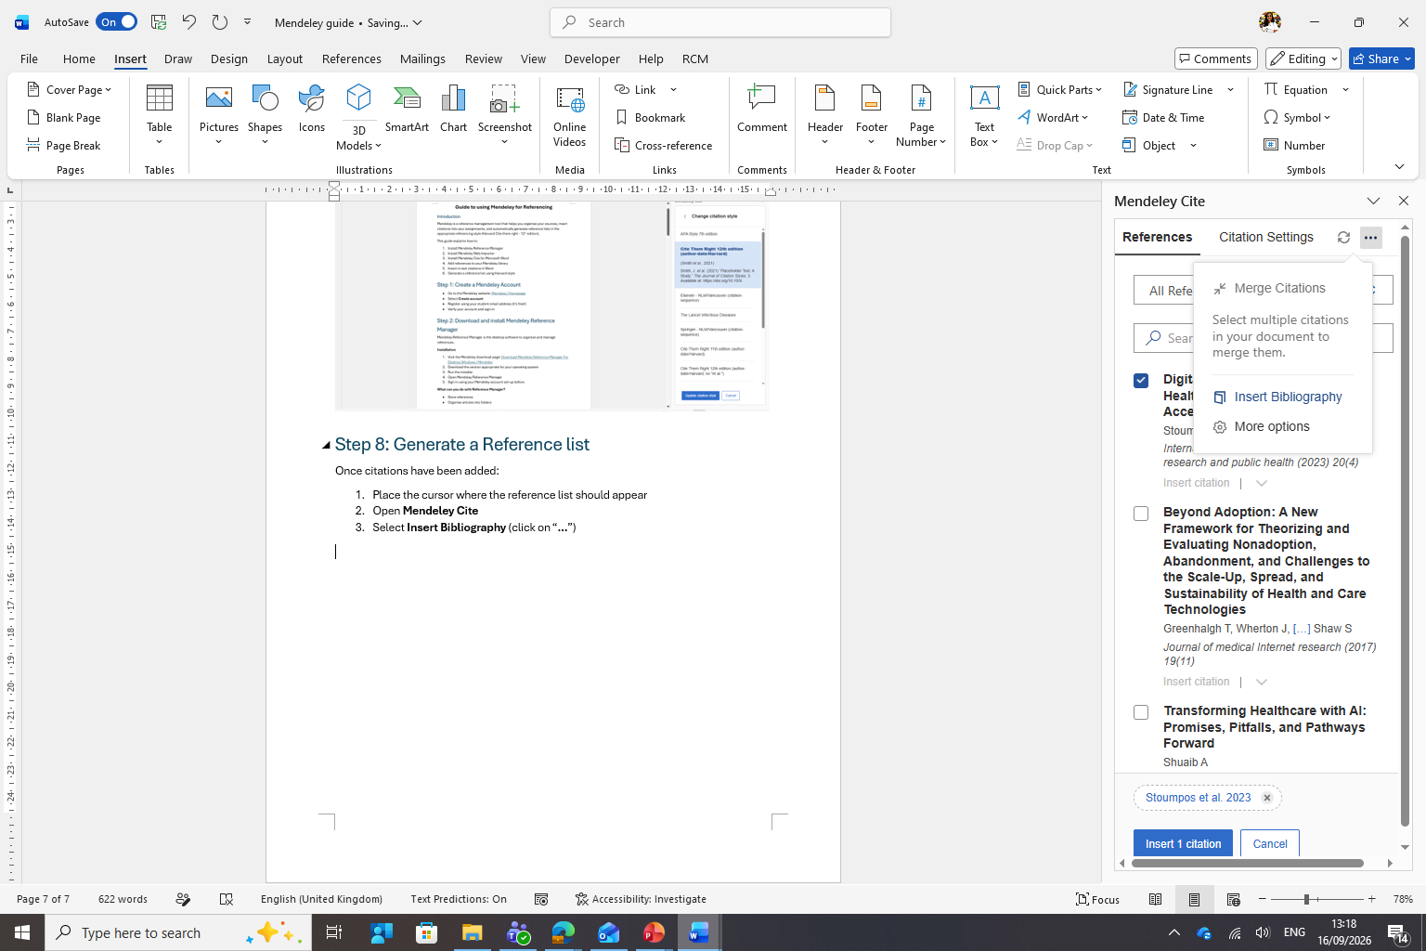
Mendeley will automatically create and update your reference list.
Example:
References
Topol, E. (2019) Deep Medicine: How Artificial Intelligence Can Make Healthcare Human Again. New York: Basic Books.
Wachter, R. (2016) Making IT Work: Harnessing the Power of Health Information Technology to Improve Care in England. London: Department of Health.

Good practice tips
- Check all imported references for accuracy
- Add page numbers to direct quotations where required
- Ensure all in-text citations appear in the reference list
- Ensure all references in the reference list are cited in the text
- Proofread your final reference list before submission
❌ Do not assume imported references are always correct
❌ Do not edit citations manually within Word once they have been inserted by Mendeley

Troubleshooting
If citations are not appearing correctly:
- Ensure you are signed into Mendeley Cite
- Check that the reference exists in your Mendeley Library (Desktop or Web app)
- Verify that the correct citation style is selected
- Refresh the bibliography

Before you submit your assignment
- Check every in-text citation appears in the reference list
- Check every reference in the reference list has been cited in the text
- Ensure the citation style is set to Cite Them Right Harvard 12th edition
- Proofread the reference list for formatting errors

