Changemakers: Creativity and Value Creation ACCA5033, BSC Applied Computing Dr Fahad Ahmed
Walter Ernesto Melendez Dominguez (2413597)
Assignment 2: Project Management & Innovation.
| UWTSD
2025
Contents
Introduction 2
Task 1: Project Management 3
Project Scope and Proposed Solution 3
Required Technologies and Resources 3
Project Timeline, Schedule & Constraints 4
Project Schedule (Gantt Chart) 4
Development Methodology: Agile Scrum 5
Task 2: Enterprise 6
Project Reflection: Developing NEXUS Digital Solutions 9
Conclusion 11
References 12

Introduction

This portfolio documents the development of NEXUS Digital Solutions Ltd; a conceptual project I have designed to address the challenges of data fragmentation and connectivity. is structured into three main tasks, guiding the reader from the initial technical definition to the visual identity and finally to a personal evaluation:
Task 1: Project Scope and Proposed Solution. In this first section, I define the boundaries of the project and propose a technical solution. I identify the core problem—disorganized data in organizations—and outline how NEXUS acts as a central system to integrate and streamline these digital assets.
Task 2: Enterprise. This section focuses on the business identity. Here, I present the visual concept and logo for the enterprise. The design reflects the technical solution proposed in Task 1, visualizing the "NEXUS" as a glowing core that brings order and structure to scattered information nodes.
Through these tasks, I aim to demonstrate not only my understanding of technical concepts but also my ability to build a cohesive brand and reflect critically on my own learning process.

Task 1: Project Management

Project Scope and Proposed Solution
The aim of this project is to develop a Minimum Viable Product (MVP) [2]. for "Nexus Student," the intelligent academic assistant app proposed in Assignment 1. The solution addresses the problem of student disorganization and burnout by centralizing academic schedules and providing wellbeing prompts. [1]
- Proposed Solution: A cross-platform mobile application that integrates with university APIs to fetch timetables automatically. It features a "Wellbeing Engine" that tracks assignment density and suggests breaks.
- In-Scope: Core interface design, calendar synchronization (mock API), mood tracking functionality, and user authentication.
- Out-of-Scope: Integration with external banking apps, complex social networking features, or payment gateways are excluded to ensure the project remains feasible within the timeframe.

Required Technologies and Resources
To implement the solution efficiently given my current experience level, I have selected standard Web Technologies to build a responsive Web Application:
Development Stack: HTML5, CSS3, and JavaScript. I have chosen these core technologies because they allow for the rapid creation of a "cross-platform" prototype. By building a web application, "Nexus Student" will be accessible on any device (mobile or desktop) via a web browser, eliminating the need to learn complex native languages like Swift or Kotlin at this stage. [3]
Data Storage: Browser LocalStorage. For this MVP (Minimum Viable Product), I will use the browser's built-in LocalStorage API. This allows the app to save the student's schedule and mood logs directly on their device without needing a complex external database or server configuration. It is simple, secure, and works offline.
Prototyping Tool: Figma. I will use Figma to design the User Interface (UI) visually before writing code. This ensures the layout is user-friendly and helps me visualize the "Wellbeing Dashboard" before development. [4]
Development Environment: Visual Studio Code (VS Code) will be used as the text editor due to its excellent support for web development and live-preview extensions

Project Timeline, Schedule & Constraints
The project is scheduled for a duration of 12 weeks, moving from initial planning to the final MVP delivery.
- Primary Constraint (Time): The submission deadline is fixed, meaning feature creep must be avoided.
- Secondary Constraint (Technical Skill): As a student project, the learning curve for integrating specific APIs (like Canvas/Moodle) is a risk factor.
- Budget: There is no financial budget; the project relies entirely on open-source software and free-tier cloud services.

Project Schedule (Gantt Chart)
To visualize the project stages, I have created a Gantt chart outlining the critical path.

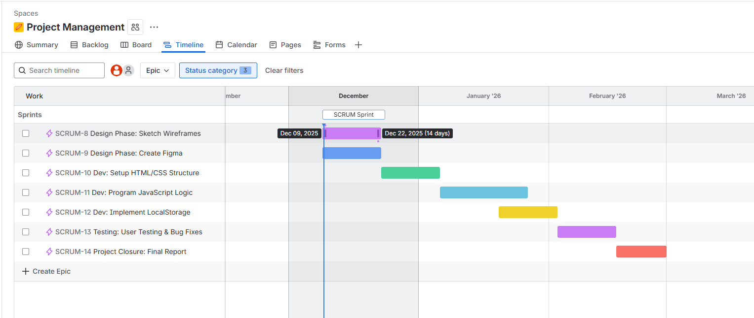

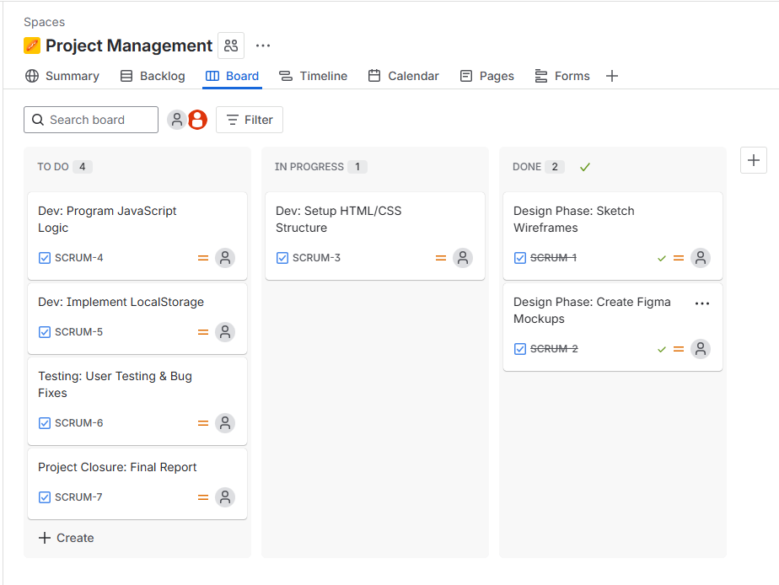

Development Methodology: Agile Scrum
I have selected the Agile Scrum methodology to manage the development lifecycle.
- Justification: Unlike a rigid "Waterfall" approach, Agile allows for flexibility. Given that "Nexus Student" requires user feedback (as discussed in the Assignment 1 research strategy), Agile enables me to work in 2-week "Sprints." This iterative approach allows for regular testing and refinement of features (e.g., the mood tracker) based on user input, reducing the risk of developing a product that doesn't meet student needs. [5]

Task 2: Enterprise

Selected Tech Company: Microsoft Corporation To understand the macro-environmental factors affecting the technology sector, I have conducted a PEST and SWOT analysis on Microsoft. This analysis highlights the legal and ethical considerations relevant to software development.

PEST Analysis (External Factors)
- Political: Microsoft faces increasing scrutiny regarding data privacy regulations (GDPR in Europe) and antitrust investigations. Trade tensions between the US and China also impact their hardware supply chain.
- Economic: The global shift to remote work and hybrid learning (post-pandemic) has surged the demand for cloud services (Azure) and productivity tools (Office 365), boosting revenue despite economic inflation.
- Social: There is a growing societal demand for "Digital Wellbeing" tools. Users are increasingly aware of burnout, pushing companies like Microsoft to integrate "Viva Insights" to monitor employee mental health.
- Technological: The rapid rise of Generative AI (integration of ChatGPT/CoPilot) is the primary driver of innovation, forcing Microsoft to invest heavily to stay ahead of Google. [6]
SWOT Analysis
Strengths (Internal) | Weaknesses (Internal)
Market Dominance: Windows and Office are standard in education/business. | Hardware Struggles: Surface devices struggle to compete with Apple.
Cloud Growth: Azure is a leading cloud platform. | Dependence on PC Market: Slowing PC sales impacts Windows revenue.
AI Integration: Strong partnership with OpenAI (ChatGPT). | Legacy Software: Older systems are vulnerable to security breaches.

Opportunities (External) | Threats (External)
EdTech Expansion: Growing market for digital education tools. | Cybersecurity Attacks: Increasing ransomware threats targeting big tech.
Gaming: Acquisition of Activision Blizzard expands metaverse potential. | Intense Competition: AWS (Amazon) and Google are fierce rivals in cloud/AI.

Legal & Ethical Considerations
- Ethical: Microsoft has committed to "Responsible AI," ensuring their AI algorithms do not propagate bias or discrimination.
- Legal: Compliance with global data protection laws (GDPR/CCPA) is critical. Breaches can lead to billions in fines and loss of user trust.
Q2. Start-up Identity (Name & Logo)

- Company Name: Nexus Digital Solutions Ltd.
While the app is called "Nexus Student," the company name "Nexus Digital Solutions" allows for future expansion into other software markets.
- Brand Logo:
The logo features a multi-dimensional constellation of nodes converging into a bright core, symbolizing the dynamic interconnection between Data, Infrastructure, and Intelligent Solutions. Colour Palette: It uses Electric Cyan (digital innovation) and Deep Blue (corporate stability and security).

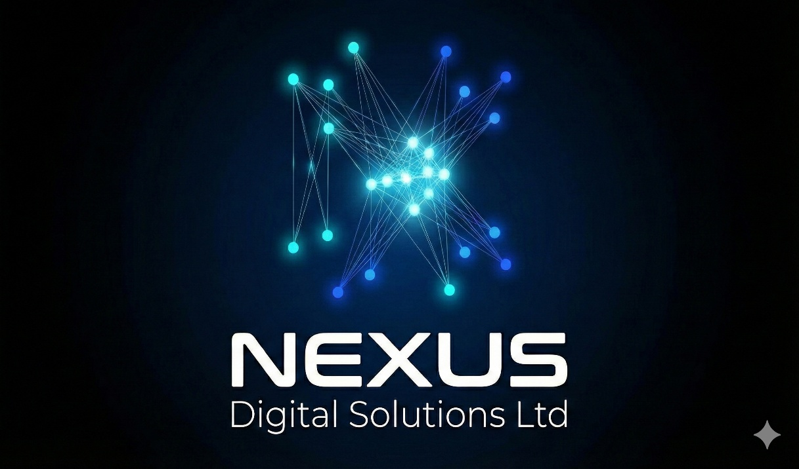

Business Type (Legal Classification) I have selected the legal structure of a Private Limited Company (Ltd) in the UK.
- Justification: Unlike a Sole Trader structure, a "Ltd" company creates a separate legal entity. This provides Limited Liability, meaning my personal assets (savings, car, etc.) are protected if the business faces debt or legal action. This structure also adds credibility when approaching universities for partnerships or investors. [7]
Business Strategy (The "Freemium" Model) The core business strategy is Product-Led Growth (PLG) using a "Freemium" revenue model:
- Free Tier: Basic calendar syncing and mood tracking. This maximizes user acquisition and data collection to improve the AI.
- Premium Tier (£2.99/month): Advanced features such as "AI Study Plan Generation," "Exam Stress Analytics," and "Ad-free experience."
- B2B Partnership: The long-term strategy is to sell licenses directly to universities, allowing them to offer the Premium version to all their students for free as part of their mental health support package.
Funding Initiatives To fund the initial development (Pre-Seed Stage), I will use the following initiatives:
- Bootstrapping: Initial costs (hosting, domain name) will be self-funded from personal savings to retain 100% equity.
- University Enterprise Grants: I will apply for student innovation grants such as the UWTSD Enterprise Fund or Innovate UK Young Innovators Awards, which offer non-repayable funding for student start-ups.
- Crowdfunding: A Kickstarter campaign targeting the student community to validate demand and raise funds for the initial MVP launch.

Project Reflection: Developing NEXUS Digital Solutions

Creating the concept and logo for NEXUS Digital Solutions has been an exciting process that sparked my interest in how technology connects different parts of an organization. However, looking at the complex network in the logo, I realize that turning this visual idea into a real, functioning project is a massive challenge. As a student beginning my journey in computing, I see this project not just as a business idea, but as a practical "sandbox" to apply what I am learning in class and to push myself to learn new skills that I don't have yet.

How I intend to use this opportunity to develop new skills Currently, I have some basic understanding of technology, but "Task 3" asks me to look forward. Taking NEXUS forward would force me to develop two main skill sets. First, I need to improve my Project Management skills. I tend to focus on the technical details, but a project like NEXUS requires organization. I intend to use this opportunity to learn about Agile methodologies. I have read that Agile helps break down big, scary projects into small, manageable tasks [5]. Practicing this would help me stop feeling overwhelmed by complex assignments. Second, I want to develop my technical skills in Database Management and Cloud Basics. The logo I designed represents a "core" of data. To build this, I need to move beyond theory and learn how databases interact with the cloud. I don't know how to build a secure cloud architecture yet, but this project would be the perfect motivation to take online courses or extra modules to understand how to store data centrally and securely.

Positive impact on society Reflecting on "Unit 2 Topic 4: Creating Value," I learned that value isn't just about profit; it's about helping people. If I can get NEXUS to work, even on a small scale, it could have a positive impact by simplifying technology for non-experts. Many local businesses or charities struggle with disorganized data. They waste time trying to find files or information. My project could help them become more efficient, saving them time that they can spend on their actual work—like helping their community—rather than fighting with computers. Additionally, in the long term, systems like NEXUS can contribute to sustainability. By helping organizations analyse their data better (like energy usage or supply chains), we can help them reduce waste. Even if my contribution is small, helping a business use fewer resources contributes to a greener society [8].

Risks and Challenges To be honest, there are several risks that worry me as I think about this project. The biggest risk is my own lack of technical experience (The "Knowledge Gap"). I might promise a feature—like "real-time data connection"—that is too difficult for me to code right now. This could lead to a project that looks good on paper but doesn't work in real life. To reduce this risk, I will need to be realistic. I should start with a "Minimum Viable Product" (MVP)—a very simple version of the software—and only add complex features once I have learned how to build them properly.

Another major challenge is Security. Centralizing data, as shown in my logo, makes it a target for hackers. Since I am not a security expert yet, there is a risk that I could accidentally leave "backdoors" open. To mitigate this, I need to prioritize security learning. Instead of trying to build my own security system from scratch (which would be risky), I should research and use established, industry-standard security protocols and perhaps seek mentorship from more experienced developers or teachers to review my work [9].

The NEXUS project is ambitious. It intimidates me a little, but it also excites me. It offers a clear path for me to move from a student who understands concepts to a professional who can build solutions. By focusing on learning Agile management and proper data handling, and by being honest about my current limitations regarding security and coding, I believe I can use this project to build a solid foundation for my future career.

Conclusion

Working on the NEXUS Digital Solutions project has been an eye-opening experience. It has shifted my perspective from simply "designing a logo" to understanding the complex machinery required to build a real-world digital business. While the risks of security and my current lack of technical expertise are real challenges, they also serve as a roadmap for my studies. By using this project as a guide to learn Agile management and secure cloud architecture, I am confident that I can turn these initial ideas into concrete professional skills that will serve me throughout my career.

References

[1] K. Salmela-Aro, "School burnout and engagement," European Journal of Developmental Psychology, vol. 14, no. 6, pp. 643-649, 2017.
[2] E. Ries, The Lean Startup: How Today's Entrepreneurs Use Continuous Innovation to Create Radically Successful Businesses. New York: Crown Business, 2011.
[3] J. Duckett, Web Design with HTML, CSS, JavaScript and jQuery Set. Indianapolis, IN: Wiley, 2014.
[4] C. Snyder, Paper Prototyping: The Fast and Easy Way to Design and Refine User Interfaces. San Francisco, CA: Morgan Kaufmann, 2003.
[5] K. Schwaber and J. Sutherland, The Scrum Guide: The Definitive Guide to Scrum: The Rules of the Game. Scrum.org, 2020. [Online]. Available: https://scrumguides.org/scrum-guide.html
[6] Microsoft Corporation, "Annual Report 2023: Earnings Release FY23 Q4," Microsoft Investor Relations, 2023. [Online]. Available: https://www.microsoft.com/investor
[7] Companies House, "Incorporation and names," GOV.UK, 2023. [Online]. Available: https://www.gov.uk/government/publications/incorporation-and-names
[8] M. U. G. Khan et al., "The Role of Big Data Analytics in Smart City Development," IEEE Access, vol. 8, pp. 1632-1645, 2020.
[9] Open Web Application Security Project (OWASP), "OWASP Top Ten Web Application Security Risks," OWASP Foundation, 2021. [Online]. Available: https://owasp.org/www-project-top-ten/

