
assignment 1 – dawid trochim
Worksheet 4

April 26, 2021
UWTSD
Cyber Security

Table of Contents
1. Introduction 2
2. How does it work? 20
3. Failover Clustering for high availability systems/services 20
4. Network policy 21
4.1 Network topology 21
4.2 Policies 21
4.3 Enforcement of security policies 22
4.4 Analysis of security risks 22
4.5 Monitoring the security operations 22
4.6 Mitigations in the event of violations 23
5. References 23

Introduction

This document is going to show routing and packet filtering within core tcp/ip services and critical failover/redundancy practices. It is also going to include screenshots just for evidence that it has been done correctly and also appropriate description of what is the screenshot representing.
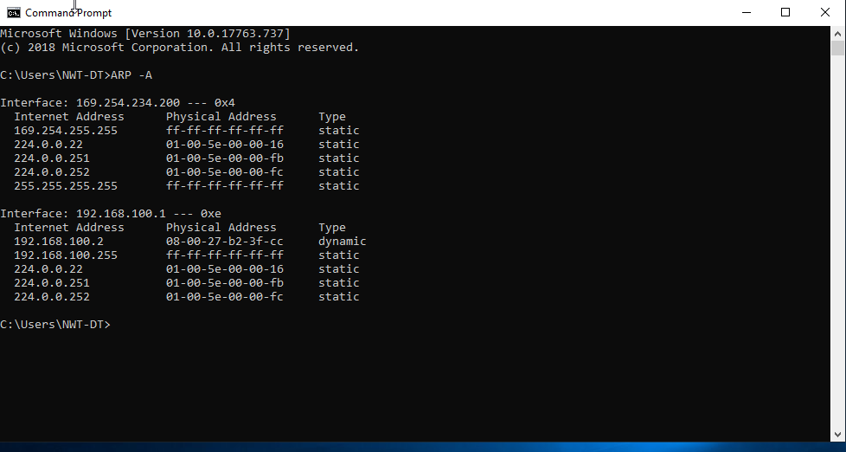

This screenshot shows a command prompt with two network interfaces and this is done thanks to the ARP -A command.

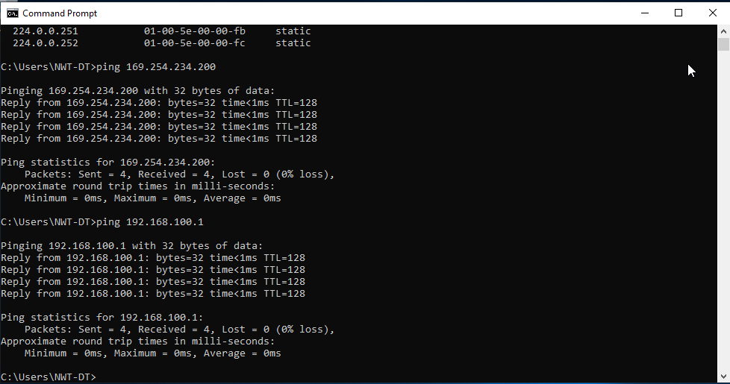

This screenshot shows that pinging two other hosts has been done successfully
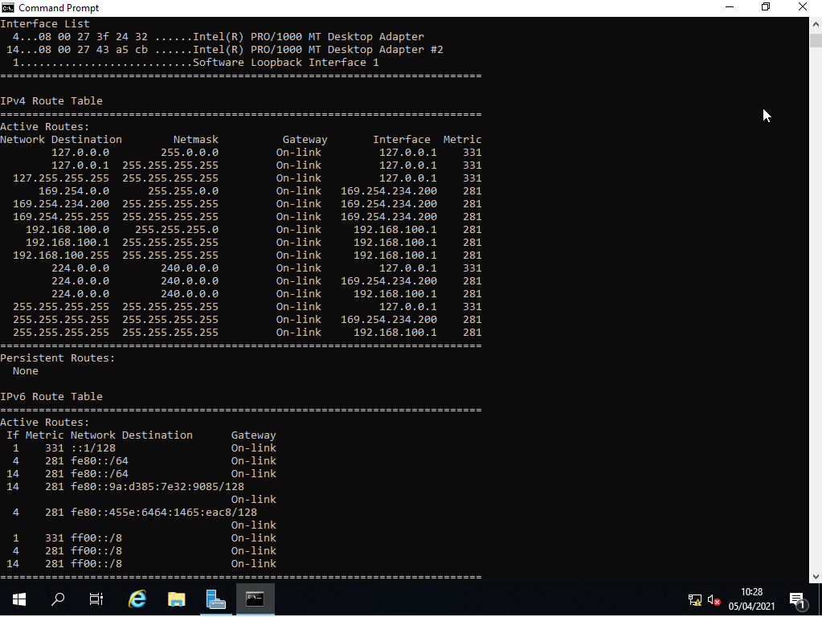
This screenshot shows a routing table, it contains interface list, active routes and persistent routes.

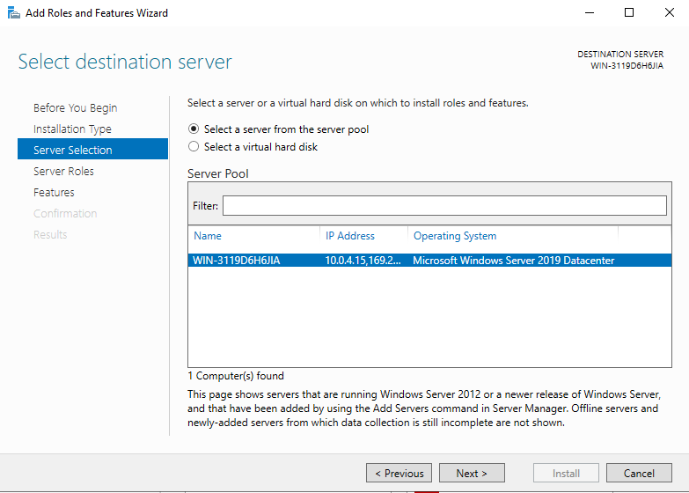

This screenshot shows that the ftp server is being configured and the server is selected
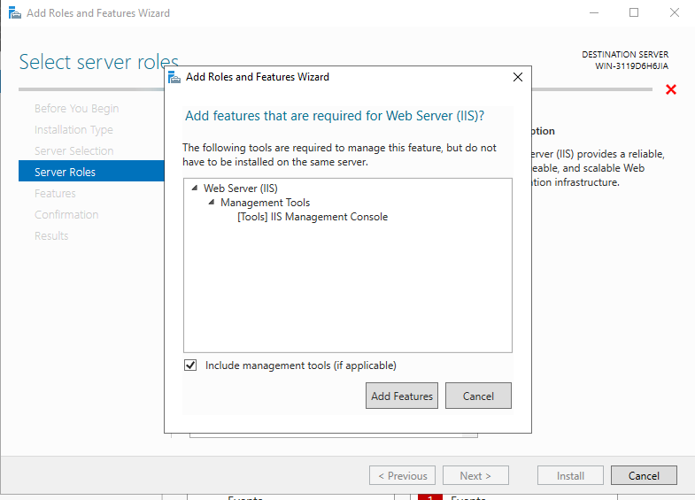
This screenshot shows that web server feature is about to be installed along with management tools

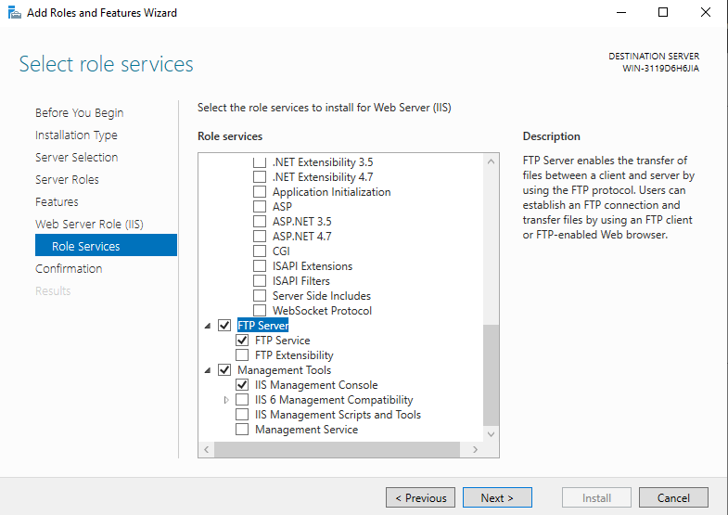

This screenshot shows that the FTP server and service has been selected in role services so it can be installed
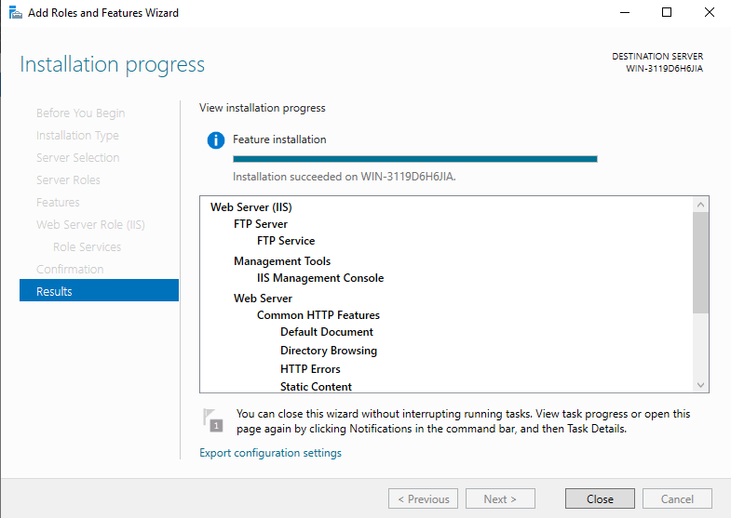
This screenshot shows that the FTP server has been successfully installed

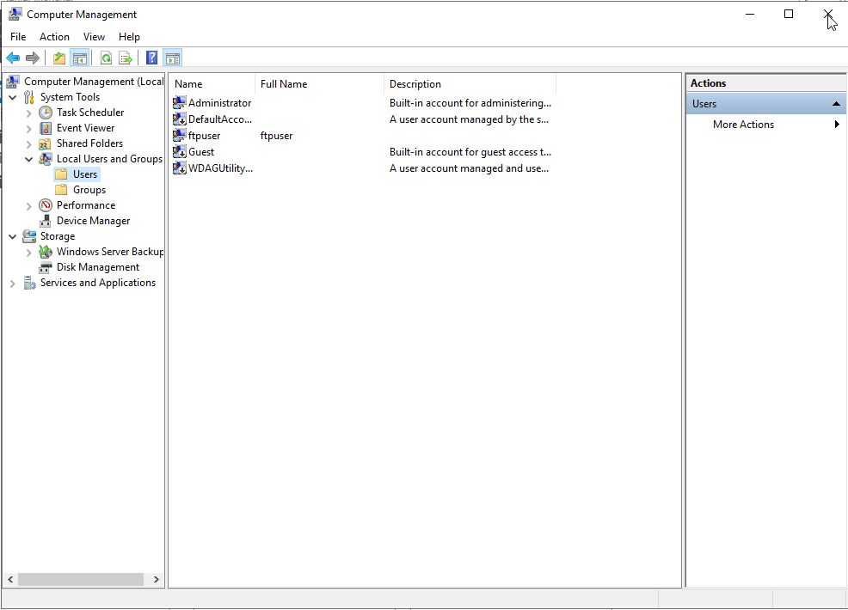
This screenshot shows that the local user “ftpuser” has been created inside the “users” folder
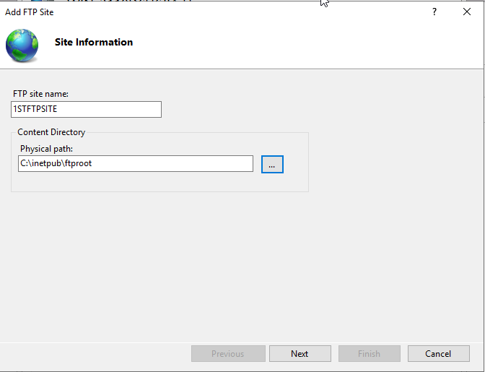

This screenshot shows that the FTP site name is being added

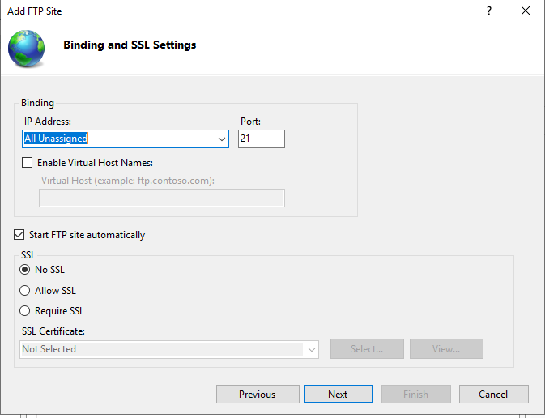

This screenshot shows that binding and ssl settings are configured properly
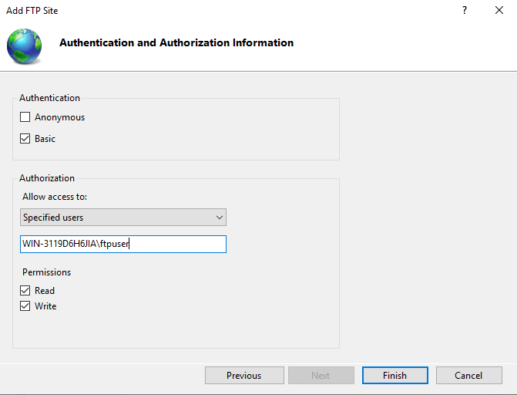

This screenshot shows that the FTP server is going to use basic authentication and also only specified user is authorised – WIN-3119D6H6JIA\ftpuser with read and write permissions

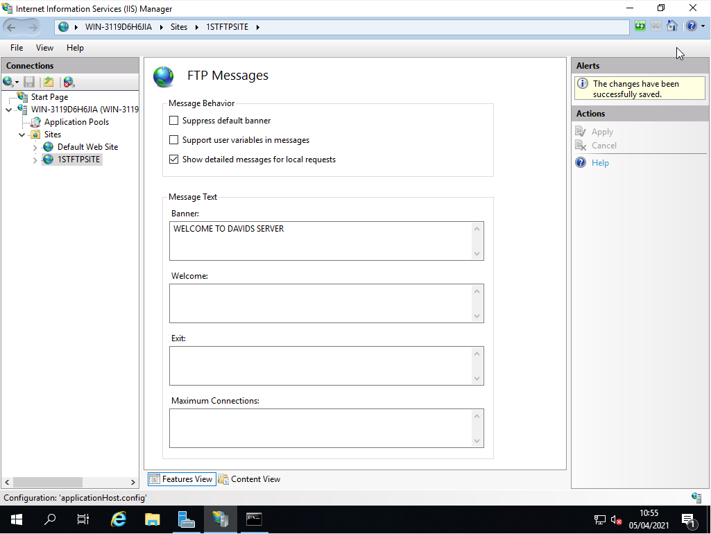

This screenshot shows that the banner has been changed and set manually to a custom one
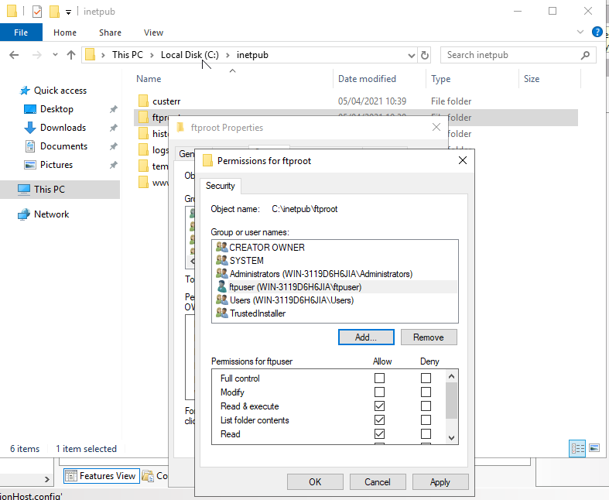

This screenshot shows that the ftpuser has been added to ftproot folder as a user with permissions

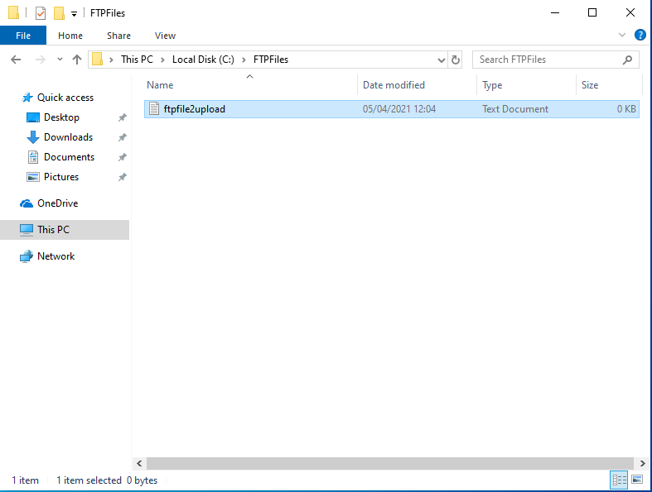

This screenshot shows that FTP file with a name of “ftpfile2upload”has been created inside “FTPFiles” folder to upload later on client 2
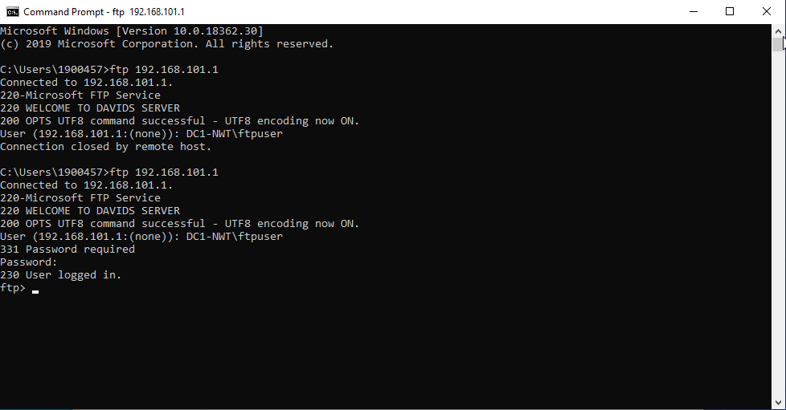
This screenshot shows that the attempt of accessing the FTP server has been successful and the user is logged in

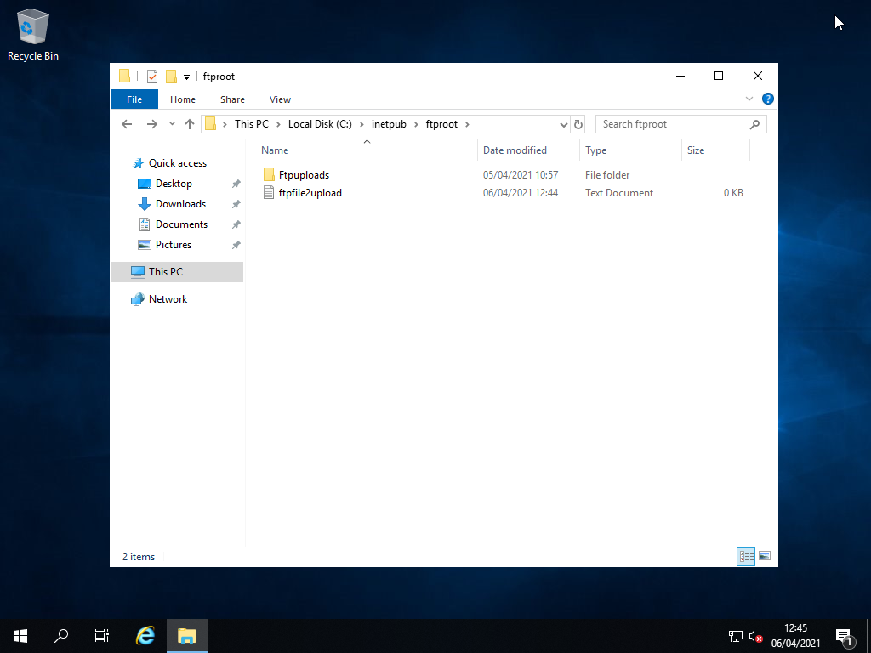
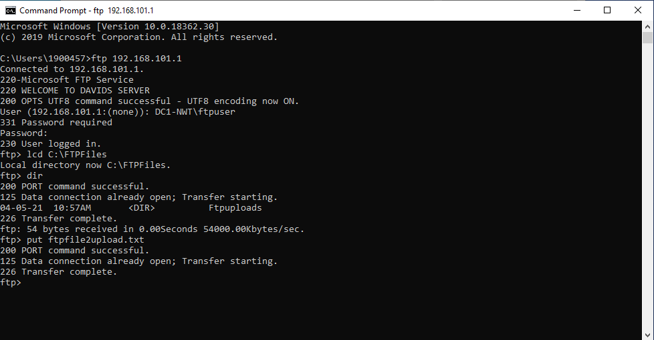
This screenshot shows that the user has accessed the directory and transferred a file through FTP
This screenshot shows that the file has been successfully transferred to a server through FTP services

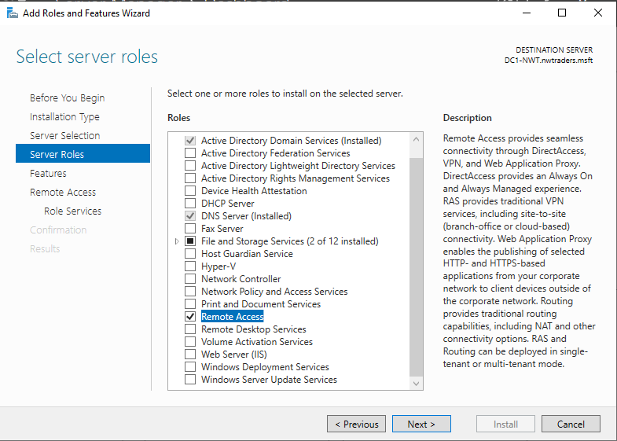

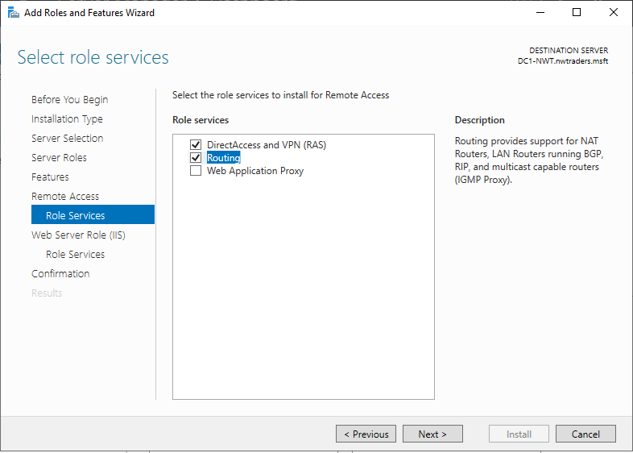
This screenshot shows that remote desktop services are about to be installed
This screenshot shows that routing and DirectAccess and VPN (RAS) will be installed

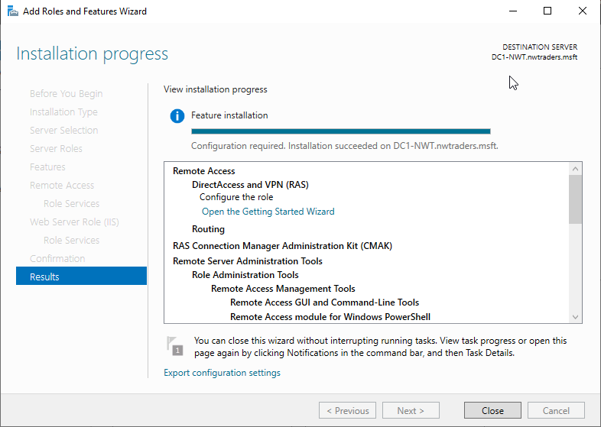

This screenshot shows that remote access services (direct access and vpn) were installed successfully along with RAS and routing.
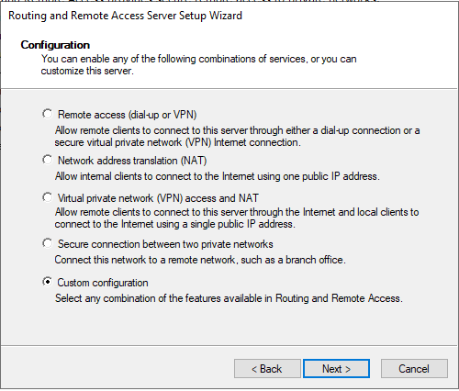

This screenshot shows that the RDP is being configured and custom configuration is going to be applied

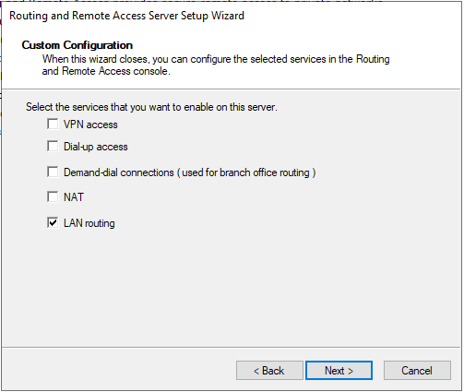

This screenshot shows that LAN routing is going to be enabled on the server
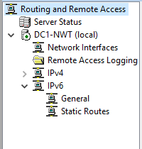

This screenshot shows that server DC1-NWT is up and running and also configured successfully

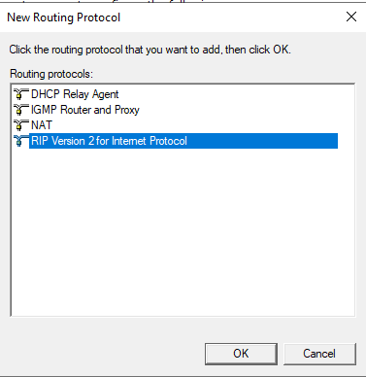

This screenshot shows that a new routing protocol “RIP Version 2 for Internet Protocol” is being added
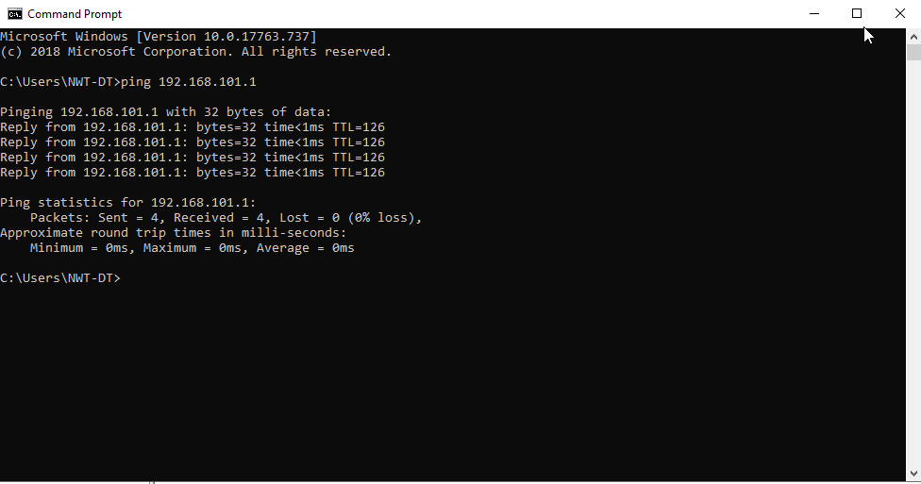

This screenshot shows that pinging server 2 PublicNet IP address is successful

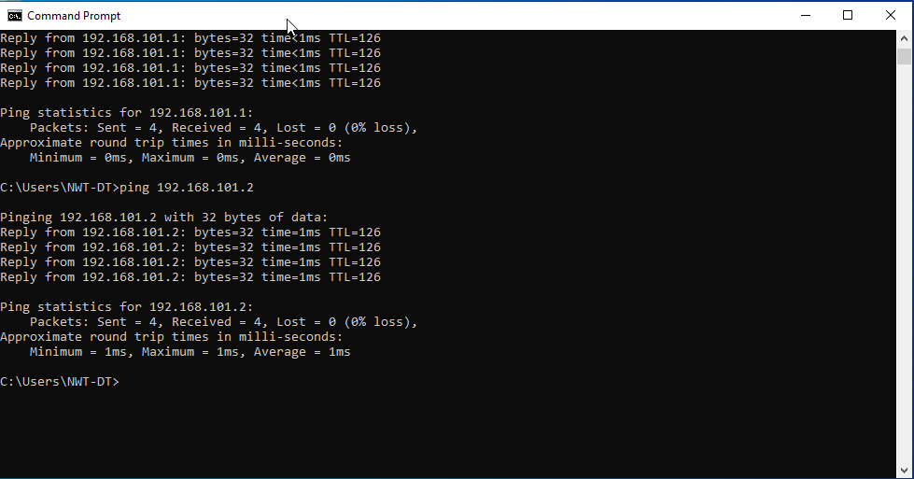
This screenshot shows that pinging client 2 from client 1 has been successful
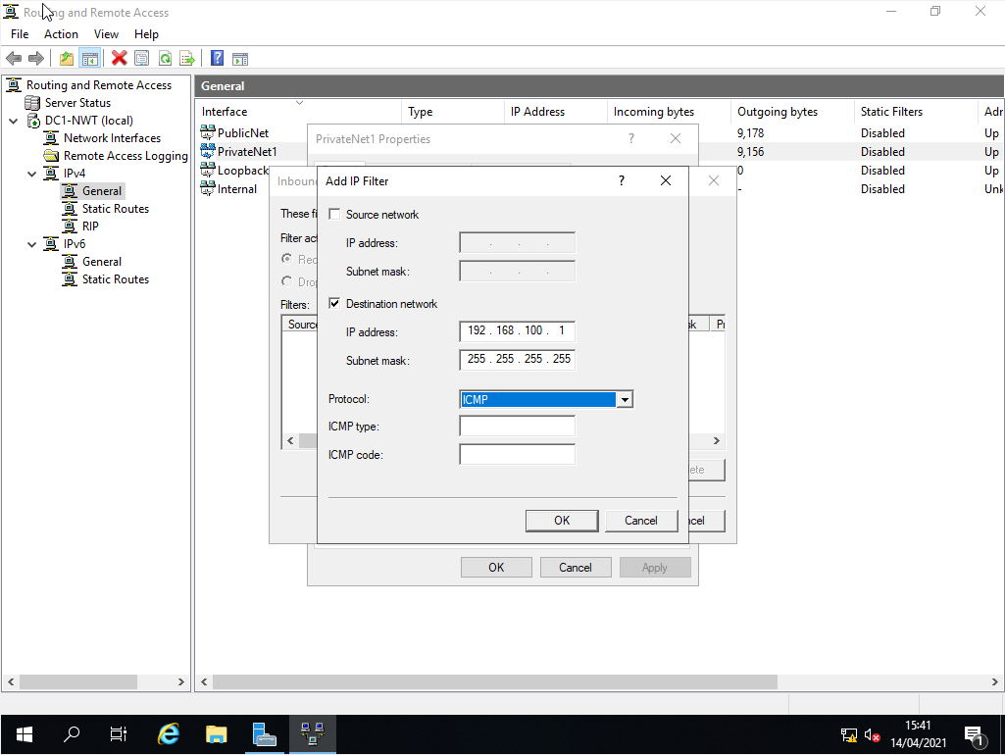
This screenshot shows that the IP filter on PrivateNet1 on server 1 is being added through Routing and Remote Access

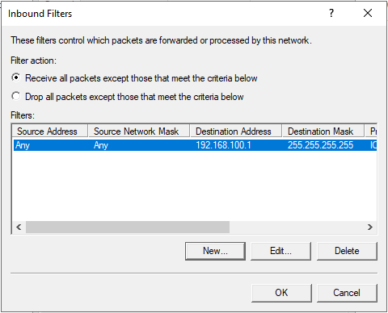

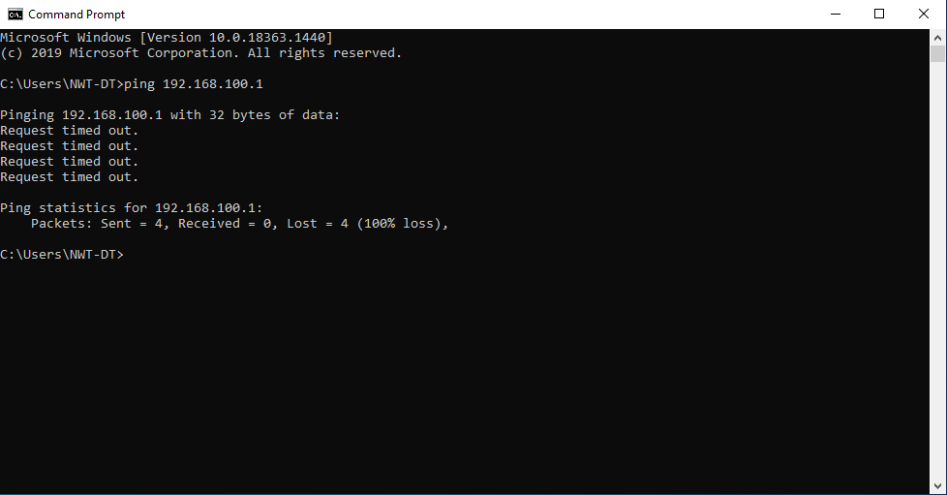
This screenshot shows that the IP filter has been installed successfully
This screenshot shows that the IP filter works and the ping is not being received

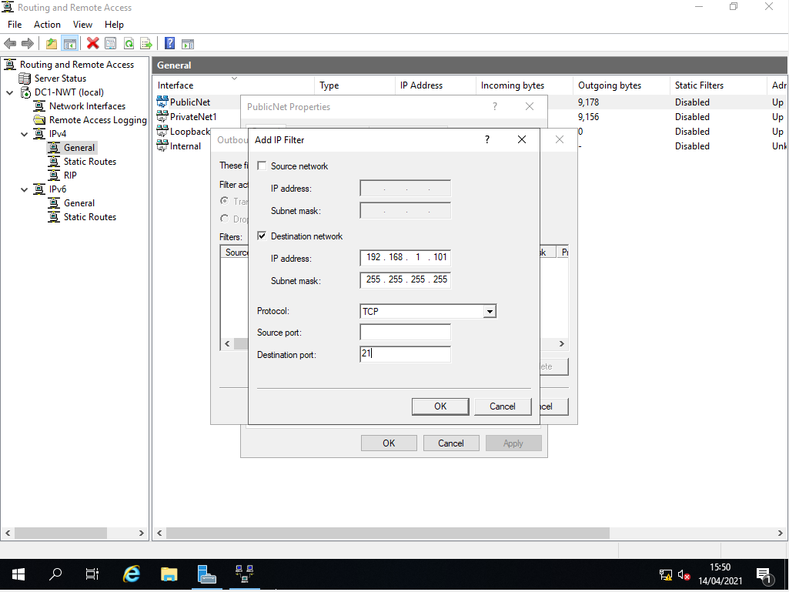

This screenshot shows adding outbound filter on server 2 on PublicNet
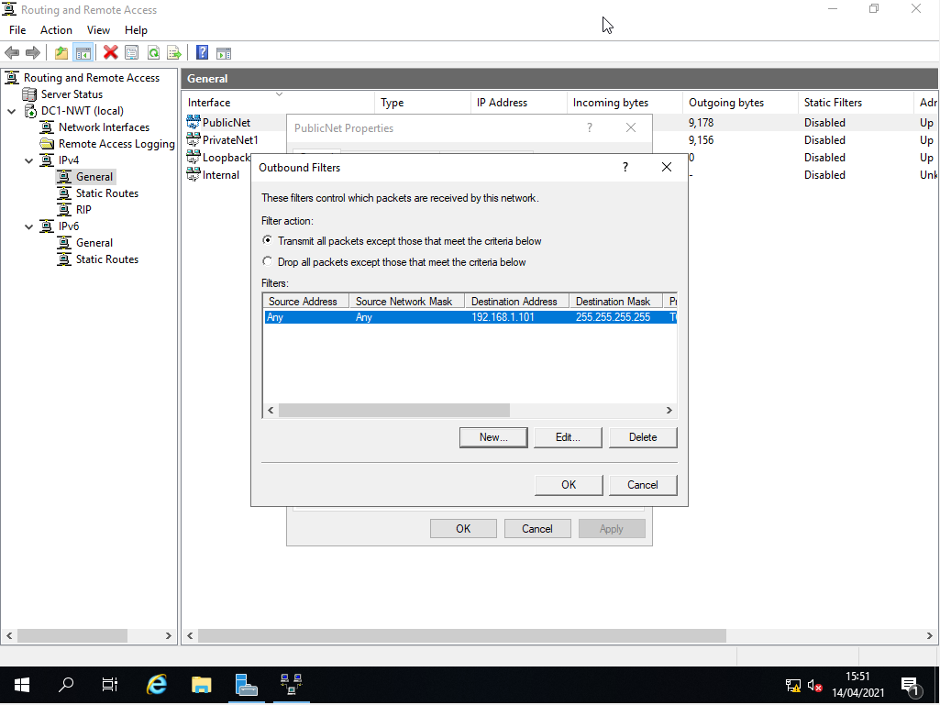

This screenshot shows that outbound filter has been successfully installed

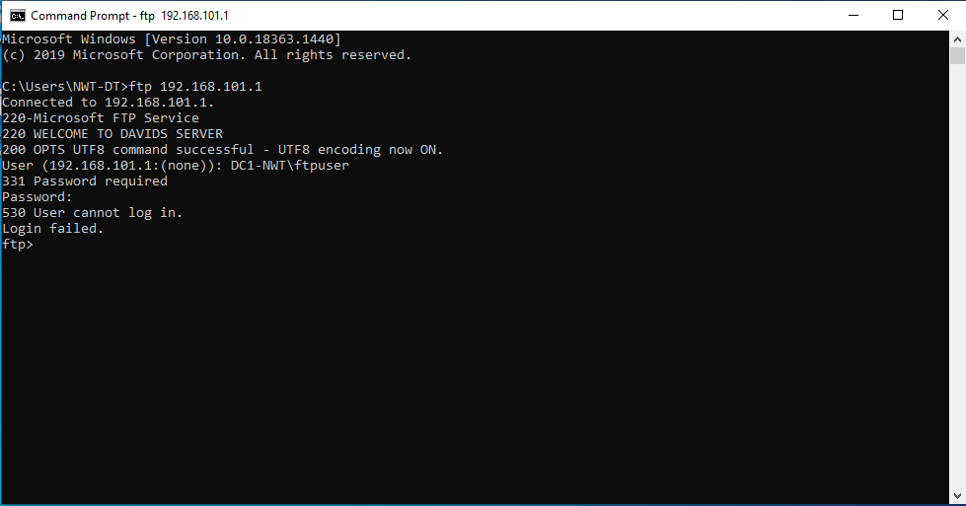
This screenshot shows that outbound filter works on FTP and prevents user from getting in

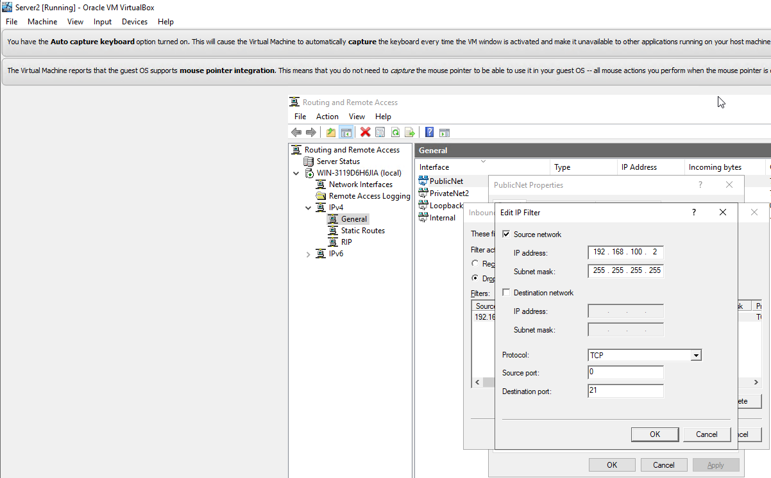
This screenshot shows the process of installing an inbound filter to drop all packets except those that meet the criteria below and restrict FTP access to everyone except client 1

How does it work?

The rule was set up on server 2 PublicNet, it works as an inbound filter and drops all packets except those that meet criteria above (screenshot above) with the IP 192.168.100.2 which is client 1. So any incoming packets from server 1, server 2 and client 2 are going to be dropped.

Failover Clustering for high availability systems/services

Failover clustering usually consists of two types, computer one which is the main one and work on daily basis and a second one which is failover computer and this computer works when the main computers fails to perform. High availability clusters are commonly used to backup, balance the load and for failover purposes. In order to properly configure HA cluster, all the computers which are called hosts need to have to the same drive which is shared. This is going to let VMs on a certain host to pass the failure which is failover to a different host without causing any disruptions in the system. Failover clustering is going to work if the service is a mediator for the server and the client and also if the architecture is in 3rd tier. In a high availability cluster there are many servers constantly running to provide the service to the customers, if any interruption occurs then all the work is being transferred onto the backup server. The things that need careful consideration when using a system like that is definitely a shared drive because all hosts need to have an access to the same share drive and also servers, if one server fails then the backup one takes over and performs tasks, network adapters, fibre channel, a processor that supports Hyper-V [1]. One possible role within the Windows Server OS environment that could provision these requirements is Active Directory (AD) and there are many roles such as DNS server, DHCP server etc. but (AD) is the most important because it is responsible for managing authentication of any hardware, device or a user that is currently on the network or tries to get an access, it is also putting all the policies in place and enforcing them on every hardware, device and a user. It behaves comparable to a heart, it would not work without it. Many companies and organisations are creating a redundant domain controller and this is done if one of the servers on which Active Directory is operating goes down. [2]
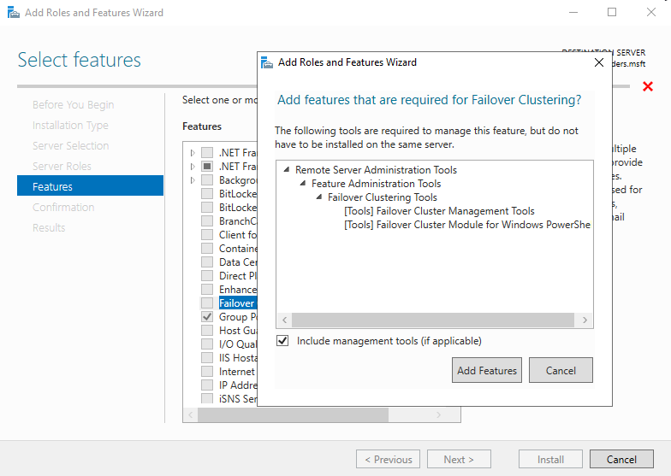

This screenshot shows the process of adding failover clustering

Network policy

4.1 Network topology

The size of the network is massive and operates in multiple locations nationwide. That’s why star topology is the best solution. The reason why it’s the best is because the software which is responsible for managing the network only needs to communicate with the switch / hub or a computer. It is also easy to add another computer to the network considering the size of the network and needs of constantly adding different machines. A massive nationwide network cannot let simple failures such as a computer failure to disrupt the whole network from functioning properly, star network will keep working as usual even if something fails. [3]
Security team is responsible for keeping the data safe. Security teams consists of key roles and responsibilities, every person should be responsible for different aspect of security. There should be different people that manage user access controls and who is accessing the network.
Most common roles:
- CISO (Chief Information Security Officer)
- Security specialist
- Cryptographer
- Security Software Developer
- Security Engineer
- Security manager [4] [5]

4.2 Policies

The policies that will be there and are essential:
- Acceptable Use Policy – Allows people to do their job with the right access to the right files, it prevents them from doing anything that is illegal by the law and banned by the employer. It states what won’t be acceptable on the network.
- Back-Up Policy – This policy states how often the backups should be made, how it will be stored, tested.
- Password policy – Will require user to set a password that meets complexity requirements such as:
Min Length: 10 characters
Needs to contain special characters
Needs to have an uppercase character
- Failover policy – This policy states what hardware and devices are going to be used and set up when a disaster happens and the main device fails.
[6]

4.3 Enforcement of security policies

Enforcement of security policies has 2 types – detecting if the policy has been violated and taking action if the policy has been violated. Policies won’t be effective if there is no enforcement, e.g., password policy is going to be enforced by setting a minimum complexity requirements, the user will be prevented from setting a password if it is too weak. Another example could be where the user is trying to access an application that should not be accessed, a simple warning error could be shown to inform the user that this application should not be accessed. This will not stop the user from accessing the application, however an effective solution would be manually deleting and removing applications that shouldn’t be accessed. [7] [8] [9]

4.4 Analysis of security risks

Analysis of security risks is risk assessment in other words, this is a way of identifying potential risks to the network and also providing a solution to these problems, there are many potential risks that can happen to the network. IT industry has faced a wide variety of potential risks but no one can ever be sure when a new risk appears, this would be a challenge for IT Technicians. However, there are some most common security risks that can occur on daily basis:
- DoS – This can be solved by having a properly configured server, hosts and the firewall which is the main source of defence since it is blocking connections that are coming in and the ones that are going out. Blocking ports that are open could also help.
- Misuse of data and information – This can be treated by punishing the employee and revoking some rights and permissions to certain information.
- Leaked data – This can be treated by carrying out an investigation to find out how the data was leaked and who did it.
- Losing data – This can be treated by introducing a backup policy which is going to require to make regular backups.
- Getting unauthorised access – This can be treated by improving overall security of the network, blocking certain connections, restricting employees from accessing certain information.
- Malware – This can be treated by installing antimalware software.
[10] [11]

4.5 Monitoring the security operations

The changes that could be made to the risk assessment is just adding more types of risks that can happen and train employees what to do when one of them occurs. There could be more policies added to the policies mentioned above and also monitoring tools such as SolarWinds which isn’t free. The policies and risk assessment should be given out in both forms – paper form and also sent through and email so the employee can access both of them at any time. The employer should also make sure that every single employee has signed both forms of risk assessment and also policies. These two documents are invalid unless signed.

4.6 Mitigations in the event of violations

Mitigation in the event of violations means the steps that need to be taken when something was violated. It can by anything such as financial punishment, a simple verbal warning or even firing someone. The steps that are going to be taken if something was violated depends on the priority and importance of the violation e.g. an employee accidentally leaked some sensitive information. It could be removing certain employees from accessing information or creating another policy. An employee that validated a policy would have their permissions revoked unless it has been proven that the mistake was made on accident and not on purpose. If something has been violated and the company lost money and reputation because of that then the employee is going to be responsible for paying for the damage. [12]

References

[1] | M. P. D. P. V. D. P. D. S. Nilesh V. Patil, “Failover clustering,” COST EFFECTIVE FAILOVER CLUSTERING, vol. 3, pp. 218-219, 2014.
[2] | A. G. L.-N. Robbie Allen, “Role within Windows OS,” in Active Directory, O'Reilly Media, 2003, pp. 292-294.
[3] | S. S. Nivedita Bisht, “Star topology,” ANALYTICAL STUDY OF DIFFERENT NETWORK TOPOLOGIES, vol. 2, no. 1, pp. 1-2, 2015.
[4] | L. O. Tom Karygiannis, “Security team,” Wireless Network Security 802.11, Bluetooth and Handheld Devices, pp. 3-23 - 3-25, 2002.
[5] | The George Washington University, “Cybersecurity Roles and Job Titles,” [Online]. Available: https://www.cs.seas.gwu.edu/cybersecurity-roles-and-job-titles. [Accessed 27 April 2021].
[6] | Texas Wesleyan University, “Network-Protection-and-Info-Security-Policy,” [Online]. Available: https://txwes.edu/media/twu/content-assets/documents/it/Network-Protection-and-Info-Security-Policy.pdf. [Accessed 29 April 2021].
[7] | J. David, “Enforcement of security policies,” Policy enforcement in the workplace, vol. 21, no. 6, pp. 506-513, 2002.
[8] | T. Norman, “Enforcement of security policies,” Integrated Security Systems Design (Second Edition), 2014.
[9] | R. J. Anita K.Jones, “Enforcement of security policies,” The enforcement of security policies for computation, vol. 17, no. 1, pp. 35-55, 1978.
[10] | D. J. Landoll, “Risk assessment,” in Security Risk Assessment Handbook A Complete Guide for Performing Security Risk Assessments, CRC Press, 2005, pp. 6-12.
[11] | B. Metivier, “6 Steps to a Cybersecurity Risk Assessment,” [Online]. Available: https://www.tylercybersecurity.com/blog/6-steps-to-a-cybersecurity-risk-assessment. [Accessed 28 April 2021].
[12] | C. V. S. B. F. Sahar Farshadkhah, “Mitigations in the event of violations,” Onlooker effect and affective responses in information security violation mitigation, vol. 100, 2021.

