ACCOUNTING
FUNDAMENTALS
Table of Contents
INTRODUCTION 1
TASK 1 1
(a) Ledger accounts of Maxim 1
(b) Trial balance of Maxim 3
(c) Final Statements of maxim 4
TASK 2 5
(a) Ledgers accounts of Pendo 5
(b) Trial balance of Pendo 6
(c) Income statement of Pendo 7
TASK 3 8
(a) Ledger accounts of Mafuta 8
(b) Trial balance of Mafuta 10
TASK 4 11
(a) Ledger accounts of Ricardo 11
(b) Trial balance of Ricardo 14
TASK 5 14
CONCLUSION 16
REFERENCES 17

INTRODUCTION
Accounting fundamentals are using as tool by every company for accounting activities. (Joseph and Renardy, 2013). With the help of these tools solve complex terms that are occur in business when recorded transactions. Advanced accounting totally depended on the fundamental equation that described all business's success and failure. These fundamentals are helping to deal with particular financial function of business. This report consist of analysis of ledger accounts, income statement and financial position statement of each company. Evaluation distinction between revenue expenditure and capital expenditure as per international accounting standard is also performed in this report.

TASK 1

(a) Ledger accounts of Maxim
Accounting terms are firstly recorded in journal account as entries than these entries are recorded in ledger accounts. These accounts are helping to maintain all component that are connected to financial statements (Niroomandi, et. Al, 2012). Financial information are stored in ledger account and presenting opening balance and closing balance of each account during accounting period. Single transactions are identified with in a ledger account with a transaction number. Ledger accounts are divided into two parts according to financial statements these are income statement ledger account and balance sheet ledger account.

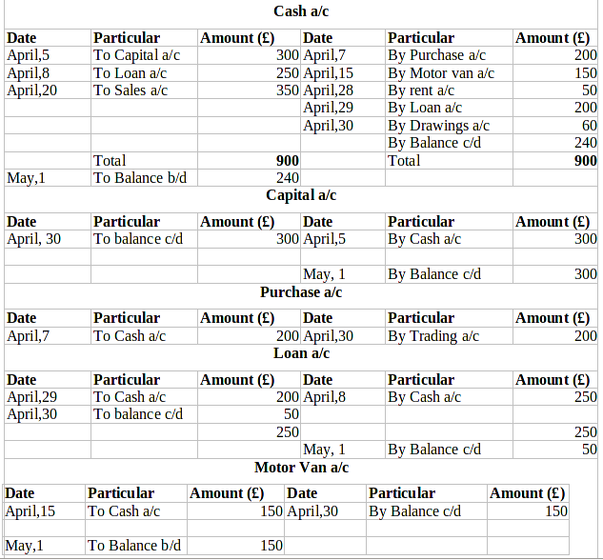Rent a/c
Date | Particular | Amount (£) | Date | Particular | Amount (£)
April,28 | To cash a/c | 50 | April,30 | By profit & loss a/c | 50
Drawings a/c
Date | Particular | Amount (£) | Date | Particular | Amount (£)
April, 30 | To Cash a/c | 60
Sales a/c
Date | Particular | Amount (£) | Date | Particular | Amount (£)
April,30 | By Trading a/c | 350 | April,20 | To cash a/c | 350

(b) Trial balance of Maxim
List of accounts balances at April,30
Particulars | Debit (£) | Credit (£)
Cash A/c | 240
Capital a/c |  | 300
Purchase a/c | 200
Loan a/c |  | 50
Motor van a/c | 150
Rent a/c | 50
Sales a/c |  | 350
Drawings a/c | 60
Total | 700 | 700

Interpretation – As per the above trial balance accounts are recorded from journal book. After journal entries these transactions are recorded in trial balance as end balance of these accounts such as cash a/c shows on debit side with amount £240, capital account £300 (credit), purchase account £200 (debit), Loan account £50 (credit), Motor van account £150 (debit), Rent account £50 (debit), Sales account £350, drawings account £60 (debit).

(c) Final Statements of maxim
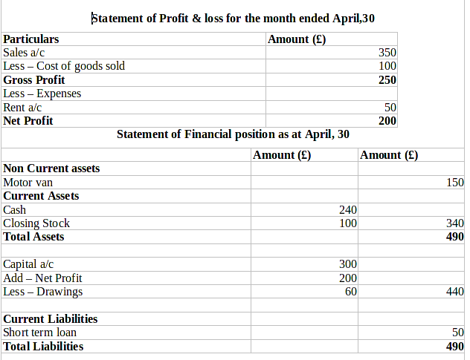
Working Note -
Cost of Sales = Opening balance + Purchase + direct expenses – Closing balance
= 0 + 200 + 0 – 100
= 100
Interpretation – As per the above table for getting net profit prepare statement of profit and loss. There is gross profit 250£ and net profit 200£ and it is shows good position of the company. Statement of financial position through know financial position of the company and

TASK 2

(a) Ledgers accounts of Pendo
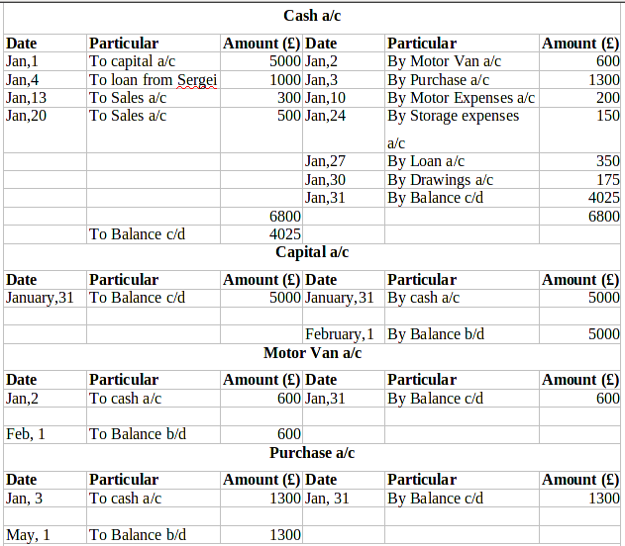
Loan from Sergei a/c
Date | Particular | Amount (£) | Date | Particular | Amount (£)
Jan, 27 | To cash a/c | 350 | Jan, 4 | By cash a/c | 1000
Jan, 31 | To Balance c/d | 650
 |  | 1000 |  |  | 1000
 |  |  | Feb, 1 | By Balance b/d | 650
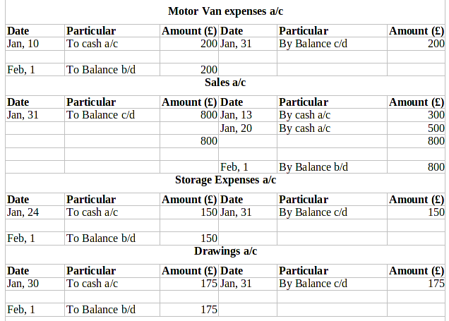

(b) Trial balance of Pendo
Trial Balance at 31 January
Particulars | Debit (£) | Credit (£)
Cash a/c | 4025
Capital a/c |  | 5000
Motor van a/c | 600
Purchase a/c | 1300
Loan from Sergei a/c |  | 650
Motor van expenses a/c | 200
Sales a/c |  | 800
Storage expenses a/c | 150
Drawings a/c | 175
 | 6450 | 6450
Interpretation – As per the above table there are presents all closing balances of the various accounts these are as follows – Cash account £4025 (debit), capital account £5000 (credit), motor van account £600 (debit), purchase account £1300 (debit), Loan account £650 (credit), motor van expenses account £200 (debit), sales account £800 (credit), storage expenses account £150 (debit), and drawings account £175 (debit).

(c) Income statement of Pendo
The profit & loss statement is one of the important financial statement that help to know profit and loss of the company for particular accounting period. The profit & loss is calculated by tracking all incomes and expenses from operating and non operating activities. Income statement applied by all corporate sector for finance and accounting. This statement present company's costs, incomes, gross profit, selling and administrative expenses, tax paid, net profit in a logical manner (Demski, 2013).
In comparison it represent what occur over a month, quarter or year. It is mainly supported on a fundamental accounting equation ( income = Revenues – Expenses) and shows the rate at which the owners equity is changing for better or worse. With the help of cash flow statement and balance sheet it forms the basic set of financial information required to manage to manage of business (Newville, 2014).
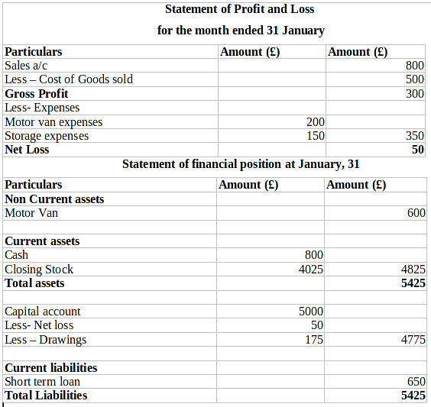

TASK 3

(a) Ledger accounts of Mafuta
Cash a/c
Date | Particular | Amount (£) | Date | Particular | Amount (£)
Jan, 1 | To Balance b/d | 343 | Jan, 5 | By Wages a/c | 12
Jan, 7 | To Smith's a/c | 18 | Jan, 9 | By Max's a/c | 21
Jan, 11 | To Sales a/c | 64 | Jan, 14 | By Wages a/c | 14
Jan, 21 | To Sales a/c | 110 | Jan, 14 | By Purchases a/c | 75
Jan, 23 | To Harvey's a/c | 25 | Jan, 15 | By Rich's a/c | 162
Jan, 28 | To Sales a/c | 84 | Jan, 20 | By Fixtures and fittings a/c | 32
Jan, 31 | To Sales a/c | 31 | Jan, 21 | By Wages a/c | 17
 |  |  | Jan, 23 | By office expenses a/c | 3
 |  |  | Jan, 28 | By Wages a/c | 15
 |  |  | Jan, 31 | By Balance c/d | 323
 |  | 674 |  |  | 674
Feb, 1 | To Balance b/d | 323
Capital a/c
Date | Particular | Amount (£) | Date | Particular | Amount (£)
Jan, 1 | To Payables | 33 | Jan, 1 | By Cash in hand a/c | 343
Jan, 31 | To balance c/d | 1049 |  | By Inventory | 458
 |  |  |  | By Furniture and fittings | 198
 |  |  |  | By Receivables | 83
 |  | 1082 |  |  | 1082
Fixtures and fittings a/c
Date | Particular | Amount (£) | Date | Particular | Amount (£)
Jan, 1 | To Balance b/d | 198 | Jan, 31 | By Balance c/d | 230
Jan, 20 | To cash a/c | 32
 |  | 230 |  |  | 230
Feb, 1 | To Balance b/d | 230
Sales a/c
Date | Particular | Amount (£) | Date | Particular | Amount (£)
Jan, 31 | To Trading a/c | 412 | Jan, 2 | By Harvey's a/c | 124
 |  |  | Jan, 11 | By Cash a/c | 64
 |  |  | Jan, 21 | By Cash a/c | 110
 |  |  | Jan, 28 | By Cash a/c | 84
 |  |  | Jan, 31 | By Cash a/c | 30
 |  | 412 |  |  | 412
Wages a/c
Date | Particular | Amount (£) | Date | Particular | Amount (£)
Jan, 5 | To cash a/c | 12 | Jan, 31 | Profit and loss a/c | 58
Jan, 14 | To cash a/c | 14
Jan, 21 | To cash a/c | 17
Jan, 28 | To cash a/c | 15
 |  | 58 |  |  | 58
Purchase a/c
Date | Particular | Amount (£) | Date | Particular | Amount (£)
Jan, 5 | To Rich's a/c | 150 | Jan, 31 | By Trading a/c | 225
Jan, 14 | To cash a/c | 75
 |  | 225 |  |  | 225
Office Expenses a/c
Date | Particular | Amount (£) | Date | Particular | Amount (£)
Jan, 23 | To cash a/c | 3 | Jan, 31 | Profit and loss a/c | 3
Receivables from Smith's a/c
Date | Particular | Amount (£) | Date | Particular | Amount (£)
Jan,1 | To Balance b/d | 18 | Jan, 7 | By Cash a/c | 18
Receivables from Harvey's a/c
Date | Particular | Amount (£) | Date | Particular | Amount (£)
Jan, 1 | To Balance b/d | 39 | Jan, 23 | By Cash a/c | 25
Jan, 2 | To Sales a/c | 124 | Jan, 31 | By Balance c/d | 138
 |  | 163 |  |  | 163
Feb, 1 | To Balance b/d | 138
Receivables from Moon's a/c
Date | Particular | Amount (£) | Date | Particular | Amount (£)
Jan, 1 | To Balance b/d | 26 | Jan, 31 | By Balance c/d | 26
Feb, 1 | To Balance b/d | 26
Payable to Rich's a/c
Date | Particular | Amount (£) | Date | Particular | Amount (£)
Jan, 15 | To cash a/c | 162 | Jan, 1 | By Balance b/d | 12
 |  |  | Jan, 5 | By purchase a/c | 150
 |  | 162 |  |  | 162
Payable to Max's a/c
Date | Particular | Amount (£) | Date | Particular | Amount (£)
Jan, 9 | To cash a/c | 21 | Jan, 1 | By Balance b/d | 21
Inventory a/c
Date | Particular | Amount (£) | Date | Particular | Amount (£)
Jan, 1 | To Balance b/d | 458 | Jan, 31 | By Trading a/c | 458
Jan, 31 | To Trading a/c | 374 | Jan, 31 | By Balance c/d | 374
Feb, 1 | To Balance b/d | 374

(b) Trial balance of Mafuta
Trial Balance at 31 January
Particulars | Debit (£) | Credit (£)
Cash in hand a/c | 323
Capital a/c |  | 1049
Fixtures and fittings a/c | 230
Sales a/c |  | 412
Wages a/c | 58
Purchase a/c | 225
Office expenses a/c | 3
Receivables a/c
Harvey | 138
Moon | 26
Inventory a/c | 458
 | 1461 | 1461

(c) Financial position statement of Mafuta
It is ending procedure of financial statement that represent of financial position of the company. It is also known as balance sheet and it reports an entity's assets, liabilities and the difference in their totals (Aizenman, Jinjarak and Park, 2016). It is more meaningful when it is prepared under the accrual method of accounting. The balance sheet record the business accounting information on last day of financial year.
Statement of Profit and Loss
For the month ended 31 January
Particulars |  | Amount (£)
Sales |  | 412
Less- Cost of goods sold |  | 309
Gross profit |  | 103
Less – Expenses
Wages | 58
Office Expenses | 3 | 61
Net Profit |  | 42
Statement of Financial position at 31 January
Particulars |  | Amount (£)
Non current assets
Fixtures and fittings |  | 230
Current assets
Inventory | 374
Trade receivables (138+26) | 164
Cash | 323 | 861
Total Assets |  | 1091
Capital account | 1049
Add – Net Profit | 42 | 1091
Total Liabilities |  | 1091

Working Note – Cost of goods sold = Opening inventories + Purchase – Closing stock
= 458 + 225 – 374 = 309

TASK 4

(a) Ledger accounts of Ricardo
Sales a/c
Date | Particular | Amount (£) | Date | Particular | Amount (£)
Jun, 27 | To Trading a/c | 28500 | Jun, 2 | By Claire – Receivable a/c | 8500
 |  |  | Jun, 14 | By Hywel – Receivable a/c | 9000
 |  |  | Jun, 20 | By Cash a/c | 6000
 |  |  | Jun, 24 | By Mandy – Receivable a/c | 5000
 |  | 28500 |  |  | 28500
Sales Returns a/c
Date | Particular | Amount (£) | Date | Particular | Amount (£)
Jun, 22 | To Claire – Receivables | 1000 | Jun, 27 | By Trading a/c | 1000
Purchase a/c
Date | Particular | Amount (£) | Date | Particular | Amount (£)
Jun, 13 | To Georgina – Payable a/c | 12000 | Jun, 27 | By Trading a/c | 16500
Jun, 21 | To Andrew – Payable a/c | 4500
 |  | 16500 |  |  | 16500
Cash a/c
Date | Particular | Amount (£) | Date | Particular | Amount (£)
Jun, 20 | To Sales a/c | 6000 | Jun, 25 | By Georgina – Payable a/c | 11160
Jun, 24 | To Claire – Receivable | 7125 | Jun, 27 | By Andrew – Payable a/c | 4410
Jun, 25 | To Hywel – Receivables | 9000 | Jun, 27 | By Balance c/d | 6555
 |  | 22125 |  |  | 22125
 | To Balance b/d | 6555
Discount allowed a/c
Date | Particular | Amount (£) | Date | Particular | Amount (£)
Jun,24 | To Claire – Receivable | 375 | Jun, 27 | By Profit and loss a/c | 375
Discount received a/c
Date | Particular | Amount (£) | Date | Particular | Amount (£)
Jun, 27 | To Profit & loss a/c | 930 | Jun, 25 | By Georgina – Payable a/c | 840
 |  |  | Jun, 27 | By Andrew – Payable a/c | 90
 |  | 930 |  |  | 930
Claire – receivable a/c
Date | Particular | Amount (£) | Date | Particular | Amount (£)
Jun, 2 | To Sales a/c | 8500 | Jun, 22 | By Sales return a/c | 1000
 |  |  | Jun, 24 | By Cash a/c | 7125
 |  |  | Jun, 24 | By Discount allowed a/c | 375
 |  | 8500 |  |  | 8500
Hywel – receivable a/c
Date | Particular | Amount (£) | Date | Particular | Amount (£)
Jun, 14 | To Sales a/c | 9000 | Jun, 25 | By Cash a/c | 9000
Mandy – receivables a/c
Date | Particular | Amount (£) | Date | Particular | Amount (£)
Jun, 24 | To Sales a/c | 5000 | Jun, 27 | By Balance c/d | 5000
 | To Balance b/d | 5000
Georgina – payable a/c
Date | Particular | Amount (£) | Date | Particular | Amount (£)
Jun, 25 | To Cash a/c | 11160 | Jun, 13 | By Purchase a/c | 12000
Jun, 25 | To Discount received a/c | 840
 |  | 12000 |  |  | 12000
Andrew – payable a/c
Date | Particular | Amount (£) | Date | Particular | Amount (£)
Jun, 27 | To Cash a/c | 4410 | Jun, 21 | By Purchase a/c | 4500
Jun, 27 | To Discount received a/c | 90
 |  | 4500 |  |  | 4500

(b) Trial balance of Ricardo
It is a defined as informal accounting schedule or statement that lists the ledger account balances at a point in time compares the total of debit balances with the total of credit balances. The debit balance amounts are listed in a column with the heading of debit balances and the credit balance amounts are listed in another column with the heading of credit balances. The total of each of these two columns should be identical (Gorton, Hayashi and Rouwenhorst, 2012). The trial balance consist of taking listing every balance in the ledger at that date in order to carry out an arithmetic check of double entry system. To analysis the total of debits and credits in the accounts are equal, the accountant periodically prepares a trial balances.
Trial balance at 27 June of Ricardo
Particulars | Debit | Credit
Sales a/c |  | 28500
Purchase a/c | 16500
Cash a/c | 6555
Sales return a/c | 1000
Mandy – Receivable | 5000
Discount allowed a/c |  | 930
Discount Received a/c | 375
 | 29430 | 29430

TASK 5
Revenue Expenditure -
Daily basis repairs are related to revenue expenditure because these are deduct directly from an account such as maintenance and repairs expenses (Dhillon, et. Al, 2014). It is also known as income statement expenditure. These costs are connected to assets that are not beneficial because they will not supply a financial benefit in future periods. In different words, revenues expenditure are excess expenses obtain because of an assets but they don't add any extra amount to the asset or addition its useful life or productivity. These type expenses are not recorded in book value of the assets because it is not providing benefits in future. These expenditure are shows in income statement instead of Balance sheet life (Rahman and Hassan, 2013).
Capital Expenditure -
It mention to funds which are used by business to purchase new machinery and equipment to modify and improve the business. It is spent for maintenance of long term assets to improve the capacity and efficiency of those assets (Hutton, 2017). Long term assets are normally physical, fixed and non consumable assets like property, equipment or infrastructure that have a useful life of more than one accounting period. Capital expenditure broadly takes two forms first one maintenance expenditures, where by business buy new assets that extend the useful life of existing assets. Second one is expansion expenditure. It is important to understand that money spent to repair or conduct ongoing, normal upkeep on assets is not considered capital expenditure and should be expensed on the income statement when it is incurred.
Distinction between Revenue and capital expenditure
Basis | Revenue Expenditure | Capital Expenditure
Meaning | Revenue expenditure is the expenditure receive form day to day activities of the business and also for repair of fixed assets (Monte‐Mor, Galdi and Costa, 2018). | Capital expenditure is the expenditure receive for the buy of fixed assets.
Earning Capacity | Revenue expenditures helps to maintain the present capacity of the assets. | These expenditure outcomes in the increase of earning capacity of the business.
Benefits | The benefits from the revenue expenditure are short time period such as only one financial year. | The benefits from the capital expenditure are extended over many years such as more than one financial year.
Recording in accounts | These expenditure related to those items which are recorded in trading and income statement in the accounting books | The expenses made for capital items are recorded under assets side of the balance sheet (Penman and Reggiani, 2018).
Time frame | The revenue expenditure is recurring and regular in nature. It is also related to short time period. | The capital expenditure is non recurring and one time in nature. It is related to long time period because it will improve efficiency.
Nature of expenditure | Money spent on the fixed asset after it is used for a while is considered as a revenue expenditure. | When money spent for the organisation to purchase fixed assets that is advised as a capital expenditure.
Assets | The revenue expenditure does not result in the getting of assets and regarded as expenses for daily activities. | The capital expenditure outcomes in the getting of assets and used for earning profits and sold when they become unfit for the business.
International accounting standard | It is recorded in the books of accounts according to IAS 16 (Difference between capital expenditure and revenue expenditure, 2017). | These expenditures are recorded in the accounting books according to IAS 18.

CONCLUSION
From the above report it is concluded that accounting fundamentals are that elements which help business for recording, recognising and summarising of financial statements. In financial statement including income statement and balance sheet. In the above tasks presents trial balance, profit & loss statement and financial position statement of particular accounting period. These financial statements are prepared according to international financial standard because it should be care of every accounting principles and concepts like going concern and accrual basis. Revenue expenditure and capital expenditure have great impact on financial statements and both are different.

REFERENCES
Books and Journals
Joseph, D. D. and Renardy, Y. Y., 2013. Fundamentals of two-fluid dynamics: Part i: Mathematical theory and applications(Vol. 3). Springer Science & Business Media.
Niroomandi, S., et. Al, 2012. Accounting for large deformations in real-time simulations of soft tissues based on reduced-order models. Computer Methods and Programs in Biomedicine. 105(1). pp.1-12.
Demski, J., 2013. Managerial uses of accounting information. Springer Science & Business Media.
Newville, M., 2014. Fundamentals of XAFS. Reviews in Mineralogy and Geochemistry. 78(1). pp.33-74.
Aizenman, J., Jinjarak, Y. and Park, D., 2016. Fundamentals and sovereign risk of emerging markets. Pacific Economic Review. 21(2). pp.151-177.
Gorton, G. B., Hayashi, F. and Rouwenhorst, K. G., 2012. The fundamentals of commodity futures returns. Review of Finance. 17(1). pp.35-105.
Dhillon, H. S. et. al, 2014. Fundamentals of throughput maximization with random arrivals for M2M communications. IEEE Transactions on Communications. 62(11). pp.4094-4109.
Rahman, M. A. and Hassan, M. K., 2013. Firm fundamentals and stock prices in emerging Asian stock markets: some panel data evidence. Review of Quantitative Finance and Accounting. 41(3). pp.463-487.
Hutton, A. P., 2017. Discussion of “Aggregate Margin Debt and the Divergence of Price from Accounting Fundamentals”. Contemporary Accounting Research. 34(3). pp.1446-1452.
Monte‐Mor, D. S., Galdi, F. C. and Costa, C. M., 2018. The role of accounting fundamentals and other information in analyst forecast errors. International Finance. 21(2). pp.175-194.
Penman, S. and Reggiani, F., 2018. Fundamentals of Value versus Growth Investing and an Explanation for the Value Trap. Financial Analysts Journal. 74(4). pp.103-119.
Online
Difference between capital expenditure and revenue expenditure. 2017. [Online]. Avilable through: <http://topdifferences.com/difference-between-capital-expenditure-and-revenue-expenditure/>

