Name:_Collette Owen________

Student Number: _2517697________

WORKSHEET 5 – TESTING (Pointless)

For this worksheet, there are several possible approaches to the problem.
Create your own test set to show the strengths and/or limitations of your solution. Use as many of the boxes below as you need.

Test: 1 – 4 player’s test

Screenshot(s) of output:
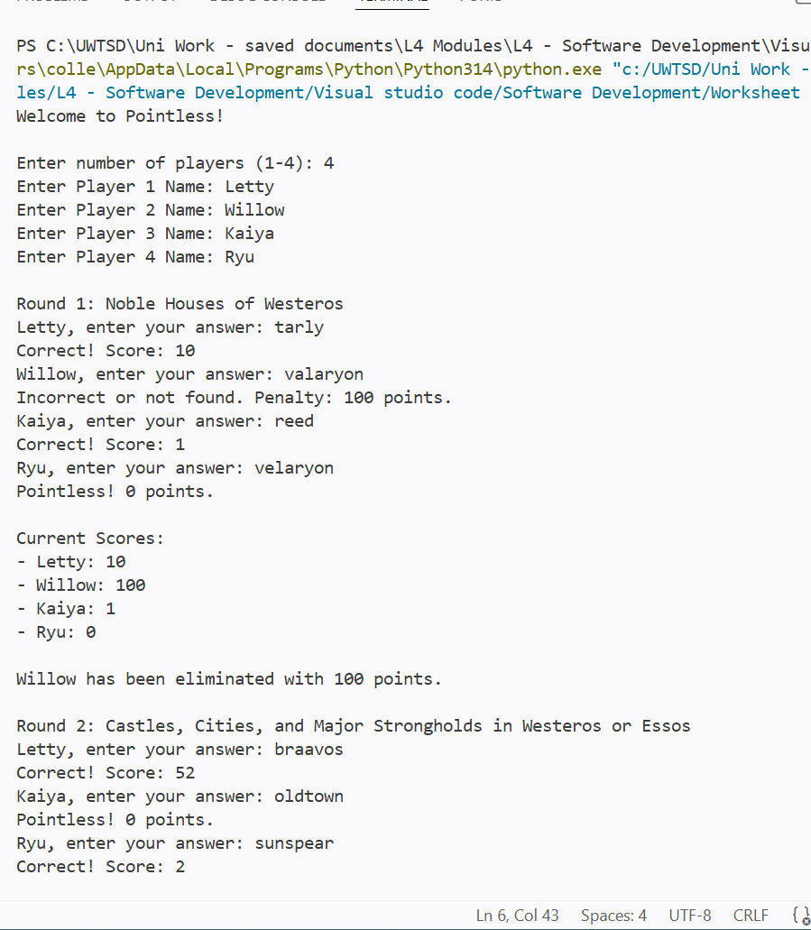
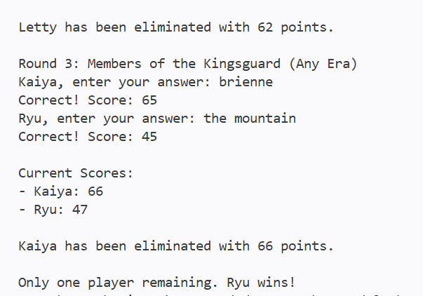
Result: Did the programme behave as expected ie syntactically and logically correct?
YES

Test: 2 – 3 player’s tests

Screenshot(s) of output:
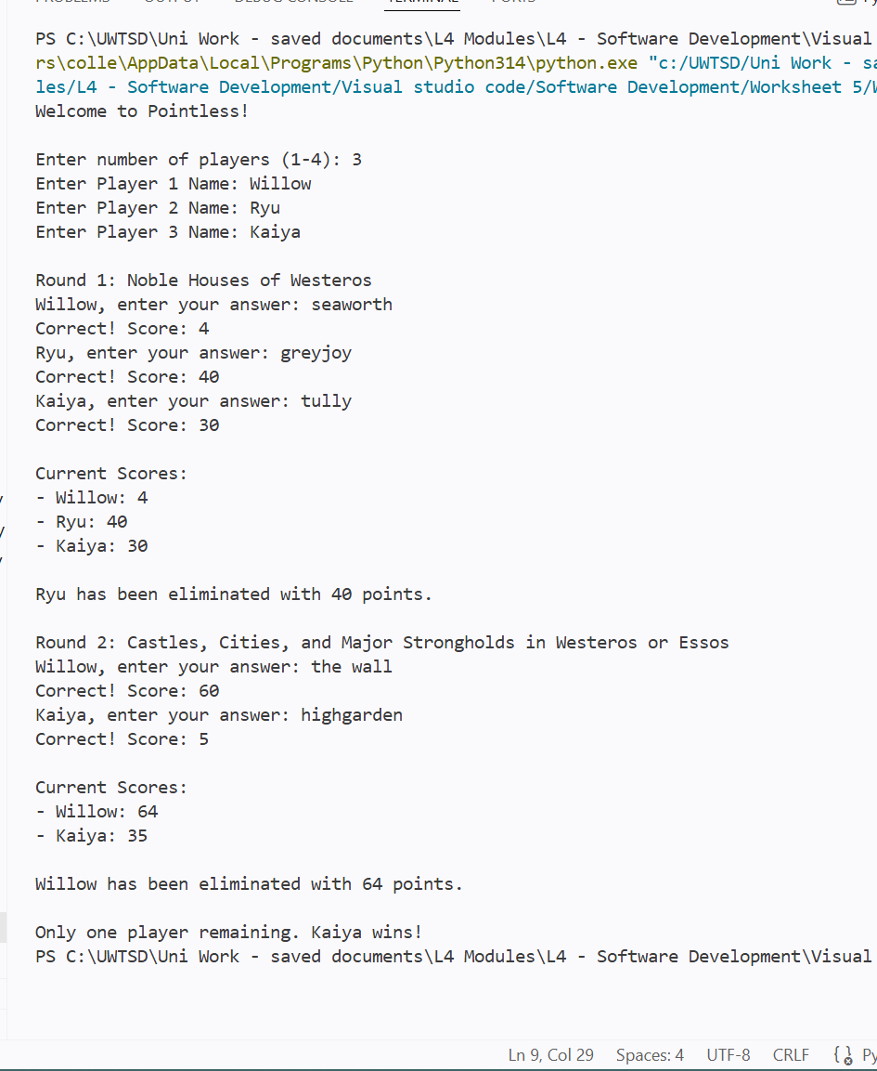
Result: Did the programme behave as expected ie syntactically and logically correct?
YES

Test: 3 - invalid entry error

Screenshot(s) of output:
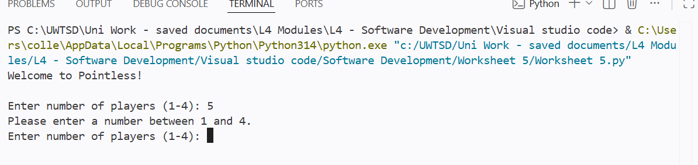
Result: Did the programme behave as expected ie syntactically and logically correct?
YES

Test: 4 – Score draw error

Screenshot(s) of output:
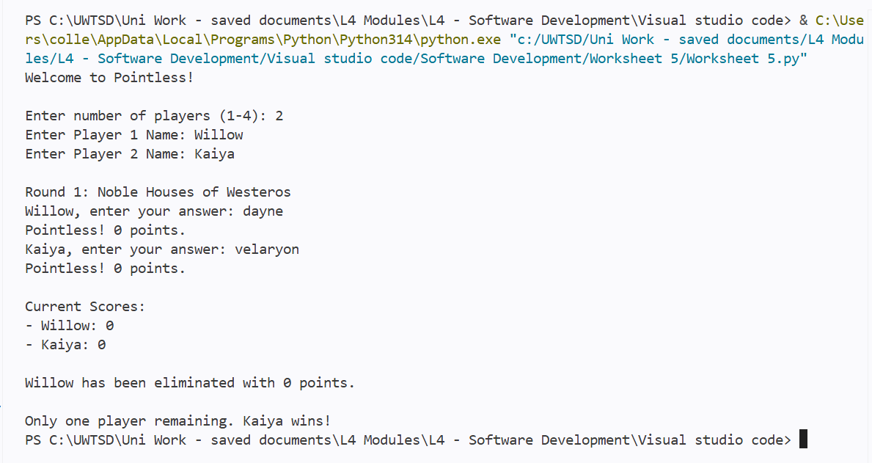

After correction:

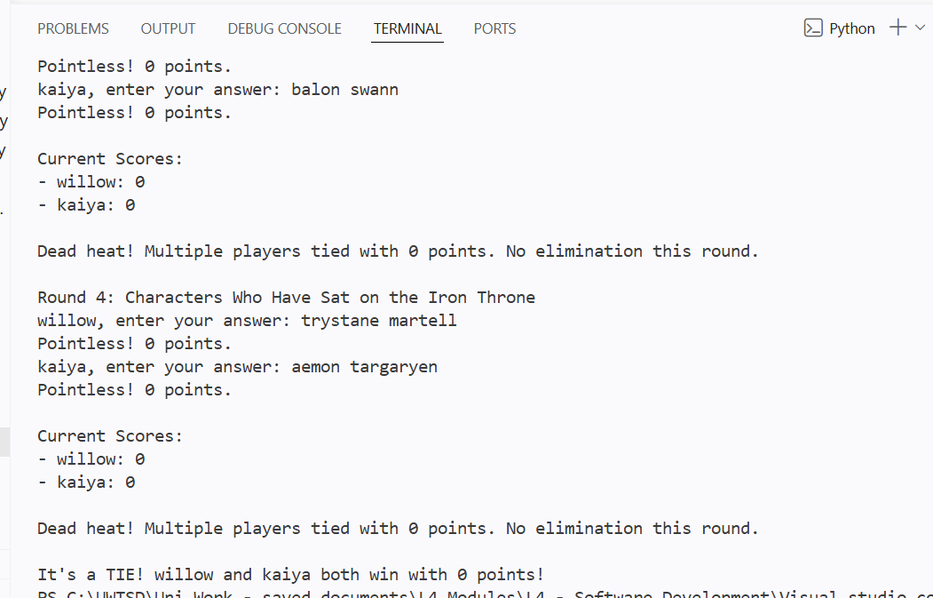
Result: Did the programme behave as expected ie syntactically and logically correct?
NO

I updated the code to properly handle draws, so no player loses unfairly. In a test scenario where both players scored 0 points across all rounds, the system now awards a win to both players rather than assigning a win to one and a loss to the other.

Final code:

[Copy and paste your code here – note, do not use a screenshot.

Note that there is no “before” and “after” code for this Worksheet because it is “Open” – not done in class. Therefore, just post your final code below]

import time

QUESTIONS = [
{
"num": 1,
"topic": "Noble Houses of Westeros",
"answers": {
"stark": 95, "lannister": 90, "targaryen": 85, "baratheon": 60,
"tyrell": 45, "greyjoy": 40, "martell": 35, "tully": 30,
"arryn": 25, "mormont": 15, "tarly": 10, "clegane": 8,
"seaworth": 4, "reed": 1, "velaryon": 0, "dayne": 0
}
},
{
"num": 2,
"topic": "Castles, Cities, and Major Strongholds in Westeros or Essos",
"answers": {
"kings landing": 98, "winterfell": 95, "dragonstone": 78, "the wall": 60,
"braavos": 52, "harrenhal": 35, "casterly rock": 33, "pyke": 25,
"meereen": 20, "qarth": 15, "the eyrie": 12, "volantis": 8,
"riverrun": 6, "highgarden": 5, "sunspear": 2, "bear island": 1,
"moat cailin": 0, "oldtown": 0
}
},
{
"num": 3,
"topic": "Members of the Kingsguard (Any Era)",
"answers": {
"jaime lannister": 88, "jaime": 88, "the hound": 72, "sandor clegane": 72,
"brienne of tarth": 65, "brienne": 65, "barristan selmy": 50, "barristan": 50,
"the mountain": 45, "gregor clegane": 45, "arthur dayne": 30, "meryn trant": 20,
"loras tyrell": 18, "gerold hightower": 8, "oswell whent": 8, "boros blount": 4,
"mandon moore": 1, "preston greenfield": 0, "balon swann": 0
}
},
{
"num": 4,
"topic": "Characters Who Have Sat on the Iron Throne",
"answers": {
"joffrey baratheon": 92, "joffrey": 92, "cersei lannister": 90, "cersei": 90,
"robert baratheon": 85, "robert": 85, "daenerys targaryen": 80, "daenerys": 80,
"aerys targaryen": 60, "aerys": 60, "tommen baratheon": 55, "tommen": 55,
"ned stark": 40, "eddard stark": 40, "jaime lannister": 30, "jaime": 30,
"tywin lannister": 22, "tywin": 22, "rhaenyra targaryen": 18, "rhaenyra": 18,
"viserys targaryen": 15, "viserys": 15, "maegor the cruel": 5, "jaehaerys targaryen": 3,
"aegon the conqueror": 1, "trystane martell": 0, "aemon targaryen": 0
}
}
]

def clean_input(text):
return text.strip().lower().replace("'", "").replace("-", " ")

def play_game():
print("Welcome to Pointless!\n")

while True:
try:
num_players = int(input("Enter number of players (1-4): "))
if 1 <= num_players <= 4:
break
print("Please enter a number between 1 and 4.")
except ValueError:
print("Please enter a valid number.")

players = []
for i in range(num_players):
name = input(f"Enter Player {i+1} Name: ").strip()
players.append({"name": name, "score": 0})

total_rounds = min(4, len(QUESTIONS))

for round_idx in range(total_rounds):
if len(players) == 1:
print(f"\nOnly one player remaining. {players[0]['name']} wins!")
return

question = QUESTIONS[round_idx]
print(f"\nRound {round_idx + 1}: {question['topic']}")

round_scores = {}

for player in players:
ans = input(f"{player['name']}, enter your answer: ")
clean_ans = clean_input(ans)

if clean_ans in question["answers"]:
score = question["answers"][clean_ans]
if score == 0:
print("Pointless! 0 points.")
else:
print(f"Correct! Score: {score}")
else:
score = 100
print("Incorrect or not found. Penalty: 100 points.")

player["score"] += score
round_scores[player["name"]] = score

print("\nCurrent Scores:")
for p in players:
print(f"- {p['name']}: {p['score']}")

if len(players) > 1:
highest_score = max(p["score"] for p in players)
losers = [p for p in players if p["score"] == highest_score]

if len(losers) > 1:
losers.sort(key=lambda x: round_scores[x["name"]], reverse=True)

eliminated = losers[0]
players.remove(eliminated)
print(f"\n{eliminated['name']} has been eliminated with {eliminated['score']} points.")

if len(players) > 0:
players.sort(key=lambda x: x["score"])
winner = players[0]
print(f"\nWinner: {winner['name']} with {winner['score']} points!")

if __name__ == "__main__":
play_game()

