Ranu Begum 1710178

BMSK5001

Developing workplace critical thinking
Leadership and Management Skills for the Workplace

Executive Summary

Contents
Executive Summary 1
Introduction 3
Section 1 3
Values, Beliefs and Culture 3
Figure 1: Edgar Schein 4
Transformative Learning 5
Figure 2 – Diagram, 5
Section 2 7
Management Theories 7
Charles Handy 8
Henry Fayol 8
Management Theories In a workplace 9

Conclusion 11
Appendices 13
Figure 1- 13
Figure 2- 13
Figure 3 – 14
Figure 4 – 14
Figure 5 – 15
Figure 6 – Fayol’s Principle of Management Model 15
References 16
Bibliography 19
Presentation Notes 22

Introduction

(Do at end)

Section 1

Values, Belief and Culture

There is a significant difference between Value and Belief. Beliefs are assumption that we hold to be true. When we use our beliefs to make daily decisions, we are reflecting on past experiences or an incident that make us have this belief and apply for the future. (Ref) Beliefs are potent because they drive behaviour. Behind every action, communication and decision are beliefs (Mullins and Christy 2016). In any workplace every employee will carry their own personal beliefs (Huffpost, 2019), But its learning how to accept and understand others beliefs to have a greater understanding and build better relationships in the workplace.

Beliefs
)

Figure 1

Edgar Schein Model

Figure 2 Transformative lL

Section 2

Management Theories

Conclusion

Appendices

Figure 1-

Figure 2-

Figure 3 –

Figure 4 –

Figure 5 –

Figure 6 – Fayol’s Principle of Management Model
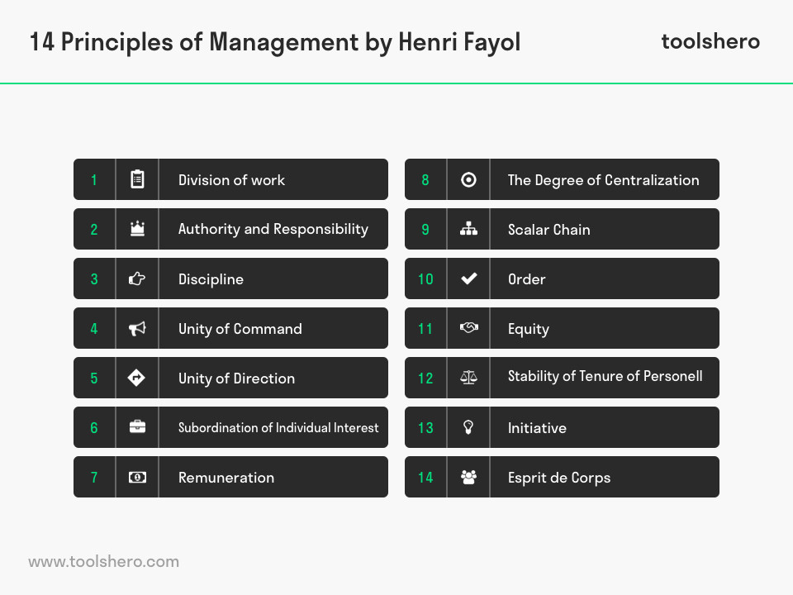

References

