

Marketing Management (LCMB7001) Assessment 2
Student Name: Franco Okojie-Aidonojie
Student ID: 1809189
Lecturer’s Name: Tushara Balendran

Contents
Introduction: 3
Mission Statement 3
Macro-environmental Analysis – PESTEL Analysis 3
Political factors: 3
Economic factors: 4
Sociocultural factors: 4
Technological factors: 4
Environmental factors: 5
Legal factors: 5
Porter’s Five Forces Model: 6
Threat of New Entrants: 6
Bargaining Power of Entrants: 6
Bargaining Power of Buyers: 7
Threat of Substitutes: 7
Competitive Rivalry: 7
Harrod’s SWOT Analysis: 8
Advantages and Disadvantages of Porters Five Forces Situational Model. 9
Advantages of Porter’s five forces 9
Disadvantages of Porter’s five forces: 9
Harrod’s Segmentation, Targeting, and Positioning: 10
Marketing Mix (4Ps) 10
Product: 10
Price: 11
Place: 11
Promotion: 11
Recommendations 11
Improve digital footprint and augment e-commerce functionalities 11
Incorporating personalised and experimental marketing strategies: 12
Strengthen sustainability initiatives: 12
Leverage Data Analytics and artificial Intelligence: 12
Conclusion: 13
References: 13

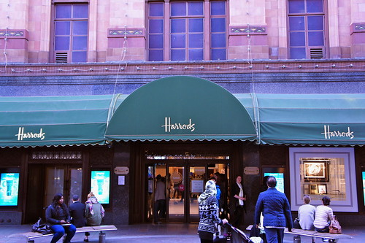
This Photo by Unknown Author is licensed under CC BY

Introduction:
Harrods Limited is a globally recognised luxury departmental store in one of London’s most affluent neighbourhoods in Knightsbridge and has been associated with luxury and opulence with an exceptional customer service reputation since it was founded in 1834 by Charles Henry Harrod. Harrod’s is synonymous with wealth, luxury and renowned for its rich heritage and iconic presence.
In 1834, when Harrods was founded, it was initially a small grocery store located in the east end of London. Charles Harrod’s vision and dedication to delivering quality and excellence quickly gained him a reputation as a striving entrepreneur with an eye for excellence resulting in the growth of the company.

Mission Statement:
Harrod’s aims to establish itself as the pinnacle of luxury retail by incorporating these fundamental values which is geared to create an unparalleled and memorable shopping experience that eclipsed its customer’s expectations.
- Harrods aim to provide products and services of exceptional quality, guaranteeing that their customers have access to the most exquisite and luxurious brands in the market.
- Harrod’s strives to be at the forefront of innovation, continuously adapting and evolving to stay one step above its rivals and to cater for the needs of its affluent clientele changing desires and expectations.
- Harrod’s prides itself on providing personalised and attentive services to its customers, offering bespoke and tailored experiences beyond ordinary shopping experiences.

Macro-environmental Analysis – PESTEL Analysis


This Photo by Unknown Author is licensed under CC BY-SA

Political factors:
The United Kingdom’s political stability is beneficial to Harrod’s business model, it can easily make business choices and investments in a secure political environment. The UK government’s backing for luxury shopping enables Harrod’s politically (Shephard, 2022).
The UK government backs Harrod’s and other luxury retailers. “Tax benefits, progressive rules, partnerships, collaborations can help boost Harrod’s market competitiveness.
Conversely, corporate tax rates and import/export tariffs can significantly threaten the company’s profitability and pricing strategy (Xu, Hsu and Niu, 2018a).
Harrods may lose price competitiveness and profitability if trade and taxes rise. Political instabilities or extreme factors like wars can negatively impact consumer moods and trends thus reducing the possibility of high-end consumers and foreign customers visiting Harrods. This will undoubtedly hurt sales and brand reputation.

Economic factors:
The economic stability and growth of the United Kingdom positively favours Harrod’s. A robust, vibrant, and expanding economy induces a favourable atmosphere for consumer expenditure, particularly in the luxury category (Aboelsoud, AlQudah and Paparas, 2021).
The availability of income and disposable income levels within the segmented market presents Harrods with the prospect to lure and entice affluent clientele and boost sales. Furthermore, economic growth fosters consumer confidence and generates a favourable outlook for luxury retail. On the opposite spectrum, economic downturn may bring in challenges for Harrod’s. the prospects of an economic recession or financial crises can have the potential to diminish consumer confidence discretionary spending, which may directly impact the sales and revenue of Harrod’s. during any period of economic decline, there’s typically a slowdown in discretionary spending which can impact the luxury market sector and performance of Harrod’s (Dell’Ariccia, Rabanal and Sandri, 2018).

Sociocultural factors:
The societal trends in the UK must be monitored by Harrod’s to understand in the context of consumer spending to be able to satisfy its affluent customers. Wealthy and upper-middle class clientele dominate the luxury market therefore Harrod’s success is incumbent on its ability toto adapt its marketing strategies to the changing sociocultural environment of its customers. Consumers are now prioritising sustainability, ethics, and responsible consumption. Harrod’s must include societal trends in its marketing approach (Nash, 2019a). Harrod’s can attract eco-conscious customers by showing commitment to sustainability, ethical sourcing, and corporate social responsibility.
Harrods marketing methods can also be impacted by the UK demographic shifts, ageing population, and multiculturalism. Harrod’s can attract consumers by adapting its marketing strategies to various dynamics and recognising targeted markets variety (Thorisdottir and Johannsdottir, 2019a).

Technological factors:
In the digital transformative era, Harrod’s must adopt technological innovations to maintain a competitive edge. The importance of e-commerce has had a significant importance especially in the aftermath of the Covid pandemic. It is paramount that Harrod’s invest in robust online platforms, intuitive interfaces, and streamline consumer experiences to tap into and maintain the ever-increasing market of online luxury shoppers. Incorporating technology into its brick-and-mortar retail experiences, such as interactive displays, augmented reality, or bespoke recommendations can enhance customer engagement and boost sales revenue (Ki, Chong, and Ha-Brookshire, 2020a).

Data analytics is also fundamental in the comprehension of customer preferences and boosting marketing strategies (Arriba and Alfaro, 2018).
Utilising customer data, Harrods’s can enhance its marketing strategies, customising product offerings, and delivering a personalised shopping experience to its customers. Additionally, technology enables Harrod’s to enhance operational efficiency, make the best use of its supply chain management, and increase inventory management by leveraging automation and data-driven insights.

Environmental factors:
Most recently, there has been a significant increase in environmental issues, mainly due to the prevalent awareness of sustainability and climate change. These comprises of environmental regulations, consumer demands for environmentally sustainable products, and the environmental impacts of business operations (Thorisdottir and Johannsdottir, 2019b).
It is therefore recommended that Harrod’s ensures measures are taken to address these environmental concerns so that its operations are aligned with sustainable practices. Including eco-friendly like reduction of carbon emissions, advocating for energy efficiency, and embracing sustainable sourcing cultures can boost Harrod’s brand reputation and attract environmentally conscious clienteles to its brand. an added benefit of providing eco-friendly product lines or establishing partnerships with sustainable brands amplify Harrods’s standing as a dedicated luxury retailer.

Legal factors:
There are many laws, policies and regulations that govern businesses. Legality underpins Harrod’s reputation and ethics. Retail needs consumer protection. It is vital that Harrod’s upholds consumer rights and fair commerce. The following laws govern product safety: Labelling, pricing, transparency, and warranties (Ki, Chong, and Ha-Brookshire, 2020b). Harrod’s must label its products appropriately, display prices, and fulfil warranties. These standards can help Harrod’s establish consumer confidence and prevent consumer protection difficulties. It is fundamental that Harrod’s protects it brand name, logo, and other intellectual properties to prevent unauthorised usage. Unlicensed merchants and counterfeiters must be held to account and prosecuted. Harrods’s must maintain its exclusivity and branding image by safeguarding it IP.

Porter’s Five Forces Model:
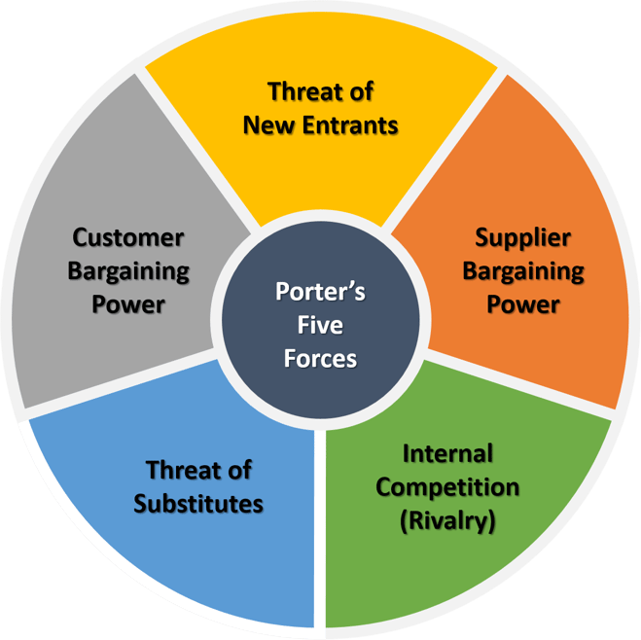

Threat of New Entrants:
The threat of new entrants to Harrod’s is relatively low. Various obstacles hinder the ability of new entrants to compete in the market effectively. Firstly, Harrod’s has built a strong brand image in its extensive tenure, making it difficult for new contenders to secure customer confidence and allegiance effectively. Additionally, the luxury retail sector requires substantial capital investments, including expenses for securing prime store location, creating sophisticated and modern store aesthetics, and procuring unique product assortments (Nash, 2019b). Harrod’s robust supplier relationships and adeptness in acquiring exclusive and rare merchandise confers a competitive edge that would challenge potential new market players to emulate. Therefore, the degree of new entrants to the market posed by competitors is very low.

Bargaining Power of Entrants:
The UK luxury market experiences a very high level of bargaining power from suppliers. Harrod’s procures products from many suppliers most notably from luxury fashion brands, high-end jewellery designers, and cosmetics manufacturers. These suppliers usually maintain a dominant position in the market owing to their distinct and exclusive product offerings. Suppliers can establish conditions, incorporating pricing, product accessibility, and distribution agreements. Additionally, suppliers can exert discretion in their choices of retail partners, augmenting their leverage in negotiations.

Harrod’s enduring associations with suppliers and branding can offer advantages. The capacity of the company to provide a distinguished platform for suppliers to exhibit their products may influence the balance of power.

Bargaining Power of Buyers:
In the luxury retail sector of the UK, the bargaining power of buyers is comparatively low. Harrods’s caters to a niche clientele in a specific market segment of affluent customers attracted to exclusivity and high-quality products. This targeted audience exhibit lower price sensitivity than the general population and is inclined to paying a premium for high-end merchandise and superior retail experiences (Ki, Chong, and Ha-Brookshire, 2020c). Consequently, their ability to negotiate prices or request discounts on products is restricted. Harrod’s emphasis on delivering niche and bespoke personalised services is an added strength in value proposition, making is difficult for customers to find comparable alternatives. With the emergence of online luxury retailers and the growing accessibilities of luxury goods worldwide, consumers now have bigger range of options to choose from. This enables the buyer to have leverage, albeit relatively limited to other variables.

Threat of Substitutes:
The threat posed by substitute products for Harrod’s in the luxury retail market in the UK is medium. Although Harrod’s provides a distinctive and carefully chosen variety of high-end merchandise, clients may wish to explore other options, like procuring from other luxury retailers, engaging in online shopping, or selecting used luxury items. The proliferation of e-commerce platforms and online luxury marketplaces has increased the availability of substitute products and their accessibilities (Thorisdottir and Johannsdottir, 2019b).

Harrod’s robust brand reputation, exclusive partnerships, and exceptional customer service are distinguishing factors that set its offering apart from its rivals. In addition, the appeal of the Harrods retail experience, which includes the grandeur of its store’s atmosphere and the esteem reputation, creates a degree of patron allegiance that mitigates the imminent competition from alternative options.

Competitive Rivalry:
The competition between Harrod’s and its rivals are fierce. High-end departmental stores, fashion boutiques and online retailers like Selfridges, Liberty, John Lewis are directed competitors to Harrod’s, and the market is very fluid, but Harrods has an edge over its rival due to its illustrious clienteles and name brand. The shopping experience is iconic around the world and shoppers celebrate this experience putter Harrod’s at the pinnacle of shopping excellence.
The UK luxury retail market is mature and attracts domestic and global organisations. Market share and customer attention are closely battled for (Varley et al., 2018).
Luxury retailers must constantly update and diversify the offers to compete and remain in the sector. The emergence of luxury online retailers may be a potential threat to Harrods due to retail digitisation. Harrod’s employs several strategies to sustain its competitive edge. Excellent customer service, its Christmas sales and the fabulous store décor makes shopping at Harrod’s a truly memorable experience. These features set Harrod’s apart from its rivals. Harrod’s works with a wide variety of top brands providing vast selection of attractive and niche product to its wealthy and trendy customers. Harrod’s also advertises and draws customers (Ozkan, 2020). The organisation employs social networking, internet commerce and innovative technologies to improve customer services.

Harrod’s SWOT Analysis:

Strengths | Weaknesses
Bricks and Mortar - online platform | Visual Experience (VM online).
Qatar ownership – An attractive arena for VIP clientele from the Middle East. | Innovation.
Solid relationship with suppliers and partners (distinguished styles and collaboration). | Lacks a wide range of brands/products compared to rivals (Selfridges designer space/genderless shop floor.
Heritage/tourist attraction- famous reputation and regular customers (loyalty schemes and rewards). | Online offering.
Personalised shopping/high-end service and standards.
Renowned Christmas sales promotions and attractive decorations.

Opportunities | Threats
Exclusive online contracts with brands (Net-a-Porter, Fendi, Peekaboo). | Monobrand e-com business.
Foremost destination for brand enthusiasts and niche lovers. | Intense competition (eg, new launch of LVMH 24 sevres).
Heightened awareness of Harrod’s e-commerce and social media. | Customer saturation (key bags/shoes).
More publicity/social media for private/exclusive events. | New technologies (direct shopping via online tutorials, etc).
Global outreach and growth. | UK economic climate
Increased younger target audience | Target market
Digital trunk shows and pre-order system. | Sky rocketing interest rates
SWOT ANALYSIS HARRODS by (Wimmer, 2017)

Advantages and Disadvantages of Porters Five Forces Situational Model.

Advantages of Porter’s five forces:
- It gives a comprehensive analysis that covers a broad range of factors that impacts the competitive environment of an industry.
- It is very easy to use and can be universally used in a wide range of businesses and industries.
- It is very analytical and helps to identify who has the competitive edge in an industry. It critically examines the bargaining power of suppliers and buyers, including threats of new entrants and substitutes. Businesses can identify the power brokers of the industry and formulate better strategic decisions.
- It’s a good mechanism of identifying opportunities and threats by examining the competitive balance of an industry, this will provide ideas for potential opportunities and threats, enabling them to make better strategic judgements (Study Smarter, 2020a).

Disadvantages of Porter’s five forces:
- It has a limited range, only focusing on the external factors that can impact an industry, it doesn’t address the internal factors like the company’s management, culture, or resources.
- This model is very regimental and old, it doesn’t address the changes in the industry or the broader business environment.
- It can be coerced by the subjective ideologies of whomever is carrying out the analysis, subjecting to possible flaws in the outcome.
- This model can be limited for businesses with a bigger portfolio of services and products, because competitive dynamism can differ massively in different parts of the business (Study Smarter, 2020b).

Harrod’s Segmentation, Targeting, and Positioning:

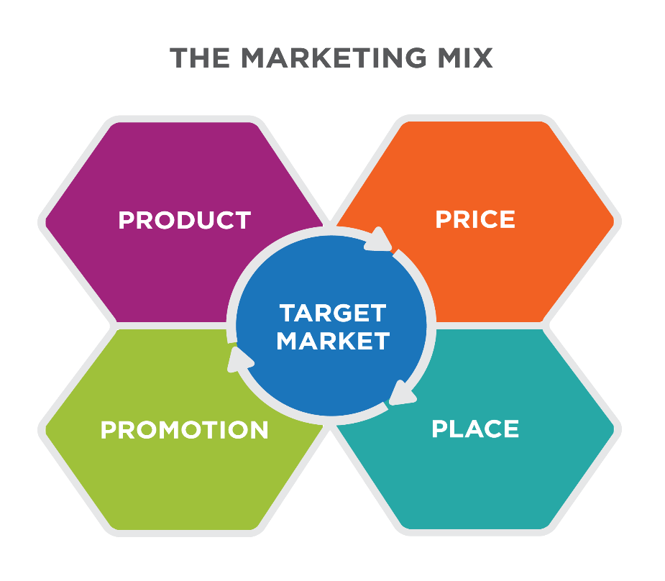
This Photo by Unknown Author is licensed under CC BY
Harrods has employed a sophisticated segmentation strategy to designate its target market into discreet groups based on various criteria, such as demographic, psychographic, and behavioural elements. Harrod’s targeted customer base comprises individuals with high net worth, luxury enthusiasts, and international tourists searching for the premium shopping experience. Harrod’s can customise its marketing strategies and product offerings to cater to each segmented market’s distinct requirements and preferences.
Harrod’s enlists a targeted approach to cater to specific segments within the retail market. The corporation aims to appeal to and cater for clients who prioritises exclusivity, opulence, and exceptional customer service. The target customers of Harrod’s value the brand’s extensive variety of luxury goods, exceptional artistry, and tailored shopping encounters. Harrod’s can effectively deliver customised marketing messages and experiences that align with the desires and aspirations of the affluent and discerning consumers through targeted marketing strategies.
Harrod’s has established itself as a major luxury department store in the UK market. The brand is widely recognised for its associations with luxury, tradition, selectiveness. It is the premier destination that provides top-quality luxury goods from renowned brands and an extraordinary customer service. The brands positioning accentuates the distinct shopping encounter, its iconic store site, and the status linked with the buying experience of Harrod’s. Harrod’s is strategically positioned to distinguish itself from other rivals and uphold its image as a prominent emblem of opulence, exclusivity, and sophistication.

Marketing Mix (4Ps)

Product:
Harrod’s provides a wide selection of luxury products in diverse categories, like fashion, accessories, beauty, home goods, and gourmet foods. The assortment of products has been meticulously hand-picked to feature renowned high-end brands and limited-edition lines. Harrod’s utilises the concept of brand equity to ensure that its product lines embody characteristics such as quality, prestige, and exclusivity. The retail establishment offers a diverse range of premium products, including globally recognised luxury labels and merchandise bearing the Harro’s brand.

Price:
Harrod’s has implemented a premium pricing strategy to align with its products and services for exclusivity and superior quality. The pricing strategy is formulated based on the value perception of luxury consumers, with due considerations given to factors such as brand reputation, craftmanship, and scarcity. Harrod’s employs a pricing strategy known as price skimming to extract value from early adopters of new luxury products. Additionally, the company utilises price discrimination techniques such as personalised offers and loyalty programmes to improve customer loyalty and retention.

Place:
Harrod’s flagship store in Knightsbridge, London is a fundamental component of its marketing strategy. The brick-and-mortar establishment offers a distinctive retail encounter, distinguished by its impressive structural design, sophisticated product presentation, and luxurious atmosphere. The strategic positioning of the store in a prominent shopping district draws the attention of the local and global customer searching for high-end merchandise. Harrods has established a robust online platform in addition to its brick-and-mortar store, enabling customers to shop from any location conveniently. Adopting an omnichannel approach guarantees a cohesive customer experience across multiple touchpoints.

Promotion:
Harrod’s uses diverse promotional tactics to increase brand exposure among its intended demography. The company allocates resources towards advertising to target its affluent customers through upscale publications, premium fashion magazines, and online platforms. Harrod’s engages in high profile collaborations with renowned designers and hosts exclusive events, such as fashion shows and product launches, to enhance brand visibility and attract attention. Using celebrity endorsements, influencer partnerships, and social media campaigns increases the brands exposure and solidifies its status as a luxury brand.

Recommendations
Improve digital footprint and augment e-commerce functionalities:
With the emergence of digital commerce and the evolving consumer purchasing patterns, Harrod’s should prioritise the improvement of its online presence and e-commerce capabilities. It is recommended that the company allocate resources towards developing a sophisticated and intuitive e-commerce platform that aligns with the premium and exclusive image associated with the Harrod’s brand. this proposed solution will facilitate convenient access to Harrod’s products and services for customers, ensuring a seamless and personalised shopping experience irrespective of location. Additionally, the online platform can function to expand the customer base, encompassing global customers who may not have access to the brick-and-mortar store located in London. By adopting digital technologies, Harrod’s can enhance its market reach, boost sales, and reinforce its customer engagement.

Incorporating personalised and experimental marketing strategies:
For Harrod’s to enhance its competitive advantage and establish stronger customer relationships, it must prioritise the implementation of personalised and experimental marketing strategies. The organisation can obtain valuable insights into individual preferences and behaviours by collecting and analysing customer data. This in turn facilitates the provision of personalised recommendations, offers, and experiences. Implementing targeted email marketing campaigns, customised loyalty programmes, and incorporating customer relationship management (CRM) systems can facilitate the attainment of this objective. It is recommended that Harrod’s maintain focus on developing immersive and memorable in-store experiences by utilising its renowned store ambience, opulence services, and exclusive events. Harrod’s can establish enduring impressions, foster customer allegiance, and distinguish itself from rivals by providing bespoke and interactive experiences.

Strengthen sustainability initiatives:
Harrod’s must address the significant increases of environmental sustainability and awareness. The recommendations for Harrod’s are to enhance its sustainability initiatives. The organisation can reduce its carbon footprints by adopting energy-efficient measures, streamlining waste management systems, and procuring sustainable products. The recommendations for Harrod’s are to effectively communicate its dedication to sustainability to its customers by highlighting the measures implemented to reduce the environmental impact of its operations. Harrod’s can improve its brand reputation, attract new customers, and cultivate long-term loyalty by aligning with the values and preferences of environmentally conscious consumers.

Leverage Data Analytics and artificial Intelligence:
Data analytics and artificial intelligence (AI) can boost Harrod’s customer insight, operational efficiency, and marketing effectiveness advantages. Utilising data analytics tools, Harrod’s can enhance its understanding of customer preferences, purchasing patterns, and trends. This data can provide important decision-making-regarding product assortment, pricing tactics, and tailored marketing initiatives. Finally, artificial intelligence (AI) technologies, like chatbots and virtual assistants can offer tailored and effective customer assistance, guaranteeing a seamless and smooth customer journey. Inventory management system powered by artificial intelligence can optimise stock levels, minimise wastage, and improve the efficiency of the supply chain.

Conclusion:
Harrods a prominent luxury department store in London UK, has effectively implemented diverse marketing strategies and tactics to establish itself as a renowned brand in the luxury retail sector. It effectively caters to the unique needs and preferences of affluent customers who seek exclusivity, quality, and opulence thoroughly understanding its target market and utilising segmentation, targeting, and positioning strategies.
For it to improve its competitive edge and enhance customer satisfaction, it recommended that Harrod’s continue to adapt to the evolving external environment. This entails adopting digital transformation, allocating resources towards technology, and optimising data analytics to customise customer experiences and boost engagement. The organisation should prioritise sustainability and corporate social responsibility to conform to consumers changing values and expectations.

References:
Aboelsoud, M.E., AlQudah, A. and Paparas, D. (2021). Effectiveness of Interest Rate Policy on the Management of Macroeconomic stability: Evidence from the United Kingdom. Journal of Organisational Studies and Innovation, [online] 7(4), pp.35–50. Available at: https://hau.repository.guildhe.ac.uk/id/eprint/17648/ [Accessed 1 Jun. 2023].
Arriba, V. and Alfaro, Jose. A. (2018). 3D Technology in fashion: from Concept to - ProQuest. [online] www.proquest.com. Available at: https://www.proquest.com/docview/2036406110 [Accessed 13 Jun. 2023].
Dell’Ariccia, G., Rabanal, P. and Sandri, D. (2018). Unconventional Monetary Policies in the Euro Area, Japan, and the United Kingdom. Journal of Economic Perspectives, 32(4), pp.147–172. Doi: https://doi.org/10.1257/jep.32.4.147.
Ki, C., Chong, S.M. and Ha-Brookshire, J.E. (2020a). How Fashion Can Achieve Sustainable Development through a. [online] www.researchgate.net. Available at: A systematic Literature Review, Corporate Social Responsibility and Environmental Management [Accessed 18 Jun. 2023].
Ki, C., Chong, S.M. and Ha-Brookshire, J.E. (2020b). How Fashion Can Achieve Sustainable Development through a. [online] www.researchgate.net. Available at: A systematic Literature Review, Corporate Social Responsibility and Environmental Management [Accessed 18 Jun. 2023].
Ki, C., Chong, S.M. and Ha-Brookshire, J.E. (2020c). How Fashion Can Achieve Sustainable Development through a. [online] www.researchgate.net. Available at: A systematic Literature Review, Corporate Social Responsibility and Environmental Management [Accessed 18 Jun. 2023].
Nash, J. (2019a). Exploring How Social Media Platforms Influence Fashion Consumer Decisions in the UK Retail Sectors. Journal of Fashion Marketing and Management: An International Journal, 23(1), pp.82–103.
Nash, J. (2019b). Exploring How Social Media Platforms Influence Fashion Consumer Decisions in the UK Retail Sectors. Journal of Fashion Marketing and Management: An International Journal, 23(1), pp.82–103.
Ozkan, K.S.L. (2020). International Market Exit by firms: Misalignment of Strategy with the Foreign Market Risk Environment. International Business Review, [online] 29(6), p.101741. Doi: https://doi.org/10.1016/j.ibusrev.2020.101741.
Shepherd, D. (2022). UK Luxury Brands Urge Government to Bring Back Tax-Free Shopping. Bloomberg.com. [online] 23 May. Available at: https://www.bloomberg.com/news/articles/2022-05-23/uk-luxury-brands-urge-government-to-bring-back-tax-free-shopping#xj4y7vzkg [Accessed 12 Jun. 2023].
Study Smarter (2020a). Porter’s Five Forces: Definition, Model & Examples. [online] StudySmarter UK. Available at: https://www.studysmarter.co.uk/explanations/business-studies/strategic-analysis/porters-five-forces/ [Accessed 15 Jun. 2023].
Study Smarter (2020b). Porter’s Five Forces: Definition, Model & Examples. [online] StudySmarter UK. Available at: https://www.studysmarter.co.uk/explanations/business-studies/strategic-analysis/porters-five-forces/ [Accessed 15 Jun. 2023].
Thorisdottir, T. and Johannsdottir, L. (2019a). Sustainability within Fashion Business Models: a Systematic Literature Review. [online] https://www.researchgate.net. Available at: https://www.researchgate.net/publication/332402984_Sustainability_within_Fashion_Business_Models_A_Systematic_Literature_Review [Accessed 14 Jun. 2023].
Thorisdottir, T. and Johannsdottir, L. (2019b). Sustainability within Fashion Business Models: a Systematic Literature Review. [online] https://www.researchgate.net. Available at: https://www.researchgate.net/publication/332402984_Sustainability_within_Fashion_Business_Models_A_Systematic_Literature_Review [Accessed 14 Jun. 2023].
Varley, R., Roncha, A., Radclyffe-Thomas, N. and Gee, L. (2018). Fashion Management: a Strategic Approach. [online] ResearchOnline. Red Globe Press. Available at: https://researchonline.gcu.ac.uk/en/publications/fashion-management-a-strategic-approach [Accessed 17 May 2023].
Wimmer, N. (2017). SWOT ANALYSIS HARRODS. [online] prezi.com. Available at: https://prezi.com/p/ern87pilrpb7/swot-analysis-harrods/ [Accessed 10 Jun. 2023].
Xu, J., Hsu, V.N. and Niu, B. (2018). The Impacts of Markets and Tax on a Multinational Firm’s Procurement Strategy in China. www.researchgate.net, [online] 27(2), pp.251–264. Available at: Production and Operations Management [Accessed 18 Jun. 2023].

