How a school develops one aspect of its SDP: a report that critically reflects on the actions, impact and evidence base

Introduction
The aim of this assignment is to discuss and critically reflect on a school’s actions of its School Development Plan (SDP), specifically focussing on how it develops one aspect of it. A SDP summarises the steps needed to reach certain priorities (Education Authority, 2020). It should identify targets and the resources needed to achieve those targets. I will discuss the development plan of a Welsh medium secondary school which will be referred to as ‘School B’ in order to comply with BERA’s (2018) Ethical Guidelines for Educational Research. School B has 804 pupils, aged 11-18 (Estyn, 2019). Its pupils are fluent Welsh speakers, with 90% coming from English speaking backgrounds. 12.1% receive free school meals.

The aspect of School B’s SDP (2019) I will focus on is ‘improving mathematics performance amongst Key Stage 4 (KS4) pupils. I taught mathematics whilst on placement in School B and had an insight into how it planned, implemented and reflected upon the steps taken to improve this priority. Relevant literature will be reviewed in order to show my understating of School B’s SDP process and to evaluate it. To conclude, I will suggest practical steps which could be taken in order to improve the SDP. Relevant parts of School B’s (2019) SDP have been attached to the end of this assignment for reference (see appendices 1-3).

Literature Review
It is an ongoing challenge for schools to improve their performance and effectiveness and Agi (2017) suggests that this might be because not enough consideration is given to SDPs. The needs of our education system are ever-changing, and SDPs are vital in ensuring that schools adapt to meet those changes (Jones, 1996).

The Welsh Government (2014) established a set of requirements for all schools in Wales. Each school should have a SDP in place in order to address the national priorities of raising literacy and numeracy standards and reducing the impact of poverty on achievement. Plans should be rolling over a three-year period in order to allow for achievements to be evaluated.

Teachers, headteachers, parents, governors and pupils should be involved in formulating the plan, setting targets against each of its aspects and planning strategically for its implementation (Wallace, 2009). Morrison (1991) recognises the role of headteachers in decision making of the plan’s actions but also states that they should not have complete power over them.

The Welsh Government (2014) identifies four stages of a successful SDP as being ‘self-evaluation’, ‘strategic planning’, ‘making improvements’ and ‘reviewing impact’. Bainbridge (2007) states that these stages should take place within the context of a long-term plan as school development is an ongoing process.

‘Self-evaluation’ should be based and revised on the schools latest Estyn report (Welsh Government, 2014). Sampaio and Leite (2017) found that external evaluation, such as Estyn inspections, can strengthen self-evaluation processes and head teachers’ performances, but they do not necessarily improve pupil achievement levels. Hofman et al. (2009) claim that in order to do so, the rest of the SDP process must follow. Estyn (2020) recognises this and states that self-evaluation is central in allowing schools to make improvements in pupils’ achievement levels and changes have been made in that the inspections now result in a discussion rather than a report. This approach retains the benefit of an outside body’s view on what needs to be improved and also encourages school staff to take a lead on some of these priorities.

A strategic plan should document the school’s long-term priorities and targets and the actions needed over the next three years to achieve them. There are certain steps that can be taken in order to construct and optimise a strategic plan. Chang (2006) believes these steps should involve analysis (of what is and is not currently working), planning (of how to improve this), implementation (of said plans) and evaluation (of these). Yikıcı and Altinay (2018) emphasise the importance of effective strategic plans, however their qualitative research raised concerns about their logistics. Financial restraints and the lack of training in strategic planning, restricts schools from reaping the benefit of an effective strategic plan. Frequent teacher transfers between schools can also inhibit its delivery. Qualitative research is able to summarise different opinions within its target group, but researchers must be careful that their sample is not bias, and that it can be generalised (Skinner et al., 2000). Marshall and Rossman (1995) noted that this type of research allows organisations to understand why policies or practices may be failing, and therefore it is a beneficial method used by Yikıcı and Altinay (2018). Yikıcı and Altinay’s (2018) study was conducted in Cyprus where teachers frequently move between schools. The situation is similar in Wales where an increasing number of teachers are leaving the profession (NFER, 2017). Funding and staff training are important if a strategic plan is to be effectively constructed in the context of a SDP.

In order to make improvements in the school the actions and strategies planned in the previous steps must be implemented. The SDP must include details of each responsibility, who is accountable for them, and what actions and timescales are required for each one (Welsh Government, 2014). Mazzotti et al. (2018) identify key steps needed in order to optimise improvements. One of these key steps is to monitor and evaluate the results of the development plan. Park et al. (2013) see the development process as a recurring and continuous cycle and emphasise the importance of monitoring and evaluation. If schools fail to complete this step, they are unlikely to see change.

The final stage of a SDP, is to review the impact of the preceding steps. In order to ensure that the SDP reflects the school’s current context it must be reviewed and updated annually or following an Estyn inspection, whichever is sooner. This then leads back to the first stage of the SDP process and repeats itself in order to continue making developments.

Mathematics and numeracy support many aspects of our everyday lives and is therefore fundamental in developing pupils’ progress in all areas of learning (Welsh Government, 2019). Developing these skills will lead to their application to real-world problems. It is therefore imperative for teachers to provide engaging, stimulating and accessible mathematics and numeracy lessons. Mathematics is a skill which helps pupils to develop knowledge in other curricular subjects and prepare them for working life (Pound and Lee, 2011).

Developing an Action Point
It is important to stress that since the Welsh Government (2014) set out its requirements for all schools in Wales, those schools would have a SDP in place. Therefore, in School B’s latest Estyn report (2019), the previous SDP has been critically evaluated. The report praised the school’s ability to identify the strengths and weaknesses of each department, including mathematics. However, Estyn (2019) reported that there was a lack of clear actions in the SDP which might cause a barrier to improve pupils’ standards in mathematics and numeracy. In contrast to this though, Estyn (2019), stated that teachers had high expectations of their pupils and used stimulating tasks which motivated and challenged them. A recommendation was made in the report, to improve KS4 pupils’ achievements in mathematics and numeracy. School B took this on board, and it became a priority in its subsequent SDP.

Steps were then taken to strategically plan towards achieving this improvement. As a student on my professional teaching experience (PTE), I participated in weekly mathematics departmental meetings where we discussed current and future actions needed to meet this priority. The meetings were attended by all mathematics staff. The headteacher would attend once a term. The department agreed that extension tasks must be prepared for lessons in order to increase the level of challenge to pupils. Extension tasks are ones that extend pupils’ learning who have finished compulsory work (Cambridge University Press, 2017). They have been found to help pupils’ long-term memory, whilst increasing their motivation and confidence. These tasks must be differentiated in an attempt to improve results. However, in School B, mathematics classrooms are set according to ability thus reducing the need for differentiation (Anderson, 2016). However, differentiation is widely identified as a powerful tool which allows pupils to reach their full academic potential (Ritzema et al., 2016). Ollerton (2014) identifies the use of extension tasks as a differentiation strategy. These should be challenging and should stretch pupils beyond their current achievement levels. Their purpose is to encourage independent learning and discussion amongst pupils which is beneficial in creating learning gains (Eddy and Kuehnert, 2018).

As previously mentioned, the Welsh Government (2014) identified the steps needed to create and implement a successful SDP. School B clearly used the Estyn (2019) report when considering its current SDP. It took on board the critical assessment of the previous SDP in the external report thereby realising that ‘self-evaluation’ is critical in allowing the school to improve in the area of pupil achievement.

The development of the specific action point relating to the improvement needed in mathematics and numeracy achievements for KS4 pupils, involved all of the relevant staff within that department. The specific action undertaken in the mathematics department contributed to the overall SDP, suggesting that the school was adopting a strategic approach to its process, thus fulfilling the ‘strategic planning’ requirement set out by the Welsh Government (2014).

During the departmental weekly meetings, I observed all members of staff engaging positively in the process and also discussing the use of extension tasks. I also observed the use of extension tasks in every lesson I participated in as part of my PTE. This demonstrates that staff are engaging with the strategic plan, thereby assisting in its delivery and hopefully delivering on its objectives.

The school’s SDP identifies that teaching staff have responsibilities for these actions (see appendices 1 and 2, where teacher’s initials have been removed for confidentiality purposes) and again this complies with the Welsh Government’s (2014) third stage ‘making improvements.

Following School B’s latest inspection, the Estyn report (2019) noted that it did not have a clear enough image of pupils’ skill levels. Regarding the mathematics department, this was due to the fact that School B did not include data of previous KS4 mathematics and numeracy results as a method of monitoring change. As suggested by Mazzotti et al. (2018), the monitoring and evaluation of the actions is essential for schools to see change. They also state the importance of using data as a resource to monitor progress. If School B makes better use of data, for example by looking at trends of grades alongside the movement of teachers or changes to the SDP, it will be in a position to review the effectiveness and adapt the plan if necessary. This will demonstrate the school’s effective engagement in the final stage set out by the Welsh Government (2014), ‘reviewing impact’.

Reflection and Evaluation
In order to reflect on the specific action within the SDP undertaken in the mathematics department, I will use Gibbs’ reflective cycle (1988). This allows educational staff to effectively develop pupils’ learning and develop themselves professionally (Potter, 2015). I have previously used this tool and have found it useful in my own professional development.

School B clearly took on board the criticism levelled at it which was contained in the Estyn (2019) report. The report stated that the actions identified in the school’s previous SDP lacked incisiveness which inhibited its ability to raise pupils’ standards.

During the weekly departmental meetings, the SDP was discussed and the priority of improving mathematics and numeracy standards amongst KS4 pupils was reviewed. It was clear that all teachers were fully engaged in delivering this priority as they would share their individual actions in attempting to implement extension tasks with the rest of the group. It appeared that everyone felt comfortable within the team to express their progress and to ask for advice if it was needed. The implementation of extension tasks appeared to be successful, as they were used as an addition to mandatory work and little guidance was given in order to encourage independent learning, which Ollerton (2014) noted to be their purpose. The actions undertaken by the staff of the mathematics department, clearly demonstrate that the criticisms of the previous SDP were considered when developing the current one.

There are, however, additional actions that could be undertaken which I believe might increase the school’s capability to meet the specific priority of improving achievement levels in KS4 pupils, within the mathematics and numeracy area. One action would be to make better use of data. By tracking data and analysing trends, it would be able to identify whether or not the use of extension tasks was benefiting pupils’ mathematics and numeracy skills. This would, however, need to be completed over a period of time in order to identify trends. Therefore, the benefits of this would not be noticed immediately. It would also require teachers to continue to fully engage in the use of such tasks so that the evaluation was accurate.

Another action that might enhance the school’s ability to meet its priority could be if staff were given the opportunity to observe each other using extension tasks. Observation of other teachers is a technique which can help share good practice and allow teachers to reflect on and develop current practices (Marsigit, 2007). Uitto and Bays (2011) add that observation of other teachers improves the use of different teaching approaches and their performance, which consequently helps to improve pupils’ performance. There are drawbacks with this method of observation, in that it is time consuming in an already demanding occupation (Suma et al., 2019). Lewis et al. (2009) acknowledge this but claim that its benefits are worth the time spent on it. It would therefore be beneficial for the mathematics teachers of School B to be allowed time during the term to observe each other’s teaching, to improve their provision of increasing the level of challenge in mathematics lessons.

Conclusion
The focus of this assignment was to discuss and evaluate how School B developed a specific action point in relation to its SDP. As suggested by the Welsh Government (2014), mathematics and numeracy skills are vital for pupils to progress in all other areas of learning. As a prospective mathematics teacher, it was valuable for me to focus on the priority of improving KS4 mathematics and numeracy standards within the context of the SDP.

Relevant literature on SDPs and improving mathematics and numeracy standards has been reviewed in order to enhance my understanding of the SDP process. That understanding has been increased as a result of the research for this assignment. I have described how the school developed a specific action point within its SDP and I have critiqued its impact on teacher’s practice and pupil’s learning. I have reflected on the school’s actions regarding parts of the SDP which hopefully benefit teachers and pupils.

I have also highlighted the importance of schools to reflect upon their SDPs as well as the importance of self-reflection. Self-reflection is central to making improvements, even if the current process seems to be working effectively.

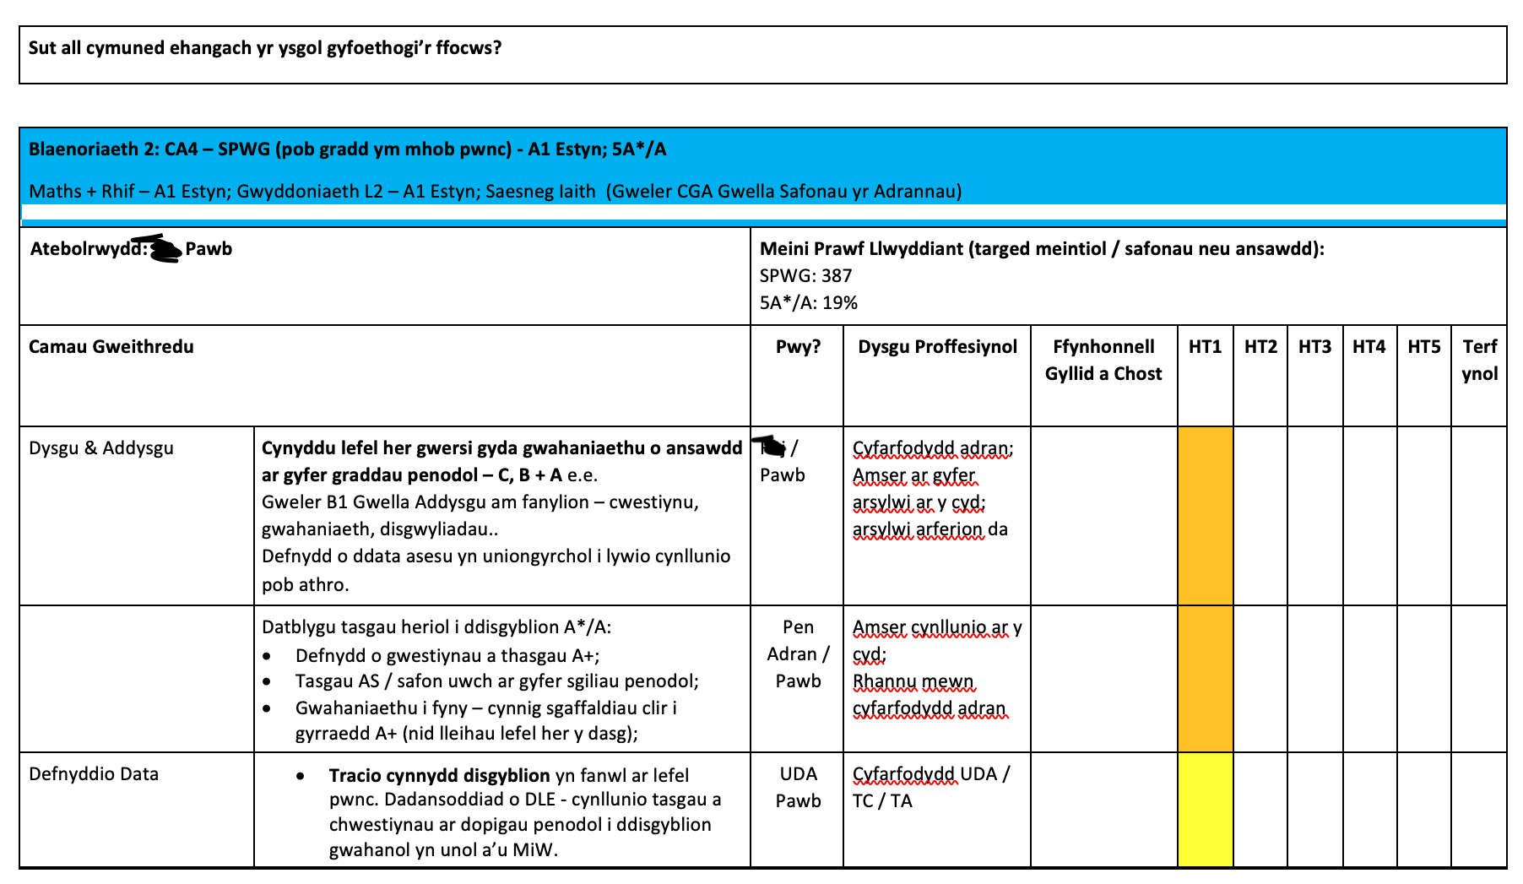
Appendices
Appendix 1
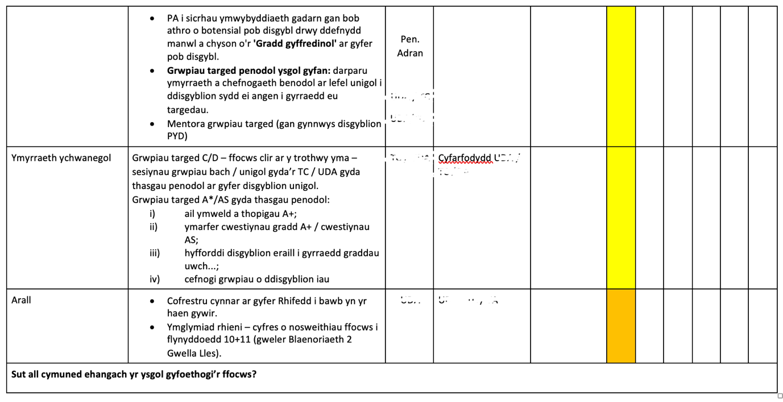
Appendix 2

Appendix 3
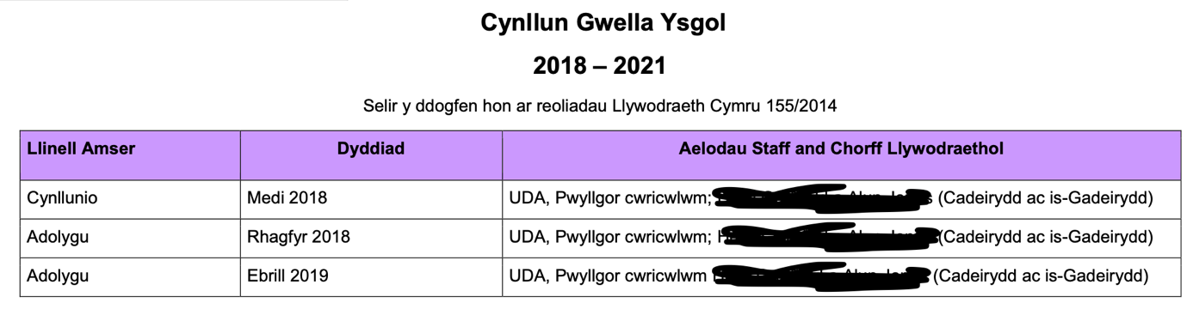
References
Agi, U.K. (2017) ‘School Development Planning: a Strategic Tool for Secondary School Improvement in Rivers State, Nigeria’, International Society for Teacher Education, 21(1), pp.88-100.

Anderson, M. (2016) Learning to Choose, Choosing to Learn: The Key to Student Motivation and Achievement. Virginia: ASCD.

Bainbridge, S. (2007) Creating a Vision for Your School: Moving From Purpose to Practice. California: SAGE Publications.

British Educational Research Association [BERA]. (2018) Ethical Guidelines for Educational Research. 4th Ed. London.

Cambridge University Press (2017) 5 Great Reasons to Extend Activities. Available at: https://www.cambridge.org/elt/blog/2017/10/10/5-great-reasons-to-extend-activities/ (Accessed: 15th April 2020).

Chang, G.C. (2006) Strategic Planning in Education: Some Concepts and Steps. Paris, France: UNESCO Press.

Eddy, C.M. and Kuehnert, E.A. (2018) ‘The Advancement of Teacher Questions in Mathematics Education’, American Educational History Journal, 45(1/2), pp. 33-53. DOI: https://search.proquest.com/docview/2114227336/fulltextPDF/3D4FB15AD22D45FBPQ/1?accountid=130472.

Education Authority (2020) School Development Planning. Available at: https://www.eani.org.uk/school-management/school-governors/school-improvement/school-development-planning (Accessed: 15th April 2020).

Estyn, Her Majesty’s Inspectorate for Education and Training in Wales. (2019) Report for School B. Available at: https://www.estyn.gov.wales/sites/www.estyn.gov.wales/files/documents/Ysgol%20Gyfun%20Bryn%20Tawe%20en.pdf. (Accessed: 10th March 2020).

Estyn, Her Majesty’s Inspectorate for Education and Training in Wales. (2020) A National Evaluation and Improvement Resource for Schools. Available at: https://www.estyn.gov.wales/inspection/national-evaluation-and-improvement-resource-schools (Accessed: 31st March 2020).

Gibbs, G. (1998) Learning by Doing: A Guide to Teaching and Learning Methods. London: FEU.

Hofman, R. et al. (2009) ‘School Self-evaluation and Student Achievement’, School Effectiveness and School Improvement, 20(1), pp.47–68. DOI: https://doi.org/10.1080/09243450802664115.

Jones, G.R. (1996) ‘School Development Planning in Jersey Schools: A Contingency Analysis’, School Organisation, 16(3), pp.281-297. DOI: 10.1080/02601369619395.

Lewis, C. et al. (2009) ‘Improving Mathematics Instruction through Lesson Study: A Theoretical Model and North American Case’, Journal of Mathematics Teacher Education, 12(4) pp. 285-304. DOI:10.1007/s10857-009-9102-7.

Marshall, C. and Rossman, G.B. (1946) Designing Qualitative Research 6th Ed. London: SAGE 2015.

Marsigit. (2007) ‘Mathematics Teachers’ Professional Development Through Lesson Study in Indonesia’, Eurasia Journal of Mathematics, Science & Technology Education, 3(2), pp.141-144. DOI: https://doi.org/10.12973/ejmste/75388.

Mazzotti, V.L. et al. (2018) ‘Steps for Implementing a State-Level Professional Development Plan for Secondary Transition’, Career Development and Transition for Exceptional Individuals, 41(1), pp.56-62. DOI: 10.1177/2165143417741478.

Morrison, M. (1991) ‘Finding the Right Dominoes. Introducing School Development Plans: A Case-Study of Primary School Management’, School Organisation, 11(2), pp.171-186. DOI: 10.1080/13632434.1991.10384448.

National Foundation for Educational Research [NFER]. (2017) Retaining Teachers in Wales – What Do We Know? Available at: https://www.nfer.ac.uk/news-events/nfer-blogs/retaining-teachers-in-wales-what-do-we-know/ (Accessed: 1st April 2020).

Ollerton, M. (2014). ‘Differentiation in Mathematics Classrooms’, Association of Teachers of Mathematics, 240(0), pp.43-47.

Park, S. et al. (2013) Continuous Improvement in Education. Advancing Teaching – Improving Learning. Stanford, CA: Carnegie.

Potter, C. (2015) ‘Leadership Development: An Applied Comparison of Gibbs’ Reflective Cycle and Scharmer’s Theory U’, Industrial and Commercial Training, 47(6), pp. 336-342. DOI: 10.1108/ICT-03-2015-0024.

Pound, L. and Lee, T. (2011) Teaching Mathematics Creatively. 1st Ed. New York: Routledge.

Ritzema, E.S. et al. (2016). ‘Differentiation Practices in Grade 2 and 3: Variations in Teacher Behavior in Mathematics and Reading Comprehension Lessons’, Journal of Classroom Interaction, 51(2), pp. 50. DOI: https://eric.ed.gov/?id=EJ1117456.

Sampaio, M. and Leite, C. (2017) ‘From Curricular Justice to Educational Improvement: What is the Role of Schools’ Self-evaluation?’, Improving Schools, 20(1), pp.62-75. DOI: 10.1177/1365480216688553.

[School B] (2019) School Development Plan: Improving Standards. Internal report – School B, Unpublished. Available at: https://www.bryntawe.swansea.sch.uk/reports/school-improvement-plan-2018_cy.pdf (Accessed: 15th April 2020).

Skinner, D. et al. (2000) ‘Managers and Research: The Pros and Cons of Qualitative Approaches’, Management Learning, 31(2), pp.163-179. DOI: https://doi.org/10.1177/1350507600312002.

Suma, K. et al. (2019) ‘The Effect of Lesson Study on Science Teachers' Pedagogical Content Knowledge and Self Efficacy’, International Journal on New Trends in Education & Their Implications, 10(4), pp. 1-12. DOI: https://pdfs.semanticscholar.org/fb1f/18c28a7510e04c131066b1d8f1b94e1916c7.pdf.

Uitto, D.J. and Bays, G.A. (2011) ‘Why Early Reflection Matters in Education Programs: Lessons in Personal Growth and Pedagogy’, National Teacher Education Journal, 4(2), pp.41-48.

Wallace, S. (2009). A Dictionary of Education 2nd Ed. United States of America: Oxford University Press.

Welsh Government (2014) School Development Plans. Available at: https://gov.wales/sites/default/files/publications/2018-03/school-development-plans.pdf (Accessed: 3rd April 2020).

Welsh Government (2019) Area of Learning and Experience: Mathematics and Numeracy. Available at: https://hwb.gov.wales/curriculum-for-wales/mathematics-and-numeracy (Accessed: 1st April 2020).

Yikıcı, B. and Altinay, F. (2018). ‘The Importance of Strategic planning and Humanpower in School Development’, Quality & Quantity, 52(1), pp.509-520. DOI: 10.1007/s11135-017-0631-3.

