Ground InVESTIGATION
Introduction
This report relates to the proposed renovation of Port Talbot Parkway car park, were geotechnical investigations undertaken on the site which is former steel work southwest of permanent way and objective is to process one of the common forms of geotechnical investigation techniques used nowadays, the plate bearing test which is helping to determine the composition of stabilised platform of soil during the construction. We also carry on Soakaway test to assess the ground to a depth of 200cm in order to have opportunity to assess and monitor the ground condition of site through observation and recording in order ensure the safeguarding of the resource in the development area prior to and during construction work.
The Purpose of Ground Investigation
The objective of the ground investigation is to facilitate a site-specific evaluation of geotechnical and geo-environmental factors pertaining to the current ground conditions, in order to assist in the design of the foundation and assessment of potential contamination risks for the proposed mixed-use development. The common forms of geotechnical investigation techniques used nowadays, the plate bearing test which is help to determine the composition of stabilised platform of soil during the construction. We also carry on Soakaway test to assess the ground to a depth of 200cm in order to have opportunity to assess and monitor the ground condition of site through observation and recording in order ensure the safeguarding of the resource in the development area prior to and during construction work. The comprehensive evaluation of human and environmental risks will entail the meticulous collection and analysis of samples of soil, surface water, groundwater, and soil gas, tailored to the specific objectives of the investigation and considering the information acquired in previous stages.
During the subsequent assessment of risks and hazards, all possible migration routes relevant to the contamination should be considered and a four-dimensional picture (in space and time) of the contamination established. These requirements should be borne in mind when designing the main investigation, since to reach defensible conclusions, detailed knowledge of physical and chemical soil properties and of the local hydrology is essential.
The amount and nature of the information required from the main investigation will vary depending on the nature of the site, the possible requirements for remedial action and the confidence required in the decision-making process.
The main investigation may involve some further targeted sampling points, for example, at areas of specific concern or to achieve delineation of contamination confirmed/detected in the exploratory investigation. However, the greater proportion of sampling points are normally non-targeted We orchestrated a ground investigation at the site. During the investigation, we took tens of bore hole samples to find out the condition of the ground on which the complex was to be built on. The results showed that the ground was made up of clay and sand with no evidence of rock in the areas that were sampled.
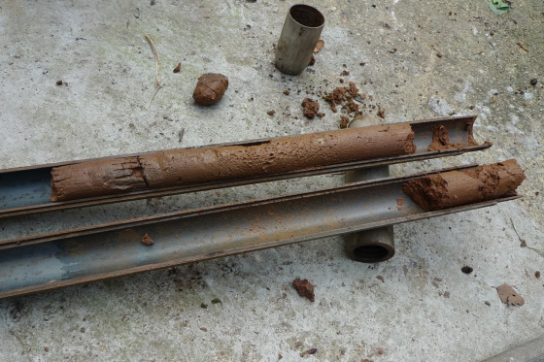
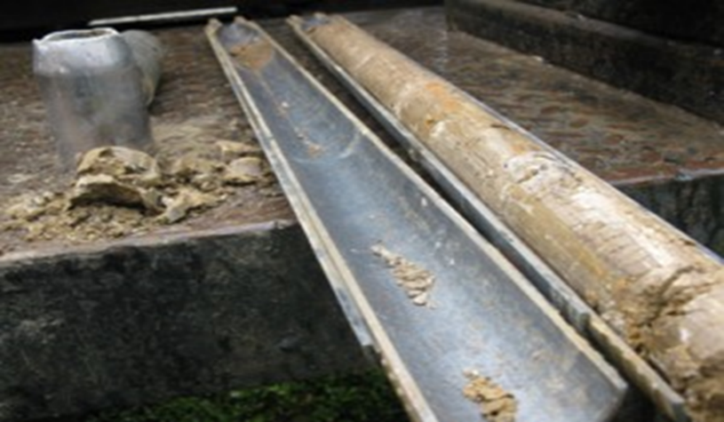
MGC Ltd decided to implement the Diaphragm Wall system due to the makeup of the ground. The diaphragm wall system is ideal for use when its locations. Diaphragm walls can be used in most needing a large basement. It is also very useful when constructing large buildings within inner ground conditions to construct underground stations in city centers, multi-level underground car parks, road junctions and underpasses, and open cut and cut & cover rail tunnels – as well as deep shafts for tunnel ventilation, intervention shafts and water treatment plants. Diaphragm walls are often located in confined inner-city areas where space is at a premium.
Clay sample taken from site.
Land at Port Talbot Parkway September 2011
(www.archearitage.co.uk)

Clay sample taken from site.
Land at Port Talbot Parkway September 2011
(www.archearitage.co.uk)

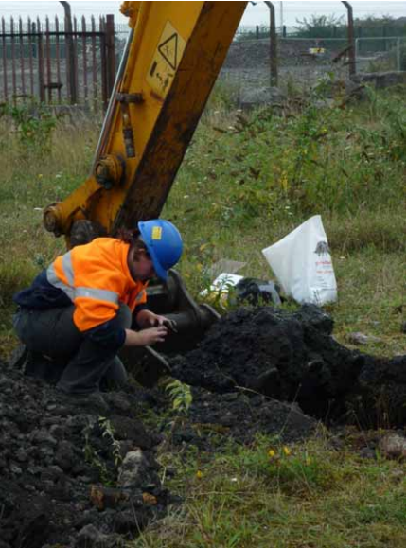
Land at Port Talbot Parkway September 2011
(www.archearitage.co.uk)

Environmental issues
The possible of natural environment features that linked the new project in Port Talbot Library is to identify as a formal process used to predict the environment consequences of any development project and we make ensure that the potential problems are foreseen and addressed at an early stage in the projects planning and design and make sure to assessed and investigate the following environment features:
Land use Port Talbot Library
The assessment of the effects of land-take, for Port Talbot Library scheme, can cover a wide range of land values and primary uses. Group of specialists will need to assess the potential effects land take for scheme can cover a wide range of land values and primary uses.
Dust pollution.
To control any of the dusty that coming from the construction
Noise pollution
To reduce any noise pollution on the construction site we could use quite power tools and we could use different wall structures such as sound shields. The construction industry is a major source of pollution responsible for around 4% of particulate emissions more water pollution incident than any other industry and thousands of noises and complaints every year. Although construction activities also pollute the soil the main areas of concern are water and noise pollution.

Dust pollution.
To control any of the dusty that coming from the construction site and on the road the site could be dampened down with fine sprays of water. This will catch the dust and stop if form travelling through the air.
In Site must include the works area, working space and safety zone in the area to be marked off with cones, or barriers. Warning lights should be placed where necessary.
You must provide safety zones when either: Operatives are present, or a pedestrian walkway is in the site.
The ecologist visits the site of the project cross project are to collecting baseline information. The team will use this information to describe and assess the potential effects on plants and animals within land taken area.
The heritage assessment will include a review of existing information, followed by a field walking. This will enable that the group specialists to identify and value the heritage assets of the site area include Tree Preservation Order (TPO)
Finding and recommendations
1.According to the history of site and baseline information of Port Talbot Council data site investigations information, we found that Port Talbot Parkway rail station was former steelworks southwest of the permanent way. For that reason, we need to consider possible Technogenic magnetic particles (TMPs) are specific type of soil pollutant often originating from steelwork sits. During construction we should take Soil samples were sent for routine as result of Asbestos test and documents any contamination.
If there is any indication of Asbestos/ contamination, we need to use Consultant/ analytical laboratories which have necessary skill and experience may require which is cost £445 low range contaminated land and £1900 on high range according to www.groundconsultant.co.uk that is produce extra cost for client.
2. during site visit 18 October 2023 we figure out same trees on the site and we found species in the trees due to the site nearly close to the river Afan its always command to find some species and birds the trees near to the rivers.
Ecological Survey
The ecologist visits the site of the project cross project are to collecting baseline information. The team will use this information to describe and assess the potential effects on plants species and animals within land taken. And Ecological survey will cost £400-£7000 According to (www.ecologysurveys.uk). That is bring extra cost for client.
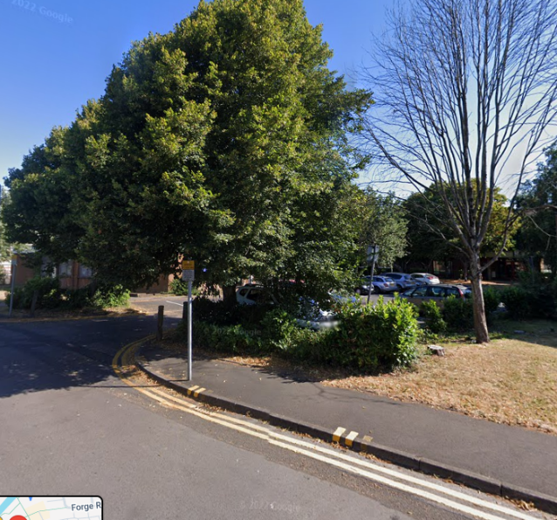
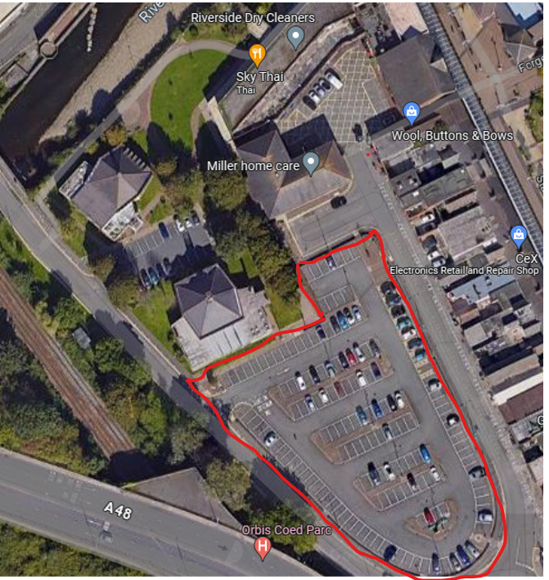
Tree Assessment also needed survey, without permission its an offence to cut tree or damage the TPO face fine up to £20 000. For that reason we need Consultant conduct survey which cost £300 according to (www.arborescencetreecare.co.uk/how-much-does-a-tree-survey-cost-uk)
Site location Trees we found near site.

Reference
(www.archearitage.co.uk PDF Desk Top Study & Ground Investigation for Port Talbot Parkway accessed 20 October 2023)
(www.ggat.org.uk) PDF Archaeological Watching Brief - Port Talbot Parkway Accessed 28October 2023
(www.quantum-geotech.co.uk) PDF The Plaza Cinema, Port Talbot Ground Investigation Report 2019 Accessed 14 November 2023
(www.ecologysurveys.uk) Accessed 18April 2024
(www.arborescencetreecare.co.uk/how-much-does-a-tree-survey-cost-uk) Accessed 18April 2024.

