"Driving Sustainability in the Hotel and Hospitality Industry: A Report on Sustainable Accreditation and its Implications"
Assignment 2
Module code: BMIH5006
Student name: Andreea Marin
Student number: 2206723
Lecturer name: Huw Thomas

Executive Summary
Many hotels are trying to be greener and seeking certification like Green Key. This suggests that the hotel business is becoming more environmentally conscious. This article examines what is required to achieve sustainable approval, the merits and downsides of adding sustainability, and new hotel and hospitality company opportunities. The key findings suggest that although conserving money and improving operations are positives, hotels nevertheless face issues such the large initial investment and logistical management. Future sustainability initiatives in the sector are projected to develop. Changing consumer expectations and industry rules will trigger this. Hotels should prioritise sustainability and follow new trends to be competitive and satisfy stakeholders.

Table of Contents
Introduction 4
Sustainable Accreditation Requirements 4
Benefits and Challenges of Sustainability Integration 6
Future Outlook for the Hotel & Hospitality Industry 9
Conclusion 12
Analysis and Recommendations 13
References 14

Introduction
Environmental awareness is growing in the restaurant and leisure industry. Increasing environmental awareness and changing client preferences are driving this transformation. Hotels are realising how crucial it is to include environmentally friendly measures into their everyday operations and are working hard to acquire clearance(Abdou, Hassan and Dief, 2020). This article discusses sustainable certification standards, sustainability merits and downsides, and industry prospects. This research examines five key aspects to assess hotel and restaurant sustainability. The periodical will also provide eco-friendly hotel suggestions. With sustainability becoming more crucial to companies worldwide, the hotel sector must thoroughly comprehend its consequences to remain ahead of the competition and suit the expectations of eco-friendly tourists.

Sustainable Accreditation Requirements
Sustainable approval can show what a hotel needs to do to be socially and environmentally responsible. To get accredited, you must meet the requirements of foreign certification programmes like the Green Key award.

Criteria for Sustainable Accreditation
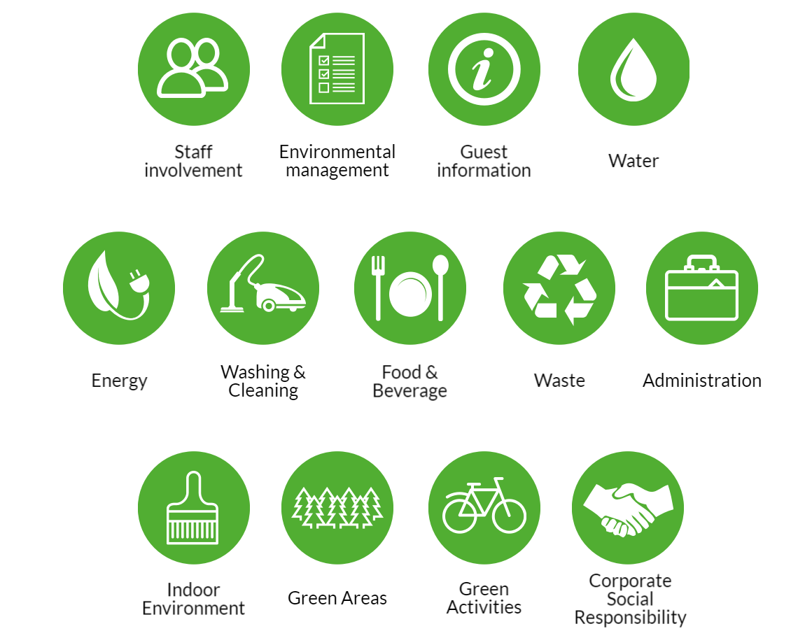
Figure 1: Criteria for Sustainable Accreditation
(Source: Al-Shetwi, 2022)
For hotels to get sustainable approval, they may have to save water, deal with waste, use less energy, and involve the community in their operations. Hotels need to start sustainable programmes to lessen the damage they do to the earth. Some of these projects are recycling, lighting that uses less energy, and using green energy(Almuhaideb and Saeed, 2020). Companies must also show they care about society by giving back to their communities, working for fair wage standards, and hiring people from a wide range of backgrounds.
Procedures for Compliance
A full review of the hotel's processes and equipment is the first step towards getting sustainable approval. Hotels must make and follow through on action plans to get better after the review. To get people to support sustainable efforts, it may be necessary to spend money on eco-friendly technology, train staff, and involve stakeholders. After the necessary steps have been taken, the hotel is inspected by trained inspectors. This review checks to see if the hotel meets the requirements for approval.
Information and Reports
For hotels to get certified, they need to keep track of their environmental efforts and be able to show that they are following the rules during exams. To do this, we need to keep an eye on greenhouse gas pollution, water use, trash, and energy use(Feng et al., 2020). Also, hotels have to give monthly sustainable reports that show their approval status, as well as what they've done well and what they could do better.
Financial Considerations
Even though there are many perks, hotels might not be able to afford to meet the requirements for sustainable approval. Upgrades to facilities and technologies that use less energy may be pricey, so planning your budget and allocating your resources wisely is very important. It's important to remember that these purchases usually save money in the long run(Jowitt, 2020). You may be able to save money by having lower energy bills, operating costs, brand recognition, and competition in the market.
Continuous Improvement
For approval to be sustainable, it needs to keep getting better. Hotels need to review and change their sustainable plans on a regular basis to keep up with changes in the industry and new environmental worries(Kansakar, Munir and Shabani, 2019). Hotels could lead the way in responsible travel and help people and the environment if they encourage new ideas and long-term thinking.

Benefits and Challenges of Sustainability Integration
Sustainable hotel business practices safeguard the environment and boost brand image. Despite these advantages, hotels must face several challenges while implementing and maintaining ecologically friendly practices.

Benefits of Sustainability Integration
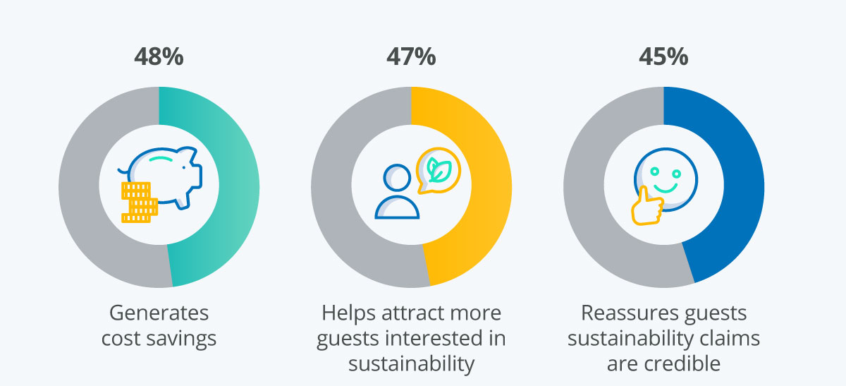
Figure 2: Benefits of Sustainability Integration
(Source: Litvinenko et al., 2022)
Sustainability in hotel activities is good for more than just protecting the environment. Some of these are better operating effectiveness, lower costs, and a better image for the company. First, sustainable methods save resources(Siddiki et al., 2022). For example, by using less water, electricity, and trash, the hotel has less of an effect on the earth. Hotels help save resources and the environment by using smart heating, ventilation, and air conditioning systems, water-saving features, and lighting that uses less energy. These programmes help reach global environmental goals and show hotels as responsible stewards of the Earth's limited resources(Yogesh, Khedkar and Pawar, 2019). Second, using eco-friendly methods helps hotels save money over time. Investing in tools that use less energy and reducing waste lowers power bills, operating costs, and the cost of getting rid of trash. By cutting waste and making better use of resources, hotels may be able to run more efficiently, make more money, and stay in business. Sustainability also makes a brand more well-known and competitive in the market(Abdou, Hassan and Dief, 2020). Hotels that show they care about the environment by getting certification and being open with their customers may stand out and attract people who care about the environment. Customers arrange excursions with the environment in mind. Sustainable hotels that collaborate to tackle environmental issues may fare better in the market(Al-Shetwi, 2022). This will boost brand trust, like, and respect. Sustainable practices strengthen relationships with consumers, employees, the community, and government authorities. Participating in sustainability initiatives develops trust, openness, and cooperation, which boosts long-term corporate success. Sustainable practices in a hotel's fundamental values and operations may improve visitor satisfaction, worker morale, and stakeholder value. Sustainability improves the environment, differentiates your company, and engages stakeholders(Almuhaideb and Saeed, 2020). These benefits will make hotels responsible tourist leaders and revolutionise the global hospitality industry.
Challenges of Sustainability Integration
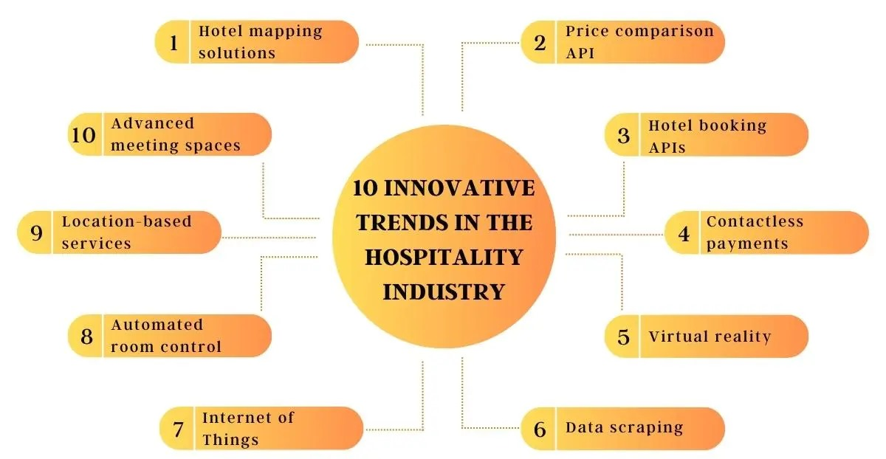
Figure 3: Challenges of Sustainability Integration
(Source: Feng et al., 2020)
Sustainable hotel practices have many advantages, but many issues must be resolved before they can be implemented and maintained. One of the major issues restaurants face is green project startup expenses. Improving infrastructure, adopting energy-efficient technologies, and becoming green may be expensive for smaller enterprises(Kansakar, Munir and Shabani, 2019). These measures may also benefit the environment. Some hotels may struggle to embrace environmentally friendly practices because they must compare the expenses against the long-term advantages. Changing how things are done and how personnel behave to include sustainability into everyday operations may be tough for businesses. Hotels must solve several logistical issues to keep customers happy and service quality good(Litvinenko et al., 2022). Trash, energy, and green shopping are among these issues. Workers that don't want to change, don't comprehend, or hold to old behaviours may make implementation harder. Therefore, constant education and process. Third, restaurants in varied regulatory regimes struggle to comply with environmental standards. To navigate the complex municipal, national, and international environmental laws, one must be vigilant and comply(Siddiki et al., 2022). Hotels must keep up with new legislation and adjust their practices to prevent penalties and brand harm. Because there are communication activities are essential to get workers engaged in the application no standard measures or data collection methods, it may be difficult to evaluate environmental projects and report on success. Hotels and restaurants must invest in monitoring and reporting technologies to measure KPIs and satisfy stakeholders. For enduring impact, visitors and workers must modify their behaviour and thinking. Sustainability may be difficult if individuals are hesitant to adapt, lack understanding, or follow outdated methods. Keeping individuals engaged in learning and conversing may solve these issues. Hotel management, personnel, and others must collaborate to tackle the issues(Yogesh, Khedkar and Pawar, 2019). Developing and generating new ideas ethically requires devotion. If they address these issues and exploit sustainability possibilities, hotels may generate value for everyone, reduce their environmental footprint, and become global hotel stars.

Future Outlook for the Hotel & Hospitality Industry
Over the next several years, the hotel and restaurant sector will alter drastically. Changes in client preferences, new technology, and sustainability tendencies will create this. This section examines the industry's future and the biggest trends and possibilities hotels could seize to be competitive and long-lasting.

Sustainable Tourism as a Key Driver
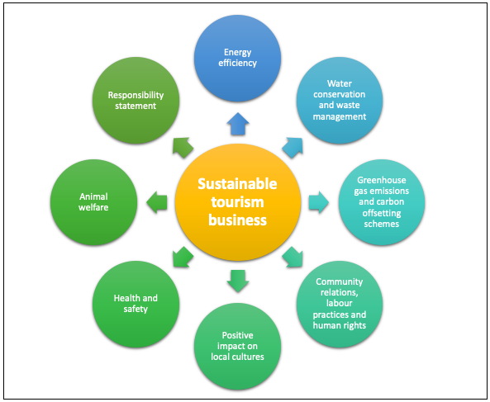
Figure 4: Sustainable Tourism as a Key Driver
(Source: Abdou, Hassan and Dief, 2020)
Hotel and hospitality industry growth and new ideas may be driven by sustainable tourism. As caring for the environment and travelling responsibly grow in importance, hotels that put sustainability first will have an easier time getting people who care about the environment. Sustainable practices like using less energy, reducing trash, and getting involved in the community all help the earth and people while also improving the image and attraction of hotels. Hotels can become leaders in responsible travel by promoting sustainable tourism and getting certified. This will help them attract more customers who care about the environment.

Technological Innovation and Guest Experience
New technology will affect how tourists feel in the leisure business, including hotels. New technologies like mobile check-in, keyless access, and virtual butler services will simplify, streamline, and direct hotel services(Al-Shetwi, 2022). In-room automation systems allow visitors to easily adjust their hotel settings and utilise the utilities, creating customised experiences. Augmented and virtual reality may allow travellers to digitally explore areas or access interactive material, making their trips more interesting. These technology innovations allow hotels to provide seamless, memorable, and customised experiences for tech-savvy guests. This makes visitors happy and more loyal towards the firm.
Embrace of Circular Economy Principles
The hotel and leisure industry's use of circular economy principles has led to more sustainable resource management and reduced waste. Circular economy strategies are growing in popularity to reduce waste, maximise resources, and profit from rubbish. This objective may be achieved by composting food waste, reusing water, and repurposing goods and structures(Almuhaideb and Saeed, 2020). A cycle economy helps firms save money, function more effectively, and encourage innovative environmental protection initiatives while reducing their environmental impact. A circular economy perspective may help hotels shift away from the "take-make-dispose" paradigm and towards regenerative and resilient practices. It supports bigger environmental aims and aids the sector's future.
Shift Towards Wellness and Well-being
More hotels prioritise visitors' physical, social, and emotional wellness. Wellness and well-being are becoming more important in the hotel and hospitality sectors. (Feng et al., 2020)Hotels are also harnessing nature to enhance visitor experiences and help them relax, recuperate, and learn. Hotels can meet the increased need for health-conscious travel and well-being to distinguish out and make visitors happy. This fitness and well-being trend is part of a societal change towards self-care and awareness. It also reflects the industry's commitment to travellers' overall well-being.

Collaboration and Partnerships for Impact
To maximise hotel and leisure industry environmental efforts, collaboration and connections are essential. Communities, NGOs, government agencies, and industry players will collaborate with hotels to promote environmental, social, and community development. Hotels can improve their efforts, build more comprehensive sustainable initiatives, and solve difficult challenges by sharing resources, talents, and networks(Kansakar, Munir and Shabani, 2019). Hotels will be able to enter new markets, discuss best practices, and be motivated to reinvent their companies in environmentally friendly ways. Working with hotels can produce shared value, strengthen communities, and make the hospitality sector more sustainable and inclusive.

Conclusion
Future prosperity depends on how well the hotel and hospitality industry prioritises sustainability and improves the sector. Beginning investment expenditures, running the company, and meeting standards might make sustainability difficult. However, it offers significant benefits. These advantages include saving money, resources, and brand image. Hotels must emphasise sustainability, invest in technology and innovative ideas, engage with stakeholders, and innovate to be competitive in a sustainable society. Hoteliers may become more competitive, boost business, and ensure the hotel and hospitality sector's future by doing so. Being green is the right thing to do, but it can also help hotels make money, stimulate new ideas, and create a more sustainable and inclusive industry.

Analysis and Recommendations
Looking at how sustainability may be employed in the hotel and hospitality business indicates that environmentally conscious hotels confront both possibilities and obstacles. Hotels face significant start-up costs, intricate operations, and strict regulations when adding sustainability(Yogesh, Khedkar and Pawar, 2019). Sustainability saves resources, cuts expenses, and boosts the company's image. Hotels may avoid these issues and maximise environmental benefits by following this advice: The organisation should first make sustainability a strategic imperative and incorporate sustainability objectives in company goals, success measurements, and decision-making. From frontline workers to executives, the organisation must foster a culture of sustainability(Siddiki et al., 2022). The company must also meet consumer demands and industry norms. The second phase is to invest in new technologies and ideas to improve operations and reduce environmental effect. Hotels might consider implementing energy-saving, water-saving, and waste-reduction technologies. By doing this, they may be able to leverage innovative technology to save resources and reduce waste. In phase three, stakeholders must work together to increase sustainability(Litvinenko et al., 2022). Hotels may collaborate with local communities, NGOs, government agencies, and industry partners to promote environmental action, share best practices, and develop more sustainable solutions. Improve and prolong methods. Success must be analysed and sustainable ideas implemented. Monitor progress, highlight successes, and alter your strategy as market and government demands change using monitoring technologies, data analytics, and partner feedback(Kim, Barber and Kim, 2018). Hotels that emphasise sustainability and follow these rules may be able to compete, earn more money, and be more versatile and long-lasting.

References
Abdou, A.H., Hassan, T.H. and Dief, M.M.E. (2020). A Description of Green Hotel Practices and Their Role in Achieving Sustainable Development. Sustainability, [online] 12(22), p.9624. doi:https://doi.org/10.3390/su12229624.
Al-Shetwi, A.Q. (2022). Sustainable development of renewable energy integrated power sector: Trends, environmental impacts, and recent challenges. Science of The Total Environment, 822(822), p.153645. doi:https://doi.org/10.1016/j.scitotenv.2022.153645.
Almuhaideb, A.M. and Saeed, S. (2020). Fostering Sustainable Quality Assurance Practices in Outcome-Based Education: Lessons Learned from ABET Accreditation Process of Computing Programs. Sustainability, 12(20), p.8380. doi:https://doi.org/10.3390/su12208380.
Feng, H., Wang, X., Duan, Y., Zhang, J. and Zhang, X. (2020). Applying blockchain technology to improve agri-food traceability: A review of development methods, benefits and challenges. Journal of Cleaner Production, [online] 260(1), p.121031. doi:https://doi.org/10.1016/j.jclepro.2020.121031.
Jowitt, P.W. (2020). Systems and sustainability. Civil Engineering and Environmental Systems, 37(4), pp.253–263. doi:https://doi.org/10.1080/10286608.2020.1839892.
Kansakar, P., Munir, A. and Shabani, N. (2019). Technology in the Hospitality Industry: Prospects and Challenges. IEEE Consumer Electronics Magazine, 8(3), pp.60–65.
Kim, Y.H., Barber, N. and Kim, D.-K. (2018). Sustainability research in the hotel industry: Past, present, and future. Journal of Hospitality Marketing & Management, 28(5), pp.1–45. doi:https://doi.org/10.1080/19368623.2019.1533907.
Litvinenko, V., Bowbriсk, I., Naumov, I. and Zaitseva, Z. (2022). Global guidelines and requirements for professional competencies of natural resource extraction engineers: Implications for ESG principles and sustainable development goals. Journal of Cleaner Production, [online] 338, p.130530. doi:https://doi.org/10.1016/j.jclepro.2022.130530.
Siddiki, Sk.Y.A., Mofijur, M., Kumar, P.S., Ahmed, S.F., Inayat, A., Kusumo, F., Badruddin, I.A., Khan, T.M.Y., Nghiem, L.D., Ong, H.C. and Mahlia, T.M.I. (2022). Microalgae biomass as a sustainable source for biofuel, biochemical and biobased value-added products: An integrated biorefinery concept. Fuel, [online] 307, p.121782. doi:https://doi.org/10.1016/j.fuel.2021.121782.
Yogesh, Khedkar, E. and Pawar, S. (2019). Challenges and solutions to the development of the tourism and hospitality industry in India. African Journal of Hospitality, Tourism and Leisure, [online] 8(3). Available at: https://www.ajhtl.com/uploads/7/1/6/3/7163688/article_67_vol_8_3__2019.pdf.

