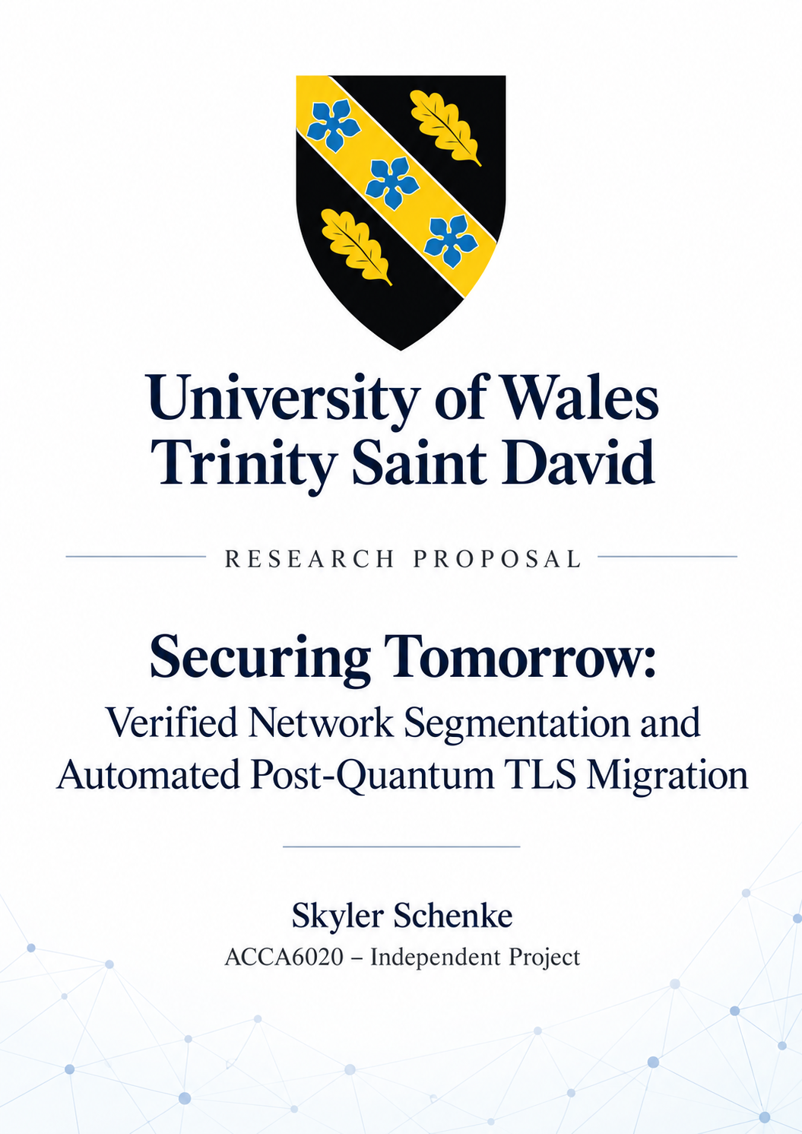

Table of Contents
1. Introduction 2
2. Background to the Proposed Research 3
3. Research Problem Statement 5
4. Research Aim and Objectives 5
5. Research Methodology 6
5.1 Research Design 6
5.2 Materials 6
6. Project planning 6
7. References 7

Introduction
Enterprise networks must protect sensitive information against existing cyber threats while maintaining high service availability. Lateral movement is a persistent security threat, allowing attackers to move deeper into compromised networks to access valuable systems and information [1]. As well as existing threats, the development of quantum computing presents a future risk to widely used public-key cryptography, particularly RSA and elliptic-curve cryptography [2].
Network segmentation is the process of dividing a network into subnetworks through the use of VLANs and firewalls. It is an important defence against lateral movement (LM), which is a central tactic in contemporary cyberattack methodologies and an important consideration in threat modelling [1]. Inadequate network segmentation or misconfigured firewall rules can allow LM, whilst overly restrictive configurations may disrupt legitimate services. Therefore ensuring accurate segmentation and configuration is essential in restricting unauthorised access without affecting availability [3].
Sufficiently powerful quantum computers are a future threat, but the risks they present are already relevant today. Although such computers are not currently capable of breaking widely used public-key cryptography, organisations need to prepare for their development. TLS is widely used to secure network communications, which makes preparing for post-quantum TLS migration important. One reason organisations need to prepare now is that attackers can collect encrypted data today and potentially decrypt it using sufficiently powerful quantum computers in the future. This is known as “harvest now, decrypt later” [4].
Configuring network segmentation or deploying post-quantum TLS does not automatically prove that either works as intended. Implementing these changes requires testing to ensure security requirements are met while maintaining legitimate connectivity. The purpose of the proposed tool is to verify network segmentation and to automate, test and evaluate hybrid post-quantum TLS migration. The complications of enterprise security, alongside the interest in developing a practical tool with real economic value, motivate this research. The aim is to produce a working system with measurable results that demonstrate its effectiveness.

Background to the Proposed Research
As Chen et al. [3] evaluated, the generation of restrictive micro-segmentation policies limited attackers' lateral movement within the evaluated environments. Their study analysed 184 services across 61 projects, successfully generating restrictive policies for over 96.7% of projects. This demonstrates the effectiveness of automatically generating policies through service configuration analysis. However, the evaluation concerns cloud-native applications, meaning the findings should not be generalised to every enterprise network. Furthermore, the research focuses on generating policies rather than verifying and repairing firewall errors after deployment.
Firewall rules control permitted traffic between network segments. Bringhenti et al. [5] reviewed existing approaches to network security configuration automation, identifying developments and continuing limitations in the field. However, overly permissive, conflicting or incorrectly ordered rules can undermine intended restrictions. As a consequence, unauthorised connections may become possible, while overly restrictive rules can interrupt required services. Hu et al. [6] investigated methods for detecting and resolving firewall policy anomalies. Ceragioli et al. [7] also demonstrated that different firewall systems cannot necessarily enforce the same policies. These findings highlight the importance of checking whether a security policy can be implemented and whether the required connectivity is maintained.
The purpose of segmentation verification is to check whether actual or modelled network connectivity matches the intended access policy. Batfish is an existing tool that analyses network configurations to identify potential errors [8]. Its benefit is checking connectivity and proposed changes before applying them. Diekmann et al. [9] also developed a formally verified approach for analysing iptables firewall rules using Isabelle/HOL. Both approaches provide methods for analysing network configurations, although their techniques differ. However, configuration analysis does not itself demonstrate that applications work on the running network. Practical connectivity testing therefore provides complementary evidence.
Detecting a configuration error is only the first step; it must then be corrected. Gember-Jacobson et al. [10] developed an automated repair approach using MaxSMT, treating repair as a constraint-solving problem that seeks configuration changes satisfying specified network requirements while minimising repair costs. Their research evaluated 96 data-centre networks, producing repairs in under one minute for 98% of those networks. However, the correctness of repairs depends on the requirements provided. An omitted access restriction could therefore remain unenforced. This supports defining explicit permitted and prohibited connections and testing them after changes are applied.
The public-key mechanisms used in conventional TLS rely on mathematical problems that sufficiently powerful quantum computers could solve. This creates the concern of attackers collecting encrypted traffic now and decrypting it later, known as “harvest now, decrypt later” [11]. Organisations therefore need to prepare for post-quantum migration, particularly where information must remain confidential for many years.
Hybrid post-quantum TLS combines classical and post-quantum key exchange, retaining classical protection while introducing protection against future quantum attacks. However, migration presents challenges involving compatibility, larger handshake messages and potential performance overhead. Rubio García et al. [12] investigated quantum-resistant TLS using a different hybrid approach combining post-quantum cryptography and quantum key distribution, demonstrating practical implementation and performance trade-offs. Montenegro et al. [13] evaluated classical, hybrid and post-quantum TLS configurations, examining handshake performance and communication overhead under controlled network conditions. Farooq et al. [14] also evaluated post-quantum algorithms in TLS, showing that handshake performance and computational requirements vary between algorithms and operating systems. These studies demonstrate the need to consider performance and compatibility during migration, but do not establish the effects of combining migration with firewall verification and repair. The proposed tool will therefore verify the negotiated key exchange and measure connection success and handshake time after migration.
Existing research demonstrates developments in segmentation verification, automated configuration repair and post-quantum TLS deployment. However, the reviewed approaches focus on different parts of the security process. Batfish provides network configuration verification [8], Gember-Jacobson et al. [10] investigated automated network repair, while Montenegro et al. [13] evaluated post-quantum TLS performance. These approaches do not establish whether combining segmentation verification, firewall repair and hybrid TLS migration into one workflow can reduce manual effort and missed failures. This research will investigate this combination through practical connectivity testing, TLS verification and rollback, while measuring whether legitimate services remain operational.

Research Problem Statement
Security changes can leave unwanted access, disrupt legitimate services affecting availability, or fail to provide the intended TLS protection. Checking configuration alone does not establish that running services meet all specified requirements. This research therefore investigates whether a combined automated workflow can reduce manual effort and missed failures compared with a manual workflow using existing tools.

Research Aim and Objectives
The overarching aim is to develop and evaluate a tool combining segmentation verification and automated hybrid post-quantum TLS migration, investigating whether it reduces manual effort, maintains service availability and reduces missed failures.
There are four objectives:
- Analyse relevant research and existing tools to define network access requirements, TLS requirements and evaluation criteria.
- Design an isolated virtual environment with permitted and prohibited connections, a TLS service and reproducible fault scenarios.
- Develop a prototype that verifies segmentation, repairs selected firewall errors, migrates the TLS service, retests changes and rolls back specified failures.
- Evaluate the prototype against a manual workflow using existing tools, measuring fault detection, operator effort, connection success, handshake time and recovery time.
Deliverables: A working prototype and source code, documented lab configurations, test results and an evaluation report.

Research Methodology

5.1 Research Design
Design Science Research (DSR) is the chosen research design, as the project involves developing a cybersecurity tool and evaluating its effectiveness [15]. A simulated virtual corporate network will be created to test segmentation verification, firewall repair and hybrid TLS migration. The research will use software development and controlled quantitative experiments, comparing automated and manual workflows against identical fault scenarios.
Data collected will include fault detection, connection success, handshake time, service downtime, operator effort and recovery time. Results will be analysed using detection and connection success rates, alongside average timings and operator effort. Repeated experiments will help identify inconsistencies between results.
The isolated lab may not represent real-world network traffic, limiting generalisability. However, using identical virtual machines, network configurations and fault scenarios will support reliability. For validity, detected faults will be checked against deliberately introduced misconfigurations. Successful repairs will be confirmed by testing permitted and prohibited connections, while TLS migration will be verified through negotiated cryptographic algorithms. Ethically, testing will remain within isolated virtual machines using synthetic traffic.

5.2 Materials
A computer with 32 GB RAM will support the virtual environment. VirtualBox and Linux will provide the isolated network, while Python will be used for verification and automation. OpenSSL with post-quantum support will enable hybrid TLS testing, and Wireshark will analyse network traffic. React and FastAPI will support the interface and backend. Test results and logs will provide the quantitative data for evaluation.

Project planning
The project will follow a structured timeline as shown in Figure 1. The Gantt chart identifies key activities, milestones and their corresponding timescales. It covers research, development, testing, evaluation and future improvements and scaling.
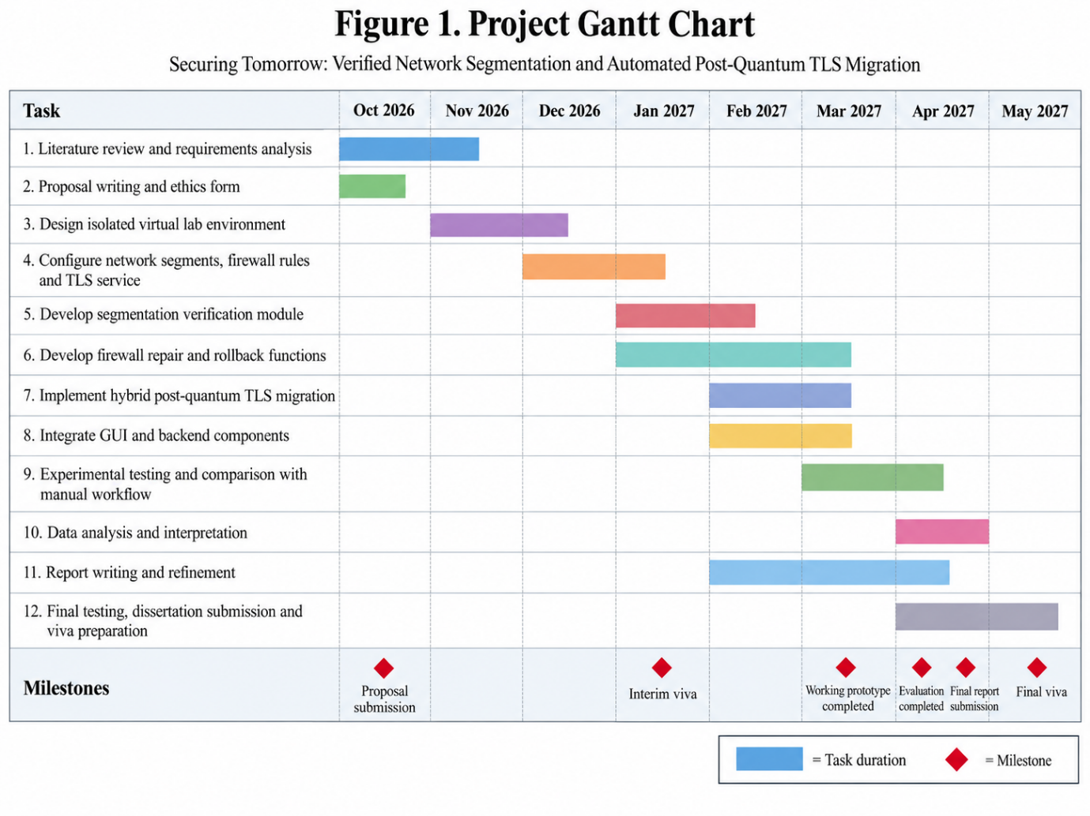

7. References
[1] C. Smiliotopoulos, G. Kambourakis, and C. Kolias, “Detecting lateral movement: A systematic survey,” Heliyon, vol. 10, no. 4, Art. no. e26317, 2024, doi: 10.1016/j.heliyon.2024.e26317.
[2] K. Cherkaoui Dekkaki, I. Tasic, and M.-D. Cano, “Exploring post-quantum cryptography: Review and directions for the transition process,” Technologies, vol. 12, no. 12, Art. no. 241, 2024, doi: 10.3390/technologies12120241.
[3] A. Chen, Z. Jin, Z. Li, Y. Chen, Y. Ning, and Y. Wang, “AutoSeg: Automatic micro-segmentation policy generation via configuration analysis,” Computers & Security, vol. 157, Art. no. 104591, 2025, doi: 10.1016/j.cose.2025.104591.
[4] S. Baradziej, “Harvest now, decrypt later as a cross-sector threat: A scoping review of data-confidentiality lifetimes against post-quantum migration readiness,” International Journal of Computational Intelligence Systems, 2026, doi: 10.1007/s44196-026-01526-2.
[5] D. Bringhenti, G. Marchetto, R. Sisto, and F. Valenza, “Automation for network security configuration: State of the art and research trends,” ACM Computing Surveys, vol. 56, no. 3, 2024, doi: 10.1145/3616401.
[6] H. Hu, G.-J. Ahn, and K. Kulkarni, “Detecting and resolving firewall policy anomalies,” IEEE Transactions on Dependable and Secure Computing, vol. 9, no. 3, pp. 318–331, 2012, doi: 10.1109/TDSC.2012.20.
[7] L. Ceragioli, P. Degano, and L. Galletta, “Can my firewall system enforce this policy?,” Computers & Security, vol. 117, Art. no. 102683, 2022, doi: 10.1016/j.cose.2022.102683.
[8] A. Fogel et al., “A general approach to network configuration analysis,” in Proc. 12th USENIX Symposium on Networked Systems Design and Implementation (NSDI), 2015, pp. 469–483.
[9] C. Diekmann, L. Hupel, J. Michaelis, M. Haslbeck, and G. Carle, “Verified iptables firewall analysis and verification,” Journal of Automated Reasoning, vol. 61, pp. 191–242, 2018, doi: 10.1007/s10817-017-9445-1.
[10] A. Gember-Jacobson, A. Akella, R. Mahajan, and H. H. Liu, “Automatically repairing network control planes using an abstract representation,” in Proc. 26th ACM Symposium on Operating Systems Principles (SOSP), 2017, pp. 359–373, doi: 10.1145/3132747.3132753.
[11] F. Kagai, P. Branch, J. But, and R. Allen, “Harvest-now, decrypt-later: A temporal cybersecurity risk in the quantum transition,” Telecom, vol. 6, no. 4, Art. no. 100, 2025, doi: 10.3390/telecom6040100.
[12] C. Rubio García et al., “Quantum-resistant transport layer security,” Computer Communications, vol. 213, pp. 345–358, 2024, doi: 10.1016/j.comcom.2023.11.010.
[13] J. A. Montenegro, R. Rios, and J. Lopez-Cerezo, “A performance evaluation framework for post-quantum TLS,” Future Generation Computer Systems, vol. 175, Art. no. 108062, 2026, doi: 10.1016/j.future.2025.108062.
[14] S. Farooq et al., “Analyzing post-quantum cryptographic algorithms efficiency for transport security layer,” Computers and Electrical Engineering, vol. 125, Art. no. 110437, 2025, doi: 10.1016/j.compeleceng.2025.110437.
[15] A. R. Hevner, S. T. March, J. Park, and S. Ram, “Design science in information systems research,” MIS Quarterly, vol. 28, no. 1, pp. 75–105, 2004, doi: 10.2307/25148625.

