

PORTFOLIO
Postgraduate Certificate in Teaching
in Higher Education
(Advanced HE accredited)

UNHE7007 Effective Teaching & Assessment
in Higher Education

For: Mark FLAGG, Programme Lead, PG Cert tHE
By: Antoinette Milne (#2326711)
Approximately 8000 words

January 2025

January 2025

I confirm that I have not used any AI tools in the research and creation of this assignment. I confirm that I have not presented any AI generated materials as my own work. I confirm I have copies of my drafts, notes, and other resources I used, which I may be asked to provide in evidence.
Antoinette Milne
December 8, 2024

TABLE OF CONTENTS

Page
Teaching Statement 4
Microteach 7
Link to Microteach 20
Microteach Reflection 21
Teaching Intervention 22
Observation #1 (Antoinette Milne, Observer) 32
Observation #2 (Charlotte Joyner Observer) 36
Observation #3 (Chris Wilkin, Observer) 40
CPD #1 WSET (Wine & Spirit Education Trust) 44
CPD #2 Artificial Intelligence (Dr. Tim Bashford) 46
CPD #3 Humour and Laughter (Michaela Shriek, MSc) 48
Appendix A: Teaching Hours Log 50

STATEMENT ON TEACHING AND LEARNING

For: Mark Flagg
By: Antoinette Milne
April 3, 2024

Starting out on this PG Cert tHE journey with Mark and the cohort, I am excited to learn as much as possible about teaching and learning theories and approaches, so that I can be a more effective teacher. My speciality subject is wine and overall, hospitality management.

From experience, I believe that teaching and learning are a dynamic and interdependent activity, where teaching is a planned, structured activity and spontaneous interaction can be helpful for enhanced learning, as it can encourage the trust, passion and engagement of the students, who are at the heart of both. Reece and Walker (2007, P. 62), mention how teaching responds to and reflects how students learn.

I am learning the difference between pedagogy and andragogy. According to Knowles et al (2020, p. 51, 52), andragogy focuses on the adult learner where the Educator is a facilitator, encouraging student self-direction.

I believe that it is crucial to ensure that the learning environment is safe, welcoming and inclusive. To do this, I welcome everyone at the beginning and give time for students to settle in. An icebreaker to start, usually helps to lighten the mood.

I have been aware that students learn in different ways, though unsure about these ways. I am learning about classic learning theories, such as Behaviourism, Cognitivism, Humanism and Educational Neuroscience (Bates, 2023, p. 27, 43, 59, 71). I endeavour to present to students in various ways, auditory (group discussions), visual (videos) and tactile/kinaesthetic such as wine tasting, (Reece and Walker, 2007, p. 141, 142) and in this way, all or most students can be accommodated and have equal opportunities to learn as much as possible. I am also learning about Bloom’s theories and taxonomies and how they impact learning and evaluation (Aubrey and Riley, 2016, p. 73, 77, 78). I am aware of the deep approach to learning, as compared to the surface approach (Biggs, Tang and Kennedy, 2022, p.22-25) and favour the deep approach when teaching, so that students learn effectively.

I always prepare a lesson plan with learning outcomes (Bates, 2023, p. 31) and have learned to include the importance of the topic, so learners can relate to their own goals (Bates, 2023, p. 39, 45, 93), which can help to motivate. Also, determining prior knowledge (Bates, 2023, p. 37) is important to take into consideration to ensure student interest. Briefly reviewing the previous lesson (Bates, 2023, p. 55) can help to prepare students for the current lesson.

During the lesson, I try to be aware of any students not participating or engaging and gently attempt to draw them out. I monitor the level of attention, interest and individual needs. Breaks are taken every hour and/or when needed. At the end of the session, there is a summary of what has been discussed.

According to Reece and Walker (2007, P. 22, 23), the introduction to a lesson can serve to motivate learning and the conclusion can be used to maximise information being retained. I have sometimes run out of time and the conclusion sometimes rushed. Armed with this new found knowledge, I will ensure to leave enough time. 10% of the total time of the lesson is suggested for the summary (Reece and Walker, 2007, p. 23).

I have felt that it is important to ensure students are supported, by discussing this openly. For example, we discuss the importance of understanding the tasks clearly, that they can get in touch with me via email and/or Teams and that the Student Hwb provides much support.

When I teach, I am respectful and considerate to all students. If a student is having difficulty understanding a point, I am patient and take the time to make sure the student understands. It may mean talking after class. During class, we frequently discuss how the learning relates to professional practice, (independent restaurants).

To determine if the learning outcomes have been achieved, I use a formative approach during the lesson by making the learning outcomes and assessments clear. I ask questions and give feedback to ensure understanding (Bates, 2023, p. 312, 313). At the end, a summative approach is taken to ensure the learning outcomes have been achieved (Bates, 2023, p.311), by a quiz, for example.

To demonstrate respect to students and to motivate, when giving feedback and assessments to students, I look to point out the positive points and suggest what was either omitted and/or could have been improved. For example, I have mentioned that …”it can be important to consider including a particular point”. This way, it is up to the student to take action and I believe that they may be more likely to if they feel it is an invitation rather than a command. Bates reinforces this approach when discussing radical behaviourism (2023, p.35), that “…positive reinforcement will have a longer-lasting effect than negative reinforcement”.

In summary, I believe teaching and learning are interdependent and that the student is at the heart of both.

References:

Armitage A et al. (2007) Teaching and Training in Post-Compulsory Education. 3rd edn. Berkshire: McGraw-Hill Education.

Aubrey, K and Riley, A. (2016) Understanding and Using Educational Theories. London: Sage Publications Ltd.

Bates, B. (2023) Learning Theories Simplified…and how to apply them to teaching. London: Sage.

Biggs J, Tang, C and Kennedy, G. (2022) Teaching for Quality Learning at University. 5th edn. Maidenhead: McGraw Hill.

Knowles et al. (2020) The Adult Learner. 9th edn. London and New York: Routledge.

Marshall, S. (2020) A Handbook for Teaching and Learning in Higher Education. 5th edn. Oxon: Routledge.

Reece, I. and Walker, S. (2007) Teaching, training & learning. 6th edn. Tyne and Wear: Business Education Publishers Limited.

360 Learning (2024) 10 Learning Theories to Structure Your Training Programs. Available at: https://10 Learning Theories to Structure Your Training Programs (360learning.com) Accessed on March (Accessed: March 28, 2024).

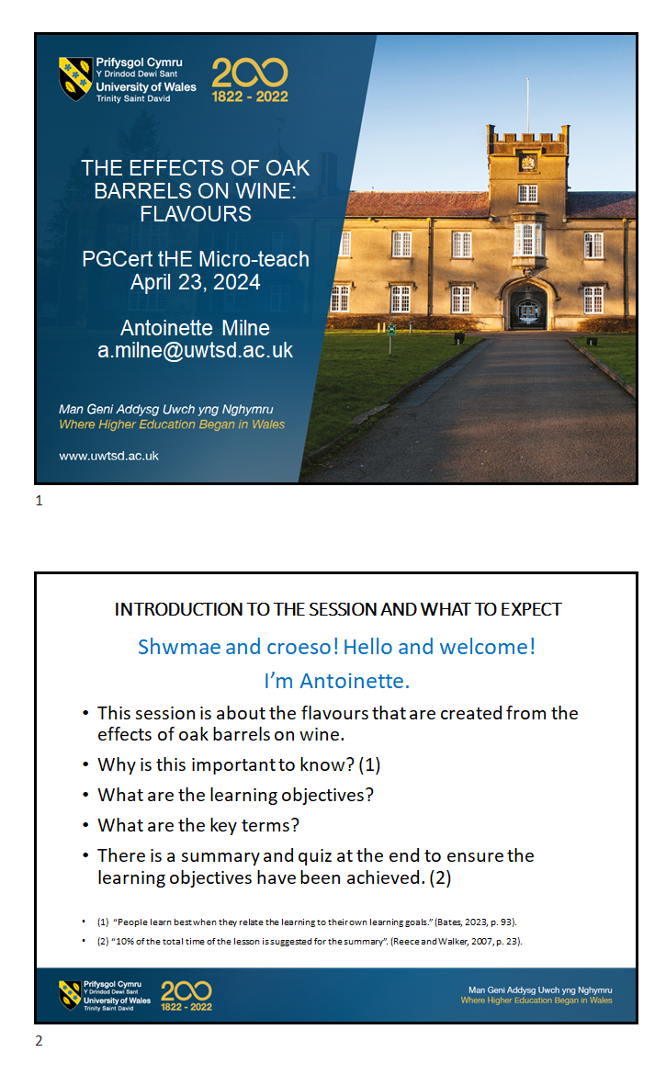
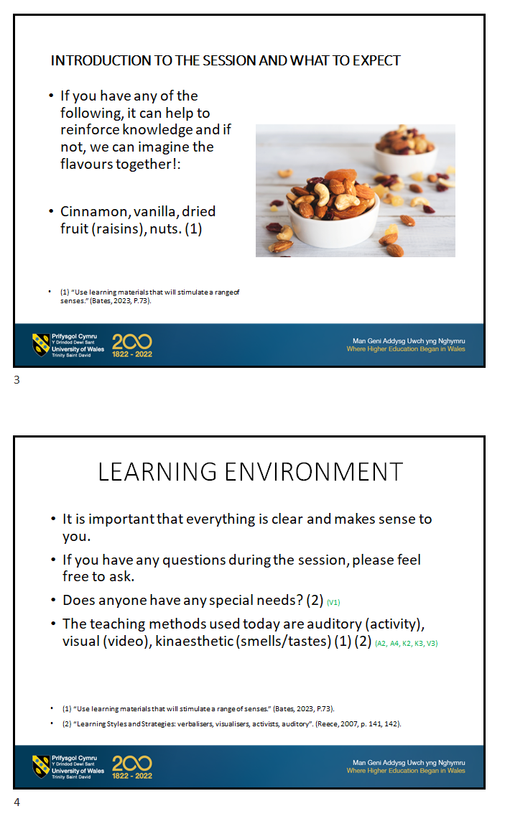
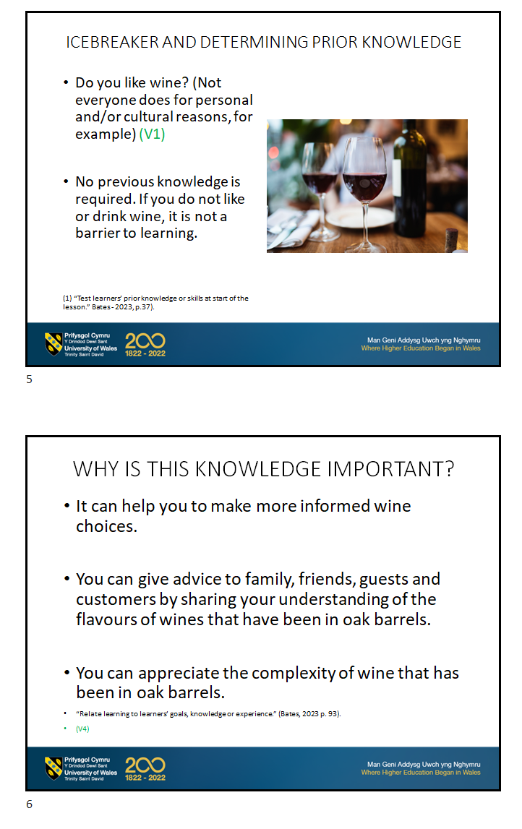
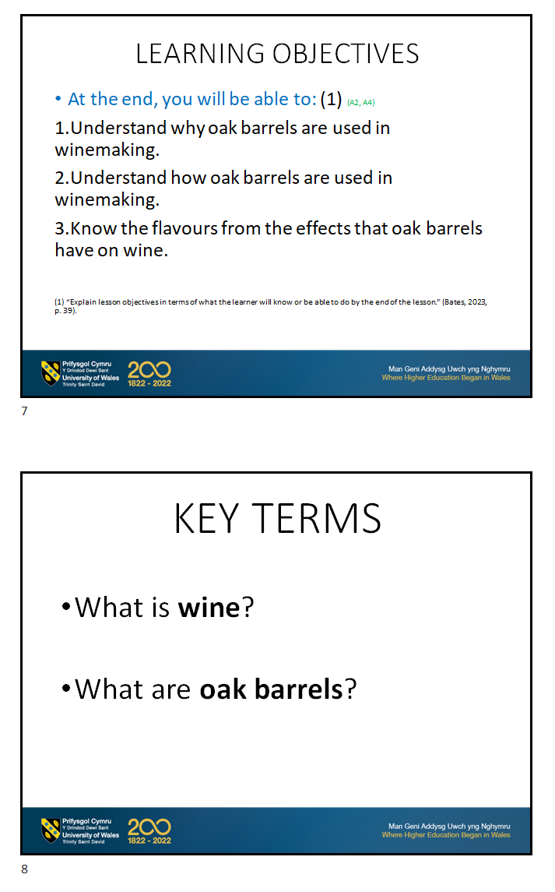
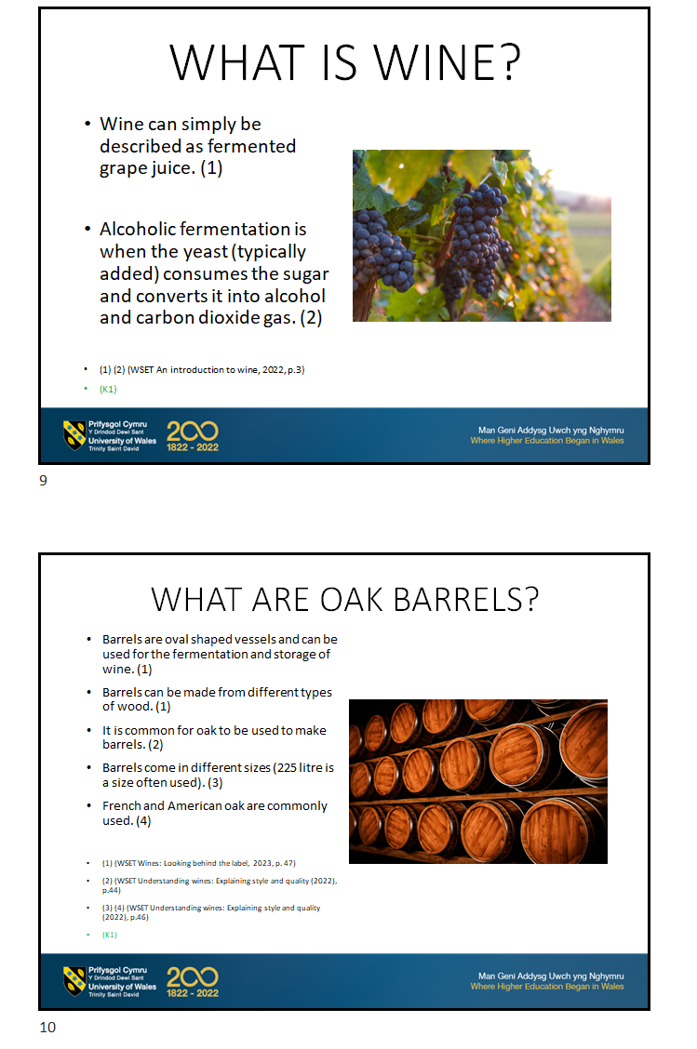
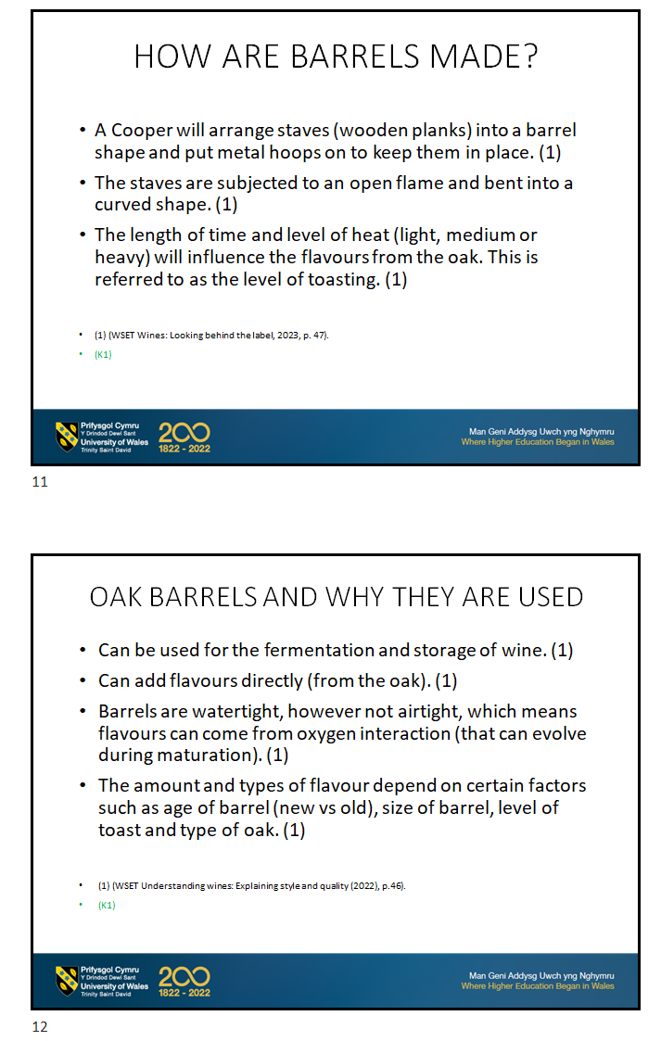
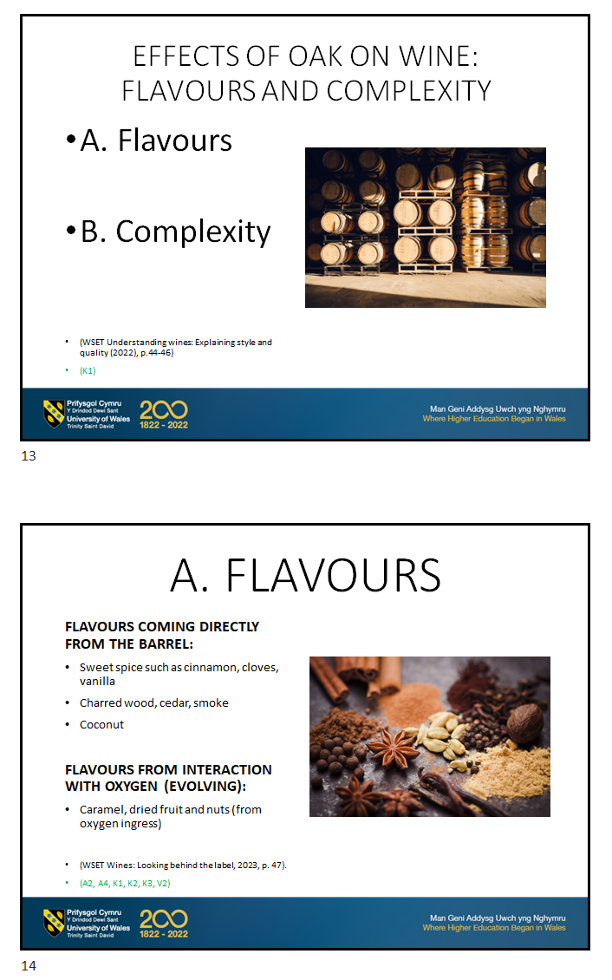
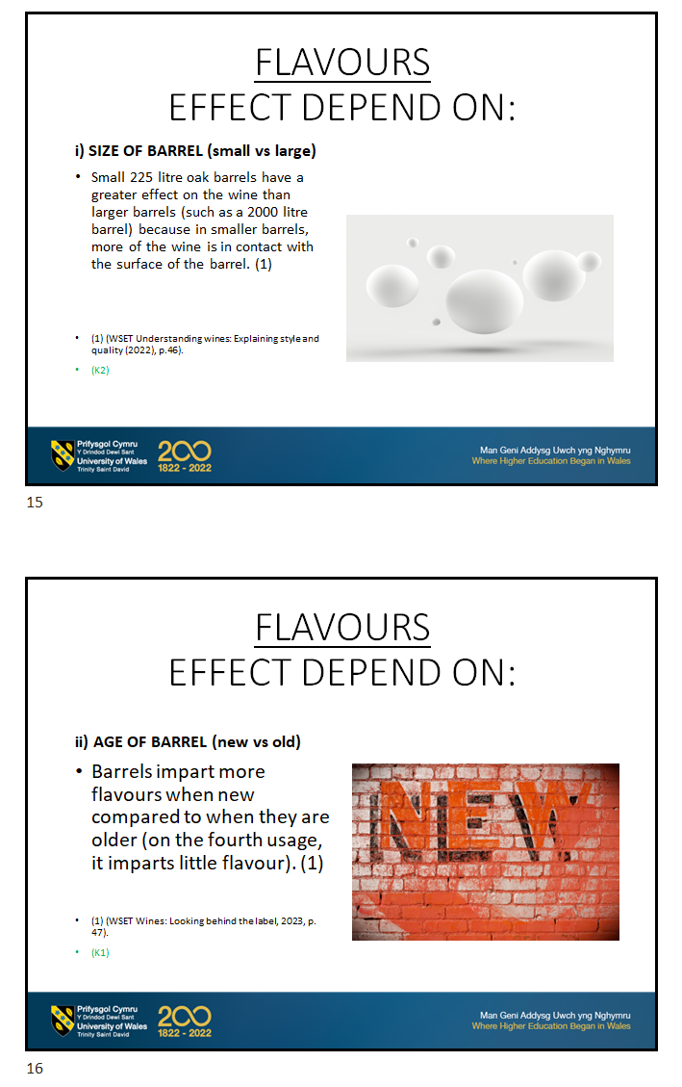
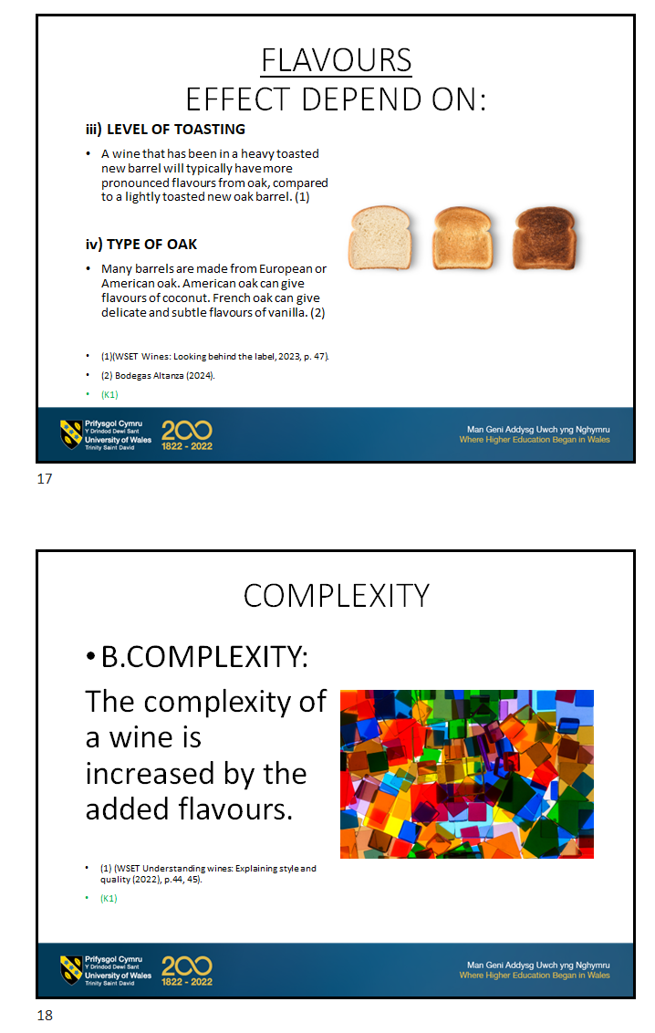
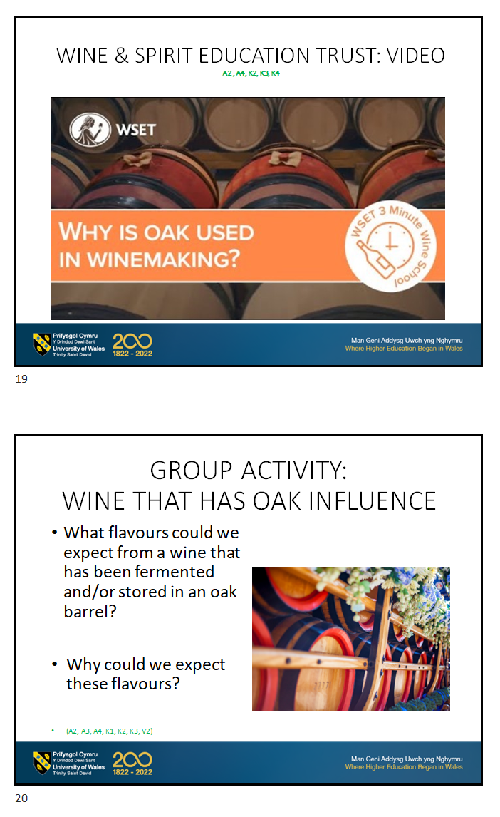
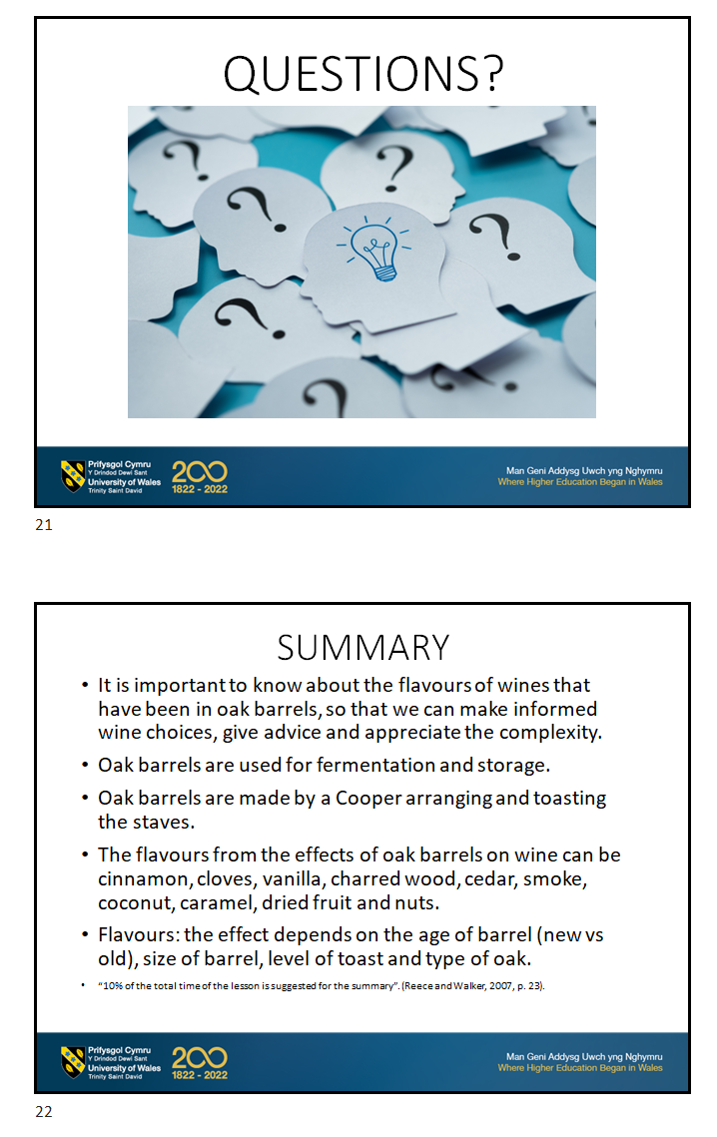
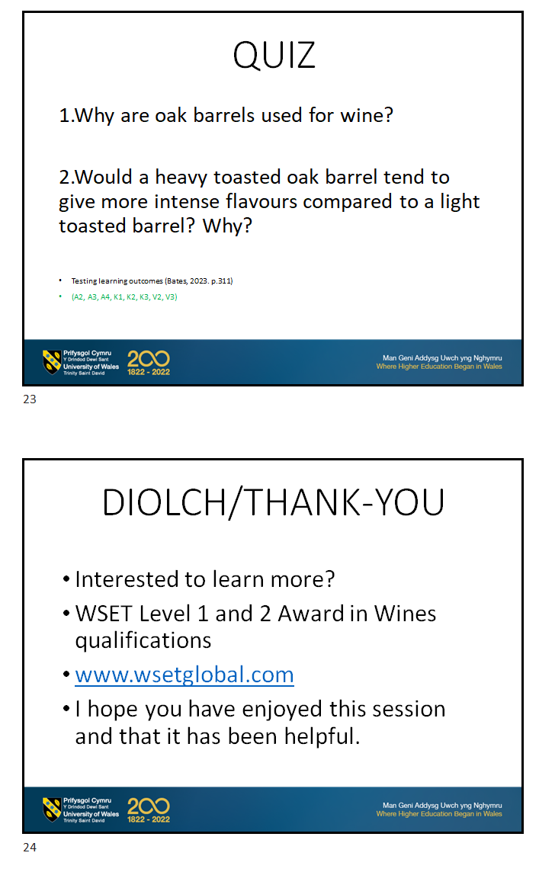
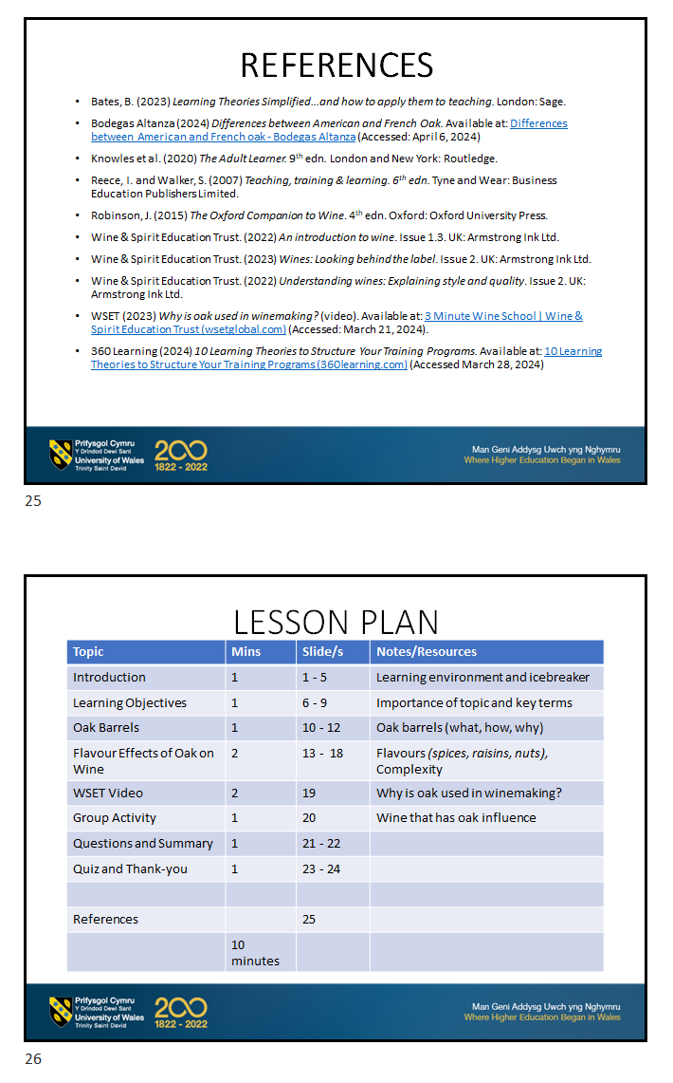
Link to PG Cert tHE Microteach:
Microteach session-20240423_151514-Meeting Recording.mp4

PG Cert tHE
Microteach Reflection

For: Mark Flagg
From: Antoinette Milne
April 23, 2024

The feedback from the microteach was very positive and constructive. My peers mentioned that the presentation was professional, inclusive and that they had learned much. In particular, the video was pointed out as being well-chosen and an effective tool for supporting the content.

One area to improve, is the amount of content, which I believe was too much. Using Gibbs’ model of reflection, the feedback indicated that there was a lot of information and one peer felt overwhelmed. I agree with the feedback. Upon hearing this, I felt disappointed in myself. After feeling the feeling, I felt glad that it was pointed out, as I am now aware. My analysis is that if students have too much information presented at once, they will likely not be able to process it. I have learned that it will be helpful to consider having less information and to take the necessary time to discuss. Therefore, I will now adjust the amount of content to the session time, so that students will have time to process it. This should result in better understanding and retention.

According to Bates (2023, p. 74), Miller suggests that there are limits on our capacity for processing information. It is therefore important to not overload learners with complicated material (Bates, 2023, p.75).
Reece and Walker (2009, p. 273) make the point that you can be explaining to students and they seem to be responding, however, they may not be understanding. This can be due to the complexities of sending and receiving of messages (2009, p. 274). I am now more aware of the importance of continuing to ask questions and encouraging the students to ask questions throughout, to ensure effective learning (2009, p. 280).

References:
- Bates, B. (2023) Learning Theories Simplified…and how to apply them to teaching. London: Sage.

- Reece, I. and Walker, S. (2009) Teaching, training & learning. 6th edn. Tyne and Wear: Business Education Publishers Limited.

- The University of Edinburgh (2020) Gibb’s Reflective Cycle. Available at: https://Gibbs' Reflective Cycle | The University of Edinburgh (Accessed: April 25, 2024).

PG CERT tHE
Intervention Reflection Essay
January 2025

For: Mark FLAGG
By: Antoinette Milne

I believe that reflection is a vital part of learning and evolving, both professionally and personally. It would seem that without this ability, one is at a distinct disadvantage. By identifying an area to be improved during reflection, an intervention has the power to make a positive change for students (V1, V3).

According to Ashwin (2022, p. ix), reflective teaching in higher education is of central importance, as it is a means to enhance our students’ learning and to further develop the quality of higher education (V4). Reflective action has been explained by John Dewey (Ashwin, 2020, p.51, 52), as engaging in continuing self-appraisal and development. Dissatisfaction is at the heart of reflection and involves a cyclical process of questioning (Ashwin, 2020, p.52). Evidence of both a problem and of measurement are also central to reflective teaching practices (Ashwin, 2020, p. 59) (V3).

Looking at how reflexivity can be applied specifically to the Hospitality industry, Fullagar and Wilson (2012) suggest that tourism and hospitality are facing complex global and local challenges that require increased critical thinking and new ways of understanding (V3, K3). According to Fullagar and Wilson (2012), non-western perspectives within hospitality, in both research and teaching practice, is an area where there is tremendous potential to include reflexivity (V3, K3). There is research to show the dominance of a minority world-view and the need for greater cultural engagement in knowledge production (Fullagar and Wilson, 2012) (V1, V2, V3, K3).

Fullagar and Wilson (2012) also discuss the management of teaching tourism and hospitality and state that critical reflection may help to further understand inequities, such as racism, gay experiences and disability (V1, V2, V3, K3).

The Gibbs reflection model is used for the following intervention, as I believe it suits the intervention particularly well, due to its clarity, thoroughness and succinctness (V3). According to the University of Edinburgh (2020), the model starts with the description of the experience, secondly, the feelings and thoughts about the experience, thirdly, the evaluation of the experience, followed by the analysis to make sense of the situation, then the conclusion about what has been learned and what could have been done differently and finally, the action plan for how one would deal with similar situations in the future.

The Academic Director discussed an issue with me in October 2023, about the standard of student reflective writing submissions in the International Gastronomy Management Programme (IGM). It was suggested that generally, the students had not been following a reflective model clearly, which had resulted in low marks. This indicated at the very least, that perhaps the students did not understand reflective writing. It concerned me deeply as a lecturer, because I strongly value supporting and developing students’ academic skills, especially critical thinking and research. (V1, V3). I decided to investigate the situation further and to establish a starting point of knowledge for the IGM student cohort.

I wanted to ensure that all the students clearly understood reflective writing and that they were able to use at least one reflective model and be able to demonstrate this through the upcoming submission. This was important to me because it would ensure the students could demonstrate reflective critical thinking and would enable them to work towards improving themselves professionally and personally (V2, V3, K3, A2, A4). As potential leaders in the Hospitality industry, it is vital for students to have the ability to critically reflect in order to successfully lead and manage effectively (Fullagar and Wilson, 2012), which is why I believed an intervention was necessary (V1, V2, V3, K3).

I asked the students to attend a Reflective Writing Workshop. Once there, I asked the students to explain what they understood about reflective writing. None of the students could explain. We discussed the importance of reflective writing in academia and in a professional hospitality working capacity (A2, A4).
To provide an example, I offered a professional yet personal reflection using the Kolb model (V3). I then asked the students to spend 30 minutes thinking about a specific hospitality work experience to reflect upon and to write it down following the Kolb model (V3, K2, K3, A2). The Kolb model was chosen for its simplicity, in terms of the four steps for the cycle. Reece and Walker (2007) explain the steps as follows: concrete experience (do), reflective observation (review), abstract conceptualisation (model) and active experimentation (test) (V3, K2).

When they were ready, a student volunteered and as they revealed their reflection, I reinforced their understanding of the model by giving feedback and asking questions to ensure they were clear about each of the four steps (V1, V3, K2, K3, A2, A3, A4). The tendency was for the students to emphasise the description step. If one of the students seemed to be struggling with the second step of reflective observation, I asked them to think about their feelings and in some cases, suggested different feelings, to give an example, as a way of letting them know they were supported (V1, V2, V3, K2, K3, A2, A3, A4). Each student took their turn and were open and honest. The students also questioned each other and discussed each other’s reflections (V2, K2, A2). It demonstrated that they understood the Kolb model and could now reflect critically. I also invited them to consider reading around the subject of reflective writing, as a way of encouraging self-directed and independent learning (V1, V2, V3, K2, A4).

When I first learned about the dilemma, I immediately felt very challenged by the prospect of ensuring the students would be able to understand and apply critical reflective writing. This is because I care, value and respect all learners and want to promote their engagement in learning and provide equal opportunity and inclusivity for all to reach their potential (V1, V2, V3). I am especially motivated to inspire and facilitate student’s learning of critical reflective writing, because I have seen the positive effect it has had on my progress and life. As a result, the contribution I am able to make towards improving students’ lives, gives me a great amount of pleasure and joy.

To evaluate, when I reviewed the reflective writing submissions in the previous term to see what had been written, I believed that there were at least three possible reasons why the students had not submitted a higher standard of reflective writing. They were, a lack of understanding about reflective writing, a lack of motivation and a lack of being able to identify their feelings and articulate them (K3).

Firstly, the general lack of understanding about reflective writing was demonstrated by some students confusing reflective writing with a report, for example. Some students did not follow the steps of a model and some students emphasised the descriptive step. I believed the lack of understanding was redressed by the intervention (V3, K2, K3, A2, A4).

Secondly, I believed that the students may not have been motivated to excel at the previous reflective submission because having observed and listened to them for the first time in the new term, they seemed to not reveal any particular interest or curiosity about reflection. During the intervention, the intention was to encourage motivation through inspiring the students to be curious and willingly want to learn and practice reflection. This was achieved by discussing why it was important to have this knowledge (to be able to do their jobs properly and for quality of life, for example) (V1, K1, K2, K3, A2, A4).

Lastly, it became apparent that the students struggled to identify their feelings and to articulate them. By providing a professional, yet personal reflection, it seemed to encourage the students to open up and willingly share their reflections. The honesty and vulnerability shown during the professional and personal reflection example, seemed to resonate with the students, inspiring them to reciprocate. There seemed to be a greater engagement in teaching and learning by both the students and me, compared to previous sessions (V1, V2, K1, K2, A2, A4).

Based on observing the students in the reflective workshop, I believe they all understood reflection and felt more confident about approaching reflective writing. This is because they all engaged by sharing their reflections, worked through the Kolb model steps and seemed to enjoy the learning. At the end of the session, I asked the students for feedback. They all believed they had a better understanding of reflective writing. One area of improvement that was mentioned by the students, was that a video explaining and demonstrating critical reflection could help to reinforce the session’s learnings. (V1, V2, V3, K1, K2, K3, A1, A2, A4).

Much has been learned when reviewing the relevant literature.

Knowles (2020, p.43) states that the andragogical model is based on certain assumptions that are different to those of the pedagogical model, which are particularly relevant in this context. One of the assumptions is that adults need to know why they need to learn something before they learn (Knowles, 2020, p.43). This can be a motivating factor in adult learning and this is what I believed happened during the intervention, when we discussed the importance of reflective writing. As Knowles (2020. P.46) states, adults are responsive to many motivators, such as better jobs, promotions, higher salaries and increased job satisfaction. (V2, V3, K1, K2, K3).

Ashwin (2020, p.24) states that students are not passive receivers of information and that it is important to focus on how students can engage actively (K1, V3). Bates (2023, 43), believes that constructivism is a branch within cognitivism. According to Bates (2023, p. 43), the behaviourist approach does not focus on developing a student’s capability, and is more concerned with outcomes. Petty (2004, p. 4) mentions that the cognitivist theory of ‘constructivism’ is about students’ making sense of their learnings Petty (2004, p.14) also states that cognitivist or constructivist teaching strategies include, teaching by asking or guided discovery and question and answer. This is an approach that I have concentrated on in this intervention (V1, V2, V3, V4, K1, K2, K3, A2).

According to Billings and Walqui (2017), Vygotsky’s socio-constructivist theory of learning and development is the Zone of Proximal Development (ZPD). The ZPD is the gap between what a student can do without aid and what a student can do working together with others more experienced (Billings and Walqui, 2017). The ZPD is the space where learning happens and where teaching takes place (Billings and Walqui, 2017). Whilst a student is in the ZPD, Vygotsky believed that students learn through discussion, interaction, support and the guidance of peers and teachers (Billings and Walqui, 2017). During the intervention, guidance and support were given to the students (in the ZPD), as previously described, whilst they shared their reflections, and questioning and discussion took place, to ensure understanding. This was both social and collaborative. (V1, V2, V3, V4, V5, K1, K2, K3, A2, A4).

As a lecturer, it is important to have an understanding of the students’ level of knowledge by formatively assessing them, for example, to determine where the next learnings should be and combined with scaffolding (Billings and Walqui, 2017). Scaffolding takes in to consideration the students’ current understandings and interests and their future potential for development (Billings and Walqui, 2017). Bates (2023, p.48) suggests an analogy of scaffolding as used in constructing a building, where it is essential when first learning and then can be taken away as the work progresses. The structural part of the scaffolding is planned, as in a Think, Pair, Share (TPS) task, where a question is asked and students share their responses with each other and then to the class (Billings and Walqui, 2017). Students can adapt and adopt the information to build on their understanding (Billings and Walqui, 2017). During the intervention, the use of scaffolding and the TPS task could have been more effective in determining how much knowledge the students had and of building on their understanding. Vygotsky’s emphasis on the independent ‘processes of learning’, rather than the memorising and regurgitating of facts or ‘knowledge’ is an important result for students (Aubrey and Riley, 2016, p.54). It means that deep learning is achieved. (V1, V2, V3, V4, V5, K1, K2, K3, A2, A3, A4).

Von Glasersfeld (1995) states that Radical Constructivism is a theory of knowing that provides a pragmatic approach to questions about reality, truth, language and human understanding. According to Lesser (1995), who reviewed Von Glasersfeld’s book, Radical Constructivism: A Way of Knowing and Learning, radical constructivism has two principles, the first is that knowledge is actively constructed and the second is that cognition is adaptive and organises rather than discovers.

Like the TPS task, Von Glasersfeld (1995) suggests putting students into groups and assigning one that needs the most support, to talk about the results at the end of the session. It compels them to explain their thoughts to each other, which is helpful. Talking can mean that one must reflect and students will likely listen more openly to other students, as compared to the teacher (Von Glasersfeld, 1995). This explains why the sharing of reflections with each other during the intervention seemed to work so well. Von Glasersfeld (1995) believes radical constructivism suggests to educators that teaching knowledge is not the only purpose, inspiring learning, is a main purpose. It would appear that Vygotsky and Von Glasersfeld had similar theoretical and practical approaches. Overall, they both seemed to extol the benefits of social and cooperative learning. (V1, V2, V3, V4, V5, K1, K2, K3, A2, A4).

According to McGill and Beaty (2001), action learning is a continuous process of learning and reflection supported by colleagues, with an intention of getting things done. Important skills needed for action learning are active listening, reflection, questioning, empathy, giving and receiving feedback and specifying actions. According to McGill and Beaty (2001, p. 158, 159), learning is a reflective process where insights are gained through collaborative working. This chimes with the theories of Vygotsky and Von Glaserfeld. (V1, V2, V3, K1, K2, K3, A4).

The flipped classroom method, according to Erbil (2020), is where traditional teaching takes place out of the classroom, through videos and activities. Projects and homework take place during classroom time, which is considered to be active (Erbil, 2020). In active learning methods (cooperative learning, problem-based or project based), the student makes sense of the learning (as a constructor) and has an active role (Erbil, 2020). Erbil (2020) states that cooperative learning and flipped classroom are among the active learning approaches based on constructivist theory and when used together, research has shown they have positive impacts on student success. (V1, V2, V3, V4, V5, K1, K2, K3, K4, A2, A4).

Petty (2004, p. 13, 14) states that it is important to set high-order tasks, citing Bloom’s taxonomy, such as analysis, synthesis and evaluation, because using only lower-order tasks leads to ‘surface learning’. According to Petty (2004, p.5), deep learning is where students create their own meaning for new learning. According to AdvanceHE (2020), when students focus and study deeply and for understanding and meaning, they read widely and think critically. In surface learning, students tend to repeat knowledge without necessarily understanding concepts and ideas (AdvanceHE, 2020). AdvanceHE (2020), mentions that research shows that those who mostly take a deep learning approach are more likely to learn more and perform better academically. (V3, K1, K2, K3, A2, A4).

According to Ellen (2024), pragmatism in education is an approach that focuses on teaching practical skills and applying knowledge to real-life situations. Dewey and James both liked the idea that learning by doing and learning through direct experience were important to effective education (Ellen, 2024). At the core of pragmatism is the principle of student-centred learning, as it caters to individual needs and learning styles. (V1, V2, V3, V4, V5, K1, K2, K3, A2).

Constructive alignment is an assessment approach to curriculum design which is focused on closely aligning teaching and assessment to intended learning outcomes (Queen Mary University of London, 2024). Assessments favour learning experiences, such as what a student might do in a workplace (Queen Mary University of London, 2024). From the 1960’s when educational emphasis turned towards student-centred learning, included were elements of experience, discovery, cooperation and self-assessment in terms of self-improvement (Jarvis, 2010, p.234). (V1, V4, K1, K2).

According to Daneshfar and Moharami (2018), dynamic assessment (DA) is a sub-category of ZPD from Vygotsky’s theory, where education and assessment work together. It is different to the traditional assessment, which does not include learning or any help from the teacher (Daneshfar and Moharami, 2018). It can be argued that traditional assessment is not so helpful in determining a students' learning potential (Daneshfar and Moharami, 2018). Overall, Daneshfar and Moharami (2018) make the point that within DA, assessment and learning work together. To some extent, this approach was taken whilst practicing with the students during their sharing of reflections as a way of formatively assessing them. (V1, V2, V3, V4, V5, K1, K2, K3, A2, A3, A4).

To conclude, there were 5 students in the pre-intervention cohort (December 2023) that submitted a reflective portfolio. Two of the five students did not pass and the average mark was 39%. After the intervention in March 2024, the students submitted another reflective assignment and all the students passed and increased their mark from the previous reflection assignment except for one. The average mark was 49% and therefore, the average increase of the cohort was 20%. Although the assignments and markers were different, this indicates there was significant improvement in the students’ understanding and application of reflective writing. The assignment can be considered a summative assessment, indicating what the students have learned at the end of the module. A formative assessment, such as Vygotsky’s interactionist DA, could be very useful alongside the learnings, as it would reveal the student’s current learning and potential. (V1, V2, V3, V4, K1, K2, K3, A2, A3).

The results of the intervention were very exciting, as they indicated a significant increase in the students’ understanding and application of critical reflective writing. I have learned that when students work cooperatively and are guided and supported, this can instigate self-awareness, more expression of feelings and more critical thinking. After reading relevant literature and applying much of the knowledge, combined with applying knowledge from my life experiences, I feel I have inspired change in the students that will serve them well in both their professional and personal lives. I hope that colleagues will find this helpful and that we can all collaborate to further improve student learning through discussions, forums, research and peer observations, for example. A flipped classroom approach, where students watch teaching video/s at home and work on projects in class, can lead to more effective learning. Also, implementing Vygotsky’s Think, Pair, Share technique can help to establish students’ prior knowledge and understanding of a subject, which can help to know where to start and build on the learning. (V1, V2, V3, V4, V5, K1, K2, K4, K5, A1, A2, A3, A4, A5).

In the future, for a similar intervention, it is vital to have an action plan that will drive results. I believe it is important to identify the issue clearly and to accurately establish where students’ learning currently is. Vygotsky’s TPS activity is perfect for this. It is vital to be clear about the objectives of the intervention, how the intervention will resolve the issue and to ensure learning outcomes are clear to students. To motivate students to learn, it is important to ensure linking the knowledge to the outcomes (better job, for example). Using Vygotsky’s approach such as scaffolding, can improve learning. Cooperative and experiental learning can also improve learning. Including a video explaining the topic and more flipped classroom and active learning approaches can improve learning. Giving personal examples and sharing honesty, vulnerability and humility, to encourage students to reciprocate, can inspire trust and cooperativeness. Using both formative and summative assessments can both help to indicate what the learner has learned and can ensure deep learning has taken place. Keeping a log after each session about what went well and what can be improved upon, can help support reflection and teaching improvement.

Overall, the students have learned to critically reflect and write reflectively, which will support their learning and evolving and will enable them to manage the specific challenges in their hospitality careers and personal lives effectively. It is a distinct advantage and one I hope will give them great joy.

References:

- AdvanceHE (2020) Education for Mental Health Toolkit – Deep and Surface Learning. Available at: https//Education for Mental Health Toolkit - Deep and Surface Learning | Advance HE (advance-he.ac.uk) (Accessed: August 7, 2024).

- AdvanceHE (2020) Assessment and Feedback in Higher Education. Available at: https//Assessment and Feedback in Higher Education | Advance HE (advance-he.ac.uk). (Accessed September 15, 2024).

- Armitage, A and Bryant, R Et. Al. (2007) Teaching and Training in Post-Compulsory Education. Maidenhead: McGraw-Hill Education.

- Aubrey, K. and Riley, A. (2016) Understanding and Using Educational Theories. London: Sage.

- Ashwin, P. (2022) Reflective Teaching in Higher Education. London: Bloomsbury Publishing Plc.

- Bates, B. (2023) Learning Theories Simplified…and how to apply them to teaching. London: Sage.

- Biggs, J. and Tang, C. (2022) Teaching for Quality Learning at University. Maidenhead: Open University Press.

- Billings, E. and Walqui A. (2017) ‘Zone of Proximal Development: An Affirmative Perspective in Teaching ELLs’, Office of Bilingual Education and World Languages, NYSED (New York State Education Department). Available at: https://Zone of Proximal Development: A Perspective for Teaching English Learners (wested.org) (Accessed on July 13, 2024).

- Carr, W. and Kemmis, S. (1986) Becoming Critical. East Sussex: The Falmer Press.

- Campbell, A. and Norton L. (2007) Learning, Teaching and Assessing in Higher Education. Exeter: Learning Matters Ltd.

- Daneshfar S. and Moharami, M. (2018) ‘Dynamic Assessment in Vygotsky’s Sociocultural Theory: Origins and Main Concepts’. Journal of Language Teaching and Research, Vol. 9, No. 3, pp. 600-607. Available at: https//Dynamic Assessment in Vygotsky’s Sociocultural Theory: Origins and Main Concepts - CORE Reader (Accessed August 22, 2024).

- Downey M.E. and Kelly A.V. (1979) Theory and Practice of Education, An Introduction. London: Harper & Row Ltd.

- Ellen, N. (2024) Pragmatism in Education: Fostering Real-World Learning. Available at: https//Pragmatism in Education and How to Integrate It Into Your Curriculum (academichelp.net) (Accessed: August 7, 2024).

- Erbil, D.G. (2020) ‘A Review of Flipped Classroom and Cooperative Learning Method Within the Context of Vygotsky Theory’ Frontiers in Psychology, 11 (June) article 1157.

- Fullagar S. and Wilson E. (2012) ‘Critical Pedagogies: A Reflexive Approach to Knowledge Creation in Tourism and Hospitality Studies’, Journal of Hospitality and Tourism Management, 19 (1), p. 1 – 6.

- Gibbs, G. (1989) Learning by doing: a guide to teaching and learning methods. Oxford: Oxford Polytechnic.

- Illeris, K. (2007) How we Learn, Learning and non-learning in school and beyond. Oxford: Routledge.

- Jarvis, P. (2010) Adult Education and Lifelong Learning Theory and Practice.. Oxford: Routledge.

- Jordan, F. (2008) ‘Internationalisation in Hospitality, Leisure, Sport and Tourism Higher Education (HLST HE): A Call for Further Reflexivity in Curriculum Development’, The Journal of Hospitality, Leisure, Sport and Tourism, 7(1), p. 99 – 103.

- Harvard University (The Derek Bok Center for Teaching and Learning). (2024) Flipped Classrooms. Available at: https//Flipped Classrooms | Derek Bok Center, Harvard University (Accessed September 15, 2024)

- Howell, E. and Smalley, P. (2024) ‘Flipped Classrooms’. Student Centered Approaches in K-12 and Higher Education. Available at: https//EdTech Books (Accessed September 14, 2024).

- Kim, J. (2020) ‘Dynamic Assessment: A Vygotskian Approach to Understanding and Promoting L2 Development, reviewed by Jisoo Kim, Australia’, Humanistic Language Teaching. Available at: https// August 2020 - Dynamic assessment: A Vygotskian Approach to Understanding and Promoting L2 Development, reviewed by Jisoo Kim, Australia (hltmag.co.uk) (Accessed August 22, 2024).

- Knowles, M. (2020) The Adult Learner, The Definitive Classic in Adult Education and Human Resource Development. New York: Routledge.

- Lesser, L. (1995) ‘Review of Radical Constructivism: A Way of Knowing and Learning by Ernst von Glaserfeld’, The Mathematics Teacher, 88 (8), p.688.

- Lohman, L. (2023) What is the Theory of Social Constructivism? Available at: https//Social Constructivism | Definition, Benefits & Examples - Lesson | Study.com (Accessed July 13, 2024).

- Marshall, S. (2015) A Handbook for Teaching and Learning in Higher Education. Oxon: Routledge.

- McGill, I and Beaty, L. (2001) Action Learning. London: Kogan Page Limited.

- Petty, G. (2004) Teaching Today. Cheltenham: Nelson Thornes Ltd.

- Philpott, C. (2014) Theories of Professional Learning, A critical guide for teacher educators. Northwich: Critical Publishing Ltd.

- QAA (2024) Assessment. Available at: https//Assessment (qaa.ac.uk) (Accessed September 15, 2024).

- Queen Mary University of London (2024) Constructive Alignment. Available at: https//Constructive alignment - Queen Mary Academy (qmul.ac.uk) (Accessed August 8, 2024)

- Reece, I. and Walker, S. (2007) Teaching, training & learning. Tyne and Wear: Business Education Publishers Limited.

- The University of Edinburgh (2020) Gibbs’ Reflective Cycle. Available at: https//Gibbs' Reflective Cycle | The University of Edinburgh (Accessed June 23, 2024).

- 360 Learning (2024) 10 Learning Theories to Structure your Training Programs. Available at: https//10 Learning Theories to Structure Your Training Programs (360learning.com) (Accessed March 28, 2024).

- Von Glasersfeld E. (1995) Radical Constructivism: A Way of Knowing and Learning. PA: Falmer Press, Taylor & Francis Inc.

PGCert tHE OBSERVATION FORM


Details of the Observation
Observee | Charlotte Joyner, Programme Manager (International Hotel Management), MBA, BA, PGCE
Observer | Antoinette Milne
Date of the Observation | November 29, 2024
Campus / Location | Dylan Thomas Centre (UWTSD Campus)
Date, Time, Duration | 1 hour (2:30 – 3:30pm)
Subject Speciality | Managing Organisational Behaviour (Level 5) (Strategic Management)
Type of activity | Delivered lecture (online)
This observation will contribute to the participant’s portfolio of evidence to satisfy the assessment of the PGCert tHE and should be undertaken by an experienced academic colleague or professional colleague. Observation by a fellow participant on the programme is not permissible as a means of authenticating practice.

Teaching/Support preparation [A1: Design and plan learning activities]
i.e. Preparation, selection and organisation of content. Choice of teaching/learning methods.

Comments
Charlotte’s slides were clearly presented and were used as prompts (with a few sentences, rather than being overcrowded). They were in a precise order (where one concept led to the next), which were straightforward to follow. Charlotte used a variety of teaching/learning methods, such as asking questions, having activities/tasks, use of video (Strategic Management), use of repetition and reviewing previous content from previous lectures.

Teaching [A2: Teach and/or support learning.]
i.e. Beginning class, introduction, continuity with other sessions, students’ prior knowledge. Clarity of presentation. Pace. Attitude to the subject matter. Use of appropriate reinforcement. Ending the session – summary, future work etc. Technique and Aids: General apparatus – board, data projector, use of handouts. Was effective communication achieved? Was there good student–teacher rapport? Were the aims/outcomes achieved? Appropriateness of teaching/learning methods.
Comments
Charlotte began the class by welcoming everyone and reviewing the previous week (used a recap slide), which was about change management and change leadership. She outlined the session for the day and asked the students to define strategy, as a starting point, whilst reinforcing understanding. Charlotte spoke clearly and at a pace where everyone was able to understand (not too slowly or too quickly). She used the slides as prompts and spoke naturally and in a well-informed way. Charlotte demonstrated a passion for her subject and spoke with authority. The class ended with a brief review of the session and a brief overview of what will be discussed at the next session. Charlotte included a video and online activities to encourage engagement, which seemed to work, as all the students took part. For the video, Charlotte asked the students to think about what the elements of strategic management are (planning, evaluating etc.), which would be discussed after the video. After the video, Charlotte summarised it and there was a general discussion. Effective communication was achieved, as evidenced by students participation in the activities, answering questions and asking questions. Charlotte reinforced all student interactions. The students demonstrated understanding and the achievement of the aims/outcomes through participation in the activities and by answering questions.
Effective Learning Environments [A4:Develop effective learning environments and approaches to student support and guidance.]
i.e General class atmosphere, level of participation, attention, and interest. Student attitude and ability to carry out classwork. Were learning problems identified and overcome? Awareness of individual needs. Attitude to students.
Comments
The general class atmosphere was receptive and students participated in the activities and asked/answered questions. The students were attentive and interested, as demonstrated by the participation. Charlotte reinforced individual students and was respectful to all of the students.
Assessment [A3: Assess and give learners feedback]
i.e Formative/summative assessment examples , Question and answer technique. Other evaluation procedures, class management, instructions to students005C.
Comments
Charlotte used formative assessment by checking regularly with the students about the content (asking questions of what had been discussed). She reminded the students about the summative assessment (the upcoming assignment due) and briefly reviewed it. Charlotte gave clear instructions to the students about the activities and followed up the activities by asking students what they had found out (after researching, for example).
Core Knowledge
- Subject knowledge
- Teaching methods
- Student learning
- Learning technologies
- Evaluation
- Teaching effectiveness
- Quality assurance

Comments
Charlotte clearly has deep knowledge of the subject and mentioned in the class that she had studied Strategic Management during her MBA. The knowledge was demonstrated by her ease and naturalness of speaking. She used a variety of teaching methods aligned to the student’s way of learning. She used a video and online research for the activities. She used formative assessment regularly and reviewed the summative assessment. The students seemed to understand the content.

Professional values
- Respect for learners
- Promote participation
- Evidence informed approaches
- Wider context of HE
Comments
Charlotte showed respect for the students, demonstrated by reinforcement and encouraged participation by asking questions continually. Charlotte used evidence informed approaches, such as reviewing previous sessions, asking questions, setting activities with clear instructions and then summarising, using summative and formative assessments and setting the scene for the next session.

Examples of good practice:
Charlotte communicated clearly and with deep knowledge and authority of the subject. She respected the students and used evidence informed teaching approaches. The students understood and learned, as evidenced by the formative assessments.
Action points: My Reflective Paragraph on the Observation
In particular, I have learned to use more evidence informed approaches to teaching/learning, such as breaking up the lecture more so, using more activities/tasks and videos, for example and using more formative assessments to check learning. I realised the importance of reviewing the previous session’s content/knowledge to remind students, and as a way of introducing and leading into the current session, which helped to get students into the mood. Equally, I saw the importance of reviewing the session at the end and discussing what would be following at the next session. This allowed students to realise the continuity and how the sessions fit together, and also so they could prepare. I saw the effect that Charlotte’s enthusiasm for the subject resonated with the students, by their engagement and I will continue to endeavour to show the passion I have for the subjects I teach. The importance of respect and empowerment that Charlotte showed towards students also seemed to encourage participation and mutual respect. Overall, I learned a lot about teaching/learning approaches from observing Charlotte teach and interact with her students and will seek to apply them.

Observer ...................................................... Date December 1, 2024

Observee .....Charlotte Joyner.............................................. Date December 1, 2024

PGCert PARTICIPANTS
On completion of the peer observation reports for each module, compose a short reflective paragraph on your observation experiences for inclusion in your portfolio along with the observation sheets.

PGCert tHE OBSERVATION FORM

Details of the Observation
Observee | Antoinette Milne
Practice Advisor / Expert peer observer | Charlotte Joyner
Date of the Observation | 11.07.24
Campus / Location | Online
Date, Time, Duration | 9am-1pm
Subject Speciality | Foreign Language and Culture
Type of activity | Lecture
This observation will contribute to the participant’s portfolio of evidence to satisfy the assessment of the PGCert tHE and should be undertaken by an experienced academic colleague or professional colleague. Observation by a fellow participant on the programme is not permissible as a means of authenticating practice.

Teaching/Support preparation [A1: Design and plan learning activities]
i.e. Preparation, selection and organisation of content. Choice of teaching/learning methods.

Comments
- Good structure to slides, clear introduction and clearly sectioned into part 1 Language , part 2 culture
- Good use of recap to link all lectures together
- I like the consistent format of sessions and this followed on nicely from week 4 and it give a good structure so students know what to expect

Teaching [A2: Teach and/or support learning.]
i.e. Beginning class, introduction, continuity with other sessions, students’ prior knowledge. Clarity of presentation. Pace. Attitude to the subject matter. Use of appropriate reinforcement. Ending the session – summary, future work etc. Technique and Aids: General apparatus – board, data projector, use of handouts. Was effective communication achieved? Was there good student–teacher rapport? Were the aims/outcomes achieved? Appropriateness of teaching/learning methods.
Comments
- Good links made between content and assignment requirements
- Strong knowledge show from lectures that supported the content of the lesson – e.g. ability to speak French to support the written slides which gave students two different forms of communication and definitely enhanced the learning.

Effective Learning Environments [A4:Develop effective learning environments and approaches to student support and guidance.]
i.e General class atmosphere, level of participation, attention, and interest. Student attitude and ability to carry out classwork. Were learning problems identified and overcome? Awareness of individual needs. Attitude to students.
Comments
Strong engagement from the class with learner actively wanting to practice their speaking ability. Opportunity here to maybe introduce a form of ‘cold calling’ to see if other members of the group could have a good at speaking, not just the same few.
This is harder to achieve online but something to consider in a classroom environment that you are achieving participation from a larger percentage of the class.
Assessment [A3: Assess and give learners feedback]
i.e Formative/summative assessment examples , Question and answer technique. Other evaluation procedures, class management, instructions to students005C.
Comments
- Opportunities for student to try the language skill and this gave the lecturer a chance to check understanding. However, an activity here e.g. in breakout rooms could have been introduced to give more students the opportunity to speak to the language and check understanding.

- There could have been inclusion of an activity to check understanding of the cultural element. This could have been formative e.g. quick questions or discussion throughout or summative at the end of the session a short MCQ to check understanding.
Core Knowledge
- Subject knowledge
- Teaching methods
- Student learning
- Learning technologies
- Evaluation
- Teaching effectiveness
- Quality assurance

Comments
Strong level of knowledge shown by the lecturer and a good level of preparation which certainly benefitted the students learning experience

Professional values
- Respect for learners
- Promote participation
- Evidence informed approaches
- Wider context of HE
Comments

Examples of good practice:
- Strong knowledge shown to support lesson
- Good rapport with students which encouraged lots of engagement with the language component

Action points:
- More activities or discussions in the culture section
- Introduce a formative or summative assessment in the culture section to ensure understanding is checked throughout the whole lesson.

Antoinette Milne review of Charlotte’s observations:
Charlotte reinforced a number of positive teaching approaches, which was very helpful. I am pleased with the high level of student engagement in many parts of the session. She did suggest “cold calling” on students who were not engaging, as a way of increasing participation. Charlotte also suggested having more activities as another way of increasing student engagement and as a way of checking understanding. She suggested including more formative assessments throughout the session, by asking questions and/or having more discussions. She mentioned the importance of having a summative assessment at the end of the session, such as multiple choice questions. Charlotte also mentioned that the session appeared to be well prepared and that is something that I am disciplined about. I feel it is vital to be prepared, so that the session is delivered smoothly and so that it allows for some spontaneity, which I feel can increase engagement and learning. I felt that Charlotte was quite positive about the session and pointed out teaching approaches that she thought were effective. This made me feel happy and reinforced my learning so far. This is because I value the rapport with students and maximising student engagement, in particular. The experience was very good, as it helped me be more aware of some of the strong points, as well as the points to work on. I think Charlotte’s review was balanced, showing both the effective approaches and approaches to introduce to increase effectiveness. I know there are specific actions to take to increase teaching effectiveness and therefore, student learning. As mentioned above, there are specific actions that I will endeavour to take to do this.

Observer c.joyner Date 11.07.24
Observee ..Antoinette Milne................................................ Date 11/14/2024
PGCert PARTICIPANTS
On completion of the peer observation reports for each module, compose a short reflective paragraph on your observation experiences for inclusion in your portfolio along with the observation sheets.

PGCert tHE OBSERVATION FORM

Details of the Observation
Observee | Antoinette Milne
Practice Advisor / Expert peer observer | Chris Wilkin
Date of the Observation | 15/11/24
Campus / Location | UWTSD Business Campus
Date, Time, Duration | 1.00 hr
Subject Speciality | Wine WSET
Type of activity | Delivered lecture
This observation will contribute to the participant’s portfolio of evidence to satisfy the assessment of the PGCert tHE and should be undertaken by an experienced academic colleague or professional colleague. Observation by a fellow participant on the programme is not permissible as a means of authenticating practice.

Teaching/Support preparation [A1: Design and plan learning activities]
i.e. Preparation, selection and organisation of content. Choice of teaching/learning methods.

Comments
Adapting the materials from 2 hr to 1 hr would be beneficial, quality content teaching methods would be great in person but online would benefit from more pedagogical range Unnecessary slides, was originally designed for 2 hour lecture this could have been tailored for the 1 hour delivery.

Teaching [A2: Teach and/or support learning.]
i.e. Beginning class, introduction, continuity with other sessions, students’ prior knowledge. Clarity of presentation. Pace. Attitude to the subject matter. Use of appropriate reinforcement. Ending the session – summary, future work etc. Technique and Aids: General apparatus – board, data projector, use of handouts. Was effective communication achieved? Was there good student–teacher rapport? Were the aims/outcomes achieved? Appropriateness of teaching/learning methods.
Comments
Welcomes into the class room, assessment quick recap, could use a recap of the previous session, clear discussion and clarity of tone well introduced and outline of the session outlined practical application of the content, direction to learning materials,
Good reinforcement and embedded Welsh context,
Embedded video as pedagogical variation.

Effective Learning Environments [A4:Develop effective learning environments and approaches to student support and guidance.]
i.e General class atmosphere, level of participation, attention, and interest. Student attitude and ability to carry out classwork. Were learning problems identified and overcome? Awareness of individual needs. Attitude to students.
Comments
Limited environment as online, participation could be prompted as multiple student cameras are off.
Some student engagement questions posed,
Some opportunities to engage students could have been leveraged for formative assessment
Opportunity to use video as a quiz or interactive tool.
Assessment [A3: Assess and give learners feedback]
i.e Formative/summative assessment examples , Question and answer technique. Other evaluation procedures, class management, instructions to students005C.
Comments
Could use diagnostic assessment to gauge students current knowledge.
Little formative assessment opportunities which could have been embedded.
No summative assessment to frame learning objectives.
Core Knowledge
- Subject knowledge
- Teaching methods
- Student learning
- Learning technologies
- Evaluation
- Teaching effectiveness
- Quality assurance

Comments

Clear subject knowledge mastery, Some evidence of VARK, few technologies included,(opportunities for questionnaires votes etc..)
A limited range of methods and technologies and variations employed. Needed summative assessment

Professional values
- Respect for learners
- Promote participation
- Evidence informed approaches
- Wider context of HE
Comments
This areas could be strengthened with more drive for student participation e.g cameras on etc low learner participation more could be made of evidence learning approaches some wider HE context but no intro preparatory for next session.

Examples of good practice:
Communicates well, excellent subject knowledge respects student knowledge and drive for learning,
Action points:
Greater engagement with assessment methods and embedding technology and multiple pedagogy.

Antoinette Milne review of CW observations:

Chris has observed a number of areas for improvement. Overall, Chris has suggested that it is important to include more opportunities for student participation, including using more questions, more use of technology (such as questionnaires) and more activities, although we did do a wine tasting at the end. Including more formative assessment (by asking more questions) and a summative assessment, is vital to ensure students have understood and learned, such as a quiz, which I usually do, however did not do on this occasion (although, we did a wine tasting, as a way of having a summative assessment). To assess prior knowledge, I could have included a think, pair, share activity (learned from researching Vygotsky and mentioned in the essay) whereby, the students in pairs, could talk to each other to find out each other’s prior knowledge and then share with the class. In addition, I should do more of a recap from last session and ensure to clearly summarise the current session, as well as mentioning what to expect for the next session. There was visual (presentation and video), aural, read/write and kinaesthetic (wine tasting at the end) included, however, I should endeavour to include more VARK. I felt disappointed in myself for omitting certain teaching approaches because I want to do the best for the students and ensure they learn and understand as much as possible. Overall, the observation is positive, as I have a better idea about what to work on. I understand what action I need to take to be a more effective lecturer and know what I can do differently. As mentioned above, there are specific actions I will now take to ensure students’ learnings are maximised.
Observer ..............C Wilkin........................................ Date 15/11/24

Observee ................................................... Date

PGCert PARTICIPANTS
On completion of the peer observation reports for each module, compose a short reflective paragraph on your observation experiences for inclusion in your portfolio along with the observation sheets.

PG CERT tHE
CPD #1
December 5, 2024

WSET (Wine & Spirit Education Trust) Global APP Summit 2024

“Educator Development: Beyond the Educator Training Programme (ETP)
Irene Fung DipWSET (WSET Educator Development)

July 21, 2024 watched online (3-4pm on June 25, 2024 for 1 hour)

The WSET qualifications (Level 1 and 2 Award in Wines) are now embedded in the International Gastronomy Management Programme. The first WSET Level 1 Award in Wines was taught in the Autumn 2024 term.

The Gibbs model was used (University of Edinburgh, 2020), for the conciseness and simplicity of the six steps.

The presentation was designed specifically to discuss strategies and resources which can help empower educators to enhance student outcomes and learning experiences. The ETP (Educator Training Program) currently focuses on active learning and how students learn (not passively, not telling), encouraging students to ask questions. It also focuses on teaching at appropriate level and to focus on the application of knowledge. Adding value, by including interactive elements, such as webinars, discussion forums and Kahoot, for example, was discussed as a way of maintaining student interest. To support students, evidence based practices are used to contribute to higher pass rates and overall academic excellence. (A4, A5, K6, V3, V4)

I felt invigorated by the discussion, to think about ways to improve my teaching skills which could help students to learn more effectively. This is because I value empowering students by focusing on the application of knowledge. I particularly felt motivated by the WSET’s approach of building the skills of the WSET educators and students using Bloom’s taxonomy (Petty, 2004, p. 13, 14). This approach also aligns with linking theory to practice (why wine tastes the way it does, by applying the theory when tasting). (A4, A5, V3, V4)

I also felt the discussion of assessment and feedback to the educators was a reminder for increasing teaching effectiveness. One factor that is linked to academic student success was discussed, which was student motivation and as most of the students are adults and have signed up willingly, they tend to have a reasonable degree of motivation. (K2, K5)

The experience was empowering and very positive. It was supportive with much detail about the action teachers can take to maximise student’s learning and outcomes.

It makes sense that managing the students to be prepared for their studies is vital to maximise their learning and their results. Specific suggestions were made about how this can be achieved.

I have learned that by taking specific actions, student learning outcomes should improve. The advice is to make the classroom more dynamic, engaging, relevant, interactive and meaningful using innovative teaching methods with active learning approaches and technology integration. (A4, A5, K2, V3, V4)

Looking at an action plan, understanding the needs and previous level of knowledge of the students mean educators can adapt and plan the teaching to align with the students. This can also include the use of scaffolding as discussed by Vygotsky (Billings and Walqui, 2017). (A4, A5, K2, K6, V3, V4)

Pre-course readings can help to prepare students for the first class and put them at ease, as it was mentioned that a lack of student preparation can be a barrier to learning. (A4, K2, V3)

It is vital to manage student expectations and to ensure that students understand that self-directed learning is a part of the qualification. Along with this, time management is important to consider, along with coming to class prepared. (A4, K2, K6, V3, V4)

Using the educator time effectively is of prime importance, as there are many approaches to learning, such as group work, small presentations, peer to peer reviewing and self-reflection. (A4, K2, K5, K6, V3, V4)

References

- Billings, E. and Walqui A. (2017) ‘Zone of Proximal Development: An Affirmative Perspective in Teaching ELLs’, Office of Bilingual Education and World Languages, NYSED (New York State Education Department). Available at: https://Zone of Proximal Development: A Perspective for Teaching English Learners (wested.org) (Accessed on July 13, 2024).

- Friedman, A. (2012) Continuing Professional Development. Oxon: Routledge.

- Petty, G. (2004) Teaching Today. Cheltenham: Nelson Thornes Ltd.

- The University of Edinburgh (2020) Gibbs’ Reflective Cycle. Available at: https//Gibbs' Reflective Cycle | The University of Edinburgh (Accessed June 23, 2024).

- Wine & Spirit Education Trust Global APP Summit (2024) Educator Development: Beyond the Educator Training Programme (ETP) online 25 June, Available at: https://GlobalAPPSummit2024,Tue,Jun25th,2024@1:00amWine&SpiritEducationTrust(wsetglobal.com)/ (Accessed July 21, 2024)

PG CERT tHE
CPD #2
December 2, 2024

KEY DEVELOPMENTS IN AI – IMPLICATIONS FOR IMH
Staff Development Day (IMH) UWTSD
Dr.Tim Bashford

September 5, 2024 watched live online (2:00pm-3:00pm)

Dr. Tim introduced the topic of AI and GAI (generative artificial intelligence) and stated that the policy of the University is not to ban the use, rather to limit the use and to suggest using it in specific ways. (V4)

Dr. Tim mentioned that Chat GPT can write an essay if directed to and this is not allowed. Dr. Tim asked about the ethics of using AI and GAI and if it is a problem. I raised my hand and answered that it could potentially be a problem if the students’ work is not original. Dr. Tim responded and said that often we may all say and write things that we know, however, do not necessarily reference that knowledge (as it has become assumed). Everyone seemed to agree that there is a grey area. It was generally agreed that the importance of transparency and referencing is paramount.

During the presentation, I felt at first a bit intimidated and apprehensive, because my knowledge of AI and GAI to this point has been limited. I felt this way, because I want to ensure that I give students the best opportunity to submit original work so that they can learn as much as possible from their research. (A4, A5, K6, V4)

It was a valuable and important discussion because AI and GAI cannot be stopped and by accepting it, we can learn to work with it to ensure that students can maximise their learning and still submit original work.

To make sense of the discussion, I realise that action can be taken to maximise the chances of students learning from using AI and GAI within the University’s policies and that this can enhance their original research. (A4, A5, K6, V4)

I have understood that AI and GAI is here to stay and that I must learn how to use it and take action to maximise the chances of students submitting original work.

I plan to seek help and support from my peers (lecturers) if I have questions and to attend AI and GIA sessions to gain knowledge that I can put into practice.

I will discuss the use of AI with students at the start of the term and what is allowed and not allowed for each assignment. (A4, K2, K6, V4)

I will carefully consider assignments in light of AI and GAI that will maximise the chances of the students submitting original work and thereby having to research and learn as much as possible. According to Dr. Tim, this can be achieved by setting an assessment that includes current knowledge, including vivas and presentations. (A4, A5, K2, K5, K6, V3, V4).

As Dr. Tim mentioned, the point of assignments is to determine what a student knows and whether the learning outcomes have been met. Using AI to write an assignment, is not a demonstration of what the student knows. This means the student isn’t learning and this can ultimately damage the quality of the University qualifications.

References

- AdvanceHE (2020) Assessment and Feedback in Higher Education. Available at: https//Assessment and Feedback in Higher Education | Advance HE (advance-he.ac.uk). (Accessed September 15, 2024).

- Ashwin, P. (2022) Reflective Teaching in Higher Education. London: Bloomsbury Publishing Plc.

- Friedman, A. (2012) Continuing Professional Development. Oxon: Routledge.

- HE Professional (2024) Understanding the Use of Artificial Intelligence (AI) in Higher Education Available at: https//Understanding the Use of Artificial Intelligence (AI) in Higher Education — HE Professional. (Accessed December 1, 2024)
- The University of Edinburgh (2020) Gibbs’ Reflective Cycle. Available at: https//Gibbs' Reflective Cycle | The University of Edinburgh (Accessed June 23, 2024).

PG CERT tHE
CPD #3
December 2, 2024

Benefits of Positive Psychology in HE
Staff Development Day (IMH) UWTSD
Michaela Shriek (Programme Manager, IMH, MSc)

September 5, 2024 watched online (11:30am-12:30pm)

Michaela began by saying that humour and laughter bring people together and forges trust. Michaela explained that she had done primary micro-research on mature students.

The hypothesis of the research was that the benefits of laughter included attention, attendance, self-awareness, cognition, creativity, memory recall and was stress lowering. Michaela said that laughter can make people more approachable, which is the utmost of importance if some students have a fear of education, particularly a fear of failure and having self-doubt.

The hypothesis was tested on fellow educators, fellow researchers and students. The laughter wasn’t necessarily planned, however, it was part of a teaching style.
It was found that using humour to demonstrate being treated as equals contributed to removing barriers to learning. Also found, was that humour helped the students learn from each other more easily, where they felt safe and more relaxed to ask questions and to be creative. This aligns with Vygotsky’s theory of Think Pair Share, where students work together to learn ((Billings and Walqui, 2017). According to Michaela, humour helped with engagement, as they felt drawn to people who were humorous.

Michaela went on to say that many of the students had not wanted to be in education previously, however had decided to give it a try. Some of the students had experienced trauma and felt that humour had helped to establish a safe environment, where they could happily learn.

Michaela’s research also showed that adult learners want to be respected and do not want to be in a formal environment. They also want value for money and want an experience, rather than traditional learning. They want more fun and humour. Therefore, this led Michaela to believe that it seems that this is what a University must demonstrate they can do in order to attract adult learners.

Michaela’s session increased my awareness of humour and laughter in a classroom setting and the importance of it. I felt empowered and motivated to use humour and laughter when teaching, as a way to boost student’s engagement, in particular. This is because I want to ensure that the environment is at an optimum for the receptivity of students. (A4, A5, K2, V3, V4)

This was a valuable experience because it helped to reinforce the importance of laughter and humour as a way to boost student engagement and achievement.

This session has made me realise that the use of humour and laughter can help to maximise student learning by relaxing students and encouraging receptivity of knowledge. It is reassuring that the use of humour and laughter can be quantified by a study. (A4, A5, K2, K5, K6, V3, V4)

I have learned that being more aware of using laughter and humour in the classroom, in a planned way, can help to optimise student engagement and potentially, overall results on assignments.

I have been using humour and laughter in the classroom instinctively, however, this session has made me realise that I can plan it in and think of parts of the session where it may be appropriate. I will endeavour to plan to use humour and laughter in my session plans, through the use of icebreakers and within informal discussions, for example. (A4, A5, K2, K5, K6, V3, V4)

References

- AdvanceHE (2020) Education for Mental Health Toolkit – Deep and Surface Learning. Available at: https//Education for Mental Health Toolkit - Deep and Surface Learning | Advance HE (advance-he.ac.uk) (Accessed: August 7, 2024).

- Ashwin, P. (2022) Reflective Teaching in Higher Education. London: Bloomsbury Publishing Plc.

- Billings, E. and Walqui A. (2017) ‘Zone of Proximal Development: An Affirmative Perspective in Teaching ELLs’, Office of Bilingual Education and World Languages, NYSED (New York State Education Department). Available at: https://Zone of Proximal Development: A Perspective for Teaching English Learners (wested.org) (Accessed on July 13, 2024).

- Friedman, A. (2012) Continuing Professional Development. Oxon: Routledge.

- The University of Edinburgh (2020) Gibbs’ Reflective Cycle. Available at: https//Gibbs' Reflective Cycle | The University of Edinburgh (Accessed June 23, 2024).

Appendix A

PG Cert tHE -TEACHING LOG

Candidate: Antoinette Milne | Campus: Swansea Business Campus

Date | Session Details | No of Hours | Practice Advisor’s Signature
16/04/2024 | BMGM5001 Marketing & Sales:  The Consumer Decision Making Process | 3.5 hours | Cwilkin
23/04/2024 | BMGM5001 Marketing & Sales:  The Marketing Mix (Product and Services) | 3.5 hours | Cwilkin
30/04/2024 | BMGM5001 Marketing & Sales:  Pricing | 3.5 hours | Cwilkin
07/05/2024 | BMGM5001 Marketing & Sales:  Place and Promotion | 3.5 hours | Cwilkin
14/05/2024 | BMGM5001 Marketing & Sales:  The Extended 3 Ps | 3.5 hours | Cwilkin
21/05/2024 | BMGM5001 Marketing & Sales:  Sales | 3.5 hours | Cwilkin
17/04/2024 | BMIH5003 Foreign Languages and Cultural Awareness:  Introduction to the Module | 3.5 hours | Cwilkin
01/05/2024 | BMIH5003 Foreign Languages and Cultural Awareness:  Regulators of Human Life + German | 3.5 hours | Cwilkin
08/05/2024 | BMIH5003 Foreign Languages and Cultural Awareness:  Hofstede’s Cultural Dimensions + Italian | 3.5 hours | Cwilkin
22/05/2024 | BMIH5003 Foreign Languages and Cultural Awareness:  High Vs Low Context Cultures + French | 3.5 hours | Cwilkin
29/05/2024 | BMIH5003 Foreign Languages and Cultural Awareness:  Challenging Unconscious Bias + Welsh | 3.5 hours | Cwilkin
05/06/2024 | BMIH5003 Foreign Languages and Cultural Awareness:  Module Summary | 3.5 hours | Cwilkin
Hours = 42 | Hours Carried Over= 2 | Total Hours = | 42

Participant’s signature……………………….

