An investigation into the design and integration of a chilled thermoelectric compartment into an aircraft cabin.

Morgan Wheeler

University of Wales Trinity Saint David

BEng Honours in Mechanical & Manufacturing Engineering



20th May 2024

Contents
Table of Figures ii
Abbreviations and Acronyms iii
Declaration iv
Abstract: v
1. Introduction 1
2. Acknowledgement 3
3. Aims and objectives of the project. 4
4. Timing plan 7
5. Research/literature survey 8
5.1 Previous Solutions 10
5.2 Competitors Solutions 11
5.3 Applications of Thermoelectric Devices 12
5.4 Material Research 13
5.5 Fans Research 13
6. Work carried out 15
6.1 Calculations 26
7. Testing 28
7.1 Changing Ambient Temperature 28
7.2 Changing Insulation Thickness 29
7.3 Changing Location of Thermoelectric Device 29
7.4 Changing Contents in Compartment 29
7.5 System Electrical Architecture 30
8. Discussion of results 31
8.1 Test 1 – No insulation in a cold workshop 31
8.2 Test 2 – No insulation in representative aircraft cabin temperature 32
8.3 Test 3 – Additional fan setup in aircraft ambient temperature 33
8.4 Test 3 – Additional fan setup in aircraft ambient temperature 34
8.5 Test 4 – Cooling plastic aluminium and glass bottles 35
8.6 Test 5 – 5mm Plastezote foam installed 37
8.7 Test 6 – 10mm Plastezote foam installed 39
8.8 Test 7 – 15mm Plastezote foam installed 41
8.9 Comparison of insulations 42
8.10 Complete Prototype 43
9. Conclusion 47
10 Recommended further work 48
11 Bibliography 50
12 Appendices 52

Table of Figures
Figure 1 - Aircraft Simulator at SSGB 5
Figure 2 - Aircraft Simulator at SSGB 5
Figure 3 - Technology Readiness Level Process 6
Figure 4 - Diagram of Heat Transfer Between Junctions - (Zheng, 2014) 8
Figure 5 - Previous Concept of Cooled Compartment 10
Figure 6 – Previous Concept Thermoelectric Device Stack-up 10
Figure 7 - Cooling Compartment System 11
Figure 8 - Collins Aerospace - Space Chiller Concept - (Collins Aerospace, 2022) 11
Figure 9 - Collins Aerospace Thermoelectric Device Filed Patent 12
Figure 10 - Colour, Trim and Finish Document (Bourguignon, 2024) 15
Figure 11 - Renders of Compartment Integrated Into Suite 16
Figure 12 - Internal of Cooled Compartment Render 16
Figure 13 - Location of Thermoelectric Device 17
Figure 14 - Front Side of Thermoelectric Device 18
Figure 15 - Rear Side of Thermoelectric Device 18
Figure 16 - Test 3D Printed Insert 19
Figure 17 - Thermoelectric Device in Insert 19
Figure 18 - Test Rigs Mid-Build 20
Figure 19 - R&T Integration Test Suite 21
Figure 20 - Second Version of Thermoelectric System with New Fan Installation 21
Figure 21 - Top Mounted Cooled Compartment Test Rig 23
Figure 22 - Top Mounted Cooled Compartment Test Rig 23
Figure 23 - Micronel Optimisation of SSGB Original Solution 24
Figure 24 - Top-mounted Cooled Compartment Prototype 25
Figure 25 - Space Envelope for Top Mounted Thermoelectric Device System 25
Figure 26 – Internal CAD Dimensions of Cooled Compartment 26
Figure 27 - Production Electrical Architecture 30
Figure 28 - Test 1 - Empty Compartment With No Insulation in Cold Environment 31
Figure 29 - Test 1 - Empty Compartment With No Insulation in Aircraft Ambient Environment 32
Figure 30 - Additional Fan System Test 1 33
Figure 31 - Removing Back Panel For Ventilation 34
Figure 32 - Three Different Material Fluid Containers 35
Figure 33 - Fans Turned Off For Drinks to Return to Ambient Temperature 36
Figure 34 - 5mm Plastezote Foam Installed 37
Figure 35 - 5mm Foam Insulation - Drinks Returning to Ambient Temperature 38
Figure 36 - 10mm Insulation Installed 39
Figure 37 - 10mm Foam Insulation - Drinks Returning to Ambient Temperature 40
Figure 38 - 15mm Insulation Foam Installed 41
Figure 39 - Comparing 5mm, 10mm and 15mm Thick Insulation Foam (Cold Side) 42
Figure 40 - Internal Images of Cooled Compartment 43
Figure 41 - Internal Images of Cooled Compartment with Lighting 44
Figure 42 - Internal Images of Cooled Compartment with Bottles 45
Figure 43 - Integrated Cooled Compartment 46

Abbreviations and Acronyms

Acronyms
SSGB | Safran Seats GB
R&T | Research and Technology
AIX2024 | Aircraft Interior Exhibition 2024
dBA | Decibel
V | Volts
W | Watts
AC | Alternating Current
DC | Direct Current
Hz | Herts
POC | Proof of Concept
ECU | Engine Control Unit
TRL | Technology Readiness Level
FST | Fire, Smoke & Toxicity
ACT | Advanced Concepts Team
CMF | Colour, Materials and Finish
R&D | Research and Development
NDA | Non-Disclosure Agreement
CAD | Computer Aided Design
BOM | Bill of Material
Ft | Feet
ρ | Rho (Density)
Kg | Kilogram
Kg/m³ | Kilogram Per Meter Cubed
m³ | Meter Cubed
°C | Degrees Celsius
J | Joules
J/Kg°C | Joules per Kilogram Degrees Celsius
g | Grams
mm | Millimetre
CFD | Computational Fluid Dynamics

Declaration

This thesis is the result of the author’s original research. It has been composed by the author and has not been previously submitted for examination which has led to the award of a degree.

Signed: MORGAN WHEELER Date: 18/05/2024


Abstract:

Enhancing the passenger experience has been the goal of many commercial aircraft cabin designers. One approach that is being investigated to achieve this, is to provide a chilled compartment for the passenger.
Initiated by Safran Seats GB (SSGB), this potential solution addresses the growing demand for improving the passenger experience, particularly within business and first-class suites. Providing a chilled compartment, within the proximity to passengers, has emerged as a desirable feature. This will provide convenient access to cooled beverages while maintaining optimal cabin temperatures.
Through rigorous research, analysis, and testing, this study aspires to pave the way for the adoption of thermoelectric cooling technologies as a viable and eco-friendly means to create chilled compartments within commercial aircraft cabins. The project aims to aims to show how the chilled compartment may be integrated into SSGB's technology demonstrator for presentation at Aircraft Interior Exhibition 2024 (AIX24), thereby differentiating SSGB from competitors and establishing a strong rapport with airlines.
Key objectives of the project include achieving target internal temperatures for the chilled compartment, ensuring efficient circulation and cooling within a confined space and minimising noise levels to enhance passenger comfort. Tests conducted on the thermoelectric cooling system provided valuable insights into its performance under various conditions, highlighting the efficacy of insulation materials and ventilation strategies in maintaining desired temperatures. Further refinement based on these findings, will enhance the system's performance and contribute to advancing air travel comfort and sustainability.
To systematically evaluate and optimise the thermoelectric cooling system, a meticulous approach was undertaken, incorporating Design of Experiments (DoE) methodology. Through controlled experiments, variables such as ambient temperature, insulation thickness, thermoelectric device placement, and container materials were scrutinised to ascertain their impact on system performance.
Findings from these tests underscored the critical role of insulation in temperature retention within the compartment, with Plastezote foam emerging as the preferred material with an optimal thickness of 10mm. Moreover, investigations into container materials revealed minimal differences in cooling rates, emphasising the significance of insulation to maintain ‘cold’ temperatures for long durations.

Introduction

The aviation world is continuously evolving. Enhancing passenger comfort and experience is regarded as key to attracting the discerning customer. Commercial aircraft cabin environments, traditionally engineered for safety and functionality, are increasingly being scrutinised for their capacity to provide optimal features for the comfort of passengers. Amongst these various factors cabin features play a significant role, especially in long-haul flights.
Safran Seats GB is a French subsidiary company based in South Wales with approximately one-thousand employees. They design, manufacture, assemble and retrofit business class, premium business class and bespoke first-class suites for aircraft of various types.
On some airlines such as Emirates, there is a ‘minibar’ where drinks can be stored but not cooled. These drinks however are stored at ambient temperature and are not desirable to some passengers who would prefer their drinks to be chilled. This feature has been the focus of sales bid requests from many airlines such as British Airways, Emirates and Etihad, who would like to see future projects such as a ‘chilled compartment’ or ‘minibar’ being made available to passengers. However, there are certain limitations for such a system on an aircraft, as normal domestic appliances are cooled by refrigerants. These refrigerants are banned on aircraft due to their behaviour under rapid decompression, as they can be explosive.
The demand for more sophisticated cooling solutions within aircraft cabins has led to exploration the use of more innovative technologies. One promising approach has been the integration of thermoelectric devices to create the chilled compartments within the cabin. Thermoelectric cooling, leveraging the Peltier effect, offers a compact and energy-efficient alternative to traditional compressor-based systems. By harnessing the temperature differential between two conductive materials when an electric current passes through them, thermoelectric modules can generate a cooling effect for the application required.
When a passenger travels in a business class or first-class suite, they expect impeccable standards which have a high perceived quality. The price of a business class ticket can cost anywhere from £3,000 to £6,000 and the first-class tickets can range from £7,000 up to a staggering £50,000 as Alpen Air (2023) states. It is vital for Safran Seats GB (SSGB) to be continuously innovating and showcasing new technologies that can be sold to airlines to enhance the passenger’s experience.
Undeterred by challenges, SSGB uses the airline insights to fuel the Research and Technology (R&T) department’s efforts to produce concepts and prototype cutting-edge solutions. With sights set on the prestigious Aircraft Interior Exhibition 2024 (AIX24), SSGB aims to showcase not just a concept but a tangible, high-quality solution that redefines in-flight luxury.
Ultimately, through rigorous research, analysis and testing, this study aspires to pave the way for the adoption of thermoelectric cooling technologies as a viable and eco-friendly means to create chilled compartments within commercial aircraft cabins, thus advancing air travel comfort and sustainability.

Acknowledgement

I would like to say a special thank you to some key stakeholders that have been involved in the project, who helped to make it more enjoyable and would motivate me to carry out the best work possible.
Thomas and Claire - The expertise and insights from industrial design have played a crucial role in shaping the conceptualisation and aesthetics of the thermoelectric device integration within the aircraft cabin. Their creative input has been invaluable in ensuring both functionality and elegance in the design.
Mike North, Ciaran Doherty, and Julian Guy: The expertise in mechanical design and topic knowledge has been indispensable in creating conceptual designs into practical and functional solutions. Their attention to detail and dedication to produce innovative products have greatly contributed to the development and optimisation of the thermoelectric cooling system.
Robert Goodson and Emma Davies: The knowledge and feedback I have received from both Rob and Emma have helped to keep me on track and focused on carrying out a good project. They have provided plenty of support and spare time on helping me which I’m very grateful for.
European Thermodynamics and Micronel: I extend my gratitude to both European Thermodynamics and Micronel for their collaboration and support as suppliers of critical components for the thermoelectric cooling system. Their commitment to quality and reliability has been essential in ensuring the performance and effectiveness of the cooling system.
Ogle Models: A special acknowledgment to the team at Ogle Models for their expertise and craftsmanship in building the mock-up of the cooled compartment. Their precision and attention to detail have provided valuable insights into the physical realisation of the design concept, and have enhanced the overall quality of the finished concept.

Aims and objectives of the project.

As previously mentioned, the main objective of the project is to have a high quality concept, integrated into R&T’s technology demonstrator ready for AIX24. As AIX24 is held at the end of May, the project objective will be to get a concept which can be shown to stakeholders and customers. Production solutions were also investigated however, only concept prototypes will be available for the show. There were various performance targets set by airline customers which needed to be achieved, to ensure the hardware performed correctly to achieve desired results. As stated by airlines, they would expect the internal temperature of the chilled minibar to be between five to eight degrees. The ideal internal temperature for a domestic fridge is between one and three degrees as stated by O'Meara (2023). A reason for this is due to ‘the danger zone’ which is when food is defrosted at temperatures between eight and sixty-three degrees Celsius, bacteria grows which can make the consumer ill (Food Standard Agency, 2020). For this reason, only drinks should be stored in the cooled compartment within the suite.
When the door is opened, the cold internal air will escape from the cooled compartment. The target time for the internal temperature to reach seven to ten degrees once closing the door again is ten minutes. This will allow the air to circulate through the thermoelectric device and allow the Peltier effect to cool the air. It will be important for the fans to stop when the door is open, as it will prevent any unnecessary energy being used and it can also extend the lifespan of the hardware which is being used. M.Durgut (2023) describes that considering the average lifespan of an aircraft is between twenty to thirty years, it is important that hardware can be turned off when not required, to save on electrical power and to extend the life period of the hardware for as long as possible.
Due to the location of where the system will be integrated, it will be close to the passenger’s head which means that the fans will need to be as quiet as possible when running. This will be able to be tested in SSGB’s aircraft simulator which consists of over 80 speakers and exciters to mimic the real sound and vibration of an A350. An aircraft on ground with air conditioning is 61dBA so 55dBA would be a good target to aim for so that the system is not perceivable by the passenger.
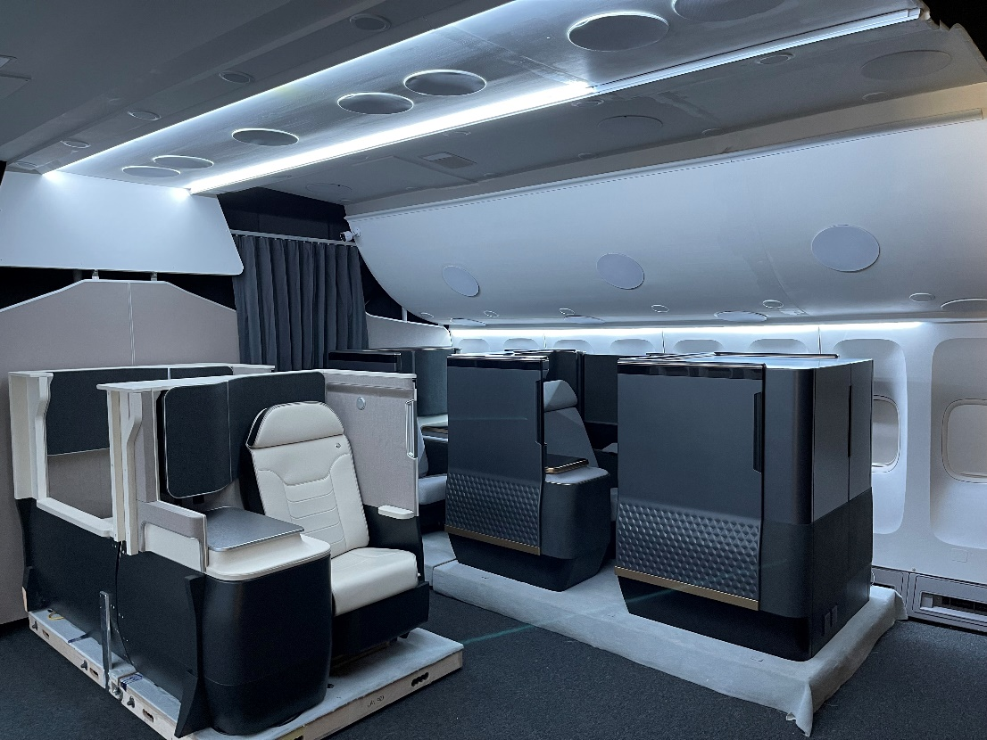
Figure 1 - Aircraft Simulator at SSGB
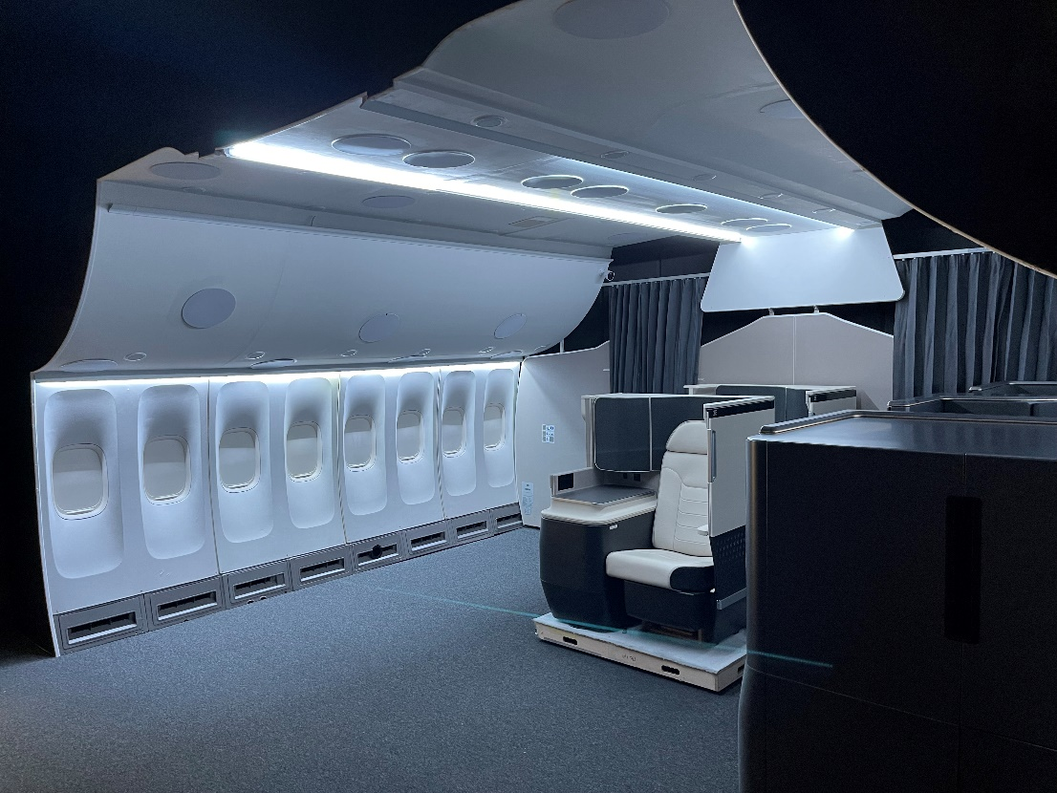
Figure 2 - Aircraft Simulator at SSGB

An aircraft’s power is typically 115VAC 400Hz (Skybrary, 2023). R&T technology bricks are developed with DC power because once the technology bricks are productionised, they will be powered by the seat ECU. The ECU will then transform and filter the aircraft’s 115VAC power to the 28VDC required to power the system. The power supply and system will need to be robust enough to handle up to 32V for any peaks that might occur. This could result in reduced efficiency and shorten the lifespan of the system. The target power consumption for the system is going to be 30W with a maximum of 55W, this is so that any power spikes are accounted for and the power supply will be able to cope with any excess power requirements.
During this project it was imperative to gather data, information, knowledge and evidence to input into the different stages of the Technology Readiness Levels (TRL). Levels one to six are within the remit of R&T, and no technology can be offered or integrated onto a programme unless it has reached TRL six. When each level has been achieved, a TRL review is required with a group of experts and stakeholders within Safran, who can identify that the technology adheres to air framers certification requirements and to ensure all testing and safety requirements are met.
Levels one and two are usually research and case studies which can be undertaken by universities. TRL 3 is where a Proof of Concept (POC) is produced to be able to test. TRL four is to be able to test that the performance of the concept is suitable for what is required. TRL five and six are integrating the technology into a representative environment and demonstrating its targeted application. These are usually integrated into R&T’s integration test suite within the aircraft simulator, for an aircraft representative environment.
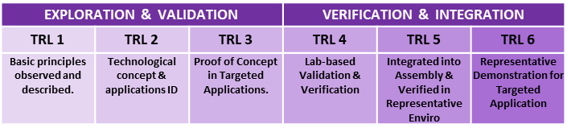
Figure 3 - Technology Readiness Level Process

Once the technology has reached TRL six, it will then be passed onto an architect to find possible programmes which they can be implemented on.
The compartment should also be easy to clean and maintain as this will help airlines be able to keep the compartment looking and functioning to a good standard. This can be done by using radiuses on the internal corners instead of sharp corners. This will help any dust build-up be easily cleaned with a cloth. Fan guards must also be installed and kept in good condition as it is a safety feature, so nothing small e.g. fingers, pens and other small items can be inserted into the fan while it is rotating which can damage the hardware.

Timing plan

The Gantt chart which was followed throughout this project can be found in Appendix 1. The second solution testing dates were adjusted to after AIX, as there were so many tests to undertake, the time scale would have been too compact to conduct them all.
The other dates which were not met on the Gantt chart are related to the insulation testing. Due to long lead times on the 20mm thick insulation, this part of the testing had to be skipped however, from testing other thicknesses such as 5mm, 10, and 15mm, the 20mm insulation would not have been beneficial to test.
Otherwise, the Gantt chart was updated and checked frequently to ensure the work was being completed successfully and on track.

Research/literature survey

As part of this dissertation, research had been carried out on multiple solutions to determine what way the project should be steered. To start with, the use of refrigerant was investigated as it is the most common way to create a ‘fridge-like’ environment. Discovering that refrigerants can be very flammable, toxic and volatile when compressed, it would not make sense to use these types of fluids and gases within an aircraft cabin, as if the aircraft underwent a rapid decompression, this can cause the refrigerant to become explosive within the cabin (Delta , 2024). After finding out this information, a system containing refrigerant could be disregarded as a feasible option and an air cooled solution would be best suited to the application.
Thermoelectric cooling devices are a small, compact, lightweight and reliable piece of hardware. Dongliang Zhao (2014) narrates that they have no mechanical moving parts as they work by using direct current being passed through the thermoelectric device. A thermoelectric device is made up of soldered junctions of two different semiconductor materials (usually copper and bismuth), and two electrical insulator plates which are ceramic. This allows the temperature to be increased when the current passes from copper to bismuth which will create a temperature difference.
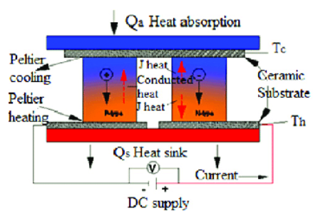
Figure 4 - Diagram of Heat Transfer Between Junctions - (Zheng, 2014)

Likewise, the temperature will decrease when passing from bismuth to copper which will create a ‘hot side’ and ‘cold side’ (Zebarjadi, 2015). This effect created by the device is called the ‘Peltier effect’. This effect creates the temperature difference and chemical potential between the two materials to cause a cooling effect. The reverse effect of this which is used for heating is called the ‘seebeck effect’. This is where heated electrons flow to the cold side (Terasaki, 2016). The hot side can reach temperatures of up to two-hundred degrees in some instances and the cold side can reach temperatures as low as minus forty-five degrees, which are very dangerous temperatures. For the thermoelectric devices to be useful and more efficient, heatsinks are necessary on the hot side to significantly decrease the temperature from the hot side of the thermoelectric device. This will help extend the lifespan of the component and increase the efficiency of the system. It also stops the component from malfunction or causing extensive damage to itself. Heatsinks are usually made from Aluminium as they’re great thermal conductors and they can be easily machined into certain shapes and sizes for different applications (Advanced Thermal Solutions Inc., 2018). As the heatsink withdraws the heat from the device, there must be a fan or blower to remove that heat from the heatsink so the system can be efficient as possible. This required a study to be carried out on where the hot air should be exhausted to. The seat ECU is stored underneath the seat and can get to temperatures of up to thirty-four degrees Celsius when all peripherals of the suite are connected to it. As the temperature from the exhaust was lower than that temperature of the ECU underneath the seat, it could potentially act as a cooling air flow by decreasing the temperature underneath the seat.
The drinks at a cooled temperature will be affected by convection, this is where the transfer of heat occurs through the movement of fluids. When a cooled drink is left in an ambient temperature surrounding, the air around the drink will warm up as heat always flows from the warmer body to the colder body, it then becomes less dense and rises. The continuous circulation of warm air around the bottle will facilitate the heat transfer, making the drink temperature increase to the ambient temperature.

5.1 Previous Solutions

SSGB have previously investigated integrating a thermoelectric device for a cooled compartment for an airline in 2022 however, the time limit was too short to come up with a substantial solution.
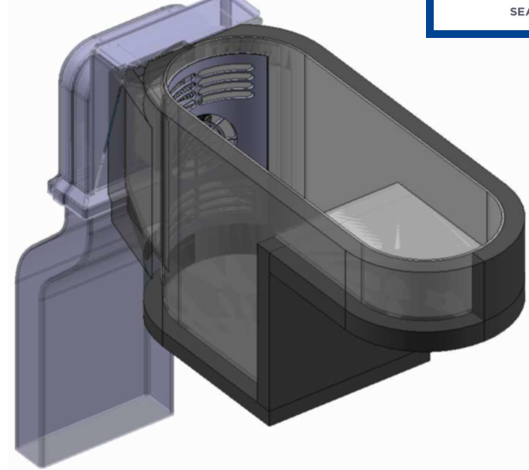
Figure 5 - Previous Concept of Cooled Compartment
Figure 6 – Previous Concept Thermoelectric Device Stack-up

As seen in Figure 6, there are fans attached to both heat sinks that push the cold air into the compartment where drinks are stored, and the other fan will extract the hot air from the hot side of the thermoelectric device.
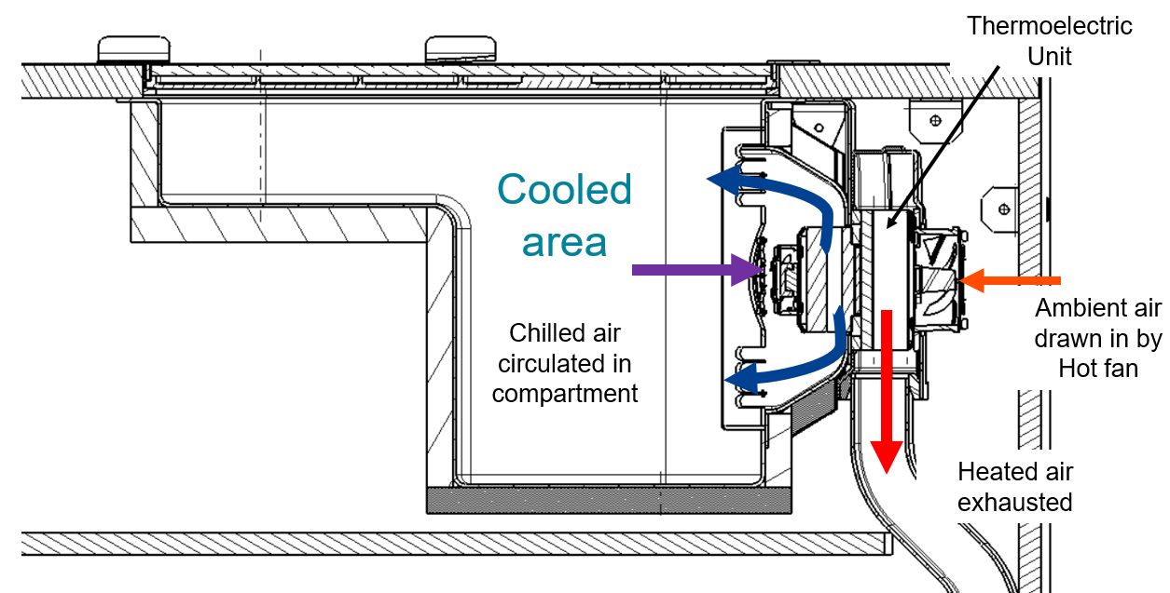
Figure 7 - Cooling Compartment System

As seen in Figure 7, the ambient air is drawn in from the rear of the compartment, then subjected to the Peltier effect where the cold air will go through the cold heat sink and into the compartment. This was a good system to draw knowledge from for the updated cooled compartment.

Competitors Solutions

Safran Seats GB’s main competitor is Collins Aerospace, they are based in Newry and also produce first class and business class seating for airlines. They had also started to look at transforming a normal cubby stowage into a cooled compartment where drinks can be cooled and stored. Their version of this is called ‘space chiller’ which was demonstrated at AIX2022. There has been no productionised system released, so SSGB are still able to be the first to market with this solution. SSGB’s solution is also be a much higher perceived quality system which will be more aesthetically pleasing for airlines.
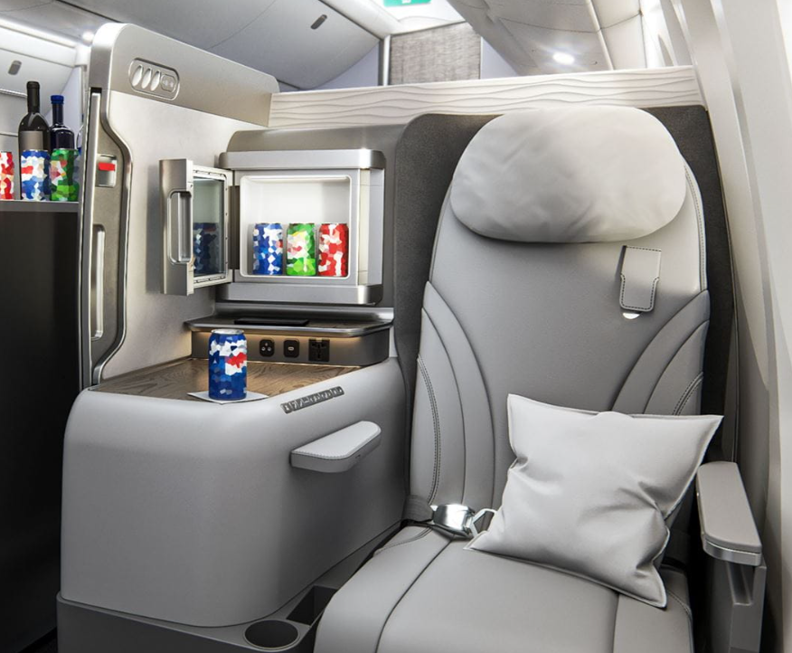
Figure 8 - Collins Aerospace - Space Chiller Concept - (Collins Aerospace, 2022)
The Collins Aerospace solution has the same bottle capacity of three cans or bottles however, the surrounding area of the bottles is smaller which will make the cooling more efficient as there is less air to cool. This different form factor was worth testing to see how much more efficient it was than the volume SSGB needs to cool.
Collins Aerospace have also filed a patent for the system in Figure 9. This system uses a coolant on the hot side of the thermoelectric device however, an air to air solution which will be more appealing to airlines and customers. The patented solution is very general as it is widely used in the automotive industry.
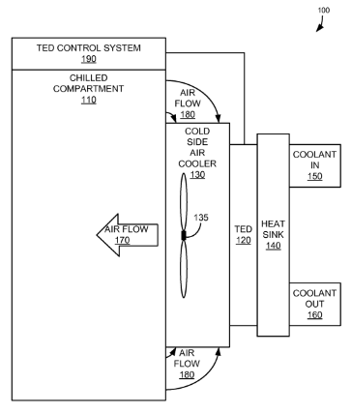
Figure 9 - Collins Aerospace Thermoelectric Device Filed Patent

5.3 Applications of Thermoelectric Devices

While researching different applications of thermoelectric devices, it was interesting to find that they are also used in portable electric cool boxes. They are stored within the lid of the cool box and have a very simple solution. From this already-proven solution, it was decided that a variant different variant should be created. A thermoelectric device in the top of the compartment rather than positioned in the side, could be tested to determine the most efficient location. There would have to be a change in form factor to fit heat sinks, fans and thermoelectric devices in the top however, the circulation of air may be improved due to the heat rising straight up out of the compartment. The thermoelectric devices in these cool boxes can achieve a temperature of up to eighteen degrees below ambient temperature (World of Camping, 2023).
Within first class, it is likely to find a variety of drinks that can be stored within the fridge such as cans of fizzy drinks, plastic bottles of water and even glass bottles of champagne.
SSGB’s fridge needed to have the capacity to store a total of three cans, bottles, champagne glasses or a mixture of the three.
FerroTec (2023) describes some other applications where thermoelectric devices are used such as wine cabinets, small power generators, all the way to sophisticated temperature control systems within missiles.

Material Research

For the insulation material, there were two main foams which stood out as they were already utilised on aircraft. Meetings were had with Safran galleys, as they use the same material in their cooled compartments in a similar application. The Plastezote and Zotek foams are very similar however, the Zotek foams has better fire retardant properties over Plastezote. The data sheets for both of the foam materials can be found in Appendix 2 and Appendix 3. To ensure that these materials are suitable for the application, various tests between the two were carried out with different thicknesses to see the performance difference.
‘Thinsulate’ by 3M is also another alternative insulation material. This material is a wool-like insulation, whereas Plastezote and Zotek are both foam insulators. The foam insulation would be easier to cover composite panels as it is a semi-rigid foam, which makes increasing the thickness stack-up easier than using the 3M ‘Thinsulate’.
To achieve the tinted mirror finish for the door (as per industrial design requirements), glass or polycarbonate was not a sufficient material as they’re transparent. After some research, a company called ‘Aviation Glass’ was found, who provided glass that had been tested and had passed all aviation certification tests, such as Fire, Smoke and Toxicity (FST) and hardness tests. They were also able to provide different types of finishes and transparencies which could achieved the desired finish. The data sheet for the material can be found in Appendix 4.
For the production solution, it will be important to investigate what thickness and type of composite will be best suited for the application. This activity will take place after AIX24 as the goal is to just have a working prototype for the show to demonstrate the concept to customers and airlines.

Fans Research

Due to the amount of various fans that are available on the market, the axial fan best suited the application as they can be purchased in a slim profile, which helped save some space within the suite. The axial fan would pull air from the cold side heat sink and push it into the internal compartment. Radial fans were found to not be as useful due to the exhaust output being at ninety degrees to the inlet. This would make the system build-up much thicker than that of an axial fan. The radial fans are usually louder than axial fans which is a big disadvantage due to the target of 55dBa. Pauls Fan Company (2019) also describes how the axial fans displace more air than radial fans, just at lower pressure, which would be better suited to the larger compartment within the suite.

Work carried out

To start this project, it was important to research previous applications and past projects in which knowledge and information can be drawn from. From this, thermoelectric devices were found to be the most appropriate solution that just needed to be matured from previous attempts.
As this project is to be shown at AIX24, it is vital that the cooled compartment has a high level of perceived quality, and it’s integrated seamlessly into the suite. Due to this requirement, alignment meetings and workshops were created and attended by SSGB R&T, Advanced Concepts Team (ACT) and the industrial design team. The meetings covered various topics such as different Colour, Materials & Finishes (CMF) and how the thermoelectric device can fit into the suite without making too many modifications for the mock-up builder.
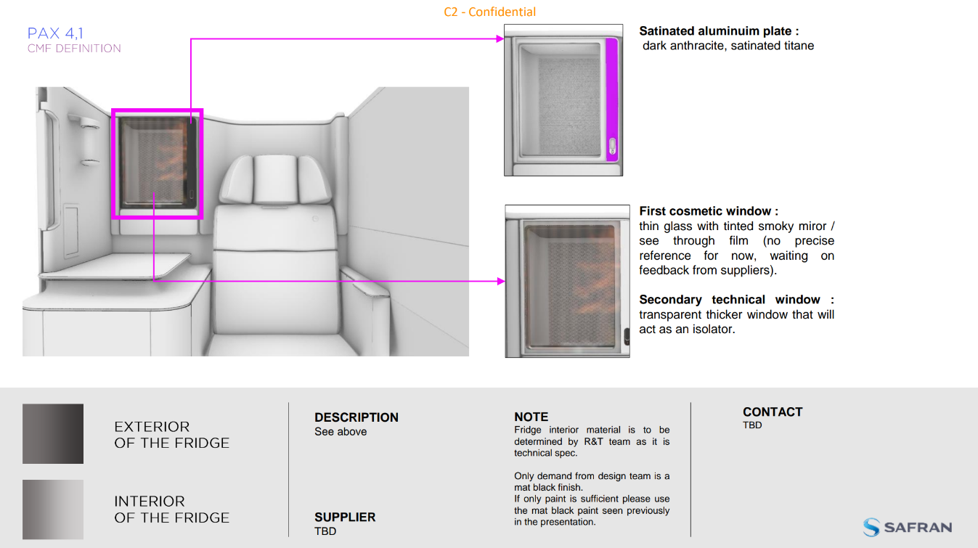
Figure 10 - Colour, Trim and Finish Document (Bourguignon, 2024)

The CMF document is produced by the CMF expert, who is part of the industrial design team. The document is full of mood boards, which is where the inspiration come from. The document is also full of different suppliers which needed to be narrowed down to supply the paints and trims. Pantone references were given so different suppliers can produce the same colour and reduced the changes of having any discrepancies. Any special notes, or actions to be taken are also on each slide, so the CMF document was constantly updated with selected suppliers etc.
From the visuals the industrial design team produced, it was then R&T’s job to turn the vision into a reality, while still ensuring all performance requirements were met.
Figure 11 - Renders of Compartment Integrated Into Suite
Figure 12 - Internal of Cooled Compartment Render
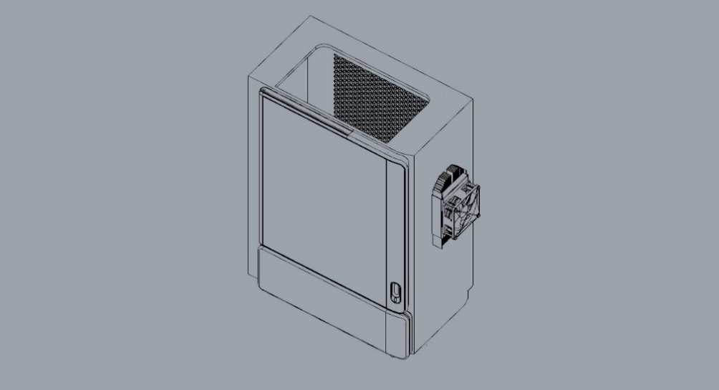
Figure 13 - Location of Thermoelectric Device

Once the final renders were created, the final CAD files were checked over by Thomas Jourdan-Gassin and Michael North and the rest of the SSGB R&T team. This CAD was then sent to Ogle Models to double-check all of the dimensions and tolerances were valid. Ogle Models produce all of R&T’s mock-ups and technology demonstrator suites. SSGB requested Ogle Models to produce six of the compartment mock-ups, this is so analysis could be carried out on different solutions and compared against each other. Some were also sent to suppliers so they could undertake their own testing, and could carry out optimisation of the system.
The lead time of creating these compartments was approximately seven weeks. During this time, SSGB engaged in meetings with UK based suppliers, as support is much easier and convenient to obtain than that from an international supplier. The cost of shipping parts back and forth would also be cheaper and more efficient.
For the thermoelectric device, we spoke to European Thermodynamics who are based in Leicestershire and developed a good relationship straight away. They were very accommodating to the requirements and willing to undergo Research and Development (R&D) to make the solution work. SSGB decided to setup a Non-Disclosure Agreement (NDA) which would keep the project and innovations confidential between the two companies (Egan, 2021).
Once the NDA was completed, European Thermodynamics visited SSGB to see the application for themselves.
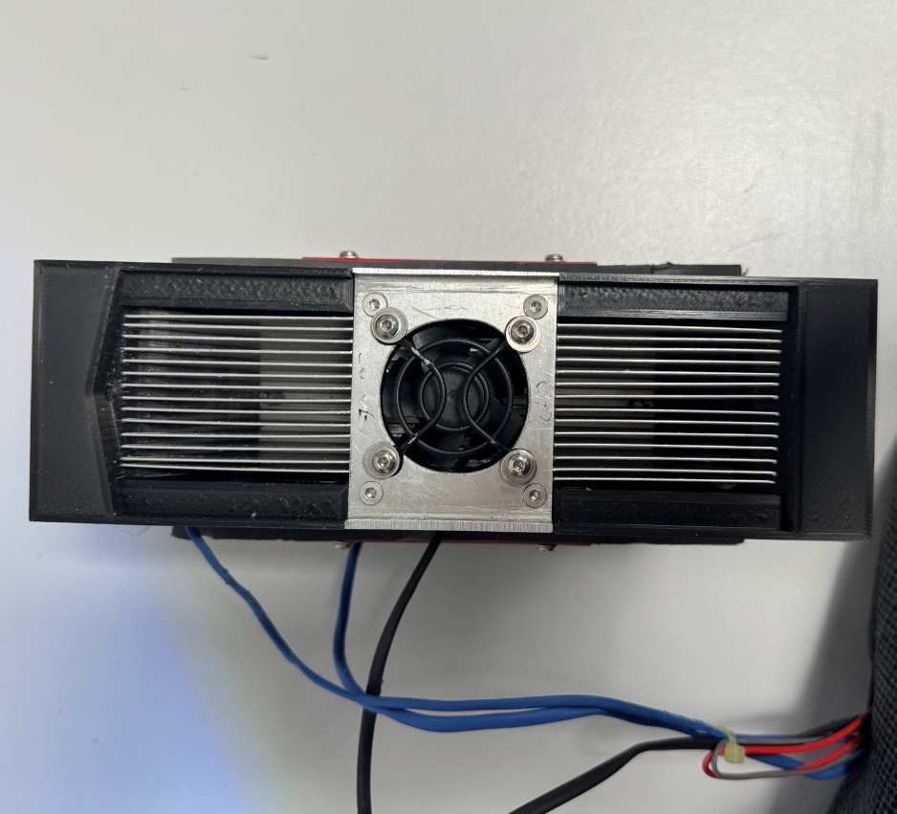
Figure 14 - Front Side of Thermoelectric Device
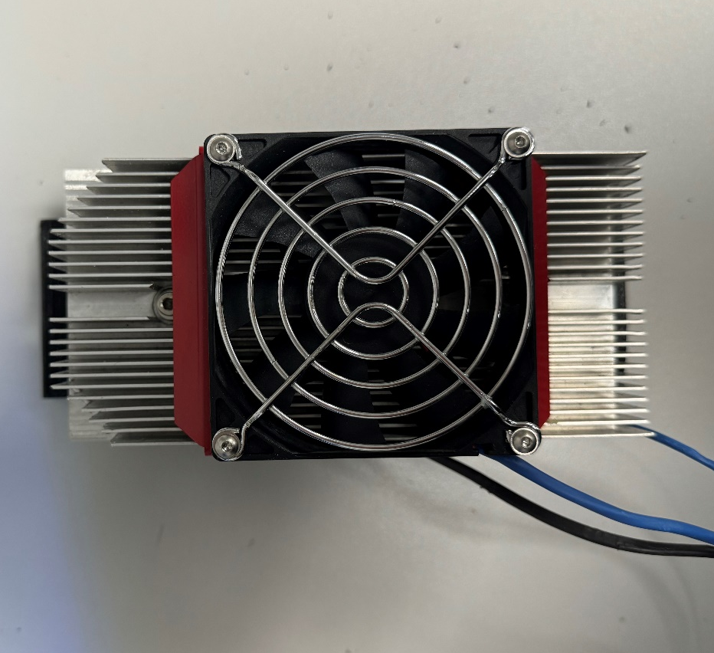
Figure 15 - Rear Side of Thermoelectric Device
After three weeks, European Thermodynamics came up with a system consisting of a cold side heat sink, hot side heat sink, two fans and a thermoelectric device which would fit within the desired space.
The data sheets for the fans in Figure 14 and 15 can be found in Appendix 5 and Appendix 6.
To be able to mount the thermoelectric device, it was decided to create a 3D printed insert jig. This jig would allow the thermoelectric device to be fixed into place and also provide an ‘A’ surface finish within the cooled compartment.
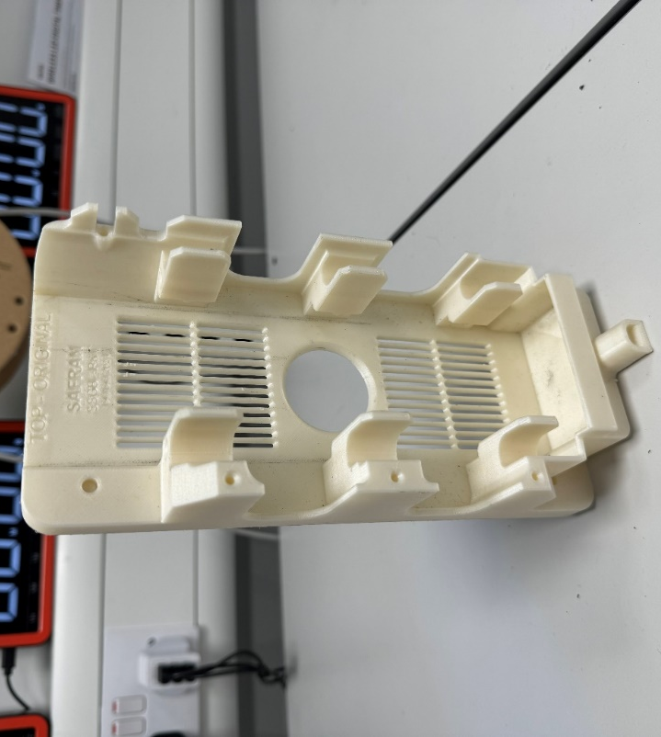
Figure 16 - Test 3D Printed Insert
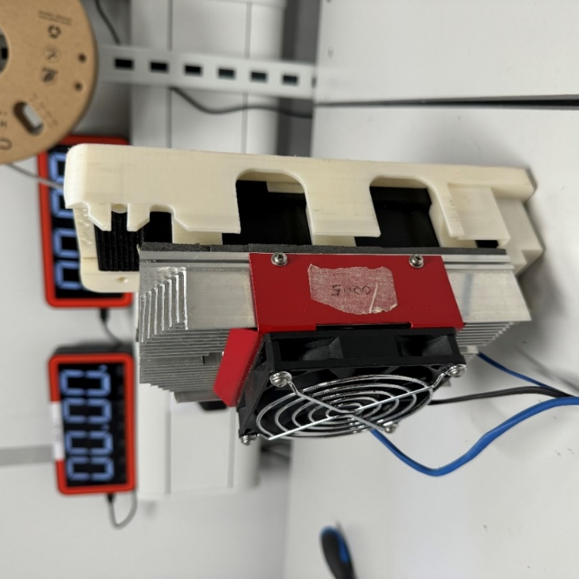
Figure 17 - Thermoelectric Device in Insert
This jig allowed the thermoelectric device to be slid downwards through a channel of the insert which will then be secured from inside of the cooled compartment.
When the demo test units were completed by Ogle models, the thermoelectric device was installed and testing was carried out using a PICO Data Logger. The PICO TC-08 was used to measure temperatures in different locations of the system, it has eight different channels which could record temperatures from -270°C to 1820°C which was more than sufficient for SSGB’s application. The data logger also came with a very simple and easy-to-use software application, which can create graphs and record all raw data in an excel spreadsheet format. All of the tests can be found within the ‘Testing’ section.
This system was installed into one of the test rigs, which was originally built by the prototype builders and tested. This test rig could either be used on a bench or installed into the R&T integration test rig, which allowed different variations to be tested in a representative environment.
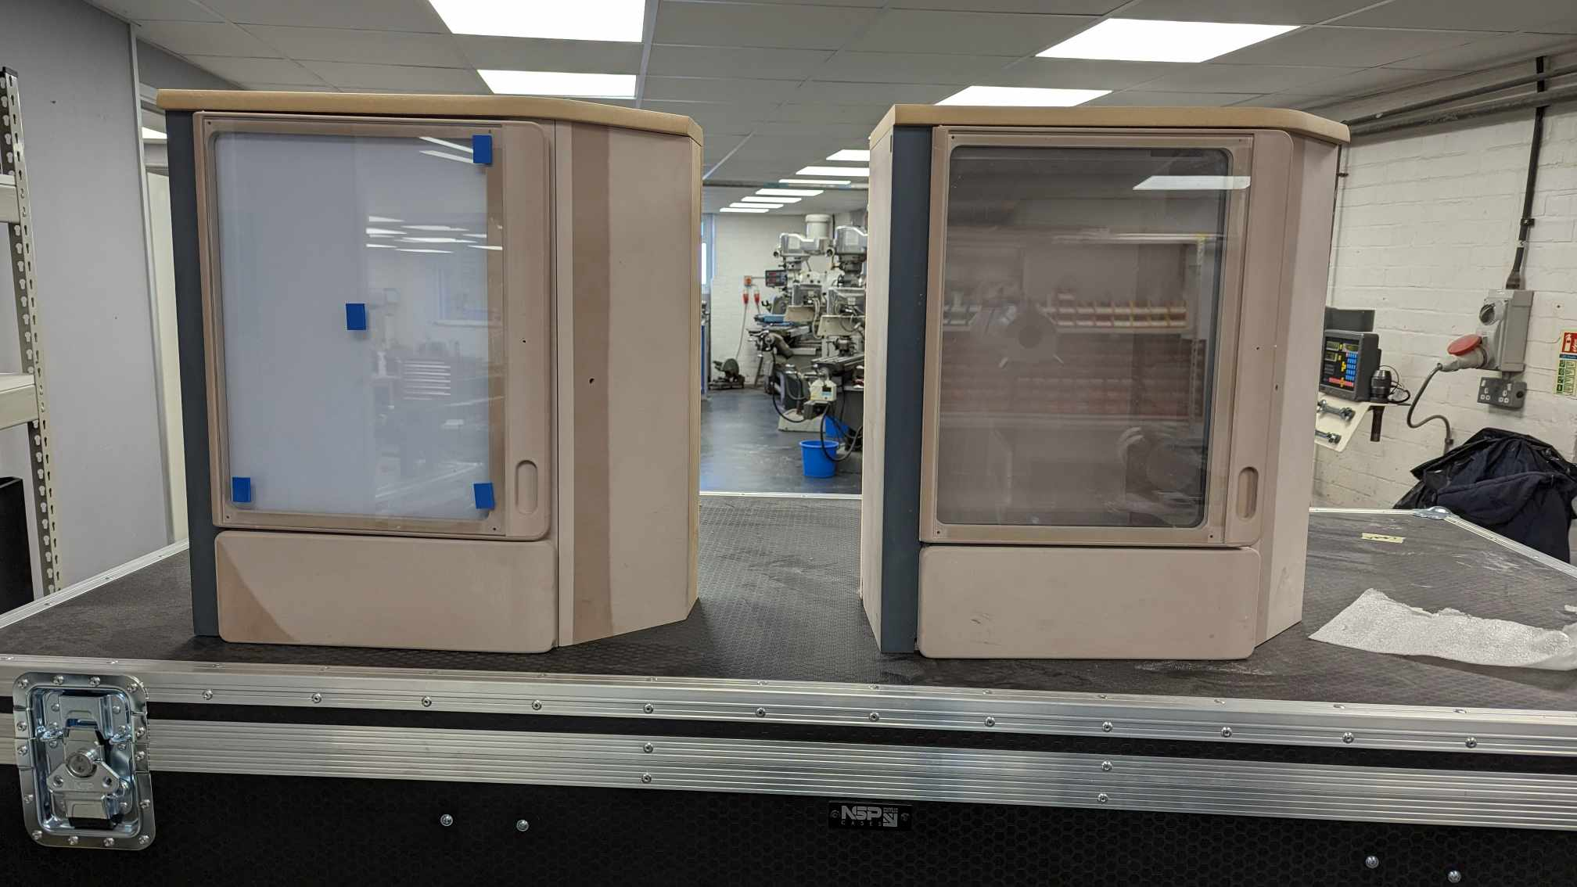
Figure 18 - Test Rigs Mid-Build
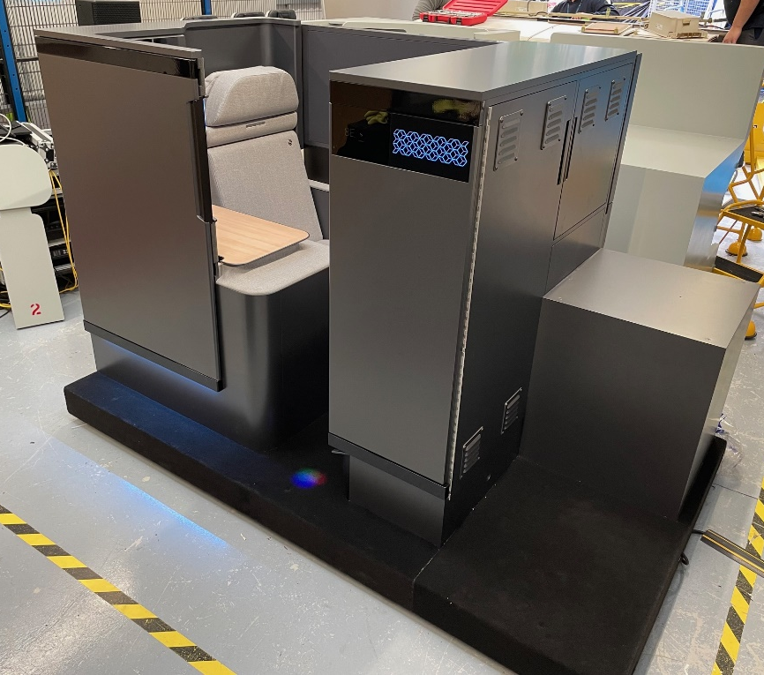
Figure 19 - R&T Integration Test Suite

Once the testing of the first version thermoelectric system was complete, some modifications were made to introduce another fan to the system, in the hope of providing better air circulation.
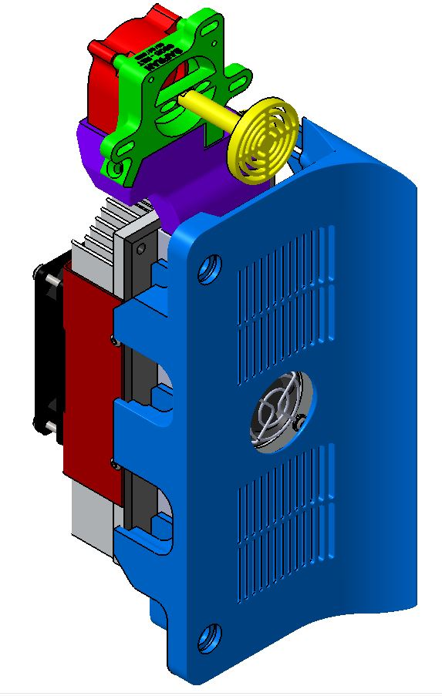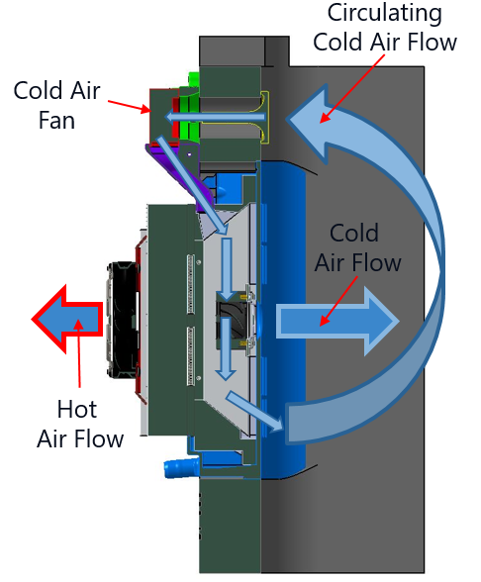
Figure 20 - Second Version of Thermoelectric System with New Fan Installation
From Figure 20, the new fan at the top of the system draws air in from the top of the cooled compartment, then directs the same air back over the cold side heat sink, which the fan will blow directly back into the compartment. By adding this fan, the cold air was effectively being re-used and cooled again, decreasing the temperature of the air on each circulation of the cooled compartment. To ensure the air was directed back down the cold side heat sink, a 3D printed section was printed to attach to the fan exit, down to the heat sink. The tests were conducted again to see if this modification had any improved effects on the results. The data sheet for the fan can be found in Appendix 7.
Weight is a crucial factor in every section of aerospace as this can increase operating costs significantly, by adding large amounts of weight onto an aircraft.
The weight estimations for the thermoelectric are as per the numbers below however, these will need to be optimised even more for a production solution.
Front piece = 573.7g
Back piece = 500g
Ali spacer = 305g
Thermoelectric device with connectors = 750g
Three bottle shelf = 392g
The weight of the composite structure will depend on the location of the thermoelectric device and other factors such as adhesives and fixings.
After completing all of the tests, a new chiller test rig was created so that the thermoelectric device could be installed in the top of the unit. This decreased the overall internal volume of the compartment, requiring less air to be cooled. This test rig also allowed SSGB to be able to work with a new supplier called Micronel. They are a Swiss company that produce miniature fans and blowers, which can assist in reducing the overall size of the thermoelectric system. Micronel provide a lot of fans and blowers for medical applications, which automatically gave the impression of reputable and reliable products. Some of the new fans which were demonstrated to SSGB provided much a much faster air flow and pressure.
After working with Ciaran Doherty and Michael North, a top mounted design test rig was created utilising Micronel fans. The new design looked completely different to the first version which was side mounted.
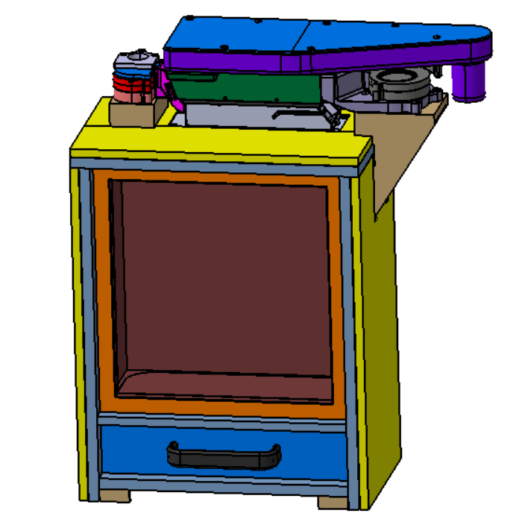
Figure 21 - Top Mounted Cooled Compartment Test Rig

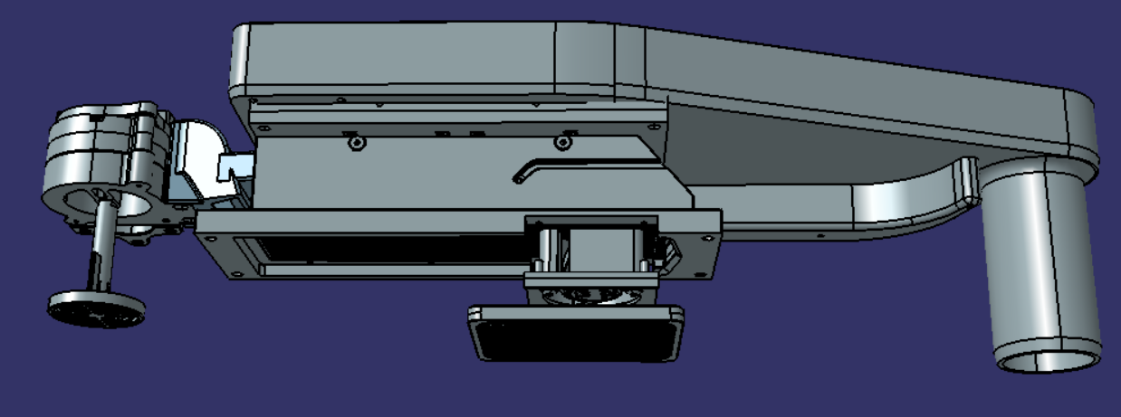
Figure 22 - Top Mounted Cooled Compartment Test Rig

As Figure 21 demonstrates, the internal dimensions have been shrunk to 290.5mm x 145.2mm x 298mm, which was a reduction from the first version, mainly in height. The capacity of three bottles is still the same, but the surrounding area had been reduced to help aid the cooling of the compartment, also reducing the amount of air required to be cooled. The test rig will be manufactured from 0.5 inch composite to further advance the production solution. The yellow surfaces seen in Figure 21 are the Zotek foam sections which retain the cold air within the compartment.
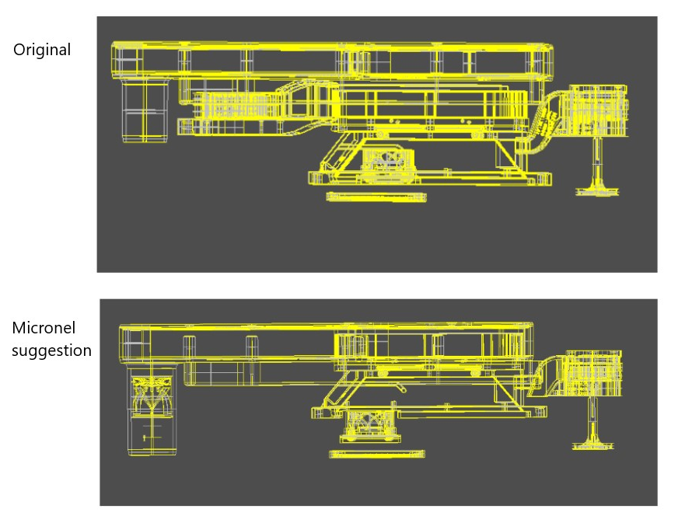
Figure 23 - Micronel Optimisation of SSGB Original Solution

Micronel then took SSGB’s suggested design and modified it so that less fans were required. They suggested using a D-line fan which are very powerful. Instead of using a fan to blow hot air over the heatsink, then a fan at the entrance of the exhaust to exit the air, the D-line fan will be able to pull the air over the heatsink then exit the air through the outlet side of the fan. This will help remove one fan from the Bill of Material (BOM) when it comes to production and also helps to reduce the height of the unit, allowing more space for air flow in the top mounted solution.
Due to time constraints, the top-mounted solution was not able to be fully tested to provide full confidence for taking it to AIX24. It was then decided that the side-mounted solution would be implemented into the show suite to demonstrate to customers, then the top-mounted solution could be shown in a more optimised and production ready state for AIX25.
Below are some images of the finished prototype for the top mounted system. Integrated into this is a realistic magnetic seal for the door, this will assist in retaining as much cold air as possible. There are access hatches to install insulation foams, fans and drinks within the compartment. This prototype will be tested after the AIX24 show to develop and mature as a full system.
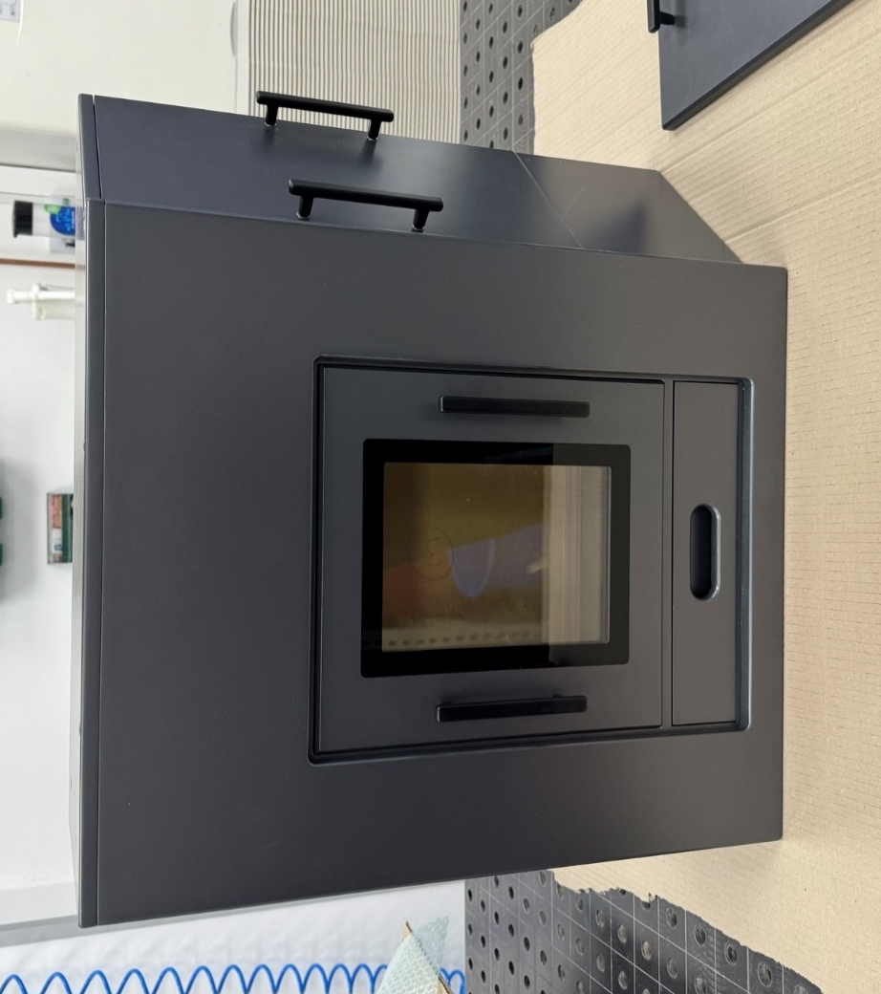
Figure 24 - Top-mounted Cooled Compartment Prototype

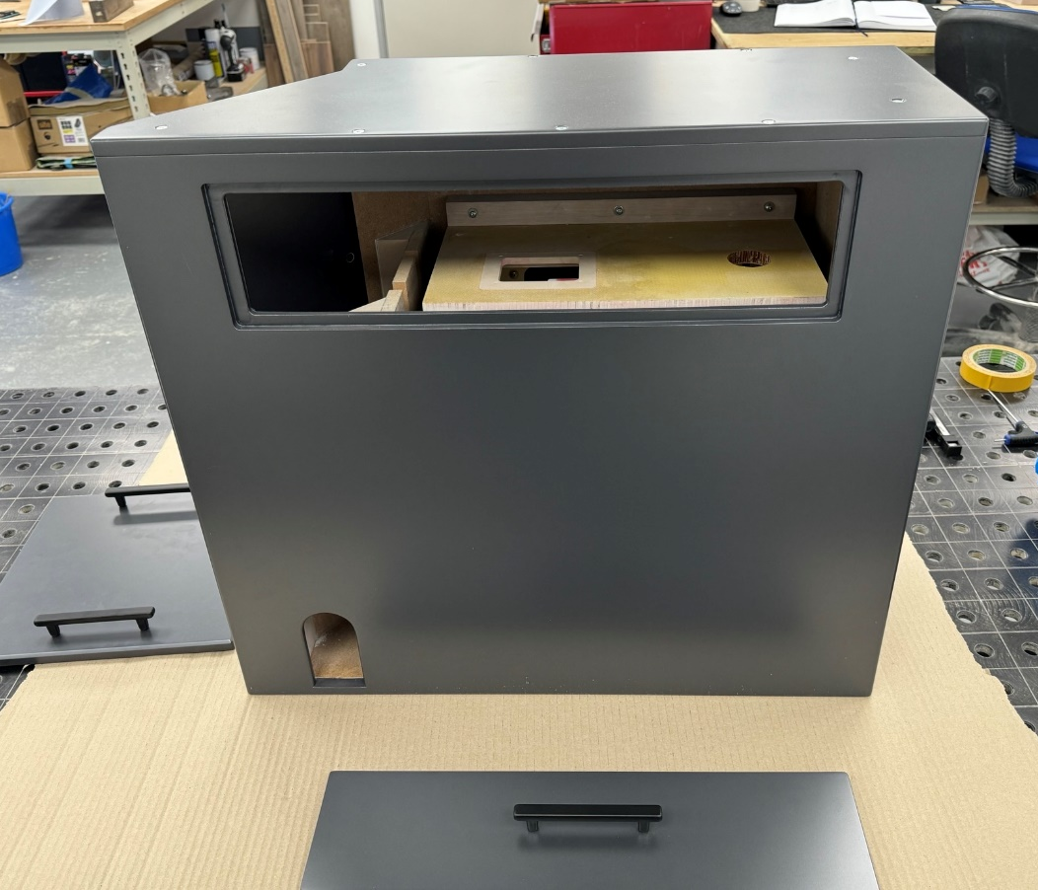
Figure 25 - Space Envelope for Top Mounted Thermoelectric Device System

To prepare the cooled compartment to be show ready, the fridge was painted and installed into the PAX4.0 suite, making the installation look neat and flush to all of the surrounding surfaces. An overlapped mesh background was also implemented to make the compartment aesthetically pleasing and provide a good background for the drinks on show.
The final modifications for the cooled compartment were to install sensors and lighting in the shelf which the drinks stand on. The weight sensors were part of demonstrating more functionality of SSGB’s ‘connected system’, which help cabin crew offer better service by being alerted when the drinks are almost or fully empty.
Small spotlights were installed under the bottles so the light can shine upwards through the glass, resulting in a premium looking setup which would catch customer’s attention straight away.

Calculations

It was important to carry out some calculations to determine some estimated values on how much energy the system would require, to get the cooled compartment from twenty degrees Celsius (which is the average temperature within the cabin) down to eight degrees.
Firstly, the internal volume of the cooled compartment had to be calculated, so the dimensions were taken from the CAD file on CATIA V5.
Figure 26 – Internal CAD Dimensions of Cooled Compartment

The internal volume of the compartment $= \frac{290.3mm}{1000} × \frac{149.6mm}{1000} × \frac{354.5mm}{1000}≈$ ${0.01567m}^{3}$
Due to the nature of aircraft, the mass of the air inside the cooled compartment will be more than when it is cruising at 40,000ft. This is because even though aircraft are pressurised to 6,000ft - 8,000ft, the density in the cabin will still be less while the aircraft is cruising, than it will be while on the ground (Monroe Aerospace, 2020). This indicated that the system would require more energy to decrease the temperature, while the aircraft was on the ground. The mass of the air on ground is approximately ρ=1.293 kg/m³ (0.0202Kg) as told by UBC ATSC (2019), then while cruising and the cabin is pressurised to 6,000ft, it is approximately ρ=0.95328 kg/m⁻³ (0.01493kg).
To calculate the worst case scenario, the plastic water bottles of water needed to be used within the calculation. This is due to the aluminium and glass being better thermal conductors than the plastic. The aluminium and glass bottles also help to keep the contents of the bottle cooler for longer. The mass of a 500ml water bottle is 500g. The specific heat refers to how much heat is required to raise the temperature of a single gram by one degrees (Gregersen, 2023). The specific heat of water is 4182 J/Kg°C, and the specific heat of air is 1005 J/Kg°C.
These values could then be transferred into the equation to find out the total energy required, for cooling the air on ground, while cruising and cooling a water bottle from 20°C to 8°C.
Air in compartment (on ground) = $Q_{ground }= m_{ground}× c_{ground }×{∆T}_{ground}$ = 243J
Air in compartment (cruising) = $Q_{cruising }= m_{cruising}× c_{cruising }×{∆T}_{cruising}$ = 180J
1x water bottle = $Q_{water }= m_{water}× c_{water }×{∆T}_{water}$ = 25.14KJ

To calculate the energy required for the smaller top-mounted version, the new internal volume will need to be considered in the calculations.
The new internal volume $= \frac{290.5mm}{1000} × \frac{145.2mm}{1000} × \frac{298mm}{1000}≈$ ${0.0125}^{3}$
Assuming that all other values of the previous calculation stayed the same, the system had an improved efficiency as less air required cooling, as the internal volume of the compartment has decreased. The smaller internal volume also had an advantage of having less surface area for air to escape from the compartment.

Testing

To ensure there was a systematic approach to the testing, also making sure no time was wasted, research was carried out into Design of Experiments (DoE). As More Steam (2023) describes, this method is used to plan, conduct and then analyse controlled experiments, which can then be used to compare and optimise systems. Using DoE was important to identify variables that could be controlled, also have a factor on how the system operates.
Due to only having two prototypes, it was important to ensure that these hardware devices were running at the correct current and voltage so they could be well maintained and not potentially damaging the devices. Running the hardware devices at higher and lower voltages were not the main tests, as these fans and thermoelectric device have all been optimised so they run the most efficient at the stated voltage and current.
From this, a test plan was created to log how the tests should be carried out. The tests involved:
- Changing the ambient temperature (Low: 15°C - 19°C), (Medium: 20°C - 24°C)
- Changing the insulation thickness stack-up around compartment (5mm, 10mm, 15mm)
- Changing the location of the thermoelectric device (Side mounted, top mounted)
- Changing the contents of the cooled compartment (Plastic bottles, Glass bottles and Aluminium cans)
These tests were carried out a total of three times each to account for repeatability, verifying that the tests are free from anomalies and errors.

Changing Ambient Temperature

For testing the unit in a representative environment, the ambient temperature should be between twenty-two and twenty-five degrees Celsius. To achieve this, the tests were carried out in the aircraft simulator in SSGB where the temperature can be controlled via an air conditioning unit.
The unit was also tested in a colder workshop environment to compare how much colder the compartment got by changing the ambient temperature.

Changing Insulation Thickness

To help retain the cold air within the compartment and to stop any leaks, insulation foam was used to aid this however, the thickness which was required for best effect was not clear. Thicknesses of 5mm, 10mm and 15mm were used to compare each thickness. 20mm insulation foam was on longer lead times from the supplier, so this thickness can be tested in future work.
To test the different insulation thicknesses, they had to be ordered then cut to the dimensions of the exterior of the unit. They were then secured to the exterior of the compartment to act as an insulator. The aim of the tests were to see which thickness could help achieve the target temperature. Too much thickness would have added unnecessary weight to the system and taken up more space when installed within a suite.
Increasing the thickness of insulation can enhance the thermal insulation properties of the compartment, reducing heat transfer between the interior of the compartment and the external environment. This can result in improved temperature stability and reduced energy consumption of the cooling system, as less cooling capacity is required to maintain the desired temperature.

Changing Location of Thermoelectric Device

To optimise the system, the thermoelectric device was mounted in the side and top of the compartment to see which performed better. These were the only locations in which the device could be installed due to space constraints, so it was important to compare these thoroughly. Various designs were created to be able to account for various factors such as maintenance accessibility, condensation, moisture management and temperature distribution.

Changing Contents in Compartment

The contents within the cooled compartment such as plastic bottles, glass bottles and cans were changed as all of these materials have different thermal conductivity properties. It was important to measure the temperature of the fluid in different materials, as the thermal conductivity of each plastic, glass and aluminium is different. The cans were likely to get colder quicker than the glass and plastic due to having a better thermal conductivity. The glass and aluminium were likely to stay colder for longer, once removed from the cooled compartment due to the material characteristics and can typically reach the same temperature rise in a similar time frame (Bailey & Elban, 2008).

System Electrical Architecture

The electrical architecture that was used when carrying out all of these tests can be found in Appendix 8. The junior controller can be used to set target values, then the controller will provide adequate current to achieve that set target as informed by European Thermodynamics Limited (2017). This was also connected to a laptop to be able to use the junior controller software, where the set points were input manually.
For the production solution, the thermoelectric device will be powered by the ECU which will transform and filter the aircraft power to the required 28V to run the thermoelectric system. Figure 25 demonstrates the simple architecture of the thermoelectric device.
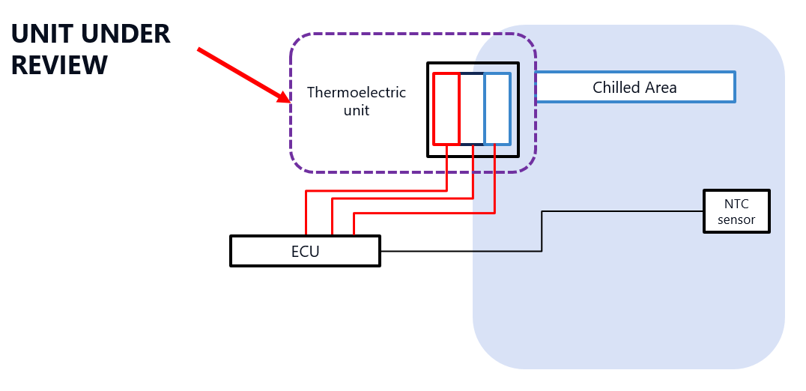
Figure 27 - Production Electrical Architecture

To find a location for the hot air to be exhausted to, it must either have acted as a cooling flow for an already hot area, or have been routed to a large open space to stop heating up any other surfaces of the suite to high temperatures. This could have had effects on some glues and adhesives used within the suite. To see if the hot air could act as a cooling flow, the temperature under the seat was measured as that is where the ECU’s and electrical hardware are installed. If the exhaust air can act as a cooling air flow, it will help maintain cooler temperatures for the electrical hardware.
The temperature under the seat structure got to temperatures of 32°C to 34°C next to the ECU and comfort system pumps. This coincided well with the hot air exhaust gases exiting from the thermoelectric device. The hot air is able to be pumped under the seat without increasing the temperature and provides an easy route for exhaust piping to be implemented.

Discussion of results

Test 1 – No insulation in a cold workshop
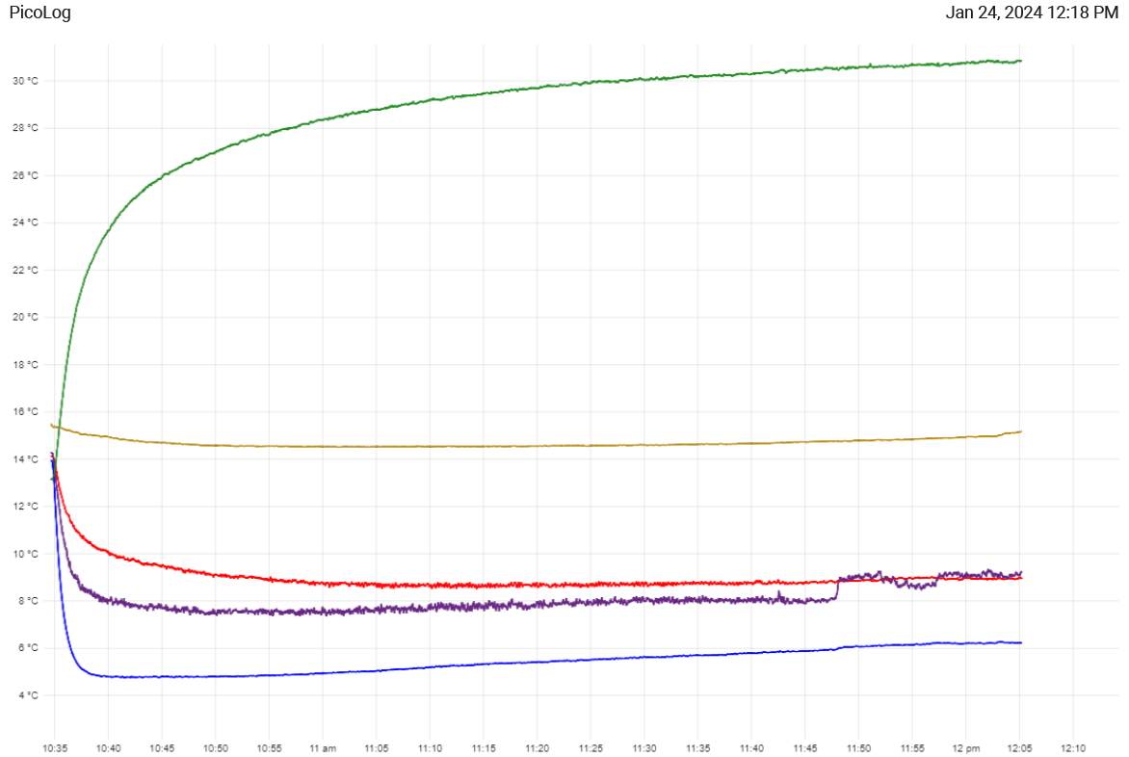
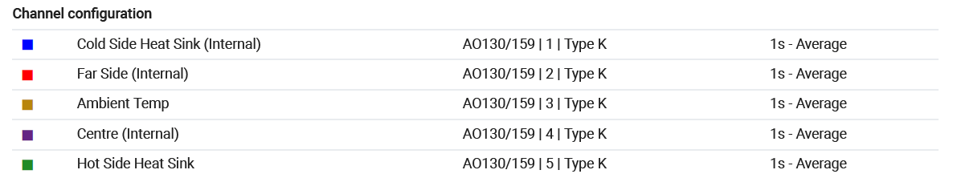
Figure 28 - Test 1 - Empty Compartment With No Insulation in Cold Environment
In Figure 28, this was the first test that was carried out on the cooled compartment. The compartment was empty and had no insulation surrounding the exterior of the compartment. This was planned to see how much cold air could be retained within the compartment as a baseline without any insulation. The first tests were conducted in a cold workshop with an ambient temperature of 15°C. This is 8°C below the ideal temperature for testing as an aircraft cabin temperature is maintained at 22°C - 24°C in ‘normal conditions’ according to Korean Air (2024). It’s visible from the graph that there was a significant temperature drop within the compartment in the first ten minutes. The temperature started to creep back up which could suggested that the internal volume could be too large to be cooled sufficiently, without some form of insulation material. This test was repeated three times to ensure that the results were valid and there were no anomalies within the results. The other two test graphs can be found in Appendix 9 and 10. Due to the cold ambient temperature, it was important to see how much of an effect this had on the cooling of the compartment so the next trial was to move the demo unit into a warmer environment which can be controlled by a thermostat.

Test 2 – No insulation in representative aircraft cabin temperature

When testing the thermoelectric device at an ambient temperature of 22°C, the performance of the thermoelectric device did not perform as well as when in a cold environment. The ambient temperature is a very important factor, as the thermoelectric device could only decrease the temperature by a certain amount below room temperature.
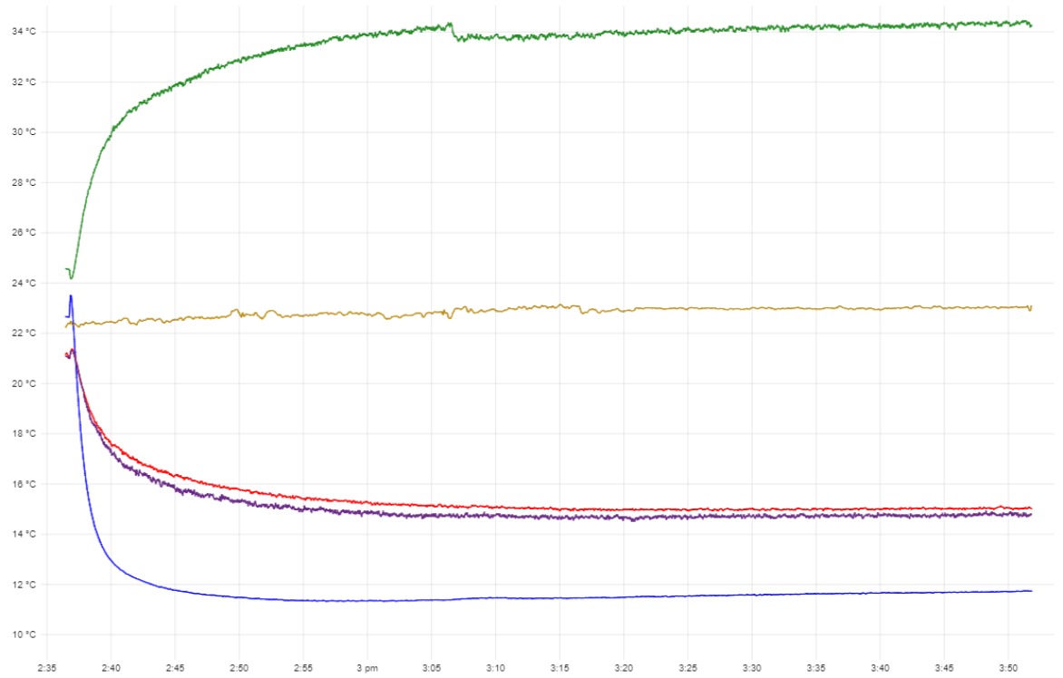
Figure 29 - Test 1 - Empty Compartment With No Insulation in Aircraft Ambient Environment

Comparing Figure 28 to Figure 29, it shows that as the ambient temperature increased, the effectiveness of the thermoelectric device decreased. As the ambient temperature has increased by 7°C, the lowest temperature achieved by the thermoelectric device was approximately 12°C. This result does not meet the required target of five to eight degrees however, these tests also had no insulation installed.

Test 3 – Additional fan setup in aircraft ambient temperature

The next test which was carried out was with the extra fan being installed on the top of the unit. These were carried out at aircraft cabin temperatures as they are the most representative conditions.
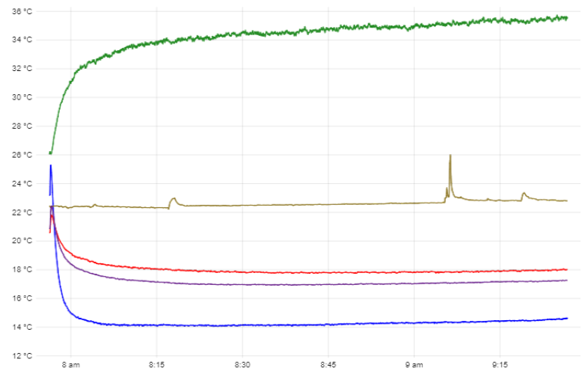
Figure 30 - Additional Fan System Test 1

The first test carried out showed a surprising result as the temperature did not decrease as expected. After carrying the test out two more times, the results were very similar which were disappointing. After some investigation into the system, a conclusion was made that the space the system is installed in is too small. This small space envelope meant that the hot air builds up in the area and it’s then much harder to circulate cold air. This also meant that another solution had to be created for exhausting the hot air to a suitable location, as it was just accumulating around the thermoelectric cooler system, which affected the efficiency quite dramatically. The other two tests for this set up can be found in Appendix 11 and 12.

Test 3 – Additional fan setup in aircraft ambient temperature

To test that this was having a negative effect, the removable panel to the thermoelectric device was removed while another test was carried out. Removing the panel allowed the hot air to exit the enclosure and prove it was having an effect on the efficiency. An image of the panel can be found in Appendix 13.
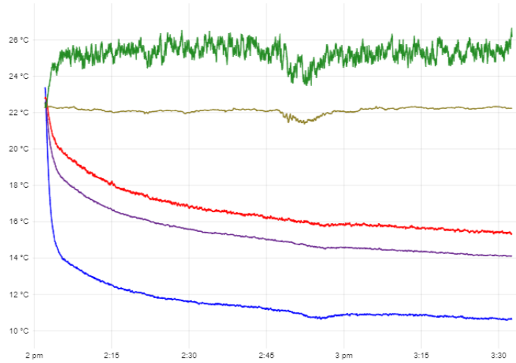
Figure 31 - Removing Back Panel For Ventilation

Comparing the test results in Figure 31 and Appendix 14 and 15, after an hour and thirty minutes, the temperature was still decreasing towards two degrees lower than previous tests when the back panel was installed. This indicated a good step which could be optimised to help lower the temperature by a couple of degrees.

Test 4 – Cooling plastic aluminium and glass bottles

To investigate if there was a better material to use for the container of the fluid, plastic, aluminium and glass bottles were inserted into the fridge and tested at the same time to measure the rate of cooling for each. From the results below, the rate of cooling was quite consistent with only 1.5°C being the maximum difference between all different materials. This difference could have been due to the locations of the containers as one would have been closer to the fan side of the compartment, the other would be further away due to the layout of the drink shelf.
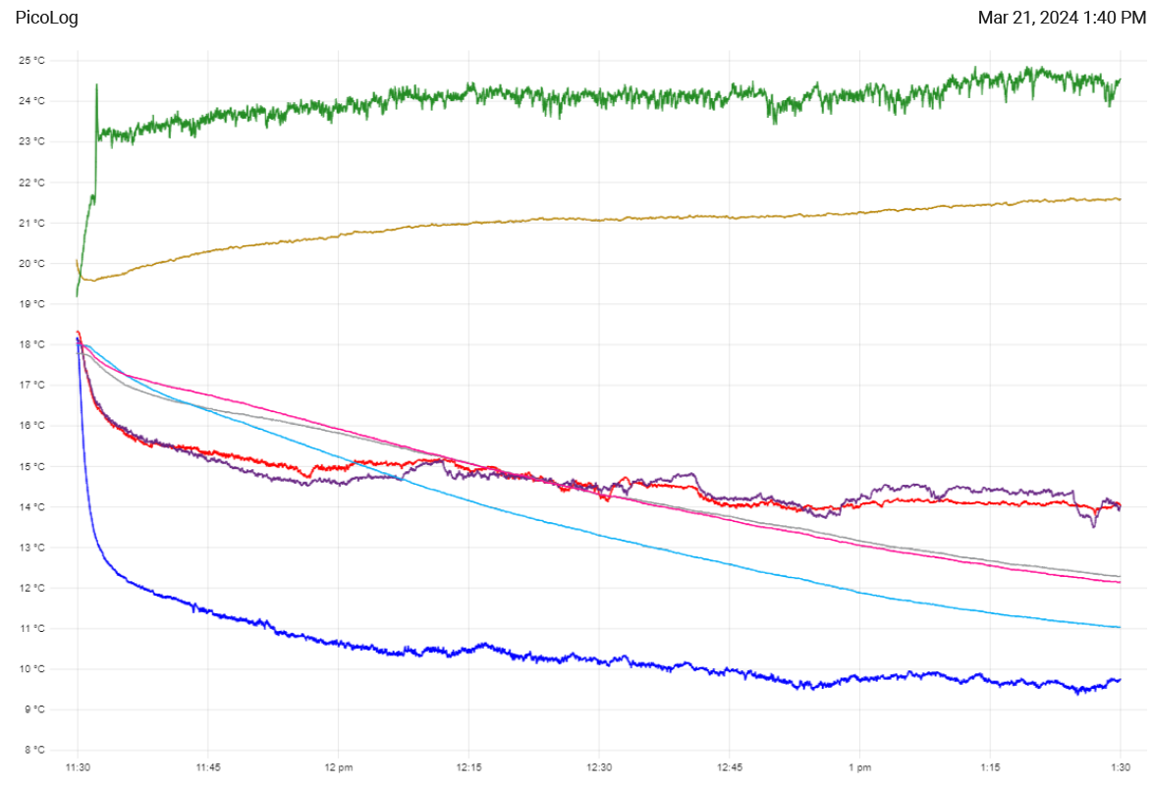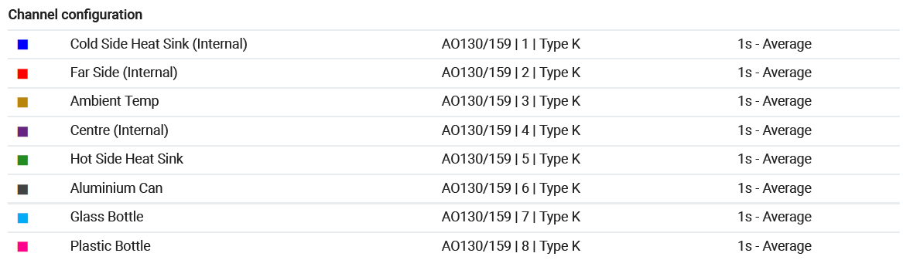
Figure 32 - Three Different Material Fluid Containers

The two additional tests can be found in Appendix 16 and 17.
To then determine the heat transfer of each container, the Peltier device was switched off and the bottles were left in the compartment for two hours, to see how much the temperature of the fluid increased. The results below demonstrates how the temperature of the fluid only increased by 1.5°C over two hours, so it would take a couple of hours for the bottles to get back to ambient temperature, as long as the door to the cooled compartment was closed.
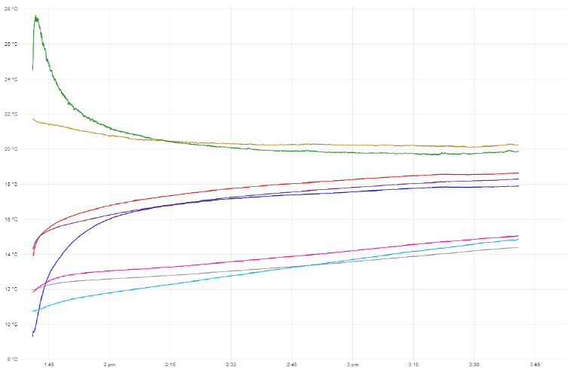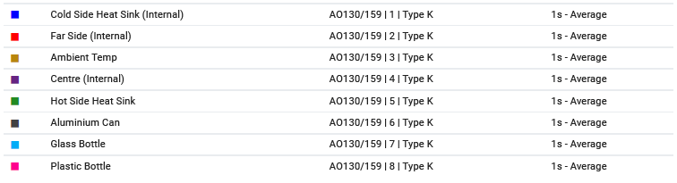
Figure 33 - Fans Turned Off For Drinks to Return to Ambient Temperature

The remaining two tests that consisted of leaving the bottles to return back to ambient temperature for two hours can be found in Appendix 18 and 19.

Test 5 – 5mm Plastezote foam installed

To stop the cold air escaping from the compartment, an insulation foam was installed around the external walls of the compartment. This also helped to block any small orifices from joints or fixing points. The plastezote foam helped to retain the cold air within the compartment so the same air could be re-circulated and cooled through every cycle.
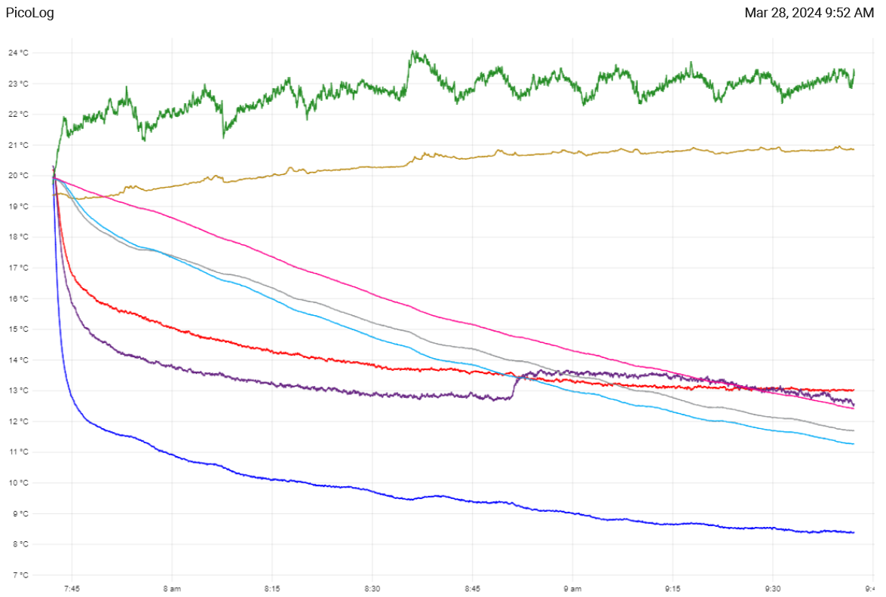
Figure 34 - 5mm Plastezote Foam Installed

As seen in Figure 34, there was a small temperature decrease of 1.2°C from 8.3°C with the 5mm insulation, compared to 9.5°C without the insulation. This provides evidence that the insulation reduces the amount of convection heat transfer in the compartment. The time it took to reach below nine degrees Celsius took one hour seventeen minutes.
The two additional tests for repeatability can be found in Appendix 20 and 21.
The three drinks were then left for two hours to return to ambient temperature, to see how the insulation effected the retention of cold air, and to determine if the drinks would stay colder for longer.
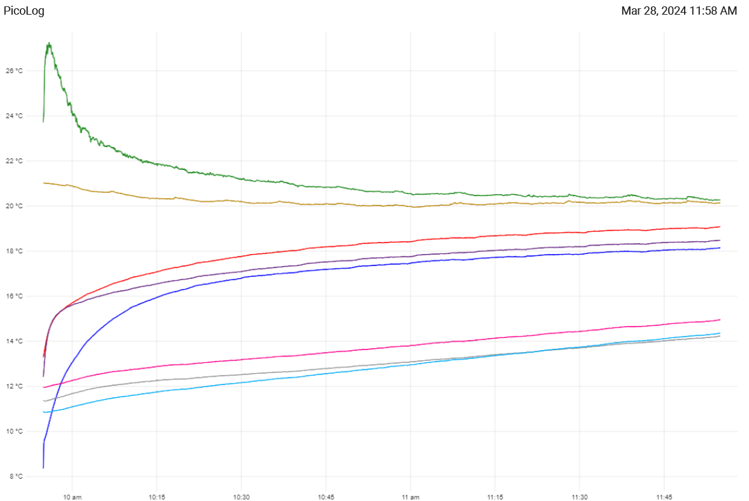
Figure 35 - 5mm Foam Insulation - Drinks Returning to Ambient Temperature

The two additional tests for reliability can be found in Appendix 22 and 23.
All three of the containers had a similar rate of change when returning to ambient temperature. The aluminium and glass container retained the cold fluid longer than the plastic bottle. The plastic and glass bottle temperature increased roughly three degrees after two hours, while the aluminium can increased 2.4°C in the two hours.

Test 6 – 10mm Plastezote foam installed

Once the 5mm insulation was tested, 10mm insulation was installed to compare the results, and how much heat transfer was reduced between inside and outside of the compartment. The extra insulation thickness really helped to improve the reduction in heat transfer, this can be seen from Figure 36. The 10mm insulation assisted the compartment in reaching 6.8°C which is well within the targets SSGB initially set out to achieve. The increased insulation thickness will also aid in reducing some of the noise generated from the system.
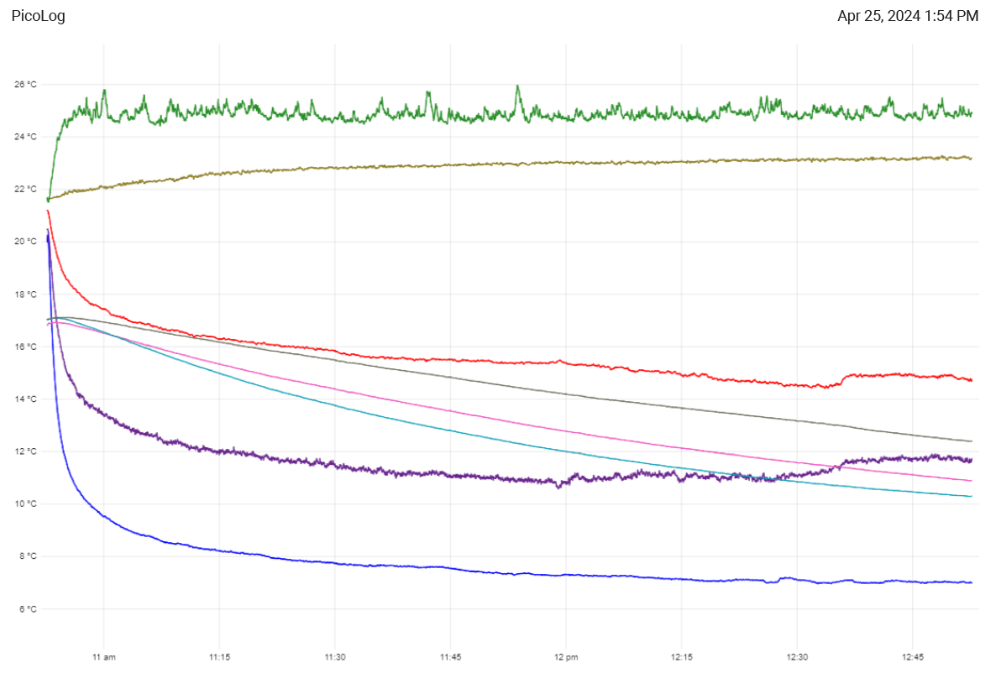
Figure 36 - 10mm Insulation Installed

The drinks initial temperature was approximately 20°C, which ended up between 12°C and 13°C. This is a suitable temperature for the fluid as it felt chilled and pleasant to drink however, this will be subjective to each person’s preference.
The cold side of the heat sink achieved a temperature below nine degrees Celsius in the first ten minutes. This meant that the fluid within the containers could start to cool down at a quicker rate and sooner.
The additional tests can be found in Appendix 24 and 25.
The drinks were then left for two hours, to identify how the different fluid container materials handled convection heat transfer. From the graph below, it indicates how the aluminium can is a good conductor of heat, meaning it can quickly transfer heat from one place to another. However, it does not facilitate convection as readily as glass or plastic, because it does not allow for the same kind of fluid movement. Glass and plastic, being insulators, tend to trap heat more effectively and allow for more convection to occur within them.
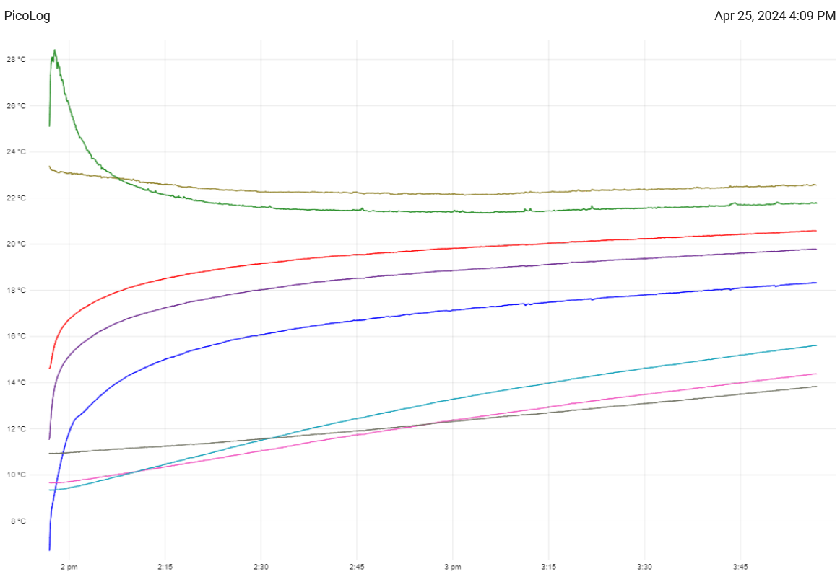
Figure 37 - 10mm Foam Insulation - Drinks Returning to Ambient Temperature
The additional tests can be found in Appendix 26 and 27.
As can be seen from Figure 37, the plastic bottle and glass bottle reached a similar temperature of 9.7°C while the aluminium can only reached 11°C. After switching off the thermoelectric device for two hours, the aluminium can was the coldest of all containers. This could have happened because although Aluminium cans have a higher thermal conductivity, the containers react to the temperature of the compartment. Due to the plastic and glass containers being at a colder temperature than the aluminium can, the rate of change in temperature will be greater in the glass and plastic containers.

Test 7 – 15mm Plastezote foam installed

Due to long lead times, the 15mm plastezote foam was unavailable to be tested as a single thickness foam. To get around this, a 5mm and 10mm thick section of foam were stuck together to make the 15mm stack, required to compare the impact of different insulation thicknesses. The results displayed below demonstrate that the extra thickness of insulation did not benefit the heat retention of the compartment massively. The cooling rate to reach below nine degrees Celsius was nineteen minutes. This was eleven minutes slower than the 10mm insulation, the lowest temperature within the two hours was 7.2°C compared to 6.9°C with the 10mm insulation.
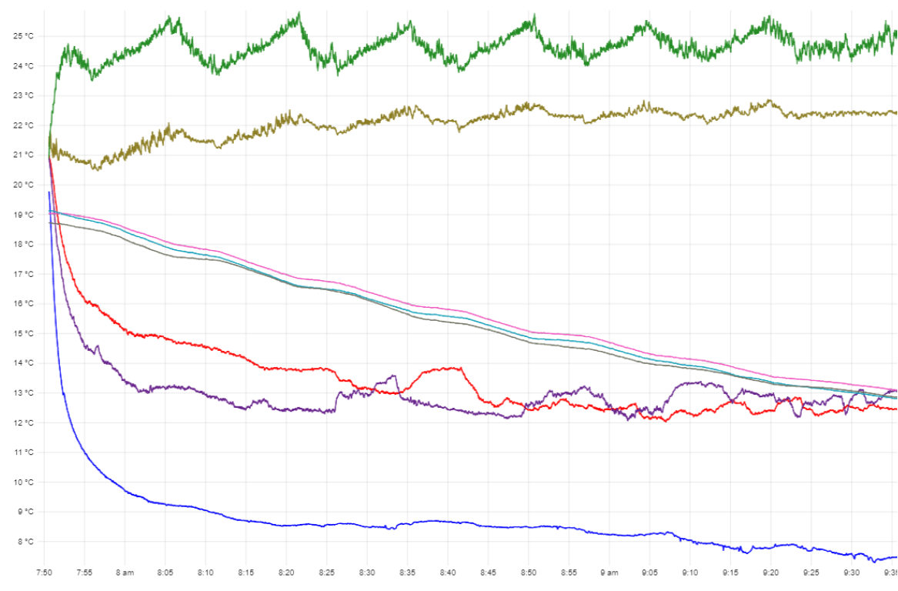
Figure 38 - 15mm Insulation Foam Installed
As a result of limited testing time and long lead times on the 20mm insulation sheets, it was decided the 10mm insulation was the most optimal for the desired application. The 20mm insulation would have required a lot of extra footprint within the suite which is rarely available. After proving that 10mm is sufficient enough to meet the specified requirements, the thicker material would start to add unnecessary weight to the product, which could affect the customers appeal for installing the system on their aircraft.

Comparison of insulations

To visually display how the different thicknesses compared to each other, the graph below in Figure 39 shows how the 10mm thick insulation foam outperformed the 5mm and 15mm thickness insulation. It reached below nine degrees Celsius in the quickest time, reached the lowest temperature of all, also maintained a steady decrease in temperature throughout the two hour tests.

Figure 39 - Comparing 5mm, 10mm and 15mm Thick Insulation Foam (Cold Side)

Complete Prototype

For AIX24, ensuring a high-quality finish was paramount in the design process. The images below vividly depict the professional, modern appearance of the cooled compartment, highlighting its seamless integration with the aircraft's interior aesthetics. Every aspect, from the sleek contours to the premium finishes radiates sophistication and functionality. Moreover, the emphasis on attention to detail guarantees not only an aesthetically pleasing design, but also optimal performance in maintaining the desired temperature for stored items.

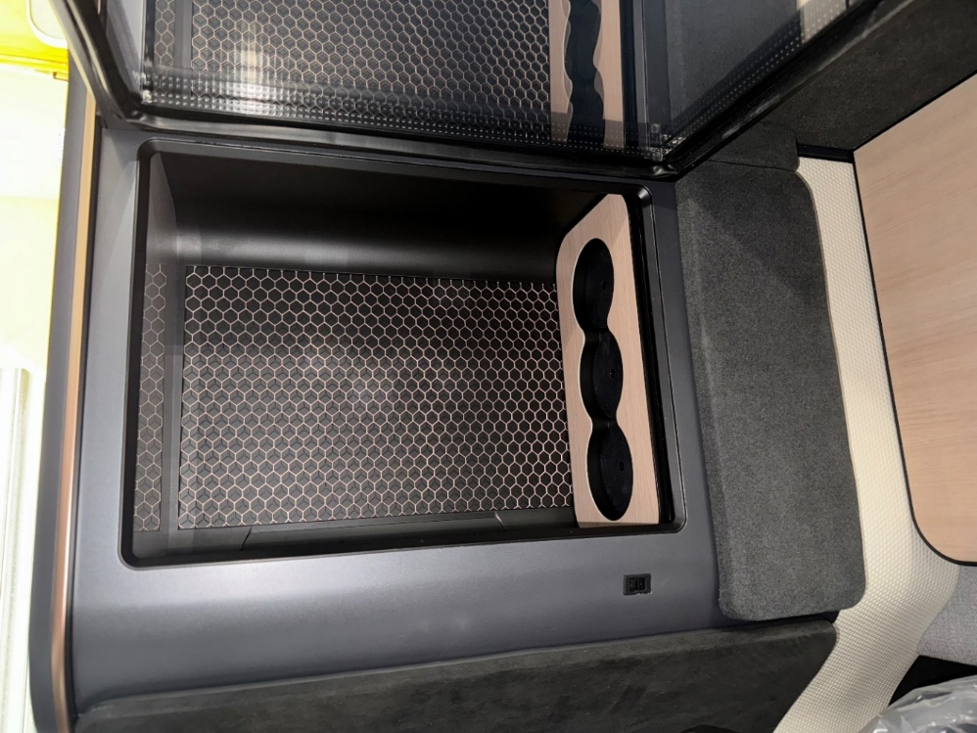
Figure 40 - Internal Images of Cooled Compartment
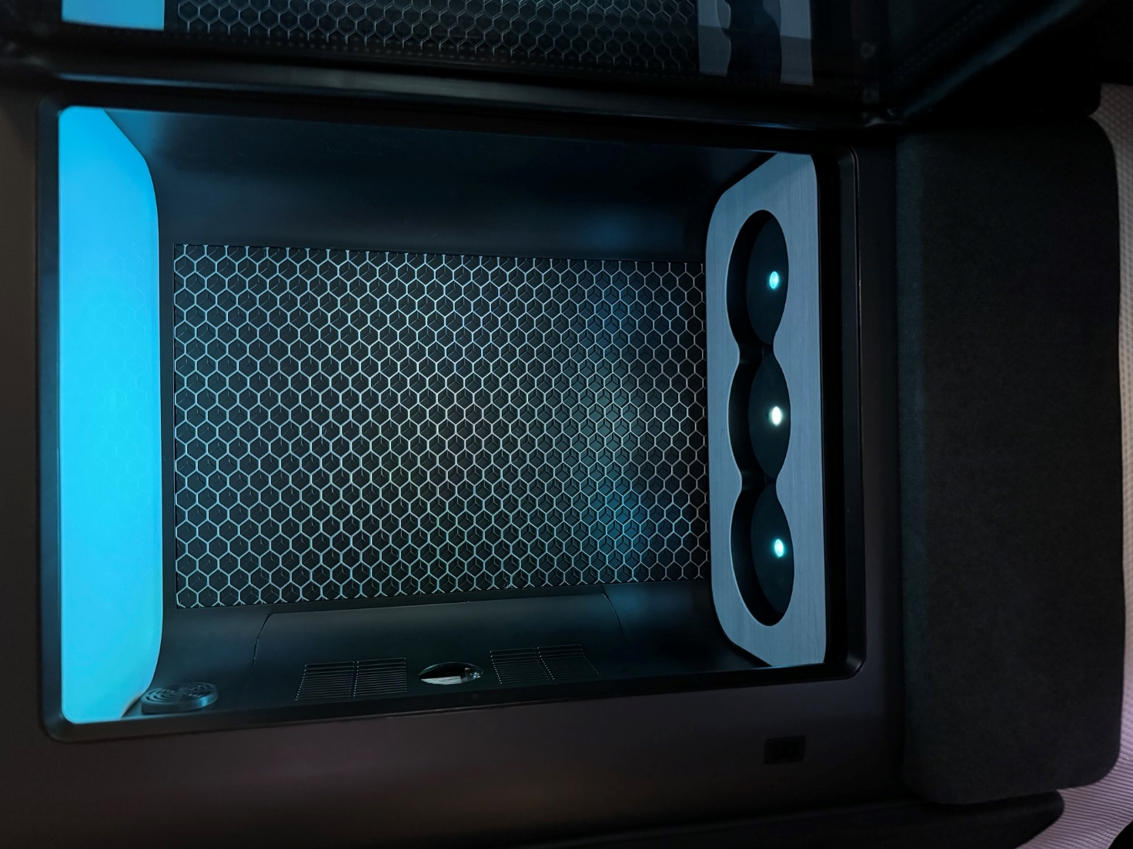
Figure 41 - Internal Images of Cooled Compartment with Lighting
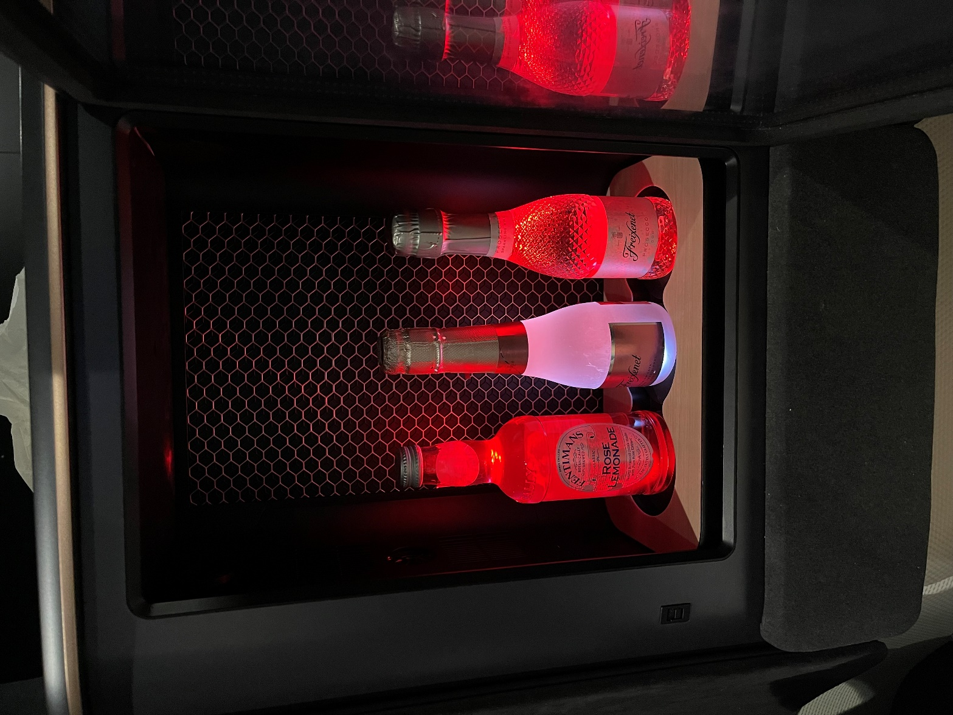
Figure 42 - Internal Images of Cooled Compartment with Bottles

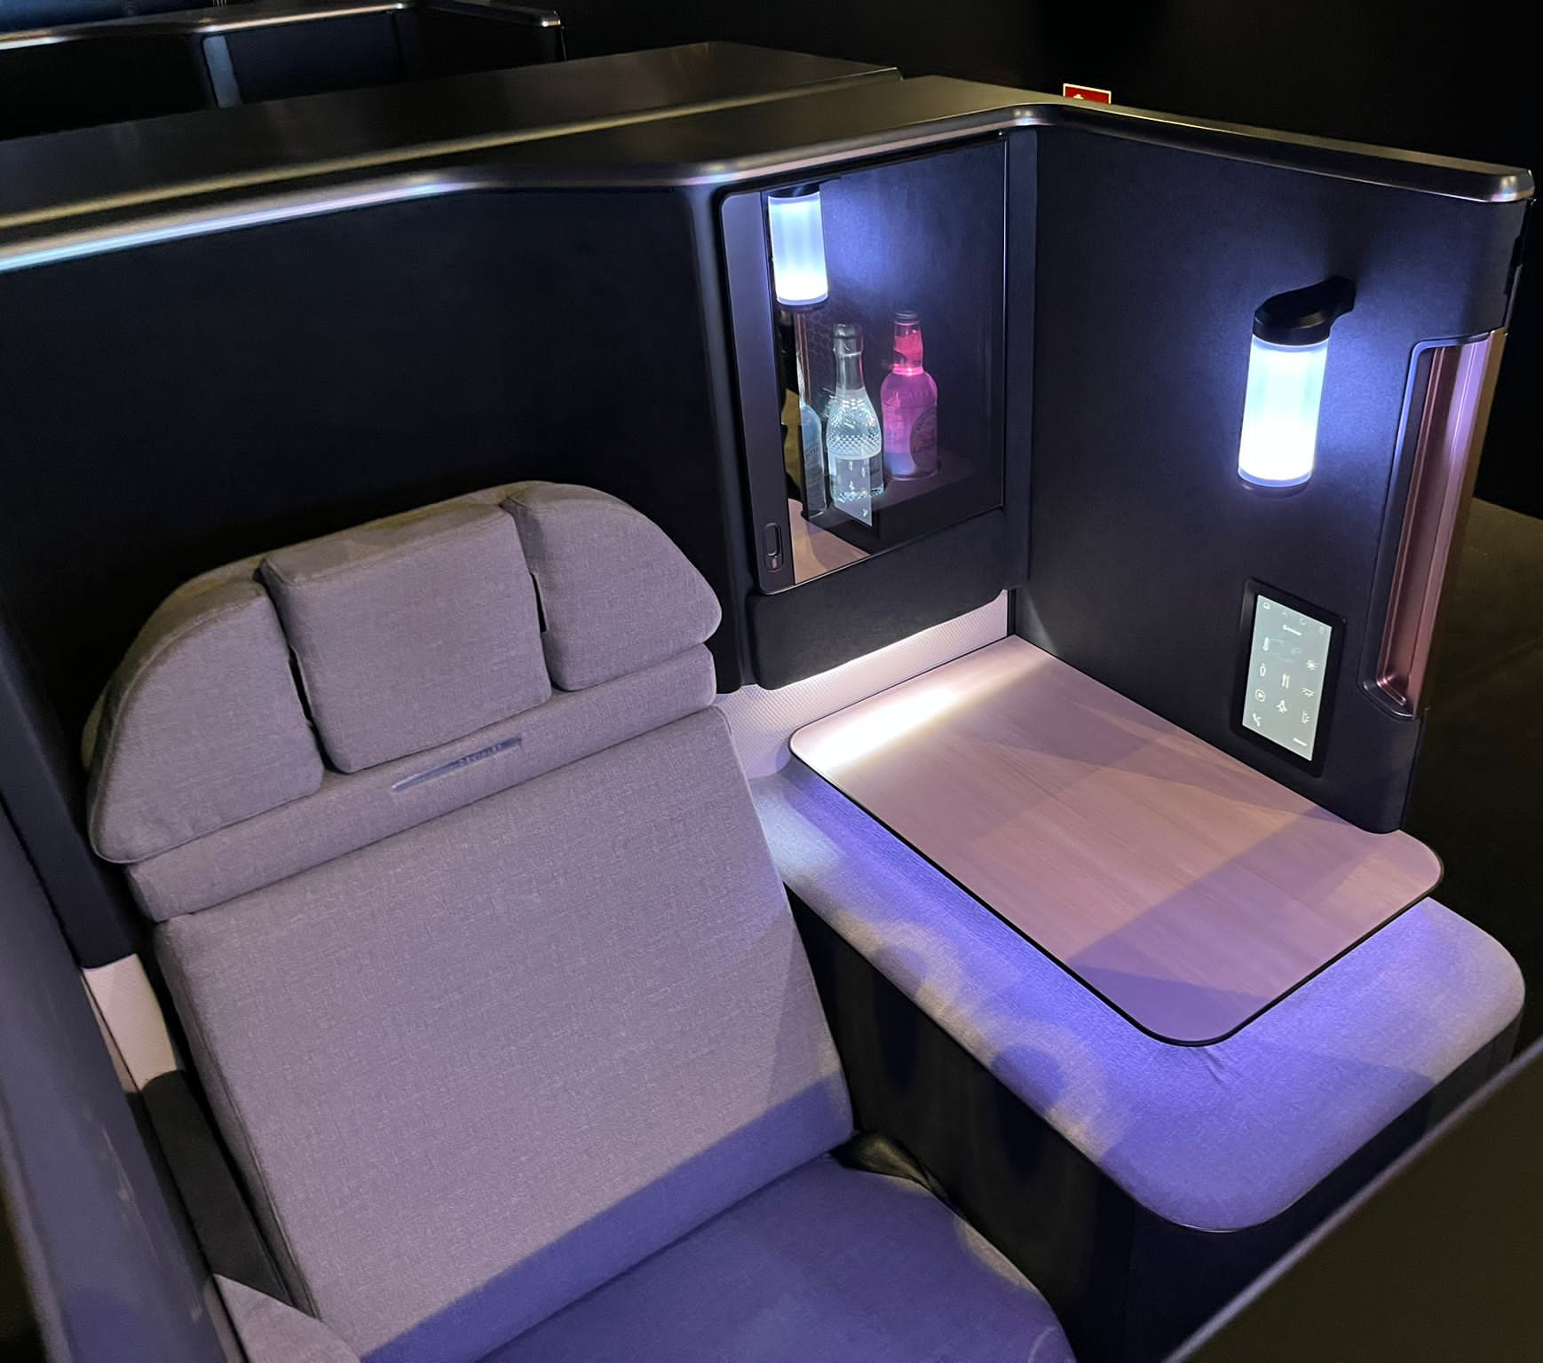
Figure 43 - Integrated Cooled Compartment

Conclusion

The series of tests conducted on the thermoelectric cooling system provided valuable insights into its performance under various conditions.
The first test, Test 1, was conducted in a ‘cold’ workshop without insulation. It established a baseline for temperature retention within the compartment. Subsequent tests demonstrated the impact of ambient temperature on the system's efficiency, with Test 2 highlighting a decrease in performance at higher temperatures.
Introducing an additional fan into the system, initially seemed promising, but the test revealed limitations due to spatial constraints. This led to a re-evaluation of ventilation strategies. Removing the back panel of the system to increase ventilation, showed that there was potential for improving the efficiency of the system due to the resulting heat dissipation.
Investigations into the use of different container materials used for the storage of the cooling fluid, indicated that there were minimal differences in cooling rates – this, with insulation playing a crucial role in maintaining cold temperatures over extended periods.
The implementation of insulation, particularly the 10mm Plastezote foam, significantly improved temperature retention within the compartment, with the target temperatures being met effectively. Further tests confirmed the efficacy of 10mm insulation and highlighted practical considerations regarding thickness and weight.
Overall, these tests provided valuable data for optimising the thermoelectric cooling system, ensuring its effectiveness and practicality for real-world applications, particularly within aircraft environments. Further refinement based on these findings, will enhance the system's performance and customer satisfaction.

10 Recommended further work

Future recommendations for work following the AIX event encompass several key areas aimed at enhancing the production solution and functionality of the system. These recommendations are outlined below:
Production representative article: Develop a comprehensive production representative article that integrates all production materials, retention mechanisms, door locking latches, and foam insulation materials. This article will serve as a tangible representation of the final product, allowing for thorough evaluation and validation of its design and functionality.
Integration of junior controller: Incorporate a junior controller into the system to regulate the operation of the fan, based on the position of the door. By implementing this control mechanism, the system will be able to optimise energy efficiency and maintain optimal temperature conditions within the compartment.
Gasper valve for suite ventilation: SSGB should look at installing a gasper valve to facilitate ventilation in suites from the exhaust air from the fans, not the air conditioning system located in the ceiling of the aircraft. This solution will ensure adequate airflow and ventilation within business / first-class suites, enhancing passenger comfort and satisfaction during flight.
Testing and validation: Conduct thorough testing and validation of the implemented recommendations to ensure compatibility, functionality, and safety within the aircraft environment. This phase will involve rigorous testing under simulated conditions to identify any potential issues and refine the system accordingly.
Continuous improvement and feedback loop: Establish a continuous improvement process and feedback loop to gather insights from stakeholders, including passengers, flight crew, and maintenance personnel. By soliciting feedback and incorporating suggestions for improvement, the system can evolve to meet evolving needs and address any emerging challenges effectively.
Documentation and training: Develop comprehensive documentation and training materials to support the implementation and operation of the system. This will include user manuals, maintenance guides, and training programs to ensure that all stakeholders are equipped with the necessary knowledge and skills to manufacture and maintain the system effectively.
Computational Fluid Dynamics (CFD): For better understanding of the fluid flow path around the thermoelectric device system, CFD should be carried out to gain a better understanding on how the system can be optimised. This will also save time and money on creating prototypes which may not give the desired result.
Unit Price: To ensure the unit will be commercially viable, discussions and meetings will need to be held involving all of the correct parties to determine a sensible cost per unit, once a production representative is complete.
By focusing on these recommendations, SSGB can further enhance the functionality, efficiency, and reliability of the system, ultimately delivering an exceptional passenger experience and maximising the value proposition for airlines.

11 Bibliography
Advanced Thermal Solutions Inc., (2018) What is a heat sink?. United States : Youtube.
Alpen Air, (2023) Luxury scheduled flights: The most expensive flights in the world. [Online]
Available at: https://www.alpenair.de/en/magazin/airline-flights/luxury-scheduled-flights-the-most-expensive-flights-in-the-world/
[Accessed 29 December 2023].
Bailey, R. T. & Elban, W. L., (2008) Thermal Performance of Aluminum and Glass Beer Bottles. Heat Transfer Engineering , 29(7), pp. 643-650.
Bourguignon, C., (2024) PAX4.0 CMF. s.l.:s.n.
Collins Aerospace, (2022) Collins Aerospace’s SpaceChiller™ wins a Crystal Cabin Award for advancing passenger comfort. s.l.:Collins Aerospace.
Delta, (2024) PROHIBITED OR RESTRICTED ITEMS. [Online]
Available at: https://www.delta.com/us/en/baggage/prohibited-or-restricted-items/overview
[Accessed 18 05 2024].
Dongliang Zhao, G. T., (2014) A review of thermoelectric cooling: Materials, modeling and applications. Applied Thermal Engineering, 66(1-2), pp. 15-24.
Egan, B., (2021) Non-Disclosure and Other Preliminary Agreements In Business Transactions. Texas Journal of Business Law, Volume 49, pp. 1-2.
European Thermodynamics Limited, (2017) Press Release: NEW - Adaptive® Thermoelectric Temperature Controllers. [Online]
Available at: https://www.europeanthermodynamics.com/news/new-te-controllers
[Accessed 26 February 2024].
FerroTec, (2023) Applications for Thermoelectric Coolers. [Online]
Available at: https://thermal.ferrotec.com/technology/thermoelectric-reference-guide/thermalref03/
[Accessed 8 January 2024].
Food Standard Agency, (2020) Chilling. [Online]
Available at: https://www.food.gov.uk/safety-hygiene/chilling#:~:text=The%20Danger%20Zone&text=The%20bacteria%20haven't%20been,grow%20and%20make%20you%20ill.
[Accessed 29 December 2023].
Gregersen, E., (2023) Specific Heat. Britannica , 8 December.
Korean Air, (2024) Cabin Travel Tips. [Online]
Available at: https://www.koreanair.com/jo/en/in-flight/onboard-service/travel-tips/cabin-environment#:~:text=Cabin%20Temperature,at%2023%E2%80%9325%C2%B0C.
[Accessed 29 January 2024].
M.Durgut, (2023) How Long Does a Commercial Aircraft Last?. [Online]
Available at: https://www.aviationfile.com/how-long-does-a-commercial-aircraft-last/#:~:text=Lifespan%20of%20a%20commercial%20aircraft%3A,-The%20lifespan%20of&text=On%20average%2C%20a%20commercial%20aircraft,prominent%20commercial%20aircraft%20manufacturers%20globally.
[Accessed 29 December 2023].
Monroe Aerospace, (2020) Cabin Pressurization: How It Works and Why It’s Important for Airplanes. [Online]
Available at: https://monroeaerospace.com/blog/cabin-pressurization-how-it-works-and-why-its-important-for-airplanes/
[Accessed 4 January 2024].
More Steam, (2023) Design of Experiments. [Online]
Available at: https://www.moresteam.com/toolbox/design-of-experiments
[Accessed 29 January 2024].
O'Meara, E., (2023) What temperature should your fridge be?. [Online]
Available at: https://www.currys.co.uk/techtalk/kitchen-and-home/refrigeration-news/what-temperature-should-your-fridge-be.html
[Accessed 29 December 2023].
Pauls Fan Company, (2019) The Difference Between an Axial and Radial Fan. [Online]
Available at: https://paulsfans.com/blog/difference-axial-radial-fan/
[Accessed 06 February 2024].
Skybrary, (2023) Aircraft Electrical Systems. [Online]
Available at: https://skybrary.aero/articles/aircraft-electrical-systems#:~:text=Depending%20upon%20the%20aircraft%2C%20generators,28V%20DC%20or%2014V%20DC.
[Accessed 30 December 2023].
Terasaki, I., (2016) Thermal Conductivity and Thermoelectric Power of Semiconductors. Reference Module in Materials Science and Materials Engineering, 1(1), pp. 326-358.
UBC ATSC, (2019) Standard Atmosphere - Pressure and Density. [Online]
Available at: https://www.eoas.ubc.ca/courses/atsc113/flying/met_concepts/02-met_concepts/02a-std_atmos-P/index.html
[Accessed 7 January 2024].
World of Camping, (2023) EXPERT ADVICE ON COOL BOXES. [Online]
Available at: https://www.worldofcamping.co.uk/expert-advice/coolers-and-fridges/cool-boxes#:~:text=Whilst%20these%20cool%20boxes%20have,heating%20up%20to%2050%20degrees.
[Accessed 4 January 2024].
Zebarjadi, M., (2015) Electronic cooling using thermoelectric devices. Applied Physics Letters , 106(20), pp. 1-2.
Zheng, X., (2014) A review of thermoelectrics research – Recent developmentsand potentials for sustainable and renewable energy applications. Elsevier, p. 486–503.

Appendices

Appendix 1 – Gantt Chart (Timing Plan)

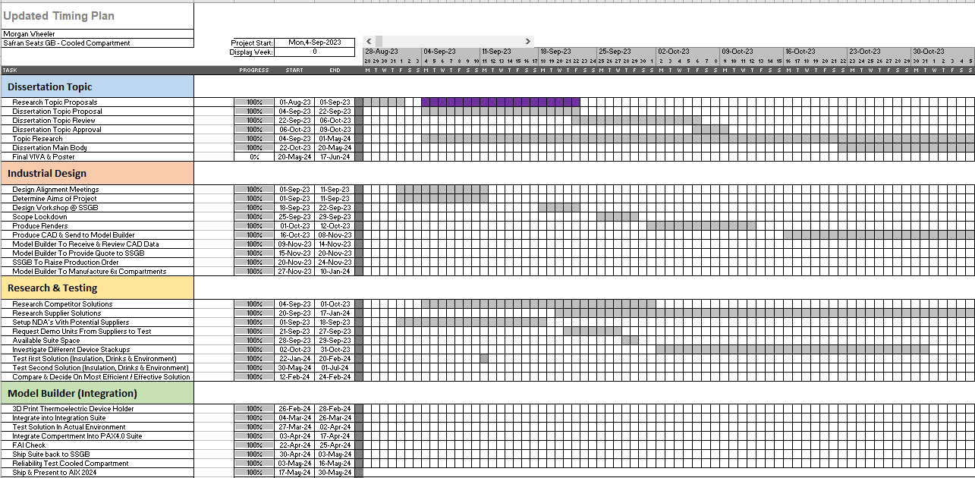
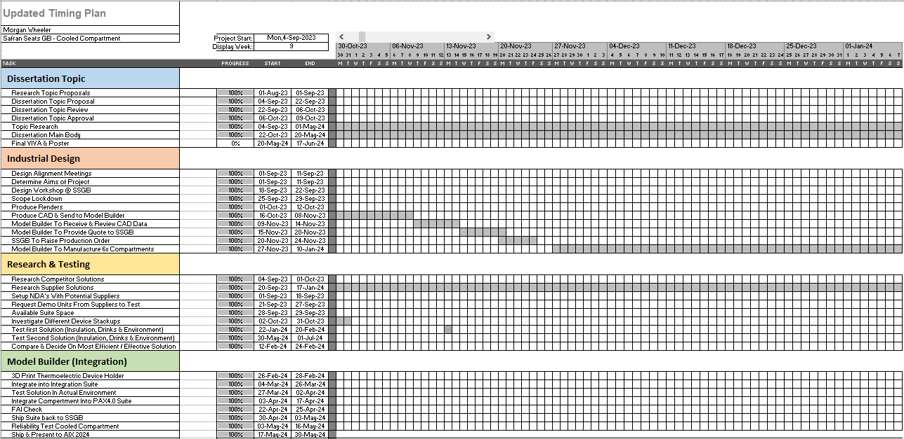
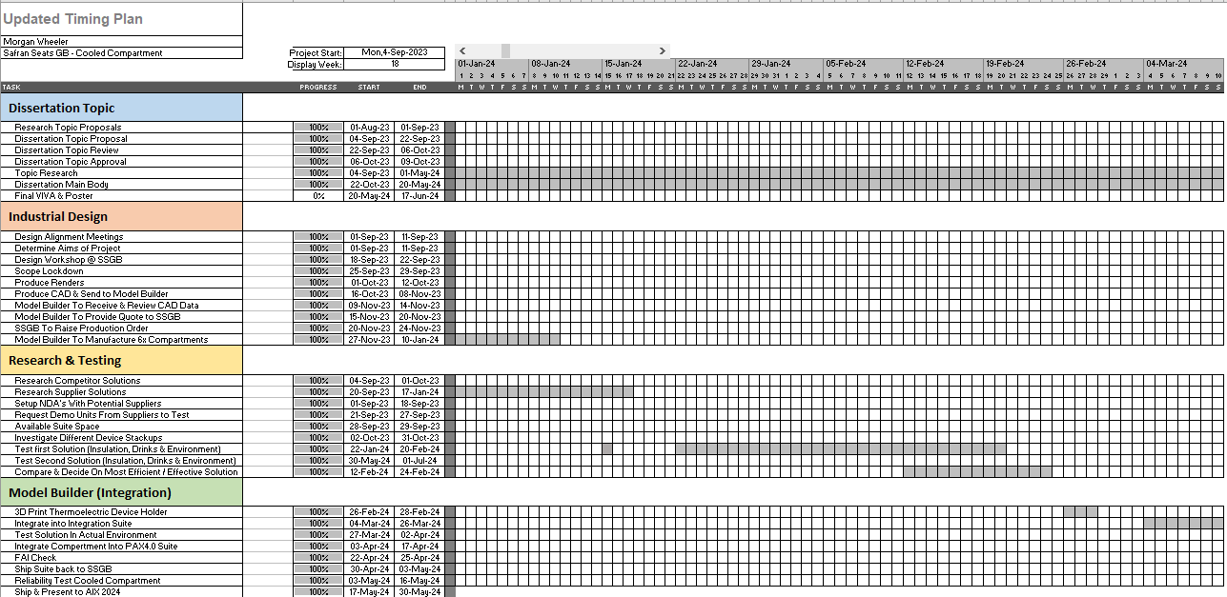
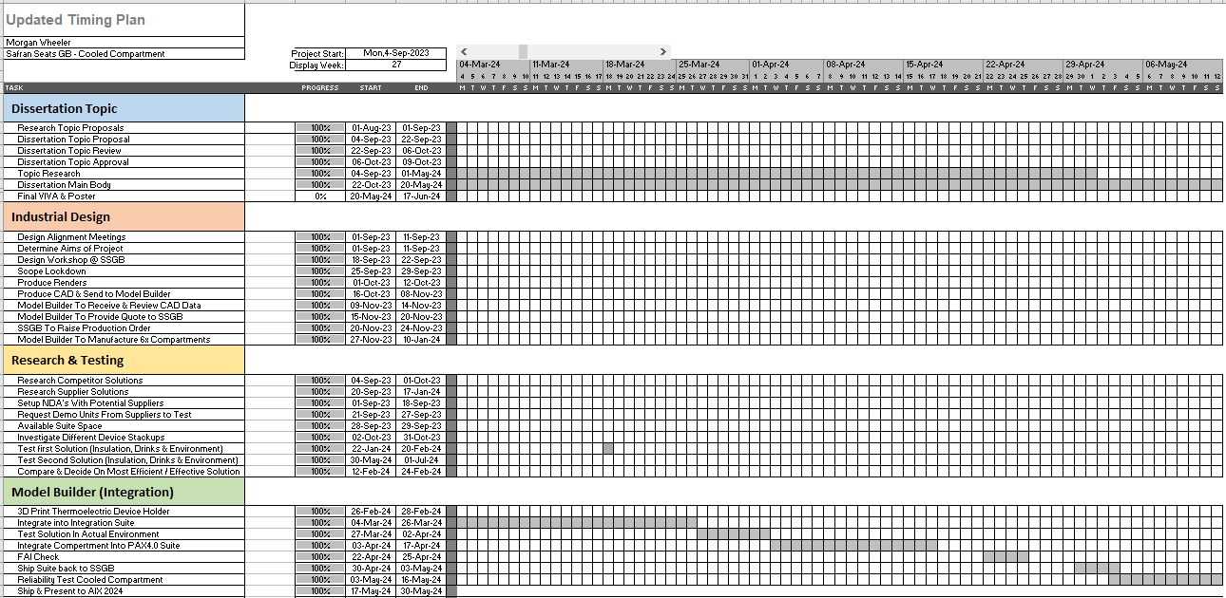
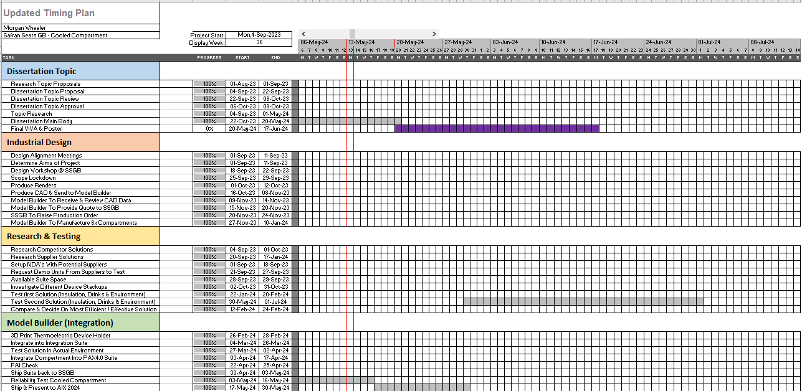

Appendix 2 – Zotek foam data sheet
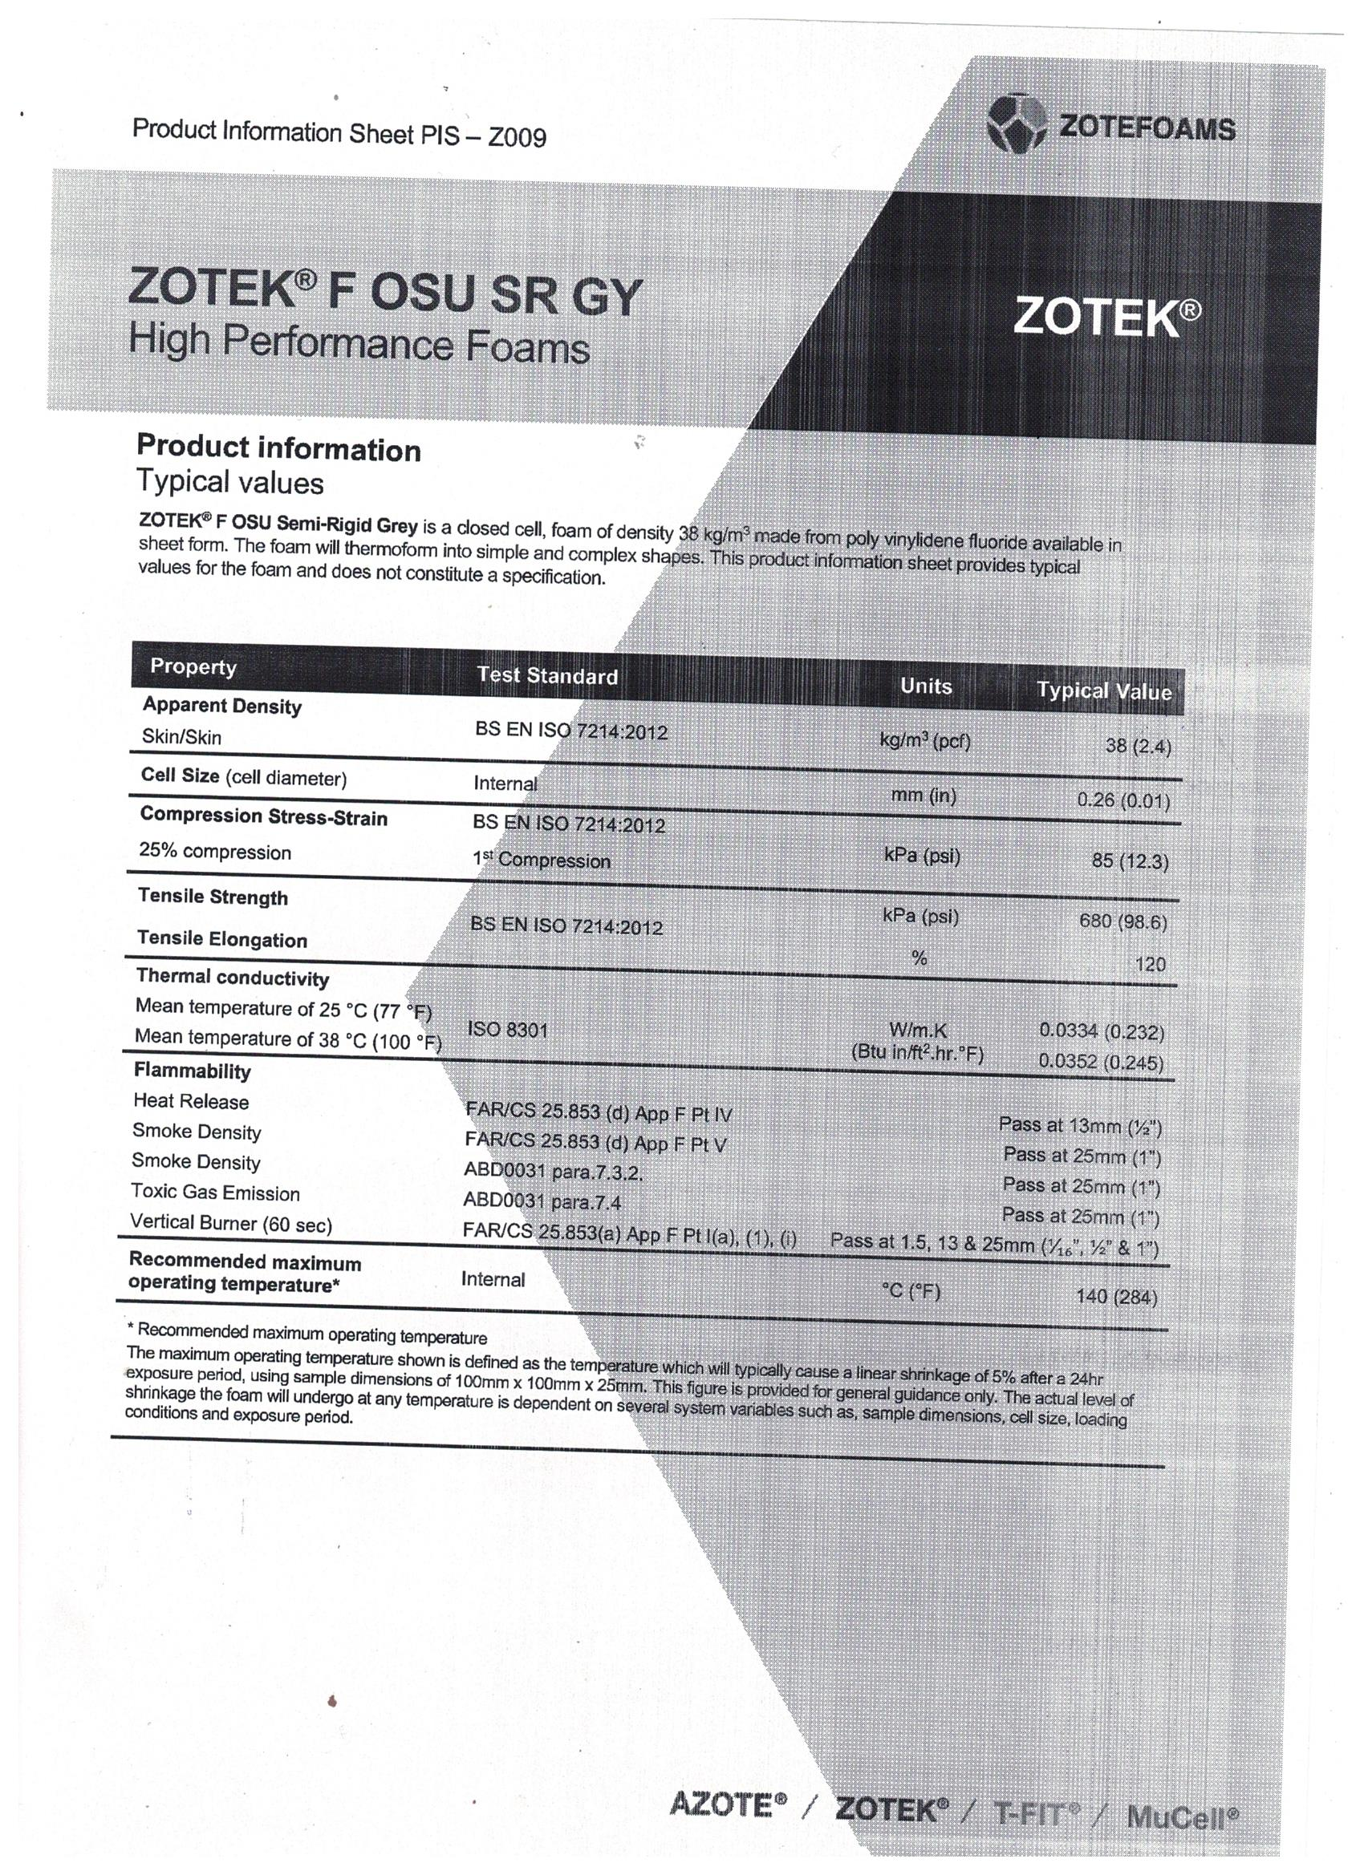

Appendix 3 – Plastazote foam data sheet
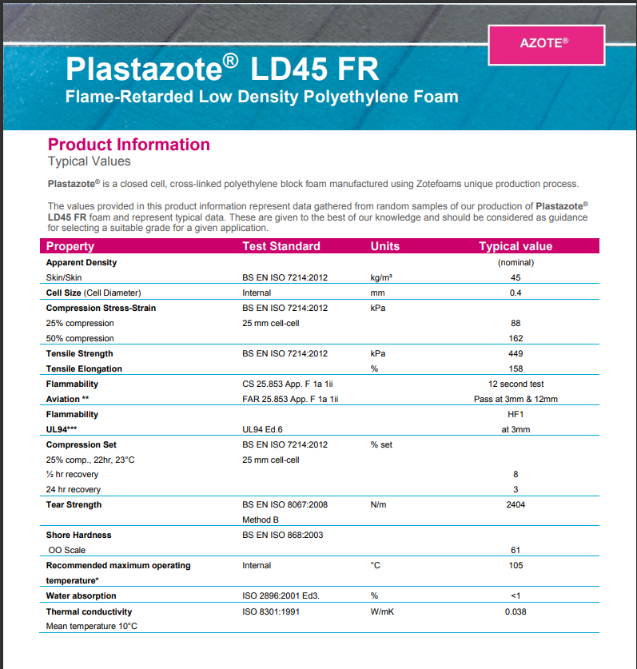

Appendix 4 – Aviation glass data sheet

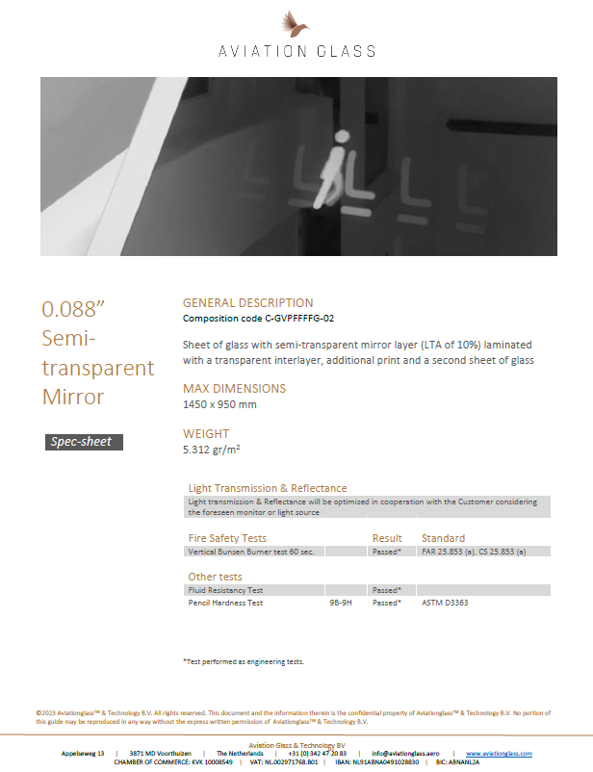

Appendix 5 – Front Fan Data Sheet

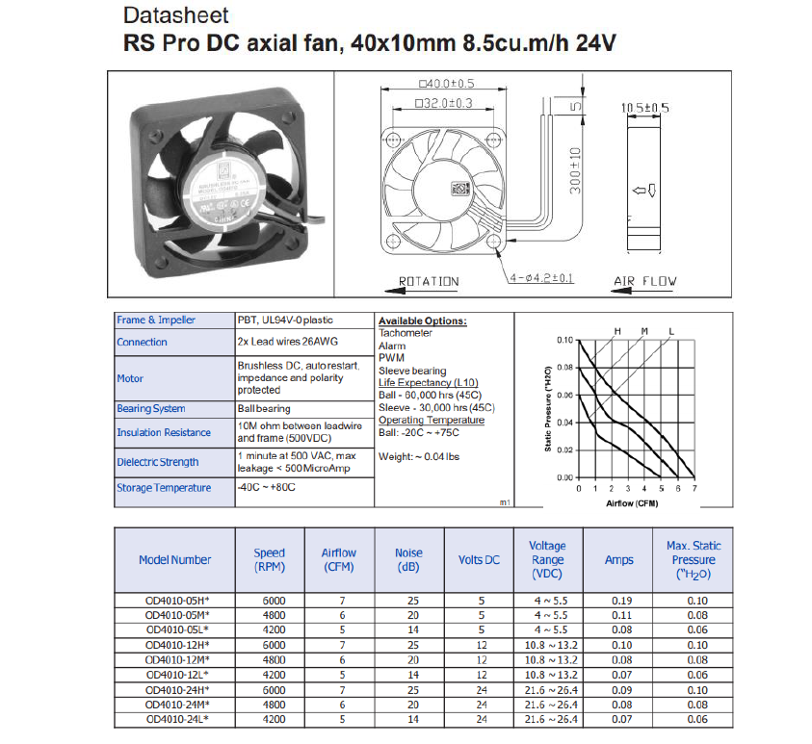
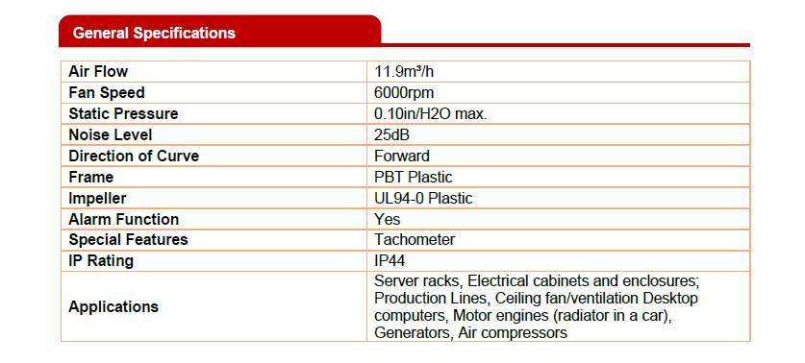
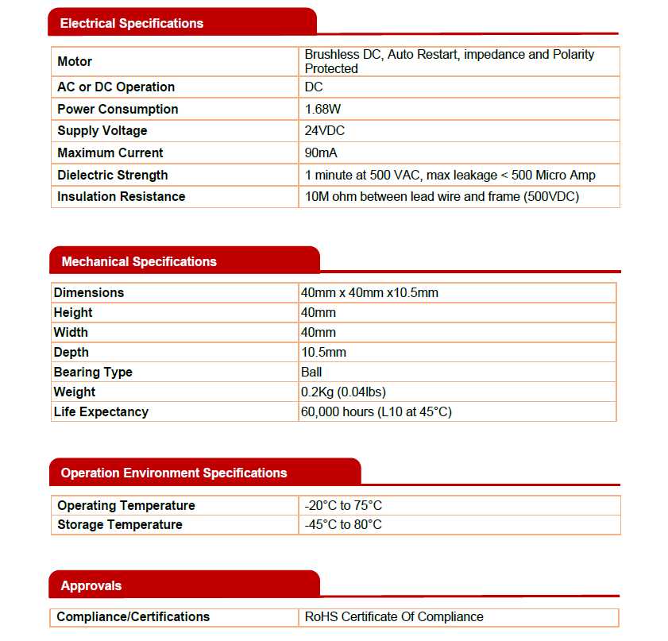

Appendix 6 – Rear Fan Data Sheet
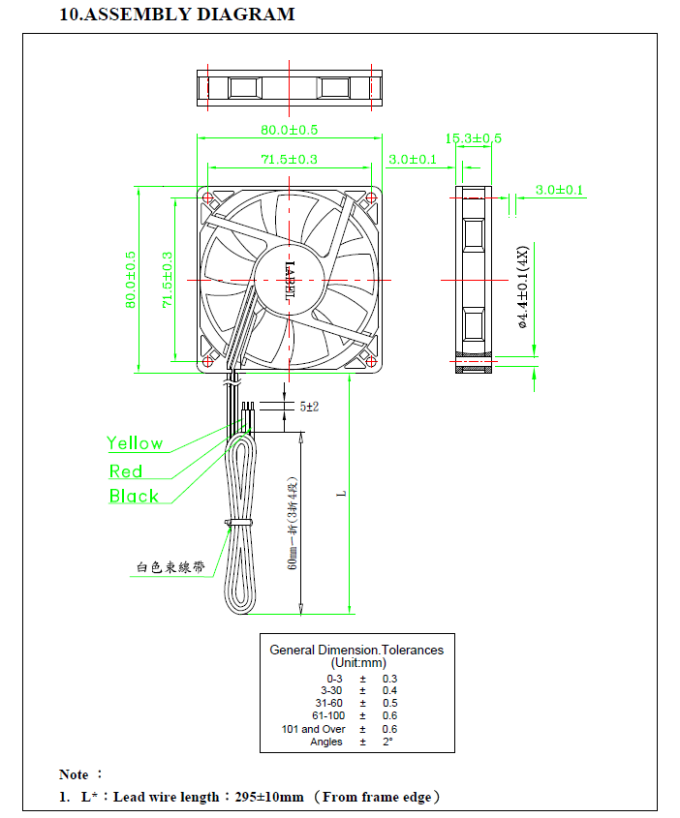
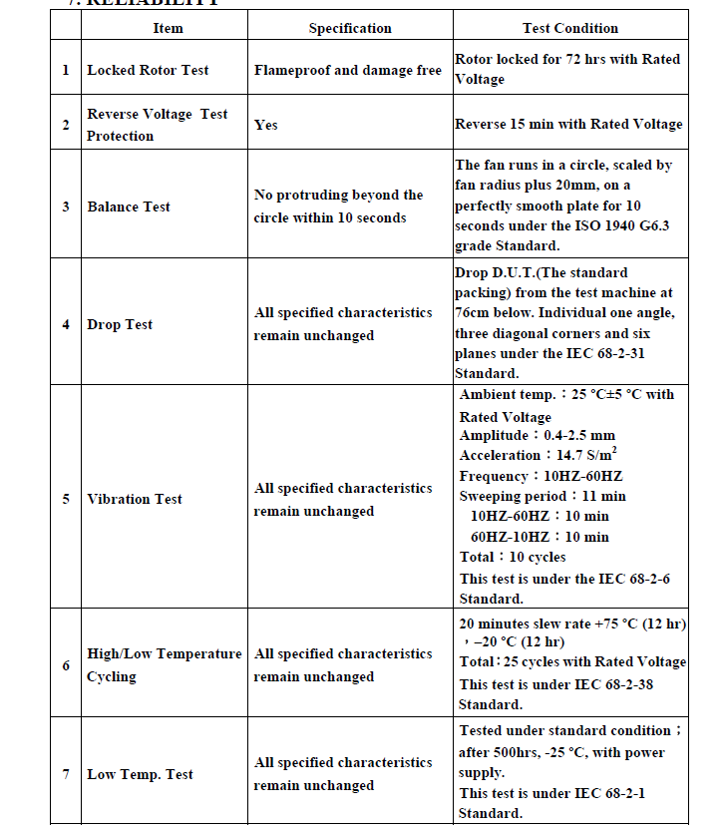
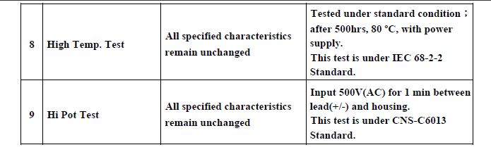

Appendix 7 – 12v DC blower
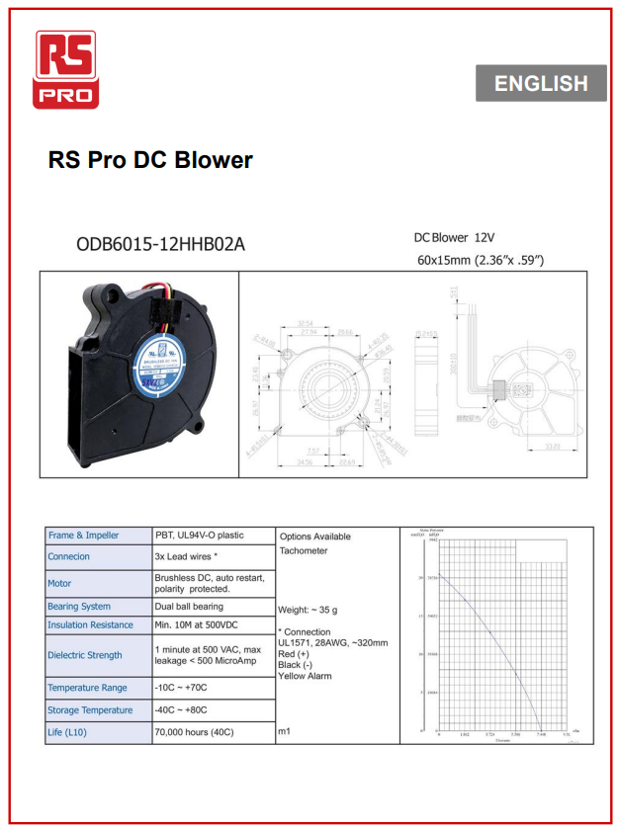

Appendix 8 - Test Electrical Architecture

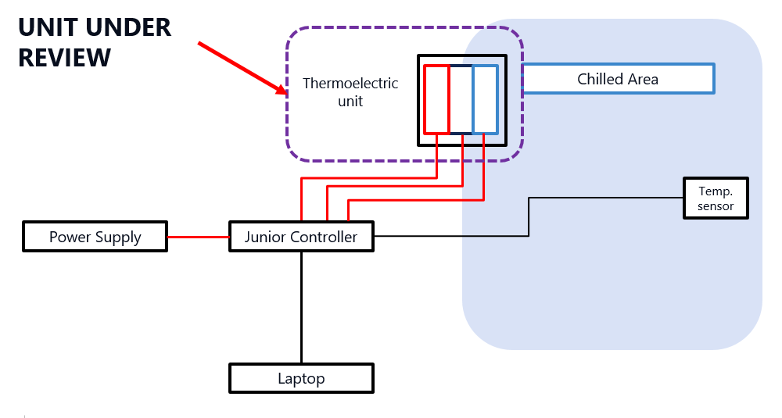

Appendix 9 – Test 1 (Second Result)

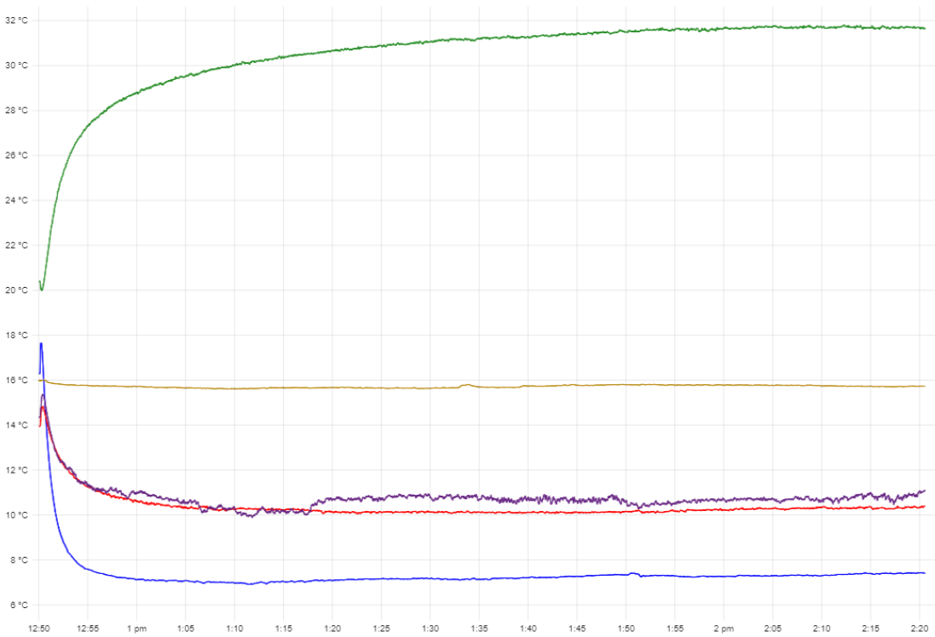
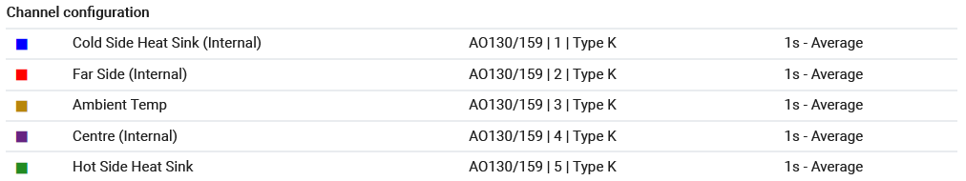

Appendix 10 – Test 1 (Third Result)

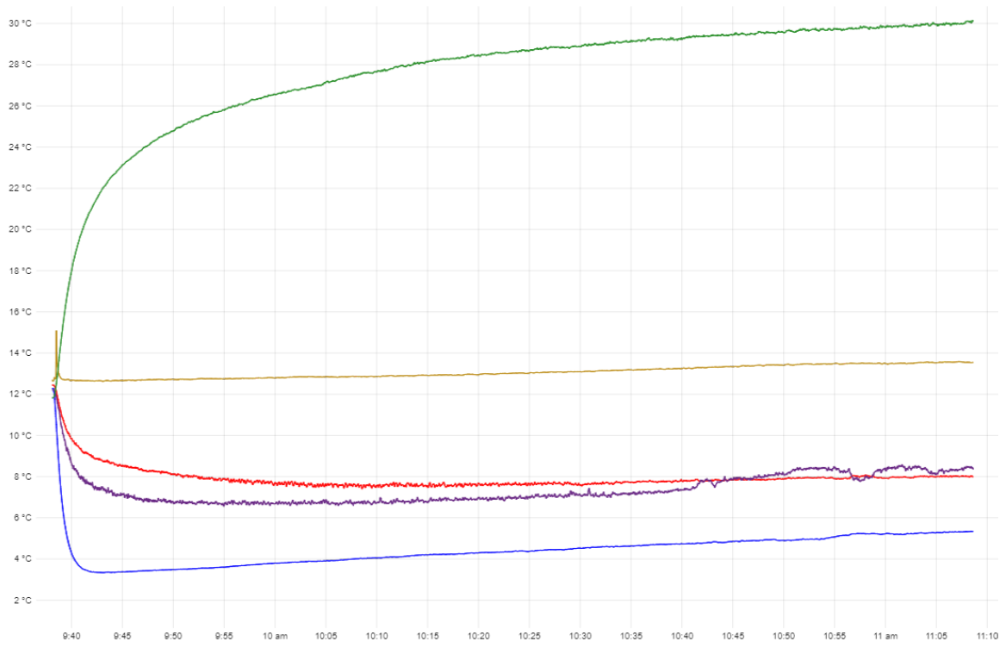

Appendix 11 – Test 2 (Second Result)

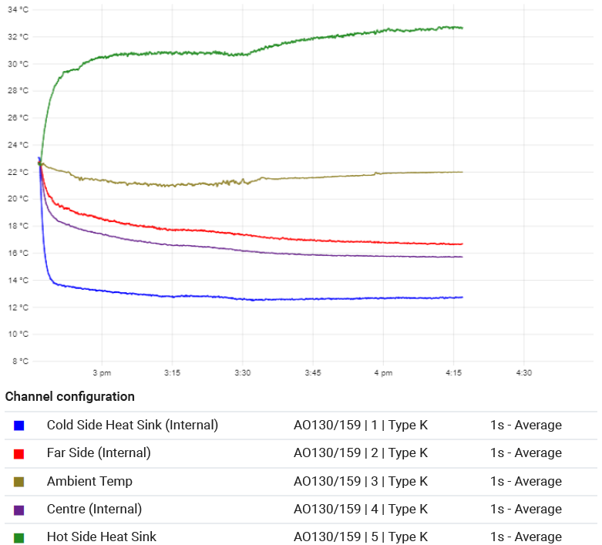

Appendix 12 – Test 2 (Third Result)

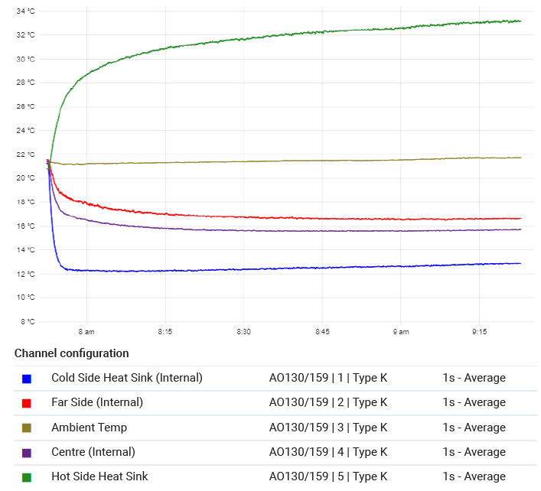

Appendix 13 – Removable Panel

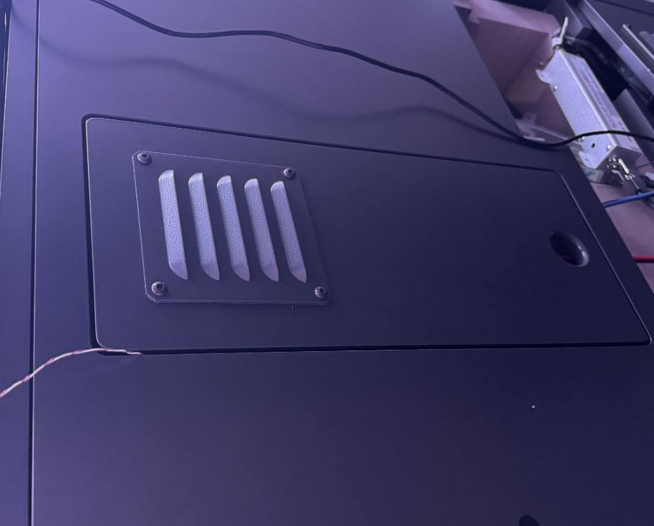

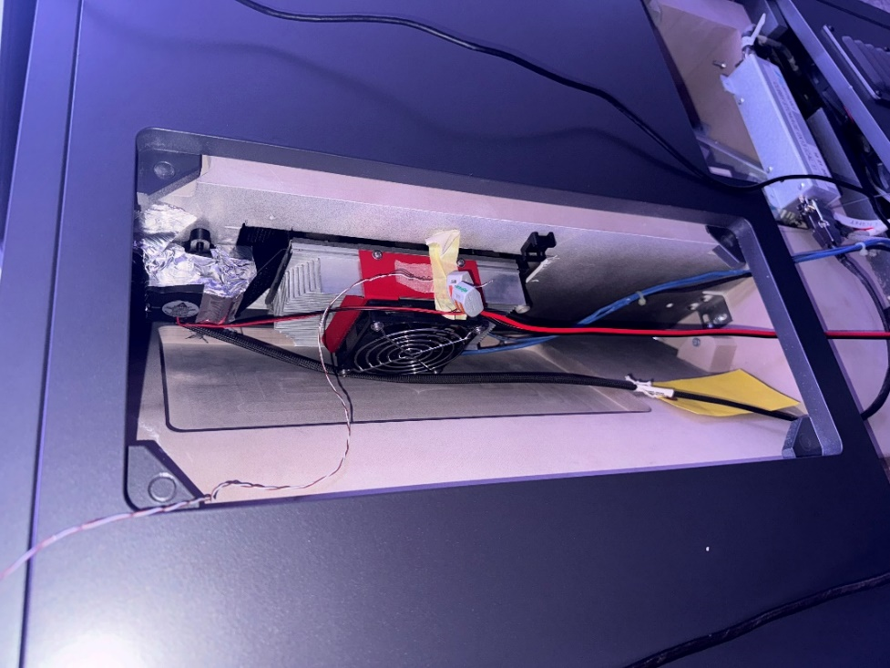

Appendix 14 – Test 3 (Second Result)
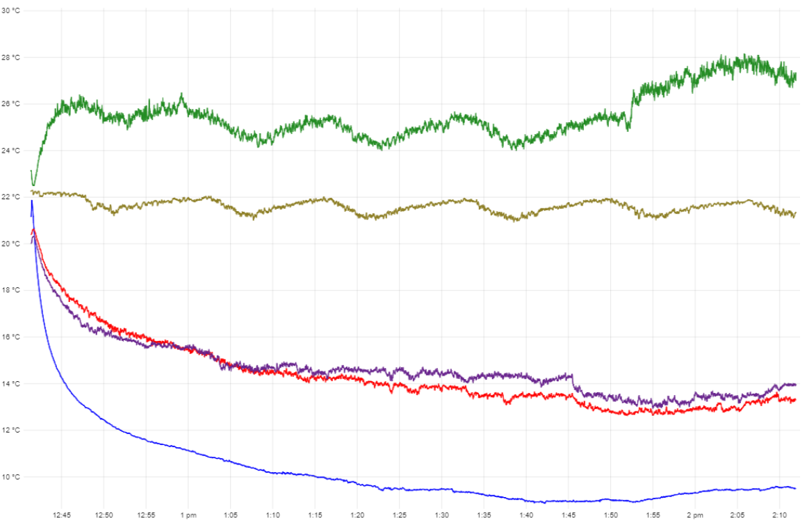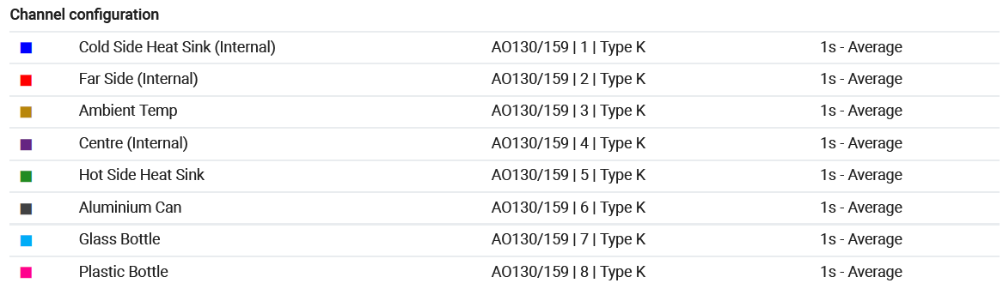

Appendix 15 – Test 3 (Third Result)
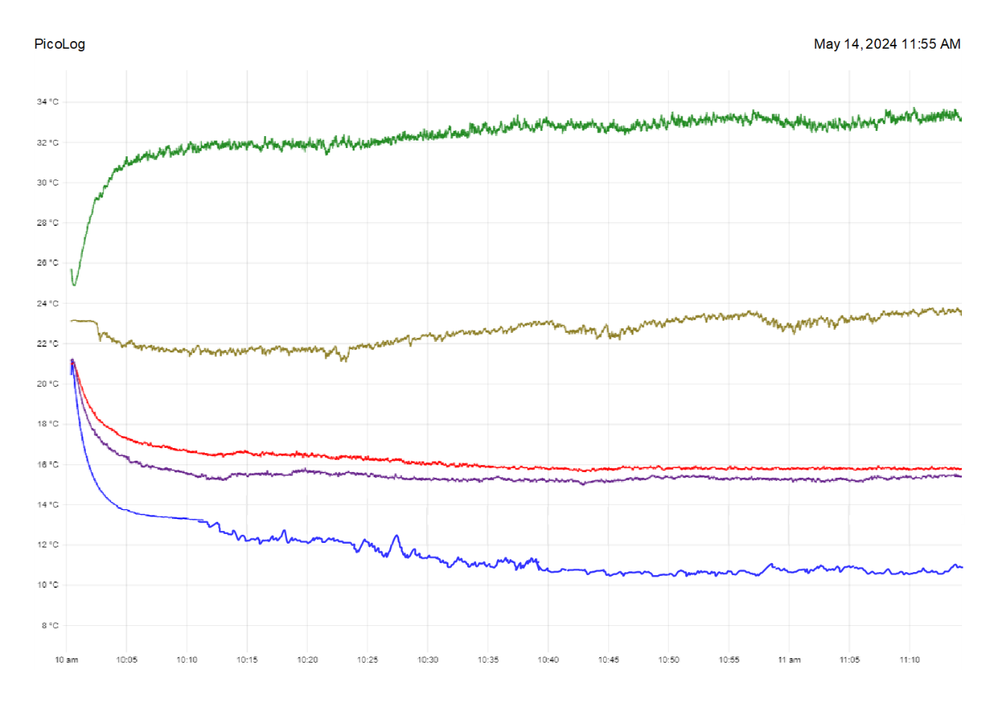

Appendix 16 – Test 4 (Second Result)
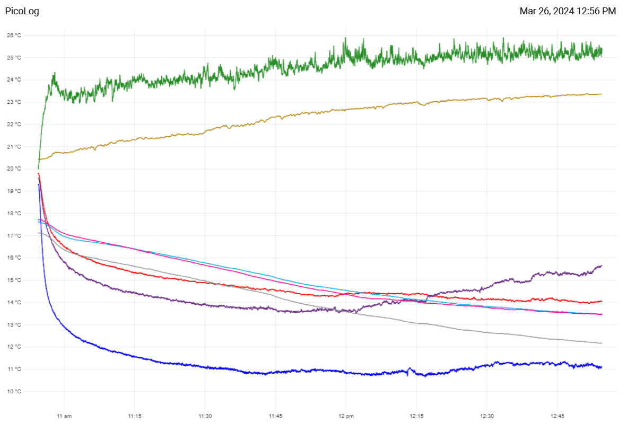

Appendix 17 – Test 4 (Third Result)

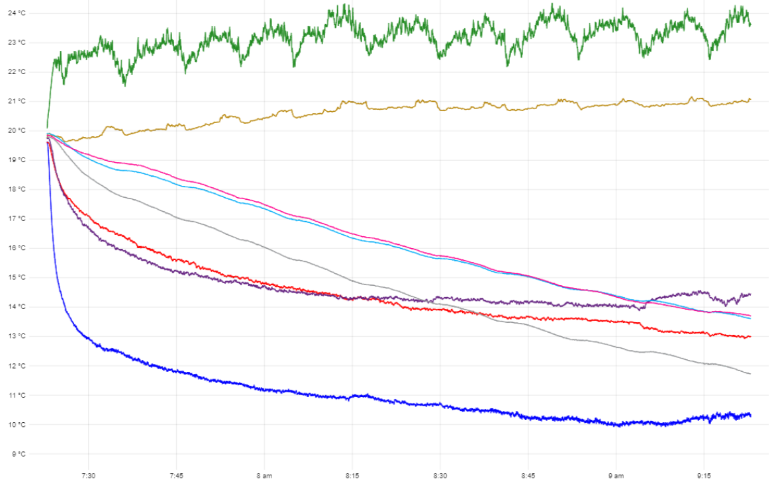

Appendix 18 – Test 4 Cooling (Second Result)
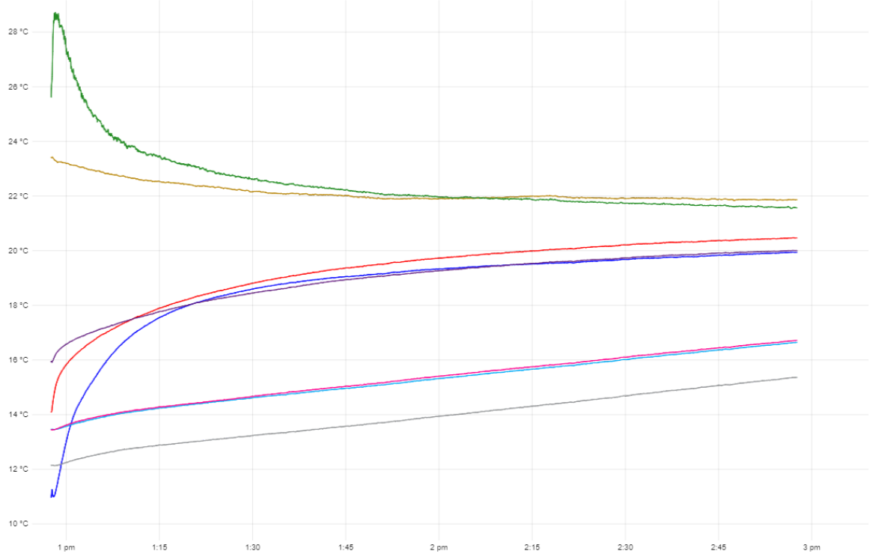

Appendix 19 – Test 4 Cooling (Third Result)

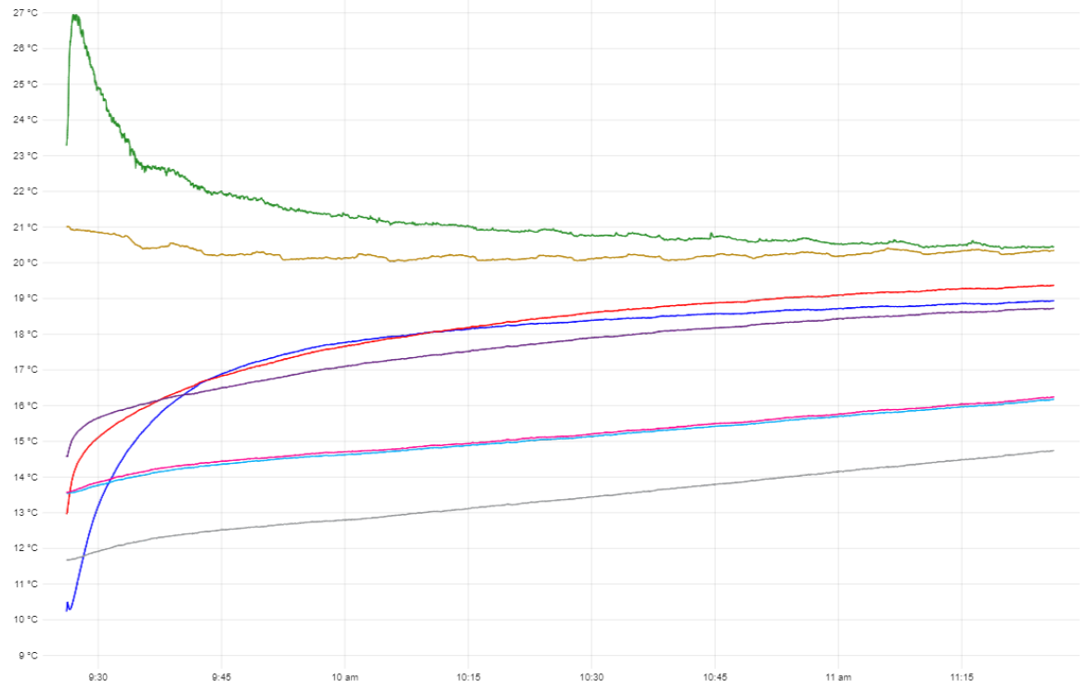

Appendix 20 – Test 5 (Second Result)
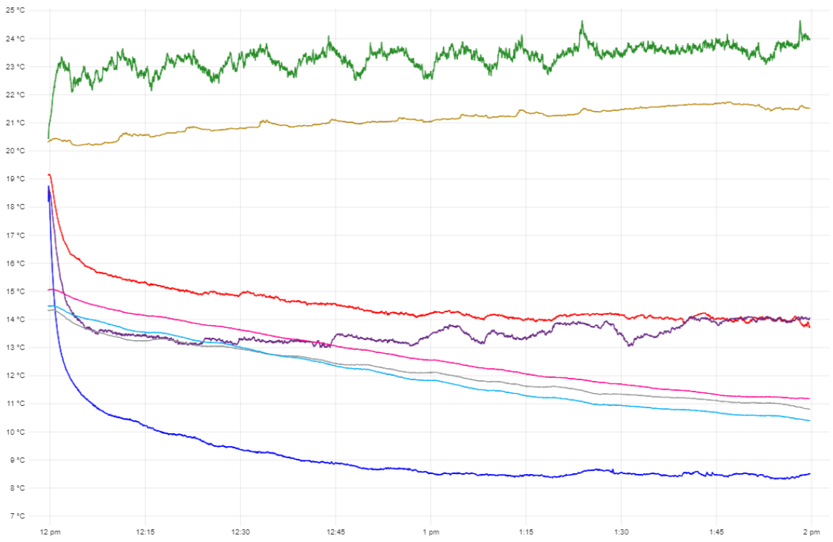

Appendix 21 – Test 5 (Third Result)
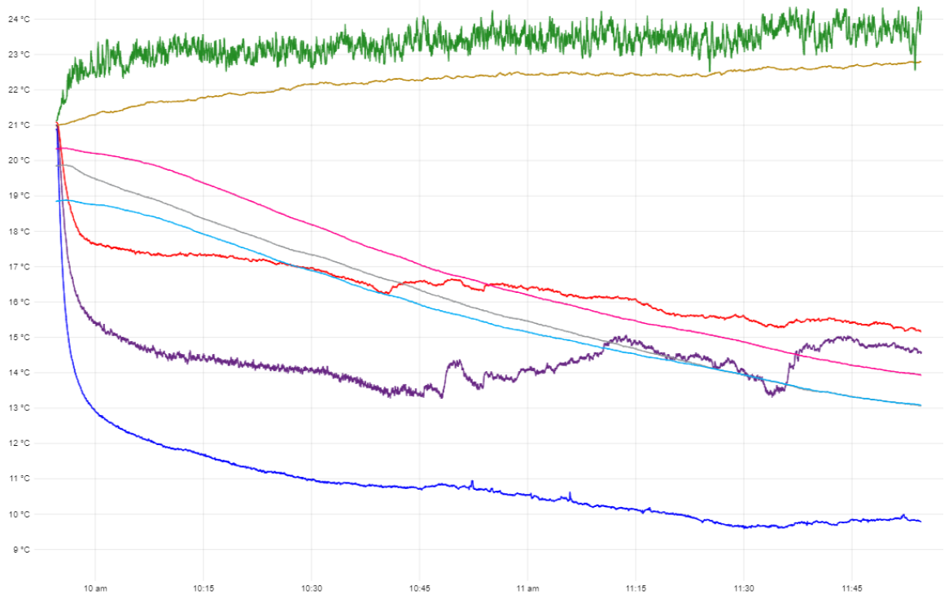

Appendix 22 – Test 5 Cooling (Second Result)

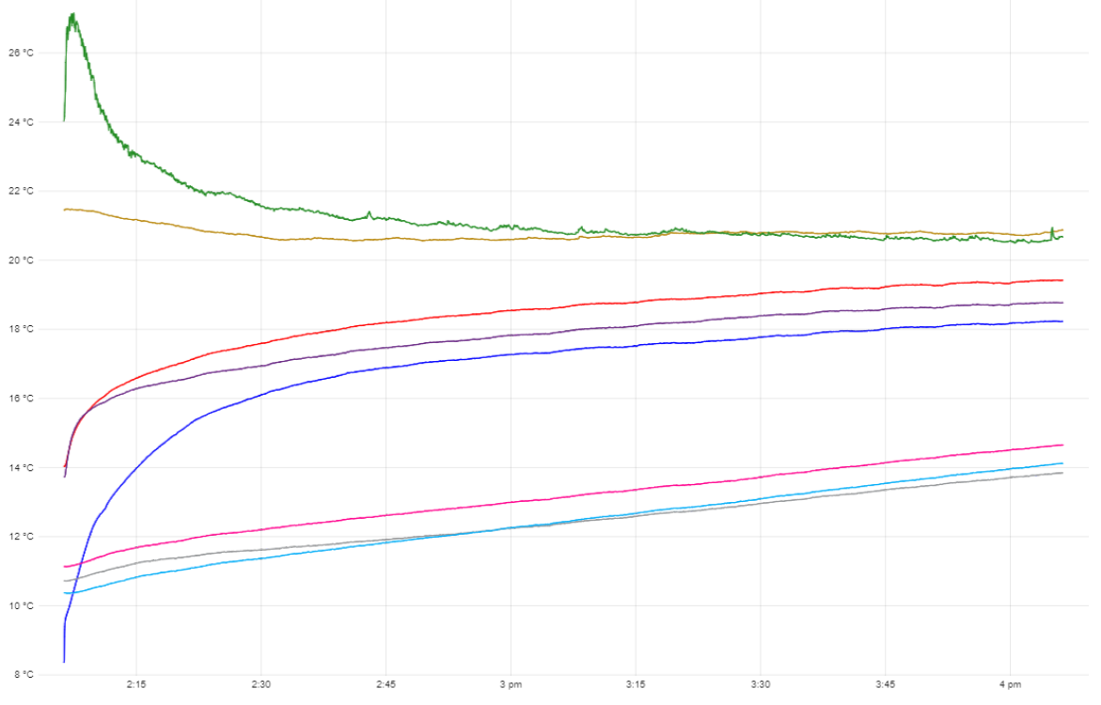

Appendix 23 – Test 5 Cooling (Third Result)

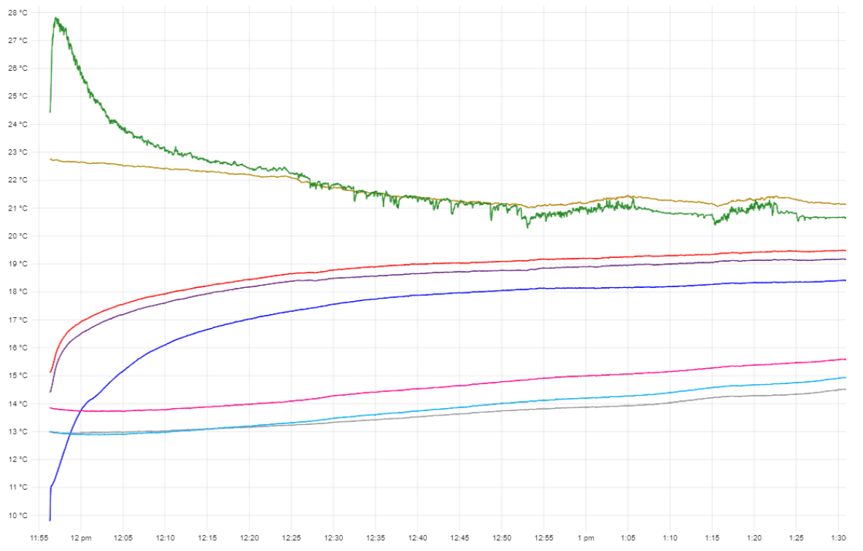

Appendix 24 – Test 6 (Second Result)
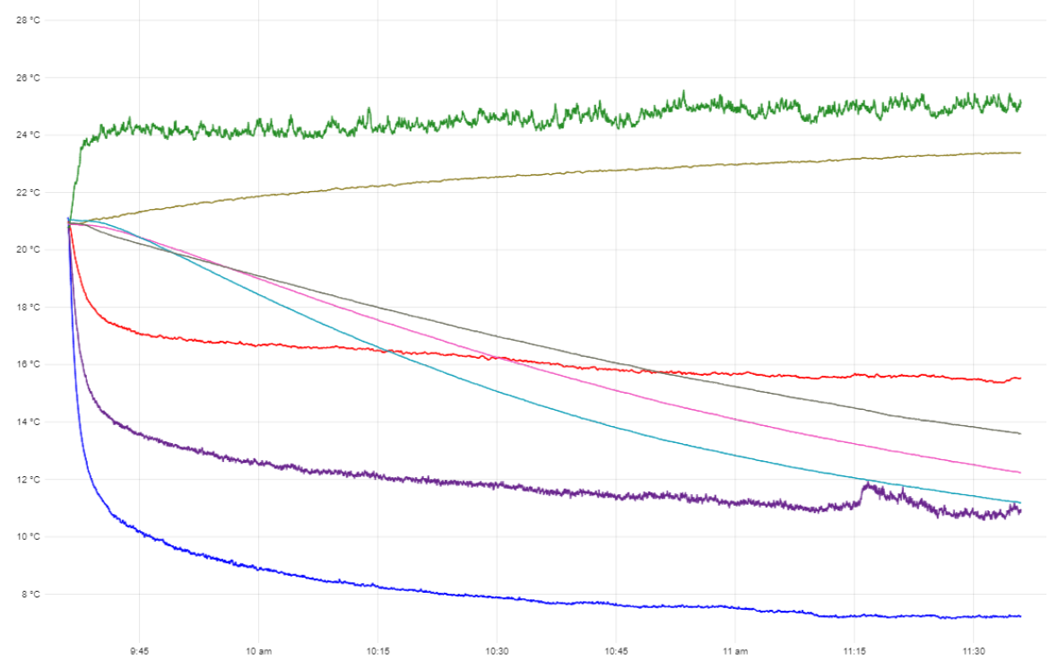

Appendix 25 – Test 6 (Third Result)

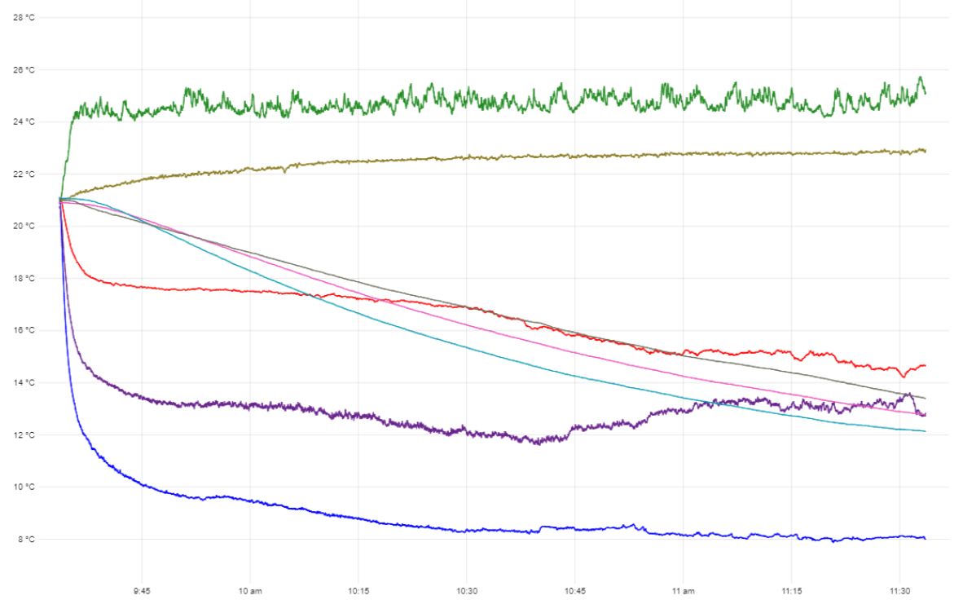

Appendix 26 – Test 6 Cooling (Second Result)
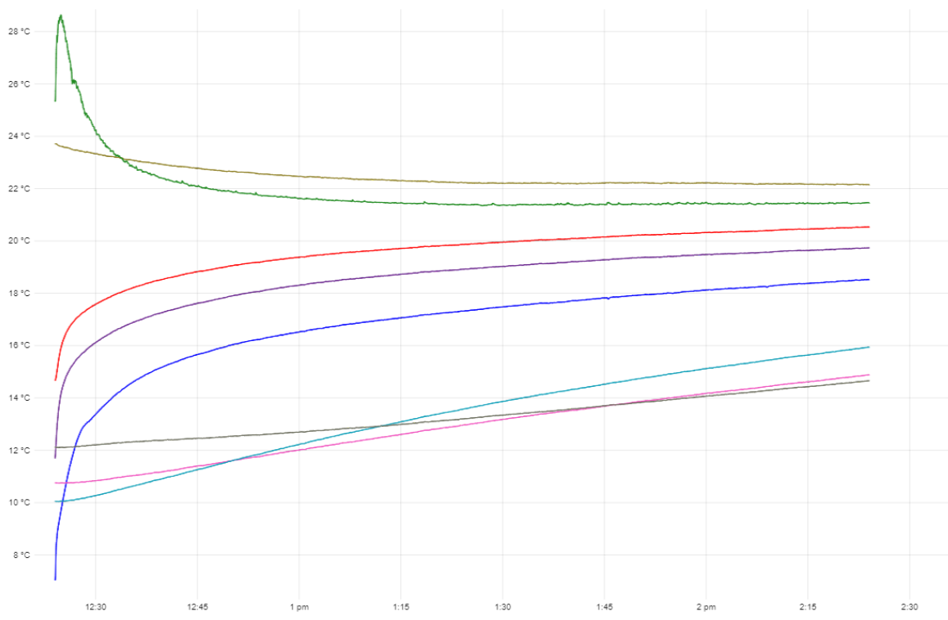

Appendix 27 – Test 6 Cooling (Third Result)


