

Module Name: Managing Enterprise
Module Code: BMSW4011
Assignment Name: Business plan and reflection
Student Name: Nikolaya Velinova
Student Number: 2412929
Lecturer: Mel Squire
Deadline: 28 November 2025

Wordcount: 2028
AI Acknowledgement
Examples of statements If you have not used AI
I confirm that I have not presented any AI generated materials as my own work.
I confirm that I have copies of my drafts, notes, and other resources I used, which I may be asked to provide in evidence.
Examples of AI statements if you have used AI
Example 1:
I acknowledge the use of Grammarly (https://www.grammarly.com/) on Date to check my work using the prompt(s):
1. Please check the following text for readability, grammar and syntax.
I confirm that I have not presented any AI generated text as my own work. I confirm that I have copies of my drafts, notes, and other resources I used before, and after the use of AI tools which I may be asked to provide in evidence.
Example 2:
I acknowledge the use of SciSpace (https://typeset.io/) on 7 March 2024 to support my research using the prompt(s):
1. Please provide me with materials on the biology of the liver.
2. Please provide me with materials on liver cells.
I confirm that I have not presented any AI generated text as my own work. I confirm that I have copies of my drafts, notes, and other resources I used before, and after the use of AI tools which I may be asked to provide in evidence.
Example 3:
I acknowledge the use of ChatGPT (https://chatgpt.com/) on 13 April 2024 to write my notes into submission format using the prompt(s):
1. Please write up these bullet points as an essay paragraph at university level.
I confirm that I have not presented any AI generated text as my own work. I confirm that I have copies of my drafts, notes, and other resources I used before, and after the use of AI tools which I may be asked to provide in evidence.
Example 4 - acknowledgement of the use of multiple AI tools:
I acknowledge the use of SciSpace (https://typeset.io/) on 28 June 2024 to support my research using the prompt(s):
1. Please provide me with materials on the American Civil War.
2. Please provide me with materials on the reception of Gone with the Wind.
I confirm that I have not presented any AI generated text as my own work. I confirm that I have copies of my drafts, notes, and other resources I used before, and after the use of AI tools which I may be asked to provide in evidence.
I acknowledge the use of Adobe Express (https://www.adobe.com/express/) on 24 June 2024 to edit photographic material:
1. Remove background from Figure 1.
I confirm that I have not presented any AI generated materials as my own work. I confirm that I have copies of my drafts, notes, and other resources I used before and after the use of AI tools which I may be asked to provide in evidence.

Business plan and reflection



MODULE NAME: Managing Enterprise
MODULE CODE: BMSW4011
Student NAME: NIKOLAYA VELINOVA
STUDENT NUMBER: 2412929
LECTURER NAME: MEL SQUIRE
WORDCOUNT: 2028

TABLE OF CONTENT:
TASK 1 BUSINESS PLAN
- Business proposition description and name..............................................6
- The Story behind my idea.............................................................................6
- Legal structure ..............................................................................................7
- Mission statement, aim, SMART objectives and USP................................7
- Physical location (including google maps) ................................................8
- Human resource strategy ............................................................................8
- Marketing strategy ........................................................................................8
- Market research.............................................................................................9
  - Primary research .....................................................................9
  - Secondary research ..............................................................10
- Financial resources.....................................................................................10
  - Cash flow forecast ................................................................10
  - Financial overview summary ...............................................10
- A critical analysis ......................................................................................11
  - SWOT ......................................................................................11
  - PESTLE ..................................................................................12
- References ..................................................................................................14
- Appendices .................................................................................................16
TASK 2 INDIVIDUAL REFLECTION
- New business/Entrepreneurial Skills ........................................................25
- Development plan .......................................................................................26
- Feasibility of Business proposition ..........................................................27

- Business proposition description and name
Company name: Nikolaya’s Delicious Place
My idea is to create a mobile kitchen where people can enjoy delicious and healthy food — either by visiting us or having it delivered to their door. Customers will be able to design their own meal plans for a day, a week, or a month.
The menu will include a variety of options such as tortillas, sandwiches, burgers, salads, seasoned roasted and grilled meats, lentil dishes, and more. We will also offer drinks like tea, coffee, matcha, and spirulina lattes, along with healthy yet indulgent desserts.
Each dish will have clearly calculated calorie information, and for those following specific nutritional goals, we will provide personalised meal plans tailored to their individual needs.

- The Story behind my idea
I have always loved preparing fresh and delicious meals for my family, and since the birth of my two children, I have developed a strong passion for healthy eating and understanding how food affects our wellbeing.
That is when I realized that many people want to lose weight but often turn to “magic” diet pills that do not actually help — and can even do harm (GOV.UK, 2017). Others try to eat as little as possible and constantly feel hungry, which is not good for their bodies either (Habib et al, 2023).
I noticed that there are many people who would love to eat healthy but simply do not have the time to cook at home. That is why I decided to create my own healthy food place — a spot where people can enjoy nutritious, balanced, and truly tasty meals without compromise (Mackison, Wrieden and Anderson, 2009).
- Legal structure
I chose to operate as a sole trader during the first 12 months, as I believe this is a crucial period for the business and I need to dedicate myself fully to its development (Gorilla, 2019). I appreciate that this structure requires less paperwork when it comes to legal and tax matters. If everything goes according to plan and my business grow successfully, I intend to transition from a sole trader to a limited company (LTD) structure (Mann, 2025).
I also recognize the risk that comes with being solely responsible for any potential losses. Level of available funding can sometimes be limited, which might restrict its growth.
- Mission statement, aim and SMART objectives plus USP.
Mission statement: On a mission to prove that healthy eating does not have to be boring.
Aim: To promote healthier lifestyles by providing fresh, nutritious, and delicious food.
SMART objectives:
Specific –I have to find suppliers that provide meat, eggs, and dairy products from free-range animals. Become a partner with suppliers who offer vegetables, fruits, and seeds grown with minimal use of pesticides, as well as high-quality spices.
Measurable - Meet with six potential suppliers.
Achievable - Meetings with potential suppliers take place on time and I receive an affordable price.
Relevant - Compare quality and pricing and select the best overall option for the business.
Time-bound - All supplier contracts are planned to be finalized and signed by 3rd February 2026.
Unique Selling Proposition – At Nikolaya’s Delicious Place, customers can enjoy delicious, healthy meals made from verified ingredients and tailored to their individual preferences — with every dish carefully calorie-calculated for full transparency.
- Physical location (including google maps)
Spring Meadow Road, Spring Meadow Business Park, Rumney, Cardiff, CF3 2ES
https://www.google.com/maps/place/51%C2%B030'06.6%22N+3%C2%B007'06.3%22W/@51.
I chose this location because it has a high footfall, being close to many offices, factories, and other businesses, while still remaining within convenient distance of residential areas (Traylor, 2021).
- Appendix 1 Map

- Human resource strategy
I plan to hire two employees to assist in the kitchen. They will help with tasks such as cutting and preparing ingredients, cooking, making beverages, cleaning, and other kitchen-related duties.
- Marketing strategy (include examples)
To increase sales, I plan to offer various discounts such as a main dish combined with a dessert and a drink, or a main dish with a salad at a discounted price (Sharpe and Staelin, 2010). Additionally, I will introduce a loyalty card program where every 10th drink or meal will be free (Myftaraj and Trebicka, 2023).
Social media advertising will be targeted at people living or working in Cardiff, supported by collaborations with local influencers to boost brand visibility.
Offline marketing will include distributing discount leaflets and placing billboards in high-traffic areas near the business location.
As a mobile kitchen, I will participate in outdoor events and festivals, giving people the opportunity to try my dishes in person and providing them with business cards containing details on how to order online or visit the business. (Accion Opportunity Fund, 2024).
- Appendix 2 Billboards picture
- Appendix 3 Competitor prizes
- Appendix 4 Logo

- Market research
  - Primary research
As part of my primary research, I used a questionnaire to understand the taste preferences of men and women aged between 25 and 60, as well as how much they would be willing to pay for their favourite dishes from my proposed menu.
The taste preferences of the people who completed the questionnaire will help me select the dishes for my menu and create the visuals for my promotional materials.
The pricing information gathered from the questionnaire will guide my pricing strategy. I plan to calculate an average price based on participants responses while also analysing competitor prices to ensure my offerings remain both attractive and competitive.
- Appendix 5 Questionnaire

  - Secondary research
For my secondary research I used articles and websites.
According to Just Eat (2025), the average price of a cup of coffee in the UK is around £4.00, depending on the location. For burger prices, I referred to Fat Hippo (2025), where the average price for a beef burger is approximately £15.50. However, my prices will be lower since my business is not located in the city centre. Most of the other prices were determined based on the results of my questionnaire.
- Financial resources
  - Cash flow forecast
  - Financial overview summary
Considering the cost of a fully equipped mobile kitchen (Bistro Trailers, 2025), a coffee machine (Pure Gusto Coffee, 2025), solar panel installation (ANKER SOLIX, 2025), a power generator (EcoFlow, 2025), and essential utensils, pans, and pods, I will need approximately £33,500.95 to purchase the necessary equipment and start my business.
When adding approximately £10,000 for initial food supplies for the first two weeks of operation, the total estimated start-up cost will be around £43,500.95.

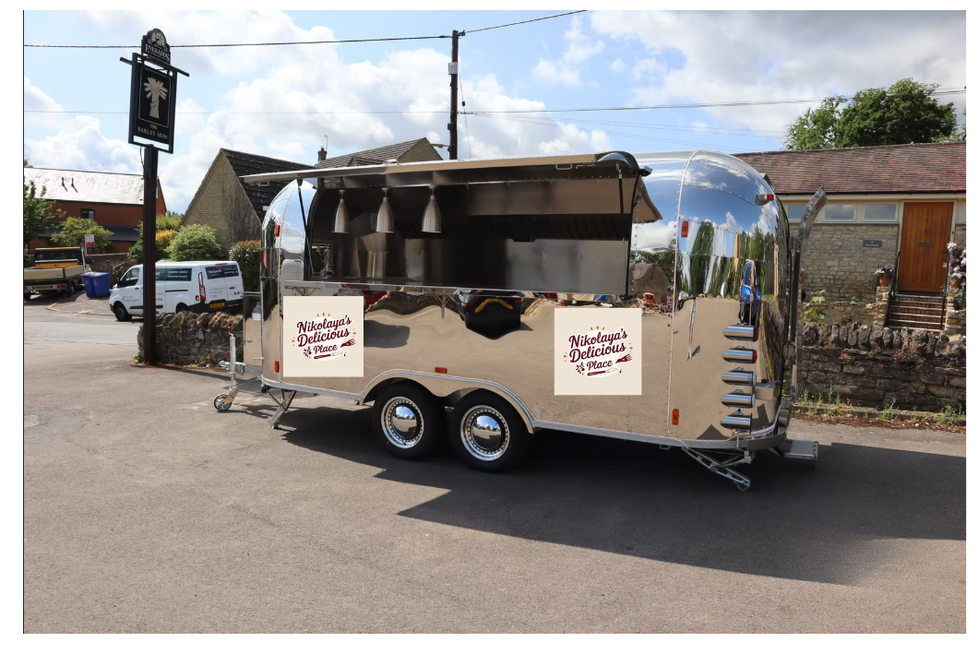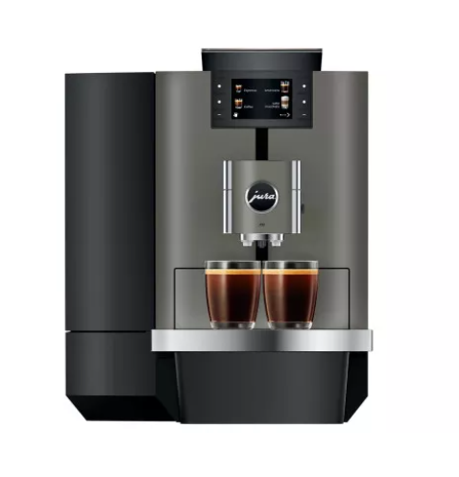
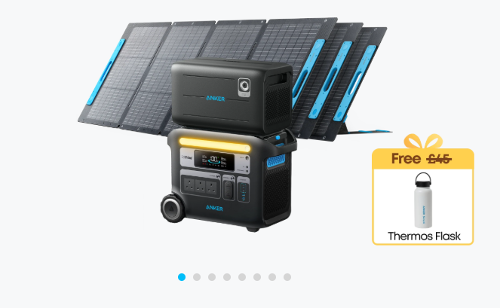
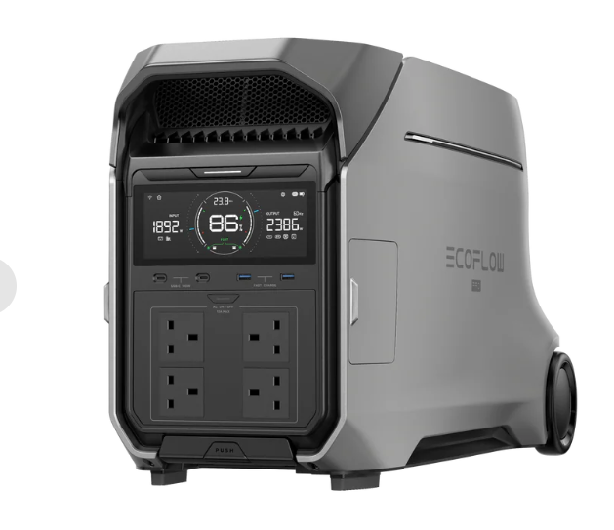
- A critical analysis
  - SWOT
Strengths
- Unique concept: Combines healthy, calorie-calculated meals with convenience through a mobile kitchen and delivery service.
- Customisation: Customers can design meal plans (daily, weekly, or monthly) according to their dietary goals.
- Flexible business model: Mobility allows the business to attend outdoor events and festivals, increasing brand exposure.
Weaknesses
- Limited initial funding: Operating as a sole trader may restrict access to larger investments and financing options.
- Owner dependency: Heavy reliance on the owner for management, cooking, and operational decisions may slow down scaling.
Opportunities
- Rising demand for healthy food: Increasing public awareness of nutrition and health creates a strong market for healthy and balanced meals.
- Potential to expand: If successful, the business could grow into a chain of mobile kitchens or transition into a fixed-location café or restaurant.
Treats
- High competition: Many cafés, food trucks, and healthy food outlets operate in and around Cardiff.
- Customer behaviour: Consumers may choose cheaper, less healthy fast-food options due to convenience or price sensitivity.

- Appendix 6 SWOT Analysis

  - PESTLE
Political Factors
- Food safety and hygiene regulations: The business must comply with UK Food Standards Agency regulations on hygiene, allergen labelling, and food preparation standards (Food Standards Agency, 2025).
- Mobile trading permits: Operating a mobile kitchen requires local council trading licenses and parking permissions in Cardiff (Cardiff Council, 2025).
Economic Factors
- Inflation and food costs: Rising prices for ingredients, energy, and fuel may increase operating costs and affect profit margins.
- Funding limitations: As a sole trader, access to large-scale loans and investments is more limited until the business transitions into a limited company (LTD).
Social Factors
- Changing dietary trends: Rising interest in plant-based, gluten-free, or high-protein diets creates opportunities for menu diversification.
- Busy lifestyles: Many people working in offices or industrial areas prefer convenient, ready-to-eat, but nutritious options — matching the mobile kitchen’s offer.
Technological Factors
- Solar energy technology: Installing solar panels reduces energy costs and supports the brand’s eco-friendly identity.
- Online ordering systems: Integrating an online platform or app for meal plans and deliveries can increase convenience and sales.
Legal Factors
- Health and safety laws: Compliance with the UK’s Health and Safety at Work Act (1974) and Food Safety Act (1990) is mandatory.
- Employment legislation: Fair wages, working hours, and employee safety must meet UK labour laws.
Environmental Factors
- Sustainability focus: Using solar panels, recyclable packaging, and locally sourced ingredients supports environmentally friendly operations.
- Waste management: Food waste disposal and recycling must follow local council regulations.

- Appendix 7 PESTLE Analysis

- References
  - Accion Opportunity Fund (2024) Food Truck Marketing: Top Strategies to Boost Your Sales. Available at: https://aofund.org/resource/food-truck-marketing/?utm_source=chatgpt.com (Accessed: 9 November 2025).
  - ANKER SOLIX (2025) Anker SOLIX F2000 + Expansion Battery + 3× 200W Solar Panels. Available at: https://www.ankersolix.com/uk/products/f2000-expansion-battery-200w-portable-solar-panel-3?variant=49876563132752&utm_source=google&utm_medium=shopping&utm_content=hes&utm_campaign=uk_ankersolix_pps_m3_google-shopping_BFCM_allpn_purchase_web_2025_1128&utm_term=23305412112_190908929882_786054054181&gad_source=1&gad_campaignid=23305412112&gbraid=0AAAAABVgOKk9ojxZdMc_8w8voBdmyDybU&gclid=CjwKCAiAraXJBhBJEiwAjz7MZUiAqWG-1b5Vus4dwyMoDm6fkMt8U9NqW9rbF-jUgAErmtoWFItbJRoCcHUQAvD_BwE (Accessed: 25 November 2025).
  - Bistro Trailers (2025) MODEL I 5 Metre. Available at: https://www.bistrotrailers.co.uk/model-i (Accessed: 20 November 2025).
  - Cardiff Council (2025) Business permits. Available at: https://www.cardiff.gov.uk/ENG/resident/Parking-roads-and-travel/parking/permits/business-permits/Pages/default.aspx (Accessed: 01 December 2025).
  - Eco flow (2025) EcoFlow DELTA Pro 3 Portable Power Station. Available at: https://uk.ecoflow.com/products/delta-pro-3-portable-power-station?variant=49296152723795 (Accessed: 25 November 2025).
  - Fat Hippo (2025) Beef Burgers. Available at: https://fathippo.5loyalty.com/order (Accessed: 25 November 2025).
  - Food Standards Agency (2025) Getting ready to start your food business. Available at: https://www.food.gov.uk/business-guidance/getting-ready-to-start-your-food-business (Accessed: 01 December 2025).
  - Gorilla (2019) What Are the Pros and Cons of Being a Sole Trader? Available at: https://gorillaaccounting.com/blog/what-are-the-pros-and-cons-of-being-a-sole-trader/ (Accessed: 9 November 2025).
  - GOV.UK (2017) New research shows desperate dieters in danger - the secret world of online slimming pills. Available at: https://www.gov.uk/government/news/new-research-shows-desperate-dieters-in-danger-the-secret-world-of-online-slimming-pills?utm_source=chatgpt.com (Accessed: 5 November 2025).
  - Habib, A., Ali, T., Nazir, Z., Mahfooz, A., Inayat, Q., Haque, M. (2023) Unintended consequences of dieting: How restrictive eating habits can harm your health. Available at: https://www.sciencedirect.com/science/article/pii/S240585722300116X?utm_source=chatgpt.com (Accessed: 5 November 2025).
  - Just Eat (2025) Coffee #1. Available at: https://www.just-eat.co.uk/restaurants-coffee-1---cwmbran-cwmbran/menu#category_7569bc96-e0d5-4f68-996b-f39755b27ca4 (Accessed: 16 November 2025).
  - Mackison, D., Wrieden, W.L. and Anderson, A.S., 2009. Making an informed choice in the catering environment: what do consumers want to know?. Journal of Human Nutrition and Dietetics, 22(6), pp.567-573.
  - Mann, G. (2025) When should I transition from sole trader to limited company? Available at: https://www.money.co.uk/business/guides/when-should-i-transition-from-sole-trader-to-limited-company#:~:text=Register%20your%20company%20%2D%20You'll,with%20a%20business%20bank%20account. (Accessed: 9 November 2025).
  - Myftaraj, E. and Trebicka, B., 2023. Analyzing the impact of loyalty card programs on customer behavior: insights from the Albanian market. F1000Research, 12, p.1028.
  - Pure Gusto Coffee (2025) Jura X10 Bean To Cup Coffee Machine. Available at: https://www.puregusto.co.uk/jura-x10-bean-to-cup-coffee-machine-best-price (Accessed: 20 November 2025).
  - Sharpe, K.M. and Staelin, R., 2010. Consumption effects of bundling: consumer perceptions, firm actions, and public policy implications. Journal of Public Policy & Marketing, 29(2), pp.170-188.
  - Traylor, R. 2021. Food trucks and parking: Location critical to success. Food trucks and parking: Location critical to success.

- Appendices
  - Appendix 1 Map
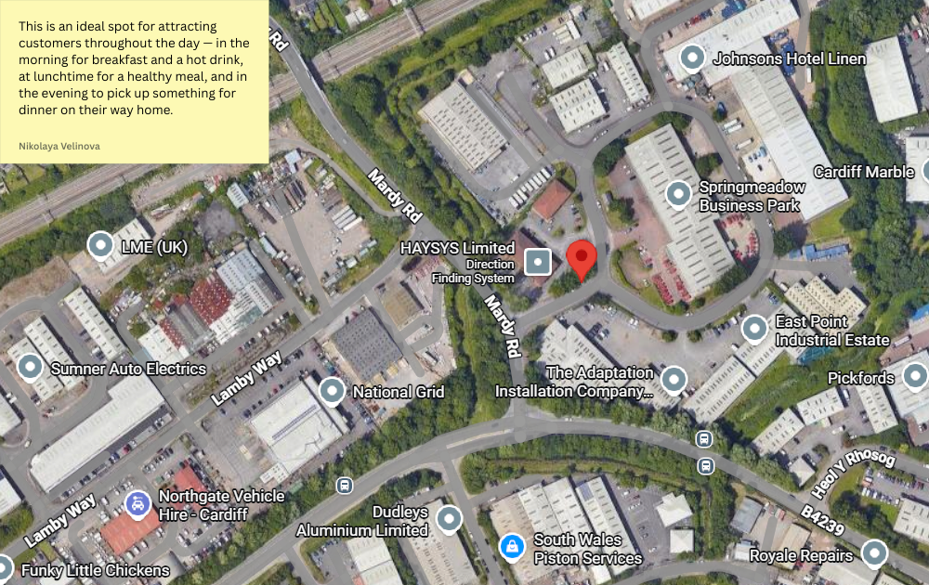
  - Appendix 2 Billboards picture
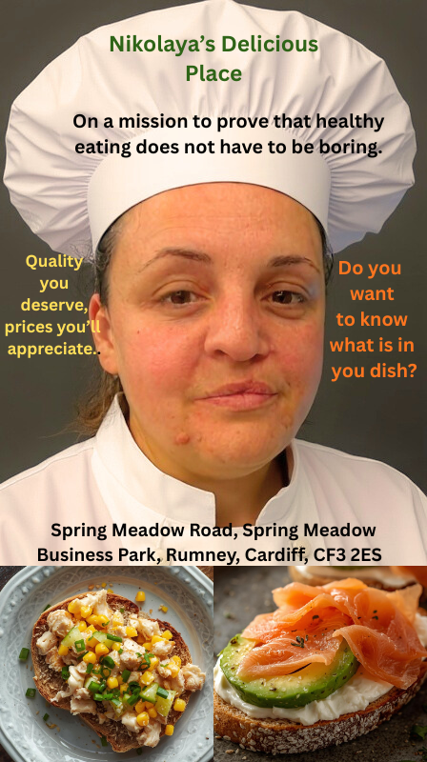

  - Appendix 3 Competitor prizes
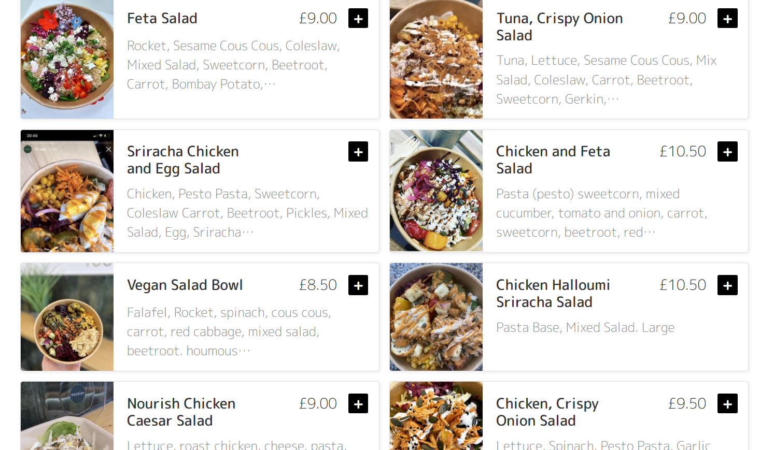
  - Appendix 4 Logo


  - Appendix 5 Questionnaire
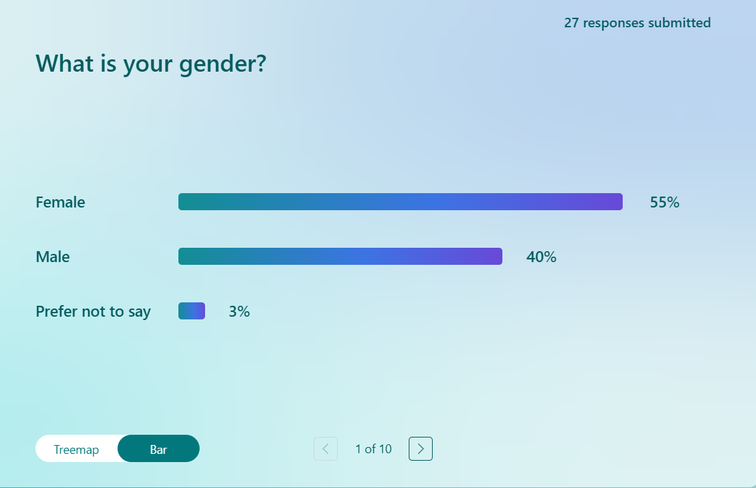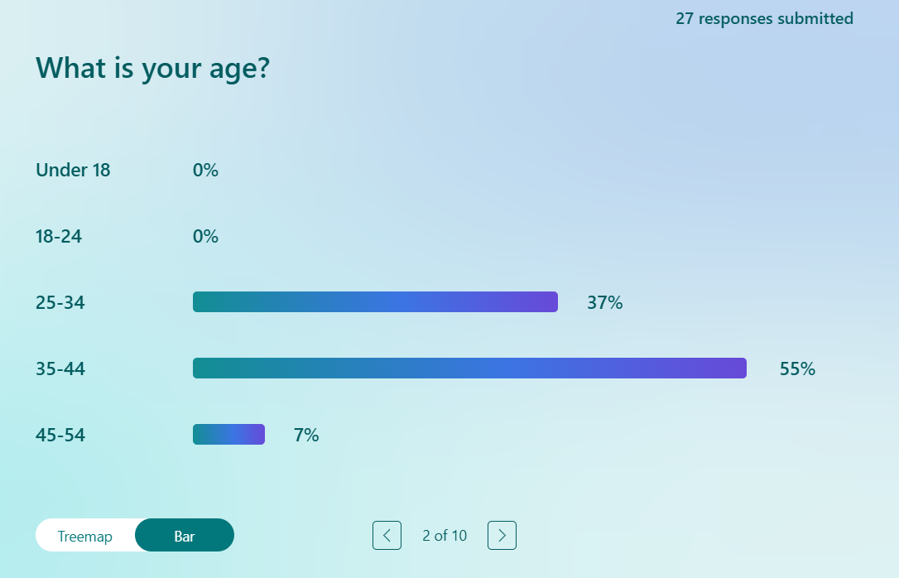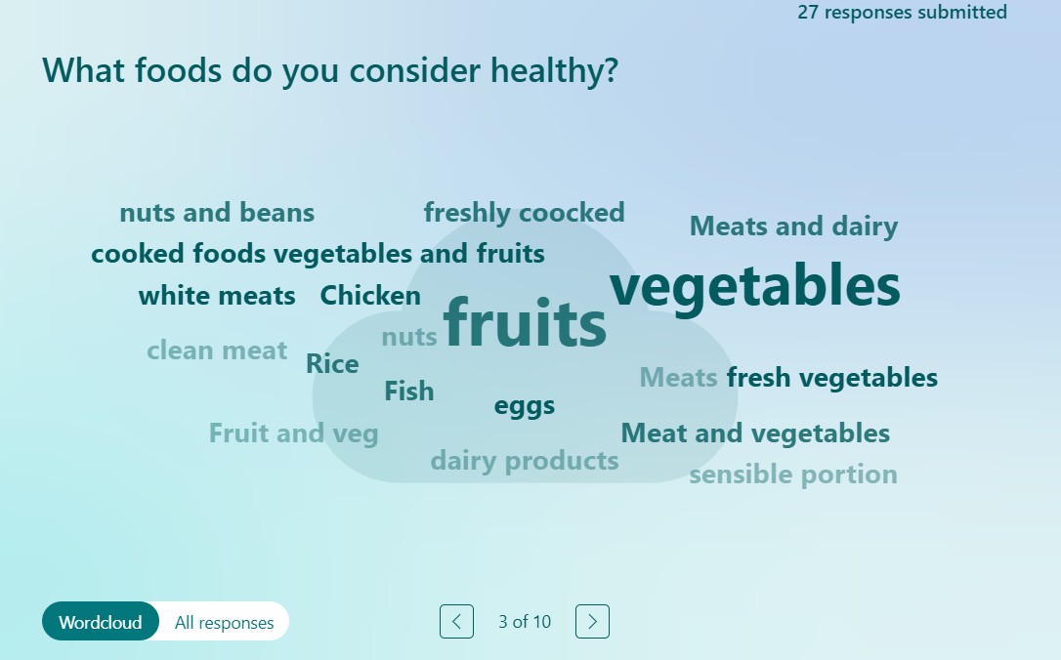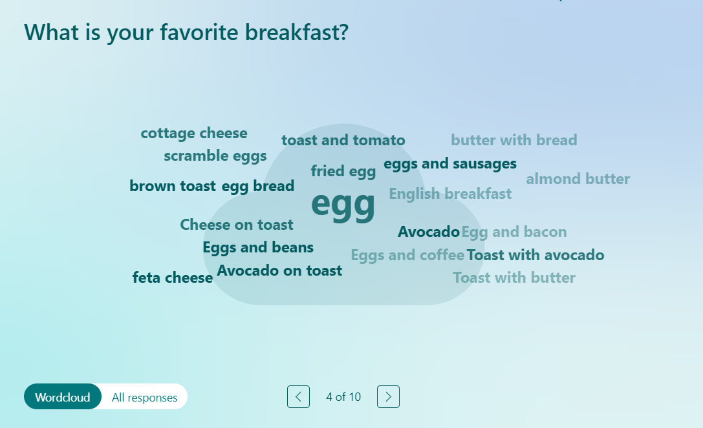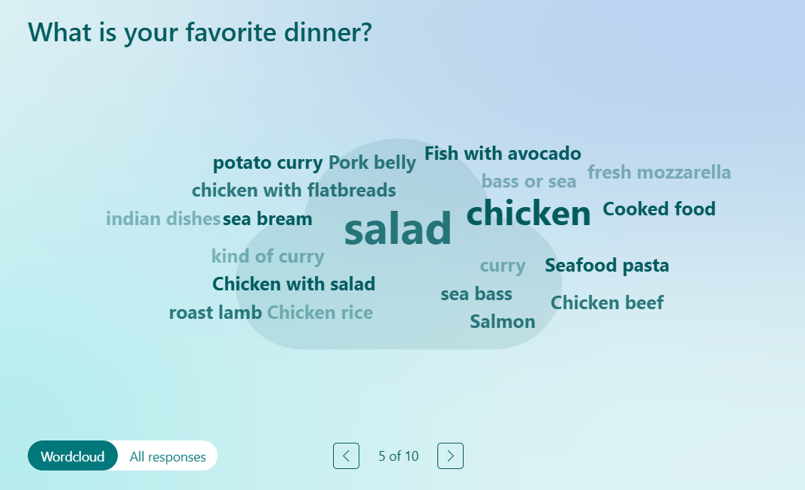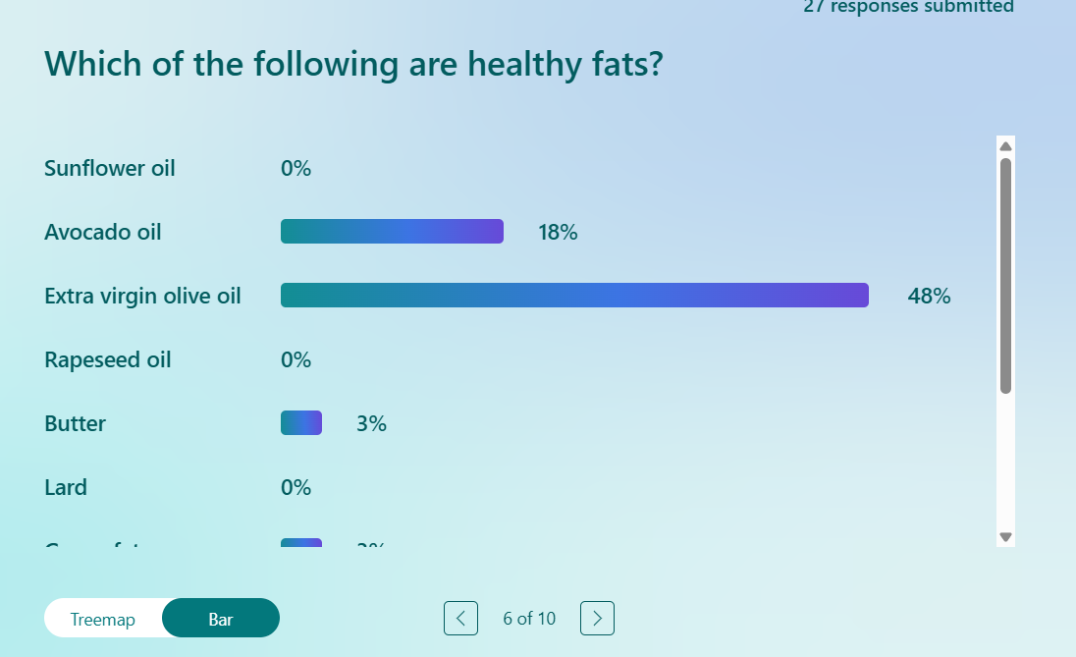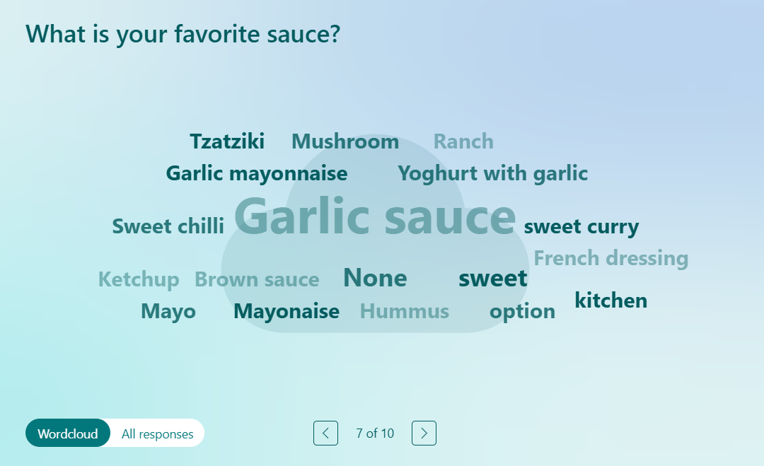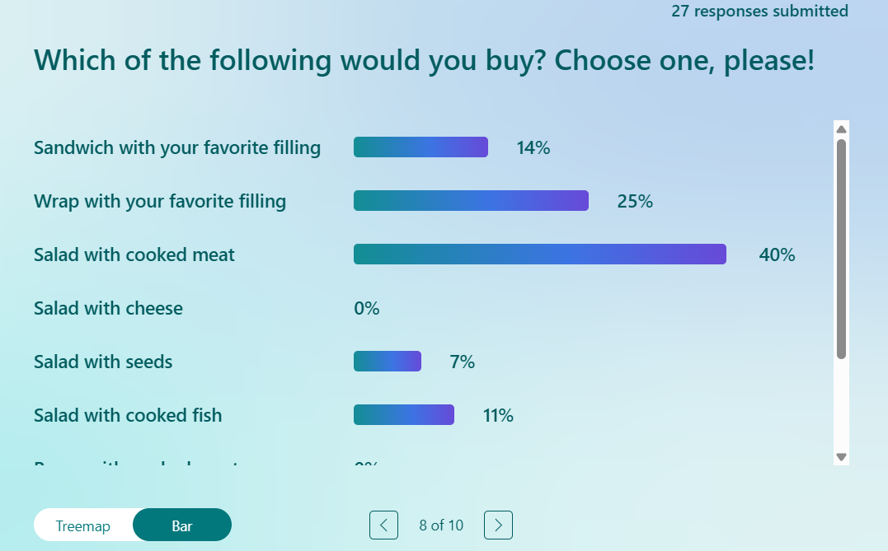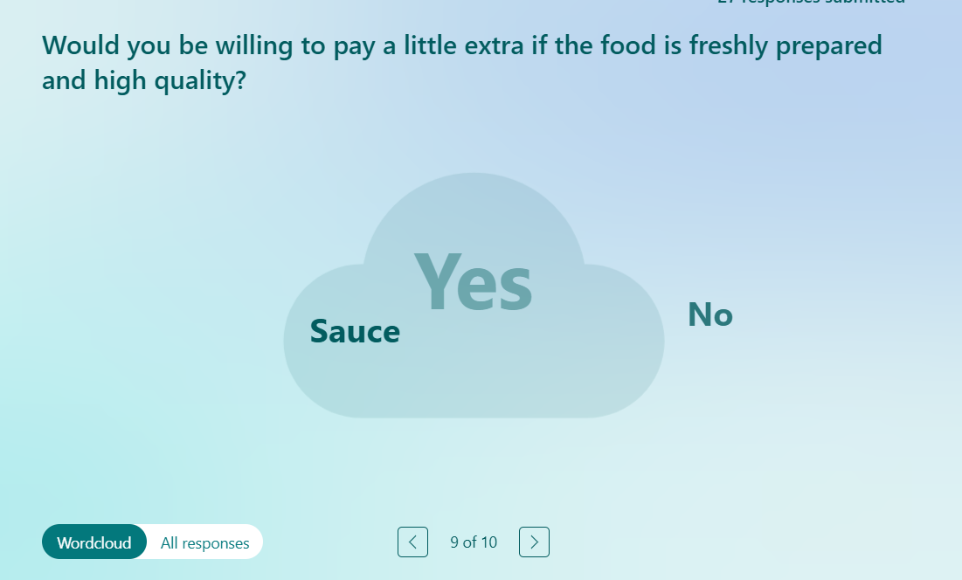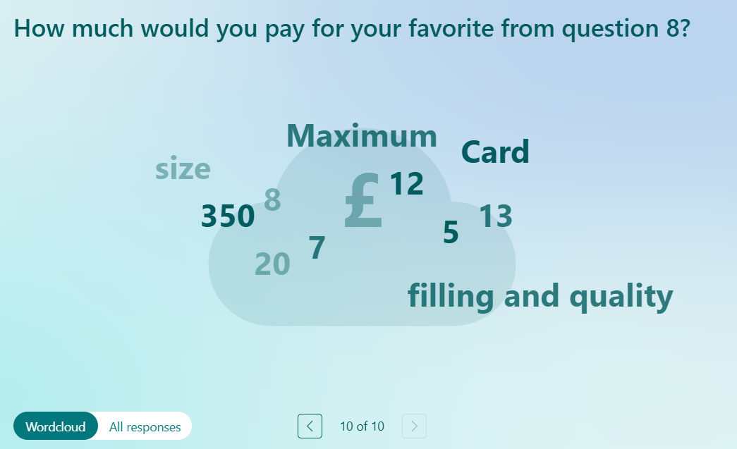

12.5. Appendix 6 SWOT Analysis
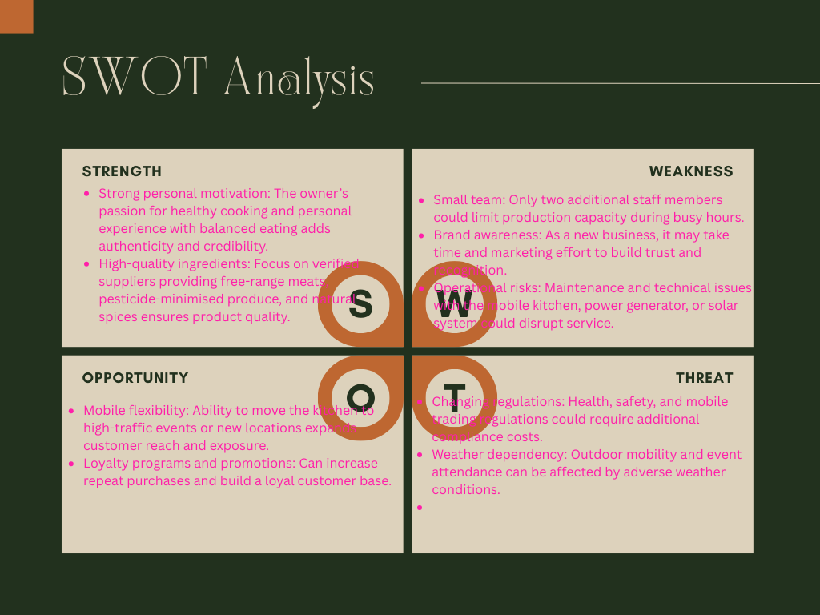
12.6. Appendix 7 PESTLE Analysis
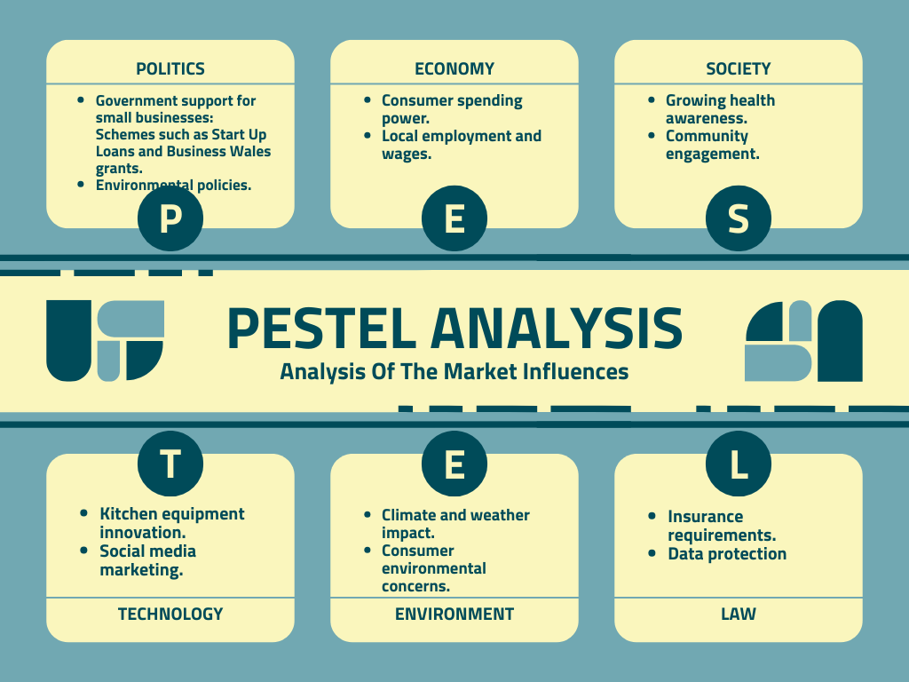
TASK 2 INDIVIDUAL REFLECTION
- New business/Entrepreneurial Skills
Leadership and Decision-Making - As the owner and manager, I will be responsible for making key business decisions, supervising employees, and ensuring smooth daily operations. My leadership skills will help motivate the team, maintain quality standards, and create a positive working environment.
Financial Management - I have developed the ability to plan and manage budgets effectively, which includes monitoring costs, setting prices, and forecasting cash flow. Understanding how to allocate funds efficiently will help ensure that the business remains profitable and sustainable.
Marketing - Strong marketing skills are essential for attracting and retaining customers. I will use both digital and offline marketing strategies — including social media advertising, influencer collaborations, and promotional events — to raise awareness and build a loyal customer base.
Adaptability and Problem-Solving - As a new entrepreneur, I understand that challenges will arise, such as equipment issues, supply delays, or changes in customer demand. Being flexible and able to find quick, practical solutions will be key to maintaining business continuity.
Time Management and Organisation - Balancing multiple responsibilities such as ordering supplies, managing staff, and promoting the business requires strong time management. Effective organisation will help maintain consistency and ensure that deadlines and goals are met.
These entrepreneurial skills — combined with passion, determination, and continuous learning — will enable me to build a strong foundation for Nikolaya’s Delicious Place and ensure its successful growth in the competitive food industry.
- Development plan
Risk Taking - One entrepreneurial trait I have identified that I need to develop further is risk taking. As a new business owner, I tend to be cautious when making financial and strategic decisions because I want to avoid potential losses. However, I understand that taking calculated risks is essential for innovation, growth, and long-term success.
Successful entrepreneurs often take well-assessed risks to seize new opportunities — such as expanding into new markets, introducing new products, or investing in better technology. Developing this skill will allow me to make bolder but informed decisions that could lead to greater business rewards.
To improve my ability to take calculated risks, I plan to:
- Increase my financial knowledge
- Learn from experienced entrepreneurs
- Start small and evaluate outcomes
- Maintain a contingency plan

- Feasibility of Business proposition
After analysing the key elements of my business plan, I believe that Nikolaya’s Delicious Place is both realistic and viable. The concept of offering healthy, freshly prepared, and calorie-calculated meals aligns strongly with current consumer trends toward healthier lifestyles and convenience. The mobile kitchen model reduces the need for expensive premises and allows flexibility to reach different customer locations, events, and business areas around Cardiff.
The financial requirements are reasonable for a start-up of this size, and the projected investment of approximately £43,500.95 appears achievable through personal savings, small business loans, or government start-up support. My market research shows a growing demand for healthy and convenient food options, which supports the long-term sustainability of the business.
Potential challenges such as competition, rising ingredient costs, and weather-dependent operations are acknowledged but manageable through careful planning, flexible pricing, and strong marketing. With commitment, continuous improvement, and the development of key entrepreneurial skills — particularly in risk management and financial planning — I am confident that the business has strong potential to succeed and grow within the Cardiff area.

