MD Jayedur Rahman Talukder
Student number: 2327181

Business Plan: Bangla Kitchen
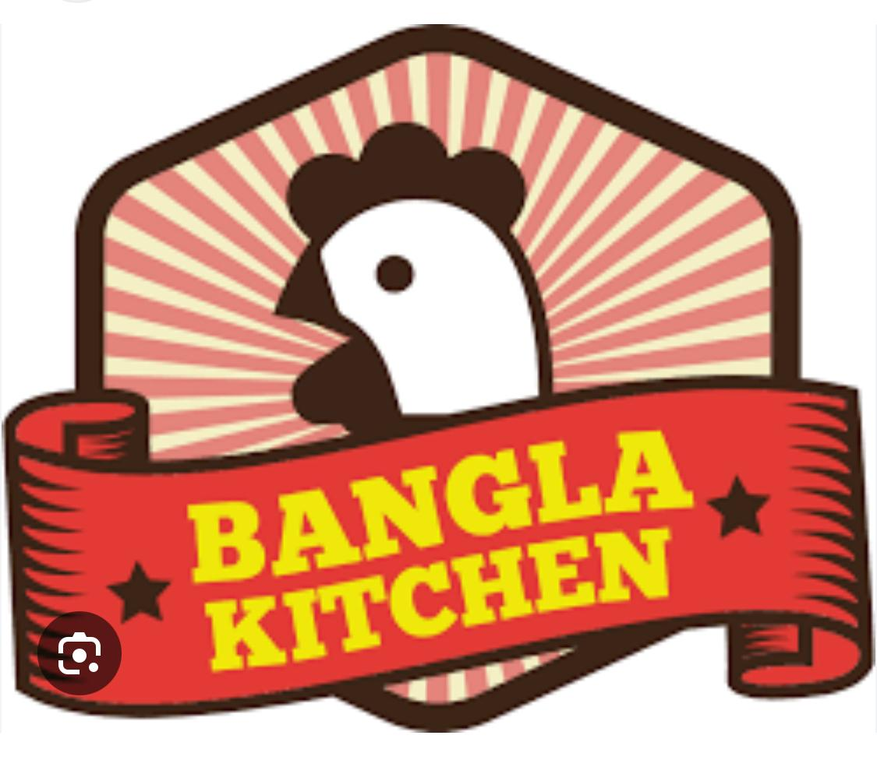
Business Overview
Bangla Kitchen is an authentic Bengali takeaway located in Port Talbot, offering traditional home-style Bengali cuisine made with fresh ingredients and bold flavours. Our mission is to bring the taste of Bangladesh to your doorstep, in every bite.
The Story Behind the Idea
As a proud Bengali, I grew up in a household where the kitchen was the heart of our home. The aroma of spices, the sizzle of mustard seeds, and the stories shared over a plate of shorshe ilish (hilsa in mustard curry). it was culture, identity, and connection. Over time, I realised that while Indian cuisine has become mainstream, authentic Bengali food is still underrepresented in the UK takeaway market.
I started Bengali Kitchen because I wanted to share a food experience that is deeply personal. Currently what’s available in the market is a generic version of Indian food that doesn’t capture the richness of Bengali cuisine. Bangla Kitchen aims to change that.
Product/Service Proposition
Bengali Kitchen will serve a carefully curated menu of Bengali dishes, with options for both meat-eaters and vegetarians. Our offerings will include:
Signature Dishes: Shorshe Ilish (Hilsa in mustard sauce), Kosha Mangsho (Slow-cooked spicy mutton), Chingri Malai Curry (Prawns in coconut milk), and Begun Bharta (Roasted eggplant mash).
Biryani & Rice Dishes: Kolkata-style biryani, Basanti Pulao.
Street Food: Puchka (Bengali-style pani puri), Egg Rolls, Ghugni.
Combo Meals: Affordable set meals for office workers, students, and families.
Desserts: Mishti Doi, Rasgulla, and Sandesh.
All meals will be available for takeaway and home delivery via online platforms like Uber Eats, Deliveroo, and JustEat, as well as our own app and website.
Type of Business Ownership
We will start the business as a Sole Trader.
Other Options Considered:
Partnership. This option allows for us to share the responsibility and capital and minimise costs when starting up. It also allows for us to pool together our experience (Korchak, 2024). Doing it this way is also easier than starting up a limited company which would result in more costs. The largest issue with this method is finding someone like-minded who will be committed to the business. This risk of disagreement is too big for me to ignore. There is also the downside of sharing profits as well.
Another option would be to set up a Limited Company. This would help keep the business separate to myself legally and mean that there is less liability on me (Rachel Craig, 2019). This method however is more complex to set up, meaning that there would be more costs associated with this.
In the end I have chosen to start the business as a sole trader (HSBC, 2024). By being a sole trader, I will be able to cut costs and get the business started as soon as possible. It will allow me to test the market and retain 100% of the profits. As there is no partnership being formed it will also allow me to make the decisions quicker. Making a Limited company will be the long term goal as it provides opportunity for further growth
Mission Statement
"To bring authentic Bengali home-style food to the community, celebrating heritage through every meal we serve."
Aim
To establish Bengali Kitchen as the leading provider of Bengali takeaway in our city within the first 12 months.
SMART Objectives
- Specific: Launch Bengali Kitchen by October 2025 with a fully operational kitchen and online ordering system.
- Measurable: Reach 500 regular customers and 3,000 total orders in the first year.
- Achievable: Start with a limited menu and increase offerings gradually.
- Relevant: Focus on food delivery and takeaway, in line with current market trends.
- Time-bound: Break even within the first 9 months and achieve profitability by month 12.
Unique Selling Point (USP)
The first and only Bengali-only takeaway in the city that delivers freshly prepared, authentic dishes using recipes passed down through generations.
Employee Structure & Roles
To ensure smooth operations, the following team structure is proposed, this will allow for efficient service:
Role | Quantity | Responsibilities
Head Chef | 1 | Preparing all of the signature dishes, food prep, hygiene control
Assistant cooks | 2 | Cooking under the head chef’s supervision
Delivery drivers | 2 | Local delivery
Front staff | 1 | Take orders, interact with customers
Marketing assistant | 1 (part -time) | Social media, online campaigns, design menus etc.

Marketing & Promotional Activities
Firstly, we will promote the business on social media. I will create Instagram reels & TikTok’s showing food preparation and Bengali culture. We will also try and promote via local Facebook groups.
I will also do a promotional offer on the opening week for “Buy One Get One Free” for the first 100 customers to help generate a buzz and promote this on social media. I will also do a giveaway to help promote the business further (Gawkowski, 2023). I will also do seasonal events with further discounts, such as the Bangladeshi new year. I will also introduce a loyalty program, allowing customers to have a free meal after 7 visits. This will incentivise repeat customers.
I will be handing out the menu personally locally to people’s houses to try and spread the word locally about the business. I will also try and contact the local newspaper and food magazines to help promote the business further.
Financial Resources
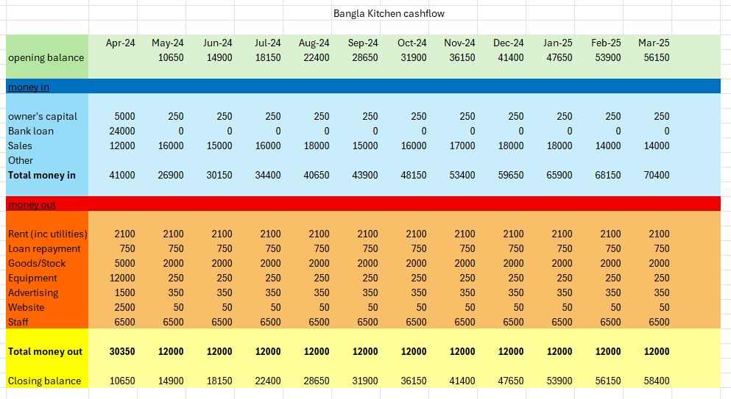
Above is the projected cashflow for the first year of the business. In the first month I have included the startup costs in the respective areas.
Item | Cost (£)
Kitchen equipment | 12,000
Initial inventory | 3000
Branding, logo, signage | 1500
Website & app development | 2500
Business license/insurance | 1000
Total | 20,000

Item | Cost per month (£)
Rent | 1500
Utilities | 600
Wages | 6500
Stock | 2000
Loan repayment | 750
Equipment maintenance | 250
Advertising (menu, social media) | 350
Website maintenance | 50
Total cost monthly | 20,000

Revenue Forecast
I expect the average order to be around £15; this would be the cost for one person. I anticipate that the weekly average of orders will be around 280. Feeding 280 people a week is achievable I believe. This would make our weekly income from orders to be roughly £4200. Making us £16,800 a month making the annual revenue £218,400. These numbers are just an estimate and there will be a large fluctuation dependant on the time of year. I feel like these numbers are reasonable as I have worked a long time in this industry.
SWOT Analysis
Strengths | Weaknesses
Unique offering (authentic Bengali) | High staff and operational costs
Strong cultural story and mission | Limited initial brand awareness
High-quality, homemade recipes | Dependence on delivery platforms
Local community appeal | Niche market appeal may limit early growth
Opportunities |  | Threats
Expand to new areas via delivery |  | Rising food and energy prices
Grow into catering or events |  | High competition from generic takeaways
Collaborations with local businesses |  | Risk of poor online reviews
Seasonal festivals |  | Economic downturn impacting spending habits

Weakest Area Identified: High Operating Costs
I have identified that the high operating costs could potentially be my biggest weakness. I will make sure to cross-train the staff to be able to handle multiple roles, this will reduce the need for extra hires. I will try and negotiate bulk discounts with suppliers for ingredients and packaging, and try and reduce utility costs (Sullivan, 2017). I will also try and optimise delivery routes and offer more incentives to customers to pick up further reducing some of the delivery costs. I will also hire some part-time staff and try and do more of the roles myself to help minimise costs further. By doing all of this I will hopefully cut down on some of the operational costs.
Conclusion
Bengali Kitchen is more than just a food business, it's a cultural movement aimed at bringing the rich, authentic flavours of Bengal to a broader audience. With a strong brand identity, clear financial planning, and a compelling USP, the business has every opportunity to thrive in a competitive takeaway market. By addressing our initial weaknesses with smart strategies, Bengali Kitchen can grow sustainably and become a household name in the UK food scene.
Reference list
Gawkowski, E. (2023). 20 Best Restaurant Promotion Ideas (2023). [online] UpMenu. Available at: https://www.upmenu.com/blog/restaurant-promotions-ideas/.
HSBC (2024). Sole Trader Vs Limited Company? – HSBC UK. [online] Hsbc.uk. Available at: https://www.business.hsbc.uk/en-gb/insights/starting-a-business/sole-trader-vs-limited-company.
Korchak, J. (2024). Advantages and disadvantages of a partnership business. [online] Inform Direct. Available at: https://www.informdirect.co.uk/business-management/partnership-business-advantages-and-disadvantages/.
Rachel Craig (2019). What is a limited company? [online] Rapid Formations Blog. Available at: https://www.rapidformations.co.uk/blog/what-is-a-limited-company/.
Sullivan, M. (2017). 8 Ways to Reduce Operating Costs. [online] QuickBooks. Available at: https://quickbooks.intuit.com/r/expenses/8-ways-reduce-operating-costs/.

Reflection
Creating the business plan for Bangla Kitchen has been a very difficult yet valuable experience for me. As a mature student who struggles with English at times, I was very nervous to start with. Going through this process, however, has helped me learn many new skills and build some confidence in my ideas.
One of the most important skills I have developed is planning and research for a business. I have learned how to structure a business idea. I have also been setting goals and planning finances for this business which I couldn’t have done before. I had never before thought of SMART objectives, but I know understand the value of it. Doing this assignment has really helped me understand how important careful planning is to the success of a business. I have also done research on different types of business ownership, learning about all of the different types will be important for the future.
This assignment has also helped me see things from different perspectives. I was able to be the customer, investor and even an employee through this assignment. I can now appreciate all of the different parts that make up a business and keep it going smoothly. Writing the marketing section was incredibly informative as I am now aware of how businesses use social media and promotions to attract customers.
During this process I now understand that an entrepreneurial trait that I need to develop is risk taking. I find it scary to risk money and tend to be cautious before doing anything. While this can be a good thing, you can’t have a successful business without taking appropriate risks. If I take too long to make certain decisions I might miss out.
If I were an angel investor I would consider investing in Bangla Kitchen. The uniqueness of the idea and the story behind the food make an ideal combination for a business. There aren’t many Bengali only restaurants out there. Having such a unique menu is definitely an advantage.
The large downside to this business is the high operating costs and the risk of the business not surviving in a competitive market. There are a lot of Indian cuisine already out there making it potentially difficult for the business to survive. As an investor I would need to see the business plans thoroughly and see how they aim to cover these weaknesses.
Overall, I believe Bangla kitchen has potential to do very well if operated properly. This assignment has helped me improve my business knowledge and has made me proud of my background, making me excited for whatever the future holds for me.

