Task 1
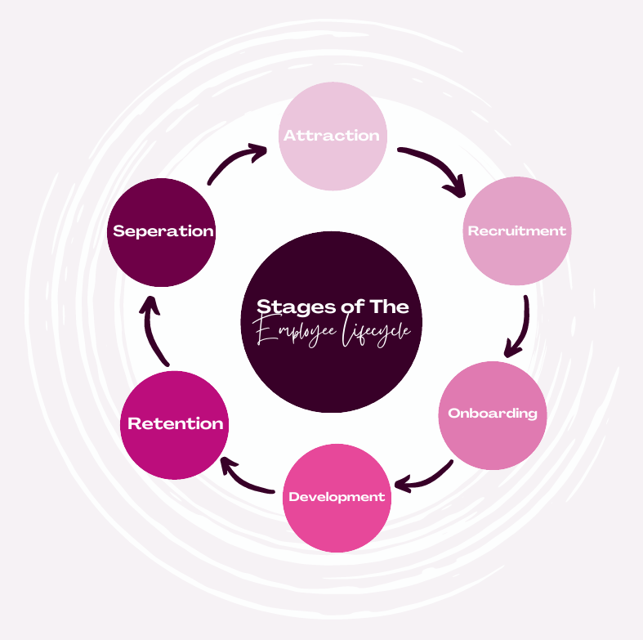
AC 1.1.

Attraction – When advertising the role, Jemijo should emphasise on what the company offers their employees and really highlighting Jemijo's flexibility. Since they have office based, home based, and hybrid roles. Their people professionals should market these options to attract a wider demographic.
Mentioning also that they have high quality customer service could attract more applicants that take pride in helping customers in emergency situations.
Recruitment - For the 2,500 employee workforce, the people professionals could implement automated screening tools for call centre roles to handle volume, while using targeted headhunting for specialised Underwriting or Market Analysis roles.
Onboarding - Introducing a Digital Induction Portal is essential for keeping home based team connected to Jemijo’s culture and various departments. Furthermore, because the insurance industry is highly regulated, People Professionals must ensure all mandatory compliance training is completed, logged, and audited during this stage to mitigate organisational risk.
Development – With 65% of Jemijo's sales and claims now occurring online, People Professionals should facilitate strategic upskilling programs. This involves transitioning traditional phone agents into digital chat experts. This ensures that while technology handles the bulk of the work, customers still have the option for high quality human interaction across all digital platforms.
Retention – The wellbeing of the team must be a top priority, particularly for the 24/7 Emergency Claims Hotline staff. People Professionals should implement a fair, transparent system for shift allocation to prevent burnout and support a healthy work life balance. Additionally, organising inclusive social events for home based team helps prevent a two-tier culture, ensuring remote workers feel just as valued and included as those in the physical offices.
Seperation – In large call centres, turnover can be high. People Professionals should conduct exit interviews to identify if team are leaving due to the pressure of emergency lines or weekend hours. This data allows for reasonable adjustments, such as offering a different shift pattern or facilitating internal mobility to a different department, ultimately saving the cost of rehiring and keeping valuable institutional knowledge within Jemijo.

AC 1.2
To create an accurate job description, I’d begin by interviewing the top performing call handler to gather as much information about the role they do and what the typical emergency hotline shift looks like. Sitting in on calls and observing their work would help understand the complexity of the claims they receive. By doing this I’ll also gather knowledge on the software they are using to manage the claims. It will be important for to mention this in the description what training could be provided in regard to the systems and software they will be using. Also, it helps knowing if they are good with technology but also gives them the confidence knowing that we can provide training.
When writing the job description, it is important to not only mention their responsibilities, but to also define them so that there is clear understanding than just “answering phones”. As Jemijo has home based and office team, they must specify in the job description that if they are to be home based, they will need high speed internet for their role. Adding what insurance software and digital chat software the handlers will be using also.
I believe the most important part of the job description is finding the right person for the job. Making it clear what you’re looking for, and the requirements will bring the right people in.
One good thing to mention would be emotional resilience. Being an emergency hotline handler, there’s times they will deal with distressed customers. It’s an essential trait to have for the role. The ability to problem solve is key also, since handlers deal with an array of different claims, from roof damage to pest infestations, the handler must be able to think on their feet, not just follow a script.
In many jobs, qualifications might be desirable, however, if the applicant has previous experience in a high pressure environment, it is a better predictor of success for the company. Mentioning this will attract those who don’t have the qualifications but have the experience as many assume they need to be qualified to do these roles.

AC 1.3
1. Company Website
Jemijo’s company website is a platform entirely controlled by the organisation, where applicants can browse vacancies, learn about the brand, and apply directly. It’s usually the first place the applicant will want to browse so they can get a vibe of the company. Including testimonials from the 24/7 emergency team or images of the offices can help an applicant decide if they are a cultural fit before they apply.
Due to having often a high turnover and frequent hiring needs, advertising on their own site means that it’s essentially free which significantly reduces the cost per hire compared to paying for external ads.
2. Commercial Job Board
Massive digital platforms such as Indeed or LinkedIn are where thousands of employers list jobs in one central location.
As Jemijo needs to maintain a workforce of 2,500, they must have a constant stream of applications. These platforms have a lot of traffic daily, meaning Jemijo’s available vacancies are there for thousands of people to come across that many never had thought to visit the company website directly or even heard of the company before.
These platforms often have the options to be able to filter keywords meaning anyone who’s searching for a specific role such as remote or customer service roles will be able to do so. Platforms like indeed also have the option for employees to leave reviews, therefore having direct opinions from past and present team give authentic testimonials.

AC 1.4
The content of a job advertisement must be adapted to suit the platform where it is hosted. At Jemijo, the people professionals should distinguish between these two channels.
Jemijo’s Own Website- When a candidate visits the Jemijo website, they are likely already interested in the company or are conducting deep research. Therefore, the copy here can be longer, more storytelling focused, and aspirational. It should focus on "The Jemijo Way," detailing the company culture, mission statement, and long-term career progression. Such as moving from the call centre into specialised roles like underwriting or market analysis. This copy is designed to sell the long-term relationship, highlighting complex benefits like pension schemes, employee resource groups, and the company's commitment to high quality human interaction in a digital age.
Commercial Job Boards- On sites like Indeed or LinkedIn, candidates are often passive or are scrolling through hundreds of competing insurance roles. The copy here must be shorter, punchier, and highly functional. It prioritises search engine optimisation by using high-traffic keywords like "Customer Service Advisor" or "Claims Handler" rather than creative internal titles. The most attractive, immediate benefits such as competitive salary, 24/7 hotline shift premiums, or the option for home-based work must be placed at the very top to stop the user from scrolling.
The difference in them both is the website copy is about brand immersion and retention, aiming to see if the candidate fits the Jemijo culture. The job board copy is about conversion and reach, aiming to compete with other large insurers by highlighting the most practical and enticing hooks of the role immediately.

AC 2.1
A structured interview means that for everyone that applies, it will be fair and consistent, and every applicant is asked the same exact questions. This structure works for Jemijo as they won’t be hiring just because a manager ‘liked’ them. It ensures fairness and that every new hire has the same level of standard in customer service.
Assessment centres are more of an audition. Instead of just talking about the job, applicants can perform tasks that will be a part of their role. It will allow Jemijo to see if the applicant can handle a complaint with a distressed or angry customer, whilst also using a computer at the same time. This is much better than just taking their word for it.

AC 2.4
Keeping records is about staying legal and fair. The original job description, the interview pack which should include interview questions, scorecard and interview feedback, should be kept for everyone. All requests for reasonable adjustments must also be kept. We keep this documentation to ensure that if an applicant was to claim they weren’t hired because of unfairness, Jemijo will have this evidence to provide and support the decision that it was based on skills and scores. The documentation for unsuccessful applicants should be kept for up to 12 months as this is the timeframe for where someone can legally complain. For successful applicants, this documentation should be kept in their permanent file for the duration of their role and up to 6 years after they leave to cover any future claims.

AC 2.5
Letter of appointment- Regarding the letter of appointment I would mention what skills and experience stood out and why we at Jemijo want them as part of our team.
In the terms of offer section, I would add in some induction and training dates so that the candidate can know in advance.
Overall, I think it’s a good standard letter. Adding in that extra information may support the candidate in knowing what stages are next in their onboarding so they’re not left wondering, feeling unsupported or lost from the get go.
Letter of Non-appointment- This letter can be hard to draft, AI has given me a professional letter to ensure the structure is clear, but I would customise it to ensure the tone is empathetic.
I would ensure that the information is correct in company policy for how long we retain the documentation before we destroy the paperwork as some are 6 months and others it could be as long as 12 months. The letter has prompted us to enter that ourselves to ensure the information we give is accurate.
To ensure the candidate doesn’t feel too disheartened, I would mention what went well and what stood out to us. I’d add in a comment for the candidate to have the option to reach out to us if they wanted to receive some feedback or to appeal our decision. Lastly, I would warmly invite them to apply in the future.

1. Letter of Appointment Template
Subject: Private and Confidential: Offer of Employment – Customer Service Representative
Date: [Insert Date]
Candidate Name: [Insert Name]
Address: [Insert Address]
Dear [Candidate Name],
OFFER OF EMPLOYMENT
Following your recent interview and assessment centre, I am delighted to offer you the position of Customer Service Representative at Jemijo. We were very impressed with your skills and believe you will be a fantastic addition to our team of 2,500 professionals.
Terms of Offer:
- Commencement Date: Your employment will begin on [Start Date].
- Work Location: Your role is designated as [Office-based / Home-based / Hybrid]. (Note: For office-based staff, your base will be our [Insert Location] office).
- Salary: Your starting salary will be [Amount] per annum, paid monthly.
- Hours of Work: Your standard hours will be [Number] hours per week. As discussed, our lines are open Monday to Saturday, 8:00 am to 6:00 pm. Your specific shift pattern is attached.
- Probationary Period: This appointment is subject to a probationary period of [e.g., 6 months].
Conditions of Appointment: This offer is conditional upon the successful completion of the following:
- Receipt of two satisfactory professional references.
- Evidence of your right to work in the UK.
- Completion of our mandatory Insurance Regulatory Compliance training during induction.
Please find attached your full Contract of Employment. To accept this offer, please sign and return the documents by [Insert Date].
We look forward to welcoming you to the Jemijo team!
Yours sincerely,
[Name] [Title] Jemijo People Department

2. Letter of Non-Appointment Template
Subject: Outcome of Application: Customer Service Representative
Date: [Insert Date]
Candidate Name: [Insert Name]
Address: [Insert Address]
Dear [Candidate Name],
Application for Customer Service Representative
Thank you for attending the interview and assessment centre for the role of Customer Service Representative at Jemijo. We appreciated the opportunity to learn more about your experience and your interest in our company.
I am writing to inform you that, on this occasion, your application has not been successful.
We received a very high volume of applications from many qualified individuals. After careful consideration of all candidates against our selection criteria, the hiring panel has decided to proceed with other applicants whose current skill sets more closely align with the specific requirements of our call centre operations and 24/7 emergency hotline at this time.
We will hold your recruitment records, including your interview notes and assessment scores, for a period of [e.g., 6 months] in accordance with our data retention policy. After this period, your data will be securely destroyed.
Thank you for the time and effort you invested in applying to Jemijo. We wish you every success in your future career.
Yours sincerely,
[Name] [Title] Jemijo People Department

