Qualitative Report: Coping with change: Exploring the lived experience of moving to a new University Campus.

This report highlights the aims of the study ‘Exploring the lived experience of moving to a new university campus.’ Allowing the researcher to identify coping strategies which are developed. A literature review has been completed to identify previous characteristics with individuals coping with change. The report highlights the amount of participants who took part and what they had to participate in. The results section shows the three initial themes found: Information, Resources and Transition. Along with sub themes that were also identified within the transcripts. Finally, the discussion links back the results found to the literature review completed to reinforce any similarities found or If there could have been any changes in the way the study was made.

Introduction

The researcher’s aim is to identify any factors which have affected the students at UWTSD. Before any research took place, the first step was to complete a literature review to enable evidence which will either support or decline a hypothesis. The first article looked at was “Living with Vitiligo: Dealing with difference” by Thompson, Kent and Smith (2002). They stated how coping methods were developed to accept their difference. As participants within this study were being evaluated based on living with a skin disease. It was encouraged that participants were able to embrace their reactions and how they dealt with the reactions of others. Furthermore, another article which was looked at in regards to identifying a hypothesis was “A qualitative investigation of problem gambling as an escape based coping strategy” by A. Wood and D.Griffiths (2007). The report uses a qualitative form of research as well as identifying coping strategies. It was identified during this research that a ‘’structured grounded theory approach was utilized” and gained success. It was also stated that the idea of ‘escape’ from the issue was a prime characteristic for individuals who gamble. Therefore, this may want to be considered in relation to the students avoiding the move to the new campus and not attending open days. As a result of these pieces of literature the following hypothesis was composed “Students would encounter the move with negative attitudes”.

Method

Participants
The use of three participants who attended the UWTSD were used to gather data for this study. There were two females involved aged 19 and 22 as well as one male who was 20, (M=20.3) (SD=1.5). These participants were recruited due to the factor that they are second year students who study Psychology and Counselling. They had previously attended the Townhill campus for their first year, therefore would have experienced the move after they had settled in to their course at the original university.

Design (Data analysis)
The type of interview used for the collection of data would be semi structured interviews. The participants were asked to answer four questions based on their experience and emotions of the move from the previous university to the new build in SA1. The type of analysis chosen to transcribe the data was Interpretative Phenomenological Analysis (IPA).

Materials
The materials used for this study included a consent form (Appendix A), which highlighted the ethical rights of the participant involved. During the interview, an Iphone X was used to record the responses along with a paper based interview schedule for the researcher (Appendix C). There was also a debrief form handed to participants at the end of the interview to highlight the aims of the study (Appendix B), and if there were any questions then the name and email address of the researcher was given on the debrief. No other materials were used during the interviews.

Procedure (data collection)
Firstly, participants were automatically recruited as they studied on the Psychology and Counselling course at the UWTSD. They were asked during lectures if they were able to take part during a particular time slot in the labs. Each individual attended at their given time slot and given a unique ID code, ensuring that their data could not be traced back to them in the future. Each participant entered the lab, and were immediately handed a consent form before any research took place. Once this had been signed and handed back, the interview began. The researcher used the interview schedule as a guide to the questions. The researcher gave a brief overview of what was to come then switched the recorder on. It was also reminded that their name will be replaced with a pseudonym and if they would like to pause/stop the interview at any given time then do not hesitate to do so. Then the questions began and the participant provided their thoughts and opinions on the proposed questions. Once they had completed all four questions, they were thanked for attending and given a detailed debrief form.

Results
The aim of the research was to establish the lived experiences of students who moved from Townhill down to SA1 waterfront at the UWTSD. The chosen analysis for this type of research was Interpretative Phenomenological Analysis (IPA) used as a format for the transcription of the data provided. The themes identified from all 3 participants were all directly linked to each other, all participants highlighted the same reoccurring themes between them all.

The first theme identified would be classed as ‘Information’ meaning the amount of information given to the participant about the move, which found to be repeatedly mentioned through all three transcripts. Highlighting the issue that there was hardly any information given based on the move beforehand, and the minimal amount given was brief (Appendix D). This can be seen within P1 “not much information was given regarding the new umm SA1 campus” (38) and repeated “Did not know which part it was going to be in” (39). Then P2’s transcript also provided the same idea “I was a bit confused as to where we were actually moving” (15) and “no idea we would be coming to this campus” (16/17). Between the first two participants, an immediate sub theme was identified; highlighting the information ‘prior’ to the move and then the ‘arrival’. As seen in P2 “given more in-depth tours and guides of the university when we arrived” (24/25). This can be reinforced with P3 “given much more information on the move since moving here” (31/32).

The second theme established would be the use of ‘Resources’, allowing there to be more facilities encouraging revision and further learning, which participants highlighted that this has shown a raise in their educational engagement on the course (Appendix D). Encouraging the participants to stay behind at university to complete extra work. This can be reflected in P1’s transcript “laptops are more assessable there’s plenty of them around” (65/66) as well in P2’s “well there’s loads of different things such as the variability, the library etc” (35/36), this continued motion of better resources is repeated within P3’s transcript “all these new things…” (56). From the analysis of this, a sub theme was then produced being the ‘Library’ and ‘Technology’ as these two are continuously spoken about within the idea of improved resources. As seen in P3 “especially the library as it much more of a study area and has a university feel to it” (42/43). Again, in P1 transcript “more technology um here such as laptops” (65).

Finally, the third theme would be the initial ‘transition’ for the participants, although participants stated that the move was almost treated as a trip, the overall transition of the participants has had a positive impact on their university lives (Appendix D). This can be seen in the transcript of P2 “settled in quite well, although it never felt like we were here forever if you get me?” (52/53), as well as within P3’s transcript “I have settled in really well” (54). Two sub themes were then developed, one being ‘Beneficial’ as all three of the participants mentioned that although the move was limited in information, it has benefitted their educational performance. This is seen in P2’s transcript as well “this move has increased my ability to study better in the new facilities, therefore has been a benefit to my results.” (60/61). Another sub theme would be that its ‘Motivated’ students that little bit more. P3 stated “will take their education a bit more serious” (43/44) and “…building has impacted my motivation to work in such a positive way” (29).

Discussion
Overall, the establishment of whether there were effects on student’s university move was found and rejected the initial hypothesis. Many themes highlighted the different changes in which students were faced with and how they used different coping mechanisms to deal with this change. The results found from the interviews can be directly linked to that found in “Living with Vitiligo: Dealing with difference” by Thompson, Kent and Smith (2002). Where this study found that coping mechanisms were developed in order to accept their difference. One of the strategies found within this study can be directly linked to the results found from the interview transcripts which would be the idea of ‘Social support’, although this was not identified as a theme there was an impression given off by all participants that the idea of peers helped. This was considered a major influence in the transition for the students as they found it easier that a lot of their peers were experiencing similar emotions. This corresponds to the idea of a coping mechanisms as they are able to use each other for support and guidance. Furthermore, the report on “A qualitative investigation of problem gambling as an escape based coping strategy” by A. Wood and D.Griffiths (2007) showed a difference in results which were found from the transcripts. The report found that gamblers use the idea of ‘escape’, however the transcripts did not produce this characteristic as most of them found an improvement and tended to stay for extra learning. This reinforces the idea of the hypothesis being rejected.

Overall, the study can be praised on the structure of the interview schedule due to the fact that the schedule was uniquely completed and allowed the interviews to flow. On the other hand, if the study was to be repeated then a bigger sample could be used to have a range of different genders, age and ethnicity involved which can then be interpretated directly to the target population.

Conclusion
In conclusion, the report reinforces the continuous themes found from the analysis. The use of IPA was successfully done by its detailed examinations of an individuals lived experiences, which is why it was the most beneficial analysis to use for this qualitative report. The theme and their sub themes found can be linked to the first literature identified, however can be used as a contrast to the second literature reviewed in the introduction. This study can be used for future repetition, however the researcher may want to reconsider certain elements. For example, more questions may want to be added to allow for a larger mix of responses.

Appendices
Appendix A

School of Psychology
SA1 Campus
Swansea

Study Consent Form

I understand that this is study is being conducted by a second year Psychology Student for the purpose of a module assessment. Taking part in this study will require me to take part in a Semi structured interview based on the move to the new SA1 campus. I also understand that I will be recorded throughout the interview.
This interview will take approximately 10 minutes to complete.
I am aware that taking part in this study us entirely voluntary, and I have the right to withdraw participation from the study at any point without having to give reason. Likewise, if I feel concerned about the study at any time, I am able to disclose such concerns or worries with the researcher or academic supervisor, either during or after completing the study.
I understand that the information that I provide will be held confidentially by the researcher, with a code assigned in place of my name in order to remain anonymous. My data will then be stored responsibly, in accordance with the Data Protection Act.
Furthermore, I am aware that once the study has been completed I will be provided with a debrief form and the chance to converse any issues with the researchers.

I, ___________________________________(NAME) consent to participate in the study conducted by Freya Hughes for School of Psychology, University of Wales Trinity Saint David, Swansea under the supervision of Stacey Coleman.

Participant Signature:________________________________________________
Date:___________________
Name and signature of researcher taking consent
___________________________________________________________________

Appendix B
School of Psychology
SA1 Campus
Swansea

Study Debrief Sheet
Coping with change: Exploring the lived experience of moving to a new University Campus

Thank you for taking part in this interview.

The aim of this study was to explore how the move to the new SA1 campus from the Townhill campus effected a students experience within the university, and whether there were any consistent themes throughout all participants.

If you wish to withdraw your data from the study you must tell the researcher now. After this point, all of your data will remain confidential and we will not trace it back to you.

If participating in this study has caused any concerns or questions, please speak the lead researcher Freya Hughes, via email on 1707638@student.uwtsd.ac.uk or the academic supervisor Stacey Coleman, via email on stacey.coleman@uwtsd.ac.uk.

Thank you once again for taking time to participate in this study.

Freya Hughes

BA Counselling Studies and Psychology

University of Wales Trinity Saint David, Swansea

Appendix C (interview schedule)

Hello participant, I am Freya. I would just like to thank you for attending today and taking part in my interview. Before we start the interview, I am aware that you have completed your consent form and you understand all the ethical guidelines and that you do that the right to withdraw at any point during the interview. I would just like to check that you are happy for me to record the interview? If so, everything that is discussed today will be recorded and listened to by me, for the purpose of interview transcription and once this has been completed, the recording will be deleted immediately. Is that okay?
I will now switch the recorder on now…

The purpose of the interview you are taking part in is to explore and to understand the effects the relocation of the UWTSD to SA1 from the Townhill campus. As you are aware from the consent form, the data collected from this interview will be provided to first year undergraduate students for the purpose of their degree assessment. Any information that you provide today will be kept strictly confidential and the audio recording will only be listened to by myself to produce a transcript.
If you do want to talk about anything that is not directly specific to the interview questions then please do not hesitate to ask me once I have turned the audio player off.

Fabulous. I’d like to let you know that your name will be replaced with a pseudonym when this interview is transcribed and any identifiable context will be removed so there is nothing traceable to you as a participant. If you would like to stop or pause the interview at any time due to you feeling uncomfortable please just let me know and the interview will be stopped immediately.

*tape recorder is now being turned on*

Do you have any questions before we begin?

Okay Great! I would also like to reiterate that anything that you mention today that could be traced back to identify you will be replaced with something non-identifiable, so for example if you mention where you live, it will be changed to a different location... is that ok?

1) Can you tell me what you knew about the move to this campus?
2) Can you tell me a bit about how you have felt since moving to this campus?
3) Can you describe the environment of the new campus compared to the previous campus?
4) Overall, how well do you feel you have settled in since moving here?

Thank you for taking part.

Appendix D

Theme | Participant 1 | Participant 2 | Participant 3 | Main/Sub theme
Lack of information | “Umm not much information was given about the new umm SA1 campus”(38) | “I was a bit confused as to where we were actually moving” (15) | “We didn’t get much information about the move”(15) | MAIN
Transition | “Since moving to the campus it is much better and I feel much better and comfortable here” (51) | “I feel that the move pause has been quite good in my experience anyway”(21/22) | “I feel more centered in my work” (27/28)  “I feel a lot happier” (29) | MAIN
Information prior to move | “Limited to informarion about the move before it happened, it almost felt like it wasn’t going to happen” (40/41) | No mention. | “Lack of information given umm to us before the move actually happened” (19/20) | SUB
Information after the move | “given much more in- depth information about the facilities here and around us, some have even explained umm to us the best routes to get here!” (57) | “at the start…” (15/16)  “Although, umm I was supported and giving umm a lot more information/knowledge when I arrived”(20/21) | “But I did find that there was more help and guidance given when we arrived in October”(20/21) | SUB
Resources | “So uh, the environment we are in now is much more new and upcoming its very modern as well as plain but there Is more technology um here”(64/65) | “umm this place is well um at least in my experience I feel the urge to stay here and do work”(33) | “I feel that the professionalism of the building has impacted my motivation to work in such a positive way.”(28/29) | MAIN
Library/Tech | “The library is also bigger, there’s small rooms which allow you to um go in and uh do group work umm if you don’t want to sit in an open space.” (67/68) | “well there’s loads of different things such as the variability, the library” (35/36) | “better learning especially the library as it much more of a study area and has a university feel to it” (42/43) | SUBS
Beneficial/motivational | “ I feel like new resources have allowed me to become more engaged and motivated in my learning which I mean that has benefitted me” (80/81) | “urge to stay here and do work and staying here to focus and then going home later on in the day” (33/34)  “…move has increased my ability to study better in the new facilities, therefore has been a benefit to my results.” (60/61) | “will take their education a bit more serious..”  (43/44)  “building has impacted my motivation to work in such a positive way”  (28/29) | SUBS

Appendix E (participant 1)

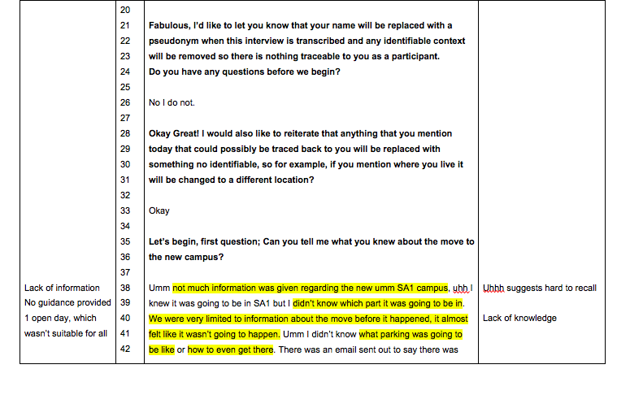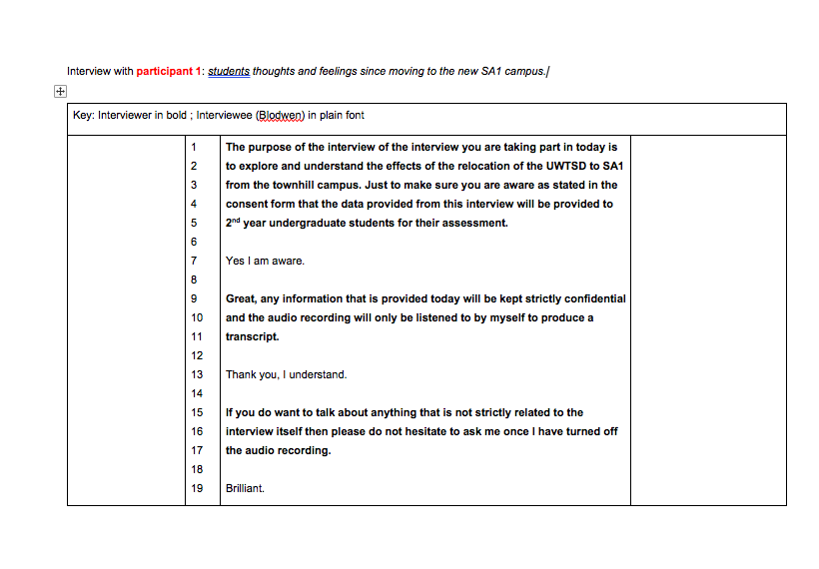

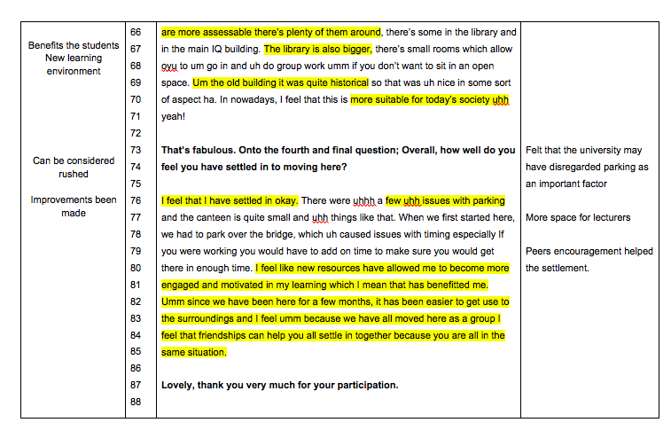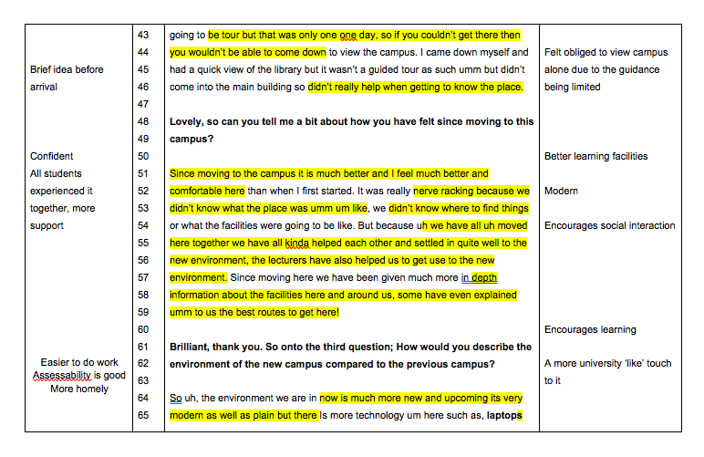

Appendix F
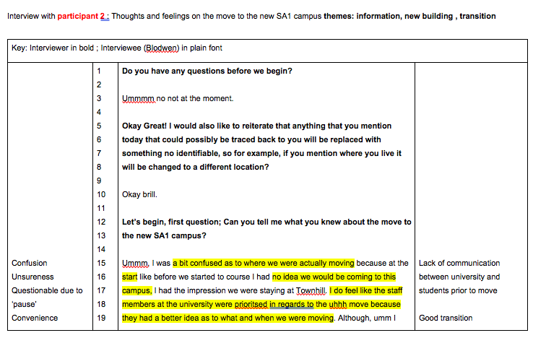

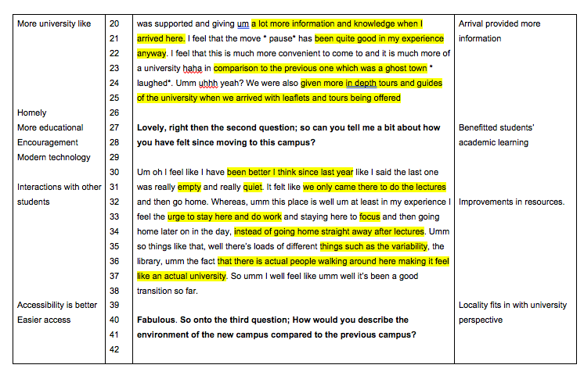

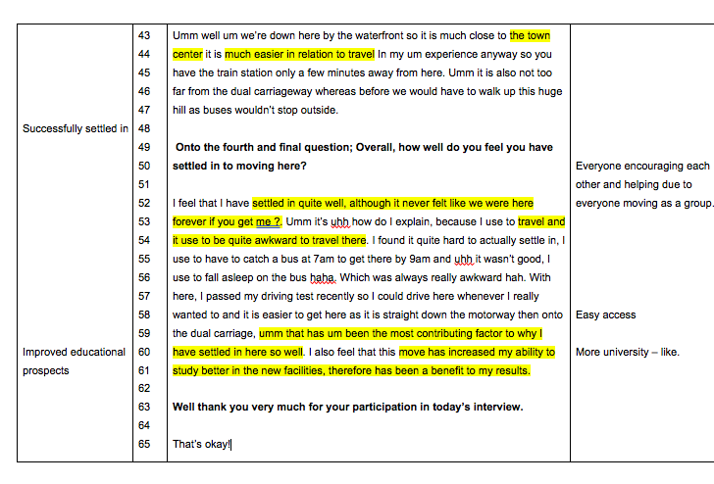

Appendix G

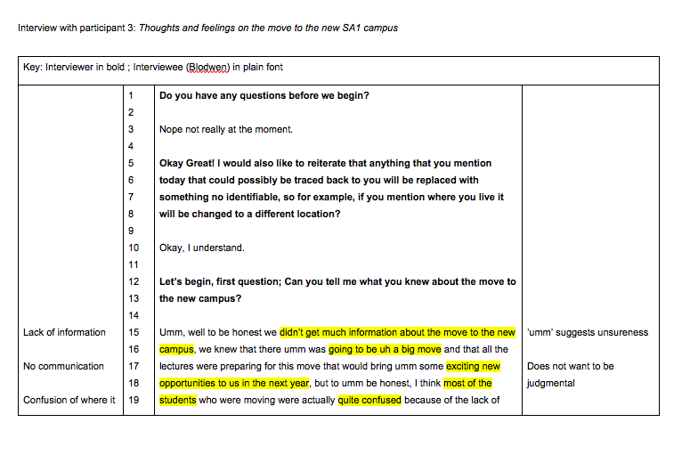

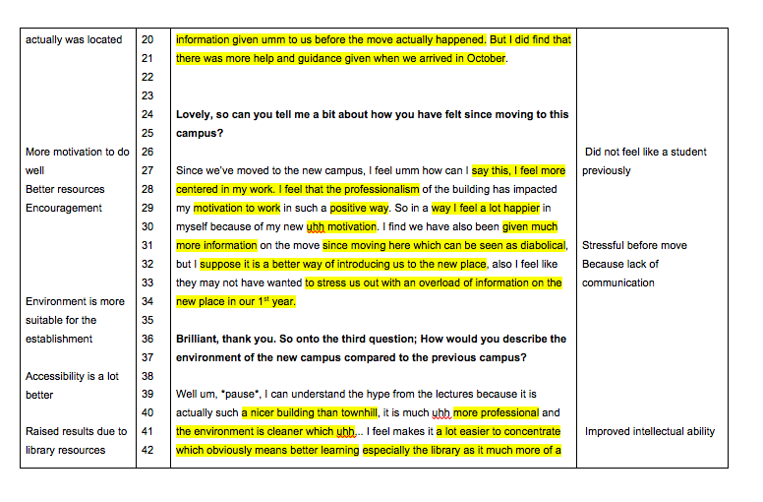

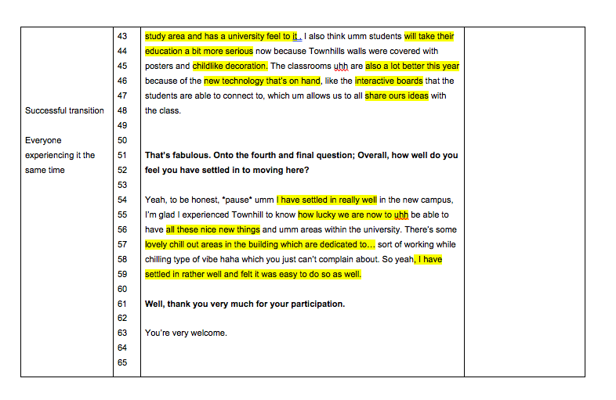

Reference list

Thompson, A. R., Kent, G., & Smith, J. A. (2002). Living with vitiligo: dealing with difference. British journal of health psychology, 7(2), 213-225.

Wood, R. T., & Griffiths, M. D. (2007). A qualitative investigation of problem gambling as an escape‐based coping strategy. Psychology and Psychotherapy: theory, research and practice, 80(1), 107-125.

