LAVINIA MIHALOIU
2113467
BMSW4004_SWAN
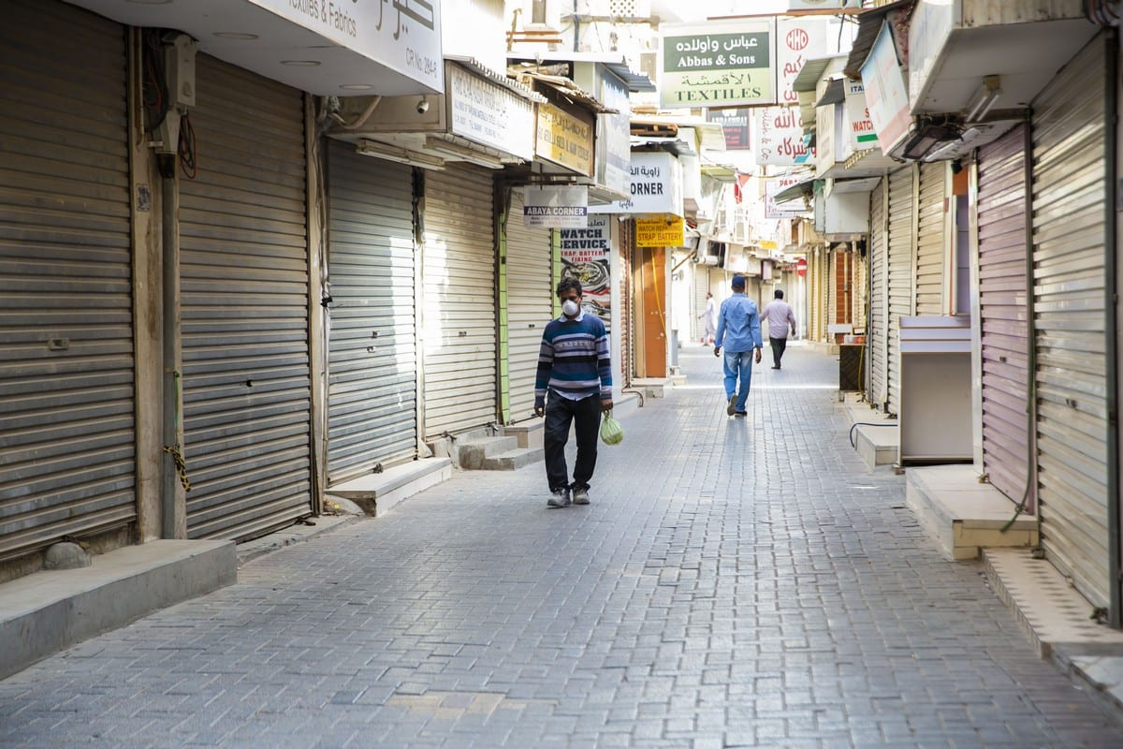
Covid 19 Lockdown- Impact Over High Street

COVID-19 didn’t impact just our lives but the way we work as well. As the High Street was struggling before Covid lockdown, the pandemic just makes the High Street to go down faster than ever.
The fear of the unknown virus takes over everybody, the clumsy decisions at the beginning of pandemic create a general panic for the first weeks. After the test centers open doors for public to be tested and the research about virus brings more clarity over the panic installed. The chank from a normal social life to isolation had a huge mental impact over most of the people. The fear of get infected with a virus scientists don’t know much about yet make the Government to act fast and change the rules of our day by day life.
As it was observed over the last two years, the new rule implemented by govern, keep the people safe but put down the business sector.
Working on the suburbs it is known that people have access to locally consumed services. Things like buying a coffee before work from the local coffee shop, spending the lunch break into the High Street restaurants and just take a shopping session after work, was something very usual for most of the people. Because over the lockdown the physical buildings work transit to work from home lead to many small businesses to close the doors.
The struggle it is real, as people spend more time home, they don’t need much of ready-made food and clothes. Statistics shows the most affected sectors was the hospitality industry and the fashion industry. Being nonessentials was the first to limited operation by the new government lockdown rules. This sector shooting doors on the high streets was just the beginning of a long number of other industries operating on the High Street to struggle with the lack of customers and close their doors in a short time.
The impact it is obviously affecting all the local and small companies having their activities on the High Street. As the transition to work from home it is now very well implemented, and the statistics show the clear direction of customer to use more often the online platforms for accessing items and services. Whit this change in customer behavior it is the time for High Street to change direction in developing the area of operation. Bringing on another facility for people to use beside shopping, open spaces for gathering and people to cam together and enjoy things the online platforms can't provide. Experiencing street food, concerts, street arts and socializing it is a mindfulness exercises government should persuade more for the good working of High Street and the people.
Bringing on another facility for people to use beside shopping, open spaces for gathering and people to come together and enjoy things the online platforms can't provide. Experiencing street food, concerts, street arts and socializing it is a mindfulness exercises government should persuade more for the good working of High Street and the people.

List of references:
- L. Ramuni, [2020], How has Covid-19 impacted our high streets?, online, accessed at www.publicsectorexecutive.com last update 23.01.2022
- E. Simpson, D. Palumbo [2021], Pandemic impact 'yet to be felt' on High Streets, online accessed at www.bbc.co.uk , last update 28.01.2022
- C. Wadham [2021], MPs demand review of Covid impact on high street, online, accessed at www.drapersonline.com , last update 01.02.2022
- The photo is A view of an empty high street as part of coronavirus (COVID-19) measures in Manama, Bahrain on 2 April 2020 [Ayman Yaqoob/Anadolu Agency] A view of an empty high street as part of coronavirus (COVID-19) measures in Manama, Bahrain on 2 April 2020 [Ayman Yaqoob/Anadolu Agency]A view of an empty high street as part of coronavirus (COVID-19) measures in Manama, Bahrain on 2 April 2020 [Ayman Yaqoob/Anadolu Agency]

