Investigating the effect of noise in ssb-sc and dsb-sc
Radio Frequency Systems (ACDA5019) (EES Version)

UWTSD
Louis S (2322688)

Contents
Introduction 5
Background Research 5
What is Modulation & Demodulation? 5
Modulation index 6
Under Modulation 6
Critical Modulation 6
Over Modulation 7
What is Noise? 7
SSB-SC 7
DSB-SC 7
Transmitter & Receiver Architecture 8
Literature Review 8
Task 1 8
a) 8
(i) 8
(ii) 8
b) 8
Task 2 8
a) 9
b) 10
Task 3 10
a) 10
b) 11
Task 4 12
a) 12
AM 12
DSBSC 13
SSBSC 13
b) 13
Power Utilisation 13
Noise Resistance 13
Conclusion 13
Bibliography 13
Appendix 14
Figures 14
Task 1 14
Task 2 25
Task 3 30
Task 4 34

Introduction
In this report, the basics of RF Modulation, Demodulation & Modulation Index, Noise and its effects on transmitted signals and DSBSC & SSBSC are covered. Simulations of AM, DSBSC & SSBSC are also run and their result compared with one another.

Background Research

What is Modulation & Demodulation?
Modulation and by extension, demodulation are processes in which data or information is encoded onto a carrier wave (or in the case of demodulation, decoded), which is then typically transmitted over wired or wireless connections.
‘Information is referred to as the baseband or modulating signal. The waveform which is used to convert the information in the physically transmitted form is called the carrier. The device which performs modulation operation is called a modulator, and the resulting waveform or output of the modulator is called the modulated signal.’ [1]
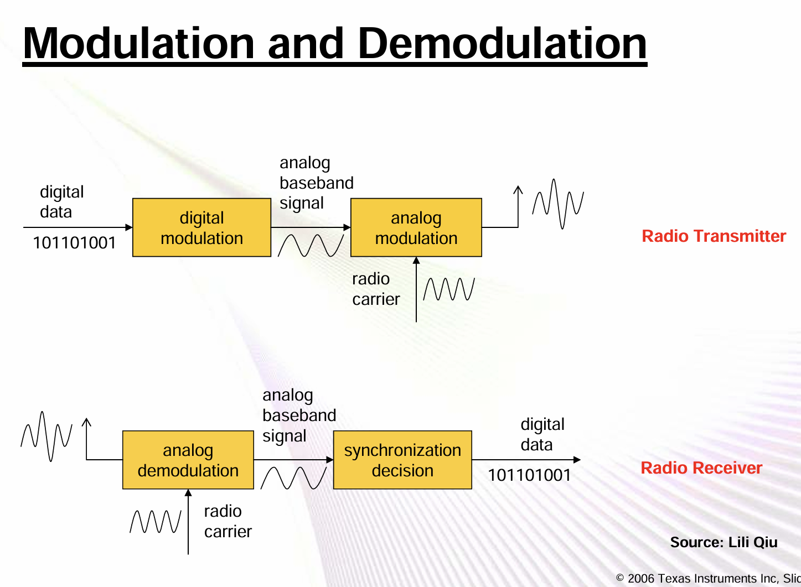
[2]

Modulation index
The modulation index is a measure of the ratio between the Signal Voltage ($V_{m}$) and the Carrier Voltage ($V_{c}$) This is expressed as
$$m=\frac{A_{m}}{A_{c}}$$
Where:
$m$ – Modulation Index
$A_{m}$ – Amplitude (Message)
$A_{c}$ – Amplitude (Carrier)
The value of the modulation index is a value between 0 and 1
The image below represents the three different types of modulation (under-modulation, critical modulation & over-modulation, respectively)
[3]
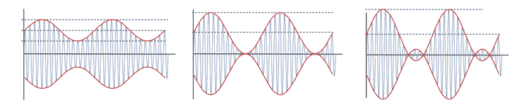
[4]

Under Modulation
Under modulation is where the carrier signal is greater than the message signal, resulting in a modulation index of m < 1. This often leads to reduced signal strength and data quality on the receiving end. Shown below is an illustration of what an under modulated signal.
[4]
Simply put, under-modulation is where the message isn’t ‘strong enough’ to alter the carrier wave fully, and thus unable to utilise the full power of the carrier wave.

Critical Modulation
Critical Modulation is where the carrier and message signals are equal, resulting in the message being able to vary the carrier wave without distortion. Essentially, the message is able to use the full extent of the carrier, without altering the message. Often demonstrated as m = 1.
[4]
Unlike under modulation, critical modulation is where the message has enough strength to alter the carrier wave and utilise the full power of the carrier wave, without distortion.

Over Modulation
Over modulation is the opposite of under modulation, where the message signal exceeds the power of the carrier wave, and causes distortion. Represented as m > 1.
[4]
The opposite to under modulation, over modulation is where the strength of the message exceeds that of the carrier wave and thus distorts the modulated wave.

What is Noise?
Noise can often be defined as the undesired or irrelevant variation, in this context, introduced that distort or attenuate desired signals. These fluctuations can be caused from a variety of factors such as:
- Johnson–Nyquist noise or thermal noise, where voltage or current is generated by thermal agitation in a conductor
- Electronic circuit switching or malfunctioning components
- EMI, RF generators like transmitters operating on nearby frequencies
- Unshielded electronics or mismatched losses
[5] [6] [7] [8]
‘Noise limits the range and/or quality with which information-bearing signals may be transported over a channel. Noise may be defined as any unwanted signal interfering with or distorting the signal being communicated.’ [9]
Evidently, the introduction of random interference and distortion to a transmitted signal is undesired, in the case of digital transmission, this can lead to errors of bits being interpreted incorrectly after demodulation. Other consequences of noise and interference can lead to inaccurate sensor readings or measurement accuracy, thus, understanding the causes and effects of this phenomenon is important for all RF applications.

DSB-SC
DSBSC (Double Sideband Suppressed Carrier) is a modulation technique that contains both sidebands carrying identical copies of the message wave, however the carrier signal is suppressed, and it is not sent saving on power used.
It can be expressed as:
$$S\left(t\right)= A_{c}m(t)cos⁡(2πf_{c}t)$$
Where:
$S(t)$ – DSBSC Modulated Signal
$A_{c}$ – Carrier Wave Amplitude
$m(t)$ – Message Wave
$f_{c}$ – Frequency of carrier Wave
[10]
With the basic block diagram for DSBSC modulation shown below:
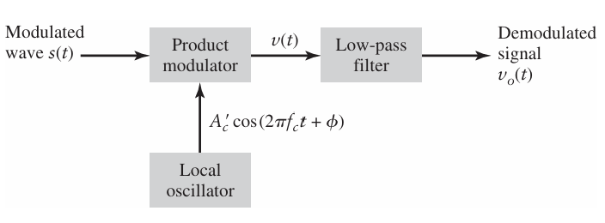
[9]

SSB-SC
SSBSC (Single Sideband Suppressed Carrier), is a form of modulation that unlike DSBSC, utilises a single sideband (either the upper or lower), and also suppresses the carrier. This allows it to be more power efficient.
It can be expressed as:
$$S\left(t\right)=\frac{A_{c}}{2}\left[m(t)cos⁡(2πf_{c}t)±\hat{m}(t)sin⁡(2πf_{c}t)\right]$$
Where:
$S(t)$ – SSBSC Modulated Signal
$A_{c}$ – Carrier Wave Amplitude
$m(t)$ – Message Wave
$f_{c}$ – Frequency of carrier Wave
[10]
With the basic block diagram for SSBSC modulation, with the use of a coherent detector shown below:
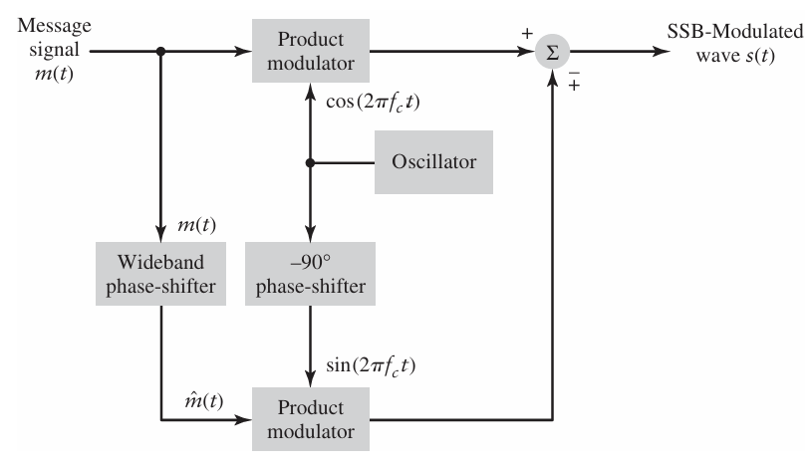
[9]

Transmitter & Receiver Architecture
The use of transmitters and receivers allows for the transmission of signals and data wirelessly.
A Transmitter can be defined as:
‘A transmitter is a device used to transmit a signal from one place to another. The signal contains information in the form of voice, video, or data. Transmitters use antennas to send signals into the air and employ modulation techniques to transmit signals over specific distances according to system design. Amplifiers are used to boost the amplitude of the signal, ensuring it reaches the required transmission distance.’ [11]

A Receiver can be defined as:
A receiver is a device that decodes the transmitted information from the received signal. Like transmitters, receivers use antennas to receive signals from the air. Similar to power amplification in transmitters, receivers also amplify the received signal, focusing on low-noise amplification. [4]

The general working of transmitters and receivers are as follows:
- A message signal, typically data or audio, which Is often unsuitable for transmission due to its weak power and low frequency
- This signal is then processed the then be suitable for transmission, this involves filtering and amplification of the initial signal.
- The Signal is then modulated with a high-frequency carrier wave to allow for better transmission range and efficiency
- The modulated signal is then further amplified by increasing its power to allow for
- The signal is then converted into EM waves via the transmitting antenna
- This signal then propagates through free space or a medium such as air or another medium. This step is often where effects of noise or interference may be introduced to the transmitted signal.
- The signal is then converted back to an RF signal by the receiver’s antenna
- The weak signal is then amplified and filtered, with the unrequired interference and signals rejected.
- The Signal is then demodulated to extract the original message signal from the transmitted
[12] [13] [14]
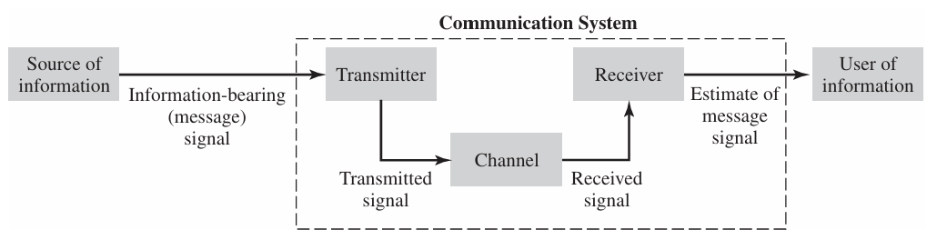
[9]

Task 1

a)

(i)
Using the following equations, and the provided table, the required modulation index was calculated:
$$c\left(t\right)=A_{c} sinω_{c} t$$
$$m\left(t\right)=A_{m} sinω_{m} t$$
$$ω_{c}=2π\left(100\right) or f_{c}=100Hz$$
$$ω_{m}=2π\left(10\right) or f_{m}=10Hz$$
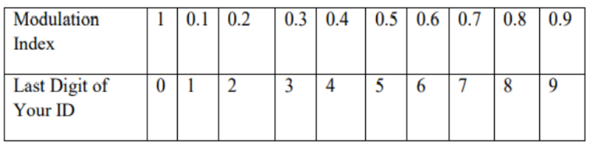
Once the modulation index was calculated, the circuit was then built to represent AM
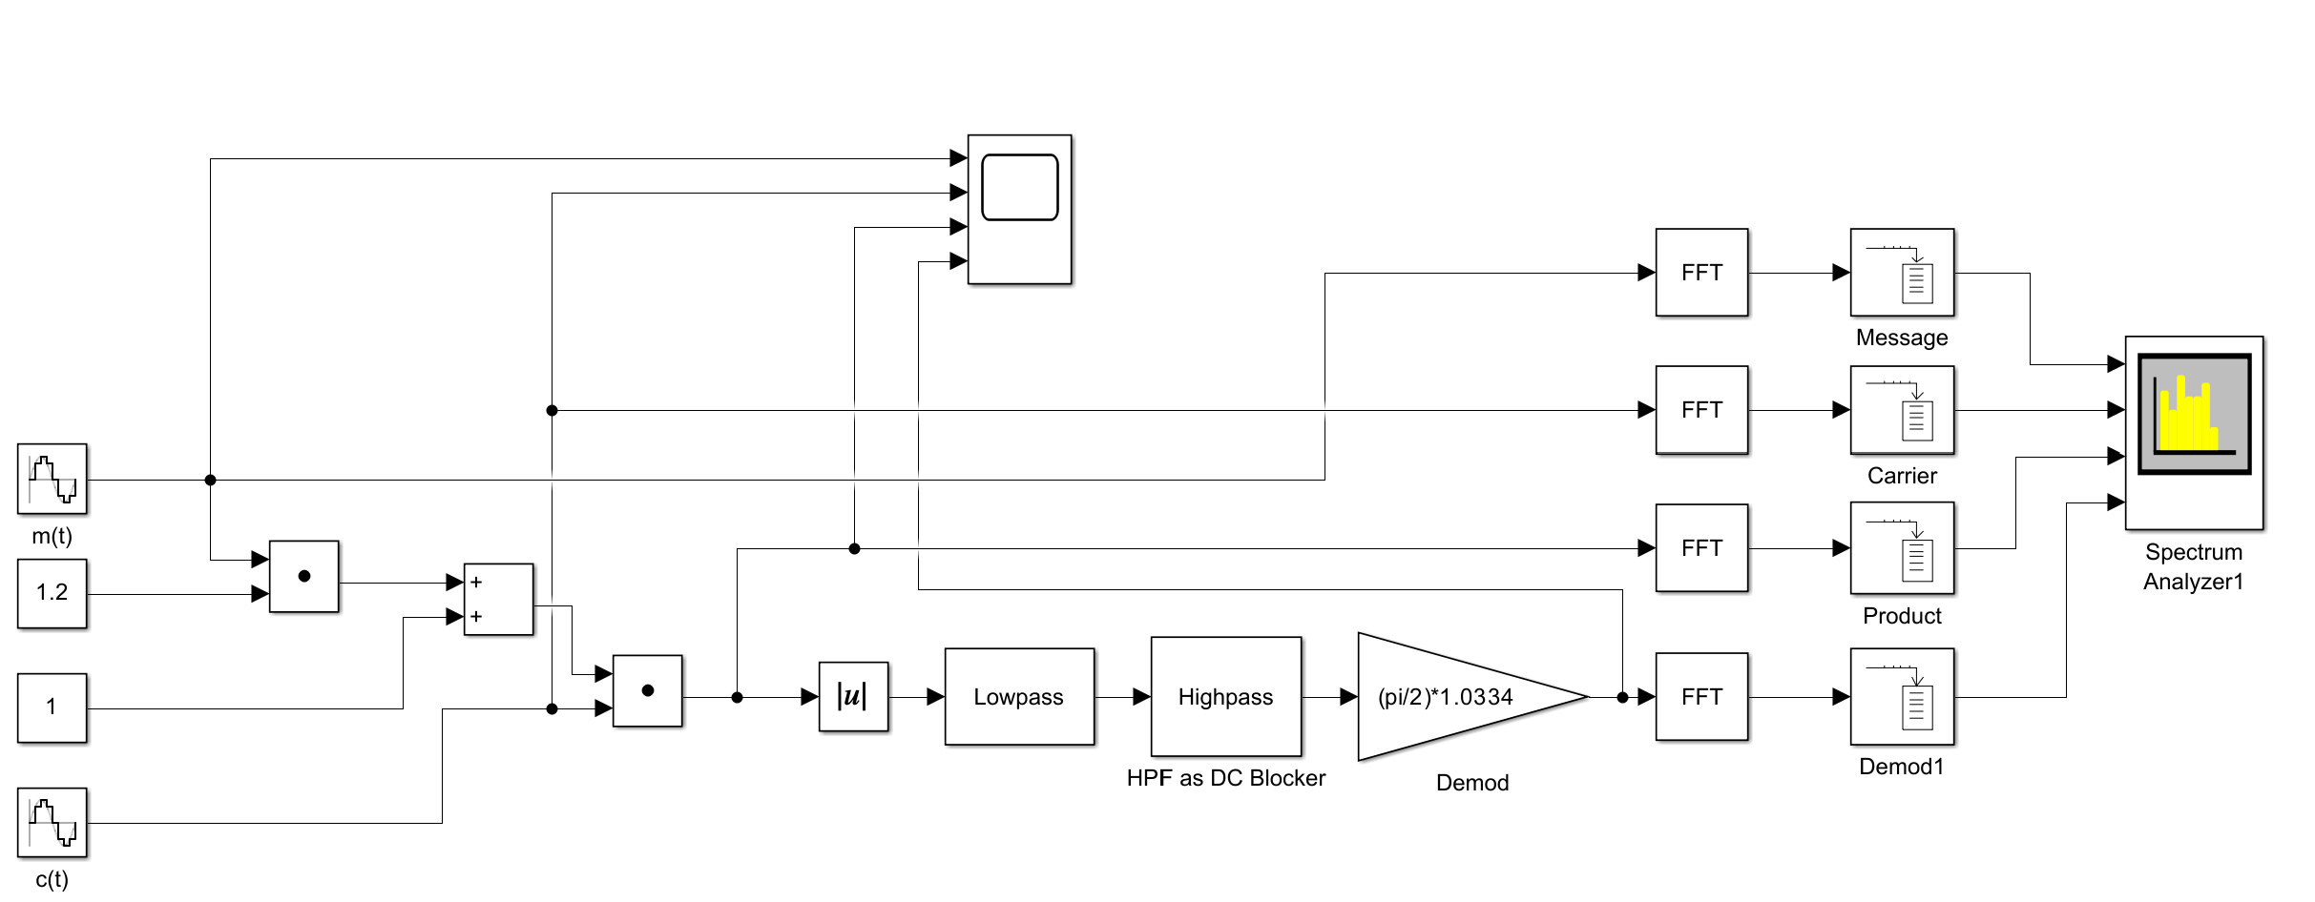

(ii)
The simulation was repeated for varying modulation index’s under, critical & over modulation at 0., 1 & 1.2, respectively. Results shown below

0.8 Modulation Index (Under-Modulation)
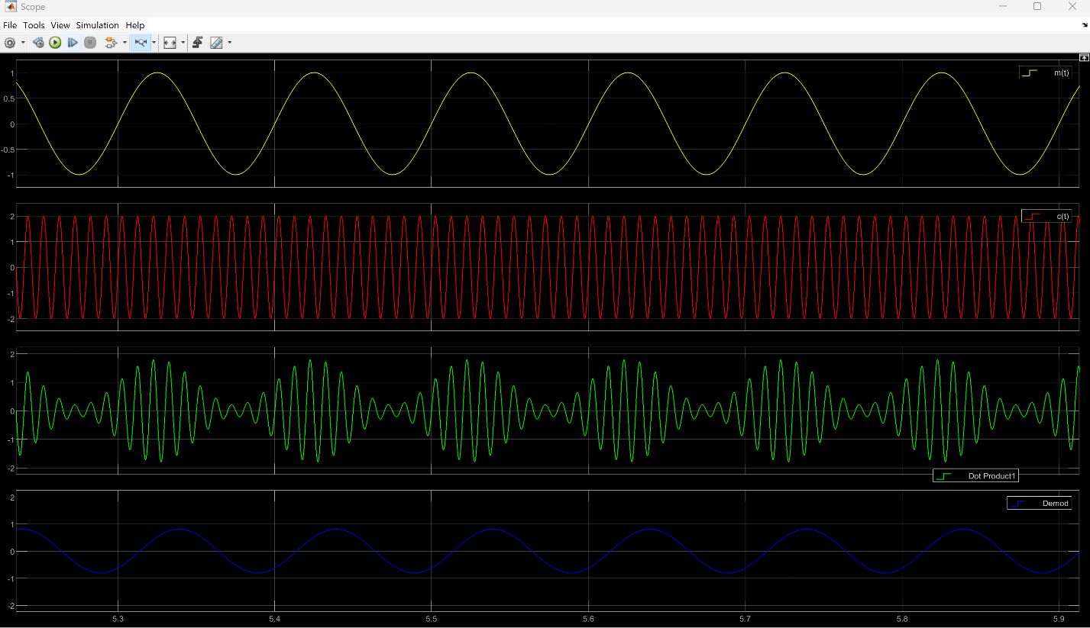

1 Modulation Index (Critical-Modulation)
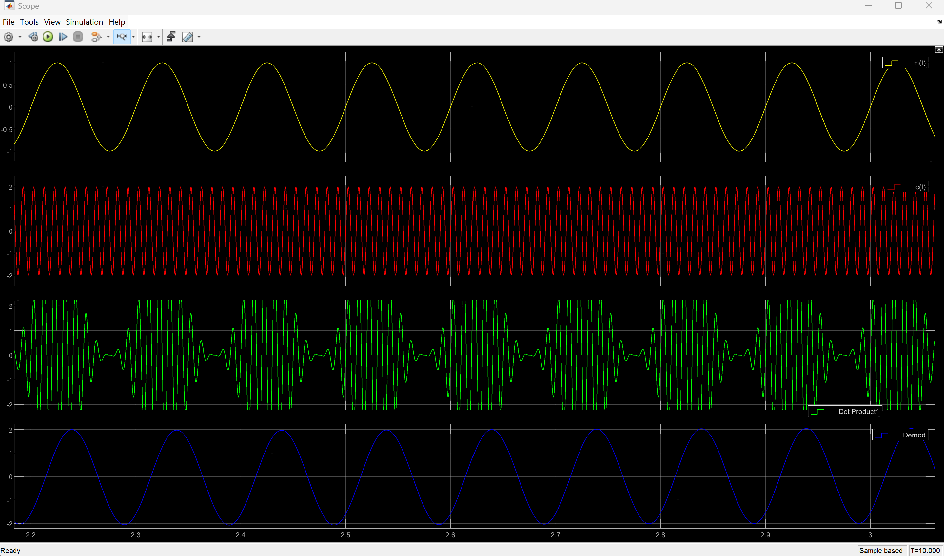

1.2 Modulation Index (Over-Modulation)
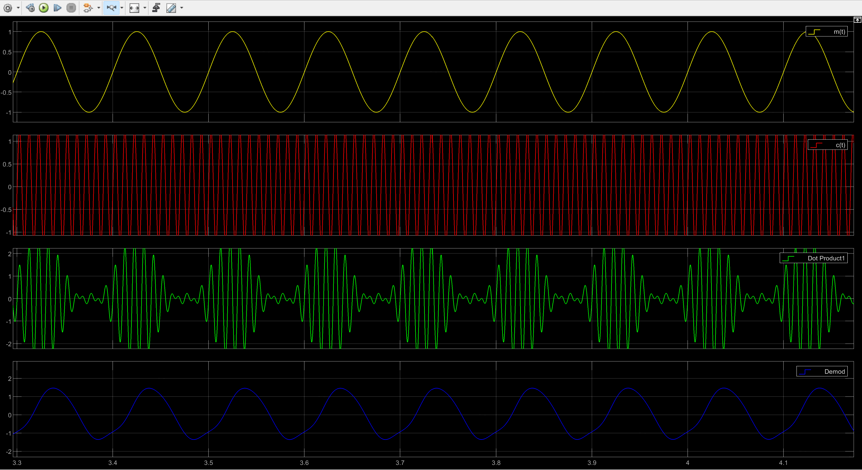

b)
When comparing the message signal to the demodulated signal with the modulation index set to 1, it can be seen that the sine waves are near identical with one another, with the exception of some slight phase shifting. This is likely due to the delay in the wave having to pass through the other blocks in the circuit.

Task 2
Shown below is the circuit for DSBSC using a balanced modulator, which features a balanced modulator
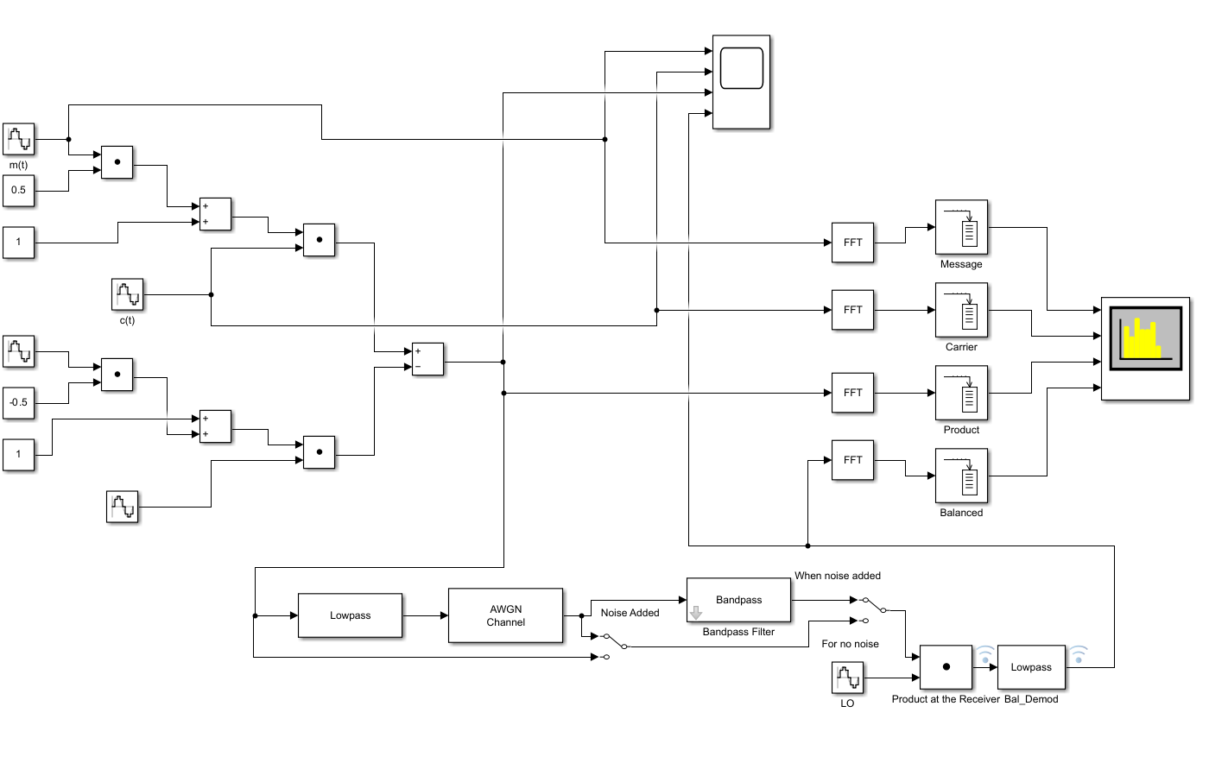

a)
Shown below is the oscilloscope output for the circuit shown above, without the noise selected to be present.
In yellow and red represent the message and carrier wave signals, these are then combined to give the modulated signal, shown in green. The dark blue represents the modulated signal after it has been combined, whilst the carrier is suppressed.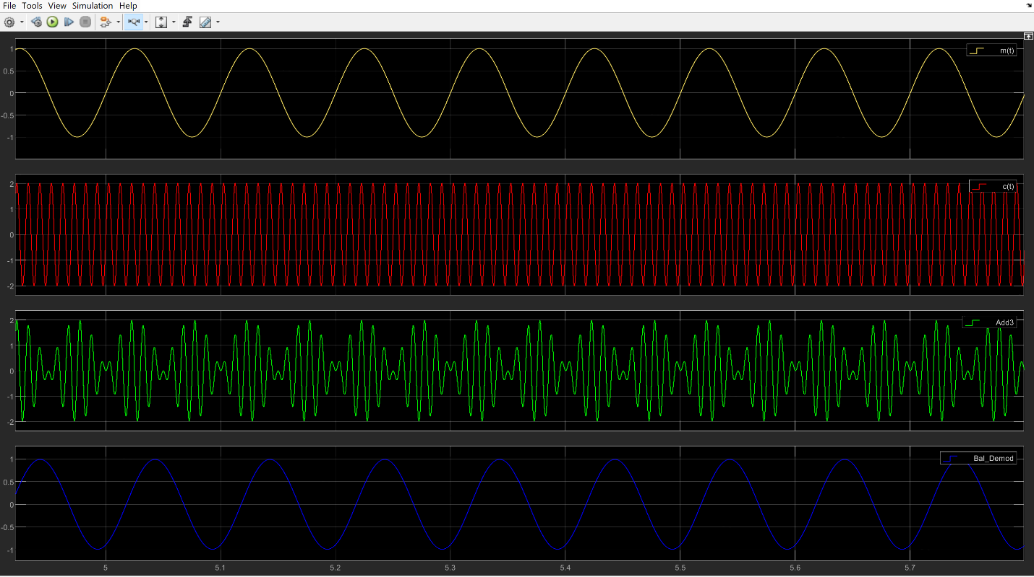

b)
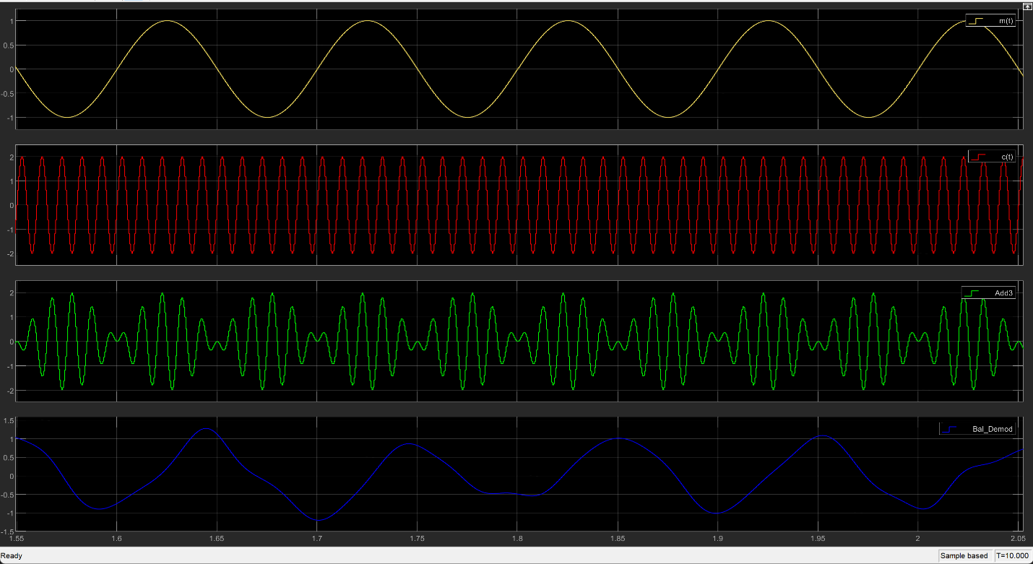
As seen when comparing the DSBSC without noise, to the one with, the final output is heavily distorted, no longer cleanly representing the initial message. Resulting in potential data loss or corruption should the signal be received digitally.

Task 3
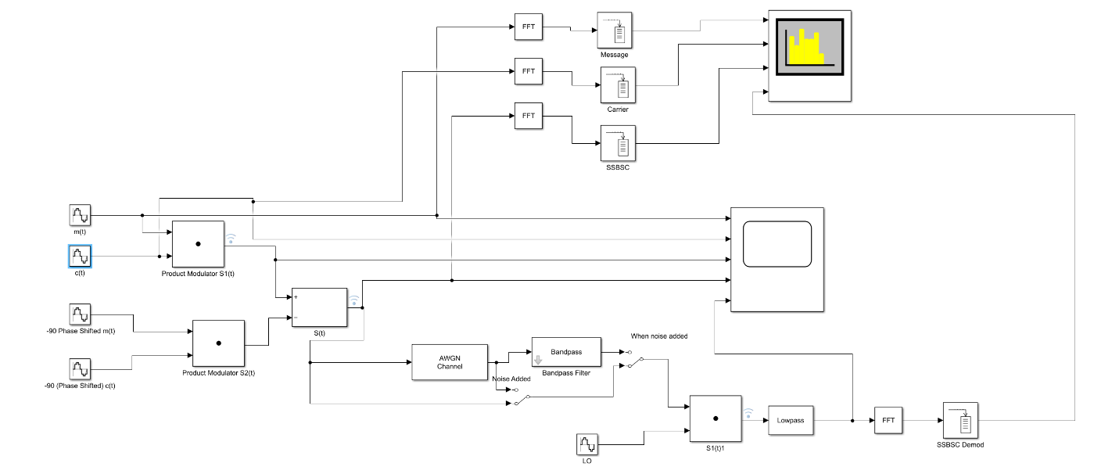

a)
Shown below is the oscilloscope output for the circuit shown above, without the noise selected to be present.
In yellow and red represent the message and carrier wave signals, these are then combined to give the modulated signal, shown in green. The dark blue represents the modulated signal after it has been combined with the phase discriminator generated by the product of two -90° sine waves. The orange represents the final output after the discriminated signal is combined with the local oscillator and passed through a low-pass filter.
Note that the final signal output is nearly identical to the initial message signal, with the exception of a slight time offset, likely due to passing through the circuit causing minor time delays.
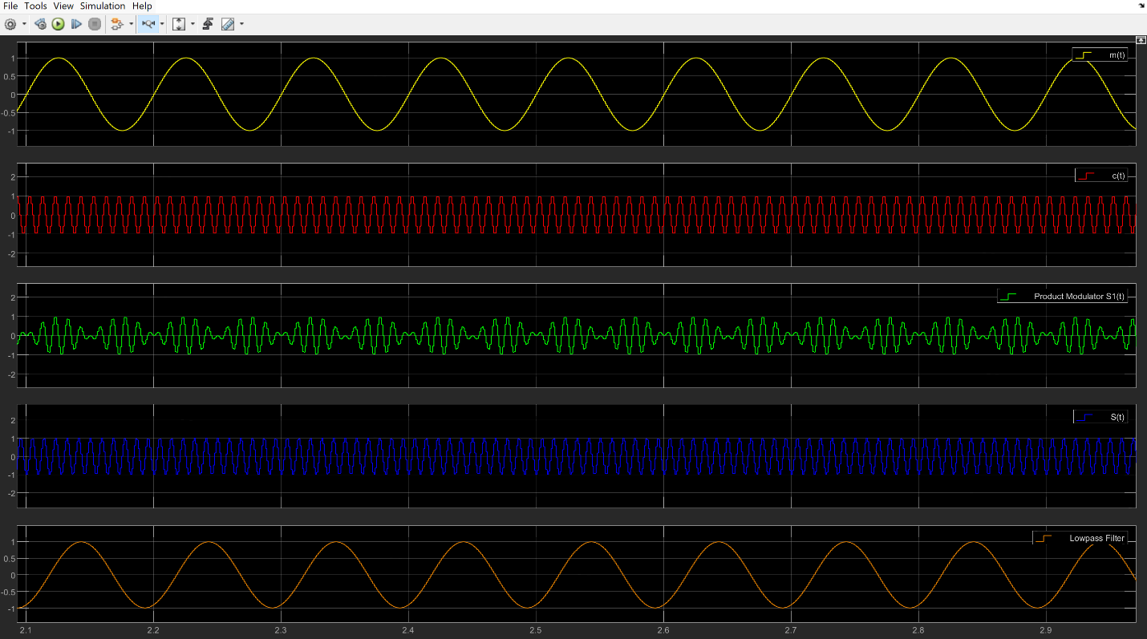

b)
Below illustrates the same circuit’s oscilloscope reading after noise is introduced into the signal.
Once noise is introduced to the signal, the clean sine wave shown in the previous example has been distorted and has little similarity to the message signal.
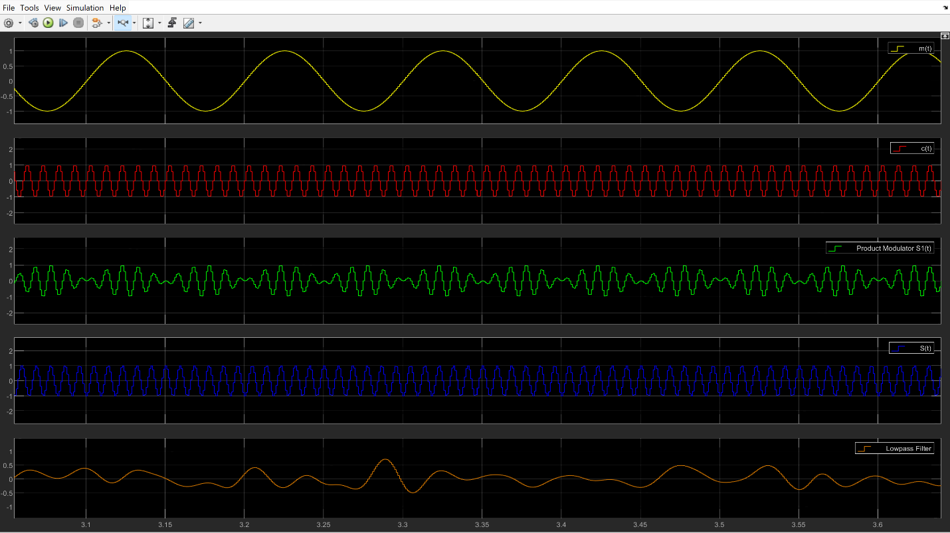

Task 4

a)
When carrying out the calculations for power, the following variables were used:
$A_{c}$ – Carrier Wave Amplitude – 2
$A_{m}$ – Message Wave Amplitude – 1
$R$– Reference Load (Ω) – 1
$P_{c}$ – Carrier Wave Power
$P_{m}$ – Message Wave Power
This was done to ensure comparison between them was fair, and the results were comparable

AM
To calculate the power for the AM signal, the following formula was used:
$${A_{c}}^{2}\left(\frac{2+m^{2}}{4}\right)$$
$$2.25=2^{2}\left(\frac{2+{0.5}^{2}}{4}\right)$$
As shown in the screenshot below, the total power adds to 2.2406, having an acceptable tolerance from the ideal 2.25 calculated.
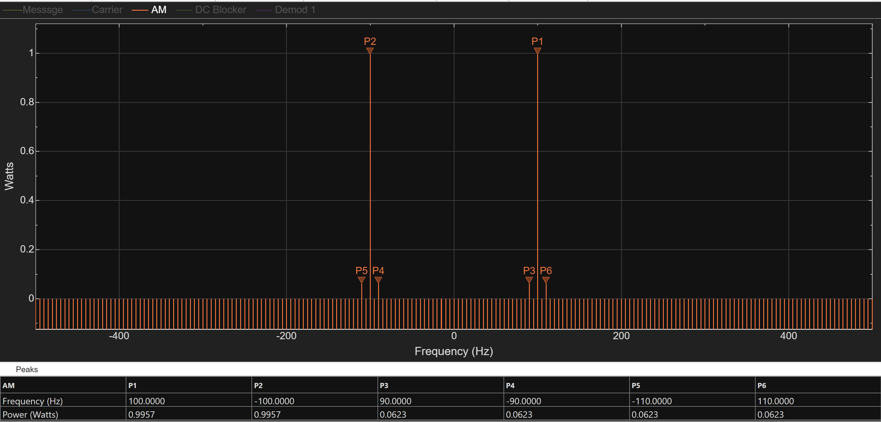

Power Density
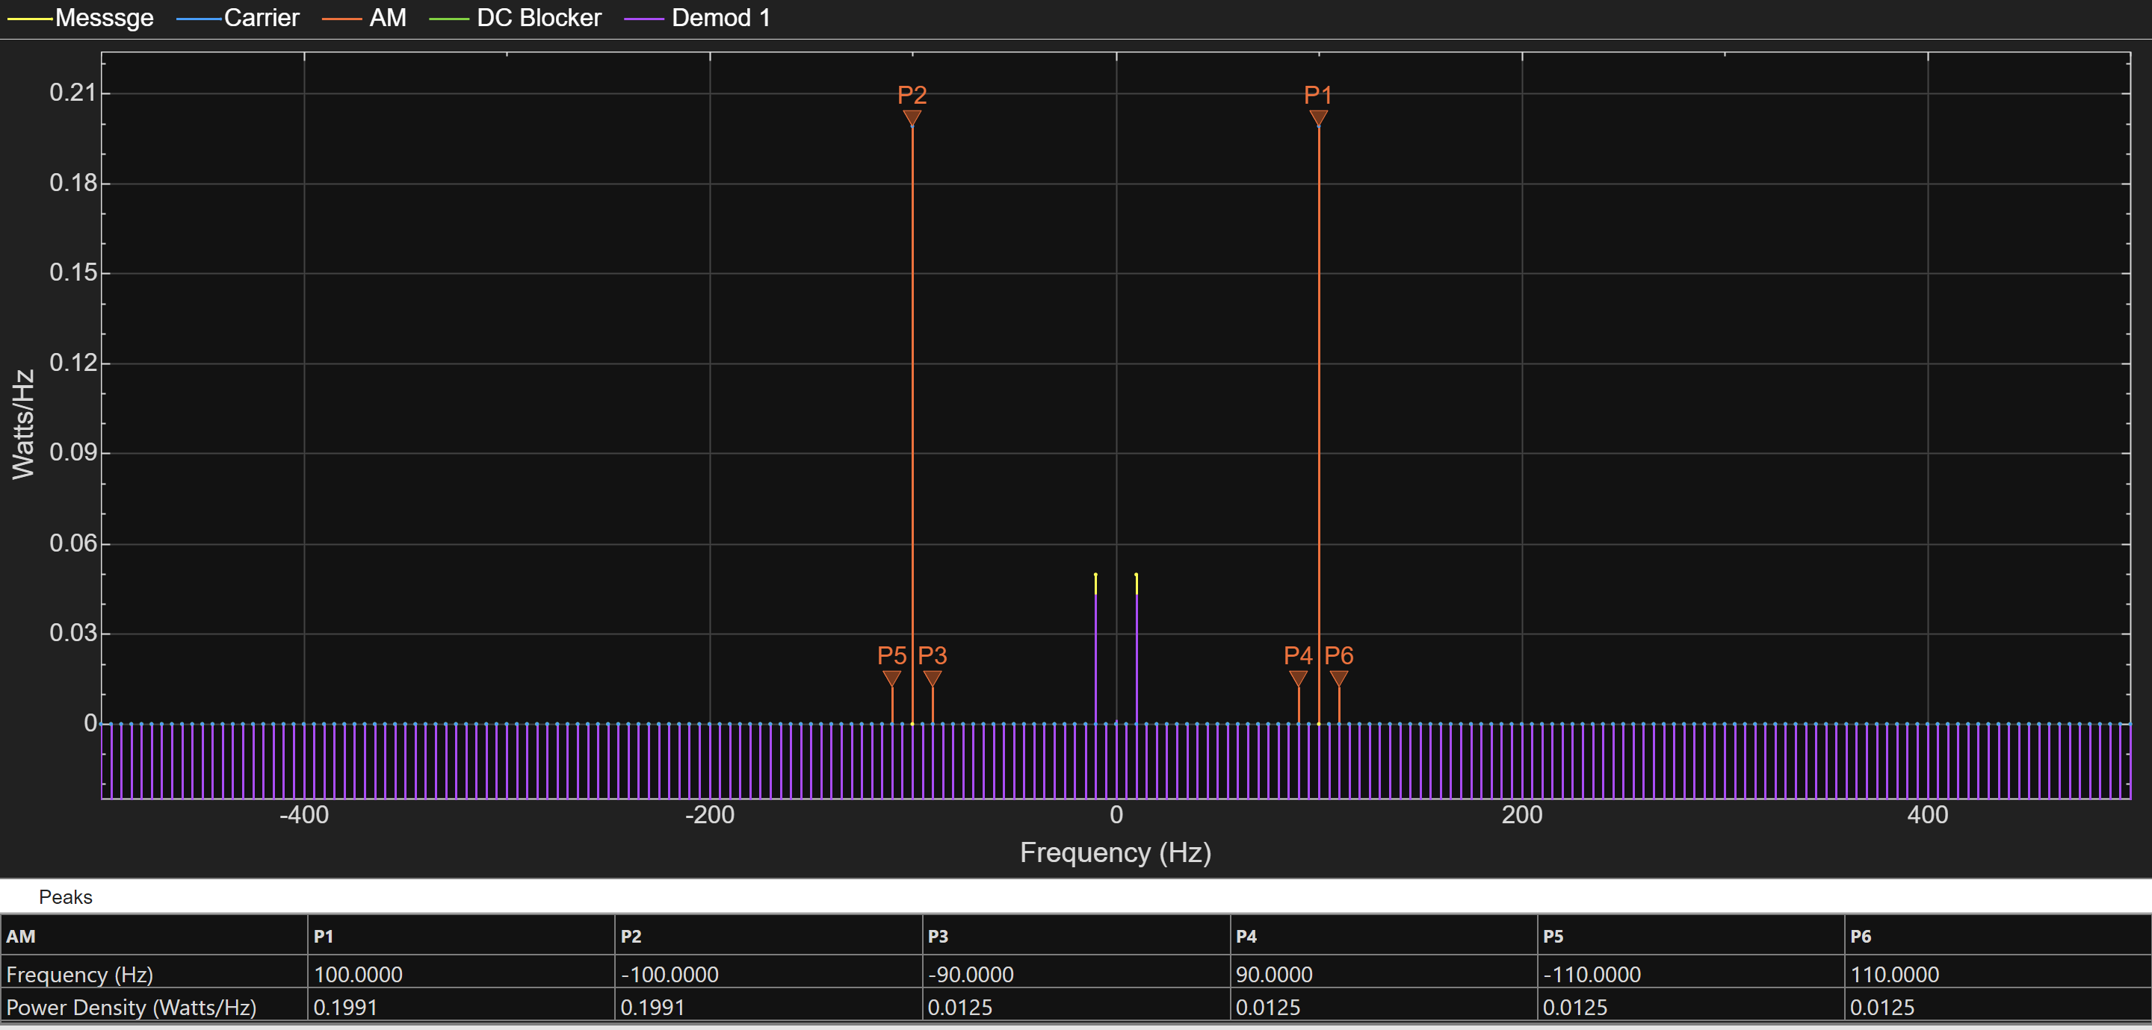

DSBSC
For both side bands:
$$P_{m}= \frac{{A_{c}}^{2} × {A_{m}}^{2}}{8}$$
$$1= \frac{2^{2} × 1^{2}}{4}$$
As shown below, when the power from the four peaks is summed, it is 0.856, which is slightly out of tolerance when compared to the ideal values.
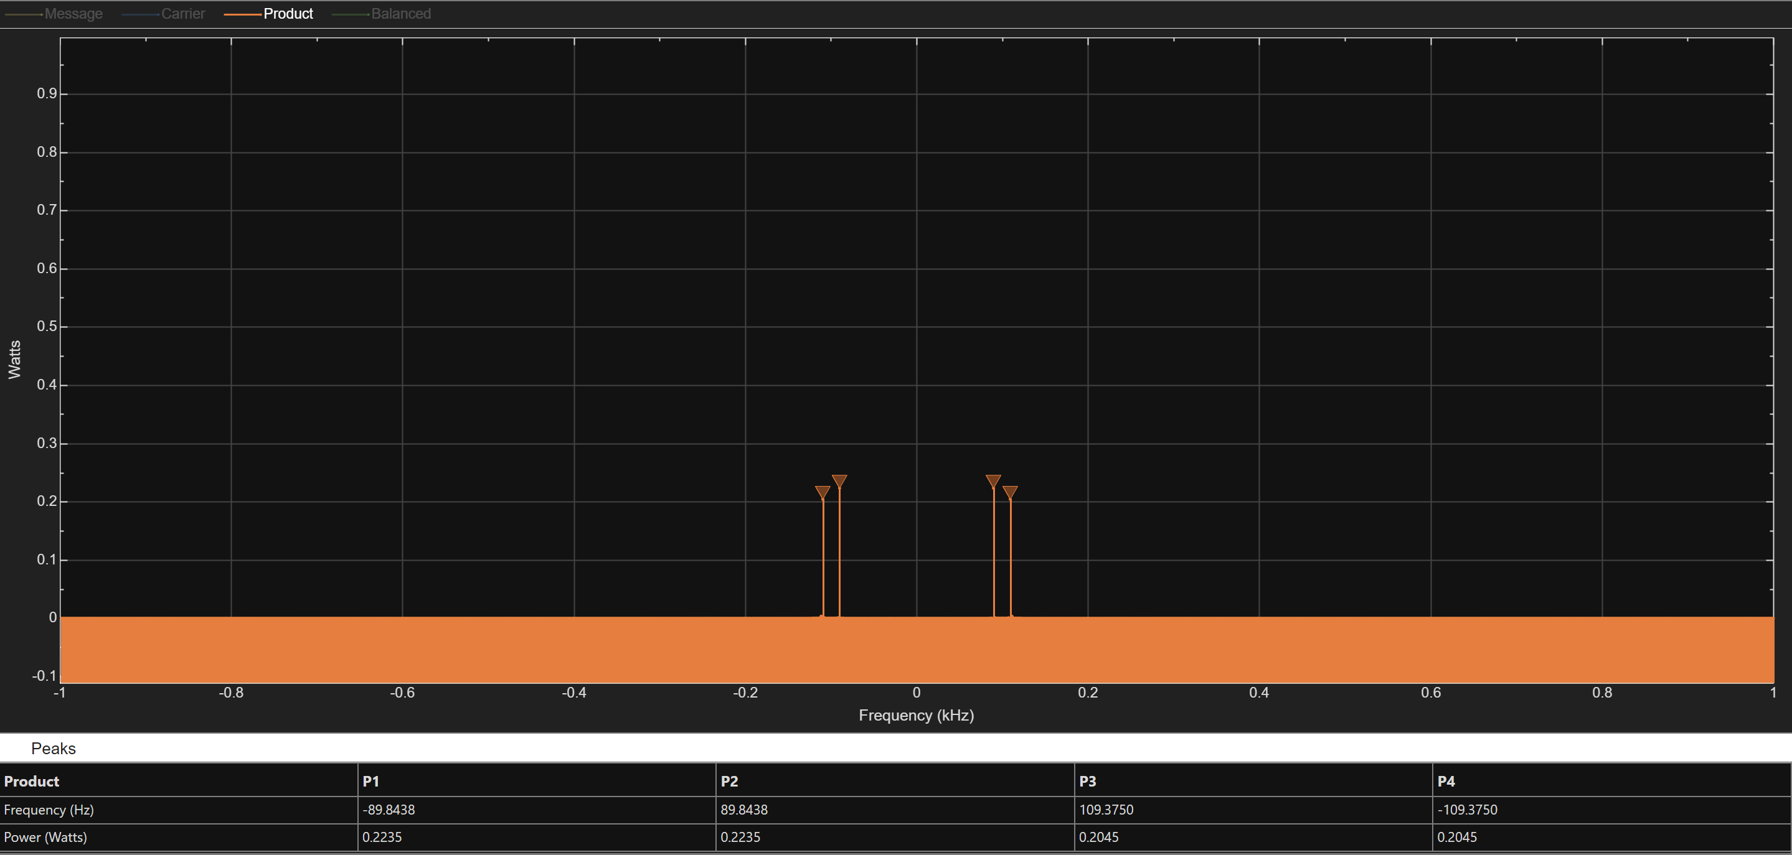

Power Density
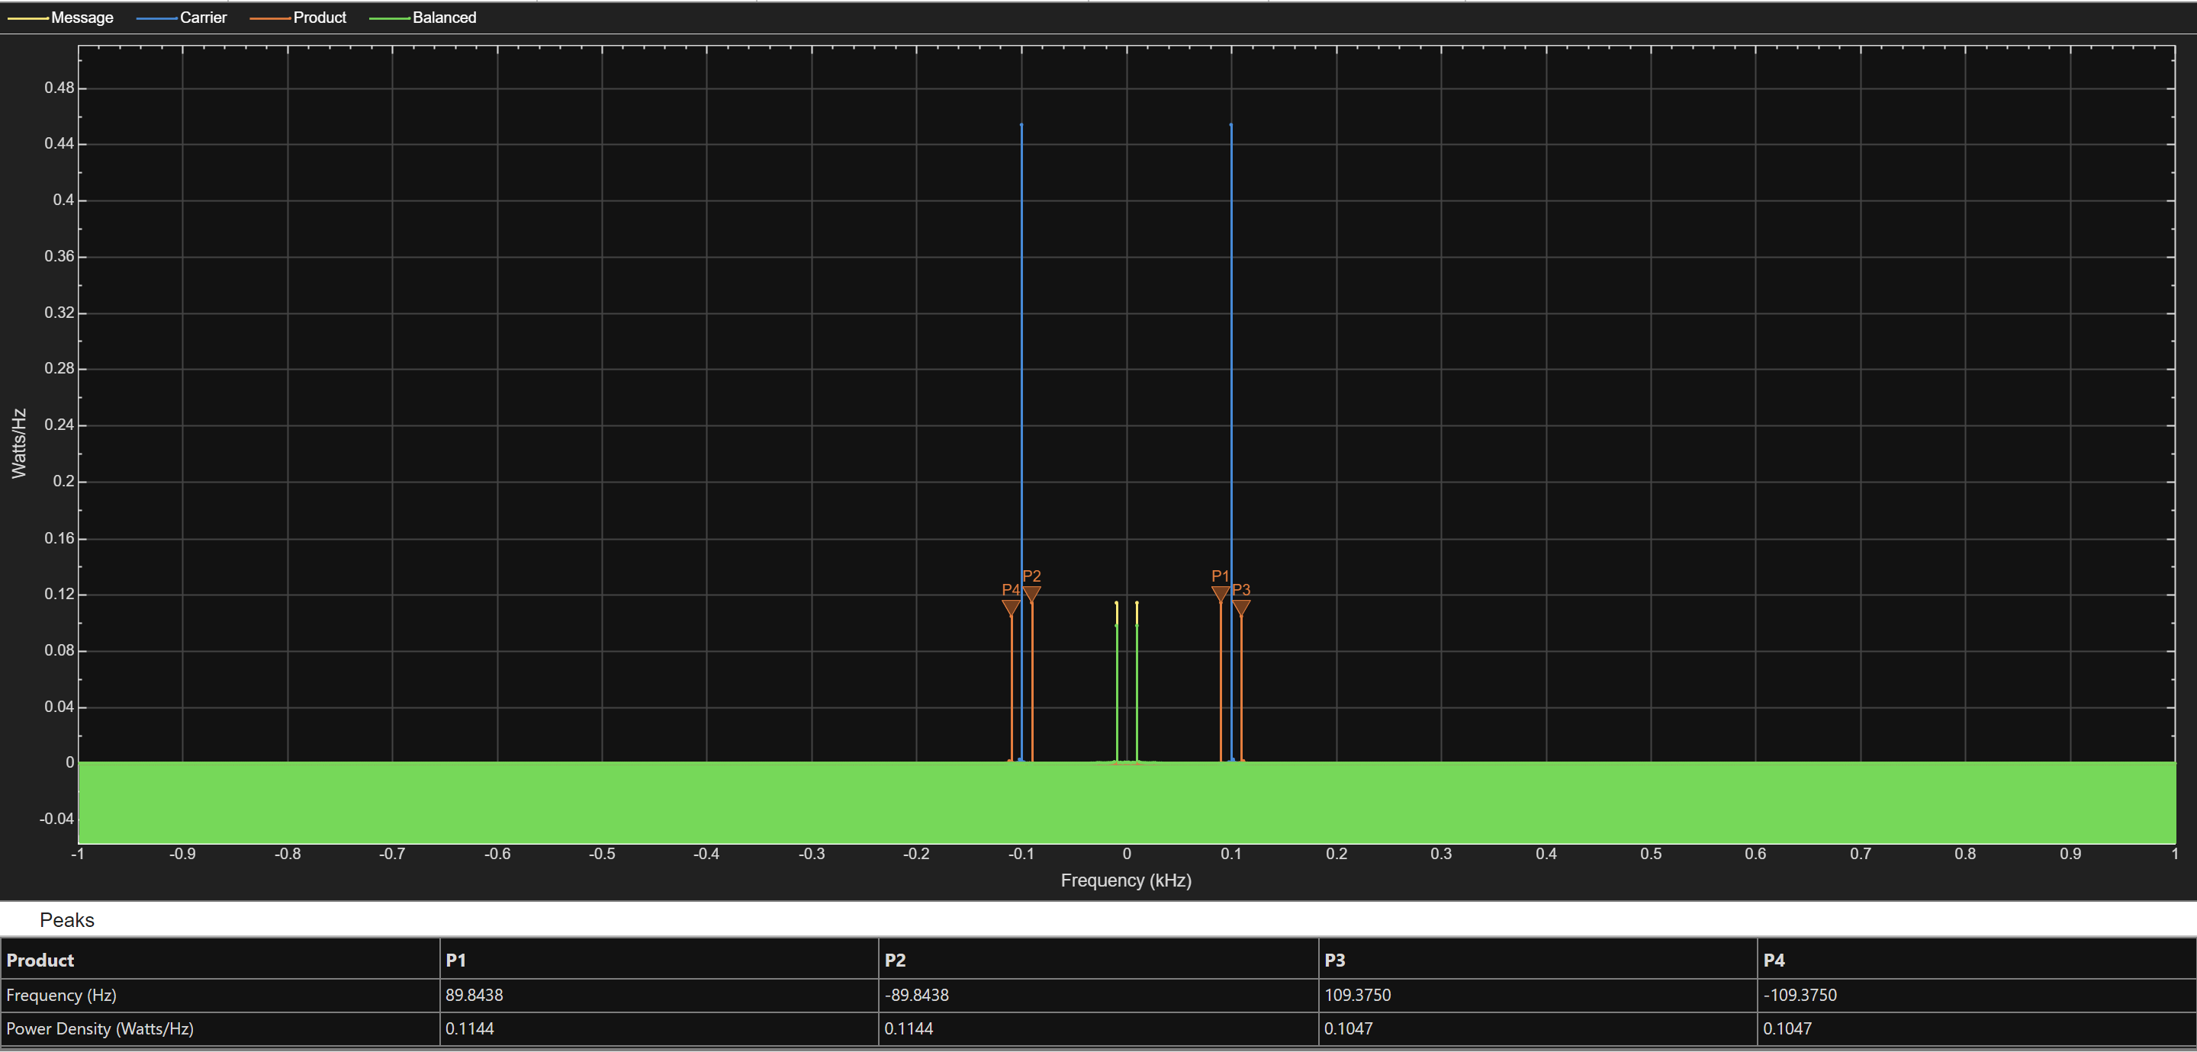

SSBSC
$$P_{m}= \frac{{A_{m}}^{2} × {A_{c}}^{2}}{8R}$$
$$P_{c}= \frac{{\left(\frac{A_{c}}{\sqrt{2}}\right)}^{2}}{R}$$
For the Message:
$$0.5= \frac{1^{2} × 2^{2}}{8 ×1}$$
As shown below, the total power equals 0.4982, which is within an acceptable tolerance of the theoretical value of 0.5.

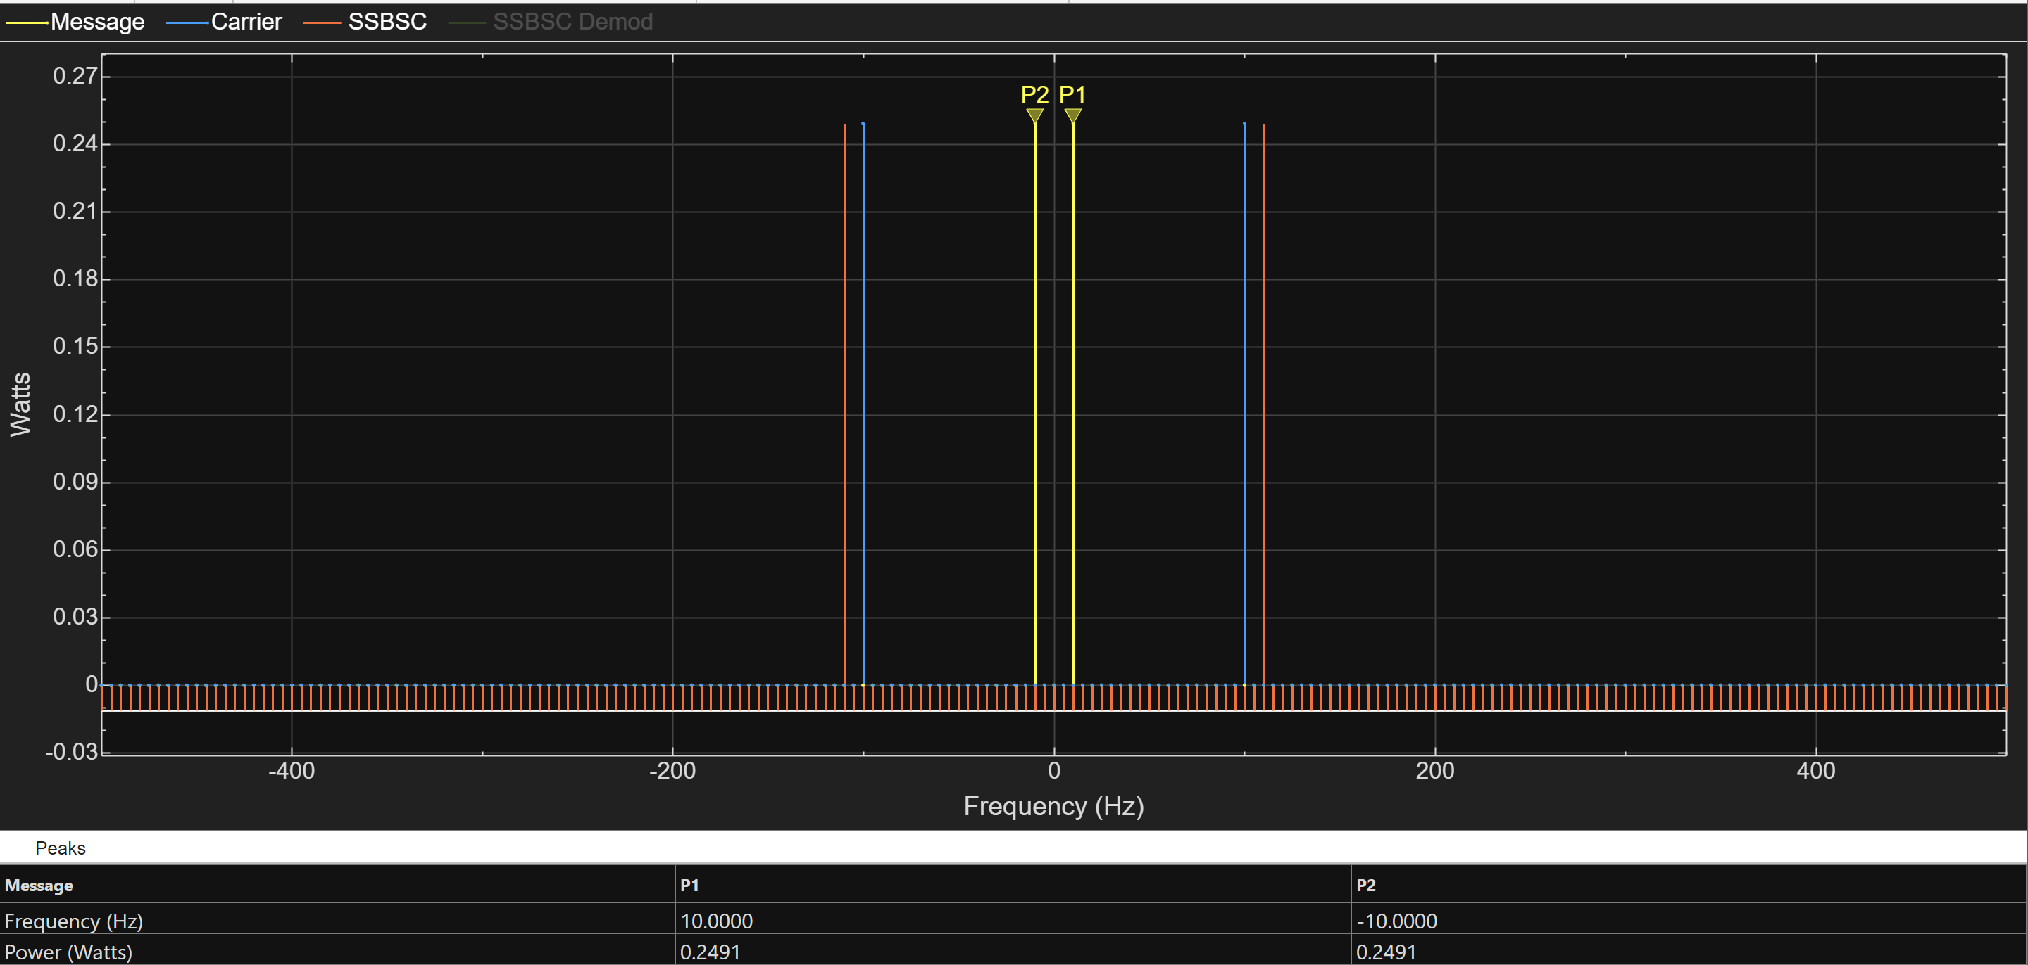
For the Carrier:
$$0.5= \frac{{\left(\frac{1}{\sqrt{2}}\right)}^{2}}{1}$$
As shown below, the total power equals 0.4982, which is within an acceptable tolerance of the theoretical value of 0.5.
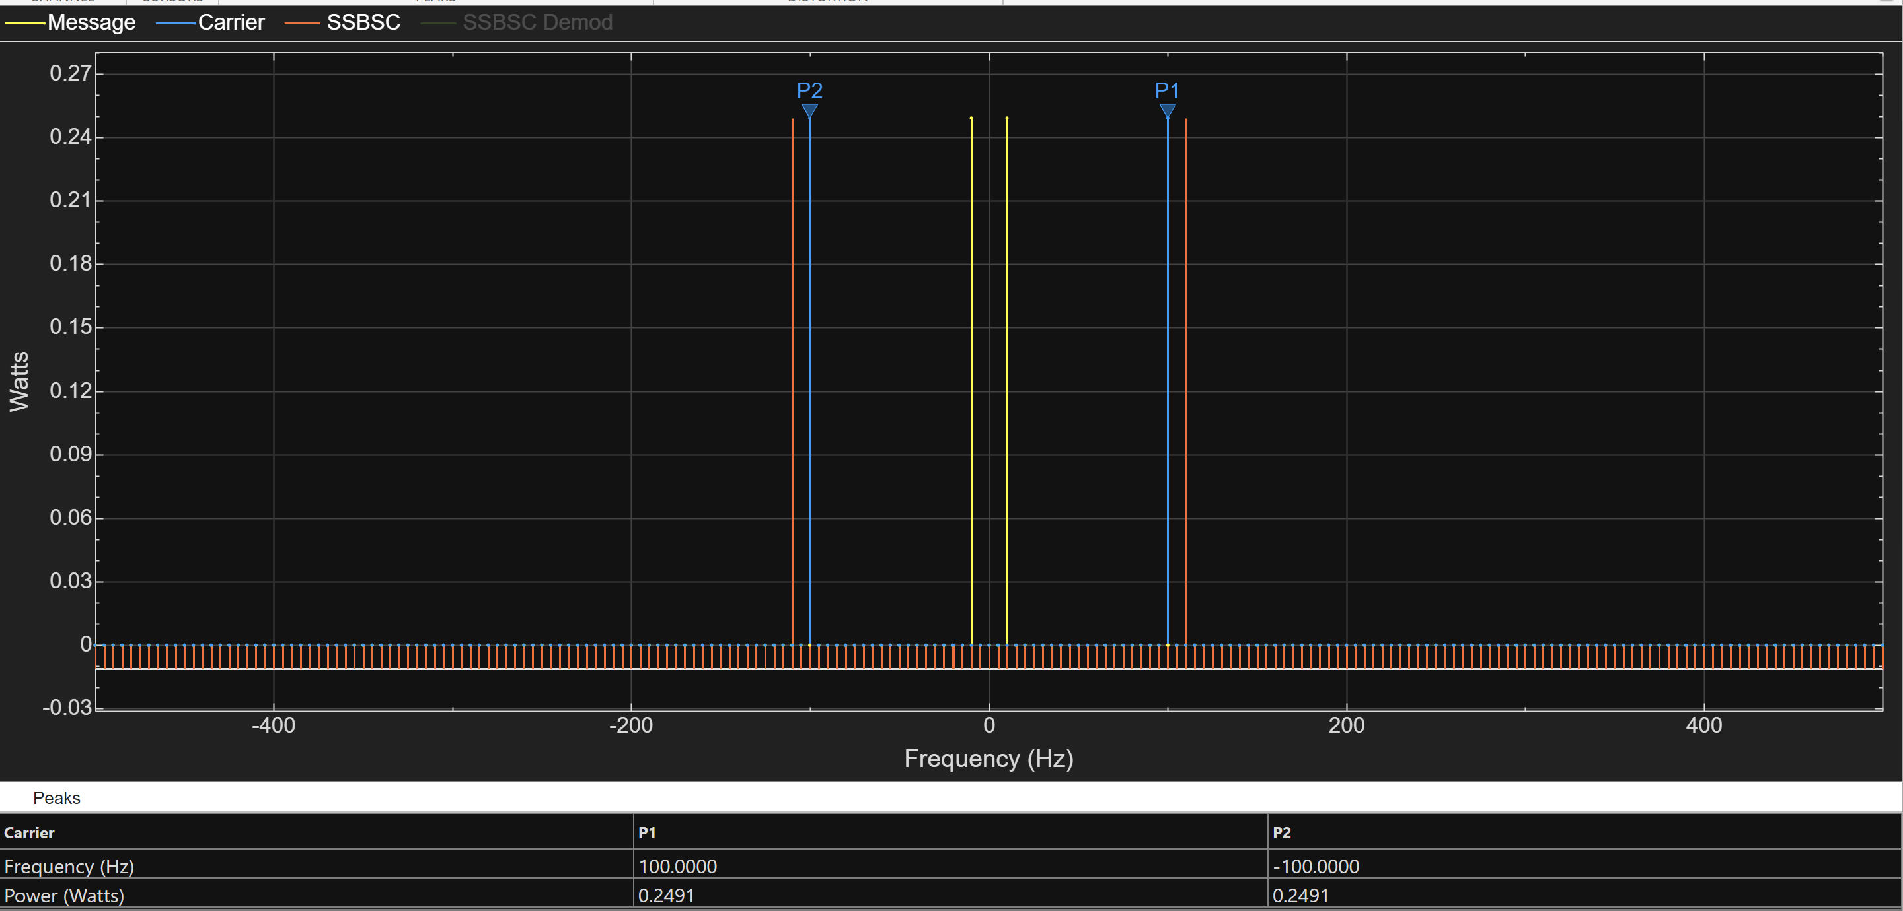

Power Density
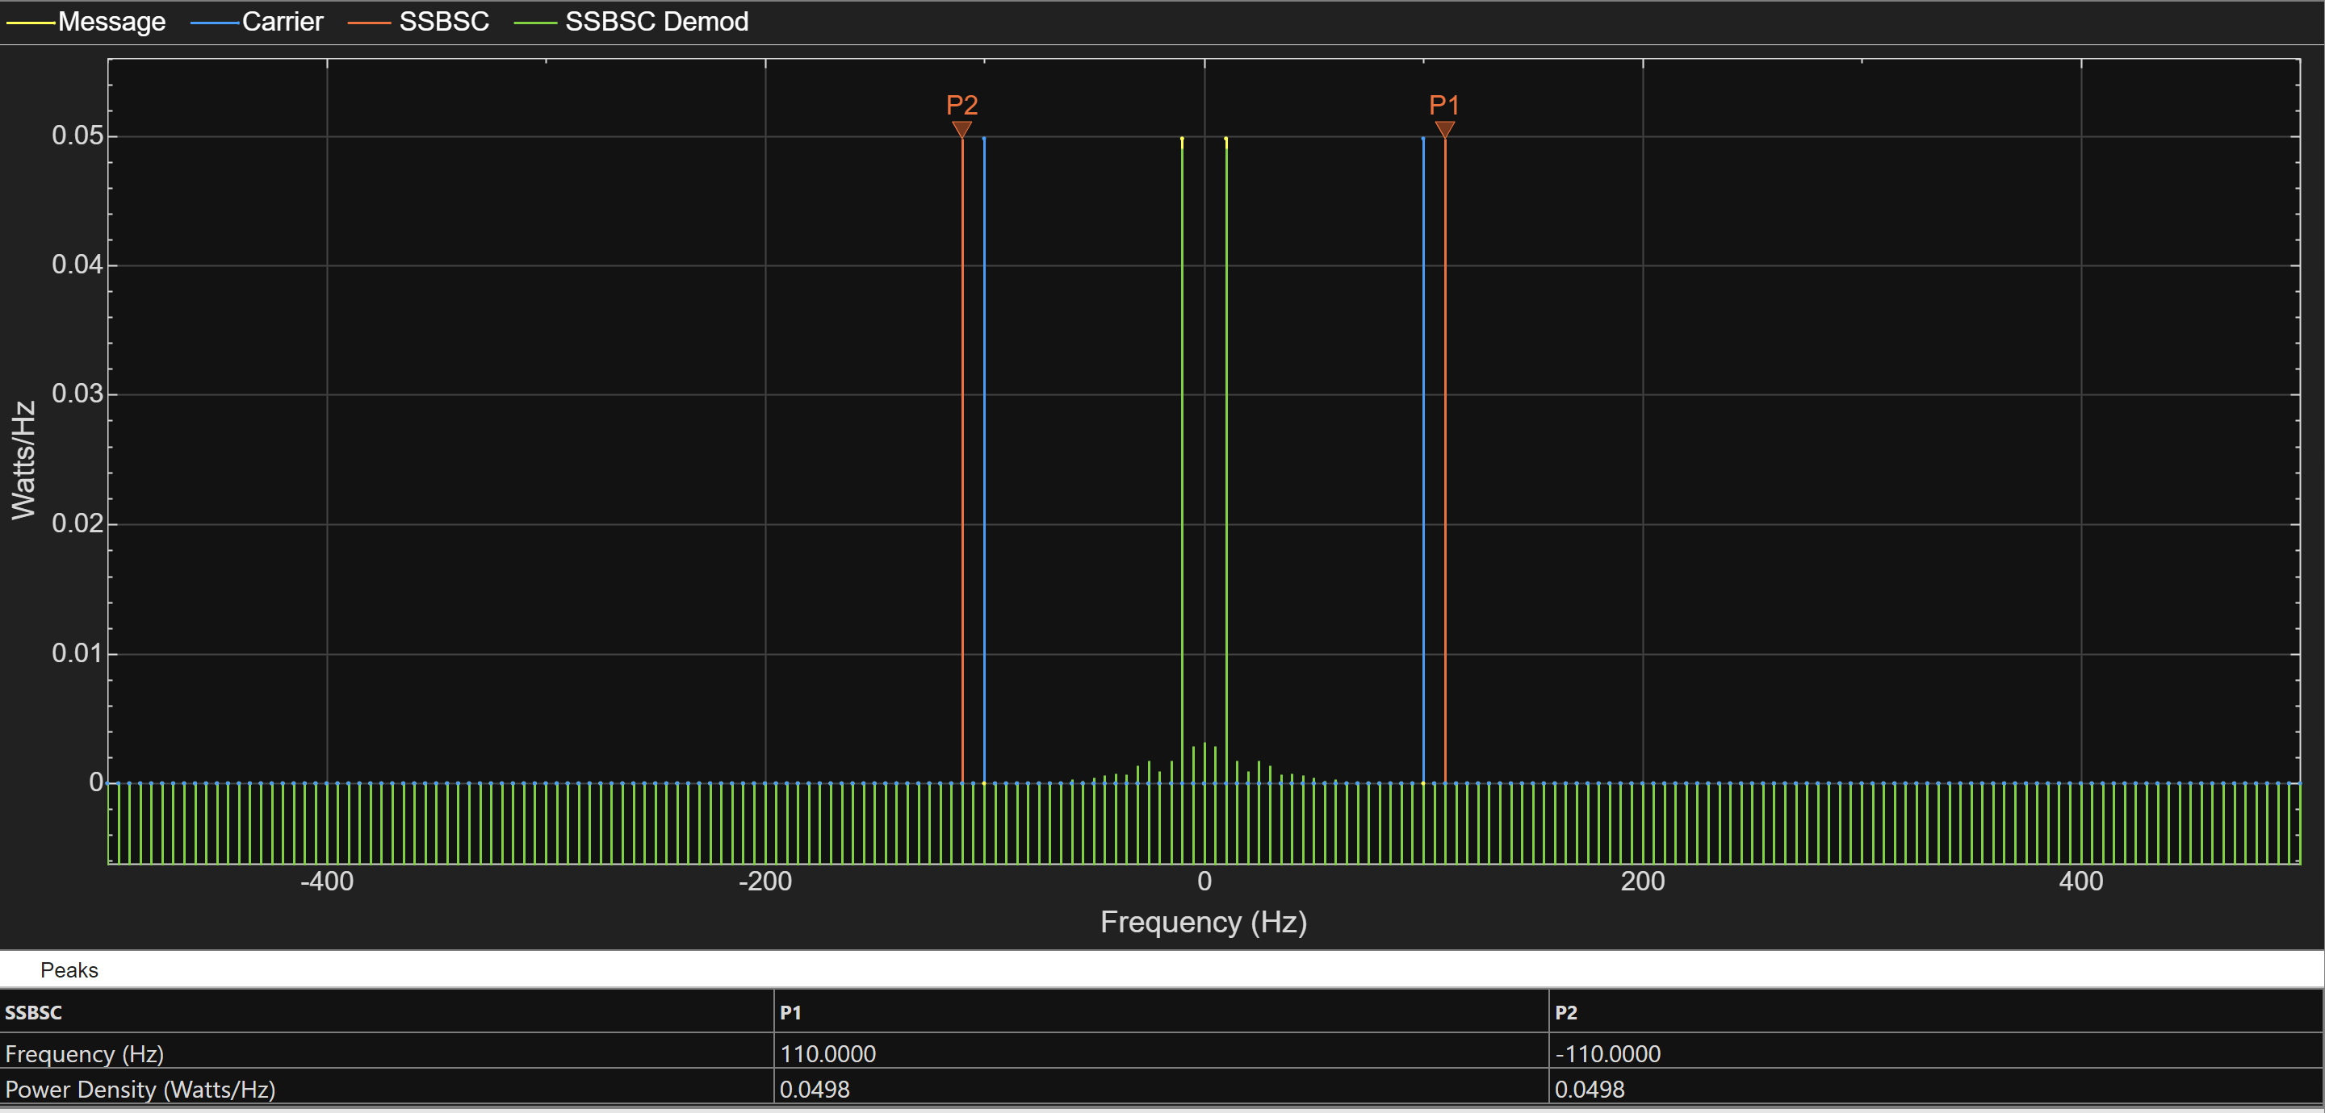

b)

Bandwidth
When comparing each of the modulation methods the bandwidth was also taken note of

AM
For AM the bandwidth occurs in a 20Hz range, 10Hz either side of the carrier wave
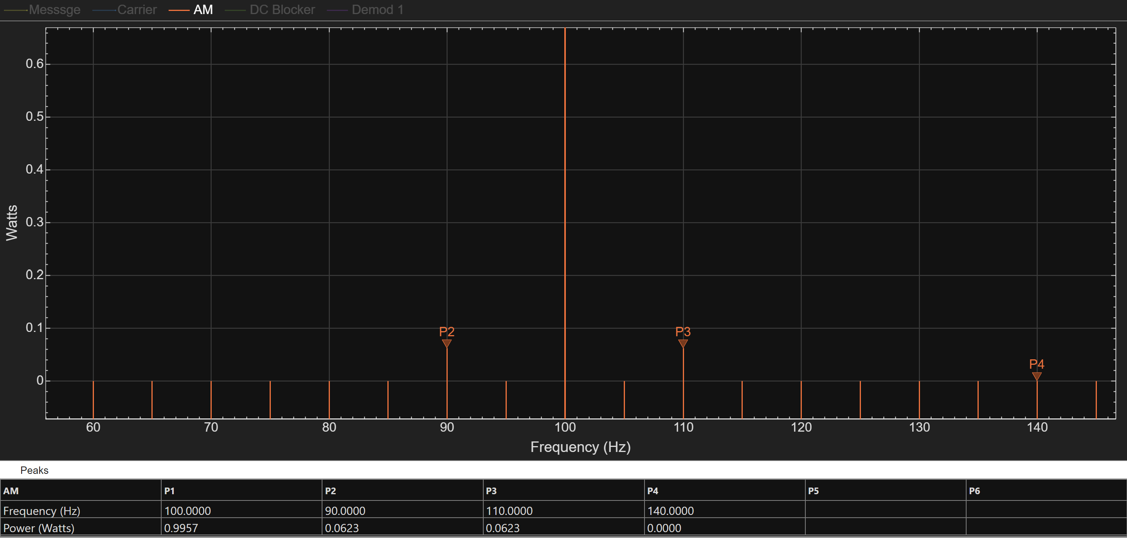

DSBSC
For DSBSC the bandwidth occurs in a 20Hz range, 10Hz either side of the carrier wave

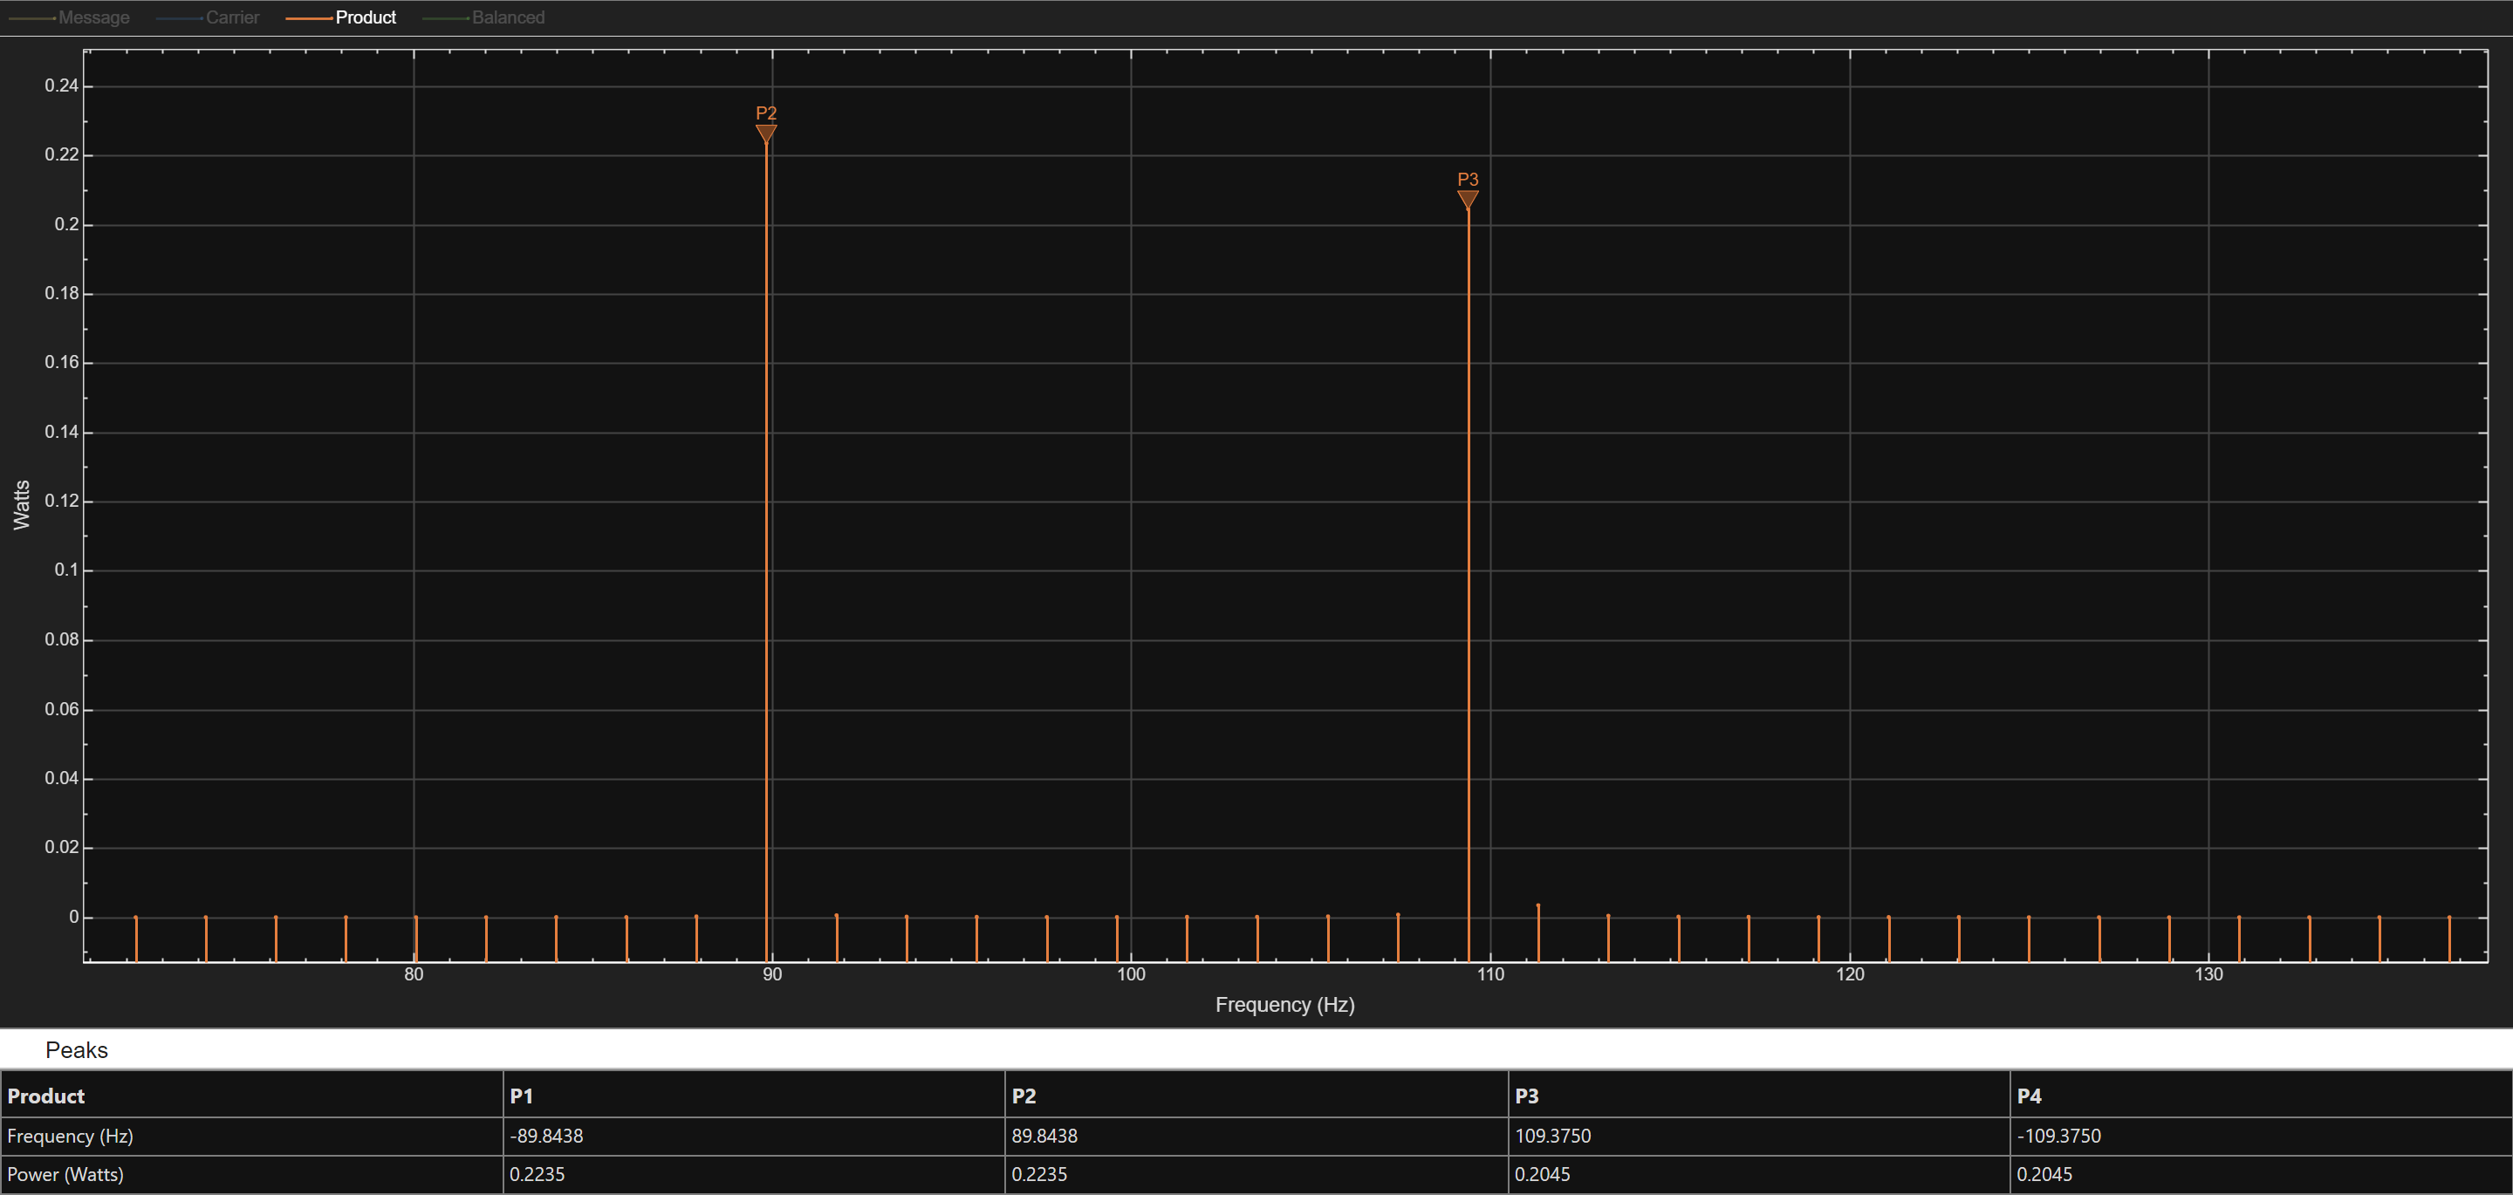

SSBSC
For SSBSC the bandwidth occurs in a 10Hz range, 10Hz to the side of the carrier wave due to using a single side band.
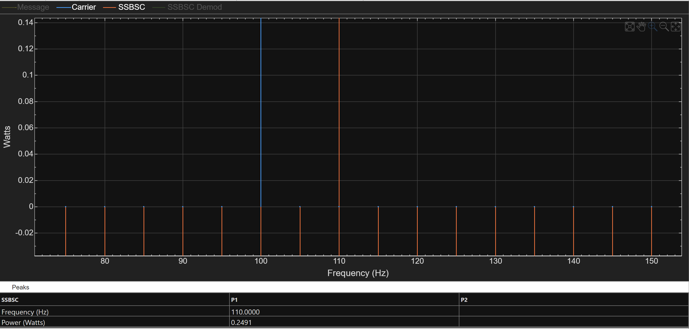

Noise Resistance
When comparing the noise resistance, the main measurement being compared here is Power, as both power density and RMS are also affected by noise, just to a lesser degree. With the main value being compare being SNR O (Signal to Noise Ratio Output) to SNR I (Signal to Noise Ratio Input)

AM
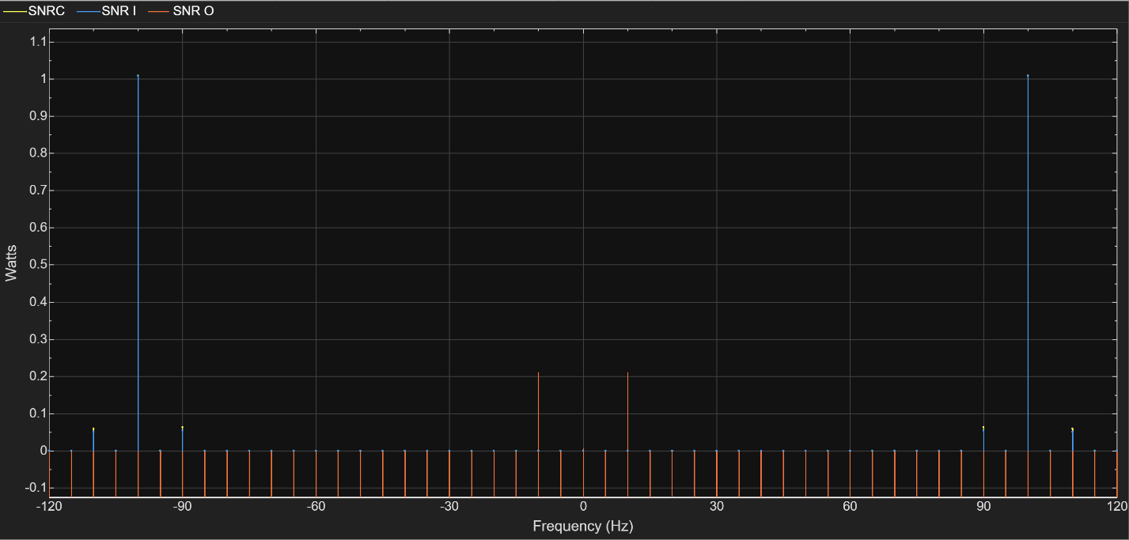
When observing the SNR O Value to SNR I, it is evident that AM is very susceptible to added noise, heavily decreasing the signal-to-noise ratio.

DSBSC
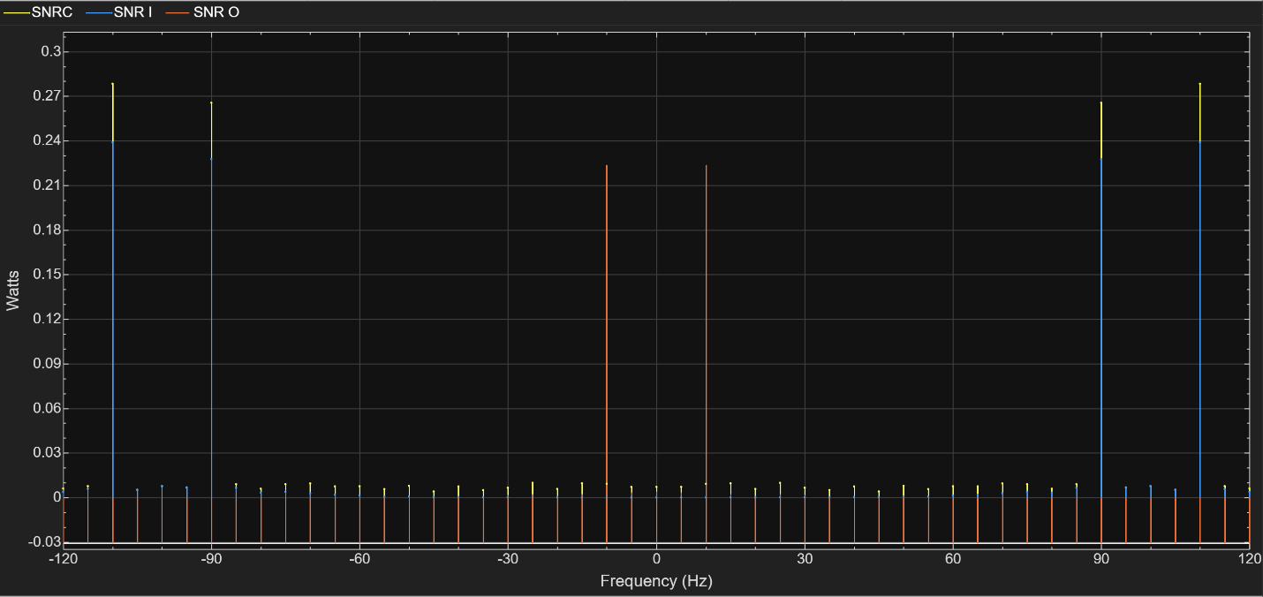
Looking at the SNR O compared to SNR I, DSBSC has a much better SNR value than AM

SSBSC
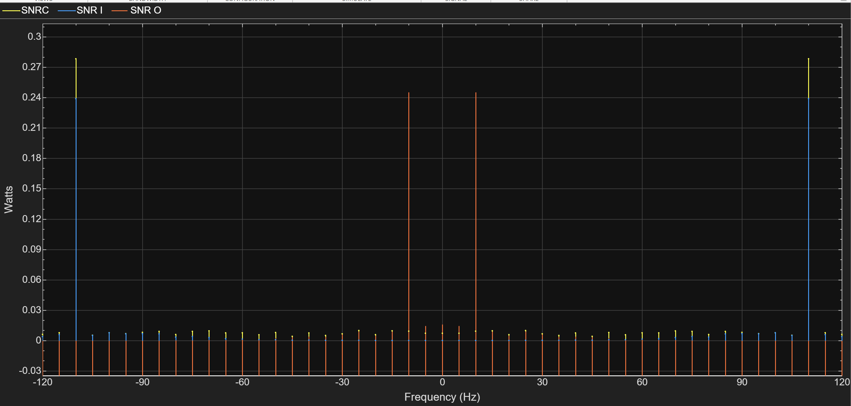
Shown in the graph, SSBSC has a very high SNR value, which exceeds that of either AM or DSBSC.

Comparison
As shown in the previous sections, the best process for noise resistance is SSBSC, DSBSC followed by AM.
This is for a number of reasons, such as:
- SSBSC has the lowest bandwidth used, being half of both AM and DSBSC
- SSBSC had the highest signal-to-noise ratio, followed by DSBSC then AM, allowing for more of the transmitted signal to be received.
- DSBSC transmits the additional sideband unlike SSBSC, which contains the redundant information resulting in wasted power
- AM also wastes power on the carrier which SSBSC and DSBSC does not

As shown in the previous sections, SSBSC also has the highest power density, due to the it effectively containing the same information as DSBSC but in half the bandwidth.
From these results, key points can be drawn:
- AM maintains simplicity while trading for performance
- DSBSC maintains a solid moderate complexity for moderate performance
- SSBSC prioritises performance whilst settling for increased complexity

Conclusion
To conclude, this report examined and compared the differences in how AM, DSBSC and SSBSC are affected.
Research was also conducted into how all RF Systems are affected in varying ways by noise and other interferences, which are often deemed as undesirable.
As shown in the analysis, AM tends to be the worst in power density, noise resistance, and uses additional power to transmit the carrier wave. With DSBSC acting as more of an intermediary, with better performance in regard to power efficiency, by not transmitting the carrier wave. SSBSC further improves this by sending only a single sideband, reducing the bandwidth by half.
Thus, this makes SSBSC the most desirable should the system require optimal performance.

Recommendations
Recommendations for this report include:
- Carry out the task physically, comparing results to simulated ones
- Carry out calculations and simulations on other modulation techniques such as phase & frequency modulation.
- Design of an RF modulation board or circuit for testing.

Bibliography

[1] | RFWirelessWorld, “Modulation: Basics, Types, and Applications,” RFWirelessWorld, [Online]. Available: https://www.rfwireless-world.com/terminology/understanding-modulation-basics-types-applications#google_vignette. [Accessed 14 December 2025].
[2] | D. Grini, “RF Basics, RF for Non-RF Engineers,” Texas Instruments, 2006. [Online]. Available: https://www.ti.com/lit/ml/slap127/slap127.pdf?ts=1765157744791. [Accessed 8 December 2025].
[3] | RF Wireless World, “Modulation Index Formula in AM/FM Communication Systems,” RF Wireless World, [Online]. Available: https://www.rfwireless-world.com/terminology/modulation-index-formula-am-fm#google_vignette. [Accessed 13 December 2025].
[4] | Electronics Note, “Amplitude Modulation, AM Index & Modulation Depth,” Electronics Notes, [Online]. Available: https://www.electronics-notes.com/articles/radio/modulation/amplitude-modulation-am-index-depth.php. [Accessed 13 December 2025].
[5] | A. Mehrotra, “Noise in radio frequency circuits: analysis and design implications,” in Proceedings of the IEEE 2001. 2nd International Symposium on Quality Electronic Design, San Jose, CA, USA, 2001.
[6] | Field Theory, “Understanding RF Noise: Sources and Solutions,” Field Theory, [Online]. Available: https://fieldtheoryinc.com/understanding-rf-noise-sources-and-solutions/. [Accessed 14 December 2025].
[7] | D. S. Arar, “Introduction to Modulation Techniques in RF Systems,” All About Circuits, 13 November 2024. [Online]. Available: https://www.allaboutcircuits.com/technical-articles/introduction-to-modulation-techniques-in-rf-systems/. [Accessed 14 December 2025].
[8] | D. S. Arar, “Understanding the RF Noise Figure Specification,” All About Circuits, 7 May 2023. [Online]. Available: https://www.allaboutcircuits.com/technical-articles/understanding-the-noise-figure-specification/. [Accessed 14 December 2025].
[9] | S. Haykin and M. Moher, Introduction to Analog & Digital Communications, Ontario, Canada: John Wiley & Sons, 2007.
[10] | salimwireless, “DSB-SC vs SSB-SC,” salimwireless, [Online]. Available: https://www.salimwireless.com/2024/08/dsb-and-ssb-sc.html. [Accessed 14 December 2025].
[11] | RF Wireless World, “Transmitter vs. Receiver: Differences and Types,” RFWirelessWorld, [Online]. Available: https://www.rfwireless-world.com/terminology/transmitter-vs-receiver-differences-and-types. [Accessed 14 December 2025].
[12] | M. Steer, “3.4: Receiver and Transmitter Architectures,” [Online]. Available: https://eng.libretexts.org/Bookshelves/Electrical_Engineering/Electronics/Microwave_and_RF_Design_I_-_Radio_Systems_(Steer)/03%3A_Transmitters_and_Receivers/3.04%3A_Receiver_and_Transmitter_Architectures. [Accessed 14 December 2025].
[13] | TU/e Technische Universiteit Eindhoven, “Receiver Architectures,” [Online]. Available: https://class.ece.iastate.edu/djchen/ee507/TranscieverArchiTUE.pdf. [Accessed 14 December 2025].
[14] | C. Woodford, “Antennas and transmitters,” Explainthatstuff, 14 February 2025. [Online]. Available: https://www.explainthatstuff.com/antennas.html. [Accessed 14 December 2025].
[15] | A. Mehrotra and A. n. Sangiovanni-Vincentelli, “Noise Analysis of Radio Frequency Circuits,” Kluwer Academic Publisher, California, 2004.
[16] | J. C. Whitaker, The RF Transmission Systems Handbook, Boca Raton: CRC Press, 2002.

Appendix

Figures

Task 1

Circuit
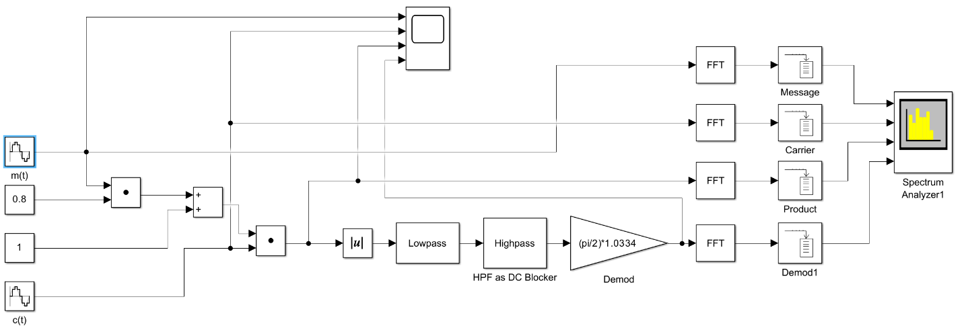

Scope

Spectrum Analyser

Power

0.8 Modulation Index
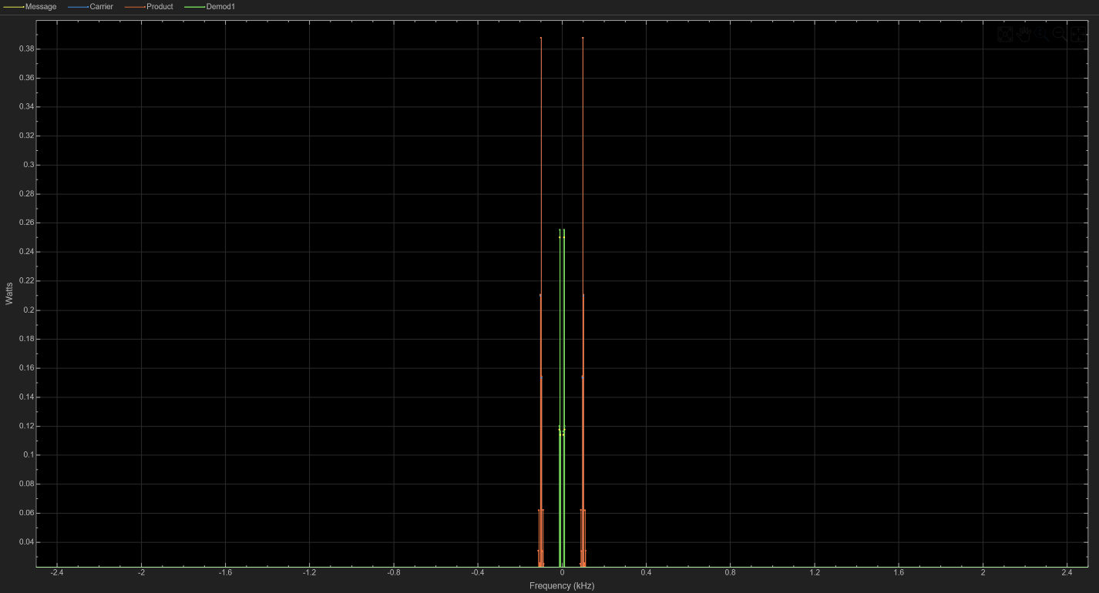
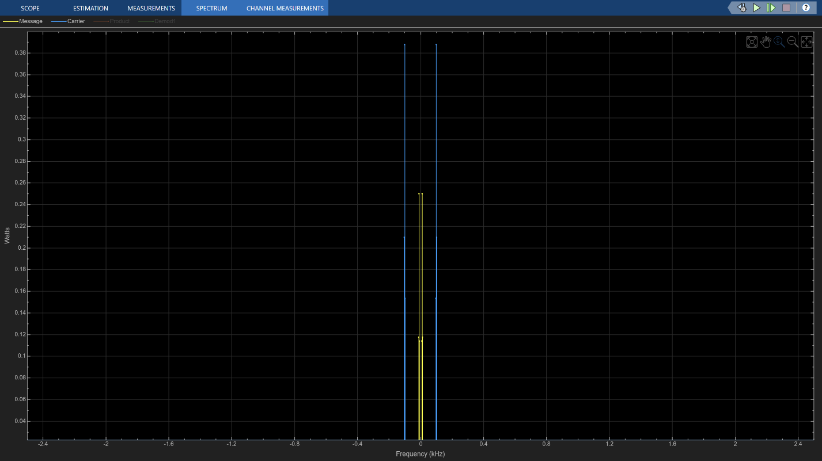

1 Modulation Index
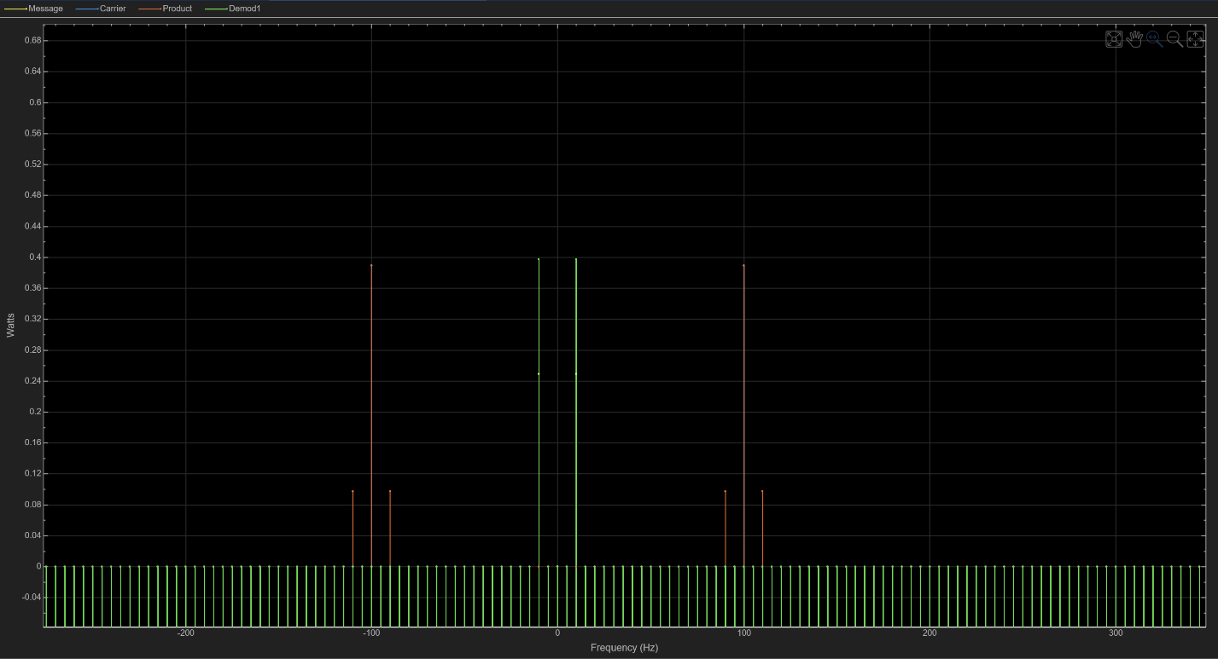
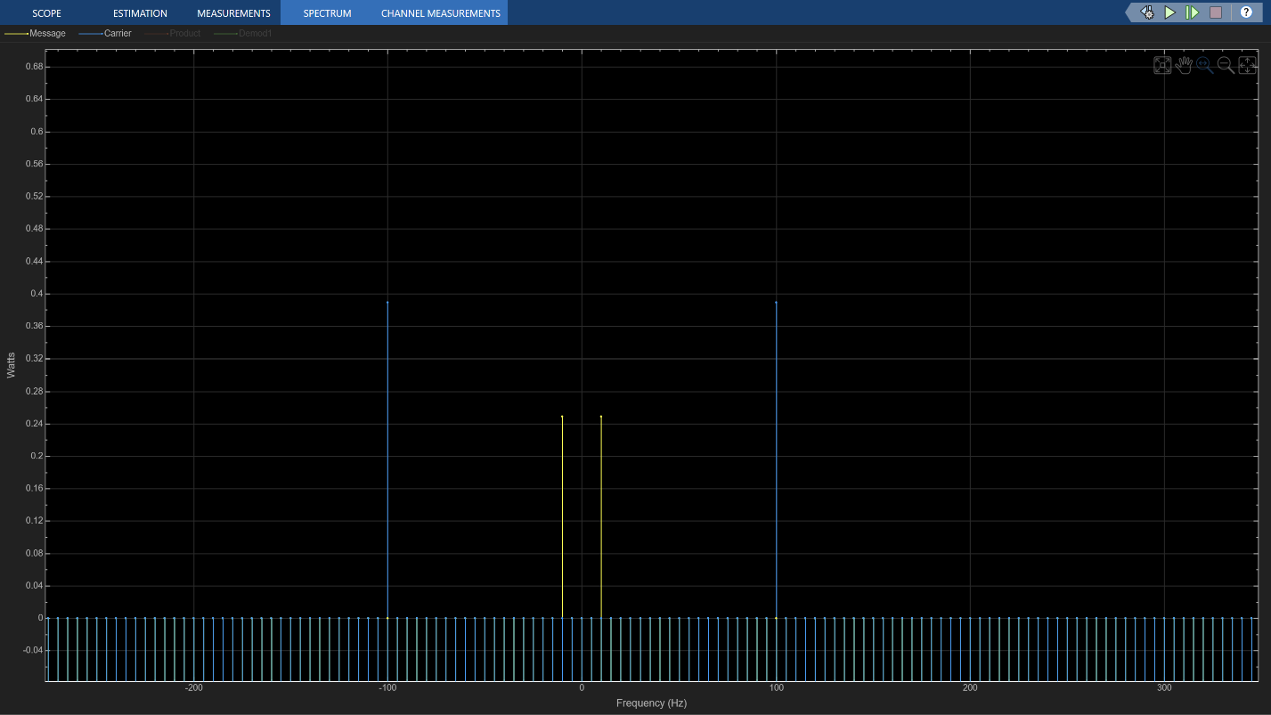

1.2 Modulation Index
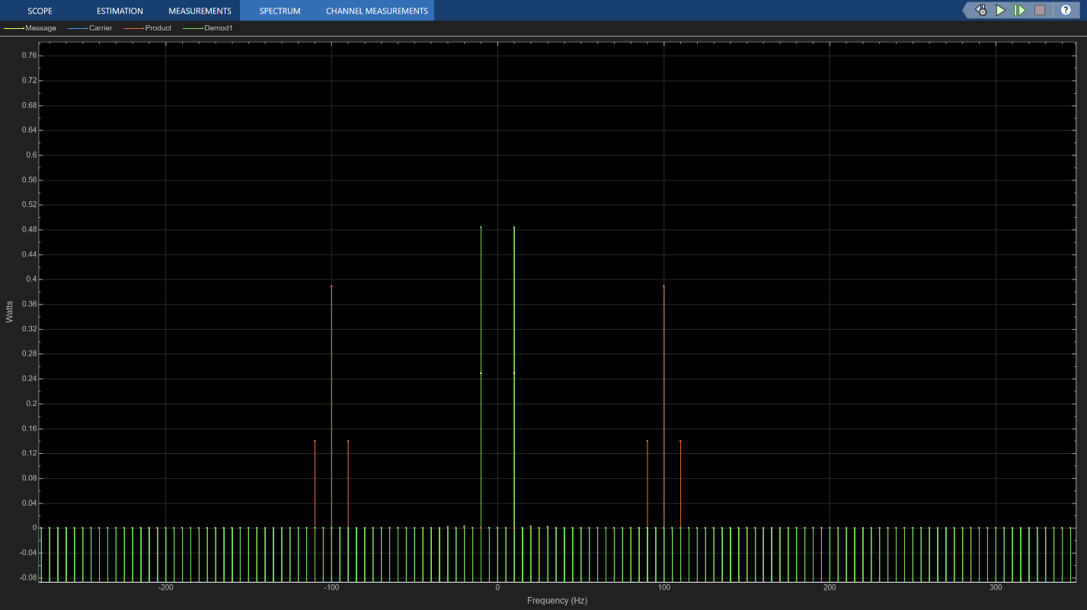
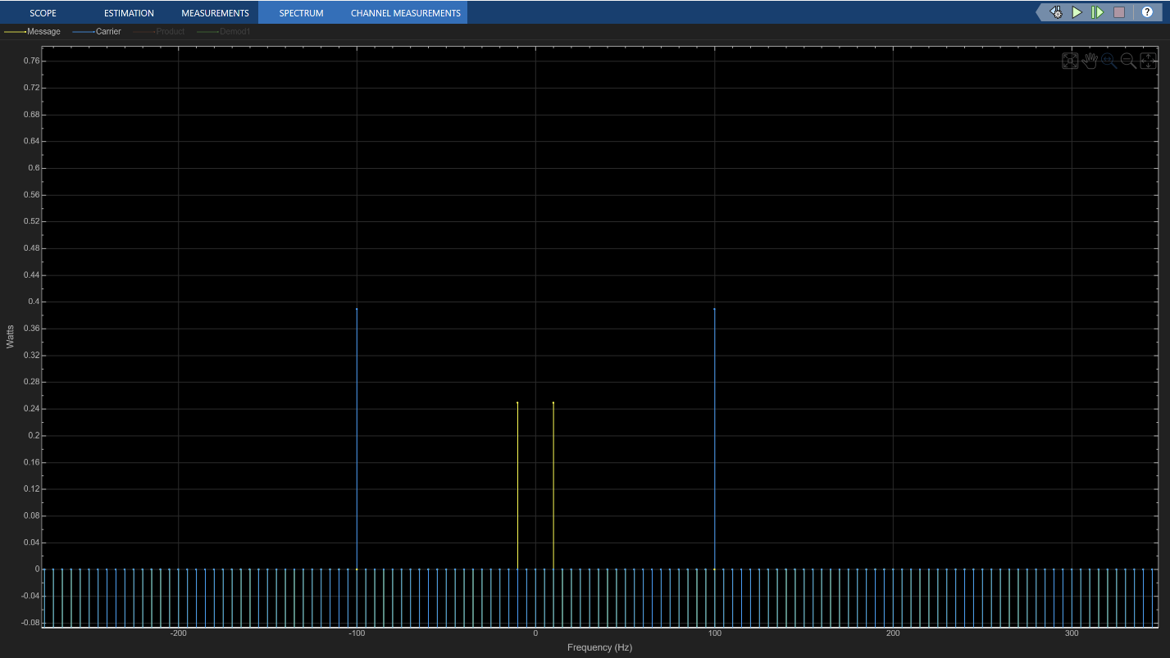

Power Density

0.8 Modulation Index
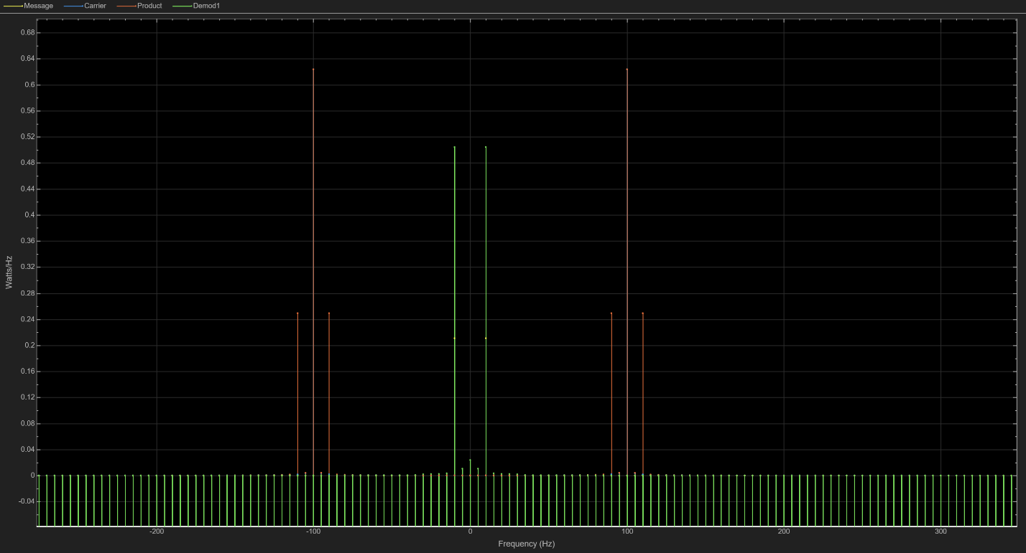
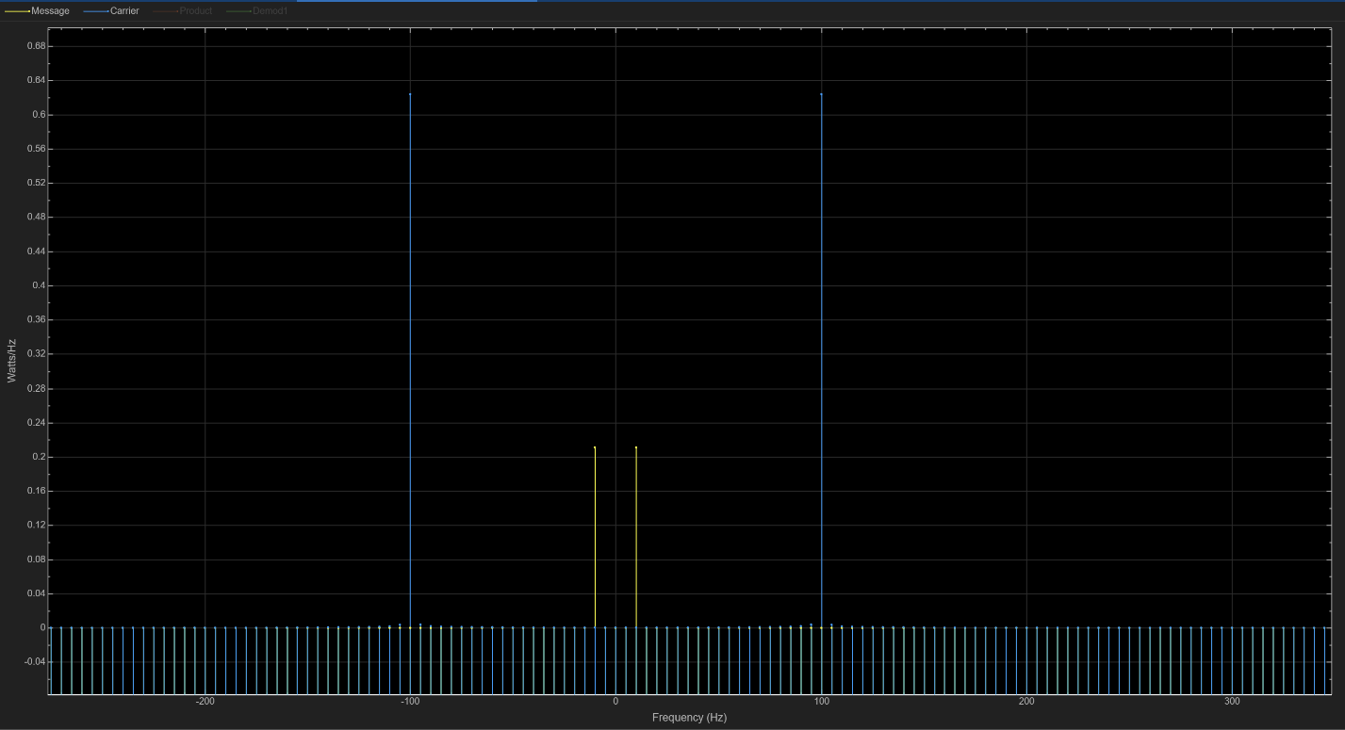

1 Modulation Index
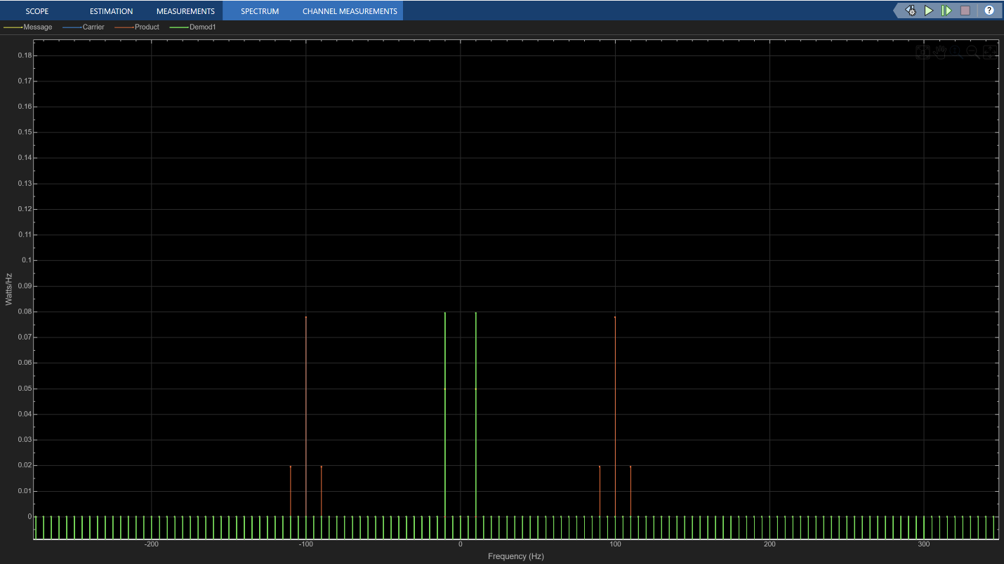
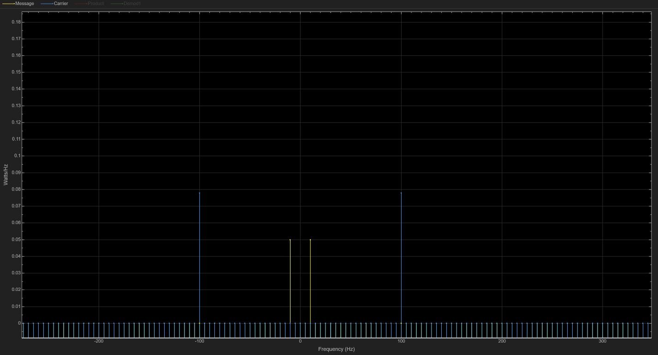

1.2 Modulation Index
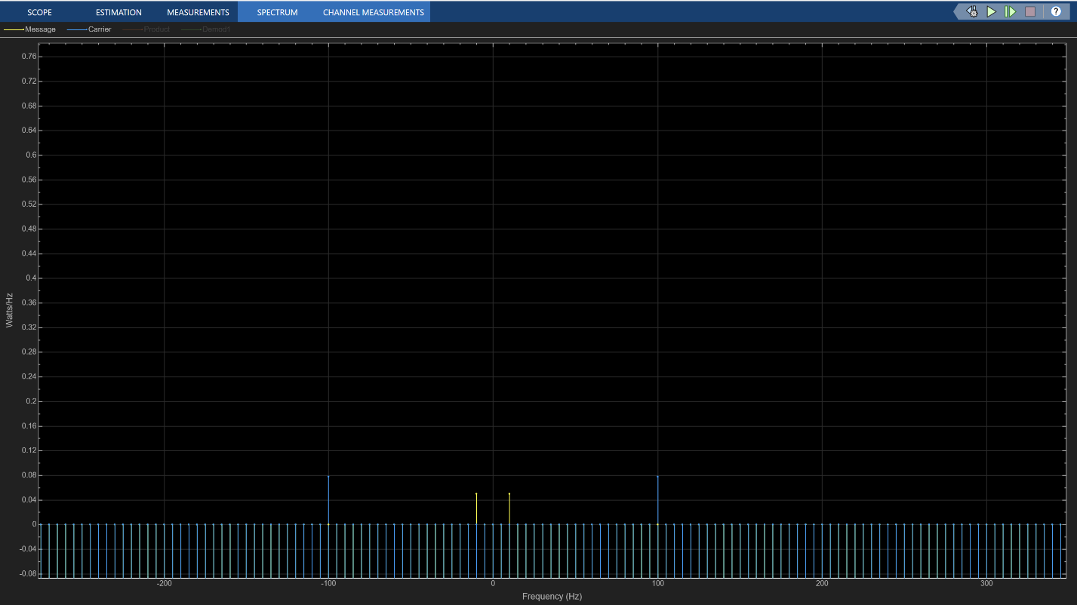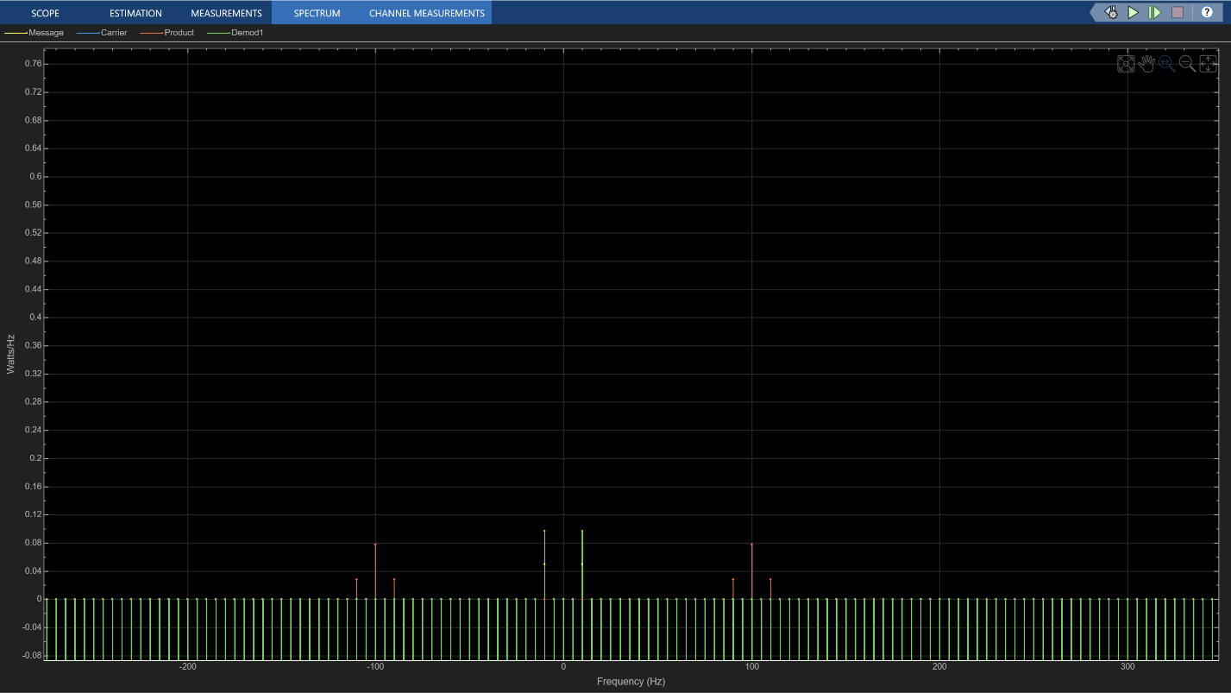

RMS

0.8 Modulation Index

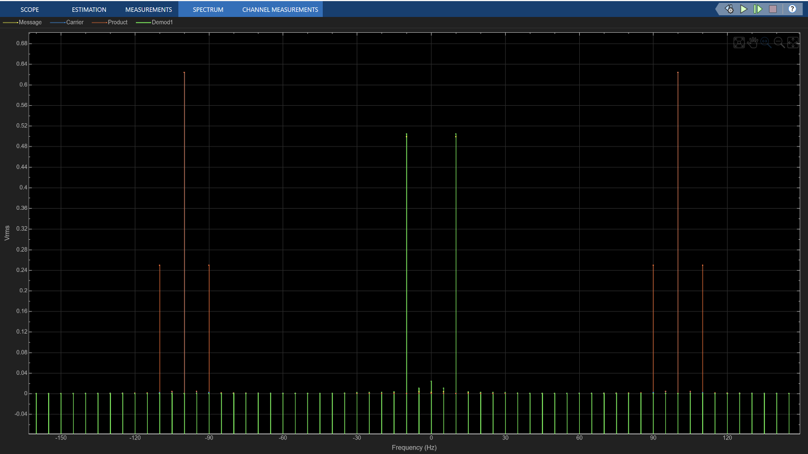
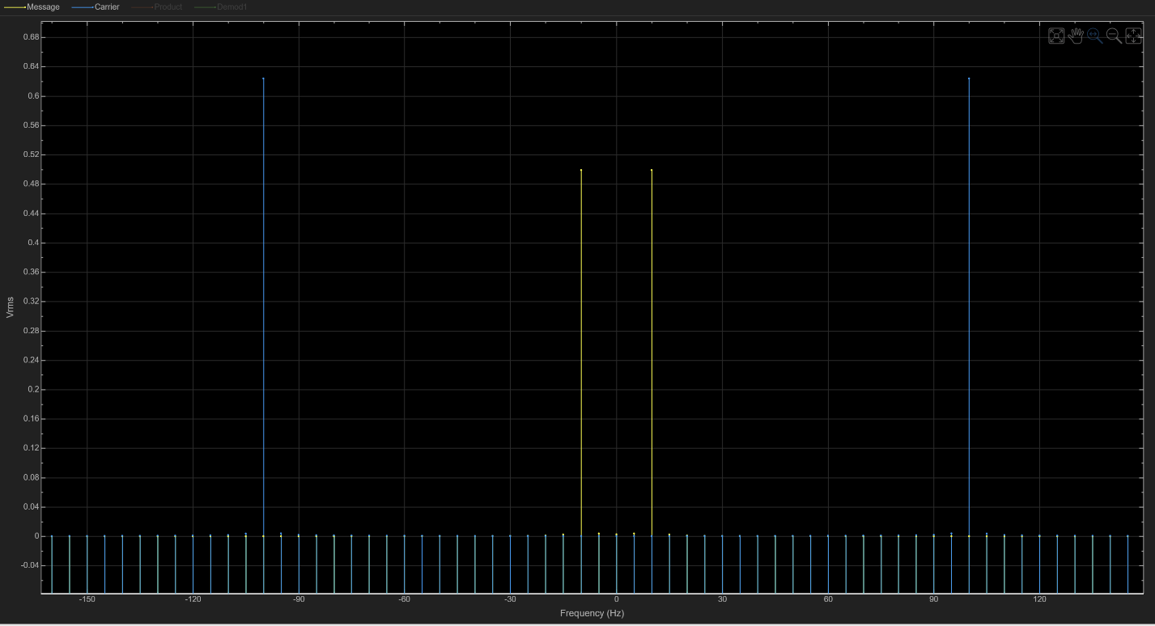

1 Modulation Index
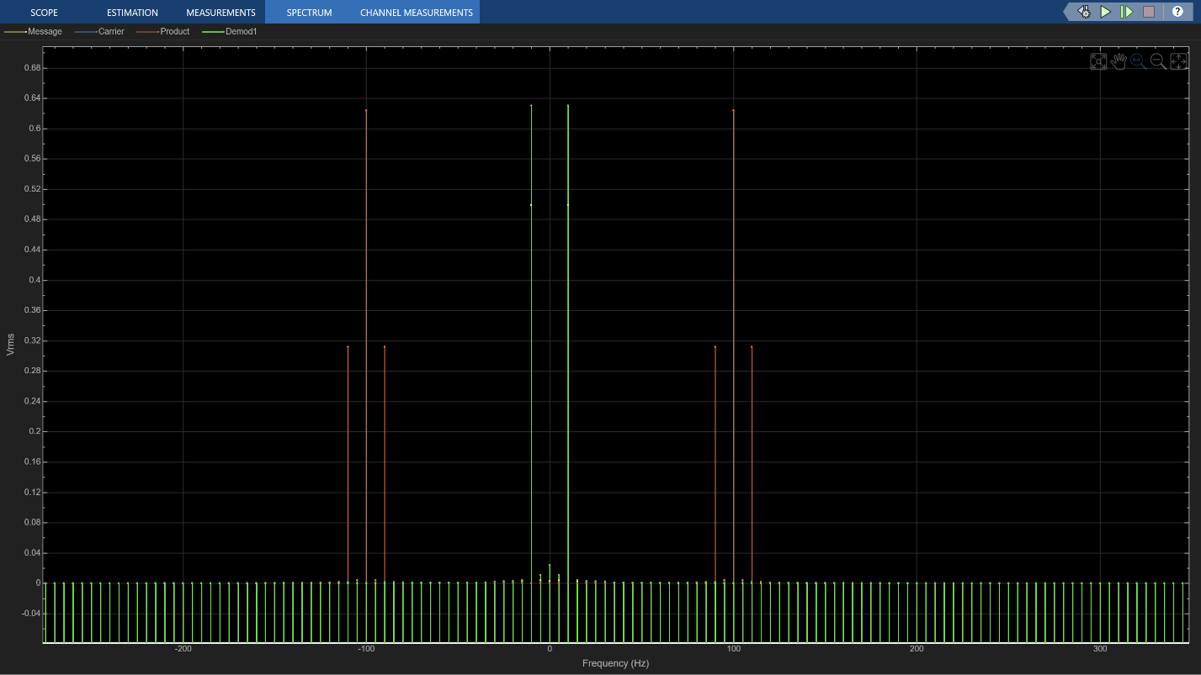
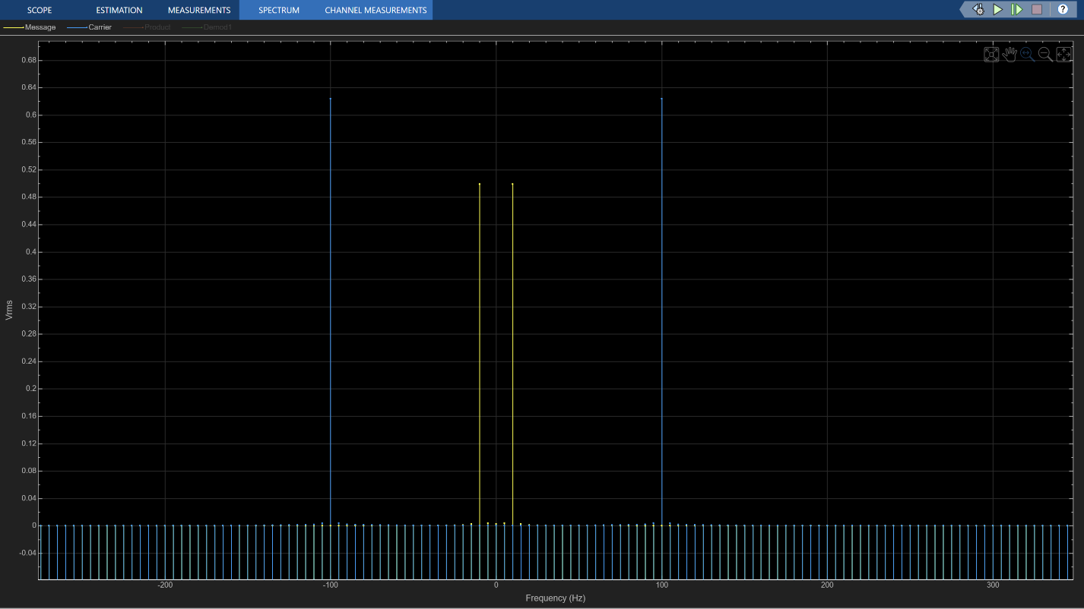

1.2 Modulation Index
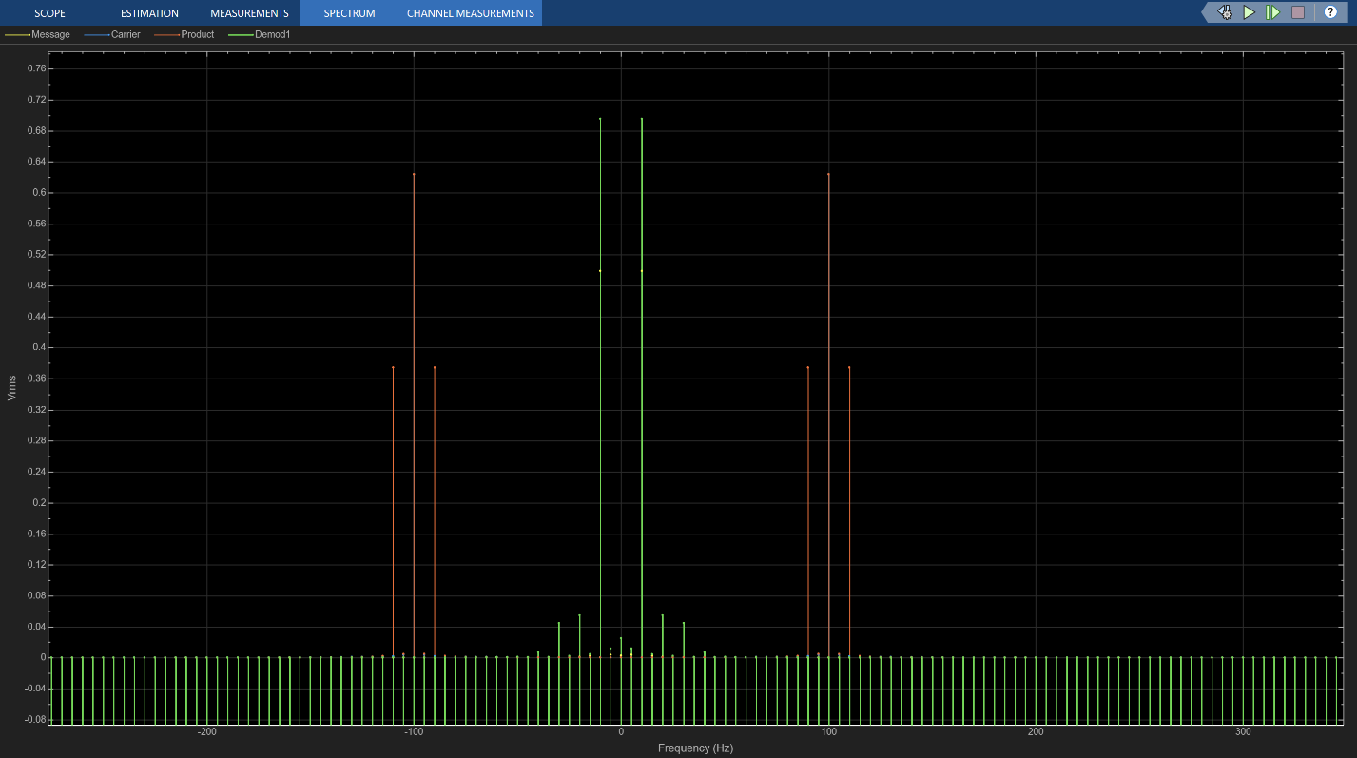
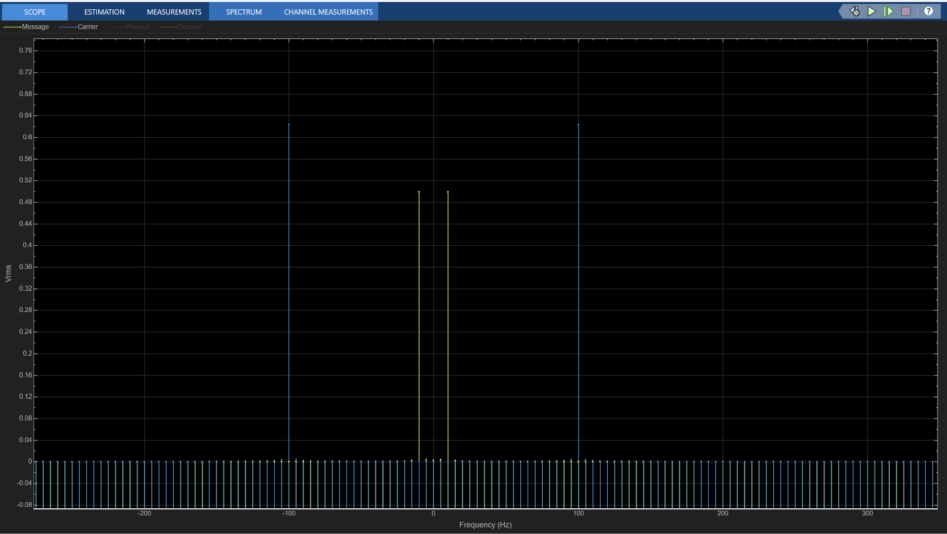

Task 2

Circuit
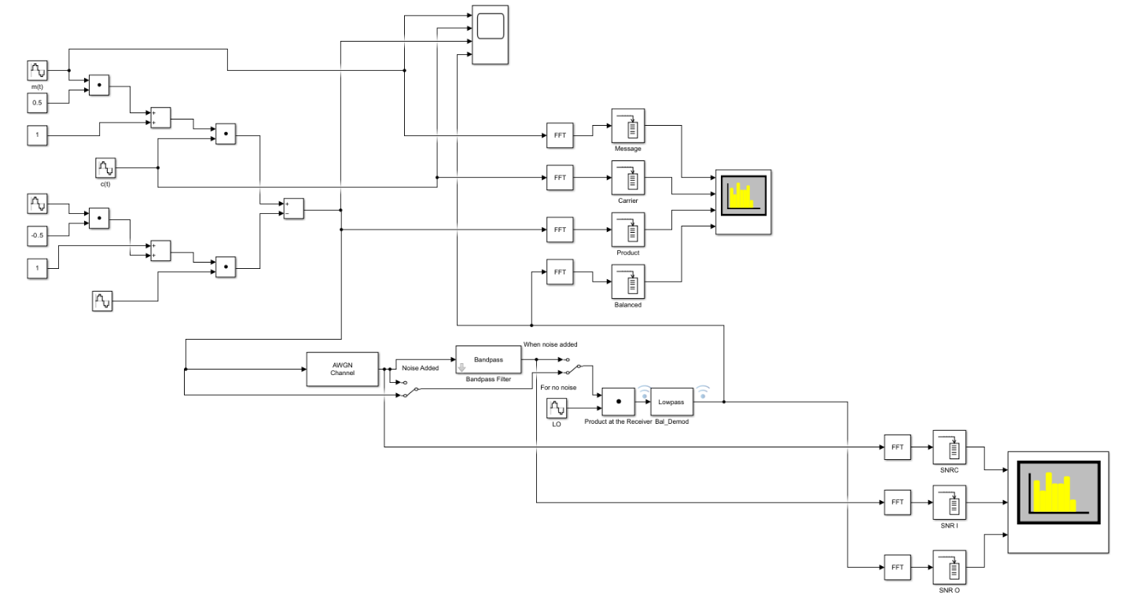

Scope
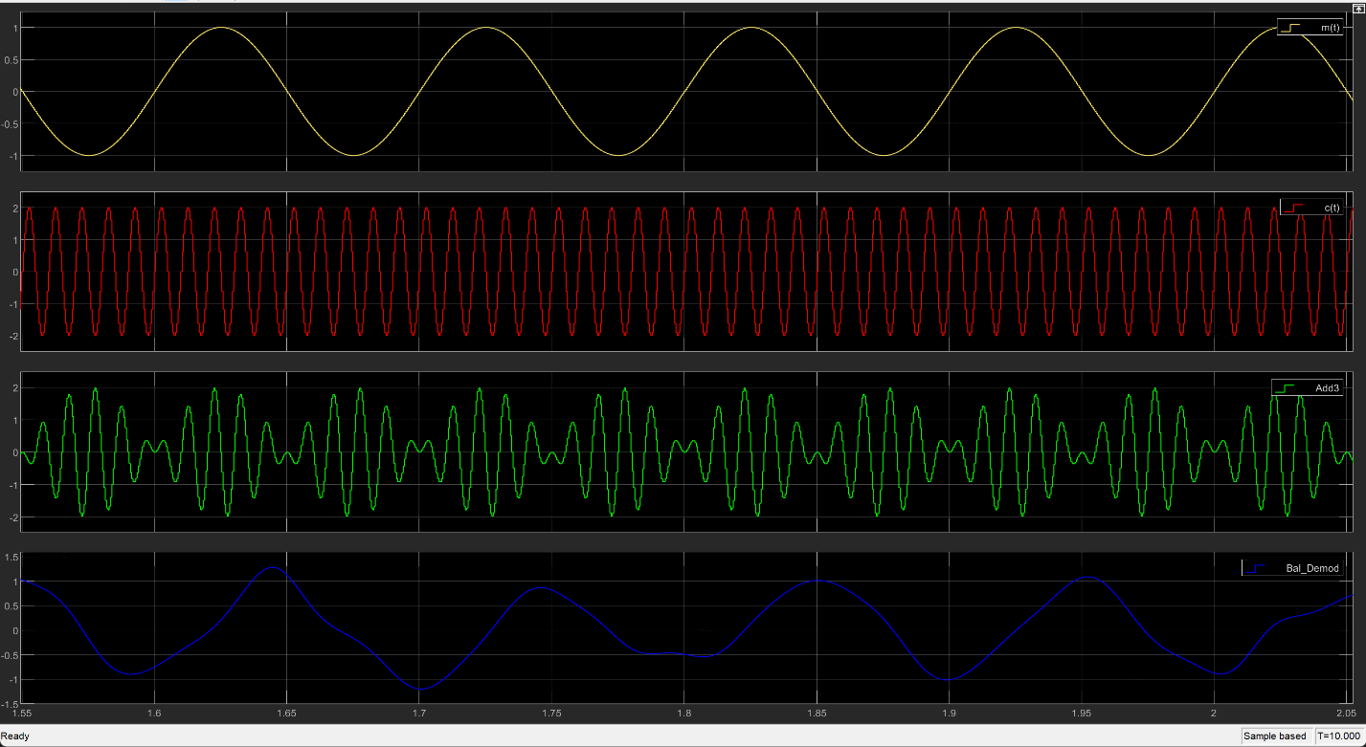
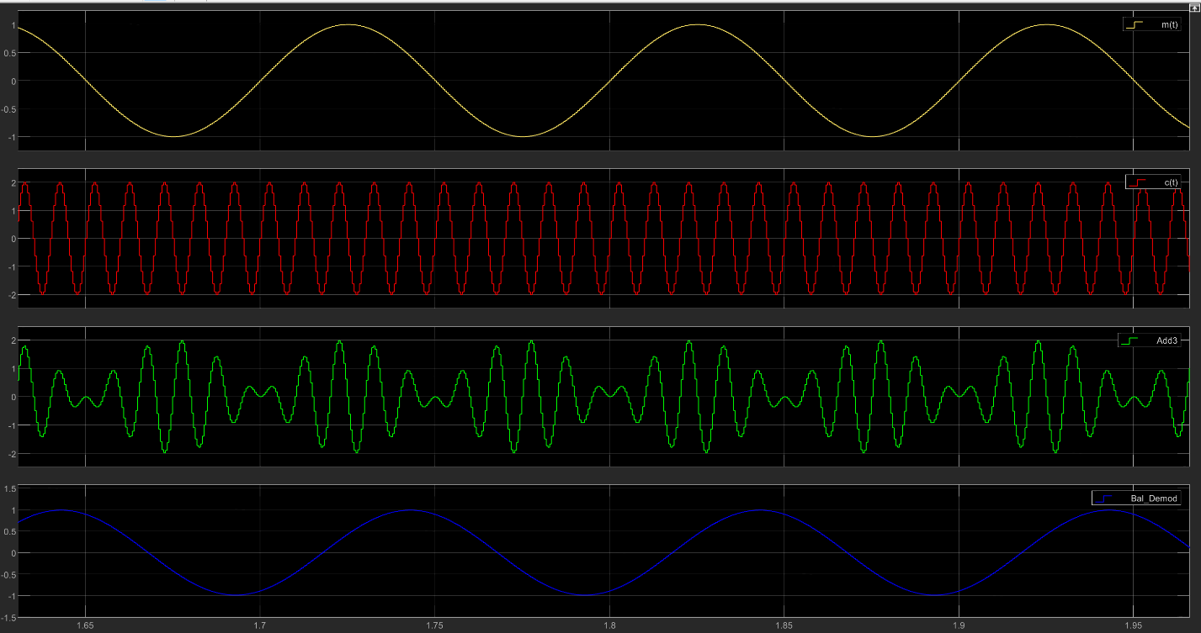

Spectrum Analyser

Power
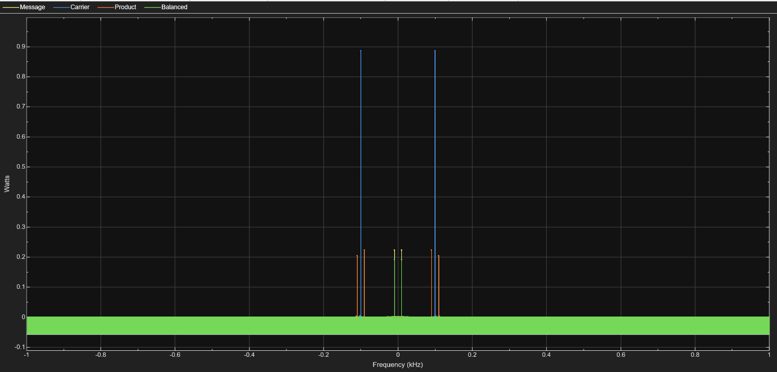
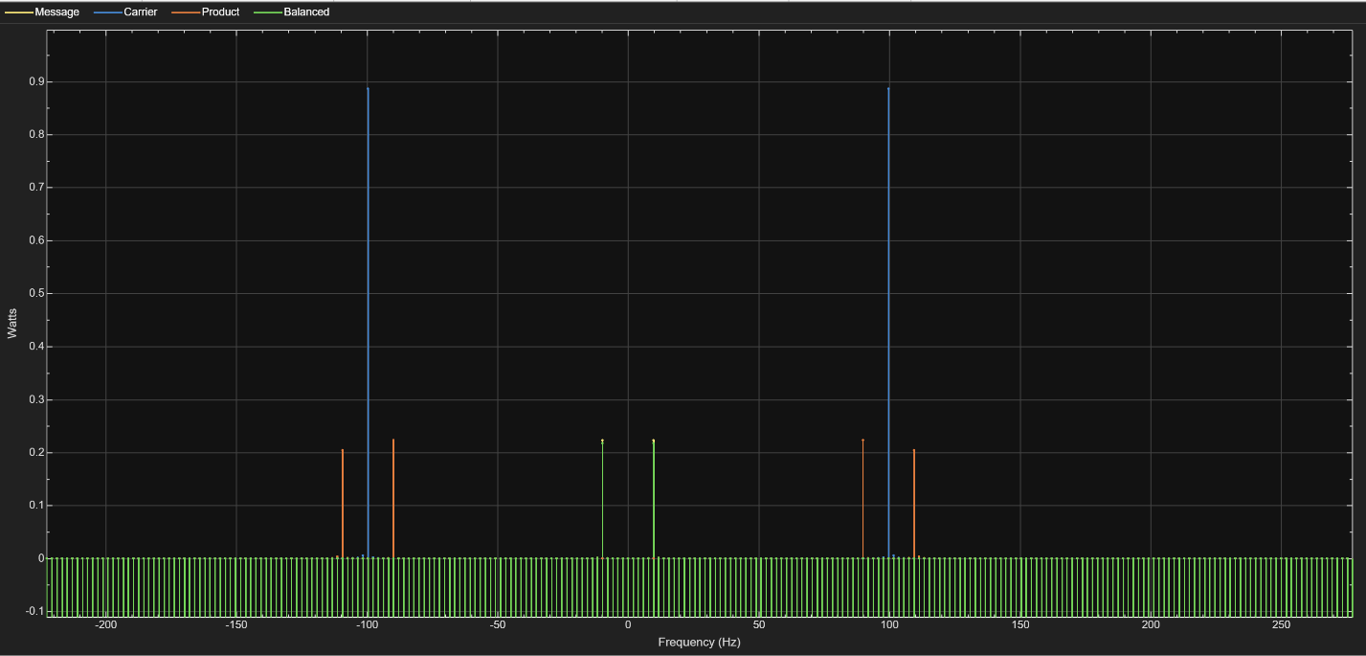

Power Density

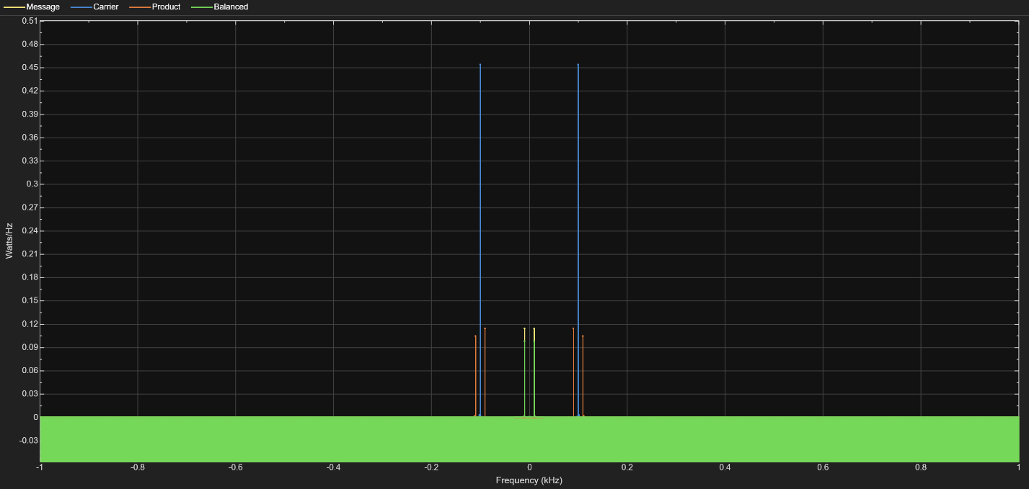
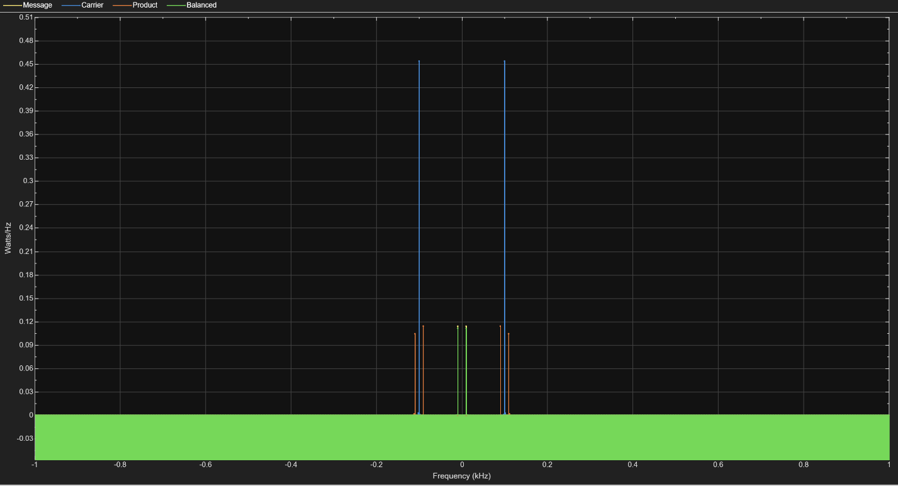

RMS
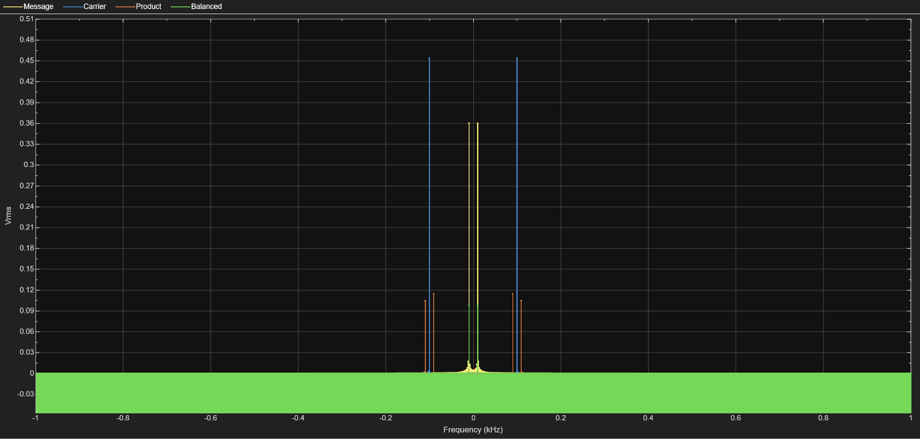
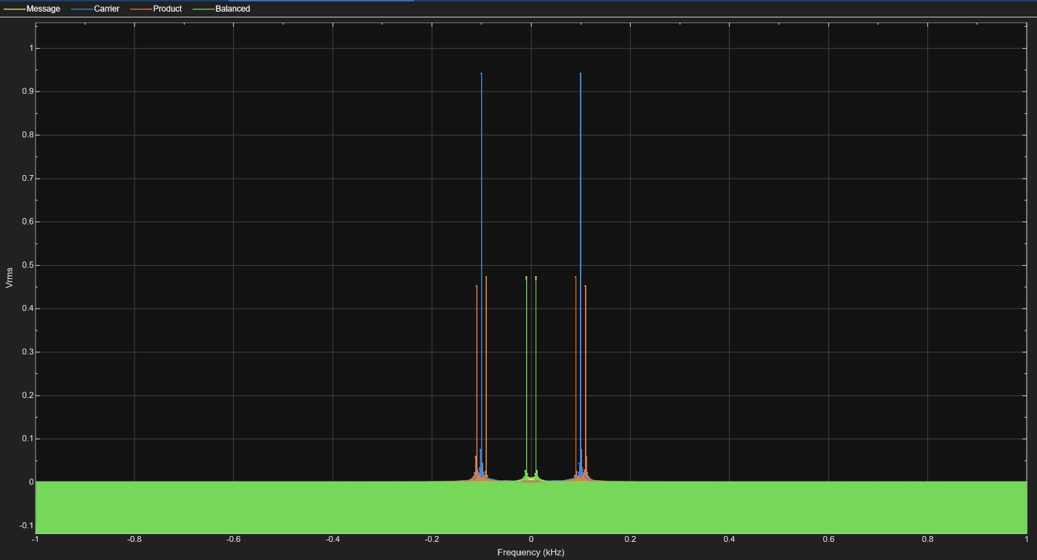

Task 3

Circuit
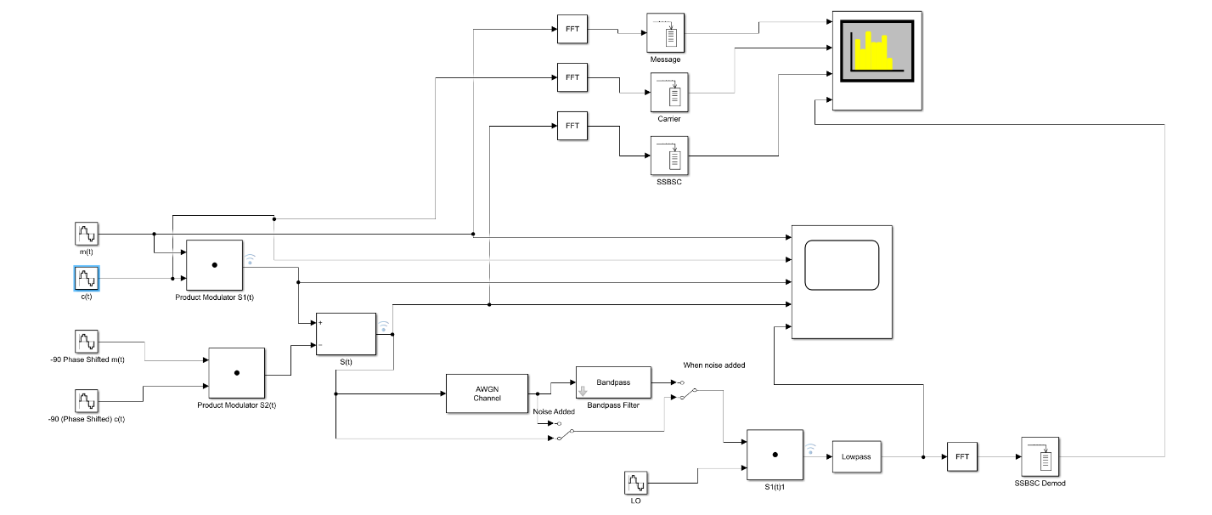

Scope
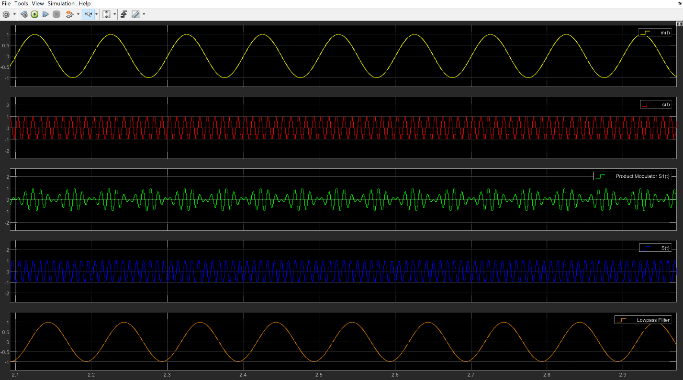
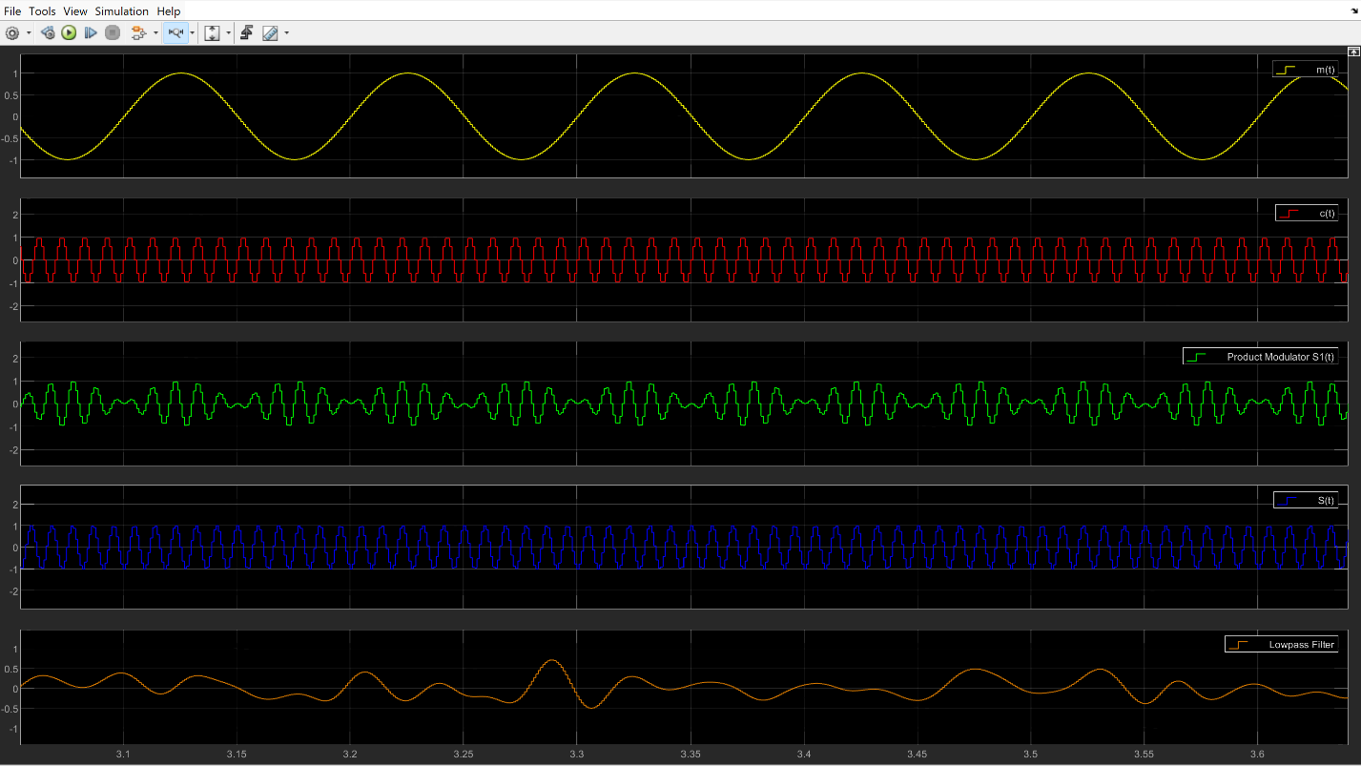

Spectrum Analyser

Power
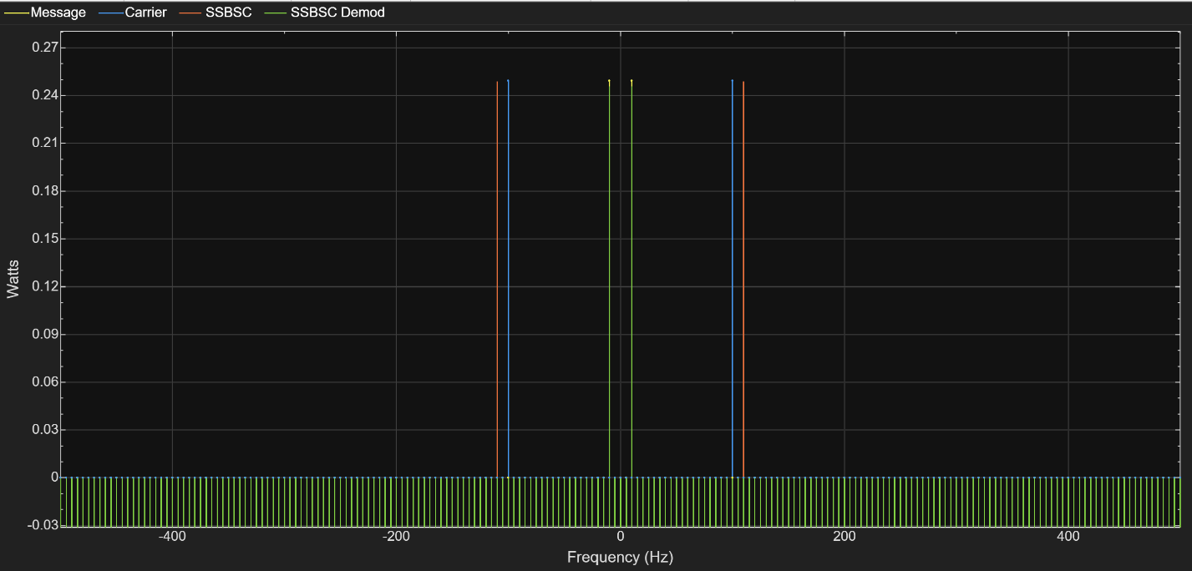
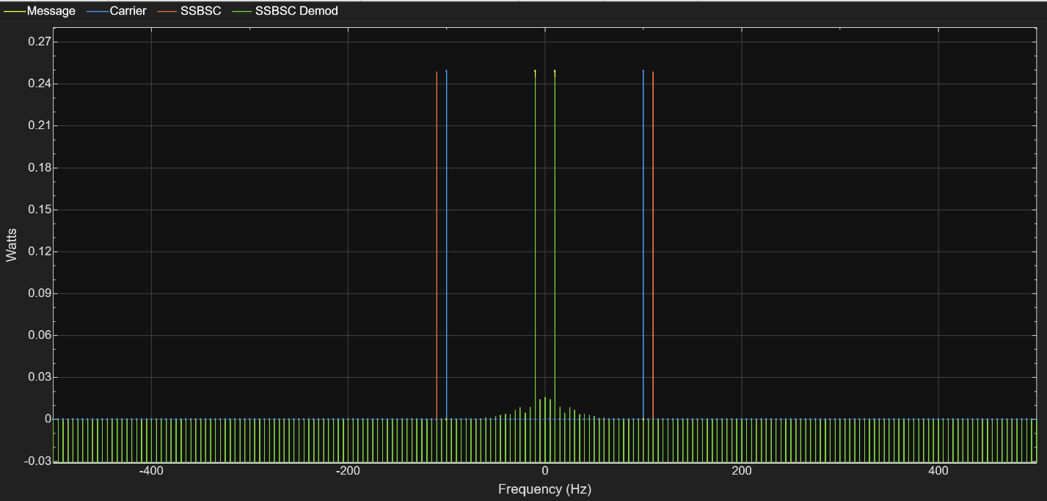

Power Density
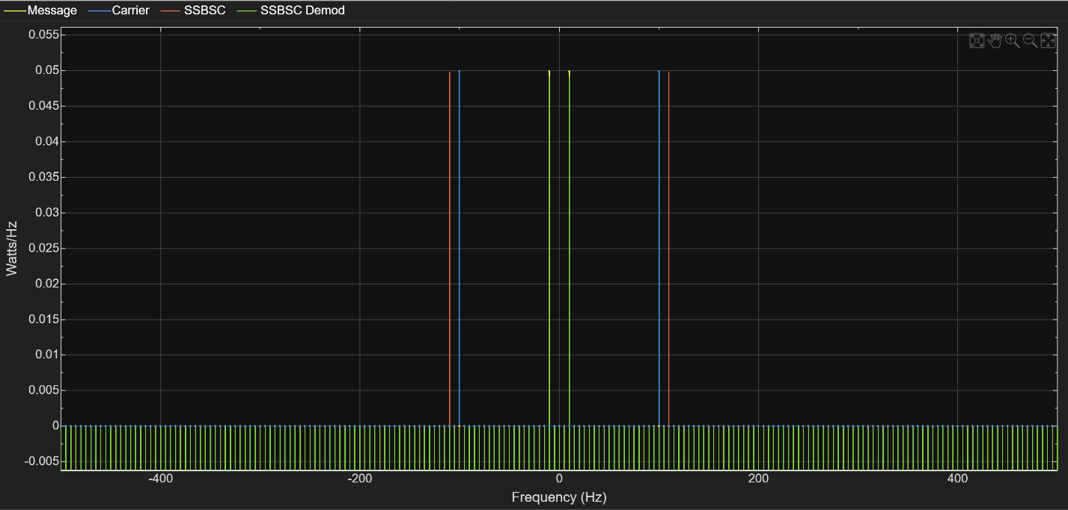
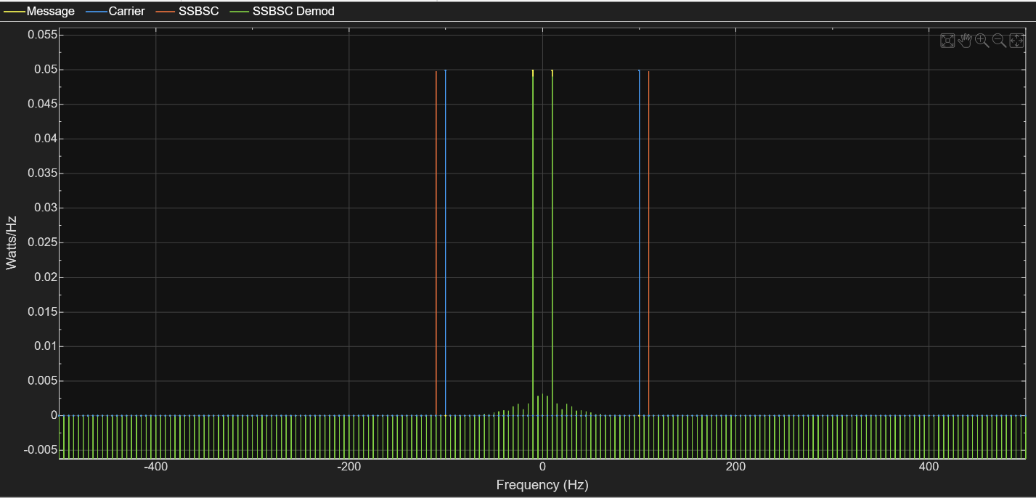

RMS
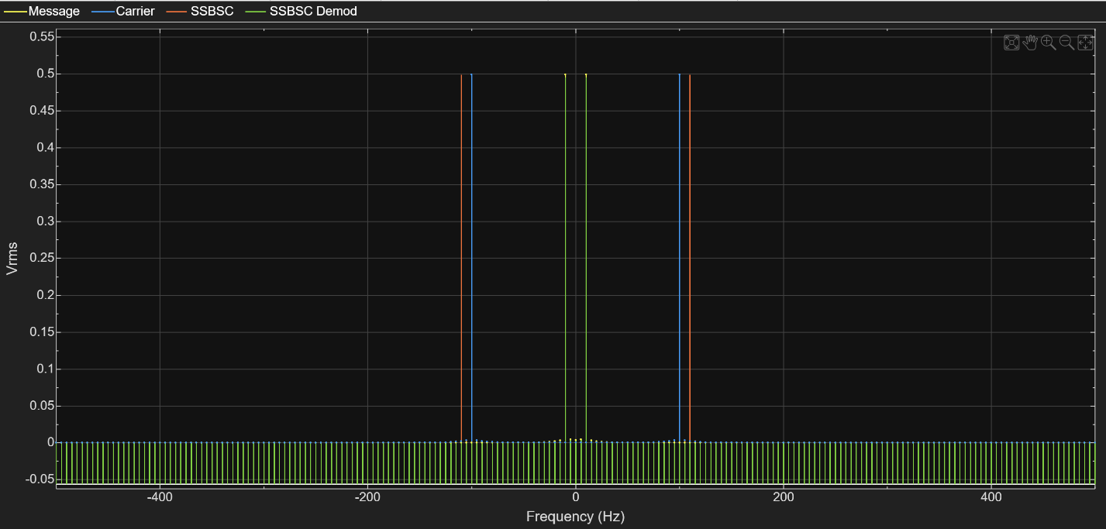
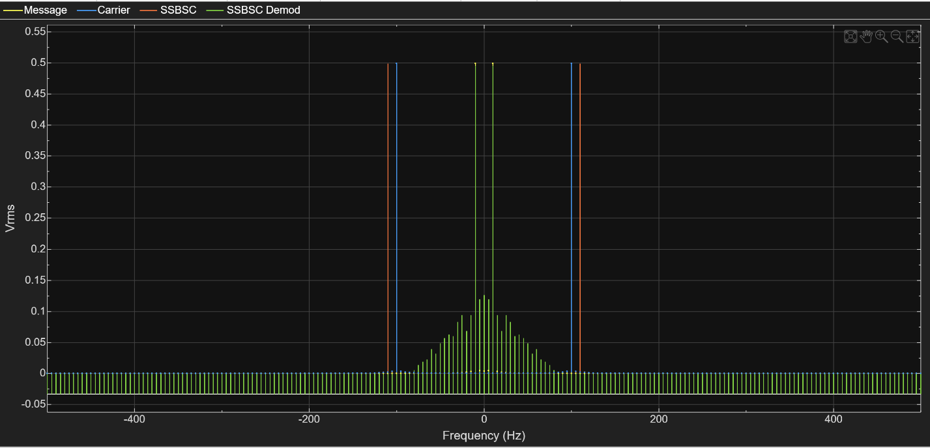

Task 4

AM – SNR

Power

Noise

No Noise
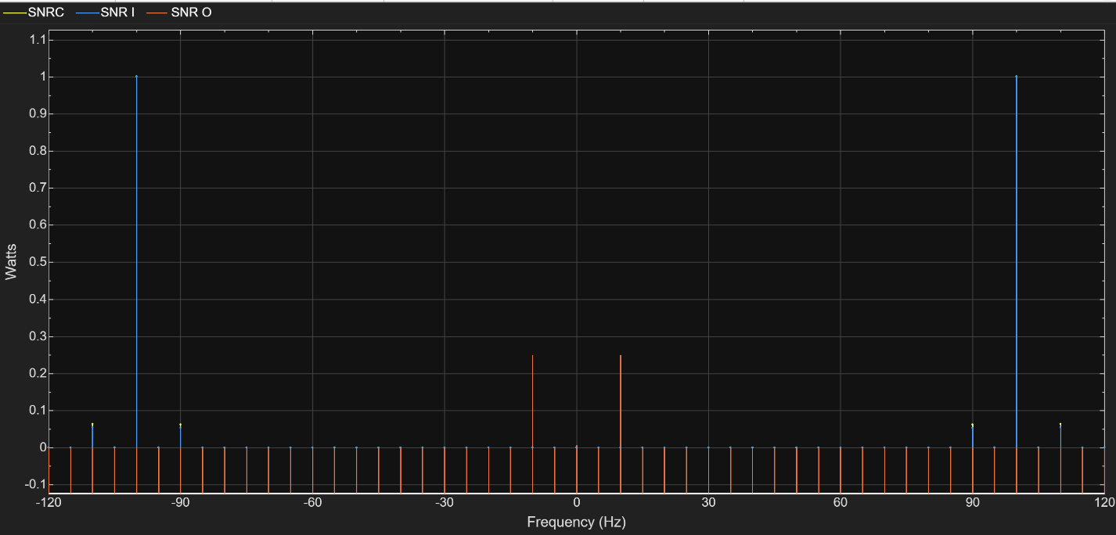

Power Density

Noise
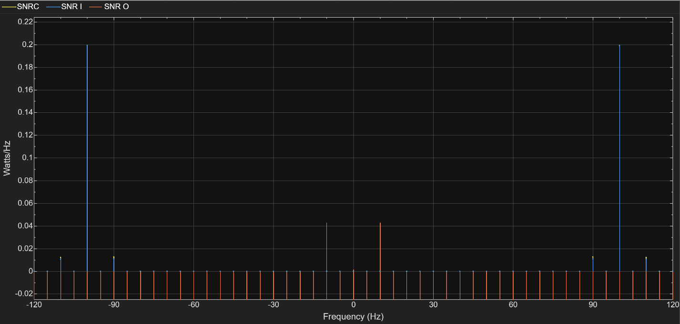

No Noise
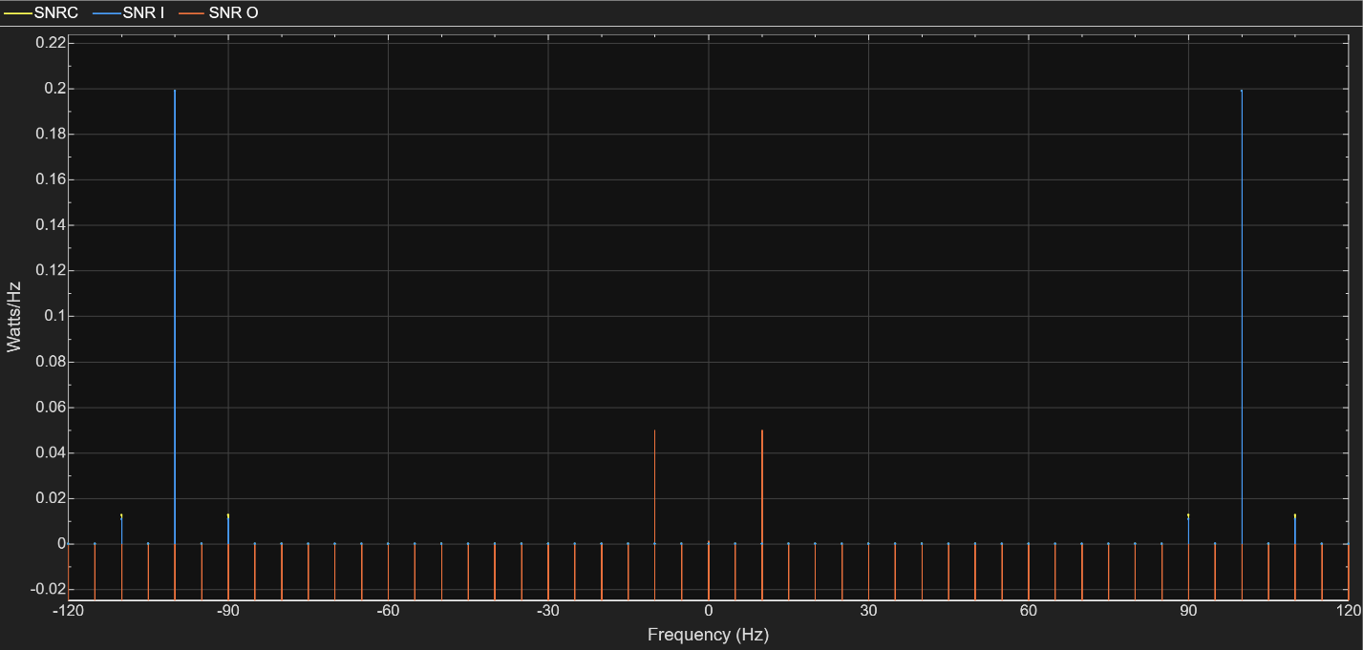

RMS

Noise
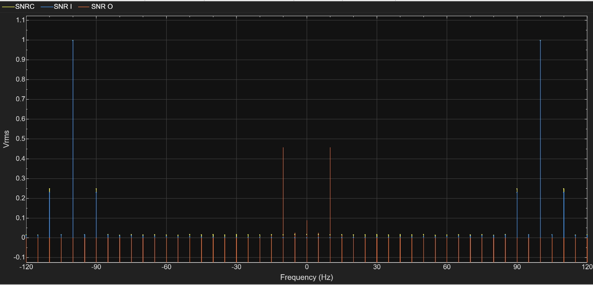

No Noise
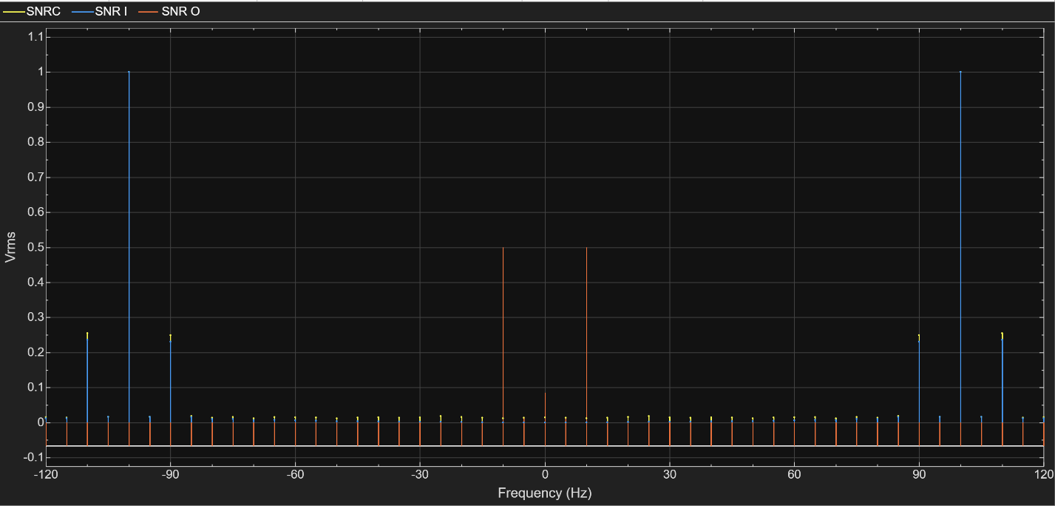

DSBSC - SNR

Power

Noise
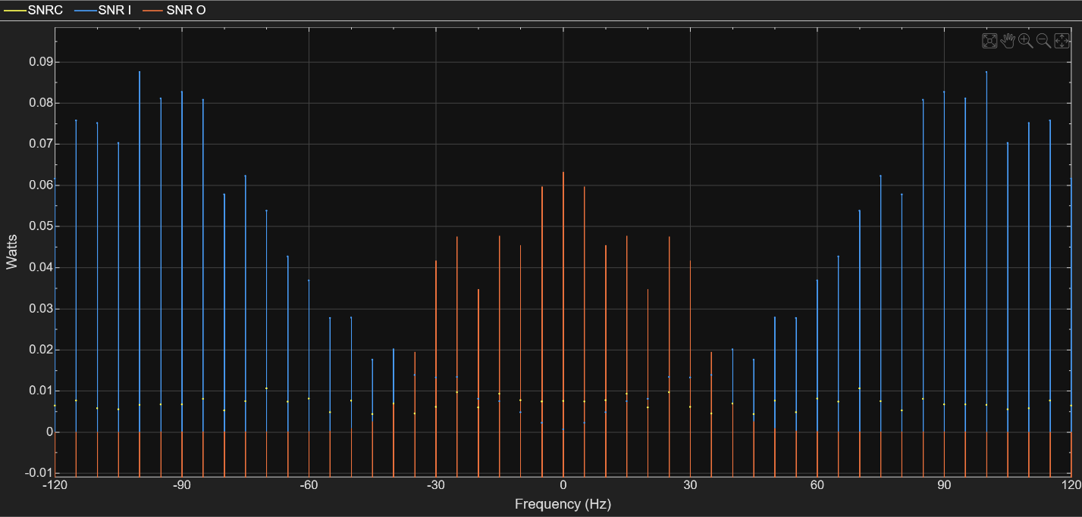

No Noise
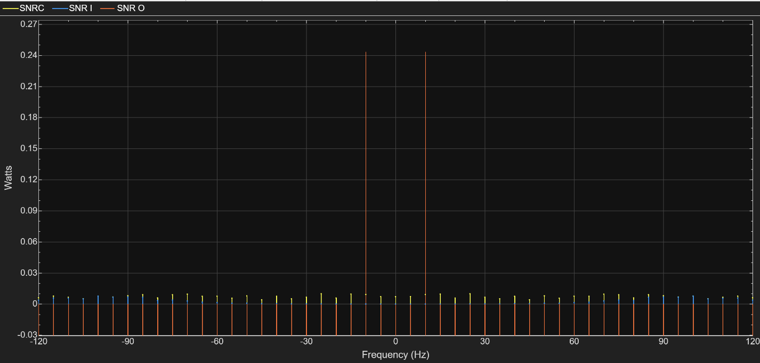

Power Density

Noise
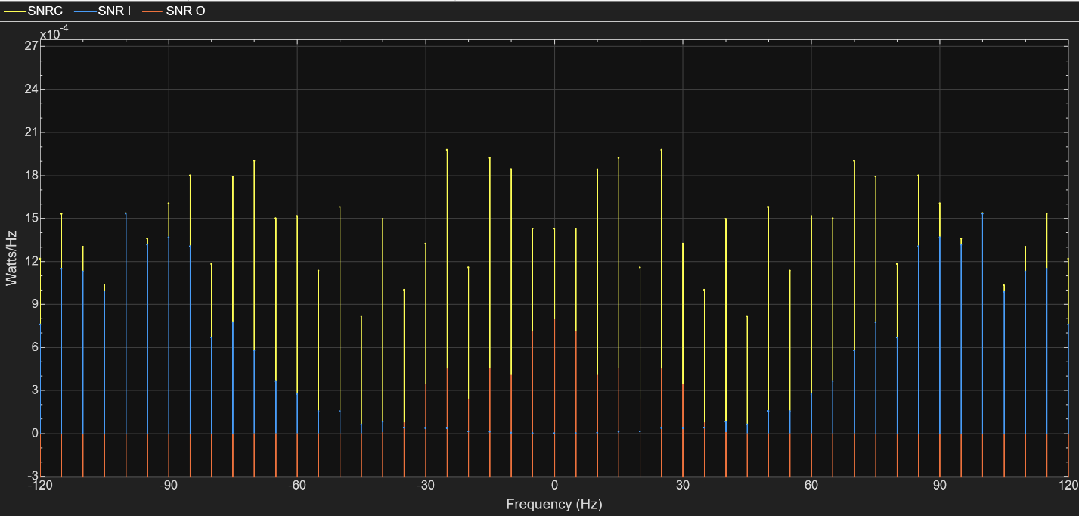

No Noise
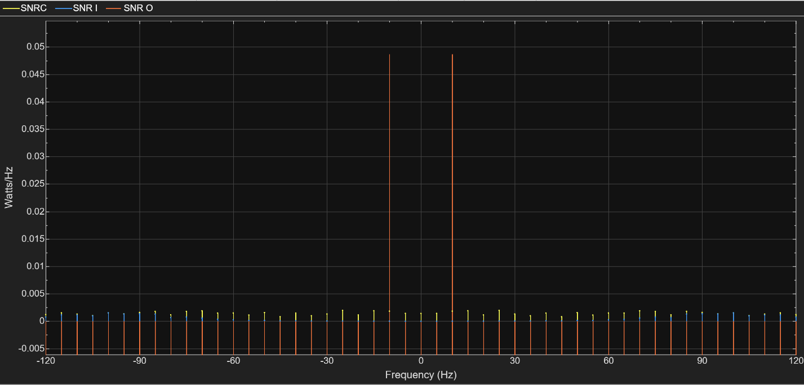

RMS

Noise
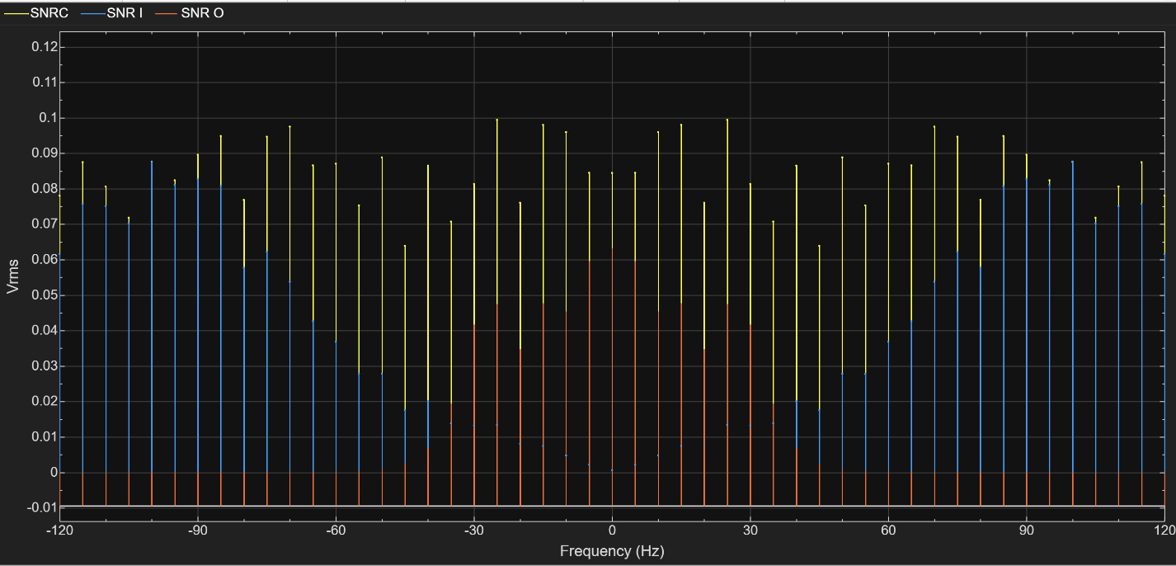

No Noise
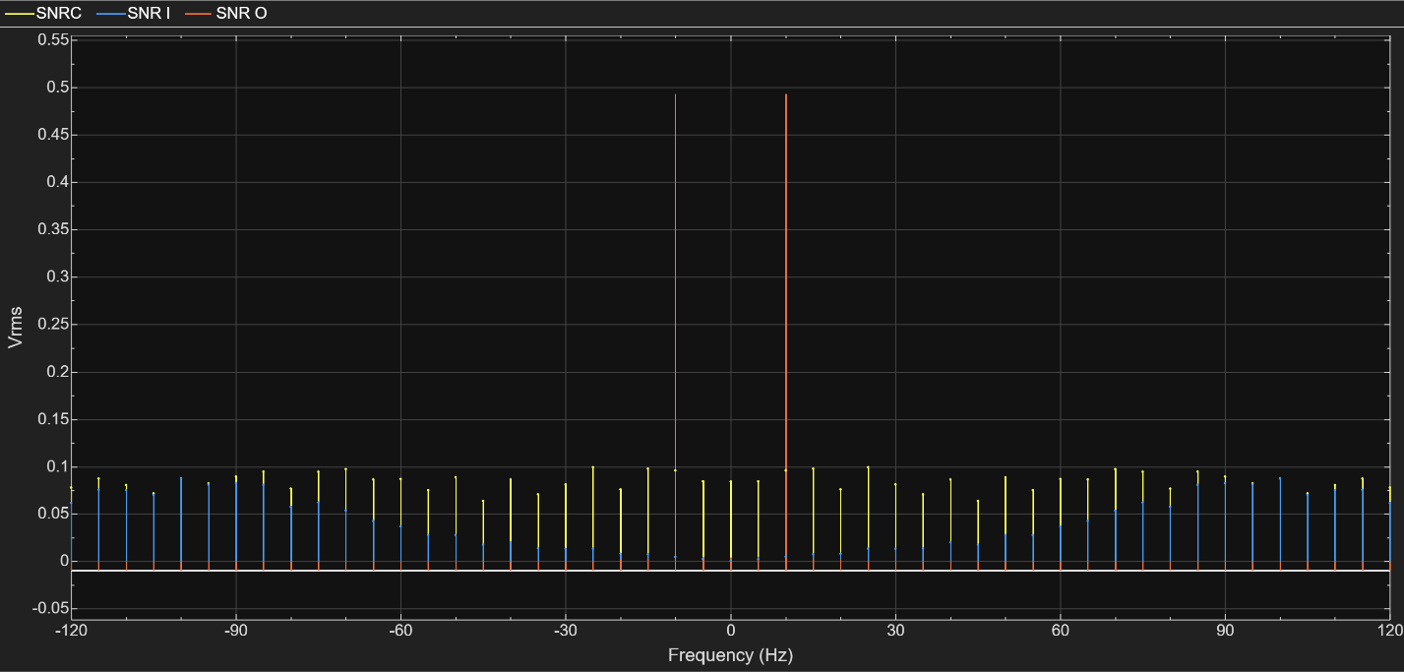

SSBSC – SNR

Power

Noise
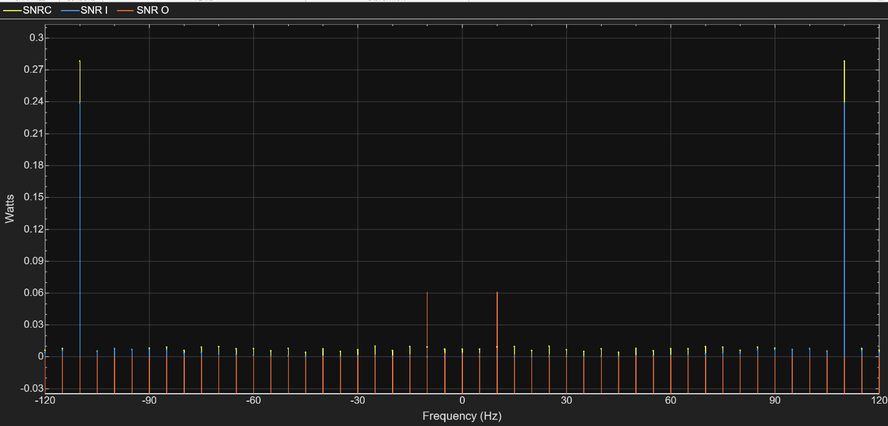

No Noise

Power Density

Noise
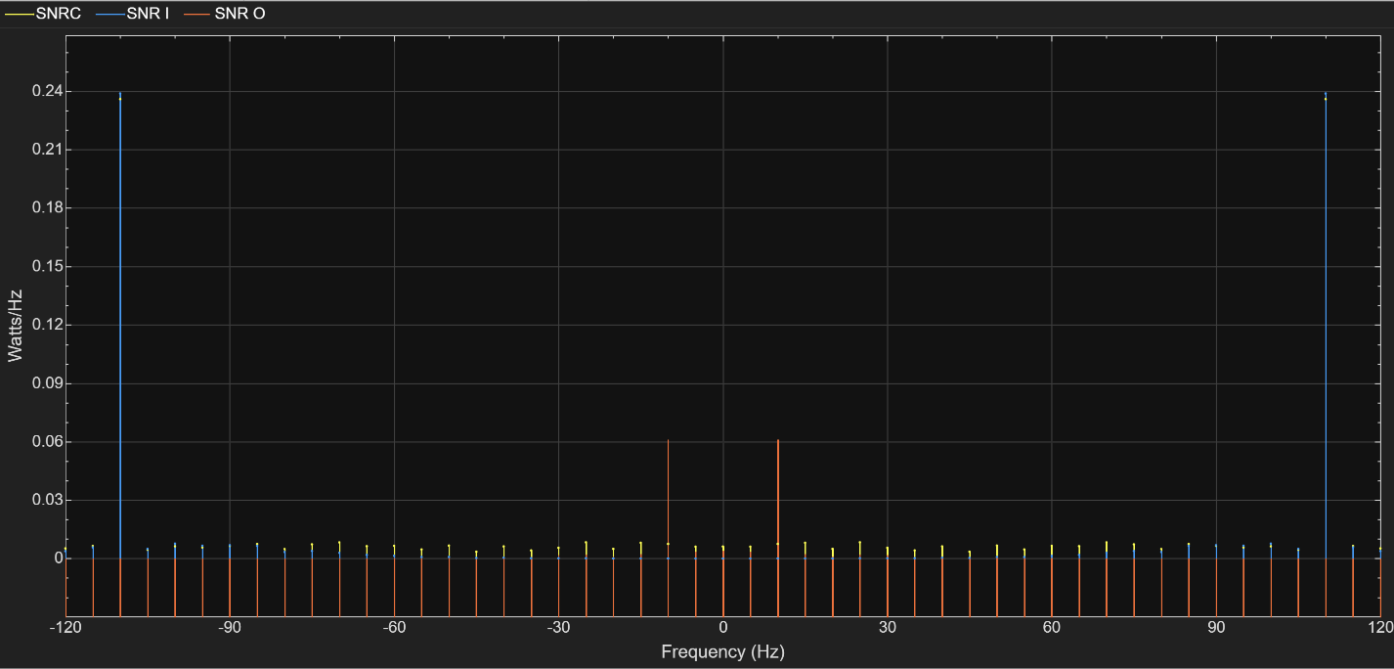

No Noise
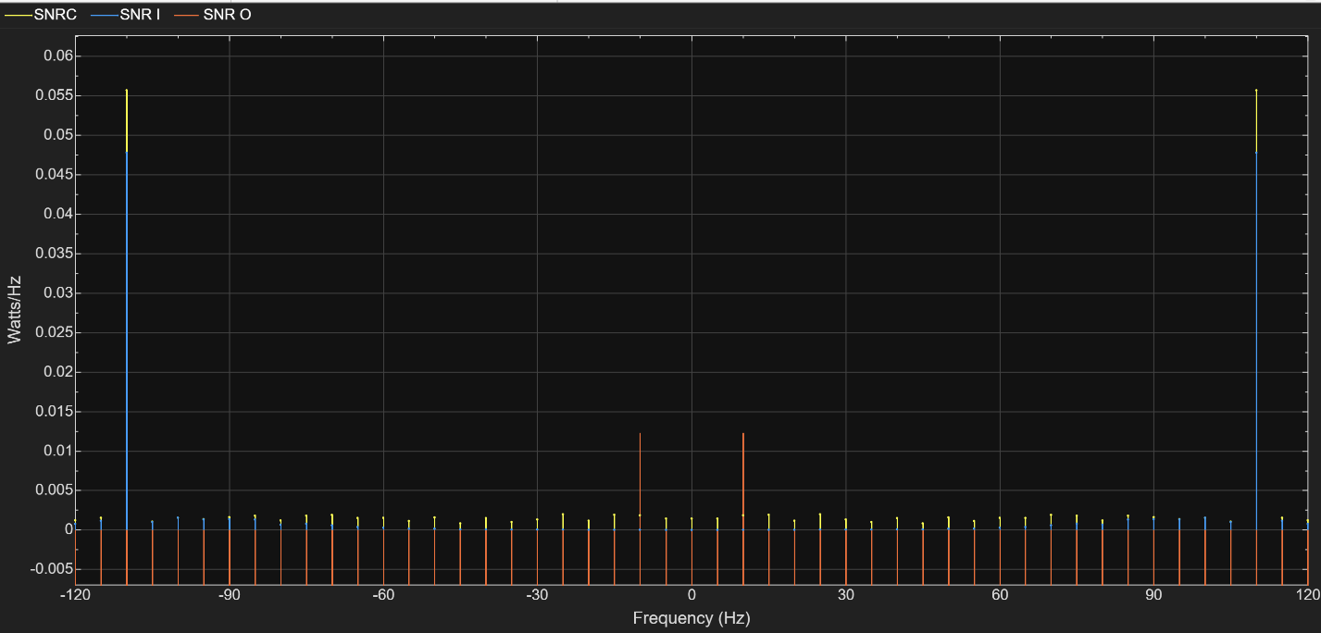

RMS

Noise
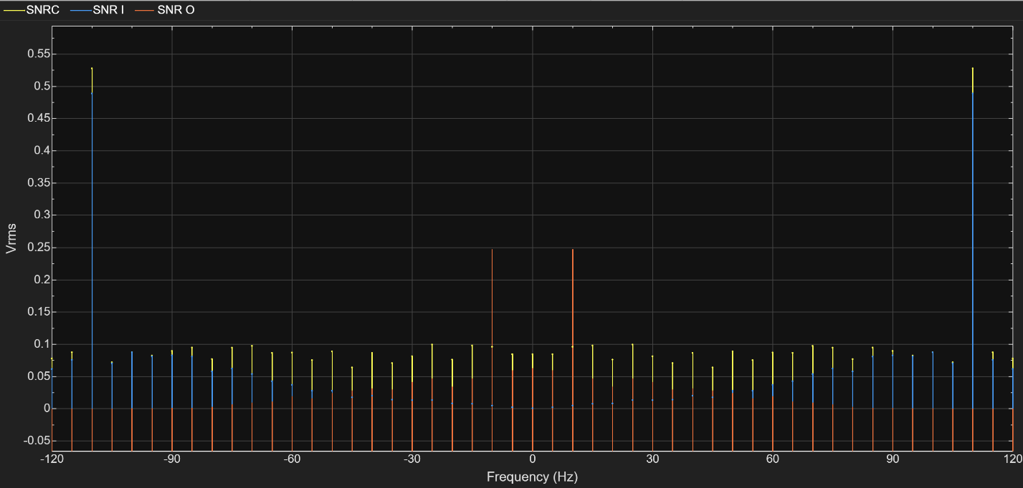

No Noise


