

(BMIH5003)
Cultural Awareness

Student Name: Mohammed Abdur Razzak
Student ID: 2215353
Lecturer Name: Heidi Prosser
Word Count: 1099
Assignment 2

Executive Summary
This report analyses Italy's cultural dynamics using the GLOBE Project and Hofstede's dimensions. Leadership at Diversity Hotel & Spa in Italy requires this insight. This emphasises the need for a management style that respects hierarchies, fosters teamwork, and balances charismatic and participatory leadership. The current hierarchy should be respected, team connections made, clear procedures created, a balance between competition and support struck, and inclusive decision-making encouraged to capitalise on Italy's cultural traits for commercial success.

Table of Contents
Executive Summary 2
Introduction 4
Main Body 5
An Overview of Italian Culture 5
Analysis of Italy 5
Hofstede's Analysis of the Country 8
Importance of Cultural Intelligence 8
Conclusion 9
Recommendations 10
References 11
Appendices 12

Introduction
To succeed in the increasingly globalised economic environment, one must possess cultural intelligence, which is the capacity to connect to and collaborate across cultural boundaries. It denotes an awareness of various cultural norms and values, facilitating sophisticated dialogue and decision-making (Christiansen et al., 2020). The general manager of our hotel in the vibrant centre of Italy has the task of understanding the subtle cultural differences in Italian customs and beliefs. To create leadership and operational strategies that are in line with the local culture and ensure a successful hospitality endeavour that honours the rich cultural diversity of this dynamic nation, this paper explores the insights provided by the GLOBE Project and Hofstede.

An Overview of Italian Culture
In Italy, a code of behaviour that prioritises warmth, close family relationships, and a love of life holds the fabric of society together. This Mediterranean nation places a high importance on civility and formal welcomes, which often include a firm handshake and a cordial "Buongiorno" (Good day) or "Buonasera" (Good evening), depending on the hour. Italians are passionate communicators, as shown by their energetic movements and expressive facial expressions; nonverbal clues are thus equally as important as spoken words (Barucci and Becheri, 2021). Despite being formal, the Italian corporate climate emphasises the value of interpersonal connections and trust.

Analysis of Italy
Culture Visualisation
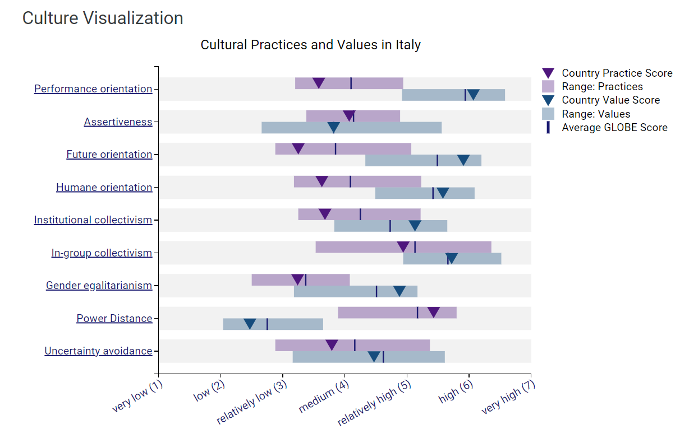
Figure 1: Culture Visualisation of Italy, Source: (Globe Project, 2023).
The cultural aspects of the GLOBE Project provide a profound understanding of Italy's social structure, which is essential for efficient leadership and management of the Diversity Hotel & Spa's new business. Italian practice scores show a moderate performance orientation (3.58), indicating that while they value quality and perfection, Italians also place a high value on their personal lives, which highlights the necessity for managers to be flexible with their expectations. The relatively neutral score of 4.07 for assertiveness suggests that the culture appreciates direct communication, but tempers it with deference and civility. The higher value score (5.91) demonstrates an ambitious vision towards future advancements and innovation, which might be leveraged in service standards and brand experience (Elik and Korcuk, 2018). The future orientation practice score (3.25) reflects a present-focused attitude.
Italy's higher value score (5.58) and practice score (3.63) for humane orientation suggest that while helpful and compassionate acts are appreciated, they may not be as common in daily operations, indicating a need for cultural enrichment within the hotel's service culture (Brandano and Crociata, 2022). The gender dynamics within the workforce may be impacted by a discrepancy between the ideal and the actual, as shown by a low gender egalitarianism practice score (3.24) compared to a higher value score (4.88). It is noteworthy that Italy has a high in-group collectivism practice (4.94), which indicates a strong desire for close-knit units. This suggests that unit cohesiveness should be emphasised in team-building exercises. Last but not least, a high power distance score in practice (5.43) indicates a hierarchical social structure; on the other hand, a low power distance score in value (2.47) indicates a hidden desire for flatter hierarchies, which general managers should take into account when choosing their leadership philosophies (Patuelli and Mussoni, 2019). The hotel's creative service initiatives benefit from relative comfort with ambiguity and change, as shown by the fact that uncertainty avoidance practises (3.70) are less apparent than the worldwide average.

Leadership Visualisation
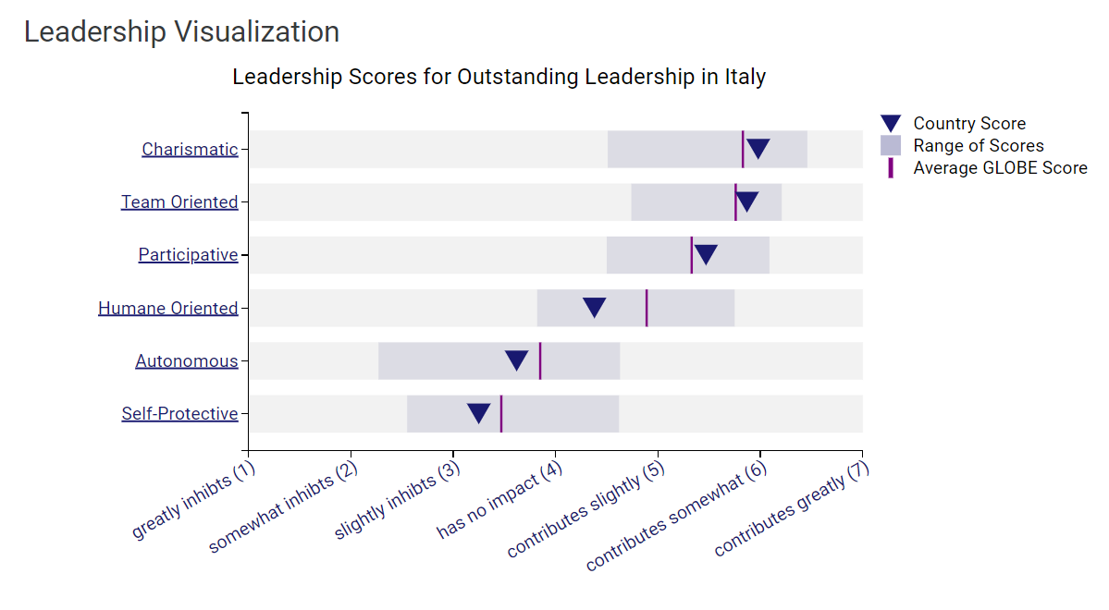
Figure 2: Leadership Visualisation of Italy, Source: (Globe Project, 2023).
The leadership landscape of Italy is well depicted by the GLOBE Project's leadership evaluation. With a score of 5.98, which is higher than the average GLOBE score, Italy has a strong affinity for charismatic leadership, indicating that Italian workers are likely to react favourably to self-assured and inspiring executives (Stolcke, 2022). Showcasing passion and vision might be beneficial for the general manager as it could inspire employees and improve hotel performance. Similar to this, Italy's high score of 5.87 for team-oriented leadership suggests a culture that rewards integrative and collaborative leaders. In actuality, the general manager needs to place a high priority on team building and cultivate a friendly atmosphere where workers feel appreciated for their services to the group. Italy's score of 5.47 in the participatory dimension is very noteworthy. It suggests that Italian workers value having a voice in decision-making processes since it is somewhat higher than the GLOBE average. To be consistent with this, the general manager needs to adopt a management approach that promotes staff involvement and group decision-making (Brandano and Crociata, 2022). Nonetheless, Italy's humane orientation score (4.38) is lower than the GLOBE average, indicating a decreased focus on caring and supportive leadership (Deresky, 2017).

Hofstede's Analysis of the Country
When Hofstede's cultural dimensions are applied to the study of Italy, it discovers a high Power Distance score, which suggests that hierarchical organisation and uneven power distribution are accepted by the society (Hofstede Insights, 2023). Due to Italy's low Individualism score which values good group cohesion and the hierarchy among the hotel personnel, it would seem appropriate for the General Manager to show respect for this hierarchy. Moreover, the high rate of uncertainty avoidance indicates a desire for ordered situations and explicit guidelines, which the hotel's operating processes have to take into account.

Importance of Cultural Intelligence
Cultural intelligence (CQ) is essential for Italian management to comprehend GLOBE Project outcomes. General Manager can navigate Italy's high in-group collectivism, which favours close-knit teams, and high power distance, which requires hierarchical sensitivity, with a high CQ. Italy values charismatic and team-oriented leadership, therefore managers must be flexible and responsive to employee preferences to create a pleasant workplace (Maheshkar and Sharma, 2018). CQ can help the management of the Italian cosmopolitan hotel increase worker cooperation and customer satisfaction by respecting local cultures and traditions. This will help the hotel retain its world-class status.

Conclusion
Accepting the cultural aspects of Italy opens the door to a smooth management practice integration into the hotel's operations. By prioritising charismatic leadership and adopting a collaborative approach, general management may optimise visitor experiences and create a devoted and devoted team (Abramson, and Moran, 2018). This report acts as a compass, directing the integration of Italian customs with international standards and creating an atmosphere where cultural intelligence is seen as the key to success.

Recommendations
The General Manager should:
- Embrace and respect the existing hierarchical order within the hotel's management structure.
- Enhance team cohesion through relationship-building activities and group-oriented incentives.
- Establish clear guidelines and protocols to align with Italy's high uncertainty avoidance.
- Balance competitiveness with a caring work environment, reflecting Italy's moderate masculinity index.
- Promote a participative approach in decision-making to engage the Italian preference for inclusivity.

References
- Abramson, N.R. and Moran, R. (2018). Managing Cultural Differences: Global Leadership for the 21st Century. 10th Ed. Abingdon: Routledge.
- Barucci, P. and Becheri, E. (2021). Tourism as a resource for developing southern Italy. Tourism Management, 11(3), pp.227–239. doi:https://doi.org/10.1016/0261-5177(90)90045-b.
- Brandano, M.G. and Crociata, A. (2022). Cohesion Policy, tourism and culture in Italy: a regional policy evaluation. Regional Studies, 29(11), pp.1–17. doi:https://doi.org/10.1080/00343404.2022.2106365.
- Christiansen, B., Branch, J.D. and Karmowska, J. (2020) Cultural Factors and Performance in 21st Century Businesses. Hershey: IGI Global.
- Crowne, K.A. (2020). Cultural exposure, emotional intelligence, and cultural intelligence. International Journal of Cross Cultural Management, 13(1), pp.5–22. doi:https://doi.org/10.1177/1470595812452633.
- Deresky, H. (2017) International Management: Managing Across Borders and Cultures: Text and Cases. 9th Ed. Harlow: Pearson Education Ltd.
- Elik, M. and Korcuk, Ü. (2018). The relationship between cultural diversity and cultural intelligence: a cross-cultural research. International Journal of Advanced Intelligence Paradigms, 1(1), p.1. doi:https://doi.org/10.1504/ijaip.2018.10019945.
- Globe Project (2023). Results - Italy GLOBE Project. [online] www.globeproject.com. Available at: https://globeproject.com/results/countries/ITA?menu=list#country.
- Hofstede Insights (2023). Hofstede Insights Italy. [online] www.hofstede-insights.com. Available at: https://www.hofstede-insights.com/country-office/italy.
- Maheshkar, C. and Sharma, V. (2018) Handbook of Research on Cross-Cultural Business Education. Hershey: IGI Global.
- Patuelli, R. and Mussoni, M. (2019). The effects of World Heritage Sites on domestic tourism: a spatial interaction model for Italy. Journal of Geographical Systems, [online] 15(3), pp.369–402. doi:https://doi.org/10.1007/s10109-013-0184-5.
- Stolcke, V. (2022). Talking Culture: New Boundaries, New Rhetorics of Exclusion in Europe. Current Anthropology, 36(1), pp.1–24. doi:https://doi.org/10.1086/204339.

Appendices
1. Cultural Visualisation Values of Italy
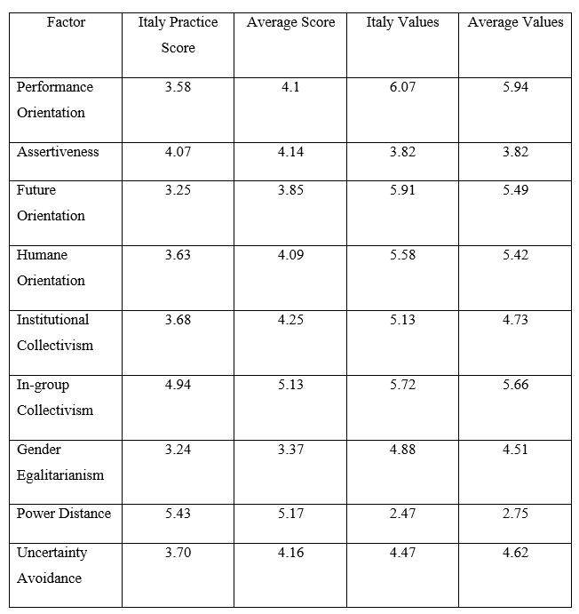
2. Leadership Values of Italy


