Title page
Student name: Mashud Ali
Student number: 1713109
Module: Emergent Leadership Skills for the workplace
Module code: BMSW6101
Assignment title: Portfolio – Task 2
Tutor name: Eric Osei
Date: 29.03.2021

Table of Contents
Part One
Introduction 3
Key Leadership Traits 4
Case Study Survey – The Leadership Traits of Ursula Burns 6
Gender stereotype 6
Challenges faced by female leaders 7
Solutions 8
Transformational leadership 10
Organisational performance 11
Relationship between transformational leadership and organisational performance 13
Conclusion 13

Part Two
Reflective Essay………………………………………………………………………………………………………………………… 13-15
References………………………………………………………………………………………………………………………………...16-18

Part 1: Case Study Analysis on Change Leadership

Introduction
Leadership means the ability of someone to help and direct others within their specific group towards reaching a certain aim.
Furthermore leadership is a great attribute for managers as they are required to ameliorate and better a company, allowing them to reach the goals that had been previously set.
A common misconception is that people within leadership roles were born with these attributes, however this is not the case, as leadership skills can be taught and picked up by individuals throughout the course of their lives.
There are particular traits and attributes which a leader must have to be effective within their role. These have been specified through multiple studies, which have shown that there are many different attributes which make a ‘good leader’. Out of these many attributes there are ‘key’ attributes which are mentioned within almost all of the research pieces; these are as follows:
1. Sociability
2. Confidence
3. Integrity
4. Charisma
5. Intelligence
6. Determination

Key Leadership Traits
  - Sociability
Sociability is the ability for a leader to maintain healthy social interactions with all team members.
It is vital for a leader to be sociable as they must be likeable, amiable and fair as well as having a good emotional intelligence. Furthermore a good leader will have an interpersonal expertise, which should be utilised in the company.
  - Confidence
Another common attribute amongst great leaders is confidence, as confidence allows a leader to be optimistic of his/her own capacity, as well as the team’s potential. Through a leader’s confidence, they will be able to encourage their team members towards reaching their aims, as well as providing determination which is much needed in certain situations.
One does not have to be born confident, but they can simply gain this attribute overtime through acknowledging their expectations and their own potential. This applies to an organisation as confidence as a whole within the company can be established over many days, months or even years.
For graduates, who are early within their career, a leader with confidence will aid in the development of their own confidence in terms of their current role, as well as their confidence when it comes to having to take the lead in specific circumstances.
  - Integrity
Another important attribute for great leaders is integrity, which is the quality of being honest and having strong morals.
A leader who has integrity will be able to display the moral thinking behind their decisions, ensuring their team members that the course of action they have chosen was not for self benefit, but for the benefit of the majority, and thus their team members will place faith and trust in their leader, which also improves their relationship. This would also encourage other team members to display integrity within their workplace.
Furthermore a leader with integrity would ensure to take accountability whenever they have made a mistake, as they would be honest about the situation, which in turn, inspires their subordinates to do the same.
  - Charisma
The fourth trait which an effective leader must have is charisma, which is the quality of being able to compellingly charm people. This certain ability would enable leaders to inspire and encourage others.
Charisma is an amazing quality to have, as long as it is used for positive purposes as an ill intentioned leader could utilise their charisma to compel others towards believing in and following a negative view. Leaders like this would be considered destructive as they would use their compelling charisma to manipulate others within their organisation for personal gain.
  - Intelligence
Intelligence is also a key trait amongst successful leaders, however this does not completely refer to intellect, but more-so thoughtfulness and the capability to comprehend complicated situations and make rational decisions based upon tough specific circumstances.
In order for a leader to remain effective and intelligent they must be aware of, and understand, all aspects their industry at all times.
  - Determination
Lastly an effective leader will need to be determined at all times. They must have certain aims and plans to achieve these goals. A method which a leader may use to ensure their goals are achieved could be setting milestones on the path to reaching an aim.
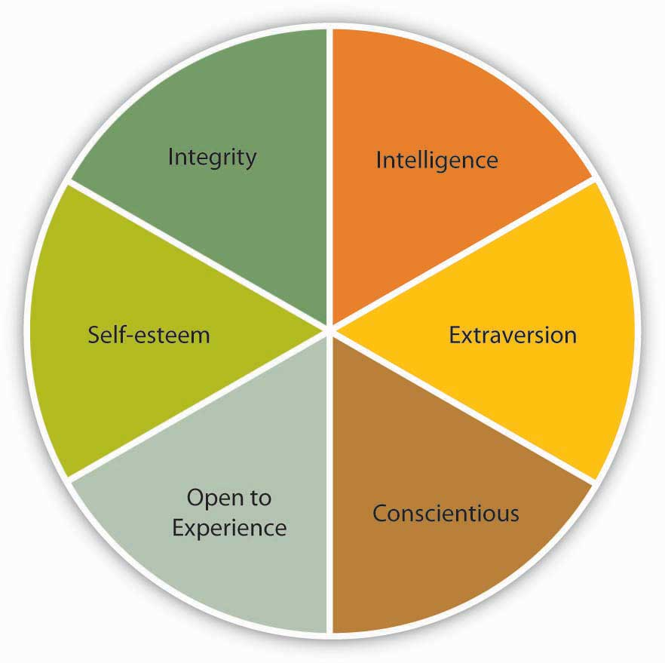
Furthermore the leader’s determination will be appreciated and reflected on their subordinates, inspiring them to also be determined towards achieving their goals.

Figure 1: Leadership Traits

Case Study Survey – The Leadership Traits of Ursula Burns

Ursula Burns is a very successful businesswoman who has mentioned that there are many different leadership traits which effective leaders have. She stated that a few of these are authenticity, the ability to vouch for one’s beliefs, as well as the acknowledgment that a good team is a necessary part of success.
Furthermore she stated that the main key leadership traits are integrity, charisma and confidence.
It has been said that throughout her career at Xerox, Ursula has vouched for, and requested for a better response from a co worker with a higher role, upon initially not receiving a satisfactory answer when she questioned why the company wasn’t very ethnically diverse. This act was recognised by the management board for Xerox which many argue built the foundation for her rapid success within the company as it was a clear show of integrity as well as her charisma and confidence.
Also her ability to encourage her team has led to the improvement in Xerox’s performance as a company.

Gender stereotype
A common problem within many businesses is the issue of gender stereotyping, which is when a person or a group of people are treated unequally due to their gender. It is often believed that only females can be discriminated against such as a lady being discriminated against in the workplace based on the stereotypical assumption that because an individual is a female, they would not be able to sufficiently commit to a demanding role, but men can also be discriminated against and it unfortunately happens quite often.


Figure 2: Gender Stereotype

Challenges faced by female leaders

Fighting gender stereotypes
There have been many studies on different opinions about how gender affects effectiveness, efficiency and success within leadership roles; one particular study in America found that society, in general, believed that the male gender were more effective and more likely to be successful within a leadership role. This study was carried out through asking members of the public about their opinions on the matter and the results revealed just how profound and common these stereotypes were within the western society.
Furthermore, in the study, the researcher asked members of their family, as well as close friends, about the certain traits they’d expect a successful leader to have and also if they thought gender played a part in how effective a leader was. It was found that ninety eight percent of the people who were asked believed that men had most of the traits necessary to be an effective and successful leader.

  - Females held to higher standards
Another study, relating gender and leadership, was carried out by PEW Research Centre which found that, between men and women in the workplace, females were held to higher standards in the sense that females would have to work harder and provide more for the company than men in order to be recognised and appreciated by co workers and managers.
Furthermore there are still many fields of work in which there are a significant amount less women employed than there are men, despite the number of females who have had the same level of education as male counterparts.

  - Managing many roles
In this day and age there is a societal structure for workplaces in which females leave their jobs to raise and care for children. This is beginning to change but females are currently still widely viewed and believed to be the main caregivers within a family.
Many females who wish to resume to their old work lives after having left the workplace for reasons such as maternity and parenting, often seem to find it extremely hard to adjust back into a working environment. There could be many reasons as to why this is the case such as the fact that the industry they work in could have changed over time or the responsibility of having to take care of their families as well as working is overwhelming.
Also there are deep rooted gender stereotypes which often affect women in a discriminative manner within companies as a lot of women receive less pay than male co-workers.
This gender discrimination applies to Ursula, who as a woman at Xerox must have had to deal with many issues in regard to gender stereotyping. This is because females are believed to be hysterical and too compassionate whereas males are viewed as dominant and able to control their emotions. These traits would be considered feminine, but Ursula managed to prove that through displaying such ‘feminine’ traits she could possess great emotional intelligence through being able to empathise with team members.
In addition to this, Ursula was rather young when she had achieved a substantial amount of success within Xerox and so many believed that she didn’t have enough experience. As well as this, many believed that due to her gender, she was not capable of great commitment towards a role as she was both a parent and spouse. Despite all of this negativity, Ursula managed to prove that these certain traits and attributes did not affect her performance at all.

Solutions
  - How to eliminate gender bias in the workplace
There has been research done in Europe that has shown some reasons as to why there is a gap in pay based on gender, relating to the number of hours worked and negotiation in salary, but there are also many ingrained stereotypes which explain this, such as many studies proving that the advice received from men within the workplace is more often utilised than advice which is given from a woman, as a lot of people believe that men usually know exactly what they are speaking about, whereas women do not.
This needs to be changed as it is clearly discriminatory behaviour and here are a few ways in which gender stereotypes could be eliminated within a business:

  - Transparency
It is vital for businesses to be transparent in regards to their pay and behaviour towards men and women within their workforce. An example of this is that in the UK it is a legal requirement for a business with over a certain amount of employees and turnover to publish information on the salaries of males and females to determine whether there is a difference in pay within their business due to the gender of employees.
  - Support women into more senior roles
Supporting females by aiding them in promotion to senior roles within a business should not be done in a way which could potentially have a negative effect on male counterparts. It should be done with the acknowledgment that women have the same capabilities of men and that not all leaders need to fit the basic stereotype of a dominant male leader, as many characteristics which are often deemed ‘feminine’ could be just as, if not more, effective than typical ‘male traits’.
  - Change the recruitment bias
A lot of the discrimination based on gender within the world of work often occurs in the recruitment stage due to gender stereotypes and bias. Removing this ingrained bias, possibly through blind interviews, would allow there to be a more equal and fair recruitment process.
  - Salary review
Another issue females face within the workplace is less pay for the same work as men. This is known as the ‘gender pay gap’ and since wages are not often openly discussed within a working environment, women do not have any comparisons of their salaries to male co workers. Therefore companies must aim to be more open and transparent in regards to the salaries that male and female employees receive, as well as ensuring that pay is equal for both genders when the same amount of work has been done.
  - Unconscious Bias Training
The issue of gender stereotyping can be dealt with, to some extent, immediately for current working generations, but it can be dealt with, in advance, to a much greater extent for future leaders. This can be done through educating young people on bias, discrimination and stereotyping, in order to prevent them from allowing deep rooted gender biases to affect their decisions as future leaders.
  - Diversify Management Teams
As mentioned before, many unfamiliar characteristics which certain leaders possess are similar and equivalent to the characteristics of a typical leader and so they offer a new outlook to management. Businesses should ensure that the management board of the company is diverse in terms of gender and ethnicities as this would aid in eliminating any bias when the management board are making decisions.
  - A Meritocratic Culture
Simply giving women equal pay, and just as many senior roles as their male co workers, will not be enough to provide complete gender equality. This is because there will still remain underlying gender biases if men are not educated on such matters.
There is not a single solution, such as providing equal pay for women that will be effective on its own towards achieving a gender neutral workplace, as an approach towards creating a gender neutral workplace would need to be holistic. An example of this is if a company began to promote more female workers to senior roles, then this by itself would not be enough to ensure a gender neutral workplace if the male employees within the workforce and senior roles were not educated about gender bias, as they would allow their gender bias to affect their decisions, hindering the process of promoting women to senior roles within the company.
In addition to this it is important to recognise that it is not only gender discrimination which occurs within the workplace, but it is also racial discrimination and bias which should also be taken very seriously.

Transformational leadership
Transformational leadership is a type of leadership in which a leader is an individual who has the ability to evoke determination in their team members and inspire them to think creatively, with the common aim of improving the performance and developing the company.
A leader who is considered to be transformational will have a certain management style which motivates team members to think independently and take accountability for their actions, as the team leader themselves will do this.
This is different to micromanagement, which a transformational leader will not do, as this can easily hinder innovation and independent thinking. A transformational leader would believe in the potential of their team members and thus will allow them to make their own decisions as opposed to micromanaging them.
Furthermore the leader will often show a mixture of the following traits:
.The ability to provide co workers with a work environment that possesses strong ethics.
. Sets reasonable aims for the company to achieve
.Encourages team members/co workers to speak up about their issues and any problems faced through open communication.
.Has a high moral understanding of situations which will be reflected on co-workers as they will also begin to share those strong morals
. The ability to motivate and inspire team members to work on self development
. Focusing towards a common aim for the organisation
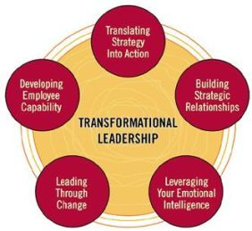

Figure 3: Transformational Leadership

Organisational performance
Organisational performance can be calculated by measuring the completion of all the aims set by the company. A key aspect of most organisations is the finances and so financial performance is very important for a business. Financial performance can be measured against the financial goals and expectations set by the company beforehand, to track the progress of the organisation.

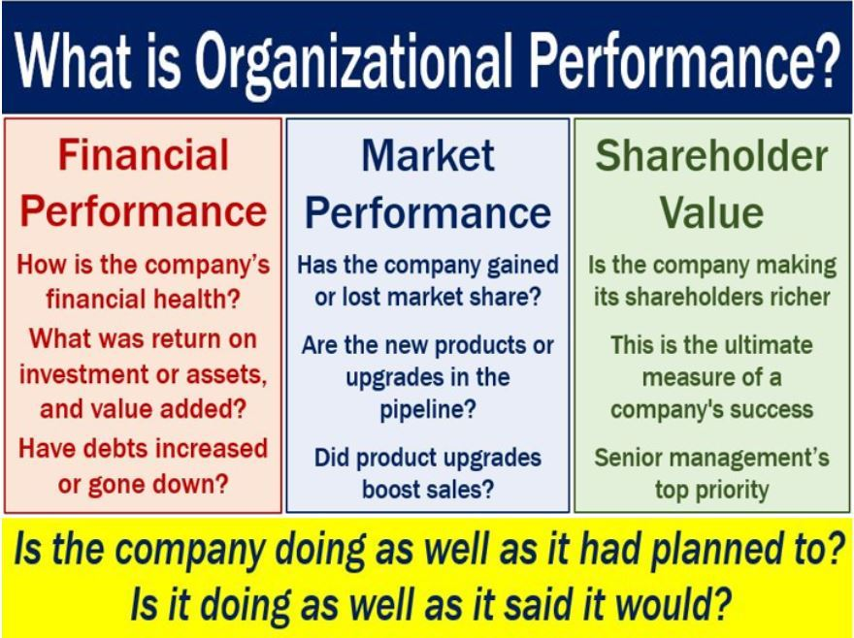
Figure 4: Organisational Performance
  - Financial Performance
The financial performance of a company refers to the company’s success in monetary terms, in other words, how well a business has performed in terms of earning revenue and deducting expenses to produce a final turnover.
Essentially the company’s financial performance will be a measure of the input money against the output money, compared to their expected earnings.
  - Market performance
Market performance will almost always vary from year to year for a business as it is the measure of how well an organisation is doing in comparison to similar organisations within the same market, and thus the same industry. When the performance of a specific product, such as the sales of a particular product, are compared to that of a similar product produced by another company within the same marketplace, this is called product market performance.
  - Shareholder value
Shareholder value is crucial to any company as a company is essentially owned by the shareholders, who usually will be paid through dividends varying from year to year due to the performance of the organisation. This means that a year in which a business performs well will see the shareholders paid a higher return than a year in which the business underperforms.

Relationship between transformational leadership and organisational performance

Ursula Burns will be considered a leader who is transformational as her traits have led to Xerox succeeding rapidly with her as the CEO.
Using Ursula Burns as evidence, it is proven that organisations with transformational leaders will have a higher performance as the leaders will set ambitious aims with milestones and aid their company in reaching those aims by providing a work environment with determined and respected employees. This is in contrast to companies in which the workers will do the bare minimum to receive their monthly wage.
A leader who is transformational will have high ambitions for the business and they will communicate with executives and subordinates to ensure that the goals will be reached. To conclude, there is a lot of evidence in favour of transformational leaders, suggesting that companies with transformational leaders tend to have higher success rates and better performance than those without.

Conclusion
The analysis of leadership characteristics, skills and management styles, shows that despite all research pieces not agreeing on the specifics of effective leadership, there are still many traits which effective leaders possess that can be taught, and so these traits do not have to be natural.
Furthermore the report shows that there are many societal gender stereotypes and biases which women face within the workplace. However this discrimination can be dealt with by educating employees within the workplace about equally valuing and treating females and acknowledging that effective leadership is not affected by the gender of the leader.

Part 2: Reflective Essay
This module has allowed me to explore and gain a deep understanding of my traits, leadership style, skills and orientation through analysing my own skill set and attributes as well as completing leadership tests and questionnaires. Through this analysis, I was able to identify my strengths and weaknesses, and the traits that I carried into my leadership style.
After completing an online test on leadership, I discovered that my three most significant leadership traits are confidence, honesty and communication.
As a confident leader, I envision a positive outcome, and believe I have the necessary skills to build a plan, find the resources and consistently deliver the desired results. I am open to calculated risks, confidently forging into the unknown, and learning from my mistakes. I believe confidence, being my strongest trait, has allowed me to be strong leader as my workplace and colleagues trust me and more willingly invest their time, energy and loyalty to ensure we all succeed.
Honesty is a strong trait of mine, I keep everyone abreast of what is going on within the organisation, whether god or bad, which is appreciated by my colleagues. This allows me to build trust and gain stronger support from them and allows the right solutions to be applied to resolve problems.
Communication is a key leadership function that I possess. I am a skilled communicator on an organisational level. I think with clarity, share information and express my ideas with a multitude of audiences. Being a good communicator means I must also be a good listener. Therefore I try to gain a clear understanding of other’s perspectives and their knowledge.
The three traits I mentioned above have benefitted me in multiple ways, however I have faced a few negative situations due to these. My confidence has sometimes been perceived as overconfidence by my peers, which has led to an awkward and tense workplace environment. I am trying to correct this situation by being more aware of my peers and how my behaviours are affecting them, as individuals and as a team.
As part of our module, I took a self assessment questionnaire to identify my leadership style. The result showed that I had aspects and traits that both a democratic and authoritarian leader has. I display authoritarian leadership when there are tight deadlines that must be met, therefore I take full control of the team and assign roles, tasks and make the final decision to ensure success. On the other hand, I display democratic leadership when there is a little more flexibility in workload and time. This gives myself and my peers the freedom to input our own thoughts and ideas and work with each other collaboratively.
As always, there are advantages and disadvantages of both authoritarian and democratic leadership. An advantage of authoritarian leadership is that it creates consistent results as there is little to no change made in the structure, planning and execution of work, therefore ensuring the results are consistent. Another advantage is that the high level of intensity of work reduces the time needed to make decisions and to complete tasks. This means that staff work at a quicker pace and can do more work in a shorter period of time. However this is also a disadvantage as all the pressure falls on the leader and staff may overwork themselves and burnout, leading to a collapse in the whole team, which can cause a huge negative impact to a team.
An advantage of democratic leadership is that it encourages strong team relationships and encourages individuals and team members to participate in sharing their thoughts and ideas. In doing so, the group or organisation has a broader opinion and wider options on decision making and ensures there is a more pleasant workplace environment. Disadvantages of democratic leadership are that it can lead to procrastination and takes time to reach a consensus. Instead of making a decision, leaders will refer to their team for ideas, even when there is not enough time to do so. Because everyone is permitted the chance to voice an opinion, ideas must be thoroughly discussed which can lead to delays in productivity as everyone attempts to find the best possible solution.
A further test I took part in determined that my orientation of leadership is people-orientated. I seek to build relationships with my fellow staff and subordinates. My focus on employee relationships makes employees feel appreciated and ensures that they know they make a difference in the company. This is an advantage of people orientated leadership as more effective efforts come from people who feel and know that they are part of the team or organisation’s success. On the other hand, a disadvantage of people orientated leadership is that ineffective decisions may be made if too much focus is put leader and team relationships rather than important decisions that need to be made for the organisation. Deadlines may not be met and tasks may not be completed to an adequate level.
The various tests and questionnaires I undertook during this module and on my own accord have helped me to gain a deeper understanding of my own leadership style, traits, skills and orientation. This has allowed me to identify my strengths and weaknesses, as well as compare the advantages and disadvantages, in all aspects of leadership. After this analysis, I can now improve by trying to assess the environment I am in before choosing an authoritarian or democratic style of leader ship. I can further improve by trying to be a little more task orientated to ensure that all tasks are completed to a good standard and that all work is dome in a timely manner.

References

admin (n.d.). Transformational Leadership and Organizational Performance – BUMBLEPHONE. [online] Available at: https://bumblephone.com/transformational-leadership/transformational-leadership-and-organizational-performance-2550/ [Accessed 22 March. 2021].
Career Stint. (2011). How Important are Conceptual Skills in the Management Scenario. [online] Available at: https://careerstint.com/conceptual-skills. [Accessed 24 March. 2021].
Center for Creative Leadership. (n.d.). How to Build Trust on Your Team. [online] Available at: https://www.ccl.org/articles/leading-effectively-articles/build-trust-in-the-workplace/.[Accessed 22 March. 2021].
Cherry, K. (2020). Transformational Leadership. [online] Verywell Mind. Available at: https://www.verywellmind.com/what-is-transformational-leadership-2795313.
Corporate Finance Institute. (2019). Leadership Traits - List of Top Qualities of an Effective Leader. [online] Available at: https://corporatefinanceinstitute.com/resources/careers/soft-skills/leadership-traits-list/.[Accessed 25 March. 2021].
Gaille, B. (2013). Xerox CEO Ursula Burns’ Leadership Style and Traits. [online] BrandonGaille.com. Available at: https://brandongaille.com/xerox-ceo-ursula-burns-leadership-style-and-traits/.[Accessed 22 March. 2021].
http://www.facebook.com/CarolineKennedyAU (2018). 5 Biggest Challenges Women Leaders Face and How to Overcome Them - Empowering Ambitious Women. [online] Empowering Ambitious Women. Available at: https://www.empoweringambitiouswomen.com/5-biggest-challenges-women-leaders-face-and-how-to-overcome-them/.[Accessed 26 March. 2021].
IMD business school. (2019). Leadership styles: Understanding and developing leadership styles. [online] Available at: https://www.imd.org/hpl/leadership-reflections/leadership-styles/.[Accessed 27. March 2021].
Investopedia. (2019). How to Improve Your Leadership Skills. [online] Available at: https://www.investopedia.com/articles/pf/12/leadership-skils.asp. [Accessed 26 March. 2021].
Jangsiriwattana, T. (2019). The Relationship Between Transformational and Transactional Leadership: Employee Perceptions of Organizational Performance And Work Engagement. Journal of the International Academy for Case Studies. [online] Available at: https://www.abacademies.org/articles/the-relationship-between-transformational-and-transactional-leadership-employee-perceptions-of-organizational-performance-and-work-8587.html [Accessed 26 March. 2021].
https://www.facebook.com/adamenfroydotcom (2019). 11 Leadership Qualities: A List of Skills To Make A Great Leader (2019). [online] Adam Enfroy. Available at: https://www.adamenfroy.com/leadership-qualities.
London Business School. (n.d.). Leading the way: Ursula Burns. [online] Available at: https://www.london.edu/think/leading-the-way-ursula-burns [Accessed 27 March. 2021].
Mindtools.com. (2009). Leadership StylesChoosing the Right Approach for the Situation. [online] Available at: https://www.mindtools.com/pages/article/newLDR_84.htm. [Accessed 22 March. 2021].
Niagara Center. (2019). Link Between Transformational Leadership and Organizational Performance Essay - Free Dessertations For Srudents. [online] Available at: https://niagarafallshypnosiscenter.com/link-between-transformational-leadership-and-organizational-performance/ [Accessed 23 March. 2021].
Nordqvist, C. (2017). Organizational performance - definition and... [online] Market Business News. Available at: https://marketbusinessnews.com/financial-glossary/organizational-performance-definition-meaning/.[Accessed 23. March 2021].
premratan (2019). What are characteristics of Transactional leadership. [online] PloPdo. Available at: https://plopdo.com/2019/01/07/what-are-characteristics-of-transactional-leadership/ [Accessed 25 March. 2021].
Ward, S. (2007). Leadership Definition. [online] The Balance Small Business. Available at: https://www.thebalancesmb.com/leadership-definition-2948275. [Accessed 24 March. 2021].
White, S.K. (2018). What is transformational leadership? A model for sparking innovation. [online] CIO. Available at: https://www.cio.com/article/3257184/what-is-transformational-leadership-a-model-for-motivating-innovation.html. [Accessed 23 March. 2021].
www.newyorkcitydiscriminationlawyer.com. (n.d.). What is Gender Discrimination in the Workplace? | New York City Employment Lawyers. [online] Available at: https://www.newyorkcitydiscriminationlawyer.com/what-is-gender-discrimination-in-the-workplace.html [Accessed 27 March. 2021].
Yale Insights. (2018). How Do You Change a Successful Company? [online] Available at: https://insights.som.yale.edu/insights/how-do-you-change-successful-company. [Accessed 24 March. 2021].
https://www.facebook.com/adamenfroydotcom (2019). 11 Leadership Qualities: A List of Skills To Make A Great Leader (2019). [online] Adam Enfroy. Available at: https://www.adamenfroy.com/leadership-qualities.

