Module name: Foreign Languages and Cultural Awareness
Module code: BMIH5003
Assignment: 2
Student name: Klaudia Modrzejewska
Student ID: 2243846

Table of Contents
Introduction 3
Outlining key differences between England and Switzerland 4
Analysing and comparing two countries using the GLOBE Project’s culture and leadership study 5
Discuss the challenges of intercultural leadership in the hospitality industry 8
Conclusion 9
References 10

Introduction
Handling multinational businesses in a border industry like hospitality explains the importance of developing cultural languages by understanding gaps. The following report will evaluate cultural elements and differences between England and Switzerland as some hotel employees from Switzerland’s branch have newly joined a multinational hotel and spa in London. It will include a leadership study and challenges of intercultural leadership.

Outlining key differences between England and Switzerland
Cultures in organisational settings can influence how people think and behave with their values, beliefs and attitudes. In order to join the London branch of the multinational hotel from Switzerland’s headquarters and manage all people with the same approach, understanding differences of cultures is a must.
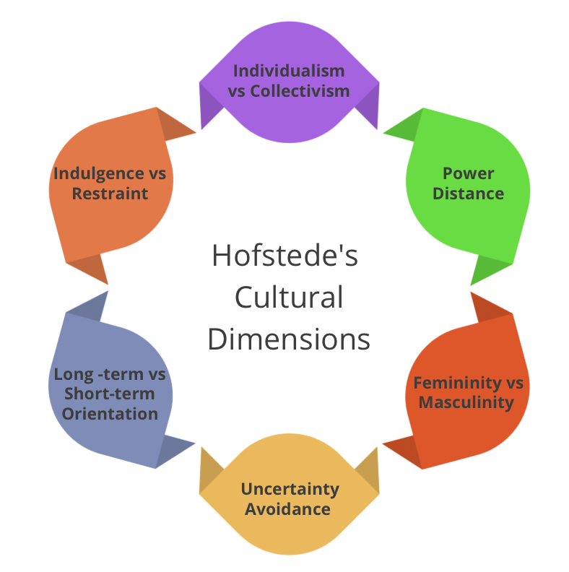
Figure 1: Hofstede's Cultural Dimensions Framework
(Source: Gerlach and Eriksson, 2021)
Here Hofstede's Cultural Dimensions Theory can be analysed with its six dimensions of cultures. In power distance, the strength of social hierarchy is maintained and both of these cultures have a low level here that explains social power is distributed equally and provides choices for all (Gerlach and Eriksson, 2021). Both of these countries have a priority for individualism focusing on individual skills and capabilities. The motivational aspect is a little higher in Switzerland than in England which explains that employees from Switzerland can feel a little demotivated without proper support and resources (Abramson and Moran, 2018).
Uncertainty avoidance is lower in England than in Switzerland which means that employees from Switzerland are able to tackle uncertainties or unpredictable situations more strongly which is favourable for managers to guide them in new working environments (Christiansen et al., 2020). Long-term orientation is higher in England than in Switzerland which explains employees from Switzerland can expect more about small-term goals and success which need to be developed into high values. The indulgence index is relatively equal in both of these countries and a little higher in England which can influence employees of the London branch to celebrate their natural human drives by enjoying lives and having fun with a sense of greater work-life balance (Gerlach and Eriksson, 2021). Additionally, the workforce in the England culture follows a much more diversified setting with supporting each other.

Analysing and comparing two countries using the GLOBE Project’s culture and leadership study
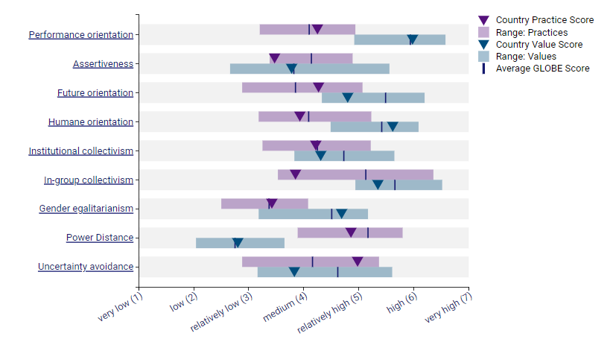
Figure 2: Cultural Practices and Values in Switzerland
(Source: GLOBE, 2020)
Globe project’s cultures and leadership study is related to the project which is research and offers international management strategies with a broader analysis. Through the study, the manager can develop and evaluate how effectively they can handle cultural and leadership strategies for both employees from Switzerland and England (Abramson and Moran, 2018).
Based on the study of Global Project, cultural practices are related to some elements such as performance orientation in which Switzerland has a medium score of 4.25 and in future orientation and institutional orientation the score of Switzerland has a score of 4.27 and 4.22 respectively which explains people from Switzerland are medium focused in collective encourages, future-oriented behaviours or any collective action (GLOBE, 2020). With scores of 4.86 and 4.98 in power distance and uncertainty avoidance, Switzerland’s relatively high engagement in social aspects by handling uncertain situations is clearly defined (Christiansen et al., 2020). It has a low score of 3.46 in assertiveness which explains its aggressiveness in any relationship and also does not minimise any gender gap with a score of 3.42 in gender egalitarianism (GLOBE, 2020). Human orientation and in-group orientation are relatively low for this country with 3.93 and 3.42 scores which explains its negative approach to working equally and enjoying individual authority.
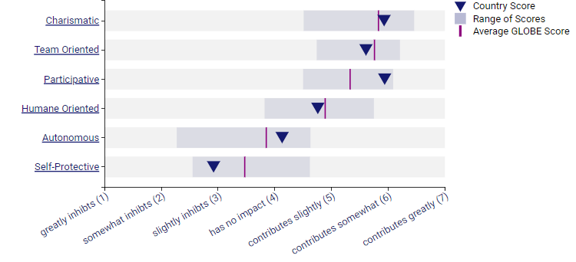
Figure 3: Leadership Scores in Switzerland
(Source: GLOBE, 2020)
In the leadership study of Switzerland, the ability to inspire or motivate people with a charismatic approach is relatively high with a 5.9 score. Additionally, team orientation and participative nature influenced by leadership are also relatively high (Maheshkar and Sharma, 2018). Here medium-range leaders support employees and also compare in independent and individualistic ways (GLOBE, 2020). Protection for individuals in a team with safety is relatively low with a score of 2.94 in self-protective nature.
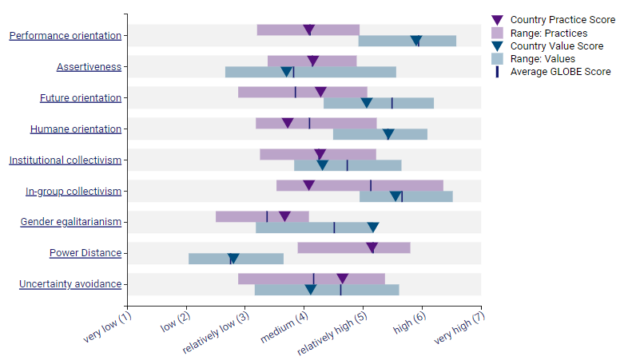
Figure 4: Cultural Practices and Values in England
(Source: GLOBE, 2020)
In England’s cultural elements, performance orientation, assertiveness and future orientation are medium with 4.08, 4.15 and 4.28 scores (GLOBE, 2020). It explains England also has a medium focus on these paths and aggressiveness is higher here than in Switzerland. Humane orientation is relatively lower than the other countries with a 3.73 score and encouragement for organisation is slightly higher here with a score of 4.27 (Maheshkar and Sharma, 2018). Group support and gender egalitarianism have a score of 4.08 and 3.67 which is slightly higher than Switzerland which explains a slightly higher focus on these paths (GLOBE, 2020). England maintains a high social hierarchy with a 5.15 score. Additionally, in uncertainty avoidance, a 4.65 score explains a relatively lower power than Switzerland to handle changes and uncertainties.
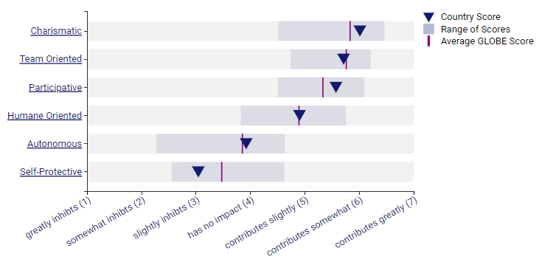
Figure 5: Leadership Scores in England
(Source: GLOBE, 2020)
In the leadership study in England, the charismatic approach is higher than in Switzerland with a 6.01 score and team orientation or participative aspects are relatively similar with 5.71 and 5.57 scores. Humane orientation has a 4.9 score which is relatively lower than Switzerland (GLOBE, 2020). However, the autonomous and self-protection score of England is relatively higher than Switzerland which explains that leaders are more independent and protective of individuals in England (Gerlach and Eriksson, 2021).

Discuss the challenges of intercultural leadership in the hospitality industry
In the hospitality practices for the multinational company in London managing staff from Switzerland can face different paths such as language barriers as both countries have different practices and communication types and handling global customers with similar training and resources can be difficult for the leaders. It also includes cultural norms from which misunderstandings between staff and leaders can occur (Maheshkar and Sharma, 2018). Additionally, managers can face issues in aligning organisational objectives with individual needs. As previously analysed slight differences in leadership elements between Switzerland and England; thus, handling leadership expectations from both cultural staffs in the London brand can be difficult for the manager (Abramson and Moran, 2018). A sudden change in time zones and social aspects can also affect the way new staff from Switzerland operate their entire activities and can make differences in outcomes which can impact overall hospitality service. Here the differences in attitude towards the hierarchy and the importance of work-life balance can create a little difficulty in handling cross-cultural people in a specific leadership setting in the organisation (Christiansen et al., 2020). Developed communication and feedback generation with continuous learning and training practices can reduce these issues for the new leadership role and development of the multinational hospitality company.

Conclusion
The conducted assignment was based on developing cultural awareness and leadership study of two different countries Switzerland and England. It can help the management and leader in a new business approach of shifting staff from a multinational hotel company’s headquarters in Switzerland to a London branch. Different elements of culture and leadership have been discussed here with Hofstede's Cultural Dimensions model and Globe project’s aspects by reflecting different channels.

References
Abramson, N.R. and Moran, R. 2018. Managing Cultural Differences: Global Leadership for the 21st Century. 10th Ed. Abingdon: Routledge.
Christiansen, B., Branch, J.D. and Karmowska, J. 2020. Cultural Factors and Performance in 21st Century Businesses. Hershey: IGI Global.
Gerlach, P. and Eriksson, K., 2021. Measuring cultural dimensions: external validity and internal consistency of Hofstede's VSM 2013 Scales. Frontiers in Psychology, 12, p.662604.
GLOBE, 2020. A unique large-scale study of cultural practices, leadership ideals, and generalized and interpersonal trust in 150 countries in collaboration with nearly 500 researchers. [Online] Available at:<https://globeproject.com/results/countries/CHE%3Fmenu=list.html#list> [Accessed on: 30th May].
Maheshkar, C. and Sharma, V. 2018. Handbook of Research on Cross-Cultural Business Education. Hershey: IGI Global.

