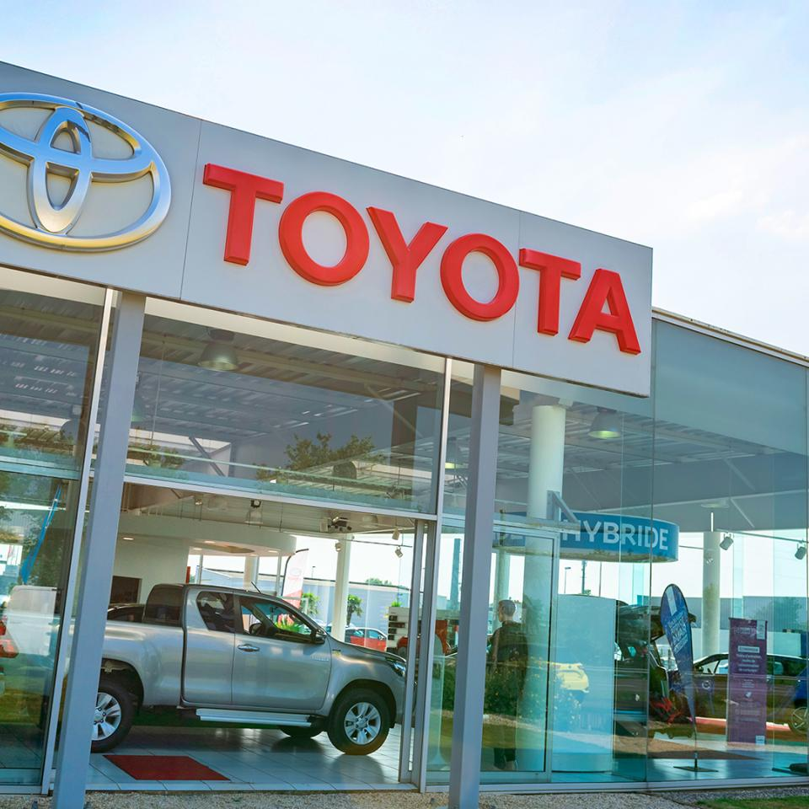

BMSK5002: Developing Relationships and Workplace Achievement

student name: nazia bi

student number: 1710512

lecture Name: doreen Nyaa amundam

Group 3
Table of Contents
Introduction 1
Individual development needs in Organisational context 1
Development Vehicles 3
Employee Engagement 3
Performance Management 4
Training and Development 5
Potential Benefits of the Development Vehicles 6
Benefits of Employee Engagement 7
Benefits of Performance Management 7
Benefits of Training and Development 9
Development Plan for Toyota Motor Corporation 9
Conclusion 11
References 12

Introduction
Recent globalisation trends and rapid changes in the technology and information management systems, have greatly impacted the work life management of people. Employees now have to ensure greater performance standards and engage in continuous improvement trends in order to ensure sustainability of the overall organisational processes and systems. Individual development needs for different organisational processes is vital to accomplish the organisational goals and objectives. Working as in the Toyota Motor Corporation UK, has enabled me to understand the core perspectives of the individual development needs within the organisational criteria in different perspectives. In order to meet the constant challenges of the professional roles and responsibilities, individual seek to develop own understanding and development criteria to meet the development goals in order to meet the challenges in different organisational scenarios. In order to acknowledge the organisational needs for individual support for the development goals, three development vehicles have been identified in the presented case. These three development vehicles are employee engagement, training and development and performance management in different contexts. To develop an effective development plan, this is necessary to identify the unique development needs for the employees in different organisational criteria. In this report, the perspectives related with the individual development goals and development vehicles such as performance management, employee engagement and training and development have been analysed in relation with the organisational perspectives of Toyota Motor Corporation UK.

Individual development needs in Organisational context
In different organisational perspectives, the abilities to develop and adapt with the organisational processes have become an important factor in today’s business scenario. Individuals need to comply with the increasing challenges and requirements of the organisational processes in order to ensure sustainable development for the organisation. Management in organisations need to adapt with the changing scenarios and development goals for individuals as well as for the organisation. Geus (1997) argued that essence of organisational learning tends to demonstrate the organisational changing processes in terms of utilising the resources and ensure competitive edge in the overall business processes. Changes in organisational scenarios can be implemented to facilitate the organisational processes in different perspectives. Positive changes can be introduced in different organisational scenarios by adopting appropriate mechanisms and processes to establish the learning and development strategies for the organisational processes in different perspectives. Organisational ability to guide the change processes are also important in different aspects. Employees in different organisational scenarios, have unique interest in terms of developing themselves in proper manner. In Toyota Motor Corporation, the thrive for developing and enriching the professional roles and responsibilities are prioritised in different perspectives. The unique interest to develop and facilitate the positive changes in organisational scenarios are termed as creative tension in different perspectives. The development and training facilities for the employees are important in terms of processing the required information and strategies in terms of addressing the change environment in different organisational processes. In different organisational scenarios, this is necessary to evaluate the progress and address the development needs for the individuals in terms of progressing the change environment in different perspectives. Butler and Glover (2007) argued that employee involvement in the mainstream organisational processes is fundamental to process the organisational performance in different perspectives. Today’s dynamic business environment suggests that the ability to quickly adapt to the changing scenario of the organisational processes are fundamentally important to process and maintain the development needs of the individuals in different organisational scenarios. Butler and Glover (2007) demonstrated that effective management of human resources in the organisational processes are important to guide the work force in terms of achieving the organisational goals and objectives. In order to align the organisational needs to meet the development needs of different organisational processes, combining the interest for both personal and organisational development are necessary in different perspectives. Individual development needs in different organisational scenarios can be assessed within the framework combining three vital stages as discussed by Butler and Glover (2007). These three stages are evaluation of the current progress of enabling the employees to adapt with the professional roles and responsibilities, determining of the future development needs and requirements and following up of the progress through the professional roles and responsibilities. In different organisational scenarios, the regular processing of information and performance play fundamental roles and impact the organisational processes in different perspectives. This is necessary for the management to provide required support and assistance in order to facilitate the effective development and growth for the executives at different levels of operation and management. Ford (1992) argued that motivational perspectives for human resource development in different organisational perspectives is important to enable the employees in the organisational processes to achieve the organisational goals and objectives. Inspiring processes and performance appraisal provide effective management criteria for the performance standards within an organisational criterion. Development of the skills and sense of responsibilities for the employees are important to guide the organisational processes in different perspectives.

Development Vehicles
Different organisational processes are facilitated by different development plans and vehicles in which the employees become engaged to boost the organisational functionalities in different perspectives. Employee engagement, performance management and providing necessary training and development for the employees are vital for the organisational processes in different aspects of the operation and management of Toyota Motor Corporation.

Employee Engagement

Employee engagement in the organisational processes in vital to accomplish the operational goals and objectives in different perspectives. Employee engagement is referred to as the idea of engagement in the roles and responsibilities by individuals to render specific job requirements. Employee engagement happens when the individuals become committed to the organisational processes and works. Motivated individuals tend to ensure high level of performance in order to ensure enhanced performance and job satisfaction. The contexts of employee engagement can be categorised into two interrelated aspects such as organisational engagement and job engagement. Job engagement happens when the employees find the existing jobs exciting and adequate for their passion and own personal goals. Individuals who are engaged in personal and professional development can engage in own development perspectives. In Toyota Motor corporation the contexts for employee engagement is regarded as highly important in terms of extracting the values and efforts from the employees. Employee engagement ensures effective performance from the individuals required for specific tasks and processes for organisations at different levels. Organisational engagement happens when the management is able to manage that employees can identify the relevant values and purposes of the organisations and are motivated to engage in the organisational processes to facilitate the organisational functioning. Guest (2009) argued that different organisational processes are facilitated by effective employee engagement so that the individuals are motivated to achieve the organisational goals and objectives. Macey et al. (2009) demonstrated that employee engagement in different organisational processes is relevant for motivating and inspiring the employees so that organisational processes can be effectively managed. Saks (2006) demonstrated that engaged employees usually provides improved performance and demonstrate better engagement with the organisational mission and vision. Alfes et al (2010) demonstrated different drivers of employee engagement in organisational perspectives. Toyota Motor Corporation ensures to establish effective criteria for the establishment of the drivers of employee engagement in different perspectives. Alfes et al (2010) identified the drivers for employee engagement as the effective communication of the organisational vision and processes, meaning workplaces, employee voice and positive perceptions about the work processes. Engaged employees result in enhanced performance in different organisational perspectives to process the organisational functionalities in terms of establishing the organisational criteria for facilitating effective performance standards. Employee engagement provides effective performance criteria for the management and align the organisational interest with the proper management of the processes in the organisational processing of Toyota Motor Corporation in different aspects. Alfes et al (2010) argued that engaged employees demonstrate better understanding of the organisational processes for better understanding of the processes. Different aspects for the employee engagement in order to maintain effective performance for the organisational processes of Toyota Motor Corporation.

Performance Management

Performance management is regarded as an important development vehicle for individual development in different organisational processes. Toyota Motor Corporation adopts Kaizen approach to maintain effective management of the performance to facilitate the organisational functioning to achieve the organisational goals and objectives. Harris, Brewster and Sparrow (2003) argued that performance management is important to ensure proper functioning of different organisational components. Harris, Brewster and Sparrow (2003) defined performance management as the set of interrelated activities and processes that are administered in the organisational processes to ensure the achievement of the organisational goals and objectives in the most efficient manner. Depending on the organisational criteria, the processes for performance management can be segmented into overall performance management, divisional, departmental development criteria for processing the organisational goals and objectives in different perspectives (Dyer and Nobeoka, 2000). Senior leadership and management usually manage the standards and benchmarking criteria for the performance management processes in organisational processes. Nielsen (2014) argued that for different organisational scenarios, the performance benchmarking systems should align to process the organisational goals and objectives effectively in different perspectives. Toyota motor corporation tried to handle the performance management system to guide and process the organisational functioning effectively to process the relevant information in different perspectives. Organisational development and utilisation of the values are facilitated by the effective performance management in different perspectives. Performance management is essential to maintain the organisational processes effectively in terms of facilitating the utilisation of the resources. Managing performance in the individual level is a vital task for the executive to orient the collective efforts of the executives effectively (Dyer and Nobeoka, 2000). Agreement on the performance expectations, designing of the processes and strategies to achieve the targets and goals, utilising feedback for personal development processes are important in organisational criteria. There are different objectives to maintain core perspectives of the performance management in organisational criteria. In order to improve the organisational performance, enhance individual performance, providing effective basis for personal development, and finally being able to develop an organisational culture considering the performance management aspects foster overall organisational processes. In Toyota Motor Corporation, proper management of the performance standards and processes are maintained by effective management of the performance standards and management of the vital aspects of the organisational processes in different perspectives. Performance management is crucial to guide the work force in terms of achieving organisational goals and objectives. In different organisational scenarios, performance management can work as a vital component of individual development vehicle in different perspectives.

Training and Development

Training and development of the individuals in different organisational processes are regarded as a vital element for developing self and others in different organisational processes. Bell and Kozlowski (2008) defined training and development as the activities and set of processes which target to enhance the effectiveness of the organisational performance and individuals in different perspectives (Dyer and Nobeoka, 2000). Training is regarded as the immediate change in the organisational processes to enhance organisational effectiveness in different aspects while the concept of development is related with the progress and accomplishment of long-term organisational goals and objectives (Koboyashi, 2001). To meet the organisational requirements, training and development perspectives in organisational criteria vary depending on the organisational requirements and processes in different perspectives. In Toyota Motor Corporation, the management prefers to maintain and manage different aspects for training and development for the organisational processes in different aspects. There are different benefits and core implications for the effective management of training and development facilities in different organisational criteria. In order to ensure effective management and processing of the required job roles and responsibilities, Toyota Motor Corporation ensures proper management of the resources and processes required for the organisational processes. Different training and development methods may include manual skill development, supervisory or team leadership training, management training, development of different interpersonal skills such as team building capabilities, leadership skills, communication skills, understanding group dynamics in workplace contexts, different personal skills such as being positive in the workplace scenario, negotiation skills, understanding the dynamics of work etc. Training and development processes and activities facilitate effective functioning of the employees and achievement of the organisational goals and objectives are facilitated by the collective approach of the motivated work force. When the employees are trained about the different approaches and training mechanisms, they become enthusiastic about the varying job roles and procedures in different perspectives. Different perspectives of the job roles and perspectives can be enhanced by the facilitation of effective training and development mechanisms. Bell and Kozlowski (2008) argued that proper training and development facilitation in organisational processes and management perspectives result in motivated work force who are ready to thrive achieving excellence. Campbell (2010) argued that different on the job and off the job training facilities are important to analyse the implications for individual development needs in different organisational perspectives. Training and development processes in organisational processes can effectively enhance the performance and management processes for the organisational approach to achieve the goals and objectives. Management in the Toyota Motor Corporation effectively utilises the training and development needs required by the individuals working the organisations. The collective approach of the employees is utilised in terms of designing and organising the processes of the organisational perspectives at the Toyota Motor Corporation. Training facilities and processes are important in different aspects of the organisational processes to ensure the achievement of the competitive edge and operational excellence in different organisational criteria to facilitate effective management of the organisational processes in different perspectives.

Potential Benefits of the Development Vehicles
Different development vehicles appropriate to the individual needs in different organisational criteria have own implications in terms of providing effective performance standards. In this report, the contexts for the employee engagement, performance management and training facilities for the employees have been discussed.

Benefits of Employee Engagement

Employee engagement in organisational criteria have greater values and perspectives for enhanced operational criteria in different perspectives (Koboyashi, 2001). Toyota Motor Corporation extracts greater value from the utilisation of suitable job engagement and organisational engagement for the employees (Koboyashi, 2001). Job engagement ensures enhanced performance and better operational contexts for the employees in different contexts (Guest, 2009). Organisational engagement supports the management to regulate and appoint the effective mechanisms to achieve the organisational goals and objectives in different perspectives. Potential benefits of employee engagement in organisational criteria are –
- Employee engagement can facilitate effective functioning of the organisational processes in different perspectives in order to facilitate the achievement of the organisational goals and objectives (Dyer and Nobeoka, 2000).
- Employee engagement ensures aligning the employee interest with the organisational interest in different aspects. Individuals become aware of the development goals and objectives to engage in different processes to proper the organisational functionalities in different perspectives.
- Toyota Motor Corporation engages in engaging the employees in the decision-making process so that the employees become motivated to ensure the achievement of the goals.
- Engaged employees show willingness to go extra mile to facilitate effective functioning of different organisational contexts. Better management of the organisational processes can be ensured by the engaged employees (Koboyashi, 2001). For this reason, employee engagement is regarded as one of vital development vehicles in different organisational processes.

Benefits of Performance Management

Performance management of the employees in organisational perspectives is vital component of maintaining overall performance perspectives in different organisational scenarios. In Toyota Motor Corporation, performance management is regarded as a vital component of achieving the strategic goals and objectives in different organisational perspectives. Establishing and utilising an effective integrated system for performance management is crucial to align the organisational interest and individual management in effective manner (Dyer and Nobeoka, 2000). However, depending on the organisational scenarios and perspectives, performance management aspects can be different in different organisations. The benefits and potential aspects of performance management in organisational perspectives are analysed below.
- Strategic performance management tools and processes result in direct financial gain for the organisations. In Toyota Motor corporation, performance management aspects are regarded as vital components for individual development vehicle in different perspectives (Koboyashi, 2001). Organisational processes and perspectives are ensured to process the information and management perspectives.
- Effective management of the performance in organisations are resulted in increased growths for the organisations, increased profitability and better management of the organisational components in different perspectives. Harris, Brewster and Sparrow (2003) argued that effective management of the performance and duties of the employees are vital to ensure the organisations thrive for achieving competitive edge and operational excellence.
- Aligning the employees with the organisational motives for attaining the goals and objectives are vital requirements for the effective performance management in different perspectives of the organisational processes (Dyer and Nobeoka, 2000). Ensuring effective balance with the distribution of the resource and requirements of the organisational processes are maintained through effective performance management for organisational perspectives.
- Effective performance management can result in motivated workforce to gain the organisational goals and objectives (Dyer and Nobeoka, 2000). Optimised incentive plans to match with the organisational requirements are also vital for facilitating the performance and management aspects in different considerations.
- Incentive plans and proper management of the workforce are vital to guide the organisational processing of information in different contexts (Koboyashi, 2001).
- Performance management can result in enhanced management control and responsive management processes to match with the organisational requirements for achieving the end goals in different perspectives of the organisational processes. In Toyota Motor Corporation, the performance management is controlled and maintained by effective utilisation of the available resources and maintenance of the employees to match with the organisational requirements in different perspectives.

Benefits of Training and Development

Training and development target to ensure effective management of the skills and knowledge required by the employees to render specific job roles. I believe that different development and training facilities in organisational processes are vital to ensure effective performance management and establishment of the performance management criteria for the management in different regard. In Toyota Motor Corporation, effective training and development processes ensure proper management of the resources and organisational components to achieve the goals and objectives. I found that the different core benefits associated with the training and development facilities in organisational processes are listed below.
- Proper training and development processes and strategies result in enhanced performance and productivity for the businesses in different perspectives (Dyer and Nobeoka, 2000). Employees learn to perform better with enhanced knowledge and skill concerning the job roles and responsibilities in different aspects. Productivity concerns and skills enhancement strategies and important to facilitate the organisational processes in different perspectives.
- Skills development for the employees and individuals relating to different job roles and processes are important to facilitate effective functioning of different organisational processes in different aspects (Dyer and Nobeoka, 2000). Organisational performance is greatly influenced by effective management tools and processes.
- Different training and development mechanisms and processes can enhance the performance and effective utilisation of the available resources in different perspectives of the organisational processes. In Toyota Motor Corporation, the proper management of the training and development processes are utilised to control and manage the processes related with the organisational processes in different perspectives. Training and development processes regarding the skill enhancement and better processing of job roles and responsibilities are maintained by the senior human resource management in the Toyota Motor Corporation in different perspectives (Koboyashi, 2001).

Development Plan for Toyota Motor Corporation

In order to support and facilitate the individual development processes in the Toyota Motor Corporation, following development plans have been prepared.
Development Vehicle | Plans | Tasks to achieve the goals | Deadline
Employee Engagement | - Enhanced Job Engagement  - Enhanced Organisational Engagement | - Toyota Motor Corporation ensures specific rewards and extensive research to engage the right persons in the right job to facilitate the job engagement processes in different perspectives.  - Regular seminars and conferences are arranged to facilitate the organisational engagement of the employees in different perspectives of the organisational processes. | 1 December, 2019
Performance Management | - Organised workforce to achieve the organisational goals and objectives | - Toyota Motor corporation strictly handles performance appraisal and management procedures to engage the employees in the organisational functionalities effectively. | 1 December, 2019
Training and Development | - On the Job training  - Off the Job training | - Toyota Motor Corporation is determined to ensure excellence in the on the job performance by regular monitoring of the performance and work processes (Dyer and Nobeoka, 2000).  - Toyota Motor Corporation is interested to enhance the overall performance by appointing different off the job training and development facilities for the employees (Dyer and Nobeoka, 2000). | 1 December, 2019

Conclusion

In different organisational scenario, the individuals need to seek for constant development processes and supporting measures in terms of meeting the development goals and objectives to understand the professional roles and responsibilities in different perspectives. In the presented report, the implications for different development vehicles such as employee engagement, performance management and performance management have been discussed within the organisational criteria of Toyota Motor Corporation UK in different perspectives. To analyse the development plans and goals effectively, relevant development plans have been provided along with supporting instances relating with Toyota Motor Corporation. To demonstrate the overall implications for individual development needs in organisational criteria, potential benefits for three selected development vehicles have been demonstration within the organisational perspectives of the Toyota Motor Corporation.

References
Alfes, K, Truss, C, Soane, E C, Rees, C and Gatenby, M (2010) Creating an Engaged Workforce, CIPD, London
Bell, Bradford S.; Kozlowski, Steve W. J. (2008). "Active learning: Effects of core training design elements on self-regulatory processes, learning, and adaptability". Journal of Applied Psychology. 93 (2): 296–316. doi:10.1037/0021-9010.93.2.296. ISSN 1939-1854.
Butler, P., & Glover, L. (2007). Employee participation and involvement. In J. Beardwell&T. Claydon (Eds.), Human resource management—A contemporary approach (5th ed., pp. 525–560). Upper Saddle River, NJ: FT Prentice Hall.
Campbell, J P (2010). "Personnel Training and Development". Annual Review of Psychology. 22 (1): 565–602. doi: 10.1146/annurev.ps.22.020171.003025. ISSN 0066-4308
Dyer, J. and Nobeoka, K. (2000). Creating and managing a high-performance knowledge-sharing network: the Toyota case. Strategic Management Journal, 21(3), pp.345-367.
Ford, M. E. (1992). Motivating humans: Goals, emotions and personal agency beliefs. Newbury Park: Sage Publications.
Geus, A. de. (1997). The living companies. Boston: Harvard Business School Press.
Guest, D (2009) Review of Employee Engagement: Notes for a discussion (unpublished), prepared specifically for the MacLeod and Clarke 2009 review of employee engagement
Harris, H; Brewster, C; Sparrow, P. (2003). International Human Resource Management. CIPD Publishing. ISBN 9780852929834.
Koboyashi, A. (2001). Technical information management in Toyota Group. An outline of "All Toyota Information management Workshop". Journal of Information Processing and Management, 43(11), pp.989-993.
Macey, W H, Schneider, B, Barbera, K M and Young, S A (2009) Employee Engagement, Wiley-Blackwell, Malden, MA
Nielsen, Poul A. (2014). "Performance Management, Managerial Authority, and Public Service Performance." Journal of Public Administration Research and Theory. 24(2):431–458.
Saks, A M (2006) Antecedents and consequences of employee engagement, Journal of Managerial Psychology, 21 (6), pp 600–619

