ENTERPRENEURSHIP
Report
Milena Adzhemova (2129045)
Lecturer: Mohammed Rahman

Contents
Business description / Market Opportunity 2
Industry Analysis 2
VRIO analysis 2
Porter's 5 forces 4
Operations and Management Team Plan 6
Marketing Plan and Strategy 6
Financial Plan 8
Closing Summary 9
References: 10

Business description / Market Opportunity

Smile Food is going to be a small restaurant, situated next to Briar Hill Primary School in Northampton. It is fast Food business that will offer pizzas, hot dogs, pancakes, hot and soft drinks, beer, wine, and spirit drinks. The idea of this business came from seeing a niche in the area. In diameter of more then a mile, there are not any restaurant or café, only a Chinese fast food without seating area. Smile Food’s interior will include ten small tables and playing zone, which could easily transform into soft playing section or dancing, The restaurant will work in weekdays and with reservations for private or birthday parties in weekends.
Smile Food is face to face business, a little bit old fashioned, but its idea is to get the people again together. After Covid our life changed, and all of the businesses became more technological than social. Our mission statement is: ‘With love to you!’. We want to give the people love with our food and service. Everyone from our customers must to go out with a smile on his face, and nice warm feeling in his hart.
The Dragons adopted our request of £100 000 for 25% share in the business, consequently the business is going to buy the property with mortgage, instead to be rent. This is essential because the property is the biggest asset in Smile Food business.

Industry Analysis

VRIO analysis
The challenges in Fast food industry require underlying experiences for strategic position.
VRIO is internal analyses, and it is a tactical instrument, used to value a company’s resources and facilities to reveal its possibility for creating and standing a competitive advantage. The resources are organizational, human, physics, technical or financial.
The measures in VRIO analysis, from where its name comes are Value, Rarity, Inimitability
and Organization.

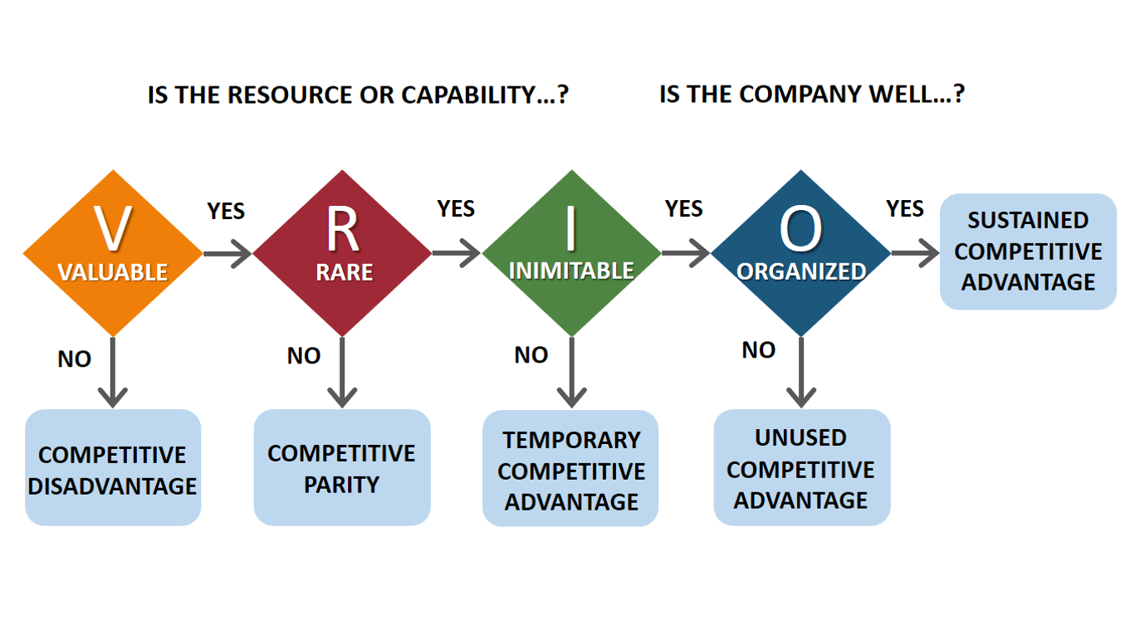
business-to-you.com

VALUABLE recourses allow the company to growth its economic value.
The main valuables in Smile Food business are the products and the service, the experience of its CEO in the restaurant industry; the property; quick returns on investment; machinery; and furniture.
RARE recourse is when only one or two company deal with it. Common recourse will cause perfect competition. Valuable, but not rare recourse can lead to competitive equality.
Smile Food will offer excellent service oriented to the children and their parents, fresh and tasty food, not forgettable memories of fun and a friendly atmosphere.
INIMITABLE recourses are when they are costly to be imitated and it is difficult for direct imitation or substitution from other companies.
The products in Smile Food are maybe easy to be imitate, but the service is quite complex and inimitable. The main profit is coming from the combination of different manages, some of them not visible for the competitors.
ORGANIZED is additional worth in Smile Food. Small company, just a few staff, family business, simple and easy menu, using robots mashine as pizza assembly line and hot dog and pancakes maker, which keep them warm and ready for selling. The rush hours are predicted and constant, because they are connected to the School’s working hours.
The effective organized structure and coordinating systems are core values in Fast food industry. (YouTube, 2020)

Acording to Voxco.com (2022) there are some advantages and limitations of VRIO and they are:
ADVANTAGES:
- It helps to figure out the organization’s unique value.
- VRIO identifies internal advantages and strengths.
- It improves the ability to stay on top of the competition.
- VRIO helps to know the company inside
LIMITATION:
- The environmental of the business is constantly and quickly changing
- It is not able to forecast the company’s future uniquiness and value
- VRIO is more difficult for small and new businesses
- The sourses are not enouph developed
- VRIO is internal and while is focused inside in the company it is easy to miss to identify any external aspect.

VRIO helps the company to develop competitive advantage recognizing the role of resources in the global model of the business. Its recourses and capabilities have to cooperate in a way that create unique core competences.

Porter's 5 forces

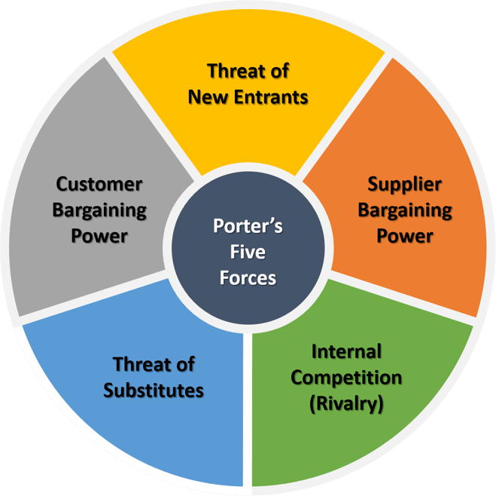
blog.fhyzics.net

Porter's 5 Forces analyse is a tactical framework that helps for identifying and analysing 5 forces that affect a company’s profitability.
Porters 5 Forces in Fast food industry:
- Threat of substitute is high. Byers can cook at home or switch to other cooking possibilities.
- Threat of the new entries is low.
Fast food industry meets a large level of financing, product development and advertising, however the barriers to new entry are low.
- Intensity of competitive rivalry is high.
- The chains for fast food offer related products and prices and compete for the same customers.
- Bargaining power of customers is high.
Byers have choices and can find better quality and lower prices.
- Bargaining power of suppliers is high, especially in big chain, because they rarely change the suppliers, and the suppliers can manipulate the market price.
(Momin, 2023)

Understanding customer satisfaction in is key point in every business and industry.
Nguyen et al (2018) analyse the effect of five factors of service quality in UK fast food market.
Tangibles includes tidy and calm dining area, readable menu, clean restrooms, well clothed staff, parking, and seating availability.
Reliability means speed service, reliability, quick solving of any problem, accurate billing, correct customer’s order.
Responsiveness means extra staff in pick hours, trigger, and fast service, helping employees, ready to oversee special requests from the customers.
Assurance indicates customers feel comfortable, their financial transactions are safe, the staff is friendly and knowledgeable.
Empathy implies employees can predict customer needs and make them feel special, sympathise, and help them if something is wrong, and to looking for customer’s best interest.
Nguyen et al (2018) indicates that responsiveness, assurance, and tangibles have crucial role in customer satisfaction, followed by empathy and reliability.
The physical facilities, attributes and employee attitude are essential in fast food industry.

Operations and Management Team Plan
Smile Food is fast food business with main products pizza slice and hot dog. It will also offer pancakes, hot and soft drinks, and alcohol drinks. In weekends It will also offer service, as organising parties, catering or provide hourly rental of the restaurant. The tables and playing zone will be easy to transform for the different kind of the service above.
Dragons are the main partner in the company with 25% share.
The CEO is Milena Adzhemova with 20 years of experience in restaurants industry. She is the chef in the company.
The manager is Kiril Lolo with 30 years of experience as a restaurant’s owner.
Lora Adzhemova is the seller, smiley person with excellent communication skills, empathic and enthusiastic person.
The CEO will hire employee for advertising in social media.
We will collaborate with suppliers as Amazon, eBay, and Tesco, and in unpredictable situations will be bought from stores by ourselves.
The revenue in the business will be generate by upselling of our main products and upgrading on the services as catering, renting and party organizing.
Our main asset is the mortgage because the rent is more expensive and not enough predictable. The rent is usually for 5 years, but the owners quickly raise the rent if the business starts to be profitable. This is quite sensitive moment, because the businesspeople excellent know what could cause to move the business. This is why they prefer to pay bigger price, but do not move. And the owners of the properties get advantage of this. In our experience this scenario happened to us two times. Now we managed this from beginning with the Dragons investment of £100k.

Marketing Plan and Strategy
Marketing plan
Marketing plan is focused on company’s marketing and product or service selling.
It is a document for upcoming period, usually for a year, and profiles the marketing strategy, advertising and promotional performances planned for a period of time. (corporatefinanceinstitute.com, 2023)
According to corporatefinanceinstitute.com (2023) the structure of market plan can include marketing plan objectives, market research, target market, SWOT analysis, marketing budget.
- Marketing Plan Objectives - figures short, realistic, and clear intentions
- Market Research - consist of market characterization, industry composition, market proportions, market share and trends, and opponent analysis. Consumer analysis investigate buying decisions – motivation, loyalty, and expectations.
- Target Market - defines the customers by their demographic profile / age, race, and gender/ and psychographic profile /their interests/. This will assist in the correct marketing mix for the target market segments.
- SWOT Analysis – analyse businesses by their strengths, weaknesses, opportunities, and threats.
- Marketing Budget - document, which contains revenues and costs listed in the marketing plan.
It balances expenditures on marketing performances and what the firm can afford.
The cost of marketing should be capable to make the company break even point and to make a profit.

Marketing Strategy
Matching to Twin, A (2023) the 4Ps are stated to as the marketing mix. These are crucial factors and appears around 1950. 4Ps are:
- Product
Understanding the product, for who and why it is needed, what design and function it will have been the first step in the marketing process.
- Price
This is the amount, that the buyers are ready to pay for the product. Occasionally, the businesspeople choose bigger price to give more exclusively and luxury of the product, or they can make discount, when it is possible.
- Place
Where the product will be sold, in physical store or online, and in which shops will be available. If the product is expensive will not be appropriate for selling in cheap retailer.
- Promotion
The idea of the promotion is customers to think that they need this product, and its price is affordable for them.
The promotion incorporates the product in public relations, advertising and media strategy for a product presentation.

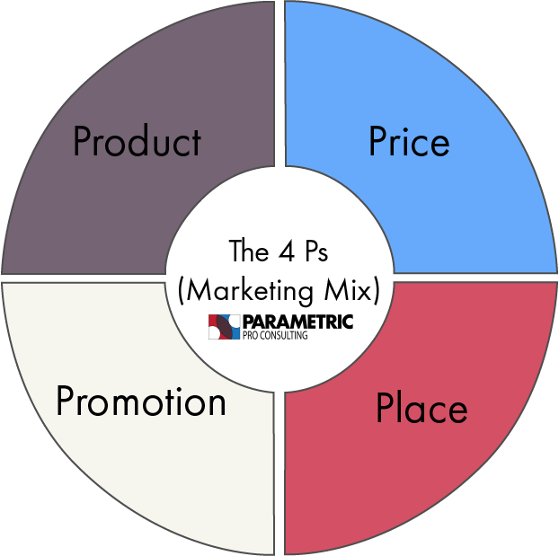

In 21 century, three more Ps /people, process, and physical evidence/ come.
Other strategies in the marketing are distribution strategy, and positioning strategy, retention strategy, and convention strategy.

Financial Plan
Smile Food is starting its business with capital of £160 000, £100k from the Dragons and £60k from the CEO. 10K is the investment for the business, spend for products and services. £5K are for inventories. The investment for the mortgage is £50K and £2K are for equipment. The rest £93K are for the first 6 mounts for liabilities, acquired wages, tax and other spendings. The business will advertise itself with flyers and social media and will rely more on satisfied customers, who will share their experience with more byers. Investigating customers behaviour, the business will be built with excellent interface and strong construction, and long term oriented.

Closing Summary
Fast-food industry has a big growth in last decades and starts to take care for human health.
Alonge et al (2023) investigate the affect of fast-food intensity on fatness in the different waves of Covid 19 and connected it with higher risk of being obese. Their study proposes that the food environment has impact on people’s nutritional choices.
If Fast-food companies offer more nutrition and healthy food, and this will make them even more successful.
Smile Food starts with big promise to their customers that they will receive fresh and healthy food. Pizzas and hot dogs can be prepared nutritional, as well, with variety of tasty vegetables.
We are ready to build strong and profitable business, where the customers will feel happy and satisfied.
We are starting slowly, but wisely and our goal is Smile Food to became so successful, that other entrepreneurs to want to do business with us. Then we will start to sell Franchise and help other people to make profit as us.

References:
Images:
Available at: https://blog.fhyzics.net/hs-fs/hubfs/porter.png?width=659&name=porter.png
Available at: https://i0.wp.com/www.business-to-you.com/wp-content/uploads/2016/11/VRIO-Model.png
Video:
(2020). YouTube. 26 July. Available at: https://www.youtube.com/watch?v=SD8XJw_qeNI (Accessed: 15 December 2023).

Barringer, B, & Ireland, D 2018, Entrepreneurship, eBook, Global Edition, Pearson Education, Limited, Harlow. Available from: ProQuest eBook Central. [14 December 2023].

Nguyen, Q., Nisar, T.M., Knox, D. & Guru, P.P. 2018, "Understanding customer satisfaction in the UK quick service restaurant industry: The influence of the tangible attributes of perceived service quality", British Food Journal, vol. 120, no. 6, pp. 1207-1222.

Alonge, O., Shiode, S. & Shiode, N. 2023, "The Impact of Fast-Food Density on Obesity during the COVID-19 Lockdown in the UK: A Multi-Timepoint Study on British Cohort Data", Sustainability, vol. 15, no. 11, pp. 8480.

Voxco (2022) 'VRIO Framework: Mapping Brand Potential,' Voxco, 14 February. https://www.voxco.com/blog/vrio-framework-definition-advantages-and-limitations/#:~:text=Limitations%3A%20VRIO%20cannot%20predict%20the%20future%20of%20your,to%20identify%20the%20external%20side%20of%20the%20business

Momin, A. (2023) Fast Food Industry Analysis, PESTLE Analysis. Available at: https://pestleanalysis.com/fast-food-industry-analysis/ (Accessed: 14 December 2023).

Marketing plan (2023) Corporate Finance Institute. Available at: https://corporatefinanceinstitute.com/resources/management/marketing-plan/ (Accessed: 15 December 2023).
The 4 PS Framework (no date) The 4 Ps Framework | Parametric Pro Consulting | Helping you Succeed. Available at: https://parametricpro.com/blog/2021/6/9/the-4-ps-framework (Accessed: 15 December 2023).
Twin, A. (2023) The 4 PS of marketing and how to use them in your strategy. https://www.investopedia.com/terms/f/four-ps.asp.

