

An investigation into the impacts of the Police Constable Degree Apprenticeship (PCDA) on response policing in Wales.

Jake Reynish 1922421
BSC Hons Professional Policing Practice

Acknowledgements

I would primarily like to thank my colleagues for their incredible display of patience for the last three years. Without their enduring support, this project would surely have failed to exist. Specific thanks are given to Sergeant’s Tucker and Fox, along with Constable’s Lloyd, Martin, and Matthews. Their dedication to keeping me on task was unrivalled and was ultimately the key to my success on this project. I must also thank my parents and immediate family for their ongoing love and support. Their constant morale boosts gave me the strength to continue when my own motivation wavered.

Declaration
This work has not previously been accepted in substance for any degree and is not being concurrently submitted in candidature for any degree.
Signed: Jake Reynish
Date: 22/03/2023

STATEMENT 1
This dissertation is being submitted in partial fulfilment of the requirements for the degree of BA.
Signed: Jake Reynish
Date: 22/03/2023

STATEMENT 2
This dissertation is the result of my own independent work/investigation, except where otherwise stated.
Other sources are acknowledged by footnotes giving explicit references. A bibliography is appended.
Signed: Jake Reynish
Date: 22/03/2023

STATEMENT 3
I hereby give consent for my dissertation, if accepted, to be available for photocopying and for interlibrary loan, and for the title and summary to be made available to outside organisations.
Signed: Jake Reynish
Date: 22/03/2023

STATEMENT 4
I hereby give consent for my dissertation, if accepted, to be available on the university’s IT system to those who have consent to use the system.
Signed: Jake Reynish
Date: 22/03/2023

Abstract
Recruitment into policing has been going through a drastic overhaul for the past four years. There has been core overhaul changes to the system with a focus on ensuring that entrants obtain higher education qualifications to substantiate their position within the service. The introduction of the police education qualification framework (PEQF) and its subsequent police constable degree apprenticeship (PCDA) has been debated. This research has been designed to look at the impacts of the current model on both the individual officers participating in it as well as the possible effects it has had on officer retention and abstraction rates.
The research consists of an in-depth literature review of the current leading themes with a view to identifying the current gaps in the topic research. This has then been followed by the researcher conducting a mix of primary and secondary research to gather data to answer the above query.

Table of Contents
Chapter One – Introduction 7
1.1 Background 7
1.2 Aims of the Research 7
Chapter Two – Literature Review 9
2.1 Introduction 9
2.2 Aims of Literature Review 9
2.3 Work Based Learning and Degree Apprenticeships in a Wider Employment Context 10
2.4 Work Based Learning and Degree Apprenticeships in a Policing Context 11
2.5 Conclusion 13
Chapter Three – Methodology 14
3.1 Introduction 14
3.2 Research Strategy and Data Collection 14
3.3 Data Analysis 15
3.4 Limitations and Potential Problems 16
3.5 Conclusion 16
Chapter Four – Analysis of Results 17
4.1 Introduction 17
4.2 Method of Analysis 17
4.3 What effect if any, has the PCDA entry route had on officer retention? 18
4.4 What effects has the PCDA scheme had on response officers? 21
4.5 How has the introduction of the PCDA scheme affected the presence of frontline officers in their primary duties due to abstractions through Protected learning time? 24
Chapter Five – Conclusion and Recommendations 26
5.1 – Introduction 26
5.2 The achievement of the objectives 26
5.3 Main Findings 27
5.4 Recommendations 28
5.5 Limitations 29
5.6 Conclusion 29
Bibliography 30
Appendices 36

List of Abbreviations

PEQF – Police Education Qualifications Framework
PCDA – Police Constable Degree Apprenticeship
DHEP – Degree Holder Entry Programme
PLT – Protected Learning Time
WBL – Work-based Learning
CoP – College of Policing
FOIA – Freedom of Information Act
S1 – Survey 1
S2 – Survey 2
R# - Respondent Number
SWP – South Wales Police
HEI – Higher Education Institution

Chapter One – Introduction

1.1 Background
The Police Constable Degree Apprenticeship (PCDA) was introduced alongside the Degree Holder Entry Programme (DHEP) to become the two primary standard routes of initial entry into the police under the Policing Education Qualifications Framework (PEQF). This overtakes the previous standard non-degree initial route which was known as the Initial Phase Learning and Development Programme (IPLDP). As of 13th August 2022, only 16 of the 43 Territorial police forces in England and Wales still offer the IPLDP entry route as an option (Joining the Police, 2022). This means that the remaining 27 forces have now exclusively adopted the new PEQF recruitment options. As part of these new entry routes, officers will be required to obtain a undergraduate degree if they have not already done so (PCDA) or obtain a diploma in professional policing practice if they already have a degree. This marks a substantial and dramatic change to the way police officers are recruited and trained.
These new routes under the PEQF have been adopted as a result of the ambition to solidify policing as a profession. The validity policing being an effective profession has been heavily debated. (Rojek et al, 2012).
The scheme has been designed for police forces to work alongside higher education providers during the first three years of a recruited officer’s employment with the aim of developing workplace competence alongside a higher knowledge of key concepts affecting the policing environment.
This substantial change to the initial entry routes into policing has coincided with a dramatic increase in the number of recruited officers in England and Wales, due to HM Government’s push to recruit 20,000 new police officers, resulting in an increase in the number of officers who will be recruited under the PCDA entry route.
The objective of this research is to understand the impacts that this programme may have on frontline officers (if any), including potential for mental health implications alongside the demands on their personal life alongside anything else that becomes relevant through the research and survey methodologies.
The justification of this research is to understand the impacts of entry the route on both officers and their police forces. Locating, recruiting and retaining the best candidates to police forces around the UK remains essential for national and localised security and it is imperative to discern whether current recruitment and training strategies are achieving these goals. This research will also be essential in detecting whether the PCDA route supports officers on the frontline by providing them with the necessary knowledge, so that they may carry out their duties professionally and expertly.

1.2 Aims of the Research
The aim of this research is ultimately to identify any impacts of the PCDA on response policing in WALES. This is to be done with a view of providing recommendations to improve on the current PCDA implementation to ensure that officers are being appropriately trained and supported to best protect the public.
The following four research objectives/questions have been adopted:
- To critically research and analyse the current academic literature and understanding surround the topics of work-based learning (WBL) and the Police Constable Degree Apprenticeship programme.
- What effect, if any, has the PCDA entry route had on officer retention?
- What effects has participation within the PCDA scheme had on response officers?
- How has the introduction of the PCDA scheme affected the presence of frontline officers in their primary duties due to abstractions through Protected learning time?

Chapter Two – Literature Review

2.1 Introduction
This chapter of the dissertation seeks to examine and critically analyse existing literature that focuses on work-based learning and the PCDA. The purpose of this analysis is to better understand both the already formed theories and beliefs inside these topics and how this research can further develop on this. Work-based learning (WBL) programmes are not a new phenomenon. “Since the 1980s there has been significant growth in the engagement of higher education with workforce development” (Lester and Costley, 2010, p.561). Many different sectors of employment already contain such schemes and most of the research conducted is either generic in nature or focused on non-policing professions. Degree apprenticeships themselves were launched by the UK government in 2015 (Department for Business, Innovation and Skills, 2015) with the Police Constable Degree Apprenticeship being formally introduced in 2018. In assessing the research that has been conducted in the topic area, it is important to make a clear distinction between WBL and degree apprenticeships. Not all research on WBL is focused on professions that aim to provide learners with qualifications at undergraduate degree level and could be based on learning at a significantly lower level, typically around level two. For context, a level two qualification is considered by the UK Government (2023) to be a GCSE grade of A*, A, B or C (alternatively 9,8,7,6,5,4 within newer marking schemes.) A degree apprenticeship or degree with honours is a level 6 qualification.

2.2 Aims of Literature Review
The aim of this literature review is to look at the different themes discovered within existing literature already published around the dual topics of work-based learning and degree apprenticeships. Given that the police degree apprenticeship is reasonably new in its incorporation, it is not unlikely that there will be a limited number of thorough academic research into its success and outcomes. As such, there will be a greater interest on looking at the programmes on a whole in a wider context, to see what trends have emerged from other industries and whether there would be any opportunities for translation to policing. The research will also be evaluating what effect the existing literature has on the proposed research questions.

2.3 Work Based Learning and Degree Apprenticeships in a Wider Employment Context
2.3.1 Work Based Learning
“The phrase 'work-based learning' has today become something of a slogan, which takes on different meanings according to its immediate context” (Shaw, 2000) Sodiechowska and Maisch (2006) provided a definition of “where students are full-time employees whose programme of study is embedded in the workplace and is designed to meet the learning needs of the employees and the aims of the organisation” The PCDA scheme fully incorporates this definition. “It is widely being acknowledged that work-based learning (WBL) strategies are a vital part in the ongoing and future development of the existing workforce.” (Lemanksi et al, 2011) There are many studies conducted around WBL at many different levels and there are widely documented studies showing the vast benefits of these programmes. Studies such as those conducted by Ferguson (2019) highlight the benefits of WBL as increased motivation, confidence and competence to the learner. Generally, this is an accepted trend, and WBL is seen as a positive method of employment. There is clearly a theoretical transposition of these benefits onto police officers under the PCDA scheme, although at this moment, there does not appear to be any well documented and academically tested studies to evaluate such. Policing has now become a graduate profession, “although little empirical evidence exists as to what impact this will have” (Cox and Kirby, 2018). This would suggest a research gap, in relation to whether the accepted benefits of WBL seen in other professions have been translated to policing. This is currently not known.
2.3.2 WBL and Degree Apprenticeships in Public Services
WBL and degree apprenticeship programmes have already been integrated into public services in fields such as medicine and law. Whilst there is implementation of WBL is organisations such as the NHS, it is important to understand the drastically different context. Traditional entries into medicine have always required a minimum degree level of education in a lot of roles and academic qualifications have always been drawn upon as means of standardized entry. (Tilley and Laycock, 2016). This is contradictory to policing where there has been no previous higher education requirement and such apprenticeships provide higher level of qualification than a traditional entry.
Studies by Baker (2019), who analysed potential implications of degree apprenticeships on healthcare education highlighted that apprenticeships have generally more negative perceptions as they are often associated with manual labour. This study also provided that those engaged in these apprenticeship entry routes were less successful in progressing to advanced roles rather than those who joined via a traditional entry. Whilst this does highlight negative aspects of these apprenticeships, it is important to note that it is not possible to draw exact parallels with policing. As such, the apprenticeship schemes were seen as a way to “scoop up any low achievers through a low entry point” (Brockmann and Laurie , 2016) Arguably, this drastic difference in context means that making any direct comparisons between public sector professions and policing difficult.

2.4 Work Based Learning and Degree Apprenticeships in a Policing Context

2.4.1 The Degree Within the Current Policing Climate
The degree Apprenticeship was introduced with the ambition to solidify policing as a profession. The validity of this concept had been previously debated. (Rojek et al, 2012) This study questioned how well police forces utilise evidence-based research in practice. The researcher highlighted specifically that there is a significant disconnect between the fields of science and policing. Other studies by researchers such as Brown et al (2018), have shared a similar sentiment, questioning policing as a true profession. On the other hand, other studies have stated that policing has since developed the traits of a profession, including a code of ethics, accredited qualifications and evidence-based practice. (Ramshaw and Soppitt, 2018) The College of Policing (2020) also states that the new framework was introduced to reflect the aims of the “Policing Vision 2025” which highlighted the need for consistency, accreditation as well as skills and knowledge, backed by qualifications. This has ultimately been a marked change from historical opinions in the police. Neyroud (2011) noted that police forces had traditionally disagreed with the necessity for educational accreditation as a pre-requisite for the police service. The reason for this change is also debated. Wood (2018) urges us to analyse it from a fiscal perspective and suggests that the introduction of the PEQF is being so strongly embraced by chief officers as a means of reducing costs. This is said to be achieved through evidence-based policing, which “aims to ensure more effective and efficient use of resources”. The College of Policing (2020) states that the introduction of the new entry path was due to the initial phase learning and development programme as it “has not kept pace with the demands of frontline policing”. They also state that the move was due to other public sector organisations that police work alongside, also moving to a professional footing. Regardless of the full account of the reasons for its introductions, there has been clearly set goals and expectations to measure the success of the PEQF. There is a current total lack of research as to whether the PEQF has met its intended goals. This clearly shows a void in the research area. Regardless of rationale for its introduction, all research appears to conclude the following. “The empirical evidence base is not strong enough to draw definitive conclusions about the improvements that more specific graduate attributes bring to policing” (Brown, 2020)
2.4.2 How has the Degree Apprenticeship Affected Student Officers
When looking at the effects of degree apprenticeships on officers, there is limited literature. One of the reasons for this, as described by Watkinson-Milley et al (2021), is that the scheme is still in the very early days of its delivery. The study by Watkinson-Milley is one of the few published works which directly discussed the experiences of student officers undertaking the degree apprenticeship and subsequently will be a core piece of literature within this review. This study utilised thirty students undertaking the PCDA from one course within one UK force. The data was collected via four focus groups. The study provided conclusions that the officers who participated valued their operational learning more heavily than their academic learning. This result is supported by the work of Wood (2020) who highlighted that it is already well established that newly recruited officers favour their work-based training over the more traditional educational structure. The participants also felt a strong disconnect between the academic and ‘real-world” aspects. This disconnect could have played some role in the favouring of operational work. This study goes some way towards understanding the effects on student officers partaking in the degree. It has both significant strengths and weaknesses. The study solely studies officers engaged in the PCDA and does not include any officers engaged in other entry routes such as the degree holder entry route. This is significant as while both routes are under the PEQF, their structure and content have differences that renders comparison difficult if not impossible. The study also has significant limitations. Firstly, it was conducted within the very earliest timeframe after conception of the PCDA. This means that it does not allow for the adjustments that have been made by higher education institutions in the time since. It was also a very limited study in its size, with a heavy focus on receiving purely qualitative data from the participants. The small sample size provides a limited amount of data. Another limitation is that the study was conducted in one force. Whilst the study does not specify which, the authors are based in a Liverpool university and so the force is likely to be that area. This is important as it is currently unclear as to what level of variation there is between PCDA schemes across the UK or specifically between England and Wales. Whilst there is a standardised structed to the PCDA, each force has its own agreements with its partner HEIs and there will naturally be variations nationally. Watkisnon-Milley’s study also raised a key potential issue that “police culture may influence students upon deployment, encouraging some students to disregard the academic learning”. The question of whether student officers feel their engagement with academia has been hindered by their deployment could form further research questions.
The College of Policing (2020) published a ‘learning to date’ document in respect of the PEQF. This publication makes several statements that relate to the research objectives of this study. It states that PCDA students have been “largely positive” about their experience. It also declares identified benefits of these students as including “deeper knowledge and understanding, critical thinking, time management and writing skill”. Since, the PEQF is still so new, most of the literature regarding its performance have been produced by the College of Policing, who have access to internal data, which is not publicly disclosed. Since the College is responsible for the incorporation of the PEQF, there are concerns about their statements lacking validity due to the potential for bias and reliability. They have also not published supporting data or explained their methodology to understand how they have reached their conclusions.

2.4.4 How has the introduction of the PCDA scheme affected the presence of frontline officers in their primary duties due to abstractions through Protected learning time?
There is little evidence to identify what effect abstractions from duty to assist in the completion of protected learning time has had on operational policing. The College of Policing (2020) stated that abstractions across the entire programme range from 21%-31%. The average in year one being 43% abstraction rate with years two and three dropping to 16% and 17% respectively. Whilst the statistical data is useful, there is little evidence to provide for the real-world implications of these abstractions and the data can only be viewed on its own merits. There are questions raised as to what effect this has had in conjunction with the mass recruitment of officers, many of whom have joined under this apprenticeship. During the years of 2020-2021, the 43 territorial police forces based across both England and Wales recruited a total of over 9200 new police constables. (Home Office, 2021) With funding to provide 20,000 additional police officers, there is the potential for a mass influx of PCDA participants, which has the potential for logistical difficulties. As new recruits are assigned to response teams, this means that the general makeup of these teams could consist of officers within their probationary period. Managing each teams abstractions to assure minimum resourcing levels would require a significant level of advanced planning. This clearly identifies a research need to better understand how frontline supervisors are coping under current regulations with the potential for disruption due to these abstractions.

2.5 Conclusion
Training within the police service is something that is under constant scrutiny and evaluation. In reviewing the material around WBL and degree apprenticeships, there is a clear and consistent trend. The overwhelming majority of conducted research is based around the theoretical importance of correct implementation of the schemes and the benefits of the schemes on learners. For example, the positive effects of degree apprenticeships on a well performing and well implemented programme. However, there is a current lack of academic research identifying the ‘real world’ effect of its implementation. This shows a clear research gap that could and should be investigated. However, such research is beyond the scope and scale of this research and the limitations of this study would prevent any meaningful research of this aspect. The current landscape of research in this field will also face a shift over the course of the next few years as research currently being conducted and not yet published will come to light, such as the work of Chris Price, on behalf of the College of Policing who has conducted a longitudinal survey of recruits under the programme over a four-year period. This study is due to be completed in October 2023.
Another conclusion I have drawn is that work currently being conducted values tests of the effects of the PEQF from a purely developmental standpoint i.e., how it has affected police officer’s skills and competence. Whilst this is incredibly important and is a step in the right direction to answering, ‘what effect the programme has had on frontline officers?’, there is a lack of research as to how participation has affected officers from any other angle. Considerations such as, how has it affected officers’ mental health have not been addressed.

Chapter Three – Methodology

3.1 Introduction
The previous chapter of this dissertation reviewed the current state of literature surrounding WBL and the PCDA. This chapter will explain to the reader what research strategies have been undertaken and how data has been collected. This is referred to as the Methodology. The systems and techniques used for this dissertation have been chosen specifically to answer my initial research questions.
To reiterate, the research objectives of this study are:
- To critically research and analyse the current academic literature and understanding surround the topics of work-based learning (WBL) and the Police Constable Degree Apprenticeship programme.
- What effect, if any, has the PCDA entry route had on officer retention?
- What effects has participation within the PCDA scheme had on response officers?
- How has the introduction of the PCDA scheme affected the presence of frontline officers in their primary duties due to abstractions through Protected learning time?

Objective one was addressed fully in the last chapter. The literature review has clearly identified a need for further research in this field. Research can be defined as “a process that is undertaken in a systematic way with a clear purpose, to find things out” (Saunders et al, 2019, p5). There are two types of research, primary and secondary. Bryman (2016) highlighted that primary research was data collected first hand from individuals. He stated that secondary research consisted of data already collected from previous studies.
Both primary and secondary research will form part of this study and each will play a key role. The remainder of this chapter will address the intended methodology.

3.2 Research Strategy and Data Collection
A combination of research methods will be deployed to complete all the objectives and for the sake of clarity, this is best broken down individually by research question.
Research objective 2 will be a straightforward in its execution as it will relate purely to secondary research and the collection of data held by South Wales Police. The data needed to answer this question is held by South Wales Police as an internal metric for measuring the performance of its variation of the PEQF against its other entry routes. A request for the relevant data held was submitted to the necessary departments in line with the FOIA obligations of the force.
Research objective 3 will be assessed through the exclusive use of a survey that will be given to the target sample. This survey will be treated as Survey 1 (S1) and the target sample for this survey will be purely officers who have participated within the PCDA scheme at any point. The questions will be designed to measure the impact the scheme has had on them as an individual both in respect to their personal wellbeing and operational performance. This is the best method of obtaining the required data as it will allow participants to provide their first-hand perspective directly. There is full access to the target sample size but engagement will depend on cooperation from the sample. This questionnaire will be transmitted via internal police systems (email and intranet) for those who fit the criteria (current or former PCDA participants).
Research objective 4 should once again be straightforward in its execution and will rely heavily on the use of a survey. This survey will be designated as survey 2 (S2) and will be targeted at the first line supervisors of response teams within the organisation. The questions will be devised to enquire about the potential impacts of PLT on the ability of the teams to operate to an effective capacity. This is done with the intent of understanding the ‘real world’ impacts of abstractions through PLT and gather a first hand view from those responsible for managing the teams.
S1 will be utilised with a view to provide supporting evidence to answer more than one research objective. For example, the questions will ask officers specific questions relating to officer retention, PLT and their own performance. This will in turn provide additional information to address research objectives 2, 3 and 4.

3.3 Data Analysis
The data is to be presented in different ways depending on its nature. The statistical data that is obtained through research question 2 will be presented through a mix of the use of tables/graphs and text where appropriate. Since the data will be largely numerical, the presentation through graphs will likely be the most appropriate means of displaying it in a clear and coherent way.
The surveys issued to police officers will vary in their structure with a mix of both quantitative and qualitative styles endorsed throughout. In order to obtain quantitative data, the devised questionnaires will, where possible, be created so that they can be responded to in a uniform manner. This will be achieved by making the majority of the questions closed, answerable by submitting Yes/No or responding on a scale of Strongly Agree- Strongly Disagree. This will allow the production of results that are easily read in bulk with easily understood statistical data. This has also been utilised for the benefit of the sample group who will all be police officers. These officers will have limited time to partake, and the intention is to make the questionnaire as straightforward and time efficient as possible. This is being adopted to ensure that the study has the best chance of encouraging as larger sample size as possible. Whilst this approach will be applicable for most of the research, some of the questions will ask the participants for more detailed thoughts, drawing on personal experience. This will be done by asking the respondent open-ended questions to solicit their opinion. This will provide written responses that cannot be categorised into graphs. The responses received to this style of question will be addressed in two ways. Firstly, if an individual respondent’s response is significant to an identified theme, the response may be highlighted verbatim and attributed to them directly. The second way would be the use of keyword analysis which will highlight the most used words in all responses. This should allow for the easy identification of key words and trends.

3.4 Limitations and Potential Problems
There are potential limitations to this study. Firstly, participation will naturally be voluntary to all parties, and will be reliant upon police officers taking time from their busy work schedules to complete the questionnaires. It is unclear what quantity will respond and participate and so there may be limitations with sample size, should the response be underwhelming. In an attempt to reduce the impact of this as far as possible, the questionnaires will be sent to as larger a sample size as is possible, in anticipation that some will fail to respond. If the issue was to be significant, this could lead to various biases such as a no-response bias. In this case, it could be that only those with the most severe of viewpoints are responding, ignoring a large amount of the target sample who may have alternative viewpoints.

3.5 Conclusion
This chapter has now identified the most suitable research methods that will be used to collect the information to answer each of the research objectives. The next chapter of this dissertation will present and analyse the data collected via the methods described in this chapter.

Chapter Four – Analysis of Results

4.1 Introduction
The previous chapter has described the methodology that was utilised in this research. This chapter will now look at the analysis of the data obtained via the adopted methods to identify key trends and themes. Data analysis is the process of organising and reviewing the relevant data obtained via research and evaluating it in a manner that will allow any themes and patterns to become clear. This chapter will present the results of the primary and secondary research carried out. The primary research consisted of two separate surveys with two separate target audiences. The first survey was targeted at current or past PCDA students. This survey will be referred to in this chapter as survey 1 (S1). The second survey was targeted at supervisors of response teams who have supervisory responsibility for officers under the PCDA programme. This will herein be referred to as survey 2 (S2).
Each survey was designed to assist in answering multiple research objectives and to provide different perspectives to each divisive topic. For example, S1 has questions which consider officer retention as well as questioning the effects of the PCDA scheme on themselves and the effects of protected learning time. This therefore contributes to answering three separate research objectives. S1 consists of quantitative and qualitative data whilst S2 consists of entirely qualitative data.

4.2 Method of Analysis
In this research, the data was gathered using the Survey Labs system. This system was deemed to be an effective tool as it allowed for the easy collection of anonymous data from the target group whilst also allowing for the easy analyses of both types of primary research. Due to the number of responses, Survey Labs allowed for the production of charts for almost all quantitative data by default. With qualitative data, the system has a built-in key word analysis function as well as allowing for the scrutiny of each individual response. This allowed for the researcher to individually scrutinise responses.
S1 was sent out via internal email and intranet systems within SWP. Not all PCDA students were targeted individually as there was no clearly defined way to identify who joined under this entry route. As such, it was made public and officers under the PCDA were invited to complete it. From the data presented below, we can see that there are currently 296 officers in the organisation eligible to complete it. In total, 43 completed it, providing a response rate of 14.5%.
S2 was sent out solely by targeted email on internal systems. 113 total eligible supervisors were identified and these 113 were emailed directly. Out of this number, 31 responded and completed the survey, providing for a response rate of 27.4%.

4.3 What effect if any, has the PCDA entry route had on officer retention?
When considering this research objective, it is important to first consider the actual statistical data. Below is several graphs showing each showing the joiner/leaver data for every new intake within South Wales Police since 2017. These have been broken down in detail and the respective data compared by entry route.

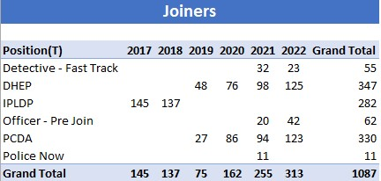

Figure 1 – Table showing the entry route of officers joining South Wales Police from 2017-2022.

As figure 1 shows, the first intake of officers under the PCDA was in 2019. The number of officers joining on this intake has then grown year on year in a similar manner as the DHEP programme. There has been a total of 330 officers recruited into SWP under the PCDA scheme since its introduction. From 2019 onwards, recruitment under the PCDA within SWP has accounted for 41% of new officers. Comparably, since 2019, total DHEP recruitment is 347 officers which amounts to 43.1% of the total.
Officer – Pre join degrees account for 7.7% and Detective fast track accounts for 6.8%. Police Now only accounts for 1.3% of new officers. Since 2019, DHEP and PCDA are the clearly the two biggest entry routes and account for the vast majority of recruitment. The next table shows the termination dates for officers within that same time period.

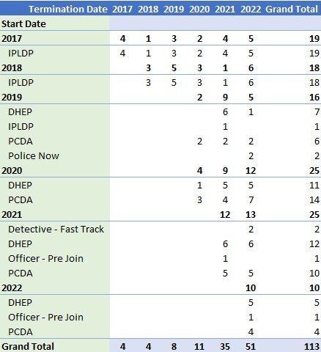

Figure 2 – Table showing the termination dates of officers leaving SWP. The data is split to show the entry route they joined under and the year of joining/leaving.

Figure 2 shows that in total, at the time of this research, 34 officers who joined under the PCDA have resigned. This amounts to an attrition rate of 10.3% of total PCDA officers. In comparison, 35 officers under the DHEP route have left, confirming an attrition rate of 10.1%.
The below chart shows the full attrition rates for all entry routes (since 2019).

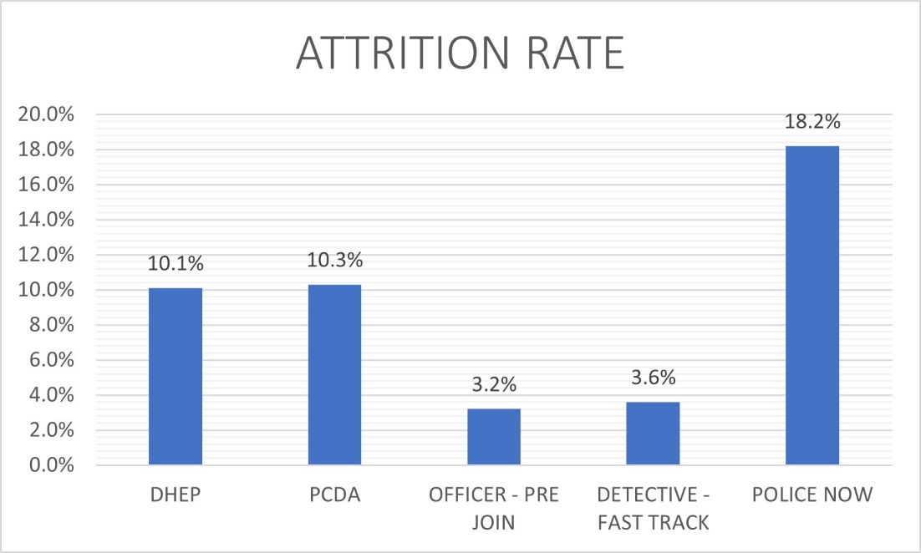
Figure 3 – Bar chart showing the attrition rate of each entry route.

While figure 3 shows that Police Now has the largest attrition rate, it is important to consider the sample size. The full number of officers that have been recruited under Police Now is 11, with two resigning. The sample size is considerably smaller than any other entry route and this small sample size has likely contributed to a disproportionate result. Therefore, I will be treating this data point as an anomaly. The results show PCDA and DHEP have an incredibly similar attrition rate to one another.
Whilst these entry routes are useful to compare against each other, it is important to compare them against the IPLDP. This was the entry route prior to the introduction of a mandatory degree requirement. IPLDP recruited 282 officers in 2017 and 2018 combined. At the time of this research, 38 of those officers have left the organisation leading to an attrition rate of 13.47%.
Whilst this data by itself shows that the PCDA has had a positive net effect on officer retention, it is important to consider its significant limitations. Firstly, officers who joined under the IPLDP in 2017/18 have had 4/5 years in which they have had the opportunity to resign. Whereas those who joined under DHEP/PCDA in 2022, may have only been in the job for a period of a couple months/years. Therefore, the attrition rate for these intakes will be likely to grow as time moves on. A further limitation is that data which explicitly shows the reason for leaving the organisation could not be obtained in a way that broke it down by entry route. Therefore, it would be unclear whether officers left voluntarily, involuntarily or whilst under investigation.
The above data shows the ‘real-world’ results, however, S1 was designed to contain three questions (Q18,Q19,Q20) to ascertain how many officers have considered resignation and to what extent the PCDA has played a role.

Q.18 asked the respondents if they had considered resignation from the organisation. Out of 43 surveyed, 42 answered the question, with 1 preferring not to answer. Of those 42, 24 said they had considered resigning (57%) and 18 said No (43%).
Q.19 then asked for the 24 who answered yes to elaborate further. Specifically, they were asked if the PCDA played a role in that consideration.
When looking at the data for this question, it is apparent there was 29 responses. This implies that 5 people answered the question when they should not have done so. Out of the 29 respondents, 23 stated that the PCDA had played a role in them considering resignation (79%). 6 persons answered no (21%). To fix the errant responses, each individual response was manually reviewed. Respondent 7,10,24,40 and 42 all answered no to question 19 when they had already selected no for question 18. These responses have been discredited from the results. This indicates that only one person stated no to question 19. The revised percentages are now 96% in favour of yes and 4% in favour of no.
Q.20 was then devised to further ask those who stated yes to Q.18 whether they agreed with the statement, “The PCDA is the primary cause of me considering resignation.” Out of the intended 23 respondents, once again there was 29 responses. Respondent 4, 10, 24, 40, 42 all answered the question when they should not have done so. 3 of these respondents answered disagree and two answered that they were unsure. These responses have been removed and the following data has been adjusted accordingly.
11 responded and strongly agreed with the statement (46%). 10 responded and agreed with the statement (42%). 2 stated they were unsure (8%) and 1 disagreed (4%). 88% of respondents agree to some degree that the PCDA is the primary cause of their considering resignation.

What effects has the PCDA scheme had on response officers?

4.4.1 Effects of General Participation
Most of Survey 1 (S1) contained questions relating to the officers and their relationship with the PCDA. The first relevant question is Q5 which asks the respondent whether the opportunity to obtain a degree was a ‘significant factor’ in them joining the police. All 43 individuals answer the question, with 2 stating that it was a significant factor (5%) and 41 answering no (95%). This is comparable to the yearly Home Office police officer onboarding survey (2022). In the most recent 2022 survey, 17% of respondents rated the ‘opportunity to gain a degree-level qualification’ as one of the most influential factors. It was the second lowest out of the options available, above only ‘lack of career alternatives’. This result further supports that new recruits are not particularly concerned with the prospect of obtaining a degree. Although the severity of the response within this survey is increased. Understanding this is vital prior to looking at the further questions as it might give an indication as to how the officer feels about the programme, even pre joining.
Q6 asked the respondents to state how far they agreed with the statement, ‘I have enjoyed my participation in the PCDA’. 42 of the 43 individuals responded overall. None of them strongly agreed, with only 3 (7%) agreeing. 4 did not agree or disagree (9%), 10 (24%) disagreed and 25(60%) strongly disagreed. This shows that 84% of the respondents have found their participation unenjoyable to some degree.
Q.7 and Q.10 asked the group to consider the content of the PCDA and how that has affected them. When asked in question 7, how relevant they thought the content was to their role, the response was concerning. A total of 0 respondents agreed in any fashion that the content was relevant. 10 (23%) neither agreed or disagreed with 15 (35%) disagreeing and 18 (42%) strongly disagreeing.
A similar sentiment was expressed in question 10 which asked the respondent to state how far they agreed with the statement, ‘Participation within the PCDA has given me a better understanding of core policing principles (vulnerability, digital crime, ASB etc). A combined 26 disagreed to some degree (61%), with 13 (30%) neither agreeing or disagreeing. This leaves only 4 respondents agreeing to some degree (9%). The results of these two questions go someway towards supporting the work of Watkinson-Milley (2021) and Wood (2020) which highlighted that officers felt a disconnect between their academic studies and real-world application. It also provides a complete objection to the findings of the CoP’s 2020 ‘learning to date’ package which found that the new PEQF was “a positive experience for students overall, with deeper knowledge and understanding.”
Questions 8 and 9 were devised to provide supporting evidence to the work of Ferguson (2019) which showed that increased motivation and competence were accepted trends of work-based learning within other professions. The results do not support the concept that these positive effects have translated into the policing environment. When asked whether they agreed that their participation within the PCDA had made the officer feel more competent, an overwhelming 37 (88%) disagreed to some extent. 4 abstained (10%) with only 1 positive reply in the ‘agree’ category (2%). When asked the same style of question about if they agreed that they were more motivated due to the PCDA, the results are similar, if not slightly worse. 39 (91%) disagreed to some degree with the same amount abstaining. No respondent agreed with the statement. This data shows that participating officers are not feeling more competent or indeed more motivated as a result of their engagement with this WBL programme.
Question 14 focussed on how the PCDA had impacted the officer’s performance operationally. 21 (49%) of respondents stated it had no effect whilst 22(51%) stated that it had a negative effect. No one stated it had a positive impact on operational performance. Any person who stated that it had a negative effect was then required to explain how it has had that negative impact.
A common theme identified was that officers felt stressed due to the high level of academic work they were required to complete which in turn took focus away from their operational work. R22 even referred to the expectation to handle the degree alongside the fulltime police duties as ‘unachievable’. R20 provided similar sentiment and went as far as to say that focus on the academic aspect of their employment had ‘hindered’ their professional development.
The officers were then asked to evaluate whether they agreed that the PCDA programme was beneficial to policing. All 43 responded with 0 agreeing with the comment (or strongly agreeing). 6 respondents (14%) neither agreed or disagreed, whilst 14(33%) disagreed and 23 (53%) strongly disagreed.
Supervisors within S2 were then asked to determine whether they agreed with the same statement. This ultimately provided similar results. No supervisor agreed or strongly agreed with the statement. 6(19%) neither agreed nor disagreed. 9(29%) disagreed and 15(49%) strongly disagreed. 1 supervisor stated they did not have an opinion on the matter or did not have the information to come to an informed opinion.
This is then furthered when both officers and supervisors were asked whether they believed the same (or better) level of training can be achieved without the requirement of a degree apprenticeship in question 13 (S1) and question 14 (S2). In this instance, 42 of the 43 total possible respondents to S1 answered the question with 1 preferring not to answer. An overwhelming 41(98%) answered yes and only 1 single respondent answered no (2%). The response from supervisors within S2 was absolute and all 31(100%) stated that they agreed with the statement. From this data, officer perception of the efficiency and effectiveness of the current PCDA format is incredibly low.
At this point, supervising officers who completed Survey 2 (S2) were asked whether they agreed that officers who had participated in the PCDA programme performed better in the following three topics when compared against officers who joined on previous entry routes.
- Demonstration of practical performance (Q10)
- Understanding of core policing principles (Q11)
- Levels of professionalism (Q12)
The response was the same across all three questions, with none of the supervisors agreeing that the officers under new entry routes were performing better in any categories. Across all three questions, supervisors who neither agreed or disagreed varied between 9-12 (37-48%). Supervisors who disagreed with the statement varied between 7-10 (28-42%) and those who strongly disagreed varied between 5-8 (21-32%) This is once again concerning as one of the core objectives of the introduction of the PEQF was to ensure enhanced performance through better understanding of core policing issues that affect the modern constable as well as ensuring policing a s profession. This data does not support that any of these objectives have been successful from an officer perspective.

4.4.2 Negative Impacts on Private Life and Mental Health
Officers completing S1(Q15) were asked to state how far they agreed with the statement, ‘Participation within the PCDA has affected my private life’. 42 out of the 43 responded to this question. 2 (5%) stated that it had a ‘significantly positive’ impact on private live. The remainder then consisted of 2(5%) saying it had no impact either way, 17(40%) stating it had a negative impact and 21(50%) stating it had a ‘significantly negative’ impact.
Q16 and Q17 within S1 asked the respondent to state whether their participation within the PCDA had an impact on their mental health, whether positively or negatively. The response was overwhelmingly negative. 33 out of the 43 surveyed stated that it had a negative or ‘strong negative’ impact on them. Only one person stated it had a positive impact with the rest saying it had no effect. Q17 asked the respondent to elaborate on what impacts that it had on them.
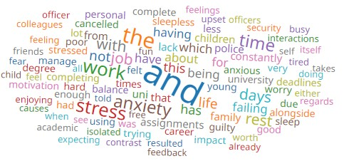
Figure 4 – Keyword analysis from Question 17 of Survey 1

From keyword analysis we can see the following words have been predominantly used, “STRESS, ANXIETY, SLEEPLESS, WORRY.” The entirely of the key word analysis shows consistent negative response with officer stating that they have suffered poor mental health. A number of individual respondents have highlighted issues such as the potential for losing their job as a key stressor. A number of respondents have also highlighted a major issues in managing work/life balance. Specifically, the lack of an acceptable home life was a cause for stress and anxiety.

4.5 How has the introduction of the PCDA scheme affected the presence of frontline officers in their primary duties due to abstractions through Protected learning time?

Both S1 and S2 have been utilised to provide differing perspectives of the impact of protected learning time, both as an individual officer and a supervisor. For both categories, the majority said that there was at 4+ persons on their teams entitled to PLT (71% for supervisors and 54% for officers.) This shows that the majority of respondents come from teams that are quite student heavy and are likely to have suffered a heavier impact from PLT. The current context of police recruitment must be taken into consideration. This is that as it stands, policing is going through a period of heavy recruitment and so a higher proportion of students should be expected at this time. This is a proportion that will likely decline as standard recruitment normalises.

4.5.1 Negative Operational Performance
One identified trend established below is that the current PLT model has, in the mind of officers and supervisors, had a negative impact on officer’s operational performance.
Firstly, both groups were asked if absence through PLT had affected their team’s ability to perform operationally. For those responding to S1, they responded with 84% stating the absence had negatively impacted the team’s operational performance. This is even more dramatic with 100% of supervisors stating the absences had a negative impact.
Both parties were then asked whether their teams had been left below minimum staffing levels due to PLT. For PCDA officers, 81% stated this had been the case, with only 7% saying no. The remaining 12% did not know or were unsure. For supervisors, the response was once again unanimous with 100% stating they had been left below minimum resource levels. This raises major concerns as to whether this current model is leading to a negative impact on the service that the public is receiving.
The first discrepancy of opinion between the two parties comes when asked if absence through PLT has affected the ability of the officer to manage their operational workload. For the PCDA officers, only 47% stated it had provided difficulties whilst 53% stated it had no impact. For supervisors, 97% stated PLT had provided difficulties with their officer’s managements of their workloads with 3% stating it had no effect. This shows some level of difference of opinion between officers and supervisors. For those officers who said it negatively impacted them, the main trend highlighted was that officers felt they had lost valuable time which could have been spent updating victims and progressing their enquiries.
Supervisors alone within S2 were asked some finishing questions. They were asked how far they agreed with the statement “Absence through PLT 'consistently' negatively impacts the presence of officers from their frontline duties”. This is arguably the most varied response in the survey. 13(42%) stated they strongly agreed, 9(29%) agreed with the statement, 7(23%) neither agreed or disagreed, with the final 2(6%) disagreeing.

Chapter Five – Conclusion and Recommendations

5.1 – Introduction
The previous chapters of this dissertation have shown the progression of the project through the introduction of the subject matter, a review of the existing literature surrounding the topic, followed by a discussion of the proposed methodology. The most recent chapter was focused on the analysis of the data derived from the stated research methods. As a result of the collected data, several themes have emerged that both support and undermine existing literature and theories. This chapter will highlight these significant themes that have become apparent as well as providing recommendations as to any issues raised. Any identified limitations with this study will be discussed and addressed.

5.2 The achievement of the objectives
The four primary objectives were set out at the start of this study. This study has now completed the objectives.
- To critically research and analyse the current academic literature and understanding surround the topics of work-based learning (WBL) and the Police Constable Degree Apprenticeship programme.
Objective one (above) was completed during the literature review section of this research project. As part of that chapter, recent literature surrounding the subject matter has been critically reviewed to better understand the current themes.
- What effect, if any, has the PCDA entry route had on officer retention?
- What effects has participation within the PCDA scheme had on response officers?
- How has the introduction of the PCDA scheme affected the presence of frontline officers in their primary duties due to abstractions through Protected learning time?

Objectives two, three and four have been subsequently completed throughout the study. Objective two has been completed by evaluating the available data surrounding officer retention. The different entry routes into the policing profession have also been compared and contrasted against each other in order to understand not only what impact the PCDA has had, but how it stacks up against its alternatives.
Objectives three and four have been addressed through the completion of the surveys. A number of questions were devised to target these specific points and to gain a first-hand account from the officers involved in the scheme.

5.3 Main Findings

5.3.1 Officer retention within the PCDA is not a major issue, comparative to its alternatives.
The statistics highlighted in the previous chapter show that the PCDA has the highest attrition rate out of all the entry routes that have been established since 2019 except for the ‘Police Now’ route. However, that entry route has a low amount of data and the result can arguably be treated as an anomaly. Since the objective was to establish what effect the PCDA had on retention, the comparison against the previous IPLDP scheme was vital. The limited data showed that the PCDA’s attrition rate was actually 3.1% lower than that of the IPLDP. In the extremely limited time period show, it can now be argued that the PCDA has had a net positive impact on officer retention. Regardless of the net change, 1 in 10 officers leaving the service is a high number that needs to be addressed. However, officer retention across the UK is getting worse. From 2021 to 2022, voluntary resignations increased by 72% (University of Portsmouth, 2022). However, due to lots of data being strictly controlled by forces and by the CoP it is unclear whether this is PEQF related, or indicative of more underlying issues.
There is also a considerable divide between the actual retention statistics and the amount of officers who stated that they have considered resignation. Recommendations as to how to investigate this are contained in the relevant chapter below.

5.3.2 Participation within the PCDA has had a negative impact on officers, mentally and operationally.
The statistics show a generally unified opinion from both the individual officers and the supervisors of the frontline teams. The data does not support that the introduction of the PCDA scheme has in any way increased the performance of its officers and it is the clear opinion of the vast majority of the surveyed officers, that their operational performance has been hindered directly as a result. Officers have highlighted clear significant concerns about the impact of attempting to manage their career alongside their academic studies. Further to this, there appears to be a complete disconnect between the academic learning and operational work. As it stands, officers cannot identify the correlation between their studies and the real-world application, with many stating the content is not relevant to their actual role.
Officers have also been clear in explaining what effects the PCDA has had on their mental wellbeing. The overwhelming majority have expressed displeasure at the amount of stress and anxiety the programme has placed upon them. Many have gone as far as to state they have had sleepless nights concerned about their marriages, mortgages and general welfare.

5.3.3 The current PLT model is adversely affecting operational performance.
What is clear from the surveys is that most respondents come from student heavy teams. Thes teams will consist of a substantial or even majority amount of officers being entitled to PLT each month. The current model sees officers get two standard days of PLT, raised to three if additional learning needs are identified. It is the overwhelming opinion of supervising officers and the majority opinion of constables that the use of PLT leads to adverse operational performance. Specifically, difficulties in managing their policing workload in an effective and efficient manner directly because of these absences. R26 of S2 provided the following comment.
“PLT is an excessive burden on my ability to provide a basic service to the public, however the provided time is clearly insufficient for officers to maintain a full-time role AND a full-time degree”.
This proposes significant concerns as to whether victims of crime can get the level of service that they should be receiving.
What is equally concerning is that despite the current level of leave clearly causing an issue with resourcing, 61% of surveyed officers still believe they should be entitled to more PLT. A similar result of 53% for supervisors echoes this sentiment. The presence of officers is ultimately negatively affected by the current PLT model.

5.4 Recommendations
This purpose of this study is not to make sweeping recommendations about the potential for a complete overhaul of the current recruitment model. Rather, it was to identify and evaluate its current state with a view to improving its current implementation into more beneficial variants. The study has identified further niche areas that need to be further investigated.

5.4.1 Recommendation One: A review of the current content within the PCDA
The research contained within the study shows supports the existing theories that officers feel a complete disconnect between the theoretical application of what they are being taught and what their actual job consists of. Officers do not understand the relevance of the content to their role. This study recommends that the College of Policing conducts a review of what is taught as part of this degree apprenticeship, to ensure that it coincides with real world practice. Within this recommendation, it is suggested that the CoP is more transparent in their reasoning for their inclusion of certain content. If officers were able to see the relevance of the academic and apply it to their work, this may positively influence their currently poor perception of the programme.

5.4.2 Recommendation Two: National Review of current models of Protected Learning Time across the UK forces, contrasted against organisational performance in meeting public demand on frontline teams.
The nature and quantity of protected learning time provided to student officers is something that is ultimately highly individual to each UK force in partnership with its attached HEI. This study shows that there is a clear concern among officers (particularly supervisors) within SWP, that current models are hindering operational capability for response teams whilst still being ineffective at providing the student with appropriate learning time. Specifically, there is clear concern from supervising officers that the force is unable to meet the current public demand due to excessive abstraction from primary duty. It is the recommendation of this research that further studies be carried out on a larger scale to identify the varied PLT models in use across the UK. This then needs to be assessed against the performance of each individual force in its ability to meet public demand.

5.5 Limitations
This study has had several limitations. Firstly, it is limited by the restricted word count allowed as part of this undergraduate research project which ultimately served to narrow and restrain the potential for a wider investigation. This issue is also caused by the limited time scale available to the researcher in order to meet statutory deadlines. A further limitation of this study is that the current state of the PCDA is in flux. As a programme in the early years of its introduction, it is still subject to significant change and alterations. As such, the findings of this study could become obsolete in this rapidly changing landscape. Finally, due to the study being entirely voluntary in its completion, it’s possible that only those with the most severe thoughts on the topic have responded. This may not be representative of the entire sample group.

5.6 Conclusion
This research project has successfully completed its research aims and objectives as set out in the introduction and has been a significant first step in identifying the impacts of the PCDA programme on its participants. There is a noticeable further gap for further research in this area. While this study identifies what some of the impacts may be, it does not identify the reason behind their presence. This is something that would clearly need to be identified to continue improving upon the programme. Since this study was completed only within one force in the UK, a more widespread study would be beneficial to test the scale and scope of these issues. As mentioned previously, UK police forces are currently undergoing vast recruitment efforts. It is a possibility that these more severe impacts may be lessened when recruitment is normalised.

Bibliography

BAKER, D., 2019. Potential implications of degree apprenticeships for healthcare education. Higher Education, Skills and Work - Based Learning, 9(1), pp. 2-17.
DOI:10.1108/HESWBL-01-2018-0006

Brockmann, M & Laurie, I. (2016). Apprenticeship in England – the continued role of the academic–vocational divide in shaping learner identities. Journal of Vocational Education & Training. 68. 1-16.
DOI: 10.1080/13636820.2016.114386

Brown, J. (2020) Do Graduate Police Officers Make a Difference to Policing? Results of an Integrative Literature Review, Policing: A Journal of Policy and Practice,14(1), Pages 9–30,
https://doi.org/10.1093/police/pay075

Bryman, A. (2016). Social Research Methods. 5th ed. Oxford: Oxford University Press.

College of Policing (2020) Policing Education Qualifications Framework Initial entry routes Learning to date: development and implementation, 2016 to 2019
Available at: https://assets.college.police.uk/s3fs-public/2021-02/peqf-learning-to-date.pdf
(Accessed: 13th August 2022)

College of Policing (2020) Policing Education Qualification Framework
Available at: https://www.college.police.uk/career-learning/policing-education-qualifications-framework-peqf
(Accessed: 13th August 2022)

Cox C., Kirby S. (2018). ‘Can Higher Education Reduce the Negative Consequences of Police Occupational Culture Amongst New Recruits? Policing.’ An International Journal 41(5): 550–562.
DOI: 10.1108/PIJPSM-10-2016-0154

Department for Business, Innovation and Skills (2015) Press Release: Government Rolls out Flagship Degree Apprenticeship
Available at: https://www.gov.uk/government/news/government-rolls-out-flagship-degree-apprenticeships
(Accessed: 18th October 2022)

Fergusson, L. (2019), ‘The nature of work-related problems: messy, co-produced and wicked’, Journal of Work-Applied Management, 11(2) pp. 106-120,
doi: 10.1108/JWAM-08-2019-0024.

Garnett, J. (2020), "Work-based learning tools to inform the implementation of degree apprenticeships for the public sector in England", Higher Education, Skills and Work-Based Learning,10(5), pp. 715-725.
https://doi.org/10.1108/HESWBL-06-2020-0134

Gov.Uk (2023) What qualification levels mean
Available at: https://www.gov.uk/what-different-qualification-levels-mean/list-of-qualification-levels
(Accessed: 25th February 2023)

Helyer, R. (2015), Learning through reflection: the critical role of reflection in work-based learning (WBL)", Journal of Work-Applied Management, 7(1), pp. 15-27. https://doi.org/10.1108/JWAM-10-2015-003

Home Office (2021) Official Statistics Police officer uplift, England and Wales, quarterly update to 31 March 2021
Available at: https://www.gov.uk/government/statistics/police-officer-uplift-quarterly-update-to-march-2021/police-officer-uplift-england-and-wales-quarterly-update-to-31-march-2021
(Accessed: 24th October 2022)

Home Office (2021) Onboarding Survey
Available at: https://www.gov.uk/government/publications/police-uplift-programme-new-recruits-onboarding-survey-2021/police-uplift-programme-new-recruits-onboarding-survey-2021-report
Accessed: 15th March 2023

Joining The Police, (2022) Forces Recruiting Via Traditional (IPLDP) Route
Available at: https://www.joiningthepolice.co.uk/whos-recruiting/traditional-ipldp
(Accessed: 13th August 2022)

Lemanski et al, (2011), An introduction to Work-Based Learning
Available at: https://s3.eu-west-2.amazonaws.com/assets.creode.advancehe-document-manager/documents/hea/private/work_based_learning_1568036792.pdf
(Accessed: 10th October 2022)

Lester, S & Costley, C (2010) Work‐based learning at higher education level: value, practice and critique, Studies in Higher Education, 35(5), 561-575,
DOI: 10.1080/03075070903216635

Neyroud P. (2011). Review of Police Leadership and Training. London: Home Office

Pepper, I., Rogers, C. and Martin, H. (2020), ‘Evidence based policing: a view on its development within the police service’, Journal of Work-Applied Management, 12(1), pp. 91-96,
doi: 10.1108/JWAM-01-2020-0001

Police Federation of England and Wales (2019) Police Education Qualifications Framework (PEQF) Implementation Frequently Asked Questions
Available at: https://www.polfed.org/Wilts/media/1580/policing-eductation-qualifications-framework-faqs.pdf
(Accessed: 21st October 2022)

Ramshaw, P., & Soppitt, S. (2018). Educating the recruited and recruiting the educated: Can the new Police Education Qualifications Framework in England and Wales succeed where others have faltered. International Journal of Police Science & Management, 20(4), 243–250.
https://doi.org/10.1177/1461355718814850

Rojek, J., Alpert, G. and Smith, H. (2012), ‘The utilization of research by the police’, Police Practice and Research, 13(4) pp. 1-13,
doi: 10.1080/15614263.2012.671599

Rojek, J., Martin, P. and Alpert, G. (2015), Developing and Maintaining Police-Researcher Partnerships to Facilitate Research Use, Springer, New York.
DOI: 10.1007/978-1-4939-2056-3

Saunders, M et al (2019) Research Methods for Business Students. 8th Edition. Pearson Education
Available at: https://ebookcentral.proquest.com/lib/trinity/reader.action?docID=5774742
(Accessed: 25th February 2023)

Sodiechowska, P. and Maisch, M. (2006) Work-Based Learning: in search of an effective model. Educational Action Research, 14(2), pp. 267-286.
DOI:10.1080/09650790600718217

Staffordshire Police (2022) Force welcomes Ofsted “good” review of police apprenticeships
Available at: https://www.staffordshire.police.uk/news/staffordshire/news/2022/march/force-welcomes-ofsted-good-review-of-police-apprenticeships/
(Accessed: 13th August 2022)

Tilley, N; Laycock, G; (2016) Engineering a safer society. Public Safety Leadership Research Focus , 4 (2) pp. 1-6.
Available at: https://discovery.ucl.ac.uk/id/eprint/1516899
(Accessed: 22/10/2022)

University of Portsmouth (2022) Police officer resignations have risen by 72% in the last year – we asked former officers why
Available at: https://www.port.ac.uk/news-events-and-blogs/blogs/democratic-citizenship/police-officer-resignations-have-risen-by-72-in-the-last-year-we-asked-former-officers-why#:~:text=However%2C%20times%20have%20changed.,33%25%20in%20the%20previous%20year.
(Accessed: 22nd March 2023)

Watkinson-Miley, C. Cox, C. and Deshpande, M (2022). A New Generation of Police Officers: Experiences of Student Officers Undertaking the Police Constable Degree Apprenticeship in One UK Police Force, Policing: A Journal of Policy and Practice, 16(1), Pages 122–134,
https://doi.org/10.1093/police/paab062

Wood, D (2020) Embedding Learning and Assessment Within Police Practice: The Opportunities and Challenges Arising from the Introduction of the PEQF in England and Wales , Policing: A Journal of Policy and Practice, 14(2), Pages 374–382,
Available at: https://academic.oup.com/policing/article/14/2/374/5161114
(Accessed: 20th October 2022)

Appendices

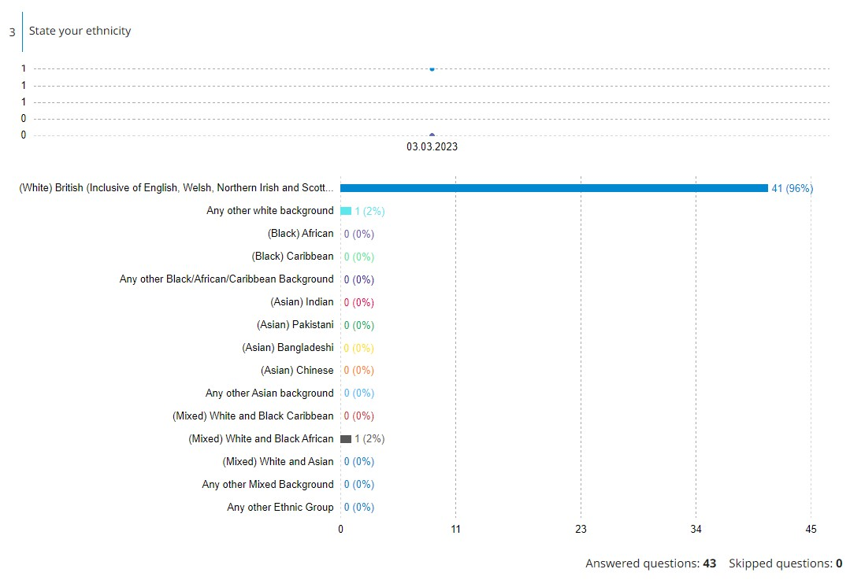
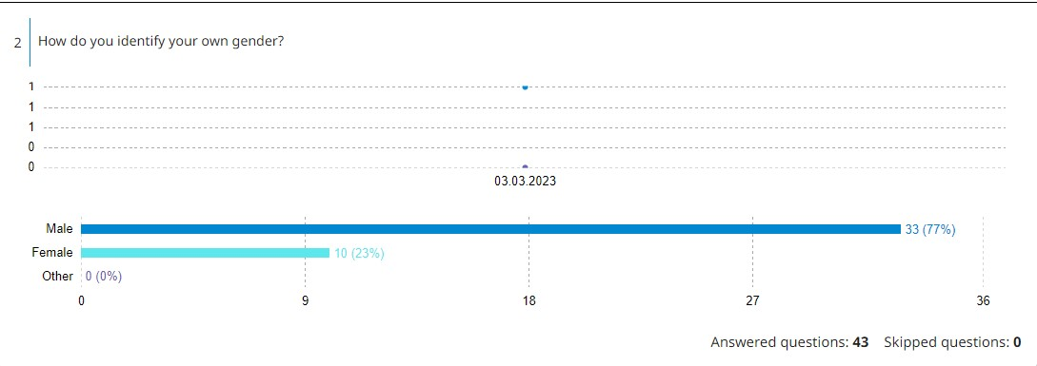
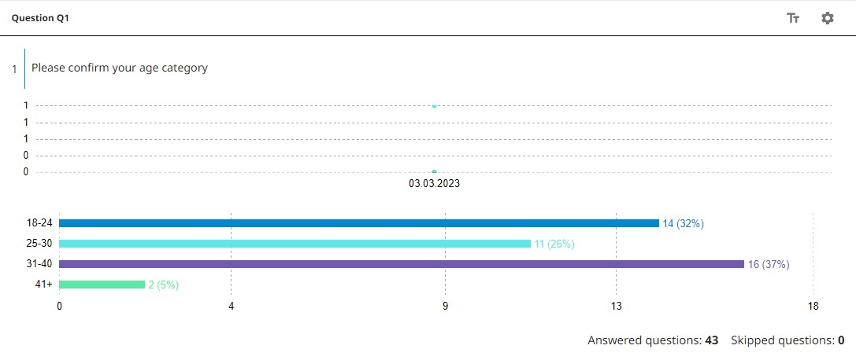
Appendix 1 – Survey 1
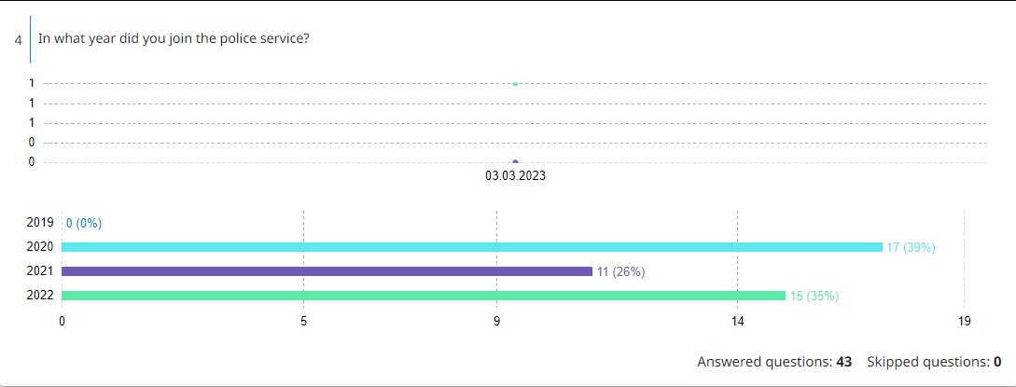
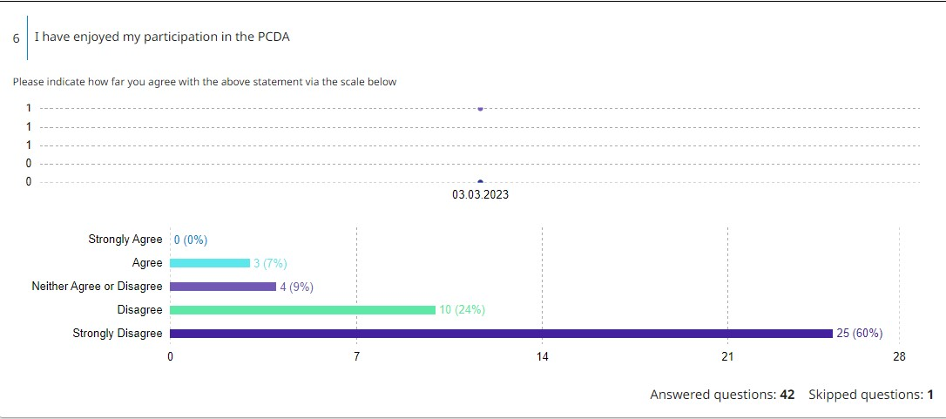
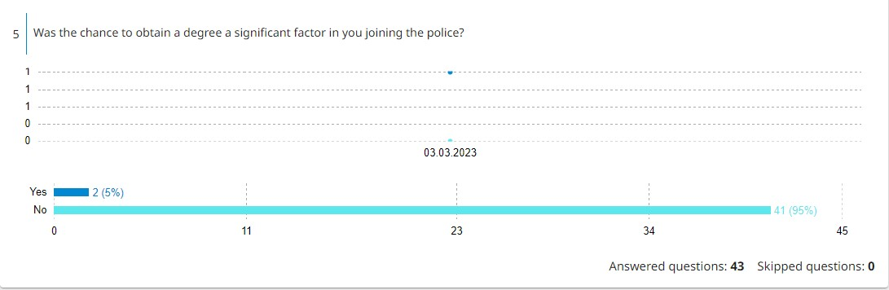

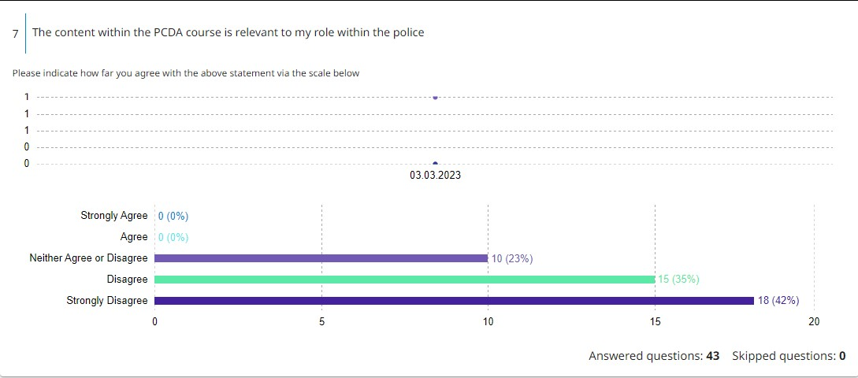
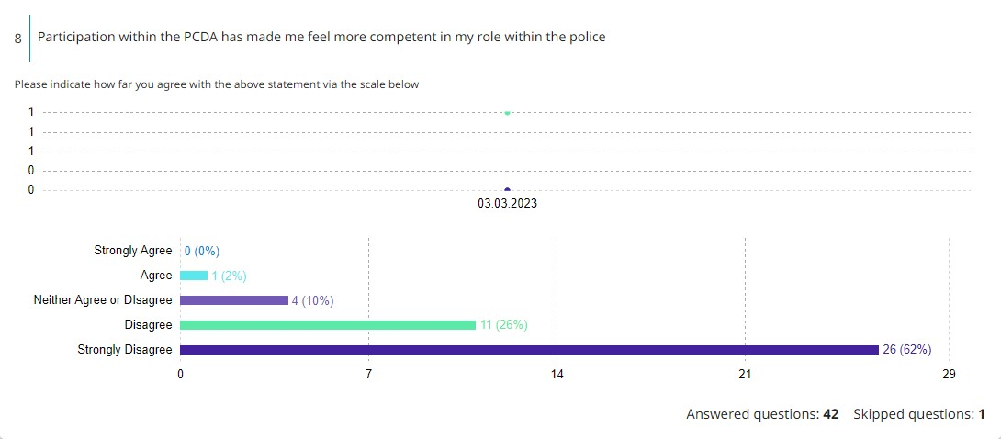
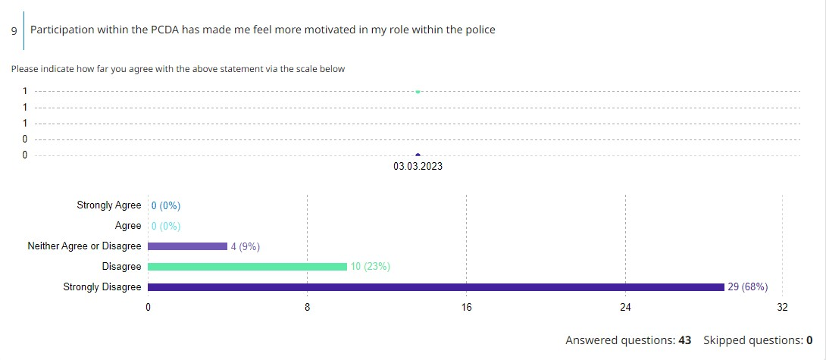
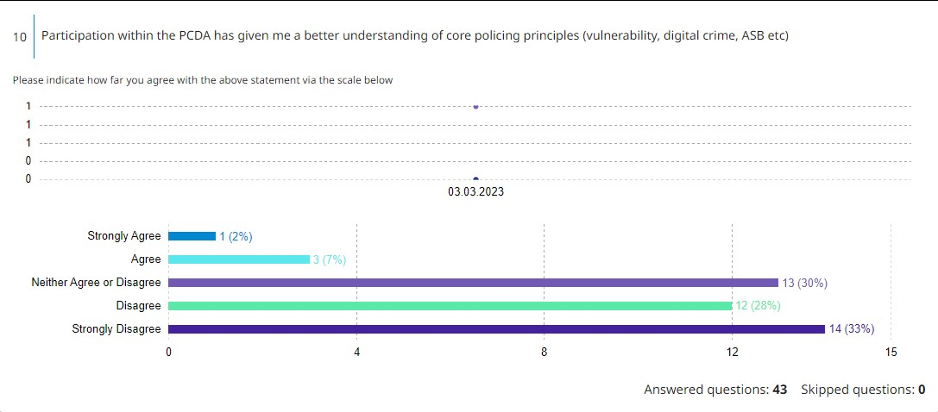
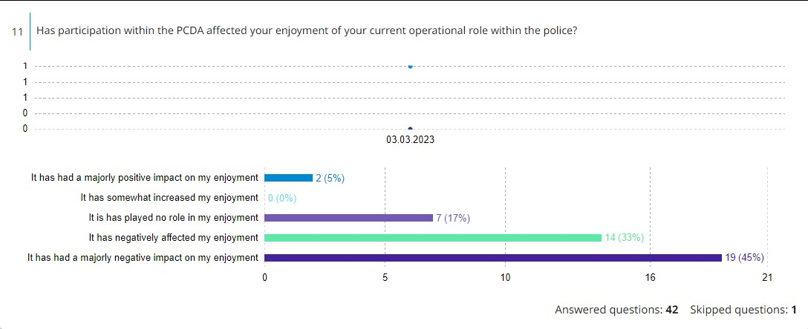
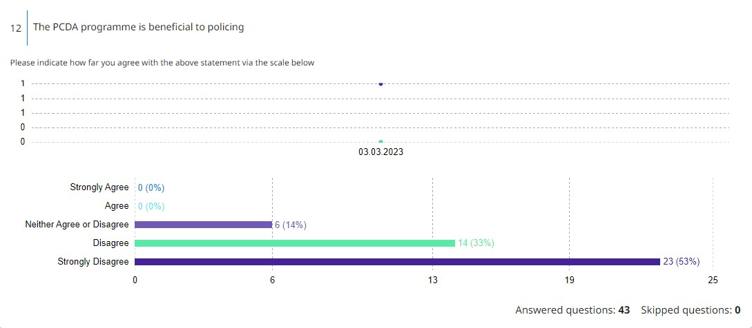
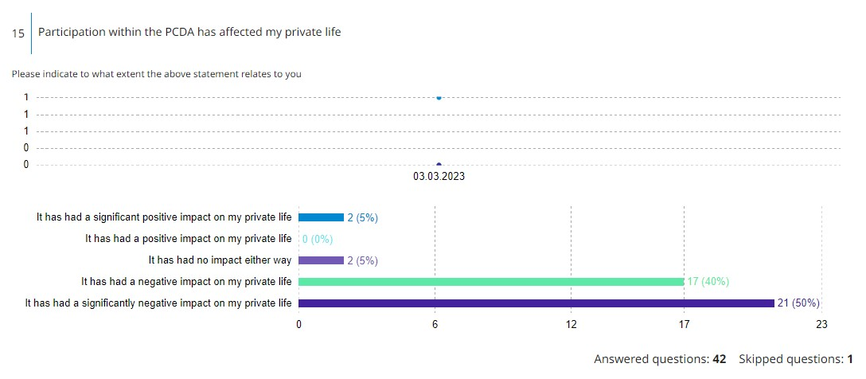
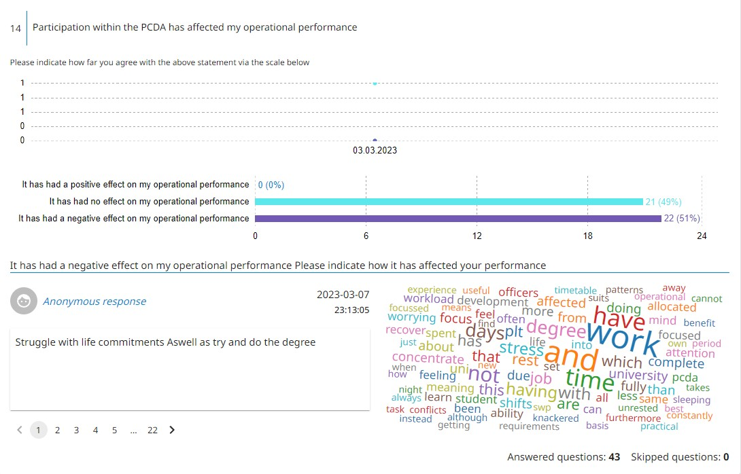
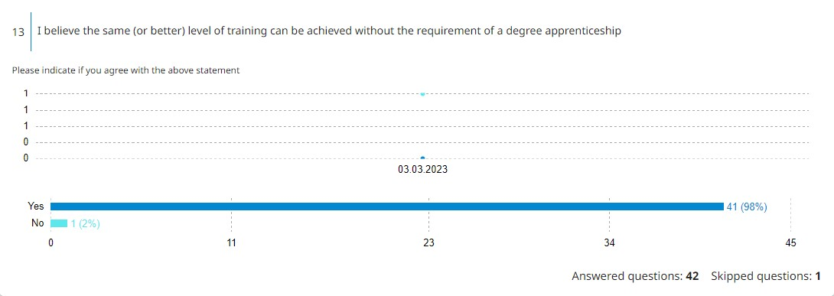
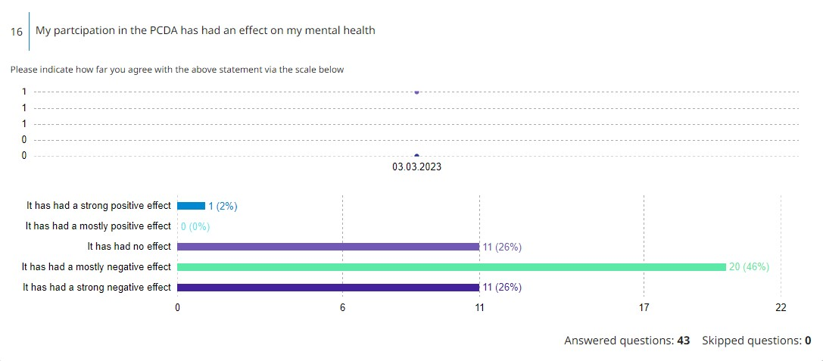
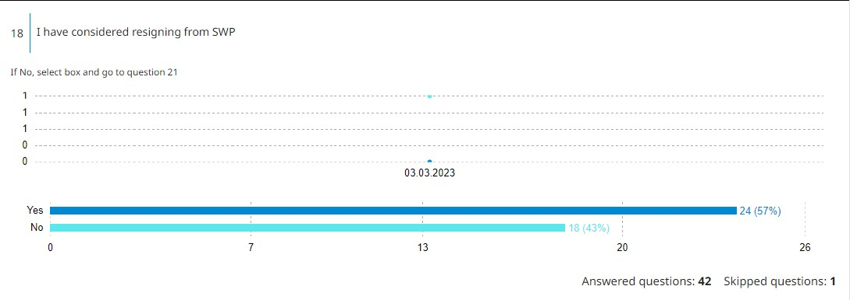
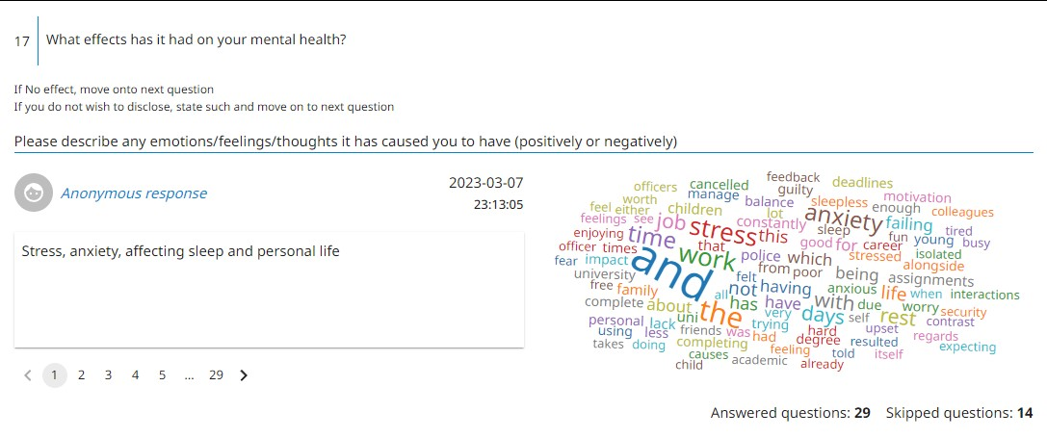

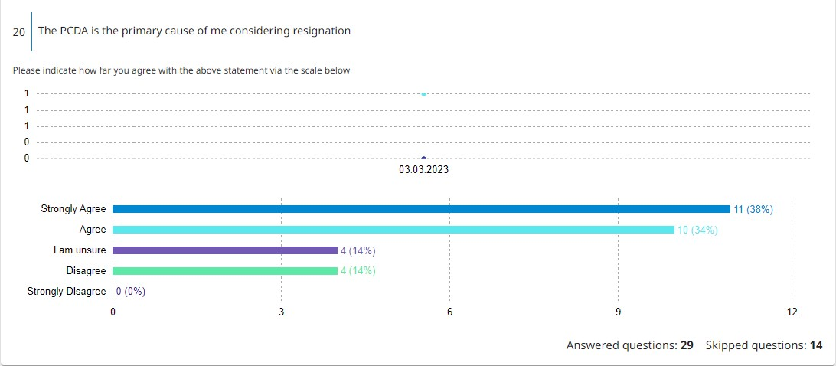
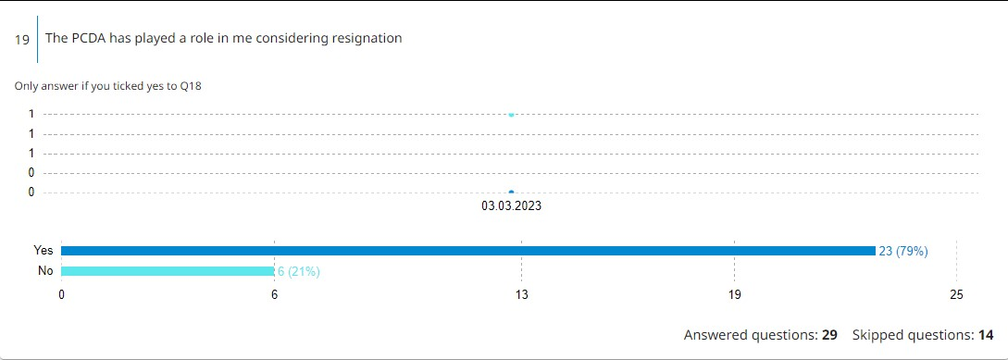
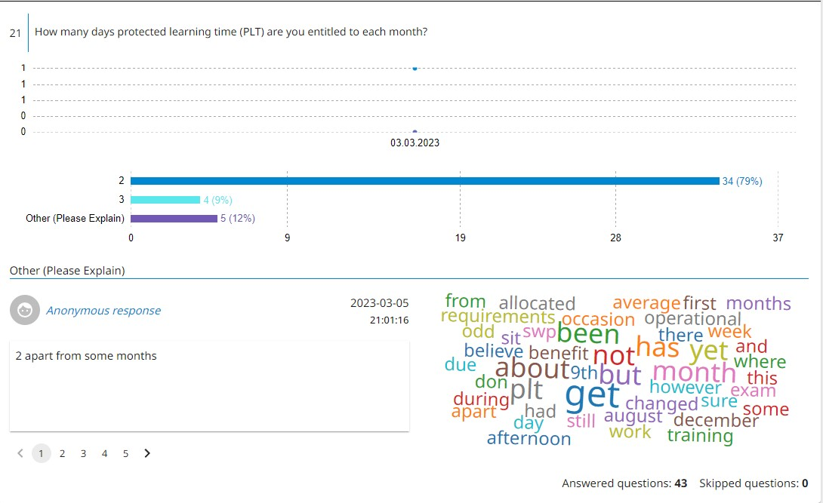
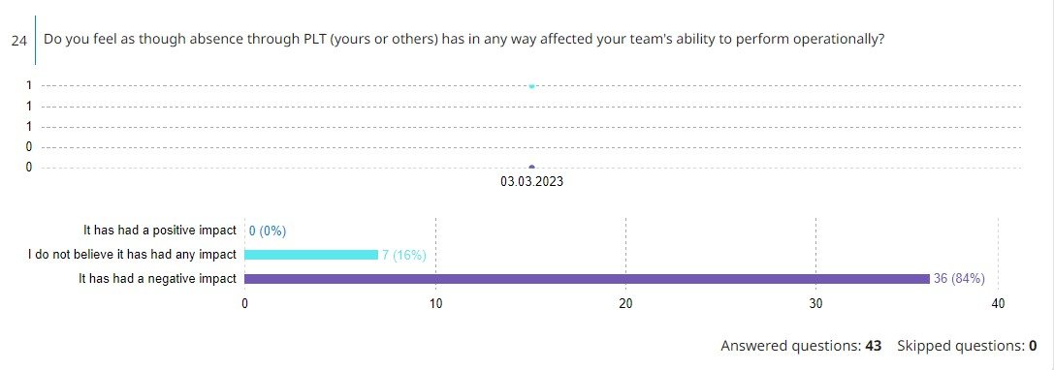
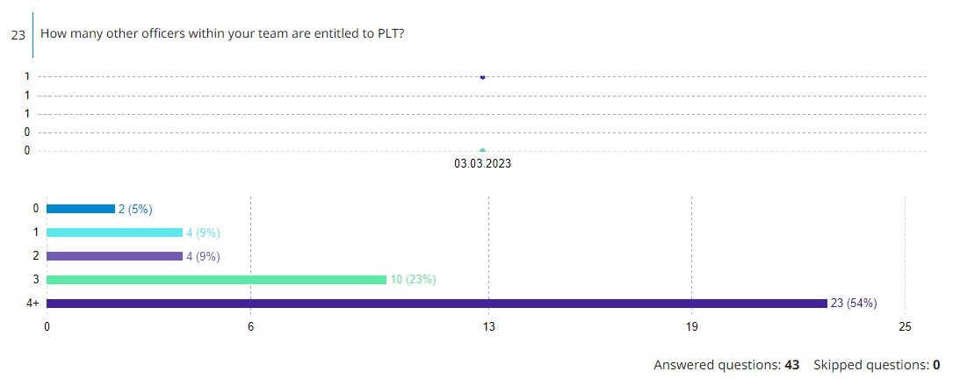
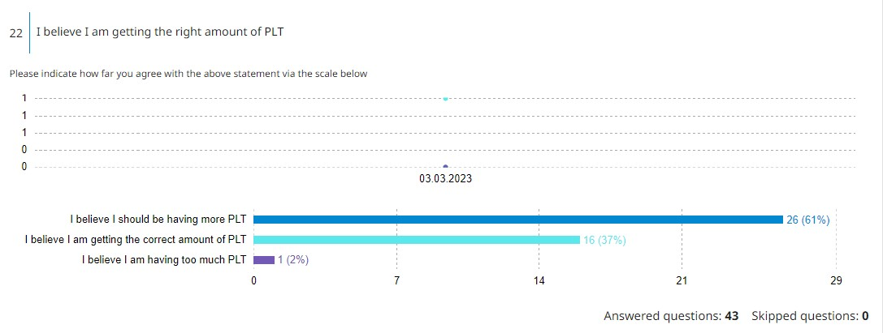

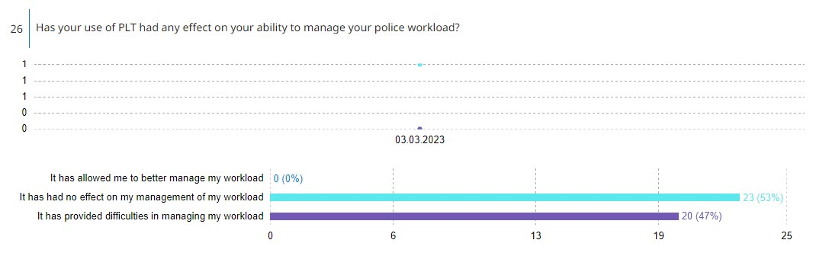
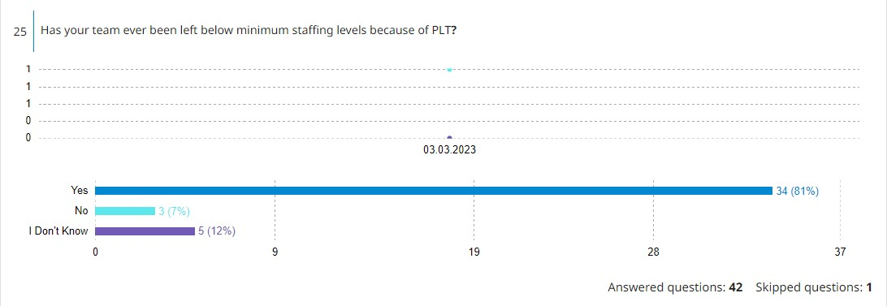

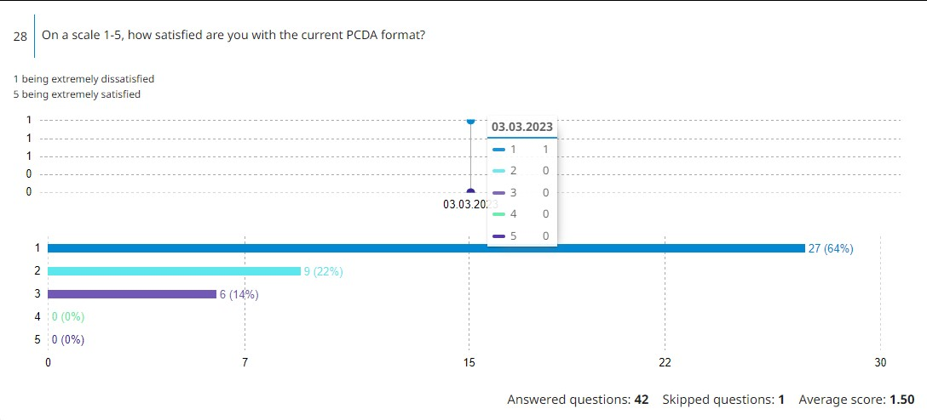

7.1 Appendix – Survey 2
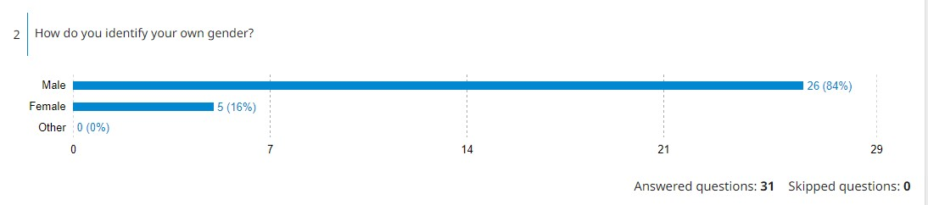
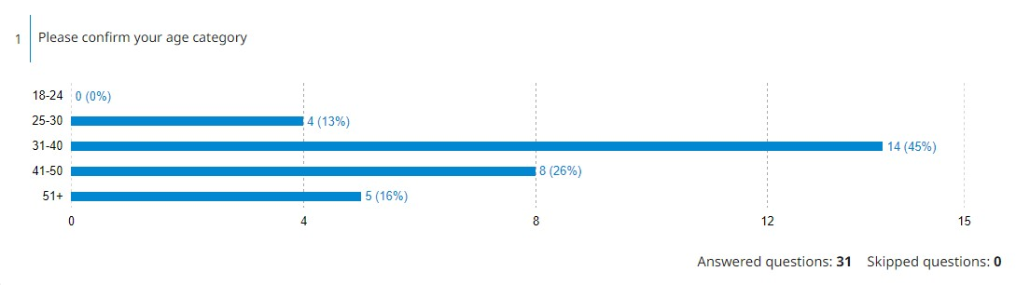

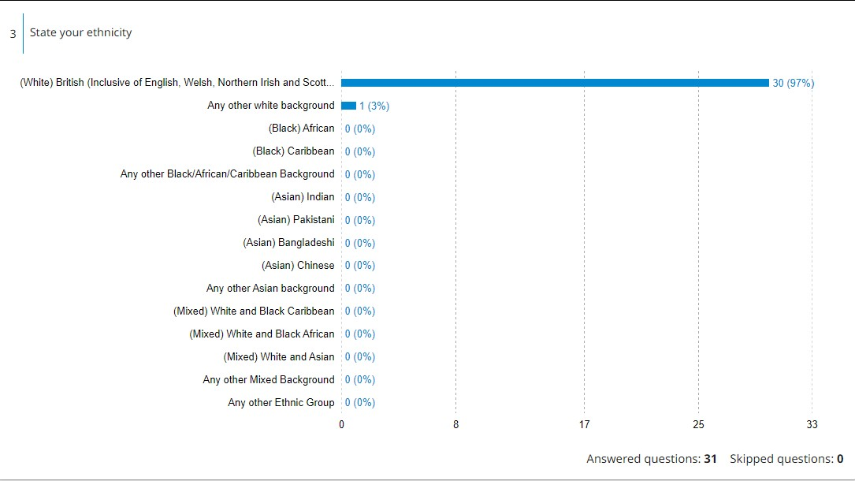

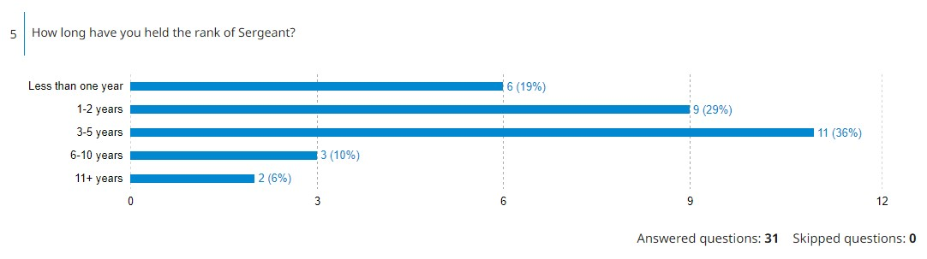
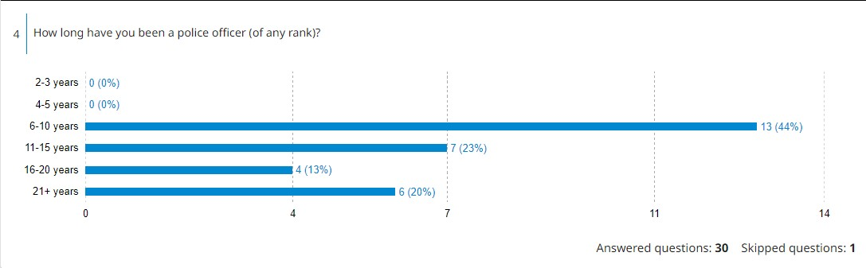
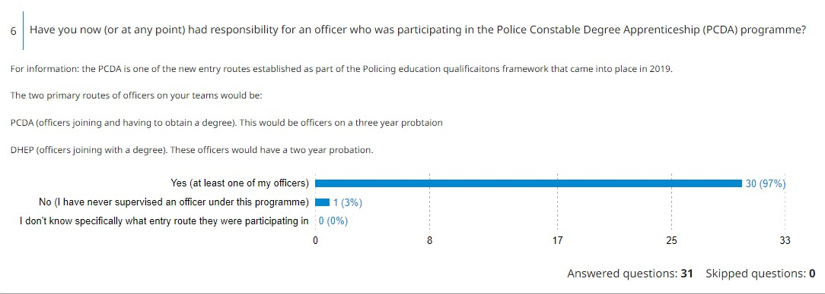
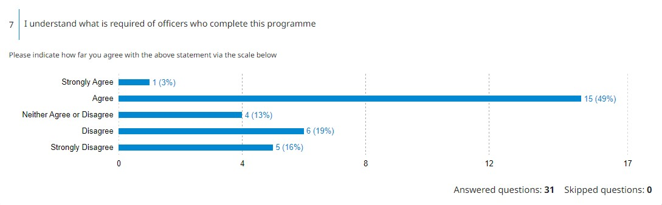
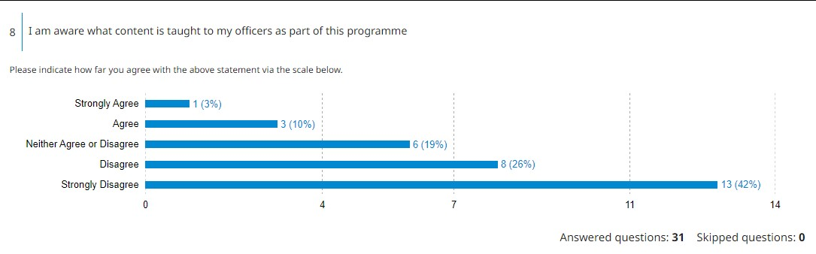

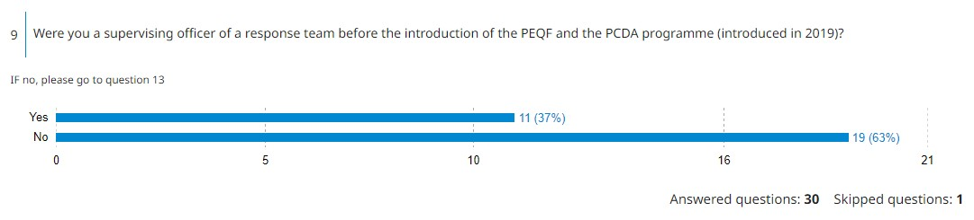

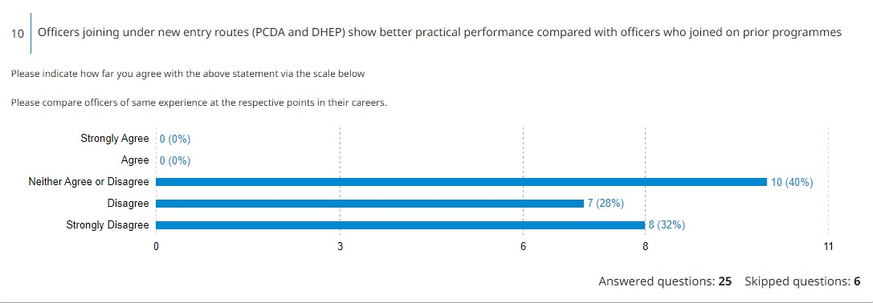

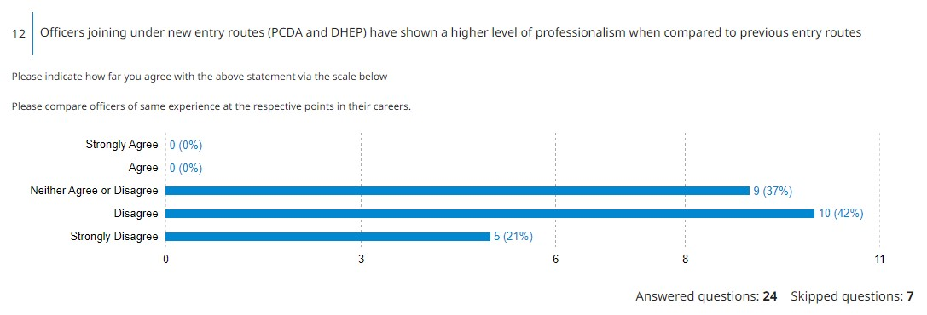
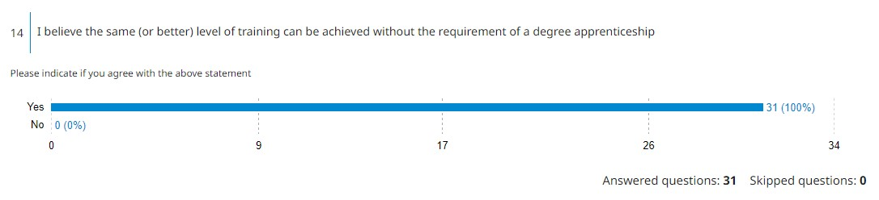
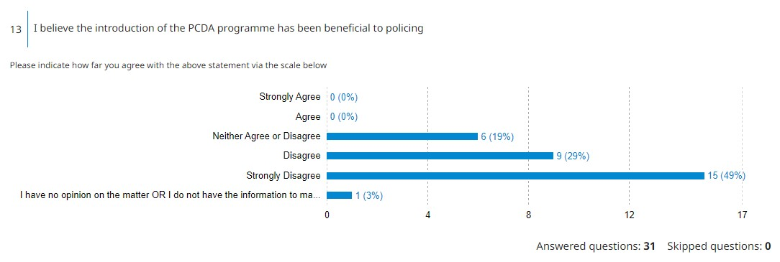
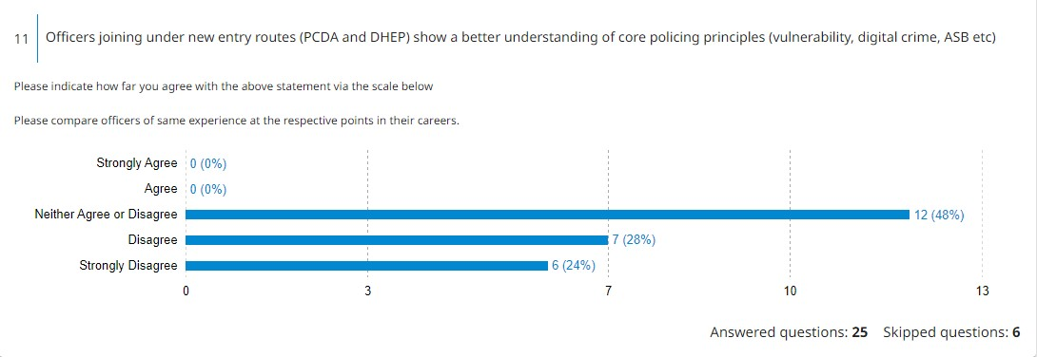
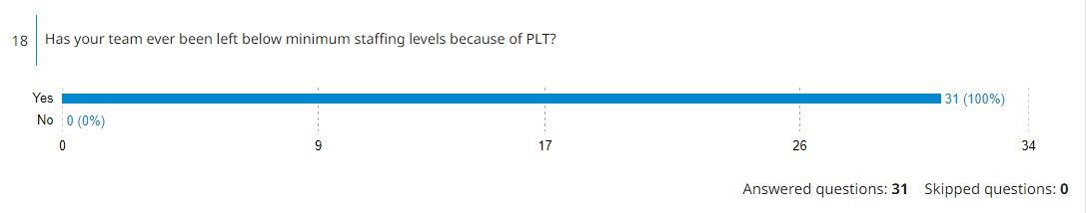
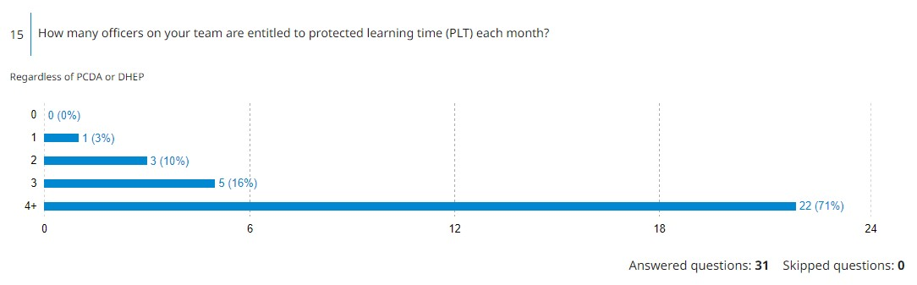
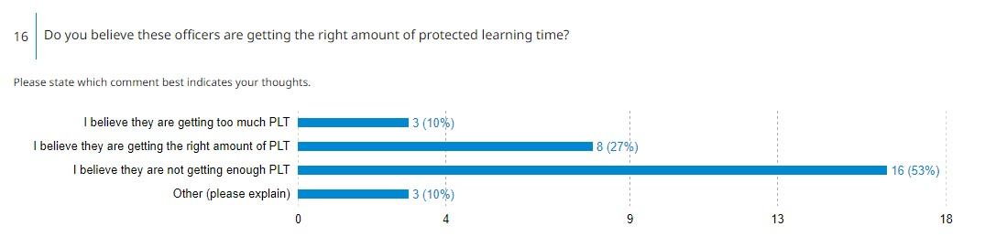

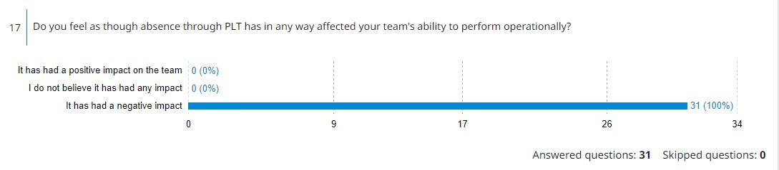

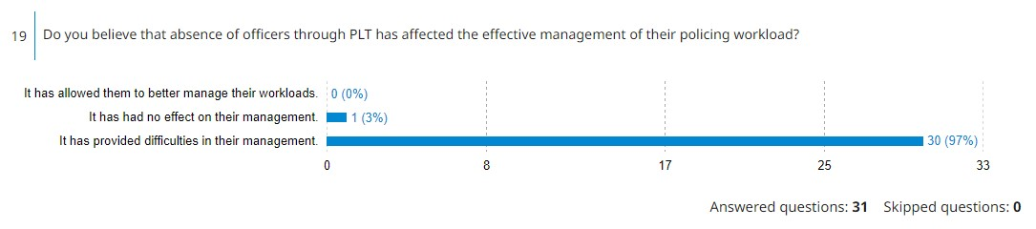

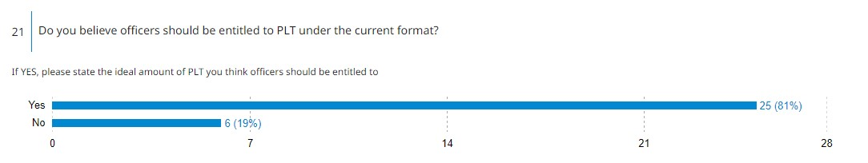

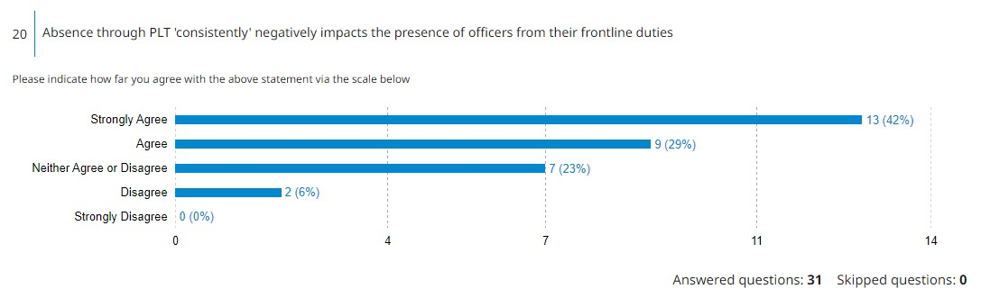

7.2 Appendix – Research Proposal



UNDERGRADUATE DISSERTATION
RESEARCH PROPOSAL FORM

NAME: Jake Reynish | STUDENT ID No.: 1922421
DRAFT RESEARCH TITLE QUESTION: An investigation into the impacts of the Police Constable Degree Apprenticeship (PCDA) on response policing in Wales.

INTRODUCTION:

The Police Constable Degree Apprenticeship (PCDA) was introduced alongside the Degree Holder Entry Programme (DHEP) to become the two primary standard routes of initial entry into the police under the Policing Education Qualifications Framework (PEQF). This overtakes the previous standard non-degree initial route (IPLDP). As of 13th August 2022, only 16 of the 43 Territorial police forces in England and Wales still offer the IPLDP entry route as an option. (Joining The Police, 2022). This means that the remaining 27 forces have now exclusively adopted the new PEQF recruitment options.
These new routes under the PEQF have been adopted as a result of the ambition to solidify policing as a profession. The validity of this concept had been previously debated (Rojek et al, 2012).
The scheme has been designed for police forces to work alongside higher education providers during the first three years of a recruited officer’s employment with the aim of developing workplace competence alongside a higher knowledge of key concepts affecting the policing environment.
This substantial change to the initial entry routes into policing has coincided with a dramatic increase in the number of recruited officers in England and Wales, due to HM Government’s push to recruit 20,000 new police officers, resulting in an increase in the number of officers who will be recruited under the PCDA entry route.

The objective of this research is to understand the impacts that this programme may have on frontline officers (if any), including potential for mental health implications alongside the demands on their personal life alongside anything else that becomes relevant through the research and survey methodologies.

The justification of this research is to understand the impacts of entry route on both officers and their police forces. Locating and recruiting the best candidates to police forces around the UK remains essential for national and localised security and it is imperative to discern whether current recruitment and training strategies are achieving these goals. This research will also be essential in detecting whether the PCDA route supports officers on the frontline by providing them with the necessary knowledge, so that they may carry out their duties professionally and expertly.

SUMMARY OF RESEARCH OBJECTIVES:

- To critically research and analyse the current academic literature and understanding surround the topics of work-based learning (WBL) and the Police Constable Degree Apprenticeship programme.
- What effect, if any, has the PCDA entry route had on officer retention?
- What effects has participation within the PCDA scheme had on response officers?
- How has the introduction of the PCDA scheme affected the presence of frontline officers in their primary duties due to abstractions through Protected learning time?

LITERATURE REVIEW:

There is an array of literature relating to the individual benefits of work-based learning programmes as stated by Ferguson (2019) as is said to include benefits such as increased motivation, confidence and competence to the learner.
Since the PCDA also incorporates Evidence Based Policing (EBP) as one of its core concepts, there is also a quantity of research into the benefits of research-based policing such as studies by Pepper et al, (2020) and Rojek et al, (2015).

However, what is apparent in this early research is that there is a prevalence of material on how well these PCDA schemes are incorporated in practice. “Police apprenticeships delivered collaboratively by Staffordshire Police and Staffordshire University have been rated as ‘good’ following an Ofsted inspection in January 2022.” (Staffordshire Police, 2022) Similarly, the College of Policing (2020) published a “Learning to date” document outlining their findings on the initial period following adoption of the PEQF framework.

Overall, the PCDA and its wider PEQF framework remains relatively new and as such there is not an overwhelming amount of academic material to consider. Specifically, there appears to be very little outside internal monitoring within police forces that wishes to evaluate the effects on the actual officers themselves and any such material located to date, as stated is produced locally by forces and has not been vigorously tested.

SUMMARY OF RESEARCH –SURVEY METHOD:

Several research methodologies will be adopted in order to gather the necessary information in relation to each separate research objective with both qualitative and quantitative date being required.

Statistical information will be vital in understanding the recruitment levels within the forces in WALES, as well as establishing the number of officers within each initial entry route and their retention rate. This data will be essential to compare and contrast the PCDA route both against the other entry routes within the PEQF but also against the traditional (IPLDP) route. Therefore, requests for this specific quantitative data will be required from South Wales Police.

Surveys will also be required to understand the level of abstractions that have occurred as a result on frontline staffing. In this context, an abstraction will be considered to be any removal from normal frontline duties to complete academic work through protected learning time. This is due to the provision of protected learning time as a means of ensuring a minimum secured amount of time for academic work to be completed. A survey will specifically be sent to the first line supervisors of response teams within South Wales Police to gauge what effect the current PLT model is having on their ability to manage their teams effectively.

To understand what effects the PCDA scheme has had on frontline officers, surveys and questionnaires will become a key component. The use of questionnaires will be the most effective means of research as it will allow me to contact a larger amount of participants in a structured and organised manner within South Wales Police. These will be the main methodologies used in obtaining this data, as receiving first-hand accounts from the target group will allow for easier measuring of certain impacts such as those on mental health.

SUMMARY OF SAMPLING FRAMEWORK: The target sample will be all officers who have participated within the PCDA. To achieve an understanding of the impacts on officers within the programme, there will be direct engagement with the target sample. This will be achieved by disseminating the questionnaires on internal systems within the organisation (email and intranet). The questionnaires will be provided to all officers who are confirmed as being involved within the PCDA programme (past or present) as well as made publicly available to all officers on the intranet so that no relevant officers are missed.

As part of my assessment on the impact of abstractions from duty, it will be required to provide questionnaires to supervising officers who are responsible for officers within their team under the PCDA programme. This in order to gain an understanding on the impacts on staffing and workload management within response teams. As a result of this specific eligibility requirement, this will limit the study purely to response officers and their supervisors.

ETHICAL ISSUES: Upon review of my initial proposal, I am satisfied that it is of ethically low risk.

The questionnaires themselves will ask officers to provide information and give opinion on contentious matters within South Wales Police. It is essential that each respondent is not identifiable. As a result, no names of individuals will be collected as this will need to be anonymous. Whilst age data will be collected, the amounts of officers within the organisation within each age bracket is so substantial that identification would not be possible.

Secondly, participation within the survey still remains entirely at the choice of the respondent, as there is no obligation for them to complete it.

To manage any ethical issues regarding the quantitative data collected from the organisation, all data has been collected internally with the express consent of South Wales Police.
TIME SCALE:
Time and resource management will be limited due to substantial work commitments, the below schedule has been adopted to provide a monitor and ensure progress.

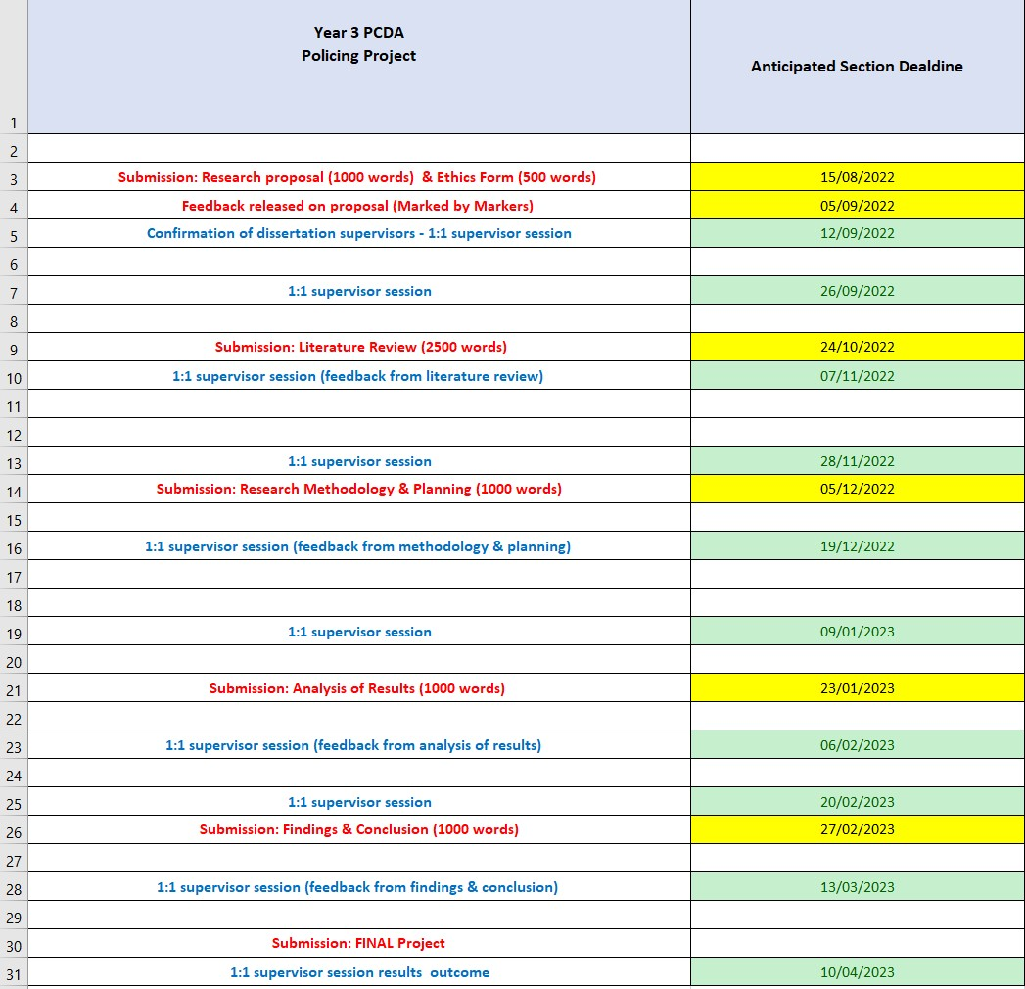

7.3 Appendix – Ethics Form

In order for research to result in benefit and minimise risk of harm, it must be conducted ethically. A researcher may not be covered by the University’s insurance if ethical approval has not been obtained prior to commencement.

The University follows the OECD Frascati manual definition of research activity: “creative work undertaken on a systematic basis in order to increase the stock of knowledge, including knowledge of man, culture and society, and the use of this stock of knowledge to devise new applications”. As such this covers activities undertaken by members of staff, postgraduate research students, and both taught postgraduate and undergraduate students working on dissertations/projects.

The individual undertaking the research activity is known as the “principal researcher”.

Ethical approval is not required for routine audits, performance reviews, quality assurance studies, testing within normal educational requirements, and literary or artistic criticism.

Please read the notes for guidance before completing ALL sections of the form.

This form must be completed and approved prior to undertaking any research activity. Please see Checklist for details of process for different categories of application.

Delete the Guidance Notes at the end of the form BEFORE submitting your application

SECTION A: About You (Principal Researcher)
Full Name: |  | Jake Reynish
Tick all boxes which apply: |  | Member of staff: | ☐ | Honorary research fellow: | ☐
Undergraduate Student | ☒ | Taught Postgraduate Student | ☐ | Postgraduate Research Student | ☐

Institute/Academic Discipline/Centre: | IMH
Campus: | SWANSEA
E-mail address: | 1922421@student.uwtsd.ac.uk
Contact Telephone Number: | N/A
For students:
Student Number: | 1922421
Programme of Study: | BSC Hons Professional Policing Practice
Director of Studies/Supervisor: | Deepak Patel

SECTION B: Approval for Research Activity
Has the research activity received approval in principle?  (please check the Guidance Notes as to the appropriate approval process for different levels of research by different categories of individual) |  | YES | ☒ | NO | ☐
 |  |  |  | Date
If Yes, please indicate source of approval (and date where known): Approval in principle must be obtained from the relevant source prior to seeking ethical approval | Research Degrees Committee |  | ☐
 | Institute Research Committee |  | ☐
 | Other (write in) |  | ☒ | Jane THOMAS

SECTION C: Internal and External Ethical Guidance Materials
Please list the core ethical guidance documents that have been referred to during the completion of this form (including any discipline-specific codes of research ethics, and also any specific ethical guidance relating to the proposed methodology). Please tick to confirm that your research proposal adheres to these codes and guidelines.
UWTSD Research Ethics & Integrity Code of Practice | ☒
UWTSD Research Data Management Policy | ☒
 | ☐

SECTION D: External Collaborative Research Activity
Does the research activity involve collaborators outside of the University? |  | YES | ☐ | NO | ☒
If Yes, please provide the name of the external organisation and name and contact details for the main contact person and confirmation this person has consented to their personal data being shared.as part of this collaboration.
Institution
Contact person name
Contact person e-mail address

Has this individual consented to sharing their details on this form? |  | YES | ☐ | NO |  |  | ☐
Are you in receipt of a KESS scholarship? |  | YES | ☐ | NO |  |  | ☐
Is your research externally funded |  | YES | ☐ | NO |  |  | ☐
Are you specifically employed to undertake this research in either a paid or voluntary capacity? | Voluntary | YES | ☐ | NO |  | ☐
 | Employed | YES | ☐ | NO |  | ☐
Is the research being undertaken within an existing UWTSD Athrofa Professional Learning Partnership (APLP) | If YES then the permission question below does not need to be answered. | YES | ☐ | NO |  |  | ☐
Permission to undertake the research has been provided by the partner organisation | (If YES attach copy)  If NO the application cannot continue | YES | ☐ | NO |  |  | ☐

Where research activity is carried out in collaboration with an external organisation
Does this organisation have its own ethics approval system? | YES | ☐ | NO | ☐
If Yes, please attach a copy of any final approval (or interim approval) from the organisation

SECTION E: Details of Research Activity
Indicative title: | Understanding the impacts of the Police Constable Degree Apprenticeship (PCDA) on response policing in Wales.
Proposed start date: | 20/06/2022 | Proposed end date: | 27/03/2023
Introduction to the Research (maximum 300 words)
Ensure that you write for a Non-Specialist Audience when outlining your response to the three points below:
- Purpose of Research Activity
- Proposed Research Question
- Aims of Research Activity
- Objectives of Research Activity
Demonstrate, briefly, how Existing Research has informed the proposed activity and explain
- What the research activity will add to the body of knowledge
- How it addresses an area of importance.
Purpose of Research Activity

The purpose of this research is to understand the impacts of the PCDA entry route on both officers and their respective police forces. Locating and recruiting the best candidates to police forces around the UK remains essential for national and localised security and it is imperative to discern whether current recruitment and training strategies are achieving these goals. This research will also be essential in detecting whether the PCDA route supports officers on the frontline, so that they may carry out their duties professionally and expertly.
The overall aim of the research activity is to help inform policies and overall direction of policing recruitment in the years to come.

(this box should expand as you type)
Research Question

What impacts has the Police Constable Degree Apprenticeship (PCDA) had on response policing in Wales?

(this box should expand as you type)
Aims of Research Activity

This research aims to answer the following questions.

- To critically research and analyse the current academic literature and understanding surround the topics of work-based learning (WBL) and the Police Constable Degree Apprenticeship programme
- What effect, if any, has the PCDA entry route had on officer retention?
- What effects has participation within the PCDA scheme had on response officers?
- How has the introduction of the PCDA scheme affected the presence of frontline officers in their primary duties due to abstractions through Protected learning time?

(this box should expand as you type)
Objectives of Research Activity

The objective of this research is to understand the impacts that this programme may have on frontline officers (if any), including potential for mental health implications alongside the demands on their personal life alongside anything else that becomes relevant through the research and survey methodologies.

(this box should expand as you type)
Proposed methods (maximum 600 words)
Several research methodologies will be adopted in order to gather the necessary information in relation to each separate research objective with both qualitative and quantitative date being required.

Statistical information will be vital in understanding the recruitment levels within each police force within WALES, as well as establishing the number of officers within each initial entry route and their retention rate. This data will be essential to compare and contrast the PCDA route both against the other entry routes within the PEQF but also against the traditional (IPLDP) route. Therefore, requests for this specific quantitative data will be required from South Wales Police.

To understand what effects the PCDA scheme has had on frontline officers, surveys, questionnaires and interviews will become a key component in providing a high level of data. The use of such questionnaires will be the most effective means of research as it will allow me to contact a larger amount of participants in a structured and organised manner. These will be the main methodologies used in obtaining this data, as receiving first-hand accounts from the target group will allow for easier measuring of certain impacts such as those on mental health. This survey will also be designed to target the other research objectives such as identifying officer’s thoughts regarding officer retention and the impact of protected learning time.

An additional survey will be designed to target the first line supervisors of response teams within South Wales Police. This survey is designed to get an idea of the ‘real-world’ impact of abstractions through PLT on response teams and the capability of supervisors to respond to this pressure. This will be used to answer research objective four.

(this box should expand as you type)

Location of research activity

SWANSEA
(this box should expand as you type)
Research activity outside of the UK
If research activity will take place overseas, you are responsible for ensuring that local ethical considerations are complied with and that the relevant permissions are sought. Specify any local guidelines (e.g. from local professional associations/learned societies/universities) that exist and whether these involve any ethical stipulations beyond those usual in the UK (provide details of any licenses or permissions required). Also specify whether there are any specific ethical issues raised by the local context in which the research activity is taking place, for example, particular cultural and/or legal sensitivities or vulnerabilities of participants.
N/A

(this box should expand as you type)
Use of documentation not in the public domain: Are any documents NOT publicly available? | NO | ☐
 | YES | ☒
If Yes, please provide details here of how you will gain access to specific documentation that is not in the public domain and that this is in accordance with prevailing data protection law of the country in question and England and Wales.

A request for data will be submitted to South Wales Police requesting data relating to officer retention. This data will be cleansed of any personal data prior to being providing to the researcher in line with South Wales Police’s obligations.

(this box should expand as you type)

SECTION F: Scope of Research Activity
Will the research activity include: | YES | NO
Use of a questionnaire or similar research instrument? | ☒ | ☐
Use of interviews? | ☐ | ☒
Use of diaries? | ☐ | ☒
Participant observation with their knowledge? | ☐ | ☒
Participant observation without their knowledge? | ☐ | ☒
Use of video or audio recording? | ☐ | ☒
Access to personal or confidential information without the participants’ specific consent? | ☐ | ☒
Administration of any questions, test stimuli, presentation that may be experienced as physically, mentally or emotionally harmful / offensive? | ☐ | ☒
Performance of any acts which may cause embarrassment or affect self-esteem? | ☐ | ☒
Investigation of participants involved in illegal activities? | ☐ | ☒
Use of procedures that involve deception? | ☐ | ☒
Administration of any substance, agent or placebo? | ☐ | ☒
Working with live vertebrate animals? | ☐ | ☒
Other primary data collection methods, please explain in this box  For example, ‘focus groups’. Please indicate the type of data collection method(s) in this box and tick the accompany box. | ☐ | ☒
Details of any other primary data collection method:  (this box should expand as you type) | ☐ | ☒
If NO to every question, then the research activity is (ethically) low risk and may be exempt from some of the following sections (please refer to Guidance Notes).

If YES to any question, then no research activity should be undertaken until full ethical approval has been obtained.

SECTION G: Intended Participants
Who are the intended participants: | YES | NO
Students or staff at the University? | ☒ | ☐
Adults (over the age of 18 and competent to give consent)? | ☒ | ☐
Vulnerable adults? | ☐ | ☒
Children and Young People under the age of 18? (Consent from Parent, Carer or Guardian will be required) | ☐ | ☒
Prisoners? | ☐ | ☒
Young offenders? | ☐ | ☒
Those who could be considered to have a particularly dependent relationship with the investigator or a gatekeeper? | ☐ | ☒
People engaged in illegal activities? | ☐ | ☒
Others (please identify specifically any group who may be unable to give consent) please indicate here and tick the appropriate box. | ☐ | ☒
Other – please indicate here:  (this box should expand as you type) | ☐ | ☒

Participant numbers and source
Provide an estimate of the expected number of participants. How will you identify participants and how will they be recruited?
How many participants are expected? | The intention is for all serving officers within South Wales Police under the PCDA scheme (both former and current) to be potential participants. The exact number is not known at the time of proposal.  (this box should expand as you type)
Who will the participants be? | Serving officers within South Wales Police who have participated within the PCDA  (this box should expand as you type)
How will you identify the participants? | Known to Principal Researcher through employment.  (this box should expand as you type)

Information for participants: | YES | NO | N/A
Will you describe the main research procedures to participants in advance, so that they are informed about what to expect? | ☒ | ☐ | ☐
Will you tell participants that their participation is voluntary? | ☒ | ☐ | ☐
Will you obtain written consent for participation? | ☐ | ☐ | ☒
Will you explain to participants that refusal to participate in the research will not affect their treatment or education (if relevant)? | ☐ | ☐ | ☒
If the research is observational, will you ask participants for their consent to being observed? | ☐ | ☐ | ☒
Will you tell participants that they may withdraw from the research at any time and for any reason? | ☒ | ☐ | ☐
With questionnaires, will you give participants the option of omitting questions they do not want to answer? | ☒ | ☐ | ☐
Will you tell participants that their data will be treated with full confidentiality and that, if published, it will not be identifiable as theirs? | ☒ | ☐ | ☐
Will you debrief participants at the end of their participation, in a way appropriate to the type of research undertaken? | ☒ | ☐ | ☐
If NO to any of above questions, please give an explanation
(this box should expand as you type)

Information for participants: | YES | NO | N/A
Will participants be paid? | ☐ | ☒ | ☐
Is specialist electrical or other equipment to be used with participants? | ☐ | ☒ | ☐
Are there any financial or other interests to the investigator or University arising from this study? | ☐ | ☒ | ☐
Will the research activity involve deliberately misleading participants in any way, or the partial or full concealment of the specific study aims? | ☐ | ☒ | ☐
If YES to any question, please provide full details
(this box should expand as you type)

SECTION H: Anticipated Risks
Outline any anticipated risks that may adversely affect any of the participants, the researchers and/or the University, and the steps that will be taken to address them.

If you have completed a full risk assessment (for example as required by a laboratory, or external research collaborator) you may append that to this form.
Full risk assessment completed and appended? |  | Yes | ☒
 |  | No | ☐
Risks to participants
For example: emotional distress, financial disclosure, physical harm, transfer of personal data, sensitive organisational information
Risk to Participant:  N/A  (this box should expand as you type) | How will you mitigate the Risk to Participant  N/A  (this box should expand as you type)
If research activity may include sensitive, embarrassing or upsetting topics (e.g. sexual activity, drug use) or issues likely to disclose information requiring further action (e.g. criminal activity), give details of the procedures to deal with these issues, including any support/advice (e.g. helpline numbers) to be offered to participants. Note that where applicable, consent procedures should make it clear that if something potentially or actually illegal is discovered in the course of a project, it may need to be disclosed to the proper authorities
N/A

(this box should expand as you type)
Risks to investigator
For example: personal safety, physical harm, emotional distress, risk of accusation of harm/impropriety, conflict of interest
Risk to Investigator:  N/A  (this box should expand as you type) | How will you mitigate the Risk to Investigator:  N/A  (this box should expand as you type)
University/institutional risks
For example: adverse publicity, financial loss, data protection
Risk to University:  N/A  (this box should expand as you type) | How will you mitigate the Risk to University:  N/A  (this box should expand as you type)

Disclosure and Barring Service
If the research activity involves children or vulnerable adults, a Disclosure and Barring Service (DBS) certificate must be obtained before any contact with such participants. | YES | NO | N/A
Does your research require you to hold a current DBS Certificate? | ☐ | ☒ | ☐

SECTION I: Feedback, Consent and Confidentiality
Feedback
What de-briefing and feedback will be provided to participants, how will this be done and when?
Participants will be provided with the relevant confirmation when the completed questionnaire has been received and informed about what will happen to the data within. This will be done at the time of receiving the completed document. There is not anticipated to be any further communication after that point with the majority of participants.

(this box should expand as you type)
Informed consent
Describe the arrangements to inform potential participants, before providing consent, of what is involved in participating. Describe the arrangements for participants to provide full consent before data collection begins. If gaining consent in this way is inappropriate, explain how consent will be obtained and recorded in accordance with prevailing data protection legislation.

All contact will be managed via an email system so that all contact is recorded.
(this box should expand as you type)
Confidentiality / Anonymity
Set out how anonymity of participants and confidentiality will be ensured in any outputs. If anonymity is not being offered, explain why this is the case.

There is no confidential information to be obtained within the overall collection strategy.
No personal identifiable information will be retained when data is provided and so all data will be anonymous.

(this box should expand as you type)

SECTION J: Data Protection and Storage
In completing this section refer to the University’s Research Data Management Policy and the extensive resources on the University’s Research Data Management web pages (http://uwtsd.ac.uk/library/research-data-management/).
Does the research activity involve personal data (as defined by the General Data Protection Regulation 2016 “GDPR” and the Data Protection Act 2018 “DPA”)? | YES | NO
“Personal data” means any information relating to an identified or identifiable natural person (‘data subject’). An identifiable natural person is one who can be identified, directly or indirectly, in particular by reference to an identifier such as a name, an identification number, location data, an online identifier or to one or more factors specific to the physical, physiological, genetic, mental, economic, cultural or social identity of that natural person. | ☐ | X
If YES, provide a description of the data and explain why this data needs to be collected:
(this box should expand as you type)
Does it involve special category data (as defined by the GDPR)? | YES | NO
“Special category data” means sensitive personal data consisting of information as to the data subjects’ –  (a) racial or ethnic origin,  (b) political opinions,  (c ) religious beliefs or other beliefs of a similar nature,  (d) membership of a trade union (within the meaning of the Trade Union and Labour Relations (Consolidation) Act 1992),  (e) physical or mental health or condition,  (f) sexual life,  (g) genetics,  (h) biometric data (as used for ID purposes), | ☐ | X
If YES, provide a description of the special category data and explain why this data needs to be collected:
(this box should expand as you type)
Will the research activity involve storing personal data and/or special category data on one of the following: | YES | NO
Manual files (i.e. in paper form)? | ☐ | ☒
University computers? | ☐ | ☒
Private company computers? | ☐ | ☒
Home or other personal computers? | ☐ | ☒
Laptop computers/ CDs/ Portable disk-drives/ memory sticks? | ☐ | ☒
“Cloud” storage or websites? | ☐ | ☒
Other – specify: | ☐ | ☒
For all stored data, explain the measures in place to ensure the security of the data collected, data confidentiality, including details of password protection, encryption, anonymisation and pseudonymisation:
Work will be conducted via home computer. This device is secured via password protection.

(this box should expand as you type)
All Data Storage
Will the research activity involve any of the following activities: | YES | NO
Electronic transfer of data in any form? | ☐ | ☒
Sharing of data with others at the University? | ☐ | ☒
Sharing of data with other organisations? | ☐ | ☒
Export of data outside the European Union or importing of data from outside the UK? | ☐ | ☒
Use of personal addresses, postcodes, faxes, emails or telephone numbers? | ☐ | ☒
Publication of data that might allow identification of individuals? | ☐ | ☒
Use of data management system? | ☐ | ☒
Data archiving? | ☐ | ☒
If YES to any question, please provide full details, explaining how this will be conducted in accordance with the GDPR and DPA (and/or any international equivalent):
N/A

(this box should expand as you type)
List all who will have access to the data generated by the research activity:
N/A

(this box should expand as you type)
List who will have control of, and act as custodian(s) for, data generated by the research activity:
N/A

(this box should expand as you type)
Give details of data storage arrangements, including security measures in place to protect the data, where data will be stored, how long for, and in what form. Will data be archived – if so how and if not why not.
N/A

(this box should expand as you type)
Please indicate if your data will be stored in the UWTSD Research Data Repository (see https://researchdata.uwtsd.ac.uk/ ). If so please explain. (Most relevant to academic staff)
No

(this box should expand as you type)
Confirm that you have read the UWTSD guidance on data management (see https://www.uwtsd.ac.uk/library/research-data-management/) | YES | ☒
 | NO | ☐
Confirm that you are aware that you need to keep all data until after your research has completed or the end of your funding | YES | ☒
 | NO | ☐

SECTION K: Declaration
The information which I have provided is correct and complete to the best of my knowledge. I have attempted to identify any risks and issues related to the research activity and acknowledge my obligations and the rights of the participants.

In submitting this application I hereby confirm that I undertake to ensure that the above named research activity will meet the University’s Research Ethics and Integrity Code of Practice which is published on the website: https://www.uwtsd.ac.uk/research/research-ethics/
Signature of applicant: | J.Reynish | Date: 13th August 2022

For STUDENT Submissions:
Director of Studies/Supervisor: |  | Date:
Signature: |  | Date:

For STAFF Submissions:
Academic Director/ Assistant Dean: |  | Date:
Signature: |  | Date:

Checklist: Please complete the checklist below to ensure that you have completed the form according to the guidelines and attached any required documentation:
☒ | I have read the guidance notes supplied before completing the form.
☒ | I have completed ALL RELEVANT sections of the form in full.
☒ | I confirm that the research activity has received approval in principle
☐ | I have attached a copy of final/interim approval from external organisation (where appropriate)
☐ | I have attached a full risk assessment (and have NOT completed Section H of this form) (where appropriate) ONLY TICK IF YOU HAVE ATTACHED A FULL RISK ASSESSMENT
☒ | I understand that it is my responsibility to ensure that the above named research activity will meet the University’s Research Ethics and Integrity Code of Practice.
☒ | I understand that before commencing data collection all documents aimed at respondents (including information sheets, consent forms, questionnaires, interview schedules etc.) must be confirmed by the DoS/Supervisor, module tutor or Academic Director.
☒ | I have deleted the guidance notes before submitting the PG2 for consideration

RESEARCH STUDENTS AND STAFF ONLY
All communications relating to this application during its processing must be in writing and emailed to pgresearch@uwtsd.ac.uk , with the title ‘Ethical Approval’ followed by your name.
You will be informed of the outcome of your claim by email; therefore it is important that you check your University and personal email accounts regularly.

STUDENTS ON UNDERGRADUATE OR TAUGHT MASTERS PROGRAMMES should submit this form (and receive the outcome) via systems explained to you by the supervisor/module leader.

This form is available electronically from the Academic Office web pages: https://www.uwtsd.ac.uk/academic-office/appendices-and-forms/

Application Process

All staff research projects and all research students must submit the Ethical Approval Form to the University Research Ethics Committee via the Academic Office (pgresearch@uwtsd.ac.uk). Staff research directly in relation to personal study for taught undergraduate or Masters programmes should be submitted via the Institute procedures explained below.

Taught masters and taught undergraduate research Ethical Approval Forms are considered within Institutes. Institutes will provide details of the specific processes for this. Where the Ethical issues within any single ethical application are of particular concern the Institute will refer these to the University Research Ethics Committee. Any student activity that involves the collection of primary data needs to undergo Ethical approval, this includes assignment work as well as dissertations.

