

Postgraduate/Distance Learning
Assignment coversheet & feedback form

THIS SHEET MUST BE THE FIRST PAGE OF THE ASSIGNMENT YOU ARE SUBMITTING (DO NOT SEND AS A SEPARATE FILE)

For completion by the student:
Student Name: Gayle Tait

Student University Email: 1200151@student.uwtsd.ac.uk
Module code: HPCA7014  Module title: Sacred Geography | Student ID number:  1200151 |  |  | Educational support needs:  Yes/No
Assignment title: Essay based on a supervised research project.

Assignment due date: 13/01/2022
This assignment is for the 1st 2nd 3rd 4th 5th 6th module of the degree
I confirm that this is my original work and that I have adhered to the University policy on plagiarism.
Signed …………Gayle Tait…………………………………………………
Email submission:if you are submitting this form via email, please tick this box □
(as a substitute for your signature) to confirm that you agree to the above declaration.
Assignment Mark
1st Marker’s Provisional mark
2nd Marker’s/Moderator’s provisional mark
External Examiner’s mark (if relevant)
Final Mark

NB. All marks are provisional until confirmed by the Final Examination Board.

For completion by Marker 1 :
Comments:

Marker’s signature: |  |  | Date:
For completion by Marker 2/Moderator:

Comments:

Marker’s Signature: |  | Date:
External Examiner’s comments (if relevant)

External Examiner’s Signature: |  | Date:

In this research project, I will examine the idea of whether a sacred space is a human construct or a natural phenomenon, through a case study of Raby Castle. This location offers an opportunity to discuss this concept because of the ground’s uniqueness; Raby Castle is not just one sacred place but can be separated into two. The grounds evoke a sacredness through the presence of deer which have been on the grounds since before the 11th century, enhancing the belief that sacredness comes from nature. However, the castle and surrounding grounds display its sacredness to visitors through its wilderness and human adaptation of the land. Suggesting that parts of the sacredness, of this site, is through human construct. Within this case study, I will examine the importance of the deer to the landscape and whether they are the main factor which makes this site sacred. I will also discuss the castle and comment on the impact manmade features had on the level of sacredness felt. I will address some of the current writings on hierophany and sacredness to explore different angles on the topic. I will examine the settlement of Raby Castle discussing the importance of location in relation to the land, whether the castle creates a feeling of sacredness or has it just harnessed the power and talk about my personal experience when visiting Raby Castle. I will also discuss who Raby Castle is a sacred space for, the deer or for the people who have settled in the area.
The main theorists who speak about what constitutes something as sacred are Lane, Otto, Eliade, Durkheim, Casey, Aristotle and Levy-Bruhl. In this section, I will explore which of these theorists apply to Raby Castle, applying it to my theory on what constitutes as a sacred place and which elements of Raby Castle contribute to this sacredness. To designate or make a place sacred we must think about the characteristics of sanctity and the experiences of hierophany. The main elements which designate a place as sacred are the individual’s feeling of awe, wonder, fear or a sense of the unknown. Some people describe this feeling as supernatural or relating to god; this link has led to people labelling areas to a religion or worship, sometime due to its close proximity to certain sanctuaries. Through reports of these feelings, the infamy of the place attracts others and allows them to be open to the aura and the chance of having a hierophantic experience, enhancing the sacred space through a sense of collective consciousness. This openness has allowed for many people to experience a sense of hierophany. These feeling can also occur in anywhere. Lane speaks of a sense of hierophany he had when he was open to the experience and was able to stumble upon it. We can have our own sacred space in which we find a sense of belonging, but in order to designate a place as sacred we must have the backing of a community to reinforce and validate this feeling. This can mean that many sacred spaces that exist have not been discovered yet, as we have yet to open up our minds to it and validate it through the collective community.
Durkheim believes that anything can be designated as sacred, a tree or even a pebble has the ability to be sacred to an individual. However for the collective to believe a place as sacred it must be agreed upon by the collective community. Durkheim speaks of the importance of buildings to the land creating sanctity by building upon it. Sacredness can be created just like an individual can use animals for totemism. The totemism of animals is not just worship of the creature, ‘but of a kind of anonymous and impersonal force that is found in each of these beings.’ This feeling does not only have to be fear but could be a feeling of awe or admiration.
Eliade, in contrast to Durkheim, states that sanctity originates from the land, we only recognise it and enhance it. He argues that everyone has an individual experience which their consciousness interprets allowing for differing variations of sanctity. This enhancement reinforces the notoriety of the site allowing it to grow, causing for more people to visit and increase the chance of having a hierophantic experience. Eliade states that nature is the link to the gods as it is ‘a divine creation; coming from the hands of gods, the world is impregnated with sacredness’ individuals just need to realize this. With this statement that all sacredness come from nature, Eliade continues to explore the idea of what part religion plays on the detection and disseminating of where sacred places originate. Eliade states there is a direct link with nature and religion, ‘for a religious man, nature is never only “natural”, it is always fraught with a religious value.’ With this theory from Eliade on nature being the starting point of sanctity, it just needs to be harnessed and understood.
Aristotle had many theories on how the world works, however the most important theory in which relates to sacred geography is the theory of ‘proper place,’ the idea that a place is the limit for an item or individual. This means that to be able to constitute something as sacred, the appropriate items or creatures need to be in their correct place, within their limits. Otherwise, the place loses part of its meaning and does not give a sense of wholeness as it is missing a component which make up the whole. Without things in their proper place, there cannot be a complete sense of sanctity.
Edward Casey discusses the importance of not separating a space into a sacred place. He believed that space and place were not separate, there was no separation between them, every space in the world is a place to someone. This thought explains the variety of sacred places that are created by individuals. These places range in variety from natural to man-made, as a place in which holds meaning to the individual. ‘We are surrounded by places. We walk over and though them. We live in places, relate to others in them, die in them. Nothing we do is unplaced.’ Casey identifies the significance on place and comments on everyone having several ‘places’ in which hold meaning to an individual, leading to the conclusion that sacred space/place is not natural but a creation by each person through existing and experience.
Lane agrees with Eliade’s theories on nature being the true source of sanctity, how it ‘irrupts’ from the land, which we are able to harness. He describes the importance of being open to an experience and the feelings in which was available when it happens. Lane had a personal experience of hierophany when he decided to venture out into the wilderness. He states before the meeting, he had a feeling of premonition, a need to wait and be still in nature. He was rewarded for his patience and belief of something other about to happen, by the appearance of a deer. He states that this experience was a ‘gift’ and symbol in which represented something divine to Lane, a connection to the land in which he was able to experience. However, Lane states that this type of hierophany is not the only way in which a person can experience sanctity, but a relationship to the land, as sanctity originates from it. Lane states for an individual to have a hierophany or a sense of sanctity they must have some connection between the landscape and their soul. With the use of an object or a place there is the distinct thought that Lane continues, the rituals which we take to the place enhance what feelings we have and allow for our connection to grow, linking Lane’s ideas to Otto’s. Overall, Lane states that sanctity comes from the land we must only be open to the feelings and chance to encounter it, that nature is the true origins in which makes a place sacred and we only enhance this.
In addition to the work of Lane and Eliade, Otto discusses the importance of an individual’s feelings to be able to and confirm a location as sacred. This thought in which he describes as ‘creature-consciousness’ is a complete and overwhelming feeling of nothingness in relation to the surrounding which the individual feels. This feeling can, when reflected on, be thought of as awe or fear: ‘it is the emotion of a creature submerged and overwhelmed by its own nothingness in contrast to that which is supreme above all creatures.’ This overwhelming emotion, in either case, creates a feeling so powerful for the individual that overwhelms them, allowing them to mistake it as a feeling of the supernatural rather than a link to sacredness. After his encounter with the deer, Lane described a feeling of awe at being allowed to encounter the creature, but with an added overwhelming sense of the ‘other’ indicating a hierophantic encounter. To be able to spread the word of the sacred place Otto states that the use of verses, legends and songs are needed, to be able to increase the collective consciousness Durkheim alludes to.
With the experiences that occur when venturing into the world, we are able to obtain our own truth. This truth is obtained through what our consciousness allows for us to feel and interpret. Whether some think that this world is supernatural or not, as Otto states we must be open to experience. However, Levy-Bruhl states that no matter what experience we have, it is a mixture between the two worlds, the natural and supernatural. Whether the individual is able to experience both worlds is up to them. Levy-Bruhl continues to state that everyone experiences the natural world as it is all around them however the other or supernatural world is only revealed to those who are open to that experience. With this notion of experience, we are able to apply this the notion of sanctity as discussed emotion is imperative on experiencing a sacred place. With individual experiences different places will give of a different aesthetic, allowing for a variety of different claims on what is sacred and where the sanctity comes from. I will use the case study of Raby castle to discuss whether sacredness is a construction of man or nature.
Raby Castle is a sacred space to the local communities as it is a protected by the National Trust. The earliest fact noted about the land Raby Castle is built on was originally a Viking settlement, where the ‘Manor of Rabi’ sat, part of the township of Staindrop, a provincial capital of the North. It was then gifted to the Prior of Durham by Cnut the Great. The property was then possessed by Sigurn, Cnut’s niece, and then moved into the hands of the Nevill family in the 14th century, this is when the castle was constructed. It was only after the unsuccessful events of the ‘Rising Of The North’ that the deed transferred to Sir Henry Vane the Elder. The castle held great importance to the locals and to the Vanes family, as they stole stones and the roof tiles of the local castle, Barnard Castle, in order to maintain and repair. The willing to steal stone and roof tiles from another historic building displays the importance Raby Castle was as a symbol to the community. We are unable to see the complete history for this property as the doomsday book for this part of the country is missing.
To be able to define where the feeling of sanctity in Raby Castle comes from, it was necessary for me to visit several times to isolate the different parts of the site. In total I visited the national trust site four times to try and identify where the feeling of sanctity was available and which part if any gave the biggest sense of sanctity. With repeated visits to the site, using the knowledge form theorists, it would allow for a higher probability of being able to experience a hierophany and a better understanding of where it comes from. On my first visit to Raby Castle, I visited the grounds that showed the history of the individuals if this place. It was informative but gave no indication of hierophany or sanctity. On my second visit to the national trust site, I visited the castle itself. The castle allowed for me to see the importance of the site to the landscape as it was decorated with many elements of grandeur. It was evident to me that the visitors of the place felt a sense of awe at the surroundings because of the beauty of the site. However, I was unable to feel a definitive sense of sanctity from the inside of the building. When standing on the outer walls of the castle before the moat, I was able to achieve a true sense of awe. This feeling was achieved by looking out onto the deer inhabited land and seeing the entirety of the land.
On my third visit, I ventured into the deer park that surrounded the castle. This is where I found my feelings of sacredness peaked, as this part of the grounds allowed for me to see out into the land and gave me sense of how small I was. Not only was I given a sense of perspective on myself, but I was able to feel a sense of rightness at where I was in the world, that everything in that moment was in the correct place, where it was meant to be. The feelings I was mostly able to identify, for myself, was awe and a sense of belonging. To be able to see the history and the evolution in which the land and the different herds of deer had gone through to reach the point in which they had today, inspired a sense of awe into the viewer. This was experienced by many in the public as they were compelled to walk into the wilderness and search out where the creatures were. I felt this need also through the need to take photographs of the deer in order to capture a part of the perfection on film and obtain it for myself.
On my last visit to the site, I made sure to visit the entirety of the national trust grounds to see if there was a difference in experience between the collective from the individual parts. I was able to conclude that the castle and surrounding wilderness gives a sense of wonder and awe associated with sanctity, but it left me questioning who the site is sacred for? Visitors are able to observe the importance of the habitat for the deer as they have not vacated the area in centuries. However, is it just the deer that find this environment sacred or does the castle and grounds make a sacred place for the community to visit?
A sense of sacredness can be felt in a place of worship such as a church or synagogue; with the many cultures of the world, there are numerous places in which every individual would be able to find this sense of sanctity. However, some individuals are not always open to the experiencing the feeling in all of these places. To be able to find a sense of sanctity they must be open to the feeling and that also allows for a higher chance of the individual experiencing a hierophany. Even some individuals that are unwilling to believe in a religion or a higher power such as God, there is always a chance that the individuals will still feel this sense of otherness through some form of natural phenomenon from the surroundings.
To see the importance of Raby Castle we must look into the morphology and etymology of the word. The name Raby came from the old Norse place name of ‘Rabi’, which can be split into the ‘rā’ from old English or ‘rá’ from old Norse and ‘bȳ’ from Old Norse. These two elements of the words show that the name of Raby form to make a description of roe-deer farm/settlement or boundary. With this morphology we are able to see the etymology of the word through the continued use of ‘rā’ into old English from old Norse. This element has the definition of a ‘roe-buck’ in both languages displaying the continued importance of the animal to the area. If we look into the name Raby in a different county, we find that the name has a different meaning. In Cheshire the name Raby means a farm or settlement on a boundary. This allows for us to see the importance in which deer and roe - bucks had to the landscape, as the naming of a place incorporated them into it.
The etymology of the name ‘Raby Castle’ shows the original deer that inhabited the grounds were predominantly Roe - bucks. It has been tested that the deer that currently reside on the land are descendants of those roe - bucks but have interbred into other breeds making the majority of the deer are red and fallow deer. The fact that some of the deer on the grounds are descendants of the original, allows for us to conclude that the deer have a sense of belonging to the land. This could be a sacred space for the deer as well as the local community. When visiting the site, I was able to see how territorial the deer were over the land showing they claimed ownership. By looking at the thoughts of Aristotle on proper place we are able to see there is a phenomenological gravity that attracts the deer to the land. The existence of the deer gives a feeling of rightness to the observer, as the land does not look complete without them. This is why so many people go into the 200 acres in search of the deer to experience a sense of competition and perfection that has been commented on when looking at both the grounds and the deer together.
When visiting Raby Castle, I was able to experience for myself the feelings which are present on the grounds and are felt by the public. Raby Castle advertises as a space to enjoy looking at the history and being in nature. Levey-Bruhl discussed the importance for people to experience nature and feeling the aura available. It is also thought that being in nature will allow for a person to release their stress and tension which may allow for an individual to become open to experiences from their surroundings. When visiting the site, I was able to see the extensive grounds in which encompass the castle. The surroundings extend and show a considerate amount of maintenance with several groundskeepers to sustain the environment. This land is also split up into different designated gardens available to the public where they are able to sit and enjoy and gain a sense of peace. The 200 acre park that surrounds the castle has been designated as wilderness for the deer to roan and live; this is also open to the public to venture into. There are several types of deer in the park that you are able to feed, observe and interact with. The land of Raby Castle can be thought of as sacred as it introduces a feeling to all those who visit, but is it natural to the land, and pre-date the manmade features, or is it purposely designed?
When considering the origins in which makes this site sacred, we must apply theories. By applying Durkheim’s thought to Raby Castle, it means that the building on the land has created the sanctity for the land, not the land itself. In addition to the building the introduction of new deer into the park displays another of Durkheim’s theories. A variety of emotions is definitely applicable to Raby Castle as the deer on the grounds are so admired that they have become a symbol of the site, so much so that the some of the visitors only attend to see the deer.
In the study of Raby Castle, we need to identify that the deer need to be present to state that it is sacred. When considering the ideas of Aristotle, the deer’s presence is required in addition to the sight of the castle as a whole: when a body is in its proper place it can become part of the whole, it can find a form of stillness or completeness. This feeling on wholeness extends from emotions of being in a place into pictorial representation. In some images, we see representations of what is complete to the individual, as seen with the photographs and paintings in which discussed the deer. This suggests that they are an integral part of what makes a place sacred at Raby Castle. Making the combination of the man-made castle with manicured gardens and the wilderness, a complete picture of sanctity, that is indistinguishable from each other. What must be considered is the totemism of the deer and the castle what has awarded this place a title of sacredness or was it there to start with.
Considering Aristotle’s theories and applying it to portrait or landscape painting of a person or place, as a representation of an individual and what they belief represents themselves. We are able to use the paintings of Raby Castle as representations of the grounds through the eyes of different artists through the ages. Joseph Miller painted a landscape of Raby Castle in the 19th century in which we are able to see the opulence of the castle in the background, highlighted with a beam of light to give it an ethereal touch. This gives an indication that the grandeur of the castle also has a hint of otherness allowing for all the viewers of the painting to try and experience the sacredness of the land also. However, within the foreground of this painting we are able to see the deer. These deer are also highlighted with beams of light to share in the indicated divinity the grounds allude towards. To be able to conclude that the land has sanctity in itself before any human modifications, it must be considered whether the deer are part of the landscape.
In some of the photography that is available we are able to see that, like myself, many of the photographers when visiting the site felt obligated to capture the deer and castle simultaneously. Showing even the photographer, needed to try and obtain the perfect shot through capturing the deer and the grounds simultaneously. The first image taken by Peter Gunton shows this through the positioning of a majestic stag at the foreground of the picture, almost overshadowing the castle. It is evident that the photographer wanted to highlight the point that to him the stag was more important than the castle, showing that to be able to obtain a piece of sanctity they needed to have a relationship with the land and all that resides in nature. In the second image from peter Gunton taken at a separate time in the year, the observers eye goes to the foreground of the picture where there are two rutting stags, you then take in the rest of the picture of the battlements and the majesty of the castle. It is seen in both pictures that there is a link between the nature and the sanctity. There may be a hierarchy between nature and architecture on how much sacredness an object shows, but overall, within these two images we are able to see that the observers and the photographer both feel that nature was the focal point of the site. This demonstrates not only the importance but the need to show that the deer were important to be included in any of the images as they were a necessity of the land to be called sacred.
In addition to how a place gets discovered as sacred, Lane discusses the importance of a place losing its sanctity. With the developments in modern technology, we are able to see the decline in the number of places found as sacred in nature. This is also through the continued urbanization of the countryside. This development onto the landscape can lead to the destruction of many natural places that could have been or were sacred. This may explain the decline in people visiting sacred places and experiencing a hierophany. In addition, the rise in scientific discoveries has led to a decline and could ‘destroy almost entirely any notion of sacred space.’ This decline in not knowing what creates and causes a place to be sacred can lead to the misunderstanding on where sanctity comes from, making it more difficult to discern where sanctity comes from natural world or through a created place.
Continuing to use Eliade’s thoughts about nature being the original defining factor of sanctity, I am able to say that the land plays a huge part in the sanctity of Raby Castle. Some of the grounds are left to the wildlife, with little maintenance, which shows that the land can be the source of sacredness or at least a main contributor. This could explain how and why the castle and the surrounding historic buildings gained its sanctity too. The fact that the local community has built onto the land to create and expand the sense of sanctity from the wilderness and the deer occupying it.
As stated earlier, without this important factor many sacred places are being lost to urbanization and the loss of the natural landscape, but also decreasing the volume of people experiencing a sacred landscape. With the growth of technology and social media, being able to communicate effectively with others has decreased. An image of a place can show part of an experience someone has but cannot effectively show these key feelings. There needs to be a descriptive feature in order show the true feelings a person feels. Otto believes the use of sagas and stories allow for an individual to describe and spread the meaning of a sacred place more effectively, as they had to reflect on their experience to create something powerful. It is imperative to describe the effect a place has on the individual. With urbanisation we are more aware of man- made sacred places, whereas some of the rivers, clearings and forests that used to be thought of as sacred have been discarded, hindering our thoughts and research into where sanctity comes from. This is why Raby Castle is an important site as it is a mixture of the natural and man-made.
Within the North East of England there are numerous places with connections to deer, these connections can be through names like names ‘Hartlepool’ - meaning stag island, through iconography of deer in crests and portraiture and through the creation of places specifically for the observation and hunting of deer. Another place in the vicinity of Raby Castle which share similar qualities, is Auckland Castle deer House. This deer House was built in the 18th century and designed for the entertainment of those who resided in the nearby castle. This designed structure had the same purpose as Raby Castle, however there is a notable difference in feeling when visiting and therefore a difference in sanctity. Even though they are only 10 miles away from each other I wanted to compare the two sites to see what made the structures sacred. When visiting the deer house, I was able to see some of the differences first-hand. Firstly, there was a completely different atmosphere to Raby Castle. The deer house has similar aspects when it comes to size and grandeur however when venturing into the wilderness there was not the same feeling as Raby Castle. There was a sense of peace that is brought to individuals when they are in nature, however this was completely different to that of Raby Castle. There was no sense of wonder or awe.
Secondly, there was the absence of deer. The grounds were designed for the deer to roam however I had the feeling that the grounds were abandoned and left to wither. The deer that were supposed to be there were absent. This also proves a point about Aristotle’s theory on phenomenology gravity. If the deer felt a sense of belonging, they would have been pulled to the site in a need to be where they belonged. Thirdly the site in which was built, the deer house, for the observation of the animals gave me no feeling of awe, wonder, fear or sense of anything other. These three points about the grounds of Auckland deer house helps in supporting Eliade’s theory that the land is what makes something sacred we only enhance it. The creation of the deer house may have once had sanctity in the past but with the loss of its inhabitants there is a sense that the land has been de-sanctified.
In conclusion, the argument between whether a sacred space is a natural phenomenon or a manmade one is difficult due to many factors. With the ideas that urbanisation and the advancement of technology changing, de-sanctifying and destroying some of the man-made and a majority of the nature based sacred apace, there needs to be a further study on where the places come from and how many have been lost. In addition to this, we need to think about the ramifications a lack of belief in religion has created. Many have lost touch and forgotten places which have created hierophantic experiences as they are unwilling to believe. Creating their own sacred places to replace the forgotten ones in their immediate aera: gardens and homes. Through my study, I am able to say that Raby Castle is a sacred place. The grounds of Raby Castle show a natural sacred place and the castle and designed gardens show a manufactured sacred place. I believe the origins of the sacredness comes from nature in which we have built upon to expand and allow its notoriety to grow. In addition to where the sacredness comes from, I believe that Raby Castle may have originally been a place in where the deer felt was sacred to them and we have been attracted to the feeling of perfection that comes with the land. However, without the ability to see the complete origins of Raby Castle, as the documents on the creation of ‘Rabi’ is lost, we are unable to see this. The morphology of the word ‘Raby’ can give us some indication on what was available at the origins of the land, showing the importance of the deer to the land. By experiencing the land, I have been able to confirm this notion that the deer of Raby Castle play an important role in designating it as sacred. Without these elements are not exclusive to one another, this is evident when compared to the local deer house, without the deer the house is just abandoned and loses all sense of sacredness.
Overall, I think that to be able to classify a place as sacred we must have a specific set of feelings. There needs to be a feeling of awe, fear of the other. I also believe, to be able to experience any feeling of sanctity or hierophany we must be open to the idea and chance to feel it. Without this acceptance that something other may be out there we are closed off to this feeling. Those who visit Raby Castle are usually open to this wonder in which they feel allowing for many to experience this feeling as sacred or to capture the sacred place of the deer. This means that the land it a sacred place in its own right and most likely nature where sacredness comes from as it is fated to be a sacredness from creation. However, as technologies have developed and notions on religions have evolved, many have a need to describe buildings as sacred to themselves making sacredness, in modern day, a man-made notion.
[Word count: 5,336]

Primary sources
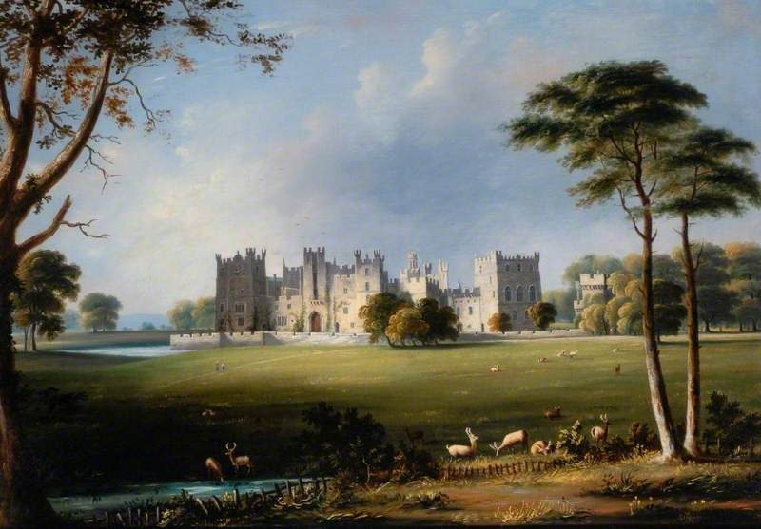
Joseph Miller, Raby Castle [painting] (c.1812-1858) [accessed on 15/11/21] <https://artuk.org/discover/artworks/raby-castle-county-durham-44094>

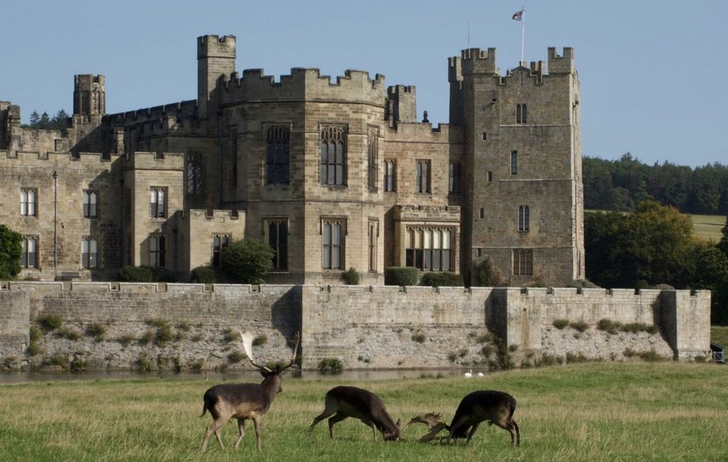
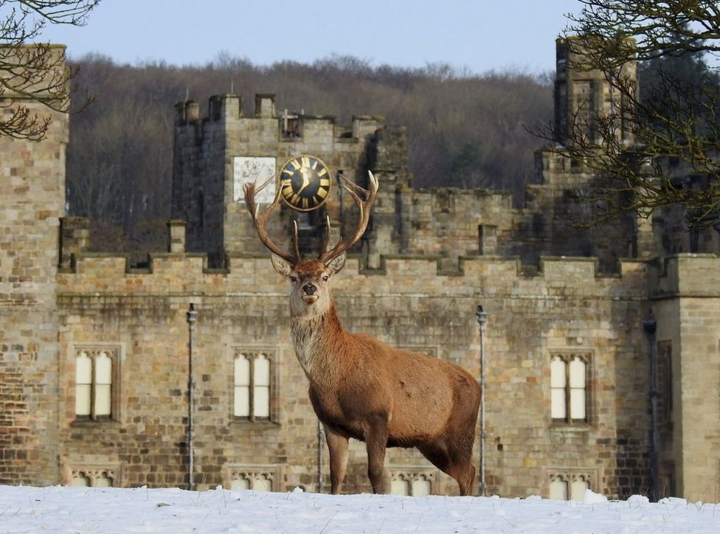
Peter Gunton, BBC News - Raby Castle 'perfect retreat' for photographer during lockdown (17 February 2021) <https://www.bbc.co.uk/news/uk-england-tees-56082490> [accessed 28 December 2021].

Image 1 Image 7

Bibliography
The Auckland Project, Deer Park, (2021) < https://aucklandproject.org/venues/deer-park/> [accessed 28 December 2021].
Casey, Edwards, The Fate Of Place, A Philosophical History. Berkeley, CA: University of California Press, 1998)
Durkheim, Emile, The Elementary Forms of Religious Life, (Oxford: Oxford Press 2008)
Eliade, Mircea, The sacred and the Profane: the nature of Religion, (Harcourt: new York, 1968)
English heritage, Auckland Deer Park, (2021) <https://www.english-heritage.org.uk/visit/places/auckland-castle-deer-house/history/> [accessed 28 December 2021].
Gunton, Peter, BBC News - Raby Castle 'perfect retreat' for photographer during lockdown (17 February 2021) <https://www.bbc.co.uk/news/uk-england-tees-56082490> [accessed 28 December 2021].
Innes-Smith, Robert, Raby Castle, (Jarrold Publishing: Raby Castle Co. Durham: 2021)
Lane, Belden, Landscapes of the Sacred: Geography and Narrative in American Spirituality, Expanded edition edn (Baltimore and London: The John Hopkins University Press, 2001),
Lévy-Bruhl, Lucien The Notebooks On Primitive Mentality trans. Peter Riviére (San Francisco: Harper & Row. Publishers, 1975)
Miller, Joseph, Raby Castle [painting] (c.1812-1858) [accessed on 15/11/21] https://artuk.org/discover/artworks/raby-castle-county-durham-44094
Morison, Benjamin, 'Aristotle's Concept of Place', in On Location (Oxford: Oxford University Press, 2002)
Nottingham University, Institute For Name-Studies, Key To English Place - Names (2021), <http://kepn.nottingham.ac.uk/map/place/Durham/Raby%20with%20Keverstone> [accessed 28th December 2021].
Nottingham University, Institute For Name-Studies, Key To English Place - Names (2021), <http://kepn.nottingham.ac.uk/map/place/Cheshire/Raby> [accessed 28th December 2021].
Nottingham University, Institute For Name-Studies, Key To English Place-Names (2021), <http://kepn.nottingham.ac.uk/map/place/Durham/Hartlepool> [accessed 28th December 2021].
Otto, Rudolf trans. John Harvey, The Idea of the Holy, (USA: Martino Publishing, 2010)
Perseus digital library, Aristotle Met. 5.1014b,
<https://www.perseus.tufts.edu/hopper/text?doc=Perseus%3Atext%3A1999.01.0052%3Abook%3D5%3Asection%3D1014b> [accessed Thursday 6th January].
Raby Castle, Discover History Of Raby Castle (2021) <https://www.raby.co.uk/raby-castle/discover/history/>[accessed 28 December 2021].
Raby Castle, Discover The Park Gardens (2021) < https://www.raby.co.uk/raby-castle/discover/the-park-gardens/> [accessed 28 December 2021].
Thorley, Anthony and Celia Gunn, Sacred Sites: An Overview, Abridged version edn, (London: The Gia Foundation, 2008)

Thorley, Anthony and Celia Gunn, Sacred Sites: An Overview, Abridged version edn, (London: The Gia Foundation, 2008), p. 9.
Lane, Belden, Landscapes of the Sacred: Geography and Narrative in American Spirituality, Expanded edition edn (Baltimore and London: The John Hopkins University Press, 2001), p17
Durkheim, Emile, The Elementary Forms of Religious Life, (Oxford: Oxford Press 2008), p. 36
Durkheim, The Elementary Forms of Religious Life, p140
Mircea, Eliade, The sacred and the Profane: the nature of Religion, (Harcourt: new York, 1968), p. 28.
Eliade, ‘The sacred and the Profane’, p. 21.
Ibid p. 116
Ibid p. 116
Benjamin, Morison, 'Aristotle's Concept of Place', in On Location (Oxford: Oxford University Press, 2002), pp. 133. p2
Edwards, Casey, The Fate Of Place, A Philosophical History. Berkeley, CA: University of California Press, 1998) p.xii
Eliade, The sacred and the Profane’, p. 28.
Lane, ‘Landscapes of the Sacred’, p.17
Lane, ‘Landscapes of the Sacred’, p.18
Lane, ‘Landscapes of the Sacred’ p.20
Ibid, p.20
Rudolf, Otto trans. John Harvey, The Idea of the Holy, (USA: Martino Publishing, 2010), p.10.
Otto ‘The Idea of the Holy’ p.19.
ibid, p.10.
Lucien, Lévy-Bruhl, ‘The Notebooks On Primitive Mentality’ trans. Peter Riviére (San Francisco: Harper & Row. Publishers, 1975), p 169.
Lévy-Bruhl, ‘The Notebooks On Primitive Mentality’ p 169.
ibid, p 2-3.
Robert, Innes-Smith, Raby Castle, p. 5.
Ibid p. 1.
ibid p. 5.
Ibid p. 5.
Raby Castle, Discover History Of Raby Castle (2021) <https://www.raby.co.uk/raby-castle/discover/history/>[accessed 28 December 2021].
Nottingham University, Institute For Name-Studies, Key To English Place - Names (2021), <http://kepn.nottingham.ac.uk/map/place/Durham/Raby%20with%20Keverstone> [accessed 28th December 2021].
Nottingham University, Institute For Name-Studies, Key To English Place - Names (2021), <http://kepn.nottingham.ac.uk/map/place/Cheshire/Raby> [accessed 28th December 2021].
Raby Castle, Discover The Park Gardens (2021) < https://www.raby.co.uk/raby-castle/discover/the-park-gardens/> [accessed 28 December 2021].
Raby Castle, Discover The Park Gardens (2021).
Benjamin, Morison, 'Aristotle's Concept of Place', in On Location (Oxford: Oxford University Press, 2002), pp. 133. p2
Lucien, Lévy-Bruhl, The Notebooks On Primitive Mentality trans. Peter Riviére (San Francisco: Harper & Row. Publishers, 1975) p, 169.
Raby Castle, Discover The Park Gardens (2021).
Perseus digital library, Aristotle Met. 5.1014b, <https://www.perseus.tufts.edu/hopper/text?doc=Perseus%3Atext%3A1999.01.0052%3Abook%3D5%3Asection%3D1014b> [accessed Thursday 6th January].
Joseph Miller, Raby Castle [painting] (c.1812-1858) [accessed on 15/11/21] <https://artuk.org/discover/artworks/raby-castle-county-durham-44094>
Peter Gunton, BBC News - Raby Castle 'perfect retreat' for photographer during lockdown (17 February 2021) <https://www.bbc.co.uk/news/uk-england-tees-56082490> [accessed 28 December 2021]. Picture 1 in the article
Peter Gunton, BBC News - Raby Castle 'perfect retreat' for photographer during lockdown (17 February 2021), Picture 7 in the article
Lane, ‘Landscapes of the Sacred’, p. 23
Otto, ‘The Idea of the Holy’, p.195.
Nottingham University, Institute For Name-Studies, Key To English Place - Names (2021), <http://kepn.nottingham.ac.uk/map/place/Durham/Hartlepool> [accessed 28th December 2021].
English heritage, Auckland Deer Park, (2021) <https://www.english-heritage.org.uk/visit/places/auckland-castle-deer-house/history/> [accessed 28 December 2021].
The Auckland Project, Deer Park, (2021) < https://aucklandproject.org/venues/deer-park/> [accessed 28 December 2021].
Eliade, ‘The sacred and the Profane’, p 116.

