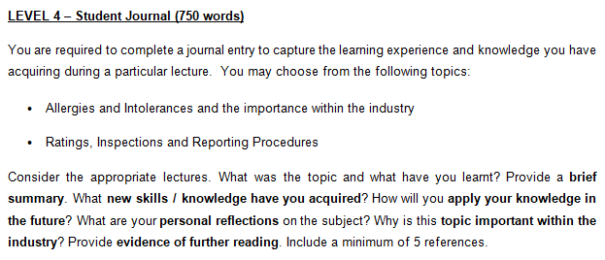
Student Name:Viorica Albu  Student Number:2029976 | Module: BMIH4002  Lecturer: Laurence Blake

Topic of choice:Ratings, Inspections and Reporting Procedures within hotels.
From the topic that I learned, I came to understand how hotels run their business and how the rating system works in the hotel business. The lessons on food and beverages had stressed the new set of skills a trained person would have and I had learned the basic industry reporting methods, professional activities, teamwork, and communication. Some of the most special one for me is verbal, presentation, and analytical skills that I have excelled in from this learning. From my learning experience, I am going to explain the ratings, inspections, and reporting procedures within hotels.

Ratings: Ratings are given to a hotel based on the inspection of trained people and their valuable reviews. The rating system represents the quality of the services and what exactly the customers think about their products. I believe that having a fundamental understanding of technical concepts will open the door to learning more complex procedures and formulae for industrial usage.
For example, A Five-Star hotel provides state-of-the-art facilities such as premium rooms, swimming pools, high-class dining, and a car parking area. The company also looks into the personal satisfaction of the clients with discreet professionalism (Chen and Wallace, 2011).
Inspections: Inspections are conducted by specialists in the field to evaluate the quality and health risks associated with them. I think public health officials are one of the most important individuals who inspect and make reports of the quality of the services. I have learned the basics of hotel inspections and related activities (Upanun and SORNSARUHT, 2020).
However, one of the significant learning for me was to know those hotel inspections and related ratings can vary from country to country. For example, an inspection method and subsequent rating can vary between the USA and an African country. So, the culture and employee performance can vary and thus can redefine the inspection process (Azab et al, 2019).
Reporting Procedures: The following process of inspection is reporting where a formal report is presented on a hotel. From my learning experience, I came to know that there are different methods for reporting and the variance of reporting style in different countries (Kuria et al, 2012). I gained an understanding of how hotels operate and how the hotel rating system works as a result of the subject I studied. The food and beverage lectures had emphasised the new set of abilities that a trained individual would possess, and I had learnt the fundamentals of industry reporting, professional activities, collaboration, and communication. For example, the linguistic barrier for different countries as most of the cases, the customers may speak a different language than a reporter. Therefore, a wide variation is seen in the reporting processes. This problem can be solved by applying an online based-method concerning reviews (Chege, 2016).

Applying this Knowledge in Future
In the professional field, subjective knowledge is highly important to become a specialist. I think my knowledge in this field will help me to prove my excellence in a professional field. For example, in the job sector, knowledge about inspection, reporting, and reviews plays a huge role. From my learning, I can be contributing to the company’s management processes, HR activities, training of the employees, performance evaluation, and result discussion.
In my personal reflection, I think this particular knowledge will help me to develop some core skills such as sampling, questioning of the workers, and development of research software, assessment of customer reviews, service quality measurement, and analyzing the year-specific reputation of the company. I think this basic technical knowledge will be a doorway to learning advanced techniques and newer formulas in industrial use.
The importance of this knowledge in the industry:
Every industry needs skilled professionals with specific knowledge in technical sides. The knowledge about hotel management, the implication of industry law, quality assurance, service evaluation, and ratings are very important for a person to conduct a business-related job. For example, a multinational company conducting business with multiple sectors hiring people with a wide range of skills and academic knowledge. From the learning, I think some of the skills I have mastered are in the same alignment with these traits (Mehta and Sharma, 2021).
Some of the other importance is the quality of the service, as every company has to ensure the integrity and involvement of each member in their productive work. Therefore, thorough supervision would be helpful in this process which would assist to make the best use of the labor. A knowledgeable person acting as a guide will enhance the potential of the employees with a great deal and also help to secure more revenues (Paryani et al, 2010).

REFERENCE LIST (not included in word count)
Azab, M., Megahed, F. and El-Sawalhy, H., 2019. Hotel Inspection Procedures in Egypt: An Exploratory Study. Journal of the Faculty of Tourism and Hotels-University of Sadat City, 3(1).
Chege, E.M., 2016. The Effect of Financial Management Practices on the Performance of Saccos in Hospitality Industry: A Case Study of Five Star Hotel Saccos in Nairobi (Doctoral dissertation, United States International University-Africa).
Chen, L. and Wallace, M., 2011. Multiskilling of frontline managers in the five star hotel industry in Taiwan. Research & Practice in Human Resource Management, 19(1), p.25.
Kuria, S., Alice, O. and Wanderi, P.M., 2012. Assessment of causes of labour turnover in three and five star-rated hotels in Kenya. International journal of business and social science, 3(15).Fahim
Mehta, K. and Sharma, S., 2021. Analyzing employee perspectives on the impact of COVID-19 on sustainable practices: a study of five-star hotels in India. Worldwide Hospitality and Tourism Themes.
Paryani, K., Masoudi, A. and Cudney, E.A., 2010. QFD application in the hospitality industry: A hotel case study. Quality Management Journal, 17(1), pp.7-28.
Upanun, K.S. and SORNSARUHT, P., 2020. Factors affecting a Thai five-star hotel reputation: A SEM analysis. Revista ESPACIOS, 41(14).

