Zainab Diallo- BMHP6009- Living with Care: The Older Person

Student name: Zainab Jalloh
Student ID: 2008337
Word Count: 3257

Contents
Introduction 3
Loneliness and Isolation 4
Elderly Person in the United Kingdom and Sweden 4
Ageing Population Statistics 6
Theories of Loneliness and Isolation 8
Impact of Loneliness and Isolation on elderly people 9
Current Legislation and Policies 11
Local, National, and Global Provision of Services 12
Prospective Future of Elderly Care and Technology 14
Recommendations 15
Conclusions 16
Reference 17

Introduction
People cannot survive on their own and require the assistance of other people, which is why people live in societies. People in societies fill each other's needs and help in various ways. The purpose of this report is to dive into this issue of the elderly people and analyse the scenario in two different countries which are the United Kingdom and Sweden. Through analysing the policies that are in place in these two countries regarding the care of elderly people the report aims to find the effective methods that can help address the issue of loneliness and isolation while also taking a look at the role that technology can play in this.

Loneliness and Isolation
In the current societies that people live in, one of the most pressing concerns is the rapid increase of loneliness and isolation and its impact on people, especially among the elderlies of the society. Various reports suggest that more than 33 per cent of the world's population suffers from loneliness and isolation. These people who suffer from loneliness and isolation are 14% more likely to die at an earlier age than the people who do not suffer from this (Victor and Smith, 2019). With time, people grow old, losing their close friends, families, and close ones for various reasons, and their social circles keep getting smaller, leading to being alone and isolated from society.

Elderly Person in the United Kingdom and Sweden
The life of an elderly person in the United Kingdom consists of various aspects which include social, cultural and economic aspects. From a cultural point of view, the people of the United Kingdom value their tradition a lot; with that, they value and respect the elderly citizens of their society. They respect the experience and the wisdom these elderly citizens provide to the communities they belong to. In the social structure, the elderly citizens receive help and care from their family including companionship and mental support from their close ones. The economic aspect of these elderly citizens varies from person to person (Gamble, 2018). Some of the elderly people in this country have access to benefits from various private pensions and they live in a comfortable financial situation. On the other hand, a big part of the population depends on the pension from the state and other social welfare programmes which can be difficult sometimes.
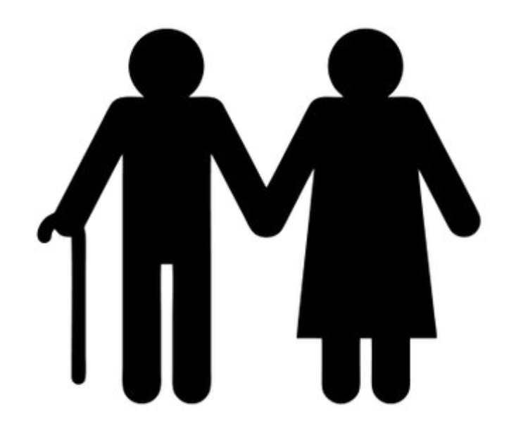
Figure 3: Elderly Person
Source: (Slowther, 2021)
On the other hand, Sweden is a country with a very strong social welfare system with promotes equal views. This can be seen in the care industry and the lives of the elderly citizens of the country. In terms of culture, the country emphasizes the independence of every individual and active ageing. The elderly people in Sweden are subject to a very high level of social integration where they take part in various community events which allows them to stay connected with their community and have a good social bond (Widén and Haseltine, 2017). The economic aspect for an elderly citizen of Sweden is quite stable as the country offers great social safety nets. This means that the individuals who require help receive the required housing, health care and financial support from the country.
If the two countries are compared, the elderly citizens are valued and respected in both of them but Sweden seems to have a better welfare system for these people. This allows the elderly citizens of Sweden to have a better life. But problems like loneliness and isolation are prevalent in both of these countries as the services are not accessible from every corner of the country.

Ageing Population Statistics
From various data from recent years, it is very clear that the number of elderly citizens in both of these countries has been increasing over the years.
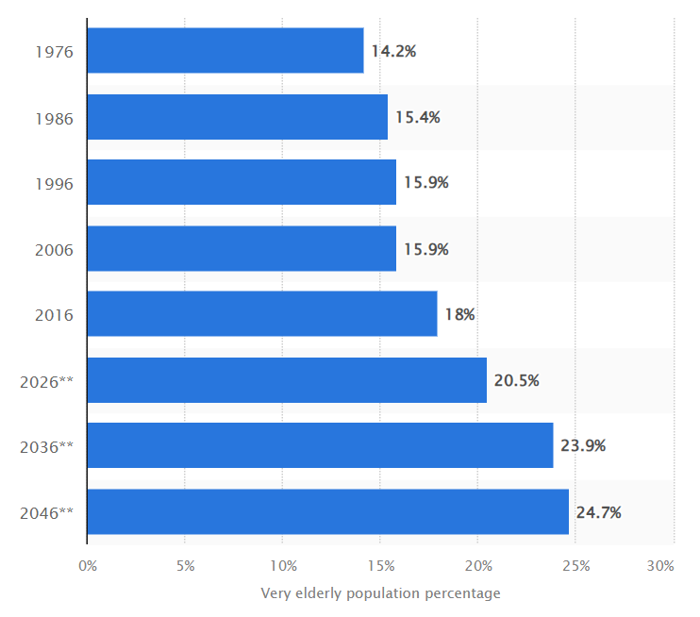
Figure 4: Distribution of the elderly population (aged 65 and over) as a share of the population in the United Kingdom (UK) from 1976 to 2046. Source: (Clark, 2020)
From the above data, it can be seen that more than 14% of the United Kingdom’s total population was over 65 years old in the year 1976. In 2006 that number rose to almost 16% and is projected to cross 24% by the year 2046. From that, it is clear that the number of elderly people who require care is increasing steadily and will continue to increase steadily for the foreseeable future.
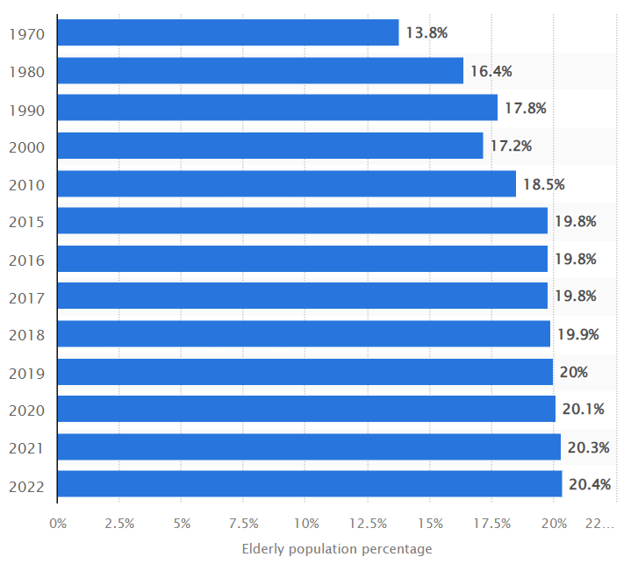
Figure 5: Share of population in Sweden aged 65 years or more in selected years from 1970 to 2022, by age group. Source: (Statista, 2023)
A similar situation can be seen by taking a look at the statistics of elder people In Sweden. In the year 1970 elderly people were about 14% of the total population of the country. This number rose to almost 20% in the year 2015. In the year 2022, the number of elderly people contributed to 20.4% of the population. This number is projected to rise in the future.
It can be seen that both of the countries are facing the same situation, a shift in the structure of their population with the rise of the numbers of elderly people rising steadily. With this shift, the countries are going to face different situations and the countries will have to address these issues to ensure that the elderly citizens are comfortable and are safe from loneliness and isolation.
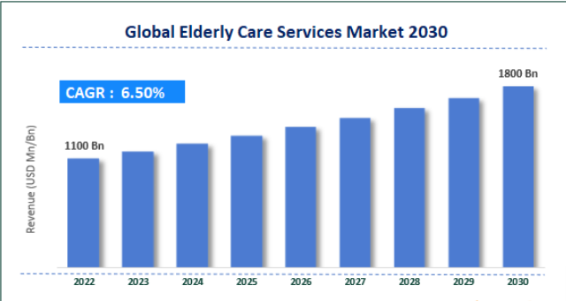
Figure 6: Global Elderly Care Services Market
Source: (Xiang et al., 2023)
With the rise of elderly people across the globe the market for elderly care services has also been growing. While it was an 1100 Bn USD industry in 2022, with a compound annual growth of 6.50%, the industry is expected to reach a valuation of 1800 Bn USD by the year 2030.
There are two main reasons behind the increasing numbers of elderly people in the UK and Sweden along with the growth of the care industry. decline in fertility rates and increased life expectancy. With diseases being eliminated, people are living longer. However, due to the decline in fertility rates, fewer people are being born. As a result, there are more elderly people each day.

Theories of Loneliness and Isolation
Various studies have been done on loneliness and isolation among elderly people. Various psychological and sociological theories have been used to conduct these studies. These theories are very crucial to understand to address the area that needs improvement. Various theories have explored the experiences of an elderly person regarding loneliness and isolation.
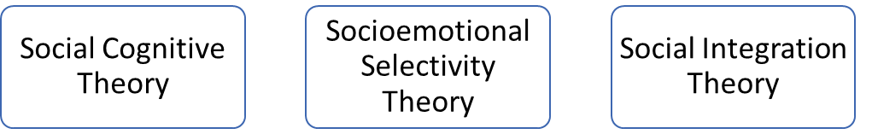
Figure 7: Theories of Loneliness and Isolation
Source: (Slowther, 2021)
Social Cognitive Theory: this theory states that an individual can learn from the things that he or she observes along with the outcomes of the interactions that they have. While addressing the issue of isolation this theory suggests that in a social interaction, if a person receives negative results;t such as being rejected or being judged that leads to feeling isolated (Portugal, 2018). This can happen to elderly people, especially the ones that are suffering from age-related complications. They often suffer from negative self-perception which negatively impacts their confidence in a social scene and increases their loneliness (Byrd-Bredbenner, Abbot and Cussler, 2020). Both the UK and Sweden suffer from negative social interactions in the lives of the elderly. However, person-centred care models in the UK help to counteract this. On the other hand, Sweden has its home-based care system to tackle this issue.
Socioemotional Selectivity Theory: This theory talks about how the social goals or interactions of an individual are influenced by the perception of time (Panagopoulos and Prysby, 2017). As people grow older, they become aware of how limited time they have, and this motivates them to value relationships that are emotionally meaningful over any relationship that is new and shallow (Mark, 2019). This helps to increase the quality of relationships that they have but often leads to isolation and loneliness. To help the elderly build meaningful relationships, the UK organizes intergenerational programs where the youth get to spend time with the elderly. Sweden also has social integration programs to help these elderly people.
Social Integration Theory: This theory sheds light on how much an individual is connected with their social environment (Chiu, Hsu and Wang, 2018). Lack of integration usually leads to a person feeling lonely and isolated due to their lack of connection with their community or their family. When a person goes through retirement, widowhood, or a physical disability it disrupts their social connection and social circle (Altizer et al., 2016). This makes it very difficult for them to stay integrated with their community or family. To help the elderly with social integration the UK provides various community engagement programs. On the other hand, Sweden helps these people in active ageing by providing them with social activities of various sorts and support networks.

Impact of Loneliness and Isolation on elderly people
Felling loneliness and isolation impacts a person’s mental, emotional and physical well-being. However, it does not impact the individual in their personal lives only (Xiang et al., 2023). Loneliness and isolation affect a person, an elderly citizen who is living in a care setting as well. while the care facilities try to help these elderly people the best that they can, loneliness and isolation can still have various effects on them.
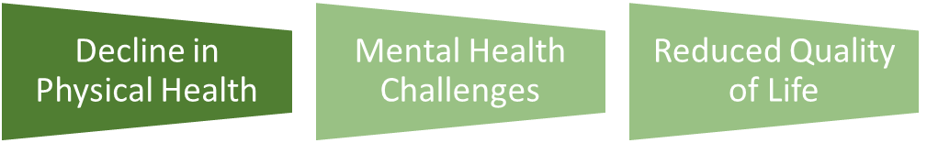
Figure 8: Impact of Loneliness and Isolation in Care Settings
Source: (Handorf, 2018)
The decline in Physical Health: Loneliness and Isolation are some of the leading causes of poor physical health in an elderly person. Various studies have shown that compared to an elderly individual who is happy and is connected with friends and family, an individual that is suffering from isolation and loneliness is more likely to develop various chronic conditions including but not limited to diabetes, cardiovascular diseases and hypertension (Choudhry, 2022). On top of that, an elderly person’s physical strength is reduced by more than 30% to 50%. In a care setting, an individual lacking social engagement leads to a sedentary life that weakens their immune system as a result of which they suffer from many diseases. It also decreases their mobility making the situation even worse.
Mental Health Challenges: Loneliness and isolation cause serious mental health issues for an elderly individual (Wittchen et al., 2021). They suffer from various mental issues such as anxiety, depression cognitive decline etc. Studies show that almost 14% of elderly people suffer from mental health challenges. If an elderly individual is deprived of social interactions required for them, they start to feel sad, hopeless and worthless (Joshi, 2018). With no one to keep them company or provide them with emotional support, their mental health situation worsens even further which hampers the quality of life that they are living.
Reduced Quality of Life: The elderly people who live in an assisted care facility often suffer from loneliness and isolation which lowers the quality of life that they are living (Böhn et al., 2013). When they feel isolated or alone, it leads to them feeling less motivated to do any task. They lose interest in any activities and lose any sense of hope or purpose of living. This often leads to them drawing themselves from community activities or social interactions that could offer them personal growth. According to a study by the National Institute of Health, almost 30% of elderly people have stated they feel alive or vital very rarely. (Nortvedt et al., 2021). As a result, they start to feel more isolated and lonelier and the overall quality of life decreases drastically.

Current Legislation and Policies
The rules and regulations that are set by a government and implemented about any specific issue to achieve a goal are referred to as legislation and policies.

Figure 9: The Care Act 2014
Source: (Choudhry, 2022)
United Kingdom
Solving the problem of loneliness and isolation is an important agenda for the policymakers of the United Kingdom. Among various strategies that the government of the UK has taken, the Loneliness Strategy is the most prominent one which was launched in the year 2018 (Rook, 2018). The goal of this strategy is to understand and remove loneliness from the lives of the elderly. With this strategy, healthcare professionals can refer a patient to do various community work as well as join various support groups. The government has also launched other campaigns such as ‘Be More Us’ that aim to raise awareness among people regarding the importance of strong social connections in the lives of elderly people (WALLCRAFT et al., 2021). Additionally, the Care Act of 2014 requires local authorities to take necessary steps that reduce the development of any reason that results in requiring care and support through various measures (McCance-Katz, Rabiner and Rivers, 2014). However, this has not been very successful due to a lack of funds.
Sweden
Social Welfare policies are a crucial part of Sweden. The government puts a lot of importance on social integration and active ageing for the elderly citizens of the country. The care service of this country runs in a decentralized manner which allows the local authorities the opportunity to adjust the supporting method to fit the needs of their community (Stephens and Olsson, 2019). The Social Services Act (Socialtjänstlagen) provides a foundation upon which elder care in Sweden is built upon. The country also puts a lot of emphasis on home-based care services where the elderly people get to stay in their homes which is familiar to them. The government also has various initiative that encourages younger people to spend time with elderly people who are living in a care setting (Jones et al., 2019). The country also provides universal health care and social services ensuring that these elder people receive their required medical support. Sweden ensures that all its citizens especially the elderly receive the medical care that they need with the help of the Patientlagen or Patient Act. However, there are many challenges such as the health care and social care services need to be able to coordinate in a better way (Handorf, 2018). On top of that, the number of elderlies needing care is increasing in the country every day which is making these services inefficient.

Local, National, and Global Provision of Services
United Kingdom
Local authorities in the United Kingdom provide daycare programmes, various social activities and community centres for elderly people (Marmot and Allen, 2014). However, these services are not often available and even if they are the quality of these services is questionable as they have very limited resources and funds.
At the national level, the country offers various mechanisms that help the elderly such as the Department for Work and Pensions which provides the elderly with financial support and the NHS or National Health Service which provides health care services (Slowther, 2021). Social prescribing initiatives and the Loneliness Strategy are also some great initiatives taken by the UK government to help the elderly. While these are aimed to help people there are some negative aspects as well. Bureaucratic Challenges make it difficult for the elderly to receive their required help. Often after crossing the Bureaucratic Challenges, they can't get help due to limited resources.
The UK collaborates with many countries and organisations to help the elderly at the global level. The country shares research data and expertise with others about elderly care (Holmes, Capper and Hudson, 2019). The UK is also a part of the World Health Organization's Age-Friendly Cities program that works to influence policies at the local and national levels to ensure a better life for the elderly. However, Cultural Sensitivity is an issue as the methods used in one country might not work in another and could even backfire.
Sweden
At the local level the country has initiatives to provide home-based health care service. The country also offers community centres for the elderly as well as various activities for them to take part in (Blomqvist, 2014). local authorities collaborate with non-profit organisations to take initiatives to make the lives of the elderly better and more enjoyable. However, these local operations are run on a limited budget which affects their efficiency. At the national level, the country has a welfare system that ensures that the elderly people receive their required social support, financial support and health care support (Wahlbeck et al., 2021). The Swedish Social Services Act ensures that elderly people who need care receive care based on their individual needs. Similar to the UK Sweden suffers from bureaucratic challenges in providing the necessary care and often the elderly fail to receive the required care due to the time it takes to solve this issue.
Just like the UK Sweden collaborates with various international organisations and countries to provide better care to the elderly. the country shares its expertise and knowledge along with research findings on this issue with others (Petridou, 2020). It also shares the technologies it has and the models it uses for providing care to the elderly which is an inspiration for the globe. Sharing the knowledge or the expertise of one country often leads to brain drain which refers to the phenomenon when experts get attracted to opportunities abroad and leave their home country which creates a problem for the country. This has been a problem for Sweden.

Prospective Future of Elderly Care and Technology
Changes in Programs Addressing Loneliness: The care sector will go through many changes in the future, one of which is that the care sector will shift towards an individual-centred model (Baum and Rubenstein, 2020). The service will be based on the person needing the care and his or her preferences. Intergenerational programs where the youth will spend time with the elderly will become more popular. Supporting the mental health of the elderly people under care will be a crucial part of the healthcare setting in the future. A health mind means a health life, keeping that in mind providing therapy sessions and counselling will be an integral part of the care setting.
Application of Technology in Elderly Care: Technology has great potential in the care setting. Robots could be used in care settings that are equipped with artificial intelligence, that can play games and provide companionship to reduce the loneliness and isolation of the elderly people in the care (Bashshur et al., 2020). Through telemedicine, the elderly can easily contact healthcare professionals remotely for assistance regarding their physical or mental health. Virtual reality devices could be used to allow elderly people to experience travelling or various social experiences. Smart home technology also has great potential (Brownie and Horstmanshof, 2021). It provides security for elderly people as it has sensors that can detect falls and contact emergency services.

Recommendations
Few recommendations are provided below:
Person-Centred Care: Person-centred care models should be developed and implemented that provides the elderly with care based on their needs, their preference and their social background that they belong to.
Technological Literacy: Technological Literacy should be provided to elderly people. This would allow them to use various digital devices such as smartphones, tablets and smart TVs which would decrease their isolation and loneliness.
Foster Community Engagement: intergenerational programs should be encouraged allowing the youth to spend time with the elderly people. Such events can be organised by schools or community centres. The youth will also benefit from this as they will learn from the experiences of the elderly.
Healthy Lifestyle Education: Educational Programs on how to lead a healthy lifestyle should be implemented in the setting to educate the elderly on how they can lead healthy and sound lives.

Conclusions
To sum it up, this report has explored how loneliness and isolation impact the lives of the elderly in the society in the United Kingdom and Sweden. Social, cultural and economic factors have been explored for this issue. Various psychological theories have been explored regarding the topic along with policies of the two mentioned countries regarding elderly care. The potential of technology to impact the care setting has also been explored. It has been found that loneliness and isolation don’t affect mental and physical health only rather it affects the quality of life. Everyone should work collectively from their position to build a perfect society where the elderly people who built these societies feel valued, wanted and connected.

Reference
- Altizer, S., Nunn, C.L., Thrall, P.H., Gittleman, J.L., Antonovics, J., Cunningham, A.A., Dobson, A.P., Ezenwa, V., Jones, K.E., Pedersen, A.B., Poss, M. and Pulliam, J.R.C. (2016). Social Organization and Parasite Risk in Mammals: Integrating Theory and Empirical Studies. Annual Review of Ecology, Evolution, and Systematics, 34(1), pp.517–547. doi https://doi.org/10.1146/annurev.ecolsys.34.030102.151725.
- Bashshur, R., Doarn, C.R., Frenk, J.M., Kvedar, J.C. and Woolliscroft, J.O. (2020). Telemedicine and the COVID-19 Pandemic, Lessons for the Future. Telemedicine and e-Health, 26(5). doi:https://doi.org/10.1089/tmj.2020.29040.rb.
- Baum, S.A. and Rubenstein, L.Z. (2020). Old People in the Emergency Room: Age-Related Differences in Emergency Department Use and Care. Journal of the American Geriatrics Society, 35(5), pp.398–404. doi https://doi.org/10.1111/j.1532-5415.1987.tb04660.x.
- Bihan, B.L. and Martin, C. (2016). A Comparative Case Study of Care Systems for Frail Elderly People: Germany, Spain, France, Italy, United Kingdom and Sweden. Social Policy & Administration, 40(1), pp.26–46. doi https://doi.org/10.1111/j.1467-9515.2006.00475.x.
- Blomqvist, P. (2014). The Choice Revolution: Privatization of Swedish Welfare Services in the 1990s. Social Policy and Administration, 38(2), pp.139–155. doi https://doi.org/10.1111/j.1467-9515.2004.00382.x.
- Böhn, L., Störsrud, S., Törnblom, H., Bengtsson, U. and Simrén, M. (2013). Self-reported food-related Gastrointestinal Symptoms in IBS Are Common and Associated With More Severe Symptoms and Reduced Quality of Life. The American Journal of Gastroenterology, [online] 108(5), pp.634–641. doi:https://doi.org/10.1038/ajg.2013.105.
- Brownie, S. and Horstmanshof, L. (2021). The Management of Loneliness in Aged Care Residents: An Important Therapeutic Target for Gerontological Nursing. Geriatric Nursing, [online] 32(5), pp.318–325. doi:https://doi.org/10.1016/j.gerinurse.2011.05.003.
- Byrd-Bredbenner, C., Abbot, J.M. and Cussler, E. (2020). Relationship of social cognitive theory concepts to mothers’ dietary intake and BMI. Maternal & Child Nutrition, 7(3), pp.241–252. doi https://doi.org/10.1111/j.1740-8709.2009.00232.x.
- Chiu, C.-M., Hsu, M.-H. and Wang, E.T.G. (2018). Understanding knowledge sharing in virtual communities: An integration of social capital and social cognitive theories. Decision Support Systems, [online] 42(3), pp.1872–1888. doi:https://doi.org/10.1016/j.dss.2006.04.001.
- Choudhry, U.K. (2022). Uprooting and Resettlement Experiences of South Asian Immigrant Women. Western Journal of Nursing Research, 23(4), pp.376–393. doi https://doi.org/10.1177/019394590102300405.
- Clark, D. (2020). Elderly population 1976-2046 Statistic. [online] Statista. Available at: https://www.statista.com/statistics/743332/elderly-population-of-united-kingdom-uk/.
- Gamble, E.R. (2018). Knowledge, Attitudes, and Behavior of Elderly Persons Regarding Living Wills. Archives of Internal Medicine, 151(2), p.277. doi https://doi.org/10.1001/archinte.1991.00400020049011.
- Handorf, S. (2018). The Swedish Model. GRIN Verlag.
- Holmes, J., Capper, G. and Hudson, G. (2019). Public Private Partnerships in the provision of health care premises in the UK. International Journal of Project Management, 24(7), pp.566–572. doi https://doi.org/10.1016/j.ijproman.2006.07.004.
- Jones, C., Burström, B., Marttila, A., Canvin, K. and Whitehead, M. (2019). Studying Social Policy and Resilience to Adversity in Different Welfare States: Britain and Sweden. International Journal of Health Services, 36(3), pp.425–442. doi https://doi.org/10.2190/e9h5-uryl-2w4u-qed6.
- Joshi, P.T. (2018). Editorial: Global mental health: challenges & opportunities. Child and Adolescent Mental Health, 23(4), pp.301–302. doi:https://doi.org/10.1111/camh.12304.
- Mark, R.E. (2019). Understanding the individual with Alzheimer’s disease: Can socioemotional selectivity theory guide us? Advances in Alzheimer’s Disease, 01(03), pp.77–86. doi:https://doi.org/10.4236/aad.2012.13010.
- Marmot, M. and Allen, J.J. (2014). Social Determinants of Health Equity. American Journal of Public Health, [online] 104(S4), pp.S517–S519. doi:https://doi.org/10.2105/ajph.2014.302200.
- Marshall, K. and Hale, D. (2021). Isolation and Loneliness. Home Healthcare Now, 39(1), pp.48–48. doi:https://doi.org/10.1097/nhh.0000000000000950.
- McCance-Katz, E.F., Rabiner, C.A. and Rivers, J.L.A. (2014). The Affordable Care Act: Implementation and implications for addiction speciality care. The American Journal on Addictions, 23(5), pp.429–430. doi https://doi.org/10.1111/j.1521-0391.2014.12139.x.
- Nortvedt, M.W., Riise, T., Myhr, K-M., Landtblom, A-M., Bakke, A. and Nyland, H.I. (2021). Reduced quality of life among multiple sclerosis patients with sexual disturbance and bladder dysfunction. Multiple Sclerosis Journal, 7(4), pp.231–235. doi https://doi.org/10.1177/135245850100700404.
- Panagopoulos, C. and Prysby, C. (2017). Polls and Elections: Socioemotional Selectivity Theory and Vote Choice. Presidential Studies Quarterly, 47(3), pp.552–560. doi:https://doi.org/10.1111/psq.12400.
- Petridou, E. (2020). Politics and administration in times of crisis: Explaining the Swedish response to the COVID‐19 crisis. European Policy Analysis, 6(2). doi:https://doi.org/10.1002/epa2.1095.
- Portugal, L.M. (2018). Naturopathy Education, Social Cognitive Theory, PrecedeProceed Model, and Lesson Plan. Journal of Natural & Ayurvedic Medicine, 2(1). doi:https://doi.org/10.23880/jonam-16000115.
- Rook, K.S. (2018). Promoting social bonding: Strategies for helping the lonely and socially isolated. American Psychologist, 39(12), pp.1389–1407. doi https://doi.org/10.1037/0003-066x.39.12.1389.
- Slowther, A. (2021). Clinical ethics support services in the UK: an investigation of the current provision of ethics support to health professionals in the UK. Journal of Medical Ethics, [online] 27(90001), pp.2i8. doi https://doi.org/10.1136/jme.27.suppl_1.i2.
- Statista (2023). Sweden: share of the elderly population 1970-2019. [online] Statista. Available at: https://www.statista.com/statistics/525637/sweden-elderly-share-of-the-total-population-by-age-group/.
- Stephens, J.D. and Olsson, S.E. (2019). Social Policy and Welfare State in Sweden. Contemporary Sociology, 21(2), p.193. doi:https://doi.org/10.2307/2075425.
- Victor, C. and Smith, K. (2019). INTEREST GROUP SESSION—LONELINESS AND SOCIAL ISOLATION: THE LANGUAGE(S) OF LONELINESS. Innovation in Aging, 3(Supplement_1), pp.S373–S373. doi https://doi.org/10.1093/geroni/igz038.1365.
- Wahlbeck, K., Westman, J., Nordentoft, M., Gissler, M. and Laursen, T.M. (2021). Outcomes of Nordic mental health systems: life expectancy of patients with mental disorders. British Journal of Psychiatry, 199(6), pp.453–458. doi:https://doi.org/10.1192/bjp.bp.110.085100.
- WALLCRAFT, J., AMERING, M., FREIDIN, J., DAVAR, B., FROGGATT, D., JAFRI, H., JAVED, A., KATONTOKA, S., RAJA, S., RATAEMANE, S., STEFFEN, S., TYANO, S., UNDERHILL, C., WAHLBERG, H., WARNER, R. and HERRMAN, H. (2021). Partnerships for better mental health worldwide: WPA recommendations on best practices in working with service users and family carers. World Psychiatry, 10(3), pp.229–236. doi https://doi.org/10.1002/j.2051-5545.2011.tb00062.x.
- Widén, S. and Haseltine, W.A. (2017). Aging with Dignity. Nordic Academic Press.
- Wittchen, H.U., Jacobi, F., Rehm, J., Gustavsson, A., Svensson, M., Jönsson, B., Olesen, J., Allgulander, C., Alonso, J., Faravelli, C., Fratiglioni, L., Jennum, P., Lieb, R., Maercker, A., van Os, J., Preisig, M., Salvador-Carulla, L., Simon, R. and Steinhausen, H.-C. . (2021). The size and burden of mental disorders and other disorders of the brain in Europe 2010. European Neuropsychopharmacology, 21(9), pp.655–679. doi:https://doi.org/10.1016/j.euroneuro.2011.07.018.
- Xiang, Y.-T., Yang, Y., Li, W., Zhang, L., Zhang, Q., Cheung, T. and Ng, C.H. (2023). Timely mental health care for the 2019 novel coronavirus outbreak is urgently needed. The Lancet Psychiatry, [online] 7(3), pp.228–229. doi:https://doi.org/10.1016/S2215-0366(20)30046-8.

