

Student Name: Kartik Mukeshbhai Raval
Student ID: 2519361

Module Name: Strategic Management
Module Code: LCMB7003

Title: Strategic Management of IKEA in the Indian Market: Analysing Geopolitical, Economic and Competitive Challenges and Opportunities
Lecturer’s Name: Amare Desta / Ghulam Mujtaba
Term 2

Table of Contents
Section 1 4
1. Organisational Context and Overview 4
2. External and Internal Analysis 5
2.1 PESTEL Analysis 5
2.2 VRIO Analysis 9
2.3 SWOT Analysis 11
3. Comprehensive and Holistic View of IKEA 13
3.1 IKEA CSR Strategy 13
3.2 Alignment Between CSR and Business Strategy 15
3.3 Balanced Scorecard 16
4. Strategic Choices and Implementation 18
4.1 Current Competitive Strategy 18
4.3 Ansoff Matrix 20
4.4 Recommended Strategy 21
4.5 Strategy Implementation 21
4.6 Implementation Challenges and Mitigation 22
Section 2: Reflective Account 24
5. Gibbs Reflective Cycle 24
5.1 Description 24
5.2 Feelings 25
5.3 Evaluation 25
5.4 Analysis 25
5.5 Conclusion 26
5.6 Action Plan 26
6. Conclusion 26
References 28

Section 1

1. Organisational Context and Overview
IKEA is a Swedish home-furnishing organisation established in 1943 by Ingvar Kamprad. It is envisioned that it “will make everyday life better for the many people”, and its business idea is to offer well-designed and functional furniture at affordable prices (IKEA, 2024). It has established itself as an omnichannel delivery model with efficient logistics and affordable products, enabled by large-scale purchasing, flat-pack packaging, and self-service retail. In FY2025, IKEA made 44.6 billion euros in retail sales from 504 stores in 63 markets around the world (IKEA, 2025).
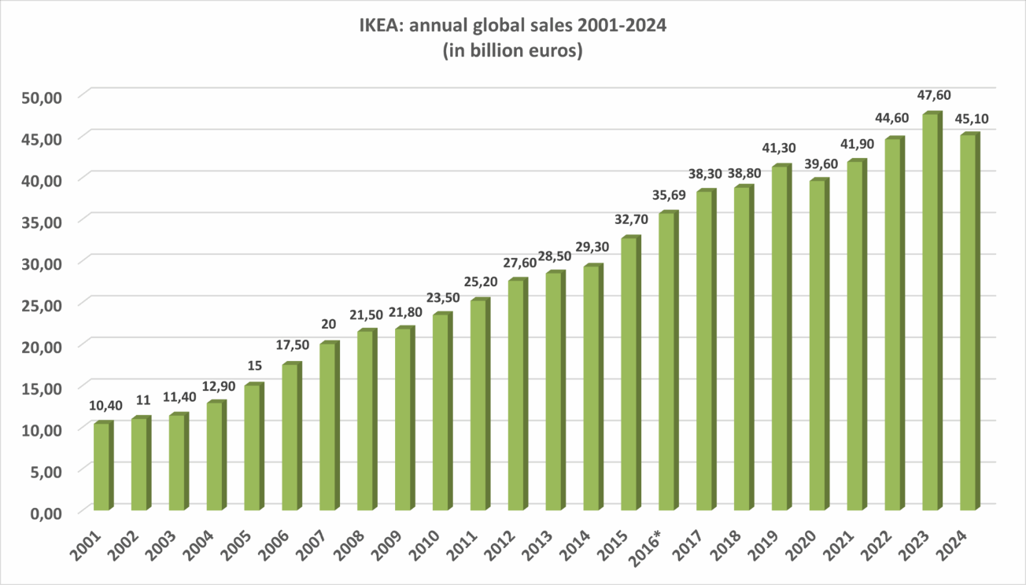
Figure 1: Key Statistics of IKEA Group
(Source: Nielsen, 2025)
Nielsen (2025) reported IKEA annual revenue reached at 32.22%, the website recorded visit at worldwide 214.7 million and increasing income of €45.1 billion in 2024. India is a significant growth market. IKEA opened its retail operations in August 2018 in its 1st store in Hyderabad and then opened stores in Navi Mumbai, Bengaluru, Mumbai, Delhi and Pune. As of March 2026, it has six stores and has invested over €900 million in India. As for IKEA India, it achieved sales growth to ₹1.88 billion during FY2024 while its operations are working towards profitability (IKEA, 2025a).
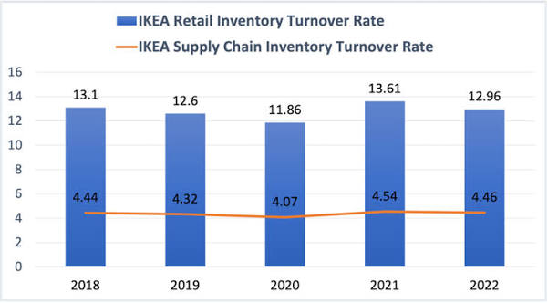
Figure 2: Inventory Turnover rate of IKEA
(Source: Jia, 2024)
The home decor sector in India is extremely unorganised and spread across various organised retailers, e-commerce platforms, and local carpenters (Jia, 2024). Fierce competition comes from Pepperfry, Urban Ladder, Wakefit, Godrej Interio and WoodenStreet. Pepperfry had ₹188.9 crore in operating revenue, and its loss was ₹117.4 crore for FY2024, while Wakefit revenue was at ₹1,017 crore, and in its FY2024, it became profitable, again after reaching the EBITDA level. WoodenStreet's revenue stood at ₹255 crore and loss at ₹10.9 crore (IKEA Global, 2025).
IKEA is therefore considered to be in an average high-end niche: Scandinavian design, international brand, local sourcing, low price and omnichannel marketing. The company's long-term strategy seems to be for expansion in India.

2. External and Internal Analysis

2.1 PESTEL Analysis
The macro-environmental forces which influence IKEA's strategic management in India are identified through the PESTEL framework. In the presentation above, it became clear that not all the factors are equally important, and it is possible to distinguish which of the external forces poses the biggest threat and opportunity to IKEA (Statista, 2020).
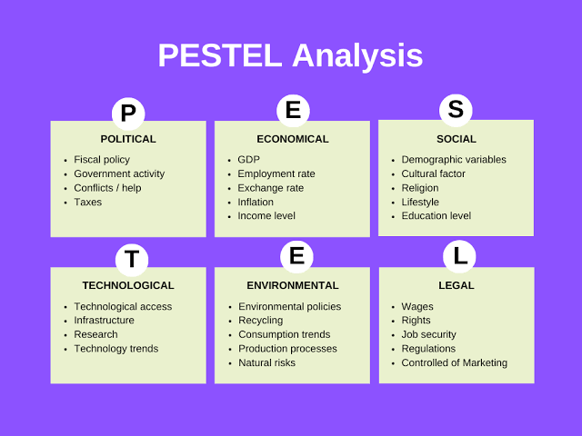
Figure 3: Overview of PESTEL Analysis
(Source: Vanzandt, 2023)
Political
The political scenario of India offers advantage/disadvantage opportunities for IKEA. The company might be able to expand in the long term with the support of the government for manufacturing, local sourcing, and foreign investments (BTI, 2024). IKEA is already fully established in India, with a supply network of some 48 suppliers, over 45,000 people who are directly employed by IKEA, and over 400,000 workers in our extended supply chain. So, India is not just a market for IKEA products, as they also buy an additional €315m worth of products each year here (IKEA, 2023).
But the fact that India has a regulatory framework continues to be of great strategic importance, as IKEA must abide by foreign-investment, retail, taxation and state-level requirements. Political conditions, therefore, provide an opportunity to expand with local sourcing, as regulatory complexity may threaten the rapid development of the market.
Economic
Especially since the value proposition of IKEA makes much of how affordable, functional and well-designed their furniture is. When it comes to buyers' willingness to spend on furniture and home improvement products, these factors have a direct impact on how much they will spend: inflation, disposable income, interest rates, and housing affordability (Majumdar and Ghatak, 2025).
Due to India's big and growing consumer market, there is significant potential for growth. IKEA has graded India as one of its key markets to grow in the future. Still, high-priced shop items like imported or big-ticket furniture can stop items from being attractive for cost-aware consumers in households handling a restricted financial plan (Turner, 2024). So, IKEA's strategic problem lies in sustaining its international positioning as a brand and still keeping its products affordable.
Another important aspect is that interest rate changes can affect the amount of housing and discretionary spending (as interest rates may rise and potentially lower consumption and residential investment), or vice versa. The monetary environment changed; for example, the Bank Rate in June 2025 was lowered from 6.25% to 5.75% by the RBI (Reuters, 2025).
Strategic implication: Despite the fact that India's economic growth is an opportunity, purchasing-power sensitivity also remains a threat. Hence, IKEA needs to push for sourcing from local areas and value-added product lines.
Social
Household entities have varying housing needs, lifestyles, and structure in India. Factors such as Multi-generational living, low-cost living, changing household needs, etc. have been identified by IKEA's study on Indian homes.
This is an opportunity for IKEA to offer niche products which include space-saving furniture, affordable home-organisation products and modular products. The urbanisation of India and the evolving lifestyle can further boost the demand for modern home furnishings (Maji and Lohia, 2023).
But IKEA's European range of products and shopping experience are unclear if transferable to India. The preferences for furniture size, materials, colours, cooking arrangement, storage, household, and furniture function can vary among Indian consumers, this cultural diversity thus involves the need for local adaptation and modifications (Arora et al., 2021). The social environment will therefore also be a safety net and a danger if IKEA is unaware of local consumer behaviour.
Technological
The technological aspect plays a vast part in this IKEA India strategy. By integrating its physical stores, e-commerce, digital services and the various smaller touchpoints with the customer, IKEA has devised an omnichannel model. Presently, over 30% of IKEA India's business is driven by online retail, which illustrates how digital retail helps to drive sales beyond its current stores.
It has also unveiled its IKEA Kreativ, an artificial intelligence-powered feature that lets consumers virtually redesign their homes. IKEA also bought Locus, another AI-powered logistics tech company, to provide its home delivery and supply-chain capabilities with additional efficiencies (IKEA, 2022).
This is a significant opportunity as India has been rapidly digitising, giving an opportunity for IKEA to access consumers without needing only large-format stores, which are quite costly for them. But with websites like Wayfair and Houzz being big competition with Amazon, tech is not the only trick in the book anymore.
Environmental
Environmental sustainability is growing in importance for IKEA due to the use of timber, textiles, plastics, transport and packaging and energy use in furniture production. IKEA's India business gives scope to further promote sustainable sourcing and to further implement the principles of the circular economy with the help of local suppliers and materials (Irshad et al., 2023).
In addition, IKEA has also pledged 100% EV deliveries in North India, enhancing its overall climate goals. It has a distribution centre at Gurgaon with future scope to grow the outlet.
But due to the scale and corresponding challenge of India's last-mile connectivity, transportation emissions and costs may rise. Sustainable sourcing may mean higher prices if the environmentally preferable alternatives are more expensive (Bianco et al., 2021).
So, the environment has the potential to threaten IKEA with supply chain emissions and to be an opportunity by enabling the company to continue the differentiation in its sustainability strategy.
Legal
IKEA needs to abide by Indian consumer-protection laws, employment, taxation and competition laws, and product-safety, environment and retail laws. The strategic importance of legal compliance is because furniture products will have to satisfy related safety and quality requirements, and because of IKEA's vast staff and worldwide source base, employment and supply-chain duties will arise (International Trade Administration, 2024).
The legal landscape can thus enhance compliance costs and burdens. Meanwhile, robust compliance can safeguard IKEA's reputation and trust levels among consumers.
Overall (PESTEL) assessment: India offers scope for sustainable development in large consumer potential, digital, local sourcing and urbanisation opportunities. The threats are harshest in the form of prices, regulations, competitor pressure, and supply-chain and logistical issues.

2.2 VRIO Analysis
VRIO analyses the resources and capabilities of IKEA that have the potential to create competitive advantage in India.
Resource/Capability | Valuable | Rare | Difficult to Imitate | Organised | Strategic implication
Global IKEA brand | ✓ | ✓ | ✓ | ✓ | Sustained competitive advantage
Indian supplier network | ✓ | ✓ | ✓ | ✓ | Potential sustained advantage
Flat-pack/low-cost business model | ✓ | ✓ | ✓ | ✓ | Sustained competitive advantage
Omnichannel capability | ✓ | No | No | ✓ | Temporary competitive advantage
Customer knowledge of Indian homes | ✓ | No | ✓ | ✓ | Potential competitive advantage
Digital/AI capabilities | ✓ | No | No | ✓ | Temporary competitive advantage
Global sustainability capabilities | ✓ | ✓ | ✓ | ✓ | Competitive advantage
Table 1: VRIO Analysis of IKEA
(Source: Self-Made)
IKEA's brand and its distinctive flat-pack business model are very important in that it is a way to design, function and yet be affordable. While it may be easy for competitors to duplicate individual products, it is quite difficult to duplicate IKEA's entire global system of design, sourcing, organising logistics, building out stores and developing the brand identity (Inter IKEA, 2024).
Further, India's supplier network is another strategic resource. IKEA has been dealing with India for some 40 years, developing ties and production know-how that may be difficult to duplicate for new players.
The omnichannel feature comes in handy too. IKEA is a combination of large stores, city stores, online channels and Plan and Order Points. Commissioning the first-ever Indian Plan and Order Point in Bengaluru, IKEA adapted its global model to the local consumers in 2025 (IKEA, 2024a).
Overall, IKEA's best potential sources of sustained competitive advantage are brand, integrated business model, supplier relationships and its capabilities to design globally.

2.3 SWOT Analysis
Strengths | Weaknesses
A well-known brand of the IKEA company.  Developed Indian sourcing and supplier arrangements.  Unique flatpack/low-cost business model.  Excellent omni-channel retail skills.  Deep knowledge in developing sustainable products.  Growing digital and AI capabilities.  The current physical presence in major cities of India.  IKEA's Indian business has evolved appreciably, and it boasts big-format stores in Hyderabad, Navi Mumbai and Bengaluru, and its growing online presence and city centre format stores. | Moderately low physical store density when considering the vast size of India.  Large format stores may be associated with higher investment and operating expenses.  The 'do it yourself' philosophy of IKEA may not be to everyone's taste among Indian consumers.  The geographically fragmented Indian market may be difficult to reach and install.  High local adaptability required.  The relatively limited physical footprint implies that omnichannel development is the most significant. IKEA's online delivery initiative in 25 markets, including Delhi-NCR, is reflective of the company's attempt to overcome this constraint in 2025 (Hub24, 2026).
Opportunities | Threats
Growth in consumer and city markets in India.  Rise in the online trend of furniture shopping.  Growth in demand for low-cost home-furnishing solutions.  Growth strategy involves expanding to North India and other cities.  Greater local sourcing and local production.  AI-enabled home-design services.  Designing sustainable and circular furniture consumption.  Omnichannel types, Plan and Order Points and smaller stores.  This is where online delivery integration by IKEA has increasingly paved the way for the brand to enter North India and offer a solution to its customers without deploying a large-format-based network (Jonwal, 2026). | Competitive Indian furniture retailers and e-commerce sites.  Consumer price sensitivity.  Changes in the value of money and prices.  High regulatory and tax complexity.  Disruption of the supply chain and logistics costs.  Changes in currency and/or international sourcing risks.  Increased pace of consumer digital expectations.  Lack of product design sensitivity towards India's cultural and geographical needs.
Table 2: SWOT analysis of IKEA
(Source: Self-Made)
Critical strategic
As per the combined analysis, IKEA's major strategic opportunity is to leverage the reach and the brand across India's burgeoning Indian consumer market in a cost-effective way, and through its global brand and its supplier network and digital efforts. Its main hurdle is balancing the standardisation that makes IKEA efficient worldwide with the adaptation that Indian consumers in various regions and with divergent price levels demand, and its Indian regulations and logistics (Jurevicius, 2025).
Thus, IKEA will not want to take a store-led approach to expansion. A more effective strategy would involve local sourcing and cheaply adapting products, e-commerce, smaller-sized stores, AI-driven service, and sustainable logistics. This would enable IKEA to remove the geographical and cost barriers and safeguard its unique competitive advantage in India.

3. Comprehensive and Holistic View of IKEA

3.1 IKEA CSR Strategy
IKEA's corporate social responsibility (CSR) in India is connected to its broader People and Planet strategy, which is about environment, social inclusion and responsible business. Environmental sustainability is strategically important due to the use of wood, energy, water and packaging during the furniture production process (IKEA, 2024a). IKEA India has committed to the transition towards renewable energy, and this has resulted in IKEA India having more than 90% of all deliveries done with electric vehicles, which has resulted in lessened transport emissions. At a global level, IKEA's longer-term ambitions are: by FY2030 to halve the impact of emissions throughout the value chain per unit product, and achieve net zero by FY2050 (IKEA, 2025a). Waste reduction via circular product design, reuse, recycling and consumer solutions which foster a longer lifespan of the products.
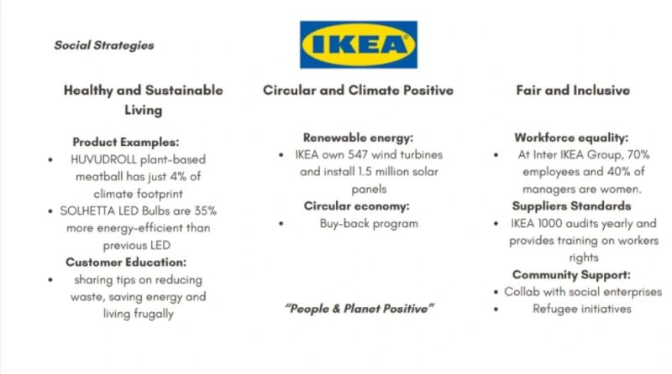
Figure 4: IKEA CSR Strategy
(Source: Nelson, 2025)
Another key CSR activity is responsible sourcing. The IWAY supplier code puts requirements on suppliers and service providers regarding labour, health and safety, environmental protection, resource management and animal welfare. This is especially true in India as IKEA has a fair amount of supplier ecosystem here. It also collaborates with women artisans and social entrepreneurs for sustainable income and for access to international markets (Nelson, 2025). The topic of CSR does not end with the environment; community initiatives, human-rights commitments and employee equality are part of the discussion.
The advantage for IKEA is that for them, food waste does not play a big role as it does when you're a grocery retailer, but there are ways to reduce waste via IKEA's food operations, efficient inventory and customer education. Employee responsibilities are fair treatment, equal opportunities, competence development, and safe working conditions (Shuwaler et al., 2020).

3.2 Alignment Between CSR and Business Strategy
When sustainability is linked to the strategies, it can create stakeholder value in IKEA's CSR activities. Its use of renewable energy and electric deliveries can minimise the effect on the environment and, over time, enhance operational efficiency. Responsible sourcing measures can minimise reputational, labour and supply-chain risks, and by implementing partnerships with local social enterprises, relationships with the community are enhanced (D’Itria et al., 2024). These results will appease the customer as more and more Indian consumers are demanding companies show evidence of their social and environmental commitment.
However, CSR is not necessarily a source of competitive advantage. Sustainability investments can lead to some initial investment increases, and customers can be very price-sensitive. Hence, IKEA must prove that CSR will not be a hindrance to its main value proposition, which is to provide quality, well-designed and affordable items for use. Integrating responsible sourcing with an efficient supply chain with circularity dramatically at the same time enhances resource productivity, reinforces brand trust, and mitigates risk, thereby turning CSR into a strategic capability, not just philanthropy (Thörnqvist and Kilstam, 2021). This alignment can set IKEA apart from its rivals and continuously uphold long-lasting resilience.
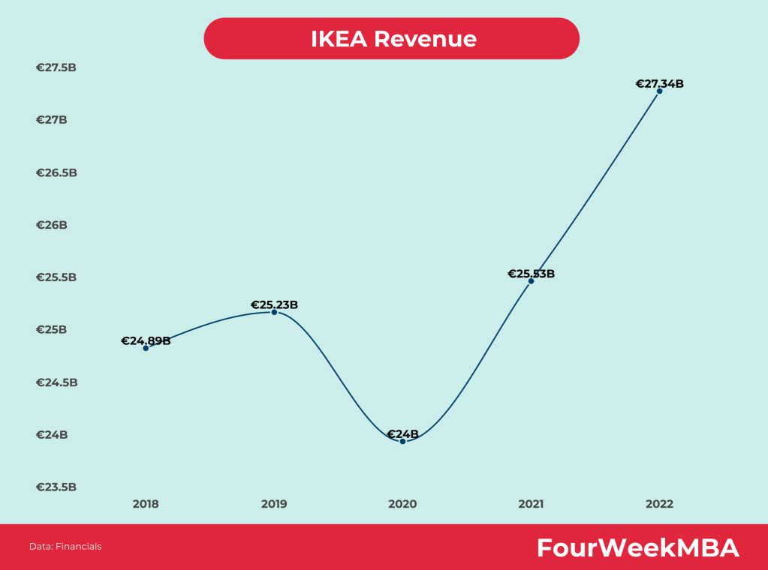
Figure 5: IKEA Revenue 2026
(Source: Cuofano, 2023)
This correlation is particularly vital within the Indian context, which sees uncertainties around geopolitical and economic conditions impacting imported materials, logistics costs and consumer affordability. Recoveries to $25.53 billion in 2021 and a record-breaking $27.34 billion in 2022, a 7.1% increase—were fuelled by increased e-commerce use and pent-up demand for home furnishings (Cuofano, 2023). There is thus an opportunity for local procurement to boost resilience and CSR performance, and also for supplier development and renewable-energy investment. The plan should also be clear, and report progress toward environmental and social promises to help stakeholders determine if IKEA means it when it comes to sustainable results. This increases the level of accountability and reduces the risk of greenwashing over time, along with building stakeholder confidence over time.

3.3 Balanced Scorecard
The Balanced Scorecard is best used to operationalise IKEA India's strategy (i.e. break it down into measurable goals):
Perspective | Strategic objective | KPI | Target | Initiative
Financial | Improve profitable growth | Increasing sales and operating margin | Increase annually | Optimising costs and using local products
Customer | Enhance trust and levels of loyalty | NPS and follow-ups | Improve year-on-year | Personalised digital services and affordable ranges
Internal Processes | Improve sustainable efficiency | Delivery rate and waste rate of EVs | Expand Electric Vehicles; minimise waste | Circular logistics and optimising inventory
Learning & Growth | Strengthen employee capability | Digital skills and training hours | Increase annually | Training in Sustainability, Technology and Customer service
Table 3: Balanced Scorecard
(Source: Self-Made)
Overall, it is concluded that IKEA's Indian strategy should be evaluated considering the Balanced Scorecard - it is not only about sales. The Financial performance is linked to customer value, efficient and sustainable processes, and employee development. A comprehensive strategy can assist IKEA in addressing Indian competitive, economic and geopolitical challenges and boost long-term competitive advantage (Sigit Gantang, 2026).

4. Strategic Choices and Implementation

4.1 Current Competitive Strategy
IKEA's strategy is not focusing on one segment of the market, but appears to be a combination of cost-leadership and differentiation. It has a global business model with business concepts rooted in functional and Scandinavian-designed furniture and home furnishing products at relatively low prices. Standardised product designs, mass ordering, flat-pack packaging, self-service retailing and efficient supply-chain operations help achieve cost efficiency (Dudovskiy, 2022). As consumers in India are price-sensitive and look for modern, appealing and utilitarian home furnishings, the need for this process is great.
But IKEA also stands out in its unique Scandinavian approach, functionality of the products, in the showroom, in the area of sustainability and integrated retail concept. In India, thus, it is a cost-effective and differentiated customer value approach. IKEA has tailored certain things to fit the Indian market, such as production in a smaller format, Indian food, products for Indian homes and a digital marketplace (The Strategy Story, 2023). This trade-off enables IKEA to be competitive by offering customers a chance to purchase a design that is convenient and affordable, but also to enjoy a strong brand experience.
A pure focus strategy would not be suitable as the consumer market will be wide, as IKEA is not aiming for a narrowly set segment. However, it can narrow its target market approach to specific Indian industry sectors like young professionals, urban families and moderate-income consumers who are looking for low-priced modern furniture.
Porter's Five Forces Analysis
This section conducts a Porter's Five Forces Analysis for PCS.
Force | Assessment in the Indian IKEA market | Strategic implication
Competitive rivalry | High | IKEA is going against the organised furniture retailers, online platforms, specialist brands and a host of local furniture stores
Threat of New Entrants | Moderate | E-commerce decreases the barrier to entry, but setting up sourcing, logistics, brand and brick-and-mortar stores is considerable
Power of suppliers | Moderate | The global scale of IKEA can bring purchasing power but can also create risks with regard to raw materials, logistics and compliant suppliers
Buyers' Bargaining Power | High | There are plenty of options available to Indian customers, and they're able to shop for cost and product online
Threat of substitutes | High | Substitutes available from local carpenters, customised furniture, second-hand furniture and other home furnishers.
Table 4: Porter's Five Forces Analysis for IKEA
(Source: Self-Made)
The relevance of competitive rivalry is accentuated by the fact that IKEA is a player in a disorganised Indian market. Another difficulty is the competition from Pepperfry, Urban Ladder, etc furniture manufacturers and retailers who can provide customised designs, price-competitive and locally acceptable products. IKEA consequently must continue to keep being cost-effective and reinforce its experiential and digital differentiation (Shastri, 2021).
Risk of new entrants is medium. Digital marketplaces make it possible for smaller businesses to participate in the furniture business without developing greater physical-store footprints. But IKEA enjoys economies of scale, the ability to source products overseas, and a renowned, international brand.
Moderate supplier power as they are not reliant on one supplier due to the size of IKEA. Geopolitical disturbance, exchange rate fluctuation, shipping and raw-material availability, however, can boost the procurement expenses. There exists high Buyer Power because folks can readily compare the buying prices and evaluations of furniture available online (Muzaky et al., 2025). High threat of substitutes means that Indian consumers have the option of buying from local manufacturers and even having customised furniture made by carpenters.
The Indian home-furnishing industry is moderately attractive, but very competitive. IKEA should therefore focus on safeguarding its cost benefits and maintaining investment in localisation, Digital, supply chain, and Customer Experience.

4.3 Ansoff Matrix
Strategy | Application to IKEA in India
Market penetration | Loyalty, targeted offers, strengthened online relationship and shopping experience to boost Indian customer sales
Market development | By expanding to more cities in India and access the "emerging middle class" and "digital consumers" via digital platforms
Product development | Stock items which are objects for Indian households and could be used in small dwellings, such as a combination multi-store with several possibilities.
Diversification | Create complementary fields of action, including digital-enabled home solutions, smart-home, and circular furniture services and home-planning services.
Table 5: Application of Ansoff Matrix in IKEA
(Source: Self-Made)
According to the Ansoff Matrix, the market penetration and product development strategies should be prioritised as they are those requiring comparatively less risk and at the same time opportunities for growth exist.

4.4 Recommended Strategy
Digital and customer-led differentiation with operational cost efficiency are recommended. IKEA shouldn't just be the cheapest because you can get very customisable products from local retailers or online at very competitive prices.
Firstly, IKEA needs to do more with their AI and data-based customer insights to gain deeper knowledge about Indian consumers' purchasing habits, household needs and regional tastes (Pingali et al., 2026). Personalised recommendations can take care of the conversion rate and customer loyalty. Second, IKEA, by having a stronger online omnichannel proposition, should enable its customers to browse, plan, purchase and arrange delivery in an easier way.
Third, the strategy must be based on the efficiency of the supply chain. If a small portion of the sourcing and inventory activity is localised and logistics only takes place with technological support, costs can be decreased, and availability of products can be improved. Fourth, IKEA should enlarge "products for sustainable use" and the circular economy: "repair, resale and recycling opportunities (Sampson and Chase, 2022). This can make IKEA stand out to eco-conscious shoppers, and can also help to drive IKEA's sustainability message around the world.
Finally, the customer experience can be enhanced with more digital home planning tools, installation and delivery options, and product ranges more relevant to the local market. This would add a level of differentiation that will be hard to duplicate by pure price competitors.

4.5 Strategy Implementation
Medium-term (2-5 years): IKEA should enhance its digital customer relationship management and develop better consumer insights along with optimising its product line and recognising the differences in Indian consumer demand, region-wise. There is also a need for enhancement of digital home-planning tools and online purchasing experiences.
Medium (2-4 years): IKEA should develop its technology in the supply chain, add sustainable and locally relevant products and have better omnichannel services. Expansion into other cities in India should be based on a demand analysis and logistical feasibility, instead of just being spread across it quickly.
Long-term (4+ years): IKEA needs to develop some sort of technology-based competitive edge based on AI, predictive analytics and integrated digital retail. It needs to provide solutions that increase customer loyalty, establish circular business models, and progressively help pave the way for even more resilient and sustainable businesses.

4.6 Implementation Challenges and Mitigation
Challenge | Potential impact | Mitigation
High technology investment | Higher running and capital costs | Use technology based on a phased investment approach and prioritise projects with high returns
Data and privacy issues | Reputation & regulatory risk | Create effective data governance, data security and clear consent collection practices amongst customers
Employee resistance | Implementation gap of technologies and processes | Train, communicate and engage employees
Strong competition | Price & margin pressure | Combine differentiation and operational efficiency
Economic uncertainty | Reduced discretionary spending | Adopt flexible pricing, low-cost product lines and flexible inventory planning
Geopolitical and supply-chain uncertainty | The sourcing cost can go up if deliveries are slowed down | Maintain contingency stock and increase supplier diversification and local sourcing
Table 6: Risk Identification for IKEA Strategic Expansion
(Source: Self-Made)
In conclusion, IKEA's journey to success in India will rely on its skill in achieving three things: affordability, local relevance, and digital convenience. Instead of just staying consistent with its existing strategy, IKEA ought to gradually evolve their practices to India's consumers whilst maintaining the existing cost and design benefits.

Section 2: Reflective Account

5. Gibbs Reflective Cycle
Gibbs' Reflective Cycle is a framework for taking a structured approach to reflection – description, feelings, evaluation, analysis, conclusion, action plan. Through this model, I have been reflecting on my research on strategic management of IKEA in the Indian market with respect to geopolitical, economic and competitive challenges.
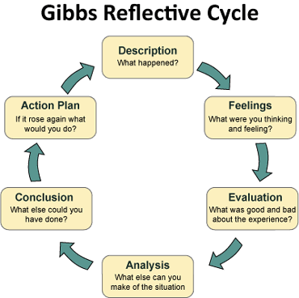
Figure 6: Gibbs' Reflective Cycle
(Source: Crowe Associates, 2019)

5.1 Description
In the process of research and analysis, I have been looking at IKEA's business model and IKEA's position in the Indian market. I examined government policy, economy, consumer behaviour, technology, sustainability and geopolitical uncertainty and how they impact the organisation. Used frameworks (such as PESTEL, Porter's Five Forces, SWOT analysis, Ansoff matrix) to structure evidence and evaluate IKEA's situation (Zhang et al., 2024). Also took into account competition, supply-chain, digitalisation, localisation and IKEA's cost-efficient business model. Finally, I synthesised the results to put forth recommendations that focused on digital differentiation, operational efficiency, sustainable products, customer experience and supply-chain resilience.

5.2 Feelings
I started with a certain confidence as IKEA is a familiar brand and they have an existing business model. But I found that it was also complicated to analyse IKEA specifically in the Indian context. Many web pages were linked to IKEA worldwide and not to IKEA in India; finding evidence was difficult. I also was not so certain about the comparison with the organised competition, IKEA. However, when introducing frameworks, I did grow in confidence as it gave a structure to interpreting info and the connections of factors with decisions (Liu et al., 2021).

5.3 Evaluation
There were a number of different frameworks, and using several different ones allowed me to look at IKEA from a range of different parts of the spectrum. PESTEL was used for influences and Porter's Five Forces for assessment of competitive pressure. Ansoff Matrix proved helpful to check the growth strategies in India. The research also had challenges, however (Zhao et al., 2024). Getting information that is recent and reliable, and also India-specific, was not an easy task. Several competitor information sources were inconsistent in terms of market performance and financial data. I also saw it was needed to ensure we did not make assumptions where there was little evidence. These challenges helped me to understand that analysis should be done with careful source selection, comparison and interpretation.

5.4 Analysis
One thing I learnt in the experience is that management is understanding the relationship between organisational capabilities, the environment and competitive conditions. Economies of scale, standardised design and supply-chain efficiency, among the strengths of IKEA, can help achieve competitiveness in India, but they are not a recipe for success. Indian consumers can also look forward to some factors like affordability, convenience, customisation, and products that will cater to their living conditions as well (Wang et al., 2021). Hence, it is necessary to adapt international strategies. I also discovered that the combinations of frameworks are the most useful. Analysing the environment together with competitive and growth analysis resulted in an understanding of IKEA's stance, what actions it can take, and what recommendations I could come up with.

5.5 Conclusion
In general, the research helped to understand the decision-making in an international market. If I were to be asked to undertake the same exercise again, I would ensure better research criteria are set up at the outset and better sources, those concerning India, are utilised first before information is gathered. For more time, I would investigate competitor information and the variables of geopolitical and economic alterations which could influence IKEA's supply chains, prices or decisions on expansion and location. This will make my analysis more exacting, critical and based on evidence.

5.6 Action Plan
I will follow a systematic research process in the future strategic-management work. Before collecting evidence, I will outline the organisation's aims, problems and environmental variables of interest. I will focus on sources from recent academic publications, industry and companies and compare data from several credible sources. I will also improve my number concept, so a proper interpretation based on the financial and market evidence is possible. In addition, frames will not be used individually. Lastly, I will assess recommendations based on feasibility, resources, risks and competitive value. This will help me to develop my critical thinking skills and to be able to create evidence-based analysis for future courses and in my academic and professional life for strategic management and for international business decisions and practical organisational analysis.

6. Conclusion
IKEA's competitive advantage in India is to be affordable and efficient in design and operation. Yet, geopolitical, economic and competitive pressures are still important. Digital differentiation, localisation, sustainability products and supply-chain resiliency are key to enhancing customer loyalty, market growth and enabling a long-term competitive advantage.

References
Abdulaziz Al Shuwaler, Majdi Anwar Quttainah, Mui, D. and Rudresh Pandey (2020). IKEA’s corporate social responsibility. [online] ResearchGate. unknown. Available at: https://www.researchgate.net/publication/342499304_IKEA [Accessed 10 Aug. 2026].
Arora, L., Singh, P., Bhatt, V. and Sharma, B. (2021). Understanding and managing customer engagement through social customer relationship management. Journal of Decision Systems, 30(2-3), pp.215-234. https://www.tandfonline.com/doi/abs/10.1080/12460125.2021.1881272
Bianco, I., Thiébat, F., Carbonaro, C., Pagliolico, S., Blengini, G.A. and Comino, E. (2021). Life Cycle Assessment (LCA)-based tools for the eco-design of wooden furniture. Journal of cleaner production, 324, p.129249. https://www.sciencedirect.com/science/article/pii/S0959652621034351
BTI (2024). BTI 2024 India country report. [online] BTI. Available at: https://bti-project.org/en/reports/country-report/IND [Accessed 10 Aug. 2026].
Crowe Associates (2019). Gibbs reflective cycle | Crowe Associates. [online] Crowe Associates. Available at: https://www.crowe-associates.co.uk/coaching-tools/gibbs-reflective-cycle/ [Accessed 10 Aug. 2026].
Cuofano, G. (2023). IKEA revenue. [online] FourWeekMBA. Available at: https://fourweekmba.com/ikea-revenue/ [Accessed 10 Aug. 2026].
D’Itria, E., Pei, X. and Bertola, P. (2024). Designing sustainability today: An analytical framework for a design for sustainability model in European fashion and furniture industries. Sustainability, 16(8), p.3240. https://www.mdpi.com/2071-1050/16/8/3240
Dudovskiy, J. (2022). IKEA business strategy and competitive advantage: Capitalising on IKEA concept - research-methodology. [online] Research-Methodology. Available at: https://research-methodology.net/ikea-business-strategy-competitive-advantage-capitalising-ikea-concept/ [Accessed 10 Aug. 2026].
Hub24, M. (2026). IKEA’s insight into DIY acceptance in India. [online] MarkHub24. Available at: https://www.markhub24.com/post/ikea-s-insight-into-diy-acceptance-in-india [Accessed 10 Aug. 2026].
IKEA (2022). IKEA launches new AI-powered, digital experience. [online] Ikea.com. Available at: https://www.ikea.com/us/en/newsroom/corporate-news/ikea-launches-new-ai-powered-digital-experience-empowering-customers-to-create-lifelike-room-designs-pub58c94890/ [Accessed 10 Aug. 2026].
IKEA (2023). Affordable, Quality Furniture & Home Furnishings. [online] Ikea.com. Available at: https://www.ikea.com/in/en/ [Accessed 10 Aug. 2026].
IKEA (2024). Our history. [online] Ikea.com. Available at: https://www.ikea.com/us/en/this-is-ikea/about-us/from-humble-origins-to-global-brand-a-brief-history-of-ikea-pubad29a981/ [Accessed 10 Aug. 2026].
IKEA (2024a). Community Engagement. [online] www.ikea.com. Available at: https://www.ikea.com/in/en/this-is-ikea/community-engagement/ [Accessed 10 Aug. 2026].
IKEA (2024a). IKEA sustainability strategy – IKEA global. [online] IKEA. Available at: https://www.ikea.com/global/en/our-business/reports/ikea-sustainability-strategy-240904/ [Accessed 10 Aug. 2026].
IKEA (2025). The story of IKEA – ikea global. [online] IKEA. Ikea. Available at: https://www.ikea.com/global/en/our-business/how-we-work/story-of-ikea/ [Accessed 10 Aug. 2026].
IKEA (2025a). Corporate social responsbility. [online] Ikea.com. Available at: https://www.ikea.com/in/en/this-is-ikea/csr-policy-ikea-india-private-limited-pubcc43bc70/ [Accessed 10 Aug. 2026].
IKEA (2025a). Page restricted. [online] Ikea.com. Available at: https://www.ikea.com/global/en/our-business/how-we-work/year-in-review-fy25/ [Accessed 10 Aug. 2026].
IKEA Global (2025). IKEA retail sales figures for FY25 – ikea global. [online] IKEA. Available at: https://www.ikea.com/global/en/newsroom/corporate/ikea-retail-sales-fy25-251016/ [Accessed 10 Aug. 2026].
Inter IKEA (2024). Management structure. [online] www.inter.ikea.com. Available at: https://www.inter.ikea.com/en/this-is-inter-ikea-group/management-structure [Accessed 10 Aug. 2026].
International Trade Administration (2024). India - labeling/marking requirements. [online] www.trade.gov. Available at: https://www.trade.gov/country-commercial-guides/india-labelingmarking-requirements [Accessed 10 Aug. 2026].
Irshad, A.U.R., Safdar, N., Younas, Z.I. and Manzoor, W. (2023). Impact of corporate governance on firms’ environmental performance: Case study of environmental sustainability-based business scenarios. Sustainability, 15(10), p.7775. https://www.mdpi.com/2071-1050/15/10/7775
Jia, J. (2024). Research on supply chain management strategies of multinational retailers in China based on IKEA. Advances in Economics Management and Political Sciences, 140(1), pp.138–147. doi:10.54254/2754-1169/2024.ga18771.
Jonwal, S. (2025). IKEA case study 2025: Strategy, marketing, & business model. [online] Young Urban Project. Available at: https://www.youngurbanproject.com/ikea-case-study/ [Accessed 10 Aug. 2026].
Jurevicius, O. (2025). SWOT analysis of IKEA 2023. [online] Strategic Management Insight. Available at: https://strategicmanagementinsight.com/swot-analyses/ikea-swot-analysis/ [Accessed 10 Aug. 2026].
Liu, X., Zhang, F., Hou, Z., Mian, L., Wang, Z., Zhang, J. and Tang, J. (2021). Self-supervised learning: Generative or contrastive. IEEE transactions on knowledge and data engineering, 35(1), pp.857-876. https://ieeexplore.ieee.org/abstract/document/9462394
Maji, S.G. and Lohia, P. (2023). Environmental, social and governance (ESG) performance and firm performance in India. Society and Business Review, 18(1), pp.175-194. https://www.emerald.com/sbr/article-abstract/18/1/175/349957/Environmental-social-and-governance-ESG?redirectedFrom=fulltext
Majumdar, R. and Ghatak, D. (2025). India economic outlook, january 2025. [online] Deloitte Insights. Deloitte. Available at: https://www.deloitte.com/us/en/insights/topics/economy/asia-pacific/india-economic-outlook.html [Accessed 10 Aug. 2026].
Muzaky, R., Zahir, M. and Saputra, M.S. (2025). Analysis of IKEA's Strategy in Facing Institutional and Cultural Differences in Target Countries. Journal of International Trade, 4(1), pp.38-41. https://ejournal2.uika-bogor.ac.id/index.php/JIT/article/view/2246
Nelson, N.A. (2025). In class, we always carry out case studies to understand deeply how ESG is being applied in real situations. [online] LinkedIn. Available at: https://www.linkedin.com/posts/nasyaariella_in-class-we-always-carry-out-case-studies-activity-7316267498713034754-qKhw [Accessed 10 Aug. 2026].
Nielsen, L.K. (2025). Key IKEA statistics: Understanding their continued success. [online] Huuray.com - The Global Reward Management Platform. Gift cards, Rewards & Incentives – Global Gift Card platform. Available at: https://huuray.com/inspiration/gift-cards/ikea-statistics/ [Accessed 10 Aug. 2026].
Pingali, S., Prakash, S. and Korem, J.R. (2026). Digital transformation strategies: theory and practice. Taylor & Francis. https://books.google.co.in/books?hl=en&lr=&id=iNWxEQAAQBAJ&oi=fnd&pg=PT10&dq=Digital+and+customer-led+differentiation+with+operational+cost+efficiency+&ots=z-bHglec2D&sig=v8AaVzsMfUy1oH3l9y_lPaj5UXk&redir_esc=y#v=onepage&q=Digital%20and%20customer-led%20differentiation%20with%20operational%20cost%20efficiency&f=false
Reuters (2025). Changes to India’s repo rate since june 2000. [online] Yahoo Finance. Available at: https://sg.finance.yahoo.com/news/changes-indias-repo-rate-since-053551856.html [Accessed 10 Aug. 2026].
Sampson, S.E. and Chase, R.B. (2022). Optimizing customer involvement: how close should you be to your customers?. California Management Review, 65(1), pp.119-146. https://journals.sagepub.com/doi/abs/10.1177/00081256221118117
Shastri, A. (2021). Complete analysis of the business model of IKEA | IIDE. [online] IIDE. Available at: https://iide.co/case-studies/business-model-of-ikea/ [Accessed 10 Aug. 2026].
Sigit Gantang (2026). 214716711-Ikea-Balanced-Scorecard.Pdf. [online] Scribd. Available at: https://www.scribd.com/doc/252077477/214716711-Ikea-Balanced-Scorecard-pdf [Accessed 10 Aug. 2026].
Statista (2020). Topic: IKEA. [online] Statista. Available at: https://www.statista.com/topics/1961/ikea/?srsltid=AfmBOorpJ7GLW9vI0UNyxkVw3q4wcRrVb4FdNwZEQvFzyyOy7wRAOW6P [Accessed 10 Aug. 2026].
The Strategy Story (2023). IKEA competitor analysis - the strategy story. [online] The strategy story. Available at: https://thestrategystory.com/blog/ikea-competitor-analysis/ [Accessed 10 Aug. 2026].
Thörnqvist, C. and Kilstam, J. (2021). Aligning Corporate Social Responsibility with the United Nations’ Sustainability Goals: Trickier than it Seems?. Economics, 9(1), pp.161-177. https://reference-global.com/article/10.2478/eoik-2021-0009
Turner, C. (2024). International business: Themes and issues in the modern global economy. Taylor & Francis. https://books.google.co.in/books?hl=en&lr=&id=c2jwEAAAQBAJ&oi=fnd&pg=PA1966&dq=economic+factors+effects+on+business&ots=w7dL7mXOkk&sig=mlOdMnOybjSdcPnV55sPpN2eLB0&redir_esc=y#v=onepage&q=economic%20factors%20effects%20on%20business&f=false
Vanzandt, P. (2023). What is PESTEL analysis? Definition, benefits and best practices. [online] IdeaScale. Available at: https://ideascale.com/blog/what-is-pestel-analysis/ [Accessed 10 Aug. 2026].
Wang, X., Gao, J., Long, M. and Wang, J. (2021, July). Self-tuning for data-efficient deep learning. In International Conference on Machine Learning (pp. 10738-10748). PMLR. https://proceedings.mlr.press/v139/wang21g.html
Zhang, K., Wen, Q., Zhang, C., Cai, R., Jin, M., Liu, Y., Zhang, J.Y., Liang, Y., Pang, G., Song, D. and Pan, S. (2024). Self-supervised learning for time series analysis: Taxonomy, progress, and prospects. IEEE transactions on pattern analysis and machine intelligence, 46(10), pp.6775-6794. https://ieeexplore.ieee.org/abstract/document/10496248
Zhao, Z., Alzubaidi, L., Zhang, J., Duan, Y. and Gu, Y. (2024). A comparison review of transfer learning and self-supervised learning: Definitions, applications, advantages and limitations. Expert Systems with Applications, 242, p.122807. https://www.sciencedirect.com/science/article/pii/S0957417423033092

