

PROGRAMME: BA (HONS) LEADERSHIP AND MANAGEMENT SKILLS FOR THE WORKPLACE
Organisational Culture
MODULE CODE: LCLM 5005
STUDENT NAME:- Nicoleta Bus
STUDENT ID : 2025237
Table of Contents
1.0 Introduction 6
2.0 Overview of Organisational Culture in British Airways 7
3.0 Influence of Organisational Culture on Structure and Decision-Making 7
3.1 Organisational Structure of British Airways 7
3.2 Influence of Culture on Organisational Structure 7
3.3 Influence of Culture on Decision-Making 8
4.0 Application of Organisational Culture Theories and Frameworks 9
4.1 Schein’s Three Levels of Organisational Culture 9
4.2 Handy’s Cultural Types 11
4.3 Determination of the Prevailing Organisational Culture 12
5.0 Organisational Culture and Adaptation to External Environment 12
5.1 External Environmental Factors Affecting British Airways 12
5.2 Role of Organisational Culture in Adaptation 14
6.0 Organisational Culture as an Enabler or Barrier 15
6.1 Organisational Culture as an Enabler 15
6.2 Organisational Culture as a Barrier 15
6.3 Critical Assessment and Justified Position 15
7.0 Impact of Organisational Culture on Organisational Performance and Recommendations 17
7.1 Impact of Organisational Culture on Organisational Performance 17
7.2 Recommendations for Improvement 18
8.0 Conclusion 20
9.0 References 21

List of Figures
Figure 1: British Airways Logo 6
Figure 2: Schein's Three Levels of Organisational Culture 10
Figure 3: Handy's Cultural Types 12

1.0 Introduction
The organisational culture can be defined as the shared values, beliefs, assumptions and behaviours that determine the manner in which employees interact, the way they undertake their duties, and how they accomplish organisational goals (Mullins, and Christy, 2016). A good organisational culture gives a shared sense of purpose, shapes the behaviour of employees, and leads to organisational effectiveness and long-term success. This report will analyse the organisational culture of British Airways and assess how it has impacted the organisational structure and decision-making processes within the organisation. It will also use reserved organisational culture theories and frameworks to determine the existing culture in the company. Moreover, the report shall study the ways British Airways uses its organisational culture to react to external environmental impacts, critically examine whether its culture is an enabler or hindrance to organisational effectiveness, and the effect of organisational culture on organisational performance and subsequently propose theory-based recommendations on how it can be improved.
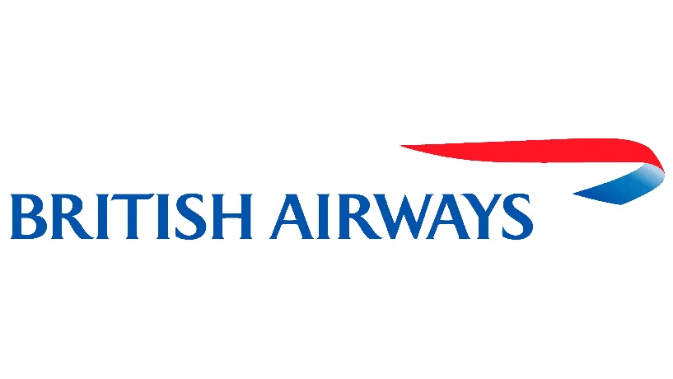
Figure 1: British Airways Logo
(Source: 1000 Logos, 2026)

2.0 Overview of Organisational Culture in British Airways
Organisational culture influences the behaviour of employees, communication and organisational practices, and it impacts the process of meeting the business goals. The aviation sector relies heavily on the presence of a good organisational culture to achieve efficiency in its operations, customer satisfaction, and adherence to safety measures. British Airways, being one of the leading airlines in the world, has been operating on a culture that talks about professionalism, focus on the customers, teamwork and operational excellence to help in the management of its diverse global operations (Zhang, 2025). The shifting culture of the organisation has, over time, evolved with the technological changes, rising competition, dynamic customer demands and challenges in sustainability. Although retaining its classic focus on safety and operational discipline, innovativeness and continuous improvement have been encouraged at British Airways. Knowing this organisational culture offers a starting point in assessing its impact on the structure of the company, decision-making directions, flexibility to changes brought about by the external environment and overall performance of the organisation.

3.0 Influence of Organisational Culture on Structure and Decision-Making

3.1 Organisational Structure of British Airways
British airway is characterised by hierarchical organisational structure that specifies the various departments within it such as flight operations, engineering, finance, human resources, customer service and marketing. Its chain of command and functions are clear and the airline can simplify its operation on an international basis. The senior management also takes part in the strategic decisions and the departmental managers watch over the implementations of the organisational policies and standard of operations (Cozmuta, 2024). It is particularly important within such a systematic approach in the sphere of aviation, where safety, adherence to regulations, and uniformity in the work are of great importance.

3.2 Influence of Culture on Organisational Structure
The hierarchical nature of the British Airways organisational culture is reinforced by professionalism, accountability and discipline support which is endorsed by the organisational culture. The employees should operate in a certain way and with a well-defined role, which ensures uniformity in service provision as well as adherence to safety rules. Formal communications and effective interdepartmental coordination are also promoted in the culture, thus allowing the organisation to stay at high standards of operations. Nonetheless, flexibility may decrease because the focus on hierarchy and standardisation may slow down the adoption of a novel idea and organisational change as various strata of management are involved.

3.3 Influence of Culture on Decision-Making
The organisational culture of British Airways has a major impact on the decision-making processes, as it promotes thorough planning, risk management and decisions that are customer-oriented (Mahapatra, and Jain, 2023). The top-level management of the firm usually involves a systematic assessment of strategic decisions focused on fleet management, service enhancement, and sustainability. At the operational level, a decision is made routinely by the employees in specifically defined organisational processes with safe and constant delivery of services. Although this will increase accountability and limit operational risks, it can also decrease employee involvement in strategic decisions and organisational reaction in rapidly evolving scenarios. Thus, the culture has been able to champion the reliability of its operations and sound governance, but is not flexible enough and needs more employee input in order to be more innovative and responsive in an industry that is becoming more and more competitive in the aviation sector.

4.0 Application of Organisational Culture Theories and Frameworks

4.1 Schein’s Three Levels of Organisational Culture
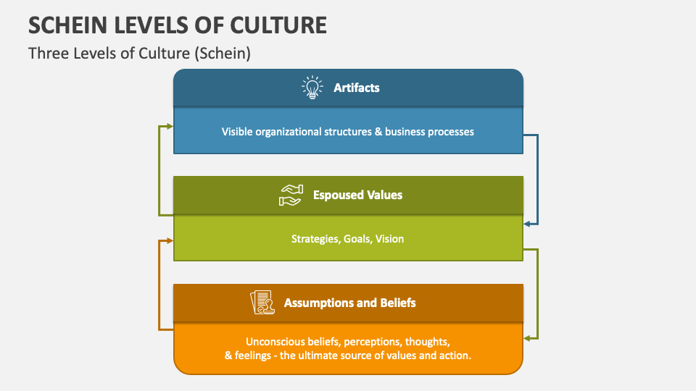
Figure 2: Schein's Three Levels of Organisational Culture
(Source: Collidu, 2025)
The Three Levels of Organisational Culture by Schein gives a detailed orientation of how culture is instilled into an organisation using the visible organisational practices, declared values, and hidden beliefs (Williams, 2022). Using this model in the context of British Airways assists in pinpointing how the organisational culture affects the behaviour of its employees, operational and service delivery behaviours.
The first level, artefacts, represents the visible and observable aspects of organisational culture. These at British Airways are the uniforms of the employees, the aircraft branding, the airport lounge, customer service processes, training programmes and formal communication channels. This professionalism is also manifested in the outlook of the employees of the company, the standardisation of the working process and a stable delivery of the services on the domestic and overseas routes. Also visible are safety demonstrations, strict operating protocols, and well-organised reporting relationships, which are key indicators of a culture that advocates discipline and operational excellence.
The second level includes espoused values, which include the values and standards the organisation boasts of having. The values supported by British Airways include safety, customer focus, teamwork, integrity, and continuous improvement. These values are manifested in efforts to improve passenger experience, operational effectiveness, staffing development and sustainability goals. The organisation promotes high-quality services among employees, keeping in mind their professionalism and not compromising safety standards.
The bottom layer is made up of fundamental underlying assumptions, which are unconscious beliefs that direct employee behaviour without necessarily having to be directed. In British Airways, one of the strongest underlying assumptions is that passenger safety is the topmost organisational priority and should not be compromised (Kassem, Salama, and Ganepola, 2023). The other assumption is that consistency in operations and service level may be a vital factor in safeguarding the image of the airline amidst a competitive environment. These are ingrained beliefs which affect the way the employees react to situations that pose a challenge to the functioning of the operation, how the employees relate to the customer and adhere to the organisational processes.
On the whole, the model provided by Schein shows that the organisational culture of British Airways is not confined to the visible practices but is supported by the shared values and well-established assumptions that can impact the everyday organisational behaviour.

4.2 Handy’s Cultural Types
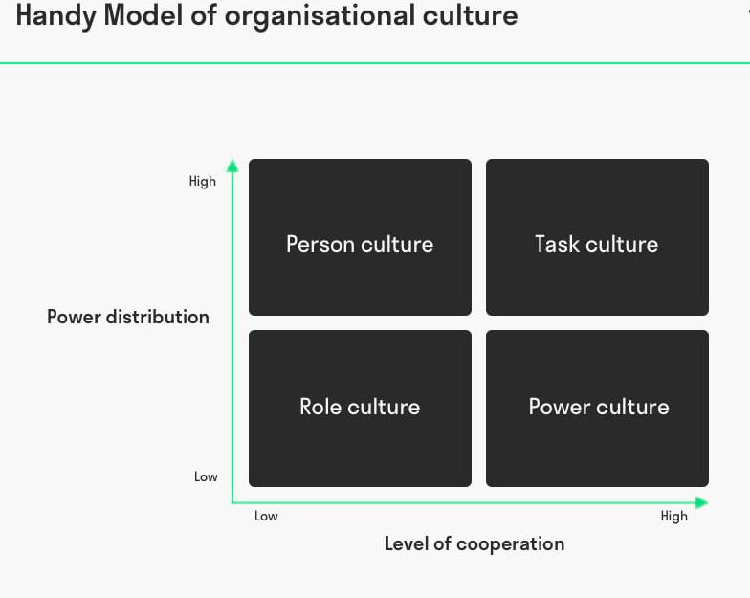
Figure 3: Handy's Cultural Types
(Source: Toolshero, 2025)
Another handy model that would be used to determine the predominant organisational culture in British Airways is the Culture Types of Handy. Of the four types of cultures, the organisation is the one that is closest to the traits of a Role Culture.
Certain responsibilities, strict procedures, hierarchy of authority and specialisation of the job functions characterise a role culture. The characteristics are more than relevant to the aviation industry, where the operational accuracy, compliance with the regulations, and inter-departmental coordination are crucial. British Airways delegates certain tasks to pilots, cabin crew, engineers, customer service employees and operational managers, so that each staff member knows his/her role in the broader organisational structure. Consistency and accountability are reinforced by the general source of decision-making power being position-based or not based on individual influence within an organisation.
Another role of culture is operational efficiency, as the introduction of standardised procedures limits the degree of uncertainty and diminishes the chances of operational mistakes through the creation of standard procedures. Employees should adhere to well-established rules, especially in flight operations, passenger safety and compliance with regulations (Punpookboon, 2025).
Nevertheless, role culture can come with some constraints as well. Decision-making based on formal procedures and a hierarchical approach may limit the flexibility of organisations and the process of implementing innovative ideas. The workers can be less involved in strategic decisions, which may reduce the creativity and responsiveness in times of a high rate of environmental change. Thus, though role culture helps to be operationally reliable, it might need more flexibility to suit any changing customer expectations and technology.

4.3 Determination of the Prevailing Organisational Culture
When the Three Levels of Organisational Culture as defined by Schein and the Cultural Types defined by Handy are applied to British Airways, it reveals that the organisation works by a Role Culture with strong, ingrained values of professionalism, safety, accountability and customer service. The well-defined roles of the organisation, a highly hierarchical organisation, standard procedures and disciplined working practices closely resemble the features of the role-oriented culture (Gutterman, 2025). Simultaneously, the phenomenon of growing popularity of collaborative teams as the innovation and organisational improvement mechanisms testifies to the emergence of the aspects of task culture gradually. Overall, British Airways has had the capacity of working towards an organisational culture that upholds operational stability, regulations, and excellence of its services. Nonetheless, to be competitive in the long run the organisation will have to keep the benefits of its role culture as well as enhance a greater degree of flexibility, collaboration and innovation in response to future technological and environmental shifts.

5.0 Organisational Culture and Adaptation to External Environment

5.1 External Environmental Factors Affecting British Airways
British Airways is a company that has a complex external environment; these forces comprise political, economic, social, technological, environmental, and legal environments, which play a profound role in the operation of the company. Culture is significant in helping the organisation to effectively respond to these external forces.
Political Factors:
The operations of the British Airways are influenced by government policies on aviation, regulations on Brexit and the international air service agreements (Hiney, and Graham, 2025). The regulatory compliance culture and operational discipline facilitate change to the organisation.
Economic Factors:
Some of the economic factors that greatly impact airline profitability include inflation and increased fuel prices. The International Air Transport Association (IATA) indicates that in 2024 fuel is projected to comprise 31% of total operating costs of airlines, and is, therefore, the greatest operating expense of airlines (International Air Transport Association, 2024). In order to handle these economic pressures British Airways is concentrating on cost-efficiency, operational excellence, and fuel-optimisation without compromising on service quality.
Social Factors:
The increasing demands of customers with more personalised and digital services push British Airways to sustain a customer-centric culture that can be facilitated by ongoing employee training.
Technological Factors:
The organisation embraces online booking services, mobile applications, and robotics. Technological innovation and service improvement are aided by the culture of constant learning.
Environmental Factors:
The need to cut down on carbon emissions has promoted the use of sustainable aviation fuel and fuel-efficient aeroplanes by British Airways as part of its sustainability measures (Singh Gill et al., 2025).
Legal Factors:
The culture of accountability and following the set procedures promotes compliance with the aviation safety, employment, and consumer protection laws.

5.2 Role of Organisational Culture in Adaptation
The British Airways organisational culture is such that it facilitates the company to adjust effectively to the alterations of the external environment, through incorporating professionalism, operational discipline and putting clients at the centre. To reinforce its performance and long-term transformation of the business, British Airways was still investing in its operational resilience, technology development, and customer experiences (International Consolidated Airlines Group, 2023). Innovation is promoted by the culture as well, whereby the investments are made in digital technologies and the enhancement of customer experiences to keep abreast with the dynamic market demands. Moreover, British Airways has incorporated the values of sustainability in its culture in terms of environmental activities directed to the minimisation of carbon emissions and enhancement of operational cost-effectiveness. Nevertheless, its base hierarchical structure might slow down the decision-making process and decrease flexibility in instances where quick organisational responses are needed. Notwithstanding this, the organisation continues to develop and improve, balancing its good culture of functional control and placing more emphasis on innovation, collaboration among the employees and sustainability. As a result, organisational culture has helped British Airways to withstand and be competitive in an ever-changing aviation industry.

6.0 Organisational Culture as an Enabler or Barrier

6.1 Organisational Culture as an Enabler
The organisational culture of British Airways is a significant facilitator of organisational performance by influencing professionalism, safety, accountability and excellent customer service. Working in the aviation sector of high regulation means that employees have to work with standard procedures and adhere to tight operational procedures. These common cultural values contribute to a reduction of the operational risks, increase the consistency of their service, and guarantee that employees clearly comprehend their roles and duties. Moreover, a high teamwork culture fosters effective teamwork between pilots, cabin crew, engineers and ground staff, where easy coordination among various operational units and provision of quality services is achieved (Al-Tit, 2025).

6.2 Organisational Culture as a Barrier
Although these strengths are there, culture has some limitations to organisational effectiveness due to some of its specifics. The formality of the decision-making procedures and the strict hierarchy system of organisational structure of British Airways may hinder organisational response to the dynamic market environment and technological changes. The workers in lower ranks do not play a big role in the strategic decision-making processes and this is bad since they are unable to be innovative and have a creative approach towards problems. Moreover, the orientation of the organisation on standardisation, although it is critical in ensuring safety, might not encourage flexibility and experimentation.

6.3 Critical Assessment and Justified Position
In a nutshell, the organisational culture of British Airways is both an enabler and a hindrance depending on the organisational situation. Its close attention to safety, professionalism and operational discipline facilitates providing reliable services, meeting regulatory criteria and long-term organisational stance, rendering it quite efficient in the aviation industry. Nevertheless, these very features can slow down the organisational agility and hinder innovation when quick adaptation is needed. The culture is therefore more of an enabler in the sense that it will guide the fundamental operations goals of the airline, which are safety, reliability and customer satisfaction. However, to sustain future competitiveness, British Airways will need to supplement its organised culture with increased employee empowerment, cooperation and flexibility, which will allow the organisation to react more efficiently to the changing customer demands, technological changes, and a business society that is getting more and more dynamic.

7.0 Impact of Organisational Culture on Organisational Performance and Recommendations

7.1 Impact of Organisational Culture on Organisational Performance
The organisational culture plays an important role in determining the performance of British Airways because it shapes the behaviour of employees as well as the quality of services, the efficiency of running the organisation and the capability of the organisation to meet its strategic goals. British Airways, being a global airline which is highly regulated, encourages a culture of professionalism, safety, accountability and customer service. These common values allow the employees to carry out their duties in a sustained manner and help promote operational excellence and organisational success in the long run. Among the most prominent contributions made by the organisational culture of British Airways, it is important to note that the culture of the company focuses on operational safety and reliability. High standards of compliance with procedures and regulatory policies must be observed, and a high level of safety culture is paramount in the airline business (Moghadasnian, and AzarHoush, 2024). Workers tend to adhere to the set standards, which leads to a reduced number of operational mistakes and streamlined operation of flights. This safety ensures that there is customer confidence and increases the reputation of the organisation as a strong international airline that is reliable. The culture also has a positive impact on customer satisfaction and brand reputation. British Airways motivates employees to deliver professional and high-quality services to customers during the customer journey, from booking to all the other processes after the flight. Customer-centric culture assists in maintaining an equivalent in service delivery, customer loyalty, and bolsters the premium airline image (Bakir et al., 2025). In addition to that, the organisational values also facilitate interdepartmental collaboration with pilots, cabin crew, engineers and ground staff being able to pull their efforts together with a great degree of success.
Although these have a positive impact, there are elements of the organisational culture that can have adverse performance implications. The former hierarchical and formal way of decision-making may decrease the nanoparticle organisation in the face of an evolving market or technological shifts; in other words, quick reaction is needed. The multi-tiered decision approval can slow down the strategic process and lower the responsiveness of the organisation to the needs of the customers and the dynamism in competition. Moreover, a culture that highly values procedures and hierarchy can inhibit the input of the staff in the decision-making process (Tierney, 2023). A lower chance to contribute ideas might demoralise employee engagement and inhibit innovation. Stabilisation of the organisations and shift in the way that the organisation works have also posed a problem in terms of keeping the employee motivated, and this has proved that even though stability in the culture was essential, it should be coupled with more flexibility and free communication. In general, the organisational culture of British Airways has helped it achieve operational efficiency, customer satisfaction and organisational reliability. The long-term performance, however, will need the organisation to maintain the strengths it has as it creates a more adaptive and creative culture that can effectively change with the times to meet the challenges of the industry going forward.

7.2 Recommendations for Improvement
In order to improve the performance of the organisation, it is advisable that British Airways promotes a more participative organisational culture by including employees in both operational and strategic decision-making within the organisation. Higher innovation would be enhanced by having more employees involved, they would be more problem solvers and would be more committed to their organisational objectives without having the wrong managerial control over them (Gandrita, 2023). The organisation also needs to foster a lifelong learning culture by investing in employee development programmes, training them on the digital and working across different functions. Such initiatives would enhance the flexibility of the workforce and equip them for the changes in technology and changing customer demands in the aviation sector. Another priority should be to increase internal communication. Creating open channels of communication and frequent employee feedback systems would enhance trust between the management and employees, decrease opposition to organisational change and ensure that the staff know organisational goals and strategic initiatives (Ify, 2024). Lastly, British Airways must persist with embedding the culture of sustainability and customer-oriented innovation in its organisation. The promotion of the employees to take part in environmental efforts, digital transformation and service improvement programmes would increase the adaptability of organisations and the long-term competitiveness without compromising safety, operational excellence, and customer satisfaction of the airline.

8.0 Conclusion
The organisational culture is vital in determining the organisation's structure, decision-making process, flexibility and overall performance of British Airways. The analysis shows that the culture of the organisation is defined as being characterised by professionalism, safety, accountability and customer focus, all of which contribute to efficiency in operations and quality of services. Though the role-oriented culture that prevails is beneficial in promoting consistency, compliance with regulations and stability in an organisation, it can also hamper flexibility and creativity within a business environment that is changing rapidly. Thus, to maintain long-term organisational success and sustainability, British Airways must keep all the positive aspects of its current culture, promote more employee involvement, flexibility, and constant improvement.

9.0 References
1000 Logos, (2026) British Airways Logo Available at: https://1000logos.net/british-airways-logo/ (Accessed on: 29th June, 2026)
Al-Tit, A.A., Al-Ayed, S.I., Alhalalmeh, M.I., Hunitie, M.F.A., AlThuwaini, S., Alqahtani, M.M., Al Sarayreh, A., Alzyoud, M., Haija, A.A.A. and Mohammad, S.I. (2025) Impact of Flexible Work Arrangements on Team Collaboration: An Empirical Study in Airlines. In Intelligence-Driven Circular Economy: Regeneration Towards Sustainability and Social Responsibility—Volume 2 (pp. 397-409). Cham: Springer Nature Switzerland. https://doi.org/10.1007/978-3-031-74220-0_30
Bakir, N., El Nemar, S., Gehchan, F.B., Samrouth, K. and Vrontis, D. (2025) Optimizing airline services: leveraging data-driven strategies for enhanced customer satisfaction and engagement. Journal of Asia Business Studies, 19(2), pp.487-510. https://doi.org/10.1108/JABS-09-2024-0559
Collidu, (2025) Schein Levels of Culture Available at: https://www.collidu.com/presentation-schein-levels-of-culture (Accessed on: 29th June, 2026)
Cozmuta, A. (2024) Selling ‘The World’s Favourite Airline’: British Airways’ privatisation and the motives behind it. Business History, 66(1), pp.181-200. https://doi.org/10.1080/00076791.2021.1926991
Gandrita, D.M. (2023) Improving strategic planning: The crucial role of enhancing relationships between management levels. Administrative Sciences, 13(10), p.211. https://doi.org/10.3390/admsci13100211
Gutterman, A.S. (2025) Classifying Culture: Typologies and Taxonomies. Available at SSRN 5534060. https://papers.ssrn.com/sol3/papers.cfm?abstract_id=5534060
Hiney, N. and Graham, A. (2025) Aviation governance in the United Kingdom and Republic of Ireland: a study of airport arrangements in the Common Travel Area. Research Handbook on Air Transport Leadership and Governance, pp.9-33. https://doi.org/10.4337/9781803926988.00008
Ify, I.P. (2024) Communication strategies and employee productivity. Global Journal of Social Sciences, 23(1), pp.97-102. https://www.ajol.info/index.php/gjss/article/download/273868/258553
International Air Transport Association, (2024) Airline Profitability Outlook Improves for 2024 Available at: https://www.iata.org/en/pressroom/2024-releases/2024-06-03-01/? (Accessed on: 29th June, 2026)
International Consolidated Airlines Group, (2023) British Airways Plc Annual Report and Accounts Year ended 31 December 2023 Available at: https://www.iairgroup.com/media/2h0hgqdq/british-airways-annual-report-and-accounts-2023.pdf (Accessed on: 29th June, 2026)
Kassem, R., Salama, A. and Ganepola, C.N. (2023) CSR, credibility, employees' rights and legitimacy during a crisis: a critical analysis of British Airways, WizAir and EasyJet cases. Employee Relations: The International Journal, 45(1), pp.1-20. https://doi.org/10.1108/ER-11-2021-0517
Mahapatra, R.R. and Jain, A.K. (2023) Situational leadership theory: An extension and a test of global organizational prescriptions. In Globalization, human rights and populism: Reimagining people, power and places (pp. 623-640). Cham: Springer International Publishing. https://doi.org/10.1007/978-3-031-17203-8_30
Moghadasnian, S. and AzarHoush, A. (2024) Enhancing Airline Safety Management: Strategic Insights into KPI-Driven Oversight. Available at SSRN 6260081. https://papers.ssrn.com/sol3/papers.cfm?abstract_id=6260081
Mullins, L. and Christy, G. (2016). Management and Organisational Behaviour (11th ed.). Pearson Education Limited.
Punpookboon, C. (2025) From Policy to Practice: Developing Airline Guidelines Communication for the Safety of Asian Passengers in Flight. Policy, 14(1). https://so01.tci-thaijo.org/index.php/bkkthon/article/download/281082/179944/1151125
Singh Gill, S., Rui Qi, L., De Yao, C., Tapiwanashe, M.N., Stanley, K.T., Shao Wei, P., Chia Yan, E.Y., Marimuthu, S. and Vincent, J. (2025) Reducing carbon emission towards sustainable aviation. Journal of Engineering Technology and Applied Physics, 7(2). https://doi.org/10.33093/jetap.2025.7.2.10
Tierney, W.G. (2023) The impact of culture on organizational decision-making: Theory and practice in higher education. Routledge. https://doi.org/10.4324/9781003447887
Toolshero, (2025) Handy Model of Organisational Culture (Handy and Harrison) Available at: https://www.toolshero.com/management/handy-model/ (Accessed on: 29th June, 2026)
Williams, P. (2022) Organisational culture: definitions, distinctions and functions. In Handbook of research methods for organisational culture (pp. 5-22). Edward Elgar Publishing. https://doi.org/10.4337/9781788976268.00008
Zhang, Y. (2025) Research on the Regional performance and Development of Aviation Culture. https://www.theseus.fi/handle/10024/884645

