
THE IMPACT OF CONSUMER SATISFACTION AND BRAND IMAGE ON BRAND LOYALTY IN THE LUXURY FASHION INDUSTRY: A CASE STUDY ON LOUIS VUITTON
BY
DAKSH VELANI
STUDENT ID :2312428
SUPERVISOR: JIA MIAO
MODULE CODE: LCNB47020
OCTOBER 2024

Master’s Degrees by Examination and Dissertation
Declaration Form.

I DAKSH VELANI declare that this dissertation has been composed by myself, that the work contained herein is entirely my own except where explicitly stated otherwise in the text, and that this work has not been submitted for any other degree or qualification, in whole or in part, except as specified.

Signature: DAKSH VELANI………………………………............................

Date: 14TH OCTOBER 2024………………………………............................

Acknowledgement
I would like to express my gratitude to my supervisor, Jia Miao for his expert and helpful guidance, constructive feedback and unvacillating support throughout the duration of the research. His thoughtful advice and motivation have been significant in the successful completion in the work. I am also thankful to the University of Wales Trinity Saint David and my department for providing the educational resources and unconditional support for this research. Very special thanks to Jia Miao for his important suggestion and encouragement during the study. I would like to thank to all participants involved in this research. I would like to express my deepest gratitude to my family and friends whose patience and love have been a source of strength for this memorable journey

Abstract
This research attempts to bridge the existing gap by establishing the research topic and providing a rationale for each aspect of the fashion industry. The study aim is to evaluate the impact of consumer satisfaction and brand image on brand loyalty in the Louis Vuitton luxury fashion industry. Primary data has been collected in this study by conducting an online survey. The data has been presented graphically to interpret.
The outcome of this study indicates that a huge percentage of people are repeat clients of the brand, demonstrating high client loyalty and hobby in Louis Vuitton's merchandise. The excessive quantity of repeat customers suggests that Louis Vuitton is effective at recruiting and maintaining clients who admire premium goods. Customer provider is important for emblem loyalty. The result also shows that sturdy customer support is a vital component in selling routine commercial enterprises. Respondents accept as true that the service they acquire complements their revel in with the employer, making them more willing to stay loyal.
The study highlights the importance of maintaining a strong brand image and meeting client expectations in the premium business. Based on the study it can be recommended that the management of Louis Vuitton needs to adopt specific steps to maintain its brand image in the luxury fashion industry

Table of Content
Chapter 1: Introduction 10
1.1 Background 10
1.2 Main Statement 10
1.3 Research Aim 11
1.4 Research Question 11
1.5 Research Objective 11
1.5 Research Rationale 11
1.6 Significance Of the Study 12
1.7 Structure Of the Dissertation 12
1.9 Chapter Summary 12
Chapter 2: Literature Review 14
2.1 Introduction 14
2.2 Louis Vuitton Brand Image 14
2.3 The Impact of Consumer Satisfaction and Brand Image on Brand Loyalty in The Luxury Fashion Industry: A Case Study on Louis Vuitton 16
2.3.1 Consumer Satisfaction of Louis Vuitton Luxury Fashion Brand 16
2.3.2louis Vuitton Business and Brad Loyalty in The Fashion Industry 18
2.3.3 Business Promotion of Louis Vuitton Fashion Company 19
2.3.4 Social Media-Based Brand Loyalty Promotion for Louis Vuitton 20
2.4 Empirical Review 21
2.5 Theoretical Framework 23
2.6 Hypothesis 24
2.7 Conceptual Framework 25
2.9 Summary 25
Chapter 3: Methodology 27
3.1 Introduction 27
3.2 Research Onion 27
3.3 Research Philosophy 28
3.4 Research Approach 28
3.5 Research Design 29
3.6 Data Collection and Analysis 29
3.7 Time Horizon 30
3.8 Sampling Technique 30
3.9 Reliability and Validity 31
3.10 Ethical Consideration 31
3.11 Limitations 31
3.12 Summary 32
Chapter 4: Data Analysis 33
4.1 Introduction 33
4.2 Socio-Demographic Question Result 33
4.3 Review Questions Result 35
4.4 Findings 52
4.5 Summary 53
Chapter 5: Discussion 54
5.1 Introduction 54
5.2 Discussion 54
5.3 Relating the Findings to Literature Review and Research Objectives 55
5.4 Link with Theories 56
5.5 Lessons Learned and Implications 57
5.6 Summary 58
Chapter 6: Conclusion And Recommendation 59
6.1 Introduction 59
6.2 Main Discoveries 59
6.3 Objective’s Realization 60
6.4 Recommendations 61
6.5 Limitations and Suggestions for Future Research 62
6.6 Summary 63
References 64

List Of Figures
Figure 1 Louis Vuitton Company Logo 14
Figure 2 Louis Vuitton Luxury Brand in Global Sales Context 15
Figure 3 Louis Vuitton’s Growth Trend 17
Figure 4 Louis Vuitton Business and Brad Loyalty in the Fashion Industry 19
Figure 5 Brand Equity Theory 23
Figure 6 Conceptual Framework of Louis Vuitton Luxury Fashion Brand Loyalty 25
Figure 7 Research Onion 28
Figure 8 Age 33
Figure 9 Gender 34
Figure 10 Highest Level Of Education 34
Figure 11 How often do you purchase luxury brands like Louis Vuitton? 35
Figure 12 Do you agree that your general happiness with Louis Vuitton items is high? 35
Figure 13 Do you agree that Louis Vuitton satisfies your demands when it comes to product quality? 36
Figure 14 Do you agree that your happiness with Louis Vuitton's excellent client service promotes your brand loyalty? 37
Figure 15 Do you agree that Louis Vuitton's pricing represents the quality of its goods, which adds to your satisfaction? 38
Figure 16 Do you agree that Louis Vuitton's durability and longevity of products contribute to your overall satisfaction? 39
Figure 17 Do you agree that the exclusivity of Louis Vuitton products enhances your satisfaction with the brand? 40
Figure 18 Do you agree that your general happiness with Louis Vuitton items is high? 40
Figure 19 Do you agree that Louis Vuitton satisfies your demands when it comes to product quality? 41
Figure 20 Do you agree that your happiness with Louis Vuitton's excellent client service promotes your brand loyalty? 42
Figure 21 Do you agree that Louis Vuitton's pricing represents the quality of its goods, which adds to your level of satisfaction? 43
Figure 22 Do you agree that Louis Vuitton’s reputation for luxury influences your perception of the brand? 43
Figure 23 Do you agree that Louis Vuitton’s presence on social media positively affects your perception of the brand? 44
Figure 24 Do you agree that the packaging of Louis Vuitton products contributes to a positive brand image? 45
Figure 25 Do you agree that Louis Vuitton’s celebrity endorsements influence your perception of the brand? 46
Figure 26 Do you agree that your allegiance to Louis Vuitton is impacted by the brand's long history? 46
Figure 27 Do you agree that the social standing that comes with purchasing Louis Vuitton items influences your brand loyalty? 47
Figure 28 Do you agree that having regular favorable encounters with Louis Vuitton items helps to enhance your brand loyalty? 47
Figure 29 Do you agree that the limited availability of Louis Vuitton products increases your brand loyalty? 48
Figure 30 Do you agree that Louis Vuitton’s commitment to craftsmanship strengthens your loyalty to the brand? 48
Figure 31 Do you agree that your loyalty to Louis Vuitton is influenced by its ability to maintain brand consistency over time? 49
Figure 32 Do you agree that your trust in Louis Vuitton’s authenticity and originality enhances your brand loyalty? 50
Figure 33 On a scale of 1 to 10, how would you rate your overall satisfaction with Louis Vuitton products? 50
Figure 34 On a scale of 1 to 10, how would you rate Louis Vuitton’s brand image in comparison to other luxury brands? 51
Figure 35 On a scale of 1 to 10, how likely are you to recommend Louis Vuitton to a friend or family member? 51

Chapter 1: Introduction

Background
The current research has attempted to explore consumer satisfaction and brand image with particular reference to the loyalty and brand image of luxury fashion brands; in this research, luxury fashion brands have been identified as Louis Vuitton. The research study examined the various aspects of the development, motivation, and production of Louis Vuitton, critically evaluating both the brand image and consumer satisfaction. At this point of the investigation, the research has attempted to explore its goal fully. This research attempts to bridge the existing gap by establishing the research topic and providing a rationale for each aspect of the fashion industry.
Luxury firms design products to inspire a way of life rather than merely sell them. Distinguished from mass-production companies, luxury fashion labels emphasise superior craftsmanship, premium pricing, limited availability, and outstanding narratives. The main focus of luxury fashion is the customer's experience with a product. Since every template and piece of work seems unique and superior to others, it is fascinating for an individual. People who buy clothing from a certain brand are optimistic regarding their decisions (ISDI, 2022). Lifestyle design is all about a person's individuality and the image they wish to project when using a product. Luxurious brands emphasise the use of sophisticated and attractive fonts. They are readable and well-spaced. Customers are drawn in by a premium fashion brand's choice of typeface because it is visually appealing. It is vital for luxury brands to develop an engaged pool of customers to remain successful in their target market.

Main Statement
Research has attempted to assess customer happiness and brand loyalty, taking into account the brand image of luxury fashion brand Louis Vuitton, which has been deemed superior in this analysis. The study concentrates on many aspects of the Louis Vuitton organization, such as customer happiness and brand value or representation. The research problem needs to be filled by producing this research to find the brand loyalty and customer satisfaction of the Louis Vuitton fashion brand as well as the development of the consumer perception of the brand image. Additionally, the promotion and the company's motivation have been carefully taken into account in this section of the study.
The goal of the research problem statement is to gather the existing gaps that need to be filled by the research. The research issue that has shown brand loyalty and consumer happiness must be taken into consideration. According to another research study, customization is the process of modifying a certain service to meet the preferences of people (Fetais, et al., 2023). Additionally, make an effort to evaluate the interactions between marketers and various brands to enhance the value of customers in particular groups on social media platforms to improve the relationship between consumers and businesses (Makkar et al., 2018). Additionally, this study aims to pinpoint the precise market for Louis Vuitton in terms of customer satisfaction and brand value in the luxury fashion sector.

1.3 Research Aim
The research aim is to evaluate the impact of consumer satisfaction and brand image on brand loyalty in the Louis Vuitton luxury fashion industry.

Research Question
- What fundamental effects has the well-known fashion brand Louis Vuitton had on generating customer satisfaction?
- What is the current consumer opinion on the brand image of the luxury fashion brand Louis Vuitton?
- What significant conventions had an impact on the fashion brand Louis Vuitton's brand loyalty?

1.5 Research Objective
- To assess the influence of Louis Vuitton fashion brand customer satisfaction
- To evaluate the brand image of Louis Vuitton as A fashion brand
- To examine critically the renowned fashion company Louis Vuitton's brand loyalty.

Research Rationale
The research intends to determine how luxury fashion company Louis Vuitton is affected by customer happiness and brand loyalty. The study rationale is to examine the efficacious research conducted to address the identified gap in the research topic. The research has attempted to critically assess the variables and the brand image according to Louis Vuitton. At this point, the influence of customer satisfaction and brand loyalty on the luxury brand image has been thoroughly assessed. The purpose of the research has been to close the gap with this investigation.
To evaluate consumer happiness and brand loyalty, the research reason considered these factors. Research has attempted to evaluate findings from previous studies that did not evaluate them thoroughly. Since brand equity is a perception and loyalty is a behavioral construct connected to repurchase intentions, other research has attempted to evaluate that loyalty is not one of the components of equity but rather a result of it (Kataria et al., 2020).In this research study, an attempt has been made to evaluate the current disparity between consumer satisfaction and perceptions of luxury fashion brand Louis Viton.

Significance Of the Study
The research has attempted to assess the influence of customer satisfaction and brand image on the luxury apparel company Louis Vuitton. This research has been assessing the Louis Vuitton Company's effective factors about the brand's efficacy. According to the research, the current state of the market has been assessed in terms of the business strategy, effective motivation, and promotion that has held on to Louis Vuitton's corporate performance, made customers happy, and created a significant impression on the market(Fetais, et al., 2023). It has fully addressed the research phenomenon's future aspects related to luxury brands and markets.

Structure Of the Dissertation
In terms of evaluating the influence of consumer happiness and loyalty to the brand of luxury fashion company Louis Vuitton, the procedure and general format of a publication that conducts a systematic review (Palmatier et al., 2018). The research has attempted to develop a framework to evaluate this methodically by examining the data chapter by chapter. The first chapter includes an introduction that demonstrates the context of the research, its purpose and objective, and how essential it is to the research overall. It also discusses the reach problem and its significance(Tams et al., 2021). To observe all the aspects in a better method, the literature study in chapter two recommended discussing many journals regarding this research issue.
The methodological section of Chapter 3 was suggested. It mostly demonstrates how the research has been conducted using instruments and strategies to evaluate the research and attempt to effectively obtain a precise conclusion. The research discussion that demonstrates the outcome and the findings analyzing the factors of the outcomes is suggested in Chapter 4. Additionally, chapter 5's recommendation and conclusion demonstrate how they analyze the entire research in summary form and attempt to present certain strategic standards that aid in the advancement of the research field.

1.9 Chapter Summary
This research focuses on the impact of customer satisfaction and brand image on brand loyalty in luxury fashion brands, specifically Louis Vuitton. The study examines various aspects of the brand's development, motivation, and production, critically evaluating both brand image and consumer satisfaction. The research problem statement aims to fill existing gaps by examining the relationship between marketing and brand value, as well as the specific market for Louis Vuitton in terms of customer satisfaction and brand value. The research objective is to assess the influence of Louis Vuitton fashion brand customer satisfaction, evaluate the brand image of Louis Vuitton as a fashion brand, and critically examine its brand loyalty. This passage also discusses the research question, which highlights several aspects related to the aim and objective, taking into account the significance of the research in this section.

Chapter 2: Literature Review

2.1 Introduction
The ultimate objective of the research has been to assess consumer happiness and luxury fashion brands' brand image. A review of the literature is, in general, a methodical approach to gathering and synthesizing prior research. As an investigation process, a well-executed review establishes a solid basis for the advancement of knowledge and helps with theory building (Snyder, 2019). The research papers and journals that have been studied in this field have been taken into consideration for the research. Research has attempted to assess several investigation aspects that demonstrate the officiousness of consumer pleasure and brand loyalty. Louis Vuitton is a notable French luxury company best known for its high-quality leather products, iconic monogram patterns, and timeless fashion items (Pngwing, 2024).This research evaluation of several literary works reveals the various facets of the brand's influence across time, and it includes the luxury fashion company Louis Vuitton.

Figure 1 Louis Vuitton Company Logo
(Source: Pngwing, 2024)

2.2 Louis Vuitton Brand Image
The desire to buy Louis Vuitton products is rather high, and the reputation of the company is well-managed. One could argue that brand image directly influences consumers' intentions to make purchases. It suggests that luxury brands seem to be built around a strong brand image. Generally speaking, a brand's image can convey a lot of information to customers (Zhong, 2020). According to the brand reputation-perceived value route, value is positively impacted by brand image. When it comes to expensive products, brand image is now recognized as an indirect predictor of intentions to buy. Better brand pictures will increase consumers' perceptions of luxury brands' perceived superiority and worth (Wiradharma, 2021). In the end, it will cause consumers to look at luxury brands more favorably and boost their propensity for buying them.
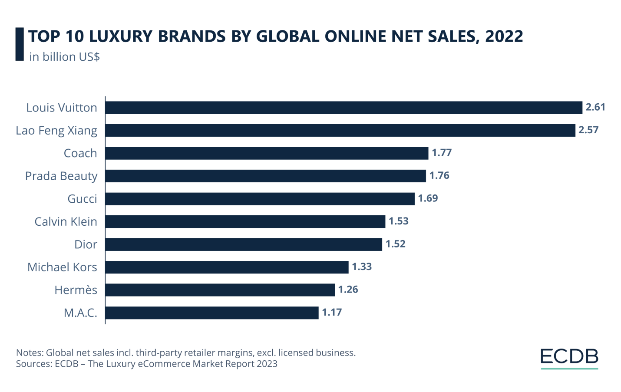
Figure 2 Louis Vuitton Luxury Brand in Global Sales Context
(Source: Ecommercedb, 2024)
The company's business strategy is to provide style and quality in a range of markets at the best price in an eco-friendly way (Stark, 2018). Sustainability is ingrained in the Louis Vuitton ethos as a core value. The unfavorable shift in sentiments towards Louis Vuitton after the co-branding received higher response values could suggest that the brand is not as enticing to consumers on its own. Partnerships with Louis Vuitton have been shown to have a negative effect on purchase intention since consumers are more likely to purchase goods straight from the fast fashion retailer (Eiras et al., 2019). There was less agreement regarding the intention to purchase luxury brands than there was around the willingness to purchase collaborative goods (Mrad et al., 2019). .
The stylish approach of Louis Vuitton combines classic workmanship with modern designs, reflecting the brand's rich history while also evolving and evolving to satisfy changing consumer demands for style (Liu, 2024). Louis Vuitton's distinctive style positions the luxury brand as a leader in the industry and represents the desire customers have for originality and taste. The meticulously thought-out marketing strategy that underpins Louis Vuitton's distinctive design style is just as essential to the brand's success as its distinctive aesthetic (Liu, 2024). With its distinctive design philosophy and fine manufacturing, Louis Vuitton has effectively established a brand identity that is hard to replicate in the fiercely competitive fashion industry. Additionally, the brand is eager to keep up with The Times' fashion shifts and continuously introduces new items that align with customer tastes in order to sustain the brand's ongoing profitability.
Luxury brands may create a distinct brand image, strengthen client relationships, and segment their consumer base with targeted marketing. Louis Vuitton has been doing well, such as using its environmental preservation strategy to reduce pollution in the natural world and leveraging the trend of brand collaboration and the web structure advancement to boost consumer desire to buy, the luxury sector can address some of the issues (Liu, 2024). Determining the areas of weakness for Louis Vuitton is beneficial to the brand. Louis Vuitton's performance and marketing strategy can serve as a model for other firms. The fashion industry's growth trend is examined, and it has some influence on different firms' marketing strategies as well as the luxury market's marketing standards. It also helps to comprehend the needs and attitudes of customers inside the luxury market.

2.3 The Impact of Consumer Satisfaction and Brand Image on Brand Loyalty in The Luxury Fashion Industry: A Case Study on Louis Vuitton

2.3.1 Consumer Satisfaction of Louis Vuitton Luxury Fashion Brand
The commercial success of Louis Vuitton is directly correlated with its accurate market segmentation. Known for its premium goods, Louis Vuitton has grown to emerge as one of the world's most popular companies in over 50 countries. The confidence of customers can be enhanced via brand inheritance. Throughout its 167-year history, Louis Vuitton has used a lengthy brand narrative to emotionally connect with customers and communicate its own story (Gan, 2022). Allow brand developers to utilize the exclusive technology of their family while doing so to produce superior modern goods.
Consumer satisfaction with the Louis Vuitton luxurious style brand is a vital component in its basic brand equity and commercial achievement. Louis Vuitton is well-known for its incredible workmanship, premium materials, and creative designs, which all contribute to high levels of purchaser pride (Makkar et al., 2018). The brand's willpower toward quality ensures that customers obtain objects that no longer meet, however frequently surpass, their expectations. In addition, Louis Vuitton's extraordinary customer support contributes considerably to expanded customer pleasure (Tams et al., 2021). The corporation affords individualized purchasing studies, committed help for customers, and particular services inclusive of bespoke gadgets and specific purchasing visits. These excessive-contact services assist in creating a deep emotional reference to customers, increasing their pride and loyalty.
Also, Louis Vuitton's continual delivery of luxury and exclusivity contributes to the brand's cost proposition. Customers advantage of a sense of grandeur and standing from having and using Louis Vuitton objects, which increases their normal happiness. The logo's capacity to hold its iconic function while usually innovating ensures that it suits the converting pastimes and demands of its affluent client base (Tams et al., 2021). In precis, patron happiness with Louis Vuitton is fuelled by the business enterprise's constant commitment to the best, super customer support, and the grandeur associated with its logo. This excessive diploma of pride no longer promotes logo loyalty but guarantees the employer's long-term achievement within the luxury fashion enterprise.
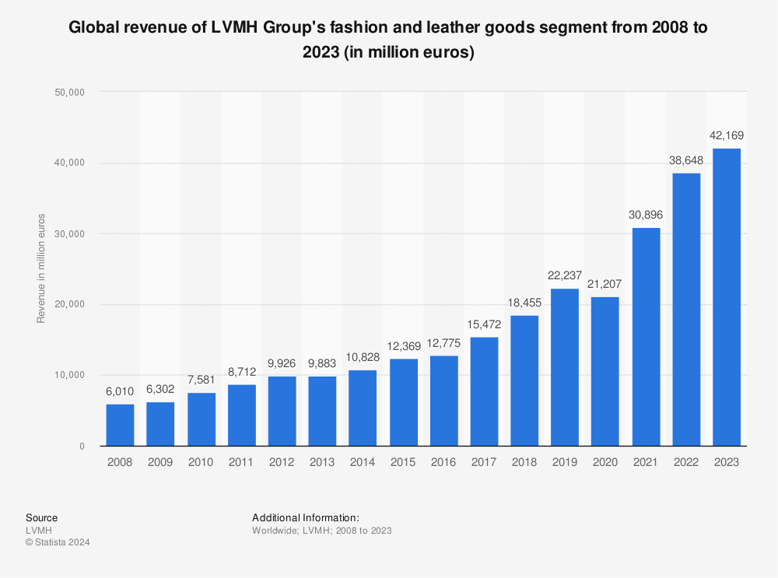
Figure 3 Louis Vuitton’s Growth Trend
(Source: Sabanoglu, 2024)
This study has concentrated on factors related to customer satisfaction. The researcher used a number of methodologies, such as sampling strategies, research instruments, study designs, procedures for gathering and processing data, statistical analysis of the data, and the validity of the pilot test, to determine how the brand image affected consumer happiness. The study's conclusions demonstrate that there is a relationship between traits that directly and indirectly impacted consumer satisfaction in the case of luxury brands (Satornsantikul and Nuangjamnong, 2022). Customer perceived value exerts a predominant considerable influence on customer satisfaction, while brand image makes a significantly substantial impact.
Louis Vuitton has consistently adhered to fashion trends and given careful consideration to the quality of its products. In the process of creating its brand emblem, Louis Vuitton effectively finished the process of creating customer identities (Siharath, 2021). The identity of the company symbol and psychological association with consumers serve as the foundation for the connection that the brand symbol builds with them. Because of its unwavering quality, Louis Vuitton is well-known among consumers and enjoys a high retention rate.
Personalized customer service is crucial when purchasing goods from high-end fashion labels. When designing a customer satisfying experience for premium apparel businesses and shops, personalization is crucial (Prusova, 2023). Technologies are a useful means of delivering a customized purchasing experience and increasing client happiness. Encourage a positive brand experience for customers at every touch point to improve customer happiness, perception of the brand, and revenue. Sales associates offer individualized customer service, geared to each customer, both in-store and online (Veg-Sala et al., 2024). Examples of this service include informing customers about events, exclusive sales, and new collections. Additionally, using brand storytelling to discuss a product and provide an experience with the brand is a good idea. Thus, while dealing with a luxury fashion company and making purchases from it, respondents generally view brand experience and customized experience for customers as highly important features.

2.3.2louis Vuitton Business and Brad Loyalty in The Fashion Industry
For Louis Vuitton, establishing a personal connection with its customers is crucial. Louis Vuitton has gained the affection and confidence of customers with its superb workmanship, personalized designs, and first-rate customer service. In addition, Louis Vuitton hosts several personalized parties and introduces loyalty schemes to improve communication and bond with customers (Liu, 2024). Through these interactions, customers can sense the affection and concern of the business in addition to gaining a greater understanding of its beliefs and way of life. The relationship and involvement between the two parties strengthen the customers' belief in brand loyalty and trust (Budiman, 2021). Louis Vuitton excels in precisely identifying its target audience and positioning itself in the market. These tactics help Louis Vuitton stick apart in the upscale premium industry and gain the trust of a large number of customers.
Prior to exploring the company's store design and management analysis, let's have a look at Louis Vuitton's business plan. Worldwide product creation, production, distribution, and marketing are all done by Louis Vuitton. According to Arrigo (2018), the cornerstones of the Louis Vuitton business strategy include in-house design, the lack of middlemen, large purchase quantities, sourcing the right products from the right markets, efficient logistics, and cost consciousness across the board. An international team of buyers, designers, pattern makers, and people of all ages work together at Louis Vuitton's Stockholm headquarters to create fashion collections that prioritize the highest quality and the most recent trends in the industry. The company works hard to ensure that everything it sells to customers is produced under favorable conditions and with the least amount of detrimental influence on the environment (Hvass, 2022)..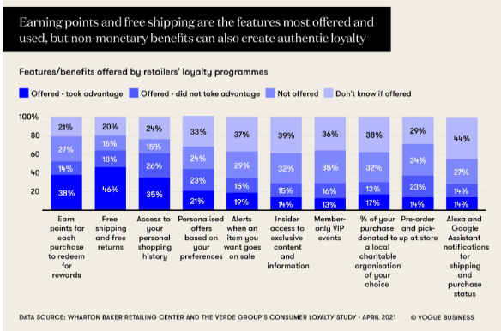
Figure 4 Louis Vuitton Business and Brad Loyalty in the Fashion Industry
(Source: Chitrakorn, 2021)
Louis Vuitton separates their clientele based on factors including gender, age, and disposable wealth. The company focuses on women who make over $75,000 annually and are around the generations of 18 and 54, indicating that they are blessed with a significant amount of income (Wang, 2024). Louis Vuitton incorporates psychographic divisions like rationale and lifestyle to more effectively define their target market. According to their consumption patterns, Louis Vuitton categorizes its clients, with frequent users receiving preferential treatment. Buyer data is recorded at the point of sale and kept in an information system. Customers with significant usage are invited to purchase exclusive lines of goods and receive seasonal catalogues in to promote recurring reputation and loyalty to the brand (Fanandaru et al., 2023). Moreover, psychological division based on lifestyle and motivations is used by Louis Vuitton.
Louis Vuitton has created a sustainable supply chain by producing eco-materials, providing safety training, supervising sustainable production, reducing carbon emissions, and marketing eco-fashion (Pal et al., 2018). Louis Vuitton relies on outsourcing and other vendors (Lanzolla et al., 2021). At every stage of the supply chain, cost-consciousness and effective flows safeguard the correct items in the right quantity for every shop. Louis Vuitton considers customer satisfaction to be a crucial factor and works hard to give its customers the best possible shopping experience because it is mostly dictated by the store. The corporation wants to open ten to fifteen percent additional locations a year.

2.3.3 Business Promotion of Louis Vuitton Fashion Company
Many people appreciate the brand Louis Vuitton for its distinctive designs and excellent workmanship. The brand's distinct originality and personality are embodied in all of its items, ranging from designer clothes to purses and accessories. To draw customers in, Louis Vuitton has expanded its product offerings and developed its signature styles (Siharath, 2021). Examples of these legendary styles are the LV, diamond, quadrilateral, and coauthor logos, which all stand for the brand's distinctive design philosophy. Louis Vuitton can satisfy the various needs of various customers thanks to its wide product line approach. Young folks who are interested in fashion or older customers who value quality can both find something that they like at Louis Vuitton.
In order to generate profits for stockholders while protecting people and the environment, the Louis Vuitton Company claims to engage in sustainable business practices. Ecological and social practices are the two components that make up the Louis Vuitton sustainability program (Javed et al., 2020). According to Pastore et al. (2022), Louis Vuitton's environmental supply chain structure is comprised of environmentally conscious customers, eco-sustainable distribution, eco-manufacturing, eco-retailing, and eco-material preparation. Furthermore, Louis Vuitton's eco-friendly claims have been divided into eight distinct message components based on the production chain: fair labor practices, improved fire and building safety, ethically sourced materials, water conservation, clothing recycling, the environment-positive value chain, fair salary increases, and decent working conditions.

2.3.4 Social Media-Based Brand Loyalty Promotion for Louis Vuitton
Customers are now considered to be an enterprise's most critical strategic resource due to developments in the competitive landscape. Customer service is intricate and invisible, and a variety of political, financial, and social contexts can have an impact on how satisfied customers are. Thus, it is imperative that fashion brand ensure customer satisfaction.
The social media account for Louis Vuitton. Louis Vuitton was the brand used as a reference in this study. The first finding indicates that the company's image variable was significantly positively impacted by e-WOM. The second finding is that the brand loyalty variable was considerably and favourably impacted by e-WOM. The final finding indicates that the brand reputation variable was significantly improved by the community on the internet. The fourth finding indicates that the brand loyalty variable was highly and favourably impacted by the online community (Xiao, 2023). Since Louis Vuitton's goods are high-end and can draw large audiences in the fashion industry, producing viral content might encourage users to share it. To boost the current level of participation, more of the materials that the general public finds most engaging must be added.
The impact of social media-based digital brand interactions on customers' perceptions of luxury fashion brands' authenticity, connection, and loyalty was examined by Lin and Ku (2023). A poll was completed by 112 Instagram followers of premium companies in order to collect data for this quantitative assessment. The given models were tested and estimated practically using the PLS-SEM. The results of the study showed that audiences' positive opinions of a brand's connection, loyalty, and authenticity are impacted by their online brand encounters. Brand connection and credibility were found to have acted as a partial mediating factor between digital brand interactions and brand loyalty.

2.4 Empirical Review
Empirical studies on Louis Vuitton demonstrate the importance of logo image on patron buy intentions. According to analysis, a robust emblem image benefits perceived value and purchase motive, especially in the luxury industry (Wiradharma, 2021). Louis Vuitton's substantial logo equity stems from its steady supply of excellence and exclusivity, which will increase purchaser happiness and loyalty (Tams et al., 2021). However, brand collaborations were shown to have a detrimental impact on customer perceptions, implying that partnerships may erode the brand's premium reputation (Eiras et al., 2019).
Consumer pride in Louis Vuitton is directly associated with its excessive quality, customer support, and potential to innovate while retaining a conventional design (Gan, 2022). Customer loyalty is strengthened in addition to the emblem's brilliant market segmentation and individualized service (Prusova, 2023). Furthermore, Louis Vuitton's emphasis on sustainability and moral requirements is constant with expanded customer demand for environmentally friendly merchandise (Pal et al., 2018). Social media is essential for improving logo image and loyalty, with suitable digital phrase-of-mouth (e-WOM) having a first-rate impact on agency recognition and consumer engagement (Xiao, 2023). In general, Louis Vuitton's empirical information emphasizes the significance of upholding a sturdy brand image and responding to client expectations within the luxury sector.
Yu and Shi (2013) focused primarily on the core customer segment in their comparison of case company customer satisfaction differences between Sweden and China. The present thesis employs a collection of primary data derived from questionnaire responses, with certain sources drawn from the literature study and the financial statement of the case firm. The instance firm is H&M firm, a well-known fashion brand in Sweden. China represents one of the most promising areas for the brand's expansion, while Sweden has an established customer base for it. The three main distinctions between these two marketplaces are acceptability of design, pricing, and service. The primary disparities between Sweden and China are the PESTs and the limited selection of products available to Chinese consumers also has an impact on their level of happiness.
Numerous online venues for luxury consumption emerged as a result of the trend towards digitalization and shifting consumer tastes. Numerous platforms in the Chinese industry integrate e-commerce with customer service. The Dewu app, one of these platforms, was first introduced to cater to consumers who were looking for fashionable, high-end trainers and was extremely popular in China's 90s generation. Another study by Chen et al., (2021), which has a lot of promise for the online luxury fashion market primarily, concentrated on raising platform consumer satisfaction levels for luxury fashion online retailing. A wide choice of products is appealing, but services like maintenance live streaming, and virtual purchasing are of low quality and superfluous. Which services are significantly associated with, and which are less related is indicated by the findings. Luxury companies serve a market that expects superior products, and it is common knowledge that these firms constantly work to improve the quality of their offerings. Luxury brands are renowned for offering customized services to its clientele. They go beyond what is necessary to satisfy customers after they have been gained.
In the context of international tourism, Abdul Haseeb Tahir et al. (2024) investigated the effect of brand image on consumer satisfaction and brand loyalty. For this investigation, 13,302 articles were located after a survey of pertinent literature. Considering the needed inclusion and the quality of research, we applied the rigorous PRISMA approach for complete data synthesising and assessed 79 publications for the final evaluation. The results highlight how important brand image is in determining consumer pleasure and building brand loyalty in the international travel industry. The study's use of self-congruity theory enhances the body of literature. Furthermore, the proposed link is highly influenced by major characteristics such as product quality, price, and promotion.
Satornsantikul and Nuangjamnong (2022) evaluated the influence of brand image on customer satisfaction: a case investigation involving luxury companies in Thailand. To ascertain how the brand image affected consumer happiness, the researcher employed several techniques, including sampling plans, tools for research, methodology, techniques for collecting and processing data, statistical analysis of the information, and the reliability of the pilot test. This study offers relevant variables that affect a customer's happiness with luxury products who is now residing in Thailand. The overview of the study is based on an evaluation of the relationships impacting customer satisfaction factors by this analysis. This study's linked elements include customer happiness, value perception, brand loyalty, service quality, spokespersons, and brand image.
Gallart-Camahort et al., (2021) intended to determine how involvement relates to the development of value for premium brands. The research results suggest that luxury businesses have to focus particularly on raising awareness within their target market, as it is this group that will have a greater potential for brand loyalty. As the current study makes evident, luxury businesses need to be mindful of how they come across to prospective customers. This is because a favourable brand image has a beneficial impact on customer engagement and loyalty, two factors that are crucial for achieving strong brand performance. Therefore, it can be seen that given the global nature of the luxury market, it might be intriguing to know more about the respondents' country and place of residence in future research.

2.5 Theoretical Framework
Brand Equity Theory
Significant developments in the realm of brands have been brought about by the concept of brand equity. The two dimensions of the model are awareness of the brand and the perception of the brand. Because brand awareness is correlated with consumers' capacity to remember or identify a brand, it will improve the capacity of customers to recognize a specific brand in a variety of contexts (Fetais et al., 2023). Therefore, the possibility that consumers would quickly recall and identify a brand is tied to brand consciousness. Customers' mental associations with a brand are reflected in its public perception.
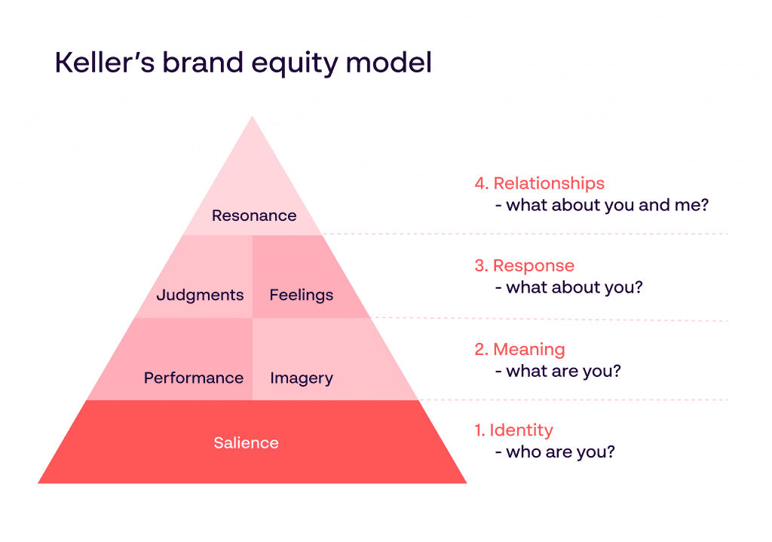
Figure 5 Brand Equity Theory
(Source: Papirfly, 2024)
The Louis Vuitton Company's brand image has been taken into consideration as having an impact on consumer happiness and brand loyalty. This research has integrated the Brand Equity Theory, which suggests that luxury fashion brands have dictated brand awareness. Through the use of theory, the Louis Vuitton Company has attempted to demonstrate the effective brand engagement of the consumer's impression of the brand and their buying intention.
Brand Equity Theory, considerably Keller's Brand Equity Model, gives a solid framework for reading the link between customer satisfaction, brand image, and brand loyalty in the luxury fashion business. Keller's method proposes that brand fairness is based on customer perceptions and the value they location on a brand according to their interplay with it and relationships. According to Keller, brand equity is heavily impacted with the aid of two crucial additives: brand focus and brand image. Brand cognizance is the diploma to which clients take into account or do not forget a logo, whereas a brand image includes the connotations and traits that customer’s partner with the brand (Raut et al., 2019). In the placing of luxury fashion, such as with Louis Vuitton, a brand image is important since it incorporates the logo's prestige, best, and exclusiveness, all of which influence customer views. Keller's version additionally shows that these logo perceptions affect brand reactions and, ultimately, brand loyalty.
In the instance of Louis Vuitton, the brand's rich legacy and comfort positioning are key in setting up purchaser views. The excessive diploma of purchaser satisfaction with the logo's services and products strengthens the brand's image as a brand of luxury and excellence (Stukalina et al., 2021). As a result, clients expand an experience of devotion to the brand and are more inclined to promote it on their social networks. Keller's Brand Equity Model emphasizes the significance of retaining a wonderful brand picture and high levels of customer satisfaction to be able to expand and preserve logo loyalty (Stukalina et al., 2021). To maintain its iconic brand image and ensure sustained client loyalty, Louis Vuitton should provide tremendous experiences on a regular foundation.

2.6 Hypothesis
Null Hypothesis (H0)
“There is no apparent association between brand loyalty and consumer satisfaction or brand image in the Louis Vuitton luxury fashion sector.”
Alternative Hypothesis (H1)
“There is a significant association between brand loyalty and consumer satisfaction or brand image in the Louis Vuitton luxury fashion sector.”
The research has supported the alternative theory, which indicates that customer happiness and brand image have a major impact on brand loyalty in the Louis Vuitton luxury fashion market. Effective research demonstrates the various elements involved in brand image and loyalty, such as consumer satisfaction and brand promotion. Thus, this section's analysis of Louis Vuitton's marketing strategy and customer feedback has been effective. It also involves the influence of social media-based brand loyalty and other significant aspects related to the growth of the Louis Vuitton Corporation and the impact of brand image.

2.7 Conceptual Framework
In the example of the luxury fashion company Louis Vuitton, the current research has attempted to evaluate the conceptual framework as the development of customer happiness and the brand image affect an effect on brand loyalty. The study aims to illustrate the aspects that influenced consumer pleasure and brand image for the luxury fashion company Louis Vuitton's concern in brand loyalty. The primary determinants of Louis Vuitton's consumer satisfaction are its emotional ties with customers and its excellent modern goods manufacturing; in turn, this influences the brand image through offerings of style, quality, and sustainability. These things are the primary driving forces behind the premium fashion industry of Louis Vuitton.
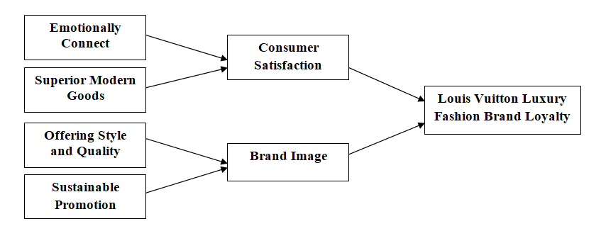
Figure 6 Conceptual Framework of Louis Vuitton Luxury Fashion Brand Loyalty
Source: Created By Author

2.9 Summary
Louis Vuitton's high desire to buy luxury products is largely due to its strong brand image, which positively impacts consumers' intentions to make purchases. The company's business concept is anchored in sustainability, offering style and quality at the best price in various markets. Luxury brands are built around a strong brand image, which can convey a lot of information to customers. Louis Vuitton's culture is firmly anchored in sustainability as a fundamental principle. The study focuses on aspects related to consumer satisfaction, focusing on customer perceived value and brand image. Louis Vuitton has consistently adhered to fashion trends and given careful consideration to the quality of its products. The company employs a design team of designers, pattern makers, buyers, and people of various ages and nationalities to develop fashion collections that emphasize high quality, the latest trends in fashion, and affordable prices. Louis Vuitton's sustainability program includes ecological and social practices, with an environmental supply chain structure that includes eco-material preparation, eco-manufacturing, eco-sustainable distribution, eco-retailing, and environmentally concerned customers.

Chapter 3: Methodology

3.1 Introduction
This research uses a pragmatic research approach to establish the relationship between consumer satisfaction and brand image in creating brand loyalty in the luxury fashion industry with LV as the area of interest. The work is based on the structured survey as the main data collection tool that serves as the main focus of the methodology. This survey is structured to collect data from a large number of consumers who have encountered the LV brand in some ways, hence giving a complete picture of the consumers’ awareness and engagement with the brand. The quantitative approach used in this research makes it easier to analyse the data collected to show the relationships between consumer satisfaction, towards the brand image and brand loyalty. This approach affords the research a sound framework within which to test the research hypothesis and make factual conclusions thereby increasing the reliability and validity of the findings to the research questions and objectives.

3.2 Research Onion
The research approach used is based on Saunders’ Research Onion and it comprises of positivism philosophy that focuses on reality in the empirical context and measurable results. This means that the study follows a deductive research framework whereby first hypotheses are formulated from theories and then compared with the real data. The research approach used in the study is quantitative in that the data collected for the analysis comprises the numbers. To be specific, the method of data collection is a survey that has to involve consumers of the Louis Vuitton brand. This is by going directly to the respondents to gather data, which is most appropriate to the research questions (Saunders, and Lewis, 2017). Participants are selected using the random sampling techniques which improves the generality of the results obtained at the end. Time horizon used in the study is cross-sectional whereby data is collected at any one point in time. Finally, a descriptive strategy is used to give a structured account of the patterns that are identified in consumers’ satisfaction, their perception of brands, and their tendency to remain loyal.
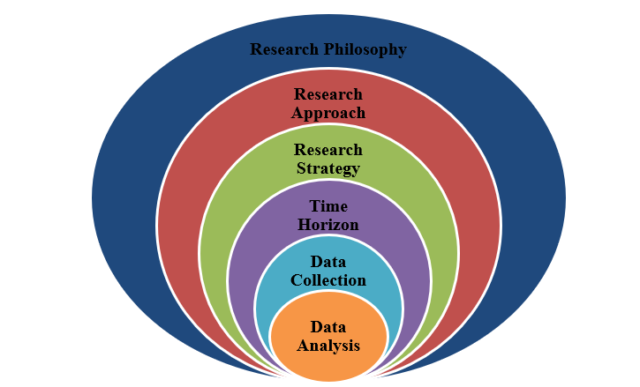
Figure 7 Research Onion
(Source: Saunders, and Lewis, 2017)

3.3 Research Philosophy
Accordingly, the use of the positivism research philosophy is crucial to this research because aspect of consumer behavior falls within the realm of facts. Positivism, from epistemological perspective holds that knowledge is obtained by the experience of phenomena. In this regard, survey data is used to examine the correlation between consumer satisfaction, brand image and brand loyalty in the context of luxury fashion brand. It also helps to have numerical data, which has been analyzed statistically to make us avoid subjective findings (Park, Konge, and Artino 2020). Epistemologically, positivism holds the view that reality exists on its own and is not a creation of someone’s perception. Here, the research assumes that consumers’ behaviours and attitudes toward Louis Vuitton brand image and loyalty are facts that are measurable and can be generalized over a wider population of consumers. Following this philosophy, the study would like to provide valid and accurate results of the extent and type of interaction between the brand and the consumers that is not skewed by the bias of the researcher or any other interferences.

3.4 Research Approach
In pursuing the research objectives, this study uses a deductive research approach based on existing theory on consumer satisfaction, brand image and brand loyalty. From these theories, particular hypotheses are derived in order to examine how these factors are operationalized within the domain of the Louis Vuitton luxury fashion brand. The deductive approach has the structure in which conclusions are derived from general assumptions to specific observations. The hypotheses are formulated from extant literature and are then examined by conducting surveys where the data collected is in a quantitative nature (Reyes, 2004). In this way, the research will support or deny the hypotheses and help extend the systematic knowledge of consumers’ behavior in the field of luxury fashion industry. This approach makes sure that the study is theoretical in nature, expectations are set prior to data collection and the results thereafter are factual and make or break the theoretical propositions.

3.5 Research Design
The research design used in the study is descriptive in nature in a bid to systematically uncover and provide an account of the linkage between the satisfaction, brand image and brand loyalty as viewed within the LV brand context. As such, this design is well fitted in any research that aims at offering a rich and accurate description of a population or phenomenon. In this research, the descriptive approach refers to the identification of the current consumer perceptions and behavior towards the use of Louis Vuitton brand wherein some variables are not controlled and influenced to determine causality (Siedlecki, 2020). As a result of using surveys as the main approach of gathering data in the study, it is possible to identify a number of consumers and the way they perceive and engage with the brand. The descriptive design helps the research to identify characteristics and trends in the context of the data such as the levels of satisfaction and loyalty and get an idea of the nature of current consumer-brand interactions in the luxury fashion industry.

3.6 Data Collection and Analysis
The quantitative research is used in this research to assess the correlation that exists between consumer satisfaction, brand image, and brand loyalty concentrating on Louis Vuitton. Quantitative method will enable the study to use numbers of data to analyse, compare with other numbers of data hence providing numerical patterns, correlation and numerical trends with regard to the research questions. The quantitative research approach makes it possible to develop hypotheses, from existing theory and test these hypotheses thus presenting a clear and measurable view of how these factors combine (Mertens, Pugliese, and Recker, 2017).
This research is focused on evaluating the impact of consumer satisfaction and brand image on brand loyalty in the Louis Vuitton luxury fashion industry. It is vital to obtain responses from the customers to address the research problem. Therefore, to collect data from a large number of participants the survey method has been adopted in this study. When characterising the features of a sizable population, surveys are helpful. This wide range of capabilities, which guarantees a sample with greater precision to obtain focused data from which to draw judgements and make crucial decisions, is not possible with any other research methodology (Groves et al., 2011). The study also focuses on understanding the current consumer opinion on the brand image of the luxury fashion brand Louis Vuitton. To achieve that a range of survey questions has been established that can serve this purpose. The customers can provide their opinion which can be analysed using statistical methods.
Survey questionnaires are used as source of primary data, and they are in the form of structured questionnaires which are used to obtain relevant information from Louis Vuitton consumers. The survey is developed with closed structured questions thus allowing for the acquisition of standard, measurable information from a large population. This method is preferred as it offers fresh and relevant information as maneuvered towards the research goals hence the analysis is based on the current consumer insights. Through the combination of quantitative analysis with survey based primary data collected the research proposes meaningful and statistically tested results thereby giving a more powerful and data supported view on consumer satisfaction, brand image and loyalty in the context of Louis Vuitton.

3.7 Time Horizon
The study follows a time series cross-sectional research design in the sense that the data are collected at a specific point in time. This approach is particularly helpful in research that is more or less of a cross-sectional type, which seeks to take a ‘freeze-frame’ view of some phenomenon—the relations between consumer satisfaction, brand image, and brand loyalty in the Louis Vuitton brand in this case. As the data was collected by surveys from respondents at a single point in time, the study indicates a current state of affairs regarding consumers’ perception and behaviour. This time horizon is most economical and practical as the research is able to depict and study the state of the market at the moment without the complications of studying transitions. There is also the cross-sectional approach that involves making observations at a specific time; this strategy is very useful in determining the relationship between various variables, and this makes it appropriate for the objective of this study to assess the consumer perception, and the level of brand loyalty in the luxury fashion sector at the time of the study.

3.8 Sampling Technique
The study adopts the random sampling technique in order to determine the participants that will complete the survey since each member of the target population of the research has equal likelihood of being chosen. This method is very important when attempting to obtain a large sample size, which in turn makes the study results generalize the findings to the Louis Vuitton population. The study reduces selection bias by limiting the methods of sampling to random sampling, thus increasing the chances of identifying the many faces of the consumers that come across the Louis Vuitton brand (Noor, Tajik, and Golzar, 2022). This is especially the case in quantitative research since the statistical conclusions derived are valid given that the sample derived is representative of the population. The involvement of the participants does not rely on any demographic or behavioral characteristics, which makes the random selection advantageous when generalising consumer satisfaction, brand image and brand loyalty. Therefore, it can be expected that the conclusions that were made in the process of this research will be valid and pertinent to any segment of the luxury fashion brand’s consumer base.

3.9 Reliability and Validity
Reliability is the measure of the stability of the instruments employed in the study. On the same note, efforts have been made to minimise the likelihood of obtaining inconsistent responses from different respondents, for instance, by the use of clear and unambiguous questions as well as adopting a structured survey instrument. The survey item is first given to a pilot sample in order to determine any potential sources of error and thus increase the measures of reliability. Criterion related validity refers to collection tool’s ability to adequately measure what it was intended to measure (Albers, 2017). To maintain content validity the survey is developed with the support of literature review and consultation with the experts, and it focuses on the research objectives of measuring the consumer satisfaction, image of the brand, and brand loyalty. This is achieved in several ways: Another form of validity that is considered in the current work is construct validity that refers to the extent that the survey questions capture the theoretical constructs postulated by theoretical and or measurement models. Criterion-related validity is tested by comparing the survey results to other studies existent in the formal body of knowledge to ensure that the results reflect prior knowledge.

3.10 Ethical Consideration
The ethical implication should be taken into consideration in this research. The study ensures that informed consent is availed to participants, which means the subjects are well informed on why the study is being conducted and what is expected of them when agreeing to participate in the study and their information will be kept confidential. Confidentiality is observed where personal details are excluded or not revealed in the survey for the respondents’ sake. It is organized on a voluntary basis with the ability of members/voters to opt out freely without any consequences (Cacciattolo, 2015). In a way, the research follows the essential ethic plan not using any force or pressure on the participants or the target group. Also, measures of ensuring the protection of the collected data it kept safe from access or misuse by unauthorized people. Through consideration of these ethical issues, the study conducts research in a manner that can best be described as ethical thus protecting rights of all the participants.

3.11 Limitations
However, this research has the following limitations, despite the strong methodology that has been adopted in the study. First, cross-sectional time horizon approach restrains from capturing dynamic changes in the consumer satisfaction, brand image and loyalty over time thus cannot explain transitional or long-term outcomes. Second, although randomness increases sample representativeness, the sample could be different from the entire population of LV’s consumers worldwide; this could lead to biases. Moreover, using surveys results that are based on people’s responses there exists response bias where participants may not be genuine in the way they live or the things they think especially taking into consideration the luxury context. On this account, the that the study is quantitative oriented can be also understood as its weakness: some more subtle processes or perceptions can be reconstructed and identified only with help of qualitative methods, for instance, interviews. Finally, there is a limitation arising from the focus on Louis Vuitton; therefore, findings may not be generalizable to other luxury fashion brands.

3.12 Summary
The chapter on methodology is as follows: It discusses a quantitative research paradigm to analyse consumer satisfaction, brand image, and brand loyalty of Louis Vuitton. Following a positivist epistemology, the research adopts a hypothesis driven deductive research strategy developed from existing theories. The data is collected by conducting a structured survey which will be conducted on a sample of the LV consumers to make the sample more representative. The cross-sectional time horizon reinforces the views that are current with the consumers. Descriptive research design is used to aim survey where chronological order is followed to describe patterns and relationships existing within the data collected. It also gives the analysis and explanation about factors related with the brand loyalty and client satisfaction.

Chapter 4: Data Analysis

4.1 Introduction
This chapter includes the result of the survey conducted in this study focused on the impact of consumer satisfaction and brand image on brand loyalty in the Louis Vuitton luxury fashion industry. The responses of the survey participants are presented in this chapter in the form of a chart to interpret the data. The information can be visualised, and the result can be used to address the objectives of this study. The key insights obtained from the survey can also be useful for answering the research questions. The following section presents the results of the survey.

4.2 Socio-Demographic Question Result
1. What is your age?
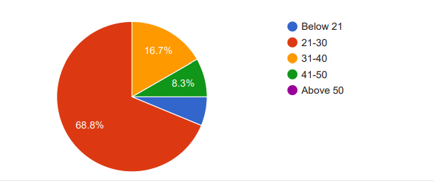
Figure 8 Age
(Source: Created byAuthor)
The bulk of responders (68.8%) are between a while of 21 and 30. The 31-forty age group is available in second at 16.7%, followed by the aged 41-50 and beneath 21, who account for 8.3 percent and 6.3 percentage, respectively. This skew closer to more youthful respondents shows a large part of the early-career or center-career population, which can also affect overall replies by reflecting the knowledge and selections of a younger generation.
2. What is your gender?
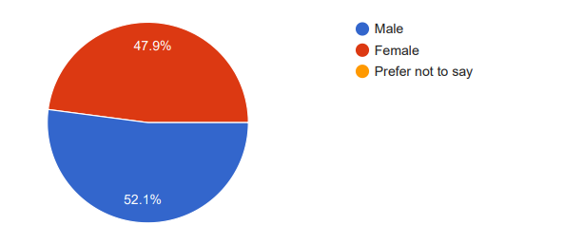
Figure 9 Gender
(Source: Created by Author)
The pie chart shows a fairly same gender distribution among participants, with adult males barely surpassing girls (52.1% to 47.9%). This tight ratio indicates almost the same representation of both genders. The facts show a diversified player pool, lowering the possibility of gender bias in replies and doubtlessly leading to greater balanced viewpoints at the survey's difficulty.
3. What is your highest level of education?
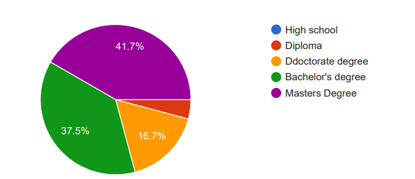
Figure 10 Highest Level of Education
(Source: Created by Author)
The pie chart illustrates that the majority of respondents (41.7%) had a Master's diploma. Bachelor's holders make up 37.5%, then come those with Doctorates (16.7%), at the same time as most effective 4.2% have a Diploma. This suggests an incredibly educated populace, with the majority of people having finished a degree or post-graduate courses, suggesting engagement in specialized or professional sectors.

4.3 Review Questions Result
4. How often do you purchase luxury brands like Louis Vuitton?
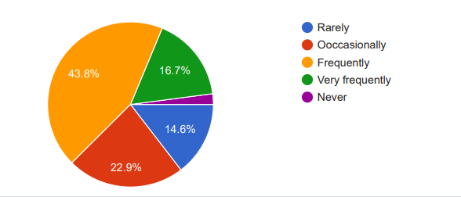
Figure 11 How often do you purchase luxury brands like Louis Vuitton?
(Source: Created by Author)
Out of 49 respondents, 42.8 per cent purchase top-fee items at the side of Louis Vuitton on an regular foundation, at the same time as 22.9 per cent do so satisfactory on occasion. This indicates that a significant share of respondents has a chronic practice of buying immoderate-give-up luxurious matters, implying a sturdy affinity for pinnacle-charge manufacturers. The data indicates the importance of Louis Vuitton in their buying options, reflecting a committed purchaser base that appreciates luxury gadgets in their lives.
5. Do you agree that your general happiness with Louis Vuitton items is high?
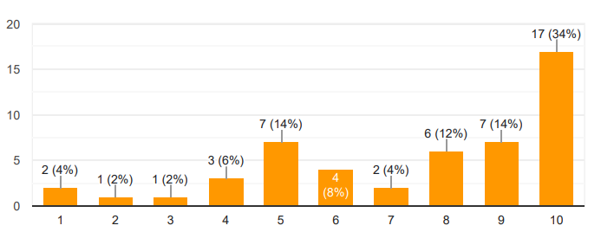
Figure 12 Do you agree that your general happiness with Louis Vuitton items is high?
(Source: Created by Author)
With an average rating of 7.46 out of 10 from 49 respondents, the check well-known shows a usually right attitude toward Louis Vuitton gadgets. This range suggests that the majority of customers are glad with their purchases. And also there is space for improvement. The high percentage indicates that Louis Vuitton continues a recognition for purchaser happiness and first-class, making it suitable to customers who are attempting to find luxury inside the shape of products and offerings.
6. Do you agree that Louis Vuitton satisfies your demands when it comes to product quality?
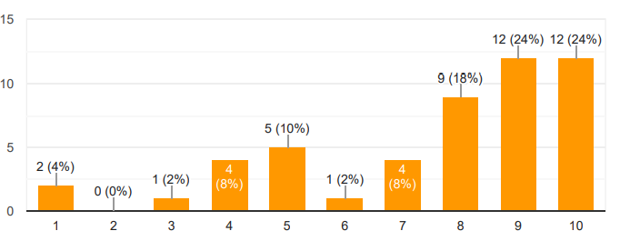
Figure 13 Do you agree that Louis Vuitton satisfies your demands when it comes to product quality?
(Source: Created by Author)
The majority assume that Louis Vuitton satisfies their product's first-rate expectancies, with 49 respondents giving it a mean grade of 7.60 out of 10. This score demonstrates a sturdy experience of exceptional quality in Louis Vuitton's goods, which is essential for consumer happiness. The excessive score indicates that the emblem's steady transport of luxury and workmanship is valued with the aid of its clients, reinforcing its popularity as an excessive-stop luxury label.

7. Do you agree that your happiness with Louis Vuitton's excellent client service promotes your brand loyalty?
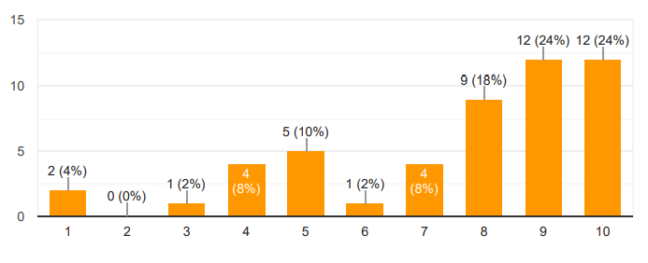
Figure 14 Do you agree that your happiness with Louis Vuitton's excellent client service promotes your brand loyalty?
(Source: Created by Author)
The look-at effects display a mean grade of 7.61 based totally on a total of 10 from 49 respondents, showing that most customers are happy with Louis Vuitton's customer support, which will increase logo loyalty. Superb provider for customers is certainly a critical aspect in fostering loyalty among luxurious shoppers who assume high-give-up reports. This rating shows that the logo's emphasis on consumer care is effective in fostering connections and repeat business over a lengthy period of time.

8. Do you agree that Louis Vuitton's pricing represents the quality of its goods, which adds to your satisfaction?
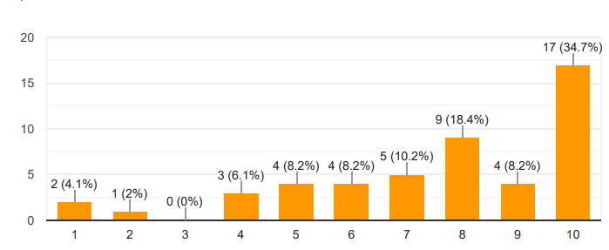
Figure 15 Do you agree that Louis Vuitton's pricing represents the quality of its goods, which adds to your satisfaction?
(Source: Created by Author)
Although luxury charges are often exorbitant, people appear to agree with that the logo affords items which might be worth the expenditure. With an average rating of 7.63 out of 10, respondents consider Louis Vuitton's price is justified by the exceptional of its merchandise, which provides to their delight. This notion is vital to maintaining Louis Vuitton's popularity as a luxury brand, as well as purchaser agrees with and loyalty. Louis Vuitton is a luxury brand that provides top-notch products in the industry. The upper-middle class and wealthy individuals are the target market for the marketing approach, which guarantees a premium pricing structure for its products since they do not need any concerns regarding product costs. The brand has found success with this price strategy since the brand items are highly valued (Xu et al., 2021).

9. Do you agree that Louis Vuitton's durability and longevity of products contribute to your overall satisfaction?
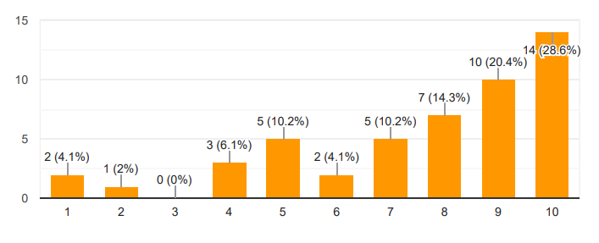
Figure 16 Do you agree that Louis Vuitton's durability and longevity of products contribute to your overall satisfaction?
(Source: Created by Author)
The survey shows an excessive average score of 7.65 out of 10, indicating that clients firmly agree that the sturdiness and lifespan of Louis Vuitton gadgets grow their delight. Longevity is critical attention in luxurious items since consumers anticipate their prices to remain. This score shows that the employer efficaciously satisfies expectancies in this location, assisting its popularity as a writer of traditional, well-crafted matters. The longevity of luxury companies' products sets them apart from ordinary category offerings. A dependable and durable reputation is one aspect of the value proposition which supports a larger initial investment. To evaluate a product's robustness and durability, all of its life cycles must be taken into account (Vanacker et al., 2022). Because LV's products are strong and long-lasting, the company can draw in new customers and foster brand loyalty.
10. Do you agree that the exclusivity of Louis Vuitton products enhances your satisfaction with the brand?
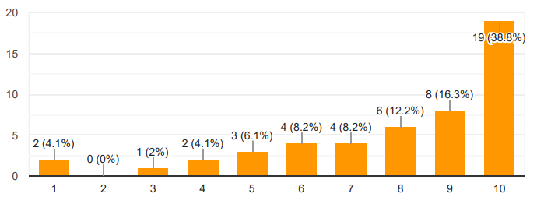
Figure 17 Do you agree that the exclusivity of Louis Vuitton products enhances your satisfaction with the brand?
(Source: Created by Author)
The highest common rating of 7.96 out of 10 suggests that respondents strongly accept as true that the individuality of Louis Vuitton items provides to their leisure. Luxury manufacturers depend in large part on exclusivity to maintain their reputation, so this rating suggests that Louis Vuitton's restricted delivery and outstanding repute make a contribution to their desirability. Customers trust that possessing something special increases the price and man or woman's happiness with their purchases. Louis Vuitton items are available only at Louis Vuitton Stores, which are operated and managed by Louis Vuitton, and across Louis Vuitton's authorised online website. Every item they produce, including purses and accessories, has a backstory. Demand for scarcity is triggered by exclusivity. An account of superior craftsmanship, distinctive materials, and an item which is special for a consumer. Every aspect of its ideas, from the use of premium components to the skilful blending of history and modernity, demonstrates an unwavering commitment to luxury (Robson, 2024). This all-encompassing strategy guarantees that each item not only displays the iconic LV emblem but also gives off a distinctly opulent vibe. These factors help the company to maintain their exclusivity among the customers.
11. Do you agree that your general happiness with Louis Vuitton items is high?
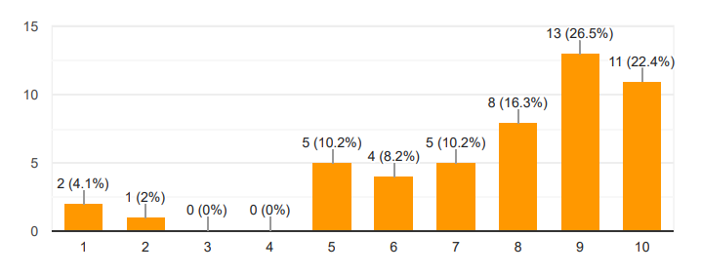
Figure 18 Do you agree that your general happiness with Louis Vuitton items is high?
(Source: Created by Author)
The standard assessment of 7.73 out of 10 suggests that the majority of contributors are glad with their Louis Vuitton purchases. This high rating reflects a positive usual experience whilst the use of the logo's merchandise. The mix of fine, confidentiality, and customer support is probable to feature to this great amount of pride, helping Louis Vuitton's reputation as a top-tier luxurious emblem that constantly meets or surpasses client expectations. The luxury market has expanded rapidly, providing several businesses with the opportunity to penetrate and prosper in this sector while expanding their consumer base. The luxury market is growing more competitive and sophisticated as it gets simpler to acquire and more widely distributed. To distinguish themselves and satisfy the discerning tastes of affluent consumers, luxury businesses need to concentrate on delivering outstanding customer service (Simply Contact, 2024). The foundation of luxury brands is the assurance of exceptional customer service and exclusivity.
12. Do you agree that Louis Vuitton satisfies your demands when it comes to product quality?
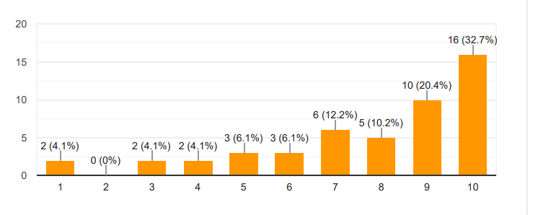
Figure 19 Do you agree that Louis Vuitton satisfies your demands when it comes to product quality?
(Source: Created by Author)
The respondents furnished a mean rating of 7.78 out of 10, indicating an excessive degree of pride in the satisfactory Louis Vuitton gadgets. This score shows that buyers believe the enterprise gives you its promise of beauty and artistry. Maintaining a tremendous product is critical for customer retention, and Louis Vuitton's potential to collect those expectancies contributes to the enterprise's reputation as a reliable and respected high-priced brand. Globally recognised for its exquisite and unparalleled genuine quality, Louis Vuitton is appreciated for the vast range of products it offers. Genuine Louis Vuitton goods are expertly crafted by competent craftsmen who take great satisfaction in creating flawless pieces using only the best materials. The brand's expert workers employ unique methods, which include employing manual sewing machines for certain aspects of the manufacturing process, boosting reliability, durability, precision, and longevity, consequently assuring perfection in their handcrafted bags and other products (Stadager, 2024).
13. Do you agree that your happiness with Louis Vuitton's excellent client service promotes your brand loyalty?
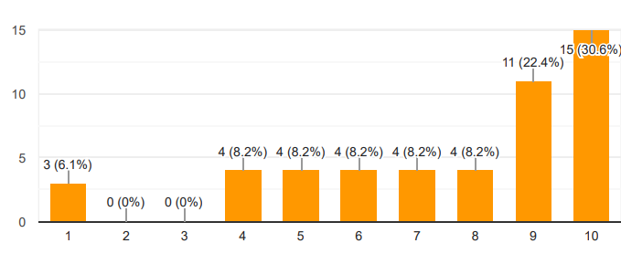
Figure 20 Do you agree that your happiness with Louis Vuitton's excellent client service promotes your brand loyalty?
(Source: Created by Author)
With a widespread score of 7.59 out of 10, respondents agree that Louis Vuitton's high-quality customer service boosts brand loyalty. Providing a top class provider is crucial in the luxurious industry, and this score illustrates that Louis Vuitton's consumer care meets consumer expectations whilst selling loyalty. This importance of pleasure within the service loved contributes to a deeper emotional hyperlink among the emblem and its customers. By keeping this in mind, agents may build relationships that go beyond simple transactions of purchase and sale. This strategy not only builds genuine, long-lasting connections but also encourages client loyalty. Consequently, for any luxury business hoping to make a splash, developing an emotional connection is essential (Macchion et al., 2015). Customisation is essential in the luxury market. As a result, luxury businesses must have a customer service plan that enables representatives to speak with clients directly, understand their requirements, and customise their interactions.
14. Do you agree that Louis Vuitton's pricing represents the quality of its goods, which adds to your level of satisfaction?
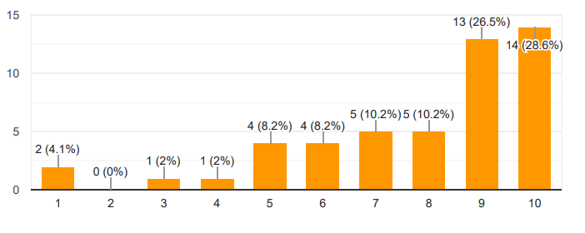
Figure 21 Do you agree that Louis Vuitton's pricing represents the quality of its goods, which adds to your level of satisfaction?
(Source: Created by Author)
An average score of 7.59 out of 10 shows that respondents normally accept Louis Vuitton's fee as true, which displays the niceness of its merchandise, which will increase their happiness. This shows that in spite of the brand's gadgets being high priced, people trust that the fee is justified through the emblem's reputation for exquisite workmanship and luxury. The notion of fee for charge is a vital aspect of customer delight, mainly inside the luxurious marketplace.
15. Do you agree that Louis Vuitton’s reputation for luxury influences your perception of the brand?
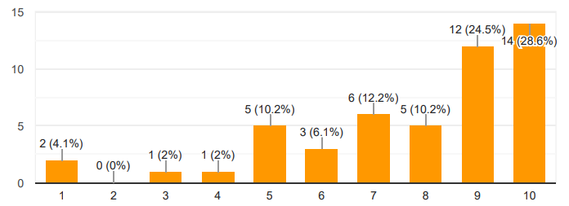
Figure 22 Do you agree that Louis Vuitton’s reputation for luxury influences your perception of the brand?
(Source: Created by Author)
A solid majority of respondents (28.6%) assessed Louis Vuitton's luxury reputation as having the greatest influence on how they view the brand. An additional 24.5% provided high agreement (rating 9), indicating that approximately 53.1% of respondents strongly believe that the brand's reputation for luxury is important to their perception. The excellence of Louis Vuitton's craftsmanship remains a major factor in the brand's success. The way the business produces its products demonstrates its dedication to excellence. Over time, the firm has kept on to develop and evolve, while keeping faithful to its past and heritage. The company's lengthy past is intricately linked to the evolution of fashion (Shults, 2023). Therefore, it can be stated that the reputation of the company impacts the consumer’s perception of the brand.
16. Do you agree that Louis Vuitton’s presence on social media positively affects your perception of the brand?
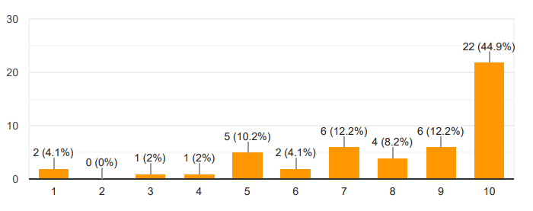
Figure 23 Do you agree that Louis Vuitton’s presence on social media positively affects your perception of the brand?
(Source: Created by Author)
Louis Vuitton's social media presence positively influences consumer perception, with 44.9% of respondents giving the highest grade (10). Another 12.2% gave it a 9, increasing the total of those strongly agreeing to 57.1%. This data demonstrates that the brand's participation on platforms such as Instagram and Twitter improve its image, especially among digitally savvy consumers.
17. Do you agree that the packaging of Louis Vuitton products contributes to a positive brand image?
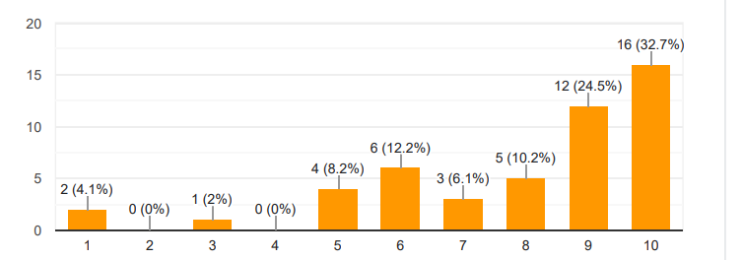
Figure 24 Do you agree that the packaging of Louis Vuitton products contributes to a positive brand image?
(Source: Created by Author)
Purchasing a luxury bag is an exciting experience that becomes much more delightful when the bag is presented in exquisite packaging. The act of unpacking an unopened luxury bag that a buyer has purchased has a unique quality. Customers who purchase anything from Louis Vuitton are greeted with a stunning gift that matches the stuff inside (Hossain, 2023). Louis Vuitton's product packaging plays an important role in shaping the brand's image. 32.7% of respondents awarded it a ten, while 24.5% gave it a nine, indicating that more than half (57.2%) of respondents believe packaging improves the brand's image. This demonstrates how important the unboxing experience is in reinforcing the brand's luxury image.

18. Do you agree that Louis Vuitton’s celebrity endorsements influence your perception of the brand?
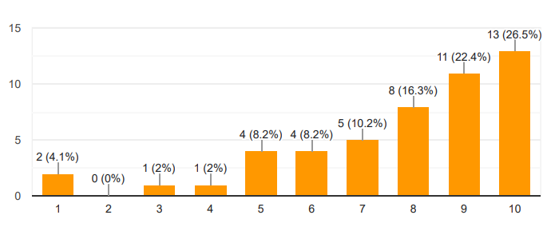
Figure 25 Do you agree that Louis Vuitton’s celebrity endorsements influence your perception of the brand?
(Source: Created by Author)
The appropriate celebrity can persuade consumers to purchase expensive goods. These famous individuals serve as essential components of luxury brands' marketing campaigns and occasionally serve as their ten-year brand representatives and spokespersons. Because of Louis Vuitton's targeted celebrity approach, more people are talking about its red-carpet visits on social media. Celebrity endorsements also have an impact on how Louis Vuitton is seen, with 26.5% ranking this influence as a 10 and 22.4% giving it a 9. This equals 48.9%, indicating that nearly half of respondents are heavily impacted by celebrity ties with the brand. The inclusion of well-known public people is critical to preserving Louis Vuitton's aspirational appeal.
Conventions Impacting Brand Loyalty
19. Do you agree that your allegiance to Louis Vuitton is impacted by the brand's long history?
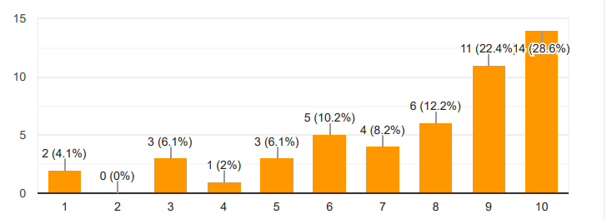
Figure 26 Do you agree that your allegiance to Louis Vuitton is impacted by the brand's long history?
(Source: Created by Author)
Louis Vuitton's lengthy history influences brand loyalty, with 28.6% awarding the maximum grade of 10 and 22.4% giving it a 9. This suggests that 51% of respondents believe that the brand's established legacy increases their loyalty. The historical significance of Louis Vuitton fosters a lasting sense of trust and connection among its customers.
20. Do you agree that the social standing that comes with purchasing Louis Vuitton items influences your brand loyalty?
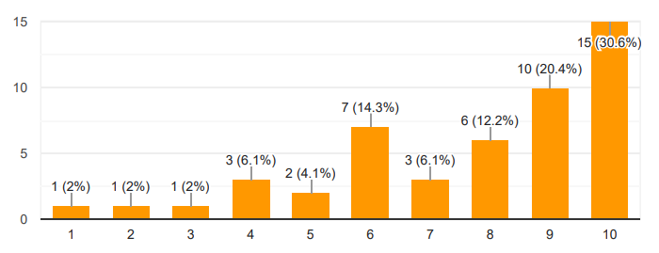
Figure 27 Do you agree that the social standing that comes with purchasing Louis Vuitton items influences your brand loyalty?
(Source: Created by Author)
The social standing associated with purchasing Louis Vuitton products influences brand loyalty for 30.6% of respondents (rating 10), while another 20.4% gave it a 9. This suggests that for more than half (51%) of respondents, social status is an important factor in brand loyalty.
21. Do you agree that having regular favorable encounters with Louis Vuitton items helps to enhance your brand loyalty?
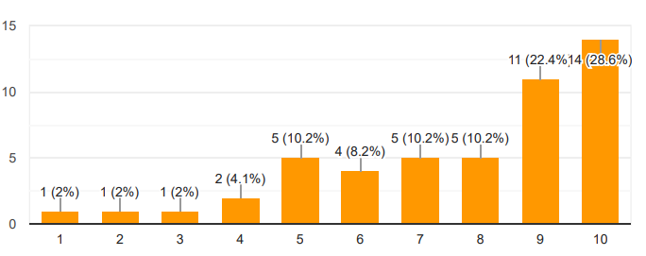
Figure 28 Do you agree that having regular favorable encounters with Louis Vuitton items helps to enhance your brand loyalty?
(Source: Created by Author)
Having regular pleasant experiences with Louis Vuitton items improves brand loyalty, with 28.6% rating it as the highest level (10) and 22.4% at 9. This 51% majority highlights how consistent favourable experiences lead to a stronger attachment to the brand.
22. Do you agree that the limited availability of Louis Vuitton products increases your brand loyalty?
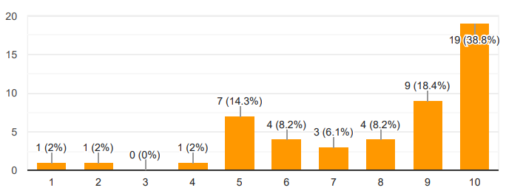
Figure 29 Do you agree that the limited availability of Louis Vuitton products increases your brand loyalty?
(Source: Created by Author)
The scarcity of Louis Vuitton products boosts brand loyalty among 38.8% of respondents who gave it a 10, and 18.4% who gave it a 9. With 57.2% strongly agreeing, this scarcity aspect increases the appeal and devotion to the brand, as exclusivity is frequently a crucial motivator in premium markets.
23. Do you agree that Louis Vuitton’s commitment to craftsmanship strengthens your loyalty to the brand?
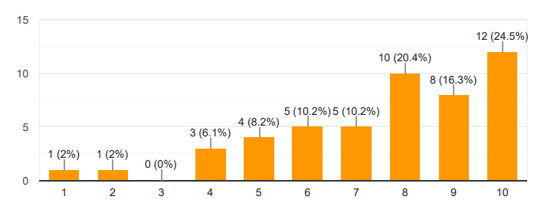
Figure 30 Do you agree that Louis Vuitton’s commitment to craftsmanship strengthens your loyalty to the brand?
(Source: Created by Author)
Louis Vuitton's dedication to craftsmanship boosts loyalty for 30.6% of respondents (rating 10), while 20.4% gave it a 9. This demonstrates that more than half (51%) of respondents believe craftsmanship is an important role in their devotion, bolstering the brand's reputation for quality and attention to detail.
24. Do you agree that your loyalty to Louis Vuitton is influenced by its ability to maintain brand consistency over time?
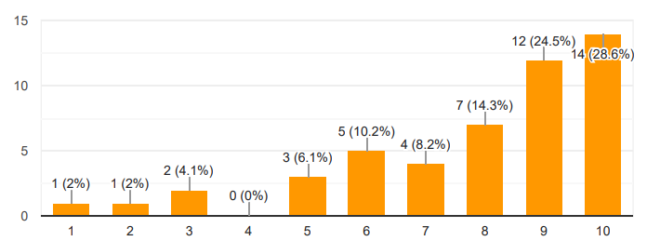
Figure 31 Do you agree that your loyalty to Louis Vuitton is influenced by its ability to maintain brand consistency over time?
(Source: Created by Author)
Maintaining brand consistency is an important feature for 28.6% of respondents (rating 10) and 24.5% (rating 9), with 53.1% strongly agreeing that consistency over time promotes loyalty. Louis Vuitton's ability to stick to its ideals and image helps them maintain long-term customers.
25. Do you agree that your trust in Louis Vuitton’s authenticity and originality enhances your brand loyalty?
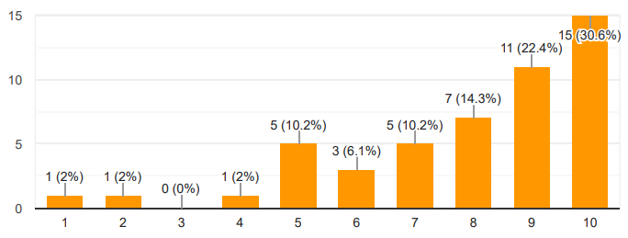
Figure 32 Do you agree that your trust in Louis Vuitton’s authenticity and originality enhances your brand loyalty?
(Source: Created by Author)
Trust in Louis Vuitton's authenticity and uniqueness boosts brand loyalty, with 30.6% ranking it a 10 and 20.4% giving it a 9. This totals 51%, indicating that the brand's ability to keep its authentic, original designs is an important factor in retaining loyal customers.
Overall Ratings
26. On a scale of 1 to 10, how would you rate your overall satisfaction with Louis Vuitton products?
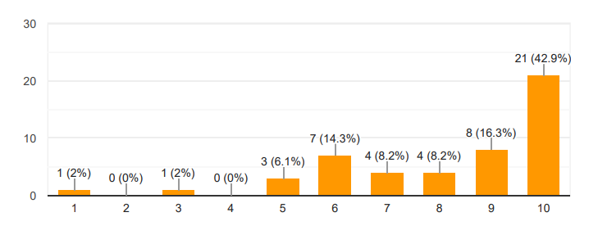
Figure 33 On a scale of 1 to 10, how would you rate your overall satisfaction with Louis Vuitton products?
(Source: Created by Author)
Satisfaction was strong, with 30.6% ranking it as a 10 and 22.4% giving it a 9. This indicates that 53% of respondents are extremely satisfied with Louis Vuitton products.
27. On a scale of 1 to 10, how would you rate Louis Vuitton’s brand image in comparison to other luxury brands?
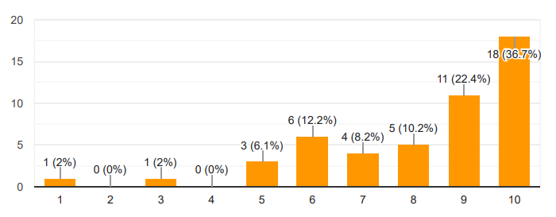
Figure 34 On a scale of 1 to 10, how would you rate Louis Vuitton’s brand image in comparison to other luxury brands?
(Source: Created by Author)
In compared to other luxury brands, Louis Vuitton's brand image achieved a high rating of 10 from 42.9% of respondents, with an additional 16.3% rating it 9. This totals 59.2%, suggesting high confidence in Louis Vuitton's brand image in comparison to competitors.
28. On a scale of 1 to 10, how likely are you to recommend Louis Vuitton to a friend or family member?
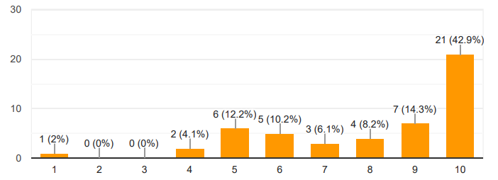
Figure 35 On a scale of 1 to 10, how likely are you to recommend Louis Vuitton to a friend or family member?
(Source: Created by Author)
A significant 42.9% of respondents said they would recommend Louis Vuitton (rating 10), while 14.3% gave it a 9. This suggests that 57.2% of respondents are highly inclined to recommend Louis Vuitton to friends and family.

4.4 Findings
The poll, which included 49 humans, reveals how satisfied clients are with Louis Vuitton, targeting their shopping patterns, product fine, price, customer support, and fashionable organization pleasure. A striking result is that 42.8 percent of respondents purchase Louis Vuitton gadgets on an everyday basis, while 22.9 percent do so handiest sporadically. This shows that a huge percentage of people are repeat clients of the brand, demonstrating high client loyalty and hobby in Louis Vuitton's merchandise. The excessive quantity of repeat customers suggests that Louis Vuitton is effective at recruiting and maintaining clients who admire premium goods. In phrases of product exceptional, respondents gave an average rating of 7.60 out of 10. This rating suggests that most consumers are glad with the craftsmanship of Louis Vuitton gadgets. The company is identified for its beauty and workmanship, and the best score indicates that it commonly meets these expectations.
Pricing is another major consideration for clients. The average assessment for whether or not Louis Vuitton's pricing should reflect the pleasantness of its products turned to 7.63. This means that clients feel the high fees can be justified via the quality of the goods. It suggests that, in spite of the better charge, many buyers accept as true that the posh and durability they receive justify the price (Cuesta-Valiño et al., 2022). The durability and lifespan of Louis Vuitton items likewise nicely appeared, with an average rating of 7.65. This demonstrates that humans feel the sturdiness of the brand's products. When clients spend a number of cash on luxury things, they need them to remain, and Louis Vuitton appears to suit that widespread.
To draw in its customers, Louis Vuitton must have a distinctive design aesthetic. It also employs distinctive marketing techniques to pique interest in its products. It examines its target market concurrently to ascertain consumption trends and strategies for product promotion. Setting oneself out from competition is crucial for a brand in a highly competitive marketplace. By concentrating on its distinctive selling propositions, Louis Vuitton has been able to do this. The company distinguishes itself from other luxury fashion labels by its dedication to workmanship, meticulous focus on detail, and utilisation of premium materials (Patty, 2023). Louis Vuitton can sustain a distinctive brand image which appeals to its target market by emphasising these differentiators. The brand often works with well-known designers, artists, and personalities to produce collector's goods and limited-edition series. Customers get excited and anticipatory about these partnerships, which raises brand awareness and boosts sales. A key component of Louis Vuitton's marketing approach is uniqueness. To convey a sense of exclusivity and desirability, the brand meticulously manages its manufacturing and distribution routes. Louis Vuitton instils a feeling of exclusivity and uniqueness in its customers by restricting the availability of specific items, making them feel distinguished to own them. In addition to increasing demand, this tactic supports the upkeep of the brand's premium reputation.
Customer provider is important for emblem loyalty. The average evaluation for how Louis Vuitton's customer service properly fosters brand loyalty was 7.61. This shows that sturdy customer support is a vital component in selling routine commercial enterprises. Respondents accept as true that the service they acquire complements their revel in with the employer, making them more willing to stay loyal (Taqi et al., 2020). The uniqueness of Louis Vuitton items received the very best average score (7.96). This excessive ranking demonstrates that the exclusivity and differences related to Louis Vuitton contribute greatly to patron happiness. People consider that owning something special contributes to their universal pride in the organization. Finally, respondents ranked their average satisfaction with Louis Vuitton products at 7.73. This good average score demonstrates common brand pride, indicating that Louis Vuitton satisfies the wishes of its purchasers in a lot of methods (Azizan et al., 2019). The survey demonstrates that Louis Vuitton efficiently combines wonderful items, justifiable rates, long-lasting goods, first-rate customer support, and exclusivity to maintain a high stage of purchaser happiness and loyalty.

4.5 Summary
It can be summarised that social media marketing is an important tool for brand image and brand loyalty among the customers of Louis Vuitton. The outcome of the study indicates that the luxury brand can leverage social media platforms to keep its target customers engaged. In this chapter, survey respondents' comments are provided as an interpretive chart to help with data interpretation. The data may be visualised, and the outcome can be applied to the goals of the investigation. The survey's primary findings may also help address the study questions. The survey's results are shown in the section that follows. The following chapter includes a discussion of the findings. Moreover, the limitations and implications of the study are also included there.

Chapter 5: Discussion

5.1 Introduction
This chapter includes a discussion of the findings of this study focused on the impact of consumer satisfaction and brand image on brand loyalty in the Louis Vuitton luxury fashion industry. The outcome of the research can be linked with findings from prior studies available on the topic. The results can be compared, and implications can be highlighted for the brands and marketers. Moreover, the outcome of the study has also been connected with the theoretical elements associated with the study.

5.2 Discussion
The survey findings on Louis Vuitton's pride ratings provide some important insights into consumer opinions and experiences with the pinnacle-rated emblem. The findings offer a whole picture of ways Louis Vuitton's great of merchandise, pricing, customer support, and exclusivity affect average purchaser happiness and loyalty. The record diagnosed one critical trouble: robust patron devotion to Louis Vuitton. The high frequency of income amongst individuals suggests that the enterprise has efficiently mounted a dedicated purchaser base (Cuesta-Valiño et al., 2022). This devotion is frequently stimulated by way of a mixture of reasons; alongside the logo's amazing recognition and the high-quality of its products. Regular purchases endorse that consumers see terrific value in Louis Vuitton's offers, which is steady with the logo's stance as a primary top-fee style employer.
Product brilliant is identified as an important issue in purchaser happiness. The observe findings recommend that Louis Vuitton normally meets or surpasses client expectations for product super. The organisation is famous for its workmanship, materials, and attention of detail, which most likely contributes to extremely good customer opinions (Taqi et al., 2020). When customers spend money on luxury matters, they assume immoderate fines, and Louis Vuitton seems to supply in this pledge. This high product extremely good not honestly improves the patron's satisfaction however additionally strengthens the commercial enterprise business enterprise's recognition of pleasure. Pricing is every other essential trouble for customers. Despite the excessive fee of Louis Vuitton gadgets, the poll positioned that customers typically take delivery of as real with the fees can be justified by using the usage of the extent of expertise they gather (Azizan et al., 2019). This feeling of really worth is essential in the costly location, in which excessive prices are regularly unavoidable. The willingness of clients to shell out a premium demonstrates their opinion that the emblem's objects are extraordinary investment, weighing value towards perceived nice and status.
Customer issuer is a critical element in figuring out emblem loyalty. According to the examined consequences, powerful customer support is vital for increasing routine revenue and strengthening purchaser connections. Louis Vuitton appears to fit the top rate quarter's requirements for individualized service and a stepped forward level of attention. Effective conversation with customers now not handiest improves the complete buying revel in but also promotes corporation devotion and connection. Exclusivity is a distinguishing feature of top rate businesses, and Louis Vuitton's strength of mind toward exclusivity helps to ensure an excessive variety of purchaser pleasure (Shabbir et al., 2020). The logo's capability to offer precise and confined-version objects provides to its enchantment and prestige, consequently improving the entire customer entertainment. Exclusiveness offers customers an experience of belonging and difference, which complements their loyalty and happiness with the brand. The survey findings endorse that Louis Vuitton efficiently blends many elements on the way to maintain immoderate stages of customer happiness and loyalty (Rachbini et al., 2023). By always meeting or surpassing patron expectations in these domains, Louis Vuitton cements its fame as a gold-general highly-priced emblem. The logo's dedication to providing super goods and studies allows it to keep customers engaged and extraordinarily joyful, ensuring lengthy-term achievement in the tough, highly-priced market.
Ulas and Vural (2018) carried out research to identify brand interaction behaviours and brand loyalty characteristics employed by users of premium brands on social media channels. Social media platform reputation determinants and user evaluations of the brand throughout this procedure have been attempted to be ascertained. The authors mentioned that the origins of the idea of brand loyalty are as firmly established as that of civilisations. The astonishing way in which global developments impact consumer conceptions and brand loyalty is evident. In brand-consumer interaction, brand loyalty is often used in conventional media channels and appears to be an ongoing endeavour. It is also possible to argue that companies are participating in this process in addition to personal use, particularly in light of the advancements made in the digital space. The customer-brand connection has taken on an entirely fresh meaning in this new communication environment defined by social media channels, and it is now imperative for companies to continue cultivating brand loyalty on these platforms rather than merely a luxury. It appears that luxury brands, a subset of brand categorisation, are gradually adjusting to this fresh means of communication, albeit a little slowly. It is important to note that brand loyalty initiatives and luxury brand communication have shifted from conventional media to social networking platforms.

5.3 Relating the Findings to Literature Review and Research Objectives
The research aimed to evaluate the relationship between customer pleasure and luxury fashion brand image. A review of the literature is a systematic way to acquiring and synthesising previous research. A thorough study helps expand knowledge and build theories (Snyder, 2019).
This research takes into account previous research publications and journals in the topic. Research examines factors that impact consumer satisfaction and brand loyalty. Louis Vuitton is a renowned French luxury brand noted for its high-quality leather products, famous monogram designs, and timeless fashion pieces (Pngwing, 2024). This research evaluates literary works to explore the brand's influence over time, including luxury Louis Vuitton is a fashion firm.
Louis Vuitton's commercial success depends on accurate market segmentation. Louis Vuitton is a well-known luxury brand with a global presence in more than 50 countries. Having a strong brand helps boost client confidence. Throughout its 167-year existence, Louis Vuitton has used a long brand narrative to interact with clients and share its story (Gan, 2022). Allow brand developers to use their family's distinctive technology to create high-quality modern products. Satisfied customers are crucial to the success of Louis Vuitton's luxury brand. Louis Vuitton is renowned for its exceptional craftsmanship, premium materials, and innovative designs, leading to high levels of customer satisfaction (Makkar et al., 2018). The brand's commitment to excellence results in products that not only meet but often exceed client expectations. Furthermore, Tams et al. (2021) found that Louis Vuitton's exceptional customer service significantly increases customer satisfaction. The company provides personalised purchase research, dedicated customer support, and specialised services such as unique gadgets and purchasing visits. Excessive contact services foster emotional connections with clients, leading to increased pride and loyalty.
The Louis Vuitton Company promises to practise sustainable business principles, earning profits for shareholders while protecting people and the environment. Louis Vuitton's sustainability program consists of two categories: ecological and social practices (Javed et al., 2020). Louis Vuitton's environmental supply chain includes eco-material preparation, manufacture, sustainable distribution, eco-retailing, and environmentally conscious customers who support the company (Pastore et al., 2022). Louis Vuitton's green claims are categorised by production chain and include eight message elements: ethically sourced materials, water conservation, recycling clothing, environment-friendly value chain, equitable salary increases, decent working conditions, animal welfare, and improved fire and building safety. The competitive situation has made customers the most important strategic resource for businesses. Customer satisfaction is influenced by political, financial, and societal factors, making customer service a complex and unseen process. Thus, it is critical that fashion brands assure client happiness.

5.4 Link with Theories
The outcome of this study indicates that a huge percentage of people are repeat clients of the brand, demonstrating high client loyalty and hobby in Louis Vuitton's merchandise. The excessive quantity of repeat customers suggests that Louis Vuitton is effective at recruiting and maintaining clients who admire premium goods. Customer provider is important for emblem loyalty. The result also shows that sturdy customer support is a vital component in selling routine commercial enterprises. Respondents accept as true that the service they acquire complements their revel in with the employer, making them more willing to stay loyal. The result of the study can be linked with theoretical elements. Four sub-motivations are covered by contemporary social media information: encouragement, prepurchase data, expertise, and observation. Keeping an eye on and being informed regarding one's social surroundings is known as surveillance. Knowledge is data regarding an organisation that customers discover to benefit from the wisdom and comprehension of other people and get further insight into an item or brand. Pre-purchase research refers to researching brand community forums or product reviews to come to informed purchasing selections (Muntinga et al., 2011). In light of the previous debate, this study defines popularity as the spread of the most recent and fashionable information on luxury companies. Individuals believe that having something unique adds to the group's overall sense of pride. Customers who follow information about a brand are inspired to come up with new suggestions; as a result, the brand-related material acts as an outlet of inspiration.

5.5 Lessons Learned and Implications
The present research on the luxury fashion company Louis Vuitton examines how consumer pleasure and brand image impact loyalty. This study examines how luxury apparel manufacturer Louis Vuitton's focus on brand loyalty affects consumer pleasure and brand image. Louis Vuitton's consumer happiness is primarily influenced by emotional connections with customers and high-quality manufacturing. These factors shape the brand's image through offerings of style, quality, and sustainability. Louis Vuitton's luxury fashion sector is primarily driven by these factors. Luxury organisations strive to provide better items and continuously upgrade their offerings to meet market expectations. Luxury brands are known for providing tailored services to its customers. They go above and above to ensure customer satisfaction after acquisition.
The outcome of the study offers key aspects that can be useful for the luxury brand. Brands may generate a feeling of immediacy in their audience by revealing items that are only accessible in limited numbers for a brief time. This strategy makes use of the notion of scarcity, which increases the item's desirability because of its restricted supply. Posting teasers, countdowns, and announcements about these launches on social media sites like Instagram or Twitter may increase interest and motivate customers to act quickly (Mediaboom, 2021). This tactic increases sales right away and strengthens the brand's appeal by providing something special and distinctive to its most devoted fans. The administration of Louis Vuitton may find these techniques beneficial.
Engaging their target demographic on social media through engaging competitions and freebies is a successful strategy employed by luxury businesses. Brands may stimulate engagement among their fans by holding contests or providing limited-edition merchandise as rewards. By giving customers, a lively and enjoyable method to interact t with the company, this tactic may draw in more customers. Furthermore, freebies and competitions may be designed to commemorate milestones, introduce new items, or just thank devoted consumers. This helps to strengthen the brand's reputation and build a feeling of community among the target audience.

5.6 Summary
Louis Vuitton's strong brand image encourages consumers to purchase expensive products. The company's business model prioritises sustainability and provides high-quality products at competitive prices across markets. Luxury brands rely on a strong brand image to effectively communicate with customers. Louis Vuitton's culture prioritises sustainability. This study focusses on consumer satisfaction, namely perceived value, and brand image. Louis Vuitton prioritises product quality and stays current with fashion Trends. The Company’s design team consists of creators, pattern producers, buyers, and individuals of various ages and nationalities. They focus on creating high-quality fashion collections with current trends and cheap costs. Louis Vuitton's sustainable program focusses on environmental and social responsibilities, with an eco-supply chain structure that encompasses eco-material planning, production, ecological shipping, retail, and mindful consumers.

Chapter 6: Conclusion And Recommendation

6.1 Introduction
This research examines consumer happiness and brand image for luxury fashion brands, specifically Louis Vuitton. The study analysed Louis Vuitton's evolution, motivation, and production processes, assessing brand image and consumer happiness. Currently, the investigation has thoroughly explored its purpose. This research aims to fill a gap by defining the research topic and offering rationale for each area of the fashion business. The study evaluated customer happiness and brand loyalty, with a focus on the premium fashion company Louis Vuitton, which was found to have a superior image. The study focused on many areas of the Louis Vuitton organisation, including customer satisfaction and brand value or representation. This research aims to assess brand loyalty, customer happiness, and consumer perceptions of the Louis Vuitton fashion brand. This component of the study considers both promotion and company motivation. The research problem statement aims to identify gaps that need to be addressed. Research indicates a link between brand loyalty and consumer happiness. Feta is et al. (2023) define customisation as the modification of a service to match individual preferences. Evaluating interactions between marketers and brands on social media can improve relationships between consumers and businesses (Makkar et al., 2018). This study aims to identify Louis Vuitton's target market for customer satisfaction and brand value in the luxury fashion sector. The study examined the impact of customer happiness and brand image on the luxury clothes firm Louis Vuitton. This research evaluates the effectiveness of Louis Vuitton's brand. Fetais et al. (2023) evaluated Louis Vuitton's market performance based on their business strategy, motivation, and promotion, resulting in positive customer satisfaction and a lasting impression on the market. This study covers the future of luxury brands and markets.

6.2 Main Discoveries
This research examines how consumer happiness and brand image affect brand loyalty in the Louis Vuitton luxury fashion business. Collecting client feedback is crucial for addressing research issues. To obtain data from a large number of individuals, this study used a survey method. Surveys are useful for identifying characteristics of a large population. Groves et al. (2011) state that no other research approach can provide such a wide variety of capabilities, allowing for more precise and focused data for critical decision-making. The survey examines consumer perceptions of the luxury fashion brand Louis Vuitton. A set of survey questions has been designed to achieve this goal. Customers can submit feedback, which can be evaluated using statistical methods.
Customer service is essential for brand loyalty. The average score for Louis Vuitton's customer service in fostering brand loyalty was 7.61. Strong customer assistance is essential for successfully marketing ordinary commercial companies. Taqi et al. (2020) found that respondents believe the service they receive enhances their experience with their job, leading to increased loyalty. The distinctiveness of Louis Vuitton goods obtained the highest average score (7.96). Louis Vuitton's rarity and uniqueness significantly impact customer satisfaction, as seen by its high rating. Owning something unique can boost employee pride in the organisation. Overall, respondents rated their satisfaction with Louis Vuitton products at 7.73. According to Azizan et al. (2019), Louis Vuitton's high average score suggests that the company meets the needs of its customers in a variety of ways. According to the survey, Louis Vuitton maintains a high level of consumer satisfaction and loyalty by combining high-quality products, affordable prices, long-lasting products, exceptional customer service, and exclusivity.
Social media marketing plays a crucial role in building brand image and loyalty among Louis Vuitton customers. The study found that luxury brands may effectively engage their target clients using social media platforms. This chapter presents an interpretive chart of survey respondents' remarks to aid data interpretation. Data visualisation can help achieve investigative aims. The survey's major findings may also help answer the study's questions. The survey findings are displayed in the section below. The following chapter discusses the findings. The study's flaws and ramifications are also discussed.

6.3 Objective’s Realization
This study examines how consumer happiness and brand image impact brand loyalty in the luxury fashion business, specifically focussing on LV. The methodology mostly relies on structured surveys for data collecting. This study aims to gather data from a wide number of consumers who have interacted with the LV brand, providing a comprehensive picture of their awareness and engagement. This study's quantitative technique simplifies data analysis and demonstrates correlations between consumer pleasure, brand image, and loyalty. This approach provides a solid framework for testing research hypotheses and drawing factual conclusions, enhancing the findings' dependability and relevance to the study questions and objectives.
The survey results on Louis Vuitton's pride ratings offer valuable insights into consumer perceptions and experiences with the highest-rated emblem. The study examines how Louis Vuitton's merchandise, pricing, customer support, and exclusivity impact consumer satisfaction and loyalty. The record identified a significant issue: strong patron loyalty to Louis Vuitton. The high frequency of income among individuals indicates that the company has successfully established a loyal customer base (Cuesta-Valiño et al., 2022). This devotion is often driven by a combination of factors, including the logo's recognition and high-quality items. Regular purchases indicate that Louis Vuitton's offers provide excellent value, aligning with the brand's position as the leading high-end fashion employer.

6.4 Recommendations
Louis Vuitton's social media account. This study employed Louis Vuitton as a reference brand. The first finding shows that e-WOM had a considerable beneficial impact on the company's image. The study found that e-WOM had a significant positive impact on brand loyalty. The study found that online communities greatly increased brand reputation. Xiao (2023) found that the online community had a significant positive impact on brand loyalty. Louis Vuitton's high-end products attract enormous audiences in the fashion business, therefore creating viral content may inspire users to share it. To increase participation, more engaging items must be added. According to Prusova (2023), the emblem's effective market segmentation and personalised service enhance customer loyalty. Louis Vuitton's commitment to sustainability and moral standards aligns with growing client demand for eco-friendly products (Pal et al., 2018). Digital word-of-mouth (e-WOM) has a significant impact on agency awareness and consumer engagement, making social media an important tool for increasing brand image and loyalty (Xiao, 2023). Louis Vuitton's empirical research highlights the importance of maintaining a strong brand image and meeting client expectations in the premium business.
The management of Louis Vuitton needs to adopt specific steps to maintain its brand image in the luxury fashion industry. Luxury digital marketers may connect and engage with their devoted audience on social media platforms. Using social media platforms, luxury firms may reach a large audience by promoting their products and introducing new options. Luxury brands may establish a strong emotional connection with customers, set them apart from the competition, and cultivate an engaged audience via social media. In social media, influencer relationships are essential for luxury businesses. Accessibility and credibility are greatly increased when influencers who respect a brand's values and style work together. Through these collaborations, the brand is presented to new consumers in settings that are engaging and trustworthy.
A luxury brand may be elevated through a well-matched influencer engagement and become more appealing to a demographic that respects the influencer's suggestions. This tactic appeals to premium buyers by successfully communicating exclusivity and genuineness. One important tactic used by luxury firms to generate excitement and anticipation on social media is the use of exclusive content previews (Mediaboom, 2021). By appealing to the audience's FOMO, this strategy creates a feeling of luxury and exclusivity surrounding gaining permission to use the brand's products.
The emotional allure of owning an LV item is essential to customer loyalty and recurring business. A sense of uniqueness and exclusivity is created by restricted stock and high price tags, and these perceptions are essential to luxury branding. Louis Vuitton's psychological tactics underline how crucial it is to comprehend customer behaviour in the premium market. LV can efficiently generate customer motivation, develop brand loyalty, and maintain its standing as a luxury icon by utilising psychological concepts. To achieve sustained prosperity and consumer loyalty, premium firms must comprehend these psychological factors (Fashion Law Journal, 2024). The brand’s ability to generate a sense of loyalty, retain exclusivity, and offer high standards adds greatly to its success. To maintain its relevance and safeguard its reputation, it must, nonetheless, constantly innovate.
Louis Vuitton has maintained its dominance in the high-end fashion industry by a comprehensive approach that blends innovation, legacy, and a thorough comprehension of customer behaviour. Issues like counterfeiting highlight how well-known the brand is around the world, but they also call for constant work to protect its uniqueness. In the future, Louis Vuitton's capacity to recognise and capitalise on new trends will be essential. It becomes clear that the company has an influence that goes beyond style (BVI, 2023). It has grown to be a powerful cultural force that shapes ideas about luxury and leaves a lasting impression on the always-changing fabric of the fashion industry. The company needs to maintain their exclusivity and ensure brand loyalty in the coming years.

6.5 Limitations and Suggestions for Future Research
The study's findings highlight critical areas that can benefit the luxury brand. Brands can create a sense of urgency by releasing limited-time offerings. This method leverages scarcity to make an object more desirable due to limited supply. Posting teasers, countdowns, and announcements on social media platforms such as Instagram or Twitter can boost client interest and prompt action (Mediaboom, 2021). This technique boosts sales and promotes brand appeal by offering something unique to loyal customers. The Louis Vuitton administration may benefit from these tactics. Luxury firms successfully engage their target demographic on social media by offering competitions and gifts. Brands can increase fan engagement by hosting contests or offering limited-edition products as incentives. Providing a fun and engaging way for customers to interact with the firm may increase client retention. Freebies and competitions can be used to celebrate milestones, launch new products, or just thank loyal customers. This strengthens the brand's reputation and creates a sense of camaraderie among the target population.
Despite the study's strong methodology, the following shortcomings remain. Cross-sectional time horizon approaches do not account for dynamic changes in consumer happiness, brand image, and loyalty over time, making them ineffective for explaining transitional or long-term results. Random sampling improves representativeness, but it may not accurately reflect the global population of LV users, thereby leading to biases. Survey results might be influenced by answer bias, as participants may not be honest about their lifestyle or beliefs, especially in the context of luxury. The study's quantitative focus may limit its ability to identify nuanced processes or impressions, which require qualitative methods such as interviews. The study's focus on Louis Vuitton limits its applicability to other premium fashion firms.

6.6 Summary
This research aims to fill a gap by defining the research topic and offering rationale for each area of the fashion business. The study aims to assess how consumer happiness and brand image affect brand loyalty in the Louis Vuitton luxury fashion business. This study's primary data was acquired using an online survey. The data has been presented graphically for easier interpretation. This survey found that a significant number of consumers are repeat customers of Louis Vuitton, indicating strong brand loyalty and interest in their products. Louis Vuitton's high number of repeat customers indicates a strong ability to attract and retain customers who value high-quality products. Customer service is crucial for brand loyalty. The study highlights the importance of strong customer service in selling everyday businesses. Respondents believe the service they receive enhances their experience with the employer, leading to increased loyalty. The study emphasises the necessity of maintaining a good brand image and meeting client expectations in the luxury industry. The report recommends that Louis Vuitton's management take particular efforts to retain its brand image in the premium apparel market.
Palmatier et al. (2018) conducted a systematic evaluation to assess the impact of consumer pleasure and loyalty to the premium fashion brand Louis Vuitton. The project aims to establish a framework for carefully evaluating data by analysing each chapter. The first chapter introduces the research setting, goal, and objective, emphasising its significance to the whole study. Tams et al. (2021) also explore the reach problem and its significance. To gain a comprehensive understanding of the research topic, the literature review in chapter two suggests reading multiple publications. The methodological section of Chapter 3 was recommended. This section shows how research was conducted utilising instruments and procedures to analyse findings and get a clear conclusion. Chapter 4 provides a research discussion on the outcomes and variables influencing them. Chapter 5's recommendations and conclusion summarise the findings and provide strategic standards to progress the subject. This research examines how consumer happiness and brand image affect loyalty to premium fashion firms, specifically Louis Vuitton. The study analyses the brand's development, motivation, and manufacturing, while also analysing its image and consumer happiness. The research issue statement attempts to address gaps in the interaction between marketing, brand value, and customer satisfaction in the Louis Vuitton market. The research aims to measure the impact of Louis Vuitton's fashion brand on consumer happiness, brand image, and loyalty. This section includes a discussion of the research question, highlighting its relevance to the aim and objective.

References
Abdul Haseeb Tahir, Adnan, M. and Saeed, Z. (2024). The impact of brand image on customer satisfaction and brand loyalty: A systematic literature review. Heliyon, 10(16), pp.e36254–e36254. doi:https://doi.org/10.1016/j.heliyon.2024.e36254.
Albers, M. J. (2017). Quantitative data analysis—In the graduate curriculum. Journal of Technical Writing and Communication, 47(2), 215-233.https://journals.sagepub.com/doi/abs/10.1177/0047281617692067
Arrigo, E., 2018. The key role of retail stores in fast fashion companies: The H&M case study. Contemporary case studies on fashion production, marketing, and operations, pp.121-137. http://ndl.ethernet.edu.et/bitstream/123456789/68002/1/4.pdf#page=130
Azizan, N.S. and Yusr, M.M., 2019. The influence of customer satisfaction, brand trust, and brand image towards customer loyalty. International Journal of Entrepreneurship and Management Practices, 2(7), pp.93-108.https://www.academia.edu/download/69386461/ijemp.pdf
Budiman, S., 2021. The effect of social media on brand image and brand loyalty in Generation Y. The Journal of Asian Finance, Economics and Business, 8(3), pp.1339-1347.https://koreascience.kr/article/JAKO202106438543818.page
BVI. (2023). This Is How Louis Vuitton Mastered the Art of Timeless Luxury with These Marketing Strategies | Brand Vision. [online] brandvm.com. Available at: https://www.brandvm.com/post/louis-vuitton-marketing-strategy.
Cacciattolo, M. (2015). Ethical considerations in research. In The Praxis of English Language Teaching and Learning (PELT) (pp. 55-73). Brill.https://brill.com/downloadpdf/book/edcoll/9789463001120/BP000005.pdf
Chen, T., Hao, Q., Jiao, F. and Zheng, D. (2021). Analysis Customer Satisfaction in Luxury Fashion E-commerce Platform Services Based on Kano Model. BCP Business & Management, 16, pp.195–206. doi:https://doi.org/10.54691/bcpbm.v16i.303.
Chitrakorn, K. (2021) What the new customer loyalty looks like, Vogue Business. Available at: https://www.voguebusiness.com/companies/what-the-new-luxury-customer-loyalty-programme-looks-like(Accessed: 13 August 2024).
Choi, T.M., Cai, Y.J. and Shen, B., 2018. Sustainable fashion supply chain management: A system of systems analysis. IEEE Transactions on Engineering Management, 66(4), pp.730-745.https://ieeexplore.ieee.org/abstract/document/8429109
‌Cuesta-Valiño, P., Gutiérrez-Rodríguez, P. and Núnez-Barriopedro, E., 2022. The role of consumer happiness in brand loyalty: a model of the satisfaction and brand image in fashion. Corporate Governance: The International Journal of Business in Society, 22(3), pp.458-473.https://www.emerald.com/insight/content/doi/10.1108/CG-03-2021-0099/full/html
E-commerce (2024) Louis Vuitton Analysis: Net sales, online to offline, B2B vs. D2C: ECDB.com, ECDB. Available at: https://ecommercedb.com/insights/louis-vuitton-generated-us-2-8-billion-in-net-sales-online-by-2022/4701(Accessed: 13 August 2024).
Eiras, B. and Azevedo, A., 2019. Cobranding between Fast Fashion Brands and Luxury Brands: A Case Study Approach. In Finding New Ways to Engage and Satisfy Global Customers: Proceedings of the 2018 Academy of Marketing Science (AMS) World Marketing Congress (WMC) 21 (pp. 771-784). Springer International Publishing. https://link.springer.com/chapter/10.1007/978-3-030-02568-7_208
Fanandaru, E.M., Kurniawati, K., Wahyuni, N. and Septiani, Y., 2023. Brand experience, attitude, and loyalty in brand equity fashion luxury brand. International Journal of Application on Economics and Business, 1(2), pp.651-669. https://journal.untar.ac.id/index.php/ijaeb/article/view/25620
Fashion Law Journal (2024). Case Study: Psychological Insights into Louis Vuitton’s Consumer Behavior - Fashion Law Journal. [online] Fashion Law Journal. Available at: https://fashionlawjournal.com/case-study-psychological-insights-into-louis-vuittons-consumer-behavior/.
Fetais, A.H., Algharabat, R.S., Aljafari, A. and Rana, N.P., 2023. Do social media marketing activities improve brand loyalty? An empirical study on luxury fashion brands. Information Systems Frontiers, 25(2), pp.795-817.https://link.springer.com/article/10.1007/s10796-022-10264-7
Fetais, A.H., Algharabat, R.S., Aljafari, A. and Rana, N.P., 2023. Do social media marketing activities improve brand loyalty? An empirical study on luxury fashion brands. Information Systems Frontiers, 25(2), pp.795-817. https://link.springer.com/article/10.1007/s10796-022-10264-7
Gallart-Camahort, V., De la Oliva-Ramos, E. and Fernández-Durán, L. (2021). Luxury Brands: awareness and image and its influence on loyalty and engagement. Contextus – Revista Contemporânea de Economia e Gestão, 19(20), pp.305–315. doi:https://doi.org/10.19094/contextus.2021.71415.
Gan, Y., 2022. Luxury Marketing in the Age of Network Traffic: Taking Louis Vuitton as an Example. Frontiers in Business, Economics and Management, 5(2), pp.18-21.https://drpress.org/ojs/index.php/fbem/article/view/1636
Geraghty, K., Hann, M. and Kurtev, S., 2019. Myalgic encephalomyelitis/chronic fatigue syndrome patients’ reports of symptom changes following cognitive behavioral therapy, graded exercise therapy and pacing treatments: Analysis of a primary survey compared with secondary surveys. Journal of health psychology, 24(10), pp.1318-1333.https://journals.sagepub.com/doi/abs/10.1177/1359105317726152
Gupta, A.D., Sui, I. and Das, A. (2022). Impact Of Brand Image on Customer Loyalty Towards Luxury Apparel. American Journal of Business and Management Research, 3(2), pp.21-30. https://www.ingentaconnect.com/contentone/smart/ajbmr/2022/00000003/00000002/art00003
Gupta, S. and Gentry, J.W., 2018. Evaluating fast fashion: Examining its micro and the macro perspective. In Eco-friendly and Fair (pp. 15-23). Routledge.https://www.taylorfrancis.com/chapters/edit/10.4324/9781351058353-2/evaluating-fast-fashion-shipra-gupta-james-gentry
Hossain, S. (2023). Everything You Need to Know About the Louis Vuitton Packaging Box - GlobItems. [online] Available at: https://globitems.com/louis-vuitton-packaging-box/.
Hvass, K.K., 2022. Business model innovation through second-hand retailing: a fashion industry case. In New Business Models for Sustainable Fashion (pp. 11-32). Routledge. https://www.taylorfrancis.com/chapters/edit/10.4324/9781003076339-2/business-model-innovation-second-hand-retailing-kerli-kant-hvass
ISDI. (2022). What is fashion luxury and lifestyle design? - ISDI - School of Design and Innovation. [online] Available at: https://isdi.in/blog/what-is-fashion-luxury-and-lifestyle-design/.
Javed, T., Yang, J., Gilal, W.G. and Gilal, N.G., 2020. The sustainability claims' impact on the consumer's green perception and behavioral intention: A case study of H&M. Advances in Management and Applied Economics, 10(2), pp.1-22. https://www.researchgate.net/profile/Tahira-Javed-2/publication/344348730_The_sustainability_claims'_impact_on_the_consumer's_green_perception_and_behavioral_intention_A_case_study_of_HM/links/5f6ae8ff92851c14bc8e3ea5/The-sustainability-claims-impact-on-the-consumers-green-perception-and-behavioral-intention-A-case-study-of-H-M.pdf
Kataria, S. and Saini, V., 2020. The mediating impact of customer satisfaction about brand equity and brand loyalty: An empirical synthesis and re-examination. South Asian Journal of Business Studies, 9(1), pp.62-87.https://www.emerald.com/insight/content/doi/10.1108/SAJBS-03-2019-0046/full/html
Lanzolla, G. and Markides, C., 2021. A business model view of strategy. Journal of Management Studies, 58(2), pp.540-553. https://onlinelibrary.wiley.com/doi/abs/10.1111/joms.12580
Lin, F. and Ku, T.-H. (2023). Effect of digital brand experience on luxury fashion brand authenticity, attachment, and loyalty. South African journal of business management, 54(1). doi https://doi.org/10.4102/sajbm.v54i1.3583.
Liu, X., 2024. Analysis Of Marketing Strategy of Age Z Luxury Group-----Take Louis Vuitton as An Example. Highlights in Business, Economics and Management, 37, pp.284-289. https://drpress.org/ojs/index.php/HBEM/article/view/22928
Liu, Z., 2024. Louis Vuitton Design Style to Attract Consumers. Highlights in Business, Economics and Management, 37, pp.253-258.https://drpress.org/ojs/index.php/HBEM/article/view/22921
Liu, Z., 2024. Louis Vuitton Design Style to Attract Consumers. Highlights in Business, Economics and Management, 37, pp.253-258. https://drpress.org/ojs/index.php/HBEM/article/view/22921
Macchion, L., Danese, P. and Vinelli, A. (2015). Redefining supply network strategies to face changing environments. A study from the fashion and luxury industry. Operations management research, 8, pp.15-31. https://www.researchgate.net/profile/Laura-Macchion-2/publication/271731752_Redefining_supply_network_strategies_to_face_changing_environments_A_study_from_the_fashion_and_luxury_industry/links/58aafe5caca27206d9bced1a/Redefining-supply-network-strategies-to-face-changing-environments-A-study-from-the-fashion-and-luxury-industry.pdf
Makkar, M. and Yap, S.F., 2018. Emotional experiences behind the pursuit of inconspicuous luxury. Journal of Retailing and Consumer Services, 44, pp.222-234.https://www.sciencedirect.com/science/article/pii/S0969698917304459
Mediaboom. (2021). Social Media for Luxury Brands - Set Your Brand Apart. [online] Mediaboom. Available at: https://mediaboom.com/news/social-media-for-luxury-brands/.
Mertens, W., Pugliese, A., and Recker, J. (2017). Quantitative data analysis. A companion, 1-8.https://link.springer.com/content/pdf/10.1007/978-3-319-42700-3.pdf
Mrad, M., Farah, M.F. and Haddad, S., 2019. From Karl Lagerfeld to Erdem: a series of collaborations between designer luxury brands and fast-fashion brands. Journal of Brand Management, 26, pp.567-582. https://link.springer.com/article/10.1057/s41262-018-00146-2
Muntinga, D.G., Moorman, M. and Smit, E.G. (2011). Introducing COBRAs: Exploring motivations for brand-related social media use. International Journal of advertising, 30(1), pp.13-46.https://www.researchgate.net/profile/Edith-Smit/publication/233894948_Introducing_COBRAs/links/559d5de708aeb45d1715c41e/Introducing-COBRAs.pdf
Noor, S., Tajik, O., and Golzar, J. (2022). Simple random sampling. International Journal of Education & Language Studies, 1(2), 78-82.https://www.ijels.net/article_162982.html
Pal, R. and Gander, J., 2018. Modeling environmental value: An examination of sustainable business models within the fashion industry. Journal of cleaner production, 184, pp.251-263.https://www.sciencedirect.com/science/article/pii/S0959652618303056
Palmatier, R.W., Houston, M.B. and Hulland, J., 2018. Review articles: Purpose, process, and structure. Journal of the Academy of Marketing Science, 46, pp.1-5. https://link.springer.com/article/10.1007/s11747-017-0563-4
Papirfly (2024) Customer Brand Equity and Understanding Keller's brand equity model, Papirfly. Available at: https://www.papirfly.com/blog/retail-marketing/customer-brand-equity-and-understanding-kellers-brand-equity-model/(Accessed: 13 August 2024).
Park, Y. S., Konge, L., and Artino Jr, A. R. (2020). The positivism paradigm of research. Academic medicine, 95(5), 690-694.https://journals.lww.com/academicmedicine/fulltext/2020/05000/the_positivism_paradigm_of_r%20esearch.16.aspx/%22
Park, Y.S., Konge, L. and Artino Jr, A.R., 2020. The positivism paradigm of research. Academic medicine, 95(5), pp.690-694.https://journals.lww.com/academicmedicine/fulltext/2020/05000/the_positivism_paradigm_of_r%20esearch.16.aspx/%22
Pastore, G., Frangiosa, A., Loria, V., Bellomo, M., Di Mezza, P.B., Falcone, M.F., Romeo, M. and De Cazotte, L.M., 2022. Sustainable fast fashion: business case of H&M. In Cases on circular economy in practice (pp. 157-179). IGI Global.https://www.igi-global.com/chapter/sustainable-fast-fashion/312040
Patty, P.C. (2023). Louis Vuitton Marketing Strategy: A Breakdown Of Their Secrets For Luxury Fashion. [online] drbrandagency.com. Available at: https://drbrandagency.com/digital-marketing/louis-vuitton-marketing-strategy/.
Pearse, N., 2019, June. An illustration of deductive analysis in qualitative research. In 18th European conference on research methodology for business and management studies (p. 264).https://books.google.com/books?hl=en&lr=&id=Uc-hDwAAQBAJ&oi=fnd&pg=PA264&dq=Research+deductive+method&ots=Mn9rseKyXd&sig=ywJhvssBxXRUAtFLXbBENSas-8I
Pngwing (2024) Louis Vuitton logo PNG images | PNGWing. Available at: https://www.pngwing.com/en/search?q=louis+Vuitton+Logo(Accessed: 13 August 2024).
Prusova, D., 2023. Key B2C Luxury Brand Marketing Strategies to Establish Strong Relationships with the Modern Consumer of Luxury Fashion. https://www.theseus.fi/bitstream/handle/10024/799251/Prusova_Daria.pdf?sequence=2
Rachbini, W., Soeharso, S.Y., Nugroho, A.S., Evi, T. and Rahmawati, E., 2023. The Impact of Brand Society and Narrative Branding on Brand Image and its Implications on Consumer Purchase Behavior: A Case Study of Luxury Fashion Brands in Jakarta. Journal of Law and Sustainable Development, 11(7), pp.e1387-e1387.https://ojs.journalsdg.org/jlss/article/view/1387
Rachbini, W., Soeharso, S.Y., Nugroho, A.S., Evi, T., Rahmawati, E. and Suyanto (2023). The Impact of Brand Society and Narrative Branding on Brand Image and its Implications on Consumer Purchase Behavior: A Case Study of Luxury Fashion Brands in Jakarta. Journal of Law and Sustainable Development, [online] 11(7), pp.e1387–e1387. doi https://doi.org/10.55908/sdgs.v11i7.1387.
Raut, U.R., Pawar, P.A., Brito, P.Q. and Sisodia, G.S., 2019. Mediating model of brand equity and its application. Spanish Journal of Marketing-ESIC, 23(2), pp.295-318.https://www.emerald.com/insight/content/doi/10.1108/SJME-04-2019-0021/full/html
Reyes, M. Z. (2004). Social research: A deductive approach. Rex Bookstore, Inc..https://books.google.com/books?hl=en&lr=&id=QboR5qfbt48C&oi=fnd&pg=PA1&dq=deductive+research+approach&ots=CZGQKh0tGp&sig=pgQaC9xgV5TC99tZUpQuijOqpVE
Robson, B. (2024). The Art of Luxury: Louis Vuitton’s Branding Strategy Unveiled. [online] wdd.my. Available at: https://wdd.my/blog/louis-vuitton-branding-strategy-explained/.
Sabanoglu, T. (2024) LVMH group’s fashion and leather goods revenue worldwide 2023, Statista. Available at: https://www.statista.com/statistics/306624/global-revenue-of-lvmh-group-s-fashion-and-leather-goods-segment/(Accessed: 13 August 2024).
Satornsantikul, A. and Nuangjamnong, C. (2022). The Impact of Brand Image and Brand Loyalty on Customer Satisfaction: A Case Study of Luxury Brand in Thailand. The Journal of Social Sciences Studies and Research, 2(04), pp.133-155. http://www.tjsssr.com/index.php/tjsssr/article/download/51/54
Satornsantikul, A. and Nuangjamnong, C. (2022). The Impact of Brand Image and Brand Loyalty on Customer Satisfaction: A case study of Luxury Brand in Thailand. The Journal of Social Sciences Studies and Research, 2(04), pp.133-155.
Saunders, M., and Lewis, P. (2017). Doing research in business and management. Pearson.https://research.birmingham.ac.uk/en/publications/doing-research-in-business-and-management
Shabbir, S.A., 2020. Impact of service quality and brand image on brand loyalty: The mediating role of customer satisfaction. Eurasian Journal of Social Sciences, 8(2), pp.75-84.https://www.academia.edu/download/69386461/ijemp.pdf
Shults, R. (2023). Why is Louis Vuitton So Iconic in the World of Luxury Fashion? - Borro. [online] Available at: https://borro.com/why-is-louis-vuitton-so-iconic-in-the-world-of-luxury-fashion/.
Siedlecki, S. L. (2020). Understanding descriptive research designs and methods. Clinical Nurse Specialist, 34(1), 8-12.https://journals.lww.com/cns-journal/fulltext/2020/01000/understanding_descriptive_research_designs_and.4.aspx
Siharath, V.M., 2021. Consumers’ perceptions and attitudes towards Louis Vuitton and their brand ambassadors.https://digital.car.chula.ac.th/chulaetd/7731/
Siharath, V.M., 2021. Consumers’ perceptions and attitudes towards Louis Vuitton and their brand ambassadors.https://digital.car.chula.ac.th/chulaetd/7731/
Simply Contact. (2024). Advanced Customer Support Techniques for Luxury Brands. [online] Simply Contact. Available at: https://simplycontact.com/customer-support-in-luxury-sector/.
Snyder, H., 2019. Literature review as a research methodology: An overview and guidelines. Journal of Business Research, 104, pp.333-339.https://www.sciencedirect.com/science/article/pii/S0148296319304564
Stadager, M. (2024). The art and precision of Louis Vuitton’s craftsmanship. [online] Collectors cage. Available at: https://collectorscage.com/blogs/guides/louis-vuitton-craftmanship.
Stål, H.I. and Corvellec, H., 2018. A decoupling perspective on circular business model implementation: Illustrations from Swedish apparel. Journal of Cleaner Production, 171, pp.630-643.https://www.diva-portal.org/smash/get/diva2:1155691/FULLTEXT01.pdf
Stark, G., 2018. The fashion show: History, theory and practice. Bloomsbury Publishing.https://books.google.com/books?hl=en&lr=&id=N9LsDwAAQBAJ&oi=fnd&pg=PA42&dq=H%26M+fashion+history&ots=5qznESTGXt&sig=-2Cd2TzLtXFY95rmIiEt_gHXmS0
Stukalina, Y. and Pavlyuk, D., 2021. Using customer-based brand equity model in the higher education context: simulating the current university’s brand. Business, Management and Economics Engineering, 19(2), pp.272-288.https://www.ceeol.com/search/article-detail?id=1039006
Tams, S., Biehl, B. and Eliseev, N., 2021. The Inner Louis Vuitton Circle: Arts-Based Research into Russian Luxury. Society, 58(5), pp.406-412.https://link.springer.com/article/10.1007/s12115-021-00611-w
Taqi, I. and Muhammad, G., 2020. Brand loyalty and the mediating roles of brand image and customer satisfaction. Market Forces, 15(1).https://kiet.edu.pk/marketforces/index.php/marketforces/article/view/410
Ulas, S. and Vural, Z.B.A. (2018). Social Media and Brand Loyalty: A Research Based on Luxury Consumers. Luxury, 5(3), pp.211–229. doi:https://doi.org/10.1080/20511817.2018.1741166.
Vanacker, H., Lemieux, A.-A. and Bonnier, S. (2022). Different dimensions of durability in the luxury fashion industry: An analysis framework to conduct a literature review. Journal of Cleaner Production, [online] 377(1), p.134179. doi:https://doi.org/10.1016/j.jclepro.2022.134179.
Veg-Sala, N. and Geerts, A., 2024. Consumers expectations toward luxury brands websites: a qualitative analysis through the lens of personal and interpersonal motivations. Qualitative Market Research: An International Journal, 27(1), pp.156-176. https://www.emerald.com/insight/content/doi/10.1108/QMR-03-2023-0032/full/html
Wang, S., 2024. A Study on the Impact of Louis Vuitton's Business Strategy. Highlights in Business, Economics and Management, 24, pp.1568-1575. https://drpress.org/ojs/index.php/HBEM/article/view/16541
Wiradharma, J., 2021. The effect of brand image and motivation on Louis Vuitton purchase intention with country-of-origin image as an intervening variable (Doctoral dissertation, Universitas Pelita Harapan).http://repository.uph.edu/39916/
Xiao, J., 2023, September. The Role of Social Media in the Purchase of Luxury Goods–Taking Louis Vuitton as an Example. In 3rd International Conference on Economic Development and Business Culture (ICEDBC 2023) (pp. 213-220). Atlantis Press. https://www.atlantis-press.com/proceedings/icedbc-23/125991369
Xu, A., Xie, Y., Su, J. and Xiao, C. (2021). Analysis of Louis Vuitton's Marketing Strategies in Chinese Luxury Fashion Market. Frontiers in Economics and Management, 2(1), pp.1-20. https://www.airitilibrary.com/Article/Detail/P20200813001-202101-202101250001-202101250001-1-20
Yu, Y. and Shi, Z.(2013). Customer satisfaction in the fashion industry: Case study of HM case company.https://www.diva-portal.org/smash/get/diva2:627836/FULLTEXT01.pdf
Zhong, M., 2020. The relationship between brand image and purchase intention in luxury brands: a case study of Louis Vuitton (Doctoral dissertation).https://www.wkuwire.org/bitstream/20.500.12540/473/1/wku_etd001_cbpm01_000434.pdf

Appendices:
1.Participation Consent Form
University of Wales Trinity Saint David (c



 |  |  |  |  | Participant Identification Number:
PARTICIPATION CONSENT FORM
(for researcher to fill)
Project Title: THE IMPACT OF CONSUMER SATISFACTION AND BRAND IMAGE ON BRAND LOYALTY IN THE LUXURY FASHION INDUSTRY: A CASE STUDY ON LOUIS VUITTON

Name of Researcher: DAKSH VELANI |  |  |  |  |  | Name of Supervisor: JIA MIAO
Email of Researcher: 2312428@student.uwtsd.ac.uk
Aim of Research: The research aim is to evaluate the impact of consumer satisfaction and brand image on brand loyalty in the Louis Vuitton luxury fashion industry.

 | (for participant to fill) |  |  |  |  |  |  |  | YES |  | NO
 | 1 | I confirm that I have read and understood the information sheet dated _________ for the above study.
 | 2 | I understand there are no material benefits for participating.
 | 2 | I have had the opportunity to consider the information, ask questions and have had these answered satisfactorily.
 | 3 | I understand that my participation is voluntary and that I am free to withdraw at any time, without giving any reason.
 | 4 | I understand that any information given by me may be used in future reports, articles or presentations by the researcher.
 | 5 | I consent for my name and title to be used within this study.
 |  | Where applicable, I understand that my details will not be anonymous.
 | 6 | I agree to be recorded (audio and/or audio-visual video).
 | 7 | I agree to take part in the above study.
 | Researcher’s Name (Print) |  | Daksh Velani | Signature |  |  | Daksh Velani |  | Date
 | Participant’s Name (Print) |  |  | Signature |  |  |  |  | Date

2.SURVEY QUESTIONNAIRE

Customer Satisfaction and Brand Loyalty Survey for Louis Vuitton
Title: : The Impact
of Consumer Satisfaction and Brand Image on Brand Loyalty in the Luxury Fashion Industry: A Case Study on Louis Vuitton

Student Researcher: Daksh Velani, 2312428@student.uwtsd.ac.uk

Invitation: You are being asked to take part in a research study on factors regarding : The
Impact of Consumer Satisfaction and Brand Image on Brand Loyalty in the Luxury Fashion Industry Louis Vuitton

What will happen?: In this study, you will be asked to answer questions from an online survey:
The Impact of Consumer Satisfaction and Brand Image on Brand Loyalty in the Luxury Fashion Industry Louis Vuitton

After taking your
informed consent, you can take part in the survey and answer the questions.

Time Commitment: The study should take 20-30 minutes and will involve a single session

Participants Rights: Participants may decide to stop being
part of the study at any time without explanation. You, the participant have the right to ask that any data you have supplied to that point be withdrawn/destroyed.

Participants have the right to see the questions beforehand.

Participants have the right to question the procedures. As a
result of reading this information sheet, the participant is free to ask questions before the study begins.

Benefits and Risks: There are no known benefits or risks for you in this study.

Cost, reimbursement and compensation: Your participation in this study is voluntary.

Purpose: Evaluate the impact of consumer
satisfaction and brand image on brand loyalty within the Louis Vuitton luxury fashion industry. Specifically, the study seeks to assess consumer opinions regarding
the brand image and how these factors contribute to overall loyalty to the brand.

Summary: I volunteer to take part in this master's degree
research questionnaire. I understand that the research aims to collect data for the student's master's degree. The data collected in this questionnaire will be used in a master's dissertation.

- I confirm that I have read and understood the information sheet for the above study.

- I understand
there are no material benefits for participating.

- I have had the opportunity to consider the
information, ask questions and have had these answered satisfactorily.

- I understand that my participation is
voluntary and that I am free to withdraw at any time, without giving any reason.

- I understand that any information given by
me may be used in future reports, articles or presentations by the researcher.

- I consent for my name and title to be
used within this study. Where applicable, I understand that my details will not be anonymous.

- I agree to take part in the above study.

For Further Information: I will be glad to answer your questions about this study at any time. You may contact me at 2312428@student.uwtsd.ac.uk
* Indicates required question

- I have read the terms and agree to participate in this survey. *

Mark only one oval.

 Yes, I agree
 No, I do not agree

Demographic Section

- What is your age? *

Mark only one oval.

 Below 21
 21-30
 31-40
 41-50
 Above 50

- What is your gender? *

Mark only one oval.

 Male  Female
 Prefer not to say

- What is your highest level of education? *

Mark only one oval.

 High school  Diploma
 Ddoctorate degree  Bachelor's degree  Masters Degree

- How often do you purchase luxury brands like Louise vuitton? *

Mark only one oval.

 Rarely
 Ooccasionally  Frequently  Very frequently  Never

Impact on Customer Satisfaction

- Do you agree that your general happiness with Louis Vuitton items is high? *

Mark only one oval.

1 2 3 4 5 6 7 8 9 10

stro strongly agree
ngly
disag
ree

- Do you agree that Louis Vuitton satisfies your demands when it comes of *
product quality?

Mark only one oval.

1 2 3 4 5 6 7 8 9 10

stro strongly agree
ngly
disag
ree

- Do you agree your happiness with Louis Vuitton's excellent client service *
promotes your brand loyalty?

Mark only one oval.

1 2 3 4 5 6 7 8 9 10

stro strongly agree
ngly
disag
ree

- Do you agree that Louis Vuitton's pricing represents the quality of its goods, *
which adds to your satisfaction?

Mark only one oval.

1 2 3 4 5 6 7 8 9 10

stro strongly agree
ngly
disag
ree

- Do you agree that Louis Vuitton's durability and longevity of products *
contribute to your overall satisfaction?

Mark only one oval.

1 2 3 4 5 6 7 8 9 10

stro strongly agree
ngly
disag
ree

- Do you agree that the exclusivity of Louis Vuitton products enhances your *
satisfaction with the brand?

Mark only one oval.

1 2 3 4 5 6 7 8 9 10

stro strongly agree
ngly
disag
ree

Consumer Opinion on Brand Image

- Do you agree that your general happiness with Louis Vuitton items is high? *

Mark only one oval.

1 2 3 4 5 6 7 8 9 10

stro strongly agree
ngly
disag
ree

- Do you agree that Louis Vuitton satisfies your demands when it comes of *
product quality?

Mark only one oval.

1 2 3 4 5 6 7 8 9 10

stro strongly agree
ngly
disag
ree

- Do you agree your happiness with Louis Vuitton's excellent client service *
promotes your brand loyalty?

Mark only one oval.

1 2 3 4 5 6 7 8 9 10

stro strongly agree
ngly
disag
ree

- Do you agree that Louis Vuitton's pricing represents the quality of its goods, *
which adds to your level of satisfaction?

Mark only one oval.

1 2 3 4 5 6 7 8 9 10

stro strongly agree
ngly
disag
ree

- Do you agree that Louis Vuitton’s reputation for luxury influences your *
perception of the brand?

Mark only one oval.

1 2 3 4 5 6 7 8 9 10

stro strongly agree
ngly
disag
ree

- Do you agree that Louis Vuitton’s presence on social media positively affects *
your perception of the brand?

Mark only one oval.

1 2 3 4 5 6 7 8 9 10

stro strongly agree
ngly
disag
ree

- Do you agree that the packaging of Louis Vuitton products contributes to a *
positive brand image?

Mark only one oval.

1 2 3 4 5 6 7 8 9 10

stro strongly agree
ngly
disag
ree

- Do you agree that Louis Vuitton’s celebrity endorsements influence your *
perception of the brand?

Mark only one oval.

1 2 3 4 5 6 7 8 9 10

stro strongly agree
ngly
disag
ree

Conventions Impacting Brand Loyalty

- Do you agree that your allegiance to Louis Vuitton is impacted by the brand's *
long history?

Mark only one oval.

1 2 3 4 5 6 7 8 9 10

stro strongly agree
ngly
disag
ree

- Do you agree that the social standing that comes with purchasing Louis *
Vuitton items influences your brand loyalty?

Mark only one oval.

1 2 3 4 5 6 7 8 9 10

stro strongly agree
ngly
disag
ree

- Do you agree that having regular favorable encounters with Louis Vuitton *
items helps to enhance your brand loyalty?

Mark only one oval.

1 2 3 4 5 6 7 8 9 10

stro strongly agree
ngly
disag
ree

- Do you agree that the limited availability of Louis Vuitton products increases *
your brand loyalty?

Mark only one oval.

1 2 3 4 5 6 7 8 9 10

stro strongly agree
ngly
disag
ree

- Do you agree that Louis Vuitton’s commitment to craftsmanship strengthens *
your loyalty to the brand?

Mark only one oval.

1 2 3 4 5 6 7 8 9 10

stro strongly agree
ngly
disag
ree

- Do you agree that your loyalty to Louis Vuitton is influenced by its ability to *
maintain brand consistency over time?

Mark only one oval.

1 2 3 4 5 6 7 8 9 10

stro strongly agree
ngly
disag
ree

- Do you agree that your trust in Louis Vuitton’s authenticity and originality *
enhances your brand loyalty?

Mark only one oval.

1 2 3 4 5 6 7 8 9 10

stro strongly agree
ngly
disag
ree

Overall Ratings

- On a scale of 1 to 10, how would you rate your overall satisfaction with Louis *
Vuitton products?

Mark only one oval.

1 2 3 4 5 6 7 8 9 10

Very Extremely satisfied
diss
atisfi
ed

- On a scale of 1 to 10, how would you rate Louis Vuitton’s brand image in *
comparison to other luxury brands?

Mark only one oval.

1 2 3 4 5 6 7 8 9 10

Very Excellent
poo
r

- On a scale of 1 to 10, how likely are you to recommend Louis Vuitton to a *
friend or family member?

Mark only one oval.

1 2 3 4 5 6 7 8 9 10

Not Extremely likely
at all
likel
y

- Is there anything else you would like to share about your experience with Louis Vuitton or suggestions for improvement? Please share your thoughts

This content is neither created nor endorsed by Google.

 Forms

