Assignment Part B – Report: SQL Injection Analysis and Mitigation
Student Name: Khadar Hassan
Module: ACCA5026 - Databases and Application Development
Assignment: Database Design & Implementation
Lecturer: Mohd Syafiq Bin Zolkeply

Website: MedAssist Clinic (PHP/MySQL)

Section 1: Engagement with Literature Skills (SQL Injection)
SQL Injection is a common and dangerous security vulnerability. It allows attackers to interfere with the queries that a website sends to its database. An attacker can view, modify or delete data without authorization by exploiting this flaw. SQL Injection occurs when untrusted data is sent to an interpreter as part of a command or query [1]. The attacker tricks the application into running unintended SQL commands.
To execute this attack, a malicious user inserts specially crafted SQL code into an input field. This could be a search box, a login form or a URL parameter. The web application builds a dynamic SQL query by concatenating the user's input with the query string. The attacker's code becomes part of the query if the application does not properly sanitize this input. The database then executes this altered command which gives the attacker the ability to bypass authentication, access confidential records or even destroy tables.
This vulnerability is a major problem for modern websites. Databases often hold sensitive information such as personal details, email addresses and financial records. A successful SQL Injection attack can lead to a massive data breach. It compromises the privacy of customers and employees.
Attackers can also use these techniques to delete tables. This disrupts the availability of the website and causes costly downtime. The reputational damage of such an attack can also be very severe. Clients lose trust in a business that fails to protect their data. Organizations may also face heavy legal fines under data protection laws like GDPR. Therefore, developers must actively guard against SQL Injection in every part of their code.
There are several classic examples that demonstrate how SQL Injection works.
Example 1:
The first is the authentication bypass. Consider a login query:
SELECT * FROM users WHERE username = '$username' AND password = '$password'.
If an attacker enters admin' -- as the username, the query becomes:
SELECT * FROM users WHERE username = 'admin' --' AND password = ''.
The -- symbol comments out the rest of the query. The password check is ignored, and the attacker is logged in as an administrator without a valid password.
Example 2:
Another example is the UNION attack which extracts hidden data. Suppose a website shows a product with a URL parameter like ?id=1.
The query might be: SELECT name, description FROM products WHERE id = $id.
An attacker could change the URL to ?id=-1 UNION SELECT username, password FROM admins.
The database then returns the admin credentials alongside the product results. This exposes highly sensitive information.
Example 3:
A more destructive example is the DROP TABLE attack. If a search query uses direct concatenation, an attacker could input:
'; DROP TABLE patients; --.
The query becomes: SELECT * FROM patients WHERE name = ''; DROP TABLE patients; --.
This malicious command would delete the entire patients' table. The website loses all its critical data permanently.
These three examples highlight why developers must treat all user input as potentially hostile. Relying on client-side validation is not enough. The defenses must be implemented vigorously on the server-side.

Section 2: Cognitive and Intellectual Skills (Defenses Implemented)
This MedAssist Clinic website was built with a security-first mindset. I chose to use PDO (PHP Data Objects) with Prepared Statements as my primary defense against SQL Injection. Prepared statements are a proven and highly effective mitigation technique [1]. The system processes user input safely by separating SQL logic from the actual data. The developer writes the query with placeholders (usually ? or named parameters). The database engine compiles this query template before the user data is introduced.
The user's input is sent to the database as pure data at runtime. It is not interpreted as SQL code. The database looks for that exact literal string which means that if an attacker types ' OR '1'='1 into a search box it is not interpreted as SQL keywords. This robust separation effectively neutralizes the threat of malicious code injection. Every database interaction in this project follows this strict approach.
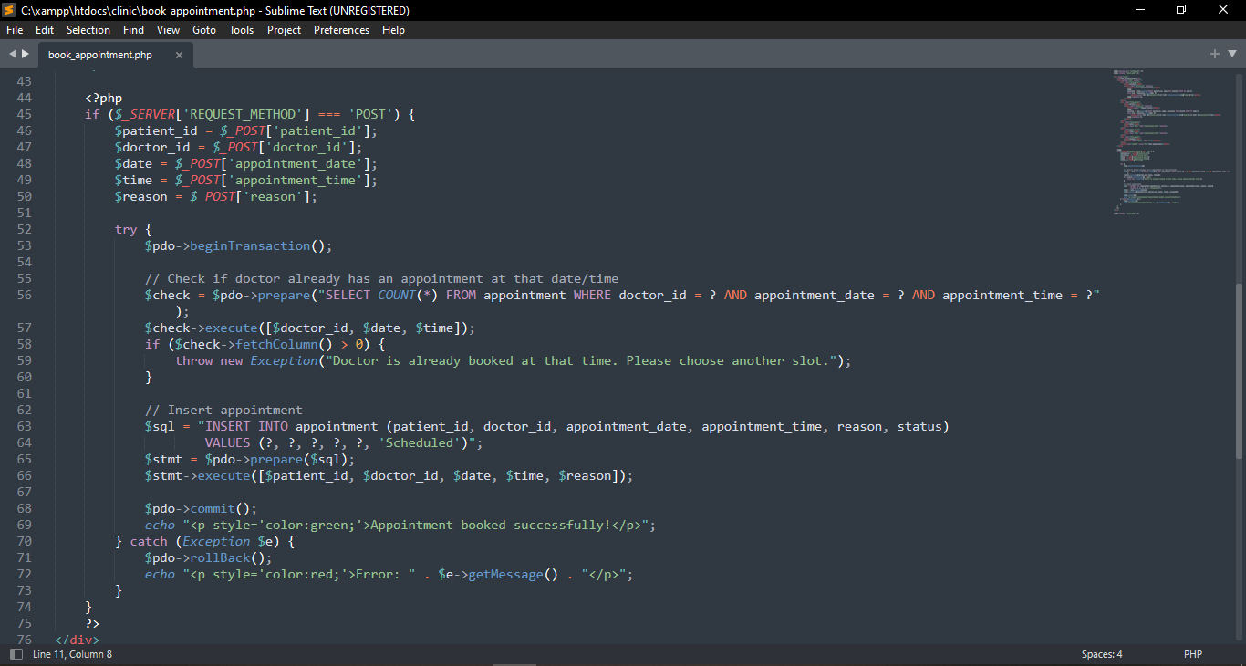
Figure 1: Screenshot of the book_appointment.php code showing $pdo->prepare() and $stmt->execute([...])
Figure 1 shows the code used to book an appointment. You can see the query uses ? placeholders. The actual values are passed as an array to the execute method. This ensures the date, time, and patient details are bound safely. Even if a user tries to inject SQL into the reason field, the prepared statement escapes it harmlessly.
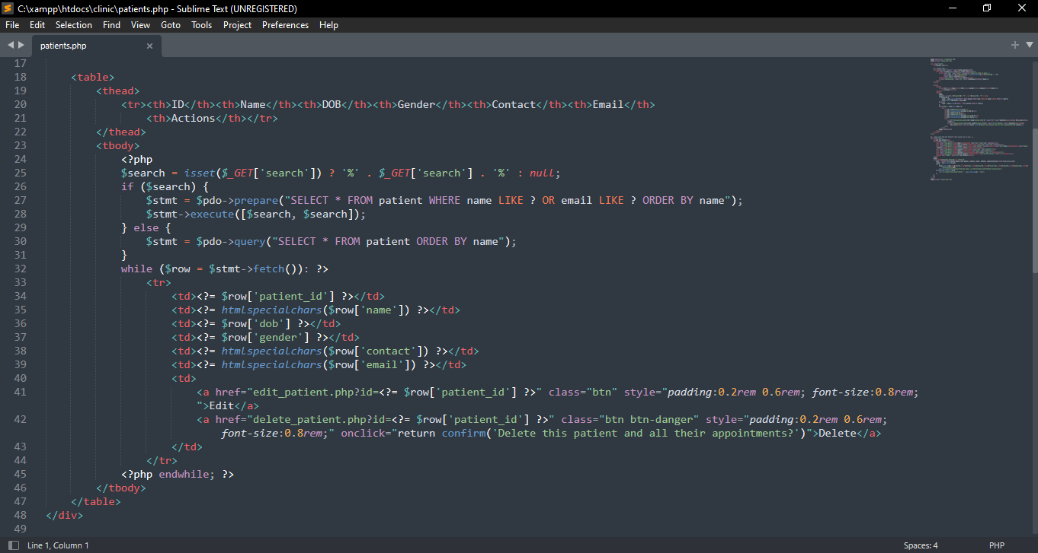
Figure 2: Screenshot of the patients.php code showing the dynamic search filter with $pdo->prepare() and $params = []]
Figure 2 shows the dynamic search feature on the patient's page. The query builds conditions based on user input but notice how every value is added to a parameters array. The final execution binds all these values safely. This means the search function offers flexible filtering and remains completely immune to injection.
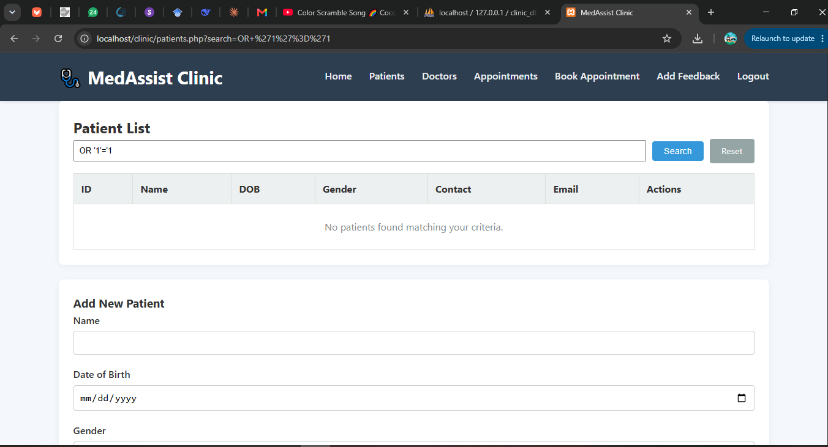
Figure 3: Screenshot of the browser showing the attempt and the result. The URL/search box should contain ' OR '1'='1 and the page should show "No patients found"
To verify the effectiveness of my defenses, I conducted a penetration test using a classic SQL Injection payload. I typed ' OR '1'='1 into the patient search box. Figure 3 shows the result. The system did not execute this as SQL code. It interpreted it as a literal name search. Since no patient has that exact name, the system returned zero results. The page displayed a "No results" message instead of crashing or dumping data. This proves that the prepared statements are blocking the attack entirely.
Aside from the prepared statements, I implemented additional security layers to harden the system. I used input validation on numeric IDs. An example is seen when editing a patient where I used intval($_GET['id']) to ensure only integer values are processed.
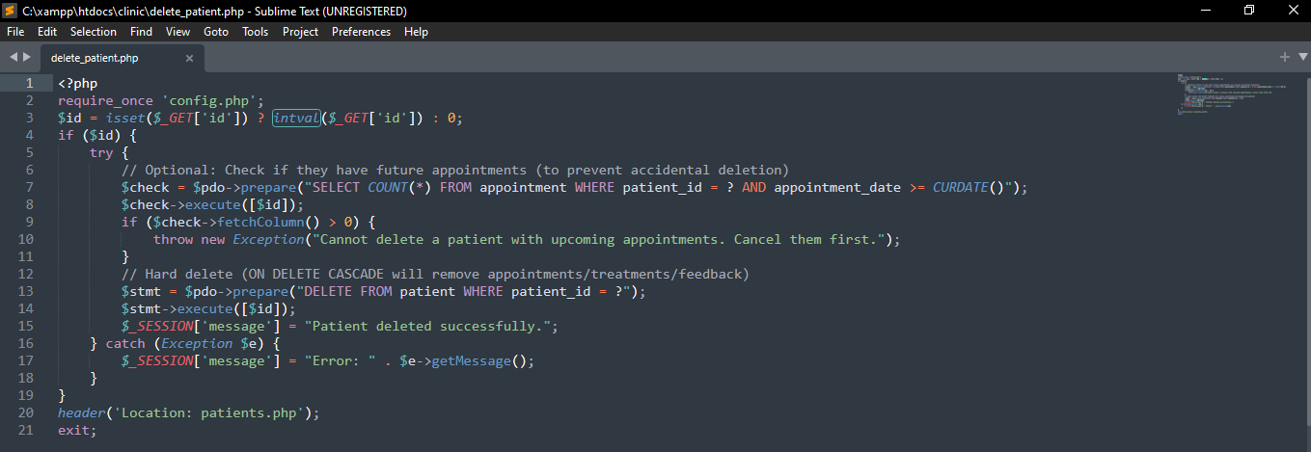
Figure 4: Input validation on numeric IDs
This prevents attackers from inserting malicious strings into the URL for deletion or update actions. For the admin authentication, I used the built-in PHP functions password_hash() and password_verify(). The actual password is never stored in plain text. The “password123” password is stored as a hashed string. This means that even if an attacker gains access to the database, they cannot read the admin password.
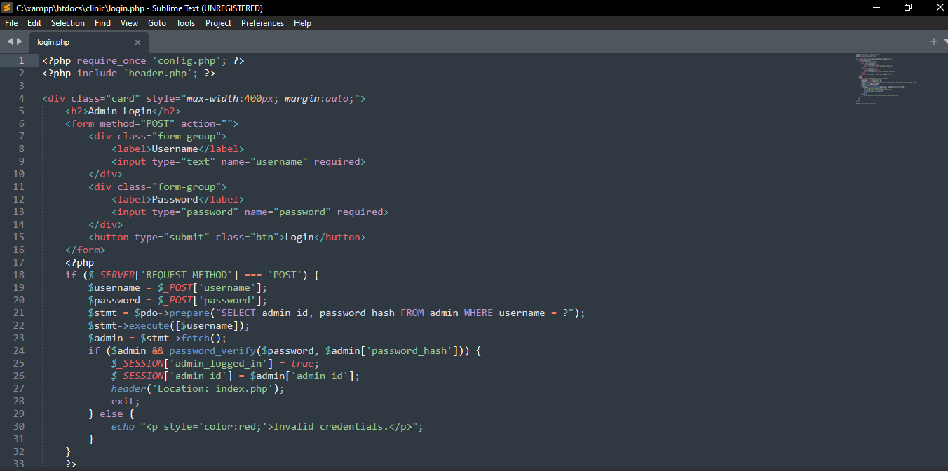
Figure 5: Hashing password using PHP Functions
Furthermore, my booking transaction uses a UNIQUE database constraint combined with BEGIN TRANSACTION and ROLLBACK. This prevents double-booking attacks where a user might try to manipulate timestamps to overload a doctor's schedule. These measures create a resilient and secure web application.
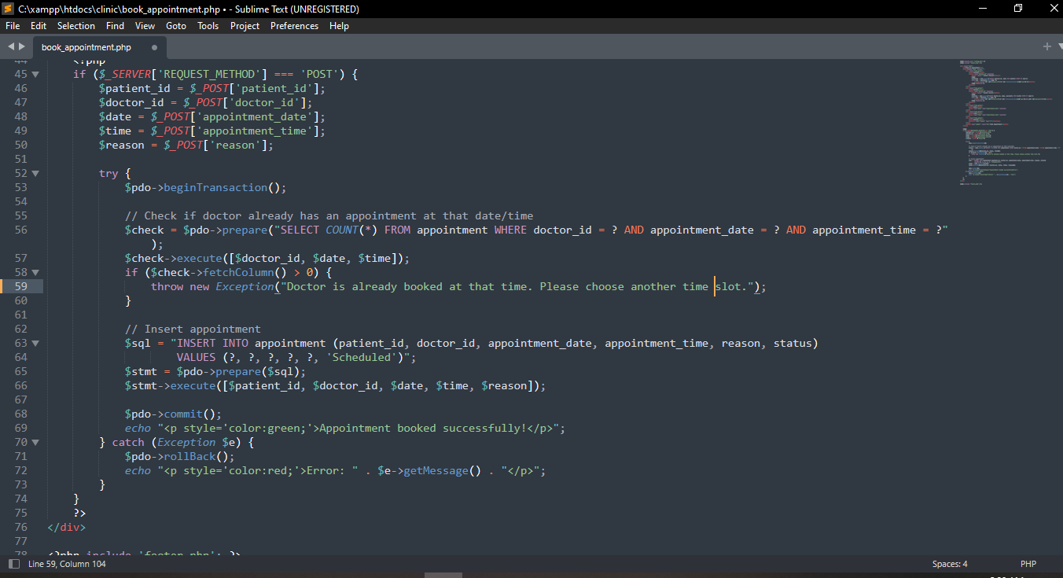
Figure 6: The BEGIN TRANSACTION and ROLLBACK database constraints when booking appointments

