Component 2 - Research Report
Student Name: Olivia Sarpong
Student Number: 2208452
Lecturer Name: Chuen Leung
LCHS4002_BIRM
Digital Skills and Research Methods.

Contents
1. Introduction 3
2. Research design 4
2.1. Research Question 4
2.2. Method 4
2.3. Ethical Considerations 4
3. Results 5
4. Discussion 7
5. Conclusion 10
6. Reference List 11
7. Appendix A – A blank copy questionnaire. 14

HOW STUDENTS USE TECHNOLOGY TO COLLABORATE AT THE UNIVERSITY OF WALES TRINITY SAINT DAVID

Introduction
Education has recently changed from teacher-centred instruction to student-centred instruction, focusing on student participation. The University of Wales Trinity Saint David (UWTSD) is leading the way in the next stage of active, collaborative learning through intelligent technology by utilising a scalable Sony Vision Exchange solution. UWTSD has made considerable infrastructure investments and launched a comprehensive regeneration effort to improve student's educational experiences. With the help of Sony, the transition from conventional lecture halls and auditoriums to a collaborative and interactive setting has been sped up, resulting in new levels of engagement and achievement (Web Development Team UWTSD, 2019).
UWTSD has also partnered with Microsoft, where students will gain knowledge via courses covering data science, artificial intelligence, and cloud computing. Additionally, it will enable students to develop vital non-technical abilities like critical thinking, creativity, communication, and collaboration (Web Development Team UWTSD, 2020 To allow students to use online resources, UWTSD has sought to create a collaborative ecosystem. Education has transitioned from "chalk and talk" to lecturers being facilitators and guides in the learning environment as students learn from one another through collaboration.
Due to the COVID-19 outbreak, universities transited from traditional teaching and learning methods to online ones (Adams, 2020). Online learning can be equally beneficial as in a regular classroom, despite research suggesting using technology to collaborate (Gopinathan et al.,.2022). Recent research has demonstrated that economic factors and computer proficiency impact its effectiveness (Banyard, 2015). Therefore, it is crucial to know the difficulties UWTSD students encounter when utilising technology to improve the assistance the institution may be able to provide. This research investigates the uses and confidence of students using technology to collaborate at UWTSD.

Research design
A research design is a strategy for using empirical data to address the question of your study. Developing a research design involves deciding the broad study objectives and methodology, the type of research design to be used, data collection techniques, data collection protocols to follow, and data analysis techniques. The proper data analysis is done, and the procedures align with the research goals, thanks to a well-planned research design.
  - Research Question
This study seeks to answer the question: Are students confident in using technology to collaborate at UWTSD?
  - Method
The study used questionnaires to collect the data. Questionnaires were chosen because they provide an affordable, effective and quick way to acquire data from any given sample size. These instruments were beneficial in assessing the respondents' views, attitudes, preferences, and behaviour. A sample size of eight respondents who are students of UWTSD was used during the study. The survey was conducted online. The participants were emailed the questionnaires on October 20, 2022, and given two weeks to email the response.
  - Ethical Considerations
One of the most important aspects of the research is its ethical issues. According to Bell and Bryman, the following rules for research ethics are the most important ones (2007). Group C asked the participant if they felt comfortable sharing their email with the group after explaining how the email would be sent. The group gave evidence that study volunteers should never suffer injury. Priority was given to treating research respondents with respect and privacy. Group C assured our respondents that the Group would not require their personal information and would keep their information private and strictly anonymous. The subjects gave their complete consent before the investigation. It was crucial to ensure that research participants' privacy was adequately safeguarded
Additionally, the study data's confidentiality was adequately safeguarded. The confidentiality of the individuals and organisations participating in the research was also ensured. Further, the group avoided making false statements or inflating the research aims, and all relationships, funding sources, and any conflicts of interest were mentioned. For study purposes, the participant was also free not to reply to their emails.

3. Results
3.1 Confidence of Students in Using Technology
Two students said they were extremely confident in using technology. Two students were neutral. Three were somewhat confident, and one was not confident (figure 1.)
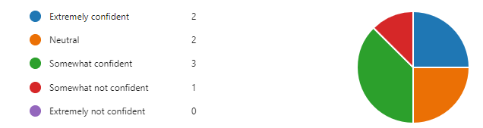
Figure 1 Confidence of UWTSD students in using technology
3.2 Exposure to Technology Tools Before College
Suppose asked if they had ever used technology tools to collaborate before joining UWTSD. Six respondents said yes; the rest had never been exposed to collaboration technology tools before (figure 2).
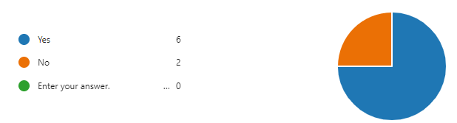
Figure 2 Respondents' exposure to technology before college
3.3 Digital Technology Tools
Most respondents are more comfortable using WhatsApp to collaborate with other students (6), while one said they were more comfortable with Zoom and Ms Word, respectively. None of the respondents liked One Drive or Google classroom (figure 3).
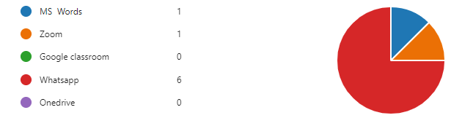
Figure 3 Respondents' comfortability with different technology tools
3.4 Confidence in Collaborating with Other Students
Only two students said they were extremely confident when collaborating with other students. One was somewhat confident, three were neutral, and two were somewhat not confident (figure 4.)
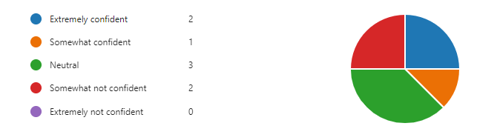
Figure 4 Confidence of respondents when collaborating with other students at UWTSD
3.5 Need for Training in Collaboration Technology
Half of the respondents said they needed additional training in using technology to collaborate, two did not need any training, while another two may need extra training (figure 5)
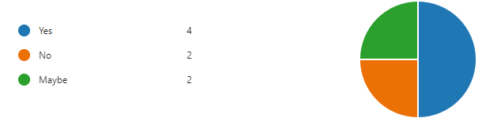
Figure 5 Need for more training on using technology to collaborate by respondents

Discussion
4.1 Confidence of Students in Using Technology
Attitudes affect the confidence of students when using technology. According to Cakir's (2012) findings, positive attitudes motivate students when using technology at the University and give them confidence. Also, students previously exposed to technology in their homes have more confidence when using technology at the University. It has been demonstrated that technology in the classroom enhances student engagement, information retention, and overall exam performance. The fact that instructional technology increases student confidence is one factor in its success because students that are confident in their skills put in more effort and treat learning seriously (Lynch, 2018). Greener and Wakefield (2015) point out that even though university students show a lot of enthusiasm for using technology, many are yet to develop technology confidence. Overall, students use technology to engage with them students, and they are comfortable when learning. However, they need to improve their confidence to achieve more.
4.2 Exposure to Technology Tools Before College
There are various ways to view how students are exposed to ICT in the years leading up to college. First, by their teachers incorporating ICT into the curriculum, students will likely receive ICT exposure at school. Second, when students finish their schoolwork at home or use ICT for recreational activities like playing games or using social media, they are exposed to it (Blackwell et al., 2014). Third, students may come into contact with ICT in a variety of contexts, such as gaming events, exhibitions, public libraries, or even just by utilising their mobile devices for any digital activity, such as gaming, web browsing, activity on social media and more (Jones et al., 2010). The ICT exposure in all those settings helps students gain enough exposure to become ICT literate and smart enough to handle the more advanced ICT tasks required in online learning models (Boudalia, 2018).
4.3 Digital Technology Tools
Most students at UWTSD use WhatsApp for collaboration because of the best social media platform for sharing information between teachers and students and students and students. It can be used as a social media platform for students to exchange non-copyrighted content. The author cannot stop it from being forwarded to anyone else after posting it. We have made several. Students can also create various WhatsApp groups to utilize its features (Sunil, 2021) fully. Zoom is also popular because students can hold meetings and discussions from multiple areas. They can also share their presentations through screen sharing, and the site is free, which is attractive to students (Mu'awanah et al., 2021). MsWord, on the other hand, is popular because students can collaboratively create a document and edit the document through co-authoring features.
On the other hand, Pappas (2015) explains that many students avoid google classroom in collaborating with other students because it makes sharing content difficult. Students can't share their work with their peers unless they "own" the paper. If they want to share a document with classmates, they must still accept sharing choices, which will be problematic. One Drive also has restrictions on sharing, which discourages students.
4.4 Confidence in Collaborating with Other Students
More than half of the respondents showed that they lacked confidence in collaborating with other students. Students must keep in mind that successful collaborative learning is not always straightforward. It may take time for everyone involved, and it is not always easy to switch to a new learning experience. The transition to collaborative approaches should be seen by students as a shared adventure. As they advance, they will continually assess and enhance approaches to gain knowledge of how cooperation works most effectively, fostering confidence in working with others.
Such flexibility is provided by a collaborative approach, which enables teachers to group students in the most effective way and then modify and reorganise those groups as you they go. A variety of learning models that can be adapted for use in various settings are provided by collaboration. Through careful teamwork, all students c be an recognise and value their contributions (Laal & Ghodsi, 2012). It empowers students to learn from and teach others, including their teachers and fellow students.
4.5 Need for Training in Collaboration Technology
Half of the respondents said that they needed training in collaboration technology. Teachers who have received training in the collaborative method can arrange students together optimally and change and adapt groups as needed. A variety of learning models are available for collaboration training that may be customised for small teams, multiple teams, or entire classes. Training enables all students to recognise and value their own contributions. It empowers students to share their expertise with others, including their instructors and classmates, and to learn from them (Gordon, 2019).
- Conclusion
This study shows that students use various collaboration technology tools at UWTSD. These tools include MS word, Zoom, Google classroom, Whatsapp, and On drive, the most popular ones being WhatsApp and Zoom. Students, however, showed low confidence in using technology and collaborating with others. Therefore, UWTSD must implement various training platforms for collaboration technology, increase chances for students to collaborate with their peers, and encourage the integration of coloration technology across the courses to improve student technology and collaboration confidence.

Reference List
Lynch, M. (2018) 9 ways that technology boosts student confidence in the classroom, The Edvocate. Available at: https://www.theedadvocate.org/9-ways-technology-boosts-student-confidence-classroom/ (Accessed: November 17, 2022).
Blackwell, C.K., Lauricella, A. and Wartella, E. (2014) [PDF] factors influencing digital technology use in early childhood education: Semantic scholar, undefined. Available at: https://www.semanticscholar.org/paper/Factors-influencing-digital-technology-use-in-early-Blackwell-Lauricella/a4afd0b3eb2f4a3ac66033e751ce4043bc82b411 (Accessed: November 17, 2022).
Boudalia, M. (2018) Effect of Early Exposure to Technology on Student Satisfaction with Online Education, Walden Dissertations and doctoral studies. Available at: https://scholarworks.waldenu.edu/dissertations/ (Accessed: November 17, 2022).
Cakir, O. (2012) "Students' self confidence and attitude regarding computer: An international analysis based on computer availability and gender factor," Procedia - Social and Behavioral Sciences, 47, pp. 1017–1022. Available at: https://doi.org/10.1016/j.sbspro.2012.06.772.
Gordon, K. (2019) Student use of technology for collaboration, DigitalCommons@WayneState. Available at: https://digitalcommons.wayne.edu/oa_dissertations/2203/ (Accessed: November 17, 2022).
Greener , S. and Wakefield, C. (2015) Developing confidence in the use of digital tools in teaching. Available at: https://www.researchgate.net/publication/281672801_Developing_confidence_in_the_use_of_digital_tools_in_teaching (Accessed: November 17, 2022).
Jones, C. et al. (2010) "Net generation or digital natives: Is there a distinct new generation entering university?," Computers & Education, 54(3), pp. 722–732. Available at: https://doi.org/10.1016/j.compedu.2009.09.022.
Laal, M. and Ghodsi, S.M. (2012) "Benefits of collaborative learning," Procedia - Social and Behavioral Sciences, 31, pp. 486–490. Available at: https://doi.org/10.1016/j.sbspro.2011.12.091.
Mu'awanah, N., Sumardi, S. and Suparno, S. (2021) “Using zoom to support English learning during covid-19 pandemic: Strengths and challenges,” Jurnal Ilmiah Sekolah Dasar, 5(2), p. 222. Available at: https://doi.org/10.23887/jisd.v5i2.35006.
Pappas, C. (2021) Google classroom review: Pros and cons of using google classroom in eLearning, eLearning Industry. Available at: https://elearningindustry.com/google-classroom-review-pros-and-cons-of-using-google-classroom-in-elearning (Accessed: November 17, 2022).
Sunil , P.G. (2021) WhatsApp as a collaboration tool in Education, LinkedIn. Available at: https://www.linkedin.com/pulse/whatsapp-collaboration-tool-education-sunil-p-g-1d/ (Accessed: November 17, 2022).
Web Development Team UWTSD (2019) UWTSD and Sony pioneer the next generation of active, collaborative learning through Smart Technology, Press Releases 2019 | University of Wales Trinity Saint David. Available at: https://www.uwtsd.ac.uk/news/press-releases/press-2019/uwtsd-and-sony-pioneer-the-next-generation-of-active-collaborative-learning-through-smart-technology.html (Accessed: November 16, 2022).
Web Development Team UWTSD (2020) Microsoft and UWTSD share vision for digital transformation in higher education, Press Releases 2020 | University of Wales Trinity Saint David. Available at: https://www.uwtsd.ac.uk/news/press-releases/press-2020/microsoft-and-uwtsd-share-vision-for-digital-transformation-in-higher-education.html (Accessed: November 16, 2022).

- Appendix A – A blank copy questionnaire.
- How confident are you in using technology?
Extremely confident
Neutral
Somewhat confident
Somewhat not confident
Extremely not confident

- Have you used technology tools to collaborate before joining UWTSD? If yes, state which one>

Yes
No
Enter your answer.

- What digital technology tools are you most comfortable using?
MS Words
Zoom
Google Classroom
WhatsApp
OneDrive

- How confident are you with collaborating with other students in UWTSD?
Extremely confident
Somewhat confident
Neutral
Somewhat not confident
Extremely not confident

- Do you feel like you would need additional training to use technology to collaborate?
Yes
No
Maybe

