Module: Introduction to Web and Database Concepts (ACCA4023)
Assignment: HTML & CSS Web Development
Student Name: Rao M A Siddique
Student ID: 2531847
Course: Computing skills for workplace
Submission Date:14-08-2026

Introduction (Abstract)

The fitness and health website Fitness Hub is a simple website that provides users with information about exercise, workouts, nutrition and healthy living. HTML is used in the content structure and CSS is used to make the website attractive, consistent, and user-friendly. It can be used on both desktop and mobile devices.

Requirements

The main requirements of the Fitness Hub website are:

* Use HTML5 to create multiple web pages.
* Use CSS to provide consistent styling and layout.
* Provide navigation links between pages.
* Provide fitness, workout, and health information.
* Use images and headings to make the content attractive.
* Make the website responsive for all screen sizes.
* Use accessible HTML elements (headings, labels, and alternative text for images).
* Validate the HTML and CSS code using online validation tools.

Implementation

The Fitness Hub website was developed using HTML5 and CSS3.

The main pages include:

Home Page: Introduces Fitness Hub and provides an overview of the website.
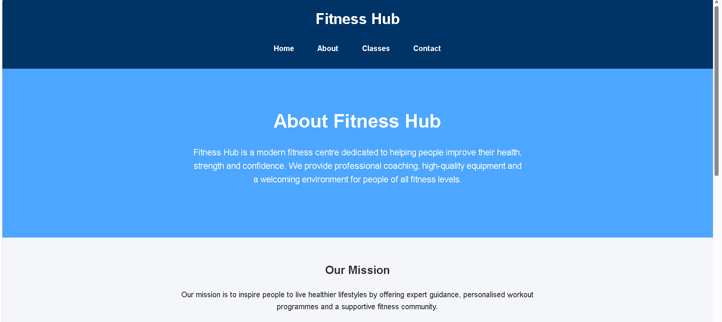

Classes Page: Provides information about classes schedule.
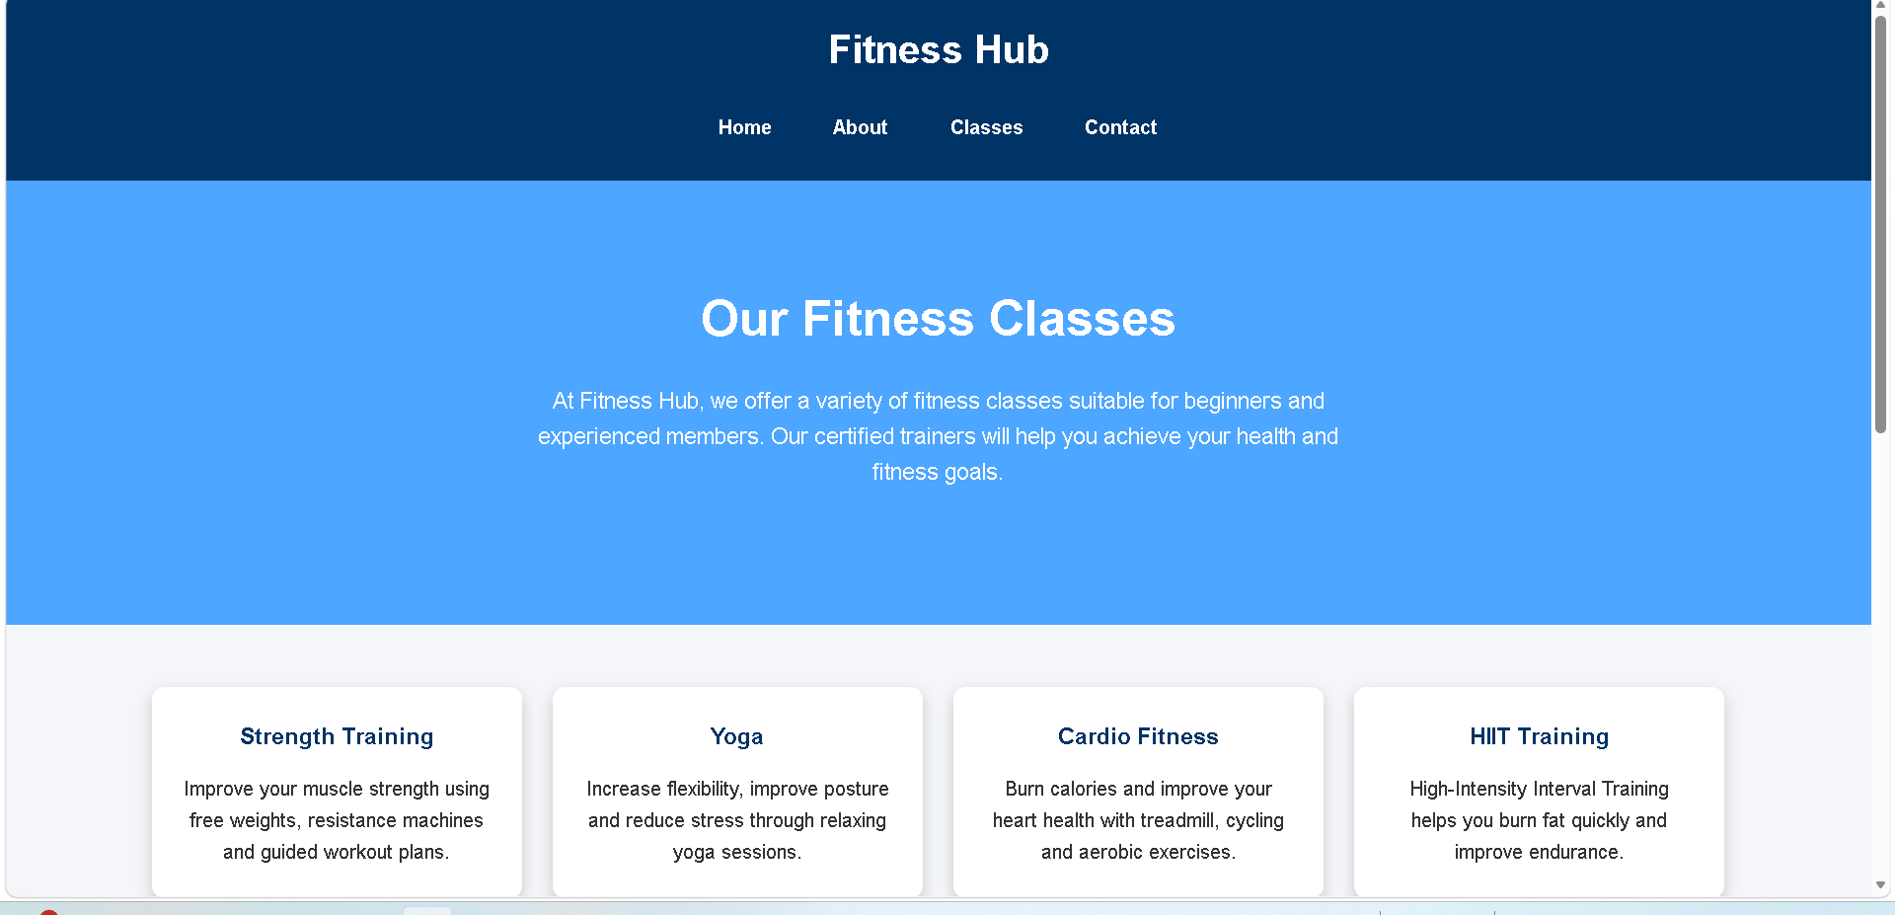
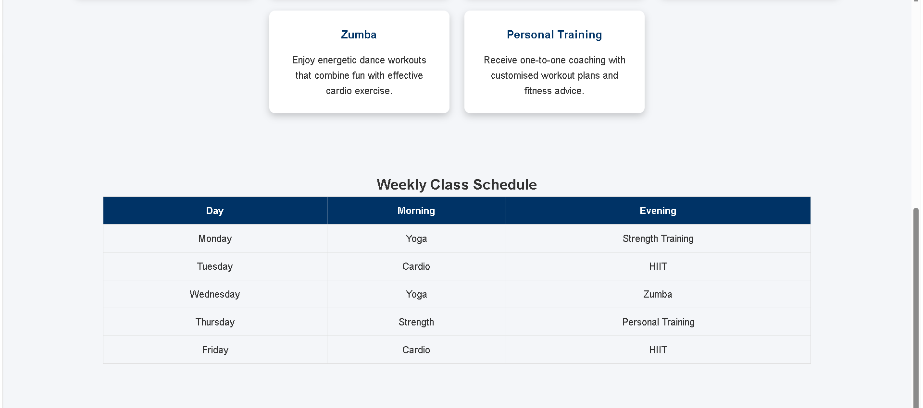

About Page: Explains the purpose of Fitness Hub.
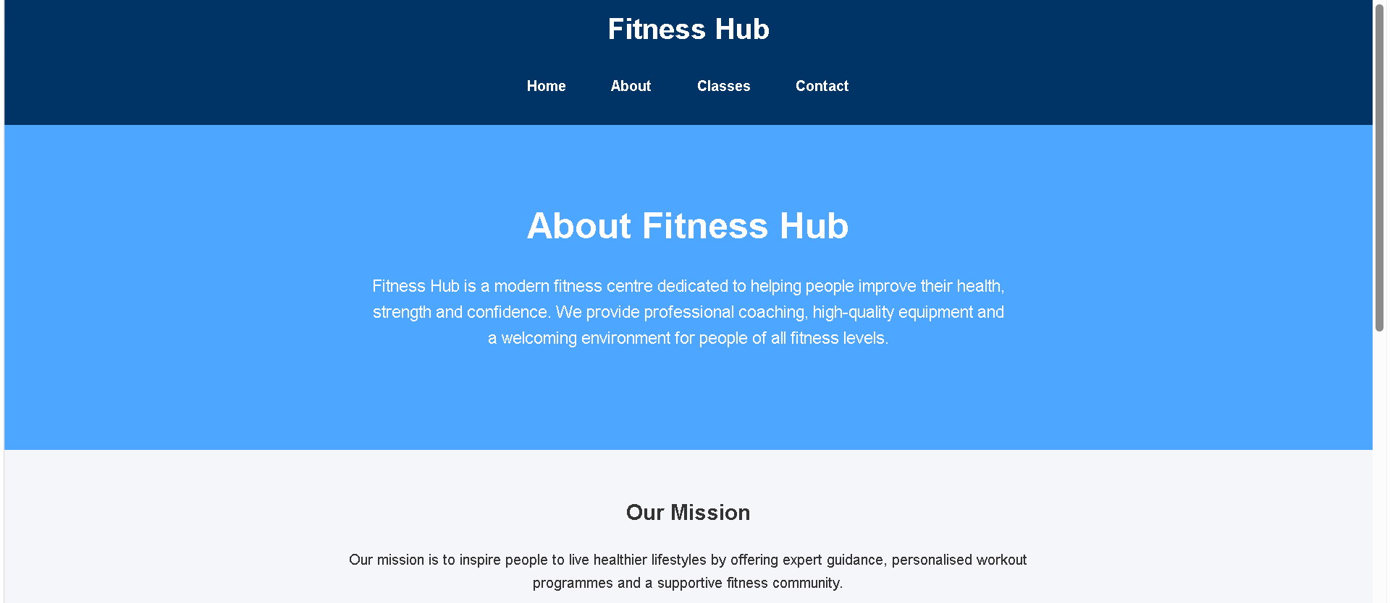
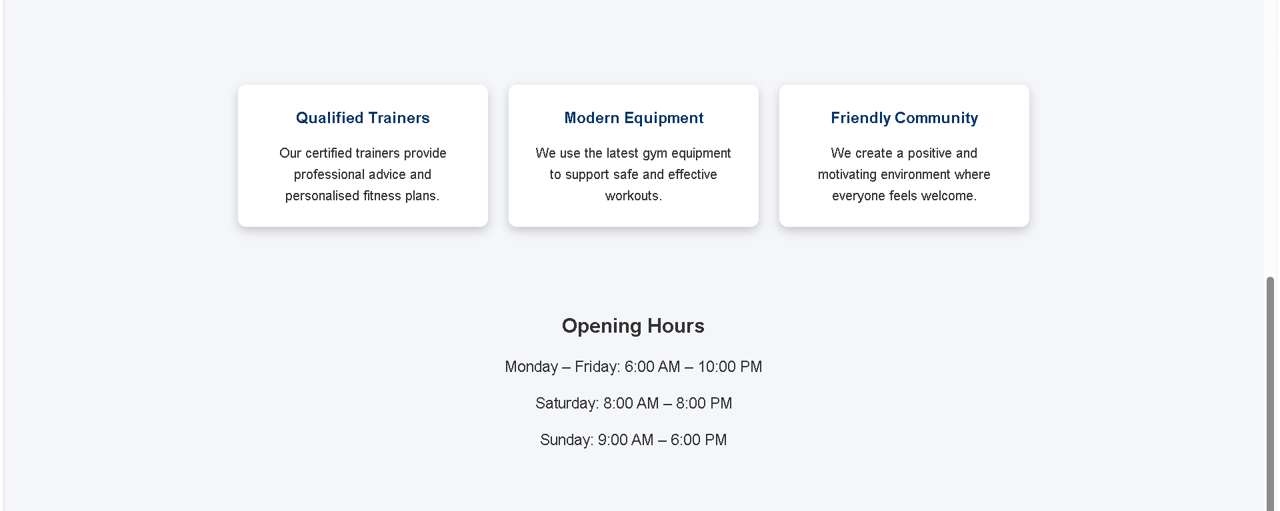
Contact Page: Allows users to find contact information or send an enquiry.
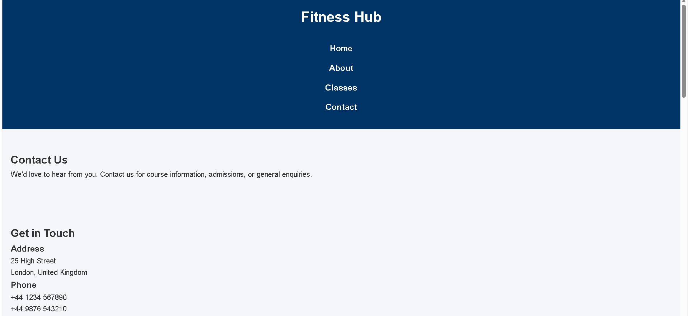
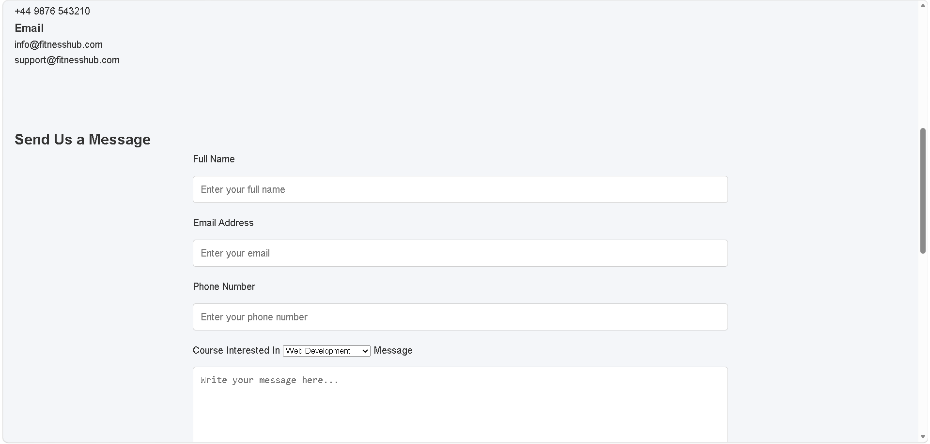
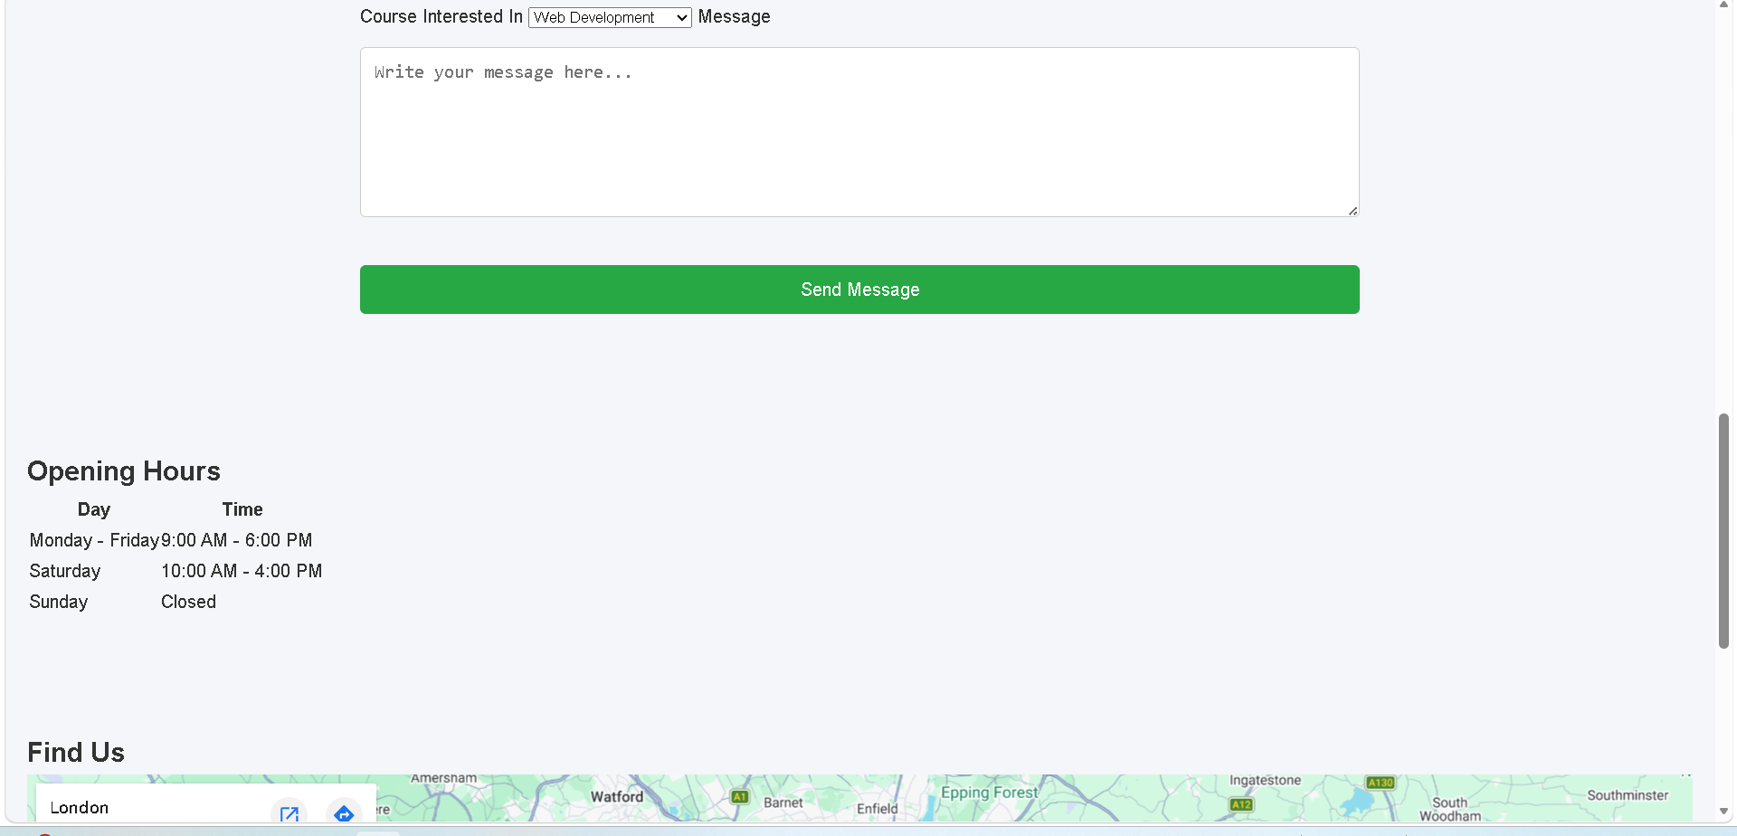
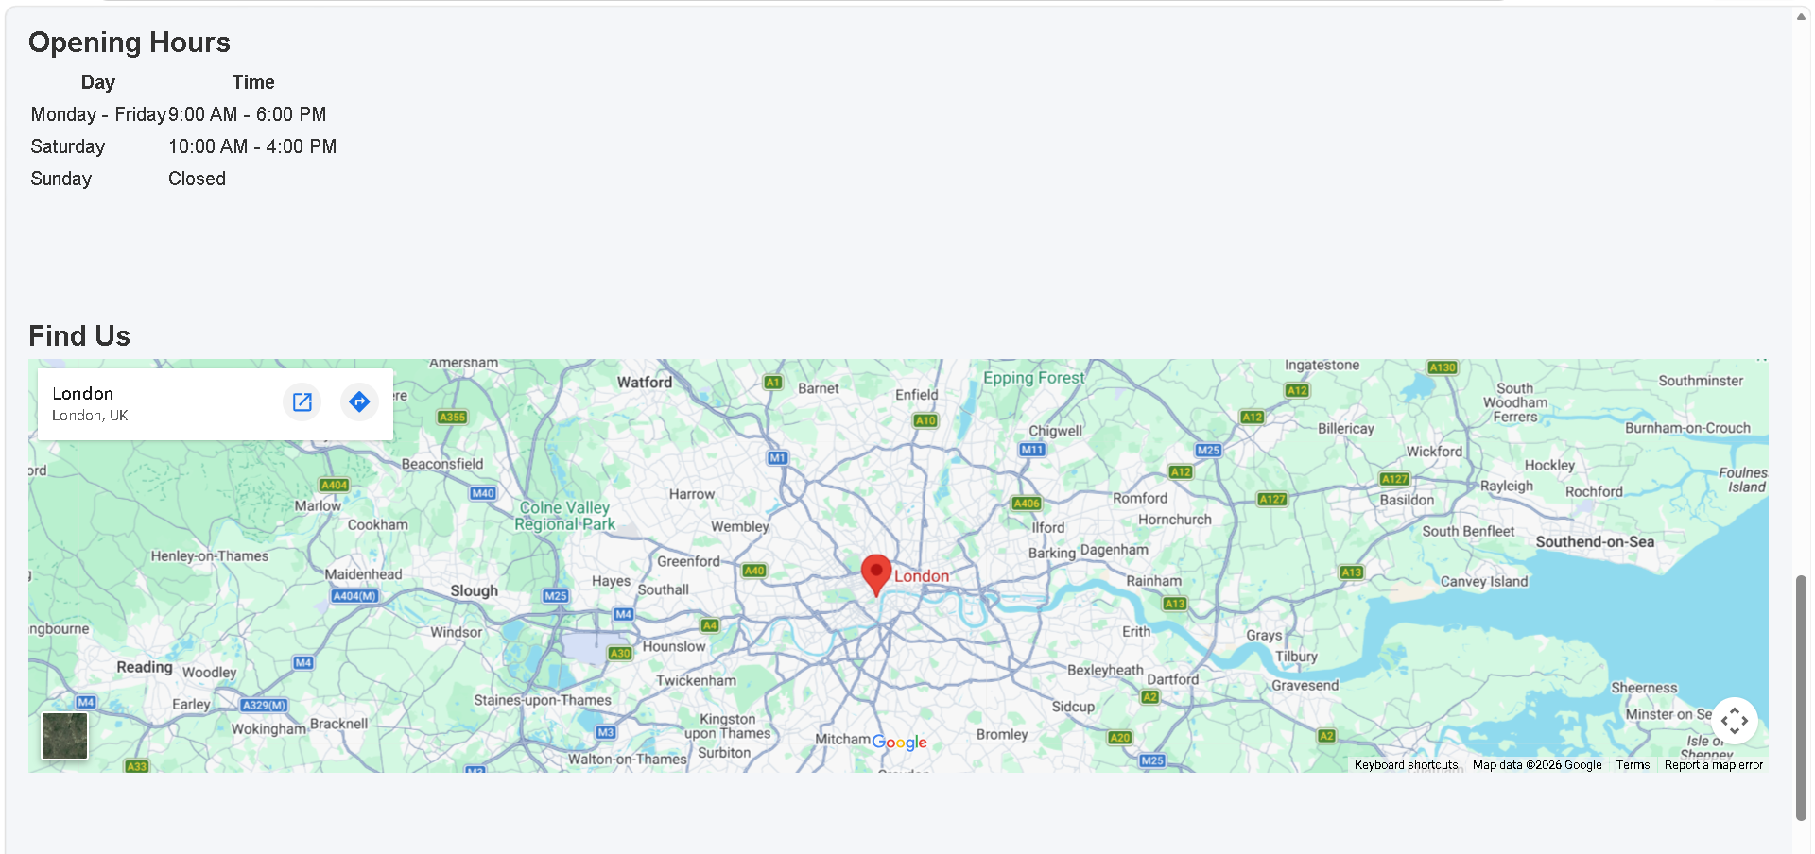

CSS was used for the navigation bar, colours, fonts, buttons, images, cards, and page layout. Responsive CSS techniques were used to improve the website on mobile devices.

Screenshots: Added screenshots of each completed website page above here.

Validation: HTML and CSS were checked using the W3C validation tools. Any errors found during the validation process were corrected by checking the HTML structure, closing tags, CSS syntax, and missing attributes.

Evaluation
Research

Usability

Usability of a website is to make it easy to navigate and use. Fitness Hub has clear navigation, readable text, clear headings, and consistent page layout so that users are able to find the information quickly.

Accessibility

Accessibility allows people with different abilities to use the website. The website uses meaningful headings, alternative text for images, readable text, and appropriate colour contrast. These features support WCAG 2.1 accessibility principles.

SEO

Search Engine Optimisation (SEO) helps search engines understand and rank website content. Fitness Hub uses descriptive page titles, headings, relevant fitness keywords, meaningful image alt text, and structured HTML.

Website Evaluation

Usability & Utility

The website is easy to navigate and the fitness and health information is very useful. The navigation menu is consistent across all the pages so that users can move around the website easily.

SEO Techniques Used

The website uses:

* Descriptive page titles.
* Relevant headings.
* Fitness-related keywords.
* Descriptive image alt text.
* Semantic HTML elements.
* Clear and relevant page content.

Accessibility (WCAG 2.1)

Fitness Hub follows WCAG 2.1 principles in terms of readable content, alternative text for images, clear navigation, and suitable colour contrast. The website is designed to be usable with different screen sizes.

Website Comparison

Fitness Hub can be compared with other fitness websites based on:

Fitness Hub has a simple and user-friendly interface. Professional fitness websites may have more advanced features, but Fitness Hub meets the basic requirements for usability, accessibility, SEO, and responsive design.

Conclusion
The Fitness Hub website demonstrates the use of HTML and CSS for web development. It provides fitness and health information in a simple and attractive interface. This project also demonstrates the concepts of responsive web development, accessibility, usability, and SEO. Validation and testing helped flag and correct coding errors.

References (IEEE Format)

Use academic and reliable web sources in IEEE format. Examples:

[1] W3C, “Web Content Accessibility Guidelines (WCAG) 2.1,” World Wide Web Consortium.

[2] W3C, “HTML5,” World Wide Web Consortium.

[3] W3C, “CSS Specifications,” World Wide Web Consortium.

[4] Google, “Search Engine Optimization (SEO) Starter Guide,” Google Search Central.

Appendices

Appendix A – HTML Code

Include the complete HTML code for all Fitness Hub pages.

Appendix B – CSS Code

Include the complete CSS stylesheet used to design the website.

Appendix C – Validation Results

Include screenshots or results from the HTML and CSS validation tools showing that coding errors were checked and corrected.

