International Meetings Management for the Hotel Industry

IONEL BABACHE
2241659
KATHRYN FLYNN
BMIH6007

LEVEL 6
Summer Term 2025

AI Acknowledgement:

I conﬁrm that I have not used any AI tools in the research and creation of this assignment. I conﬁrm that I have not presented any AI generated materials as my own work. I conﬁrm I have copies of my drafts, notes, and other resources I used, which I may be asked to provide in evidence.

Slide 1: Title Slide

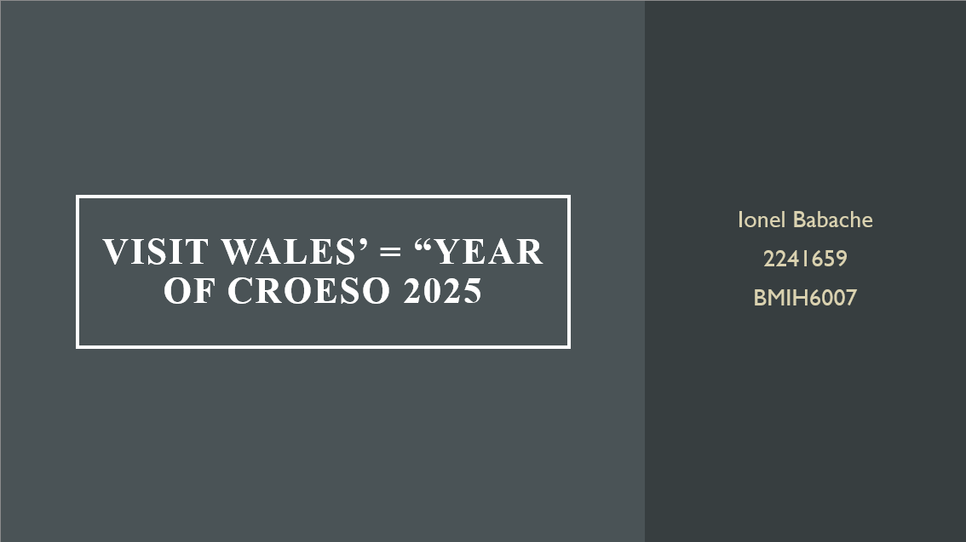

Slide 2: Event Content and Context
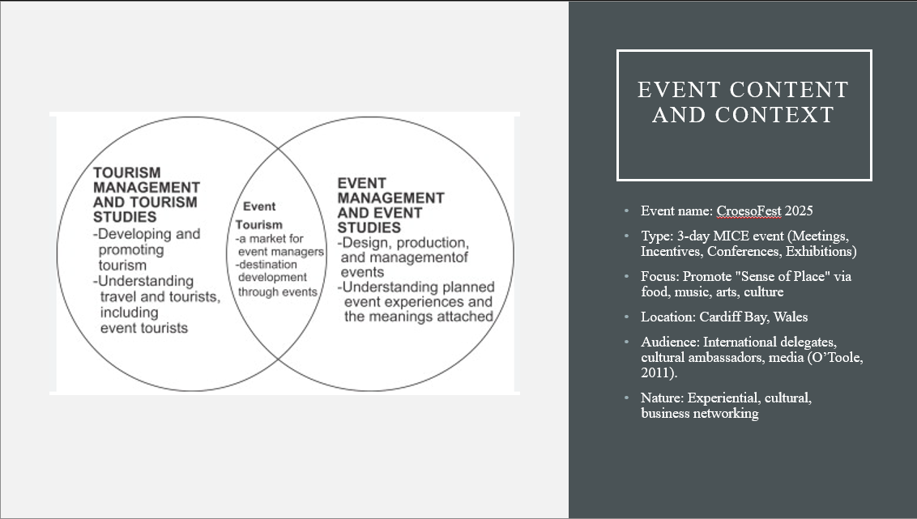
Speaker’s Notes:
The Global Culture & Cuisine Festival is happening over three days as a MICE event and will also celebrate the "Year of Croeso 2025" by showcasing food, music, and interactive exhibitions from cultures around the world (Getz, 2025). It combines the professional elements of a conference with the immersive touristic appeal of a cultural festival. Taking place in Cardiff Bay, it embodies the spirit of hospitality in Wales in order to attract the interest of international visitors and fits in with the national tourism strategies that promote inclusivity and richness in culture.
Slide 3: Background Research – Croeso 2025 &amp; Wales’ Offerings


Speaker Notes:
Visit Wales chooses the main thread of that value and moves from 2025 into emphasising core values under the growing tent of heritage, landscape, and food tourism (Rhodes II and Hannum, 2024). Government funding is strong for events that take place around culture or communities. Post-COVID, demand for experiential travel continues to grow. If the said event takes place in Wales, it would help the destination ride on these trends and issues toward becoming a major player in warm, sustainable, culturally rich travel.

Slide 4: Market Factors – Target Market

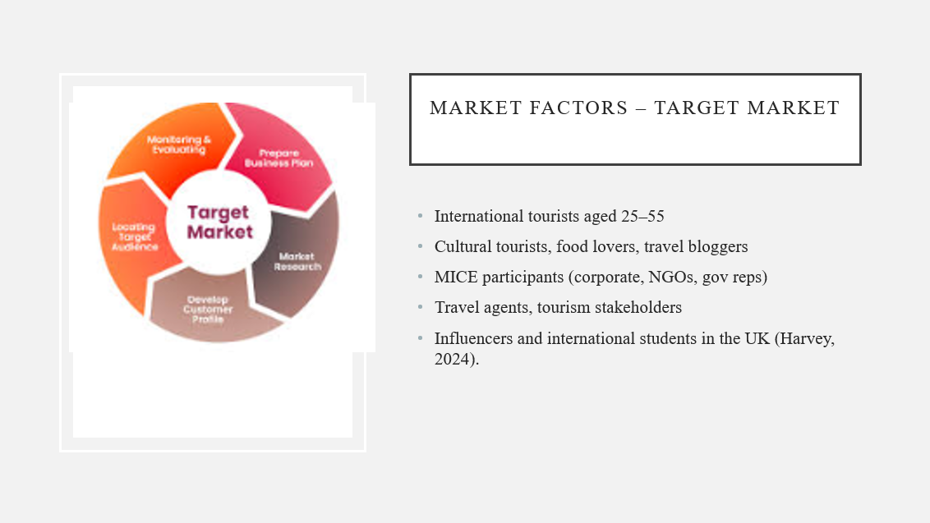

Speaker Notes:
The festival focuses on cultural wanderers aged twenty-five to fifty-five, among them tourists, influencers, and corporate members. International students, cultural representatives, and culinary specialists should attract these groups. These groups actively participate in immersive and experiential events (Harvey, 2024). The combination of Cardiff's accessibility plus the uniqueness of Wales gives the event the ability to break through into both leisure and MICE sectors, therefore increasing participation and visibility for Visit Wales' hospitality values.

Slide 5: Market Factors – Demand
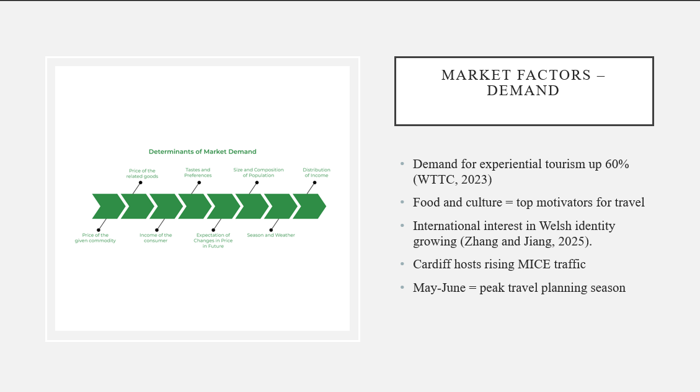

Speaker Notes:
Experiential tourism is witnessing unprecedented growth now, and travelers now craving deeper culture-based experiences (Zhang and Jiang, 2025). Events that feature food and tradition are well-attended. Indications suggest a worldwide demand increase in experiential tourism by about 60%. Such an event can, therefore, gain much interest with Cardiff's rising profile and its growing role in the MICE industry. Holding it in early summer will take the peak demand, thereby encouraging early commitment from travel planners and participants.

Slide 6: Market Factors – Supply and Competition
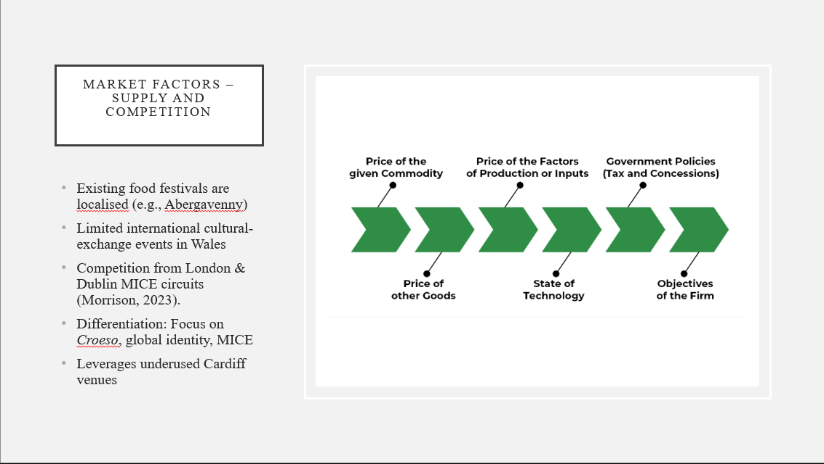

Speaker Notes:
While Wales has a number of food festivals, they are generally much more smallscale and local in focus. There are no truly global MICE-type events-cum-business-cum-culture events out there. The flagship competition would be events in London and Dublin though this event would benefit from the Croeso and multicultural exchange angle. Wales will then be marketed as a welcoming international destination creating great distinction to draw both domestic and international audiences (Morrison, 2023).

Slide 7: Market Factors – Marketing Strategy
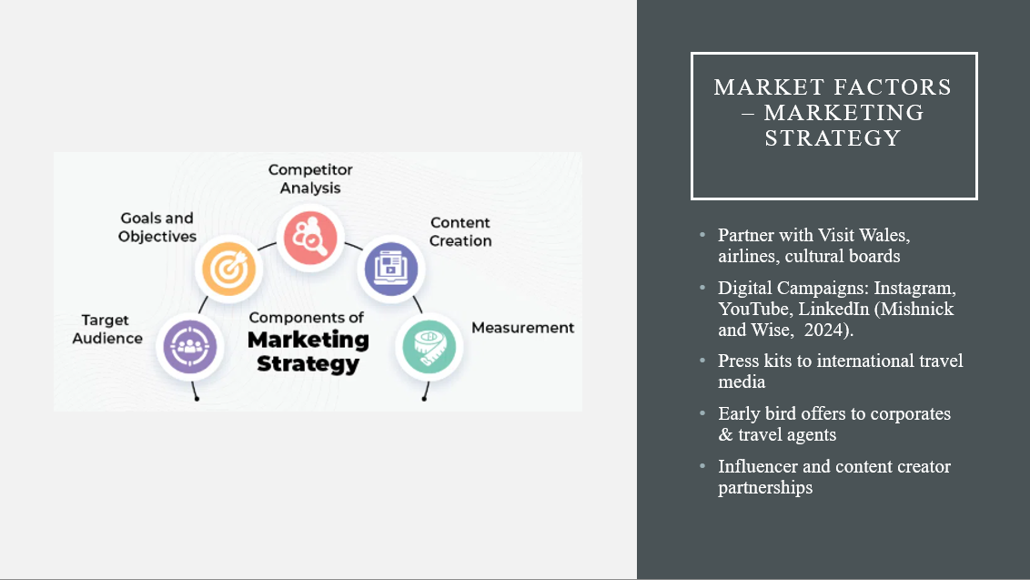
Speaker Notes:
Marketing will take a blended approach, integrating digital, influencer, and partnership strategies. Visibility will be enhanced via collaborations with Visit Wales, airlines, and cultural embassies. Event teasers will be rolled out on social media, especially Instagram, YouTube, and LinkedIn. Travel bloggers and influencers will be invited to raise buzz. Finally, some early bird discounts and media kits for travel agents will help to generate interest and secure early bookings for B2B and B2C audiences (Mishnick and Wise, 2024).

Slide 8: Operational Factors – Venue Availability

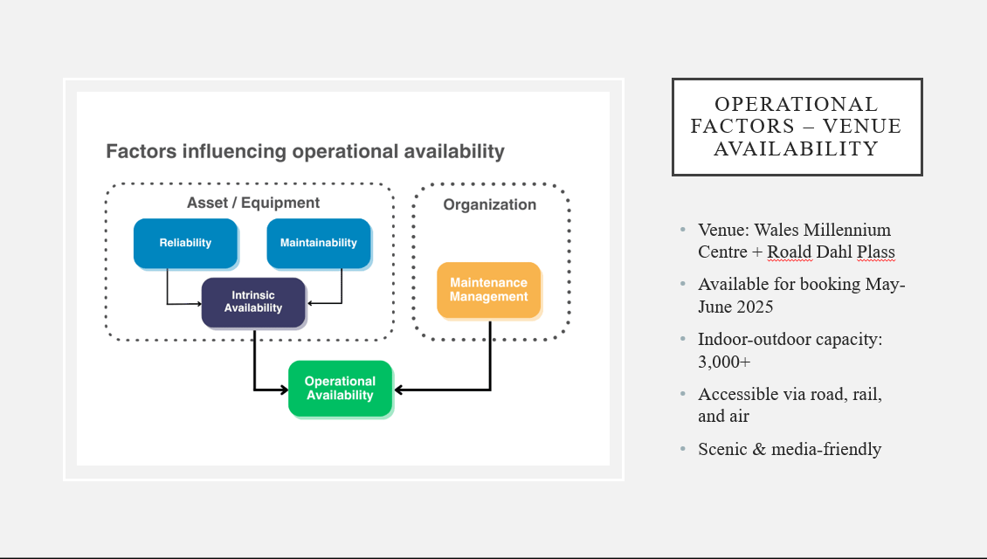

Speaker Notes:
There are plans for the Wales Millennium Centre and Roald Dahl Plass as potential venues for May and June of 2025. The indoor and outdoor intermix spaces provide flexibility for a multitude of conference events, including performances (Ike et al., 2023). Location-wise, the place is accessible through public transport and overlooks some gorgeous views, which is another consideration for marketing. Both venues have previously been utilised for large-scale events, thus satisfying our requirement with both capacity and technical specifications while reflecting Wales's rich cultural hub.

Slide 9: Operational Factors – Staffing & Skills

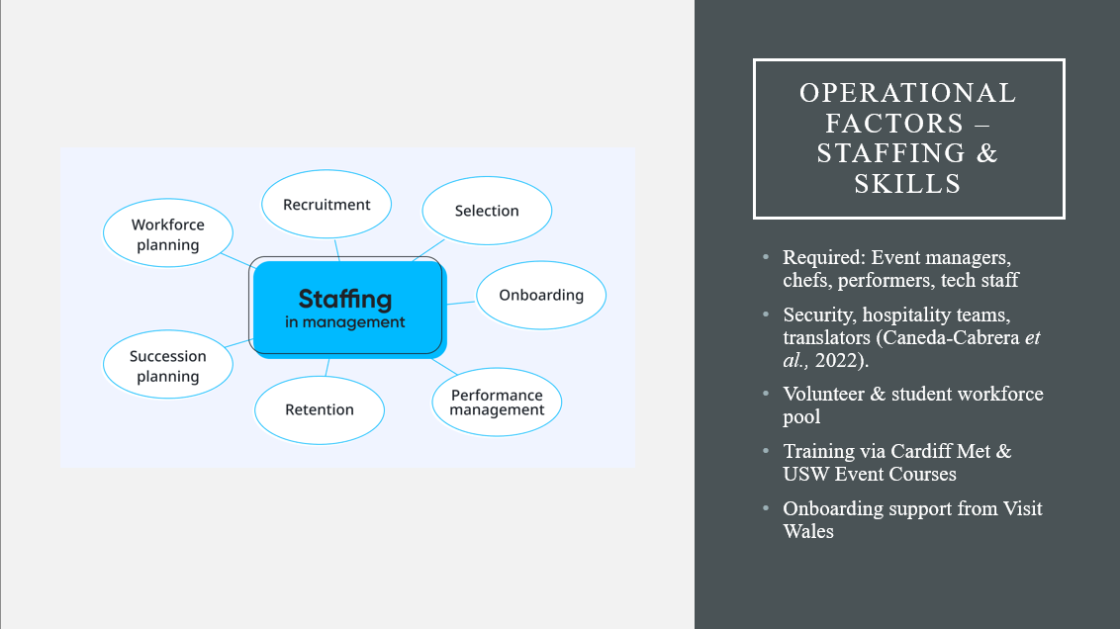
Speaker Notes:
A diverse set of personnel will be deployed for the event, including event coordinators, AV technicians, security personnel, translators, chefs, and volunteers. Universities in Wales such as Cardiff Met offer a course in event management, producing a skilled student workforce. Local agency partnerships assure recruitment of seasoned professionals (Caneda-Cabrera et al., 2022). Training will include intercultural awareness and service excellence to be in line with “Croeso.” A thorough and well-thought-out onboarding process will provide the proficiencies needed to ensure an uninterrupted and professional guest experience.

Slide 10: Operational Factors – Resources Needed
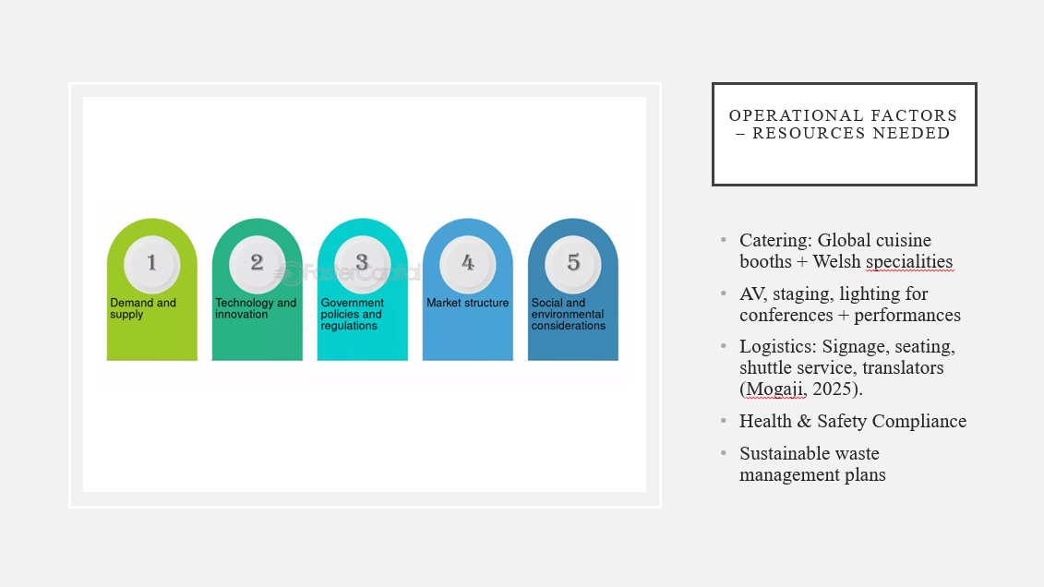
Speaker Notes:
The resource requirements include the international catering needs, AV equipment, stage design,
seating layout, multilingual signage, and waste management. Visitor logistics will be conducted
by local parking and shuttle services. Health and safety standards to meet those for public events
will be employed. Local suppliers will be used for sustainability (Mogaji, 2025).The event will
also focus on aspects like being accessible, visually appealing, and ensuring smooth transitions
between business and entertainment zones that are all harmonising with principles of Welsh
hospitality.

Slide 11: Financial Factors – Predicted Costs
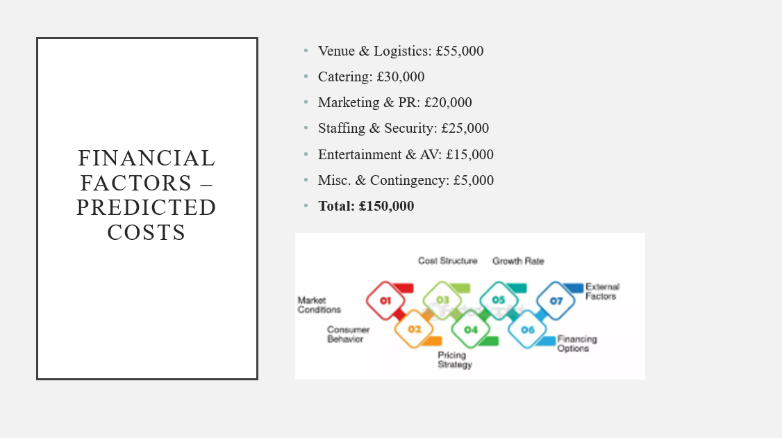
Speaker Notes:
The total event cost to be about £150,000. Major expenses include venue hire, catering,
marketing, staffing, and entertainment. These costs reflect the scale of a professional, truly
international MICE event. A £5,000 contingency is included to manage unforeseen requirements.
Each cost category supports basic objectives of providing a quality, immersive experience. This
is a realistic budget ensuring high specifications but one that will also satisfy targets for financial
sustainability (Pérez et al., 2022).

Slide 12: Financial Factors – Revenue & Funding

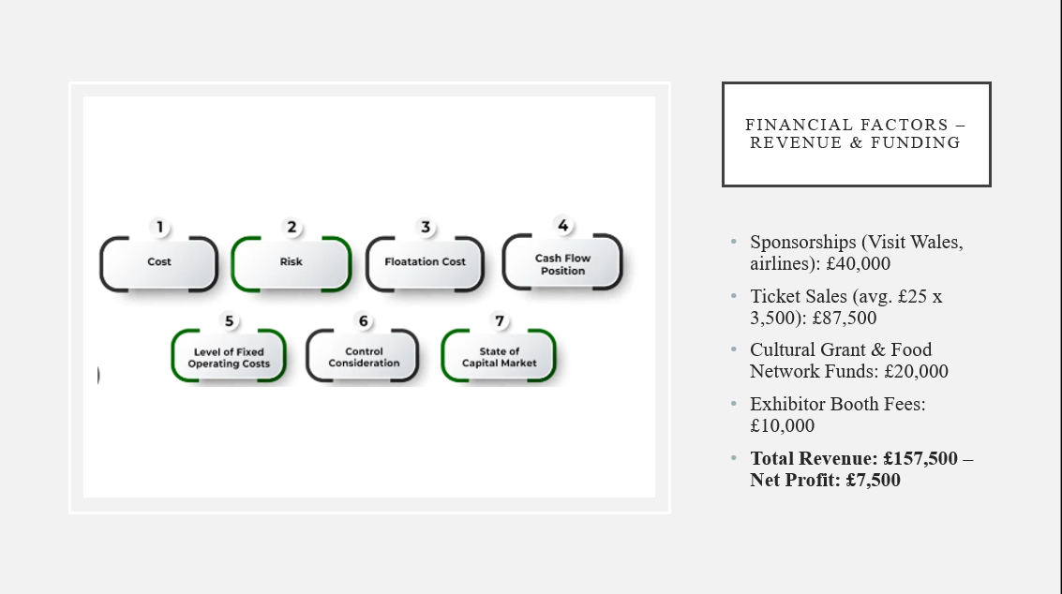

Speaker Notes:
The forecast revenue is £157,500, ensuring a slight net profit of £7,500. Sources of income are
sponsorships, grants, ticket sales, and fees from exhibitors. Core funding comes from Visit
Wales and corporate sponsors, while cultural grants support community inclusion. It will sell
tickets with an affordable average price of £25. This is a multi-channel strategy for revenues to
make sure the event is viable financially and does not run at a loss while promoting access and
profitability (Zheng et al., 2025).

Slide 13: Feasibility Summary
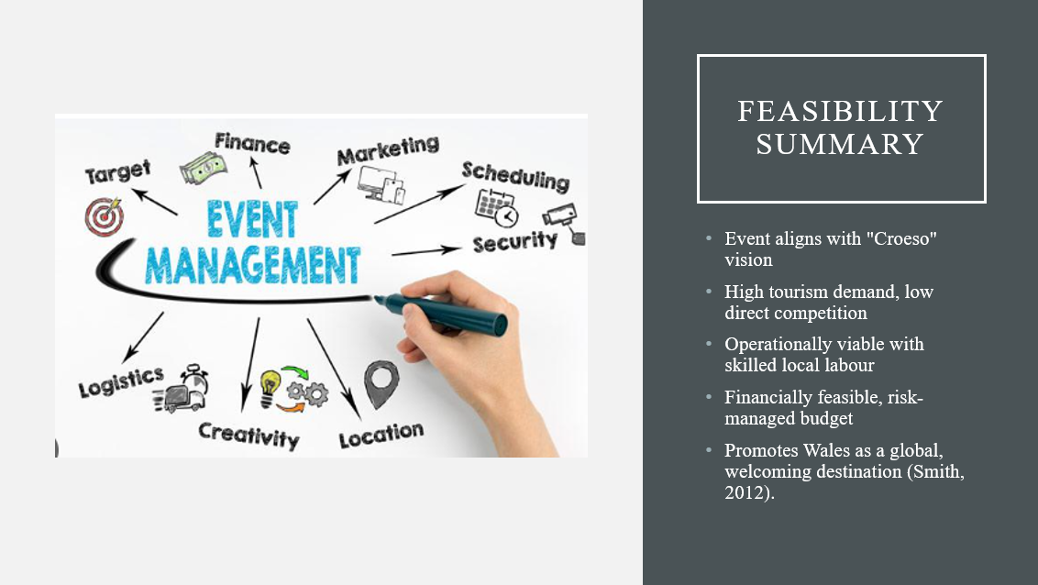
Speaker Notes:
To cut a long story short, this event is realisable and fits the national goals. Market study clearly
manifest that demand and competitiveness is low. Operationally, we have a location, skills, and
resources to deliver (Smith, 2012). Financial planning makes sure that while strong impacts are
made, we will not incur any losses. Most importantly, it&#39;s aligned with Croeso 2025 - it&#39;s a global
platform for showing off Welsh hospitality that builds community, celebrates culture, and
elevates Wales&#39; reputation internationally.

References:



