Organisational Consultancy: Project Initiation Document
jack gilmore-jones 1706465
How small catering businesses will be affected by brexit.

Contents
List of figures 2
1.0 Introduction 3
2.0 Rational 3
2.1 Aims and Objectives 3
2.2 Rational 4
3.0 Business case 5
3.1 Benefits to the organisation 5
3.2 Background literature 5
3.3 Potential risks/limitations 6
4.0 Research Methodology 6
4.1 Primary Research 6
4.2 Secondary Research 7
5.0 Project plan 7
References 9

List of figures
Figure 1:Porters Five Forces 4
Figure 2:Gantt Chart 7

1.0 Introduction
The report will be looking at how small enterprises have been affected by Brexit and how they will be in the near future. Brexit is the process of the UK leaving the European Union. The UK is currently in the “Transition Period” and will remain in this until the 1st of January 2021. (GOV.UK, (2020)) But that is not to say that there has been no effect since they stopped being a member on the 31st of January 2020. (BBC, (2020))
Primary research will be a key aspect of this project, and will be based on Seaside café, who are a small café who operate within Llanelli. Their customer base is largely confined to residents within the local area, although do get ones from further afield due to social events to do with the town itself, as well as Seaside AFC, a local football team who operate within the Carmarthenshire league.
Brexit has the potential to be a large change to the UK economy, and has led to lots of uncertainty for businesses. The uncertainty is more prevalent with smaller businesses as they are less likely to have the skilled staff that will aid them in adapting to this change.
The ex-prime minister of the UK discusses his opinion pre-Brexit and released a bold statement labelling it as the gamble of the century. (David Cameron, (2016))
My role will be to consult the business on how they can excel with Brexit and ensure they remain profitable.

2.0 Rational

2.1 Aims and Objectives
The aim of this project is to assist a small enterprise through the unprecedented Brexit process.
In order to achieve this, aim several objectives will be set, which collectively would all work as collective to aid the business. For example, an objective will be looking into how the customers will be affected by Brexit and how this will then affect the business.
“SMART” is an acronym, it stands for specific, measurable, achievable, realistic and timebound. (D Herridge)
But ensuring that my objectives are “SMART” is very important as my objectives must stay relevant and work towards fulfilling my overall aim, so if the objectives are not well thought through then it will be very hard to see results, as well as not benefitting the business in the manner intended. (Mullins (1999))

2.2 Rational
The project is necessary as small businesses are a vital part to our economy, in 2019, small and medium sized businesses accounted for 60% of all private sector jobs in the UK, and their importance is growing year by year, from 2018 to 2019 SME’s (small and medium sized enterprises) grew 3.5% and have grown every year since 2000. (Merchant Savvy)
In doing this potential threats to the businesses will be analysed, for example, there could be new restrictions to immigration within the country, which may potentially harm their customer base, as a large portion of the population of Llanelli having a foreign origin, for example in 2001 the National Assembly for Wales published that 2.1% of the population of Llanelli were born outside of the UK. Additionally, there was an influx of Polish migrants into the Llanelli area in 2007, with approximately 2000 people migrating to the area. (wales Online, (2007)
Additionally, analysis models should be used in order to obtain a greater understanding, one of the analysis models that will be used is Porters five forces, which was developed by Michael J Porter in 1979, it allows businesses to gain a competitive advantage. (S Michaux et al)

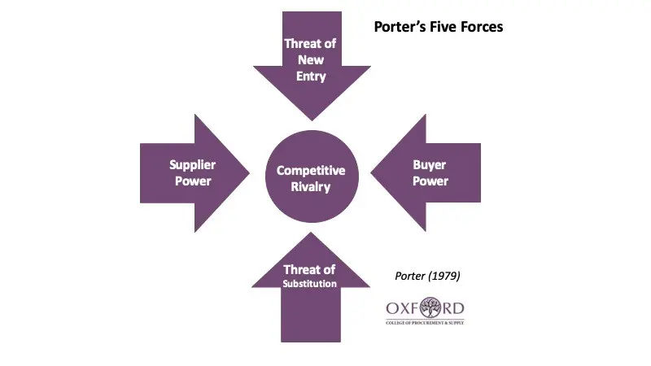

Figure 1:Porters Five Forces
Source: (Oxford college of Procurement and supply)
The figure shows the factors that contribute to the competitive rivalry of the business and will need to be considered with Brexit due to the profitability of the business being a key factor of business success.

3.0 Business case

3.1 Benefits to the organisation
The business will benefit in several ways, one being reducing the uncertainty, it has been evident that when Brexit was first mentioned a large share of the British population were somewhat unsure of its pros and cons. So much so that the vote only passed by roughly 1 million people, with 16,141,121 voting to remain in the EU, compared to 17,410,742 voting to leave. (electoral commission (2019)) This uncertainty can cause problems for not only the business, but their staff with potential fears over their job security, as well as the economy. Reassuring staff will be key as they will remain motivated knowing that they are secure in their work. Additionally, it will present them with data they previously would not have had, as with questionnaires being handed to customers, they will get more knowledge on the customers that they already have and how this will affect them. Furthermore, it will allow them to have reassurances or whether they need to have preparations in place for a new supplier, as Brexit will have a major effect on them as well as the small businesses.

3.2 Background literature
Since Brexit is a large economical event that will probably occur once ever, there is a lot of resources on it, one that will be particularly helpful, due to the fact that it targets SME’s in particular and the effect that Brexit will have is “What Happens If the Rules Change? The Impact of Brexit on the Future Strategic Intentions of UK SMEs” (Ross Brown et al (2018))
Additionally, a report published by KWF in the aftermath of the Brexit vote will be of aid to me as, it discusses stats about manufactures, which will be of aid as it will provide information of suppliers and a potential effect on them. It discusses how their suppliers are becoming more international, and when the transition period is over this will have a large effect on these deals. (J Abel Koch 2016)
An additional book is “Brexit and its economic consequences” (Winston Chang (2018)) this book will help to give a broader opinion on the economic consequences of Brexit. It will not only give a perspective on how it may affect SME’s, but maybe potential drops in the value of the pound. With this being a catering business, it will also give an insight on how it may affect agriculture in the UK. This would then show how it would affect the cost which would ultimately lead to the café itself having to pay more.

3.3 Potential risks/limitations
One key aspect of the report is the primary research that will be carried out. It must be ensured that the genuine concerns of the business are put across, as well as remembering to have consent which will be discussed further on in the report.
Furthermore, my overall aim must be kept in mind as if is go off track and start aiding them in additional areas my goal will not be completing in aiding them with the uncertainty and problems that comes with Brexit.
Additionally, time keeping will be a key aspect as everything must be completed within a time frame, so this may mean that their may be some additional planning ahead required for when the transition period is over and the effects will be more visible.
With the questionnaires their also most be enough responses, as well as unbiased distribution of questionnaires. Although a key part of the assignment will be people who are not originally from this country, as they may have greater concerns, I also must ensure that there is no bias as UK residents will also have a response to give. There is also the potential of people thinking on the positive side of Brexit and that must be considered.

4.0 Research Methodology

4.1 Primary Research
Primary research will be a key factor to this project as it will centre it more around the business. This will allow the project to stay on track on working towards the aim.
The first primary research method that will be used is interviews. With this method the business can voice their concerns around the subject allowing the project to be built around the business. Interviews will be carried out with owners, so they have a chance to voice their concerns and a financial aspect of the business is then taken into account. Then an interview will be carried out with the staff so that they can also voice their concerns, this will be a key aspect as with no staff the business wont function, so in terms of aiding the business it is key that the staffs concerns are dealt with.
But With primary research I must ensure that ethics forms are completed by anyone supplying the information for the report. This will be done through ethics forms as well as a brief description on how their information will be used and for what purpose. Furthermore, when handing out questionnaires the sample must be distributed randomly to ensure it gives a fair representation of the group sample, this should then give a wide range of answers and show how it will affect each individual differently.

4.2 Secondary Research
Advancements on potential news on Brexit will be key, especially in terms of immigration and tax on imports. Immigration will be key with customers, especially with the area having so many and them being such a large aspect of the community. Additionally, it could be key for staff, as some themselves may be of a foreign dissent. But all of this could additionally be affecting the suppliers as which could potentially affect the prices the café has to pay which would then affect their profitability.
Furthermore, any rules set against imports could influence both the café and their suppliers which would again have a knock-on effect to the café. So secondary research will be key in keeping up to date with the on goings of Brexit in order to best advise the business.

5.0 Project plan
Time keeping will be a key aspect of the project, to ensure that the project best aids the business a plan should be constructed, A Gantt chart will be able to provide the project with structure on how to designate a time for each task needed

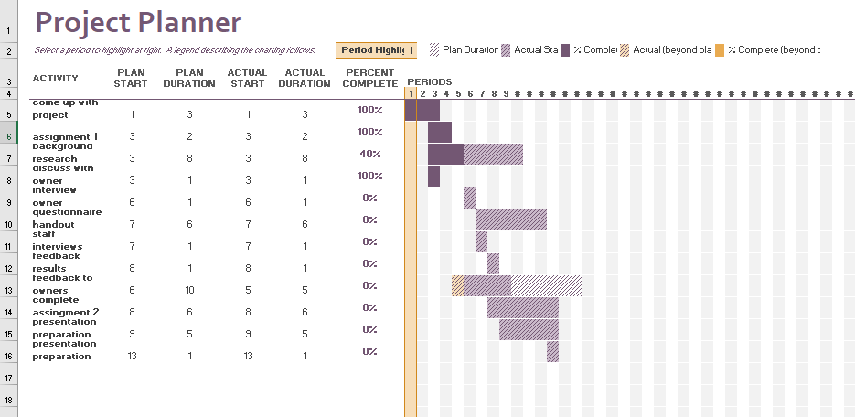

Figure 2:Gantt Chart
This is the plan that will be followed for the project, some of the time expectancy and the dates the tasks will be carried out on may not be 100% accurate at the moment as the project has not yet been carried out. Problems could interfere with the dates anticipated as well as some tasks taking longer than others. For example, if there are problems with questionnaire collection and more are needed, then the period may be extended as well as then pushing other tasks back or shortening one to make up for lost time.
The start Date was the 27th of January and the end date it is when the presentation must be presented. The project should be completed prior to the presentation, so that the business has had the aid and that this can be clearly shown.

References
(BBC) Brexit, (2020) Available at:
https://www.bbc.co.uk/news/uk-politics-32810887
accessed on: 26/02/20
Brown, R., Liñares-Zegarra, J.M. and Wilson, J.O., 2018. What happens if the rules change? The impact of Brexit on the future strategic intentions of UK SMEs. The Impact of Brexit on the Future Strategic Intentions of UK SMEs (March 1, 2018).
Accessed on: 28/02/20
David Cameron, 2016 The Telegraph, (16/02/20) Available at:
https://www.telegraph.co.uk/news/politics/david-cameron/12176325/David-Cameron-Brexit-would-be-gamble-of-the-century.html
accessed on: 26/02/20
Debbie Herridge, Apprentice for Professional Academy, available at: https://www.professionalacademy.com/blogs-and-advice/what-are-smart-objectives-and-how-do-i-apply-them
accessed on: 27/02/20
electoral commission (2019) available at: https://www.electoralcommission.org.uk/who-we-are-and-what-we-do/elections-and-referendums/past-elections-and-referendums/eu-referendum/results-and-turnout-eu-referendum
accessed on: 27/02/20
GOV.UK, 2020 The UK has left the EU, Available at:
https://www.gov.uk/transition?gclid=CjwKCAiAy9jyBRA6EiwAeclQhKfufR3hsWJ-ZYZAT10MoVnY48_sKc9ozswBGKGArtPvGNDpnzoxrRoCANgQAvD_BwE&gclsrc=aw.ds
accessed on: 26/02/2020
Abel-Koch, J., 2016. SMEs’ value chains are becoming more international–Europe remains key. Europe, 65, pp.65-9.
Accessed on: 28/02/20
Merchant Savvy, (2020) UK SME Data, stats and charts, available at: https://www.merchantsavvy.co.uk/uk-sme-data-stats-charts/
Accessed on: 27/02/2020
Mullins LJ (1999) Management and Organisational Behaviour. 5th edn. Financial Times/Prentice Hall, London
accessed on:27/02/20
National Assembly of Wales, (2010), Key Statistics for Llanelli, Pg. 3,
Available from: https://www.assembly.wales/NAfW%20Documents/10-034.pdf%20-%2014052010/10-034-English.pdf
Accessed on: 26/02/20
Michaux, S. and Cadiat, A.C., 2015. Porter's Five Forces: Stay Ahead of the Competition. 50Minutes.
Accessed on:27/02/20
Oxford College of Procurement and Supply, Porter’s Five Forces Revisited: Are There Really Five Forces?
Available from: https://www.oxfordcollegeofprocurementandsupply.com/porters-five-forces-revisited-are-there-really-five-forces/
Accessed on:27/02/20
Wales Online, Robin Turner, 2007, Poles immigrate to Welsh town by thousands
Available from: https://www.walesonline.co.uk/news/wales-news/poles-immigrate-welsh-town-thousands-2256284
Accessed on: 26/02/20

