

International Hotel Management

Submitted by: Denitsa Biserova Kazandzhieva
1905860
Business Skills for International Hotel Management
M4X 01917
Submitted to: Dale Clarke

Contents

Introduction………………………………………………………………………………….3
Data protection.……………..………………………………………………………………3
Health and safety………..………………………………………………………………….4
Risk assessment…………………………………………………………………………….4
Hotel proprietors act…………………………………………………………...…………....5
Employment legislation………….………………………………………..………………...6
References…………………………………………………………………………………...7

Introduction
As part of this report, I will explore the legal legislative risk that managers and employees need to consider in the hotel industry. I will touch on subjects such as liability, data protection, health and safety, food hygiene, risk management, licensing, including key provisions within Hotel Proprietors Act 1956. The UK’s hospitality sector remains as dynamic and fast paced as ever. The industry is no stranger to some of the hottest subjects in UK employment law and faces a countless number of challenges which show no sign of reducing in the future.

Data protection
The hospitality industry is one of the most vulnerable sectors in the world when it comes to data privacy. When it comes to the hotel section, data protection is an essential aspect, since it includes managing information in various fields: economic data such as bank accounts and credit or debit cards, financial (financial profits accounts, investments and bank transactions, balance of results and profits and losses) and personal (purchases at the hotel, tastes and likings of the client, details about the trip, companions). Data protection in the hospitality industry is taken very seriously and it is part of the basic services which is expected to be offered at every hotel. There is a specific enactment set in place by the United Kingdom government which goes by the abbreviation name GDPR. This legislation stands for General Data Protection Regulation which was approved officially in Parliament in the year 2016.
The GDPR is not an already existing regulation; in fact, its precedent was set in 1994 in the form of Data Protection Directive (DPD). The law is now improved with further extension over guest data collected digitally and holding companies’ expectations to be as transparent as possible. This is the key focus of the refreshed enactment where any immoral or unethical business will be finding it increasingly difficult to attempt to abuse customer data in any way.
Customer data is oftentimes considered to be an opportunity for hotels to get to know their customers better rather than abuse information but nonetheless there is a necessity to show the hotel guests that it will not be used. The services provided can be slightly altered and more personalised when the hotel is aware of the information which the customer provided. Nonetheless, the regulation aims to keep information completely confidential and secure and be only used in the case where the guest or customer gives their consent.

Health and safety
Health and safety is an enactment which is applied across catering and hospitality industries as a lawful requirements and standards. Those aim to keep the customers or guests and employees at the workplace safe and as far away from any potential hazards as possible (Hospitality and Catering News, 2006). While, for example, data protection was about digital information protection, health and safety are physical measure taken by a business to ensure the necessary protection for not only guests but also every other member of staff. This is the reason as to why health and safety is such an important enactment.
An example of health and safety regulation is standard fire safety measures and procedures for hotels/hostels with more than six rooms in its range. There is a requirement to fill every room with active smoke detectors including the communal areas and office environment. In addition, there is a need for easy to access routes across the buildings which leave people out of a burning building as soon as possible. Fireproof doors should be fitted everywhere across the hospitality premises.

Risk assessment
A risk assessment is descriptive paperwork which outlines a scenario with an associated danger, about the business environment – the hotel premises. It is aimed at working staff as well as the guests. There is a highlight of the situation at hand, what the predicament is issued to be, how this can be an endangerment to the person or people involved in the situation, and how to minimise this risk before it becomes an issue.
Examples of cases where risk assessment is required in the hospitality industry include uneven flooring, floor hazards like cables and other items in the way out for a person that may hinder their journey in the likelihood of fire, poor hygiene, and unfiltered drinking water supplied by the hotel, and so on.

Hotel proprietors act
The legislation which embodies property right (in terms of belongings) and outlines instances in which lost or damaged property is either the liability of the proprietor or the guest. The enactment was established back in 1956 and it includes a detailed explanation of both sides of the argument which are the customer or guest and the hotel or the proprietor. By definition of the Hotel Proprietors Act 1956, a hotel establishment is in the very least a provider of good quality food, water, and shelter/accommodation without any contract tie.
It is thought out the guests who may have lost their belonging or any type of personal property in the duration of their stay immediately becomes the responsibility of the hotel. This is untrue in many instances. The hotelier will only be held accountable for guest property damage or loss in three distinctive instances and with set limitations on payment.
The first instance is when the hotelier is to blame after the property has been assigned as missing but for a guest who has attended the hotel for more than a few hours and as well as that has slept in it for a minimum of one evening.
The second instance is when the property loss or damage liability is kept at a maximum monetary compensation of £50. Sometimes a total of £100 may be paid to a guest but no more in cash or bank transaction. The rest of the money can be compensated in the form of a deposit or safe custody instances.
The final instance is in favour of the hotelier due to the fact if the property loss or damage involved a motor vehicle or another means of independent transportation, the hotel will not be forced to pay for anything in relation to this.

Employment legislation

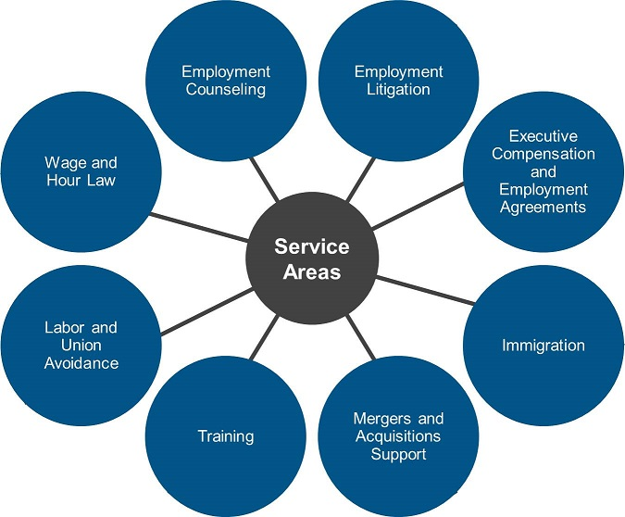

(Dorsey and Whitney, 2019)
Employment law within the United Kingdom is defined as the protective HR regulations which every company has to abide by, aiming to protect the interest of employee and employer equally. The employment law is a broad enactment which covers various smaller enactments which are set out by the government to promote human rights support.
Examples of enactments which are found in the broader, Employment UK law are Equality Act from 2010, Contract Law, Safeguarding law, National Minimum Wage Law and so on.
The employment law protects the interest of workers in the sense that it demands that the right working conditions (physical and mental) are set in place for them to integrate into. In addition, when recruitment takes place, candidates from different ethnical, cultural, social, religious, age, and gender backgrounds should be allowed to apply. With respect to this specific enactment, when selecting the candidate after the application processes, the business is forbidden from exercising any form of discriminatory behaviour which may harm the worker/candidate interests.
The Employment law does not only aim to protect the workers but also their employers. In the likelihood of a hostile employee who constantly abuses the rules at their workplace, the business has the option of filing an official report against them and dismissing them from work immediately. Generally, the enactments are created for both the workers and the employers alike to ensure that the right lawful atmosphere is set where both sides know their responsibilities and are able to collaborate together to achieve greater ends.

References
Cheary, M., ‘Why does employment law exist?’, Reed UK, 2016, https://www.reed.co.uk/career-advice/why-does-employment-law-exist/ (accessed 21 November 2019)
Clearworld, ‘General Health and Safety Risk Assessment’, Clearworld, 2019, https://www.clearworld.co.uk/general/ (accessed 21 November 2019)
Dorsey and Whitney, ‘Labor & Employment’, Dorcey & Whitney LLP, 2019, https://www.dorsey.com/services/labor_and_employment (accessed 21 November 2019)
Hospitality and Catering Services, ‘Hotel Health and Safety- Keeping Your Guests Safe’, Hospitality and Catering News, 2006, https://www.hospitalityandcateringnews.com/2014/01/hotel-health-and-safety-keeping-your-guests-safe/ (accessed 21 November 2019)
Law Now, ‘Personal data and the hotel industry’, CMS, 2006, https://www.cms-lawnow.com/ealerts/2006/07/personal-data-and-the-hotel-industry?cc_lang=en (accessed 21 November 2019)
Legislation GOV UK, ‘Hotel Proprietors Act 1956’, Legislation.Gov.UK, 2019, http://www.legislation.gov.uk/ukpga/Eliz2/4-5/62 (accessed 21 November 2019)

