Student name: Jaskaran singh
Student ID: 2221903
Module title: Global Business Environment
Module code: LCBB4005
Date: 9 may 2023

Table of Contents
Introduction 3
Overview of developing country India 3
Pestle analysis 3
Hofstede model 5
“Porters five Forces” 6
“Competitive Rivalry” (High) 6
“Power of the Suppliers” (Medium) 7
“Power of the Buyers” (High) 7
“The Threat of the Substitutes” (High) 7
The Threat of the New Entrants (Medium) 7
Opportunities and Challenges in the Country 8
Recommendation 10
Conclusion 11
Reference List 13

The following essay will discuss an overview of the country, India, and the "Pestle" analysis of the company will also be discussed in the following essay. The essay will tell about a retail company TESCO that has been shifted from the UK to India. The political and economic factors of the company and how the country will make effects with analysis will also be given in the following essay. The impact of the technology on the company in India will also be illustrated in the following essay. Moreover the legal and environmental analysis will be shown with a comparison by the help of "The Hofstede Model" between the UK and India. Porter's five forces will demonstratedas well and the opportunities and challenges faced by the retail company TESCO in India will also be discussed in the following essay. Different barriers faced by the company in India will also be shown, and recommendations will be given based on the company's shift in India. There are many recommendations which will be given for the company in the following essay.

Overview of developing country India
Developing countries have yet to gain an important stage of industrialisation relative to their population and, in most cases, a low standard medium living. There is an institution between the growth of high population and low income. India stands in the rank of second in the matter of population in the subject of quality of the population it is showing less that there are fewer skilled people.

Pestle analysis
Factor | Analysis | Impact
Political | Political problems directly impact the market capitalisation of a country. Crises of politics involving the interest of politicians, differences in ideology, and also influence the state's well-being (Thomaset al., 2021). Overall, India provides stability politically for business as India is a republic and the largest democracy in the world. They should affect by challenges for the reason of corruption. | Medium
Economic | This country's increasing rate of GDP commits growth opportunities for business growth. The policies of taxation of the government of India are fortunate for the expansion of business in the country (Hassan et al., 2019). Apart from this, the domestic market that is widely spread poses many opportunities for the growth of the business. | High
Social | India is a place of diversity. The company TESCO has to be aware of its beliefs, cultures, and acceptability to run a company in the country. The company TESCO should also know the demand for particular products and the local workforce. The broad domestic market of India is another reason multinational companies benefit this country to expand their business. | Medium
Technological | The technology of India is growing steadily. India has one of the most IT sectors that constantly support the gradation of software and advancement (Crasta and Shailashri, 2021). The tech companies of foreign are investing more and more in India thanks to the advancement of technology. Investing in technological advancement will benefit the state's economic growth in the coming days. | High
Environmental | The growing demand for products that are eco-friendly and processes between consumers have transformed the model of the demand of supply. The unpredictable and diverse nature of the climate of this country may negatively affect the companies, especially in the infrastructure. Companies must launch sustainability ideas, such as recycling, a better waste management system, and more. | Medium
Legal | Companies must maintain the laws and rules exclusive to every region or country they want to operate. Changes in recent days in some employability, recycling, and discrimination law may affect the labour cost and pricing of the company TESCO (Anderson et al., 2019). Regulations that are flexible regarding foreign business in this country provide opportunities for growth to foreign companies. | High

Hofstede model
Using the Hofstede model, this section will discuss the comparison between India and the UK.
Individualism
In this dimension, India got an intermediate score of 48, referring to both the traits of individualism and collectivism.
89 is the UK's highest score, indicating an individualist country.
Power distance
India scores highest in this dimension, 77 indicating top-down structure and application of hierarchy.
The UK scored 35, indicating a society that trusts inequalities between the people (Gupta and Sukamto, 2020).
Uncertainty avoidance
India, in this section, scored 40
In this section, the UK scored 35, and this is the low score on this dimension which indicates it is a nation where people are quite happy to rise.
Masculinity
With a high score of 56, India refers to a masculine society.
With a score of 66, the UK comes as a society of masculine that are highly driven and success oriented.
Indulgence
India got a low score in this section which is 26 means that it is a restrained culture.
In this dimension, the UK scored 69, which indicates the culture of the UK is one of the classified in this section (Malhotraand Gaur, 2020). The high marks in indulgence classify people in this country.
Long-term
With a medium score of 51, which refers to a dominant preference for the country.
In this section, the UK scored a medium of 51, a preference that is dominant in the culture of the UK that cannot be described (Bhatia and Bhatia,2019).

"Porters Five Forces."

“Competitive Rivalry” (High)
The power of the competitors of the rivals is very high, and the demand for the products produced by the rivals have been increased a lot. Therefore, the company TESCO should produce products that are innovative and should increase the demand of the customers (Anastasiu, Gavriş. and Maier, 2020). Therefore, the company TESCO should produce those products which are in high demand.

“Power of the Suppliers” (Medium)
The company TESCO has been shifted from the UK to India. Therefore, it can get many options for the suppliers. Therefore, the power of the suppliers is medium. Therefore, the suppliers need more power.

“Power of the Buyers” (High)
The power of the buyer is very high because the company TESCO should produce and sell the products liked by the customers. Therefore, the buyers can reject the products the retail company produces (Jelonek et al., 2022). Therefore, they should produce the products in high competition with the other companies.

“The Threat of the Substitutes” (High)
The power of the substitutes of the products the other retail companies produce is very high. The company has been shifted from the UK to India. Therefore the customers of India and other parts of the world can get other types of products from other companies.

The Threat of the New Entrants (Medium)
The impact of the entry of the new entrants in the market is medium because the company has already been established in the retail industry. Therefore, the company TESCO can flourish and compete with the new companies which have recently entered the world's retail industry. Therefore, the new rivals are less powerful than the already existing rivals in India (Irfan et al., 2019). Therefore, the company TESCO can compete with other retail companies in the world and also in India by implementing many new and innovative strategies for marketing and promoting the products.

Opportunities and challenges in the country
The company TESCO seeking to invade the Indian market is likely to face multiple challenges and opportunities in the Indian market. The challenges that might limit the business's functionality to expand in the Indian market include cultural differences and unstable economic conditions in India. To be specific, as previously demonstrated, the cultural perspectives of the Indian population are largely different from that of the UK's population, especially in the case of “power distance”, “indulgence”, "individualism", and more (Licsandru and Cui, 2019). These differences might create a gap for the company TESCO in building a customer base in the Indian market with the similar cultural perspective it applied in the case of the UK market. Additionally, the Indian market lacks a strong infrastructure and economic stability, which is one of the most crucial strengths of the UK's market (Akpan, Udoh and Adebisi, 2022). Along with the cultural differences, the gaps in the economic and infrastructural resilience in the Indian market can challenge the company TESCO seeking to expand itself from the UK to India.
On the contrary, some opportunities might be helpful for the business to grow in the Indian market. One such opportunity is the labour cost of the country, which s much lower than the UK. The labour market of India offers cheap labour, which can benefit companies from countries with high labour costs in promoting cost-effectiveness from human resources (Majid, 2020). Additionally, the country's growing population can contribute to the increasing scope of the business to success by expanding its access to a wider customer base (Debata, Patnaik and Mishra, 2020). On the other hand, operational and manufacturing costs can also be reduced using the resources in the Indian market. These are crucial opportunities for the UK-based company TESCO to expand in the Indian market. Additionally, it can be stated that mitigating the challenges can further facilitate the growth of the business in the Indian economy.
Different barriers experienced
Expanding industrial company TESCO operations to a developing country like India offers several challenges and boundaries that must be overcome for the company TESCO to be successful. Here are some of the key obstacles that employers have to consider:
Cultural Barriers: India's distinct lifestyle differs fairly from Western countries (Sovacool and Griffiths, 2021). These cultural variants can impact communication, administration style, decision-making processes, and common business company TESCO operations. Companies must apprehend and admire nearby cultural norms and values to succeed in India.
Legal and Regulatory Barriers: India has difficult and always altering prison suggestions and regulations that can pose exact-sized challenges for companies (Hack-Polay et al., 2020). For example, restrictions exist on distant places' possession of companies, tricky tax laws, and labour prison hints that can be tough to navigate. Companies should comply with these criminal tips to avoid jail issues.
Infrastructure Barriers: India's infrastructure is underdeveloped in many areas, which can pose good-sized challenges for companies. For example, electricity outages, bad transportation networks, and inadequate telecommunications infrastructure can affect the smooth walking of industrial corporation operations. Companies must be prepared to make investments in infrastructure to resource their operations.
Political and Economic Barriers: India's problematic political panorama can create uncertainty and instability for businesses (Mullis et al., 2021). For example, changes in authorities policies, corruption, and bureaucracy can pose magnificent challenges. Economic volatility, inflation, and foreign money fluctuations impact company TESCO operations. Companies want to be prepared to adapt to changes in the political and economic environment.
Competition Barriers: India has a pretty aggressive market, with many regional and global groups vying for market share. Companies must perceive the aggressive panorama and be geared up to compete effectively to be profitable in India.
Human Resource Barriers: India's labour market is complex, with a big populace and several tiers of education and skills (Grafström, 2020). Despite the country's huge workforce, discovering expert and trained personnel can be challenging, especially in specific areas such as science and engineering. Many corporations in India are experiencing a shortage of educated humans, and discovering the acceptable Genius is becoming increasingly difficult. Moreover, there is intense opposition among corporations to educated human beings in India. The demand for expert human beings has led to immoderate employee turnover rates, which can create greater recruitment charges and result in a loss of intellectual capital for businesses (Jayachandran, 2021). Employee retention is a considerable undertaking for businesses working in India. Many educated personnel go away from their present-day jobs for greater compensation functions or to pursue different opportunities, leaving company TESCOs with gaps in their crew of people and a loss of expertise.
Language Barriers: English is drastically spoken in India. Alternatively, there are many great languages spoken throughout the country. Companies want to be geared up to talk efficiently with consumers and personnel in close languages to assemble sturdy relationships and avoid misunderstandings. Growing industrial corporation operations in a developing country like India offers tremendous challenges and barriers that want to be overcome for the company TESCO to be successful. Companies must apprehend the nearby culture, navigate tricky jail and regulatory issues, invest in infrastructure, and compete correctly to be positive in India. By embracing innovation and adaptability, companies can navigate changes in the political and economic environment and proceed to be formerly competitors.

Recommendation
- To enable a UK-based company to succeed in India, the following appropriate strategies and recommendations are mentioned below-
- Market Research: to succeed in the Indian market, a proper understanding of the market is required, which consists of customer preferences, thoughts, likeness, cultural differences, competition and the environment.
- Localisation: Factors such as language, pricing, and packaging practices should be adapted to understand the needs of the Indian market.
- Partnering and networking: business professionals who understand the Indian market are advised to follow up (Patil et al.,2021). Local businesses, distributors, suppliers or consultants can provide relatable and valuable information regarding the hurdles to be faced and regulate the entry to the Indian market.
- Government engagement: there are various government-led projects which can help in boosting new business. Focus on different policies, tax benefits, and incentives that can benefit the company. Always stay connected to government policies, and it will help sell new and relevant opportunities regarding the company's growth.
- E-commerce and digital presence: the new India is mostly digitised and is rapidly growing in the digitalised sector. Therefore, create an easy website for the customers where the company will be easily reachable, or it can be any mobile application and target the marketing campaigns.
- Distribution and Logistics: Engage with local distributors who can navigate the gross geography of India. Invest in an efficient and quick distribution process.
- After-sales support: this will help in gaining customer reviews and loyalty and help in building a good brand name.
- Talent Acquisition and Training: Providing training regarding the brand is a must. Focus on local talents, cultural & training programmes followed in the Indian market.
- Social responsibility: The societal responsibilities related to environmental causes, etc., which resonate with the Indian customers to be incorporated well for a better work commitment.

Conclusion
Based on the above recommendations and learnings based on the UK versus Indian market structure, it can be concluded that to develop a company in a developing country like India. The focus should be on cultural differences, pricing and affordability, partnering and networking, distribution and logistics, talent acquisition and training, social responsibilities, etc. Pricing and adapting to the products that suit the local market should be focused upon (Kataria, Nandal and Malik., 2020). A well-planned logistics network is a must in a diverse country like India. Delivering orders on time and earning the customer's attention and trust are very important. It is important to understand customer preferences, and easing through the market will be easier. The language barrier is to be focused on, and local languages are to be dealt with. Local business strategies must be understood, and participation in government-aided campaigns will be helpful. Creating a user-friendly application or website according to customer preferences will boost the business and target more audiences. Overall, succeeding with a business in India requires adaptability, digital presence and a focus on customer satisfaction. By corporation these strategies and recommendations, a UK-based company can establish itself in an Indian market with a good growth rate and profitability.

Reference List
Akpan, I.J., Udoh, E.A.P. and Adebisi, B., (2022). Small business awareness, adoption of state-of-the-art technologies in emerging and developing markets, and lessons from the COVID-19 pandemic. Journal of Small Business & Entrepreneurship, 34(2), pp.123-140. https://pusheh.farafile.ir/content/demo/202207/73dbe4d8-ccd2-499b-88e6-78b21c504a5c.pdf
Anderson, J.E., Hughes, M.Ü. and Nguyen, C. (2019). The highs and lows of startups in the Cannabis industry: A PESTLE analysis of the current issues. In Business Forum (Vol. 27, No. 2, p. 26).https://www.researchgate.net/profile/Dinesh-Swami/publication/348679847_Hybrid_Secure_Data_Transfer_Scheme_Using_Cryptography_and_Steganography/links/631327e2acd814437ffd3882/Hybrid-Secure-Data-Transfer-Scheme-Using-Cryptography-and-Steganography.pdf#page=167
Anastasiu, L., Gavriş, O. and Maier, D., (2020). Is human capital ready for change? A strategic approach is adapting Porter's five forces to human resources. Sustainability, 12(6), p.2300.https://www.mdpi.com/2071-1050/12/6/2300/pdf

Bhatia, R. and Bhatia, A., (2019). A Comparative Study on Models of Organizational Culture in Higher Education in India. Research journal of social sciences, 10(6).https://www.researchgate.net/profile/Rashmi-Bhatia/publication/337732497_A_Comparative_Study_on_Models_of_Organizational_Culture_in_Higher_Education_in_India/links/5de787e34585159aa45faef7/A-Comparative-Study-on-Models-of-Organizational-Culture-in-Higher-Education-in-India.pdf
Crasta, L.C. and Shailashri, V.T., (2021). Impact of Mobile Phone Services on the Traditional Telecommunication Services in India. International Journal of Case Studies in Business, IT and Education (IJCSBE), 5(2), pp.211-225.https://www.researchgate.net/profile/Laveena-Crasta/publication/356370747_Impact_of_Mobile_Phone_Services_on_the_Traditional_Telecommunication_Services_in_India/links/62451f9757084c718b7728fb/Impact-of-Mobile-Phone-Services-on-the-Traditional-Telecommunication-Services-in-India.pdf
Debata, B., Patnaik, P. and Mishra, A., (2020). COVID‐19 pandemic! It's impacting on people, the economy, and the environment. Journal of Public Affairs, 20(4), p.e2372. https://www.academia.edu/download/68024473/1_s2.0_S0959652620332728_main.pdf
Grafström J, Aasma S. (2020). Breaking circular economy barriers. Journal of Cleaner Production. 2021 Apr 10;292:126002.https://www.researchgate.net/profile/Jonas-Grafstroem/publication/343988095_Breaking_Circular_Economy_Barriers/links/5f4cc3e5299bf13c5064c0ad/Breaking-Circular-Economy-Barriers.pdf
Gupta, M. and Sukamto, K., (2020). Cultural communicative styles: The case of India and Indonesia. International Journal of Society, Culture & Language, 8(2), pp.105-120.https://journals.sagepub.com/doi/pdf/10.1177/2277975219890932
Hack-Polay, D., TennaOgbaburu, J., Rahman, M. and Mahmoud, A.B., (2020). Immigrant entrepreneurs in rural England–An examination of the socio-cultural barriers facing migrant small businesses in Lincolnshire. Local Economy, 35(7), pp.676-694.https://eprints.lincoln.ac.uk/id/eprint/43674/1/Local%20Economy.pdf
Hassan, D.N., Aboki, H. and Audu, A., (2019). The application of Pestle theory to the role of chairman (chief executive officer) in a new business in Gurgaon, India. Int J Entrepreneurship Bus Innov, 2(1), pp.53-62.https://abjournals.org/ijebi/wp-content/uploads/sites/5/journal/published_paper/volume-2/issue-1/IJEBI_5bZj18Km.pdf
Irfan, M., Zhao, Z.Y., Ahmad, M., Batool, K., Jan, A. and Mukeshimana, M.C. (2019). Competitive assessment of Indian wind power industry: A five forces model. Journal of Renewable and Sustainable Energy, 11(6), p.063301.https://www.researchgate.net/profile/Muhammad-Irfan-73/publication/337369162_Competitive_assessment_of_Indian_wind_power_industry_A_five_forces_model/links/5dd6999f299bf10c5a26a322/Competitive-assessment-of-Indian-wind-power-industry-A-five-forces-model.pdf

Jayachandran, S. (2021). Social norms as a barrier to women's employment in developing countries. IMF Economic Review, 69(3), pp.576-595.https://www.nber.org/system/files/working_papers/w27449/w27449.pdf
Jelonek, D., Tien, N.H., Dao, M.T.H. and Minh, D.T., (2022). Comparative analysis of the business strategy of Vietnamese real estate developers: the use of Hoffer matrix. International journal of multidisciplinary research and growth evaluation, 3(1), pp.197-204.https://www.researchgate.net/profile/Nguyen-Tien-32/publication/358022086_Comparative_analysis_of_business_strategy_of_Vietnamese_real_estate_developers_The_use_of_Hoffer_matrix/links/634be9da9cb4fe44f32c843e/Comparative-analysis-of-business-strategy-of-Vietnamese-real-estate-developers-The-use-of-Hoffer-matrix.pdf

Kataria, D.A., Nandal, D.N. and Malik, D.R., (2020). Shahnaz Husain-A Successful Indian Woman Entrepreneur. International Journal of Disaster Recovery and Business ContinuityVol, 11, pp.88-93.https://www.researchgate.net/profile/Aarushi-Kataria/publication/362519242_31185-Article_Text-48486-2-10-20200828/links/62ee255b505511283e95322f/31185-Article-Text-48486-2-10-20200828.pdf
Licsandru, T.C. and Cui, C.C., (2019). Ethnic marketing to the global millennial consumers: Challenges and opportunities. Journal of Business Research, 103, pp.261-274. https://www.sciencedirect.com/science/article/pii/S0148296319300712
Majid, M.A. (2020). Renewable energy for sustainable development in India: current status, prospects, challenges, employment, and investment opportunities. Energy, Sustainability and Society, 10(1), pp.1-36. https://energsustainsoc.biomedcentral.com/articles/10.1186/s13705-019-0232-1
Malhotra, J. and Gaur, M., (2020). Application of Hofstede’s model to study the role of Indian culture for sustenance during COVID-19. Journal of Xi'an University of Architecture & Technology, 12(7), pp.961-977.https://www.researchgate.net/profile/Mamta-Gaur-4/publication/343443080_Application_of_Hofstede's_Model_to_Study_the_Role_of_Indian_Culture_for_Sustenance_during_COVID-19/links/5f2a5df4a6fdcccc43abeb64/Application-of-Hofstedes-Model-to-Study-the-Role-of-Indian-Culture-for-Sustenance-during-COVID-19.pdf
Mullis, M.D., Kastrinos, A., Wollney, E., Taylor, G. and Bylund, C.L. (2021). International barriers to parent-child communication about sexual and reproductive health topics: a systematic qualitative review. Sex Education, 21(4), pp.387-403.https://www.researchgate.net/profile/Jonas-Grafstroem/publication/343988095_Breaking_Circular_Economy_Barriers/links/5f4cc3e5299bf13c5064c0ad/Breaking-Circular-Economy-Barriers.pdf
Patil, S.M., Kumari, V.C., Sumana, K., Sujay, S., Tejaswini, M., Shirahatti, P.S. and Ramu, R., (2021). Sustainable development of plant tissue culture industry: The Indian scenario. Journal of Applied Biology and Biotechnology, 9(2), pp.18-27.https://jabonline.in/admin/php/uploads/512_pdf.pdf
Sovacool, B.K. and Griffiths, S. (2020). The cultural barriers to a low-carbon future: A review of six mobility and energy transitions across 28 countries. Renewable and Sustainable Energy Reviews, 119, p.109569.https://www.sciencedirect.com/science/article/pii/S1364032119307774
Thomas, P.J.M., Sandwell, P., Williamson, S.J. and Harper, P.W., (2021). A PESTLE analysis of solar home systems in refugee camps in Rwanda. Renewable and Sustainable Energy Reviews, 143, p.110872.https://spiral.imperial.ac.uk/bitstream/10044/1/87365/2/A%20PESTLE%20analysis%20of%20solar%20home%20systems%20in%20refugee%20camps%20in%20Rwanda%20-%20Accepted%20Version.pdf

Slide 1
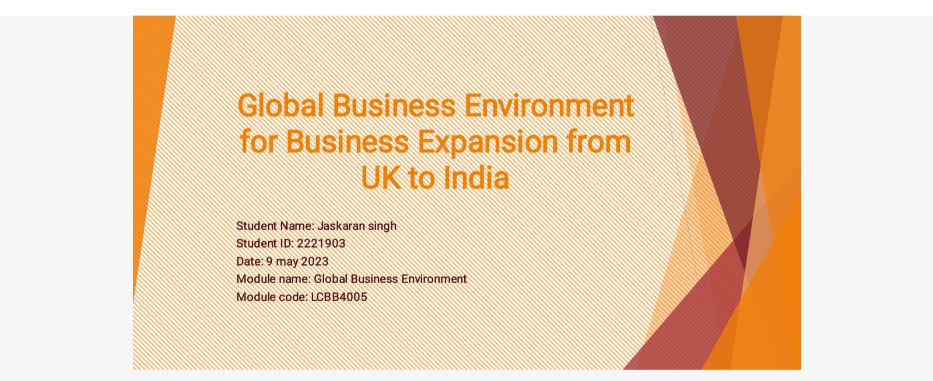

Slide 2
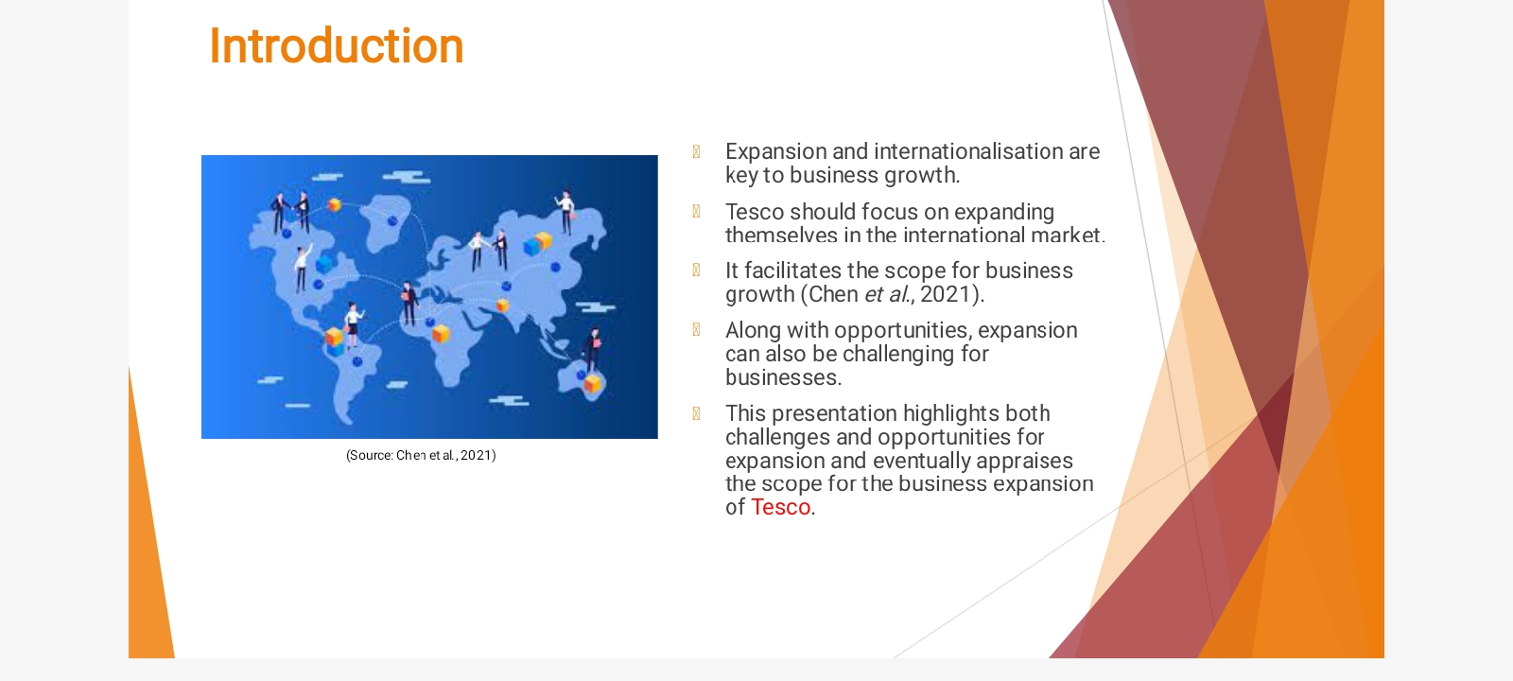

Slide 3

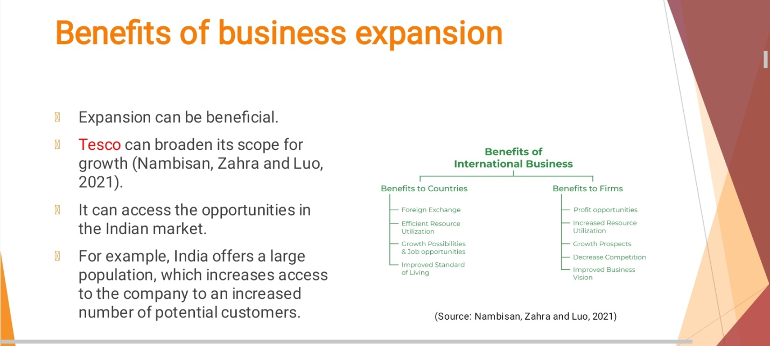

Slide 4
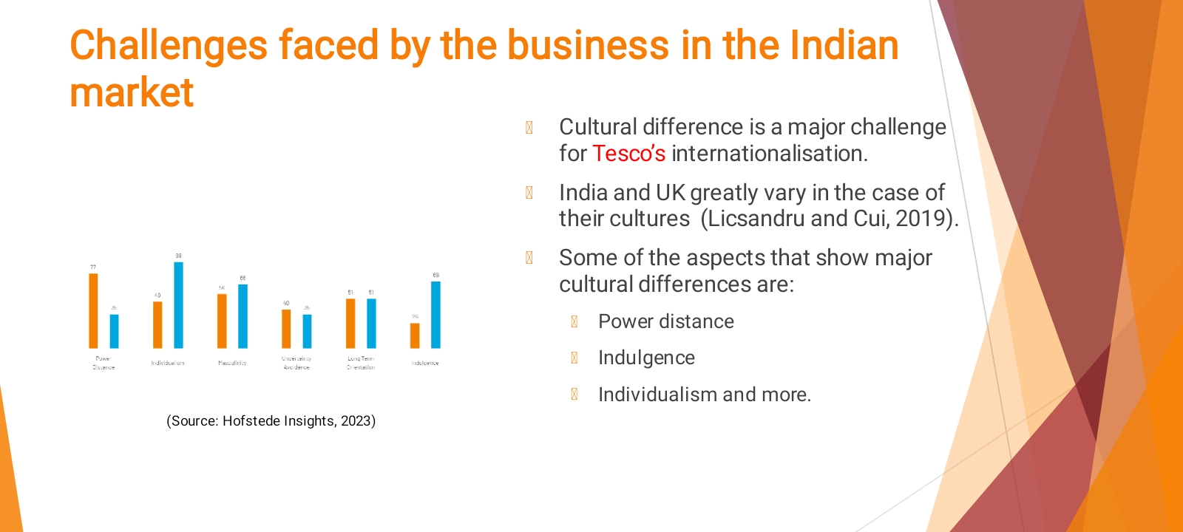

Slide 5

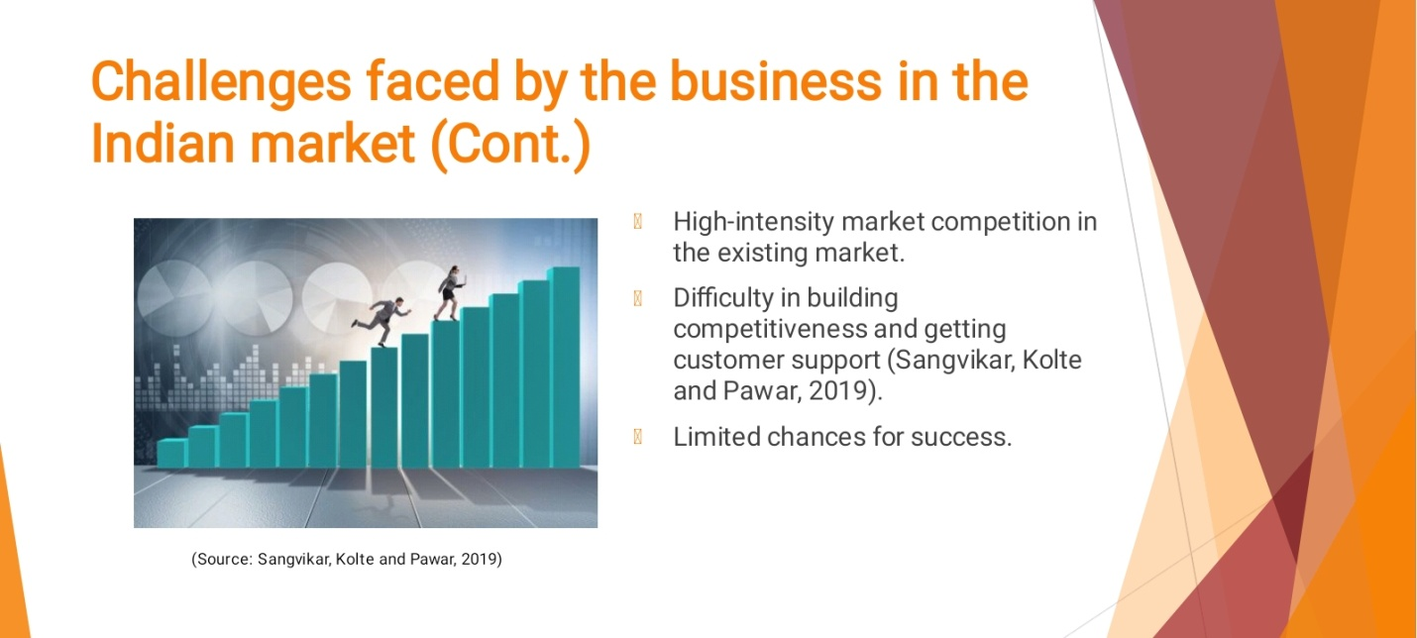
Slide 6

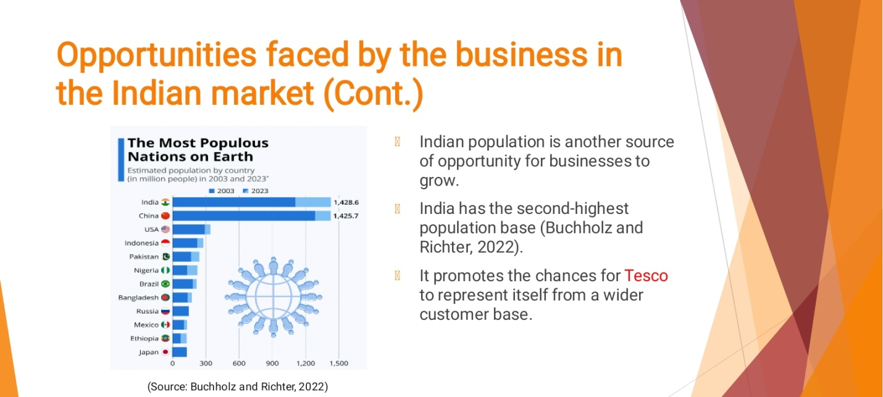
Slide 7

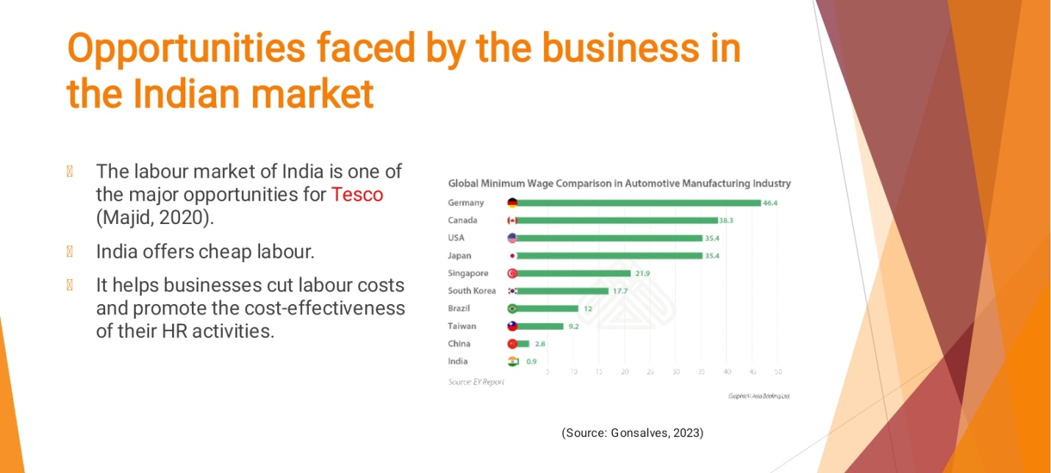

Slide 8
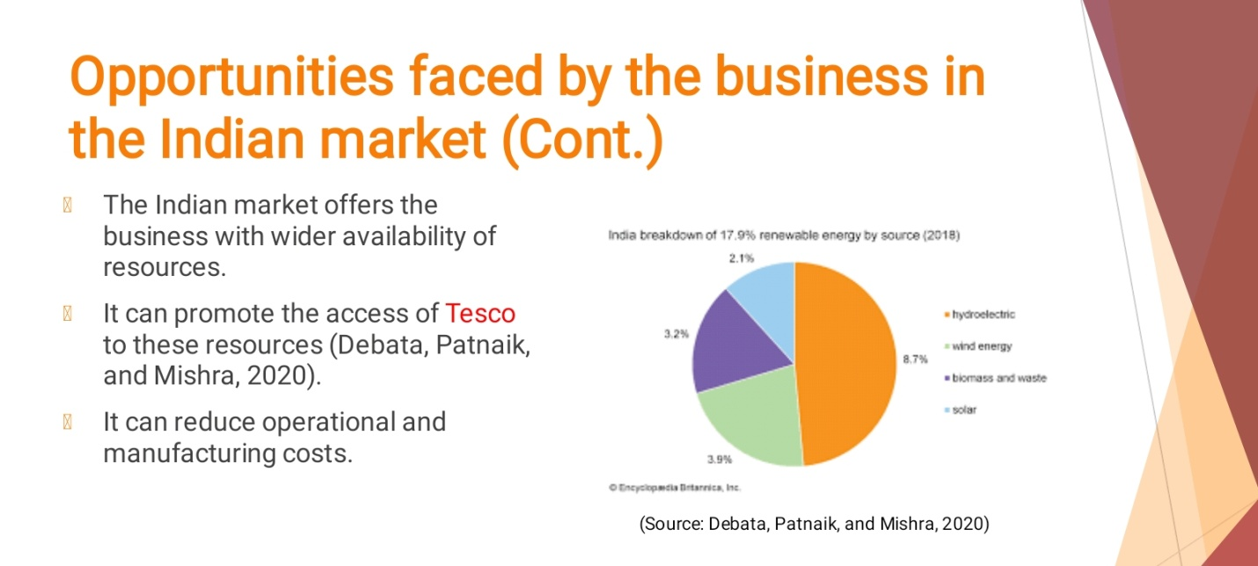
Slide 9
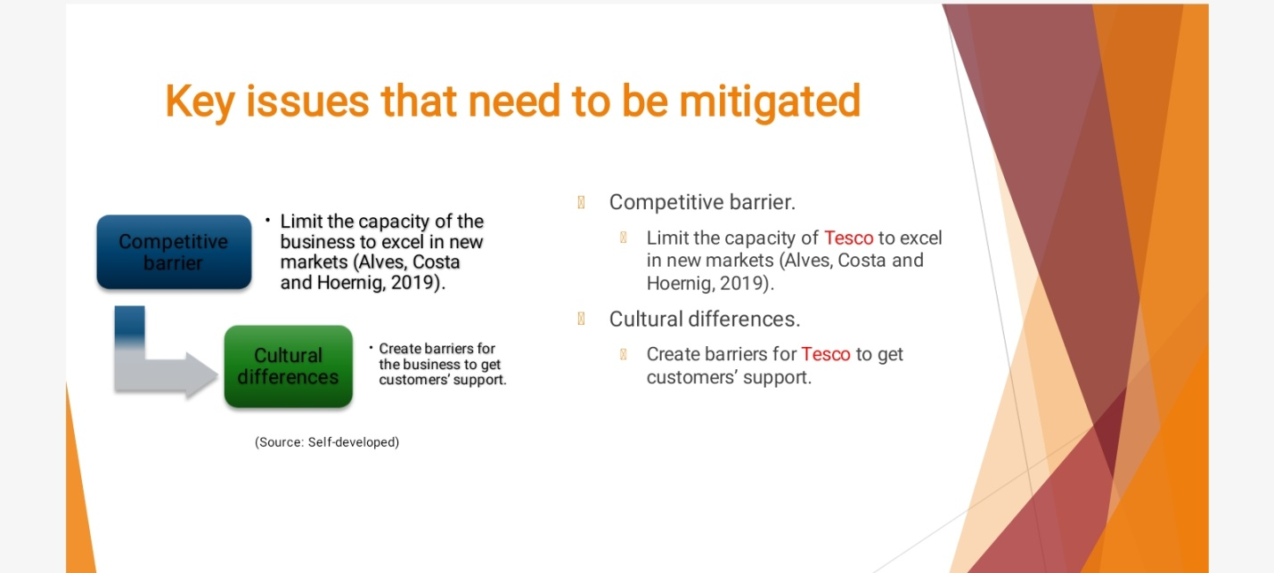

Slide 10
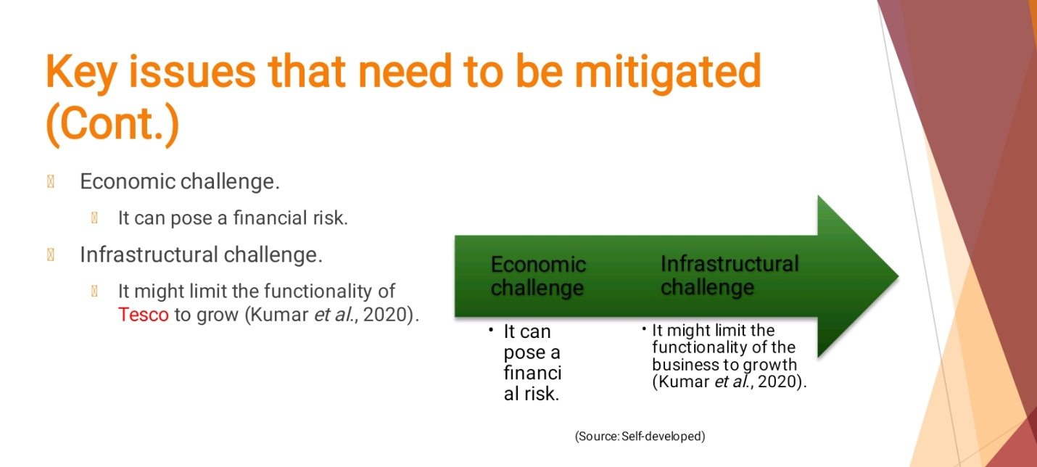
Slide 11
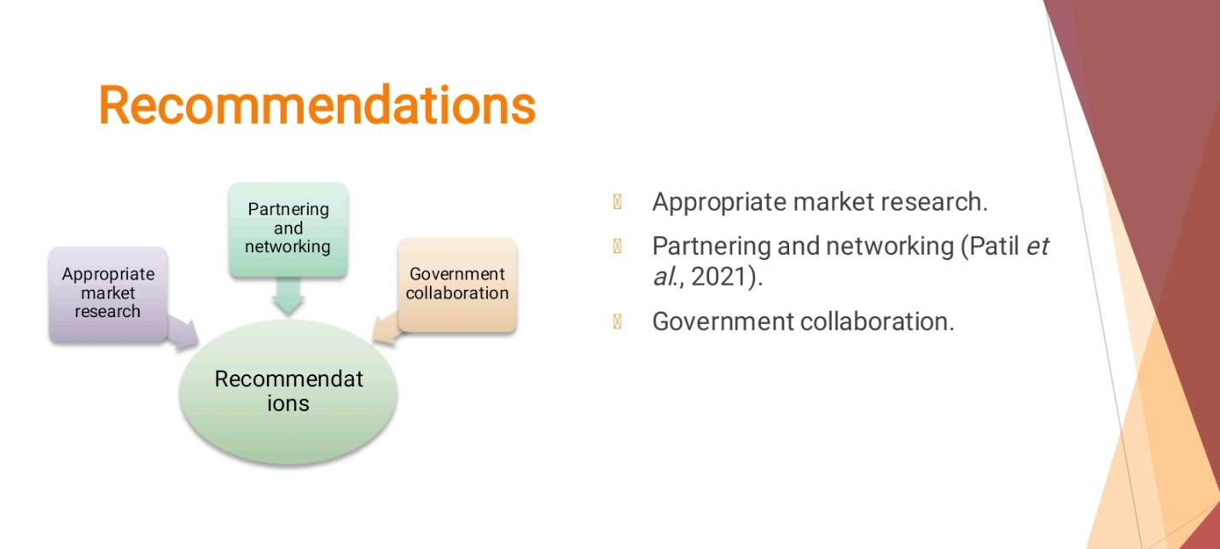

Slide 12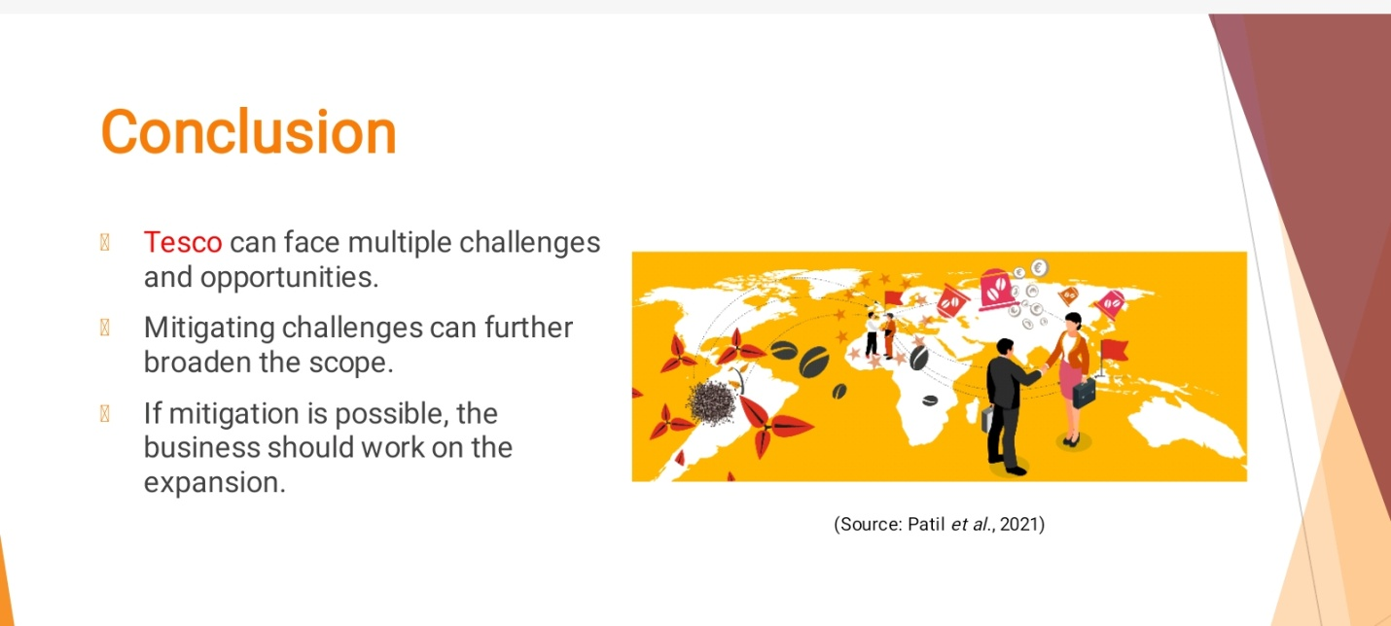
Slide 13



