7/21/2026
University of Wales Trinity Saint David

Network Operating Systems and Services
Module Name: Network Operating Systems and services
Module Code: ACCA5023
Student Name: Giuseppe Palumbo
Student ID: 2335642
Group:1
Lecturer’s Name: MD Sadeque Imam Shaikh

Table of Contents

Introduction 4
Task 1: 5
Research on Hypervisor 5
Research on IP Addressing 6
Research on Routing 7
Research on Network Services 8
Task 2: Network Deployment Evidence and Screenshots 9
Task 3: Reflection 34
Technical Reflection 34
Personal Reflection 34
References 35

Introduction:
This assignment focuses on the design, deployment and testing of a small virtual network using Oracle VM VirtualBox. The network includes two Windows virtual machines and two Debian virtual machines, configured to demonstrate successful connectivity within the same internal networks and unsuccessful connectivity between different internal networks.
The report is divided into three main parts. Task 1 provides research on hypervisors, IP addressing, routing and key network services such as VPN, DHCP, Active Directory Domain Services and Certificate Authorities. Task 2 presents practical evidence of downloading, installing and configuring the virtual machines, including network setup, IP addressing and connectivity testing. Task 3 reflects on the technical challenges and personal learning gained during the deployment and troubleshooting process.
For the practical implementation, Windows Server 2019 was used for the Windows virtual machines. This was accepted as suitable for the lab because the required networking configuration, IP addressing and connectivity testing are equivalent for this coursework task.
The purpose of this work is to show understanding of virtualisation, network configuration and systematic testing. It also demonstrates how theoretical networking concepts can be applied in a practical lab environment.
Task 1:

Research on Hypervisor
A hypervisor is a virtualisation layer that allows multiple virtual machines to run on one physical computer. Type 1 hypervisors run directly on physical hardware, while Type 2 hypervisors run on top of an existing host operating system [1]. For this coursework, I selected Oracle VM VirtualBox. Oracle describes VirtualBox as a hosted hypervisor, also known as a Type 2 hypervisor [2].
VirtualBox is suitable for this topology because it supports different guest operating systems, including Windows and Linux. This is important because the coursework requires Windows Server 2022, Debian Server, Windows clients and Debian clients. VirtualBox also provides virtual networking options, which allow isolated networks to be created safely in a lab environment.
For the BIRMINGHAM.ACCA domain environment, VirtualBox is practical because the topology is for learning, testing and evidence collection rather than a production data-centre deployment. It can run on a normal personal computer with enough CPU, RAM and storage. However, for an enhanced production topology, a Type 1 hypervisor would normally provide better scalability, performance and security isolation. Therefore, VirtualBox is justified for this coursework because it is accessible, compatible with Windows and Debian, and suitable for continuing the topology into Coursework 2.

Research on IP Addressing
I understand that data travels from one computer to another in small units called packets. Each packet contains addressing information, including source and destination IP addresses. IP addressing is therefore essential because it gives devices a logical identity and allows packets to be delivered across local networks and the Internet.
IPv4 uses a 32-bit address structure and is commonly represented in dotted-decimal format, for example 192.168.1.10 [3]. IPv6 uses 128-bit addresses, which provides a much larger address space for modern networks with many connected devices [4]. This shows why IP addressing must be structured and carefully planned.
Switches and routers support network communication in different ways. A switch connects devices within the same local area network, while a router forwards packets between different networks. For example, if a device sends data outside its local network, the router decides the next path for the packet.
Subnetting divides a larger network into smaller logical networks. It improves organisation, reduces unnecessary traffic and supports more efficient use of addresses [5]. For example:
Diagram: Example of IP Addressing
Local Network: 192.168.1.0/24
Subnet Mask: 255.255.255.0
PC 1: 192.168.1.10
PC 2: 192.168.1.11
Switch: connects devices in the same LAN
Router: forwards traffic to another networks / Internet
Overall, IP addressing improves network functionality, scalability and troubleshooting because each device and network segment can be clearly identified.

Research on Routing
Routing is the process of forwarding packets between different networks. Routers use routing tables to decide where traffic should be sent next. Static routing requires an administrator to manually configure routes, while dynamic routing protocols exchange routing information automatically and can adapt when the network changes.
Static routing is suitable for smaller and predictable topologies because it gives the administrator direct control over traffic paths. Cisco explains that static routes are manually configured and do not automatically change when the network topology changes [6]. This makes static routing easier to understand and troubleshoot in a controlled lab environment. Dynamic routing is more suitable for larger networks with many routers, sites or changing paths.
For this topology, static routing is the most suitable approach because BIRMINGHAM.ACCA is being developed as a small and controlled coursework network. It allows the administrator to decide exactly which networks should communicate. This is important because some connectivity tests are expected to succeed within the same network, while communication between different networks may be restricted.
In the enhanced topology, routing becomes more important because the Debian Server may act as a DHCP Relay and Windows Server 2022 may provide centralised services. Debian documentation explains that dhcrelay forwards DHCP and BOOTP requests from a subnet without a directly connected DHCP server to DHCP servers on other subnets [7]. Therefore, routing must be correctly planned so DHCP relay, Windows Server connectivity and client communication work only where required.

Research on Network Services
Network services provide important functions that make a network more secure, manageable and scalable. The key services relevant to this topology are VPN, DHCP, Active Directory Domain Services and Certificate Authorities. Microsoft lists DHCP Server, Remote Access, Active Directory Domain Services and Active Directory Certificate Services as Windows Server roles or role services [8].
A VPN provides secure remote access to internal resources. In an enhanced BIRMINGHAM.ACCA environment, a VPN could allow authorised users to connect from outside the site while protecting traffic through authentication and encryption. Best practice includes strong authentication, restricted access and regular monitoring.
DHCP automatically provides client devices with network configuration, such as IP addresses, subnet masks and gateway information. This reduces manual configuration errors and makes the network easier to manage as more clients are added. If clients are located on different subnets, a DHCP Relay can forward requests to a central DHCP server.
Active Directory Domain Services provides centralised management of users, computers and authentication. For BIRMINGHAM.ACCA, AD DS would allow Windows Server 2022 to manage domain users, domain computers and access policies from one place.
A Certificate Authority issues and manages digital certificates used for trust, authentication and encrypted communication. Best practices include protecting private keys, limiting administrator access, applying least privilege and keeping secure backups. Together, VPN, DHCP, AD DS and CA services support a more secure and scalable enhanced topology.

Task 2: Network Deployment Evidence and Screenshots
S.1 Oracle VirtualBox download page
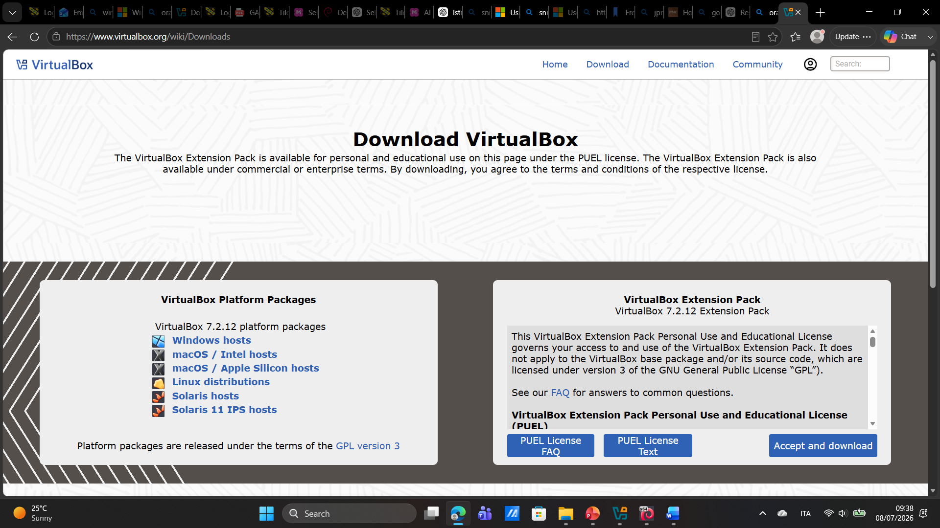

Official Oracle VM VirtualBox download page used to obtain the hypervisor installer. This confirms that the virtualisation software was downloaded from an appropriate and trusted source rather than from a third-party website.

S.2 Oracle VirtualBox installed
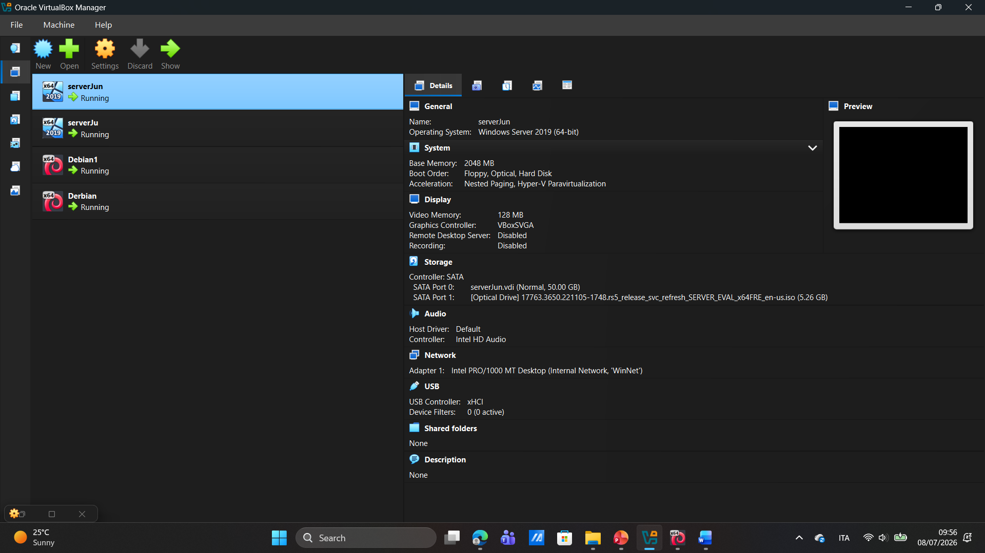

Oracle VM VirtualBox Manager opened successfully on the host computer. This confirms that the selected hypervisor was installed correctly and was ready to create and manage the virtual machines required for the topology.

S.3 Windows Server download source
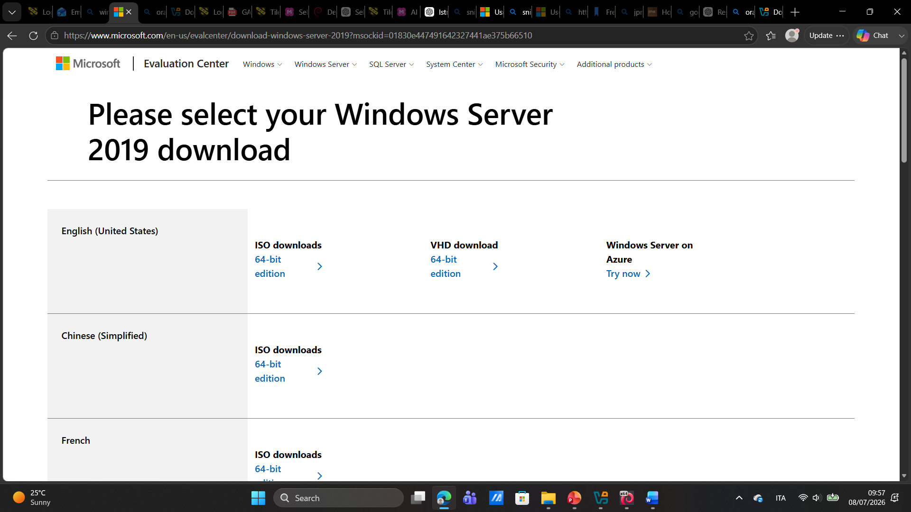
Windows Server download source used to obtain the operating system image for the Windows virtual machines. This provides evidence that the Windows server operating system was obtained from a suitable source before being installed in VirtualBox.

S.4 Debian download source
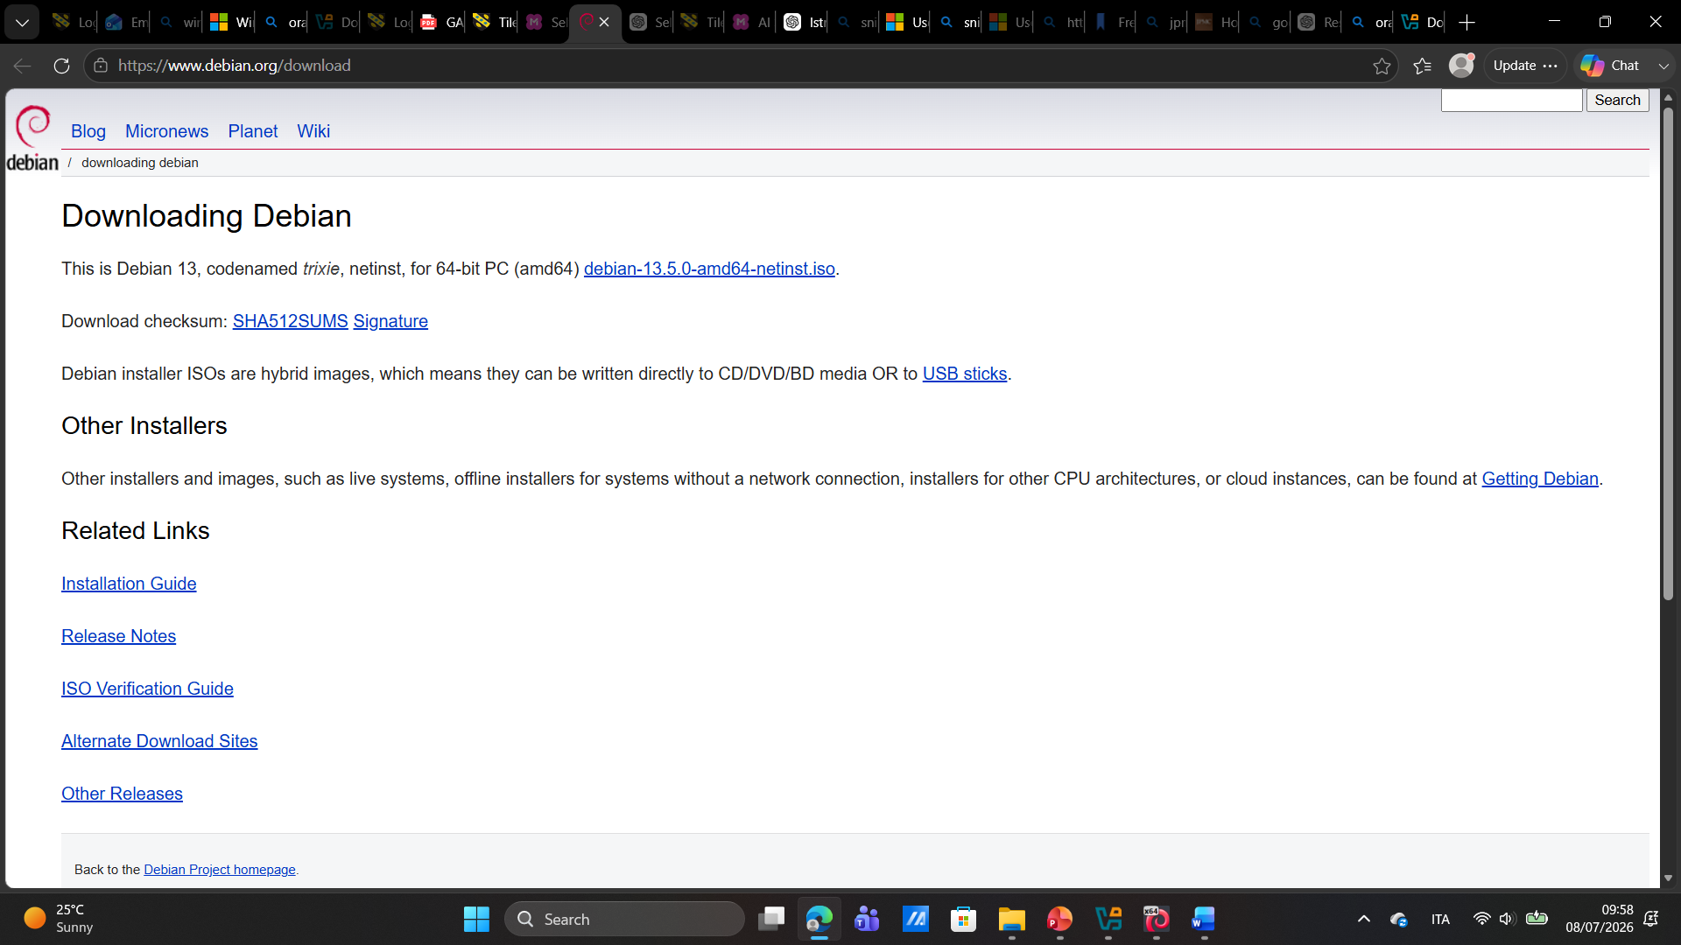
Debian download page used to obtain the Linux operating system image. This confirms that the Debian installation media came from an appropriate source and was used to create the Linux virtual machines in the network topology.

S.5 Virtual Machines Created in Oracle VM VirtualBox
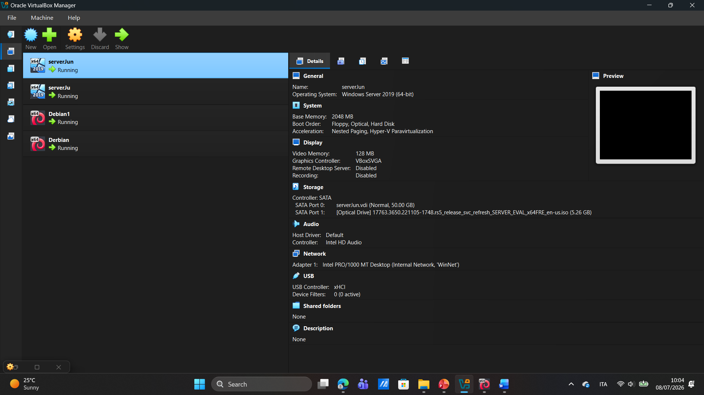
Oracle VM VirtualBox Manager displays the four virtual machines created for the lab topology. The Windows machines are named serverJun and serverJu, while the Linux machines are named Debian1 and Derbian. These names are used in the report to represent Windows 1, Windows 2, Debian 1 and Debian 2. This confirms that all required virtual machines were created successfully before the operating system installation, network configuration, IP addressing and connectivity testing stages.

S.6 serverJun desktop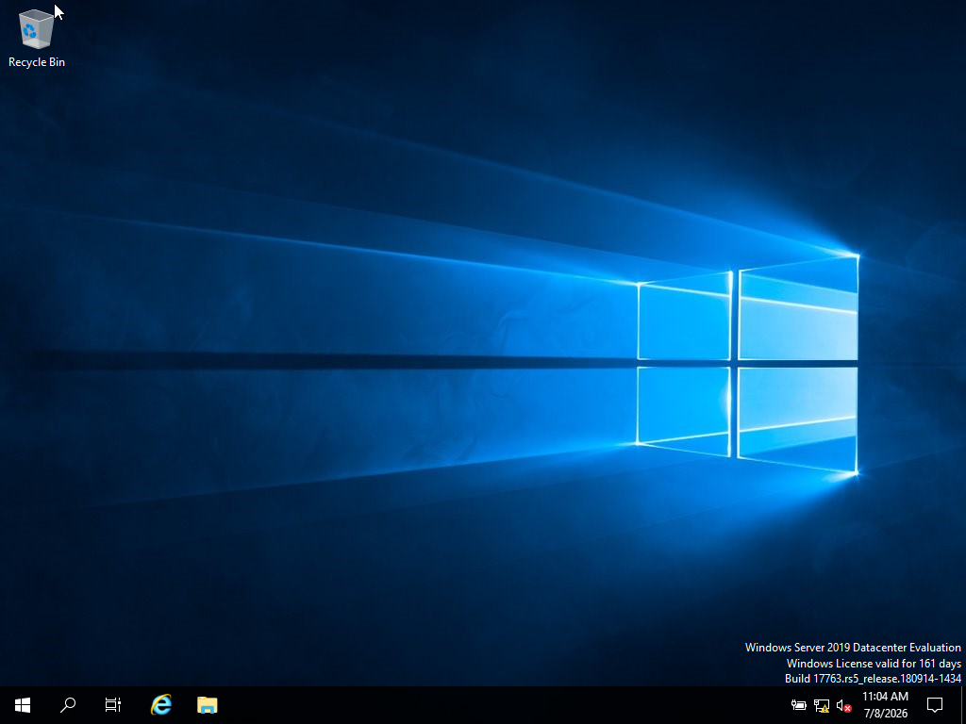
serverJun has started successfully and the Windows Server desktop is visible. This confirms that the operating system installation was completed and that the first Windows virtual machine was ready for network configuration and testing.

S.7 serverJu desktop 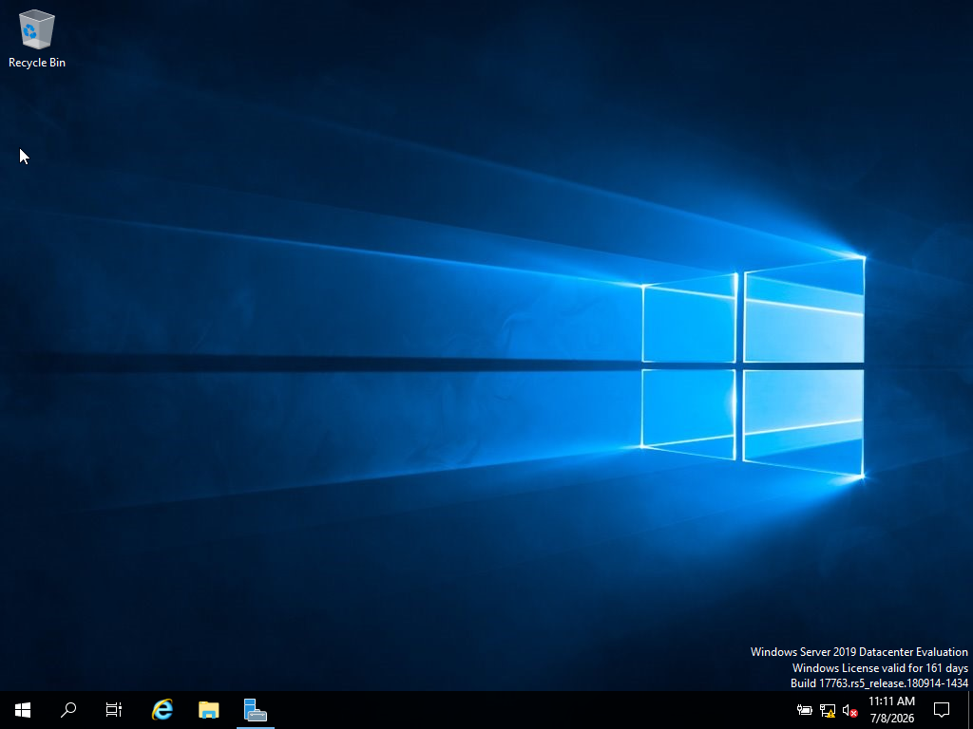
serverJu has started successfully and the Windows Server desktop is visible. This confirms that the second Windows virtual machine was installed correctly and was ready to be connected to the Windows internal network.

S.8 Derbian desktop Derbian has booted successfully into the Debian desktop environment. This confirms that the second Debian virtual machine was installed correctly and could be used as the second Linux machine in the topology.

S.9 Debian1 desktop 
Debian1 has booted successfully into the Debian desktop environment. This confirms that the first Debian virtual machine was installed correctly and was ready for IP addressing and Linux network testing.

S.10 serverJun connected to WinNet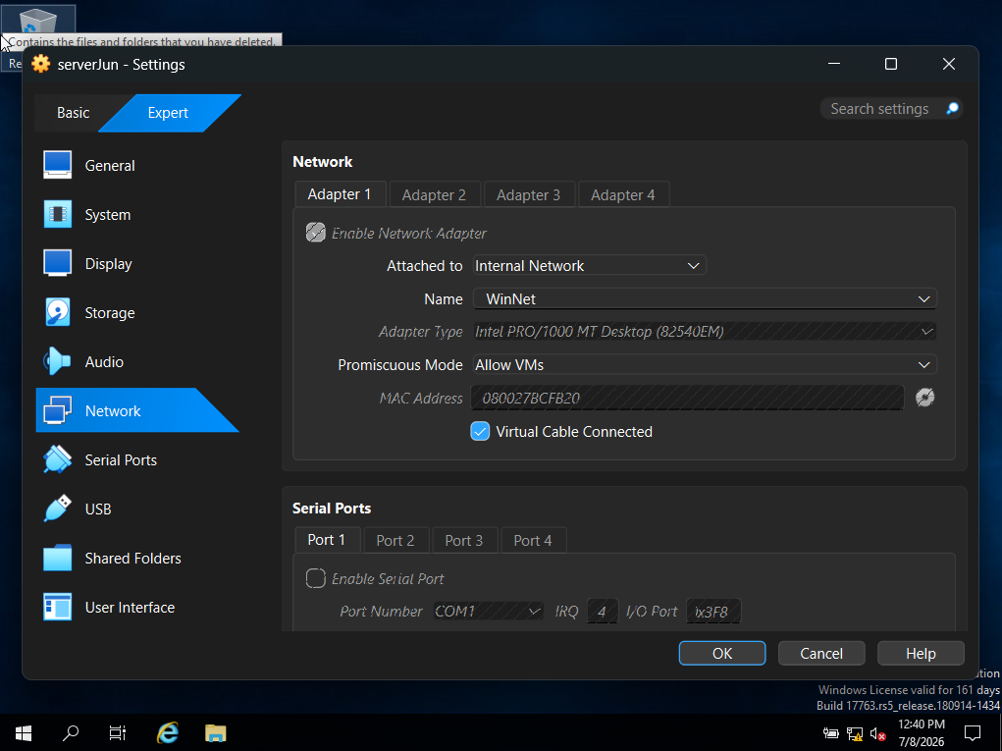
serverJun is configured with Adapter 1 attached to Internal Network and the network name set to WinNet. This confirms that the first Windows machine is connected to the correct isolated Windows internal network in VirtualBox.

S.11 serverJu connected to WinNet
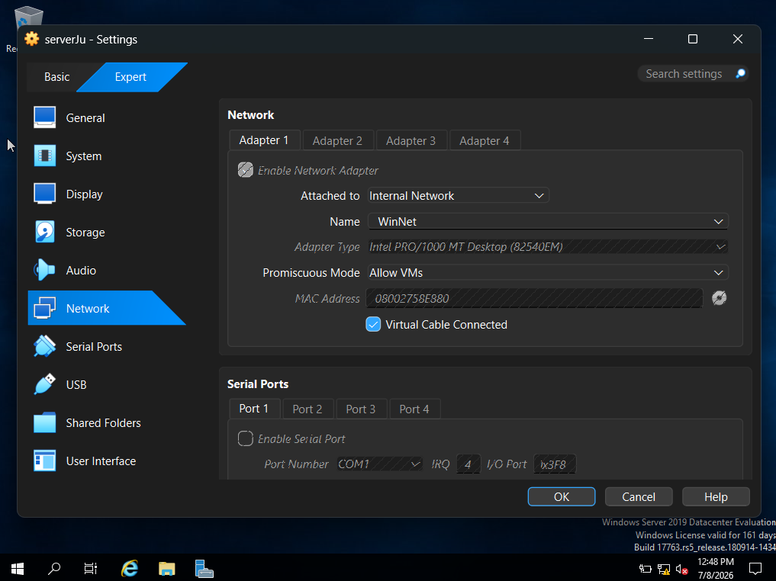
serverJu is also configured with Adapter 1 attached to Internal Network using the same network name, WinNet. This confirms that both Windows machines are connected to the same virtual network segment and should be able to communicate with each other.

S.12 Derbian connected to LinuxNet
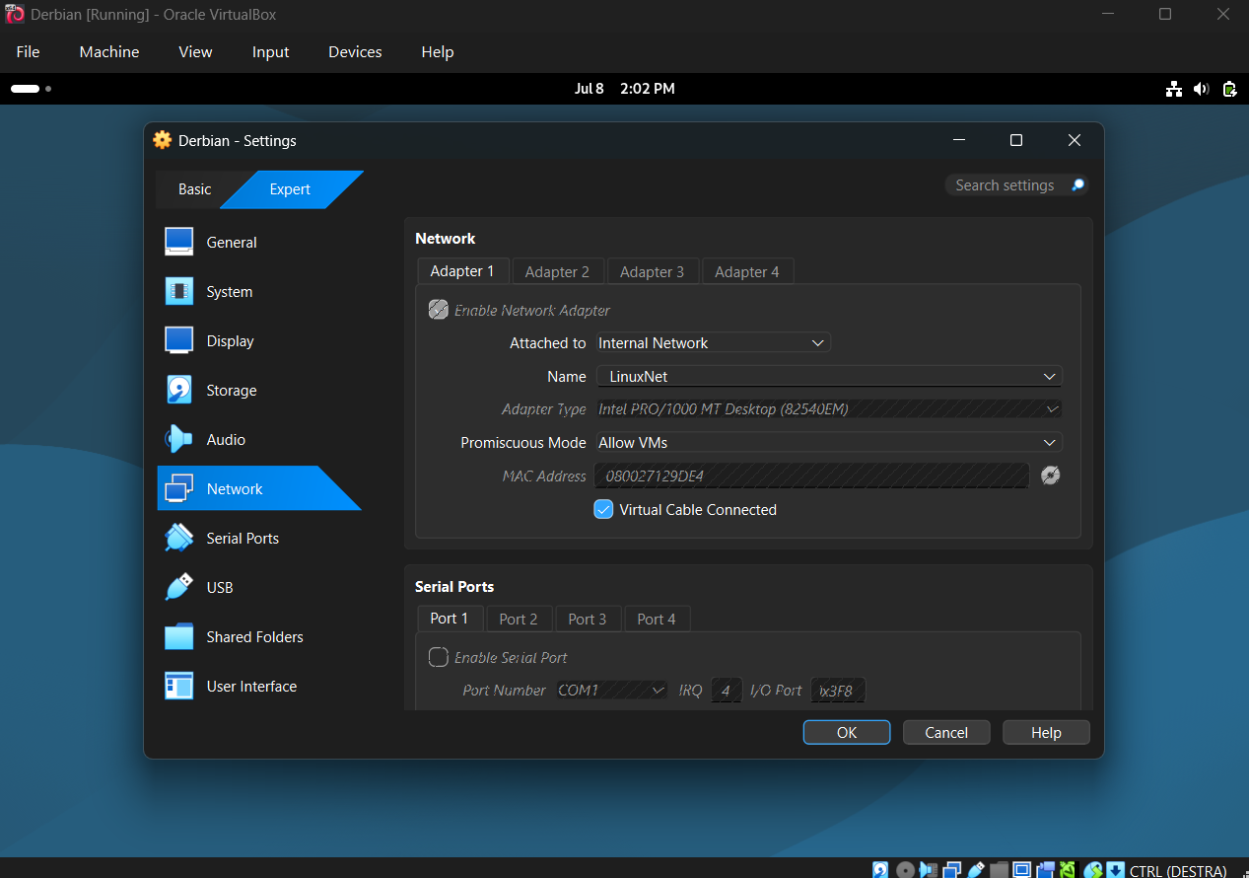Derbian is configured with Adapter 1 attached to Internal Network and the network name set to LinuxNet. This confirms that the first Debian machine is connected to the Linux internal network rather than the Windows network.

S.13 Debian1 connected to LinuxNet 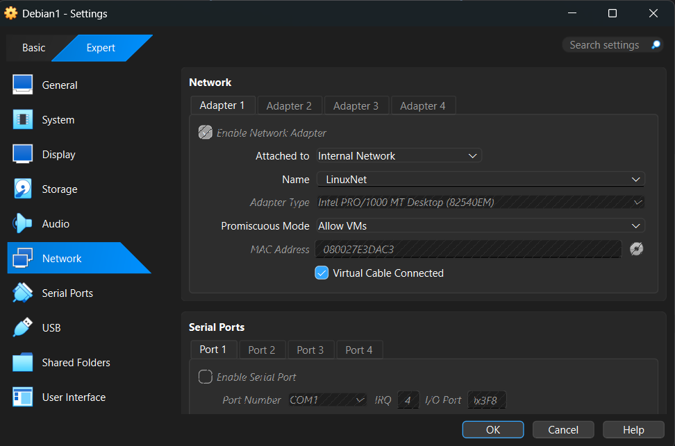Debian1 is also connected to the LinuxNet internal network. This confirms that both Debian machines are placed in the same isolated Linux network segment, allowing Linux-to-Linux communication while remaining separate from the Windows network.

S.14 IP configuration of serverJun 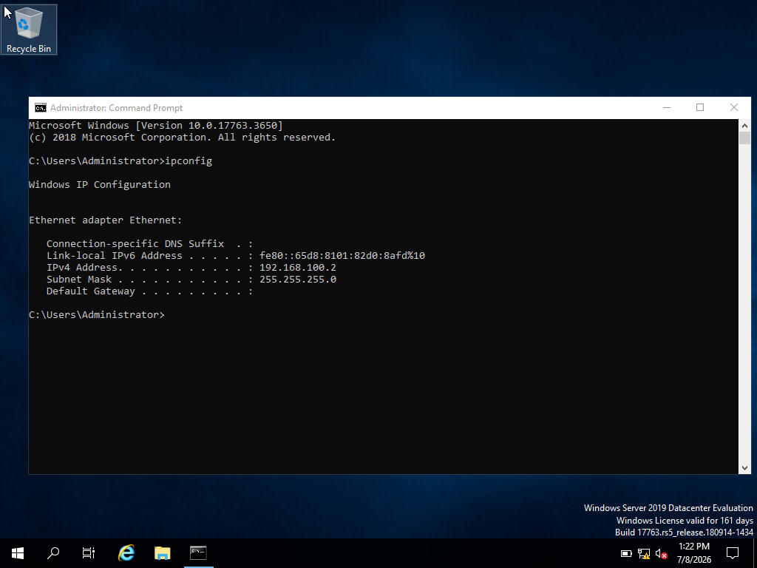
The ipconfig command confirms that serverJun has been assigned the IPv4 address 192.168.100.2 with subnet mask 255.255.255.0. This verifies the IP configuration of the first Windows machine.

S.15 IP configuration of serverJu 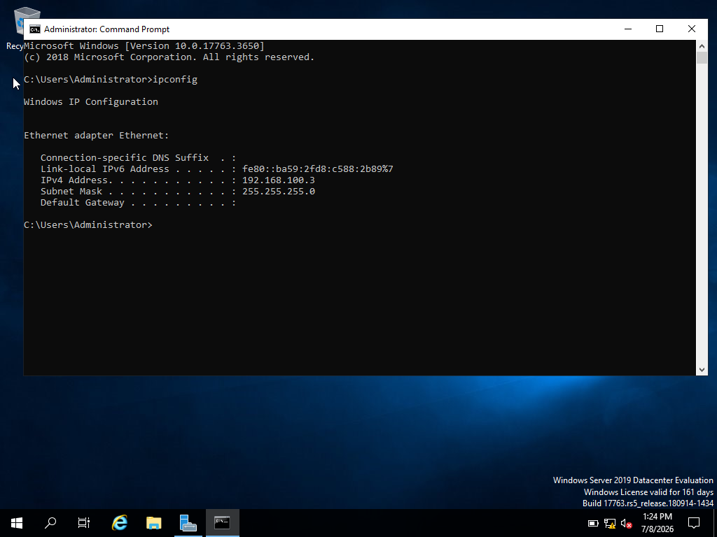 The ipconfig command confirms that serverJu has been assigned the IPv4 address 192.168.100.3 with subnet mask 255.255.255.0. This verifies that the second Windows machine has a different valid IP address in the same address range.

S.16 IP configuration of Derbian machine 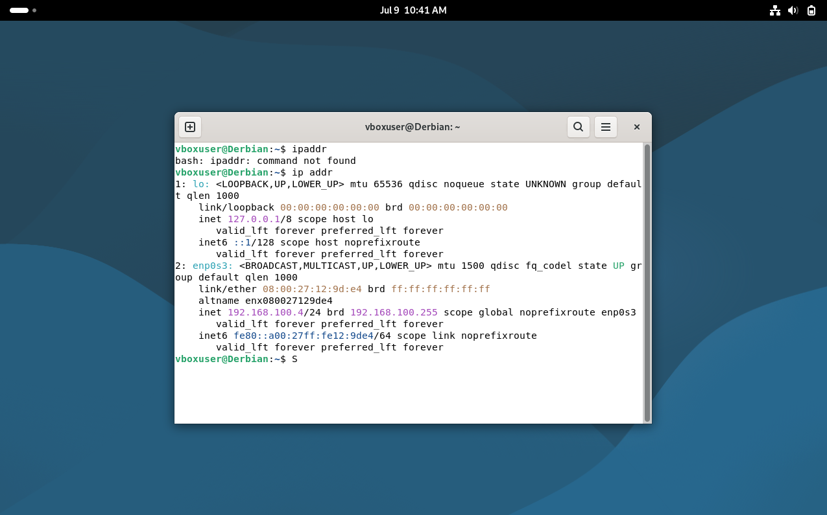
The ip addr command confirms the IPv4 address assigned to the Debian machine. The /24 prefix shows that the subnet mask is equivalent to 255.255.255.0, confirming that the Linux machine has been configured with the correct network settings.

S.17 IP address configuration second Debian1 machine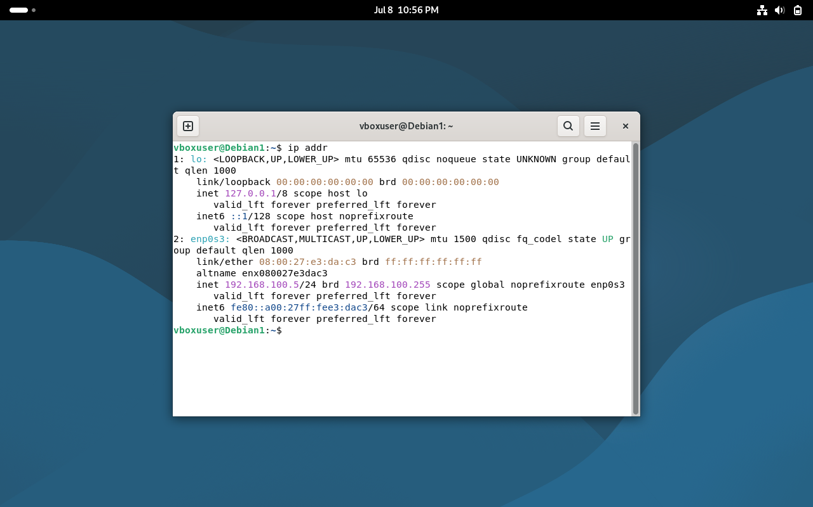
The second Debian machine is configured with its own IPv4 address in the same Linux internal network range. This confirms that both Debian machines have unique IP addresses and are ready for connectivity testing inside LinuxNet.

S.18 Windows network address 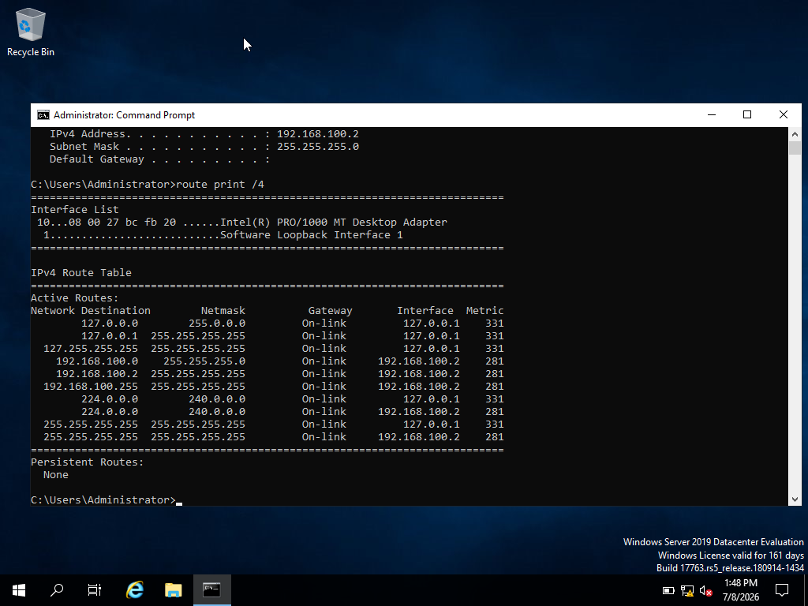 The route print /4 command displays the Windows routing table. The entry for 192.168.100.0 with subnet mask 255.255.255.0 confirms the Windows network address as 192.168.100.0/24.

S.19 Linux network address 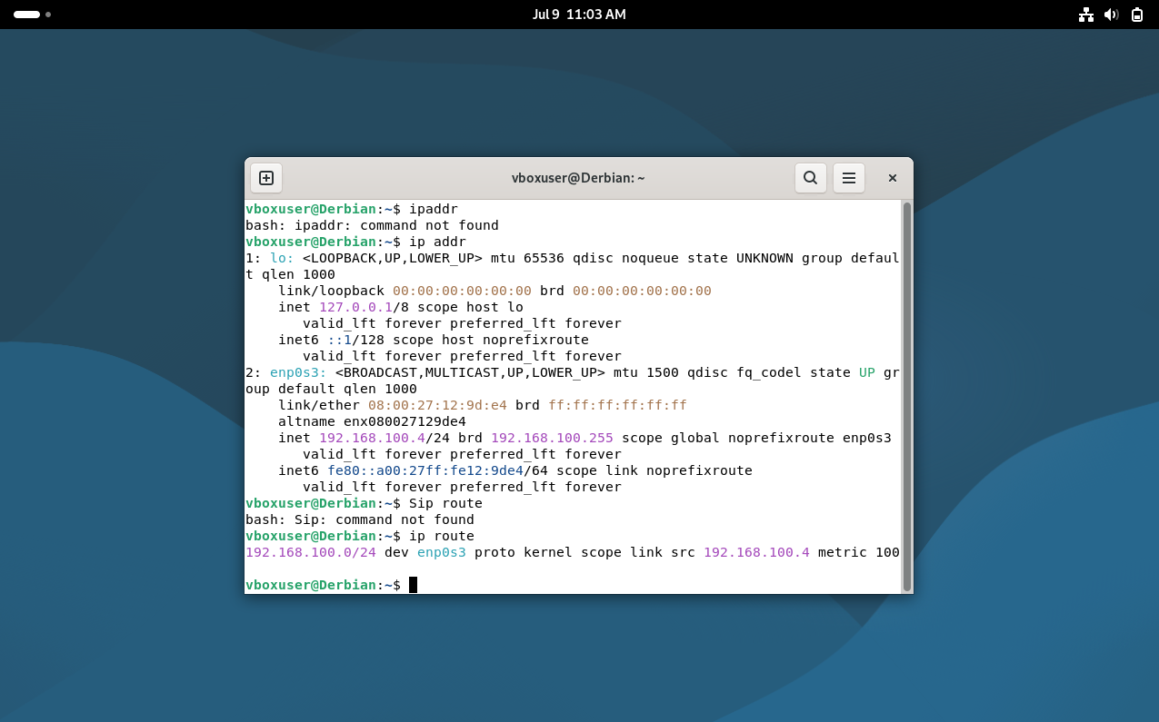 The ip route command displays the Linux routing information. The output shows the 192.168.100.0/24 network on the Debian network interface, confirming the Linux network address used for the internal Linux network.

S.20 Ping from serverJun to serverJu 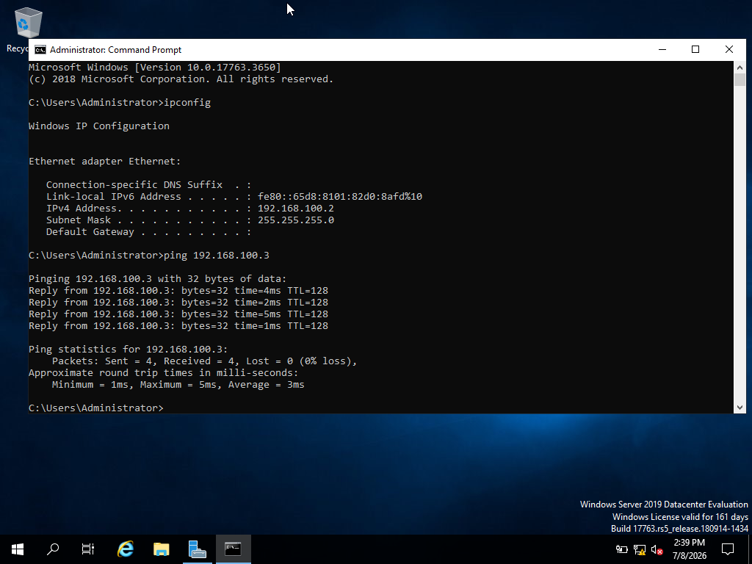 The ping from serverJun to serverJu is successful. The replies from 192.168.100.3 with 0% packet loss confirm that the two Windows machines can communicate within the WinNet internal network.

S.21 Ping from serverJu to serverJun 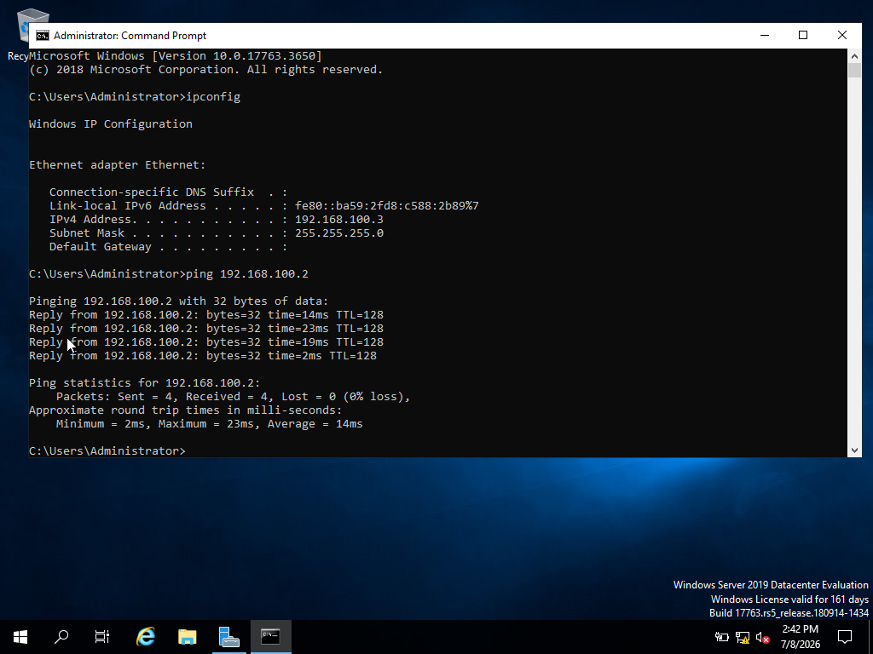 The ping from serverJu to serverJun is successful. The replies from 192.168.100.2 confirm two-way communication between the Windows machines inside the Windows internal network.

S.22 Ping between Debian machines 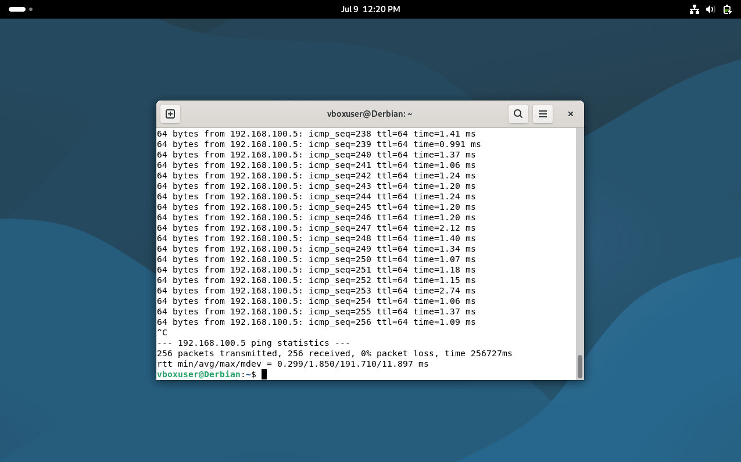 The ping test between the Debian machines is successful. The replies received from the other Debian machine confirm that devices connected to LinuxNet can communicate with each other successfully.

S.23 Reverse ping between Debian machines
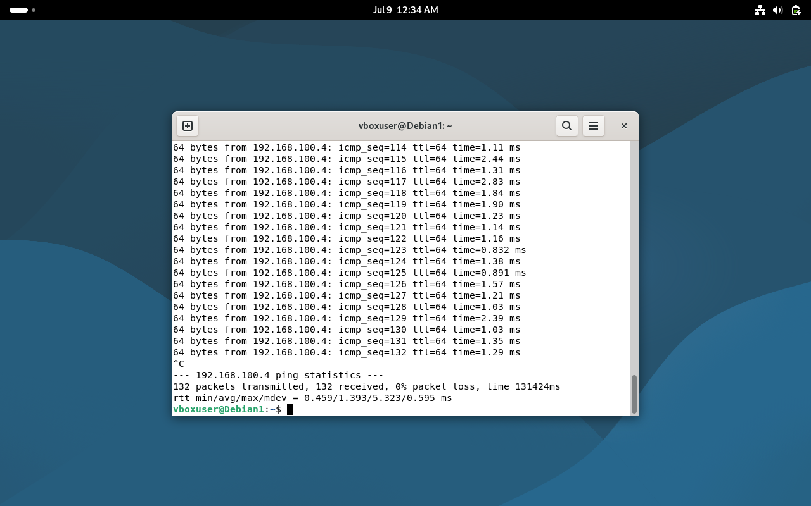
The reverse ping between the Debian machines also succeeds. This confirms two-way communication inside the Linux internal network and proves that both Debian machines are correctly connected to LinuxNet.

S.24 Failed ping from Windows to Debian 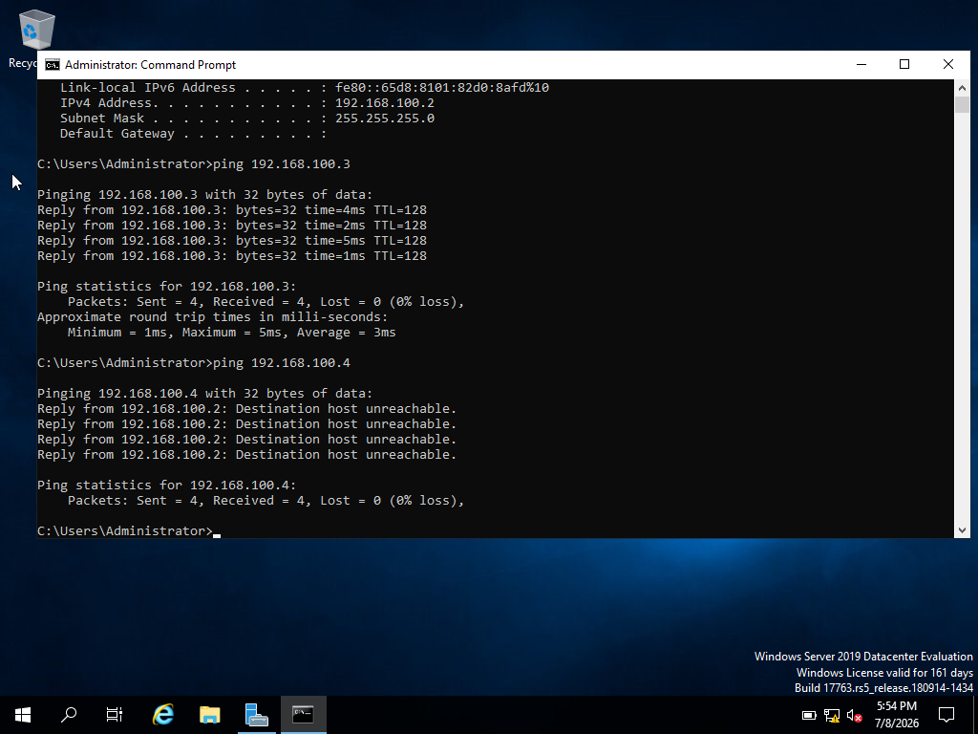 The ping from Windows to Debian fails with a Destination host unreachable message. This is the expected result because the Windows machines are connected to WinNet, while the Debian machines are connected to LinuxNet. These are separate isolated Internal Networks in VirtualBox.

S.25 Failed ping from Debian to Windows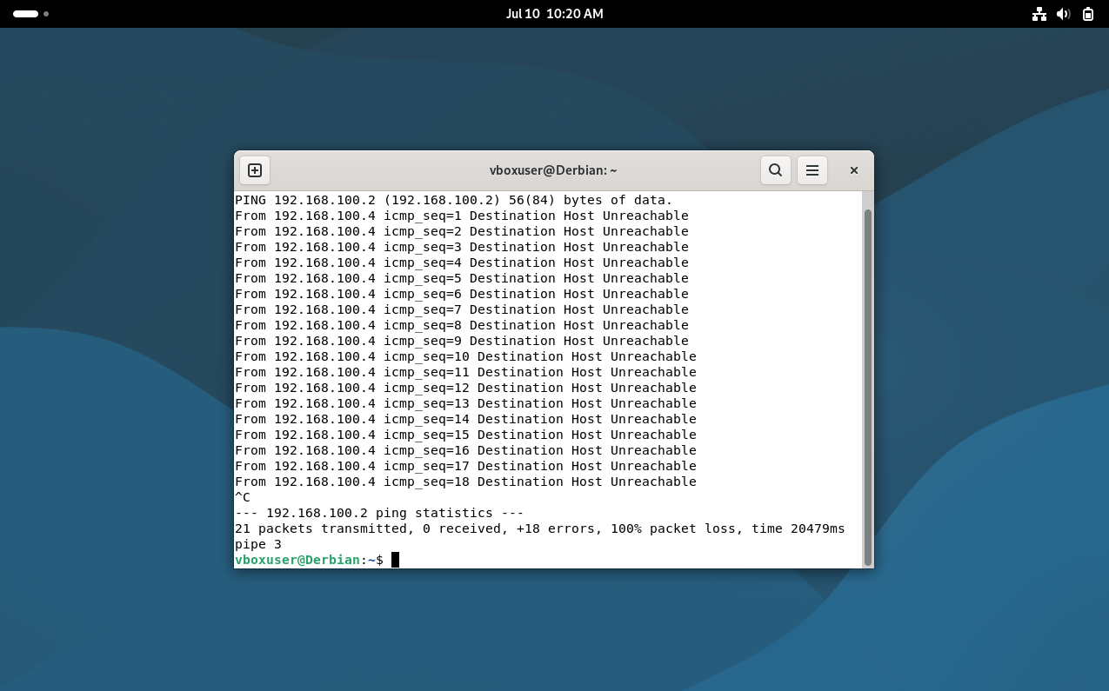 The ping from Debian to Windows fails, confirming that the Linux and Windows internal networks are isolated from each other. This meets the requirement for unsuccessful connectivity between different networks.

Conclusion

The results confirm that devices connected to the same internal network can communicate successfully. The two Windows machines communicate through WinNet, and the two Debian machines communicate through LinuxNet. However, communication between Windows and Debian fails because WinNet and LinuxNet are separate isolated Internal Networks in Oracle VM VirtualBox. This meets the requirement for successful connectivity within the same network and unsuccessful connectivity between different networks.

Task 3: Reflection

Technical Reflection
During Task 2, I deployed the network using Oracle VM VirtualBox and configured four virtual machines: two Windows machines and two Debian machines. The Windows machines were connected to the Internal Network named WinNet, while the Debian machines were connected to LinuxNet. This helped separate the two groups of machines and allowed me to test successful and unsuccessful connectivity.
One challenge during deployment was making sure that each machine had the correct IP address. I used ipconfig on Windows and ip addr on Debian to check the assigned addresses. I also used route print /4 on Windows and ip route on Debian to confirm the network address information. During testing, one Windows ping initially failed, so I diagnosed the issue by checking the IP configuration, network adapter settings and firewall configuration. After troubleshooting, the ping worked successfully within the Windows network. On Debian, I noticed that the ping command continued running, so I stopped it using Ctrl + C and checked the packet loss results.
The final tests showed that Windows-to-Windows and Debian-to-Debian communication worked successfully. However, Windows-to-Debian and Debian-to-Windows communication failed, which was expected because the machines were placed in separate Internal Networks.

Personal Reflection
This task improved my confidence in virtualisation and network testing. At first, I found the setup confusing, especially when working with IP addresses, screenshots, timestamps and VirtualBox network settings. However, by checking each step carefully, I learned how to troubleshoot problems systematically instead of guessing. I also improved my time management because I had to collect evidence regularly and organise screenshots clearly. Overall, this task helped me understand how practical networking evidence supports technical decision-making.

References
[1] IBM, “Hypervisors,” Ibm.com, Oct. 30, 2024. [Online]. Available: https://www.ibm.com/think/topics/hypervisors. Accessed: Jul. 10, 2026.
[2] “Oracle VM VirtualBox: User Manual for Release 6.1,” Oracle Help Center. [Online]. Available: https://docs.oracle.com/en/virtualization/virtualbox/6.1/user/Introduction.html.
Accessed: Jul. 11, 2026.
[3] J. Postel, “Internet Protocol,” www.rfc-editor.org, Sept. 1981. [Online]. Available: https://www.rfc-editor.org/rfc/rfc791.html. Accessed: Jul. 11, 2026.
[4] S. E. Deering and B. Hinden, “Internet Protocol, Version 6 (IPv6) Specification,” IETF, July 01, 2017. [Online]. Available: https://www.rfc-editor.org/rfc/rfc8200.html.
Accessed: Jul. 12, 2026.
[5] “Internet Standard Subnetting Procedure,” IETF, Aug. 01, 1985. [Online]. Available: https://www.rfc-editor.org/rfc/rfc950.html . Accessed: Jul. 12, 2026.
[6] Cisco, “Configuring Static Routing,” Cisco Nexus 3000 Series NX-OS Unicast Routing Configuration Guide. [Online]. Available: https://www.cisco.com/c/en/us/td/docs/switches/datacenter/nexus3000/sw/unicast/503_u1_2/nexus3000_unicast_config_gd_503_u1_2/l3_route.html. Accessed: Jul. 13, 2026.
[7] dhcrelay (8) — isc-dhcp-relay — Debian testing — Debian Manpages,” Debian.org, 2025. [Online]. Available: https://manpages.debian.org/testing/isc-dhcp-relay/dhcrelay.8.en.html Accessed July 14, 2026.
[8] pronichkin, “Roles, Role Services, and Features included in Windows Server - Server Core,” Microsoft.com, Mar. 12, 2025. [Online]. Available: https://learn.microsoft.com/en-us/windows-server/administration/server-core/server-core-roles-and-services?tabs=role . Accessed: Jul. 15, 2026.

