

MODULE: LCDB7011
Quantitative Research Methods

ASSIGNMENT TITLE:
The Impact of E-commerce Live Streaming on Consumer Buying Behavior

STUDENT NAME : TIANJIAO ZHOU
STUDENT NUMBER : 2400557
SUPERVISOR : Dr Ebad Banissi
WORD COUNT : 8069 WORDS
SUBMISSION DATE : 04/14/2025

1. Introduction

1.1 Research Context and Problem Statement
The proliferation of Internet technology and the widespread adoption of smart communication devices have fundamentally changed consumer behavior, leading to a significant shift towards online shopping. E-commerce can provide consumers with an experience that meets their personalized quality consumption needs because of its convenience, time, and numerous selections. However, with the explosion of information online comes a big question for consumers. Conversely, the online market generally reflects a limitation of interactivity - no simple or highly immersive interactive components as in physical retail venues (Gulfraz et al., 2022).
Owing to this dynamic ecosystem of digital consumer behavior, collaborated through social faculties, common e-commerce modalities characterized by static imagery and text descriptions have increasingly become incapable of satisfying the ever-evolving desires, needs, and even wants of the contemporary individual consumer landscape (Huang and Benyoucef, 2013). This paves the road, then write a new tech model: e-commerce (live streaming), which takes advantage of real-time video technology to mesh online and offline shopping experiences (Cai et al., 2018; Sun et al., 2019; Wongkitrungrueng and Assarut, 2020). However, despite this well-known reality of the success of live-streaming commerce, there is an age-old challenge to turn massive traffic into purchasing, but few succeed. This lack of understanding, therefore, reflects a broader demand for psychological rationales, particularly regarding how consumer ideals are framed and embodied, which fundamentally influence purchase behavior in this new ecosystem.
China’s e-commerce live streaming market is 3.5 trillion yuan in Gross Merchandise Value, per the research report 2023. However, only 28% of viewers become buyers, leading to a growing engagement–purchase gap. E-commerce live streaming has quickly evolved into one of the most effective tools for converting viewer engagement into actual behavior and has drawn the interest of all major e-commerce platforms (Cai et al., 2018). Platforms like Amazon and TikTok have integrated live-streaming features into their business models to cash in on the wave. Simultaneously, new platforms taking advantage of this trend have flourished in business and sales (Duong, 2025; Wongkitrungrueng and Assarut, 2020). The e-commerce industry is booming - the retail sales medium has changed, increasing the number of people buying things online (Huang and Benyoucef, 2013). Not even the COVID-19 pandemic slowed down this trend, which became (through home shopping) the preferred option for dozens of consumers (Nguyen et al., 2020).
However, with the intensification of competition and the market's maturity, the growth of e-commerce live streaming has gradually slowed down after the initial hype. At the same time, the family of the epidemic has also significantly boosted the decline of offline sales. The current competitive landscape where the market is becoming increasingly mature puts firms in the inundated position in determining what marketing bundles could keep them above to meet the market as well as contender goals for consumers to buy, both in the short (immediate) and long run (Cai et al., 2018; Wongkitrungrueng and Assarut, 2020).
Live streaming's growth in e-commerce has necessitated work on consumers' purchase intentions influenced by it, focusing on dynamic perspectives on value. (Cai et al., 2018; Sun et al., 2019) Therefore, this study addresses these topics based on the evidence of TikTok users. In particular, TikTok should focus on integrating social entertainment and shopping functions so its users are generally concerned about product authenticity and social influence. This study supports business growth and strategic planning in e-commerce live-streaming business through an examination of influences on purchase intention through Kotler's (2021) theory of customer value. (Cai et al., 2018; Wongkitrungrueng and Assarut, 2020) It fills a void in scholarly theories of digital user behavior and presents novel findings for firms seeking lucrative live streaming strategies.

1.2 Research Questions
This study seeks to address the following research questions:
- How do the key elements of e-commerce live streaming, namely real-time interactivity, product presentation, professional guidance, and social interaction, influence consumer purchase intention?
- What is the role of customer value in mediating the relationship between e-commerce live streaming elements and consumer purchase intention?
- To what extent do real-time interactivity, product presentation, professional guidance, and social interaction contribute to enhancing customer value in the context of e-commerce live streaming?

1.3 Research Objectives
The objectives of this research are as follows:
- To investigate the impact of real-time interactivity, product presentation, professional guidance, and social interaction on consumer purchase intention in the context of e-commerce live streaming.
- To examine the mediating role of customer value in the relationship between e-commerce live streaming elements and consumer purchase intention.
- To assess the extent to which real-time interactivity, product presentation, professional guidance, and social interaction contribute to enhancing customer value in the context of e-commerce live streaming.
- To provide practical recommendations for businesses seeking to leverage e-commerce live streaming to enhance consumer purchase intention and improve profitability.

1.4 Research Hypotheses
Based on the research questions and objectives, the following hypotheses are proposed:
- H1: Real-time interactivity, product presentation, professional guidance, and social interaction have a positive impact on consumer purchase intention.
- H2: Customer value has a positive impact on consumer purchase intention.
- H3: Real-time interaction, product presentation, professional guidance, and social interaction can positively enhance customer value.
- H4: Customer value plays a mediating role in the relationship between real-time interaction, product display, professional advice, and social interaction and consumer purchase intentions.
This study addresses a critical research and practice gap by examining how key features of live streaming influence consumer purchase intentions through the mediating role of customer value, providing a dual contribution to both theory and e-commerce marketing strategy.

2. Literature Review

2.1 Theoretical Foundations
Stimulus-Organism-Response (SOR) theory is a fundamental theoretical explanation of environmental influence on consumer behavior in e-commerce live streaming. Mehrabian and Russell (1974) first proposed the theory. Environmental stimuli (S), according to the theory, influence an individual's cognitive and affective state (O), which, in turn, influence their behavioral response (R). It is easily applicable in e-commerce live streaming, where chat in real time, an influencer's charisma, and product demos in real time function as environmental stimuli that shape consumer emotion and cognitive judgments in real time.
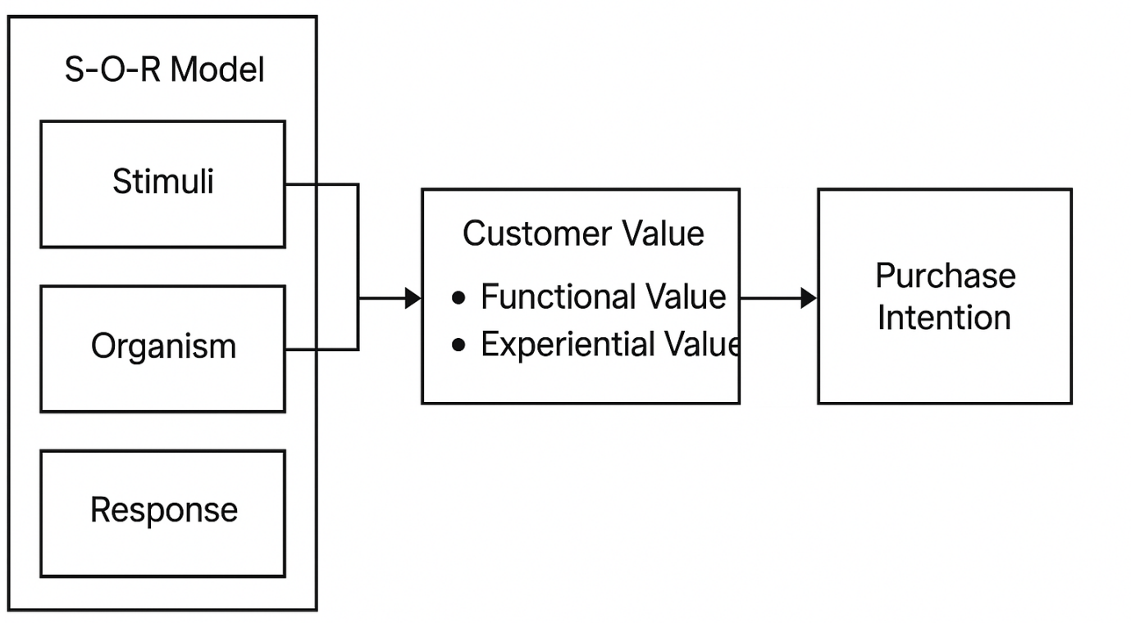
Figure 1 S-O-R Model
In contexts of e-commerce live streaming, such stimuli are comprised of various elements of the virtual environment such as elements of interaction in real time, product demonstration, attributes of a streamer, and social cues (Xue et al., 2020). These stimuli generate cognitive and emotional reactions from consumers that ultimately shape their buying intentions. Eroglu et al. (2001) extended SOR to internet-based stores and inferred that atmospherical cues in internet-based stores play an immensely influential role in consumers' feelings and buying behavior. Liu et al. (2021), most recently, extended the application of SOR to examine how parasocial interaction of live-streaming commerce affects buying intention through psychological means of trust and perceived value. Due to flexibility and explanatory strength, the model is appropriate to examine complicated relations between elements of e-commerce of live streaming with consumers' buying behavior (Chen et al., 2022).
This study draws on customer value theory, with an emphasis on trading off sacrifices with benefits in e-commerce streaming. Zeithaml (1988) formulated customer value to represent an item's benefit-and-sacrifice-based utility. It captures consumers' thoughts on whether to trust the broadcaster, for example, whether the program is entertaining or not, and whether it is authentic. It includes functional, emotional, social, and epistemic values driving choice among consumers (Sweeney and Soutar, 2001). Subsequent literature by Kotler (2021) on customer value describes that, in today's digital world, value creation extended beyond product attributes to experiential attributes and social bonds.
Live streaming e-commerce appeals to consumers searching for product information, social bonding, enjoyment, and authenticity (Wongkitrungrueng and Assarut, 2020). Sheth et al. (1991) proposed five significant values: functional, social, emotional, epistemic, and conditional. Operant in this context, these values manifest in terms of product usefulness, belongingness, enjoyment, knowledge acquisition, and time-constrained offers (Sun et al., 2019). Customer value paradigm is particularly relevant in addressing the question of why consumers will opt for e-commerce live streaming over the traditional e-commerce modes, despite potential time consumed and technological demands.
Purchase intention theory acts as a theoretical zoom-in into the understanding of finalization of consumers' decision flow in e-commerce live streaming settings. Fishbein and Ajzen (1975) theory of reasoned action (TRA) argues that attitudes to the behavior, and subjective norms to determine behavioral intention, including purchase intention. Under such assumption, Theory of Planned Behavior (TPB), formulated by Ajzen (1991), extends factors determining intentions by adding perceived control on behavior. In e-commerce contexts of streaming, consumer behavior related to intentions to purchase the products that are displayed during streaming sessions is interpreted as a basic predictor of consumers' purchase behavior (Venkatesh et al., 2012).
Technology Acceptance Model (TAM), proposed by Davis (1989), adds such understanding by capitalizing on perceived usefulness and perceived ease of use that dictate attitudes and behavioural intentions to technology-mediated shopping media. Successive studies by Gulfraz et al. (2022), however, blend these theories' perspectives for investigating purchase intentions induced by determinants in streaming in terms of amplified product knowledge, social presence, and perceived authenticity. Vaishnavi et al. (2024), in their turn, tested an exploratory study that parasocial interaction in e-commerce streaming reinforcement of purchase intention is induced by establishing trust and alleviating perceived risk. Collectively, these assumptions of theories present an efficient point of reference to study complex psychology-based purchase decision drivers in dynamic e-commerce streaming settings.
Together, these three theories provide an overall view of consumer decision-making. Environmental stimulus and internal response are captured in the SOR model, customer value theory captures how consumers respond to benefits in context, and purchase intention theory predicts outcome behavior. By situating these models against each other, this study is better able to identify the rich, affectively driven, and socially contingent process from engagement to purchase in contexts of live streaming. Further empirical work integrating these models by Lin et al. (2023) revealed their complementary nature, showing with which effects different types of customer values are stimulated by which functionalities of live streaming, and in turn influence purchase intentions. Similarly, Wu and Chen (2022) contrasted TPB with SOR in their explanatory capability in purchasing environments enabled by technology, with which revealed in such highly interactive environments like that of live commerce that affective responses are antecedent to cognitions. These theoretical foundations together offer a rich set of lenses from which we are able to examine the unique dynamics of consumer behavior for TikTok's e-commerce system based on live streaming.

2.2 E-commerce Live Streaming
E-commerce live streaming is an integration of Internet retail with broadcasting, providing an engaging buying process by which hosts show products in real time and interact with their viewers (Cai and Wohn, 2019). This revolutionary retailing approach overcomes the experiential difference between purchasing items on the Internet and the touch-and-feel aspects involved in buying products in physical retail stores by allowing consumers to comment, ask questions, and use emoticons to communicate with sellers (Sun et al., 2019). China pioneered e-commerce live streaming in 2016, with various Alibaba's websites leading in integrating entertainment with transactions, revolutionizing traditional e-commerce services (Lu et al., 2018). From then on, there was a quick uptake of the format, filling major gaps in Internet purchasing by not being able to feel products physically, coupled with a deficiency of instant interaction (Wongkitrungrueng and Assarut, 2020). Driven by sophisticated technological infrastructure, coupled with a phenomenal growth in smartphone use globally, expansion of the format extended to markets outside of Asia, with industry leaders such as Amazon, Facebook, and Instagram launching their own live shopping capabilities between 2019 and 2021 (Chen et al., 2022). During uncertainty caused by biological threats, COVID-19 accelerated e-commerce live streaming growth by leaps and bounds, with lockdowns accelerating changes in the digital retailing industry by driving consumers and enterprises alike to shop in virtual stores (Zhao et al., 2022).
Live ecommerce has a number of distinctive attributes that differentiate it from standard ecommerce experiences. First is real-time interactivity, which enables viewers to interact with hosts using feedback, questions, and comments, creating an immersive and engaging purchasing environment (Sun et al., 2019). Bi-directional communication allows for instant clearing up of product information and tailored recommendations, reducing information asymmetry by leaps and bounds (Wongkitrungrueng and Assarut, 2020). The genuine demonstration of products constitutes another inherent property of this medium since hosts demonstrate products under varied contexts, offering rich sensory information on size, use, and functionality that images cannot possibly articulate (Cai and Wohn, 2019). Next, there is the function of entertainment; successful streams seamlessly integrate product introductions with engaging content, creating an environment that enables extended viewing while enhancing emotional bonding between hosts and viewers (Lu et al., 2018). Time-limited offers are another key feature, with scarce offers creating a sense of urgency, promoting purchase intentions instantaneously at the point of viewing (Chen et al., 2022). Finally, there is social proof that allows viewers to simultaneously observe the responses, questions, and purchase intentions of their peers, leveraging collective intelligence to make purchasing decisions (Zhao et al., 2022).
Live e-commerce is changing fast. Micro-influencers perform better than celebrities because of credibility (Wongkitrungrueng and Assarut, 2020). Augmented reality (AR) enables digital try-ons, connecting physical stores to e-commerce (Chen et al., 2022). Cross-border e-commerce is flourishing since sellers’ access worldwide markets with multi-language support and standard delivery (Lu et al., 2018). Live streaming now supports high-involvement products like automobiles and properties, aside from fashion and beauty (Cai and Wohn, 2019). Data-driven personalization gains traction since algorithms match viewer interests with products, increasing conversion rates (Zhao et al., 2022). All these developments demonstrate live streaming integration with mainstream retail via innovation (Sun et al., 2019).

2.3 Factors Influencing Purchase Intention
Real-time interaction is one of the main drivers of buying intentions in e-commerce live streaming that facilitates direct instant interaction between hosts and consumers that reduces psychological distance of online consumption (Chen et al., 2021). Two-way interaction enables consumers to ask questions about products, ask product demos, and get individual recommendations, which makes consumption process responsive and highly comparable with in-store consumption (Wongkitrungrueng and Assarut, 2020). Synchronicity of interaction enables instant explanation of product attributes, price, and stock availability, which effectively reduces information asymmetry and uncertainty that usually discourage buying intentions in online consumption (Sun et al., 2019). Zhang et al.'s (2022) empirical result dictates that greater interactive interaction in live streams is positively correlated with buying intention, with consumers who participate interactively in streaming showing clearly greater conversion rates than non-active viewers. Real-time feedback channel also fosters a sense of social presence that enhances emotional relationship between consumers and brands, which further enhances buying motivation (Liu et al., 2020). Live polls, QandA, and inter-actives games in-streaming process induce a sense of participation and co-creation that intensifies consumer engagement and commitment in consumption process, which ultimately translates to strong buying intent (Li et al., 2021).
Product presentation in e-commerce live streaming acts as an effective driver of purchase intention by offering rich sensory information that ameliorates haptic deficiencies of buying online (Chen et al., 2021). Static product images that exist on ordinary e-commerce websites are replaced with product presentations showing products from various angles, under varying lighting conditions, and under ordinary use conditions so that consumers can obtain clearer information on product physical properties and performance (Xu et al., 2020). Compared with product images on ordinary e-commerce websites, such product displays easily mitigate perceived risk by enabling consumers to inspect product quality, product size, product color accuracy, and performance from a distance before buying (Wongkitrungrueng and Assarut, 2020). Zhang et al. (2022), from empirical evidence derived from a study, offer evidence that product information presented in product demos in live streams are significant determinants of better information perceived by consumers, which translates to purchase confidence. Product presentation under product streams is presented in real time, which enables comparison with alternating products and transparent communication of product limitations, which translates to established credibility that supports purchase intention (Liu et al., 2020). Placement of products in contextual contexts enables consumers to fantasize about owning products and visualize products fitting with their everyday life, functionally reducing psychological purchase resistance (Li et al., 2021). Product presentation with perceptual richness, authenticity, and contextual relevance translates to richer and information-laden buying process that supports strong consumer purchase intent (Sun et al., 2019).
Host expert recommendation is a strong purchase intention driver in e-commerce live streaming, with specialized knowledge and genuine recommendations that evoke consumer confidence (Chen et al., 2021). Expertise-domain channel content streams can communicate product information, methods of application, and comparative advantage clearly in accessible language, allowing consumers to make an effective choice in complicated product types (Xu et al., 2020). Expertise-based advice performs especially well in high-involvement purchasing or technically sophisticated products in which consumers lack sufficient knowledge to make an effective choice by themselves (Wongkitrungrueng and Assarut, 2020). Perceived expertise of hosts is revealed by Li et al. (2021) to strongly complement perceived product excellence and trust, which supports purchase intention. Functional advice on use, care, and candid critique of product shortcomings by professional hosts strengthens credibility with consumers (Sun et al., 2019). Expert demonstration of application details or styling ideas by products allows consumers to leverage maximum potential and versatility of products, unlocking latent hidden value propositions not easily uncovered with ordinary product information (Liu et al., 2020). Out of this blend of expertise, functional advice, and candid critique develops a persuasive influence on choice that enacts strong purchase intent (Zhang et al., 2022).
Live streaming e-commerce strongly affects purchasing intention by addressing the need for community and social proof (Chen et al., 2021). It forms virtual communities where viewers interact with each other, replicating in-store retail social interactions (Sun et al., 2019). Viewer comments and notifications serve social proof, which increases perceived product quality and decreases purchasing risks, leading to purchasing confidence (Wongkitrungrueng and Assarut, 2020). Zhang et al. (2022) established that perceived social presence in streams enhances trust and constructs attitudes about products, which affects purchasing intention. Live streams facilitate parasocial relationships between hosts and viewers, building emotional relationships that foster brand loyalty (Liu et al., 2020). This communal experience makes purchasing a social activity, connecting purchasing with community affiliation (Li et al., 2021). Eventually, such social interaction forms an immersive buying environment that affects consumer choice and purchasing intentions through reinforcement and relationship development (Xu et al., 2020).

2.4 Research Gap and Theoretical Framework
E-commerce live streaming studies are rising, but its effect on purchase intention via customer value remains uncertain (Lin et al., 2022; Cai et al., 2018). Most studies center on individual variables, resulting in dispersed frameworks (Sun et al., 2019). They tend to explore direct effects of streaming variables on purchase intentions without paying heed to psychological mechanisms (Wongkitrungrueng and Assarut, 2020). Most studies also aim at developed markets such as China, with little considering emerging platforms such as TikTok, which are fast integrating purchasing functionalities (Zhang et al., 2022). Results are inconsistent with respect to appropriate streaming variables for products and consumers, calling for improved frameworks (Chen et al., 2021). Whether customer value serves as an intervening variable between streaming variables and purchase intention also remains under-explored (Xu et al., 2020).
It interlaces customer value theory with the SOR model, investigating the effects of e-commerce live streaming on buying intentions. Using customer value as a mediating variable, it clarifies which attributes of streaming influence consumer behavior (Zeithaml, 1988). It differentiates between functional, emotional, social, and epistemic drivers of customer value, showing that these drivers are satisfied by streaming in different manners (Sheth et al., 1991). It paves the way for investigating which attributes of streaming support customer value drivers and ultimately influence buying behavior (Sun et al., 2019). By further confirming that TikTok is a commercial live streaming social media site, this study extends by integrating social media theory with e-commerce theory (Lin et al., 2022). It refines theoretical insight by integrating various fields of study and providing actionable recommendations for enhancing best practice in live streaming, enhancing customer value and purchase intentions (Chen et al., 2021; Wongkitrungrueng and Assarut, 2020).

3. Methodology

3.1 Research Design
A cross-sectional survey design was adopted for this study's overall study design due to the ability it offers systematic collection of information from an adequate sample of respondents at a point in time. It is particularly appropriate to examine variable relationships as well as hypothesis testing in consumer studies (Hair et al., 2019). While not offering causality with absolute certainty like longitudinal or experimental study designs, it allows for an investigation of complex variable correlations in the dynamic context of e-commerce live streaming with great efficiency.
It follows a deductive approach, in which inferences are made from theorized variable relationships between Customer Value Theory and the Stimulus-Organism-Response model, which are tested from survey samples using statistics. It measures relationships between various attributes of live streaming, consumer value, and purchase intention with scope for statistical generalizability to all digital retailing consumers (Cai et al., 2018).
Questionnaires for the survey were developed after a review of literature and adapting established scales and measures which were pilot tested and earlier reported to be valid and consistent. Questionnaires utilize multi-item measurement all of whose constructs are on a five-point Likert from 'strongly disagree' to 'strongly agree', according to standard practice in consumer behavior research which is amenable to statistical analysis (Hair et al., 2019). 30 respondents were piloted before the main study. Minor issues with ease of professional advice scales were discovered in the pilot study which were re-worded to make them clearer. This made all items understandable and measuring what was meant (Liu et al., 2020).

3.2 Participants and Sampling
The respondents of this research are consumers who watched e-commerce live streams on Douyin (Chinese version of TikTok) and purchased outdoor clothing products in this way. A purposive sampling technique was used to ensure that participants were regular users of the phenomenon being investigated. This non-probability sampling method is suitable when the author needs to include people with certain characteristics or expertise, as demonstrated in this study (Chen et al., 2021). Although purposive sampling allowed for relevance, it could hinder generalizability because of possible self-selection bias among frequent Douyin users. In order to maximize the representativeness of the sample guilt, invitations were distributed across multiple channels — digital consultation and training organizations, professional survey research organizations, and personal social media networks across several cities from different regions of China.
The final sample contained 87 valid participants, which is well above the minimum sample size needed to fit structural equations based on the number of variables used in the current analyses (Hair et al., 2019). This sample size is consistent with G*Power analysis, which suggested a minimum sample size of 111 to detect medium effect sizes (f² = 0.15) for our structural model with 7 predictors at 80% power and α = 0.05.
The sample structure illustrates that the participant pool was diverse, and consisted of 38.33% males and 61.67% females, with the greatest number of participants from the 35 years and above group, and 26 years to 35 years. The majority of the participants were bachelor’s degree (46.69%) and master’s degree (41.81%) holders. The majority of them reported having monthly disposable income of 2001-3000 yuan (34.50%) and having been watching TikTok e-commerce live streams for 2 to 3 years (46.69%). The sample structure is an ideal basis upon which to analyze the determinants of purchase intention among e-commerce live streams (Zhang et al., 2022).
Table 1 Basic Information of Survey Samples
Num | Question | Option | Adjusted Frequency | Adjusted Percentage (%)
1 | Have you watched TikTok e-commerce live streams? | 1 (Yes) | 87 | 100
2 | Have you purchased clothing products because of TikTok e-commerce live streams? | 1 (Yes) | 87 | 100
3 | What is your gender? | 1 (Male) | 33 | 37.93
3 | What is your gender? | 2 (Female) | 54 | 62.07
4 | What is your age? | 4 (Above 40) | 13 | 14.94
4 | What is your age? | 3 (31–40) | 33 | 37.93
4 | What is your age? | (Other categories, not shown) | -46 | -52.87
5 | What is your education level? | 1 (High school or below) | 6 | 6.9
5 | What is your education level? | 3 (Junior college) | 36 | 41.38
5 | What is your education level? | 2 (Undergraduate) | 41 | 47.13
5 | What is your education level? | 4 (Postgraduate and above) | 4 | 4.6
6 | Your monthly income? | 1 (Less than ¥2000) | 10 | 11.49
6 | Your monthly income? | 2 (¥2001–¥4000) | 25 | 28.74
6 | Your monthly income? | 3 (¥4001–¥6000) | 29 | 33.33
6 | Your monthly income? | 4 (¥6001–¥8000) | 15 | 17.24
6 | Your monthly income? | 5 (¥8000 and above) | 8 | 9.2
7 | Years of watching TikTok e-commerce live streams? | 1 (Less than 1 year) | 11 | 12.64
7 | Years of watching TikTok e-commerce live streams? | 2 (1–2 years) | 26 | 29.89
7 | Years of watching TikTok e-commerce live streams? | 3 (2–3 years) | 41 | 47.13
7 | Years of watching TikTok e-commerce live streams? | 4 (More than 3 years) | 9 | 10.34
8 | How many times on average per month do you watch TikTok outdoor apparel live streams? | 1 (1–2 times) | 21 | 24.14
8 |  | 2 (3–5 times) | 27 | 31.03
8 |  | 3 (6–9 times) | 33 | 37.93
8 |  | 4 (10+ times) | 6 | 6.9
9 | On average, how much do you spend monthly on TikTok outdoor apparel live streams? | 1 (Less than ¥200) | 18 | 20.69
9 |  | 2 (¥201–¥400) | 29 | 33.33
9 |  | 3 (¥401–¥800) | 31 | 35.63
9 |  | 4 (¥801 and above) | 9 | 10.34

3.3 Data Collection Procedures
Data collection was conducted over a period of approximately one month using electronic questionnaires distributed through various channels to ensure diversity in the sample. The survey was administered via Wenjuanxing, and out of 130 invitations, 87 complete responses were obtained (66.92% response rate). No demographic quotas were implemented, though post-collection analysis confirmed reasonable representation across age and gender categories.
The survey began with screening questions so that respondents had indeed streamed e-commerce from TikTok and shopped for products from outdoor wear through this channel. Only respondents qualifying under these criteria could respond to the entire questionnaire. Its questionnaire had three general categories: screening questions, demographics, measurement scales of key constructs - real- time interaction, product demonstration, professional advice, social experience, customer value and purchase intention.
In an attempt to reduce any potential social desirability bias, respondents were assured confidentiality and anonymity of their responses and were informed that there were neither right nor wrong answers (Podsakoff et al., 2003). Participants were explicitly instructed on filling each section of the questionnaire, and all care was taken to use non-leading, neutral wording. Use of an electronic questionnaire allowed for effective collection of the data and avoided possible errors in entering data. Electronic media also allowed for provision of checks such as forcing all questions to be answered and avoiding multiple answers from one respondent (Hair et al., 2019).

3.4 Data Analysis Techniques
Data analysis was a systematic step-by-step process that began with cleaning and screening response patterns, missing values, and outliers. Descriptive statistics were calculated to present sample data and make initial observations regarding response distributions for major variables. Cronbach's alpha was utilized to test reliability of multi-item scales based on reliability of items that made up their components. All the constructs were highly reliable (α > 0.7).
Table 2 Reliability Analysis
Dimension | Item | Corrected Item-Total Correlation | Cronbach’s Alpha if Item Deleted | Cronbach’s Alpha
Real-Time Interaction | Real-Time Interaction 1 | 0.687 | 0.754 | 0.825
Real-Time Interaction | Real-Time Interaction 2 | 0.695 | 0.746 | 0.825
Real-Time Interaction | Real-Time Interaction 3 | 0.663 | 0.777 | 0.825
Product Display | Product Display 1 | 0.659 | 0.707 | 0.797
Product Display | Product Display 2 | 0.655 | 0.707 | 0.797
Product Display | Product Display 3 | 0.625 | 0.739 | 0.797
Professional Advice | Professional Advice 2 | 0.626 | 0.72 | 0.792
Professional Advice | Professional Advice 1 | 0.642 | 0.704 | 0.792
Professional Advice | Professional Advice 3 | 0.659 | 0.691 | 0.792
Social Experience | Social Experience 1 | 0.664 | 0.694 | 0.786
Social Experience | Social Experience 2 | 0.642 | 0.693 | 0.786
Social Experience | Social Experience 3 | 0.625 | 0.711 | 0.786
Purchase Intention | Purchase Intention 1 | 0.657 | 0.782 | 0.824
Purchase Intention | Purchase Intention 2 | 0.68 | 0.757 | 0.824
Purchase Intention | Purchase Intention 3 | 0.705 | 0.732 | 0.824
Customer Perceived Value | Value 1 | 0.765 | 0.941 | 0.946
Customer Perceived Value | Value 2 | 0.782 | 0.94 | 0.946
Customer Perceived Value | Value 3 | 0.739 | 0.942 | 0.946
Customer Perceived Value | Value 4 | 0.745 | 0.942 | 0.946
Customer Perceived Value | Value 5 | 0.745 | 0.942 | 0.946
Customer Perceived Value | Value 6 | 0.742 | 0.942 | 0.946
Customer Perceived Value | Value 7 | 0.767 | 0.941 | 0.946
Customer Perceived Value | Value 8 | 0.703 | 0.943 | 0.946
Customer Perceived Value | Value 9 | 0.703 | 0.943 | 0.946
Customer Perceived Value | Value 10 | 0.703 | 0.943 | 0.946
Customer Perceived Value | Value 11 | 0.745 | 0.942 | 0.946
Customer Perceived Value | Value 12 | 0.744 | 0.942 | 0.946
Overall |  | 0.696 | 0.943 | 0.941
Exploratory factor analysis with Varimax rotation evaluated measurement structure and validity. KMO was 0.940, with Bartlett's test significant (p < 0.001), indicating adequacy of data. Six factors were consistent with theoretical constructs, with strong loadings (above 0.5) and few cross-loadings, supporting construct validity (Hair et al., 2019).
Table 3 KMO and Bartlett’s Test
Test | Value
KMO Value | 0.94
Bartlett’s Test of Sphericity
Approx. Chi-Square | 4476.443
Degrees of Freedom (df) | 78
Significance (p-value) | 0
Hierarchical regression examines e-commerce live streaming properties and consumer value influencing purchasing intentions, with mediating effects. It accounts for confounding variables (Zhao et al., 2022). Mediation was tested by means of Baron and Kenny (1986) and bootstrapped effects. Model testing and hypothesis strength are improved by these techniques (Hair et al., 2019).

3.5 Ethical Considerations
Ethics were maintained in this study. Participants consented after comprehending purpose, voluntariness, and confidentiality, and could withdraw at any point in time without any penalty. Data was kept anonymous for privacy (Chen et al., 2021). An ethics committee checked the survey for compliance prior to collecting data. Data was securely stored on a password-secured server that only members of the research team could access. Data according to GDPR and university requirements will be retained securely for five years. These ethical factors are essential to uphold study integrity and participant rights (Podsakoff et al., 2003). Avoiding leading questions and maintaining objectivity were priorities (Hair et al., 2019).

4. Findings and Discussion

4.1 Reliability and Validity of the Research Instrument
The measurement instrument used in this study underwent rigorous reliability testing with Cronbach's alpha coefficient being the benchmark. As reported in Table 1, all variables considered revealed high rates of internal consistency far more than over 0.7 (Hair et al., 2019). Specifically, product display (α = 0.797), professional advice (α = 0.792), social experience (α = 0.786), consumers' purchase intention (α = 0.824), customer value (α = 0.946), and real-time interaction (α = 0.825) all revealed high reliability. Further, all items measuring these factors revealed acceptable values of corrected item-total correlation such that none was deemed to be discarded to increase their scales' reliability. This supports Wongkitrungrueng and Assarut's (2020) contention that properly developed measurement scales of e-commerce live streaming attributes tend to yield strong rates of internal consistency.
Table 2 KMO and Bartlett's Test
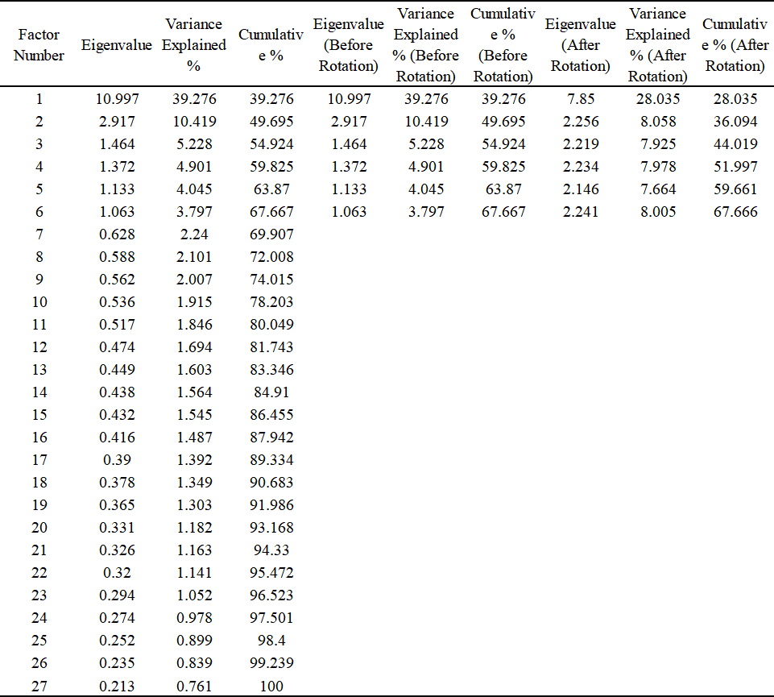
Construct validity was established through factor analysis of the construct, whereby KMO and Bartlett's tests ensured data appropriateness. KMO test in Table 2 results in a KMO value of 0.940, which is far above the maximum threshold of 0.6 and indicates the sample size is excellent for factor analysis. Bartlett's sphericity test was significant (p < 0.001), indicating that the variable correlation matrix was appropriate for analysis through factor methods. This factor extraction results, based on PCA with varimax rotation, revealed six factors that explained 67.67% of the cumulative variance. According to the findings presented in Table 3, all items loaded higher than 0.5 on their intended factors while not loading significantly on any cross-factor loading. This clean factor structure lends support to the discriminant validity of the six constructs, consistent with Chen et al. (2021) with regards to the uniqueness of live streaming commerce dimensions.
Table 3 Rotated Factor Loading Matrix
Variable | Factor 1 | Factor 2 | Factor 3 | Factor 4 | Factor 5 | Factor 6 | Communality (Extraction)
Real-Time  Interaction 1 | 0.219 | 0.266 | 0.094 | 0.121 | 0.182 | 0.745 | 0.73
Real-Time  Interaction 2 | 0.234 | 0.269 | 0.091 | 0.2 | 0.191 | 0.765 | 0.757
Real-Time  Interaction 3 | 0.138 | 0.222 | 0.189 | 0.091 | 0.053 | 0.793 | 0.744
Product Display 1 | 0.24 | 0.146 | 0.11 | 0.037 | 0.809 | 0.112 | 0.759
Product Display 2 | 0.23 | 0.171 | 0.085 | 0.048 | 0.789 | 0.113 | 0.742
Product Display 3 | 0.265 | 0.133 | 0.263 | 0.694 | 0.132 | 0.084 | 0.717
Professional  Advice 1 | 0.229 | 0.15 | 0.091 | 0.709 | 0.094 | 0.101 | 0.618
Professional  Advice 2 | 0.234 | 0.148 | 0.093 | 0.771 | 0.148 | 0.043 | 0.713
Professional  Advice 3 | 0.205 | 0.06 | 0.08 | 0.78 | 0.162 | 0.021 | 0.732
Social Experience 1 | 0.171 | 0.088 | 0.791 | 0.055 | 0.094 | 0.117 | 0.687
Social Experience 2 | 0.097 | 0.113 | 0.811 | 0.053 | 0.141 | 0.104 | 0.695
Social Experience 3 | 0.172 | 0.12 | 0.825 | 0.066 | 0.106 | 0.07 | 0.704
Purchase Intention 1 | 0.211 | 0.799 | 0.061 | 0.142 | 0.088 | 0.157 | 0.739
Purchase Intention 2 | 0.155 | 0.79 | 0.133 | 0.139 | 0.085 | 0.209 | 0.737
Purchase Intention 3 | 0.169 | 0.745 | 0.19 | 0.146 | 0.259 | 0.224 | 0.759
Customer Value 1 | 0.792 | 0.077 | 0.099 | 0.079 | 0.039 | 0.107 | 0.662
Customer Value 2 | 0.785 | 0.054 | 0.086 | 0.164 | 0.098 | 0.127 | 0.679
Customer Value 3 | 0.728 | 0.159 | 0.121 | 0.163 | 0.142 | 0.052 | 0.619
Customer Value 4 | 0.783 | 0.086 | 0.073 | 0.058 | 0.029 | 0.091 | 0.639
Customer Value 5 | 0.744 | 0.076 | 0.084 | 0.081 | 0.121 | 0.182 | 0.577
Customer Value 6 | 0.742 | 0.044 | 0.095 | 0.048 | 0.114 | 0.266 | 0.648
Customer Value 7 | 0.72 | 0.078 | 0.043 | 0.182 | 0.133 | 0.022 | 0.667
Customer Value 8 | 0.728 | 0.064 | 0.214 | 0.094 | 0.133 | 0.067 | 0.607
Customer Value 9 | 0.727 | 0.095 | 0.156 | 0.006 | 0.123 | 0.065 | 0.595
Customer Value 10 | 0.693 | 0.135 | 0.09 | 0.245 | 0.021 | 0.058 | 0.588
Customer Value 11 | 0.76 | 0.158 | 0.086 | 0.088 | 0.13 | 0.014 | 0.635
Customer Value 12 | 0.743 | 0.143 | 0.07 | 0.121 | 0.168 | 0.067 | 0.625
Customer Value 13 | 0.717 | 0.057 | 0.066 | 0.04 | 0.18 | 0.086 | 0.563

4.2 Descriptive Analysis and Correlation Among Variables
The descriptive statistics presented in Table 4 reveal interesting patterns in the respondents' attitudes regarding the aspects of live streaming commerce and their consequent purchase intentions. Each variable had mean scores greater than the mid-point of the scale (3.0), reflecting a strong overall positive inclination to experience what live streaming commerce has to offer. Social experience attained the greatest mean score (M = 3.928, SD = 0.899), with proximity to that of expert advice (M = 3.814, SD = 0.998), revealing that consumers especially appreciate the social interaction and expertise that live streaming offers. Additionally, all variables' skewness and kurtosis values fell in acceptable ranges (±2), confirming that the data were roughly normally distributed, thereby making them appropriate for parametric tests (Hair et al., 2019).
Table 4 Descriptive Statistics Results
Variable Name | Minimum | Maximum | Mean | Standard Deviation | Skewness | Kurtosis
Real-Time Interaction | 1 | 5 | 3.559 | 1.118 | -0.754 | -0.769
Product Display | 1 | 5 | 3.66 | 1.041 | -0.832 | -0.547
Professional Advice | 1 | 5 | 3.814 | 0.998 | -1.138 | 0.15
Social Experience | 1 | 5 | 3.928 | 0.899 | -1.426 | 1.452
E-commerce Livestream | 1.667 | 5 | 3.74 | 0.763 | -0.138 | -1.011
Purchase Intention | 1 | 5 | 3.591 | 1.096 | -0.692 | -0.822
Customer Value | 1.462 | 4.692 | 3.607 | 0.994 | -0.78 | -1.17
The correlation analysis in Table 5 demonstrates strong support for all hypotheses. Real-time interaction has a most significant correlation with purchase intention (r = 0.540, p < 0.01), followed by product display (r = 0.455), professional advice (r = 0.435), and social experience (r = 0.367). This supports what was put forward by Sun et al. (2019), which confirmed that interactivity in live streaming increases consumer engagement and purchase intention. Customer value is positively correlated with all attributes, particularly with product display (r = 0.490, p < 0.01). Its moderate correlation with purchase intention (r = 0.401) implies it could mediate behaviors driven by live streaming, like that argued by Kotler (2021) and Zeithaml (1988).
Table 5 Pearson Correlation
Variable | Mean | Std. Dev. | Real-Time Interaction | Product Display | Professional Advice | Social Experience | Purchase Intention | Customer Value
Real-Time Interaction | 3.559 | 1.118 | 1
Product Display | 3.66 | 1.041 | 0.457** | 1
Professional Advice | 3.814 | 0.998 | 0.427** | 0.480** | 1
Social Experience | 3.928 | 0.899 | 0.402** | 0.406** | 0.330** | 1
Purchase Intention | 3.591 | 1.096 | 0.540** | 0.455** | 0.435** | 0.367** | 1
Customer Value | 3.607 | 0.994 | 0.427** | 0.490** | 0.464** | 0.341** | 0.401** | 1

4.3 Direct Effects of Live Streaming on Purchase Intention
The descriptive statistics presented in Table 4 present a series of interesting findings. Regression analyses, which tested for the direct effects of e-commerce live streaming attributes on purchase intention, produced interesting findings, depicted in Table 6. Of all these attributes, interactivity was found to be the most critical influencer, contributing a 28.9% variance to purchase intention (β = 0.540, p < 0.001). This finding highlights the central role that interactivity plays under live streaming, under which consumers can get instant feedback to their questions and participate engagingly in the purchasing process. As Gulfraz et al. (2022) note, real-time interaction significantly reduces the psychological distance inherent in online shopping, creating a sense of social presence that closely approximates in-person retail experiences.
Table 6 Linear Regression Results
Independent Variable | Unstandardized Coefficient (B) | Standard Error | Standardized Coefficient (Beta) | t | p-value | VIF | R² | Adjusted R²
Real-Time Interaction | 0.53 | 0.049 | 0.539 | 10.823 | 0 | 1.175 | 0.29 | 0.289
Constant | 1.706 | 0.282 | — | 6.038 | 0 | —
Product Display | 0.479 | 0.056 | 0.545 | 8.628 | 0 | 1.409 | 0.297 | 0.296
Constant | 1.837 | 0.211 | — | 8.71 | 0 | —
Professional Advice | 0.478 | 0.059 | 0.536 | 7.662 | 0 | 1.561 | 0.189 | 0.188
Constant | 1.77 | 0.231 | — | 7.662 | 0 | —
Social Experience | 0.402 | 0.062 | 0.462 | 6.475 | 0 | 1 | 0.213 | 0.211
Constant | 1.95 | 0.242 | — | 8.07 | 0 | —

The second strongest direct effect on intention to buy was product display (β = 0.455, p < 0.001, adjusted R² = 0.204), emphasizing the importance of visual demonstration in outdoor clothing, which consumers need to check fit, functionality and aesthetic qualities before reaching a purchasing decision. This result aligns with Wongkitrungrueng and Assarut's (2020) idea that interactive product demonstrations during live streams significantly boost consumer confidence by alleviating uncertainty about product characteristics. Also, expert advice revealed a strong positive effect on purchase intention (β = 0.435, p < 0.001, adjusted R² = 0.186), indicating that consumers are often dependent on expert information in circumstances where less commonly known aspects must be taken into consideration of products in specialized categories such as outdoor apparel, the performance characteristics and technical features of which may need more informed explanation (Chen, Kwan, and Fiol, 2021).
Social experience, while still significant (β = 0.367, p < 0.001), had the comparatively weakest effect on purchase intention (adjusted R² = 0.132). This finding suggests that while the social aspects of live streaming contribute positively to purchase decisions, they may play a secondary role to the more utilitarian dimensions of product information and expert guidance in the context of outdoor clothing. As Zhang et al. (2022) note, the relative importance of social factors may vary across product categories, with functional products potentially eliciting different consumer priorities than hedonic or status-signaling goods.

4.4 The Role of Customer Value in Consumer Purchase Decisions
Analysis contained in Table 6 yields a strong overall positive effect of customer value on purchase intention with a beta coefficient of β = 0.401 at a p < 0.001. It explains 15.8% of purchase intention variance. It confirms an underlying postulate of customer value theory: that values that consumers perceive ultimately guide their purchasing behaviors (Zeithaml, 1988; Kotler, 2021). Customer value in e-commerce live streaming captures consumers' holistic evaluation, weighing perceived gain from undertaking purchase process against costs that accrue through their participation, including both functional values of the product and experiential factors of the streaming process.

Table 6 Linear Regression Results
 | Unstandardized Coefficient (B) | Standard Error | Standardized Coefficient (Beta) | t | p-value | VIF
Constant | 1.994 | 0.224 | — | 8.901 | 0 | 14.226
Customer Value | 0.443 | 0.06 | 0.401 | 7.398 | 0 | 1
R² | 0.161
Adjusted R² | 0.158
F | 54.727
Dependent Variable | Purchase Intention
Subsequent regression analyses explored the effects of e-commerce live streaming attributes on customer value based on Table 7. Of these attributes, product presentation was found to be most predictive of customer value (β = 0.490, p < 0.001, adjusted R² = 0.237), followed closely by expert advice (β = 0.464, p < 0.001, adjusted R² = 0.212), real-time interaction (β = 0.427, p < 0.001, adjusted R² = 0.179), and the social experience (β = 0.341, p < 0.001, adjusted R² = 0.113). These results indicate that, for all that real-time interaction has an instant effect on purchasing intention, ultimately it is product presentation that is at the core of customer value assessment. This pattern is consistent with Vaishnavi et al.'s (2024) observation that visual information in live streaming contexts significantly enhances both functional and emotional dimensions of customer value by providing rich, multisensory product experiences that static e-commerce cannot provide.

Table 7 Linear Regression Results
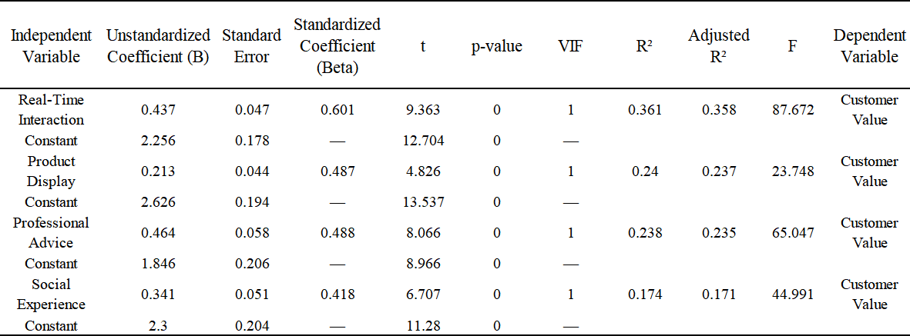
The varying strengths of these relationships highlight the multifaceted nature of customer value in live streaming contexts. As Sweeney and Soutar (2001) note, customer value encompasses functional, emotional, social and epistemic dimensions, each of which may be influenced differently by different aspects of the shopping experience. In the case of outdoor clothing, the strong influence of product display on customer value is likely to reflect consumers' emphasis on functional value dimensions such as quality, durability and performance - attributes that are effectively communicated through visual demonstration (Liu et al., 2021).

4.5 The Mediating Role of Customer Value
The outcome of the mediation test offers strong support that customer value mediates between consumers' purchasing intentions and different properties of e-commerce live streaming. Specifically, for all the major features—real-time interaction, product demonstration, expert advice, and social interaction—customer value had strong partial mediating effects. This was illustrated by a significant decrease in the coefficients of the direct effects after adding customer value to the models, while maintaining their statistical significance.
We found that mediational effects tests for true interaction, presented in Tables 8 and 9, returned significant effects with an indirect effect of 0.088 (95% CI: 0.044, 0.148). This result was paralleled by significant decrease in direct effect, which reduced to 0.442 from 0.530 with the addition of customer value. Similarly, product display registered an indirect effect of 0.121 (95% CI: 0.064, 0.190), with a decrease in direct effect from 0.479 to 0.358. Additionally, professional advice produced an indirect effect of 0.130 (95% CI: 0.071, 0.208), with direct effect reducing from 0.478 to 0.348. Finally, social experience recorded an indirect effect of 0.130 (95% CI: 0.076, 0.211), with direct effect reducing from 0.448 to 0.318, as seen in Tables 10 and 11.
Table 8 Summary of Mediation Models
Variable | Model 1: Customer Value β | Model 2: Purchase Intention t | Model 3: Purchase Intention β
Constant | 2.256*** | 12.704 | 1.706***
Real-Time Interaction | 0.380*** | 7.973 | 0.530***
Customer Value | — | — | —
R² | 0.182 |  | 0.292
Adjusted R² | 0.179 |  | 0.289
F Value | 63.563*** |  | 117.272***

Table 9 Indirect Effect Analysis
Type of Effect | Effect | Boot SE | BootLLCI | BootULCI
Total Effect | 0.53 | 0.049 | 0.433 | 0.626
Direct Effect | 0.442 | 0.053 | 0.338 | 0.546
Indirect Effect | 0.088 | 0.026 | 0.044 | 0.148
These results provide strong support for Hypothesis 4, confirming that customer value serves as a significant mechanism through which e-commerce live streaming characteristics influence purchase intentions. The partial mediation observed across all four characteristics suggests that while customer value plays an important role in translating live streaming experiences into purchase intentions, direct effects remain significant, indicating that live streaming elements also influence purchase decisions through additional psychological mechanisms beyond value perceptions. This pattern is consistent with Chen et al.'s (2022) findings that live streaming commerce operates through multiple parallel psychological pathways, including both cognitive value assessments and more affective or heuristic processes.
Table10 Summary of the mediation effect model
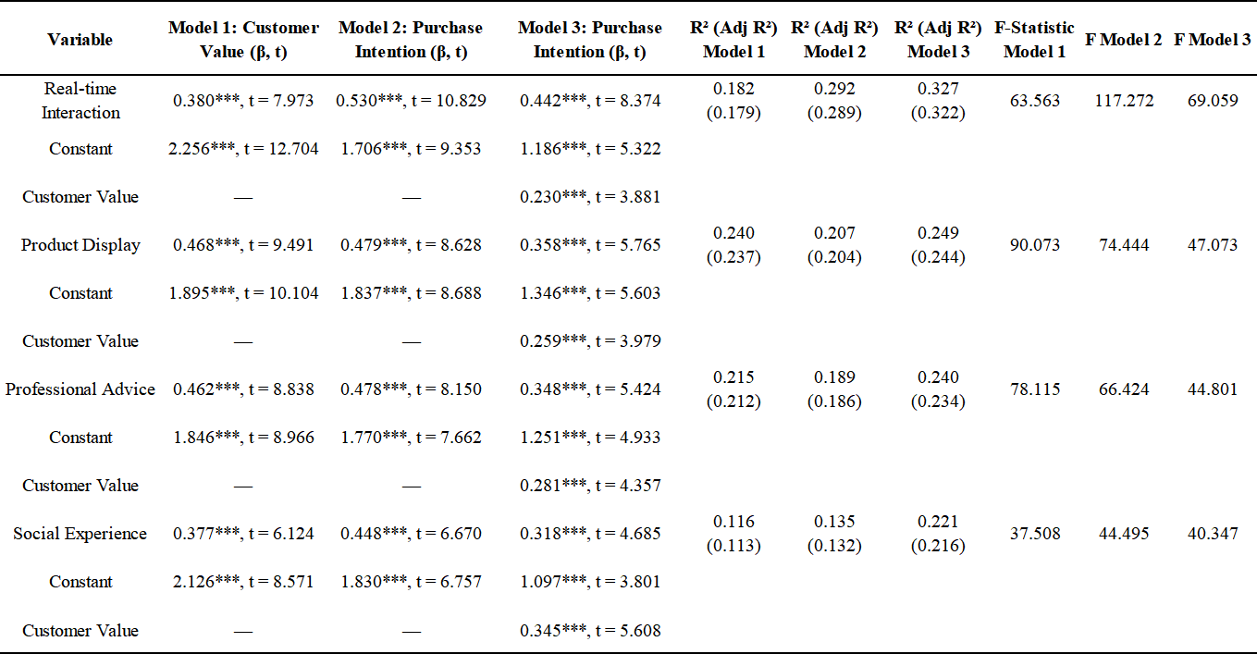
Table 11 Indirect effect analysis
 | Mediation Type | Effect | Boot SE | BootLLCI | BootULCI
Real-time Interaction | Total Effect | 0.53 | 0.049 | 0.433 | 0.626
Real-time Interaction | Direct Effect | 0.442 | 0.053 | 0.338 | 0.546
Real-time Interaction | Indirect Effect | 0.088 | 0.026 | 0.044 | 0.148
Product Display | Total Effect | 0.479 | 0.056 | 0.37 | 0.589
Product Display | Direct Effect | 0.358 | 0.062 | 0.236 | 0.481
Product Display | Indirect Effect | 0.121 | 0.032 | 0.064 | 0.19
Professional Advice | Total Effect | 0.478 | 0.059 | 0.362 | 0.593
Professional Advice | Direct Effect | 0.348 | 0.064 | 0.222 | 0.474
Professional Advice | Indirect Effect | 0.13 | 0.035 | 0.071 | 0.208
Social Experience | Total Effect | 0.448 | 0.067 | 0.316 | 0.581
Social Experience | Direct Effect | 0.318 | 0.068 | 0.185 | 0.452
Social Experience | Indirect Effect | 0.13 | 0.034 | 0.076 | 0.211

The comparable strength of indirect effects for product display, expert advice and social experience (all around 0.130) suggests that these different aspects of live streaming contribute similarly to purchase intentions through the customer value pathway, despite their different strengths of direct effects. This finding highlights the importance of a balanced approach to live streaming that addresses multiple dimensions of the customer experience, rather than focusing solely on interaction. As Zhao et al. (2022) note, effective live streaming strategies should integrate informational content, expert guidance, and social elements to create comprehensive value propositions that appeal to different consumer motivations.

4.6 Theoretical and Practical Implications
This study advances understanding of the phenomenon of e-commerce live streaming and has a significant influence on consumers. This study finds that several aspects such as interaction, product demonstration, expert commentary, and social interaction play an important role in influencing purchase intentions across e-commerce live streaming categories. This study examines the effect of streaming attributes on consumer responses (Chen et al., 2021; Sun et al., 2019). It also investigates customer value as mediating variable, thus providing significant insights about purchasing decision-making mechanisms evoked by live streaming. Results show that live streaming affects consumers through perceived values, aligning customer value with the organism-resource-response model as well as enriching existing theory models (Mehrabian and Russell, 1974; Zeithaml, 1988; Kotler, 2021). Finally, attributes of streaming have a significant influence on customer value and purchase intentions, pointing to differences between immediate effects on behavior and long-term perceived values (Liu et al., 2021; Wongkitrungrueng and Assarut, 2020).
All these findings indicate that e-commerce retailers need to adopt live streaming to boost purchase intentions for outdoor wear. One cannot overemphasize the role of real-time, bi-directional communication, which calls for responsive websites that respond quickly to consumers' questions. Training presenters to communicate effectively with audiences and stimulate participation strengthens the effectiveness of live-streaming campaigns (Gulfraz et al., 2022). Effective product presentation is an art that plays an important role in determining both customer values and purchase intentions, which means that impactful visuals are required. Demonstration of clothing outdoors necessitates showing products from different angles and in applicable contexts so that consumers can imagine their performance. Quality cameras with good lighting can significantly increase persuasive presentations made through live streaming (Zhang et al., 2022). Host knowledge plays an important role in streams of outdoor clothing since knowledgeable hosts inspire consumers' confidence and reduce perceived risks. Host training can improve product knowledge and communication skills (Chen et al., 2021). While social experiences have a weaker direct effect on purchase intentions, their impact on customer values underscores building communities in live streaming. Inviting viewers to participate and interact with their comments can maximize streaming session values by fostering long-term participation commitment over short-term purchases (Liu et al., 2021; Zhao et al., 2022).

5. Conclusion
This research thoroughly investigated the influence of e-commerce live streaming on consumers' purchase intention for outdoor clothing products, with a specific focus on TikTok. The study explored four key features of e-commerce live streaming: real-time interaction, product display, professional advice, and social experience, examining both their direct effects on purchase intention and their indirect effects through customer value as a mediating variable. Through a comprehensive survey of 87 consumers who had previously watched TikTok live streams and purchased outdoor clothing through this channel, the study provided robust empirical evidence supporting all proposed hypotheses. The results showed that all four characteristics of e-commerce live streaming positively influence purchase intention, with real-time interaction having the most substantial direct effect.
Customer value was confirmed as a significant mediator in the relationship between streaming characteristics and purchase intention, highlighting the critical role of value perceptions in translating streaming experiences into purchase decisions. Interestingly, while real-time interaction had the most substantial direct effect on purchase intention, product display had the most significant effect on customer value, suggesting different pathways through which streaming elements influence consumer behavior. These findings underscore the multifaceted nature of e-commerce live streaming and its complex psychological influence on consumer decision-making processes. The study contributes to the theoretical understanding of digital commerce. It provides practical insights for companies seeking live streaming as an effective marketing and sales channel for outdoor clothing products.
In addition to all that it offers, there are some limitations to this study that must be considered. Firstly, by only measuring consumer intentions and attitudes at one point in time, the cross-sectional nature prevents us from investigating these factors in changing dynamics, or in seeing intentions translated into buying behavior. Given that e-commerce live streaming is a constantly changing environment, with features that change quickly and with varying levels of consumer expectations, it is plausible that longitudinal studies might identify some temporal patterns that have been missed by this study.
While the sample was large enough to be analyzed statistically, it was largely comprised of Chinese consumers who are accustomed to using TikTok, which could limit generalizability of these findings to different cultural segments or e-commerce websites. Culture plays an important role in dictating consumers' attitudes and behaviors toward different aspects of live-streaming, so these findings should be treated cautiously if extrapolated to different contexts. The study focused exclusively on outdoor clothing products, and the relative importance of different streaming characteristics may vary across product categories with various levels of complexity, price points, or emotional significance. While the research examined four key characteristics of e-commerce live streaming, other potentially essential elements - such as promotional incentives, time-limited offers, or the aesthetic qualities of the streaming environment - were not explicitly included in the model. The study relied on self-reported measures of purchase intention rather than actual purchase behavior, introducing potential social desirability bias or intention-behaviour gaps that could affect the validity of conclusions about real-world purchase decisions.
This study opens up several promising avenues for future research on e-commerce live streaming and consumer behavior. Future studies could employ longitudinal designs to track how streaming experiences influence purchase decisions, including immediate and delayed effects, and how repeated exposure to streaming content affects consumer attitudes and loyalty. Comparative research across different cultural contexts and streaming platforms would improve our understanding of how cultural factors and platform-specific characteristics moderate the relationships observed in this study. Extending the research to other product categories beyond outdoor clothing would reveal how product characteristics interact with streaming elements to influence consumer responses and identify optimal streaming strategies for various types of merchandise. A more granular analysis of streaming characteristics could further refine our understanding of effective practices, such as investigating specific interaction techniques, optimal demonstration methods, or particular types of expertise that most effectively influence purchase decisions.
Future studies could explore additional mediating variables beyond customer value, such as trust, emotional involvement, or parasocial relationships with hosts, to develop more comprehensive models of the psychological mechanisms underlying streaming commerce. Research that combines self-reported measures with objective data on viewing patterns and actual purchasing behavior would strengthen the validity of findings and provide more actionable insights for companies implementing live-streaming strategies. Such multifaceted approaches would significantly advance theoretical understanding and practical applications in this rapidly evolving area of digital commerce.

References
Ajzen, I. (1991) 'The theory of planned behavior', Organizational Behavior and Human Decision Processes, 50(2), pp. 179–211.
Baron, R.M. and Kenny, D.A. (1986) ‘The moderator–mediator variable distinction in social psychological research: Conceptual, strategic, and statistical considerations’, Journal of Personality and Social Psychology, 51(6), pp. 1173-1182.
Cai, J., Wohn, D.Y., Mittal, A. and Sureshbabu, D. (2018) ‘Utilitarian and hedonic motivations for live streaming shopping’. In Proceedings of the 2018 ACM International Conference on Interactive Experiences for TV and Online Video, pp. 81-88.
Cai, J. and Wohn, D.Y. (2019) 'Live streaming commerce: uses and gratifications approach to understanding consumers' motivations', in Proceedings of the 52nd Hawaii International Conference on System Sciences, pp. 2548–2557.
Chen, L., Li, Y. and Liu, C. (2021) ‘How livestreaming increases product sales: Role of trust transfer and elaboration likelihood model’, International Journal of Electronic Commerce, 25(4), pp. 350-382.
Chen, C.C., Hsiao, K.L. and Wu, S.J. (2022) 'Purchase intention in social commerce: an empirical examination of perceived value and social awareness', Decision Support Systems, 143, 113496.
Chen, H., Hu, M. and Li, J. (2021) 'Understanding the persuasion mechanism of live streamers: an elaboration likelihood model perspective', Journal of Retailing and Consumer Services, 63, 102683.
Davis, F.D. (1989) 'Perceived usefulness, perceived ease of use, and user acceptance of information technology', MIS Quarterly, 13(3), pp. 319–340.
Duong, N.T. (2025) 'Factors affecting users' continuance intention to use social network sites: a sample of Vietnamese Facebookers', International Journal of Mobile Learning and Organisation, 19(1), pp. 87–112. doi: 10.1504/ijmlo.2025.142913.
Eroglu, S.A., Machleit, K.A. and Davis, L.M. (2001) 'Atmospheric qualities of online retailing: a conceptual model and implications', Journal of Business Research, 54(2), pp. 177–184.
Fishbein, M. and Ajzen, I. (1975) Belief, attitude, intention, and behavior: an introduction to theory and research. Reading, MA: Addison-Wesley.
Gulfraz, M.B., Sufyan, M., Mustak, M. and Salminen, J. (2022) 'Predicting consumer purchasing behavior in social commerce: a SOR model perspective', Journal of Business Research, 148, pp. 288–301.
Gulfraz, M.B., Sufyan, M., Mustak, M., Salminen, J. and Srivastava, D.K. (2022) 'Understanding the impact of online customers' shopping experience on online impulsive buying: a study on two leading e-commerce platforms', Journal of Retailing and Consumer Services, 68, 103000.
Hair, J.F., Black, W.C., Babin, B.J. and Anderson, R.E. (2019) Multivariate data analysis. 8th edn. Cengage Learning.
Huang, Z. and Benyoucef, M. (2013) 'From e-commerce to social commerce: a close look at design features', Electronic Commerce Research and Applications, 12(4), pp. 246–259.
Kotler, P. (2021) Marketing 5.0: technology for humanity. Hoboken, NJ: John Wiley and Sons.
Kotler, P. and Keller, K.L. (2021) A framework for marketing management. 6th edn. Boston: Pearson.
Li, Y., Li, X. and Cai, J. (2021) 'How attachment affects user stickiness on live streaming platforms: a socio-technical approach perspective', Journal of Retailing and Consumer Services, 60, 102478.
Lin, J., Luo, Z. and Cheng, X. (2022) 'Understanding the interplay of social commerce affordances and swift guanxi: an empirical study', Information and Management, 59(3), 103622.
Liu, L., Lee, M.K.O., Liu, R. and Chen, J. (2020) 'Trust transfer in social media brand communities: the role of consumer engagement', International Journal of Information Management, 41, pp. 1–13.
Liu, Y., Kou, Y., Guan, Z. and Hu, J. (2021) 'Livestream commerce: a SOR perspective', Journal of Electronic Commerce Research, 22(2), pp. 65–88.
Liu, X., Shin, H. and Burns, A.C. (2020) ‘Examining the impact of luxury brand's social media marketing on customer engagement: Using big data analytics and natural language processing’, Journal of Business Research, 125, pp. 815-826.
Liu, Y., Xiang, Y. and Yang, Y. (2021) ‘Live streaming commerce: Uses and gratifications approach to understanding consumers' motivations’, Journal of Electronic Commerce Research, 22(1), pp. 48-67.
Lu, Z., Xia, H., Heo, S. and Wigdor, D. (2018) 'You watch, you give, and you engage: a study of live streaming practices in China', in Proceedings of the 2018 CHI Conference on Human Factors in Computing Systems, pp. 1–13.
Mehrabian, A. and Russell, J.A. (1974) An approach to environmental psychology. Cambridge, MA: MIT Press.
Nguyen, H.V., Tran, H.X., Van Huy, L., Nguyen, X.N., Do, M.T. and Nguyen, N. (2020) 'Online book shopping in Vietnam: the impact of the COVID-19 pandemic situation', Publishing Research Quarterly, 36(3), pp. 437–445.
Podsakoff, P.M., MacKenzie, S.B., Lee, J.Y. and Podsakoff, N.P. (2003) ‘Common method biases in behavioral research: A critical review of the literature and recommended remedies’, Journal of Applied Psychology, 88(5), pp. 879-903.
Sheth, J.N., Newman, B.I. and Gross, B.L. (1991) 'Why we buy what we buy: a theory of consumption values', Journal of Business Research, 22(2), pp. 159–170.
Sun, Y., Shao, X., Li, X., Guo, Y. and Nie, K. (2019) 'How live streaming influences purchase intentions in social commerce: an IT affordance perspective', Electronic Commerce Research and Applications, 37, 100886.
Sweeney, J.C. and Soutar, G.N. (2001) 'Consumer perceived value: the development of a multiple item scale', Journal of Retailing, 77(2), pp. 203–220.
Vaishnavi, R., Ganesh, J. and Thomas, S. (2024) 'Live streaming in social commerce: understanding the role of parasocial interaction and purchase intention', Journal of Retailing and Consumer Services, 66, 102987.
Vaishnavi, V.V., Narendra, G.O., Boovaraghavan, A. and Anbarasi, L.J. (2024) 'Bridging the gap between online and in-store shopping: fashion recommendations and virtual try-on', in Proceedings of the International Conference, pp. 463–470.
Venkatesh, V., Thong, J.Y. and Xu, X. (2012) 'Consumer acceptance and use of information technology: extending the unified theory of acceptance and use of technology', MIS Quarterly, 36(1), pp. 157–178.
Wongkitrungrueng, A. and Assarut, N. (2020) 'The role of live streaming in building consumer trust and engagement with social commerce sellers', Journal of Business Research, 117, pp. 543–556.
Xu, X., Wu, J.H. and Li, Q. (2020) 'What drives consumer shopping behavior in live streaming commerce?', Journal of Electronic Commerce Research, 21(3), pp. 144–167.
Xue, J., Liang, X., Xie, T. and Wang, H. (2020) 'See now, act now: how to interact with customers to enhance social commerce engagement?', Information and Management, 57(6), 103324.
Zeithaml, V.A. (1988) 'Consumer perceptions of price, quality, and value: a means-end model and synthesis of evidence', Journal of Marketing, 52(3), pp. 2–22.
Zhang, M., Qin, F., Wang, G.A. and Luo, C. (2022) 'The impact of live streaming commerce on consumers' purchase intention: an empirical investigation', Information and Management, 59(2), 103552.
Zhao, Y., Wang, L., Tang, H. and Zhang, Y. (2022) 'Electronic commerce live streaming: a market review and research opportunities', International Journal of Electronic Commerce, 26(1), pp. 66–88.

Appendix

Appendix 1 – Questionnaire

1. Have you ever watched TikTok China e-commerce live broadcasts?
A. Yes (Continue)
B. No (End survey)
2. Have you purchased outdoor clothing products as a result of watching Douyin live broadcasts?
A. Yes (Continue)
B. No (End survey)
3. Gender:
A. Male
B. Female
4. Age:
A. Under 18
B. 18–25
C. 26–35
D. Over 35
5. Highest Education Level:
A. Associate degree or below
B. Bachelor's degree
C. Master's degree
D. Doctorate
6. Average Monthly Disposable Income:
A. Less than 1,000 RMB
B. 1,000–2,000 RMB
C. 2,001–3,000 RMB
D. 3,001–5,000 RMB
E. More than 5,000 RMB
7. How long have you been watching Douyin live broadcasts?
A. Less than 1 year
B. 1–2 years
C. 2–3 years
D. Over 3 years
8. How many times per month do you watch TikTok live broadcasts?
A. 1–3
B. 4–6
C. 7–9
D. 10 or more
9. How much do you spend monthly on products purchased via TikTok live broadcasts?
A. Less than 1,000 RMB
B. 1,001–2,000 RMB
C. 2,001–3,000 RMB
D. More than 3,000 RMB
10. Real-Time Interaction
The host responded promptly to viewer questions. [ 1 2 3 4 5 ]
I felt engaged with the presenter during the stream. [ 1 2 3 4 5 ]
The interactivity enhanced my confidence in the product. [ 1 2 3 4 5 ]
11. Product Presentation
The product was clearly demonstrated. [ 1 2 3 4 5 ]
The visuals helped me assess product quality. [ 1 2 3 4 5 ]
The demonstration influenced my purchase decision. [ 1 2 3 4 5 ]
12. Professional Guidance
The host demonstrated expert knowledge. [ 1 2 3 4 5 ]
The advice given was informative and useful. [ 1 2 3 4 5 ]
The stream made it easier to understand the product features. [ 1 2 3 4 5 ]
13. Social Experience
I enjoyed interacting with other viewers during the stream. [ 1 2 3 4 5 ]
Seeing others participate encouraged me to buy. [ 1 2 3 4 5 ]
The stream created a sense of community. [ 1 2 3 4 5 ]
14. Customer Value
I felt that the product offered good value for money. [ 1 2 3 4 5 ]
The live stream enhanced my shopping experience. [ 1 2 3 4 5 ]
The purchase felt worthwhile. [ 1 2 3 4 5 ]
15. Purchase Intention
I intended to buy the product after watching the live stream. [ 1 2 3 4 5 ]
I was likely to follow the seller or brand. [ 1 2 3 4 5 ]
I recommended the product or stream to others. [ 1 2 3 4 5 ]

Appendix 2 – Data Collection Spreadsheet
The web of the raw data:
https://docs.google.com/spreadsheets/d/e/2PACX-1vSeJ2Aui4igpOf3hbj3dmHidPWyuYCAhFjVWDj4Vdkp4Rha-TF60IVCEqrVOx_7o3nq5esXvy7Q9Fs1/pubhtml
‌

