University of Wales Trinity Saint David
London

Module Name: Management Economics
Module Number: LCBB5003
Name of the Lecturer: Emad Elkhashen

Title of the Assignment: Assessment 1 - Resit

Student Name: Rumyan Zarankov
Student Number: 1913489

Submission Date: 09/05/2022

Table of Contents
Introduction 3
Adidas footwear 4
Factors that influence demand and their impact on the Demand for Adidas Footwear 4
The price of substitute goods 4
The price of complements goods: 5
Consumer Income: 6
Consumer taste and preference: 6
Consumer expectations of future price changes: 7
Demographics: 7
Price elasticity of demand for Adidas footwear 7
Substitution effect: 7
Income Effects: 7
Pricing 8
Conclusion 9
References 11

Introduction
Adidas is a German-based company specializing in manufacturing and distributing sportswear and apparel. The company operates in the sportswear industry, and its greatest competitors are Nike, Puma, and Under Armour. The name Adidas comes from its founder, who was known as Adolph Dassler. Adolph invented spiked shoes in 1920, and they became a hit for track and field. And in 1924, Adolph joined his brother, who had a shoe company, and established a sports shoe company named Gebruder Dassler OHG, which would later become the modern Adidas (Jeffery, 2021).
Their sports shoes started to gain a worldwide reputation during the 1928 Olympics when an athlete, Jesse Owens, won four gold medals while wearing a pair of Dassler's sports shoes. A fallout between the brothers came in between World War Two, and Rudolf founded a rival shoe company in 1948, the modern Puma (Jeffery, 2021).
The growth of Adidas continued to be tremendous, and it was the top sports shoe brand sold in the U.S. in the 1970s (Tasselline, 2019). Although Adidas continues to be a well-established sports brand worldwide, its market share has dropped significantly. The rival company Nike occupies the number one spot as the most preferred sportswear brand.
Today, Adidas has over 2,400 stores globally and manufacturing plants in 62 countries. 60 % of its products are manufactured in the Asia-Pacific region, around 20% in the Americas, and approximately 17 % in the Middle East and Africa (Adidas.com, 2022). Most Adidas products are outsourced from over 1000 independent factories worldwide. Adidas deals with producing sports merchandise, including sports shoes, clothing, balls, and other sports apparel.
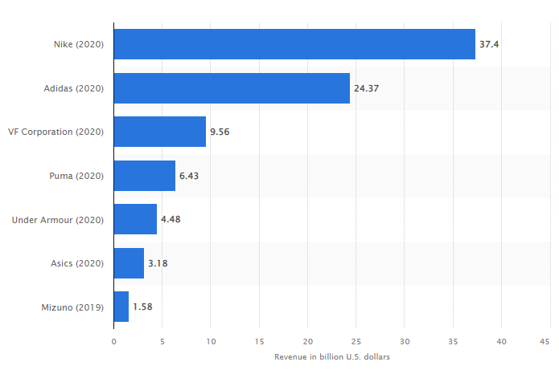
Figure 1.0. sportswear companies' revenue share as of 2020 (Statista, 2022)

Adidas footwear
For this study, I would select Adidas footwear because sports and fitness have become one of the most common activities in the world. Billions of dollars are transacted through sports activities such as Clicket, football, Rugby, athletics, etc. (Pomfret, 2016). All these sports and games require the participants to wear specialized footwear to perform at the highest level. The footwear also protects the players from unnecessary injuries. Therefore, it will be of great importance to analyse the trends in footwear and how Adidas footwear is faring in the market. We can also note that the demand for sneakers is also increasing for ordinary consumers, not only sportspeople. The lightweight of these sneakers makes them attractive for day-to-day usage, and people are shifting from using traditional shoes to using sneakers. Footwears are important sportswear for any sportsperson, and the kind of shoes a player wears has a huge impact on the player's performance. Rules have also been put in place by sports bodies and federations on the standards of footwear to ensure the safety of the player and the opponent. The large investment in sports has attracted many sportswear companies, with each trying to dominate the market. This has created huge competition and promoted innovation.
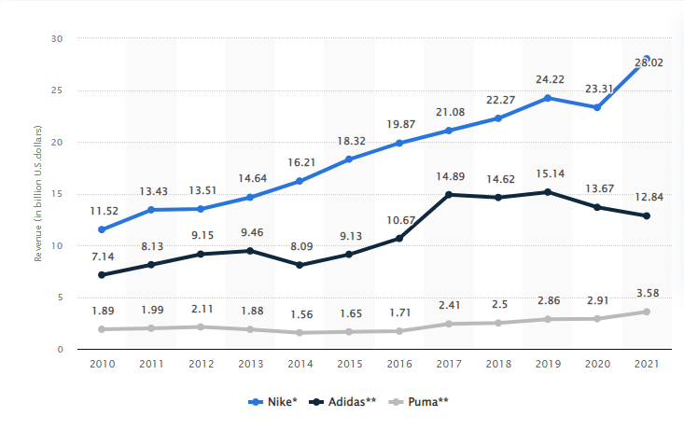Figure 1.1: revenue generated from the sale of footwear (Statista, 2022)
Annual Footwear Revenue since 2010

Factors that influence demand and their impact on the Demand for Adidas Footwear
The price of substitute goods: Substitute goods are goods that serve the same purpose as the given product. The price of substitute goods affects the demand for a given product because they are direct competitors, and consumers can use one product instead of the other (Porter and Heppelmann, 2014). In our case, substitute products for the Adidas footwear are footwear produced by other sportswear companies such as Nike, Puma, Fila, Under Armour, etc. the prices for footwear produced by the emerging companies are relatively cheaper compared to those produced by Adidas, and this has been one of the factors affecting the demand for Adidas footwear. The availability of cheap sports footwear has made Adidas footwear lose market for the lower end customers as the majority prefer shoes from the less known companies that are more affordable. Subsequently, Adidas faces competition for high-end customers from more established companies producing footwear, such as Nike. Although Adidas has lost a significant share of the footwear market, its sales have not entirely decreased, with the company producing approximately 448 million pairs of shoes in 2019, the highest number in the company's history (Statista, 2022). The dip in production in 2020 and 2021 can be attributed to covid 19, which affected the whole sportswear industry rather than decreased substitute prices.
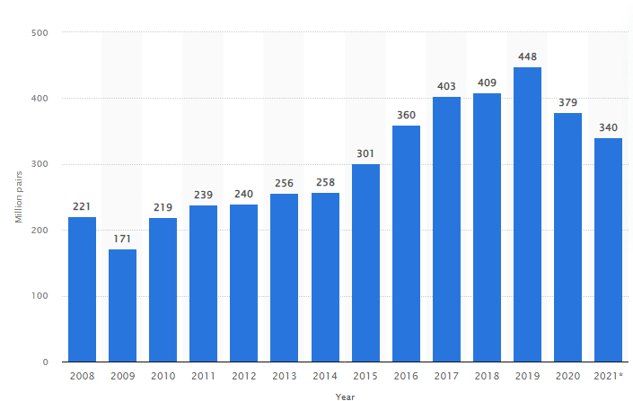
Adidas footwear production
Figure 1.2: Number of Adidas footwear produced annually (Statista, 2022)
The price of complements goods: Complements goods are products used together with the selected product (Gornig and Schiersch, 2017). In our scenario, footwear complement clothing such as socks and other sports apparel. Many upcoming clothing companies are producing rather affordable clothing. And more companies are producing sports apparel. The prices of clothing and other complement attires such as shin guards have decreased, and it's almost affordable to everyone interested in sports worldwide. The number of people participating in sports and fitness activities has significantly increased. This can be attributed to the affordability of clothing and other apparel that compliments footwear (Lange 2022). Some years back, most players in the grass-root leagues and in developing economies could not afford sports facilities and proper clothing. However, the price of these products has greatly reduced, which has promoted the demand for footwear, thus increasing the demand for Adidas footwear.
Consumer Income: consumer income is the amount of income that people earn. Consumer income has been on the rise yearly. A survey on GDP per capital indicates that Nation's economies have been growing annually, reflecting an increase in consumer income (Fred, 2021). Figure 1.3 below indicates GDP per capita for different continents. Development in technology, international trade, and global peace has contributed to the growth of employment opportunities and increased investment (Litsareva, 2017). Several countries have also set minimum wages to ensure the employees get substantial payment. The increase in consumer income has enabled them to have more disposable income to spend on sporting gear such as Adidas footwear. This has led to an increase in the demand for Adidas footwear over the years.
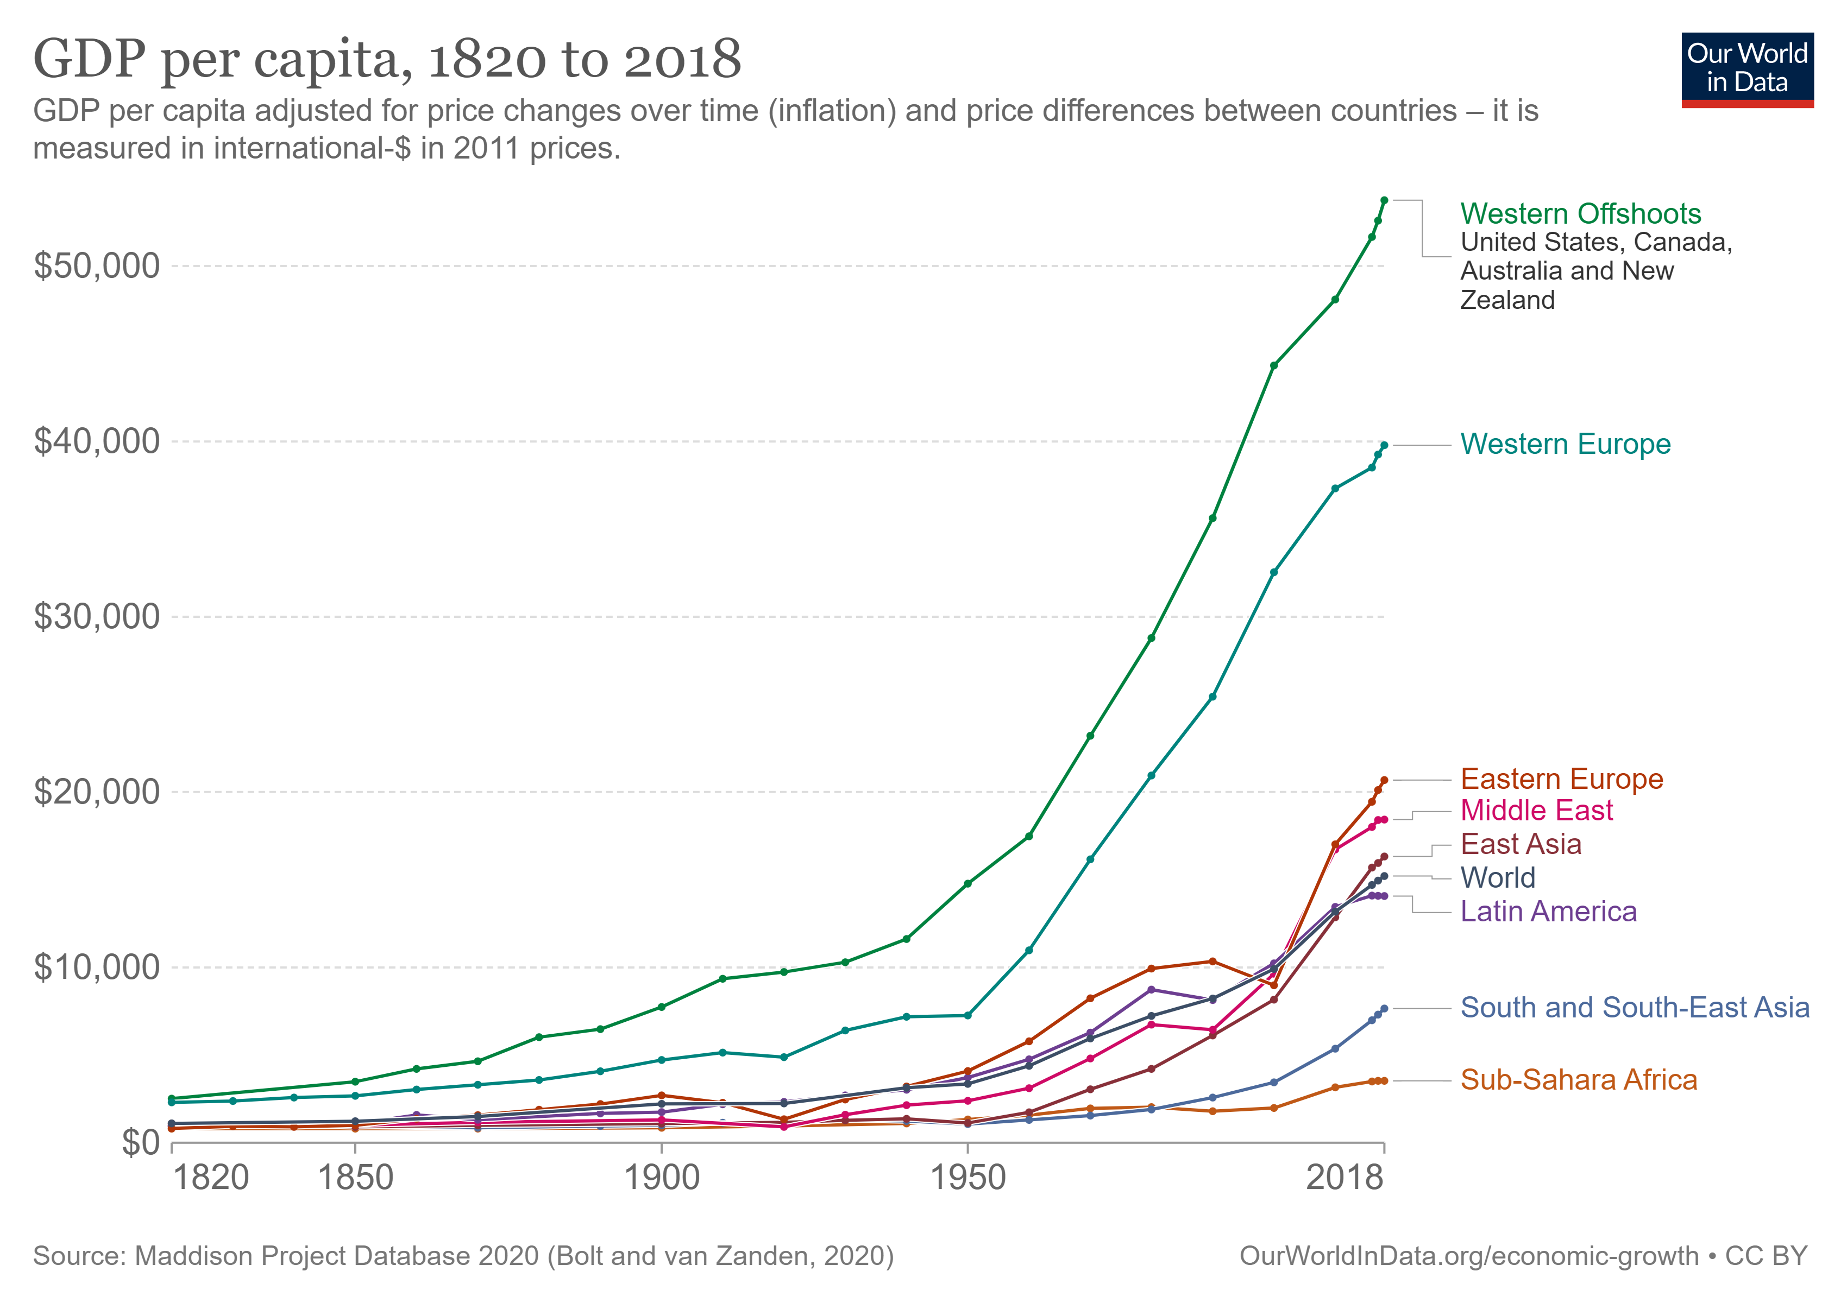
Figure 1.4. Continents GDP per capita: (Roser, 2013)
Consumer taste and preference: Consumer taste and preference are consumers' feelings toward a product. It represents what the consumer wants from a product. The world is changing, and technology changes consumer preferences and tastes (Siregar et al., 2017). Global warming, safety, climate, and other factors influence consumer tastes and preferences on footwear. Consumers want lightweight, long lasting, stable, and environmentally friendly footwear. In addition, the consumers move with the trending fashion in terms of shoe size, colour, and shape. According to Euromonitor International, consumers' preference for healthy living has increased the demand for lightweight sneakers which can be used for athletic and fitness activities (Euromonitor, 2017). Most consumers also prefer comfortability, and sports footwear offers exactly that due to its lightweight. Adidas has tried to meet those preferences by producing footwear using sustainable materials. Since 2018, Adidas has been making footwear using recycled polyester and sustainable cotton and leather. The changes in consumer preferences have increased the demand for Adidas footwear. The steady increase in demand can be seen through the increase in revenue collected by the sportswear companies.
Consumer expectations of future price changes: Sports activities have seasons and tournaments such as the world cup, Olympics, or local Leagues. Consumers expect sportswear prices to increase during tournaments or the peak seasons. The demand and prices of footwear are also affected by global occasions such as holidays and festivals. An assessment done by
Demographics: globalization and technological advancement have enabled sports activities to reach many parts of the world. In today's world, people worldwide can watch different sports from the comfort of their homes. Sports such as football have become popular in many parts of the world, with many people aspiring to become professional players. This popularity of sports has led to an increase in the number of consumers demanding sports footwear (Aigner-Walder, 2015). Diseases and diet issues have also increased the demand for fitness activities. There has been an increase in demand for gym activities, which has led to an increase in demand for gym footwear. All these activities have led to a significant increase in the number of people requiring sportswear, which has boosted the demand for Adidas footwear.

Price elasticity of demand for Adidas footwear
Substitution effect: substitutions effect refers to a change in the demand of a commodity due to a change in price relative to a change in the price of substitute commodities (Andreyeva et al., 2015). Footwear can be categorized as either a necessity or a luxury, depending on the consumer. Some consumers participate in sports activities as a source of income, and to them, footwear is a necessity as its one of their tools of trade. On the other hand, some do sports activities as leisure, and sportswear may be a luxury to them. Therefore, we can conclude that the demand for sports footwear is more elastic in some markets where sports activities are done for leisure. A slight change in price affects the demand for adidas footwear as people shift to purchasing other sports shoes. On the other hand, the demand for Adidas footwear is more inelastic in some markets where sports are done as a trade and a source of income. Footwear is necessary for all professional players and athletes, and a slight change in price does not affect their demand for Adidas footwear.
Income Effects: The income effect is the change in demand for a commodity due to a change in consumers' net income (Andreyeva et al., 2015). Net income affects the purchasing power of the consumer. Therefore, a change in the real income affects the commodities demanded by the consumer. In our case of Adidas footwear, a change in consumer income is likely to impact the number of shoes demanded significantly. On the pecking order of necessities, shoes are less necessary, and one can do without them. Therefore, if the consumer's income reduces and has less disposable income to spend, they will likely choose to ignore sportswear to afford more of the higher necessities. Therefore, a decrease in consumer real income will reduce the demand for Adidas footwear. Subsequently, an increase in consumer income will likely increase the demand for sportswear. When consumers have more disposable income to spend, they will likely spend more on footwear since it’s an important tool for athletes and daily life. This concludes that based on Income effects, the demand for Adidas footwear is more elastic, and a change in consumer income will likely affect their demand.

Pricing
Pricing is the setting of a seller's selling price of a product. Organizations employ different pricing policies to maximize their profit without compromising the quantity sold. In this study on Adidas footwear, price discrimination is the most effective pricing policy the company can employ to maximize its profit. Price discrimination is a pricing policy where the seller prices their products differently to get more profit margin from the consumers who get more benefits from the product and a smaller profit margin from the consumers with lower benefits (Baker, 2003).
Sports footwear benefits people differently. Some earn from it while others use them for leisure. This shows that people's benefits from sports footwear vary from one user to another. Those who earn from sports will be willing to pay more for sports footwear than those who play for leisure, since to them, the sports footwear is a necessity, while for those who play for leisure is just a luxury. Using price discrimination, Adidas can group the consumers depending on the benefits they get from their footwear and price them differently while also preventing arbitrage.
Another reason Adidas can use price discrimination pricing strategy in the sales of their footwear is that the product is sold in different countries and regions with different economic strengths. Adidas sells its footwear in developed regions, developing nations, and the sub-Saharan. Consumers from this region have different abilities to pay. Adidas could group the customers depending on their income level and set different prices for each group. Data on GDP and income for different nations are readily available, and Adidas can use the data to differentiate between high-end customers and lower-end customers (Sloman & Jones, 2011). This will help them maximize profits and reduce consumer surplus by charging high prices for high-end customers and lower for low-end customers.
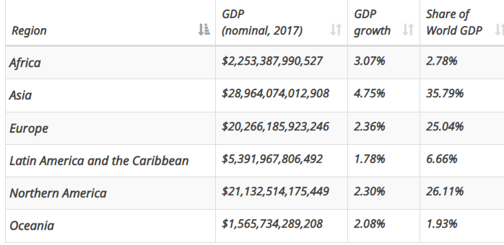
Figure 1.6: table showing world GDP per region (Worldometer, 2022)

The third reason adidas can succeed in using price discrimination pricing strategy is that their customers are distributed worldwide. It will be expensive for customers to buy in one market and resell in the other market (Armstrong, 2018). Adidas can group the regions according to their economic strength, which usually reflects the ability of the consumers to pay. Customers from developed economies will likely pay more for sports footwear than a customer from developing economies. The company can take advantage of this and group the nations according to their economic strength. They would sell at high prices in developed economies and sell at relatively lower prices for markets in developing economies. Adidas will be able to control arbitrage due to the large distance between the countries and the restrictions of movement from one country to another. Consumers will not be able to purchase in the region of lower prices and resell in regions of high prices, and this will help Adidas maximize their profit by getting the maximum each consumer is willing to pay for the footwear while at the same time maintaining the quantity sold by selling to both the high end and lower-end consumers.

Conclusion
Adidas is one of the oldest sportswear companies and dominated the industry in the early stages. However, the emergence of other sportswear companies has seen it lose a substantial size of the market to its competitors. Nike has overtaken Adidas as the most valuable sportswear company (Fredberg and Piller, 2015). This can be attributed to the innovation within Nike products and the diversification of their business. The sportswear market is highly competitive, with each player in the market striving to provide the most efficient products. This competition makes the demand for sportswear to be highly elastic. A change in consumer income, price of products, and consumer preference are likely to impact the demand of particular sportswear significantly. Therefore, Adidas must be very vigilant in ensuring they are innovative to meet consumer preferences. They should also ensure an effective pricing policy that maximizes their profits without compromising their sales. Adidas serves a wide market, with its customers having different purchasing power. The clear income disparity among the consumers can help Adidas efficiently price discriminate by identifying and differentiating the high-end and low-end consumers.

References
Adidas.com. (2022). Adidas.com. Available at: https://www.adidas-group.com/en/investors/financial-reports/ [Accessed 24 April 2022]
Aigner-Walder, B. (2015) Effects of the Demographic Changes on Private Consumption: An Almost Ideal Demand System Analysis for Austria. Journal of Economic and Social Studies, 5, 1, 33-57
Andreyeva, T., Long, M. and Brownell, K. (2010) The Impact of Food Prices on Consumption: A Systematic Review of Research on the Price Elasticity of Demand for Food. American Journal of Public Health, 100, 2, 216-222.
Armstrong, M., 2018. Price discrimination. MIT Press.
Baker, J. (2003) Competitive Price Discrimination: The Exercise of Market Power Without Anticompetitive Effects (Comment on Klein and Wiley). Articles in Law Reviews & Other Academic Journals. Paper 278.
Euromonitor. (2017). Sportswear Developments: Has Athleisure Reached the Finish…. Euromonitor. Available at: https://www.euromonitor.com/sportswear-developments-has-athleisure-reached-the-finish-line-/report [Accessed 1 May 2022]
Fred, 2021. Search Results | FRED | St. Louis Fed. [online] Fred.stlouisfed.org. Available at: https://fred.stlouisfed.org/searchresults/?st=gdp&isTst=1 [Accessed 24 April 2022].
Fredberg, T. and Piller, F.T., 2015. The paradox of tie strength in customer relationships for innovation: a longitudinal case study in the sports industry. R&D Management, 41(5), pp.470-484.
Gornig, M. and Schiersch, A., 2017. Intangible capital: Complement or substitute in the creation of public goods?
Jeffery, N., 2021. ENT 600: ADIDAS AG COMPANY.
Lange, D., 2022. Topic: Physical Activity. [online] Statista. Available at: https://www.statista.com/topics/1749/physical-activity/#topicHeader__wrapper [Accessed 24 April 2022].
Litsareva, E., 2017. Success factors of Asia-Pacific fast-developing regions' technological innovation development and economic growth. International Journal of Innovation Studies, 1(1), pp.72-88.
Pomfret, R., 2016. The evolution of professional team sports. In Sports Through the Lens of Economic History. Edward Elgar Publishing.
Porter, M. E., & Heppelmann, J. E. (2014). How smart, connected products are transforming competition. Harvard business review, 92(11), 64-88.
Roser, M., 2013. Economic Growth. [online] OurWorldInData.org. Available at:
https://ourworldindata.org/economic-growth [Accessed 26 April 2022]
Siregar, R.S., Siregar, A.F., Manik, J.R. and Lubis, R.F., 2017. Factors Affecting Demand Requests Of Beef Cuts In The Market Sibuhuan. AGRIUM: Jurnal Ilmu Pertanian, 20(3).
Sloman, J., Jones, E., 2011. Economics and the Business Environment, Edinburg, Prentice Hall
Statista, 2022. Revenue from footwear segment of Nike, Adidas & Puma 2010-2021. Available at: https://www.statista.com/statistics/278834/revenue-nike-adidas-puma-footwear-segment/ [Accessed 1 May 2022]
Statista, 2022. Sportswear/ Sporting goods companies ranked by worldwide revenue in 2020. Available at: https://www.statista.com/statistics/241885/sporting-goods--sportswear-companies-revenue-worldwide/ [Accessed 29 April 2022]
Statista, 2022. The Adidas Group’s footwear production worldwide from 2008 to 2021. Available at: https://www.statista.com/statistics/227015/the-adidas-groups-footwear-production-worldwide/ [Accessed 02 May 2022]
Tasselline, 2019. What is The History of the brand Adidas and what was its impact? [online] Tasselline | Latest Articles By Singaporeans, for Singaporeans. Available at: https://tasselline.com/the-history-of-adidas/ [Accessed 24 April 2022].
Worldometer, 2022. GDP by Region. Available at: https://www.worldometers.info/gdp/ [Accessed 1 May 2022]

