

Postgraduate/Distance Learning
Assignment coversheet & feedback form

THIS SHEET MUST BE THE FIRST PAGE OF THE ASSIGNMENT YOU ARE SUBMITTING (DO NOT SEND AS A SEPARATE FILE)

For completion by the student:
Student Name: Amelia Nicol

Student University Email: 2220140@student.uwtsd.ac.uk
Module code: HPCA7028  Module title: Sacred Skies | Student ID number:  2220140 |  |  | Educational support needs:  Yes
Assignment title: A Critical Examination of the Sky in Relation to Material Culture

Assignment due date: 18th May 2023
This assignment is for the 1st 2nd 3rd 4th x 5th 6th module of the degree
I confirm that this is my original work and that I have adhered to the University policy on plagiarism.
Signed …………………………Amelia Nicol…………………………………
Email submission:if you are submitting this form via email, please tick this box □
(as a substitute for your signature) to confirm that you agree to the above declaration.
Assignment Mark
1st Marker’s Provisional mark
2nd Marker’s/Moderator’s provisional mark
External Examiner’s mark (if relevant)
Final Mark

NB. All marks are provisional until confirmed by the Final Examination Board.

For completion by Marker 1 :
Comments:

Marker’s signature: |  |  | Date:
For completion by Marker 2/Moderator:

Comments:

Marker’s Signature: |  | Date:
External Examiner’s comments (if relevant)

External Examiner’s Signature: |  | Date:

Essay title: A Critical Examination of the Sky in Relation to Material Culture

Word count: 4570 (Excluding headings, bibliography and image captions)

‘There are then innumerable suns, and an infinite number of earths revolve around those suns, if not exactly as our own, and if not more nobly, at least no less inhabited and no less nobly.’
– Giordano Bruno

Introduction

Representations of the sky throughout human history are prolific, ranging from ancient wall art and paintings from tens of thousands of years ago, to contemporary Hollywood blockbuster movies. Material culture is one form of cultural representations of the sky, and this essay will critically examine how the genre of science fiction movies can produce and reflect varying cultural expressions of the sky through a variety of mechanisms. Through the critical analysis of the films Arrival (2016), Contact (1997), Ad Astra (2019) and Independence Day (1996), this essay will compare and contrast the cultural contexts of each film and their distinct representations of the sky through the lens of multiple key themes, such as the sky as Other, the sky as enchantment and the sky as sovereign. The plotlines of the films will be used to analyse the representations of the sky within each piece, while movie stills from each film will be used as reference points. Furthermore, these cultures will be dissected and analysed through the lens of multiple cultural theories and theorists, including theories of Marxism, Othering, Weber’s theory of disenchantment and other appropriate secondary sources around the topic of cosmology and cultural studies. Indeed, each of the films assessed in this text fit the genre of science fiction (SF), wherein genre is defined by John Rieder as a ‘historical process’, with SF described by Heilein as ‘a realistic speculation about possible future events, based solidly on adequate knowledge of the real world, past and present, and on a thorough understanding of the nature and significance of the scientific method’. According to Muriel Rukeyser, ‘the universe is made up of stories, not of atoms’, and thus the two-dimensional art form of film is but one way of expressing these stories. As well as representing stories, material culture is an expression of a culture’s cosmology. Nicholas Campion argues that cosmology is a vital cultural influence that shapes philosophy, the arts and psychology. In line with Campion’s contention of cosmology as a cultural influence, this essay will focus specifically on the representation of the sky within a selection of contemporary films from the last 25 years, each with their own differing storylines but all featuring cultural expressions of the sky.

The Sky as Sovereign

One example of how the sky’s representation is culturally constituted is within the film Arrival (2016). Arrival was directed by the popular dystopian film director Dennis Villeneuve and was adapted by Eric Heisserer from the original short story by Ted Chiang called ‘Story of Your Life’. The intention of the film’s creation was noted by Heisserer as his personal desire to popularise the works of Chiang, after being deeply impacted by the story. Furthermore, Menadue et al expresses that functions of the science fiction genre include to inform and to educate, therefore a widely agreed upon definition is vital to prevent miscommunication and misunderstanding. However, there are a number of classic SF tropes which make representations of the genre easily identifiable, such as travel through space and time, extra-terrestrial or alien invasions, and as described by Phillip K. Dick, a transcendence of the ‘metal and ideological imprisonment’ of the present day. Arrival is a film which features each one of the aforementioned SF tropes. The film initially appears to be set in what appears to be the present day, with the protagonist Dr. Louise Banks being asked by the US military to use her linguistics knowledge to attempt to communicate with one of the twelve alien spacecrafts that have landed across the globe. The film focuses mainly on Dr Banks’ process of learning the mysterious language of the aliens, who are named Heptapods after their seven finger-like appendages. The alien species is entirely unknown to humanity prior to its arrival, and the immediate reaction of human societies across the globe is one of immense concern, demonstrated by scenes of panic, chaos and the emergency evacuation of the school that Dr. Banks works in, whilst a crisis zone is set up in the immediate vicinity of the Heptapod ships by the US military as shown in Figure 1.

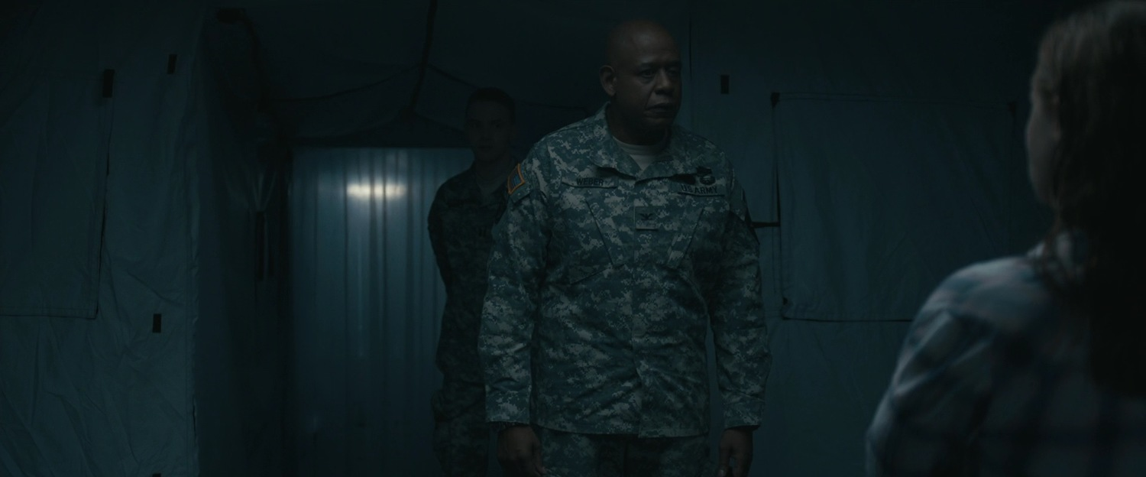
Figure 1: Dennis Villeneuve, 'Arrival', 2016 [Film], Paramount Pictures, United States

In Figure 1, Dr. Banks is shown meeting with Colonel Weber, whereby he informs her of the urgency and details of her mission of communicating with the alien visitors. The significant military presence at the arrival of the Heptapods suggests the sky hence is represented as a boundary to Earth which must be defended. The implications of this are to suggest the sky is a possessed entity, a landscape with agency and sovereignty. Indeed, Christopher Tilley argues in favour of the agency of landscape, and contends that landscape is intrinsically bound with personal perspective and lived experience.

With regards to Arrival, the representation of the sky is therefore ontologically based within the lived experience of who is producing it, how they are experiencing it and the cultural basis wherein their experience originates. The representation of the sky in the film Arrival, and all other films, is undeniably rooted in the perceptions and phenomenological experiences of those who are creating it, ultimately being inseparable from the Western culture that has produced the art form. As evidenced by Kamei, films are constructive, symbolically, and literally representing the dominant cultural ideologies and practices of the cultures from which they originate. This is evidenced by Tilley’s argument that ‘we can never sense the entire world from the determinate situatedness of our bodies. We exist in the world and relate to it from a point of view’, with this point of view being shaped by culture. Indeed, the film is set in modern day America, produced by an American production company and the director is French Canadian. Therefore considering Tilley and Kamei’s contentions, the film thus represents the sky from a decidedly Western point of view, being influenced by the capitalist values and societal ideals of American culture. The supremacy of the capitalist West is represented in Arrival through how Russia is said to execute one of their own in order to protect the information they have acquired, while China is shown to be rushing to use brute force against the alien race whilst the United States shows restraint with their military policy. Considering Russia and China are two historically contentious countries within American global politics, notably with the Cold War and the war against communism, this film can be said to be reproducing the ideological ideal of communist countries as violent and brutal nation-states. Neo-Weberian sociologist Collins defines nation-states as the foremost institutional power in the contemporary era who are ‘involved in the geopolitical struggle over prestige, power and resources’. In this way, Arrival’s representation of the sky proffers new potential in which the struggles identified by Collins can play out. There is the physical threat, but also the prestige and status obtained through whichever country is the first to make significant progress with the alien visitors. There is also the potential for new and advanced technology and resources. Consequently, the representation of the sky in Arrival plays out as a form of battleground wherein the human tendency to compete and destroy each other, our desire to communicate and our lack of knowledge surrounding whether other life exists elsewhere in the universe is played out through the storyline of Louise’s developing communication with the Heptapods, and the geopolitical tensions of the global stage. As such, the sky in Arrival is represented as a sovereign entity, and each country who has a Heptapod land in their nation recognises this invasion as a potential threat to their way of life and the material survival of humankind. Though the sky is essentially without borders, humans and the countries in Arrival interpolate boundaries onto the sky with incredibly real and affective boundaries over the countries that lie below them, such as military airspace boundaries. Thereby despite the sky possessing no physical boundary of its own in Earth’s atmosphere, it has real and potentially life-threatening agency depending on the reactions of those who claim said airspace. This is illustrated by Tilley, who describes how the agency of a landscape is affective upon bodies through its material impact. Ultimately, both the storyline and the visual representations of military action express the sky as a sovereign entity, and how politics can interfere with technological advancement and development.

The Sky as Other

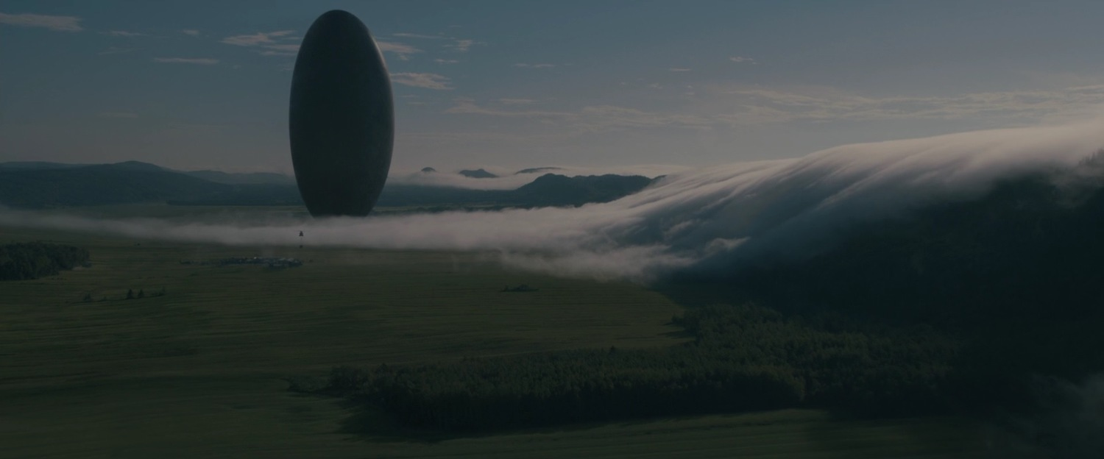
Figure 2: Dennis Villeneuve, 'Arrival', 2016
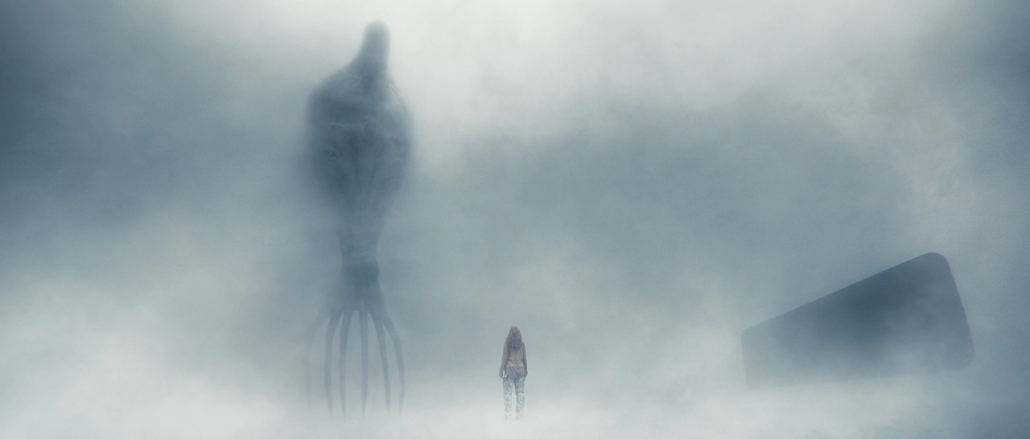
Initially, the Heptapod spacecrafts in Arrival are shown as being shrouded in mist with the camera eventually panning to Figure 2 to reveal the large, oval shaped spacecraft. The atmospheric nature of the cinematographic and stylistic editing choices gives the impression of awe and mystery; however the impending seriousness of the situation is reflected in the aggressive military presence that lies just beyond the mist. The arrival and appearance of the Heptapods is in direct contrast to Rieder’s contention that the SF alien typically is not a represented as a mysterious metaphysicality, however Rieder’s argument does align with the culturally constituted nature of extra terrestrial invasions within the particular context and historical background of Western capitalist society. For instance, Rieder argues that modern SF can demonstrate a tendency to express alien races as ‘grotesque…fantasies of freedom and power’, as shown in Figure 3 with the completely un-humanlike Heptapod being, with Rieder supposing that the SF alien is a demonstrable example of the Other. In postcolonial theory, the process of Othering makes use of the Marxist framework of hegemony whereby those who do not and cannot fit the hegemonic societal ideological expectations are discursively, materially and affectively subjugated through a multiplicity of mechanisms, institutions and infrastructures. As such, representations of the sky can contribute and reproduce the process of Othering, such as acting as projections of the Other and effectively normalising their subjugation.
Figure 3: Dennis Villeneuve, 'Arrival', 2016

The 1996 film Independence Day is another example of two-dimensional media whereby the sky demonstrates the cultural and socio-political phenomena of the marginalisation of the Other. In Independence Day, the sky becomes a literal battleground as opposed to a metaphorical one in Arrival, whereby the invasion of the alien race is a dangerous threat to not only American human life, but the American way of life. Indeed, Gramsci describes the potential for a ‘war of attack’ upon the dominant hegemonic ideology that pervades the capitalist West by oppressed groups. Figures 4 and 5 show the scenes in Independence Day where the alien ship hovers enormously over the iconic and semiotically significant American buildings such as the Brooklyn Bridge and the Empire State building. Both structures rise high into the sky above the buildings that surround them, their reach into the sky landscape a symbol for the American dream and Western capitalism. These massive, foreboding structures claim their position in the skyscape of New York as instantaneously recognisable representations of the successes and supremacy of American capitalist ideology and economics, in line with Lewandowski’s contentions that the built environment symbolises ‘a society’s ideas, its forms of economic activities and the beliefs and values which prevail’. Cristofario argues in favour of the agency of non-human entities and landscapes, contending that ‘people, things, spaces and places all cohabit’, each one possessing an affective nature which imposes upon the other, reacting continually to each other’s co-constitutive nature. Similarly, Tilley conceptualises space as possessing agency, whilst Barbara Bender also argues against the neutrality of space and landscape. In this way, the sky’s agency in Independence Day can be considered as being represented as a metaphor for hegemonic American ideology.
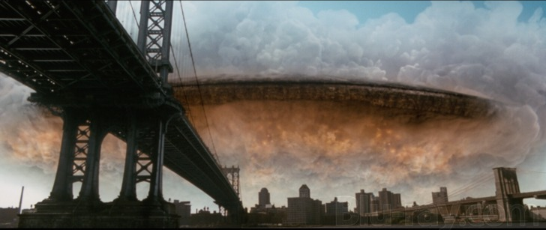
Figure 4: Emmerich Roland, ‘Independence Day’, [Film], 1996, Twentieth Century Fox: United States

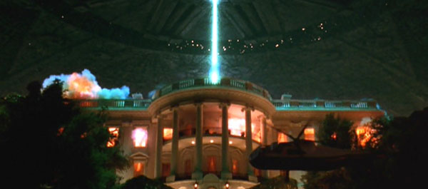
Figure 5: Emmerich Roland, ‘Independence Day’, 1996

The eventual overcoming of the aliens by America against all perceived odds hereby represents the sky as a sovereign entity, one that belongs to, and will be defended by, the American people and military. Despite the immense material power, technological resources and intelligence of the alien race called the Harvesters, the audience witnesses the characters in Independence Day eventually outsmart and consequently destroy the Harvester ship. The sky then becomes a representation of the success of humanity over the impossible and the people rejoice in the triumph of the United States military power. However in line with the contentions of Gramsci, this scene and eventual conquering by the US means the sky is also represented as a metaphor for American propaganda which serves to reproduce and uphold the dominant hegemonic ideology of the immense military power, strong ideals and superior intelligence of the American people. If one considers the alien race as a ‘representation of bourgeois consciousness itself’, the bourgeois therefore succeeds over the threat imposed against Western capitalism by the Harvesters. With relation to the concept of Othering, the functional purpose of Othering serves to portray the dominant ideological status quo at the stronger, more legitimate way of life, whilst the Other is seen as a threat to the hegemonic societal norms and behaviours.
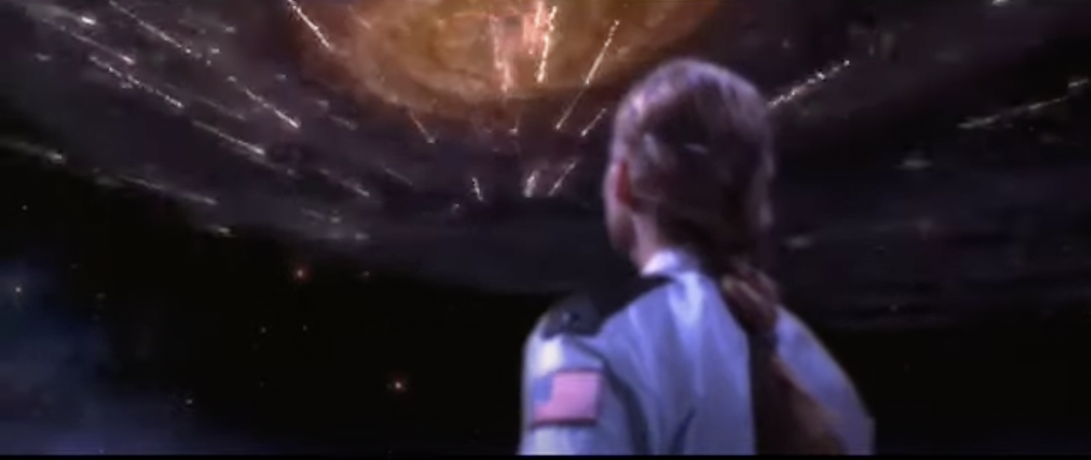
Figure 6: Robert Zemekis, ‘Contact’, [Film], 1997, Warner Bros: United States

However, in the 1997 film Contact, the protagonist Ellie travels through space to meet the distant alien race that contacted Earth, who show her kindness, compassion and grace by representing the location of her arrival as familiar to her, resembling a beach on Earth, albeit in outer space. The aliens demonstrate additional compassion wherein after downloading all of her memories and phenomenological lived experiences, they recreate a scene from her childhood where she finally gets to reunite with her late father to watch the meteor shower they missed due to her father’s death, as shown in Figure 6. This is a contrasting representation of our neighbours in outer space, as instead of being portrayed as ‘estranged or alienated figures’ who appear grotesque in form, the aliens in Contact are demonstrated as not too dissimilar from humans with their ability to communicate, empathise and understand human emotion and experiences. In this way, Contact directly contradicts the representations of the sky in the films Arrival and Independence Day through its differing depiction of the humanness of the aliens, contrasting Rieder’s contentions that SF aliens are typically monstrous, cruel and brutal and instead representing the sky as having potential for communication and connection with any life that may exist elsewhere in the universe.

The Sky as (dis)Enchantment

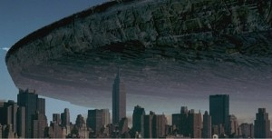
An alternative perspective for the representation of the sky in Independence Day can be found in the theories of Weber, who argues that the modern world is disenchanted, partly due to technological advancements of the world. Richard Tarnas’ definition of disenchantment describes how the contemporary era ‘has been voided of any spiritual, symbolic or expressive dimension…in which human existence finds its grounds of meaning and purpose’. Initially when the alien ship arrives in Independence Day, the people in the film react with a mixture of both fear and awe at the sight of the sheer size of the ship as it enters the airspace above them, depicted in Figure 6. As the film progresses, any awe or enchantment experienced by those who witness the ships is replaced entirely by fear, chaos and destruction. Weber’s theory suggests that technology acts as a servant of the process of disenchantment, not necessarily being the sole cause, but rather facilitating the loss of spiritual contentment within the human race in the contemporary era through industrialisation and intellectualisation. Independence Day features a highly intelligent and technologically advanced, yet vicious and brutal alien race which enacts the physical destruction of not only culturally significant iconography but also the material structures necessary for human survival, killing thousands of people in the process. In this way, the sky in Independence Day becomes a representation of the removal of the experience of enchantment, whereby human life is symbolised by the ‘magical aliveness of, and psychic human participation with, the natural world’. Technology, then, becomes the threat to life as opposed to an opportunity for advancement and development, which is shown in Arrival with the gifting of unknown technological and psychic advancement from the Heptapods to Dr. Banks. The critical examination of the representation of the sky within Independence Day then differs according to whether it is assessed through the lens of phenomenological perspective, Marxist or Weberian thought. Using the framework of phenomenological study, the sky in Independence Day is a contested landscape whereby the cultural originations of the film contributes to the reproduction of the dominant narratives within their own lived and phenomenological experiences. A Marxist view on how the sky is represented in Independence Day reveals how the production of Hollywood films serves to uphold and reproduce dominant hegemonic ideals, such as that of the American dream and Western capitalism. Conversely, Weberian analysis reveals that the sky can act as a representation of the disenchantment of the modern world.
Figure 7: Emmerich Roland, ‘Independence Day’, 1996
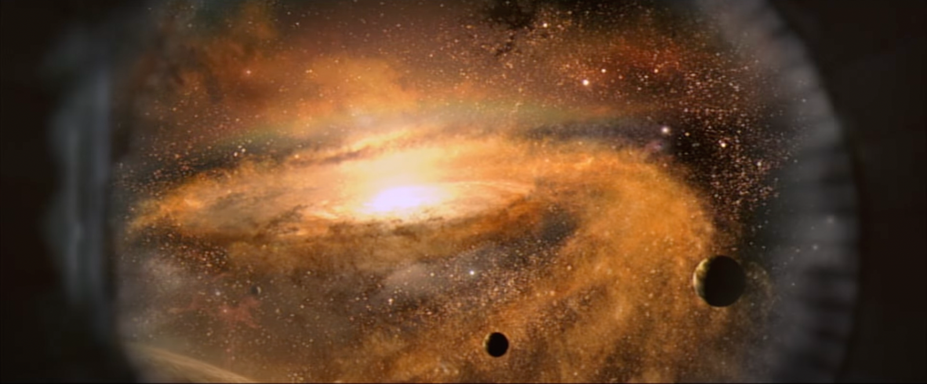
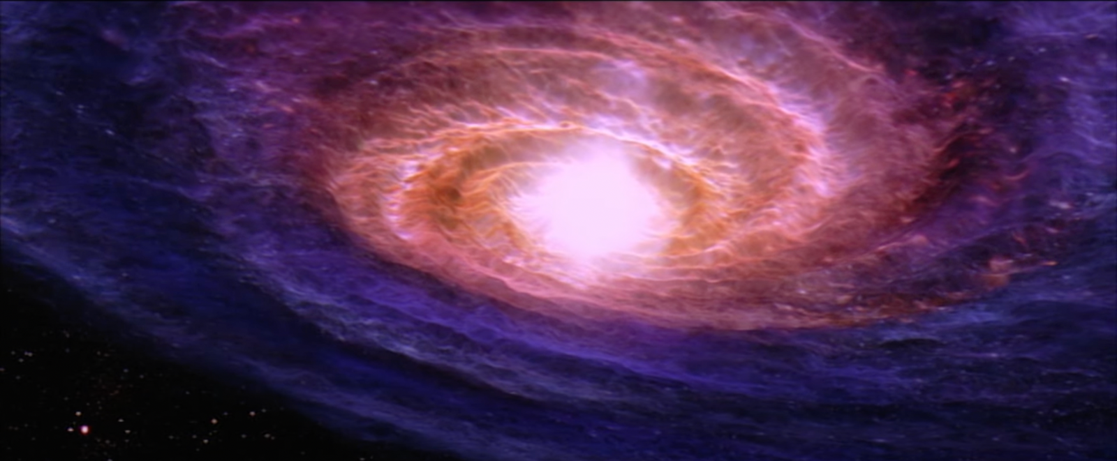
Figure 9: Robert Zemekis, 'Contact', 1997
Figure 8: Robert Zemekis, 'Contact', 1997

Alternatively, Nicholas Campion proposes that the intellectualisation and technological advancement of the world does not mean the determinate end of experiencing awe and enchantment at the cosmos. This is exemplified in how the sky is represented in the films Contact and Ad Astra. Campion states that in his own phenomenological experience, the use of technology was essential to facilitating his own experiences of awe and enchantment, such as when viewing the planets of Jupiter, Saturn and Venus through a telescope for the first time, an experience made possible by the use of technology. This perspective is also demonstrated in Contact through how the protagonist Ellie experiences enchantment at the cosmos as a young child, with these experiences propelling her into a career in astrophysics, wherein her enchanting experiences only continue. In Contact, there is a discovery of data consisting of a radio transmission containing a series of prime numbers that appear to have originated near Vega. Upon detailed study, it is found that the radio transmissions contain instructions for building a machine that can be used to travel through space-time. Similarly to in Independence Day and Arrival, the general reaction of humanity in the face of alien contact begins as exceedingly mixed representations of fear, anxiety, and panic, however Contact features the direct and continued dedication to the potential of contact with outer space. Later in the film, while travelling through deep space, Ellie encounters enchanting celestial events, as pictured in Figures 8 and 9. Ellie’s reaction is fundamentally awe-struck, she is left near speechless by the sights as evidenced by Ellie saying there are ‘No words…no words to describe. Poetry…they should have sent a poet, it’s so beautiful’. In addition, although the aliens in Contact are perceived as being more technologically advanced by the human characters, it is revealed that they were not the ones who built the machine that allowed Ellie and the other species to travel to them, as they state ‘we don’t know who built the machine that connects us’. There is juxtaposition here between Ellie’s atheism and the faith of the alien race in something potentially larger, but certainly older, which can be considered a representation of the Cartesian binary between religion and science. Throughout Contact, Ellie is portrayed as in favour of the logical and rational science of her profession over any notions of faith or God, something that at one point almost costs her the opportunity to travel in the machine, and later is revealed to have been something that saved her life. Patrick Curry argues that the divisive binary of science and religiosity is ‘the primary act of disenchantment: dividing everything up into two competing monisms, either ‘supernatural’ or ‘physical’’. Later in the film, Ellie must rely on people having faith in her as she attempts to recount her experiences in outer space and prove that life indeed does exist elsewhere in the universe. As such, Contact can be said to be a representation of how it is not the technology itself that results in disenchantment, but the faith in either science or religion of one as superior to the other that culminates in the disenchantment of the contemporary era.
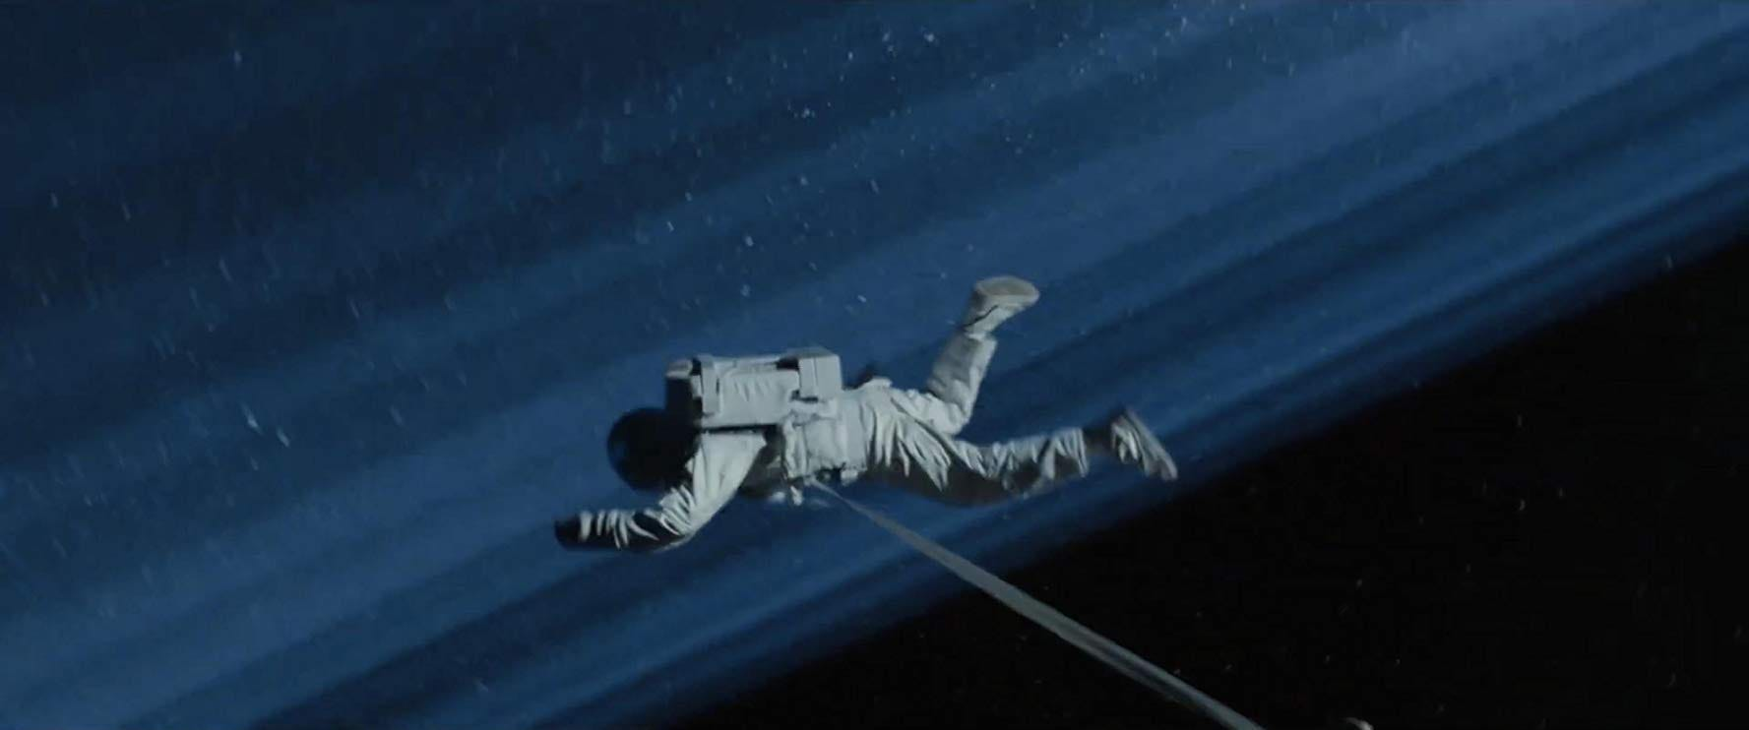
Figure 10: James Gray, 'Ad Astra', [Film], 2019, Twentieth Century Fox: United States

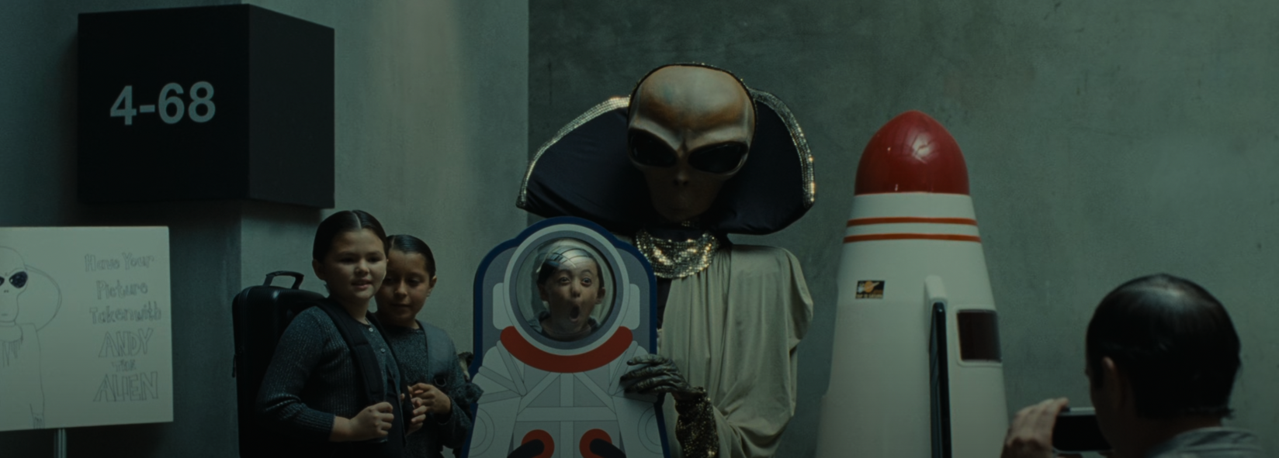
Similarly, the 2019 blockbuster film Ad Astra also represents the sky as a place where experiences of awe and enchantment are bountiful, to the extent that the protagonists’ father eventually chooses to die on the outskirts of Neptune rather than return home to Earth, as shown in Figure 10. The protagonists’ father is so enchanted by the potential that life exists elsewhere in the universe that he is willing to sacrifice not only his own life, but the lives of innocent people on board his craft to ensure the search continues. This character’s enchantment, near obsession with the cosmos is not limited or reduced by his technological study; in fact the opposite occurs. Likewise, the author of the original Contact story, Carl Sagan, reports that his own depth of knowledge of the inner workings of the universe have increased and deepened his experiences of awe and enchantment. This is reflected in Ad Astra by how the longer Roy’s father spends in space conducting research, the more he is fascinated by it and the less desire he experiences to return to Earth. However, the Western scientific view of the cosmos is only one expression of the universe, as other cultures such as the Aboriginal Australians represent the sky differently. Whilst both cultures feature storytelling as a way of expressing their representations of the sky, one myth from indigenous Australian cultural mythology features the Pleiades as a number of sisters who are being chased across the sky by men in Orion. Conversely, Sagan is a scientist and cosmologist, therefore his interpretation and understanding of the universe is shaped by the rational logic of his background as well as the Western culture his lived experiences are founded in.
Figure 11: James Gray, 'Ad Astra', 2019

Although Ad Astra is a representation of the potential enchanting nature of outer space, the sky in Ad Astra is also a represented as an extension of Western capitalism. The protagonist Roy describes human beings as ‘world-eaters’ whilst scenes of the tourist base on the Moon are demonstrated, which is shown in Figure 11. This is a direct contrast to the representation of the sky in the films Arrival and Independence Day, as Ad Astra portrays the sky as somewhere sacred that humans are a plague upon, in opposition to how Independence Day represents the sky as a sovereign entity to be defended and protected. Campion also notes that whilst movies that feature journeys through and representations of the sky, they can and often do express deeper meanings. Merton would describe this underlying meaning of the film from a Functionalist perspective that states social action can have both manifest and latent functions. The manifest function of films such as Ad Astra are predominantly to entertain large audiences, also to produce profits for the production companies and film industries. However, the latent function of the film is a warning against the potential destructiveness of human hubris and technological advancement. Conversely, Susan Sontag argues that science fiction and horror media genres that specifically feature apocalyptic world endings or dystopian futures enact a different function, instead being creative manifestations of the anxieties and concerns that trouble society regarding our own mortality and temporality.

Conclusion

In conclusion, this essay has critically examined representations of the sky in the films Independence Day, Arrival, Contact and Ad Astra. The film’s distinct representations of the sky have been demonstrated the significance of understanding the cultural contexts and background from which they were produced and originated from. Through analysing both the plotlines and visual still images of the films, representations of the sky have been examined through the lens of three main ideas, the sky as sovereign, the sky as Other and the sky as enchantment. In line with significance of storytelling and cosmology within any given culture, this essay showed that films are culturally constituted, being made up of elements pertaining to the lived experiences and cultural backgrounds from who, and where they originate. The films discussed in this essay were chosen as examples from the science fiction genre in Western cinema and this essay has analysed the way in which this has influenced their representations of the sky, and the affective nature of such notions. Cinema has been shown to exert more than one function within society, including both over, manifest functions and latent, hidden functions.

Bibliography

- Bender, B., ‘Stonehenge: Making Space’, Oxford, Berg, 1998
- Bruno, G., ‘De l’Infinito, universe e mondi’, 1584
- Campion, N., ‘Enchantment and the Awe of the Heavens’, THE INSPIRATION OF
ASTRONOMICAL PHENOMENA VI ASP Conference Series, 2011
- Campion, N., ‘The Importance of Cosmology in Culture: Contexts and Consequences’, Trends in
Modern Cosmology, InTech, 2017
- Chiang, T., ‘Stories of Your Life and Others’, 2002, Penguin Books, New York
- Cristofario, I., ‘Harmony and a Phenomenology of Liquid Skies’ in Nicholas Campion (ed.), ‘The
Harmony Debates: Exploring a practical philosophy for a sustainable future’ (Lampeter: Sophia Centre Press, 2020)
- Curry, P., ‘The Work of Wonder’, Western Humanities Review 72.2 (Summer 2018)
- Gramsci, A., 1891-1937, ‘Selections from the Prison Notebooks of Antonia Gramsci’ New York:
International Publishers, 1971.
- Hamacher, D.W. and Norris, R.P., ‘“Bridging the gap” through Australian cultural astronomy.
Archaeoastronomy and Ethnoastronomy: building bridges between cultures’, 2011, edited by Clive Ruggles. Cambridge University Press
- Heisserer, E., ‘Contender Conversations – Arrival’s Eric Heisserer “What is Arrival about?”’ via
YouTube, 2017. Accessed via https://www.youtube.com/watch?v=nHsK7qQ-0Ow&list=PLwqbRLnnj2ap6IPyWeQw8Wt7QMfbHXsgH. (Accessed on 5th May 2023)
- IMDb., ‘Denis Villeneuve’, IMDb. Available at: https://www.imdb.com/name/nm0898288/
(Accessed: 18 May 2023).
- Kamei, M., ‘Films as Cultural Artefacts’, International Journal of Advance and Innovative Research,
Vol 6, Issue 1, 2019
- Leong, N., ‘RACIAL CAPITALISM’, Harvard Law Review, 2013, Vol 126, no. 8,
- Lewandowski, S. J., ‘The City in Cultural Context’, 2006, Routledge
- Loyal., S, Malešević, S., ‘Contemporary Sociological Theory’, Sage Publications, 2021, London
- Menadue, C., Giselsson, K., Guez, D., ‘An Empirical Revision of the Definition of Science Fiction:
it’s all in the Techne’, Sage Pub, 2020
- Page, J. “Modernity and Cinematic Time in Science Fiction Film.” In Science Fiction in Argentina:
Technologies of the Text in a Material Multiverse, University of Michigan Press, 2016. https://doi.org/10.2307/j.ctv65swtz.10.
- Rieder, J., “Embracing the Alien: Science Fiction in Mass Culture (Le Baiser à l’extraterrestre: La
Science-Fiction Dans La Culture de Masse).” Science Fiction Studies, 1984, Vol. 9, no. 1
- Rieder, J., “On Defining SF, or Not: Genre Theory, SF, and History.” Science Fiction Studies 2010,
37, no. 2
- Rukeyser M., ‘The Speed of Darkness, IX: The Collected Poems of Muriel Rukeyser’. 1992.
Available from: https://www.poetryfoundation.org/poems-and-poets/poems/detail/56287
- Sagan., C. Cosmos: ‘The Story of Cosmic Evolution, Science and Civilisation’, London, Warner
Books, 1994
- Sontag, S., ‘Notions of Genre: Writings on Popular Film Before Genre Theory’, eds by Barry Keith
Grant and Malisa Kurtz, New York, USA: University of Texas Press, 2016
- Shaw, T., and Youngblood, D., “Cold War Sport, Film, and Propaganda: A Comparative Analysis of
the Superpowers.” Journal of Cold War Studies , 2017, Vol. 19, no. 1 https://www.jstor.org/stable/26925679.
- Thomas-Olalde, O, Velho, A., ‘Othering and its effects: exploring the concept’ in Writing
Postcolonial Histories of Intercultural Education, 2011, Austria
- Tilley, C., Cameron-Daum, K., ‘An Anthropology of Landscape: The Extraordinary in the Ordinary’,
2017, UCL Press

Filmography

- Gray, J., 'Ad Astra', [Film], 2019, Twentieth Century Fox: United States
- Roland, E., ‘Independence Day’, [Film] Twentieth Century Fox, 1996
- Villeneueve, D., ‘Arrival’, 2016, [Film], Paramount Pictures, United States
- Zemekis, R., ‘Contact’, [Film], 1997, Warner Bros: United States

Bruno, G., ‘De l’Infinito, universe e mondi’, 1584
Campion, N., ‘The Importance of Cosmology in Culture: Contexts and Consequences’, Trends in Modern Cosmology, InTech, 2017
Rieder, John. “On Defining SF, or Not: Genre Theory, SF, and History.” Science Fiction Studies 37, no. 2 (2010): p.194
Rukeyser M. ‘The Speed of Darkness, IX: The Collected Poems of Muriel Rukeyser’. 1992
Campion, N., ‘The Importance of Cosmology in Culture: Contexts and Consequences’, 2017
Villeneueve, D., ‘Arrival’, 2016, [Film], Paramount Pictures, United States
Chiang, T., ‘Stories of Your Life and Others’, 2002, Penguin Books, New York
Heisserer, E., ‘Contender Conversations – Arrival’s Eric Heisserer “What is Arrival about?”’ via YouTube, 2017. Accessed via https://www.youtube.com/watch?v=nHsK7qQ-0Ow&list=PLwqbRLnnj2ap6IPyWeQw8Wt7QMfbHXsgH. (Accessed on 5th May 2023)
Menadue, C., Giselsson, K., Guez, D., ‘An Empirical Revision of the Definition of Science Fiction: it’s all in the Techne’, Sage Pub, 2020
Page, Joanna. “Modernity and Cinematic Time in Science Fiction Film.” In Science Fiction in Argentina: Technologies of the Text in a Material Multiverse, p.156. University of Michigan Press, 2016
Tilley, C., Cameron-Daum, K., ‘An Anthropology of Landscape: The Extraordinary in the Ordinary’, 2017, UCL Press, p.7
Kamei, M., ‘Films as Cultural Artefacts’, International Journal of Advance and Innovative Research, Vol 6, Issue 1, 2019, pp.81-85
Tilley, C., Cameron-Daum, K., ‘An Anthropology of Landscape: The Extraordinary in the Ordinary’, 2017, UCL Press, p.7
IMDb., ‘Denis Villeneuve’, IMDb. Available at: https://www.imdb.com/name/nm0898288/ (Accessed: 18 May 2023).
Shaw, T., and Youngblood, D., “Cold War Sport, Film, and Propaganda: A Comparative Analysis of the Superpowers.” Journal of Cold War Studies 19, no. 1 (2017): pp.160–92
Loyal., S, Malešević, S., ‘Contemporary Sociological Theory’, Sage Publications, 2021, London
Bender, B., ‘Stonehenge: Making Space’, Oxford, Berg, 1998, pp.100-109
Tilley, C., Cameron-Daum, K., ‘An Anthropology of Landscape: The Extraordinary in the Ordinary’, 2017
Rieder, John. “Embracing the Alien: Science Fiction in Mass Culture (Le Baiser à l’extraterrestre: La Science-Fiction Dans La Culture de Masse).” Science Fiction Studies 9, no. 1 (1982): p.26
Ibid., pp.26-29
Thomas-Olalde, O, Velho, A., ‘Othering and its effects: exploring the concept’ in Writing Postcolonial Histories of Intercultural Education, 2011, Austria
Roland, E., ‘Independence Day’, [Film] Twentieth Century Fox, 1996
Gramsci, A., 1891-1937, ‘Selections from the Prison Notebooks of Antonia Gramsci’ New York: International Publishers, 1971.
Lewandowski, S. J., ‘The City in Cultural Context’, 2006, Routledge, p.18
Cristofario, Iaria, ‘Harmony and a Phenomenology of Liquid Skies; in Nicholas Campion (ed.), The Harmony Debates: Exploring a practical philosophy for a sustainable future (Lampeter: Sophia Centre Press, 2020), pp.269-287.
Bender, B., ‘Stonehenge: Making Space’, Oxford, Berg,1998, Chapter 4, pp.117-121
Gramsci, A., 1891-1937, ‘Selections from the Prison Notebooks of Antonia Gramsci’ New York: International Publishers, 1971
Rieder, John. ‘Embracing the Alien: Science Fiction in Mass Culture’, 1982, p.26
Leong, Nancy. ‘RACIAL CAPITALISM’, Harvard Law Review 126, no. 8 (2013): 2151–2226
Zemekis, R., ‘Contact’, [Film], 1997, Warner Bros: United States
Rieder, John. ‘Embracing the Alien: Science Fiction in Mass Culture’ 1982
Weber, M. ‘From Max Weber: Essays in Sociology’, London, Kegan Paul, Trench, Trubner & Co., 1947, p. 139
Tarnas, R., in Campion, N., ‘Enchantment and the Awe of the Heavens’, THE INSPIRATION OF ASTRONOMICAL PHENOMENA VI ASP Conference Series, 2011
Ibid., p.145
Campion, N, ‘Enchantment and the Awe of the Heavens’, 2011, p.145
Bender, B., ‘Stonehenge: Making Space’,1998, pp.117-121
Gramsci, A., 1891-1937, ‘Selections from the Prison Notebooks of Antonia Gramsci’ 1971.
Weber, M., ‘From Max Weber: Essays in Sociology’, 1947, p. 139.
Gray, J., 'Ad Astra', [Film], 2019, Twentieth Century Fox: United States
Campion, N., ‘Enchantment and the Awe of the Heavens’, 2011, p.145
Curry, P., ‘The Work of Wonder’, Western Humanities Review 72.2 (Summer 2018) pp.28-41
Campion, N., ‘Enchantment and the Awe of the Heavens’, 2011
Sagan., C. Cosmos: ‘The Story of Cosmic Evolution, Science and Civilisation’, London, Warner Books, 1994, p.12
Hamacher, D.W. and Norris, R.P. (2011). ‘“Bridging the gap” through Australian cultural astronomy. Archaeoastronomy and Ethnoastronomy: building bridges between cultures’, edited by Clive Ruggles. Cambridge University Press, pp. 282-290
Campion., N., ‘Enchantment and Awe at the Heavens’, 2011
Loyal, S., Malesevic, S., ‘Contemporary Sociological Theory’, Sage Publications, 2021, p.382-385
Sontag, S., ‘Notions of Genre: Writings on Popular Film Before Genre Theory’, eds by Barry Keith Grant and Malisa Kurtz, New York, USA: University of Texas Press, 2016, pp. 186-201.

